Human Rights Grants Scheme

Attachment A: Expression of Interest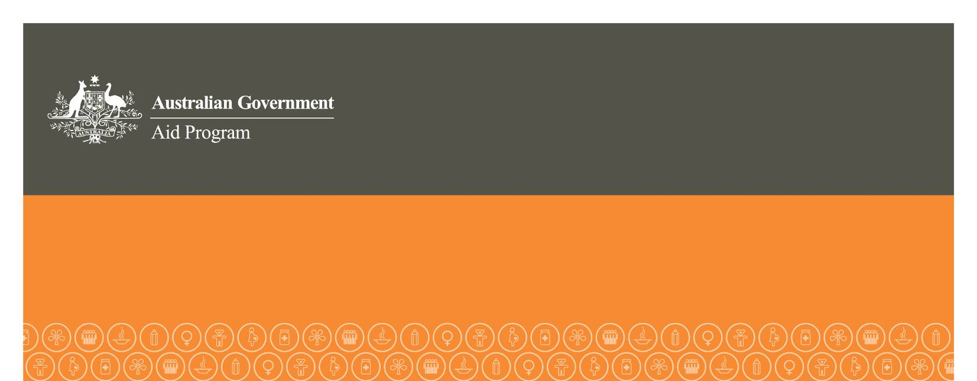

|  |
| --- |
| Instructions |
| This form is to be completed by the applicant organisation. The form must be typed and in English. The form must be received by the relevant Australian diplomatic mission by 4 pm (local time) **17 August 2012.** The form can be mailed or delivered in person, but will not be accepted by e-mail. Late applications will not be accepted, without prior agreement from the relevant Australian diplomatic mission.  **THIS FORM MUST BE NO LONGER THAN 2 PAGES** |

|  |  |
| --- | --- |
| ORGANISATION AND PROJECT DETAILS (maximum 2 pages) | |
| Name of organisation and address |  |
| Name of project |  |
| Need for and purpose of project (maximum 300 words) |  |
| Country in which project will be implemented |  |
| Amount of funding sought from HRGS (maximum AUD100,000) |  |
| Name of contact person |  |
| Contact numbers | Work Mobile |
| Email address |  |