Health Alliance International

Annual Report 2010

Support for Improved Maternal and Newborn Care

in Timor-Leste in Partnership with the

Timor-Leste Ministry of Health

**AusAID aGREEMENT 54456**

**December 10, 2010**

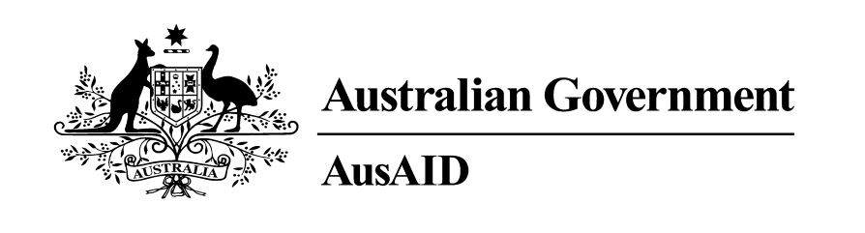

# ministry health logo-354gr HAI Logo - Color SMLIntroduction

Beginning in March 2010 the Australian Agency for International Development provided Health Alliance International funding to improve maternal and newborn care and family planning in partnership with the Timor-Leste Ministry of Health (MOH). The overarching goal of the program is to improve health and reduce mortality and morbidity for mothers and their infants in Timor-Leste thus contributing to the MDG goals four and five. The specific objectives during the 21-month funded period (March 2010 – December 2011) are to:

* Improve the health policy environment and ensure national policies reflect the most up-to-date research in antenatal, delivery, postpartum and newborn care and family planning
* Support the MOH in cross-cutting areas such as information collection/use and supervision tools, and improving skills in program evaluation and operations research
* Expand the capacity of the district health facilities to deliver MNC services with a goal of:
  + - improving quality of care delivered by district midwives through supportive supervision
    - supporting safe delivery sites through the provision of Birth Friendly Facilities in selected subdistricts
* Improve selected behaviors among the community with a focus on the following initial goals (indicators were revised in the light of the 2010 data from the Demographics and Health Survey):
  + - Percent of pregnant women who receive the recommended four antenatal care visits (according to the MOH definition of K4) will increase from by 5 percentage points in HAI districts between 2009 and 2011
    - Percent of women who deliver with a skilled birth attendant (SBA) will increase by 5 percentage points in HAI districts between 2009 and 2011
    - Percent of annual deliveries that occur at a health facility will increase by 5 percentage points in HAI districts between 2009 and 2011
    - Percent of annual postpartum and newborn visits within the first week will increase by 5 percentage points in HAI districts between 2009 and 2011
    - Couple Years Protection will increase by 4% each year for HAI districts between 2009 and 2011

To achieve these objectives a variety of activities have been carried out in 2010 in six districts in which HAI has been active since 2004: Manatuto, Liquica, Aileu, Ermera, Manufahi and Ainaro (as well as limited activity in Dili).

This report will outline the key program approaches employed during the reporting period and detail progress toward goals.

# Why Support Maternal/Newborn Care and Family Planning in Timor-Leste?

Poverty and low literacy in Timor-Leste are widespread and despite achievements since gaining independence over a decade ago, maternal and child health remains among the worst in the region as evidenced by a maternal mortality ratio of 557 per 100,000[1] live births. Thus while in Australia a woman dying in childbirth would be very rare, one in almost 12,000 births, in Timor-Leste, that number is one is 180 woman who will die. This makes having a baby the number one risk of death for Timorese women. Infant mortality is estimated at 44 per 1,000 per live births, of which one-half occurs in the neonatal period. According to the TLDHS 2009-2010 64 per 1,000 children in Timor-Leste die before reaching age five.[2] Utilization of critical maternal health services is low. While pregnant women receiving at least one prenatal care visit is common in Timor (86%), only 55% of women receive the WHO recommended four visits during pregnancy to assure that their pregnancy is being adequately monitored. The vast majority of deliveries (78%) still occur in the home and only 30% are assisted by a skilled attendant. Nearly one fifth of deliveries are carried out by a traditional birth attendant (18%) and nearly one in two (49%) are assisted by only a family member or friend.[3] As with many health indicators in Timor-Leste, there is wide disparity between urban and rural areas with 59% of urban births assisted by a skilled attendant compared to only 21% in rural areas.[4]

The main causes of maternal mortality are well known: hemorrhage, infection, hypertensive disorders, and obstructed labor. However, contributing substantially to the high maternal mortality in Timor-Leste is the frequency of unintended pregnancies. While Timor-Leste has made progress in reducing its total fertility rate from 7.8 in 2003[5] to 5.7 in 2009[6] (two children less per family), it remains relatively high and is still the highest in the Southeast Asian region. While the contraceptive prevalence rate doubled during this same period it remains low at 22%. As with other health indicators there is a marked difference in contraceptive use between urban and rural areas at 28% and 19% respectively.[7] While progress has been made in community-level health promotion to increase awareness of the health benefits to mother and child when pregnancies are adequately spaced as well as to strengthen health provider skills in delivering family planning counseling, there is still much work to be done to improve access to modern contraceptive methods for women wishing to delay or limit future pregnancies.

# Program Approaches

The following approaches have been carried out by HAI staff in partnership with our colleagues and counterparts at the Ministry of Health. Please see Annex 1 for a detailed work plan that outlines specific activities and output indicators under each of the following program approaches.

* Supportive supervision visits and partnership with MOH DPHOs to assure quality health care delivery by MOH MCH DPHOs and midwives
* Ensure competence of all midwives in program districts in providing post partum and essential newborn care and recognition of common newborn danger signs and deformities
* Improve access to and quality of BFFs (birth friendly facilities)
* Provide technical support to MCH-DPOs, including Local Area Monitoring
* Improve quality of SISCa events in providing MCH and FP services
* Supportive Supervision of PSF volunteers
* Improve outreach of MNC services at SISCa posts
* Increase quality and regularity of SISCa events
* Increase media messages about ANC
* Increase community referral of pregnant women to health centers
* Work with community leaders on the importance of creating birth plans and emergency referral and transport strategies.

# Key Achievements in 2010

1. Community Level Health Promotion

**HAI works at the community level to increase knowledge about important maternal, newborn and family planning behaviors and over the past few years has developed culturally-responsive, multimedia Behavior Change Communication (BCC) tools to facilitate this work. These resources include films, radio spots, songs, photo cards and posters. In 2010, AusAID has supported HAI to make these tools more widely available for MOH staff and other partners.**

***Films: Espasu Oan (Child Spacing) and Hakat Ba Naroman (Step Towards the Light)***

*Espasu Oan,* is a two-part film highlighting the health benefits to women and their babies when pregnancies are adequately spaced (part 1) and describing modern family planning methods to achieve this spacing (part 2). Throughout 2010 our local NGO contractor, Health Net, traveled to villages in our six program districts showing the film and leading post-film discussions with men and women. In addition, HAI staff have begun showing the film at monthly SISCa[8] events where FP services (counseling and methods) are available. Since March of 2010, an estimated 4,261 people viewed the film and 3,963 participated in guided discussions on key film messages after watching the film through these venues. One of the greatest successes of the year was showing the film on national television. It aired in the time slot just before the World Cup semi-final on July 3rd, which an estimated 150,000 people watched nationwide! Reaching roughly 15% of the population marks a great achievement, especially as it reached our usually hard-to-capture male audience.

*Hakat Ba Naroman* is another film project developed by HAI and consists of five 10-minute educational videos covering the importance of birth planning and prenatal care, having a skilled birth attendant assist with delivery, the importance of postpartum and newborn care and early and exclusive breast feeding. *Hakat Ba Naroman* was also aired on national TV and is shown in villages, at SISCAs and in health center waiting rooms. In order to facilitate and expand the use of the *Hakat Ba Naroman* as well as *Espasu Oan*, HAI donated TVs and DVD players in four of our Birth Friendly Facilities. The films are now used as part of antenatal care and FP counseling to assist health providers to deliver key messages.

HAI has trained midwives from the districts of Dili, Ainaro, and Ermera, as well as conducted a training for staff of Marie Stoppes International, on use of the film *Espasu Oan* for health promotion. A total of 96 people participated these 3-day trainings geared toward familiarizing health staff with the content of the films and gaining confidence in facilitation of the post-film discussions.

***Creative Use of Radio***

In 2010 radio spots containing maternal and family planning messages and tailored songs were aired on national and local radio stations. Although monitoring the listenership numbers is difficult, given the low cost of $115 per month for a four-minute airing every day, the initiative was well worthwhile and the feedback has been very positive. Responses revealed that the radio messages were catchy and memorable. HAI has produced one song that lists the danger signs that can occur during a woman’s pregnancy. Another song features the importance of colostrum for newborns in an effort to dispel the popular Timorese myth that this milk is ‘bad’ or ‘dirty’.

***Mai Ita Koko (Come Let’s Try!)***

HAI developed a BCC communication package that we call *Mai Ita Koko* or “Come Let’s Try”, which consists of ten photo cards depicting relevant Timorese images and portraying recommended maternal health behaviors (please see Annex 2). HAI provides training for the MOH cadre of community health workers, PSFs, to use the photo cards as an educational tool during home visits and to encourage women and families to adopt one or more behavior, such as having a skilled birth attendant, giving birth at a facility or choosing a family planning method. The chosen behavior(s) is checked off on a colorful poster that contains each of the photos and the poster is left with the family to remind them of their selection. During 2010 HAI completed the planned training of PSFs on the “*Mai Ita Koko*” behavior change materials in all six of our program districts. A total of 210 PSFs have been trained in the *Mai Ita Koko* communication package. HAI Health Promotion staff have carried out monitoring and supervision visits with PSFs during home visits in 6 sub-districts to coach and provide feedback on their skills in delivering health promotion messages.

Given the popularity of our BCC materials and tried and tested methods for effective utilization, HAI receives requests from other organizations, such as Café Clinic Timor (CCT), IMOG (an Australian MCH project) and Save the Children, to conduct additional staff training on effective use of the BCC tools.

In addition, 29 Community Health Worker (PSFs) underwent participatory refresher training on FP health promotion techniques and the use of HAI’s full range of multimedia materials.

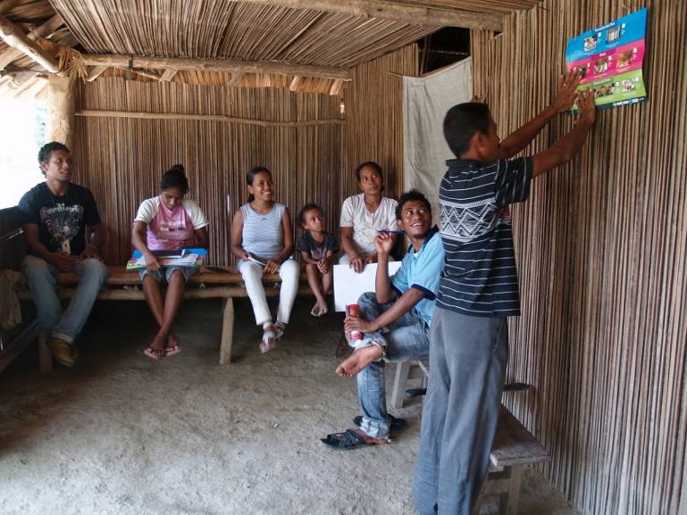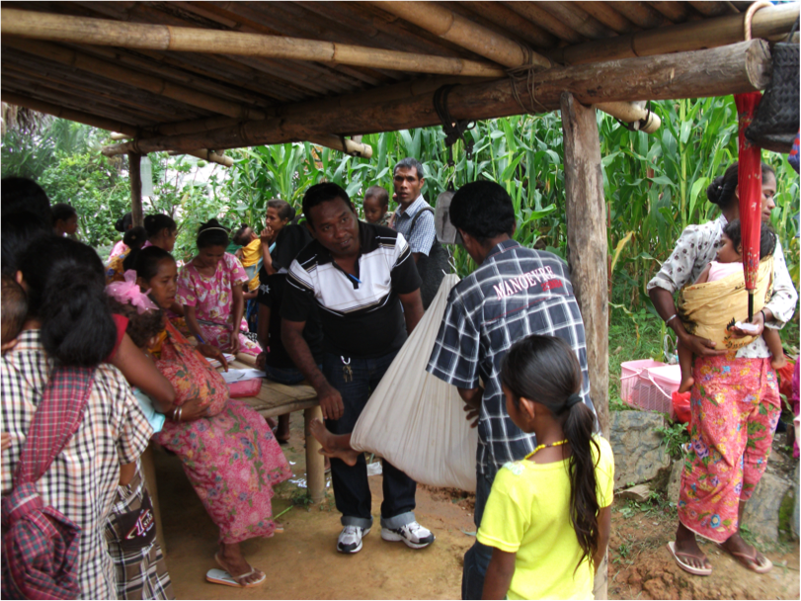

*HAI Health Promotion staff coaching PSFs during a home visit with a pregnant mom encouraging health maternal care seeking behaviors.*

*HAI Health Promotion staff providing supervision to PSFs at a SISCa event*

1. Improving Maternal, Newborn and Family Planning Services

**HAI works in close partnership with the MOH to improve maternal, newborn and family planning services that are delivered through the government-run health system. Achievements in 2010 were made in a number of key areas as outlined below.**

***Servisu Integrado Saude Communitaire (*SISCa)**

Our staff provides support for the MOH-initiated SISCa events (*Servisu Integrado Saude Communitaire* ) through monitoring and supervision of the cadre of community health workers, PSFs, tasked with staffing the registration table and conducting health promotion activities at SISCa events. Our team also builds the capacity of district health leadership staff by working with team members specifically charged with overseeing the events. In order to assist the health teams in providing the highest quality services to rural communities, HAI worked with the MOH to develop a national SISCa checklist to ensure the completeness of equipment and medicines provided at a SISCa post and additionally the quality of services provided. On the SISCa day, the HAI team arrives early at the community health centre to assist in any last minute preparations and then helps transport the SISCa team to the location where they meet the PSFs who live locally. Since March 2010, 133 SISCa events were supported by HAI staff.

***Supportive Supervision for District-based Midwives***

HAI supports the MOH staff to strengthen the quality of public sector services for maternal care, newborn care, and family planning. In the understanding that health workers benefit most from on-site, on-the-job training and follow-up coaching to ensure that new skills are understood and applied correctly, supportive suppervision is a key function of of HAI’s maternal, newborn care and family planing programs in Timor-Leste.

In order to direct HAI’s support to those midwives most in need, we organise our supportive supervision (SS) schedule to include those midwives in more remote health facilities and those who have not received a SS visit for some time. Additionally we shifted some of the focus of SS to include SISCa posts in order to monitor and build the quality of services delivered at this important part of the health system. Furthermore, HAI worked with the MOH and other MCH stakeholders to review and revise the SS checklist in order to ensure the tool was clear and easy to use as well as captured important information about the competency of midwives and quality of services delivered .

***Safe Motherhood, Essential Newborn Care and Family Planning Training in Timor-Leste***

HAI’s experienced midwives are master trainers in Safe Motherhood, Essential Newborn Care and Family Planning. HAI has assisted the MOH and the Institute for Health Sciences in facilitating training to national midwives throughout the country. This activity has also included reviewing the training materials prior to delivering the training and revising to ensure it is of the highest quality**.** HAI has co-facilitated ENC training in Dili, Maliana, Baucau and Oecussi, with a total of 53 midwives and nurses trained. Additionally, HAI conducted Safe Motherhood training for the18 newly returned Timorese doctors returning from Cuba.

***Birth Friendly Facilities***

AusAid are familiar with our efforts to provide facilities that are tailored to the needs of Timorese woman and their communities. Our Maubara BFF was visited by Governor General Her Excellency Quentin Byrce in 2008 and has received ETCAS AusAid Funding. At the beginning of HAI’s maternal and newborn health program, a community assessment was conducted to gain a better understanding of the knowledge, beliefs, practices, preferences and care seeking behavior related to maternal and newborn health. Through dozens of interviews and focus group discussions, community voices revealed some deeply entrenched traditional practices related to birthing. Women and children are understood to be vulnerable following birth and traditional practices are carried out to protect their wellbeing. The community assessment also revealed a widespread lack of awareness of the benefits of delivering with a skilled birth attendant, and many negative associations with deliveries in a health facility. These conversations with communities informed the concept of a Birth Friendly Facility (BFF). A BFF is designed as a Timorese house located next door to a health facility and is meant to provide a comfortable, culturally acceptable place for women to come to deliver their babies with a skilled birth attendant. HAI staff work closely with local communities and district health staff to establish each BFF site. The BFFs are fully integrated into and staffed by the Ministry of Health.

While the rate of facility-based deliveries has been slow to increase in our BFF communities there has been a gradual increase over time. In the summer of 2010, a MPH student from the University of Washington spent two months conducting a situational analysis to provide HAI with a base of knowledge on how three of the four BFFs are currently used, what obstacles the community faces in using them, and what opportunities exist in expanding programming. This report will be available in January 2011 and will provide HAI with useful recommendations to with the hope to increase the utilization of the BFFs.

***Participation in Key MOH Strategic Planning***

The Family Planning Working Group (FPWG) was re-established in March 2010. This marks a major accomplishment for the program. HAI has attempted without success since 2006 to facilitate regular meetings of this body of key stakeholders in family planning in Timor-Leste. A watershed moment in this effort was the attendance of HAI staff, key MOH counterparts and other partner organizations at the "Reconvening Bangkok: 2007 to 2010 — Progress Made and Lessons Learned in Scaling-Up FP/MNCH Best Practices in the Asia and Middle East (AME) Region." This meeting provided a wonderful opportunity to build stronger relationships and for partners to coalesce around family planning initiatives in the country. Since the meeting in Bangkok the FPWG has met regularly to discuss topics that include the ToR for the Working Group, the MOH Family Planning 2010 workplan, the possibility of training PSFs in family planning promotion as well as other national priorities. HAI works closely with the Head of Family Planning to assist her in planning these monthly meetings and encouraging NGO partner organizations to share their workplans with the MOH. The FPWG meetings are held in the local language, Tetum, which has empowered the Head of Family Planning to take more ownership of the Working Group.

HAI, as a leading health organization in Timor-Leste, was chosen to meet with the Minister of Health, Dr. Nelson Martins, for what will be monthly feedback sessions with organisations and agencies working in the health field. HAI’s senior staff use this important opportunity to discuss issues such as data management strengthening, district leadership capacity, persistent maternal mortality, etc. The Minister requested further support from HAI to examine the cause of maternal mortality and to improve quality and impact of health services in the districts.

HAI works closely with the Head of the Family Planning Department. Recently we have supported her national FP evaluation effort with four HAI staff undertaking rapid research to identify areas of good practice and improvement. We were then asked to help use this information to devise a new National Family Planning Strategy 2010-2015. Finally, during the July 2010 Health Sector Review HAI was asked to be the NGO representative to the organizing committee and asked to make the national presentation on Maternal Health Services in Timor-Leste.

# Building in Sustainability through Strengthening the Health System

Health Alliance International’s (HAI) primary mission is to promote policies and support programs that strengthen government primary health care systems, and promote decision making by national Ministry of Health (MOH) staff. Over the more than 10 years that Health Alliance International has been active in Timor-Leste it has built strong relationships with MOH counterparts at the central, district and subdistrict levels and implemented programs in consultation with the MOH at every stage. HAI supports the MOH staff to strengthen public sector services for maternal care, newborn care, and family planning and in doing so believes it makes the best case for long-term sustainability and good stewardship of donor funding.

# Work toward Gender Equality

HAI is committed to leveling the playing field for women by ensuring access to high quality health services that are provided free of charge through government-run health facilities in Timor-Leste. With our MOH partners and donors we work to ensure that all women know how to make pregnancy safer, that babies receive the best start to life, and that families are informed about choices to delay or limit childbearing. Our work with the birth friendly facilities and essential new born care training with midwives, helps ensure that all newborn babies have equal opportunity to develop their health and talents. In the words of Professor, Jeffery Sachs, who recently visited Timor Leste, gender equality will never be achieved until Timorese woman’s have stronger reproductive health rights. We hope our multi-media education on FP decisions and on-going training of healthcare professionals to be competent in all FP methods and in their counseling skills, will gradually strengthen woman’s reproductive rights in Timor-Leste.

# Risk Management

Managing risk is an important part of this work and accountability requirements of AusAID. HAI uses a number of systems for the management of risk and to ensure achievement of our objectives these include:

* Financial Systems that track and record all expenditure in accordance with AusAid regulations
* Our project management and head office ensure that international standards for administrative and legal issues are adhered to
* We ensure activity accountability by monitoring, reporting and overall performance assessment including clearly defined roles and responsibilities of key players as well as a comprehensive staff workplan of all activities (see our attached workplan). This plan was devised jointly with MOH counterparts, implementing partners and HAI staff
* HAI monitoring and evaluation management team oversees progress against the targets and timelines outlined in the workplan, taking action as necessary to ensure its overall objectives are achieved.

# Cross Cutting areas

The monitoring system for the program is closely linked with the National Health Management Information System (HMIS). The HMIS is complex and poorly constructed, and it is currently undergoing extensive revisions; HAI has been working with the partners and MOH programs to help define the data standards. HAI supports district and local efforts to increase the ownership and use of the data. HAI will continue to use the HMIS to track progress for indicators that are consistently reported and understood, and will also assist the district staff to monitor process indicators of quality improvements, which will promote greater ownership over their progress and enhance the ability to track changes over time.

HAI has been working with the MOH and other stakeholders to create a system for ongoing monitoring and supervision, and to assure competency levels of specific skills. To that end, quality improvement checklists, forms for competency checks (particularly for contraceptive clinical methods) and quality monitoring forms for routine supervision visits have been developed and are now accepted for use nationally.

***Technical Support to Local Area Monitoring (LAM) and increasing use of data by district health staff***

In 2010 HAI hired dedicated monitoring and evaluation (M&E) staff. The M&E team supports data use by MOH staff at the national, district, and sub-district levels. HAI began providing support to districts in monitoring and evaluation of health indicators with the goal of increasing evidence-based decision making. At the request of MCH District Program Health Officers (DPHO) in Ermera and Manatuto, HAI’s new M&E team conducted three 1-day workshops for midwives in each district to review the use of routine health data collected at the facility level. The workshops were attended by a total of 78 midwives. The M&E team also provided data analysis and presentation preparation support for the Chefe CHC (CHC Manager) and the MCH DPHO in four program districts (Ermera, Manatuto, Manufahi, and Liquica) prior to the District Health Council Meetings. Finally, the M&E team worked with a partner organization, TAIS, to conduct a 5-day refresher and problem-solving workshop on the Health Information System in the district of Ermera for 24 Chefe CHC and data collection focal points.

***National-level HMIS support and data management***

HAI was invited to join the weekly HMIS Think Tank that contributes to issues of national-level data collection and analysis. HAI also assisted Macro International in writing their final DHS report and four members of HAI staff are formally acknowledged in the report.

***Operations Research Workshop***

Operations research (OR) has been used for decades to improve the quality, efficiency, and effectiveness of service delivery strategies in a variety of health settings. By integrating research methods into program implementation, OR is an important tool to help project managers develop and test new service delivery approaches, improve program effectiveness, and inform policy decisions.

In November 2010, HAI, in partnership with the Health Research Cabinet conducted a week-long OR workshop in Timor-Leste. This workshop emphasized practical application of OR concepts and active, hands-on experiential and problem-based learning, and focused on making quality improvements in health service delivery through SISCa. The core sessions of this workshop were conducted by a team from HAI’s Seattle office, Kenneth Sherr and Sarah Gimbel, who have conducted similar workshops in Mozambique, Ivory Coast, Peru, and Seattle. The organizing team of HAI staff and the Health Research Cabinet were also able to find local speakers to compliment these sessions, including Dr. Rui de Arujo, Dra. Lydia Gomes, Sr. Valente da Silva, Sr. Carlito Freitas, Sr. Domingos Soares, and Mrs. Sarah Moon.

Of the eight groups that participated in this workshop, five were formed from geographically-established MOH teams: one group each from the districts of Aileu, Liquica, Manatuto, Ermera, and Ainaro. A highly motivated leader was invited from each district to participate and was asked to build a team of 4-6 participants, with a total of 34 participants. The teams worked together during the workshop to design a small OR project to then implement in a 6-month post-workshop follow-up period. Follow up mentorship will be provided to the five district-based teams and a Learning Session to reconvene and share results is scheduled for June 2011.

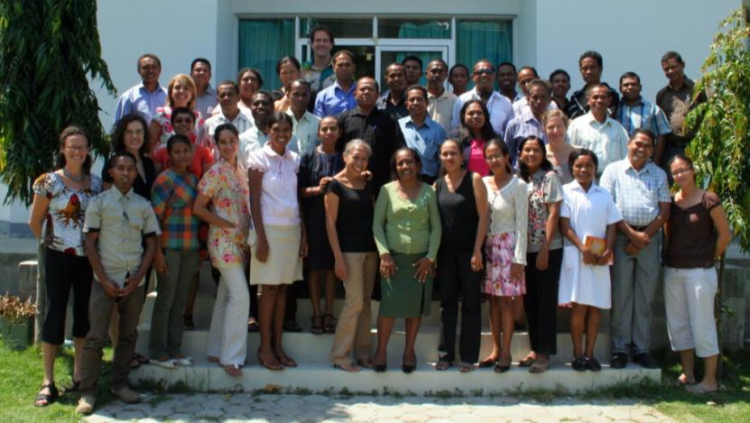

“[This] workshop was such a fantastic opportunity for health staff in Timor-Leste.  There were open debates, lots of questions, plenty of time for group work, clear presentations and supportive facilitators.  This was one of the most motivated groups I have come across in my time here.”

-Dr. Zoe Hawkins, Advisor to the Ministry of Health for Mental Health, Epilepsy, and Health Research, Group Facilitator

# Results

HAI uses national Health Management Information System data, collected from the districts, to monitor progress toward our key indicators. We can see improvements in facility births and skilled birth attendance, as well as postpartum and newborn care visits (see Table 1). Overall K4 (percent of women who receive 4 or more ANC visits on the set MOH schedule of 1 during the first trimester, 1 during the second, and 2 during the third trimester) does not appear to have changed much since 2009. Couple year protection seems to be on track to accomplish the target for 2010, with the largest improvements in Manatuto, Aileu, and Ermera Districts.

***Table 1: Key maternal and newborn health and family planning indicators for HAI districts***

|  |  |  |  |  |
| --- | --- | --- | --- | --- |
| **Key indicators** | **Percent coverage for HAI districts 2009** | **Average percent coverage Q1-Q3 2010** | **Target 2010** | **Target 2011** |
| Percent of pregnant women who receive the recommended four antenatal care visits (according to the MOH definition of K4) will increase by 5 percentage points in HAI districts between 2009 and 2011 | 30% | 28.8% | 32.5% | 35% |
| Percent of women who deliver with a skilled birth attendant (SBA) will increase by 5 percentage points in HAI districts between 2009 and 2011 | 30% | 33.9% | 32.5% | 35% |
| Percent of annual deliveries that occur at a health facility will increase by 5 percentage points in HAI districts between 2009 and 2011 | 11% | 14.6% | 13.5 | 16% |
| Percent of annual postpartum and newborn visits within the first week will increase by 5 percentage points in HAI districts between 2009 and 2011 | 30% | 33.9% | 32.5% | 35% |
| Couple Years Protection will increase by 4% each year for HAI districts between 2009 and 2011 | 18858.02 | 14234.35 | 19612.34 | 20396.83 |

1. Timor-Leste Demographic and Health Survey. 2009-2010
2. Ibid
3. Ibid.
4. Ibid.
5. Timor-Leste Demographic and Health Survey, 2003
6. Timor-Leste Demographic and Health Survey. 2009-2010
7. Ibid.
8. SISCa—*Servisu Integrado Saude Communitaire (SISCa)* orIntegrated Health Services at the Community Level is a MOH initiative which seeks to deliver health services outside of facilities and closer to where people live. Monthly SISCa events are conducted at 442 SISCa posts throughout Timor-Leste.