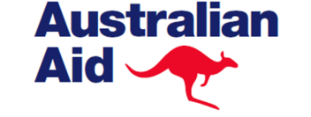 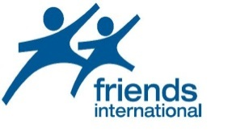

**PROGRAM COMPLETION REPORT OF HAARP CAMBODIA**

**Organization: Friends-International**

**Project Title: Expanding Drug Harm Reduction Coverage for Youth in Phnom Penh**

**Location: Phnom Penh**

**Project Period: 22/10/2009 to 31/12/2014**

**Reporting Period: 22/10/2009 to 31/12/2014**

**Date of Submission: 20th January 2015**

**TABLE OF CONTENTS**

1. **Abbreviations and Acronyms 2**

1. **Executive Summary / Overview 3**

**Introduction / Program rationale and objectives**

**Program Achievement**

**Conclusions, key lessons learned and recommendation**

1. **The Program Achievements 4**
   1. **Service Deliveries (Needle and Syringe 4**

**and Methadone Maintenance Treatment)**

* 1. **Enabling Environment 8**
  2. **Capacity Building 10**
  3. **Coordination 10**
  4. **Activities Related to Research/Quality Data 11**
  5. **Monitoring and Evaluation 13**
  6. **Changes in Drug Use Trends 14**
  7. **Involvement of PWUD/PWID in project implementation 15**
  8. **Gender 16**

1. **Other Issues 17**
   1. **Lessons Learned 17**
   2. **Recommendations 17**
   3. **Plans to Sustain Program 17**
2. **Success Stories 18**
3. **ABBREVIATIONS AND ACRONYMS**

ART – Antiretroviral therapy

ASEAN - Association of Southeast Asian Nations

ATS – Amphetamine type stimulants

DFAT – Department of Foreign Affairs and Trade (Australia)

DIC – Drop-in centre

EW – Entertainment workers

FI – Friends International

HAARP - HIV/AIDS Asia Regional Program

HR – Harm reduction

HTC – HIV testing and counseling

KMCC – Kaliyan Mith Chom Chao

MARP – Most at-risk population

MMT – Methadone maintenance therapy

MoH – Ministry of Health

MoI – Ministry of Interior

MOU – Memorandum of understanding

MS – Mith Samlahn

NAA – National Aids Authority

NACD – National Authority for Combating Drugs

NPMH – National Program for Mental Health

NCHADS – National Centre for HIV/AIDS Dermatology and STDs

NGO – Non-government organization

NSP – Needle syringe program

PSI – Population Service International

PWID – People who inject drugs

PWUD – People who use drugs

TC – Training centre

UIC – Unique identifier code

VCCT – Voluntary confidential counseling and testing

VCSP – Village Commune Safety Policy

1. **EXECUTIVE SUMMARY / OVERVIEW**
   1. **Introduction / Program rationale and objectives**

On the 22nd of October 2009, Friends-International (FI) entered into an agreement with the HIV/AIDS Asia Regional Program (HAARP) – Cambodia to implement its project “Expanding drug harm reduction coverage for youth in Phnom Penh” through funding from the Australian Agency for International Development (DFAT). The project has been co-implemented by Friends-International and its partner Mith Samlanh (MS).

**Goal:** Improve access to service provision to young drug users (with an emphasis on injecting drug use) in Phnom Penh by strengthening coverage of harm reduction services including NSP and by supporting participants of the MMT program to stabilize their lives and build their futures.

**Objectives:**

1. To strengthen the capacity of FI’s partner MS to provide NSP and other harm reduction services to street-based drug using youth
2. Develop harm reduction services, including NSP where feasible, for hard to reach at-risk populations, specifically community based children and youth
3. Support youth participating in the Methadone Maintenance Therapy (MMT) program to stabilize their lives and build their futures
   1. **Program Achievement**

Through a ‘Continuum of Care’ model, designed to be flexible to meet the changing needs of clients over time, a team of social workers, drugs specialists and medical staff has provided a range of services to drug users and/or at-risk populations, their families and communities. These services were provided through outreach on the streets (6 days per week, day and evening) and at strategically located Drop-in Centres (DIC) in vulnerable communities. By providing a comprehensive range of services and activities, FI has effectively meets the complex daily and ongoing needs of drug users and provides long-term alternatives.

From 2009 to 2014, the number of drug users reached has increased respectively by 242% and 72% for PWUDs and PWIDs.

Each year:

* + FI and its partners deliver activities related to HIV prevention and education on drug use to approximately 2,000 drug users, their partners and their families in the “most at risk” communities of Phnom Penh.
  + Over 300 000 clean needles and syringes are distributed by FI and MS to PWID in Phnom Penh
  + NSP reaches more than 350 PWIDs where each of them receives two to three clean needles and syringes per day, which is close to universal coverage, significantly reducing the risk of needle sharing***.***
  + 86% of the Needles and Syringe distributed per year are collected from the ground by NSP staff, peers educators and through direct returns by PWID to NSP staff
  + More than 200 drug users are supported through voluntary detoxification
  + Approximately 120 drug users successfully complete formal rehabilitation, of which more than 100 will go on to vocational training at the MS center
  + Approximately 260 drug users and their partners are referred to [Voluntary Confidential Counseling and Testing](http://aidsdatahub.org/en/reference-librarycols2/itemlist/category/107-voluntary-confidential-counseling-and-testing-vcct) for HIV (VCCT)
  1. **Conclusions, key lessons learned and recommendation**

## Benefiting from its extensive experience, FI and its partner organizations have achieved great success in implementing a comprehensive drug program in Cambodia and have set the standards for a holistic harm reduction service for young drug users in the country. However, much still needs to be done to further reduce HIV transmission among this population.

FI aims to continuously improve the quality and accessibility of integrated services, expand the coverage for HIV interventions and engage populations not yet reached. In this regard, FI has recognized service gaps for drug users especially PWID, where this population with a high HIV prevalence includes women with overlapping sex work risks and drug users in closed settings such as prisons.

Improving the quality of services, expanding the coverage for HIV interventions and accessing populations not yet reached are the main challenges FI will overcome in the future.

It is only by working together - civil society, the Government, NGOs, international organizations and drug users themselves - which we will achieve our common goal set for Cambodia in 2020: Zero new HIV infections, Zero discrimination and Zero AIDS related deaths.

1. **THE PROGRAM ACHIEVEMENTS**
   1. **Service Deliveries (Needle and Syringe and Methadone Maintenance Treatment)**

**a.1. Needle and Syringe Program**

FI’s NSP commenced in 2004 when its implementing partner MS received Cambodia’s first NSP license from the MoI to deliver HR materials to PWID. HAARP funding to continue support of NSP commenced in October 2009 and covered 25% of the HR program implemented by MS.

Although initially funded as a two year project (Oct 2009-June 2011), this was amended in 2010 following a significant jump in the number of PWID and PWUD identified and reached by the project. HAARP funding was subsequently secured through to December of 2014 where this has allowed FI and MS to continue to strengthen the reach and quality of HR key component activities, increase the capacity of the HR team, and develop materials and training modules on safe injection, HTC and MMT.

To better understand the needs of PWID and any gaps in their service delivery, MS carried out a comprehensive needs assessment in 6 communities of Phnom Penh in 2010. As a result of that survey, service schedules were increased and have continued to increase over the project life to meet the needs of PWID for NSP service delivery at night, during the week-end, and holidays.

NSP is provided by MS in three delivery modes: community DICs, mobile DICs and outreach. At the end of program period MS was providing services through 5 community DICs located in *hotspot* areas of Phnom with mobile DICs covering remote and relocated communities around Phnom Penh. These DIC service points were complemented by NSP outreach teams covering 4 districts of Phnom Penh where each team were comprised of two social workers and one medic. Since 2013, the core outreach teams have also included Outreach Workers recruited from key populations (such as PWID and EW) to better identify and reach hidden and unreached drug users.

Increasing evidence of the overlapping risks of commercial sex work and drug use has expanded services in 2013 to include nighttime mobile DIC outreach to EWs offering a place to rest, socialize, and apply make-up while offering low-threshold access to HR services, counseling, primary health care, condom distribution, reproductive health services, and referral to health and non-health related services (such as VT, family reintegration, and job placement). Expanding services to EW has also included collaboration with other NGOs already working with EW to develop targeted drug related services (through training of staff, workshops, and improved referral pathways).

To complement the work of outreach teams and DICs, FI has utilized a peers-to-peer network working on HIV and drug prevention where the number of peers and the quality of service has increased since 2010. Today 233 peers are assisting the work of MS’s social workers to promote safe practices and key prevention message in their own communities.

The project achievements under the HAARP grant are summarized as follows:

*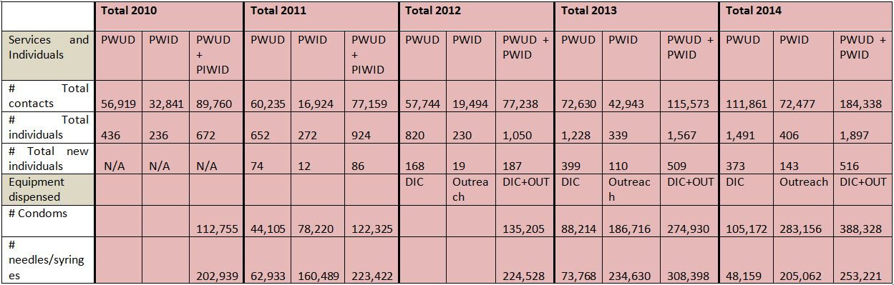Table 1. HAARP/DFAT Project Achievements 2010-2014*

From 2010 to 2013, service targets were based on the provision of a service package in 9 districts of Phnom Penh. However, in November 2013, NCHADS and DFAT jointly requested service providers to separate their target areas for implementing outreach HIV services for PWUD and PWID (documented in the ‘*Joint Statement among the National Centre for HIV/AIDS, Dermatology and STDs, DFAT, KHANA, Korsang, SFODA, Friends International and Mith Samlanh on the Target Area for Implementing HIV Interventions among PWUD/PWID in Phnom Penh*’). As a result, from January 2014, MS restricted HR and others HIV related services to 4 districts (Chamkar Morn, 7 Makara, Russey Keo and Por Senchey) instead of the 9 previously covered. Some PWID and PWUD were lost to follow-up during that year and some gaps were observed to have occurred in NSP in some hotspots.

The number of contact with PWID and PWUD has consistently increased over the program period (105% from 2010 to 2014). This overall increase occurred despite the decreases in the 2011-2012 reporting period resulting from the implementation of the VCSP (noted below in detail in the MMT section). Following a relaxation of the VCSP in the subsequent year in which less drug users were arrested the number of contacts with PWID/PWUD again increased. In the last reporting year there was an overachievement of 76% of the intended target of PWID reached.

Distribution of safe injection materials is a key component of the HR services. On average, 2.3 needle and syringes were distributed every day to each PWID. With PWID who are regular users injecting approximately 3 times per day, the reported result is close to achievement of universal coverage for NSP. However, additional efforts will be needed to ensure that appropriate amount of needles and syringes are effectively delivered to PWID. Once the NACD NSP policy that presently prevents non-NGO staff from distributing needles and syringes is revised, FI and MS will strengthen secondary distribution through its peer network within hotspots and during the night.

To complement NSP, FI’s CDP has also been implemented over the project period as part of the HR package, alongside activities related to behaviour change communication. The number of condoms distributed has tripled over the project life.

**a.2. Methadone Maintenance Therapy**

The MoH MMT Clinic opened in July of 2010 with FI’s Kaliyan Mith Chom Chao (KMCC) making its first referrals that same month. Supported by KMCC, FI’s implementing partner MS also began referrals during the final year of the program. Over the project period a total of 59 clinic enrolments resulted from these referrals. From these initial enrolments a further 30 client re-enrolments occurred. By the end of program, 20 clients continued to receive MMT daily with ~15% of these having been on MMT for more than 1 year. Of the 59 individuals enrolled, 12% were female (being a representative sample based on ~14% of PWID being female in 2012 population size estimates [NACD 2012: Preap Samorphum Report]).

From KMCC representative data, the average age of clients initiating MMT was 24 years old (with a client age range of 19 to 35 years old). ~25% of clients were assisted with referrals for employment and ~10% were referred to the MS Training Centre for vocational training. Other client referrals during the program period included TB screening, HIV testing, ART and pre-ART.

Reasons for MMT client drop out during the program period included relapse (30%), imprisonment (25%), moving out of province (15%), and death (4%).

**Challenges**

Referral and ongoing support of FI clients in MMT was challenged in the first year of clinic operation by salary related MMT Clinic staffing problems. This issue resulted in poor MMT Clinic staff motivation, frequent interruptions in services, and limited capacity for new referral intakes. During this early period FI also recognized the lack of a clear referral system.

Other challenges experienced during this time (that have persisted throughout the program) relate particularly to MMT Clinic access. These challenges include limited opening times only during normal work hours where the clinic will often open later than the posted hours, a single clinic nationally with no satellite services, and no availability of take-home doses. These issues limited the ability of clients to participate in paid employment and attend the clinic due to long daily travel distances and expense. Further, these access limitations geographically tied clients to Phnom Penh and may have compound their reluctance to enroll or remain in MMT when they knew that they would not be able to travel to the provinces for work or to visit family during culturally important national festival periods.

Outside of systemic challenges, opiate dependent clients like other substance dependent clients can experience possible health/psychological related issues and relapse during a lifetime course. Further compounding these possible challenges is the concurrent client use of ATS that MMT cannot be used to manage. This concurrent use has an impact upon both health and adherence to MMT routines and the ability to engage clients in counseling and employment as important supportive measures.

An expected challenge over the coming year is the introduction of MoH user-payment for MMT dosing and services for clients who are not holders of an ID Poor Card. This policy change may present an additional barrier to enrollment, particularly for members of already marginalized communities such as street-living families.

**Overcoming Challenges**

To address these challenges FI utilized its ability to link clients to its own services and the existing comprehensive medical and non-medical services of its implementing partner MS. This included active referral to work, vocational training, transitional housing, medical services such as HIV testing, TB screening, medical care, and detox/rehab for ATS users. During the last year of the program, program capacity for MMT referral was expanded through direct MMT referrals by MS social workers.

In recognizing the importance of ongoing support for successful MMT, FI has responded to the above challenges through the use of social workers/case managers and outreach workers specifically allocated to MMT referral and support as part of their portfolio. This has allowed for the development of a clear referral system and significant relationship building to better understand client needs and respond accordingly. This support addresses issues with transportation, employment, housing, and assistance with the re-establishment of client relationships within their families and communities.

The aforementioned introduction in 2015 of user payment for MMT for non-ID Poor Card holders is expected to reinforce the importance of program specific social workers/case managers to support appropriate identification and issuing of ID cards to reduce any obstacles to MMT enrollment.

* 1. **Enabling Environment**

Advocacy is embedded within FI and MS’s work with PWID/PWUD through continuous awareness raising among communities, government and local authorities, and other relevant key stakeholders. Awareness raising has included issues surrounding HIV and injection drug use, and the effectiveness of harm reduction strategies to address these issues.

A close working relationship with PWID/PWUD has equipped FI with knowledge on the issues that pertain to their lives, where these issues have been bought forward to a variety of meetings and forums. During the program period, FI has actively participated in and worked to infuenced the development of laws, policies, and guidelines. As part of its participation in coordination activities and technical working groups during the program period (outlined in *coordination* section below) FI has ensured that the needs and rights of PWID/PWUD have been consistantly advocated for during these meetings.

Additionally, FI teams have built close relationships with key stakeholders and provided information and education related to harm reduction concepts and project approaches. This has included meetings with village chiefs, parents, and general community representatives to keep them informed and updated on project implementation, and to building a mutual understanding of project goals. At the service delivery level, FI has recognized that the provision of quality services has also been key to achieving ongoing community support and continued access to communities for the delivery of harm reduction activities.

FI’s work in creating enabling environments has been particularly important since the introduction in 2010 of the *Village Commune Safety Policy (VCSP)*, an executive edict (rather than a law) from the MoI, intended to reduce crime at the local level. Of particular concern was the implementation of the VCSP with disregard to fundamental rights of PWID/PWUD to privacy and presumption of innocence till proven guilty, set out in the Constitution. In response to the VCSP, FI joined a group of key stakeholders involved in HR service provision to create an advocacy strategy to target various levels of government involved in the new policy (both implementers and policy makers). While advocating for changes to the VCSP, MS continued to work with and maintain close relationships with local authorities

In 2013, in order to formalise strong collaboration at commune level with local authorities, Friends International and Mith Samlanh have also been involved in the Police Community Partnership Initiative (PCPI) led by MoI under support from HAARP and implemented by FHI 360. This has allowed local level governmental officials to learn about and understand in depth the way FI works and to promote further harm reduction approaches with local authorities. During the program period FI has conducted several trainings for local police focusing on FI’s holistic approach to working with PWID/PWUD using a *Continuum of Care* model. These included trainings on HR and sensitization to issues of drugs and HIV, including site visits to MS to talk openly with former PWID/PWUD.

In 2014, To respond to the implementation of the VCSP while continuing to support the Cambodian 3.0 strategy to eliminate new HIV infections by 2020, MS has signed an MoU with Phnom Penh Municipality to strengthen their long term collaboration in working with marginalized people, including drug users.

* 1. **Capacity Building**

FI has supported the development of its government and non-government partners and helped to build their capacity to address drug use issues in their respective contexts and environments. This has included the use of its knowledge and expertise on drug use to provide training on drug awareness (including intravenous drug use), working with children and youth, general health, HIV transmission related to drug use, HR, project administration and management and a wide variety of other related themes dependent on the needs of the agencies and their target groups. FI has built a network of service providers targeting PWID/PWUD in Cambodia in order to facilitate the exchange of experiences and best practices to encourage long term development outcomes for Cambodia.

* 1. **Coordination**

Coordination mechanisms have been developed and enhanced by FI over the project life.

Coordination at national and sub-national level is part of FI’s approach to ensure that best practices related to HIV and HR interventions are shared and replicated.

At the national level, FI has been involved in several working groups, national assessments, and surveys, and in the design of the main guidelines and Standard Operation Procedures related to service provision for MARP, and especially PWID/PWUD, in Cambodia. These have included participation in or development of the following:

* Harm Reduction Working Group (since 2010)
* Continuum of Prevention to Care and Treatment-Psychological Rehabilitation (CoPCT-PR) (2012)
* SOP for Boosted CoPCT for MARPs
* Working group on comprehensive MARPs mapping (2013)
* Development of the Unique Identifier Code (UIC) for PWID/PWUD in Cambodia (since 2011)
* Working group Harm Reduction Supporting Guide (since 2010)
* Working group to strategize approaches to reach and serve un-reached key populations with overlapping risks, led by WHO and NCHADS (2014)
* Sensitization workshops with local authorities and police in the framework of the PCPI (since 2013)
* Working group on the implementation of the Community Based treatment (CBTx) (2012)
* Technical working group of the Methadone Maintenance Therapy project (2010)
* Asian Epidemiological Model (2014)
* National AIDS Spending Assessment (NASA) (2012)
* National Strategic Plan for Harm Reduction 2015-2020 (2014)

**National referral Network**

As part of its approach, FI has developed a network referral system for coordination, case management and follow-up with other national and international organizations working in Cambodia in the field of HIV, health, human rights, education, human trafficking, and legal aid.

FI has also established its own internal program coordination mechanisms where for example the *Child Safe* team now works closely with the *Drug Team* to ensure that awareness messages are passed on regarding drug use.

**International Network: ‘*City Alliance’***

Initiated by FI, *City Alliance* is a network of NGOs and Government services working together to provide the highest standards of direct services to marginalized children, their families and their communities. To date, the Alliance counts 38 members across 11 countries. Together the alliance develops innovative approaches and creates higher standards, where this influence and impact is multiplied by the strength of the number of participating organizations.  
  
**Sub-National Working Group**

Since 2012, FI has organized and lead the Substance User Program Working Group on a quarterly basis with all services providers working with drug users. The process has allowed organizations and agencies to express their concerns, challenges, and progress with regard to implementation of HR activities in Phnom Penh. Using an informal process, those representatives can freely provide comments and share their experiences in working with policies at local and national level.

* 1. **Activities Related to Research/Quality Data**

**Regular surveys**

During the program period FI has utilized to two annual and one monthly data collections tools to better understand the trends in drug use so as to quickly and appropriately respond to these changes.

Throughout the program period one of the mainstays of quality data for MS has been the annual *Drug Snapshot Survey* conducted in December of each year. Initiated in 1999, the annual *Drug Snapshot Survey* identifies and monitors drug and substance use trends among street-based young people using drugs in Phnom Penh, capturing the data of more than 3000 respondents in each survey. During the program period, as a response to reported changes in substance use, the survey was expanded to establish a more detailed picture of drug use categories and sub-categories.

During the program period, data from the annual *Drug Snapshot Survey* was augmented by the MS annual *Street Children’s Profile Survey* which monitors trends in the life situation of street child and youth populations countrywide (including Phnom Penh, Battambang, Siem Reap, Poipet, and Sihanoukville). This survey has added further valuable data on drug and substance use trends and increased FI’s understanding of this vulnerable/at-risk population.

At the program implementation level, FI has conducted a monthly NSP assesssment survey throughout the program period. The objective of this survey was to assess PWID satisfaction regarding needle and syringes distribution, where the survey collected information on the use of HR materials during the last injection, access to HR materials, and the source of their HR supplies.

During the program period, MS undertook a restructuring and reorganization of its database to improve the overall quality of data collection and analysis.

**Other research**

In addition to the regular quantitative data collection, FI facilitated two graduate level research studies by foreign universites that added a qualitative data complement its understanding of drug use. The studies were entitled “*What are the characteristics of methamphetamine use in Cambodia, and which drug policies are applicable and effective on the usage of this drug?”*and “*What are the specific needs, perceptions and vulnerabilities of and surrounding pregnant women who use drugs in Phnom Penh, Cambodia?”.*

**Unique Identifier Code**

The use of a unique identifier code (UIC) was piloted beginning in June 2014 to provide a more accurate data management system to services providers working on HR.

The use of UICs was initiated by DFAT/HAARP, with technical support of PSI Vietnam. The system was coordinating by the National Program for Metal Health (NPMH) and implemented by the NGOs working on HR.

 The UIC was introduced for the purpose of:

•          Avoiding overlap of activities

•          Tracking MARPs from outreach to services update

•          Assessing outreach and service coverage among MARPs

•          Keeping confidentiality and privacy of clients

•          Eliminating double counting of clients

•          Linking between various points of contact

However several factors have made this new system very challenging so far. These include difficulties in the conversion of Khmer script into Latin script, issues relating to confidentiality and misunderstanding from PWID on the purpose of the UIC. These challenges will need to be rectified if and when the scale-up of the UIC is to be carried out.

* 1. **Monitoring and Evaluation**

Throughout the program period, FI collected data during service provision on a daily basis. Data was collected during outreach, in DICs, and in the detoxification and rehabilitation center where applicable. This included information designed to present an overview of HR activities (including NSP and CDP, VCCT and HTC, referral, treatment, and the comprehensive continuum of care services). Data was collected and inserted in a standard data reporting format and reported on a semi-annual basis along with a brief narrative progress report.

Data collection and reporting allowed FI to closely monitor indicators and the implementation of services in collaboration with MS, and enabled FI to follow-up on deviations, anticipate changes in project activities and time frames, and check project progress. Reports were checked and clarified with MS where needed. To complement the regular quantitative data collection mechanisms required for the program, FI utilized existing data from its organizational monitoring and evaluation processes.

The community assessments among target population that were conducted in the frame of the project ascertained a range of issues including drug use in order to identify areas for direct implementation and explore potential for replicability.

**Monthly Update Meetings**

To facilitate bi-directional communication on the progress of program indicators and better understand the challenges of data collection on the ground, monthly update meetings were held by FI with MS and KMCC project zone leaders and field staff. These meetings provided the opportunity for FI and MS to:

* Share experiences in service provision
* Signal and share trends in drug and substance use
* Present on a specific topics
* Receive formal and non-formal training
* Clarify financial/data reporting where needed

**Field Visits**

FI’s Project Manager conducted regular field visits to MS and KMCC. These visits enabled FI to review progress and make an inventory of issues that should be improved, where any deviations in project planning were addressed through review of the work plan and project implementation reports. Through field visits, FI was able to supervise the project implementation as conducted by MS and offer support and guidance where needed.

The field visits also consist of a training component. Training and ongoing support were delivered to project staff on procedures and organizational mechanisms by the FI team. Needs for further training and support were reviewed during the program period.

* 1. **Changes in Drug Use Trends**

Cambodia has experienced an emergence and rapid growth in the use of ATS since the 1990s. During the program period the use of the more potent form of ATS, crystal methamphetamine *‘Ice’,* has been observed to increase over the use of cheaper and less potent ATS ‘*Yama’*. The use of opiates such as heroin has remained relatively unchanged. Cheaper and more accessible drugs such as solvents *‘glue’* have continued to be used where they have been used as a drug of substitution when opiates have been scarce. Diazepam has been used as a complementary drug for opiate injectors when opiate quality has been poor or less affordable/available. There have also been ongoing reports of increased use of diazepam, ATS, and glue as drugs of substitution by PWID who are enrolled in MMT (see MMT section of report).

During 2010 *brown sugar heroin* was introduced into the opiate using PWID population where there were reports of heroin being cut with it in order to increase demand for its use. *Raw black opium* of good quality and initial high cost was reported to be used mainly by foreigners in 2011. More *black opium* entered the market in 2012 at a price 2 – 3 times cheaper that heroin where there were reports of free samples to promote demand with relative success. Reports of low quality and more complicated drug preparation via cooking seemed to have lead to a progressive disappearance of *black opium* in 2013.

**Cost**

Over the program period the cost of all drugs have increased. Increases were noted from decreased drug supply particularly related to the arrest of drug dealers from ongoing enforcement of the VCSP and during the ASEAN summit in 2012. Crystal methamphetamine has increased from $5 to $12/package (with reports of high quality). *Yama* has progressively increased from $1.50 to $8 per pill (with reports of decreasing quality), and while initially stable the price of heroin has increased from $2.50 to $7.50 per dose. Glue is also reported to have increased in cost from $0.75 to $0.90 per can.

When drug supply has been decreased, drug dealers have limited supply to purchases of larger drug amounts only. PWID/PWUD reported that had to combine resources to purchase up to $50 worth of drugs in order to access supply.

* 1. **Involvement of PWUD/PWID in Project Implementation**

FI/MS promote participation of beneficiaries in project implementation through the following mechanisms:

* Rules and regulations for DICs, mobile DICs are set together with service users.
* Input/feedback on service are collected from users who are encouraged to discuss and express their concerns in accessing the services. With those information, the team can review/adjust the approach.
* PWUD and PWID can voluntarily join the programme as Safety Agents. They are then trained by MS’s staff so as to be able to provide key messages/information and materials to their peers about safe pactice related to drug uses as well as safe sex. They distribute condoms, and collect the used needles/syringes from PWID and from the ground. Their involvement also consists in helping their friends in emergency cases by calling the FI HOTLINE 24h/7days. To date, there are 247 Safety Agents active in MS’s programme. Peer educators also involved in the design IEC materials and contributed in testing it.
* NA (Narcotic Anonymous group) is organized on a weekly basis with the strong support of a social worker who is a former drug user. The NA is now facilitated by two former drug users studying at MS Vocational Training Center. The process of handed over to other members of the NA group has been started in November 2012. The expansion of the NA meeting to other areas is in consideration.
* Former drug users accessing MS’s center are encouraged to be part of the children/youth representatives (electing through a voting system). During MS management meeting, representative brougth messages, concerns, or suggestion regarding service provision for management to discuss and find adequate responses.
* The link is made with MS weekly Emotional Support Group (held in 4 zones) for PWUD/PWID living with HIV: average of 25 drug using children/youth including 14 IDUs attended the meeting on a weekly basis.
* 8 formers drug users were hired to be outreach workers and are now working with MS outreach social workers on the field. They have been trained by MS staff on capacity building such as life skill education (HIV, drug harm reduction, referral), and they also help in finding their PWUD/PWID peers who are unreached or hidden from service providers.
* Seven (4 females) children/youth who are former and current drug users were encouraged to involve in several sessions of discussion group to share their experience and opinion on gender equity to access HIV/AIDS services in Cambodia. These sessions were led by NCHADS and NAA in September 2013.
* 12 (5 females) children and youth who are former and current drug users are involved in the Asian Network of People who Use Drug (ANPUD). ANPUD has carried out an assessment on how to develop appropriate capacity building and empower the drug users to be able to bring voice or communicate and advocate to high level government/donors/Stakeholders.
  1. **Gender**

FI has an inclusive policy towards all children and youth regardless of their background, religion, gender or otherwise. The organization recognises that women, girls, boys and men often have different needs and face different threats.

Considering the overlap between sex work and drug use, and the existing vulnerabilities of young people in general – it is necessary to strengthen specialized gender sensitive services and provide effective, user-friendly, accessible and relevant service to women of reproductive age who are most at-risk.

FI intends to address this challenge by increasing the service coverage for women who use or inject drugs with services specifically tailored to their needs. To achieve this end, FI has started piloting the “Mobile Outreach Bus for Street-based EW” in collaboration with several NGOs whose core strategy is working with entertainment and sex workers.

The package of services available directly from the outreach bus include: basic medical care, HIV testing and counseling, and referral to appropriate health and non-health services. The package of services also includes HIV and drug education, the provision of condoms and equipment for safer drug use, and personal hygiene kits.

The pilot phase of the project has so far demonstrated good service acceptability with approximately 150 clients already reached during the 6 month pilot period. Feedback has noted that the service is highly appreciated by street-based sex workers as well as their sweet-hearts and clients.

FI has been requested by these project beneficiaries to extend the service until midnight every night of the week. We are presently seeking external support to transition this pilot to regular programming and expand this successful project to other hotspots in Phnom Penh and Siem Reap.

1. **OTHER ISSUES**
2. **Lessons Learned**

FI acknowledges that PWID/PWUD clients are challenged by much more than their drug abuse or addictions. They face changing and complex factors including psychosocial, emotional or mental health issues; poverty; lack of education or training; unemployment; meeting daily or basic needs (such as water, food, shelter, laundry, showers) abuse and/or violence; criminal or legal problems; incarceration; relationship or family breakdown; migration; physical health concerns (chronic and acute); lack of life skills; limited or no social support; risks associated with HIV/AIDS; prejudice, gender-based or self discrimination and a sense of fatalism or hopelessness about the future. A comprehensive approach delivering health and non-health services is necessary to address these interlinked issues and offer long term development opportunities in order to sustainably reduce HIV prevalence in Cambodia.

Therefore clients need supportive interventions that address much more than their drug addiction. FI also respects that individuals are part of a family, who are in turn members of communities. Therefore, the program is working at all level to prevent further infections and reduce stigma attached to drug addiction and HIV. One-off, limited and singular-focus interventions that focus solely on the drug user, do not consider the combined effects of the multiple issues faced by vulnerable people. That is why FI uses a comprehensive approach aiming to stabilize and empower lives to build futures.

1. **Recommendations and Plans to Sustain the Program**

A lot has been achieved so far: Systems were built, new service providers started work in new areas, collaborative networks were created and the number of drug users reached and the services provided to them increased as well.

Improving the quality of services, expanding the coverage for HIV interventions and accessing populations not yet reached are the main challenges FI will overcome in the future. The following strategies are designed to effectively overcome these challenges:

* Promoting secondary distribution of needles and syringes
* Strengthening services for street-based sex workers who use drugs
* Extending the program in prisons
* Developing formal partnership with organizations working on legal aid
* Expanding outreach and DIC opening hours
* Continuing advocacy for HR and for access to HIV services in closed settings.

Sustainability drives innovation and allows for the continuous improvement in the design, delivery and management of services aimed to educate and empower vulnerable communities in Cambodia. Best practices in terms of service delivery, as promoted by the project will be of great benefit to the Government of Cambodia, partner organizations and the community at large.

Sustainability is a crucial factor which determines the long term effectiveness and delivery of quality and advantageous community services; as such FI has found alternatives and will find more ways to support projects after HAARP funding is terminated.

* To support Harm reduction and other HIV interventions for drug users, FI and MS projects are currently supported by the Global Fund. The current grant cover the period until June 2015, but a further grant is expected to extend funding until December 2017.
* FI and MS are also supported by successful social businesses including two vocational training restaurants in Phnom Penh (*Friends the Restaurant* and *Romdeng*), both of which have developed into profitable businesses. MS is currently 54% financially sustainable.

**V. SUCCESS STORIES**

**Success Story #1**

***“They taught me how to deal with problems and encouraged me to build self confidence and self esteem”***

I am a 26 years old boy originally from Kampong Cham province. I have five siblings with three sisters and I am the forth. My parents are farmers and very poor. Because of extreme poverty, my family decided to migrate to Phnom Penh.

The life was not easy in the capital city, Phnom Penh. My parents found it difficult to get a good job. They applied almost everywhere and finally my father got a job as taxi driver. My mother started selling snacks. Even though they made some money to support the family, we still faced malnutrition, unhealthy and unstable housing, and my siblings and I could not access public school. Those problems pushed me to go to work on the street by selling newspapers and shining shoes.

Living on the street, I made many friends and some of them are drug users and involved in gangs. I spent a lot of time with them and one day I was influenced to use drugs by smoking Methamphetamine/ICE. I start injecting heroin in 2004. I could not stop it by myself and my friends could not really help me, but MS staff come to visit me regularly during the day and evening and provided many services such as clean needles and syringes, condoms, hygiene materials, education, and medical care. They also introduced me and my friends to all of MS’s services. In late 2005, I was supported to access Detoxification and Rehabilitation at Green House and then I was supported to study cooking skills in MS Training Center. During my study, I get a lot of support which included food, safe shelter, medical care and emotional support but I still found difficult to stop using drugs.

I was supported to go to Green House for the second time. I was still a student in cooking skills at level 3 and I was trying very hard to finally stop using drugs by being involved in sports activities such as football and volley ball and sometime when I could not overcome the peer pressure, I always came to discuss this with the staff of MS. They taught me how to deal with problems and encouraged me to build self confidence and self esteem.

I finally graduated from cooking skill in October 2013. I am now able to do many things related to hospitality and skills in preparing Western food, Asian/Khmer food. I am now employed in a Khmer restaurant as cook. My starting salary is $120/month which includes 2 free meals per day. In the first 3 months of my job, MS continued support with a work uniform, rent payments and a bicycle.

I am very proud of moving away from heroin addiction and really thank MS staff for their kind support.

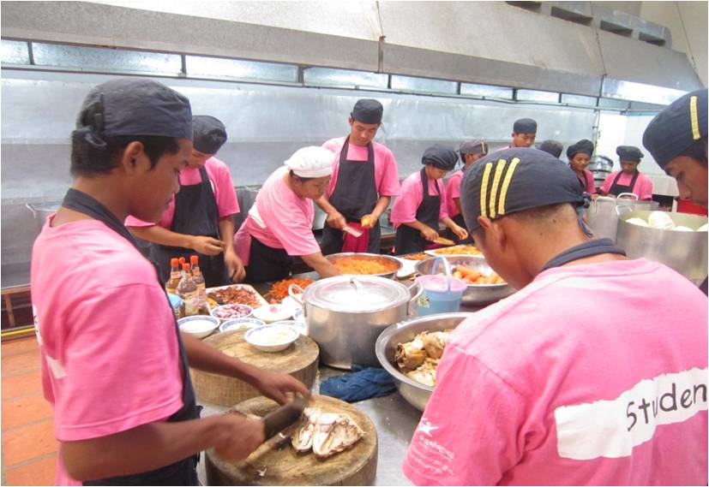

Cooking Skills students at work at the MS Vocational Training Centre*

**Success Story #2**

***“Today he works as food seller and financially supports his own family”***

In 2013 the MS drug project coordinator was contacted by FHI360 to provide support to Dara*, a 25 year old man. Dara turned himself in to the police to get help after having been beaten in the street. Dara had been smoking methamphetamine/ICE for several days without a break and was beaten up following aggressive behavior induced from his drug use.

MS social workers went to meet Dara at the police office and, in an agreement with the police, decided to take him to MS DIC. MS team also contacted Dara wife to better understand any social and family issues. After the drugs wore off Dara continued to experience aggression and delirium from his drug use so MS took him to the mental health service of the Soviet-Khmer Friendship Hospital, where Dara stayed as a patient for 7 days. During his stay in hospital, MS visited him everyday providing him with financial and emotional support.

Dara now lives with his family in the provinces where he maintains his daily treatment for mental health problems and stays away from drugs. Today he works as food seller and financially supports his own family.

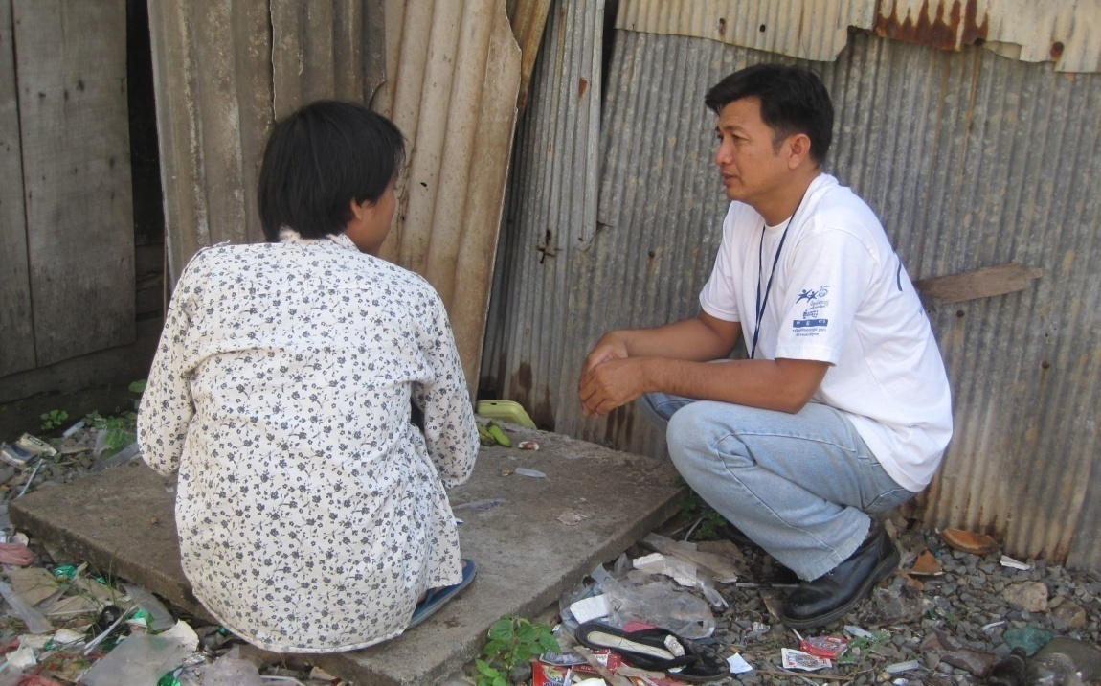

A MS social worker meeting a client in outreach*

[*Names have been changed and photos are general representations of program activities to protect the identity of individuals]