

**New Colombo Plan Scholarship Program - 2018 Round**

**Guide to Referee Reports in New Colombo Plan Online**

The following guide aims to provide further information for applicants, referees and universities regarding the referee report process for the 2018 round of the New Colombo Plan Scholarship Program using New Colombo Plan Online.

As part of a scholarship application, **each applicant is required to obtain two referee reports during the application period** (ending 11.59 pm AEST on 31 August 2017). These must be completed by the referees before an application can be submitted.

A referee must be able to comment substantially on the applicants abilities and experience with respect to the selection criteria, and must hold a position that gives their comments credibility (e.g. a position in the applicant’s university, workplace or community). At least one report must be prepared by an academic referee.

If you experience any technical issues using the referee report functionality or have any questions, please contact the NCP Scholarship team at [ncp.scholarships@education.gov.au](mailto:ncp.scholarships@education.gov.au).

### Application Form Functionality

The referee report process begins as each student is completing their application form. Under Section 11: Referee details, applicants have the ability to add referees, which will automatically send the referee the report to complete.

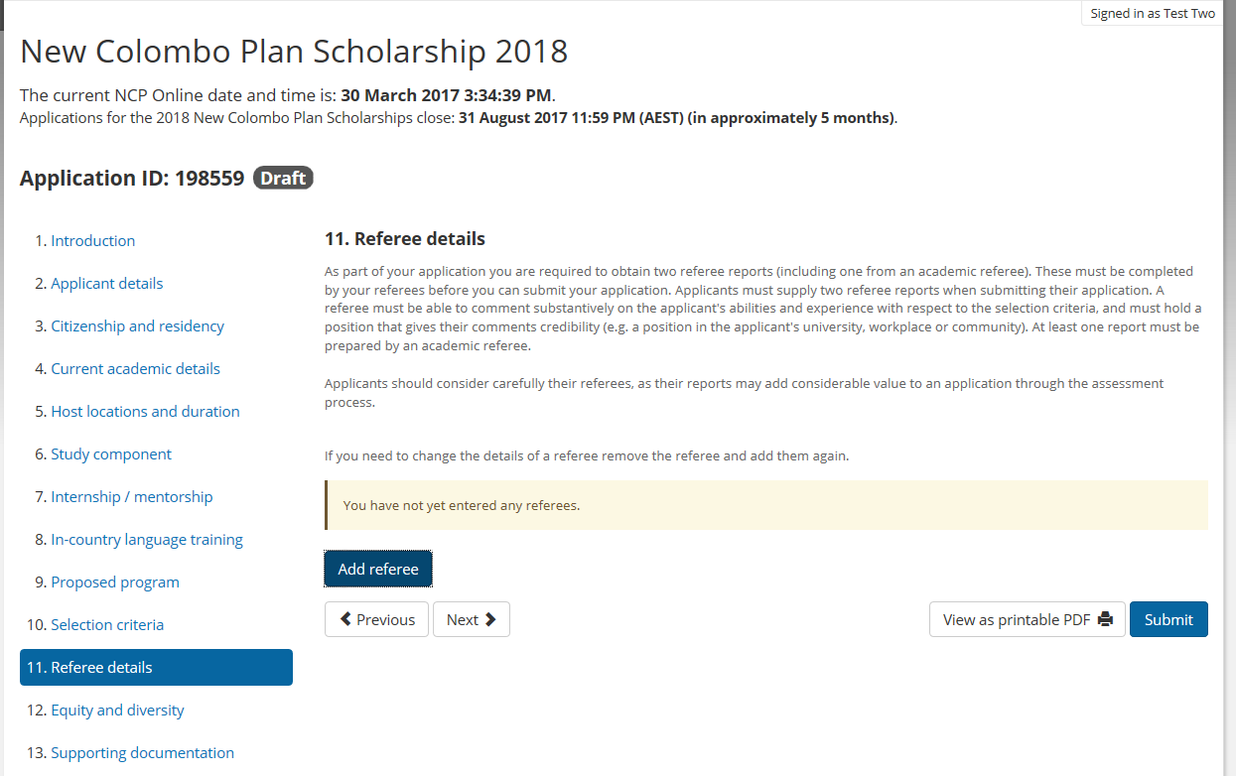

To begin the process applicants should select the blue ‘Add referee’ button under Section 11.

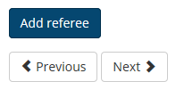

Applicants can then enter the details of their referee and designate the referee as either an academic or non-academic referee. Each applicant must have at least 1 academic referee in order to submit their application.

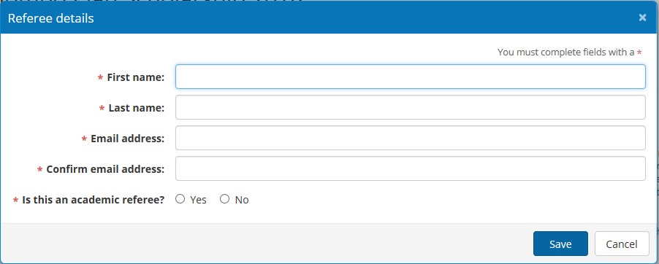

Once the applicant has entered the referee details and selected the ‘Save’ button, they will receive a notification that saving the details will automatically send the report to the referee to complete and asks the applicant to confirm they want to do this.

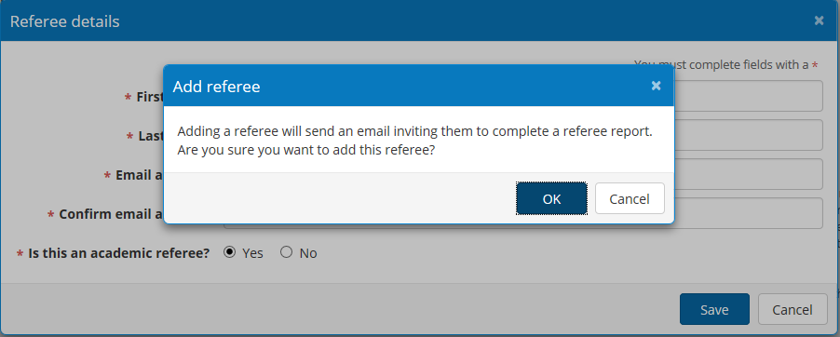

Selecting ‘OK’ will send the referee report to the referee. The status of the referee will appear as ‘Request sent’.

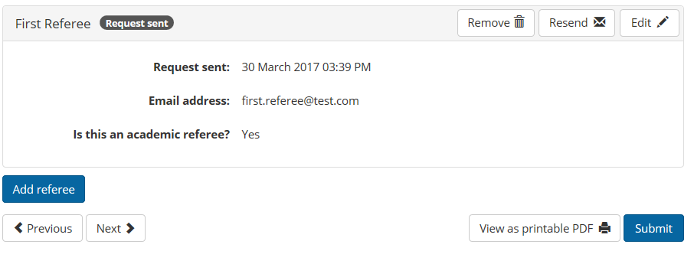

A referee request can be cancelled using the ‘Remove’ button if the applicant needs to change one of their referees.

If a referee has not received the referee report request email, the applicant can resend it using the ‘Resend’ button.

If the applicant has mistakenly designated the referee as the wrong type (i.e. academic or non-academic), this can be changed using the ‘Edit’ button functionality.

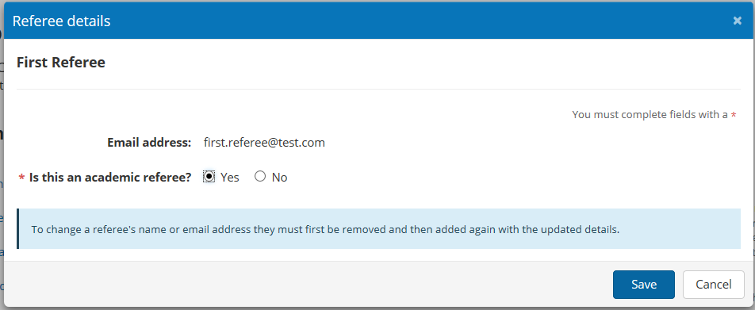

However, if an incorrect email address or name has been entered, the applicant must create a new referee by removing and re-adding them using their correct details.

Please note that the referee may also edit their name through the referee report. If this occurs the applicant will be notified via email to ensure the report is completed by the intended referee.

*Dear Miss Test 2*

*Your referee for your 2018 New Colombo Plan Scholarship application updated their name details from First Referee to Initial Referee.*

*Kind regards*

*New Colombo Plan Scholarships Team*

Once the referee has completed their report, the applicant will be advised via email and the status of the report in the application will change to ‘Complete’.

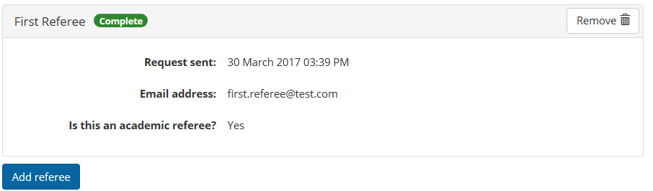

### Referee Report Functionality

Once the referee has entered the pass key contained in their referee email they will be logged in to their report. **The applicant will not be able to view the referee report**. The report will be returned directly to the Department of Education and Training once it has been completed.

It is not necessary to complete the entire referee report in one session. The report will be saved each time the referee saves a completed section, allowing the referee to continue later.

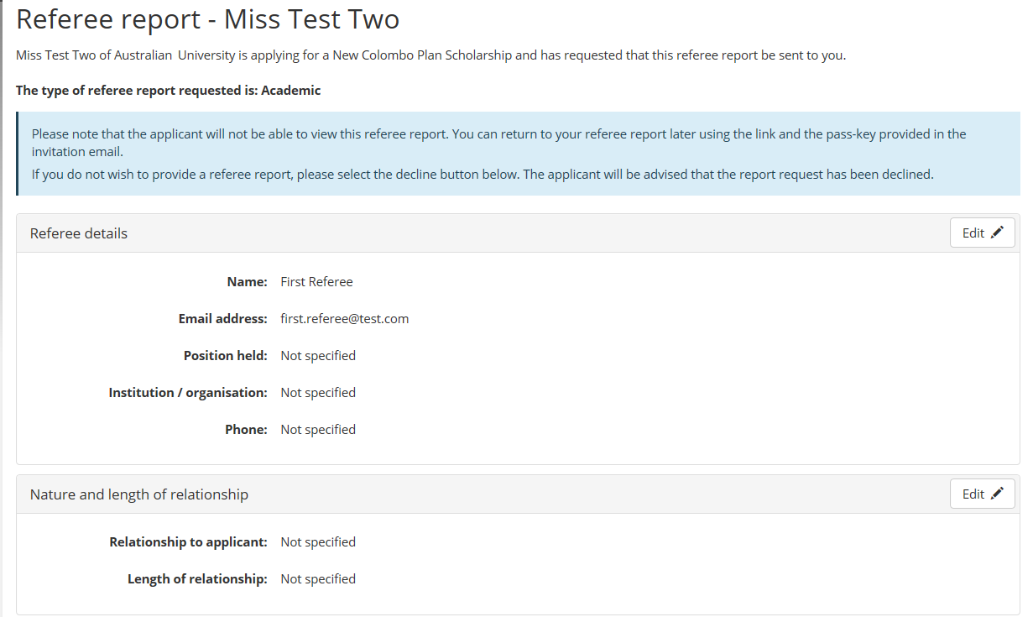

If the referee does not wish to provide a referee report, the request can be declined using the red ‘Decline to offer referee report’ button at the bottom of the report. If declining a request to be a referee, please do so as soon as practicable. The applicant will be advised via email the request has been declined and can add a new referee in their application after removing the old referee.

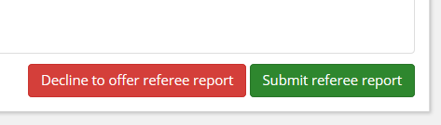

The referee is first requested to provide their personal information and the contact details in case further information is required during the assessment process.

The referee may also edit their name; if this occurs the applicant will be notified via email to ensure the report is completed by the intended referee.

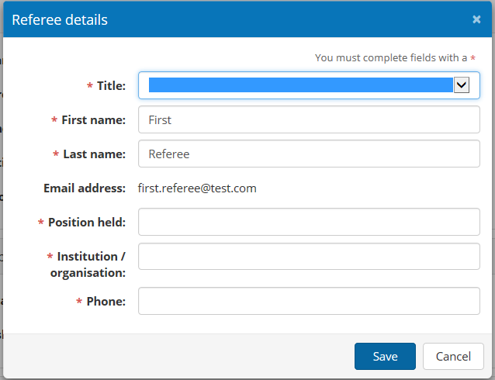

The referee must also provide details of the nature and length of their relationship to the applicant.

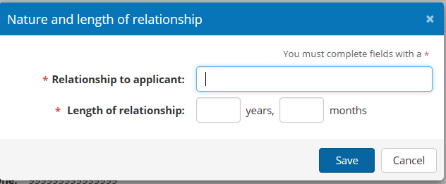

The referee is then asked to assess the applicant against the same criteria specified in the program guidelines and application form.

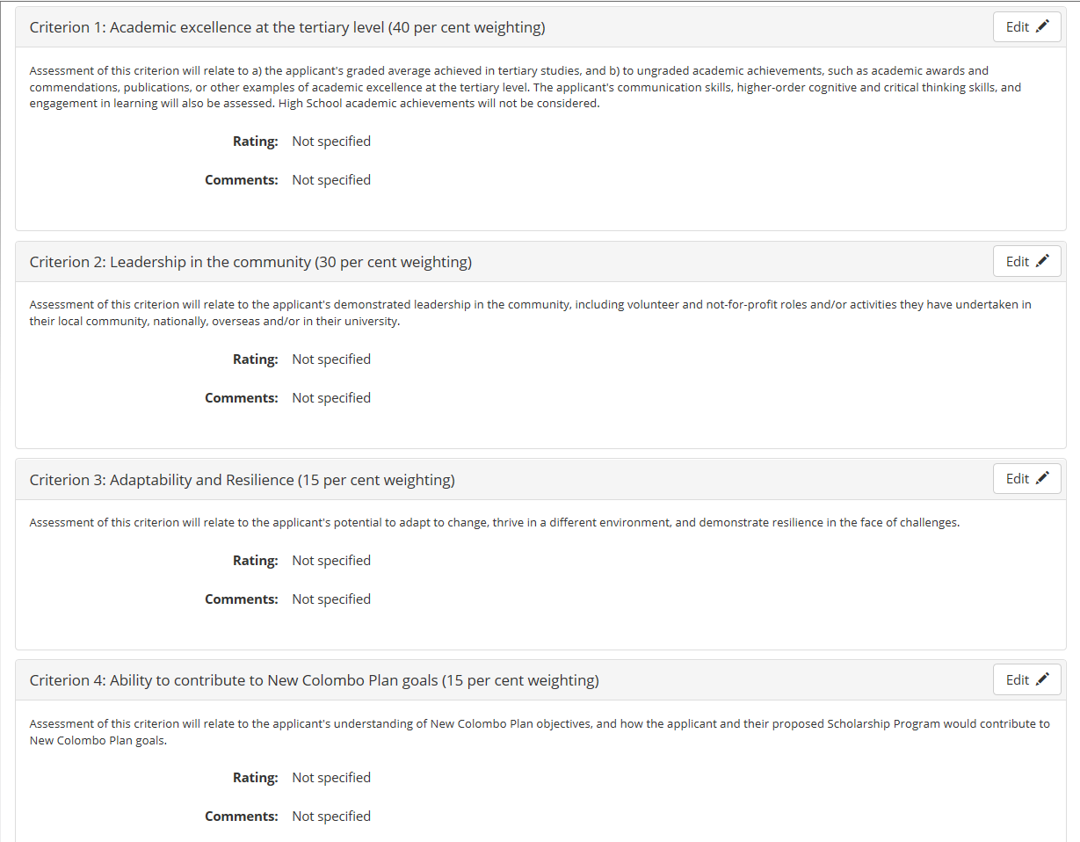

Referees may enter their rating and comments by selecting the ‘Edit’ button for each criterion. Comments are limited to 300 words. Referees must give the applicant a score of A-E for each criterion. However, if a referee feels they are unable to assess the applicant in relation to a particular criterion they have the option of selection ‘NA’, as Not Assessed.

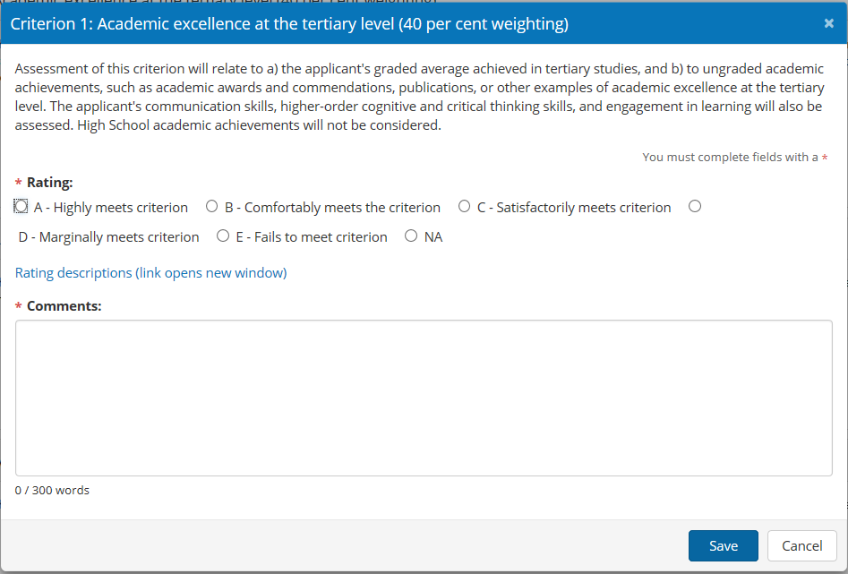

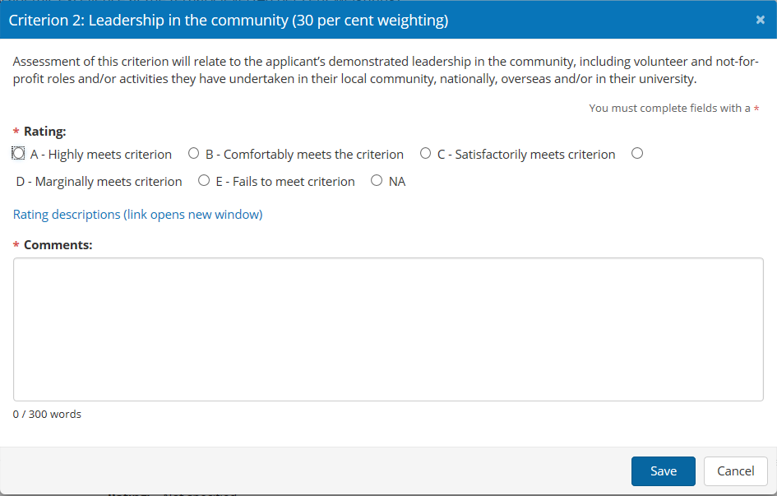

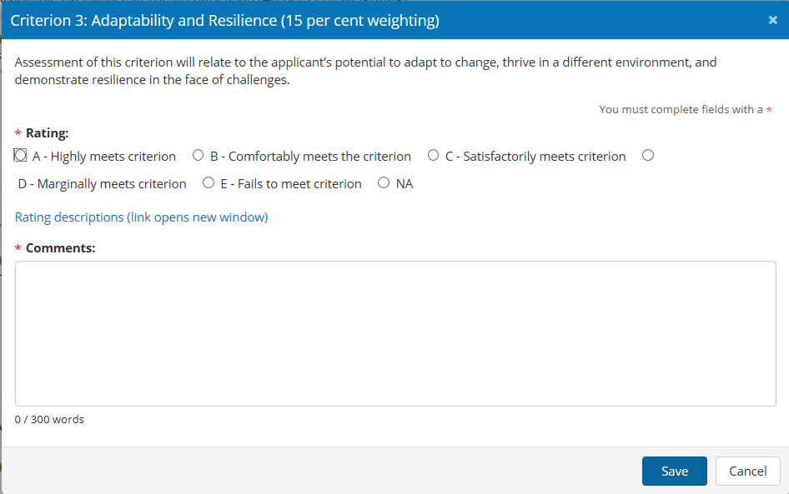

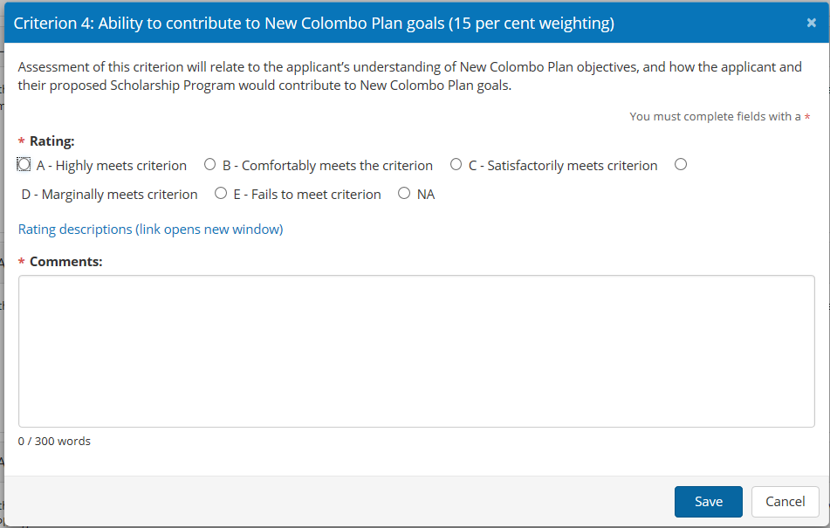

Once ratings and comments have been entered for all four criteria the report must be submitted by selecting the green ‘Submit referee report’ button at the bottom of the referee report form.



Referees will then be presented with the Referee privacy notice, which outlines the New Colombo Plan Scholarship Program’s privacy policy regarding referees’ personal information. Once the referee indicates they have read and understood the privacy notice by ticking the box, they can submit the referee report using the blue ‘Submit’ button.

The submitted report is returned to the Department of Education and Training and will not be seen by the applicant. A completion notice will be sent to the applicant to advise the referee report has been completed.

