

# Australia Awards Global Tracer Facility

Kiribati Case Study: Mapping Alumni Networks and Links to Australia

October 2020

The views expressed in this report are those of the authors and do not necessarily reflect the policy or position of the Australian Government, its agencies or representatives.

Australian Department of Foreign Affairs and Trade

With the exception of the Commonwealth Coat of Arms and where otherwise noted, all material presented is provided under a Creative Commons Attribution 3.0 Australia license.

**Acknowledgement:**

The authors of this report would like to thank the Australian High Commission, Tarawa, Kiribati for their enthusiastic cooperation and assistance in this research. We sincerely hope that the findings within the research help in further engagement with the Australian alumni of Kiribati.

The authors would also like to thank colleagues at the Swinburne University Centre for Transformative Innovation, Social Network Research Laboratory, especially Professor Thomas Spurling, and Professor John Webb. These colleagues were involved in the development of the project, providing guidance relating to the social interactions of alumni.

Special thanks to the alumni who participated in the survey for this research. The response and engagement of I-Kiribati alumni was beyond expectations and the time dedicated by these alumni to completing the survey has greatly contributed to the insight and analysis contained in this report.

**Recommended citation**

Buckley, S., Haddow, A., Lusher, D., & Clarke, L. (2020). *Kiribati Case Study: Mapping Alumni Networks and Links to Australia*, Australia Awards Global Tracer Facility, Australian Department of Foreign Affairs and Trade, Canberra. Retrieved from: <https://www.dfat.gov.au/people-to-people/australia-awards/australia-awards-global-tracer-facility-year-5-results>

Table of Contents

Abbreviations and Acronyms 4

Executive Summary 5

I-Kiribati alumni long-term outcomes 5

Social network analysis of I-Kiribati alumni 5

Recommendations for enhancing engagement with I-Kiribati alumni 6

1. Introduction 8

1.1 Objectives 8

1.2 Social network analysis 9

1.3 Scope and alumni participants 9

2. Australia Awards long-term Outcomes 10

2.1 Introduction 10

2.2 Public diplomacy outcomes 10

2.3 Views of Australia, Australians and Australian expertise 13

3. Social network analysis of I-Kiribati alumni 15

3.1 Introduction 15

3.2 Alumni networks 15

3.3 Australian connections network 16

3.4 Job advice network 18

3.5 Information sharing network 19

3.6 Informal connections network 20

3.7 Overlapping networks: Combining networks for added perspective 20

4. Conclusion and recommendations to increase engagement with I-Kiribati alumni 24

4.1 Summary of findings 24

4.1 Recommendations 24

5. References 26

Annex 1: Methodology 27

Case study design 27

Survey instrument development 27

Target population 28

Fieldwork 29

Limitations 30

Alumni data and contact information 30

Abbreviations and Acronyms

**DFAT** Department of Foreign Affairs and Trade

**GTF** Australia Awards Global Tracer Facility

**SCB** Scholarships and Alumni Branch (DFAT)

**SNA** Social network analysis

Executive Summary

This report examines the professional and social networks of Australian scholarship alumni from Kiribati to provide insight into the links between alumni, and how these contribute to the long-term outcomes of the Australia Awards. Based on survey responses from 64 alumni, this Kiribati Case Study utilises social network analysis (SNA) tools to analyse and map interactions amongst the I-Kiribati alumni and to Australia. This research was conducted by the Department of Foreign Affairs and Trade’s (DFAT) Australia Awards Global Tracer Facility (GTF) in September and October 2020.

The overall aim of the Australia Awards is to help ‘partner countries progress their development goals and have positive relationships with Australia that advance mutual interests’. This aim is extrapolated in four long-term outcomes of the Australia Awards. Outcome 2, cooperation with Australia, Outcome 3, partnerships with Australia, and Outcome 4, views of Australia, Australians and Australian expertise, form the basis of the findings for the alumni from this case study. The mapping of the I-Kiribati alumni network provides an opportunity to understand better how the alumni are linked, and the levers that influence their contribution to achieving Outcomes 2, 3 and 4.

### I-Kiribati alumni long-term outcomes

The alumni surveyed predominantly hold strong positive views of their experiences of Australia and their Australian education, and their encounters with Australian people, with all alumni having recommended Australia as a place to study to other people. Alumni also have diverse networks with I-Kiribati, international and Australian students developed while on award in Australia, with most maintaining occasional contact with fellow students following their award. In this regard, Australia Awards long-term Outcomes 2 and 4 are being achieved.

Nearly all alumni are working with Australians and Australian businesses or organisations as part of their work. However, alumni reported their contact with Australian professionals and academics that they met while on award to be infrequent, with alumni also less frequently providing advice about developing connections with Australians and Australian businesses, professional associations or organisations. While Outcomes 2 and 4 are being achieved by the alumni surveyed, increasing opportunities on and post award to connect with Australian professionals and academics more frequently will likely improve the extent to which Outcomes 2 (cooperation) and 3 (partnerships) with Australia are being achieved.

Alumni engagement by the Australian High Commission in Kiribati appears to be reaching a wide cohort, with four in five alumni reporting they had contact with the Australian High Commission. However, 70 per cent stated that this was infrequent, thus indicating an opportunity for increased regularity of contact. Target engagement with alumni in positions of influence appears to be effective with most alumni in a leadership position in their community or employment reporting they had contact with the Australian High Commission.

### Social network analysis of I-Kiribati alumni

In this case study, four types of interactions or networks were investigated: alumni’s interactions with alumni peers related to (1) developing connections with Australia, (2) seeking job advice, (3) for sharing information and skills related to their field of work, and (4) informal connections based outside of participation in the Australia Awards and including those linked to work, family, church or friendships.

Analyses of the social network data collected in the case study demonstrate that alumni are most likely to interact with one another because they have existing informal relationships and/or in order to develop connections with Australia. The analysis also highlighted that some alumni are not currently linked within the network. One fifth of alumni responded that they do not interact with other alumni in any of the relationships investigated.

### Recommendations for enhancing engagement with I-Kiribati alumni

One key suggestion stemming from this new research is the opportunity to leverage the influence of informal relationships between alumni to help drive and direct alumni engagement rather than focussing efforts on other types of relationships where fewer connections between alumni are evident. Findings also suggest that alumni are less likely to seek job advice from one another, which may be an area that Post could focus on in professional development sessions to support alumni.

Other recommendations based on the case study analyses relate to the structural implications of the social networks investigated. Disconnected groups of alumni could be missing key information transmission across the network and may benefit from targeted information campaigns. Directing information to members of these groups that are also in leadership positions in their employment or the community could make these campaigns more successful. The other structural implication of the SNA was that 13 alumni (one fifth of the alumni that participated in the case study) reported that they did not interact with any other alumni for any of the relationships or ties investigated. For Post, there could be opportunities to host events to help connect these types of disconnected alumni with the rest of the network to encourage more engagement, collaboration and cooperation with their alumni peers.

Title: Australia Awards alumni in Kiribati - mapping the social networks of alumni
Text:
Australia Awards alumni are contributing to cooperation and public diplomacy between Australia and Kiribati:
• Most of the alumni surveyed have maintained contact with fellow students, and Australians they met while on award, and all alumni have recommended Australia as a place to study.
• Nearly all alumni are working with Australians and Australian businesses or organisations as part of their work.
• Most alumni (80%) reported they had contact with the Australian High Commission in Kiribati, indicating alumni engagement activities are reaching a wide cohort.

Title: A Network Map of Kiribati Alumni
Text: 
In this map, relationships between alumni for the Australian connections, job advice, information sharing, and informal connections network are illustrated together in the same network map. The combined network map shows 112 circles spread out in a circular pattern where each circle represents an alumnus. Sixty-four of the circles/alumni are coloured blue to show that these alumni completed the social network survey questions. Forty-eight of the circles/alumni are coloured grey to show that these alumni did not respond to the survey but were nominated by one or more of the 64 alumni in the social network survey questions.
Lines between circles/alumni are used to illustrate relationships in the network and these are coloured black for Australian connections relationships, green for job advice relationships, orange for information sharing relationships and red for informal connections relationships. Arrowheads on the end of the lines indicate the direction of the nominated relationship.
The combined network map shows:
• A group of circles/alumni in the centre of the map that are connected to each other by black, green, orange and red lines. Many of these relationships/lines overlap and most of them are red.
• Some smaller groups of alumni in pairs or triads who are tied to each other but that are separate from the larger group. 
• 1 group of ten in the top of the map and 1 group of 6 alumni in the top right section of the map where the relationships/lines overlap. These groups are separate from the larger group. 
• 13 of the blue circles/alumni that responded to the social network survey questions are unconnected to any other alumni in the network.

Title: Kiribati alumni networks
Text:
The social network map highlights the complexity of Kiribati alumni networks.
Key findings from this analysis are:
• Alumni are most likely to interact with one another because of existing informal relationships and/or in order to develop connections with Australia. Informal relationships are those not necessarily related to participation in the Australia Awards and include those linked to work, family, church or friendships.
• Some alumni are disconnected individually or members of disconnected groups and there could be opportunities to bring them together for collaboration with the greater network.

Title: What can social network analysis offer that is different?
Text:
1. It determines the level of connectivity between people in a network. 
2. It can identify enablers in a network (e.g. the people who are highly connected that may be better placed to spread new information or lead new initiatives).
3. It can identify people who are isolated in the network and provides an opportunity to connect these people to others.

PARTICIPANTS: Alumni from Kiribati who undertook their award in Australia.

CASE STUDY PARTICIPANTS: 64 alumni - 40 women, 24 men.

1. Introduction

The Australia Awards Global Tracer Facility (GTF) commenced in 2016 and is funded by the Australian Department of Foreign Affairs and Trade (DFAT). Research by the GTF helps DFAT to assess the development contributions and public and economic diplomacy outcomes of Australia’s investment in the Australia Awards. The key research and reporting activities being undertaken annually by the GTF are a quantitative Global Tracer Survey and qualitative Case Studies, which are prepared concurrently throughout the project.

This Kiribati Case Study is a first by the GTF to utilise social network analysis (SNA) tools to examine the interactions within the Australia Awards alumni network from one country, Kiribati. The key findings of this report map the networks of I-Kiribati alumni and explore their links to Australia. Insights into alumni outcomes and their networks was collected by GTF researchers through an online survey conducted in September 2020.

### 1.1 Objectives

The Australia Awards offer study, research and professional development in Australia to over 45 partner countries to progress their development goals and build links with Australia. The GTF generates high-quality information on Australia’s investment in international scholarships, with a focus on the outcomes of less recent alumni (three years post-graduation and later). This information provides a strong evidence base for country programs and the Scholarships and Alumni Branch (SCB) of DFAT to evaluate the impact of Australia Awards on alumni, and on their home institutions and countries.

As noted above, this case study is unique in its approach and application. For this particular research, two specific aims were developed to provide focus. These are:

* To better understand the social network of alumni in Kiribati; and
* To develop an approach to using social network analysis to inform other Australia Awards countries/programs about the interactions of alumni and how to best utilise these networks.

In addition to the aims specific to this case study, all research conducted by GTF is framed within the overall objective of the Australia Awards: to help ‘partner countries progress their development goals and have positive relationships with Australia that advance mutual interests’. Four long-term outcomes to achieve this overall aim are outlined in the *Australia Awards Global Strategy[1]* and *Australia Awards* *Global Monitoring and Evaluation Framework[2]*. Briefly, these outcomes are:

* **Outcome 1:** Alumni are using their skills, knowledge and networks to contribute to sustainable development.
* **Outcome 2:** Alumni are contributing to cooperation between Australia and partner countries.
* **Outcome 3:** Effective, mutually advantageous partnerships between institutions and businesses in Australia and partner countries.
* **Outcome 4:** Alumni view Australia, Australians and Australian expertise positively.

This case study uses the above framework along with a social network approach to better understand connections developed by I-Kiribati alumni as a result of their award and how these link to achieving the long-term outcomes of the Australia Awards. Outcomes 2, 3 and 4 are the focus of this case study. It is intended that the approach used, and insights generated in this case study can inform SCB and Australia Awards country programs about the interactions of alumni and how to best utilise these networks.

### 1.2 Social network analysis

The application of SNA (social network analysis) can enable insights into the patterns and implications of how a network of people interact and with whom; essentially, ‘any type of relationship can be studied using SNA’ (Australian Network for Social Network Analysis, n.d.). A network can be those within an organisation, sports team, class, or alumni cohort, for example.

The purpose of using SNA in the context of the Australia Awards is to provide a deeper understanding of the relationships developed and maintained by alumni as a result of their award experience, and how these contribute to achieving the public diplomacy outcomes of the investment. In addition, insights into the way alumni are linked to each other and Australia can support targeted and meaningful engagement by DFAT Posts and Australia Awards country programs.

The use of social network analysis in this case study broadens the insights generated by the quantitative Global Tracer Surveys conducted by GTF, which provide data on the frequency of contact and type of links alumni have developed which can be disaggregated by gender, region and country. This case study provides a mapping of the connections within the I-Kiribati alumni network and their links to Australia.

### 1.3 Scope and alumni participants

The focus of the GTF is alumni of DFAT’s Australia Awards and previous Australian Government-funded scholarship programs, awards and fellowships. For this case study, the focus is on all alumni from Kiribati who undertook their development award in Australia. This focus included recent alumni who are less than three-years post-graduation to capture a more complete picture of the alumni network for analysis. This target population included 243 I-Kiribati alumni. Of this group, contact details were available for 122 alumni who were then invited via email to participate in the survey. A total of 64 alumni responded to the survey, a 52.5 per cent response rate (Annex 1 details the methodological approach of this case study).

1. Australia Awards long-term Outcomes

Alumni in this case study are contributing to Australia Awards Outcome 2—cooperation—and Outcome 4—positive views of Australia—through their ongoing networks and by recommending opportunities for study in Australia. While ongoing contact with Australian people, organisations and the Australian High Commission is occasional, alumni have developed diverse networks with fellow I-Kiribati, Australian and international students, as well with members of the Australian community outside of their host university or professional setting. Interestingly, nearly all alumni currently interact with Australians or Australian organisations as part of their work. Even though most of these connections are not a direct result of relationships developed while on award in Australia, they do still highlight strong and ongoing links to Australia for this group.

### 2.1 Introduction

This chapter explores the public diplomacy outcomes (Australia Awards Outcomes 2 and 3) and alumni’s views and attitudes towards Australia (Outcome 4) as a result of their award. The findings and discussion are based on the responses of alumni to the survey developed for this case study. The insights from the I-Kiribati alumni surveyed assist in providing further understanding into the ways in which the alumni are linked to each other and Australia, and factors which are contributing to achieving the intended long-term outcomes of the Australia Awards. The groups of interest in this case study are fellow students, lecturers, individuals from a professional setting, other people alumni met on award, as well as the Australian High Commission in Kiribati.

### 2.2 Public diplomacy outcomes

Analysis of the survey suggests that ongoing contact with networks developed by alumni as a result of their time on award in Australia is mostly occasional. More than half of the alumni surveyed stating they ‘sometimes’ have contact with those they met in Australia and with the Australian High Commission in Kiribati.

Figure 1: Frequency of contact since returning from award by selected groups (n=57)

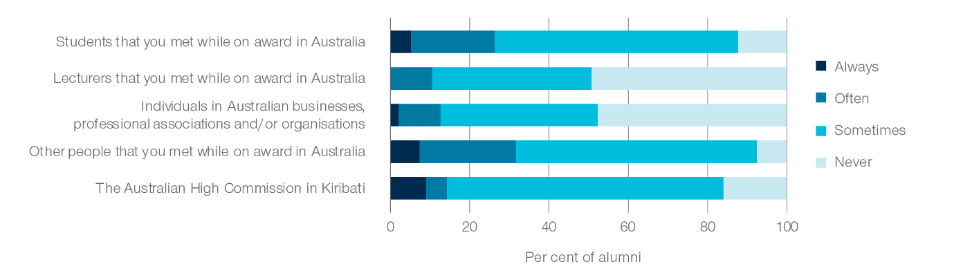

Figure 1 shows that since returning from award, alumni are most frequently in contact with students (26%) and other people (32%) that they met while on award, likely those they met outside of the university or professional setting. The alumni in this survey were most likely never to have contact with lecturers (49%) and individuals in Australian businesses, professional associations and/or organisations (47%), with only one in 10 alumni surveyed ‘often’ or ‘always’ in contact with these groups. These results indicate that while I-Kiribati alumni are achieving cooperation through people-to-people links, cooperation through professional connections with Australian academics and professionals is less common. While this section of the survey only focussed on the frequency of contact and does not measure how meaningful the contact is, most alumni in this case study (70%) reported that they had contact with the Australian High Commission in Kiribati ‘sometimes’. This result suggests Australia Awards alumni engagement in Kiribati could reach a broader number of alumni more frequently.

The survey asked alumni about the extent of connection alumni had with certain groups while on award—testing the assumption that alumni would be more likely to stay in touch with people with whom they had more contact with while in Australia. Figure 2 shows the contact frequency for four key groups that alumni had contact with during their on-award experience. More than half of alumni in this case study had frequent contact (often or always) with other I-Kiribati students (74%), Australian students (53%) and other international students (61%), indicating there are opportunities to engage with a diverse range of students at their host institutions. When comparing these results to the ongoing ‘post-award’ connections discussed in Figure 1, a clear pattern emerges, the groups that alumni were most in contact with while they were in Australia are the groups that have the most common contact with following their return from Australia.

Figure 2: Frequency of contact while on award in Australia by selected groups (n=57)

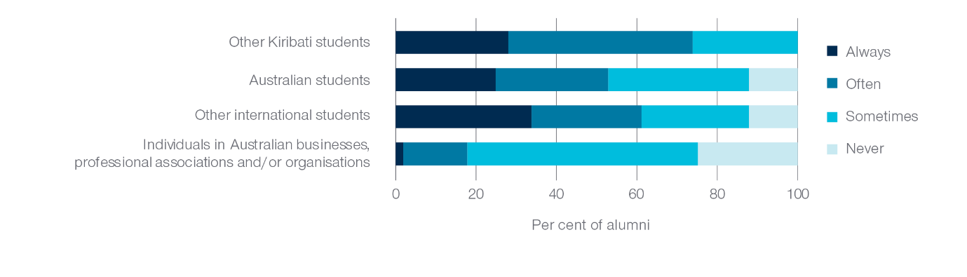

Figure 2 also shows that over half of the alumni reported only ‘sometimes’ having contact with Australian businesses or organisations. Only 18 per cent of alumni had frequent contact (often or always) with individuals in Australian businesses, professional associations and organisations while they were in Australia on award. Similarly, only 12 per cent of alumni report maintaining frequent contact once they had completed their award. For the alumni who have maintained an ongoing connection with an Australian organisation, further exploration of how these connections were made may provide useful insight into the factors which enable ongoing professional networks with Australia.

Of the alumni in this case study, more than half (55 per cent) reported holding a formal leadership role in their employment, with a further 14 per cent in an informal leadership role. Alumni are also leaders outside of their work, with one third of the alumni surveyed holding leadership roles in their communities with functions such as church or community leaders. Only 7.8 per cent of alumni do not have a leadership role in their employment or community. To foster strong public diplomacy and people-to-people links under Outcome 2—cooperation—it is important alumni leaders, in particular, are connected with Australia and Australian organisations. The following analysis explores the extent to which those in leadership positions are connecting with Australia.

Figure 3: Frequency of contact since returning from award with Australian professionals by leadership (both in employment and community) (n=52)

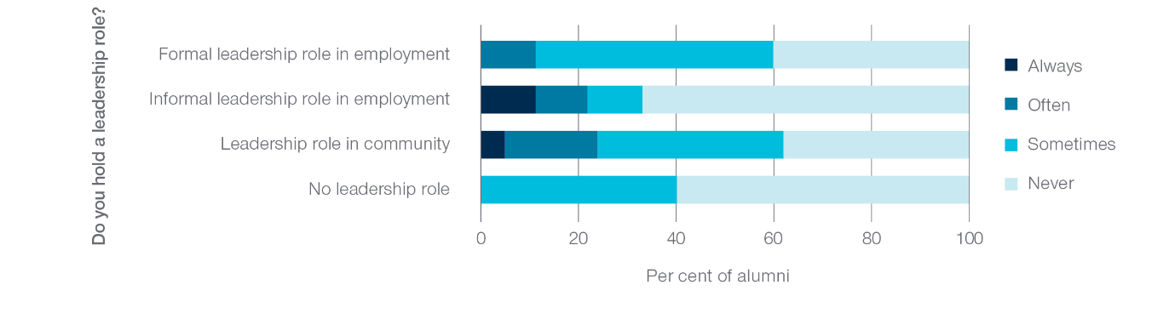

Figure 3 shows contact with Australian professionals was more frequent by alumni who hold a leadership role in their employment or community. Nearly two-thirds of alumni in these leadership positions had contact with individuals in Australian businesses, professional associations or organisations. In contrast, those in informal leadership or had no leadership roles were more likely to have no contact (67% and 60% respectively). The higher level of contact for alumni who are leaders in a formal leadership role in their employment or community with Australian professionals may likely be due to the responsibilities entailed with their positions.

Figure 4: Frequency of contact with the Australian High Commission in Kiribati by leadership   
(both in employment and community) (n=52)

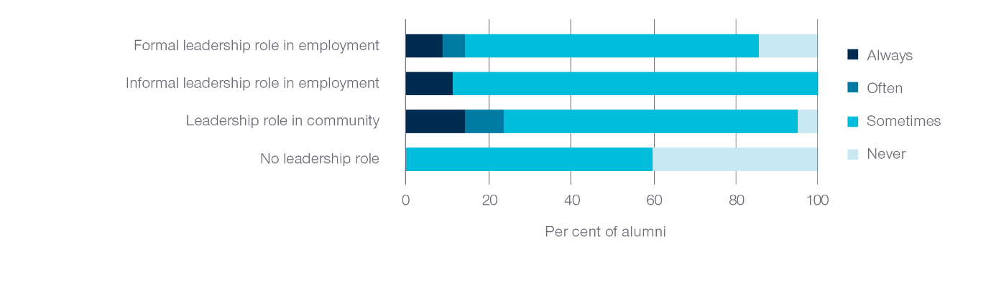

In Figure 4, most alumni with leadership roles in the community (95%) or their employment, formally (86%) and informally (100%), had contact with the Australian High Commission in Kiribati, compared with 60 per cent of alumni without a leadership role, indicating targeted engagement with alumni in positions of influence is being achieved. In particular, nearly one quarter (24%) of alumni with a leadership role in the community had frequent contact (often or always) with the Australian High Commission.

Figure 5: Where alumni get information about alumni engagement activities (n=58)

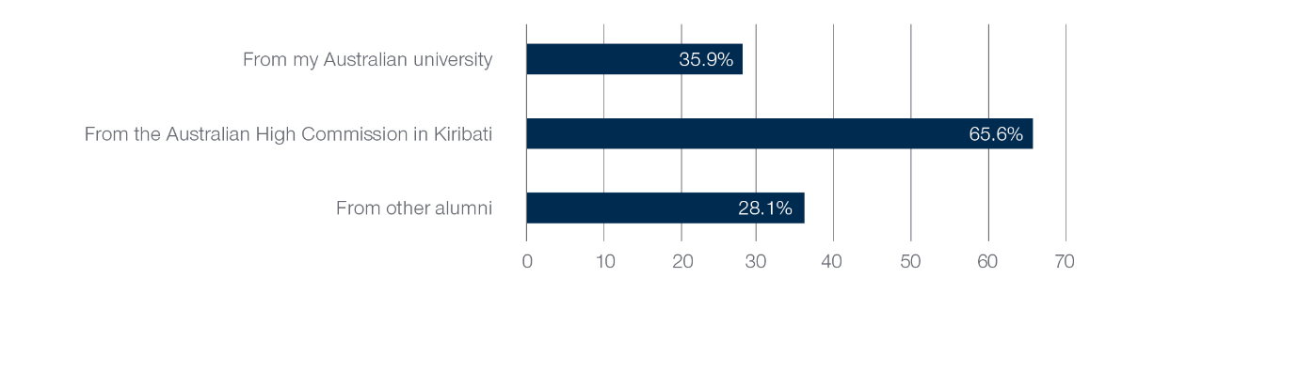

Alumni were asked how they found out about alumni engagement activities. Figure 5 shows nearly two thirds (66%) of alumni indicate receiving information from the Australian High Commission in Kiribati. More than one third (36%) of alumni have maintained a link with their host institution, stating that they receive alumni information from their Australian university. About one quarter (28%) sourced information about alumni engagement activities from fellow alumni, showing that while alumni are sharing this information with each other, the more formal options through the High Commission or university were more common.

Figure 6: Alumni’s experience of Australia while on award and their attitudes towards Australia (n=58)

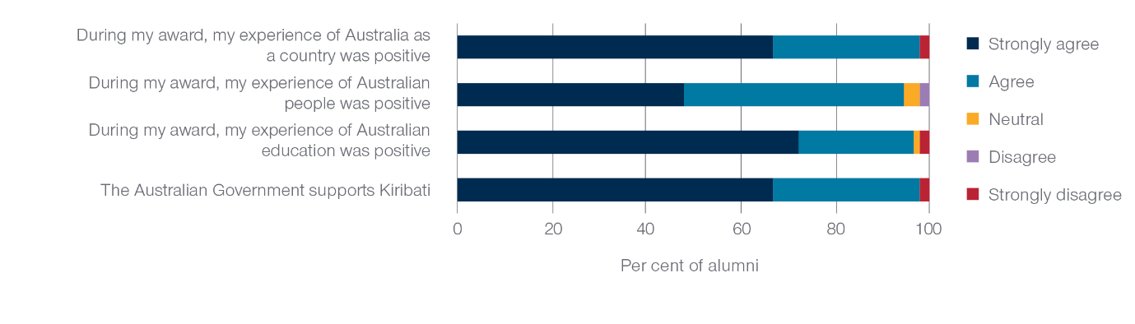

### 2.3 Views of Australia, Australians and Australian expertise

The factors which can influence alumni’s views of Australia, Australians and Australian expertise can occur before, during and after award and be the result of a variety of experiences and interactions. Figure 6 shows that nearly all alumni agreed or strongly agreed they had positive experiences while on award of Australia as a country (98%), Australian people (95%), and their Australian education (97%). In addition, 98 per cent of the alumni agreed or strongly agreed that the Australian Government supports Kiribati.

Figure 3 shows contact with Australian professionals was more frequent by alumni who hold a leadership role in their employment or community. Nearly two-thirds of alumni in these leadership positions had contact with individuals in Australian businesses, professional associations or organisations. In contrast, those in informal leadership or had no leadership roles were more likely to have no contact (67% and 60% respectively). The higher level of contact for alumni who are leaders in a formal leadership role in their employment or community with Australian professionals may likely be due to the responsibilities entailed with their positions.

Figure 7: Frequency of alumni recommending and providing advice to their networks about study and developing professional connections in Australia (n=58)

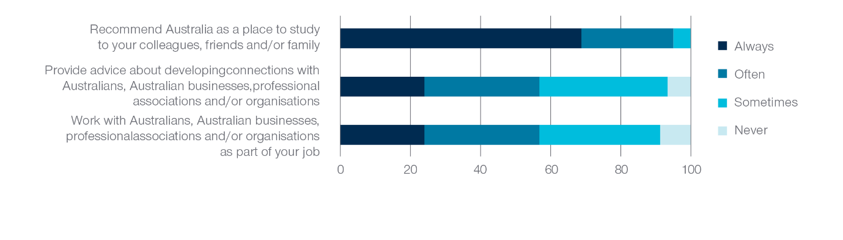

In addition to expressing positive attitudes towards Australia, Australians and Australian education as a result of alumni’s on award experiences, Figure 7 shows most of the alumni surveyed have recommended opportunities and provided advice about Australia. Nearly all the alumni (95%) have frequently (often and always) recommended Australia as a place to study to their colleagues, friends and family, providing further evidence of their strong, positive sentiments regarding their Australian education experiences. However, reflecting the trend of lower frequency of contact with Australian professionals post award (see Figure 1), just over two fifths of alumni (43%) only ‘sometimes’ or ‘never’ provide advice about developing connections with Australian professionals, businesses and professional associations or organisations. With nearly all the alumni (91%) reporting that they work with Australians, Australian businesses, professional associations or organisations as part of their job, post award opportunities to continue building professional networks with Australia seem to be available.

1. Social network analysis of I-Kiribati alumni

Analyses of the social network data collected in the case study demonstrate that alumni are most likely to interact with one another because of existing informal relationships and/or in order to develop connections with Australia. Informal relationships are those not necessarily related to participation in the Australia Awards and include those linked to work, family, church or friendships. One fifth of alumni respondents were isolates across all four networks; that is, these alumni responded that they do not interact with other alumni in any of the relationships investigated.

### 3.1 Introduction

This chapter presents the results of the SNA undertaken in this case study. These results address the first aim of the case study; to better understand social networks amongst I-Kiribati Australia Awards alumni, including relationships amongst alumni that help to encourage ongoing connections with Australia.

Social network terms

**Ties**—Relationships in a network/between alumni

**Isolates**—Network members/alumni with no ties in a network

**Nomination**—A term used to describe one alum identifying a tie/relationship with another alum

**Dyadic relationship**—A relationship between two people

**Clustered relationships**—Broader than a dyadic relationship, when relationships overlap with one another in a network

### 3.2 Alumni networks

Alumni interact with one another in different ways. In this case study, four types of interactions or networks were investigated using the following four network questions in the alumni survey:

1. Which alumni do you contact if you want to develop connections with Australians or Australian organisations?
2. Which alumni have you contacted for advice about job opportunities?
3. Which alumni do you share information or skills related to your field of work?
4. Which alumni do you also interact with as part of other networks (for example, family, church, work, friends)?

The data from these questions were used to create the four types of networks: the **Australian connections network**, the **job advice network**, the **information sharing network** and the **informal connections network**, respectively.

Sixty-four alumni responded to the social network questions. Given there are 243 I-Kiribati alumni who undertook an Australian Government development scholarship in Australia, and each social network question asked respondents to identify alumni that they interacted with, it was possible for each alum to nominate any of the other 242 I-Kiribati alumni in any of the social network questions.

Descriptive statistics for the four networks were calculated. Table 1 shows the average number of contacts or alumni nominations made by the 64 participating alumni and the minimum and maximum number of nominations made for each network. On average, alumni nominated more informal interactions with other alumni (e.g. in relation to family, church, work, friends) followed by interactions to develop connections with Australia. These two networks also had the highest maximum number of nominations.

To explore each network graphically, the program VPNet (SNA Toolbox Pty Ltd, 2020) was used to create network visualisations. In each visualisation, a circle is an alumni member, and a line between circles represents a tie or relationship between alumni. The arrowheads represented on the ties illustrate the direction of the relationship. For instance, if an arrowhead is shown on both ends of a tie between two circles/alumni then this indicates that both alumni nominated one another in a network. However, if an arrowhead is only shown on one side of a tie, then this indicates the relationship was only identified by one of the alumni.

Table 1: Descriptive statistics for alumni nominations in each network

|  | **Average number  of nominations** | **Minimum  nominations** | **Maximum  Nominations** |
| --- | --- | --- | --- |
| **Australian connections** | 1.02 | 0 | 6 |
| **Job advice** | 0.30 | 0 | 4 |
| **Information sharing** | 0.63 | 0 | 4 |
| **Informal connections** | 1.30 | 0 | 8 |

### 3.3 Australian connections network

A visualisation of the Australian connections network is presented in Figure 8. Alumni that responded to the survey are blue circles, and grey circles are non-respondents. Almost half of the alumni in the case study reported that they contact other alumni in order to develop connections with Australia. A close look at the mapping shows that relationships in this network tend to occur in separate groups or clusters.

Figure 8 and all network maps presented in this chapter show 112 of the I-Kiribati alumni. This includes the 64 alumni that responded to the survey and an additional 48 alumni that did not respond to the survey but were nominated by others.

Alumni were also asked who they contact outside of the alumni network for developing connections with Australia or Australian organisations. Figure 9 presents the results for the 58 alumni that responded to this question. Work colleagues and the Australian High Commission are the most nominated contacts followed by friends, lecturers and university staff that alumni met while on award, and other Australians met while on award in Australia.

Figure 8: Australian connections network: Relationships among I-Kiribati alumni for developing connections with Australia (blue=survey respondents, grey=non-respondents)

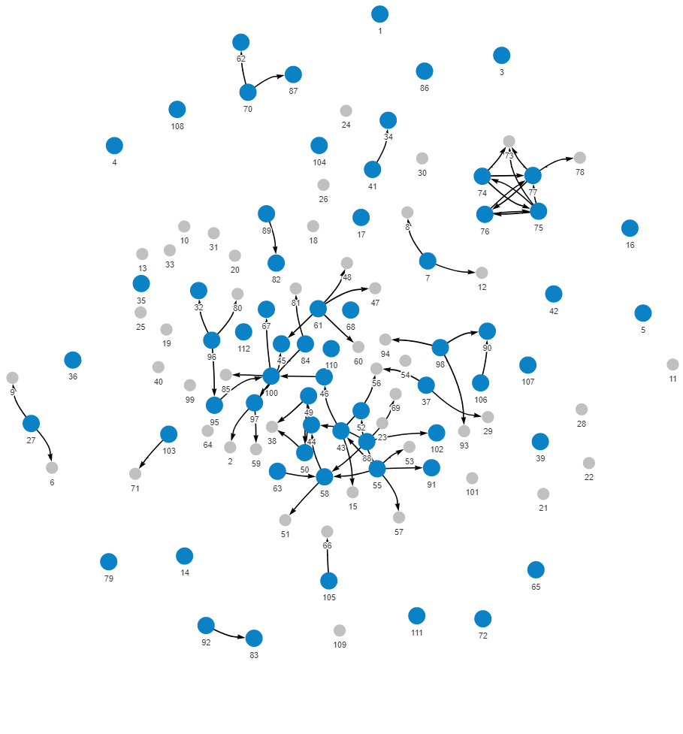

Figure 9: Alumni sources for developing connections with Australia outside the alumni network (n=58)

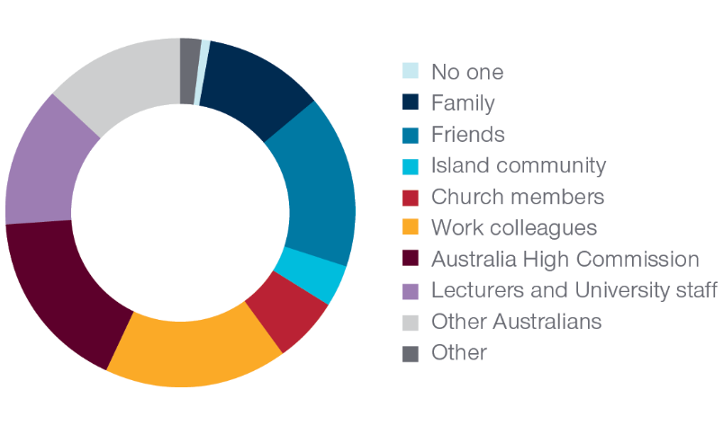

### 3.4 Job advice network

Figure 10 presents the job advice network. This network has the lowest density, with only one fifth of alumni in the case study indicating that they seek job advice from other alumni. This suggests that alumni receive job advice outside of the alumni network. The job advice network was also characterised by more dyadic interactions (i.e., between two alumni) rather than clustered relationships.

Figure 10: Job advice network: Relationships among I-Kiribati alumni for seeking job advice (blue=survey respondents, grey=non-respondents)

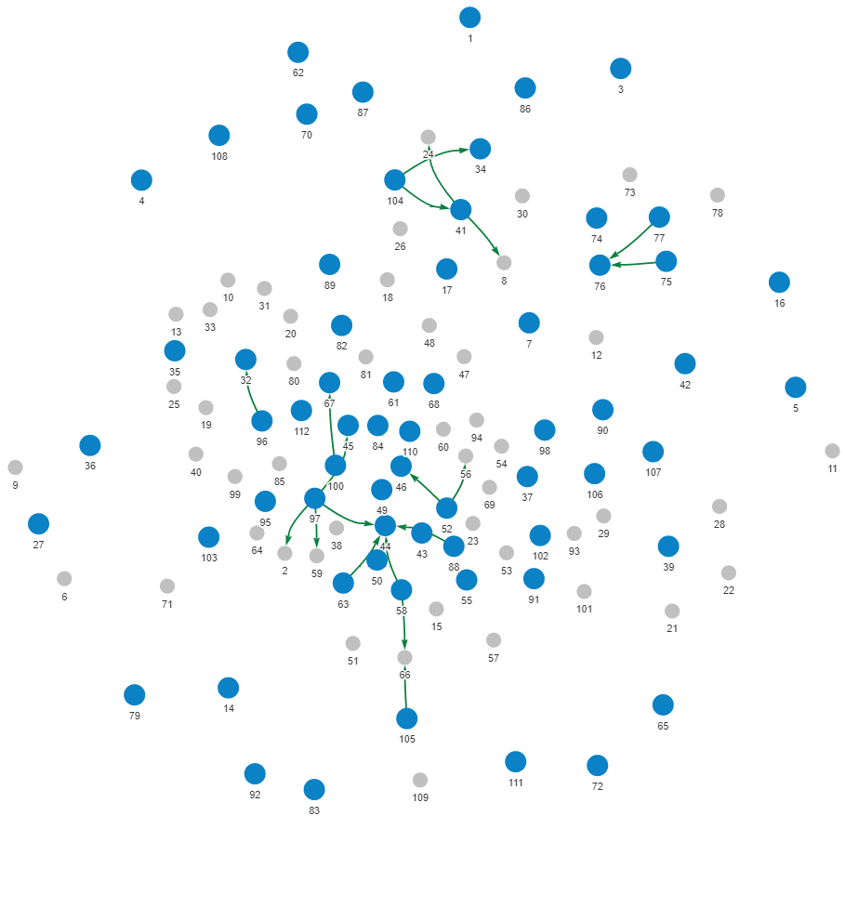

### 3.5 Information sharing network

Figure 11 shows a visualisation of the information sharing network. Approximately two fifths of alumni in the case study interact with other alumni to share information or skills related to their field of work. Similar to the Australian connections network, interactions between alumni in this network are represented in more separate groups of alumni.

Figure 11: Information sharing network: Relationships among I-Kiribati alumni for sharing work-related information (blue=survey respondents, grey=non-respondents)

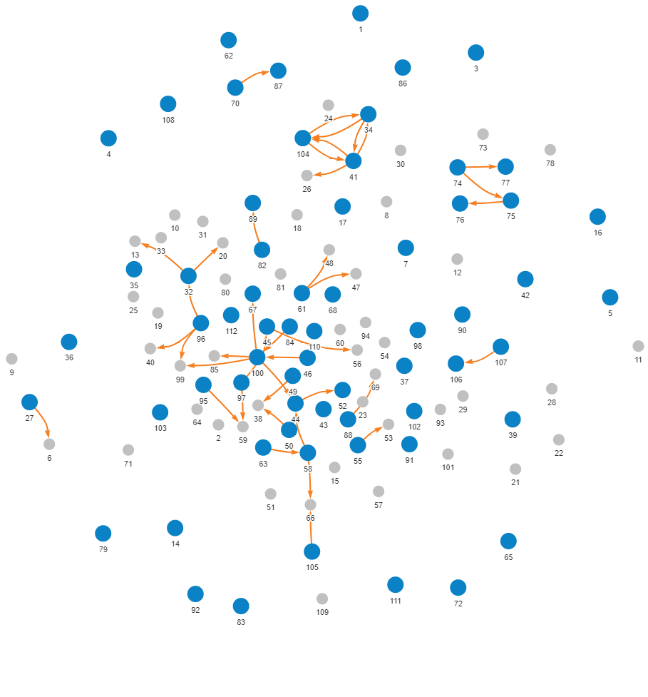

### 3.6 Informal connections network

In Figure 12, a visualisation of the informal connections network is presented. Interactions in this network are based outside of participation in the Australia Awards and include relationships linked to work, family, church and/or friendships. Almost three fifths of alumni in the case study indicated that they are related to, socialise and/or work with other alumni. This network has the highest density and is the most clustered of all four networks. In other words, informal relationships between alumni are more likely to overlap with other relationships in the broader network. The most clustered set of relationships is visualised in the centre of Figure 13 with smaller clusters and dyadic relationships around the edges of the map.

Figure 12: Informal connections network: Relationships among I-Kiribati alumni linked to work, family, church and/or friendship (blue=survey respondents, grey=non-respondents)

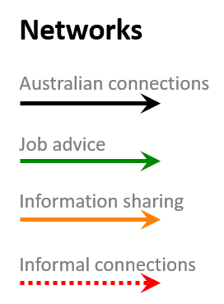

### 3.7 Overlapping networks: Combining networks for added perspective

Figure 13 visualises all four of the networks examined above, the **Australian connections network**, the **job advice network**, the **information sharing network** and the **informal connections network**, in one network map. Considering these multiple networks together helps to illustrate the interconnectedness of different alumni interactions and also makes it possible to identify the types of interactions that drive and/or bind the alumni network in general (Shafie, 2015).

Figure 13 shows that the most common forces driving interactions among alumni are informal relationships and interactions designed to develop connections with Australia. The combined network also helps to highlight the structural features of alumni interactions. For instance, while there is a large interconnected cluster of alumni represented in the middle of Figure 13, there are also groups of separated clusters shown on the periphery. Furthermore, 13 alumni are isolates across all four networks and therefore did not nominate other alumni in response to any of the social network questions. Further analyses of these 13 alumni indicated they range in age, from 22 to 66, and graduated from their awards between 1993 and 2020, with only two of the 13 graduating in the same year. These data suggest that these 13 alumni are not isolates because of any age or cohort effects.

SNA also allows for merging the network data shown in this chapter with survey data shown in Chapter 2 (Australia Awards long-term Outcomes). An Exploratory analysis was conducted to examine whether patterns emerged when combining alumni social network data with data on alumni encouragement of partnerships and interactions between Australia and Kiribati. Data on alumni leadership positions was also investigated.

Figure 13: Combined networks: Relationships among I-Kiribati alumni in the Australian connections, job advice, information sharing and informal connections networks

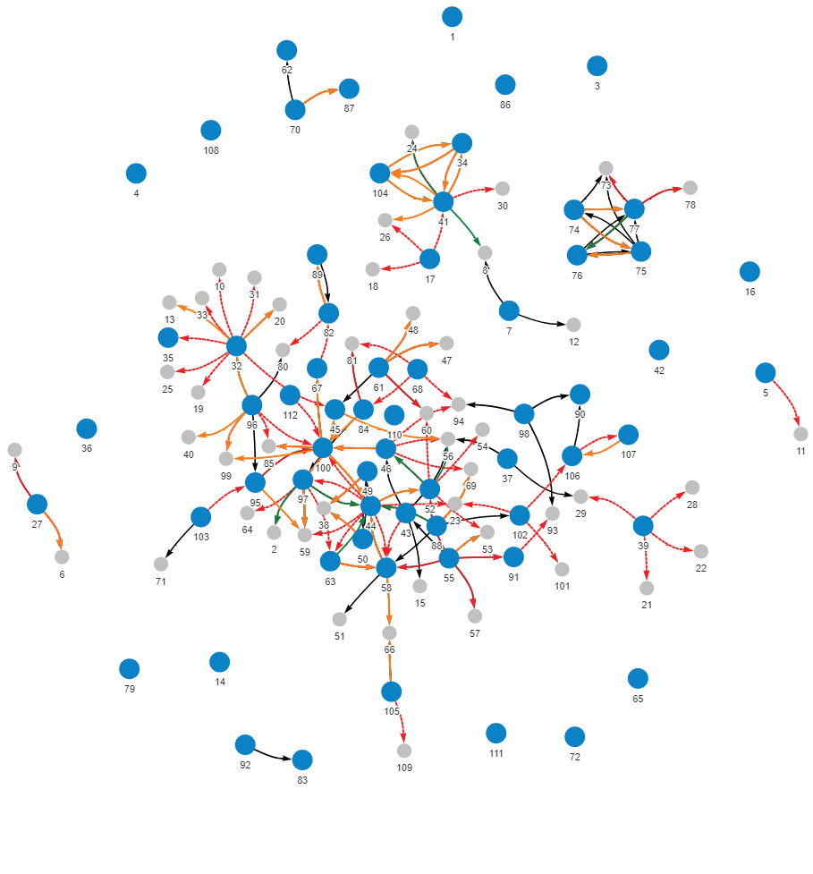



Figure 14: Formal leadership, providing advice about Australian and relationships among I-Kiribati alumni in the Australian connections, job advice, information sharing and informal connections networks (red=respondent, formal leader; yellow =respondent, not a leader; grey=non-respondents; larger circles=alumni more frequently provides advice about Australia)

Formal leadership, providing advice about Australia and relationships among Kiribati alumni in the Australian connections, job advice, information sharing and informal connections networksIn this figure, relationships between alumni for the Australian connections, job advice, information sharing and informal connections network are illustrated together in the same network map. The combined network map shows 112 circles spread out in a circular pattern where each circle represents an alumnus. Forty-eight of the circles/alumni are coloured grey to show that these alumni did not respond to the survey but were nominated by one or more of the 64 alumni in the social network survey questions. The remaining circles/alumni are red or yellow. Red alumni are those that are formal leaders at their place of employment and yellow alumni do not hold leadership positions. The red and yellow circles/alumni are also different sized circles. Larger red and yellow circles represent alumni that more frequently provide advice about Australia.Lines between circles/alumni are used to illustrate relationships in the network and these are coloured black for Australian connections relationships, green for job advice relationships, orange for information sharing relationships and red for informal connections relationships. Arrowheads on the end of the lines indicate the direction of the nominated relationship.The combined network map shows:• a group of circles/alumni in the centre of the map that are connected to each other by black, green, orange and red lines. Many of these relationships/lines overlap and most of them are red.• some smaller groups of alumni in pairs or triads who are tied to each other but that are separate from the larger group. • 1 group of ten in the top of the map and 1 group of 6 alumni in the top right section of the map where the relationships/lines overlap. These groups are separate from the larger group. • 13 of the red and yellow circles/alumni that responded to the social network survey questions are unconnected to any other alumni in the network.• Red circles/alumni with formal leadership roles are represented all around the map. Some of these red circles/alumni are highly connected to other alumni and some are unconnected.• There does not appear to be a relationship between the size of circles and where they are positioned or connected around the network map.



Figure 14 merges three types of data—alumni interactions across the four networks, alumni who are formal leaders in their employment and how frequently alumni reported providing advice about developing connections with Australia. Red circles in Figure 14 represent alumni who hold a formal leadership role at their place of employment, while yellow circles represent alumni who do not hold leadership positions and grey circles indicate alumni who did not respond to the survey. The size of red and yellow circles indicates how frequently alumni reported providing advice about Australia (larger circles denote more frequent provision of advice).

Figure 14 shows that alumni with formal leadership roles are spread throughout the various clusters featured across the networks. Alumni that report more frequently providing advice about Australia are also represented across the different parts of the network.

Figure 15: Community leadership, providing advice about Australia and relationships among   
I-Kiribati alumni in the Australian connections, job advice, information sharing and informal connections networks networks (dark green=respondent, community leader; light green=respondent, not a community leader; light grey=non-respondents; larger circles=alumni more frequently provides advice about Australia)

Community leadership, providing advice about Australia and relationships among Kiribati alumni in the Australian connections, job advice, information sharing and informal connections networksIn this figure, relationships between alumni for the Australian connections, job advice, information sharing and informal connections network are illustrated together in the same network map. The combined network map shows 112 circles spread out in a circular pattern where each circle represents an alumnus. Forty-eight of the circles/alumni are coloured light grey to show that these alumni did not respond to the survey but were nominated by one or more of the 64 alumni in the social network survey questions. The remaining circles/alumni are dark green or light green. Dark green alumni are those that are community leaders and light green alumni do not hold community leadership positions. The dark green and light green circles/alumni are also different sized circles. Larger dark green and light green circles represent alumni that more frequently provide advice about Australia.Lines between circles/alumni are used to illustrate relationships in the network and these are coloured black for Australian connections relationships, green for job advice relationships, orange for information sharing relationships and red for informal connections relationships. Arrowheads on the end of the lines indicate the direction of the nominated relationship.The combined network map shows:• a group of circles/alumni in the centre of the map that are connected to each other by black, green, orange and red lines. Many of these relationships/lines overlap and most of them are red.• some smaller groups of alumni in pairs or triads who are tied to each other but that are separate from the larger group. • 1 group of ten in the top of the map and 1 group of 6 alumni in the top right section of the map where the relationships/lines overlap. These groups are separate from the larger group. • 13 of the green circles/alumni that responded to the social network survey questions are unconnected to any other alumni in the network.• Dark green circles/alumni with community leadership roles are represented all around the map. Some of these dark green circles/alumni are highly connected to other alumni and a few are unconnected.• There does not appear to be a relationship between the size of circles and where they are positioned or connected around the network map.



A similar pattern emerges when considering alumni that hold leadership roles in the community, which is illustrated in Figure 15. In this map, dark green alumni are those with leadership roles in the community, light green alumni are those who do not hold leadership roles and grey alumni did not respond to the survey. This map shows that alumni with community leadership roles again tend to be dispersed throughout the separated clusters across the network. Furthermore, comparing Figure 14 and Figure 15, it is evident that some alumni hold leadership roles in their employment and the community.

1. Conclusion and recommendations to increase engagement with I-Kiribati alumni

### 4.1 Summary of findings

The mapping of networks among I-Kiribati alumni using SNA presents new insight into the extent to which alumni are linked to each other and to Australia. The responses from the alumni survey also provide detail of the frequency of contact with groups of people key to achieving Australia Awards long-term Outcome 2, cooperation, Outcome 3, partnerships, and Outcome 4, alumni’s perceptions of Australia as a result of their award experience. The findings of this report are intended to support SCB and Post understanding of the I-Kiribati alumni network to increase engagement contributing to the long-term outcomes of the Australia Awards.

Advice and recommendations made are based on the data collected in the case study, and the responses of the 64 alumni that completed the survey. While these 64 alumni do not represent all I-Kiribati alumni, the data and patterns that emerged from the case study analyses suggest ways in which alumni engagement with each other, Post and Australian organisations could be enhanced for the benefit of alumni careers and Australia’s partnership with Kiribati. The authors note that there are broader contextual factors that can help explain and understand these outcomes, and hope that this new way of exploring networks can be used in conjunction with local knowledge to help engage with alumni.

### 4.1 Recommendations

Alumni do use their networks to find out about alumni engagement activities—almost one third reported receiving information from fellow alumni on alumni engagement activities. However, the social network approach adopted in this case study revealed that alumni networks extend beyond this purpose. There are several implications and/or recommendations that could be made based on the network analyses presented in this report.

Important in this context is the finding that almost half of the surveyed alumni contact other alumni in order to develop Australian connections. This finding suggests that participation in the Australia Awards has helped to foster relationships between alumni that encourage cooperation and partnerships with Australia in line with Outcomes 2 and 3. From here, the next step from these data would be to develop a better understanding of the networks that are the foundation of alumni interaction—in particular, the informal connections network—and how this network could be used to promote alumni engagement and further links with Australia.

Another finding is that alumni seek job advice outside of the alumni network. Seemingly, the current alumni network in Kiribati is not seen as one that helps in this regard. However, alumni networks do have the potential to be important in this regard. As such, exploring whether there is an opportunity to help on this front could be something for Post to consider. For example, would professional development events that foster alumni connections around job advice be useful?

The other two major implications of the SNA revolve around the structure of alumni network interactions. Firstly, there are groups of separated clusters on the periphery of the alumni network. There may be legitimate reasons for why they are separated; however, because these groups are disconnected, it may mean that transmission of information across the network does not always reach individuals in these groups. Based on this, it would be useful for Post to consider ways in which they could ensure that someone in each group is specifically targeted by information campaigns relating to engagement and opportunities. In addition, it appears it would be worth investigating whether there are opportunities to bring these clusters together for professional development events.

There may be added benefit to combining information campaigns with the data collected in this case study in terms of leadership roles held amongst alumni. Alumni with leadership roles in their employment and/or in the community may be the best network members to direct information to, particularly given that informal relationships seem to be a common basis for alumni interactions and these informal connections relate to work and the community. These leaders may be in the best position to promote alumni engagement with their peers. It should be noted that not all alumni with leadership roles are connected within the network. Several leaders are also isolates and focussing on alumni with leadership roles who are connected to their alumni peers would be important for the success of these strategies.

The second structural implication of the SNA relates to the 13 isolates represented in the network. These 13 alumni reported that they do not interact with any other alumni for any of the relationships or ties investigated. For Post, there could be opportunities to host events to help connect these types of disconnected alumni with the rest of the network to encourage more engagement, collaboration and cooperation with their alumni peers.

1. References

Australian Network for Social Network Analysis. (n.d.). *What is SNA and why use it?* https://www.ansna.org.au/sna#.

Mawer, M. (2014). *A study of research methodology used in evaluations of international scholarship schemes for higher education.* Commonwealth Scholarships Commission. United Kingdom.

SNA Toolbox Pty Ltd. (2020). *VPNet: Software for the visualisation of network data.* Version 2.3.2.

Shafie, T. (2015). ‘A Multigraph Approach to Social Network Analysis’. *Journal of Social Structure*, 16, 1-22.

Annex 1: Methodology

This case study involved the development, fieldwork implementation and analysis of a survey designed specifically for building an understanding of I-Kiribati alumni through a social network approach. This annex outlines the methodological approach applied to the work.

### Case study design

As noted in the introduction to this report, the core aims specific to this Kiribati Case Study are:

* To better understand the social network of alumni in Kiribati; and
* To develop an approach to using social network analysis to inform other Australia Awards countries/programs about the interactions of alumni and how to best utilise these networks.

Alongside these specific aims, all research conducted by the Australia Awards Global Tracer Facility (GTF) is framed within the overall aim of the Australia Awards: to help ‘partner countries progress their development goals and have positive relationships with Australia that advance mutual interests’. Further detail relating to this aim is articulated through the long-term outcomes of the Australia Awards and detailed in the *Australia Awards Global Strategy[3]* and *Australia Awards Global Monitoring and Evaluation Framework*.[4] The long-term outcomes of the Australia Awards are:

* **Outcome 1:** Alumni are using their skills, knowledge and networks to contribute to sustainable development.
* **Outcome 2:** Alumni are contributing to cooperation between Australia and partner countries.
* **Outcome 3:** Effective, mutually advantageous partnerships between institutions and businesses in Australia and partner countries.
* **Outcome 4:** Alumni view Australia, Australians and Australian expertise positively.

As detailed in the sections that follow, the specific aims of this case study and the Australia Awards long-term outcomes provided the framework for the design of this research—in both the development of the survey instrument and the analysis of outcomes.

### Survey instrument development

The survey instrument for this case study was designed to enable social network analysis and the exploration of some of the Australia Awards long-term outcomes. The instrument for the research was developed as part of a collaboration between the GTF and the Swinburne University Centre for Transformative Innovation, Social Network Research Laboratory. The initial framework and approach for the survey was developed through workshopping sessions with the Swinburne Team. Draft versions of the survey were shared with the Australian High Commission, Tarawa, with feedback built into the final instrument.

The final structure of the survey developed for the project is as follows.

Section 1—Social Networks:

* Networks among alumni for connecting with Australians or Australian organisations
* Networks among alumni for advice about job opportunities
* Networks among alumni for sharing information and skills related to field of work
* Networks among alumni that exist outside of work, scholarships etc. (e.g. family, church, friends, Island)

Other connections with Australia or Australian organisations.

Section 2—Australia Awards long-term outcomes:

* Views of Australia and Australians
* Ongoing contact with people met on award
* Connections while in Australia
* Australian alumni engagement activities.

Section 3—Background information:

* Employment
* Leadership positions
* Award details
* Demographic characteristics.

Given the nature of the case study and the focus on networks and connections, the final instrument developed has a strong emphasis on Australia Awards long-term outcomes 2, 3 and 4—which focus on connections and views of Australia.

### Target population

The Australia Awards and predecessor scholarship programs have been an important aspect of Australian aid to Kiribati since the 1980s. Development scholarships have provided I-Kiribati with opportunities for study in Australian universities and vocational education providers, as well as funding study within the Pacific Region. As part of the planning for this study, a specific population was identified for engaging in the survey. The decision on the focus population was developed based on balancing the specific objectives of this case study, with the overall long-term outcomes of the Australia Awards.

As such, **the target population for the survey was defined as I-Kiribati who had spent time in Australia studying as part of a development award provided by the Australian Government.**

Data relating to this target population was compiled via two means. First, the Australian High Commission, Tarawa provided the GTF with its lists of alumni that it maintains for ongoing engagement with this group. The GTF researchers supplemented this list with an extract of alumni information from the DFAT Global Alumni database. The two lists were merged for the purpose of identifying alumni who fit the population, and ensuring fields relating to contact details, demographics and award information were as complete as possible.

In total, based on the information available to the GTF, 243 I-Kiribati alumni were identified as fitting in the target population for this research. Of this group of target alumni, more than half did not have an email address or phone number in their records. The GTF worked with the Australian High Commission, Tarawa to update some of these addresses and used a snowballing technique[5] during survey fieldwork to gather contact details for more alumni.

Based on existing lists and updates during fieldwork, in total, **122 alumni in the target population were invited to participate in the survey** via email (50 per cent of the target population).

### Fieldwork

Survey data collection was conducted using an online survey platform. Each alum in the target population was provided with a unique URL to link to the survey. The GTF employed an approach to survey collection which involved: having a clearly defined target population; identifying the extent to which the target population can be reliably contacted; and providing each member of the population with a unique access link to the survey. This approach helps to ensure accurate data collection, enables a clear understanding of response patterns, and provides a baseline for which to examine the validity of survey responses and findings.

Fieldwork commenced on September 4 and closed on September 28, 2020. Survey response data were collected and stored on servers in Australia. Throughout the fieldwork period, response data was routinely extracted by the GTF team and used for updating response lists. Alumni who had not responded to the survey were contacted via email and SMS (where mobile phone numbers were available) with personalised reminders[6] to complete the survey. In total, four reminder emails and one reminder SMS were sent during fieldwork to encourage alumni to participate in the survey.

Engagement of alumni in the survey was also encouraged by the Australian High Commission, Tarawa, through posts on social media and via meetings with key stakeholders. The High Commission used messages developed by the GTF to increase awareness of the survey among alumni through its Facebook page—with posts in the week leading up to the survey, as well as during the fieldwork period. The GTF also developed a one-page ‘explainer’ note about the survey that the High Commission used for distributing at meetings with Kiribati public sector leaders during fieldwork as a means of raising awareness among this group of whom many are Australian alumni.

Of the 122 alumni invited to participate, **64 responded to the survey and were included in the analysis for this report—a response rate of 52.5 per cent.** This rate of response is high in the experience of the GTF research and in relation to other alumni-based development surveys undertaken worldwide. For example, in the GTF Global Tracer Surveys, conducted in 2016–17, 2017–18 and 2018–19 across all Australia Awards recipient countries, achieved response rates of between 23 and 36 per cent. In a review of alumni surveys internationally, Mawer (2014) found that post-programme surveys worldwide tend to have low response rates, especially in comparison to surveys involving current recipients.

### Limitations

Positive response bias

It is probable that alumni who felt that they had a positive experience as an Australian Government scholarship recipient and/or had success in their career following their award are more likely to agree to participate in Case Studies. In a study by the Commonwealth Scholarship Commission in the UK (Mawer, 2014), recognition of positive response bias is highlighted:

…there is widespread recognition that a more pressing problem is nonresponse bias in which those who reply to sample surveys are likely to be engaged with alumni associations or tracing (e.g. Day, Stackhouse and Geddes, 2009) and disproportionately represent the ‘successful’ outcomes of scholarship programmes (p.9).

Accordingly, it is possible that the alumni in the Kiribati Case Study had a positive bias towards their experience, outcomes and views of Australia. The GTF has developed survey items focussed on avoiding leading questions and ensuring a wide range of response options were available as a means of working towards minimising some of the issues with positive response bias.

### Alumni data and contact information

A key factor to keep in mind in the interpretation and analysis of data in this survey is that the GTF was limited in its ability to connect with the entire population identified as the focus for this research. As noted above, 243 alumni were identified as being within the focus population. Of these alumni, viable contact information for about half were available, and then among those who did have a valid email address or mobile number for contacting, half ended up responding to the survey. The overall response rate achieved here was relatively high in the context of alumni surveys (as discussed earlier), but nonetheless, there are still limitations on the use of the data based on the responses collected. In this sense, it is suggested that the findings in this report are strong indications of the outcomes and interactions across the whole alumni network but need to be considered as indicative rather than definitive.

A greater response rate to future social network surveys would provide a more complete picture of the dynamic interactions between alumni in the network. For instance, for the 48 alumni included in the social network data that were nominated by fellow alumni but did not complete the survey themselves, would they have reciprocated the nominations made by their peers and/or nominated other alumni beyond the 112 that were included in the analyses?

1. For further information: <https://www.dfat.gov.au/sites/default/files/australia-awards-global-strategy.pdf>
2. For further information: [https://www.dfat.gov.au/sites/default/files/australia-awards-global-monitoring-evaluation-framework.pdf](https://www.dfat.gov.au/sites/default/files/australia-awards-global-monitoring-evaluation-framework.)
3. <https://www.dfat.gov.au/sites/default/files/australia-awards-global-strategy.pdf>
4. <https://www.dfat.gov.au/sites/default/files/australia-awards-global-monitoring-evaluation-framework.pdf>
5. Specifically, this involved using the responses from the social network questions to gather further contact details. Respondents who mentioned other alumni for whom there were no contact details were asked via a follow-up email if they could help in providing contact information.
6. For example, alumni who had started the survey but not completed were encouraged to finish; and alumni who had been mentioned by others as members of their network were sent a tailored message.