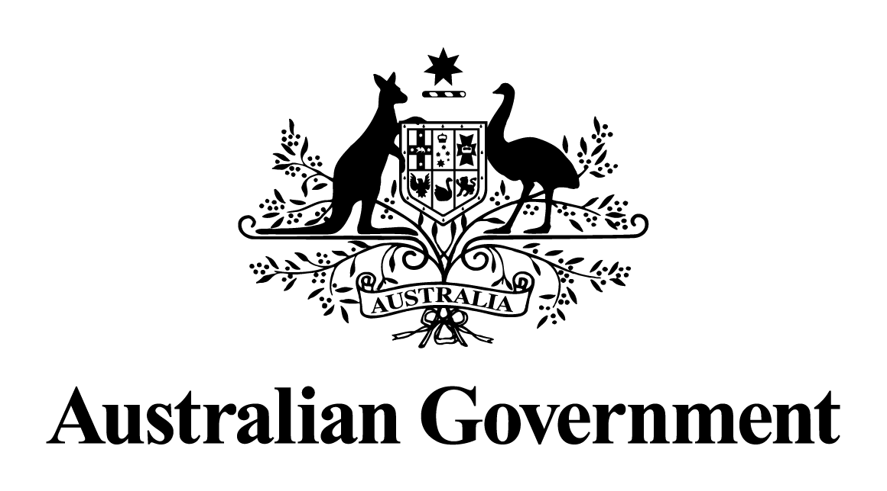

Australian Government response to the   
Senate Legal and Constitutional Affairs Legislation Committee report:

*Customs Tariff Amendment (Comprehensive and Progressive Agreement for Trans-Pacific Partnership) Bill 2018 [Provisions]*

*Customs Amendment (Comprehensive and Progressive Agreement for Trans-Pacific Partnership Implementation) Bill 2018 [Provisions]*

APRIL 2019

**Australian Government response to the Senate Legal and Constitutional Affairs Legislation Committee report**

*Inquiry into the Customs Amendment (Comprehensive and Progressive Agreement for Trans-Pacific Partnership Implementation) Bill 2018 [Provisions], Customs Tariff Amendment (Comprehensive Agreement for Trans-Pacific Implementation) Bill 2018 [Provisions]*

The Government thanks the Committee for its consideration of the provisions of the Customs Amendment (Comprehensive and Progressive Agreement for Trans-Pacific Partnership Implementation) Bill 2018 and Customs Tariff Amendment (Comprehensive and Progressive Agreement for Trans-Pacific Partnership Implementation) Bill 2018.

The Government provides the following responses to the Committee’s recommendations.

**Recommendation 1:**

***The committee recommends that the bill be passed.***

**Response:**

The Government agrees with the recommendation and notes that the bills passed both Houses on 17 October 2018 and received assent on 19 October 2018. Australia ratified the TPP-11 on 31 October 2018 and it entered into force on 30 December 2018.

**Dissenting Report – Australian Greens**

**Recommendation 1**

***The Australian Greens recommend that the bill be rejected.***

**Response:**

The Government does not accept the recommendation. Australia ratified the TPP-11 on 31 October 2018 and it entered into force on 30 December 2018.

**Recommendation 2**

***The Australian Greens recommend that the process for signing and ratifying trade deals and treaty agreements be radically overhauled to ensure genuine transparency and community consultation. The current system is opaque, outdated and no longer serves the public interest.***

**Response:**

The Government does not accept the recommendation.

The Government believes that Australia’s existing treaty-making system is working well and is sufficiently flexible to accommodate the different approaches needed for the wide variety of treaties to which Australia becomes a party. The existing system allows for extensive consultations and enables briefing of stakeholders where appropriate.

Today, close to 70 per cent of Australia’s total trade enjoys preferential access into export markets through these agreements. Australia recorded a $22.2 billion trade surplus in 2018, the highest ever for a calendar year, and two-way trade in goods and services also reached a record high of $854 billion. Australia continues to navigate challenging global trading conditions, having delivered 12 monthly trade surpluses in 2018, and 23 in the last 25 months.

The Government keeps its consultation practices in relation to trade negotiations under active review, regularly considering whether there is scope for improvement.

The Government will continue to explore new options for securing input from stakeholders and disseminating information on FTAs.

**Recommendation 3**

***The Australian Greens recommend that there be a legislated ban on current or future Governments negotiating or signing any trade agreement or treaty that includes ISDS provisions.***

**Response:**

The Government does not accept the recommendation.

The Government considers the inclusion of ISDS clauses in FTAs on a case-by-case basis in light of the national interest. This approach provides flexibility in FTA negotiations.

ISDS provisions provide important protection for Australian businesses investing abroad. The mechanism allows investors to enforce their rights directly under international investment treaties.

Where the Government agrees to include ISDS, it ensures robust safeguards to protect the Government’s ability to regulate in the public interest and pursue legitimate public welfare objectives, such as public health and the environment.

In relevant negotiations, the inclusion of ISDS provides an opportunity to replace older-style bilateral investment treaties lacking these explicit safeguards with a modern FTA chapter that includes them.

Concluded FTAs represent a negotiated outcome, reflecting a balance of interests. Reopening such negotiations to remove ISDS provisions would likely result in a shift in the balance of outcomes against Australia’s interests in other areas.

**Dissenting Report – Senator Rex Patrick**

**Recommendation 1:**

***That the commencement date of the legislation be delayed until bilateral side letters are exchanged between Australia and each other party to the Agreement agreeing that:***

* ***Chapter 9 of the Agreement, which deals with Investor-State disputes, does not apply in relation to an investment in Australia; and***
* ***Labour market testing must occur in relation to contractual service suppliers entering, or proposing to enter, Australia from the other Party.***

**Response:**

The Government does not accept the recommendation.

The Government decided the overall balance of the deal, including the commitments on movement of natural persons, was beneficial to Australia and in line with our national interest. Any change to those commitments could only be made through re-negotiation with all TPP-11 Parties, which would risk losing significant market access gains. The agreement provides unprecedented outcomes for Australian exporters, and sets a benchmark for economic liberalisation in our region. Australia agreed to waive labour market testing for TPP-11 Parties in categories where they offered similar substantive temporary entry commitments to Australian business persons.

ISDS provisions provide important protection for Australian businesses investing abroad. The mechanism in the TPP-11 allows investors to enforce their rights directly under the agreement.

TPP-11 includes robust safeguards to protect the Government’s ability to regulate in the public interest and pursue legitimate public welfare objectives, such as protecting public health and the environment.

**Recommendation 2:**

***That in the event recommendation 1 is not agreed, alternative amendments should be passed to include a sunset clause so that unless bilateral side letters are exchanged relating to ISDS provisions and labour market testing by 1 January 2020 the legislation will automatically be repealed.***

**Response:**

The Government does not accept the recommendation for the reasons outlined in relation to the response to recommendation 1. Any change to commitments on ISDS and labour market testing could only be made through re-negotiation with all TPP-11, which would risk losing significant market access gains.

**Recommendation 3:**

***That unless either of the above recommendations is adopted, the bills be opposed.***

**Response:**

The Government does not accept the recommendation. The Government notes the bills passed both Houses on 17 October 2018 and received assent on 19 October 2018. Australia ratified the TPP-11 on 31 October 2018 and it entered into force on 30 December 2018.