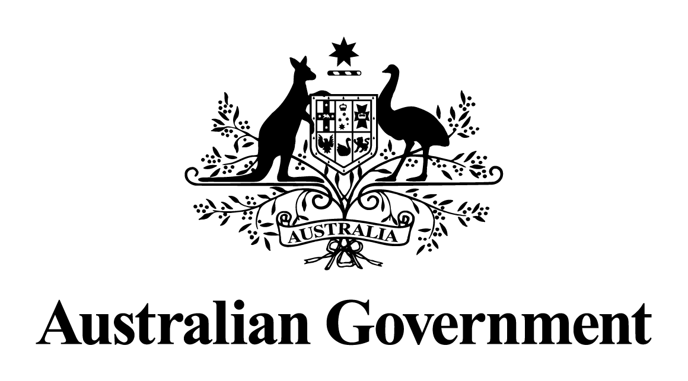

Australian Government response to the   
Joint Standing Committee on Treaties report 181:

*Inquiry into the Comprehensive and Progressive Agreement for Trans-Pacific Partnership*

APRIL 2019

**Australian Government response to the Joint Standing Committee on Treaties Report 181**

*Inquiry into the Comprehensive and Progressive Agreement for Trans-Pacific Partnership*

The Government thanks the Committee for its consideration of the Comprehensive and Progressive Agreement for Trans-Pacific Partnership (TPP-11).

The Government welcomes the Committee’s final recommendation that binding treaty action be taken in relation to the TPP-11. Australia ratified the TPP-11 on 31 October 2018 and it entered into force on 30 December 2018.

The Government provides the following responses to the Committee’s recommendations.

**Recommendation 1**

***The Committee recommends that, in the event that the Parties to the Comprehensive and Progressive Agreement for Trans-Pacific Partnership between the Government of Australia and the Governments of: Brunei Darussalam, Canada, Chile, Japan, Malaysia, Mexico, New Zealand, Peru, Singapore and Vietnam agree to reinstate the suspended provisions of the Trans Pacific Partnership Agreement, the reinstatement be treated as an amendment to the Treaty and be subject to an inquiry by the Committee.***

**Response:**

The Government notes the recommendation.

Should the suspended provisions be reinstated, this would be treated as a treaty amendment and would be subject to scrutiny by the Joint Standing Committee on Treaties (JSCOT).

**Recommendation 2**

***The Committee recommends that the Australian Government review Australia’s bilateral trade agreements with TPP 11 Parties with a view to withdrawing from those which are no longer beneficial to Australian businesses.***

**Response:**

The Government notes the recommendation.

As a plurilateral agreement with eleven parties, the negotiation of the   
TPP-11 needed to take into account the interests of a diverse group of countries. Bilateral agreements between Australia and its trading partners, including TPP-11 countries, provide an opportunity to pursue bilateral interests, typically in the form of greater market access. For example, the bilateral agreement with Peru contains far better market access outcomes on priority areas than what is contained in the TPP-11. These include quota access for sugar, dairy, rice and sorghum, faster phase out of tariffs for beef, and elimination of tariffs for pharmaceuticals and medical devices. Peru will also recognise Australian university degrees.

The Government is helping business maximise the benefits of all of our trade agreements, including through the Free Trade Agreement (FTA) portal, through over 100 FTA seminars targeting SMEs, conducted across metropolitan and regional Australia, and through regular consultation with business.

**Recommendation 3**

***The Committee recommends that the Australian Government consider implementing a process through which independent modelling and analysis of a proposed trade agreement is undertaken by the Productivity Commission, or equivalent organisation, and provided to the Committee alongside the NIA to improve assessment of the agreement.***

**Response:**

The Government notes the recommendation.

Economic modelling of trade agreements is only one tool to assess whether an agreement is in the national interest. The Department of Foreign Affairs and Trade commissions economic modelling of trade agreements on a case‑by‑case basis. Statistical and methodological limitations mean that current models are unable to estimate the total impact of an FTA on the economy. For example, it is difficult to model accurately the impact of changes to non-tariff barriers, trade facilitation, increased regulatory certainty and other aspects of an FTA such as rules of origin.

**Recommendation 4:**

***The Committee supports the Comprehensive and Progressive Agreement for Trans-Pacific Partnership between the Government of Australia and the Governments of: Brunei Darussalam, Canada, Chile, Japan, Malaysia, Mexico, New Zealand, Peru, Singapore and Vietnam and recommends that binding treaty action be taken.***

**Response:**

The Government agrees with the recommendation. Australia ratified the TPP-11 on 31 October 2018 and it entered into force on 30 December 2018.