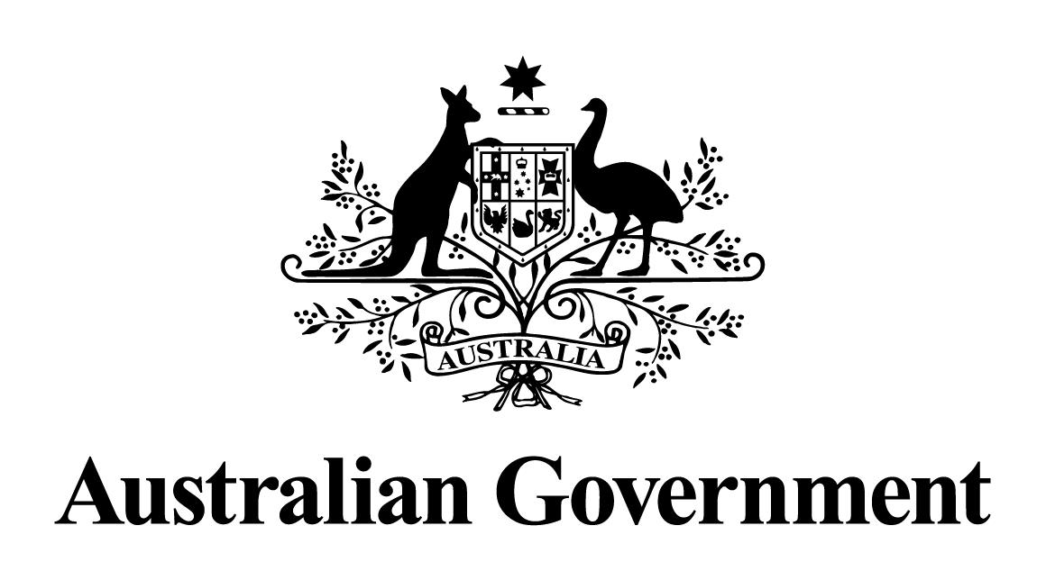

Australian Government response to the
Joint Committee on Foreign Affairs, Defence and Trade report:

Australia’s thematic sanctions framework
June 2026

Introduction
The Australian Government welcomes the opportunity to respond to the report of the Joint Standing Committee on Foreign Affairs, Defence and Trade on its inquiry into the operation of the Autonomous Sanctions Amendment (Magnitsky-style and other Thematic Sanctions) Act 2021 (the Amending Act).
Since the introduction of the Amending Act, the use of thematic sanctions has steadily increased as threats to international security and situations of international concern have grown in number and complexity. Sanctions listings are carefully assessed on a case-by-case basis against the relevant thematic framework.
As at 20 November, Australia has imposed thematic sanctions in response to various situations of international concern, including:
- 25 persons for the mistreatment and death of Sergei Magnitsky
- 14 persons for their involvement in the corruption uncovered by Sergei Magnitsky
- 36 persons and 17 entities for their involvement in the oppression of women and girls in Iran, and for the violent crackdown on protests in Iran
- 3 persons in response to the poisoning of Vladimir Kara-Murza
- 7 persons for their involvement in the poisoning of the late Alexei Navalny, and 7 persons for their involvement in the mistreatment of Mr Navalny in Russian prison IK-6
- 12 persons and 3 entities for their involvement in significant cyber incidents, including the compromise of Medibank Private
- 9 persons and 1 entity for their involvement in settler violence against Palestinians in the West Bank.
The Australian Government uses sanctions as one of the tools available to impose costs on foreign individuals, entities, regimes and governments for breaches of international law, human rights abuses and violations, and other behaviours that are contrary to Australian values and national interests. Australia’s sanctions frameworks equip the Government to respond flexibly and effectively to situations of international concern. The Government uses sanctions judiciously, where it is in our national interest, and in concert with international partners where it is appropriate. Decisions to impose sanctions are made on a case-by-case basis.

Response to the recommendations

Recommendation 1
The Committee recommends that the Australian Government includes detailed reasoning for listing decisions in legislative instruments that impose autonomous sanctions.
Response: Noted
The Government notes this recommendation.
Each legislative instrument adding or removing a sanctions listing is already accompanied by a publicly available Explanatory Statement providing reasons for the Minister for Foreign Affairs’ decision. The Minister and the Department of Foreign Affairs and Trade also provide information about listing decisions in media releases and announcements that accompany listings decisions.
The Government’s decisions to impose sanctions are carefully considered on a case-by-case basis against the legal requirements of Australian sanctions laws, and in pursuit of Australia’s national interest. The Minister, with the agreement of the Attorney-General, may impose thematic sanctions when, based on the information available to the Minister at the time, the Minister is satisfied that the thematic listings criteria are met.
Listed persons and entities can also seek information on the reasons for listing by the Minister. They also have a right to apply for a revocation or judicial review of a listing or a decision relating to a listing. Listed persons and entities are afforded procedural fairness through these processes.
The Government will review the information currently provided in relation to listing decisions, and consider whether there are other, appropriate options to enhance or increase the information provided.

Recommendation 2
The Committee recommends that the Australian Sanctions Office updates and maintains the Consolidated List to include detailed reasoning for each designation.
Response: Noted
The Government notes this recommendation.
The purpose of the Consolidated List is to provide the regulated community with sufficient information about listed persons and entities to satisfy their legal obligations under Australia’s sanctions laws.
Throughout 2024, the Australian Government undertook extensive consultation on the Consolidated List with stakeholders across the regulated community. The feedback from consultation has informed work to improve the functionality of the Consolidated List, which was delivered in December 2025.
Listed persons and entities can seek information on the reasons for their listing by the Minister at any time.

Recommendation 3
The Committee recommends that the Minister for Foreign Affairs reports annually to the Parliament on all autonomous sanctions decisions taken during the previous 12 months.
Response: Agreed in principle
The Government agrees in principle to this recommendation.
The Australian Government is planning to commence the annual publication of a sanctions report, with the first such report in early 2026 on sanctions actions in 2025. This action is being undertaken to enhance transparency of the administration of sanctions and in line with regulator best practice. The report will not be tabled in Parliament.

Recommendation 4
The Committee recommends that the Australian Government amends Section 6A of the Autonomous Sanctions Regulations 2011 to:
- include criteria for the thematic area of ‘threats to international peace and security’

- include criteria for the thematic area of ‘serious violations of international humanitarian law’, in conformity with the term’s meaning under international law.
Response: Noted
The Government notes this recommendation.
Depending on the circumstances, it is possible for the existing thematic criteria to be applied to situations to which the proposed new criteria for ‘international peace and security’ and ‘serious violations of international humanitarian law’ would also be intended to apply.
The government will continue to keep its sanctions frameworks under review, including the thematic sanctions listing criteria, to consider whether they remain appropriate to address international situations of concern.

Recommendation 5
The Committee recommends that the Australian Government, in consultation with the humanitarian sector, amends the Autonomous Sanctions Act 2011 to provide a standing exemption from all sanctions measures for legitimate humanitarian assistance, consistent with the approach taken in United Nations Security Council Resolution 2664 (2022).
Response: Agreed in-principle
The Government agrees in-principle to this recommendation.
The Government keeps Australia’s autonomous sanctions framework under regular review to ensure it remains effective. In 2023, the Department released an Issues Paper that raised the potential for a specific humanitarian exemption. The Department received numerous submissions in response to the Issues Paper, including from the humanitarian sector. The Government is considering the outcomes of this review and what reforms to Australia’s sanctions framework may be necessary.
Australian entities may rely on the general humanitarian exemption under UNSCR 2664 to provide assistance in support of UN affiliated humanitarian operations to countries subject to UNSC sanctions. A sanctions permit may also authorise prohibited activities. The Department prioritises permit applications relating to humanitarian activities.

