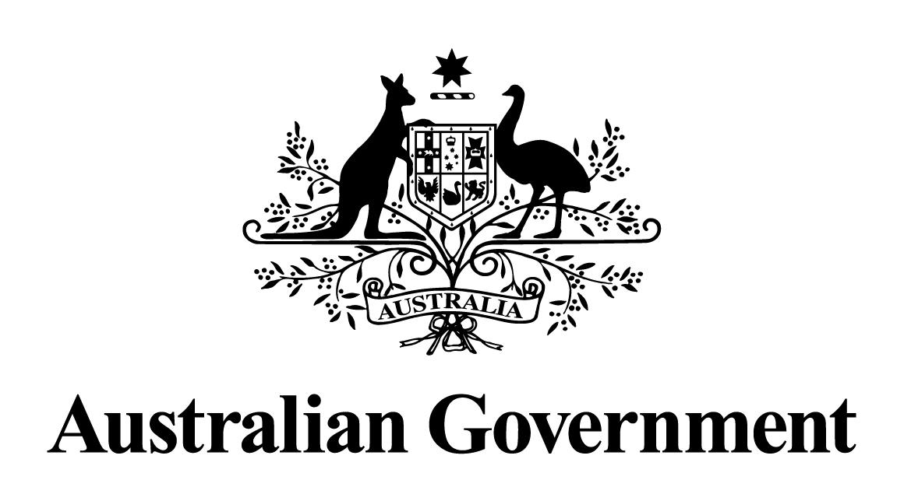

Australian Government response to the
Foreign Affairs, Defence and Trade References Committee report:

Australia’s sanctions regime
June 2026

Introduction
The Australian Government welcomes the opportunity to respond to the report of the Senate Standing Committee on Foreign Affairs, Defence and Trade (the Committee) on its inquiry into Australia’s sanctions regime (the Report).
The Government is taking action to ensure Australia’s sanctions regime is strong, effective, and responsive to situations of international concern.
As part of the 2024–25 Budget, the Government committed $26.4 million to significantly strengthen sanctions enforcement - including establishing a dedicated monitoring capability and enhancing compliance functions within the Australian Sanctions Office. This investment materially improves Australia’s capacity to detect non‑compliance and uphold the credibility of our sanctions regime.
As threats to international security and agreed rules, norms and standards have grown, so too has Australia’s use of autonomous sanctions. Since Russia’s invasion of Ukraine in 2022, the number of listings under Australia’s autonomous sanctions framework has increased substantially. Over the past 12 months, the Government has expanded sanctions listings to a range of individuals and entities for acts of global terrorism, human rights abuse and cybercrime in response to evolving threats. On 6 December 2025, the Government also established a world-first autonomous sanctions framework for Afghanistan, as part of our ongoing efforts to hold the Taliban to account. The framework enables Australia to directly impose its own sanctions and travel bans to increase pressure on the Taliban, targeting the oppression of the Afghan people, particularly women, girls, and minority groups, as well as actions that undermine the rule of law and good governance in Afghanistan.
Our sanctions listings and the legislative framework that supports them are subject to regular and rigorous review to optimise their effectiveness and integrity. The Government uses sanctions judiciously, where it is in our national interest, and in concert with international partners where it is appropriate. Decisions to impose sanctions are made on a case-by-case basis.
The Government thanks the Committee for its work in preparing the report, including considering the 45 submissions and evidence provided during the public hearing.

Response to the recommendations

Recommendation 1
The Committee recommends that the Australian Government consider its application of thematic sanctions and explore ways to further strengthen consistency where appropriate.
Response: Agreed
The Government agrees to this recommendation.
Consistent with longstanding Australian Government policy, the Government does not speculate on potential future sanctions measures.
Sanctions are just one of the tools available to the Government to respond to situations of international concern, and careful consideration must be given as to whether sanctions are the most appropriate and effective measure in each circumstance. For example, in the human rights context, other foreign policy measures such as bilateral representations, advocacy on human rights in multilateral or other forums, including the United Nations General Assembly and the Human Rights Council, development assistance and humanitarian support may be more effective at a particular time.

Recommendation 2
The Committee recommends that, in circumstances where foreign policy objectives allow, the Australian Government, while continuing to make its own judgments concerning the imposition of sanctions, prioritise the alignment of sanctions with allies to maximise effectiveness and place greater emphasis on imposing such sanctions promptly.
Response: Agreed
The Government agrees to this recommendation.
Consistent with longstanding Australian Government policy, the Government does not speculate on potential future sanctions measures.
A decision to impose sanctions is carefully considered on a case-by-case basis against the legal requirements of Australian sanctions laws, and in accordance with Australia’s national interest. The Foreign Minister may impose sanctions when satisfied that the listing criteria are met, and after careful consideration that sanctions are the most appropriate action for Australia to respond to the situation of international concern.
The Government regularly engages with international partners when considering the imposition of autonomous sanctions, noting sanctions are often most effective when applied in concert with others. For example, in late 2023 and 2024 Australia joined partners in targeting Hamas financial networks and facilitators after the October 7 attacks; in 2024 Australia joined countries including the UK, Canada, New Zealand and the US in imposing targeted financial sanctions and travel bans on Israeli settlers and extremist groups linked to violence in the West Bank; a substantial proportion of our sanctions on Russian individuals and entities are coordinated with partners; and we coordinated with partners to enact sanctions following human rights abuses in Iran after the death of Mahsa Amini.
However there may be times when it is not possible or appropriate to impose the same sanction or at the same time as international partners. Legal frameworks, legal criteria and thresholds, national interests and the range of diplomatic measures available among countries may differ.
The Government also considers the impact of potential sanctions on Australia, and the Australian Sanctions Office within the Department of Foreign Affairs and Trade engages other agencies on these considerations.
In taking a decision to impose sanctions, where appropriate the Government does, and will continue to, consider carefully actions taken by partner countries.

Recommendation 3
The Committee recommends that the Australian Government consider establishing a mechanism for engagement with civil society on Australia’s sanctions regime.
Response: Agreed
The Government agrees to this recommendation.
The Australian Government engages regularly with civil society and other stakeholders through ad hoc, formal and informal outreach, and targeted engagement, in-person, virtually and by correspondence.
These activities are complemented by the Government’s publication of both guidance and advisory notes, and responses to direct inquiries and submissions.

Recommendation 4
The Committee recommends that the Australian Government work with its global partners to increase focus on sanctions enforcement and close loopholes which allow Iran and Russia to evade the financial impact of Australian sanctions.
Response: Agreed in-principle
The Government agrees in-principle to this recommendation.
The Government is committed to strengthening monitoring and enforcement of Australia’s sanctions framework. In the 2024-25 Budget the Government provided $26.4 million over four years from 2024-25 (and $6.6 million per year ongoing) towards this work. A key element of this is working across agencies, and with international partners to strengthen the impact and effectiveness of sanctions, and to identify and respond to sanctions breaches and evasion, including by Iran and Russia.
Amendments to the Anti-Money Laundering and Counter-Terrorism Financing Act enacted in December 2024 and the new Anti-Money Laundering and Counter-Terrorism Financing Rules 2025, will also reinforce sanctions implementation in Australia. Under the reforms, AUSTRAC-regulated businesses will have new obligations to prevent sanctions contraventions, namely to:
- establish whether their customers (and specific associated persons) are designated for targeted financial sanctions as part of on-boarding and throughout the business relationship, and
- develop, maintain and comply with policies, procedures, systems and controls to ensure that the business does not contravene targeted financial sanctions.

Recommendation 5
The Committee recommends that the Australian Government continue to impose sanctions on Iranian officials involved in serious violations or serious abuses of human rights, including wrongful detention.
Response: Agreed in-principle
The Government agrees in-principle to this recommendation.
The Albanese Government has taken stronger action against Iran than any previous Australian government. We bolstered our autonomous sanctions framework to enable us to target more Iranian individuals and entities involved in oppression inside Iran, including against women and girls.
Since the violent crackdown on protests following the death of Mahsa Amini in September 2022, the Government has taken unprecedented action to hold Iranian officials and entities to account, including imposing sanctions on more than 50 individuals and entities for their involvement in serious violations or serious abuses of human rights in Iran. This represents a substantial strengthening of Australia’s response to Iran’s human rights abuses under the autonomous sanctions regime.
Consistent with long-standing Australian Government policy, the Government does not speculate on potential future sanctions measures.

Recommendation 6
The Committee recommends that the Australian Government prioritise, in consultation with international partners and non-governmental Australian stakeholders, the development of methodologies to target and measure the effectiveness of Australia’s sanctions regime.
Response: Agreed in-principle
The Government agrees in-principle to this recommendation.
The Government continues to engage with like-minded partners and the regulated community on the impact of sanctions, and ways to strengthen their effectiveness. Sanctions vary in their objectives, context and the expected timescale of their impact, which are important considerations in the development of methodologies to measure their effectiveness.

Recommendation 7
The Committee recommends that the Australian Government consider how to identify and locate all Russian and Iranian Islamic Revolutionary Guard Corps-associated assets in Australia which are currently subject to sanctions.
Response: Agreed in-principle
The Government agrees in-principle to this recommendation.
Under Australian sanctions laws it is an offence to use or deal with an asset, or allow or facilitate another person to use or deal with an asset, that is owned or controlled by a designated person or entity. That is, the assets must be ‘frozen’. The Australian Sanctions Office provides guidance material in relation to the assets of sanctioned persons or entities and undertakes targeted outreach. In addition, the Australian Sanctions Office undertakes regular checks to identify assets held by significant financial institutions.
The Department continues to improve and expand its monitoring function to identify assets of designated persons and entities that are in Australia that are required to be ‘frozen’ under Australian sanctions laws, as well as its outreach function to assist the regulated community to identify and report these assets as required under Australian sanctions laws.

Recommendation 8
The Committee recommends that the Australian Government identify all Russian assets in Australia that are subject to sanctions, and consider what legislative and other changes are required to enable the transfer of these assets.
Response: Agreed in-principle
The Government agrees in-principle to this recommendation and refers to its response to Recommendation 7.
The Government keeps the autonomous sanctions framework under regular review to ensure it remains fit for purpose and serves the national interest. The Australian Sanctions Office has established an inter-agency working group to consider this issue further.

