|  |  |
| --- | --- |
| |  | | --- | |  |   Tracer Survey Report Year 2 2017-18  Alumni of 1996 to 2005  Australia Awards Global Tracer Facility |

To change cover image,  
click on background  
and select from the   
drop-down menu  
above the top-left  
of the page.

# Contents

Contents 1

Executive Summary 5

1. Background 8

1.1 The Global Tracer Facility 8

1.2 The Tracer Survey 8

2. Methodology 10

2.1 Survey instrument 10

2.2 Fieldwork process 11

2.3 Target population 11

2.4 Survey respondent population 12

3. Contributing to Development 17

3.1 Introduction 17

3.2 Overview of outcomes 17

3.3 Passing on skills and knowledge for development 18

3.4 Introducing improved practices 21

3.5 Factors enabling alumni to contribute 25

3.6 Barriers to contribution 27

4. Cooperation with Australia 30

4.1 Introduction 30

4.2 Overview of outcomes 30

4.3 Alumni examples of cooperation 34

4.4 Factors enabling alumni to collaborate 35

4.5 Barriers to collaboration 36

5. Creating Partnerships 38

5.1 Introduction 38

5.2 Overview of outcomes 38

5.3 Alumni examples of partnerships 43

5.4 Factors enabling partnerships 44

5.5 Barriers to developing partnerships 45

6. Views of Australians and Australian Expertise 49

6.1 Introduction 49

6.2 Influence of award on perceptions of Australia 49

6.3 Providing advice about Australia 50

7. Impact of Australia Awards on Addressing Equity Issues 54

7.1 Gender and impact on contributions of alumni 54

7.2 Alumni contributions to disability inclusiveness 60

7.3 Rural alumni and impact on contributions 62

References 65

Annex 1: Characteristics of Telephone Follow-up Respondents 66

Annex 2: Response Numbers by Country 67

Annex 3: Tracer Survey Instrument 71

Annex 4: Follow-up Telephone Interview Instrument 77

Tables

Table 1: Participation statistics 12

Table 2: Demographics of alumni respondents 13

Table 3: Participation statistics by region 15

Table 4: Alumni who participated in Telephone follow-up interviews 66

Table 5: Participation statistics for scholarships by region and country 67

Table 6: Participation statistics for scholarships by region, country and gender 69

Figures

Figure 1: Employment status of alumni (n=1,063) 15

Figure 2: Alumni level of leadership in their current job (n=951) 16

Figure 3: Skills, practices and networks formed as a result of Australia Award (n=1,045) 18

Figure 4: Passed on new skills and knowledge to others, by region, gender, field of study, and position level in the workplace 19

Figure 5: Alumni Introduced improved practices and innovations through work by region, gender, and field of study 22

Figure 6: Regularity of contact with alumni by various Australian groups (n=972) 31

Figure 7: Regularity of contact with alumni by various Australian groups by region 32

Figure 8: Regularity of contact with alumni by various Australian groups by gender 33

Figure 9: Per cent of alumni who have frequent contact with various groups by field of study 34

Figure 10: Proportion of alumni who developed professional links with at least one Australian organisational group (n=984) 39

Figure 11: Proportion of alumni who developed professional links with at least one Australia organisational group by region and gender 40

Figure 12: Alumni broad field of study by region 40

Figure 13: Proportion of alumni who developed professional link with an Australia organisation by award field of study 41

Figure 14: Type of Australian organisations with which alumni have established professional links (n=409) 42

Figure 15: Work sector of alumni who have developed professional links with an Australian organisation (n=414) 42

Figure 16: Desire to create links with Australian institutions and organisations among alumni who have not made professional connections (n= 483) 45

Figure 17: Alumni who have wanted to develop professional links with Australia institutions and organisations by region and gender 46

Figure 18: Alumni perceptions on various facets of Australia while on-award (n=971) 50

Figure 19: Alumni who indicate they have provided advice to people from home country in relation to pursuing opportunities in Australia (n=970) 50

Figure 20: Age groups of alumni (n=1,064) 54

Figure 21: Leadership positions of employed alumni by gender (n=951) 55

Figure 22: Female alumni in leadership roles - comparing 1996 to 2005 cohort and 2006 to 2010 cohort 56

Figure 23: Alumni who identify as having disability (n=1,072) 61

Figure 24: Residential location of alumni (n=867) 62

Acronyms and Abbreviations

|  |  |
| --- | --- |
| ACCI | Australian Chamber of Commerce and Industry |
| ACIAR | Australian Centre for International Agricultural Research |
| ADHD | Attention Deficit Hyperactivity Disorder |
| ANU | The Australian National University |
| DFAT | Australian Government Department of Foreign Affairs and Trade |
| HIV | Human immunodeficiency virus |
| IELTS | International English Language Testing System |
| M&E | Monitoring and Evaluation |
| MAMPU | Australia-Indonesia Partnership for Gender Equality and Women’s Empowerment |
| NGO | Non-Government Organisation |
| PNG | Papua New Guinea |
| SCB | Scholarships and Alumni Branch (DFAT) |
| STI | sexually transmitted infection |
| UK | United Kingdom |
| UN | United Nations |
| UNICEF | United Nations Children’s Fund |
| UNSW | University of New South Wales |
| WiLN | Women in Leadership Network |
|  |  |

# Executive Summary

This report details the development, fieldwork and findings of the second Tracer Survey by the Australia Awards Global Tracer Facility (the Facility). This Tracer Survey involved alumni who completed scholarships as part of the Australia Awards or predecessor scholarship programs between 1996 and 2005.

Alumni were asked a range of questions via an online survey, focussed on exploring the long-term outcomes of the Australia Awards. A follow-up telephone interview with a sample of alumni respondents collected further detail for analysis.

The survey is designed to provide a valuable quantitative insight into alumni use of knowledge and skills, development of networks and contribution to cooperation with Australia. Survey responses also offer rich examples from alumni of the types of contributions they are making, the way in which they are using their award, and the things that help and hinder them in reaching their potential.

In total 1,072 alumni in this cohort from 36 different countries participated in the survey (a 23 per cent response rate). Of the online respondents, 522 participated in the telephone follow-up interview. Of the respondents to the Tracer Survey, most (85 per cent) were aged between 40 and 60 at the time of the survey, and almost all (87 per cent) were employed. Of those alumni working, 94 per cent were in a leadership role, highlighting the influence this cohort has in their workplace and country.

The Tracer Survey data enables the tracking of alumni contributions in line with the four long-term outcomes of the Australia Awards. The following summary offers some overall findings in relation to these. A further summary of the Tracer Survey is included in an infographic the end of this section.

*Outcome 1: Alumni are using their skills, knowledge and networks to contribute to sustainable development.*

* **most alumni** (98 per cent) indicated they have passed on their skills and knowledge to others in their country on return from their award
* **most alumni** (97 per cent) indicated they had introduced improved practices and innovations in their work on return from their award.

*Outcome 2: Alumni are contributing to cooperation between Australia and partner countries.*

* **more than 30 per cent** of alumni have maintained frequent contact with fellow scholarship alumni, while **28 per cent have frequent contact with friends** in Australia and 20 per cent with Australian students/alumni
* **alumni were less likely to have maintained frequent contact with Australian organisations**, with 16 per cent having frequent contact with universities, 13 per cent with Australian businesses and 9 per cent with Australian Embassies, High Commissions or Consulates.

*Outcome 3: Effective, mutually advantageous partnerships between institutions and businesses in Australia and partner countries.*

* **fewer than half** (41.5 per cent) of alumni have had a professional link with an Australian organisation at some time following award
* of these links, 43 per cent are with Australian institutions, 18 per cent within the government sector and the remainder shared between the private sector and non-government organisations.

*Outcome 4: Alumni view Australia, Australians and Australian expertise positively.*

* for most alumni **their experience in Australia positively influenced their perception of Australia** (97 per cent of alumni) and their perception of Australian skills and expertise (95 per cent)
* **Almost all alumni** (97 per cent) have provided advice to people in their home country about pursuing opportunities in Australia.

In addition to these findings, and similar to the Year 1 Tracer Survey of the 2006 to 2010 cohort, alumni highlighted that the factors that helped them to contribute following their award included **the new skills and knowledge** they had gained, **support from their employers** and **support from networks established** while on-award. They also outlined factors that challenged them in making contributions. These tended to focus on the workplace and included **cultural and bureaucratic barriers, a mismatch of skills to their jobs on return and lack of recognition of new skills**.

The Tracer Survey also explored the contribution of the Australia Awards to gender equity, disability inclusiveness and increasing opportunities in rural and remote areas. In relation to these issues of equity:

* Seventy per cent of **alumnae hold a formal leadership position in their work**, and a further 23 per cent have informal leadership roles
* alumni – both women and men – **are contributing to increasing gender equity** in their countries through advocacy, implementation of policy and programs, and mentorship of young women
* despite progress in gender equity since their return from award, alumnae highlighted that **discrimination on the basis of gender still has an impact** on their ability to make further contributions
* alumni are working on projects and policies to promote and enable the participation of people with disability and people from rural and remote areas in education, work and equal access to health care.

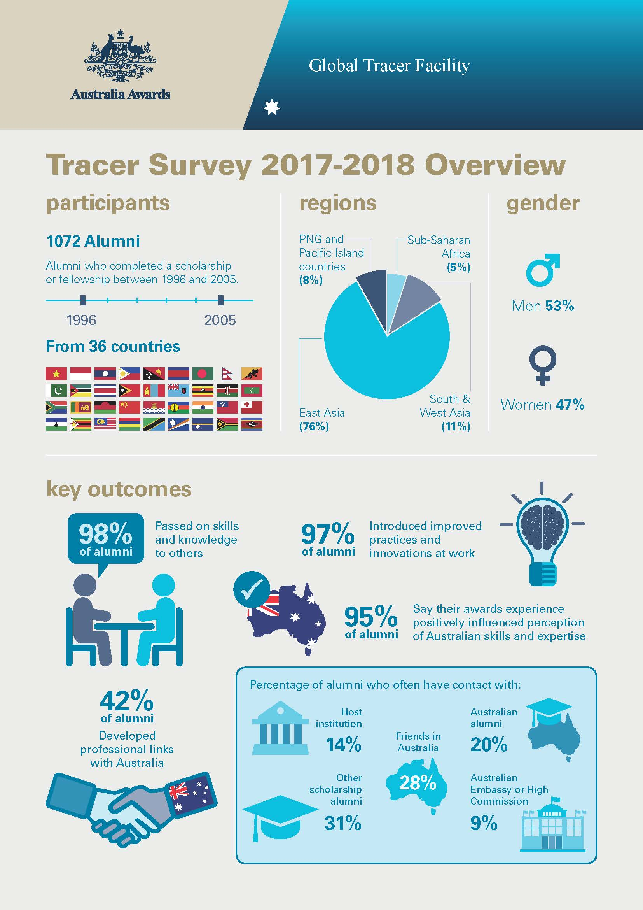

# Background

## The Global Tracer Facility

The Australia Awards Global Tracer Facility (the Facility) is a four-year project funded by DFAT and administered by the Australian Council for Educational Research. Through this project, DFAT assesses the development contributions and public and economic diplomacy outcomes of Australia’s investment in the Australia Awards.[1] The key research and reporting activities being undertaken are a Tracer Survey and qualitative Case Studies, which are prepared concurrently throughout the four years of the project.

This report gives the key findings from the Year 2 Tracer Survey – the key quantitative research element of the Facility. This survey focussed on alumni who had completed their award between 1996 and 2005. Fieldwork was undertaken from late October 2017 to mid-February 2018.

Research undertaken by the Facility is framed around the four long-term outcomes of the Australia Awards as articulated in the *Australia Awards Global Strategy: Investing in the next generation of global leaders for development 2016-2018* (the Global Strategy) and the Australia Awards Global Monitoring and Evaluation Framework (M&E Framework). These are:

**Outcome 1**: Alumni are using their skills, knowledge and networks to contribute to sustainable development.

**Outcome 2**: Alumni are contributing to cooperation between Australia and partner countries.

**Outcome 3**: Effective, mutually advantageous partnerships between institutions and businesses in Australia and partner countries.

**Outcome 4**: Alumni view Australia, Australians and Australian expertise positively.

In addition to these long-term outcomes, the Australia Awards aims to address issues of gender equality and disability inclusiveness. As such, the analyses and reporting of the Facility explores these cross-cutting issues, as well as other factors relating to disadvantage that impact the ability of alumni to contribute to these outcomes following their award.

## The Tracer Survey

The Facility Tracer Survey is undertaken annually, focusing on a different cohort of alumni each year. It is designed as a large-scale, global data collection, gathering information from alumni of the Australia Awards and predecessor scholarship programs. The quantitative data and examples of alumni contribution collected in the survey informs analysis of the Australia Awards long-term outcomes and provides evidence on which to build qualitative research through Case Studies undertaken by the Facility in the year following the survey.

This report details the development, fieldwork and findings of the Facility’s second Tracer Survey which was conducted between late 2017 and early 2018. This survey focussed on alumni who completed their scholarship between 1996 and 2005. The report begins by detailing the methodological approach to the survey, outlining the development of the survey instrument, fieldwork processes and target population. It then provides detail on the sample of alumni who participated in the Year 2 Tracer Survey, highlighting response numbers and examining the statistical robustness of the response sample.

The findings of the survey are divided into five chapters. These chapters cover each of the four long-term outcomes for the Australia Awards listed above, exploring contributions to development, professional links partnerships, cooperative relationships, views of Australians and Australian expertise. The final chapter approaches the survey data from the perspective of examining the impact of gender, disability and geography on the ability of alumni to contribute once they return from their award.

# Methodology

Each year, the Facility’s Tracer Survey provides quantitative data to help inform DFAT and stakeholders of the long-term outcomes of the Australia Awards and predecessor scholarship programs. Survey responses also offer rich examples from alumni of the types of contributions they are making, the way in which they are using their award, and the things that help and hinder them in reaching their potential. This annual survey collection sits alongside other research activities of the Facility, particularly Case Studies.

This approach to the Tracer Survey involved development of a survey instrument, design and piloting approaches to data collection, fieldwork and implementation of the final design, analysis and reporting. This chapter describes the approaches taken in the Tracer Survey for Year 2 of the Facility. It also examines the target population for the survey and concludes by detailing the characteristics of the participants in the survey.

## Survey instrument

The instrument for conducting the Tracer Survey was developed in the first year (2016-2017) by the Facility and draws on:

* the four intended long-term outcomes as articulated in the Australia Awards Global Strategy and M&E Framework
* previous survey instruments – specifically the Alumni Development Impact Survey
* reference to other surveys of alumni in a range of contexts relevant to this research
* expertise of the Facility researchers in designing, implementing and reporting on the results of survey instruments
* ongoing consultation between the Facility and SCB.

The survey instrument includes four sections, each addressing a different Australia Awards long-term outcome.

Each section is structured to include both ‘open’ and ‘closed’ questions. This approach involves a group of statements relating to a specific area being presented to participants, requesting their level of agreement on a response scale, followed by one or a number of open questions relating to these areas, prompting alumni to provide examples of significant activities/impacts. The Tracer Survey also includes a range of items collecting demographic, employment and contact details of alumni in order to update databases and assist in analyses.

The survey instrument used for implementation can be found in Annex 3.

## Fieldwork process

Fieldwork for the Tracer Survey followed the process described below. Fieldwork and data collection was undertaken by Wallis Consulting for the Facility. The data collection relied primarily on the completion of the survey online. Follow-up phone interviews were carried out with a selection of alumni who had completed the online survey and indicated an interest in discussing their answers further (see Annex 4 for the instrument used in these interviews).

The process undertaken for the fieldwork included:

1. Extraction of alumni information from the Global Alumni database, and subsequent cleaning and updating of contact details (see next section for further on this).
2. Programming of survey instrument, training and briefing of interviewers.
3. Primary Approach Email: sent to all alumni in the target population. This email directed alumni to an online survey instrument with a unique link provided to each alumni so responses could be tracked.
4. Data collection and monitoring of responses to the online survey.
5. Follow-up telephone interviews with selected alumni who completed the online survey and indicated willingness to speak about their experience further. These interviews were used to enhance the qualitative answers provided by alumni in their online survey responses.
6. Coding and data cleaning: involved the coding of open-ended responses to the Tracer Survey and the follow-up interviews and cleaning of data to ensure fit with the population specifics.
7. Finalisation of data file for analysis.

## Target population

Each year the Facility targets a specific alumni cohort for the Tracer Survey, with the aim of securing at least 1,000 responses within this identified target population. The key criterion used by the Facility in targeting for the Tracer Survey is year of award completion. For Year 2, the Tracer Survey focussed on alumni who completed their award between the year 1996 and 2005. This section details the target population for the Tracer Survey in Year 2.

The Facility extracted information on alumni who fit the target population from the Global Alumni database. Analysis of this information was undertaken to identify the extent to which contact details were available. Initial data extracted from the database revealed a relatively low proportion of the target alumni had any contact information available. Specifically, only 31 per cent[2] of the target group had an email or telephone number listed in the database and of those with such details, there was no initial way of telling whether these were still valid.

As such, the Facility undertook extensive work with DFAT posts across relevant countries in an effort to gather further information relating to alumni contact details. Through this process, data was provided by 16 country posts. This new information was matched to Global Alumni data records, cleaned and prepared for use as part of the survey fieldwork. While this resulted in a substantial amount of work by the Facility, it resulted in the Facility being able to contact 500 alumni in addition to the information from the Global Alumni database.

Based on the final identified target population, response quotas (or targets) for the survey fieldwork were assigned by region and gender so as to ensure a balanced distribution of responses were collected. This collection method was designed to reduce bias in results and increase the confidence levels of reportable outcomes.

## Survey respondent population

This section details the characteristics of the alumni who participated in the Year 2 Tracer Survey. In total, 1,136 alumni responded to the Tracer Survey. However, 1,072 alumni responses were included in the analyses as 64 alumni respondents did not meet the target population of completing their award between the years 1996 and 2005. Of the included respondents, 522 also participated in a follow-up telephone interview (see Annex 1 for details relating to this group).

In total a 22.9 per cent response rate was secured from the target population. Count and percentage statistics are shown as are other details relevant to the fieldwork. Table 1 summarises participation statistics for the Tracer Survey.

Table 1: Participation statistics

|  |  |  |
| --- | --- | --- |
| **Selection** | **Details** | **All alumni** |
| **Entire Population** | All alumni who completed their award between 1996 and 2005 | 13,702 |
| **Target Population** | All alumni who completed their award between 1996 and 2005, and have email address.[3] | 4675 |
| **Survey** | Survey start date | 27/10/2017 |
| Survey end date | 28/02/2018 |
| **Response** | Response number | 1072 |
| Responses out of scope[4] | 64 |
| Response rate[5] | 22.9% |
| **Follow-up phone interviews** | Telephone interview participants | 522 |

Table 2 reports the number (#) and percentage (%) of alumni respondents based demographic and scholarship characteristic. These figures show there was almost an even gender representation across the alumni respondents, that just over half (51.5 per cent) were aged between 40 and 49 years, and a further third (34 per cent) were aged 50 to 59 at the time of the survey. Alumni respondents from this cohort were predominantly from the East Asia region and studied in a broad range of fields of study. About a third of respondents reported they had received other scholarships in addition to their Australia Awards scholarship.

Table 2: Demographics of alumni respondents

| **Focus** | **Demographic** | **All alumni respondents** | |
| --- | --- | --- | --- |
| **#** | **%** |
| **Gender** | Female | 503 | 47.3% |
| Male | 561 | 52.7% |
| **Age at time of survey** | 20 to 29 years | 1 | 0.1% |
| 30 to 39 years | 94 | 8.8% |
| 40 to 49 years | 549 | 51.5% |
| 50 to 59 years | 359 | 33.7% |
| 60 to 69 years | 60 | 5.6% |
| 70 and older | 2 | 0.2% |
| **Country of Birth Region** | East Asia | 807 | 75.8% |
| Pacific Island Countries | 27 | 2.5% |
| Papua New Guinea | 51 | 4.8% |
| South & West Asia | 119 | 11.2% |
| Sub-Saharan Africa | 58 | 5.4% |
| Unknown* | 3 | 0.3% |
| **Year of graduation from award** | 1996 | 72 | 6.8% |
| 1997 | 71 | 6.7% |
| 1998 | 65 | 6.1% |
| 1999 | 84 | 7.9% |
| 2000 | 90 | 8.5% |
| 2001 | 84 | 7.9% |
| 2002 | 131 | 12.3% |
| 2003 | 143 | 13.4% |
| 2004 | 165 | 15.5% |
| 2005 | 160 | 15.0% |
| **Field of Study** | Natural and Physical Sciences | 102 | 10.8% |
| Information Technology | 46 | 4.9% |
| Engineering and Related Technologies | 107 | 11.3% |
| Architecture and Building | 12 | 1.3% |
| Agriculture, Environmental and Related Studies | 122 | 12.9% |
| Health | 97 | 10.3% |
| Education | 93 | 9.8% |
| Management and Commerce | 181 | 19.2% |
| Society and Culture | 158 | 16.7% |
| Creative Arts | 18 | 1.9% |
| Food, Hospitality and Personal Services | 4 | 0.4% |
| Unknown* | 5 | 0.5% |
| **Have you received any other awards?** | Yes | 362 | 34.0% |
| No | 691 | 64.9% |
| Don't know | 12 | 1.1% |

Notes: * Percentages within groups may not sum to 100 due to rounding. The ‘unknown’ category is used for alumni who requested not to have personal information published in reporting.

Analysis of response numbers and target population suggest that at a global level the data collected in the Tracer Survey can be reported at a 95 per cent confidence level within a 5 per cent margin of error. This outcome is substantially more reliable than the initial aims of the Facility to gather global data at the 90 per cent confidence level within a 10 per cent margin of error.

While the global margins are robust, it is important to note that confidence levels and error margins are lower when analyses are undertaken at the sub-group level.

Table 3 provides further information relating to participant numbers and response rates by region (see Annex 2 for further figures by gender, region and country).

Table 3: Participation statistics by region

|  |  |  |  |
| --- | --- | --- | --- |
| **Region** | **# Survey respondents** | **Target population** | **Response rate** |
|
| East Asia | 814 | 3569 | 23% |
| Pacific Island Countries | 28 | 188 | 15% |
| Papua New Guinea | 50 | 207 | 24% |
| South & West Asia | 119 | 472 | 25% |
| Sub-Saharan Africa | 58 | 234 | 25% |
| Unknown* | 3 | 5 | 60% |
| **Total** | **1072** | **4675** | **23%** |

Note: *The ‘unknown’ category is used for alumni who requested not to have personal information published in reporting.

### Alumni employment and leadership roles

Further context relating to the alumni respondent population is provided in the figures below. As shown in Figure 1, the majority of alumni (84 per cent) were working full time at the time of the survey.

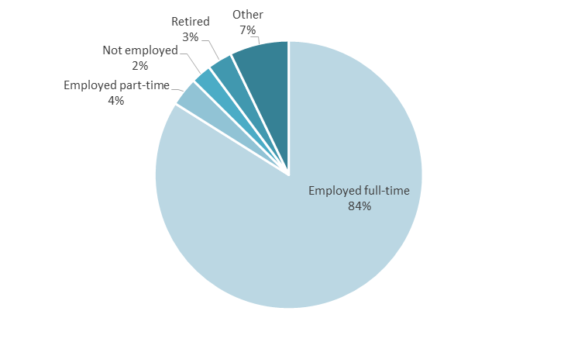

Figure 1: Employment status of alumni (n=1,063)

Alumni were asked to identify which statement best describes their level of leadership in their current job. Figure 2 indicates that the vast majority of alumni hold either a formal (74 per cent) or informal (22 per cent) leadership role in their current jobs. **This suggests that alumni have a high level of responsibility and potential influence in their occupations**.

Figure 2: Alumni level of leadership in their current job (n=951)

# Contributing to Development

## Introduction

To better understand how Australia Awards impact the lives of alumni and their countries, alumni were asked to rate how strongly they agree to a number of statements about the skills, practices and networks formed as a result of their scholarship.

Alumni were also asked to provide examples of their contributions to development in their home countries and explain the factors that have enabled them to make these contributions. Moreover, alumni were asked about the things that have made it difficult for them to contribute following their return from their award.

These questions were designed to provide evidence to explore long-term **Outcome 1 of the Australia Awards: ‘*alumni are using their skills, knowledge and networks to contribute to sustainable development*’**.

The chapter begins with an overview of the outcomes for alumni and then details the ways in which alumni have used their award to contribute to the development of their home country. It then explores factors which have helped alumni to make these contributions and the issues seen as challenges to their ability to contribute.

## Overview of outcomes

Alumni are overwhelmingly positive in their response to core statements about passing on skills and knowledge and introducing improved practices and innovations through their work, as shown in Figure 3.

In total, 98 per cent of alumni surveyed either agreed or strongly agreed that they had passed on new skills and knowledge learnt in Australia while on-award to others. Similarly, 97 per cent of alumni indicated that they had introduced improved practices and innovations through their work on return.

This positive response rate reflects the same response rate of the Year 1 Tracer Survey, indicating that alumni are consistently finding their award to be relevant in enabling them to contribute on return to their home country.

Figure 3: Skills, practices and networks formed as a result of Australia Award (n=1,045)

## Passing on skills and knowledge for development

Across regions and gender, alumni are consistently able to pass on the skills they have developed on-award, as shown in Figure 4. There was also no meaningful differences when analysed by field of study. An analysis by leadership role also did not show any meaningful differences among alumni with formal or informal leadership roles and those not in a leadership role.

This indicates that alumni across a range of contexts are able to make contributions following their award, and that broadly, this ability to contribute does not appear to be negatively affected by location, gender, field of study, or level of position in the workplace.

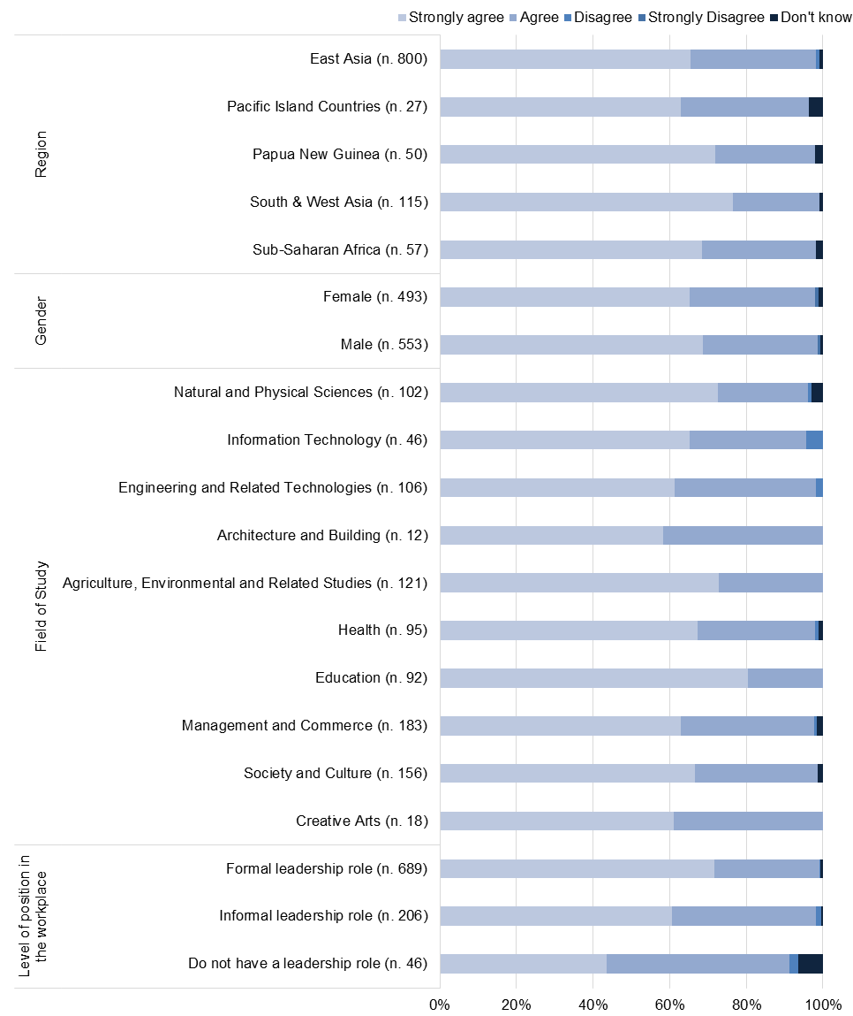Figure 4: Passed on new skills and knowledge to others, by region, gender, field of study, and position level in the workplace

Alumni were asked to share the ways in which they have used their skills and knowledge to contribute to their country’s development, and provided a range of examples. Overall, the more common ways of passing on knowledge and skills indicated by alumni were through:

* formal and informal teaching and mentoring
* professional knowledge sharing
* local community development activities.

Alumni contributions through **formal and informal teaching and mentoring** included examples in schools and the tertiary education sector. One alumna from the Maldives spoke of her experiences that was reflective of the way alumni working as lecturers and supervisors pass on their skills and knowledge:

*I have mentored many master’s level students and guided them with research projects. In addition, I have been actively involved in the training of medical students and interns.*

Another alumnus from Pakistan proudly shared his achievements working as a supervisor:

*I have produced 8 PhDs and 39 Masters of Philosophy. I reckon this is a sufficient number in just 14 years after my return from Australia.*

An alumna from Papua New Guinea (PNG) shared the opportunity that exists when working in the tertiary education sector:

*I am working with the university and [the] opportunity of passing skills and knowledge to others is very high. For example: when I do my duty, I always explain to students or staff whom I am helping what I am doing. Every time I get good feedback because they are learning while I am helping.*

Alumni also undertake additional work teaching part-time in the tertiary education sector in addition to their primary roles in the private or public sector, widening their circles of influence and impact. One such alumnus from Laos shared his experience, stating:

*Apart from my full time work with my company, I work as [a] part-time training instructor for technical colleges. For the last few years, I also worked as a visiting lecturer for the Faculty of Engineering, the National University of Laos.*

**Professional knowledge sharing in the workplace** is another common example identified by alumni. An alum from Indonesia noted that in addition to applying best practices learned during his Master of Business Administration on-award in Australia, he is able to teach his colleagues as well. An alumna from Vietnam highlighted the various levels within the Ministry in which she passed on her knowledge:

*I took a leadership role in several big development projects under the Ministry of Planning and Investment. I instructed and trained staff in the projects and during workshops or interactions with local staff (at provincial, district and communal levels).*

Alumni are also active in sharing their skills and knowledge through their professional networks and associations. An example of this is an alumna from South Africa:

*Lighting design and illumination as a specialist field was not well recognized in South Africa. I have delivered courses at the Illuminating Engineering Society of South Africa. I have also improved the delivery of the lighting design modules within the Department of Architectural Technology and Interior Design. I have consulted with local architects and interior designers introducing improved lighting design approaches.*

Similarly, an alumna from Indonesia highlighted the links and professional networks she is now familiar with:

*I knew the practice of clinical pharmacy in Australia. At that time, no clinical pharmacy was developed in Indonesia. With my knowledge, through the Indonesian Pharmacy Association where I as a Deputy of Secretary General, I think I influenced a lot. I was involved in the changing of pharmacy education from drug oriented into a patient oriented model. I was also involved in many activities for example Good Pharmacy Practice Project with the Federation Asia Pacific Association and many others.*

Alumni are also passing on skills and knowledge acquired in Australia through **local community development activities**. These include simple actions learned in Australia and shared with community members, an example of this is an alumna from Laos:

*[I passed on my skills and knowledge] by being a role model for kids and explaining to them how important the separating of waste is and guiding them on how to do it.*

Alumni also contribute through formal community development activities, and provided a wide range of examples. Following their study in Australia, alumni are involved in a diverse range of projects contributing to development across a range of fields including health, agriculture, and environment. An alumnus from PNG shared his experience working on a joint public health program:

*[I am] engaged in the PNG Australia Sexual Health Improvement Program and trained health workers in rural remote areas in Morobe and East Sepik Provinces to manage sexual reproductive health problems including STIs and HIV.*

Another alumna from Kenya working in the field of agriculture shared the opportunity that she has through her work:

*I have been training women groups and youth on how to improve food security through production and preservation.*

## Introducing improved practices

The vast majority if alumni who responded to the survey indicate that they are introducing improved practices and innovations as a result of their scholarship.

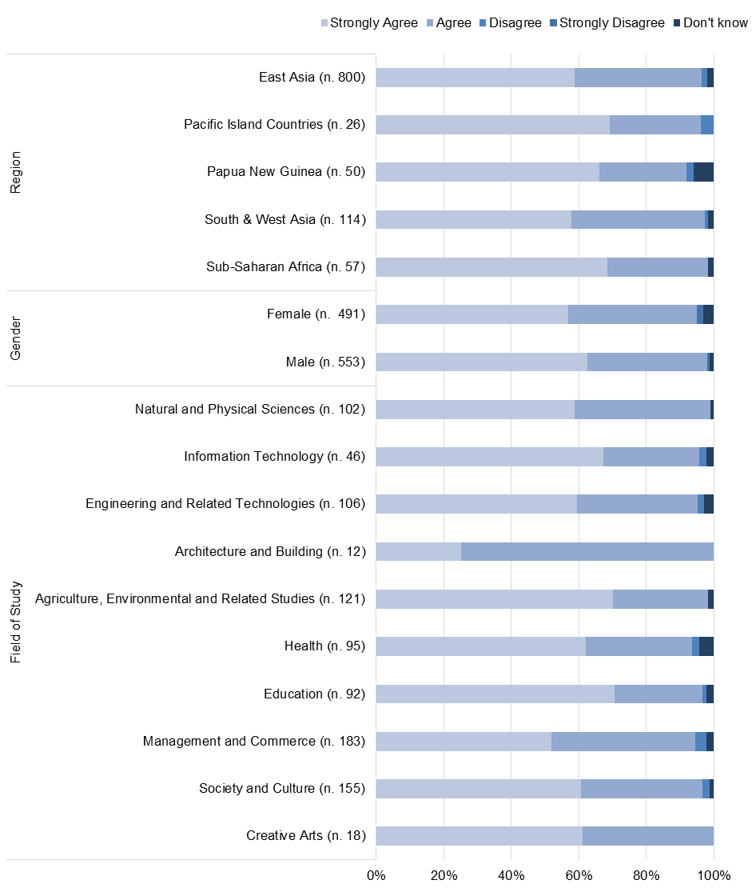As shown in Figure 5, results are consistent by region, gender and field of study, suggesting that alumni are able to make positive contributions through their work following their award, regardless of broad context.

Figure 5: Alumni Introduced improved practices and innovations through work by region, gender, and field of study

The majority of alumni provided examples of the types of innovations and improved practices they have introduced. Examples were analysed by ‘how’ it was introduced, if it included technical knowledge and practice or cultural change, and if it addressed social equity issues. The most commonly shared examples alumni provided in their reflections of actions contributing to the development of their country include:

* improving systems, processes and practices
* developing policy
* formal and informal training, conferences/seminars and workshops.

Alumni refer to the relevance and quality of learning undertaken while on-award which have provided a source inspiration and enabled them to contribute to **improving systems processes and practices in their workplace**. One such alumna from Philippines explained ‘the academic preparation I got in Australia allows me to create and implement ways that are not traditional [in human resource management]’, which has led to improved outcomes in the workplace. Pointing to the relevance of his coursework, an alumnus from Kenya explained the impact learning new practices has had in his work:

*Upon my return from Australia and within one year, I was introducing smallholders, through frequent training and group meetings on the formation and leadership of producer-owned cooperatives, in line with what I learnt about producer co-operatives in Australia. One co-operative now has thousands of members and they own the entire supply and value chain of their produce. I continue to urge farmer groups to register their groups as co-operatives, and I work with them through this process.*

Another alumna on her return to Vietnam drew on her experiences on-award undertaking work integrated learning to implement a similar practice in her workplace for tertiary students:

*As my course required me to have an industrial placement to gain real-life experience, which I found very helpful, I had created several internship programs at my work organization to facilitate that experience to students in Vietnam, which was not a common practice back then in Vietnam. Such programs were evaluated to be professional, well- designed and helpful to students and were recognized by many universities.*

Alumni are also active in **developing and influencing new policies** in their workplace and in government. This outcome reflects the fact that so many of this cohort occupy formal positions of leadership in the workplace (72.5 per cent).

Workplace policy contribution by alumni range across fields, with examples such as an alumnus from Malaysia who has ‘set up and implemented a comprehensive infection control policy’ at their institution. Another alumnus from Bhutan described the innovative banking policy he developed that is influencing other banks to follow suit:

*I undertook an assignment for the Royal Insurance Corporation of Bhutan Limited to develop a Document Management Policy and Manual. It is first of its kind in the banking sector. The recommended system will be implemented from 2018. It is expected to standardize a document management protocol in the organization, reduce risk of document loss, litigation and build customer confidence of the organization. Other banks are already looking to develop a similar system in their respective organisations.*

In government and ministry, alumni are contributing at a high-level, setting policy to improve practice across a broad range of fields. One such alumna from Laos described contributing to the ‘development in human resources health, especially the development of a National Skilled Birth Attendant Plan’. Another alumna from Fiji described her significant policy contribution:

*[I introduced improved practices and innovation] through the development of a first ever energy policy for the Department of Energy, which was then used as the basis of their planning and work plan every year.*

Through **formal and informal training, conferences/seminars and workshops**, alumni are teaching colleagues in their workplace and within their sectors. For those alumni involved in training tertiary students, they are able to use the new skills and knowledge learned on-award to build capacity of their students. An alumna from Indonesia described the opportunity arising from her study in computer assisted language learning to provide training for pre and in-service teachers to use a technology-integrated language teaching and learning. An alumnus from Uganda drawing from his experience on-award, introduced new practices for professional development support of health workers:

*[I] introduced supervision and mentorship of health workers in the management of non-communicable diseases.*

Another alumna from Vietnam points to her learning on-award as a factor in her ability to teach her students advanced statistics:

*When teaching Statistics for undergraduate students, one of innovative ideas is to use problem-based teaching and simulation plus computer labs. I have been able to implement these ideas in undergraduate Statistics courses. Furthermore, we teach students the R language, the most advanced programming language for Statistics. Thanks to my computing education in Australia, I have been able to introduce important computing elements into Statistics and data analysis courses.*

Alumni have introduced a range of new practices and innovations that were categorised as **technical knowledge and practice** (‘hard skills’ related) or **cultural change** (‘soft skills’ related). The vast range of practices utilising hard and soft skills point to the holistic learning alumni received on-award that has been utilised on their return to their home country.

Examples of technical knowledge and practices range across the fields including health, education, management and commerce, and engineering. One such example by an alumnus from Timor-Leste demonstrates the ways in which alumni adapt their skills and knowledge to their context to introduce technical innovative practices:

*I have introduced and improved practices and innovations through my work, such as applying a technology of Artificial Insemination to Bali Cattle in Timor-Leste. I will continue to promote this technology because this is a proper way of improving genetic quality of Bali Cattle in Timor-Leste.*

Alumni also draw from soft skills developed on-award to introduce new practices through their work. An alumnus from Indonesia drew from his positive and inclusive learning experience in Australia to encourage a similar empathetic learning environment:

*I've learned how good the education environment was in Australia, so that I could introduce it to my university, particularly in my class. I asked a student to be brave to try without fear of being criticized. The class became better because the discussion we had enriched us. Thank you.*

Emphasis on professionalism and leadership are qualities alumni have introduced in the workplace. An alumna from Vietnam explained gaining valuable soft skills on-award such as time-management and active self-learning which she has introduced in her workplace. Similarly, an alumnus from Marshall Islands shared:

*I try to set an example for my staff by showing up to work on time and having an open-door policy when any issues arise.*

## Factors enabling alumni to contribute

Data was collected from responses to the survey and the follow-up interviews relating to the factors which have enabled alumni to make contributions to the development of their country. The key factors identified by alumni as facilitating their contributions are listed below in order of prominence:

* the new skills and knowledge acquired through their award
* support from employers on return from award
* support through networks and friends made during award.

The fact that alumni identify the **new skills and knowledge acquired** through their award as being the key enabling factor reflects the quality and relevance of their study. Alumni made reference to technical knowledge and applied learning, as well as leadership and approaches in thinking as the most important skills developed on-award. One alumnus from Pakistan highlighted the transferability of his skills, stating: ‘the leadership and work ethics learned in Adelaide help me do anything in different multidisciplinary areas.’ Another alumna specified English proficiency, team work, logic and systematic approaches in addressing issues as being of most benefit.

A number of alumni shared explicit examples of the impact **employer support** had on their ability to contribute. In particular, alumni highlighted the conducive environment purposefully created by employers to enable them to share their skills and knowledge and implement new practices. An alumna from Fiji referred to this benefit she experienced post-award:

*The environment provided by my employer such as providing training sessions for me to pass on my knowledge to other staff, providing career advancements [has helped]. Since returning from completing the programme, I have moved up three levels in the civil service.*

Another alumna from Philippines similarly pointed to employer support as being an integral:

*A major factor is the support from my employer. Immediately after my award, returning from Australia I was assigned my training post which enabled me to DIRECTLY practice what I learned from my Masters of Human Resources Management. I was also given a supportive staff, who were my choice and whom I had the chance to retrain and manage.*

The **networks developed on-award** is a source of support for alumni and identified by respondents as being important in helping them to make contributions. Networks include fellow students and awardees, university staff and professional links. Alumni mention being able to share experiences, seek feedback, and develop opportunities. Further discussion of the extent of networking by alumni is detailed in Chapter 4. Examples from five alumni described the ways in which their on-award networks have enabled them to contribute to their country’s development:

*The close networks of friends I was able to have during and after my studies. We still keep in touch and share knowledge about specific issues that are important in the region.* Alumna from Samoa

 *Networks developed on-award - sharing experiences with other awardees and passing this to my local womenfolk back home.* Alumnus from PNG

*I had full support of my supervisor and our contact person from Curtin really kept in touch and tried to help us when she had an opportunity.* Alumnus from Philippines

*The network developed is unique; there is a bond and a willingness to assist knowing that the common factor is the Australian experience.* Alumnus from Fiji

*The most significant factor was to be socially exposed to other AusAid awardees over a long period to build knowledge and trust.* Alumna from South Africa

Although few alumni made reference, a key enabling factor raised by some was the value placed on their active Australia Awards and Australian alumni networks in their home countries. These comments are included here as they align closely with current DFAT policies on alumni engagement and offer examples of direct benefit received through continued engagement with like-minded peers. In particular, two alumni described their respective Australian alumni associations as a key factor supporting their contribution to country development:

*Papua New Guinea Australia Alumni Association provides Professional Development Skills Workshops and Members attend. Employers support by letting staff attend such workshops.* Alumnus from PNG

*As members of the Australian Alumni we are able to stay connected and share useful information and experiences on the current issues facing our region.* Alumna from Samoa

## Barriers to contribution

Alumni were also asked to provide information on issues that have challenged their ability to use their new knowledge, skills or networks to contribute when they return from award. The section below outlines the most common issues identified by alumni which largely centred on the workplace. The following four issues were the most commonly referenced barriers to contribution by alumni in order of prominence:

* culture: workplace, bureaucracy (i.e. reluctance to change, favouring seniority over experience, inflexible regulations)
* lack of work opportunities/mismatch of skills to job
* lack of recognition of skills in the workplace
* corruption or nepotism.

These barriers can often be interrelated, with one being a symptom of the other. As a result, some of the barriers to contribution faced by alumni are complex and multifaceted.

**Culture in the workplace** is a barrier identified by alumni with reference to regulations and bureaucracy. Examples such as one alumna from Mauritius sharing that ‘Rigidity in the government systems’ were identified as a challenge to their ability to contribute in the workplace.

Hierarchy and seniority was also identified as a hurdle for less senior-level alumni. An alumnus from Vietnam factored age in particular as a barrier in the workplace: ‘I was too young and in my opinion I was not taken seriously’. Similarly, an alumnus from Indonesia shared a similar sentiment relating to bureaucratic structures which ‘prevent younger staff to take more role in developing new ideas’.

Alumni also referred to reluctance to change which reflected the workplace culture or broader systemic issues. One alumna from Indonesia explained that this was due to a ‘Status quo culture, plus discriminatory social attitudes among Indonesian people’. An alumna from Philippines similarly stated ‘Tradition and culture often become hindrances to many innovations.’ Similarly, an alumnus from Malaysia mentioned ‘difficulty in that most Malaysians are afraid to change to a different way of doing things.’

Reluctance to support new practices and innovations was also identified by some alumni as a result of ‘unfamiliarity’, that the skills or knowledge are ‘too new’. An alumnus from Vietnam identified this as a facet of human nature, ‘Human habit is either too against the change or hesitant to apply new skills or practices’. An alumnus from Philippines noted that innovative practices take time to build support as a result of unfamiliarity:

*Sometimes there is a lack of support from medical institutions. We became pioneers in the field, therefore the impact of our program is slow to be felt.*

Alumni identifiedconstraints **relating to a lack of work opportunities or a mismatch of skills to job**. More explicit answers stated that this was at times related to gender (male or female), remoteness, corruption or nepotism, or a lack of reintegration plans post award. An alumnus from Mongolia, despite a pre-developed action plan preparing for his return from award was affected by internal changes to his department which resulted in a lack of work opportunity:

*I used to work in the Treasury Department of Ministry of Finance. When I received this scholarship and my action plan was closely related to duties at the Treasury Department. However, when I came back there was no workplace available in the Treasury Department and I had to work in another department.*

**Lack of recognition of skills in the workplace** is the third common barrier experienced by alumni and is an example of the multifaceted nature of the barriers alumni may experience in the workplace. Alumni who provided detailed responses attributed this as being a result of other biases in the workplace including nepotism and inequalities related to gender. One such alumnus from Timor-Leste shared his experience stating ‘lack of recognition of skills due to [the] nepotism factor’. An alumna from Fiji mentioned that in her case there were ‘those in authority who felt that I need to put in more years to be able to move up’.

Some alumni do not remain in their organisations as a result of the lack of recognition of skills in their workplace on return. A number of alumni described moving on from their organisation in order to utilise their skills and knowledge. One such alumna from India transitioned to the private sector which gave her ‘a lot of opportunities’ to use her skills and knowledge.

**Corruption and nepotism** is the fourth common factor identified by alumni, and underpins a number of other barriers experienced by alumni such as the lack of recognition of skills in the workplace explained above. Alumni experience this across the range of sectors including, public and private sector organisations. The following alumni examples demonstrate the ways corruption and nepotism have affected alumni in the workplace:

*Sometimes, corruption or nepotism generate a lack of opportunities to implement projects or new working model.* Alumnus from Mozambique

*In the Maldives, corruption and influence has crept into the judiciary, which is a huge constraint to practice as a litigator.* Alumna from Maldives

*Honestly speaking: lack of work opportunities because of nepotism mindset and bureaucratic practise.* Alumnus from Cambodia

*In my current and previous practice, corruption is also dominant and this has been a great obstacle in my career because I am against any form of corruption, and I am vocal about this. As a result most people do not like me because I am against it and that creates a great obstacle in my career.* Alumna from Indonesia

*Working environment in Bangladesh is not conducive with world best practices. There is corruption, poor governance, autocracy, etc.* Alumna from Bangladesh

*Higher level management positions are not awarded on merits, but via nepotism.* Alumna from PNG

# Cooperation with Australia

## Introduction

Australia Awards long-term Outcomes 2 and 3 pertain to the achievement of positive relationships between Australia and partners. This chapter specifically focuses on **Outcome 2 ‘*alumni are contributing to cooperation between Australia and partner countries*’**, with Outcome 3 discussed in the following chapter. For this chapter, the focus of the analysis is on the understanding that the emphasis of Outcome 2 is diplomacy, people-to-people links and cooperation developed on-award by alumni and maintained following their award.

This chapter focuses on the frequency of contact and the types of people and organisations that alumni are maintaining this contact with following their award. It also examines the types of cooperative relationships that alumni have made with Australians, using a range of examples provided by alumni to illustrate the contributions of this group of alumni towards ongoing cooperation with Australia.

## Overview of outcomes

In understanding who alumni maintain links with, alumni were asked how frequently they were in contact with various groups. Contact frequency is based on a five point scale – ‘Always’, ‘Often’, ‘Sometimes’, ‘Rarely’ and ‘Never’. Figure 6 below displays the proportion of alumni who indicate ‘Always’ or ‘Often’ having contact (termed ‘Frequent contact’ for the purpose of this report), alongside the proportion who indicated that they have no contact with the various groups. Contact groups are Australian students, other award recipients, Australian friends, Australian host institution, professional associations or businesses, and Australian Embassies, High Commissions and Consulates.

Alumni responses indicate they are most likely to have frequent contact with other award alumni (31 per cent) and friends in Australia (28 per cent). The third most frequent contact is with Australian students (20 per cent). As seen here, the most common types of relationships are with peers – understandably a group more amenable to personal and informal relationships than the other groups included (institutions, embassies and professional groups) which are likely to be more formal encounters.

Subsequently, alumni have notably lower rates of contact with their host institution, professional bodies and organisations in Australia, and the Australian Embassy or High Commission in their country. Although 12.5 per cent of alumni have frequent contact with an Australian professional organisation or business, 29 per cent have no contact. This may indicate a difference in on-award experiences for alumni regarding opportunities for engagement. Nearly one-third (30 per cent) of alumni indicated they have never had any contact with the Australian Embassy, High Commission or Consulate following their award. While these more formal groupings are understandably less likely to have frequent contact with alumni, they are an important factor in building the cooperation objective set by long-term Outcome 2.

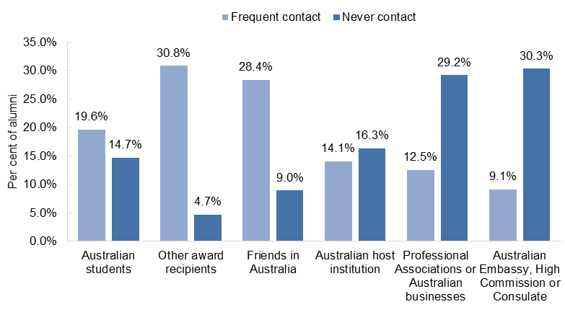Figure 6: Regularity of contact with alumni by various Australian groups (n=972)

When frequency of contact is explored by region, there some differences apparent in the patterns of contact reported by alumni (Figure 7). In particular, East Asia has the lowest rate of no contact with fellow award alumni (3 per cent) indicating a high level of engagement overall amongst this group of alumni. Interestingly, alumni from Sub-Saharan Africa had the highest rates of frequent contact with Australian students and other award alumni. However, alumni from this region also had the highest rate of no contact with professional associations and businesses in Australia. Alumni from PNG were the least likely group to have contact with Australian students, Australian institutions and the Australian Embassy, but had the equal highest levels of contact with friends in Australia.

Figure 7: Regularity of contact with alumni by various Australian groups by region

By gender, there is a similarity in trends for both males and females across contact frequency and groups (Figure 8). Both are more likely to be in frequent contact with Australian students, other award alumni and friends in Australia. Alumnae however, have a slightly higher rate of frequent contact with these groups, and are also slightly more engaged with the Australian Embassy, High Commission or Consulate. Male and female alumni have similar rates of frequent contact with their Australian host institution, but male alumni compared with alumnae have a lower rate of no contact.

Figure 8: Regularity of contact with alumni by various Australian groups by gender

Figure 9 indicates there is some variation for alumni by field of study in terms of their frequency of contact. It is important to note that some fields of study have relatively small numbers, and as such the data in this figure should be treated with caution. Student experiences can vary by the type of course they studied, for example differences in contact hours (lectures, tutorials, lab hours etc.) and work integrated learning requirements. As such, this data can be taken as indicative of the potential for identifying differences in on-award engagement by field of study.

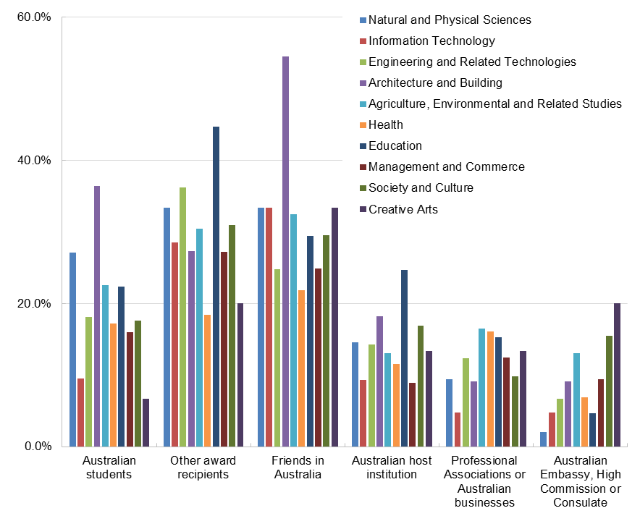

Figure 9: Per cent of alumni who have frequent contact with various groups by field of study

## Alumni examples of cooperation

Alumni were asked to provide examples of the types of contact and cooperation they have had post-award with the various groups, and their insights reflect the above findings relating to levels and types of contact with informal and formal groups. The examples suggest that **alumni interactions with Australians are predominantly based on social interactions**. Furthermore, examples demonstrating **productive links supporting cooperation were limited**. However, where alumni shared examples of cooperation, the most frequently mentioned interaction was related to **sharing knowledge and learning opportunities with colleagues or students**.

A common theme for those alumni who detailed their experiences of sharing knowledge and learning opportunities is a mutual and active interest in engagement. Alumni typically describe fellow Australian students and friends as well as their university professors and supervisors in these engagements. Illustrative examples of this include an alumnus from Bangladesh who invited Australian professors from the University of New South Wales and the University of Newcastle to present research talks at their university.

Although not as commonly experienced, a number of alumni shared examples of engagement for collaboration. **Academic collaboration** typically resulted from strong links between alumni and their lecturers or supervisors, an alumnus from Indonesia highlighted ongoing networking with his Doctoral supervisors has supported his current work:

*My PhD supervisors also put me in contact with related parties in my current assignment in the Ministry of Defence. Because there are certain lab experiments we don't have the equipment for in Indonesia we work in collaboration with Australian universities that have the resources. In a current assignment we are working with the Indonesian and Australian Ministry of Defence to research and develop defence technologies.*

In addition to these examples, there were a few alumni who mentioned in more detail their experiences in linking with a professional association. For example, an alumna from Vietnam through her role as a research assistant on-award enabled her to develop a network which she now utilises for **professional** **collaboration**. This has resulted inbeing connected with professional bodies such as Project Management Australia undertaking collaborative projects with other researchers.

Similarly, an alumna from Samoa described the learning opportunities she has gained by joining the Australian Human Resources Institute as a certified member:

*I did a mentoring program and contacted Australian Human Resources Institute to nominate a mentor for me. It was really great to find someone who was an experienced lady and we became good friends and she arranged work experience for me in South Australia. And she arranged for me to go to Australian Human Resources Institute annual conference.*

## Factors enabling alumni to collaborate

**Technology is the predominant factor which has enabled alumni to engage** in collaboration with Australians and Australian organisations. Alumni frequently referred to various social media channels and to email as their primary method for maintaining contact. An alumna from Kenya noted that they utilise multiple methods to communicate with fellow students and alumni utilising emails and WhatsApp on a near daily basis. Social media such as Facebook have also enabled alumni to reconnect with those they met while on-award in Australia. One such alumna from Vietnam highlighted this:

*I lost contact with Vietnamese and Australians who happened to be my friends for a long time, and recently resumed thanks to Facebook. Now we sometimes chat and often see each other on Facebook.*

An Indonesian alumnus explained how he benefits from LinkedIn to grow his network and remain connected with Australia:

*I am member of LinkedIn and people find me that way. It’s good because we develop business networks that way and I can ask what is going on in Australia in business and so on.*

In addition, alumni also made reference to **formal networking groups** which provided the forum for them to remain connected. This finding is significant with regards to the role the *Australia Global Alumni Engagement Strategy* (DFAT, 2016b) plays in supporting ongoing alumni links for older and newer alumni alike. Whether self-initiated with peers, or a pre-existing association, alumni associations are sought after by a number of alumni as a method for remaining engaged with fellow award alumni and likeminded individuals and groups in Australia. Examples of this include the following alumni frequently interact with alumni associations in order to maintain ongoing collaboration with Australia:

*We have created an association. We share a lot of information via the WhatsApp (daily) and meet once in a while for activities (mainly charity). Sometimes we know about other events in Australia and share information, so it is important and is valuable to be part of this association because we can be up to date regarding events and our former universities.* Alumna, Mozambique

*We organized a Curtin Alumni & Friends association... Every now and then, the Australian Embassy promote Australian education and we are asked to attend to help them. We help out with this.* Alumnus, Philippines

## Barriers to collaboration

Barriers to collaboration varied among alumni who identified the factors which challenged to connect with Australians and Australian organisations. The key themes which emerged related to the limited technology at the time of graduation and losing contact over time – an unsurprising outcome given this alumni cohort completed their awards a decade or more ago.

While technology has enabled a number of alumni to remain connected or to reconnect with networks developed in Australia, for other alumni they found their **networks waned due to limited technology and use** at the time of graduation. An alumnus from Nepal described: ‘Once I returned I didn’t have the social network we have these days. The communication died’. Another alumnus from Laos noted that at the time of their award internet or email was ‘not widely used, so it was difficult to keep contact with foreign friends in Australia’. Another limitation of technology is the changing of contact details, which an alumna from Pakistan explained became a barrier over time despite initial strong networks: ‘with the passage of time contacts and addresses changed and [I] lost contact.’

Reflecting the **passing of time** from when alumni graduated from their award (1996 to 2005), alumni made reference to **either their retirement or the retirement of people within their networks in Australia** as a factor in their ability to engage in collaboration. As their key links to Australia retired from work, some alumni highlighted the challenge they faced in renavigating or reforming networks – they could no longer rely on previously developed reputation and familiarity that they had established through their time on-award. Two such alumni described their experiences and the challenge of re-engaging:

*That would be wonderful if I can reconnect with the university to help me with my job. But I don't have that connection. The lecturers that were there when I was there have now retired, so it would be difficult to connect with the new ones.* Alumna, Laos

*Most of my teachers in Australia are retired. It's not easy to contact young people, young Australian scholars. This year, I had a paper, and sent a paper to an international conference. They didn't know who I was because my teachers and colleagues are retired, [and] I'm retired from the administration office, I'm no longer the Dean, now I'm a professor in linguistic, teaching.* Alumnus, Vietnam

The opportunity to **study in Australia is a full-time commitment** for awardees, and while on-award, as they are fully engaged in studying, which can limit their extracurricular engagement. The factors of personal expectations to succeed, the pressure of adjusting to Australian university standards and fulfilling their scholarships can affect alumni priorities on-award. Although only a few alumni made references to this, alumni experiences on-award can influence if and how they build networks. An alumnus from PNG emphasised this point: ‘[I] was too busy with my work. The fear of failure. [It] Didn’t give me the chance to make those links or networks’. Similarly, an alumna from Philippines stated ‘I failed to make contact with anyone. I was busy studying. Only when I came home did I realised I should have done that’.

# Creating Partnerships

## Introduction

This chapter focuses on Australia Awards long-term **Outcome 3: ‘*effective, mutually advantageous partnerships between institutions and businesses in Australia and partner countries*’**. Outcome 3 emphasises partnerships, and this chapter explores the achievement of alumni in contributing to positive relationships between their country and Australia.

The Tracer Survey asked alumni the extent to which they have developed professional links with Australians organisations including government departments, institutions, private sector businesses and non-government organisations (NGOs). For those alumni who indicated they had made such links, examples of these partnerships were collected in the survey and follow-up interviews. Those who had not made these links were asked to reflect on the challenges that they faced in this regard.

This chapter details the findings for Outcome 3, examining the responses of alumni to better understand the extent of partnerships and links that have been developed, and then detailing specific examples provided by alumni of these partnerships.

## Overview of outcomes

As a basis for understanding the achievement of alumni contributions to partnerships, alumni were asked if they had developed any professional links with an Australian institution, organisation or business. These included Australian national or state government departments, private sector businesses, universities and NGOs. Of the 984 alumni who responded to this question, **less than half (41.5 per cent) indicated they had developed a professional link** with an Australian organisation (Figure 10). Conversely, nearly half (49 per cent) responded that they did not develop any professional links.

Figure 10: Proportion of alumni who developed professional links with at least one Australian organisational group (n=984)

By gender, there is near parity in the number of alumni who report developing professional links with at least one Australian organisational group. In contrast, some more noteworthy outcomes are present by region (Figure 11).

When regions are compared, the data suggest that **a higher proportion of respondents from the regions of South and West Asia and Sub-Saharan Africa have developed a professional link** (63 and 55 per cent respectively). This is nearly 10 percentage points higher when compared with those from East Asia (46 per cent) and PNG (40 per cent). These differences are notable and offer an insight into the potentially different circumstances and on-award experiences that alumni face in terms of developing professional connections with Australia. In this instance, geography and distance from Australia does not appear to be a factor in the likelihood of alumni developing professional links.

However, field of study may be a factor where shared pre-existing bilateral engagement is a priority for a sector. For example, Figure 12 shows that the majority of the Sub-Saharan African alumni studied in the field of agriculture, environment and related studies. A priority sector for Australian aid in the region with a history of partnerships through organisations such as the Australian Centre for International Agricultural Research (ACIAR) (DFAT 2018).

Figure 11: Proportion of alumni who developed professional links with at least one Australia organisational group by region and gender

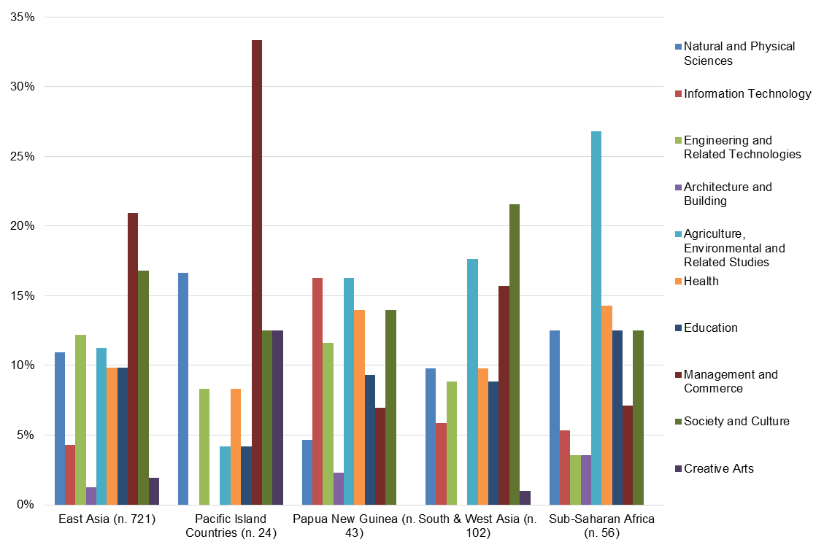

Figure 12: Alumni broad field of study by region

Further exploration **by field of study** of alumni (Figure 13) shows some indicative outcomes (noting that overall numbers for some fields are small when explored at this level). Of the fields with relatively high numbers of alumni, the data suggest that alumni in the fields of **agriculture, environmental and related studies, and education are most likely to indicate having developed professional links** (about half of all alumni in these fields have had a link). Alumni who studied in the field of information technology appear to be the least likely to have made professional links with Australia, with less than one quarter indicating they have made such connections.

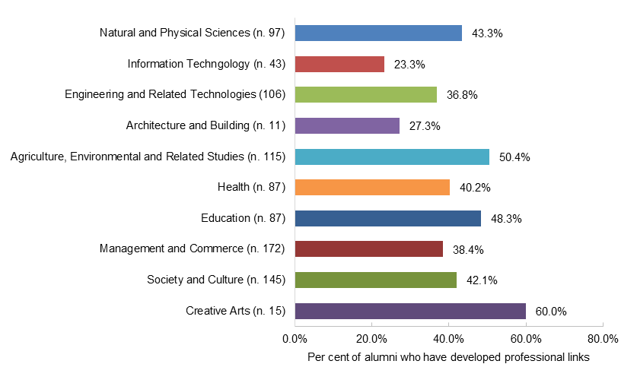Factors influencing this outcome may be on-award experience, particularly where work integrated learning and placements are more common. In addition, post-award, the type of work for each field of study, where regional and international partnerships may not always be common practice per the alum’s work requirements.

Figure 13: Proportion of alumni who developed professional link with an Australia organisation by award field of study

Further analysis of those alumni who have formed professional links explores the types of organisations and the sectors in which these partnerships are occurring. Of all the links identified by alumni through the Tracer Survey by far the most common link was with an Australian higher education institution (43 per cent of all partnerships) (Figure 14). Linked to this, it is alumni working in universities and higher education institutions were also most likely (32 per cent) to indicate that they had developed at least one professional link with Australia (Figure 15).

The second most common type of organisation with which alumni have a professional link is Australian Government departments (18 per cent). And associated with this is the fact that it is alumni working in the public sector who are the second most likely group (26 per cent) to indicate they had developed a professional link.

The high rate of links with Australian universities reflects the role universities have in hosting the majority of scholarship awardees, and the opportunities to engage with staff to develop networks. More detailed examples in the following section indicate that these links are being developed in both teaching and research pursuits.

Figure 14: Type of Australian organisations with which alumni have established professional links (n=409)

Figure 15: Work sector of alumni who have developed professional links with an Australian organisation (n=414)

## Alumni examples of partnerships

The following examples are descriptions provided by alumni of their experiences in linking with Australian organisations. The detail in these examples helps in further understanding the impact of this group in relation to Outcome 3. The quotes included here by alumni cover the four most common types of professional links in order of prominence – Australian institutions, national and state government departments, NGOs, and the private sector.

**Purposes for partnering with Australian institutions is varied** and alumni examples outlined a variety of factors. These included partnerships to exchange knowledge, collaborate for research, and expanding an Australian institution’s presence internationally.

The survey results show that **exchange of knowledge**, particularly exchanges with lecturers, occurs both ways. For example, one alumnus from Vietnam described the ongoing collaboration between his faculty and the University of Queensland’s School of Veterinary Science, including annual lecturer visits to teach in Vietnam. In another case, an alumna from PNG mentioned that she invited as a visiting lecturer to the University of Sydney as an expert in human rights for the Master of Human Rights and Democratisation.

Alumni are also engaged in **collaborative research** with Australian institutions. One such alumnus from Cambodia is undertaking economic and political research with the Korean Research Institute at the University of New South Wales.

Australian institutions are also **contributing to capacity development** in partner countries through sharing skills, knowledge, and practices. An alumna from Indonesia described the benefits of the workshops provided by the University of Canberra for academic staff at her university:

*We have workshop two times. First, a workshop on development curriculum and second, a workshop on higher education management. We got advantages of getting experiences of Australian universities. For Australia, the advantages are exchange cultures and tighten bilateral bounding between the two countries.*

Some alumni also describe **assisting Australian institutions to develop links in their countries**. One such alumnus from Philippines stated - ‘I have become a regular contact of the University of Newcastle for all its activities and partnership-building work in the Philippines.’ This reflects the interest from a number of Australian institutions in expanding their international presence. An alumnus from Vietnam shared the result of such a partnership:

*[With the] University of Technology Sydney we have a joint research centre located at Vietnam National University Hanoi. This is the first model of the kind in developing research in Vietnam. It is mutually beneficial.*

Alumni described a range of engagements they have through their work with Australian national and state government departments. These included sister city programs supporting sectoral exchanges, and bilateral relationships with government authorities such as the Australian Bureau of Statistics. An alumnus from Mauritius noted that the small grant project he collaborated with the Queensland Department of Agriculture and Fisheries would not have been possible if not for the knowledge of Australian departments that he developed through his studies on-award.

Alumni involved in development projects in their home country shared examples of working with **Australian NGOs and UN agencies based in Australia** to facilitate joint projects. Illustrative of the collaborative nature of international development activities, an alumna from Laos described their role on such a project:

*[I] organized a field visit for the National Committee for UNICEF from Australia to monitor the programme implementation once a year in rural areas of Laos. Yes this benefitted government, people, and UNICEF Laos.*

Examples by alumni of partnerships with the Australian private sector describe engagement such as with consultancies, and with professional bodies supporting bilateral engagement. One such example by an alumna from Fiji who holds the position of Chief Executive for the Fiji Commerce and Employers Federation shared that they are partnered through their work with the Australian Chamber of Commerce and Industry (ACCI), and various Fiji and Australia business councils.

## Factors enabling partnerships

Two common themes emerged from alumni examples of factors that enabled their partnerships with Australian organisations - their **on-award networks with host universities**, and **the availability of funding to undertake activities**.

In linking with Australian institutions, alumni typically described utilising their on-award exposure with their institutional hosts to develop partnership opportunities after their award. Indicative of this is the following example from an alumnus from Vietnam:

*We keep our professional links with ANU, I met many ANU professors in other conferences. We have some formal engagement with another Australian University (Monash) on possible collaboration on climate change, sustainable development goals.*

Some alumni mentioned funding as a factor enabling the partnership to develop. One such example is an alumnus from PNG who through funding from the Australian Research Council was able to join a research project with Curtin University, and describes the experience as mutually beneficial:

*I have done collaborative research with Curtin University since 2008 and have three publications on that research. The research funding came from the Australian Research Council. The relationship is a mutual one. It was only once and we need funding to expand the scope of the research especially to include me. The results [are] of significance, contributing to both teaching expanding knowledge and further research as well as contributing to government policies in Climate Change, Urban/Physical Planning and Waste Management Policies and Strategies.*

## Barriers to developing partnerships

Alumni who have not had professional links with Australian institutions or organisations were asked if they have wanted to make such links, and if they had experienced barriers which have prevented them in achieving this.

Figure 16 below shows that **the vast majority (82 per cent) of alumni yet to make a link indicate they have wanted professional links with Australia**. The factors which have prevented these alumni who are interested in developing professional links with Australia are explored below. Overall this strong desire to establish partnerships indicates there is potential for further achievement under long-term Outcome 3.

Figure 16: Desire to create links with Australian institutions and organisations among alumni who have not made professional connections (n= 483)

When this particular question is explored by region, there is consistency across most regions except for South and West Asia, where alumni showed less interest in developing professional links with Australia, with less than three quarters (69 per cent) wanting a professional link, and over one quarter (28 per cent) indicating they did not want a link with Australia ( Figure 17). This may not be a matter of geographical distance but may reflect bilateral interests in these regions.

By gender, alumni responses are similar with no significant discrepancy in responses ( Figure 17). This suggests alumni experiences are not gendered with regard to their interest in developing professional links with Australia. Similarly, by field of study, alumni response rates showed no significant differences.

Figure 17: Alumni who have wanted to develop professional links with Australia institutions and organisations by region and gender

Of the alumni who indicated that they want to develop links with Australian institutions and organisations, the main factors listed which prevented this are identified as:

* lack of opportunities after returning home post-award
* lack of interest or contact from potential networks.

**Alumni indicated that a lack of opportunities to developed professional links with Australia** were related to on-award exposure, funding, and networking opportunities.

**On-award exposure** was cited as a limitation and a missed opportunity to build professional links outside of coursework. One alumna from Vietnam in particular identified placements were limited to domestic students:

*There was limited internship opportunities or industry exposure during the study time. Australian institutions or organisations did not open opportunities to international students, as opposed to domestic students.*

Alumni identify access to **funding** as critical to fostering professional links, and are often limited by lack of resources in their country. An alumnus from Bangladesh detailed the ways in which funding is required to establish networks which he has undertaken successfully with countries such as the United States:

*After my study, I visited Australia only once in 2010 for two weeks. I met several professors at UNSW, etc. to collaborate. But I need to visit for meetings, discussions, short time research collaboration, talks, etc. so that a stronger commitment can be built. I have no funds to visit Australia - so I failed so far to make a strong connections with Australia. However, I have accomplished a memorandum of understanding with five universities in Japan, India, and USA already for research activities and students.*

Alumni also experience financial barriers to accessing professional associations. One such example is an alumna from Zimbabwe stated this as a reason she has not succeeded developing professional links with Australia; ‘[I] lacked finances to register with some Australian professional organisations so as to benefit from such networks and build more capacity.’

Some alumni mentioned that **opportunities to network are limited**, particularly occasions to attend relevant forums. A number of alumni referred to limited opportunities to return to Australia for the purpose of networking, which is a likely reflection of the time since alumni in this cohort graduated. The significance of timeliness in creating networks is highlighted in the following comment from an alumnus from Laos, who stated:

*After graduation in last ten years, I feel that the connection between alumni and Australian institutions or organisations is at a shortage. There was not many events for alumni to participate in. If there are events, they are very focussed only on the current alumni.*

**Lack of interest or contact from potential networks** was referred to by alumni, often due to differences in interests from Australian interests and Australian Government priorities. An alumna from Pakistan experienced limited interest from Australian institutions where greater interest lay with East Asian countries:

*Initially I reached out to quite a few people in Australian universities to create collaborative research and development opportunities. I also joined professional organizations. But there was no or limited interest at their end on working with me in Pakistan...They were more interested in East Asian countries. So I moved on to establish partnerships with researchers and academics in UK and Canada. It is a pity that I couldn't find people in Australia to collaborate with.*

Connecting with Australian counterparts also presented a barrier for alumni seeking opportunities. An alumna from Bangladesh simply stated ‘The response was not warm’. Another alumnus from Philippines was unsuccessful in attaining a meeting with counterparts on a recent visit to Australia, and perceived this to be a barrier in establishing their network.

Alumni were also to some extent **unsure how to approach developing links with Australian institutions and organisations**. This included uncertainty regarding who with and how to initiate contact, with an alumna from Pakistan stating that during her award ‘there was no guidance and support for developing links with Australian institutions’. This indicates that greater exposure on-award with Australian institutions and organisations related to awardee’s field of study may be beneficial. **Networking skills workshops** may also assist in ensuring alumni return following their award with the breadth of skills to support achieving all Australia Awards long-term outcomes.

# Views of Australians and Australian Expertise

## Introduction

An important facet of the Australia Awards is to provide exposure to the expertise that Australia has to offer and is explicit in **Outcome 4 -** ***alumni view Australia, Australians and Australian expertise positively***. The M&E Framework notes that this will be achieved through experiences on-award, including completing ‘good quality, relevant education, training, other professional development and research activities’, and ‘positive experience of life in Australia’ for alumni and their families.

The Tracer Survey explores these issues by asking alumni two specific questions, (1) the extent to which their views of Australia changed as a result of their time on-award, and (2) whether they have offered advice to others in their country relating to opportunities that could be pursued in Australia. This second question in particular seeks to provide constructive evidence of positive perceptions through actions and limit the potential for positive response bias.

This chapter examines alumni responses to these issues, beginning with an overview of responses broadly, and then examining in more detail examples of the advice that alumni have provided others in relation to Australia.

## Influence of award on perceptions of Australia

Alumni were asked about the extent to which their experience on-award influenced their perception of Australia as a country, the Australian people and the knowledge, skills and expertise of Australians. Overall, alumni developed a positive perception of each of these facets of Australia while on their award. As shown in Figure 18, for each of these questions, a substantial proportion of alumni indicate that they became ‘much’ or at least ‘slightly’ more positive. These large and positive responses were similar across alumni regardless of region, gender and field of study.

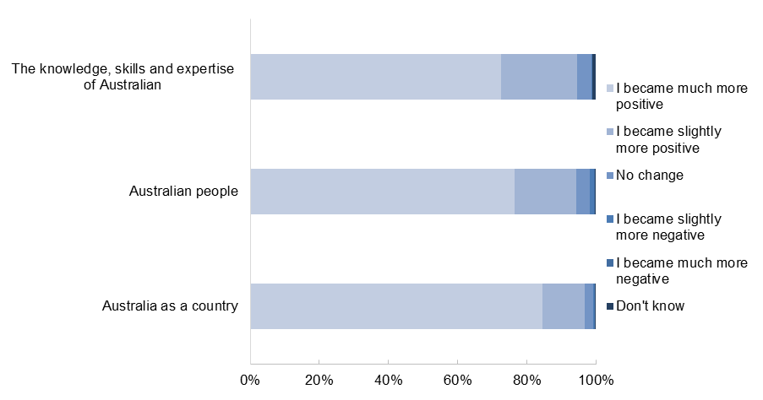Figure 18: Alumni perceptions on various facets of Australia while on-award (n=971)

## Providing advice about Australia

Almost all alumni (97 per cent) who responded to the Tracer Survey indicated that they have provided advice to people from their country in relation to pursuing opportunities in Australia.

Figure 19: Alumni who indicate they have provided advice to people from home country in relation to pursuing opportunities in Australia (n=970)

Through the survey and follow-up interviews, alumni provided examples and insight into the type of advice they were providing in regard to study opportunities in Australia. These examples are explored in more detail below.

Alumni indicated they were motivated to help a range of different people in pursuing opportunities in Australia, with the four most commonly mentioned groups (in order) being:

* colleagues
* students
* friends
* family.

Alumni examples highlight the wide range of ways in which they are providing advice about Australia. Information is being offered in **formal** settings, such as through Australian Embassy events, or through workshops within government departments and universities:

*Here in Laos, we have an education fair organised by the school that manages the Australian scholarship program. We also have an alumni association, those who have studied in Australia. Every year we meet people that are interested in studying in Australia. Students and their parents.* Alumnus from Laos

*The Australian Embassy invited me as a guest speaker to share my experience to future coming students coming to Australia.* Alumna from Vietnam

*I help on the selection committee. I always have discussion to update knowledge on Australia. I always try to share my knowledge. I did research in Australia and have done a lot of study there so know a lot about life in Australia to explain to them about academic aspects of studying in Australia and what it is like living there.* Alumnus from Indonesia

**Informal**discussions were also an integral part of the way in which alumni are providing advice and professing their positive views of Australia. The examples below encapsulate common responses in this regard:

*I recommended my friends apply for scholarships because for me it's a good place and nice environment to study. Friendly country, a lot of international students, so you don't feel lonely. The people are nice and helpful.* Alumnus from Vietnam

*People came to know [I am an Australia Awards alumni] from word of mouth, my school juniors. Some friends and relatives. I advise them about the opportunity for education in Australia.* Alumnus from Bangladesh

*Friends who want to go to study in Australia, I gave them advice about the culture.* Alumna from Thailand

*Whenever I meet a person who has the intention to study overseas I always talk about the good time I had in Australia. The good experience in Australia motivated me.* Alumnus from Vietnam

In their advice, alumni are **highlighting the quality of Australian education**, and in many cases noting the high quality in addition to other positive aspects such as the friendliness and openness of Australian culture.

*I have recommended Nepalese students pursue education there because of the quality.* Alumnus from Nepal

*Studying in Australia, it's serious and good quality - and friendly!* Alumna from Cambodia

*I have informed other Timorese about the quality of the teaching process in the university in Australia and inform them that they should try for a scholarship to Australia. I am trying my best to send my children to complete their degrees in Australia.* Alumna from Timor-Leste

When providing examples of the quality of education in Australia, a consistent theme from alumni is the benefit of **learning critical thinking** in the Australian educational context. Many alumni noted that this is a key element of the advice they give people in their country. Examples below are typical of the feedback from alumni:

*I also share with them about critical thinking, because in Vietnam, they follow what other people say and believe. But critical thinking is very important.* Alumna from Vietnam

*First and most important for people when choosing Australia: the system teaches people to think, be critical.* Alumnus from Laos

*In Australia I learnt critical thinking. I think the results are better.* Alumna from Indonesia

*Critical thinking is useful for my day to day work; to understand things, any issues and day to day things.* Alumnus from Nepal

The specific facets of advice that alumni are providing span a huge range of areas. Alumni indicate that they provide advice about **life and culture in Australia** ‘I tell them it is an opening to a new culture and mindset’ (alumna from Mauritius), and **practical advice about applying for Australia Awards**:

*People ask and I tell them about the opportunities and help them with applications and I tell them what to expect in Australia.* Alumna from Malawi

*I direct them to the website…Advise them to Google universities, to have a wider choice of where to apply. I tell them how to go through the process. I tell them what is required in the application process. Establishing they are eligible.* Alumnus from Kenya

*I tell younger colleagues they should try to improve their English, and work experience and apply for scholarship in Australia and how to prepare applications.* Alumnus from Cambodia

*I am helping students how to get scholarships and looking for scholarships and to prepare the forms and interviews, IELTS exams.* Alumnus from Pakistan

# Impact of Australia Awards on Addressing Equity Issues

This chapter explores the impact of the Australia Awards in addressing equity and disadvantage. In particular it examines the impact and contributions of alumni in addressing issues of equity within their home countries. The particular groups of focus for this discussion are women, people with disability and rural populations.

The chapter draws on the responses to the Tracer Survey to demonstrate successes of and for disadvantaged groups. It also explores issues specific to these groups that impinge their ability to make an impact.

## Gender and impact on contributions of alumni

### Contextual issues

As noted in the summary statistics of survey participants earlier in the report, of the respondents to the Year 2 Tracer Survey, 47 per cent were women. The age distribution of female alumni respondents was similar to that for the male alumni. More than half of female respondents were aged in their 40s, with a further third of respondents aged in their 50s ( Figure 20).

Figure 20: Age groups of alumni (n=1,064)

As noted in the earlier chapters of the report, on many of the key measures examined (such as skill development and utilisation, development of networks, sharing of knowledge and skills, and views of Australia), there were no statistically significant differences between the responses of female and male alumni.

Alumnae who participated in the Year 2 Tracer Survey were similarly likely to be in a leadership position as their male counterparts to be in a leadership position (see Figure 21), with 70 per cent in a formal leadership role and a further 23 per cent in an informal leadership role. It is useful to note that the findings relating to leadership by gender for this cohort of alumni from 1996 to 2005 is notably more positive from a gender equity perspective than the Year 1 Tracer Survey focussing on a younger cohort – completers from 2006 to 2010.

Figure 21: Leadership positions of employed alumni by gender (n=951)

As shown in Figure 22 a notably higher proportion of alumnae in the 1996 to 2005 cohort are in formal leadership positions than was the case for the younger group who participated in the Year 1 survey. The difference is the opposite in terms of informal leadership positions when comparing these two cohorts, with the younger group (2006 to 2010 cohort) being more likely to be in this category than the alumni from 1996 to 2005 cohort. Interestingly the same pattern was not apparent for the male alumni from these two cohorts. Those in the younger cohort had very similar levels to the older cohort (74 per cent for the 2006-2010 cohort) than the older group surveyed in Year 2 (73 per cent).

This is an important finding as it shows that transition for female alumni to develop into leaders and assume leadership positions within their countries can take time, but is occurring. In addition, the figures suggest that **over time the gender gap in terms of formal leadership positions is closing for female alumni**.

Figure 22: Female alumni in leadership roles - comparing 1996 to 2005 cohort and 2006 to 2010 cohort

### Alumni contributions to gender equity

Rich examples were provided in the Tracer Survey of the way in which **alumni are influencing policies, practice and cultural attitudes towards the contribution of women**. As highlighted in the examples below, alumni are using the knowledge and skills from their scholarships in a number of different ways. In particular, the evidence below highlights achievements by both female and male alumni in:

* advocacy relating to raising awareness of women’s rights
* implementation of policy, practice and programs to improve the lives of women
* mentorship of younger women to build leadership and participation in the workplace.

In terms of **advocacy**, one alumna from Indonesia spoke about her involvement in a pivotal collaborative partnership with Australia – the Australia-Indonesia Partnership for Gender Equality and Women’s Empowerment (MAMPU):

*I was part of the initial development of MAMPU, a national women's empowerment program that has continued for over five years and has helped tens of thousands of women across the nation. This is a success for both Australia and Indonesia and a fantastic collaboration.*

Another strong example of advocacy for the rights of women is provided by an alumnus from Vietnam who has developed policies and conducted workshops in the decade following his scholarship:

*Since graduation from Australia, I have been working on promoting gender equality and children's rights in my country. I have applied skills and knowledge to my work, to develop the Vietnam National Plan of Action for the Advancement of Women.*

On the global stage, an alumna from PNG travelled to the United Nations headquarters to present at the International Convention on the Elimination of All Forms of Discrimination Against Women. In her survey responses, she reflected on the way in which her scholarship inspired her to work in this area, and on the notable outcomes of her advocacy:

*Those courses set the foundation of my passion for human rights. [Our report and presentation to the United Nations] resulted in drawing the attention of the United Nations to the issue of torture and killing of women on the basis of sorcery allegations. Since then Papua New Guinea has repealed and replaced its Sorcery Act and there has been increased awareness of the issue.*

Alumni are also active at the local level building awareness and creating change within their workplaces. For example an alumna from Vietnam described her success in advocating for inclusive policies in the workplace:

 *[I was] successful in advocating for policy of Maternal leave which allowed a mother full paid leave for 6 months.*

**Programs and practice** that alumni are contributing in the area of gender equity and empowerment include an alumna from Pakistan who now works in community development projects to improve practices and innovations for the empowerment of women experiencing domestic violence. Similarly, an Indonesian alumnus has worked in community development to implement services for women and children:

*I played a key role in the team that developed the module for Crisis Centres for Women and Children Survivors of Violence that has since been rolled out across the country.*

Another alumnus from Indonesia has also influenced the way in which women are supported and recognised for their contributions. His work is in the agricultural sector, where women’s contributions are often overlooked. In the survey he describes working to ‘mainstream gender into and agribusiness project to offer equal access to training and empower women to improve their livelihood.’

In PNG an alumnus is directly involved in recent efforts to provide safe places for women to discuss issues relating to sexually transmitted infections (STIs). Through an audit of STI clinics, this alumnus recommended the inclusion of ‘gender specific services due to cultural sensitivity around sex between man and woman’. As a result, the majority of clinics in his province have now ‘extended a room in clinic to cater for each gender specific service.’

The leadership of alumni in the area of gender equity is also apparent through the survey responses in relation to examples of **mentoring** young people within their communities to increase respect for women and empower the next generation.

For example, an alumna from Bangladesh discussed her involvement in mentorship programs through which she has ‘encouraged and promoted female participation in technology and leadership’.

An alumnus from PNG is also making this contribution in his fields of expertise:

*I involve young employees (lecturers) in collaborative research work; gender and violence work, financial literacy work, community research work, agricultural research work… Two [women] have received internal international scholarships from two different universities, one in Australia has just been confirmed, and one in New Zealand who left in June this year and has enrolled in a university to do her PhD.*

Another alumna from Laos is building her capacity to contribute in this way, through support from Australia:

*I'm a trainee with Women Alumni, the trainers are from Sydney University and training for Women in Executive Leadership, its mentoring & coaching on how to be a good leader. In the past I was rarely in contact with them, but now that I'm a trainee we have a WhatsApp group conversation so we talk quite often.*

A further example of work within the community and workplace to build awareness and capacity was demonstrated by an alumnus through an initiative in PNG:

*I have also created a women's network group within PNG Forest Authority to address gender problems in the organisation. It is called Women in Forestry Information Network. I am currently the chairperson.*

### Enabling alumni contributions to gender equity

Importantly, a key theme in the discussion by alumni of initiatives and motivation to become involved in gender equity advocacy and activities is the ongoing involvement in alumni networks from Australia. The quotes from alumni below demonstrate the potential of alumni associations and related activities in enabling alumni to continue discussing gender equity and working on leadership skills post-award. These links and opportunities described below have helped facilitate the noteworthy contributions highlighted in the section above.

*Under the Women Network under the Africa Alumni Association based in South Africa, I share information on available study opportunities in Australia.* Alumna from Uganda

*I am a core member of the Women in Leadership Network (WiLN).* Alumna from Bangladesh

*In April, I was able to participate in a seminar relating to women and leadership and this was possible because I am in an alumni group.* Alumna from Mozambique

*Through Australian Alumni Association in Bangladesh, we meet very often. Especially, the women awardees, we are involved in increasing awareness among the Bangladeshi girls and women on higher education.* Alumna from Bangladesh

*As I am a fighter of equal opportunities, the most significant constraints were not gender but sufficient funds to carry out my work plans on time and to satisfaction. I have also created a women's network group within PNG Forest Authority to address gender problems in the organisation. It is called WIFIN (Women in Forestry Information Network). I am currently the chairperson. Under my leadership and an Australian Advisor, WIFIN was born in 2005.* Alumnus from PNG

*Presently I join an Australian Women's Leadership Executive and Mentoring Programme.* Alumna from Laos

*I joined in Australia Alumni Association and built networks with other awardees. I communicate with them through phone and e-mail and arrange programs like awareness rising among women.* Alumnus from Bangladesh

*I am one of the founding members of the women in leadership network.* Alumna from Pakistan

### Constraints for women

While there are a number of positive examples of how alumni of the Australia Awards are contributing to the empowerment of women in their home countries, alumnae also discussed the barriers they experienced in making contributions on return from award.

Many alumnae identify gender inequality as a contributing factor to their lack of recognition of skills. **Discrimination on the basis of gender** was described by some in terms of a reflection of their patriarchal society and norms across a range of areas, and by others, in relation to specific occupations or situations.

Indicative of these themes, examples of these issues as described by alumnae in the survey are offered below. In relation to **culture and norms**, some alumnae pointed out that they felt issues of gender equity were more difficult to promote in countries in a developing context. An alumna from Timor-Leste stated: ‘A constraint that I faced was gender. It is more difficult to take influence directly to Timorese, than it is in developed countries’. Another alumna from Bangladesh had a similar comment, saying that the things that had impeded her progress related to ‘gender lens, lack of appreciation and utilization of skills in bureaucratic systems of developing world.’

An alumna from Vietnam specifically noted the broader cultural expectations as being a challenging factor for her to progress, mentioning the shift in thinking that she needed to undertake as well, ‘[I am restricted by] the well-established perception about me as a woman - inside myself and inside my family as start.’

Discrimination in access to opportunities in the workplace was the most common theme mentioned. The examples below illustrate the thinking of alumna:

*Gender and lack of level of seniority are the most significant constraints I had experienced, particularly working with a public sector in my home country which is considered a patriarchal society.* Alumna from Lao

*Gender! Being young and a female I had the worst experience of my career being undermined to the point of having my contract with the University removed.* Alumna from PNG

*Gender. Being a woman - married and with two children is difficult. Most employers looked at this status in determining position and salary.* Alumna from Indonesia

*Upon my return, I was not given the opportunity to utilise my skills and knowledge earned from my study. I would say a combination of my being a woman and definitely nepotism.* Alumna from Cambodia

*I was invited on several occasions to attend international conferences but was replaced by male colleagues and other senior (in age) female colleagues to go instead.* Alumna from PNG

*Retirement age for women is less than man so I have to stop my work very soon.* Alumna from Vietnam

Another barrier mentioned in relation to the workplace was by women who were working in male-dominated professions:

*Being a woman, it is really challenging to work in unconventional professions - for example, IT. People were not ready to see woman in IT managerial roles. However, the perspective has changed over time. Which is good news!* Alumna from Bangladesh

*The field of illumination [lighting technology] is very male dominant in South Africa and I have definitely experienced gender issues.* Alumna from South Africa

## Alumni contributions to disability inclusiveness

The Australia Awards provide specific education and information about disability inclusiveness. In the Year 2 Tracer Survey population, 1.4 per cent of respondents indicated they are with disability (Figure 23).

Figure 23: Alumni who identify as having disability (n=1,072)

As such, the Tracer Survey has not been able to collate detailed insights into the contributions of alumni with disability, or to the specific constraints these alumni face in making contributions. However, analysis of responses from all alumni who participated in the survey showed that there are a range contributions being made towards improving recognition, access and equality of outcomes for people with disability. The selection of examples in this section provides some insights into these contributions:

*[I have] written a national disability policy through extensive consultations in 2005, and hosted the Asia Pacific regional seminar on disability in 2007. As a result the self-help movement in disability has grown. We now have National Association of Persons with Disability headed by a woman. A good number of persons with disability have studied overseas.* Alumnus PNG

*One of my Australian friends was active in raising autism awareness for teachers and parents, and gave me valuable information to use back home in training teachers. When I went back to Pakistan, I did awareness training for teachers and parents, and other professionals on what aspects can be improved…I raised a lot of public awareness and also among professionals about autism and ADHD. At that time there was nothing, now there is a lot. Many schools incorporated a lot of what I suggested…Now there is an institute for autism.* Alumna from Pakistan

*I always get referrals from teachers of children with disabilities to help guide parents who have children with disabilities on how to improve the parent-child relationship, motivate and encourage them.* Alumnus from Uganda

*The community development projects [I have been involved in] were designed to have improved practices and innovations. One design was on social inclusion of persons with disability.* Alumna from Pakistan

## Rural alumni and impact on contributions

The Australia Awards also recognises the importance of increasing access and opportunities through scholarships for people from rural and remote areas. Among alumni who responded to the Year 2 Tracer Survey, a notable minority are from rural or remote areas (7 per cent) (Figure 24).

This section explores some of the responses of these alumni, and also includes some examples from other alumni who are involved in programs or other activities to address disadvantage in remote and rural areas.

The contributions of alumni towards helping people from rural and remote areas are provided below. These are followed by some observations by alumni from rural and remote areas relating to the challenges and issues they have faced following return from their award as a result of their geographic isolation.

Figure 24: Residential location of alumni (n=867)

### Alumni contributions to rural and remote areas

In both Indonesia and Timor-Leste, alumni spoke about the work they have been undertaking with rural farmers, one alumnus highlighted his contribution based on the use of skills and knowledge gained in Australia:

[*As part of my] role in an NGO, we make small project in the villages. I develop nutrition for cattle as part of the research for fattening and for breeding. Farmers raise cattle for breeding and use our concentrated feed. We work with corporations here. We train the staff of the corporation and they make their own cattle feed and distribute it to the farmers. This programme still running.* Alumnus from Indonesia

A number of alumni spoke about activities or programs they were involved in that are helping to build capacity and equip families, workers and communities in rural areas to become financially sustainable. For example, two alumni, in Uganda and Vietnam, are drawing on the things they have learnt in Australia in order to help support rural communities to better participate in the national economy:

*My conflict resolution skills comes in handy, organising planning and innovation in solving rural problems has made solutions arrived at workable as we focus on identifying the problem, ideally before any solution is brought on table. The Community Co-operative approach, voluntary savings and loans schemes and resource mobilisation at community level is a success in the local communities of Uganda.*

*I work for a rural development project and also a community social action initiative around gender equality. Within the job I train people about environmental sustainability. For example, reduce practices like slash & burn. The main thing I've applied is the methodology of training. Traditionally in Lao there is only one way of teaching where the teacher tells the information but in Australia I learned that there were different methodologies to help the student to participate in the training.*

Similarly, in the Philippines, an alumna noted that through her award, ‘the degree provided me with the technical knowledge in supporting livelihoods and small businesses in rural communities.’ And in Vietnam an alumna is likewise building capacity to improve outcomes:

*Recently with a group of awardees...[we] won an award for research granted by the Australian Embassy for research, about the challenges of teachers in mountainous areas and the ability to overcome the difficulties they met. The students there are poor and don't have facilities to teach but we want to see how they can overcome and be successful in teaching and assessing the teaching materials.* Alumna from Vietnam

In PNG, an alumnus spoke about using the approaches he learnt on-award to ‘help improve and change lives of people living in rural villages.’ In particular, he is helping these communities through workshops:

*The projects involve a wealth creation message which is conducted between 3 to 4 days through a workshop. The content of the workshop is on a family teams approach and financial literacy. We have witnessed rural families improving their lives…Attending the workshop has changed their lives, they now have enough money to pay for school fees, medical expenses, food and they are saving their money for their future.* Alumnus from PNG

In terms of infrastructure for rural populations, an alumna from Bhutan highlighted the work she was involved in to develop ‘single phase power distribution networks to remote areas.’

### Constraints for rural and remote alumni

Remoteness, geographic isolation and accessibility for communities in rural areas were mentioned by many alumni as impeding their ability to apply knowledge and skills, and maintain networks on return to their home country. Interestingly, alumni from a wide range of countries mentioned such issues. Among the survey participants with comments about this were alumni from Bangladesh, Bhutan, Indonesia, Kenya, Laos, Maldives, Pakistan, Philippines, PNG, Swaziland, Timor-Leste, Tonga, Uganda and Vietnam. While each country and situation is unique in this aspect, the quotes from alumni below offer some perspective on these issues:

*Infrastructure for roads in rural PNG isn't great or not there, so I have to go by foot from one village to another and it’s hard for me. The isolation and remoteness is hard. Funding is also hard. I need money but there isn't any so I have to make sacrifices.* Alumna from PNG

*Some of the constraints I face include geographical isolation within the country and difficulty in getting required resources – including financial resources – for implementation.* Alumnus from Maldives

*So where I work is far away from where the Australian government employees come to visit, so I don't get a chance to associate with them. I work in a rural province. I got my scholarship before PAHRODF (Philippines-Australia Human resource and Organisational Development Facility) existed. PAHRODF holds activities with alumni, but it's only for those around during their time, not those of us who did it during AusAID, so it seems like we are being marginalised. It would be good if they would include us in these meetings and gatherings so we can form networks and contacts.* Alumna from Philippines

*Bhutan is a developing country, as such there are inherent physical challenges of remoteness, sparsity and inaccessibility as well as resource constraints.* Alumnus from Bhutan

*My work requires me to be reassigned to different countries every few years. This has previously put me in remote insecure locations where I have faced security challenges in implementing projects.* Alumna from Kenya

*Geographic isolation [is a challenge]. We want to provide technical assistance but sometimes the distance of our households to health facilities are making it difficult for the people to access services that they should be receiving.* Alumna from Philippines

# References

DFAT (2016a), *Australia Awards Global Strategy*, Department of Foreign Affairs and Trade, Canberra. <http://dfat.gov.au/about-us/publications/Documents/australia-awards-global-strategy.pdf>

DFAT (2016b), *Australia Global Alumni Engagement Strategy 2016-2020*, Department of Foreign Affairs and Trade, Canberra. <http://dfat.gov.au/about-us/publications/Pages/australia-global-alumni-engagement-strategy-2016-2020.aspx>

DFAT (2018). *Aid Investment Plan Sub-Saharan Africa: 2015-2019*, Department of Foreign Affairs and Trade, Canberra. <http://dfat.gov.au/about-us/publications/Pages/aid-investment-plan-aip-sub-saharan-africa-2015-16-to-2018-19.aspx>

# Annex 1: Characteristics of Telephone Follow-up Respondents

As discussed in the method section of this report, the Facility conducted follow-up interviews with 522 of the alumni who had completed the online Tracer Survey. This interview was designed to elicit further information from alumni about their responses to the online survey. It involved asking alumni to provide more specific detail relating to the examples of links, knowledge transfer, contact with Australians and Australian organisations, and views on Australia. Alumni who had short, or non-specific answers to the open-ended sections of the Tracer Survey were initially targeted for the follow-up interviews, so as to gather more detail from as many alumni as possible. The information from these interviews was coded by the Facility and used in developing the analyses for this report. In particular, many of the verbatim quotes provided in the report were extracted from these conversations. Annex 4 provides the interview questions used during this follow-up interviews.

Table 4: Alumni who participated in Telephone follow-up interviews

| **Focus** | **Demographic** | **All alumni** | |
| --- | --- | --- | --- |
| **#** | **%** |
| **Gender** | Female | 238 | 46% |
| Male | 278 | 54% |
| **Country of Birth Region\*** | East Asia | 367 | 70% |
| Pacific Island Countries | 16 | 3% |
| Papua New Guinea | 26 | 5% |
| South & West Asia | 75 | 14% |
| Sub-Saharan Africa | 38 | 7% |
| **Year of graduation from award** | 1996 | 36 | 7% |
| 1997 | 35 | 7% |
| 1998 | 41 | 8% |
| 1999 | 39 | 7% |
| 2000 | 40 | 8% |
| 2001 | 40 | 8% |
| 2002 | 62 | 12% |
| 2003 | 71 | 14% |
| 2004 | 82 | 16% |
| 2005 | 76 | 15% |

Note: *The ‘unknown’ category is used for alumni who requested not to have personal information published in reporting. As all participants in the Telephone follow-up interviews agreed for their personal information to be published, the ‘unknown’ category is not applicable in this table.

# Annex 2: Response Numbers by Country

Table 5: Participation statistics for scholarships by region and country

| **Region** | **Country** | **# Survey respondents** | **Target population** | **Response rate** |
| --- | --- | --- | --- | --- |
|
|  |
| **East Asia** | Cambodia | 47 | 157 | 30% |
| China | 4 | 52 | 8% |
| Hong Kong | 0 | 1 | 0% |
| Indonesia | 292 | 1547 | 19% |
| Lao People's Democratic Republic | 73 | 261 | 28% |
| Malaysia | 2 | 9 | 22% |
| Mongolia | 11 | 22 | 50% |
| Philippines | 59 | 255 | 23% |
| Thailand | 14 | 42 | 33% |
| Timor-Leste | 13 | 48 | 27% |
| Vietnam | 299 | 1175 | 25% |
| **Pacific Island Countries** | Fiji | 10 | 33 | 30% |
| French Polynesia | 0 | 1 | 0% |
| Kiribati | 4 | 7 | 57% |
| Marshall Islands | 1 | 1 | 100% |
| Micronesia, Federated States of | 0 | 2 | 0% |
| Nauru | 1 | 2 | 50% |
| New Caledonia | 4 | 17 | 24% |
| Palau | 0 | 2 | 0% |
| Samoa | 3 | 12 | 25% |
| Solomon Islands | 0 | 1 | 0% |
| Tonga | 3 | 103 | 3% |
| Tuvalu | 0 | 1 | 0% |
| Vanuatu | 1 | 5 | 20% |
| **Papua New Guinea** | Papua New Guinea | 51 | 207 | 24% |
| **South & West Asia** | Bangladesh | 37 | 167 | 22% |
| Bhutan | 21 | 68 | 31% |
| India | 4 | 20 | 20% |
| Maldives | 8 | 46 | 17% |
| Nepal | 24 | 95 | 25% |
| Pakistan | 18 | 52 | 35% |
| Sri Lanka | 7 | 24 | 29% |
| **Sub Saharan Africa** | Botswana | 0 | 2 | 0% |
| Kenya | 9 | 30 | 30% |
| Lesotho | 3 | 10 | 30% |
| Malawi | 5 | 9 | 56% |
| Mauritius | 2 | 3 | 67% |
| Mozambique | 15 | 61 | 25% |
| Namibia | 0 | 8 | 0% |
| South Africa | 8 | 34 | 24% |
| Swaziland | 1 | 2 | 50% |
| Tanzania | 2 | 27 | 7% |
| Uganda | 10 | 32 | 31% |
| Zambia | 0 | 8 | 0% |
| Zimbabwe | 3 | 8 | 38% |
| **Unknown\*** | Unknown* | 3 | 5 | 60% |
| **Total** |  | **1072** | **4675** | **22.9%** |

Note: *The ‘unknown’ category is used for alumni who requested not to have personal information published in reporting.

Table 6: Participation statistics for scholarships by region, country and gender

|  |  | **Female** | | | **Male** | | |
| --- | --- | --- | --- | --- | --- | --- | --- |
| **Region** | **Country** | # Survey respondents | Target population | Response Rate | # Survey respondents | Target population | Response Rate |
| **East Asia** | Cambodia | 11 | 42 | 21% | 36 | 115 | 31% |
| China | 1 | 29 | 3% | 2 | 22 | 9% |
| Hong Kong | 0 | 0 | 0% | 0 | 1 | 0% |
| Indonesia | 136 | 735 | 16% | 154 | 804 | 19% |
| Laos | 37 | 124 | 23% | 33 | 132 | 25% |
| Malaysia | 1 | 3 | 25% | 1 | 6 | 17% |
| Mongolia | 8 | 15 | 35% | 3 | 7 | 43% |
| Philippines | 24 | 133 | 15% | 35 | 122 | 29% |
| Thailand | 9 | 24 | 27% | 5 | 18 | 28% |
| Timor-Leste | 4 | 15 | 21% | 9 | 33 | 27% |
| Vietnam | 149 | 557 | 21% | 148 | 615 | 24% |
| **Pacific Island Countries** | Fiji | 5 | 17 | 23% | 5 | 16 | 31% |
| French Polynesia | 0 | 0 | 0% | 0 | 1 | 0% |
| Kiribati | 2 | 3 | 40% | 2 | 4 | 50% |
| Marshall Islands | 1 | 1 | 50% | 0 | 0 | 0% |
| Micronesia, Federated States of | 0 | 2 | 0% | 0 | 0 | 0% |
| Nauru | 1 | 2 | 33% | 0 | 0 | 0% |
| New Caledonia | 2 | 11 | 15% | 2 | 6 | 33% |
| Palau | 0 | 1 | 0% | 0 | 1 | 0% |
| Samoa | 1 | 4 | 20% | 2 | 8 | 25% |
| Solomon Islands | 0 | 1 | 0% | 0 | 0 | 0% |
| Tonga | 2 | 44 | 4% | 1 | 59 | 2% |
| Tuvalu | 0 | 1 | 0% | 0 | 0 | 0% |
| Vanuatu | 0 | 0 | 0% | 0 | 4 | 0% |
| **Papua New Guinea** | Papua New Guinea | 35 | 111 | 24% | 15 | 96 | 16% |
| **South & West Asia** | Bangladesh | 11 | 76 | 13% | 26 | 91 | 29% |
| Bhutan | 5 | 17 | 23% | 16 | 51 | 31% |
| India | 0 | 3 | 0% | 4 | 17 | 24% |
| Maldives | 6 | 30 | 17% | 2 | 16 | 13% |
| Nepal | 8 | 46 | 15% | 16 | 49 | 33% |
| Pakistan | 7 | 24 | 23% | 11 | 28 | 39% |
| Sri Lanka | 5 | 11 | 31% | 2 | 13 | 15% |
| **Sub-Saharan Africa** | Botswana | 0 | 0 | 0% | 0 | 2 | 0% |
| Kenya | 4 | 10 | 29% | 5 | 20 | 25% |
| Lesotho | 3 | 6 | 33% | 0 | 4 | 0% |
| Malawi | 2 | 4 | 33% | 3 | 5 | 60% |
| Mauritius | 2 | 3 | 40% | 0 | 0 | 0% |
| Mozambique | 7 | 25 | 22% | 8 | 36 | 22% |
| Namibia | 0 | 4 | 0% | 0 | 4 | 0% |
| South Africa | 6 | 19 | 24% | 2 | 15 | 13% |
| Swaziland | 1 | 1 | 50% | 0 | 1 | 0% |
| Tanzania | 0 | 9 | 0% | 2 | 18 | 11% |
| Uganda | 4 | 13 | 24% | 6 | 19 | 32% |
| Zambia | 0 | 6 | 0% | 0 | 2 | 0% |
| Zimbabwe | 1 | 1 | 50% | 2 | 7 | 29% |
|  | Unknown* | 1 | 2 | 33% | 2 | 3 | 67% |
| **Total** |  | 502 | 2185 | 19% | 560 | 2471 | 18% |

Note: *The ‘unknown’ category is used for alumni who requested not to have personal information published in reporting.

# Annex 3: Tracer Survey Instrument

As detailed in the Methodology chapter, Tracer Survey questions are mapped to the Australia Awards long-term outcomes documented in the Global Strategy and M&E Framework.

The instrument is supplemented with basic demographic, enrolment and employment characteristics of alumni. Where these variables are known to the Facility, they will be pre-filled, with alumni asked to verify that information is correct and update where necessary. Responses to this survey instrument from 1072 alumni were analysed in this report.

These survey questions were delivered online. The formatting and approach was adapted to suit the mode of survey delivery, as such the information here provides the question wording and response options rather than the ‘look’ of the survey as seen by alumni respondents.

At the conclusion of the survey alumni are asked if they would be interested in participating in a follow-up telephone survey. The key questions for the phone survey are provided in Annex 4.

### Tracer Survey instrument

**Personal details** (prefilled with existing data and confirmed/updated by alumni during interview)

|  |
| --- |
| Family name |
| Given name(s) |
| Gender |
| Date of birth (dd/mm/yyyy) |
| Nationality |
| Current Residential location (Urban/Rural/Remote) |
| Telephone contact number(s) |
| Personal e-mail address |
| Scholarship type/name |
| Name of course of study (e.g. Master of Education, Bachelor of Arts, etc.) |
| Field of study |
| Australian education institution attended |
| Year of graduation |
| Current employment status (employed full-time/employed part-time/retired/not employed) |
| Name of current employer agency/organisation (or last employer if retired) |
| Current position (or last position if retired) [full title] |
| Brief description of your current job (or last role if retired) – prompting for detail to be including in briefing with focus on level of seniority/influence. |

In relation to your current job (or last job if retired), which of the following statements best describe your level of leadership?

1. I have [‘had’ if retired] a formal leadership role (e.g. as a manager, supervisor)
2. I have [‘had’ if retired] an informal leadership role (e.g. mentor, opportunity to influence others informally)
3. I do not have [‘did not have’ if retired] a leadership role

Have you received any other scholarships in addition to the [insert scholarship relevant to this survey]?

1. Yes [record other scholarship/s names]
2. No
3. Don’t know

Do you give your permission for Wallis to pass on any updated details such as your email and/or phone number we have collected in this survey to ACER and DFAT?

The information will be used for the purpose of conducting and reporting on the Australia Awards Global Tracer Facility, or for DFAT to make contact with you in the future. The information will be used by authorised staff for the purpose for which it was collected and will be protected against unauthorised access and use.

1. Yes
2. No

**Outcome 1: Alumni are using their skills, knowledge and networks to contribute to sustainable development**

*To what extent do you agree with each of these statements?*

As a result of my Australia Award:

1. I have passed on my new skills and knowledge to others
2. I have introduced improved practices and innovations through my work
3. I have built networks with Australians or Australian organisations
4. I have built networks with other awardees

Response Frame: [Strongly Agree to Strongly Disagree 5 point scale, + Don’t Know]

*[If agreed or strongly agree to a) above]*

*Please provide an example of a way in which you have passed new skills and knowledge onto others to contribute to development in your country.*

Response Frame: OPEN TEXT RESPONSE

*[If agreed or strongly agree to b) above]*

*Please provide an example of a way in which you have introduced improved practices and innovations through your work to contribute to development in your country.*

Response Frame: OPEN TEXT RESPONSE

*[If agreed or strongly agree to c) above]*

*Please provide an example of a way in which you have built networks with Australians or Australian organisations that contribute to development in your country.*

Response Frame: OPEN TEXT RESPONSE

*[If agreed or strongly agree to d) above]*

*Please provide an example of a way in which you have built networks with other awardees that contribute to development in your country.*

Response Frame: OPEN TEXT RESPONSE

*In relation to [this example/these examples], what is the most significant factor that has assisted you in applying these?*

Response Frame: OPEN TEXT RESPONSE

*Again, thinking about [this example/these examples], what is the most significant constraint you have faced in applying these?*

*[Or if no examples provided for previous] What is the most significant constraint you have faced in applying skills and knowledge, introducing improved practices and building networks?*

Response Frame: OPEN TEXT RESPONSE

**Outcome 3: Effective, mutually advantageous partnerships between institutions and businesses in Australia and partner countries**

*As a result of your Australia Award, have you developed professional links with Australian institutions or organisations?*

Response Frame: [1. Yes. 2. No]

**IF YES**:

Which types of Australian institutions or organisations have you developed professional links with? [select all that apply]

* National or State Government Departments?
* Private sector businesses?
* Universities?
* Non-Government Organisations?
* None of the above

Response Frame: [tick box]

**IF NO**:

Have you wanted to develop professional links with Australian institutions or organisations?

Response Frame: [1. Yes. 2. No]

[**If Yes** to the first Q in the box above]

*Please provide an example of a professional relationship you have developed with an Australian institution or organisation as a result of your time on-award.*

Response Frame: OPEN TEXT [guided by the following – who or what organisation? What is the relationship? How frequent? How is it mutually advantageous to both countries?]

**[If No** to the first Q in the box above]

What are the main factors that have prevented you from developing professional links with Australian institutions or organisations?

Response Frame: OPEN TEXT

**Outcome 2: Alumni are contributing to cooperation between Australia and partner countries**

*How frequently are you in contact with the following groups:*

* Your Australian host institution
* Fellow Australian students
* Fellow scholarship recipients
* Professional Associations or Australian businesses operating in Australia/your home country
* Australian Embassy, High Commission or Consulate
* Friends in Australia

Response Frame: [1.Always. 2 Often. 3. Sometimes. 4. Rarely. 5. Never, + Don’t Know]

[if response 1-4 for any of the above]

*Please briefly describe an ongoing relationship you developed as a result of your time in Australia on-award..*

Response Frame: OPEN TEXT [guided by the following – who or what group? What is the relationship? How frequent??]

**Outcome 4: Alumni view Australia, Australians and Australian expertise positively**

*To what extent did your experience during your award influence your perception of the following*:

* Australia as a country
* Australian people
* The knowledge skills and expertise of Australians

Response Frame: [1. I became much more positive. 2. I became slightly more positive. 3. No change. 4. I became slightly more negative. 5. I became much more negative, + Don’t Know]

*Have you provided advice to people from your country in relation to pursuing opportunities in Australia?*

Response Frame: [1. Yes. 2. No.]

*If yes, please provide an example*

Response Frame: OPEN TEXT

[If Yes to above] Please *provide an example of a way in which you have provided advice to people from your country in relation to pursuing opportunities in Australia.*

Response Frame: OPEN TEXT

**Permissions**

When we provide the data to DFAT, do you give consent for Wallis to link your survey responses with your personal details?

You will not be identified in any reporting of the results, unless DFAT explicitly gains your permission.

Response Frame: [1. Yes. 2. No.]

**Follow-up request**

Finally, we will be conducting follow-up to this survey over the telephone to gain a more in-depth understanding of some of the topics that have just been covered. We will be telephoning a selection of alumni. Would you be willing to participate in a follow-up interview?

Response Frame: [1. Yes. 2. No.]

# Annex 4: Follow-up Telephone Interview Instrument

Follow-up telephone interviews were conducted with selected alumni who completed the online survey and indicated willingness to speak about their experience further. These interviews were used to enhance the qualitative answers provided by alumni in their online survey responses. A total of 522 follow-up interviews were conducted in this year’s Tracer Survey.

### Follow-up telephones interview instrument

**Introduction:**

…You recently completed a survey about your experience as a recipient of an Australian Government funded scholarship to study in Australia. After finishing the survey, you indicated that you would be willing to complete a short follow-up telephone interview to discuss your survey responses…

**Outcome 1: Alumni are using their skills, knowledge and networks to contribute to sustainable development**

*In the survey you completed earlier, you provided an example of the ways in which your Scholarship helped you to contribute to development in your country. I’d like to explore this further…*

[response in original online survey read out to alumni]

Response Frame: Open Text [probed with: What skills/practices/innovations/network are the key to contributing to development. HOW did this occur (i.e. How did the benefits gained on-award link with the developments achieved)]

*In relation to [reproduce responses to online survey], what is the most significant factor that has assisted you in applying this?*

Response Frame: Open Text [probed with: For example, support from employer, networks developed on-award, Skills and knowledge developed on-award etc.)]

*Again, thinking about this example, what is the most significant constraint you have faced in applying these?*

Response Frame: Open Text [probed with: These could be things such as gender, lack of recognition of skills, lack of work opportunities, corruption or nepotism, remoteness or geographic isolation etc.]

**Outcome 3: Effective, mutually advantageous partnerships between institutions and businesses in Australia and partner countries**

[If links/relationships mentioned in online survey]

In the survey, you mentioned a particular professional relationship that has developed as a result of your time on-award that you thought was important in creating a partnership between Australia and [country of citizenship from sample]. I’d like to explore this further…

[response in original online survey read out to alumni]

Response Frame: Open Text [probed with: What organisation was this? What is the relationship? How frequent? Is it mutually advantageous to both countries? What benefits arise from this partnership?]

[If no links/relationships mentioned in online survey]

In the survey, you mentioned factors that have prevented you from developing professional links with Australian institutions or organisations, even though you might have liked to develop such links. I’d like to explore this further …

[response in original online survey read out to alumni]

Response Frame: Open Text [probed with: What was the nature of these barriers? Systemic, Cultural, Linguistic etc.? What was the main source of the barrier?]

**Outcome 2: Alumni are contributing to cooperation between Australia and partner countries**

In the survey, you mentioned a particular example of where you have used a link or network you developed in Australia in your profession or employment in your home country. I’d like to explore this a little further…

[response in original online survey read out to alumni]

Response Frame: Open Text [probed with: Who or what group? What is the relationship? How frequently are you in contact?]

**Outcome 4: Alumni view Australia, Australians and Australian expertise positively**

In the survey, you mentioned that you have provided advice to people in relation to pursuing opportunities in Australia. I’d like to explore further any of the situations where you’ve been able to provide such advice…

[response in original online survey read out to alumni]

Response Frame: Open Text [probed with: for example, others may have asked for advice about scholarship opportunities they may be considering?]

Do not delete this section break >>



1. See <http://dfat.gov.au/people-to-people/public-diplomacy/Documents/public-diplomacy-strategy-2014-16.pdf> and <http://dfat.gov.au/trade/economic-diplomacy/pages/economic-diplomacy.aspx>
2. This was notably low compared with the 50 per cent available for the Year 1 Tracer Survey which focussed on a more recent cohort of alumni – those completing between 2006 and 2010.
3. Alumni with email addresses that were invalid (i.e. the Facility received a ‘bounce-back’ message when invitation for survey was sent) are excluded from this number. It is not possible to identify the extent to which ‘valid’ email addresses are currently used by alumni and as such this figure is likely to be larger than the actual *reachable* population.
4. There were 64 alumni who were excluded due to being out of scope for the target cohort.
5. The response rate is calculated as the number of responses (excluding any out of scope responses) divided by the total number of alumni in the target population, expressed as a percentage.