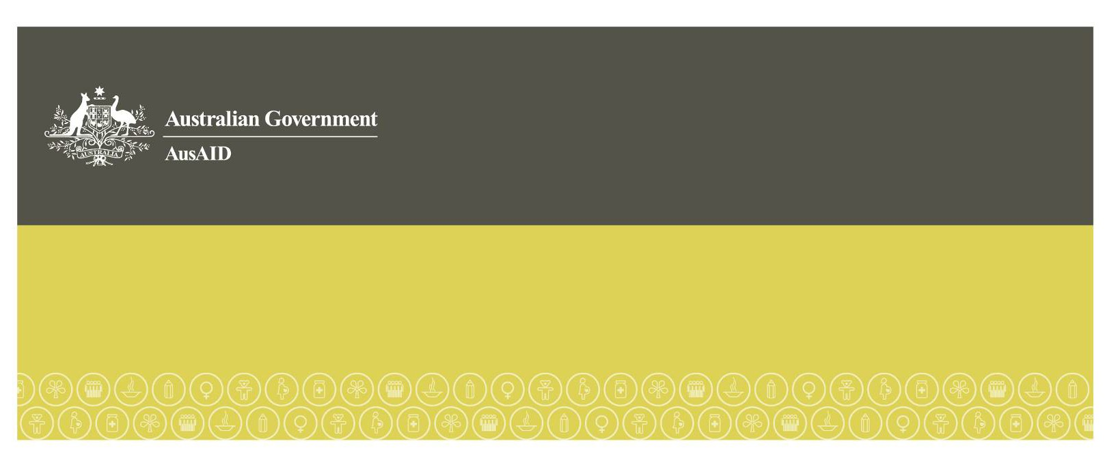Annual Thematic Performance Report 2009-10: Gender Equality and Women’s Empowerment

June 2011

Overview

## Background

**Promoting gender equality and empowering women is an overarching objective of Australia’s aid program.** This is the goal of Millennium Development Goal 3 (MDG 3), and is central to the achievement of all other MDGs. AusAID works with partners to help meet gender equality goals and targets in the following priority areas:

* ensuring equal access to gender-responsive health and education services;
* addressing three persistent challenges where progress has been slow:
* participation of women in leadership, decision-making, and peace-building;
* women’s economic empowerment; and
* safety and security of women and girls at home, in their communities, and in disaster and conflict situations.[1]

The Annual Thematic Performance Report 2009-10 (ATPR) summarises the work carried out in meeting this objective across the aid program. It will provide input to the development of a performance monitoring framework, and establishment of baselines and targets, as the aid program scales up and responds to the findings of the Aid Effectiveness Review. The framework used for this ATPR has four levels: Aid Program, Country Program, Initiative and institutional effectiveness.

## Findings

Nearly half of all expenditure (48%) in 2009-10, or $1.57 billion, was on activities with primary or secondary objectives of improving gender equality and empowering women. More than 70 per cent of this was in the health, education, and governance sectors, and aligned to the gender equality priorities. It appears that gender-related expenditures are growing in line with the aid program.

Eighty-two per cent of all Initiatives over $3 million that complete Quality at Implementation reports rated performance on integrating gender equality as satisfactory or above. At the Initiative level, new marker questions in Aidworks, and new sections in the Quality at Entry (QAE) and Quality at Implementation (QAI) forms are helping to drive the integration of gender into design and implementation. This indicates a good level of mainstreaming. Gender stocktakes/audits undertaken in four countries validated these findings and helped to identify specific areas for improvement in individual programs.

However, with gender-related expenditures potentially reaching $4 billion a year in 2015 if current trends continue, simply saying we mainstream gender equality well is not sufficient. We need to be able to show that this has contributed to making significant changes in gender equality and women’s empowerment at a country level.

While most Country Programs have gender-related expenditure totalling more than half of their program, only two countries contributed to analysis of gender issues in the country; and engagement in policy dialogue on gender equality and women’s empowerment was limited to two notable cases. Three Country Programs (including the two largest programs) had a gender equality strategic plan in place to help guide where these expenditures were targeted. There are numerous anecdotal examples of significant impacts from AusAID-funded Initiatives but there is no systematic way of monitoring outcomes and impact at a country level.

There are still a number of “black holes” in the monitoring where expenditures on gender equality and women’s empowerment is not being tracked. This includes the one fifth of Official Development Assistance (ODA) 2[2] that goes towards contributions to multilateral agencies and global funds, much of the humanitarian and emergency response work, as well as budgets allocated to other whole of government agencies. We need to engage in dialogue with our major partners, especially the World Bank and Asian Development Bank (ADB), and undertake gender audits in specific areas such as humanitarian and emergency assistance to understand better why the gender-related expenditures in these areas is lower than expected and how we work with our partners in new ways to improve the gender-related impacts.

## Recommendations

The integration of gender equality in the aid program needs to move from a focus on the process of mainstreaming gender at the Initiative level, to one that strategically and effectively addresses gender issues and closes gender gaps, including through engagement in policy dialogue on gender equality in partner countries and with partner organisations.

This will require a change in focus in how gender is addressed in country strategies. More strategic approaches need to be adopted by country teams with a focus on effectiveness which is carried through purposefully into delivery strategies. Most importantly, monitoring frameworks at Country Program level need to be designed to systematically collect information on outcomes.

This needs to come with a greater recognition of the role played by Gender Focal Points, and strengthening of the technical support given to them, and to country teams. Accuracy of data needs to be improved by providing clearer guidance to staff on completing the Aidworks marker questions, and the QAIs.

More detailed recommendations are provided at the end of this report (Section 7).

# Purpose of this report

In 2010, a draft paper was prepared on the *Gender Equality Priorities of Australia’s Aid Program* to reflect some of the significant changes that are occurring in development generally and in the aid program. The paper will be finalised later in 2011 to include recommendations of the Aid Effectiveness Review and the Government’s response to it. The paper proposed that gender equality and women’s empowerment remain an overarching objective of the aid program, and that priority areas for focus would be:

1. ensuring equal access to gender-responsive health and education outcomes;
2. addressing three persistent challenges where progress has been slow:

* participation of women in leadership, decision-making, and peace-building;
* women’s economic empowerment; and
* **safety and security** of women and girls at home, in their communities, and in disaster and conflict situations.

The ATPR examines what an “overarching principle of the aid program” means in terms of how we monitor and report against this. We look at how we report progress against the stated priorities and on our international and national commitments which include:

* Convention on the Elimination of all forms of Discrimination Against Women (CEDAW);
* Millennium Development Goals including MDG 3: Promoting gender equality and empowering women;
* Reporting on the integration of gender in the aid program to OECD DAC; and
* UN Security Council Resolution 1325 on Women, Peace and Security.

The ATPR will inform the development of a performance monitoring framework, and establishment of baselines and targets, once the draft gender equality priorities paper is finalised in late 2011.

# Monitoring Framework

An overview prepared for the AusAID Audit Committee in early 2011 identified key questions on four different levels of investigation that AusAID needs to be able to answer in order to ensure that we are adequately complying with our commitments and making progress towards our objectives. This has been developed into a monitoring framework (Table 1) which forms the basis of this report.

The analysis has highlighted a number of gaps and challenges in our current ability to articulate our achievements systematically and convincingly. These can now be addressed so that subsequent reports can be improved in the coming years.

Table 1. Framework to measure gender equality and women’s empowerment responses in the aid program

| **Level of Investigation** | **Key Questions** | **Source of Information** |
| --- | --- | --- |
| **Aid Program Level** | How has Australia contributed to achieving MDG3? | Aidworks  *Proposed Office of Development Effectiveness(ODE) evaluation 2011\** |
|  | What is the geographical and sectoral expenditure on activities with primary or significant objective of gender equality or women’s empowerment? | Aidworks  *Sectoral gender audits\** |
|  | How does this align with aid program gender priorities (leadership, economic empowerment, safety and security)? | Aidworks |
|  | How do we work with Australia and global partners to promote gender equality and empower women? | Aidworks  *High level policy dialogue discussion outcomes\** |
|  | Is AusAID-funded research on gender informing program design? | Australia Development Research Awards (ADRA) |
| **Country Program level** | Does the Country Program respond strategically to addressing the priority gender issues in the country? | Country Situational Analyses (CSA)  Country level gender analysis Country program Gender Action Plans/Strategies |
|  | Does the country team engage in policy dialogue on gender equality, and does the program contribute to improving national indicators for gender equality and women’s empowerment? | APPR  *Country program monitoring frameworks\** |
|  | Does the Country Program effectively and efficiently integrate gender? | APPR  Country Gender stocktakes |
| **Initiative level** | Does the design of Initiatives effectively respond to gender issues, ensure women and men benefit from the Initiative, and mitigate negative impacts on women? | QAE |
|  | Gender responsive interventions in Initiatives and activities are implemented well and lead to outcomes | QAI |
| **Institutional level** | Gender balance in staff at all levels [3] | Human Resource records |
|  | Are there adequate numbers, and capacity of staff to undertake the work required? | Gender team |
|  | Agency capacity developed | Gender team |

* Sources proposed in the future but where information is not currently available.

# Aid Program Level

3.1 Australia’s contribution to promoting gender equality and empowering women (MDG 3) in 2009-10

Forty eight per cent of ODA expenditure***[4]*** in 2009-10, or $1.57 billion, was spent on activities with primary or significant objectives that support gender equality and women’s empowerment. Moreover, the indications are that this expenditure is increasing in line with increases in ODA.

Figure 1: Gender related expenditure: total and as percentage of ODA

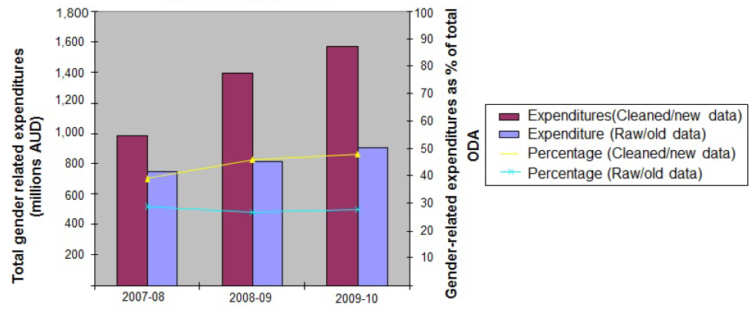

A best estimate of the trend over time is shown in Figure 1.[5] The latest data from Aidworks for 2009-10 shows a significant increase over previous data that has been used, and while more needs to be done to improve the accuracy still further[6], this is now considered to be within a margin of error that provides us with a reasonable baseline for future monitoring. It is important to note that while the two data sets are not comparable with each other, the trend over time for each set is similar. Hence, while attaching accurate figures for expenditures on gender equality is only starting to be feasible, it is relatively safe to say that the expenditures are increasing in line with ODA.

3.2 Sectoral and geographical expenditure on gender equality and women’s empowerment

The highest levels of gender expenditure as a percentage of total sector expenditure are in health, education, and rural development. Gender-related expenditures as a percentage of total sectoral expenditures are shown in Figure 2. Health and education stand out, perhaps not surprisingly given AusAID’s focus on maternal and child health, and the flagship education program. Perhaps more surprising is that rural development and food security, at 58 per cent of total sectoral expenditure, comes out ahead of governance (48 per cent). More work is needed to understand why the percentage of expenditure in the humanitarian and emergency response sector is lower than expected.

Figure 2. Sectoral expenditure on activities with primary or significant gender equality objectives 2009-10

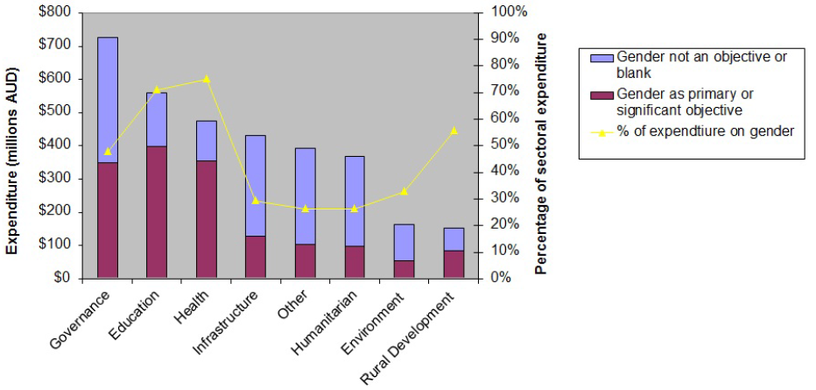

The percentage of Country Program expenditures on gender-related Initiatives ranges from 39 per cent to 88 per cent in the 12 largest Country Programs (Figure 3). It is encouraging that some countries with the greatest gender gaps and constraints such as East Timor, Bangladesh, and Iraq, have the highest percentage of the program targeted at addressing these. It also raises questions in countries such as Papua New Guinea, Afghanistan and Pakistan which have equal or greater challenges for promoting gender equality or empowerment of women, as to whether more could be done. [7]

Figure 3. Country Program expenditure on activities with primary or significant gender equality objectives 2009-10

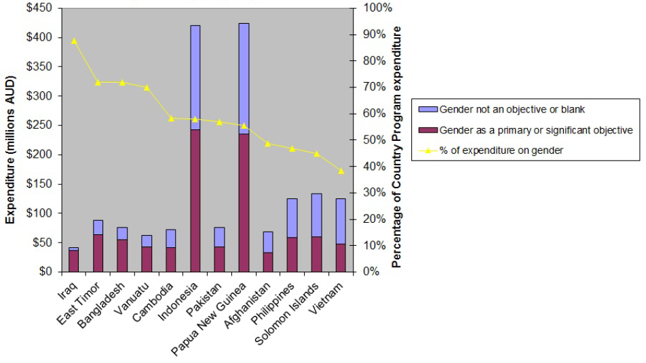

3.3 Alignment of expenditure with gender equality priorities

More than three quarters of the total ODA gender-related expenditure aligns with the AusAID stated priorities for gender equality and women’s empowerment as described in Section 1. New questions in Aidworks will allow us to break down expenditures on these priorities in the future; however, since this is not yet available, we have used sectoral breakdowns as proxies for the purpose of this report (Table 2).

Table 2. Sector gender expenditure proxies for gender equality priorities

| **Aid program gender equality priority** | **Proxy measurement for 2009-10** |
| --- | --- |
| Equal access to gender responsive health | Percentage of expenditure on activities with gender objectives in the health sector |
| Equal access to gender responsive education | Percentage of expenditure on activities with gender objectives in the education sector |
| Participation of women in leadership, decision-making, and peacebuilding | Percentage of expenditure on activities with gender objectives in the governance sector |
| Women’s economic empowerment | Percentage of expenditure on activities with gender objectives in the rural development and food security sector |
| Safety and security of women and girls at home, in their communities, and in disaster and conflict situations. | Since expenditures cut across health, law and justice, and “other/multisector” it is not possible to attach a proxy to this priority |

Figure 4. Gender-related expenditure by sector

The division of gender equality expenditure between sectors in 2009-10 is shown in Figure 4.

**By far the most significant expenditures on gender equality are in health, education and governance.** When rural development is included, 76 per cent of the gender related expenditures align with the gender equality priorities. If we were able to separate out the expenditure on safety and security of women and girls from the humanitarian and “other” gender-related expenditures, the percentage would be higher still. An example of how Australia’s support for ensuring safety and security of women and girls evolved in 2009-10 is given in Box 1.

Box 1. Safety and security of women and girls: Responding to violence against women in Melanesia and East Timor

Research by the Office of Development Effectiveness in 2008, found that violence against women in Melanesia and East Timor is severe, pervasive and constrains development. Between2007-08, and 2009-10 Australia doubled funding for programs addressing violence against women in Melanesia and East Timor to an estimated $13.6 million.

In response to the ODE report, a framework for action was prepared around the three priority areas of ensuring women’s access to justice; ensuring women’s access to support services; and preventing violence against women. Australia is providing practical support to partners in government and civil society in Vanuatu, Papua New Guinea, Fiji, East Timor, and Solomon Islands to deliver coordinated and comprehensive responses for example, counselling services, provision of shelters, and legal reforms. Australia also contributes to global and regional trust funds to support groups and organisations working to end violence against women in the Pacific.

3.4 Working with global partners to promote gender equality

Global programs, civil society partnerships, and contributions to core funding of multilaterals account for one fifth of ODA but expenditure on gender equality and women’s empowerment is unclear. These Initiatives show up as “World unallocated” in the regional breakdown of expenditures (Figure 5). The percentage of expenditure in this category identified as having gender-related objectives is 33 per cent. Partner organisations where gender equality is a primary objective include UN Women and some NGOs. Those where gender equality is a significant objective included, for example, UNICEF, UNDP, most NGOs, WHO, and various HIV/AIDS global initiatives.

However, contributions to the International Development Agency, World Food Programme and Global Environment Fund enter that gender equality is not an objective, or leave the question unanswered, as do the allocations for the Asian Development Fund, and funds allocated for humanitarian assistance, research, and environment and climate change.

Figure 5. Regional expenditure on activities with primary or significant gender equality objectives 2009-10

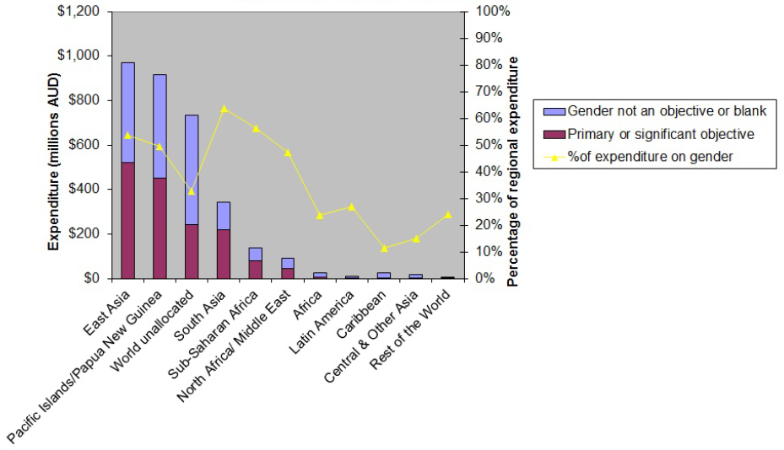

By working in partnership with different agencies, Australia has contributed to and been able to influence and add value to their work to have a greater impact on gender equality and women’s empowerment (Box 2.)

Box 2. Contributing to, influencing and adding-value to programs funded by multilaterals to improve gender equality

***Education for All Fast Track Initiative (FTI)*** works on achieving gender parity in education. The FTI is Australia’s major global partner for education. It was launched in 2002 and is the only global education fund helping poor countries to provide children with a quality education. AusAID has provide more than $50 million over four years (to 2010-11). Some of the FTI’s gender equity achievements include the following.

* In sub-Saharan Africa, girls account for 62 per cent of all new children entering school in FTI partner countries.
* In 2008 more than two thirds of girls completed the last grade of primary school in FTI partner countries compared to 56 per cent in 2002.
* Out of 43 FTI partner countries, boys and girls in 12 partner countries now equally complete a full cycle of primary education, an increase from seven countries in 2000-01. The gender parity goal in primary completion rates is within reach for 15 other partner countries.

In Laos, Australia worked with the World Bank in several different ways to improve the gender- responsiveness of their programs. For example, together with other donors, Australia and the World Bank supported the government’s education sector through a Sector Wide approach (SWaP) using partner government systems. AusAID was influential in maintaining a focus in the program on the issues of ethnic minority girls, who have had the least access to education services in the past, and ensuring appropriate monitoring indicators track progress.

Also in Laos, despite subsidised connections to electricity, a number of very poor households, including a high proportion of the households headed by women, could not connect to the electricity supply provided through the World Bank-funded Rural Electrification Project, as they could not afford to wire their houses. Australia provided a grant to the state-managed electricity company to start a house-wiring fund through which loans were provided to these households to pay private sector electricians to wire their houses. The loans are repaid through the normal billing system and the funds on-lent to poor households in other villages. This has significantly added value in ensuring the poorest, and female headed households can also benefit from the Rural Electrification Project.

3.5 Alignment of the research program on gender with operations

The link between research programs with a gender theme funded under the Australia Development Research Award program and operations needs to be strengthened. The list of research projects funded between 2007 and 2009 is given in Table 3. The findings of one of these programs were integrated into gender training for AusAID staff provided in 2010, and also used to inform the development of AusAID’s strategy for water supply and sanitation. More opportunities such as these need to be found to ensure better use of research findings to improve effectiveness of the aid program.

Table 3 Research programs with gender theme funded through ADRA 2007 to 2009

| **Question** | **Research Lead** | **Country** | **ADRA Amount** |
| --- | --- | --- | --- |
| **2009** |  |  |  |
| Triple jeopardy: gender-based violence, disability, rights violations and access to related services among women in Cambodia | Monash University | Cambodia | $537,403 |
| Measuring gender equality outcomes of economic growth in the Pacific: working with communities to develop indicators that monitor change | University of Western Sydney | Fiji  Solomon Islands  Vanuatu | $241,688 |
| **2008** |  |  |  |
| Fair Trade in the Pacific: Empowering Women Producers in Value-Added Markets | Regulatory Institutions Network (RegNet), ANU | Pacific Region | $161,797 |
| Masculinities and Violence in Indonesia and India | University of Newcastle | Indonesia  India | $116,526 |
| Making the invisible visible: documenting successes, enablers and measures of engendering water and sanitation initiatives in the Pacific to inform policy and practice* | Institute for Sustainable Futures, University of Technology, Sydney | Pacific | $152,500 |
| **2007** |  |  |  |
| Gender, status and empowerment: A study among women who work in Sri Lanka's export processing zones (EPZs) | Edith Cowan University | Sri Lanka | $131,600 |
| Budgeting for women's economic empowerment: The practices of and potential for gender responsive budgeting in the Asia Pacific region | Hawke Research Institute for Sustainable Societies, University of South Australia | Samoa or Vanuatu Indonesia/ Philippines/ or Vietnam | $199,138 |
| Integrating gender and reproductive health issues in the Indonesian national school curricula: challenges for Moslem societies | Australian National University | Indonesia | $210,000 |
| Islamic organisations and women's empowerment in Indonesia | University of Adelaide | Indonesia | $136,000 |

*Findings of this research were used in capacity building programs for AusAID staff

3.6 Expenditure managed by Gender Policy and Coordination Section

Expenditures administered by the Gender Policy and Coordination Section including allocations to UNFEM**[8]** core budget more than doubled in 2009-10 (Table 4). Apart from the UNIFEM core funding, the Gender Thematic Fund more than doubled support for activities to reduce violence against women (from $1.2 million to $2.7 million), and also contributed $1 million to an ADB fund to improve the integration of gender equality into infrastructure projects in Southeast Asia.

A small drop in allocations for capacity building from $314,000 to $250,000 was more than offset by increased number of staff and advisers, and the mobilization of the Gender Panel of specialists to provide additional advisory services to the agency.

Table 4. Changes in expenditures administered by the Gender Policy and Coordination Section (in millions AUD)

|  | **2007-08** | **2008-09** | **2009-10** |
| --- | --- | --- | --- |
| **Gender Thematic Fund** | $2.5m | $2.05m | $4.59m |
| **UNIFEM core contributions** | $1.4m | $1.6m | $3.6m |
|  | **$ 3.9m** | **$3.68m** | **$8.19m** |

# Country Level

We need to look at the country level, and at what has been achieved, to know whether AusAID’s gender-related expenditures have been effective at promoting gender equality and empowering women. Due diligence is needed in the way all Initiatives are developed to ensure equal distribution of benefits, mitigation of disproportionate negative impacts, and to improve efficiency and sustainability of the investment. This is often referred to as “mainstreaming” and will be looked at in Section 5. However, improving gender equality at a national level needs a more strategic approach where persistent gaps and barriers are identified and actions taken to close or remove them. In this section we look at the extent to which AusAID’s Country Programs are being strategic in helping countries to meet their goals and objectives with respect to gender equality and women’s empowerment.

4.1 Identifying priority gender issues at the country level

Most donors have some requirement to prepare a gender assessment or profile of a country to contribute to their strategy development. Often donors will work together with the government agency responsible to support preparation of such an assessment that is country owned. AusAID has not participated in these in the past and only in a few countries has this happened. In 2009-10, a country gender analysis was carried out in preparation of the Country Situational Analysis in the **Philippines** and the **Indonesia** country team initiated their participation in a multi-donor and government collaboration to produce a series of sectoral briefs.

4.2 Responding strategically to improving country level outcomes in gender equality and women’s empowerment

A Gender Equality Strategy prepared for the Papua New Guinea program - *Equality Matters: A strategic approach to Gender Equality for AusAID PNG program* - is an exemplary document to guide a Country Program. The gender strategy identifies the key country issues, the government’s objectives and approach, and then comprehensively identifies how Australia can respond to this within the context of the Country Program.

A gender action plan was also prepared for the **Indonesia** program which was endorsed by the management team at the end of 2009. The **Philippines** already had an existing action plan that covered this period.

The objective should be for all substantial Country Programs to prepare something to guide their gender work in the country more strategically towards achieving outcomes in line with priorities of the key gender equality stakeholders in the country.

4.3 Engaging in policy dialogue on gender equality

The ODE report on *Violence against women in Melanesia and East Timor: Building on global and regional promising approaches* in 2008 was instrumental in catalysing dialogue around violence against women in the **Pacific Islands** (Box 3). In ***Vietnam*** AusAID worked with UNIFEM to engage in policy dialogue with the government around the introduction and implementation of a Gender Equality Law, and were instrumental in introducing it into the Poverty Reduction Support Operation[9] (PRSO) as one of the triggers for release of payment.

**Philippines** is the only Country Program to fully align with country systems for promoting gender equality and empowering women. The program’s focus on improving quality in sustainability, monitoring and evaluation extended to its efforts to integrate gender. AusAID uses the guidelines provided by the government for integrating gender into their programs and, along with other donors, is expected to report annually to the government on the degree to which it integrates gender equality in the aid program in the country.

Box 3. Engaging in policy dialogue to support gender equality

In August 2009, Australia’s Prime Minister joined with leaders from across the Pacific in committing to eradicate sexual and gender based violence. The Pacific Islands Forum Leaders recognised that sexual and gender-based violence was a risk to human security and a potential destabilising factor for communities and societies. Leaders committed to support efforts to address sexual and gender-based violence, including ensuring that all individuals have equal protection of the law and equal access to justice. These commitments are part of the 2009 Pacific Islands Forum Communiqué and have been followed up with actions by national governments.

4.4 Contributing to improving country level outcomes

***Information on outcomes is not systematically recorded although there are a lot of good achievements.*** The Annual Program Performance Reports (APPRs) have a section on the quality of the gender work in the portfolio but the information was often presented in an ad hoc manner, and rarely included information on progress against stated targets, nor on the outcomes achieved. The Quality at Implementation reports sometimes included more information but the reporting was still ad hoc and not reported against intended actions or outcomes. Quality assurance processes also do not examine agency performance but focus only on implementing partners’ efforts.[10] There are, however, a lot of good things happening in the aid program and Table 5 draws a sample of the achievements reported in the APPRs and QAIs.

Table 5. Examples of achievements against AusAID gender equality priorities

| **Priority area** | **2009-10 Achievements** |
| --- | --- |
| **Education** | In the **Philippines,** AusAID-funded Basic Education Assistance for Mindanao has a gender coordinator and funds for allocating to partner service providers to implement their required gender strategies; female education staff in the Autonomous Region in Muslim Mindanao have been supported to take up training manager roles. |
| **Health** | Through its support to **Cambodia’s** national health sector, AusAID helped strengthen reproductive health services in 10 districts: deliveries by trained staff increased from 44 per cent in 2005 to 71per cent in 2010; the proportion of pregnant women that received at least two antenatal care services increased from 69 per cent in 2005 to 89 per cent in 2010; and conceptive prevalence rate for modern methods rose from 29 per cent in 2005 to 35 per cent in 2010 (CDHS 2010 & MoH report data). AusAID support (through UNFPA)to the 10 districts complements the GAVI projects and forms a small proportion of overall support in those areas. |
| **Women’s**  **economic empowerment and livelihood security** | In West New Britain in **Papua New Guinea**, women were helped to harvest the fallen fruit of the oil palm. The funds for women were paid directly into the women’s individual bank accounts The program resulted in over 1,000 women opening their own bank accounts and having independent access to their earnings for the first time.  In **Bangladesh**, Australia supported BRAC to provide a comprehensive support package (including productive assets e.g. cow or goats, stipends and training) to 21,675 extreme poor women in 2010 to develop sustainable income generating enterprises. Sustainability of this approach is demonstrated by the fact that 98 per cent of beneficiaries from previous intakes remained above the poverty line four years after completion. |
| **Women’s leadership** | In **Papua New Guinea** in 2009, Australian aid supported more women to take up leadership positions in government, business, and education and within their communities.   * 330 district women's facilitators have been trained on how to visit, train and support school boards and their local communities, covering most of the 3,000 primary schools in the country. * New women village court magistrates recruited and trained across the country was up from 10 in 2004 to 384 by the end of 2009. |
| **Ending violence**  **against women** | The **Indonesia** Australia Legal Development Facility supported research into the barriers faced by poor people in accessing courts (around 50 per cent of whom are estimated to be women), which directly resulted in the 2009 State budget for Religious Courts increasing 18 fold compared to two years ago. This means that more people had their court fees waived and in 2009, 86 per cent of applicants for divorce who had their fees waived were women: domestic violence is a factor in almost 80 per cent of divorce cases. |

4.5 Ensuring consistency across the Country Program

Gender stocktakes or reviews can help better understand how the whole program is integrating gender equality and where the opportunities for improvement lie. Stocktakes were completed in **Laos** and **Papua New Guinea** and were initiated in **Solomon Islands** and **Indonesia**.

# Initiative Level

5.1 Gender equality adequately considered during design of Initiatives

***New questions on gender in the Quality at Entry peer review forms are improving the attention to integrating gender into design***. The new questions introduced in 2009-10, ask about how gender had been integrated into the design and whether potential negative impacts on women or men had been identified and mitigated. This prompted design teams to consult with the gender advisers or seek specialist assistance. No Initiative can proceed unless a score of at least four out of six has been achieved and a number of designs needed to be revised.

5.2 Gender-related interventions and considerations in implementation

***Eighty-two per cent of all Initiatives over $3 million that completed Quality at Implementation (QAI)[11]*** reports were rated satisfactory or above for integration of gender. This lagged slightly behind the QAI overall average of 88 per cent for the aid program for 2008 (2009 Annual Review of Development Effectiveness).

Analysis of the ratings for the six largest Country Programs (Figure 6) shows a wide variation between countries. Since most of these ratings are given by country teams, at least part of the variation is probably due to differences among the country teams in the standards they apply.

Figure 6. Quality at implementation ratings for gender equality in the six target country programs

Bar chart showing the quality of implementation ratings for gender equality in the six target country programs:
Vietnam: Satisfactory or above (95%), less than adequate or below (4%).
East Timor: Satisfactory or above (87%), less than adequate or below (8%).
Indonesia: Satisfactory or above (81%), less than adequate or below (19%).
Papua New Guinea: Satisfactory or above (81%), less than adequate or below (19%).
Philippines: Satisfactory or above (72%), less than adequate or below (28%).
Solomon Islands: Satisfactory or above (45%), less than adequate or below (54%).





Figure 7. Quality at implementation ratings for gender equality across sectors

Bar chart showing the quality of implementation ratings for gender equality across sectors:
Education: Satisfactory or above (91%), less than adequate or below (9%).
Environment: Satisfactory or above (89%), less than adequate or below (11%).
Humanitarian: Satisfactory or above (82%), less than adequate or below (18%).
Governance: Satisfactory or above (77%), less than adequate or below (23%).
Rural Development: Satisfactory or above (76%), less than adequate or below (24%).
Health: Satisfactory or above (75%), less than adequate or below (25%).
Infrastructure: Satisfactory or above (72%), less than adequate or below (28%).


The only Country Program with a systematic approach is the **Philippines** where the Government of Philippines requires donors to mainstream gender into their programs according to a common set of guidelines and checklists used by all donors, and the donors are required to report annually on their progress. The criteria used are also used by the country team as a basis for the QAI entries. This systematic approach is likely to lead to more consistent integration of gender into the programs, and also to more realistic ratings.

The variation caused by country team subjectivity is borne out in the ratings by sector (Figure 7). The variation here is less significant. However, it is also notable that the ratings for the health, rural development and governance sectors, where the percentage gender expenditures are highest according to Aidworks, have a higher percentage of less than adequate Initiatives. On the other hand, the environment and humanitarian sectors which seem to fare well here were seen earlier in this report to have lower gender-related expenditures. This anomaly needs further investigation. One explanation is that many Initiatives in this sector would be exempt from the QAI process due to their emergency nature.

# Institutional Effectiveness

6.1 Adequate numbers and capacity of staff

***The Canberra Gender Team expanded over the year***. At the end of 2009-10 the Gender Team in Canberra was comprised of the Gender Policy and Coordination Section with a director and staff of five, and the Adviser cadre comprised of a Principal Adviser and two further Gender Advisers – one focusing on ending violence against women. This was up from just three people in the Gender Team at the start of 2008-09.[12] A panel of gender specialists was selected and contracted and can be mobilised through a help desk function. Several pieces of work were undertaken to assist design or provide background papers for programs.

***A Community of Practice was established***. At the start of the 2009-10 year, the Gender Thematic Network was made up of over 300 members from all over the agency and at all levels. It included senior management as well as staff that had been appointed as Gender Focal Points (GFPs) in some of the sections and posts. This was too many to work constructively with, and therefore functioned simply as a mailing list to which information was sent around periodically. During the year efforts were made to formalise the role of the GFPs and increase the networking between them by forming a Community of Practice (CoP), leaving the Gender Thematic Network as the Community of Interest (CoI). This two tiered system allowed greater information sharing between the CoP, more direct support and advice directly to them, and training and networking activities to be developed for them. At the end of the year the CoP was comprised of around 40 members. The challenge was ensuring that this role was built into performance plans, and supported by their managers.

***Several Posts increased their staffing capacity to address gender equality in their program.* Indonesia** established a Gender Unit in early 2010 to play a coordination and capacity building role for staff and recruited a Gender Unit Manager to manage it. **Papua New Guinea** and **Solomon Islands** recruited full time Gender Advisers to their teams at Post in 2008 and 2009 respectively.

Gender Advisers were widely employed by implementing partners (managing contractors, NGOs) to prepare gender action plans for different Initiatives and support implementation of them. A significant number of gender analyses carried out as part of project preparation were completed. A number of projects developed gender action plans or strategies. However, the links between Gender Advisers within the implementing partners, and the AusAID gender Community of Practice are weak. Much of the work goes unnoticed and unreported, and opportunities to get a more consistent approach through shared learning are often lost.

6.2 Agency capacity development

***Efforts to build capacity of staff were intensified*:** A series of (six) training sessions for staff were undertaken in Canberra, at country and regional locations. These courses helped to build the basic capacity and understanding of staff regarding gender equality. In addition, modules were introduced into New Starter training, Graduate Training, and other routine training sessions for staff. In May 2010, the first field-based training took place with 12 staff from Indonesia Post who were all nominated or volunteered as Gender Coordinators. The training was organised in partnership with Oxfam and involved visits to a number of activities being implemented by local civil society partners in Indonesia to promote gender equality and empower women.

***The Gender Team was engaged in Peer Reviews though the effectiveness of this needs to be assessed.*** Between October 2009 and end June 2010, the Gender Team participated in 114 peer reviews. Each one represents about a day and a half of work. Extrapolated over a year, the review burden is therefore the equivalent of one full time position. There is some anecdotal evidence that these reviews do have an impact on improving the gender analysis and preparation of Gender Action Plans for Initiatives, including from gender specialists in the field who feel their inputs were listened to because AusAID had requested them in the reviews. However, there may be better ways to achieve the same thing by getting more people already working on the designs to take on more of the responsibility, freeing the Gender Team to work more strategically.

Table 6. Peer reviews undertaken October 2009 to June 2010

| **Appraisal** | **Concept** | **ATPR/APPR** | **Independent Completion Report/QAI/Strategies** | **Other** |
| --- | --- | --- | --- | --- |
| 51 | 15 | 14 | 16 | 18 |

***New systems were introduced.*** The new sections on gender in the QAE and QAI reports and the new marker questions introduced into Aidworks have raised the attention of staff to gender related aspects of project design and implementation. They have also started to provide a rich body of data that has been used in the preparation of this report.

# Recommended Actions

Aid Program level

* ***Gender team*** to improve and verify the data by i) improving guidance to staff, and ii) cross checking against country stocktakes.
* ***Gender team*** to set 2015 targets for gender-related expenditures by extrapolating the current percentages, and taking account of projected country spend (in relation to seriousness of gender issues for development), and additional funding to priority areas.
* ***Relevant sector/thematic groups, supported by Gender team,*** to undertake sectoral gender audits to better understand the way different sectors respond to gender priorities. Humanitarian and emergency response would be a good sector to prioritise.
* ***Relevant Branch, with Gender Team,*** to broaden dialogue with the World Bank and look at how we can most effectively partner with them to ensure the gender focus in International Development Assistance (IDA) 16 is operationalised. Partnerships with East Asia and Pacific department and with the South Asia Region department of the World Bank are already ongoing but need to broaden to include partnerships with the Africa and Middle East Regions as well. Dialogues with the Asian Development Bank, and potentially with the African Development Bank need to be increased.
* ***Relevant branch, with Gender team,*** to ensure greater alignment of AusAID funded research with the gender priorities of the aid program and to more effectively use and disseminate lessons learned from research into programming decisions and choices.
* ***Office of Development Effectiveness (ODE)*** to undertake evaluation of AusAID’s contribution to helping partner countries meet MDG3.

Improving effectiveness at the Country Program level

The integration of gender equality in the aid program needs to move from a focus on the process of mainstreaming gender, to one that strategically and effectively addresses gender issues and closes gender gaps, including through engagement in policy dialogue on gender equality in partner countries.

* ***Country programs, with Gender Advisers,*** to support analytical work on gender at a country level – preferably in coordination with other donors and government, and identify key gender issues in Country Situational Analyses. Larger programs to have a strategy in place that guides their gender work with the aim of achieving monitorable outcomes. Where possible the strategy should align with the country’s own priorities.
* ***Relevant Branch, with Gender Team,*** to help develop guidelines for strategically integrating gender into country and delivery strategies.
* ***Country teams*** to integrate gender equality indicators into country monitoring frameworks. Ensuring monitoring and performance assessment frameworks are designed to facilitate the collection of information on outcomes and compile these at a country level will give a better picture of Australia’s contribution to achieving gender equality and empowering women. Monitoring at the Country Program and delivery strategy level, if aligned to track against indicators and targets, will enable appropriate management responses to be identified in a timely manner.

Improving gender integration at the Initiative level

* ***Gender team, with relevant branch,*** to revise and improve guidance to staff on completing marker questions and Quality at Implementation and Quality at Entry input.

Organisation

* ***Gender Advisers*** to work on equipping and improving the effectiveness of the Community of Practice.
* ***Gender Team*** to revisit and revise AusAID capacity building plan, with a focus on improving the tools and resources made available over the intranet, including e- learning modules, and on peer learning, knowledge sharing and mentoring opportunities.

Annex 1. A note on the data used in this report

The report draws on two main AusAID data sets, the first is the information collected from marker questions answered by Activity managers in Aidworks, and the second are the ratings given for gender equality in the Quality at Implementation reports prepared for all activities under implementation valued at over $3 million, except for those that have been given exemptions. The difference in the information collected from these two sources is shown in the table below.

Summary of the difference between Aidworks and QAI gender data

| **Aidworks marker questions** | **QAI ratings** |
| --- | --- |
| Mandatory at the Activity level | Mandatory at the Init iative level unless an exemption is given |
| Monitors whether or not the Activity has a *primary* or a *significant* objective to promote gender equality or empower women | Monitors how gender has been mainstreamed into the Initiative, the progress during implementation, and results achieved |
| Records results in terms of value of the Activities with primary or significant objectives to promote gender equality and empower women | Records the results in terms of the number of Initiatives across a range of scores |

However, changes made in the Aidworks marker questions mean that comparisons with previous years must be treated with a degree of caution.

Prior to this, data was collected from maker questions asked at the Init iative le vel which were not mandatory. This raised two critical issues. The first was one Initiative may have included several activities, one of which may have had a gender equality objective. If this was noted as a significant objective for the whole Initiative, the total amount of the Initiative, and not just that Activity, was counted toward the ‘gender spend’. On the other hand, if an Activity was ignored because gender equality was a ‘minor’ part of the Initiative (not a primary or significant objective), it was not counted toward the ‘gender spend’. Moreover, since this led to much confusion among those recording the information, and since the question was not mandatory, it was often just left with no response. The result was an enormous level of inaccuracy and very crude figures, and while some effort was made each year to manually clean the data and improve the quality, this was laborious and subjective.

Since November 2010, new questions are mandatory, and focused at the Activity level, leading to a better quality of data able to be drawn from the system. The questions were answered retrospectively for all activities over $500,000 in the 2009-10 financial year. Hence while there is still room for improvement in coming years, the margin of error is now considered to be sufficiently reduced to a level where the 2009-10 information can set a baseline for coming years, and allow for assumptions to be made and targets set that will guide the monitoring of AusAID funding for gender equality and women’s empowerment in the future.

1. This paragraph is taken from the draft paper “Gender Equality Priorities for Australia’s aid program” prepared in 2010 in consultation with whole of government partners and which will be revised in 2011 to reflect the Government’s response to the Aid Effectiveness Review.
2. References to ODA in this report refer to ODA administered by AusAID.
3. Not covered in this report
4. As noted above, references to ODA in this report refer to ODA administered by AusAID.
5. Two sets of data are used which are considered to be relatively comparable across time, though not to each other. “Cleaned/new data” for 2007-08 and 2008-09 is raw data from Aidworks at the Initiative level, cleaned manually by GPCS, and for 2009-10 is the data from Aidworks responding to the new mandatory questions at Activity level. “Raw/old data” for all three years is the data from Aidworks at the Initiative level prior to cleaning by GPCS in 2007-8, and 2008-9, and retrospective input of Activity level responses to the new mandatory questions added in November 2010 for 2009-10 activities. Further information about the data used in this report is included at Annex 1.
6. The new questions added to Aidworks in November 2010 were answered retrospectively for all Initiatives valued at over $500,000. There are a significant number of activities within Initiatives of lower values than this. However, they add up to a relatively small percentage of the total ODA which was felt to be acceptable. These smaller activities will be included in the 2010-11 figures.
7. There is still a degree of subjectivity in the way the Aidworks questions are answered which may mean that data is not yet completely comparable across Country Programs.
8. UNIFEM no longer exists since January 2011 when it was merged with several other agencies to become UN Women.
9. PRSO is a World Bank lending instrument for providing budgetary support against the introduction and implementation of policies to reduce poverty.
10. AusAID Education Resource Facility Meta-Review of AusAID Education Sector Evaluations 2006-2010, March 2011, see pp.4-5, [https://www.ausaiderf.com.au//uploads/ERF10239_EducationMetaEvaluation.pdf](https://www.ausaiderf.com.au/uploads/ERF10239_EducationMetaEvaluation.pdf)
11. See Annex 1 for a note on the data used in this report for an explanation of the difference between the Aidworks marker questions and the QAI

    ratings.
12. Note that this level of staffing was in part due to staff vacancies. At the start of 2008-09, there were six positions in the Gender team – a Gender Adviser, Director and four staff (one of which was part-time). The positions of Principal Gender Adviser and Adviser Ending Violence Against Women were created in 2008-09.