gender action platform (GAP)

CHANGING GENDER norms

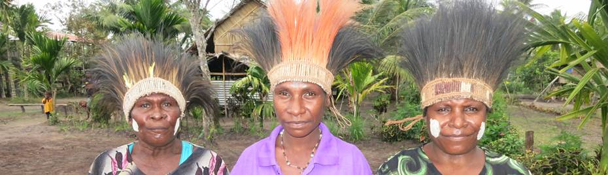

Photo credit: Bruce Bailey

GAP Summary

The Gender Action Platform (GAP) strengthened Australian non-government organisation (ANGO) programming to achieve gender equality outcomes in developing countries. In summary:

* The GAP included six projects addressing women’s economic empowerment, gender-based violence and women’s leadership.
* The GAP design prioritised innovation, collaboration, and shared learning
* Implementation dates: July 2017 to December 2020
* The GAP reached 226,131 people including 144,139 women and girls (64%); 96,340 women (42%) and 47,779 girls (21%) and 4,217 people with disabilities (2%).

participating NGOs, PROJECTS and locations

|  |  |  |
| --- | --- | --- |
| Lead NGO | Project | Location |
| Marie Stopes International Australia and WaterAid Australia | 'I'm Prepared' Equality for refugee women in the return- reintegration context | Papua New Guinea and Timor-Leste |
| Act for Peace | Action Against Gender Violence: Engaging Men, Youth and Children | Sri Lanka, India, Thailand and Myanmar |
| ActionAid Australia | Keeping girls in school through improved reproductive and menstrual health | Cambodia, Kenya, Vanuatu |
| CARE Australia | Gender Responsive Alternatives on Climate Change | Cambodia, Myanmar |
| ChildFund Australia | Rights, Respect, Resilience: skills for safe, equitable and respectful relationships | Papua New Guinea |
| World Vision Australia | Enhancing Women's Voice to Stop Sexual Harassment (STOP) | Papua New Guinea, Vanuatu |

Gender norms

Gender norms are the expectations to which women and men generally conform within a society, culture and community at a point in time. Gender norms inform roles, attitudes and behaviours of men and women within households and society. **Changing gender norms is a long-term process**. However, **changes in knowledge, attitudes, and behaviours are indicators of norms change** and can be measured in shorter project phases. Often gender equality projects only erroneously report on numbers of people that attend training or workshops and increased understanding of gender equality issues but do not measure attitudes and behaviours.

Strategies for addressing gender norms

In many contexts where the GAP projects were implemented, women had limited decision-making access; therefore, **supporting women’s leadership and decision-making** was a key strategy in most projects. For example, **ActionAid Australia** in Cambodia, Kenya and Vanuatu increased women’s knowledge on the gendered impacts of climate change and confidence building through leadership skills training and exchanges with women leaders. Norms were shifted by increasing women’s access to male-dominated government decision making processes about climate change policy. As a result, women reported having more status with their communities and increased influence in decision-making in public and private spheres.

GAP partners also specifically **addressed harmful attitudes that support violence against women**. For example, **CARE Australia** found that men’s and women’s attitudes and behaviour toward sexual harassment had changed for factory managers and female employees. In Myanmar, from the baseline to the evaluation, the proportion of factory managers who believe *‘it isn’t sexual harassment if the worker did not immediately complain about the behaviour’* halved from 1 in 3 to 1 in 6. In Cambodia, the baseline found 1 in 5 women had observed *‘inappropriate touching embracing or kissing a co-worker without their consent’.* However, in the evaluation, only 6% reported this behaviour.

Projects focused on **adolescent boys and girls** aimed to change attitudes and offer children alternatives to entrenched gender norms and **promote generational change in gender relations**. For example, two GAP projects (**ChildFund Australia and Marie Stopes International Australia /Water Aid Australia)** focused on adolescent boys and girls in schools and communities to address their attitudes to gender equality and sexual and reproductive health. Both projects found that teachers' attitudes had to be addressed through intensive training to ensure they had sufficient knowledge and supportive attitudes toward menstruation, sexual and reproductive health and respectful relationships.

‘There has been a big change in the community about women’s leadership. A lot of community people feel confident to raise their concerns and family issues and share them in public. In the past this did not happen.” Pursat - Deputy Commune Chief (ActionAid Cambodia)

Lessons

All projects reported that three years was a short timeframe to substantially change attitudes and behaviours. Some indications of change in attitudes were reported, but **harmful attitudes often proved to be persistent**:

* **World Vision Australia** reported some changes in attitudes regarding the acceptability of violence

against women in PNG and Vanuatu. However, a substantial proportion of program participants and change agents, including violence counsellors, still thought that there were instances in which it was acceptable for women to be beaten.

* **ActionAid** **Australia** learned that although female leaders felt a higher degree of trust from male leaders, Women continued to face cultural barriers to their expanding leadership and advocacy roles due to the patriarchal norms.
* **CARE Australia** found that while there was a decrease in reported instances of sexual harassment following the CARE sexual harassment prevention project in factories, 40% of female workers in Myanmar still felt it would be risky to act against sexual harassment in their factories.

Norm change programs need to be underpinned by **robust data collection processes**. GAP projects used knowledge, attitude and behaviour (or practice) surveys, and qualitative information, which is good practice. However, many projects had methodological issues in data collection, such as slightly different baseline and end-line questions or inconsistent sampling. These issues made it difficult to report on percentage changes in attitudes. Three of the six GAP projects worked with universities to support longitudinal data studies, which demonstrated incremental attitude changes.

The theory of change is also crucial to norms change projects. Some of the projects focused on **expected attitudes in primary change agents** such as private sector organisations and government officials, along with attitude changes expected in project participants. Including the expected attitude of change agents is essential because the attitudes and behaviours of change agents influence the attitudes of project participants. Many projects also measured the attitudes of project staff which is good practice.

GAP projects documented challenges in **balancing exposure versus reach for training activities** aimed to change attitudes. That is, whether to target a large number of training participants (high reach) or to work with few training participants and work more intensively (high exposure). GAP projects found that it was more effective to focus on a smaller group of people because grasping the fundamental concepts of gender equality and then applying them takes time.

Recommendations

NGOs can improve norms change projects through:

* **Gender analysis** to understand norms, attitudes and behaviours within the context.
* Ensure that **project designs** **include expected** **attitudes and behaviours of key change agents** (teachers, government staff, violence support service providers) in theories of change along with staff and project participants.
* Invest in staff training on **data collection** to measure changes in knowledge, attitudes, and behaviours related to gender equality or get support from universities or specialist research organisations. Results may demonstrate that attitudes do not change quickly, and interventions need to be continually adapted.
* Focusing **intensely on fewer target groups and/or locations** rather than spreading project resources thinly across many communities.
* **Consider resistance and backlash**. Challenging norms can result in violent backlash. Recommendations for managing resistance and backlash are included in the GAP Engaging Men and Boys summary.