Australia and the GAVI Alliance
Saving lives through immunisation March 2012

The challenge
Every year nearly two million children die from vaccine-preventable diseases, mainly in developing countries. That’s one child every 20 seconds. Immunisation not only saves lives but promotes health, allowing children to fully benefit from opportunities such as education. Good health leads to social and economic development enabling people to reach their full potential as active and productive members of society.

What is GAVI?
The GAVI Alliance is a unique public/private partnership of international organisations, donor governments, developing countries, financing institutions and vaccine manufacturers committed to protecting people’s health through increasing access to immunisation.

AusAID and GAVI
Australia, through AusAID, is supporting the GAVI Alliance to provide life-saving immunisations in the world’s poorest countries. GAVI is a critical partner for AusAID in meeting our objective of saving lives, improving maternal and child health, and achieving the Millennium Development Goals (MDGs). Since 2006, Australia has provided $94 million to GAVI and has committed to provide a further $140 million by 2013. Australia is also providing $250 million over 20 years to GAVI’s International Finance Facility for Immunisation. Australia’s support to GAVI and IFFIm helps countries build their health systems by providing better maternal and child health care services, training health staff, improving health facilities, and supplying essential drugs.

Since 2000, AusAID and GAVI have contributed to:
- the immunisation of more than 325 million children against a variety of preventable diseases in the world’s poorest countries
- the prevention of 5.5 million deaths through immunisation against preventable diseases
- the development and roll out of new vaccines that protect against pneumonia and diarrhoea – the two leading killers of children under the age of five
- an increase in vaccine coverage to 82 per cent in developing countries, with a particular focus on the poorest children
- a significant reduction in global vaccine prices.
Photo: UNICEF, 2010 – Habibul Haque (Bangladesh)
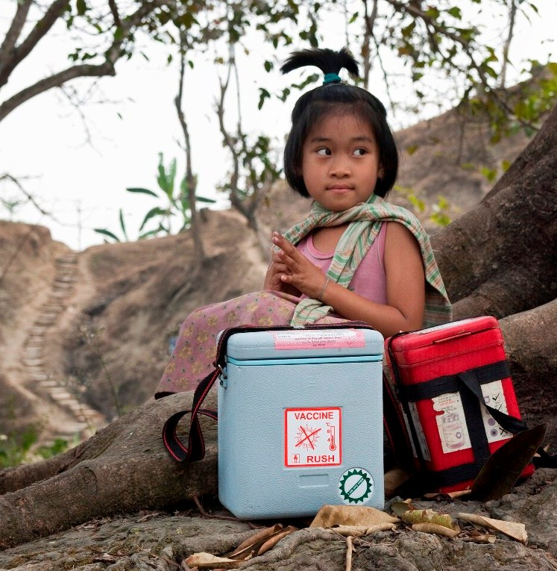

In our region
AusAID and GAVI are committed to working together to improve health in the Asia Pacific region, making a real difference to the lives of children:
- in Cambodia, GAVI-supported programs helped double the number of vaccinations in just three years: from an estimated 20 per cent of children in 2006 to 39 per cent in 2009
- the immunisation of more than 25 million children in Bangladesh, which prevented more than 215,000 deaths from preventable diseases
- a significant increase in the number of infants vaccinated against whooping cough, diphtheria and tetanus in Vietnam (96 per cent coverage) and the Solomon Islands (81 per cent coverage)
- the prevention of 170,000 deaths from preventable diseases in Indonesia, through the vaccination of more than 21 million children
- the introduction of the pentavalent vaccine –which protects children against five deadly diseases (diphtheria, tetanus, whooping cough, hepatitis B and meningitis) - in Papua New Guinea, East Timor and Burma.

This shows how many lives can be saved when diverse partners come together with a single focus.

The future
Australia and GAVI are proud of the achievements to date, but there is more to be done to ensure children can lead healthy and happy lives. By 2015 Australian support to GAVI will help:
- prevent a further 3.9 million deaths from preventable diseases
- accelerate the roll-out of new vaccines, including those which prevent pneumonia and diarrhoeal illness in children
- introduce vaccinations that prevent cervical cancer for girls and women in developing countries
- immunise 588 million children against rubella, preventing severe birth defects.
Australia will continue to support effective organisations, like GAVI, to save lives in our region. Australia’s contribution to GAVI is expected to immunise 7.7 million children in the world’s poorest countries by 2015.

Photo: GAVI, 2010 – Christine McNab (Laos)

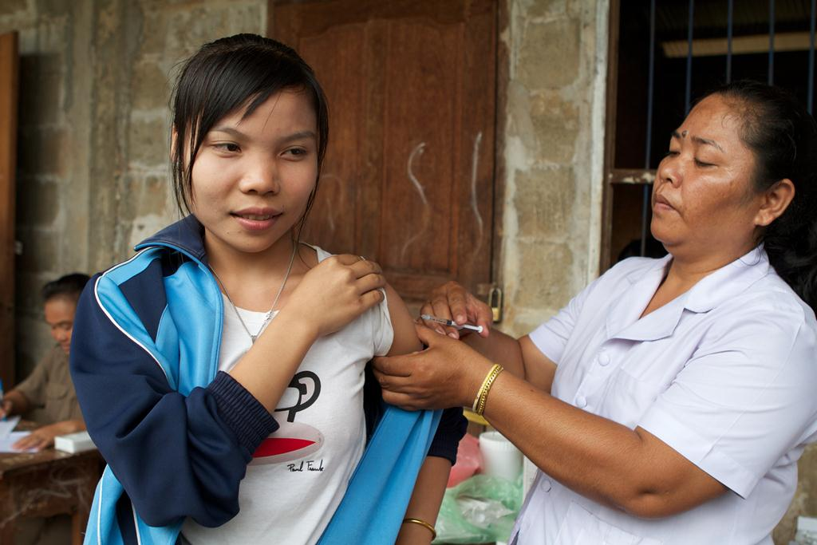
www.ausaid.gov.au I www.gavialliance.org

