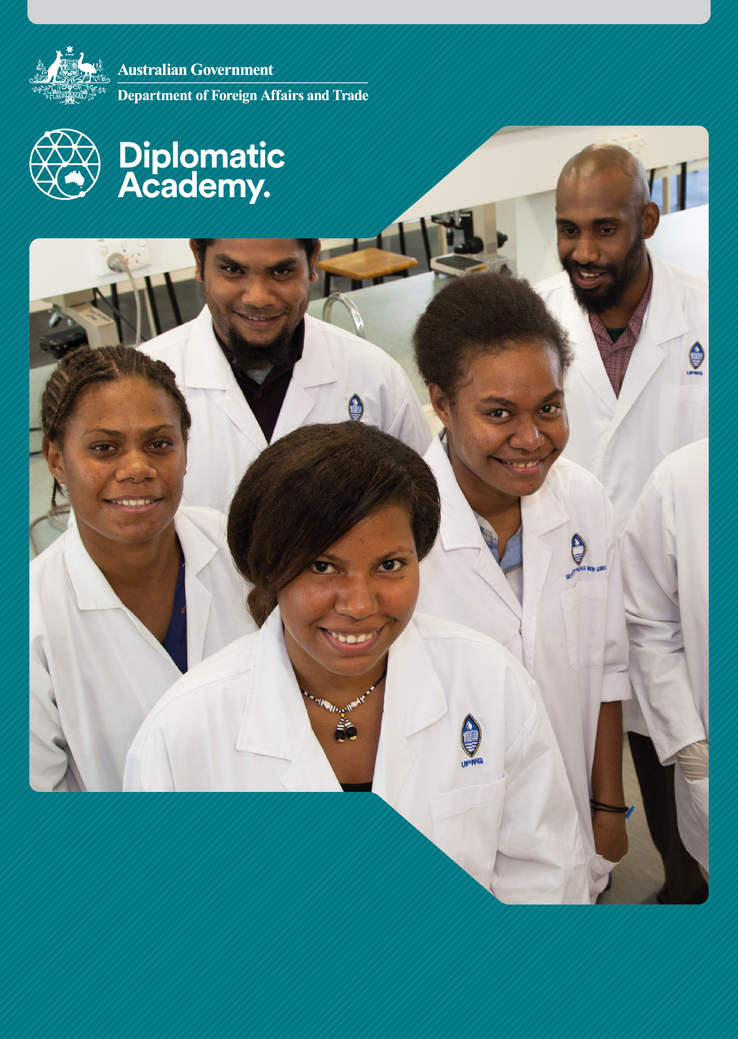

**Higher education**

Foundation Level

2018

Education Learning and Development Module

CONTENTS

Acronyms 3

1 Introduction 4

2 What is higher education? 4

3 How is higher education typically structured? 6

4 How is higher education financed? 8

5 Why is higher education important for development? 9

6 What are the key challenges facing higher education in partner countries? 11

7 Test your knowledge 15

References and links 19

# Acronyms

ISCED International Standard Classification of Education

OECD Organisation for Economic Cooperation and Development

PNG Papua New Guinea

TVET technical and vocational education and training

UNESCO United Nations Educational, Scientific and Cultural Organization

UIS UNESCO Institute of Statistics

UNITECH PNG University of Technology

USP University of the South Pacific

# Introduction

The purpose of this module is to provide introductory information about the importance, structure, purpose, key issues and outcomes of higher education. It provides a foundation to engage in this topic and apply advice from staff with operational or expert levels of knowledge in education. On successful completion you will be able to be an informed participant in forums related to higher education.

# What is higher education?

|  |
| --- |
| Definitions  There is no simple internationally accepted definition of ‘higher education’. However, the term has been traditionally associated with universities.  Higher education is now widely used internationally to refer to levels of education and training programs regardless of the institution that offers them. In many countries, including Australia and New Zealand, there is considerable overlap between the levels of programs offered by universities and by other institutions such as colleges and institutes of technology.  Higher education builds on the level of competence, knowledge, and skills normally acquired in secondary education. The exact definition of this level, and consequently of higher education and of a higher education institution or program, varies from one country to another. |

|  |
| --- |
| Key points to remember  **What does ‘higher education’ mean for your country program or a developing country known to you?**  In Australia higher education generally refers to education at degree level or above.  In most developing countries higher education refers to post-secondary education or tertiary education where a degree, diploma, or certificate is awarded at the end of study. In this context, the term is inclusive of aspects of technical and vocational education and training (TVET).  Many international development agencies prefer to use the broader term, tertiary education. |

## How higher education relates to tertiary education

Tertiary education is any type of formal education program, short duration or long duration, available to those who have generally graduated from secondary school. Tertiary education includes general, vocational, academic and professional qualifications offered by universities, other higher education institutions and by specialist TVET institutes, colleges or centres.

## What happens in other countries?

Some countries use the term tertiary education as synonymous with the terms post-secondary and higher education. Others categorise their post-secondary and tertiary education levels in accordance with UNESCO’s [International Standard Classification of Education (ISCED)](http://uis.unesco.org/sites/default/files/documents/international-standard-classification-of-education-isced-2011-en.pdf).

This classification system distinguishes between:

post-secondary non-tertiary (Level 4) programs (mostly TVET programs that prepare students for direct labour market entry)

short-cycle tertiary (Level 5) programs (sub-degree TVET and university programs)

Bachelor or equivalent (Level 6) programs

Master or equivalent (Level 7) programs

Doctoral or equivalent (Level 8) programs.

Source: UNESCO Institute for Statistics 2011.

## How does the Australian aid program view tertiary education?

The Australian aid program divides tertiary education into three categories by institution type:

universities

other higher education institutions (mostly teachers’ colleges and colleges of nursing)

TVET institutes/colleges.

# How is higher education typically structured?

## What happens in other countries?

Many countries have a government body that is dedicated to the oversight of higher education. For example, Indonesia’s Directorate General of Higher Education and Fiji’s Higher Education Commission.

Most universities have some degree of autonomy. This is in contrast to most TVET institutions and colleges. Many universities operate under their own act of parliament and set their own curriculum. Others function within the framework of a general education act or, more specifically, a higher education act.

|  |
| --- |
| Case studies: Higher education in other countries  Indonesia  There are four types of higher education institution: universities, institutes, academies, and polytechnics. These have experienced dramatic growth since independence:   * 1950 – 10 institutions of higher learning with a total of about 6,500 students. * 1970 – 450 private and state institutions enrolled about 237,000 students. * 1990 – 900 institutions with about 141,000 teachers and nearly 1.5 million students. * 2009 – 2,975 institutions of higher education and more than 4.2 million students. Of these institutions, 3 per cent were public with 57.1 per cent of the student enrolment, and 97 per cent were private, with 42.9 per cent of the student enrolment. * 2015 – 4,384 institutions with almost 7 million students. Of all institutions 91.5 per cent are private, with the balance being public.   Nevertheless, total student enrolment is low for a country with a population of about 258 million.  The government subsidies finance approximately 80 to 90 per cent of state-university budgets. Private institutions have budgets that are almost entirely tuition fee-driven. Universities with a religious affiliation may receive donations or grants from religious organisations.  The government provides only limited scholarship support for students wishing to attend private universities. |

|  |
| --- |
| The Pacific  There are 31 higher education institutions of which 12 are universities.  Established in 1968, University of the South Pacific (USP) is one of only two universities of its type in the world. It is jointly owned by the governments of 12 member countries: Cook Islands, Fiji, Kiribati, Marshall Islands, Nauru, Niue, Samoa, Solomon Islands, Tokelau, Tonga, Tuvalu and Vanuatu.  The university has campuses in all member countries, with the main campus, Laucala, in Fiji. It offers programs through distance and flexible learning in a variety of modes and technologies.  **Other higher education institutions in Pacific countries**  In Papua New Guinea (PNG), the higher education system is overseen by the Commission for Higher Education and the Office of Higher Education, under the supervision of the Minister for Higher Education, Research, Science and Technology. Most higher education institutions have been established since independence in 1975.  Public universities include the PNG University of Technology (UNITECH), University of Goroka, University of Papua New Guinea, and University of Vudal. Private universities include the Pacific Adventist University and Divine Word University.  Higher education provision is small relative to the national population and to the demand for professional and technical skills.  In other Pacific countries, several higher education institutions offer certificates and diplomas in teaching and/or nursing. For example, Vanuatu College of Nurse Education and Tonga Institute of Education.  **What can we conclude from these case studies?**  Conclusions from the case studies are as follows:   * there is a wide range of public and private higher education institutions in partner developing countries, both in terms of their size and the diverse nature of the courses they offer * the provision of higher education has grown rapidly, but there is considerable potential for further growth. |

# How is higher education financed?

## Where does the funding come from?

Worldwide, there has been rapid growth in the number of students enrolled at higher education institutions and this has led to a steady decline in public expenditure on a per student basis. Many higher education institutions are struggling to cope. In many systems, there is an increasing reliance on private sources of income, particularly student tuition fees.

### Public sources

There are wide variations in individual country approaches to financing higher education. In most partner countries the majority of the funding comes from public sources, which include:

* bulk grants and per student subsidies (the main sources of public funds for most higher education institutions)
* capital funding for specific purposes such as new buildings or equipment
* scholarships
* funding for specified research projects

provision of student loans.

### Private sources

Private sources include:

* student tuition fees (the main source of private funds for most higher education institutions)
* privately funded scholarships
* donations and endowments
* sponsorships

consultancy fees.

For more information view the modules on *Education Financing*.

# Why is higher education important for development?

## Knowledge and skills

Knowledge and advanced skills are critical determinants of a country’s economic growth and standard of living. Tertiary education institutions support knowledge-driven economic growth strategies and poverty reduction by:

* training a qualified and adaptable labour force – including professionals, technicians, high-level scientists, teachers in basic and secondary education, and future government, civil service, and business leaders
* generating new knowledge

providing the capacity to access existing global knowledge and adapt this knowledge to local use. Sustainable development and economic growth are compromised without the capacity-building contributions of an innovative higher education system, especially in low-income countries with weak institutional capacity and limited human capital.

The [Sustainable Development Goals](http://www.un.org/sustainabledevelopment/sustainable-development-goals/) now include targets related to higher education under Goal 4: Quality Education. The targets are:

* by 2030, ensure equal access for all women and men to affordable and quality technical, vocational and tertiary education, including university

by 2020, substantially expand globally the number of scholarships available to developing countries, in particular, least developed countries, small island developing States and African countries, for enrolment in higher education, including vocational training and information and communications technology, technical, engineering and scientific programmes, in developed countries and other developing countries.

Source: [United Nations 2015a](http://www.un.org/sustainabledevelopment/sustainable-development-goals/); United Nations 2015b, [Sustainable Development Goal 4 Targets](http://www.undp.org/content/undp/en/home/sustainable-development-goals/goal-4-quality-education/targets/).

## Economic benefits

Higher education is a powerful driver of economic growth. The [2017 Global Gender Gap Report](http://www3.weforum.org/docs/WEF_GGGR_2017.pdf) demonstrates that the key for the future of any country and any institution is the capability to develop, retain and attract the best talent. As women make up one half of the world’s human capital, empowering and educating girls and women and leveraging their talent and leadership fully in the global economy, politics and society are fundamental elements of succeeding and prospering in an ever more competitive world.

The availability of qualified professionals, technicians and workers capable of contributing to productivity growth in all economic sectors is a key component of a country’s development and poverty reduction strategy.

Source: World Economic Forum 2017.

### What are the potential public and private economic benefits of higher education?

Potential private and public economic benefits from tertiary education are wide ranging:

Table 1 – Potential private and public economic benefits from tertiary education

|  |  |
| --- | --- |
| **Private benefits** | **Public benefits** |
| Higher salaries | Greater productivity |
| Better employment prospects | National and regional development |
| Higher savings | Reduced reliance on government financial support |
| Improved working conditions | Increased consumption |
| Personal and professional mobility | Increased potential for transformation from low-skill industrial to knowledge-based economy |

## Social benefits

Higher education opens doors to better living standards and opportunities for people.

Tertiary-educated individuals are employed at a higher rate than people with an upper secondary or post-secondary non-tertiary education. On average across OECD countries, 84 per cent of 25-64 year-olds with a tertiary education were employed in 2015, compared to 74 per cent of those with an upper secondary education.

Source: Organisation for Economic Co-operation and Development (OECD) n.d., [OECD.Stat.](http://stats.oecd.org/)

Similarly, earnings data show a significant premium for tertiary education over upper secondary education. However, gender imbalances mean that women tend to study and become employed in sectors that pay less well than men. For example, males are the majority of graduates in the area of engineering, manufacturing and construction in all but one of 84 countries. There are also significant imbalances in business, science and the law.

Source: UNESCO Institute for Statistics n.d., [UIS Stat.](http://data.uis.unesco.org/Index.aspx)

This matters because the transition from education to paid work is a crucial moment which lays the foundation for many of the inequalities encountered in the labour market throughout women’s working lives.

### What are the potential public and private social benefits of higher education?

Potential private and public social benefits from tertiary education are wide ranging:

Table 2 – Potential private and public social benefits from tertiary education

|  |  |
| --- | --- |
| **Private benefits** | **Public benefits** |
| Better decision-making | Democratic participation; increased consensus; perception that society is based on fairness and opportunity for all citizens |
| Improved personal status | Social mobility |
| Increased educational opportunities | Improved basic and secondary education; greater social cohesion and reduced crime rates |
| Healthier lifestyle and higher life expectancy | Improved health |

# What are the key challenges facing higher education in partner countries?

## Growing national tertiary education provision

Despite some promising changes in recent years, higher education institutions and national governments confront significant challenges in trying to grow tertiary provision which:

* is affordable
* is accessible to a reasonable proportion of their school leavers
* can produce quality graduates who are in demand by employers or have the entrepreneurial skills to create their own jobs

can provide greater equity in higher education availability across genders.

## Some key challenges for higher education in partner countries

### Challenge 1: Recruitment and retention of qualified teaching and research staff

**How could a donor help address this challenge?** Provide funding for staff professional development and institutional strengthening.

### Challenge 2: Low academic standards of many students at entry

**How could a donor help address this challenge?** Support early childhood development, primary and secondary education.

### Challenge 3: Pressure to increase enrolments irrespective of quality or capacity

**How could a donor help address this challenge?** Focus support on improving quality and institutional planning.

### Challenge 4: Barriers to access of marginalised populations especially females and those with a disability

**How could a donor help address this challenge?** Address such barriers by targeting resources (for example, scholarships for specified groups). Includes improved gender equality and participation by people with a disability in performance targets and related monitoring and evaluation frameworks.

### Challenge 5: Outdated curriculum

**How could a donor help address this challenge?** Support curriculum development, based on a labour market analysis.

### Challenge 6: Limited research capacity

**How could a donor help address this challenge?** Support postgraduate scholarships, with post-degree alumni activities; encourage institutional linkages (for example, Australian university linkages with partner institutions); research projects to include international partner and local institution; engagement with national research body.

### Challenge 7: Limited capability to respond flexibly to changes in labour market demand or to deliver innovative training

**How could a donor help address this challenge?** Support robust labour market analysis nationally and/or by the institution itself, and only invest in programs for which there is demonstrated demand.

### Challenge 8: Low level of industry involvement

**How could a donor help address this challenge?** Support the development/engagement of industry advisory groups, where relevant.

### Challenge 9: Inadequate quality assurance mechanisms or benchmarking

**How could a donor help address this challenge?** Support the development of Quality Assurance (QA) systems that are internationally bench-marked; assist the institution to meet quality assurance standards set by a relevant external QA agency (often mandated by government).

### Challenge 10: Funding constraints

**How could a donor help address this challenge?** Support the development and implementation of new programs and/or additional places on existing programs, but link funding to performance (for example, quality-assured graduates).

### Challenge 11: Poor physical facilities including inadequate information technology, libraries and equipment

**How could a donor help address this challenge?** Support the provision of bulk funding for such purposes, to be used to address specific projects identified in the institution’s approved strategic plan. If possible, address such issues in project designs – for example, building refurbishment and equipment funding to support a specified program or group of programs. Supported activities must comply with the Australian aid program’s Accessibility Guidelines.

### Challenge 12: Poor student services and amenities

**How could a donor help address this challenge?** Support the development of new programs and services to enhance student experiences, including staff professional development for those with specific responsibility for student engagement. Encourage collaboration and consultation between higher education staff and student bodies.

### Challenge 13: Safety and security issues affecting both staff and students, especially females

**How could a donor help address this challenge?** Address such issues in project designs (e.g. consultations with relevant stakeholders; analyse challenges and include targets in monitoring and evaluation frameworks).

## Closing the gender gap

In many developing countries, girls have poorer educational attainments, especially at secondary level, and are therefore less well prepared for admission to tertiary education. This is particularly acute where parents believe sons can earn more than daughters and invest where they expect a greater return. Families are also less likely to educate their daughters where the primary role of women is as wife, mother and housekeeper.

### What happens when young women do enter tertiary education?

There are significant inequalities in tertiary education generally, and in relation to the areas of study. When young women do enter tertiary education they are more likely to enter fields of studies that have lower employment prospects and pay. Women are over-represented in the humanities and social sciences, and under-represented in areas such as engineering, science and technology which usually offer better employment prospects and higher pay. This hinders women’s careers, lowers their future earnings levels and deprives the country economy of a source of talent and innovation. When policy makers and planners make decisions about how to allocate scarce resources, investment in women can appear to be an inefficient use.

### How do we close the gender gap in higher education?

These factors mean that closing the gender gap in higher education requires a broad range of policy interventions beyond education itself. It requires changes in employment conditions and job quality so that women can maximise their productivity, earn a living wage, and have access to maternity leave, sick pay and other forms of social protection. Investment in physical and social infrastructure is needed to help reduce time spent on unpaid work and help women access labour markets. Policies to improve women’s access to, and control over, assets and new technologies are also important for gender equality in labour market outcomes.



# Test your knowledge

## Assessment questions

Answer the following questions by ticking ‘True’ or ‘False’. Once you have selected your answers to all the questions, turn the page to ‘The correct answers are...’ to check the accuracy of your answers.

Question 1

Higher education refers only to degree and post-graduate education at universities.

Is this statement true or false? □ True □ False

Question 2

Tertiary education is any type of formal education program available to those who have graduated from secondary school.

Is this statement true or false? □ True □ False

Question 3

Many universities operate under their own act of parliament and set their own curriculum.

Is this statement true or false? □ True □ False

Question 4

In most partner countries the majority of the funding for higher education comes from private sources.

Is this statement true or false? □ True □ False

Question 5

Tertiary education institutions support knowledge-driven economic growth strategies and poverty reduction.

Is this statement true or false? □ True □ False

Question 6

The only people who benefit from higher education are the students who attend higher education institutions.

Is this statement true or false? □ True □ False

Question 7

Key challenges facing higher education institutions in developing countries include limited funding, poor physical facilities and poor student services.

Is this statement true or false? □ True □ False



## The correct answers are...

Question 1

Higher education refers only to degree and post-graduate education at universities.

**This statement is false.** Higher education in Australia generally refers to education at degree level or above. However, in most developing countries, higher education refers to post-secondary or tertiary education where a degree, diploma or certificate is awarded.

Question 2

Tertiary education is any type of formal education program available to those who have graduated from secondary school.

**This statement is true.**

Question 3

Many universities operate under their own act of parliament and set their own curriculum.

**This statement is true.**

Question 4

In most partner countries the majority of the funding for higher education comes from private sources.

**This statement is false**. The majority of funding for higher education comes from public (government) funding.

Question 5

Tertiary education institutions support knowledge-driven economic growth strategies and poverty reduction.

**This statement is true.**

Question 6

The only people who benefit from higher education are the students who attend higher education institutions.

**This statement is false.** Both the individuals who attend higher education institutions and the broader public benefit from their attendance.

Question 7

Key challenges facing higher education institutions in developing countries include limited funding, poor physical facilities and poor student services.

**This statement is true.**

# References and links

**All links retrieved July, 2018.**

Organisation for Economic Co-operation and Development (OECD) n.d. OECD.Stat, <http://stats.oecd.org/>

2017, Education at a glance 2017: OECD indicators, OECD, <http://www.oecd.org/education/education-at-a-glance-19991487.htm>

World Economic Forum 2017, The Global Gender Gap Report, <http://www3.weforum.org/docs/WEF_GGGR_2017.pdf>

United Nations 2015a, Sustainable Development Goals, <http://www.un.org/sustainabledevelopment/sustainable-development-goals/>

2015b, Sustainable Development Goal 4: Quality education targets, <http://www.undp.org/content/undp/en/home/sustainable-development-goals/goal-4-quality-education/targets/>

UNESCO Institute for Statistics n.d., UIS.Stat, <http://data.uis.unesco.org/Index.aspx>

2011, International Standard Classification of Education: ISCED 2011, <http://uis.unesco.org/sites/default/files/documents/international-standard-classification-of-education-isced-2011-en.pdf>

Learn more about…

* *The Global Partnership for Education (GPE), found at:* <http://www.globalpartnership.org/>
* *UNESCO Atlas of gender equality, found at:* <http://www.unesco.org/new/fileadmin/MULTIMEDIA/HQ/ED/pdf/Atlas-chapter5-tertiary-education.pdf>
* *Higher education and economic development in Africa, found at:* <http://siteresources.worldbank.org/EDUCATION/Resources/278200-1099079877269/547664-1099079956815/HigherEd_Econ_Growth_Africa.pdf>
* *The University of the South Pacific, found at:* <http://www.usp.ac.fj/>
* *The trends of higher education in the Asia Pacific, found at:* <http://www.unescobkk.org/education/news/article/trends-of-higher-education-in-the-asia-pacific/>
* *The Australian aid program’s accessibility guidelines, found at:* <http://dfat.gov.au/about-us/publications/documents/accessibility-design-guide.pdf>
* *Gender equality in education, employment and entrepreneurship, found at:* <http://www.oecd.org/education/48111145.pdf>
* *The World Bank’s work in the tertiary education sector, found at:* <http://www.worldbank.org/en/topic/tertiaryeducation>
* *Education in Indonesia in this book by Frederick, Worden and Library of Congress. 2011,* [*Indonesia: A country study*](http://lcweb2.loc.gov/frd/cs/pdf/CS_Indonesia.pdf)*, Federal Research Division, found at:* <http://www.loc.gov/rr/frd/cs/pdf/CS_Indonesia.pdf>
* *Universities in Papua New Guineas in this report by Garnaut and May 2010, PNG universities review: Report to Prime Ministers Somare and Rudd, found at:* <https://dfat.gov.au/about-us/publications/Documents/png-universities-review.pdf>
* *Trends in diversification of post-secondary education in this 2011 article:* Varghese and Püttmann, UNESCO, International Institute for Educational Planning, found at: <http://unesdoc.unesco.org/images/0019/001915/191585e.pdf>