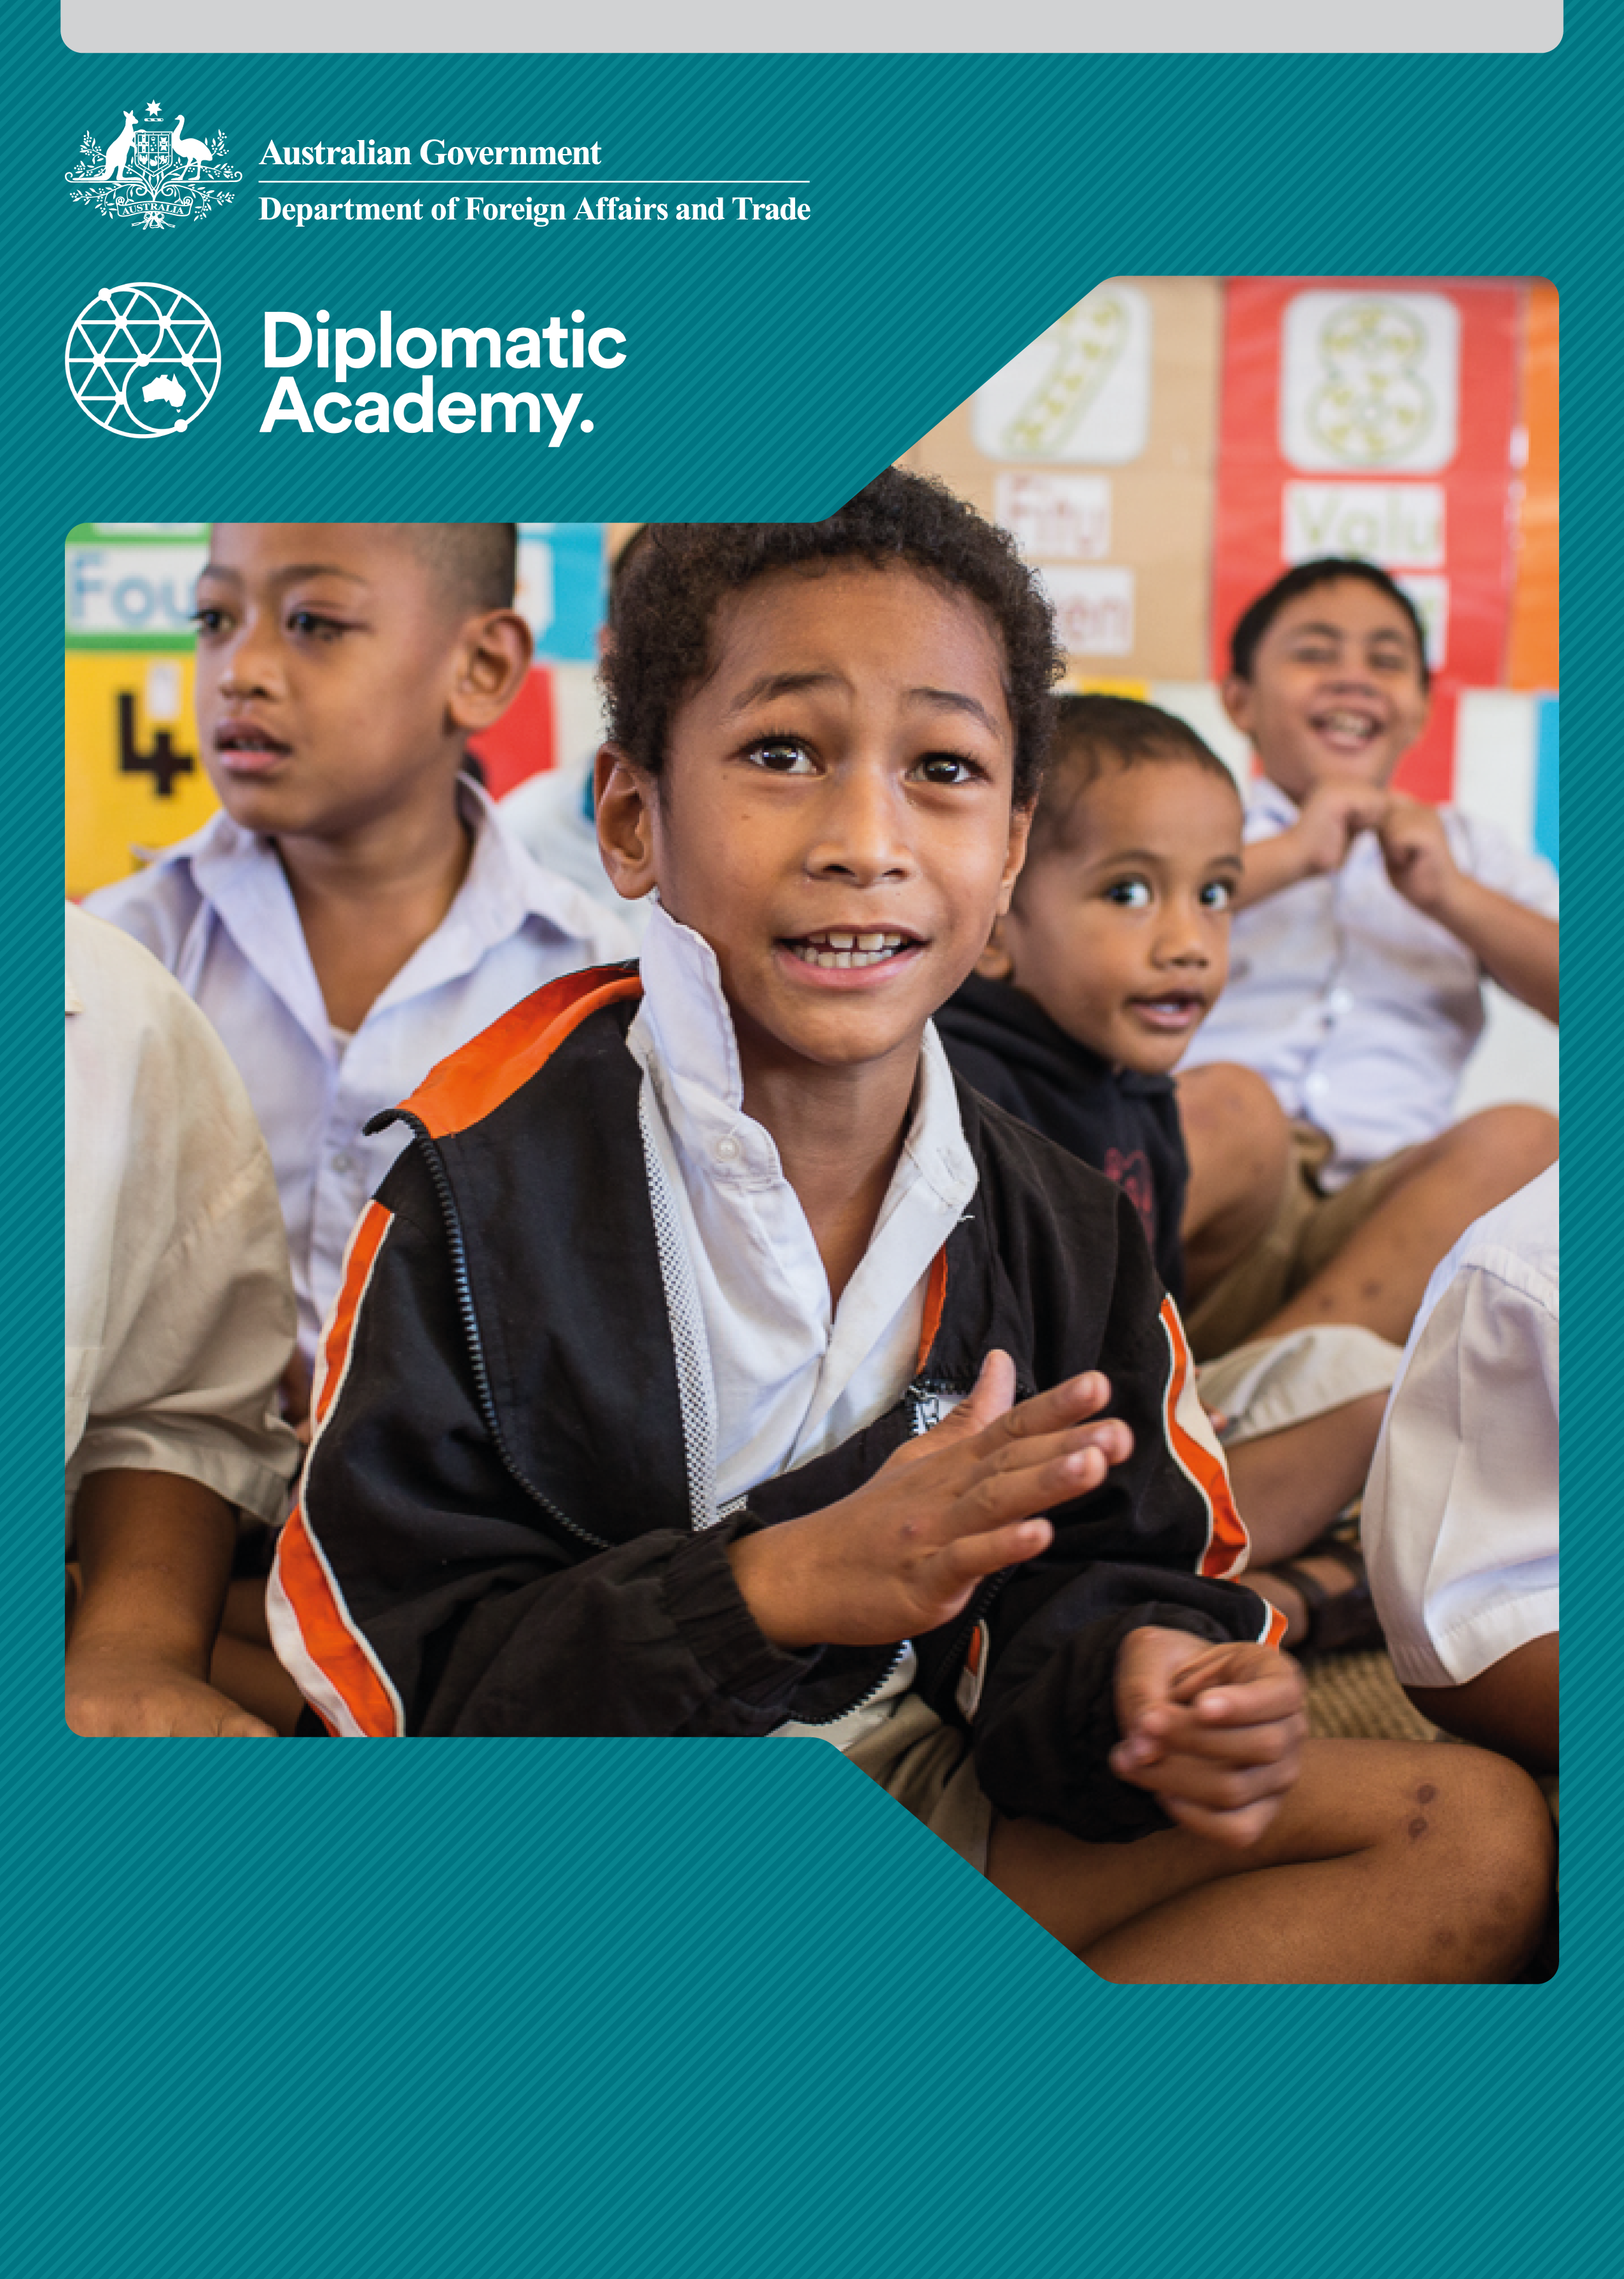

Education Learning and Development Module

**DISABILITY-Inclusive**

**education**

Foundation Level

2019

CONTENTS

Acronyms 3

1 Introduction 4

2 Defining Disability-Inclusive Education 4

3 International Commitments to Disability-Inclusive Education 7

4 Why Invest in Disability-Inclusive Education? 11

5 Disability-Inclusive Education priorities 15

6 How can Development Partners Contribute? 18

7 Test your knowledge 19

References and links 23

# Acronyms

CEDAW Convention on the Elimination of all forms of Discrimination Against Women

CRC Convention on the Rights of the Child

CRPD Convention on the Rights of Persons with Disabilities

DFAT Australian Government Department of Foreign Affairs and Trade

ECE Early childhood education

EFA Education For All

EMIS Education Management Information System

ICESCR International Covenant on Economic, Social and Cultural Rights

PacREF Pacific Regional Education Framework

PFRPD Pacific Framework for the Rights of Persons with Disabilities

PSET Post-school education and training

SDG Sustainable Development Goal

UN-ESCAP United Nations Economic and Social Commission for Asia and the Pacific

UNESCO United Nations Educational, Scientific and Cultural Organisation

USAID United States Agency for International Development

# Introduction

The purpose of this module is to provide introductory information about the rationale, purpose, benefits, key issues and outcomes of disability-inclusive education.

The module focusses on disability-inclusive primary and secondary education, with some reference to post-school education and training (PSET) and early childhood education (ECE). Whilst great gains have been made in access to quality primary education for general populations, fundamental reform is still required to enable access for children with disabilities.

This module provides foundational information to enable engagement in this topic, and the provision of general advice. A deeper presentation of issues and approaches can be found in the *Disability-Inclusive Education: Practitioner Level* module.

# Defining Disability-Inclusive Education

## Inclusive education: a broad definition

|  |
| --- |
| UNESCO definition of inclusive education  Inclusive education has been defined as a process of focusing on and responding to the diverse needs of all learners, removing barriers impeding quality education, and thereby increasing participation in learning and reducing exclusion within and from education.  Source: United Nations Organisation for Education Science and Culture (UNESCO) 2005, [Guidelines for Inclusion: Ensuring Access to Education for All](http://www.ibe.unesco.org/sites/default/files/Guidelines_for_Inclusion_UNESCO_2006.pdf). |

Inclusive education involves creating an education system which ensures the access, participation and learning achievement of all, including people disadvantaged by factors such as disability, gender, poverty, cultural, ethnic or linguistic group, migration, conflict and homelessness.

## Disability-inclusive education

The ‘inclusive education’ agenda has been adopted to refer to inclusion of all marginalised groups in education. As such, the term “disability-inclusive education” is increasingly used to describe efforts that relate specifically to ensuring the inclusion of children (or adults) with disabilities in education.

Sources: Wapling L 2016, [Inclusive education and children with disabilities: Quality education for all in low and middle income countries](https://www.cbmuk.org.uk/wp-content/uploads/2016/05/Quality_Education_for_All_LMIC_Evidence_Review_CBM_2016_Policy_Brief.pdf); Miles & Singal 2009, [The education for all and inclusive education debate: Conflict, contradiction or opportunity?;](https://www.tandfonline.com/doi/abs/10.1080/13603110802265125) Kiuppis F 2014, [Why (not) associate the principle of inclusion with disability? Tracing connections from the start of the ‘Salamanca Process’](https://www.tandfonline.com/doi/abs/10.1080/13603116.2013.826289).

This module focuses on disability-inclusive education because many barriers that cause exclusion from education for children, youth and adults with disabilities are specific to the issues of disability. These require different strategies and actions from those needed to overcome barriers due to poverty, linguistic and cultural minority status, homelessness and others.

Disability-inclusive education enables children (or adults) with disabilities to access education within regular / mainstream schools and learning settings alongside peers without disabilities, in the classrooms they would be attending if they did not have a disability, or within environments that best correspond to their requirements and preferences.

Disability-inclusive education relates to people with all types of disabilities including physical, sensory (hearing, vision), intellectual, communication and psychosocial.

Figure 1 illustrates four models of education in relation to people with disabilities.

* **Exclusion** occurs when people with disabilities are not attending educational settings at all.
* **Segregation** is the use of separate schools or institutions for education of people with disabilities, for example special schools.
* **Integration** is the use of separate classrooms specifically designated for students with disabilities, within the context of regular schools.
* **Inclusion** relates to educating students with disabilities within regular classrooms, ensuring appropriate teaching methods and supports to enable quality education and full participation.

Figure 1 - Models of education - exclusion, segregation, integration, exclusion

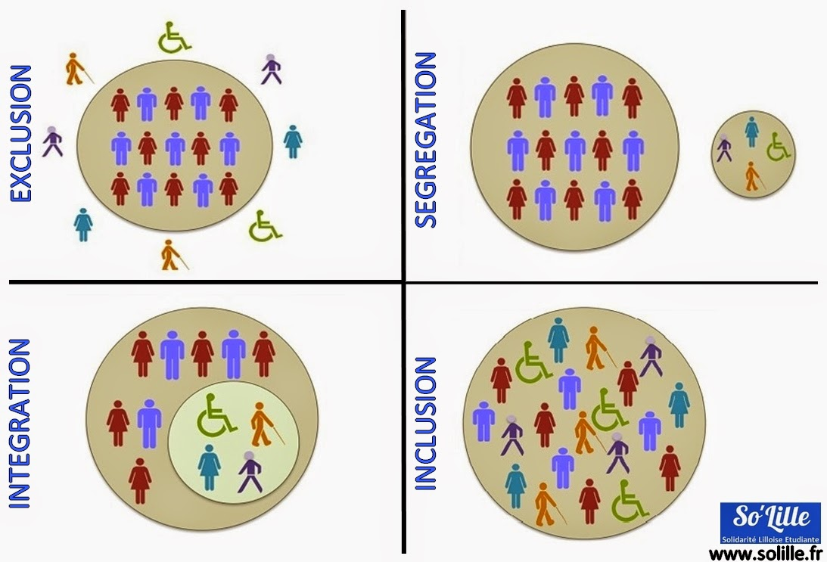  
Source: [Planchamp, C 2019, The inclusive school: Concerning integration in an inclusive school or how best to educate children with special needs.](https://lepole.education/en/pedagogical-culture/63-the-inclusive-school.html?start=1)

### Finding a balance between inclusion, integration and segregation – nuance and caution

|  |
| --- |
| Inclusive education as a human right  Article 24 of the [Convention on the Rights of Persons with Disabilities](http://www.un.org/disabilities/documents/convention/convoptprot-e.pdf) recognises inclusive education as the means to fulfil the right to education for people with disabilities. From a rights perspective, inclusive education is accepted as the most suitable approach to guarantee universality and non-discrimination in the right to education.  However, the reality in many countries is that education of children with disabilities occurs in a range of settings including special schools, integration classes in regular schools as well as in inclusive classrooms.  At certain times, a child with a disability may benefit more from a segregated or integrated setting rather than a mainstream setting. This will depend on the resources available, policies and attitudes in schools, and the nature of the child’s learning needs. This is particularly the case for children who need to learn Braille before enrolling in a mainstream school, children who need to be immersed in a sign language environment to learn the language comprehensively, and for children with high support needs.  Large, noisy classrooms can be overwhelming for some children with behavioural, attention or social difficulties. Periods of learning in a separate space within the mainstream school, particularly while a child is adjusting to school or a new classroom, can support some children to manage high levels of sensory overload.  All countries are at a different point in terms of the provision of education for children with disabilities. These journeys are affected by contextual factors including policy directives and access to resources. Human rights frameworks (see section 3), the perspective of Disabled Peoples’ Organisations, and a great deal of evidence (see section 4) highlights the fundamental need to reform education systems to become inclusive. **However, a high regard for contextual factors and a commitment to long-term reform must be at the heart of development partner approaches to disability-inclusive education.**  Sources: United Nations 2016; Office of the United Nations High Commissioner for Human Rights 2013, [Thematic study on the right of persons with disabilities to education](https://www.ohchr.org/en/issues/disability/pages/studyrightofpersonswithdisabilitiestoeducation.aspx); World Health Organisation & World Bank 2011, [World report on disability](https://www.who.int/disabilities/world_report/2011/report.pdf); World Federation of the Deaf 2016, [Policy - Education rights for Deaf children](https://www.equalrightstrust.org/content/world-federation-deaf-policy-education-rights-deaf-children). |

# International Commitments to Disability-Inclusive Education

## International human rights treaties

The fundamental human right for people with disabilities to access a quality and disability-inclusive education is clearly articulated in many United Nations treaties, as summarised below.

### Convention on the Rights of Persons with Disabilities (2006)

Article 24 of the [Convention on the Rights of Persons with Disabilities](http://www.un.org/disabilities/documents/convention/convoptprot-e.pdf) (CRPD) requires states to ensure inclusive, quality, and free primary and secondary education to people with disabilities on an equal basis with others in the communities in which they live.

Reasonable accommodations and individualised supports must be provided to students with disabilities. Reasonable accommodations, or adjustments, are measures taken to assist students with disabilities to participate in education on the same basis as students without disability. Adjustments can include provision of assistive technology, sign language interpreters or modifications to learning and assessment materials.

Article 24 includes measures to ensure that education for people who are blind, deaf and deafblind is delivered in the most appropriate languages, modes and means of communication for the individual.

States must ensure a disability-inclusive education system at all levels, including post-school education and training, as well as opportunities for lifelong learning, on an equal basis with students without disabilities.

Australia has ratified the CRPD and is committed to its fulfilment, including Article 32 which recognises the importance of international cooperation in support of national efforts for the realization of the purpose and objectives of the CRPD.

Source: United Nations 2016.

### Convention on the Rights of the Child (1989)

Article 28 recognises the right for all children to receive education without discrimination on any grounds. The [Convention on the Rights of the Child](https://www.ohchr.org/en/professionalinterest/pages/crc.aspx) (CRC) is consistent with the International Covenant on Economic Social and Cultural Rights (ICESCR) in promoting the progressive introduction of free education.

Article 23 recognises that children with disabilities “should enjoy a full and decent life”. The CRC promotes the provision of assistance to ensure that children with disabilities have effective access to education, training, health care services, rehabilitation services, preparation for employment and recreation opportunities.

Source: United Nations General Assembly 1989.

### Convention on the Elimination of all forms of Discrimination against Women (1979)

Article 10 obliges states to take all appropriate measures to eliminate discrimination against women in order to ensure to them equal rights with men in the field of education. This implicitly includes women and girls with disabilities, although the [Convention on the Elimination of all forms of Discrimination Against Women](https://www.ohchr.org/en/professionalinterest/pages/cedaw.aspx) (CEDAW) does not contain text specifically addressing women with disabilities. However, in its General Recommendation 18, the UN Committee on the Elimination of Discrimination against Women requested states to report on “measures they have taken to ensure that disabled women have equal access to education” in their periodic reports.

Source: United Nations General Assembly 1989.

### International Covenant on Economic Social and Cultural Rights (1976)

Article 13 recognises the right of everyone to education, and states that primary education should be compulsory and available free to all. The [ICESCR](https://www.ohchr.org/en/professionalinterest/pages/cescr.aspx) also declares that secondary, technical, vocational, and higher education should be made available and accessible to all by every appropriate means, and in particular by the progressive introduction of free education.

Source: United Nations General Assembly 1966.

|  |
| --- |
| An activity for you  **International commitments to disability-inclusive education**  Different countries have made different commitments to disability-inclusive education. These guide policy-making and resource allocation, as well as monitoring and evaluation.  Which international conventions have been signed and ratified by the country in which you are working? |

## International development frameworks

### Sustainable Development Goals (2015)

The education of children with disabilities is embraced within [Sustainable Development Goal (SDG) 4](https://sustainabledevelopment.un.org/) and its roadmap, the [Education 2030 Incheon Declaration and Framework for Action: Towards inclusive and equitable quality education and lifelong learning for all](https://unesdoc.unesco.org/ark:/48223/pf0000245656). The emphasis on achieving SDG 4 for people with disabilities is evident through the requirement for disability disaggregation of many of the Goal 4 indicators.

Note: Indicators are detailed in the *Disability-Inclusive Education: Practitioner* module and are outlined in the list of [SDG Indicators](https://unstats.un.org/sdgs/indicators/indicators-list/).

The Education 2030 document captures the essence of the intent towards inclusion:

“Inclusion and equity in and through education is the cornerstone of a transformative education agenda, and we therefore commit to addressing all forms of exclusion and marginalization, disparities and inequalities in access, participation and learning outcomes. No education target should be considered met unless met by all. We therefore commit to making the necessary changes in education policies and focusing our efforts on the most disadvantaged, especially those with disabilities, to ensure that no one is left behind”.

Sources: [United](https://sustainabledevelopment.un.org/) Nations 2015; UNESCO & World Education Forum 2015; United Nations Department of Economic and Social Affairs 2015.

### Salamanca Statement and Framework for Action on Special Needs Education (1994)

Adopted by the UNESCO World Conference on Special Needs Education in 1994 and signed by 92 countries and 25 organisations, the [Salamanca Statement](http://www.unesco.org/education/information/nfsunesco/pdf/SALAMA_E.PDF) states that “those with special educational needs must have access to regular schools” and that “regular schools with this inclusive orientation are the most effective means of combating discriminatory attitudes, creating welcoming communities, building an inclusive society and achieving education for all; moreover they provide an effective education to the majority of children and improve the efficiency and ultimately the cost-effectiveness of the entire education system”.

The Salamanca Statement declares that schools should accommodate all children regardless of their physical, intellectual, social, emotional, linguistic or other conditions. It includes children with disabilities, gifted children, street and working children, children from remote or nomadic populations, children from linguistic, ethnic or cultural minorities and children from other disadvantaged or marginalised areas or groups.

Source: UNESCO 1994.

### Education for All (1990)

Education for All (EFA) was an international initiative of governments, civil society and development agencies including the World Bank, led by UNESCO, which aimed to meet the learning needs of all children, youth and adults by 2015. It commenced at the World Conference on Education for All in Jomtien, Thailand in 1990, where 155 governments signed the [World Declaration on Education for All and the Framework for Action to meet Basic Learning Needs](https://unesdoc.unesco.org/ark:/48223/pf0000127583). The framework for action included, as one of six main areas of action, “universal access to and completion of primary education”.

Ten years later, in 2000, representatives from 182 countries met in Dakar, Senegal and reaffirmed their commitment in providing Education for All, which culminated in the adoption of the [Dakar Framework for Action](https://unesdoc.unesco.org/ark:/48223/pf0000121147), the goals and targets of which were to be achieved by 2015. It was widely acknowledged that, whilst large improvements in access to education were made for many children during this period, these benefits did not extend to children with disabilities. This was largely because “working children, remote rural dwellers and nomads, linguistic minorities, (those) affected by conflict, HIV/AIDS, hunger and poor health, and those with special learning needs” did not form part of the national EFA plans required under the Dakar Framework for Action. Due to data insufficiencies, “in terms of children with disabilities and their access to education, they remained unknown, uncounted and unserved”.

Sources: UNESCO 1990; UNESCO 2000; [UNESCO, 2009, Towards inclusive education for children with disabilities: A guideline.](http://uis.unesco.org/sites/default/files/documents/towards-inclusive-education-for-children-with-disabilities-a-guideline-2009-en.pdf)

## Pacific and Asian frameworks

### Pacific Regional Education Framework (2018 - 2030)

The [Pacific Regional Education Framework](http://bit.ly/PacREF2018) (PacREF) seeks to assist Pacific education systems to raise the quality of education and learner outcomes, and produce graduates capable of contributing economically and socially to sustainable development. It encourages Pacific countries to implement disability-inclusive education programs and pathways, including training for teachers and teaching assistants.

Source: Pacific Islands Forum Secretariat & University of the South Pacific 2018.

### Pacific Framework for the Rights of Persons with Disabilities (2016 - 2025)

The [Pacific Framework for the Rights of Persons with Disabilities](http://www.forumsec.org/wp-content/uploads/2019/02/Framework-on-the-Rights-of-Persons-with-Disabilities-.pdf) (PFRPD) aims to support Pacific governments to promote, protect and fulfil the rights of persons with disabilities as outlined in the CRPD, and to provide a regional modality to strengthen coordination and collaboration in support of national initiatives. It has strong links to the CRPD, the Incheon Strategy (see below) and the SDGs. The education-related outcome in the PFRPD is that “Inclusive education policies aligned to the CRPD are developed and implemented and persons with disabilities enjoy equal access to inclusive and quality education and lifelong learning”.

Source: Pacific Islands Forum Secretariat 2016.

### Incheon Strategy to “Make the Right Real” for Persons with Disabilities in Asia and the Pacific (2013 – 2022)

The [Incheon Strategy](https://www.unescap.org/disabilityhighlevelmeeting2017/incheon-strategy), adopted in Incheon, Korea in November 2012 at a high-level intergovernmental meeting of 60 countries from Asia and the Pacific, contains a set of cross-sectoral disability-inclusive development goals for the decade, focused on improving the quality of life and fulfilment of the rights of people with disabilities in the region.

Goal 5 is to “Expand early intervention and education of children with disabilities”. The targets and indicators of goal 5 are outlined in the Practitioner Module. The Incheon Strategy follows on from the previous Asia and Pacific decade, the [Biwako Millennium Framework for Action: Towards an Inclusive, Barrier-free and Rights-based Society for Persons with Disabilities in Asia and the Pacific region](http://undocs.org/E/ESCAP/APDDP/4/REV.1) (2003 – 2012).

Sources: [United Nations Economic and Social Commission for Asia and the Pacific (UN-ESCAP) 2012](https://www.unescap.org/resources/incheon-strategy-make-right-real-persons-disabilities-asia-and-pacific-and-beijing) ; UN ESCAP 2003.

# Why Invest in Disability-Inclusive Education?

## Education

Education is a priority sector for the Australian aid program. Australia’s Department of Foreign Affairs and Trade (DFAT) is committed to supporting the attainment of educational equity by investing in the inclusion of children with disabilities in education. One of four priorities in the [Strategy for Australia’s aid investments in education 2015-2020](https://dfat.gov.au/about-us/publications/Pages/strategy-for-australias-aid-investments-in-education-2015-2020.aspx), is “universal participation”, which advocates for disability-inclusive education systems.

Investing in disability-inclusive education contributes significantly to Australia’s objective of improving the quality of life for people with disabilities. It can reduce the effects of disadvantage and mitigate the risks of poverty for people with disabilities and their families.

Source: [DFAT 2015](https://dfat.gov.au/about-us/publications/Documents/development-for-all-2015-2020.pdf).

## Disability

Disability is part of being human: everyone is likely to experience disability, either permanently or temporarily, at some point in their life. Disabilities are diverse. They may be visible or invisible and their onset can be at any time.

The [United Nations Convention on the Rights of Persons with Disabilities](https://www.un.org/disabilities/documents/convention/convoptprot-e.pdf) recognises that disability is an evolving concept and explains that *persons with disabilities include those who have long-term physical, mental, intellectual or sensory impairments which in interaction with various barriers may hinder their full and effective participation in society on an equal basis with others.*

Source: United Nations 2006

This understanding of disability is in line with the social model of disability. This views disability as the result of attitudinal, environmental and institutional barriers which exclude people with impairments, preventing their full participation in society.

Source: [Mitra, S 2006, The capability approach and disability](https://journals.sagepub.com/doi/10.1177/10442073060160040501).

It is estimated that 15 per cent of people worldwide experience disability.

Source: [World Health Organisation & World Bank 2011, World report on disability.](https://www.who.int/disabilities/world_report/2011/report.pdf)

### Children with disabilities

Approximately one billion people in the world live with a disability, of whom at least one in 10 are children, and 80 per cent live in developing countries.

Children with disabilities face barriers to participation in many activities. They are less likely to enrol in school, have lower rates of attendance and lower transition rates to higher levels of education.

Source: [World Health Organisation & World Bank 2011, World report on disability.](https://www.who.int/disabilities/world_report/2011/report.pdf)

Recent studies indicate that there is a significant gap in school attendance between those with and those without disabilities. A 2016 study across 18 countries found that 85 per cent of out-of-school primary-aged children with disabilities had never been to school. Lower rates of school attendance experienced by primary-aged children with disabilities decrease further for those at the secondary level.

Sources: [Mizunoya, S Mitra, S & Yamasaki, I 2016, Towards Inclusive Education: The impact of disability on school attendance in developing countries](https://www.unicef-irc.org/publications/845-towards-inclusive-education-the-impact-of-disability-on-school-attendance-in-developing.html); [Filmer, D 2008, Disability, Poverty, and Schooling in Developing Countries: Results from 14 household surveys](https://academic.oup.com/wber/article-abstract/22/1/141/1682417?redirectedFrom=fulltext).

Children with disabilities are disproportionately represented amongst all out-of-school children. Children with physical disabilities have been found to be more likely to attend school compared to children with intellectual disabilities, vision impairments, or those who are deaf, although this varies greatly by country. Compared to boys with disabilities, girls with disabilities are less likely to attend school. Where children with disabilities do attend school, the quality of their educational experiences is frequently inadequate.

Sources: [Graham, N 2014, Children with Disabilities](http://ais.volumesquared.com/wp-content/uploads/2015/01/OOSC-2014-Children-with-Disabilities-final.pdf); [World Health Organisation & World Bank 2011, World report on disability;](https://www.who.int/disabilities/world_report/2011/report.pdf) [Singal, N & Jeffery, R 2011, Inclusive education in India: the struggle for quality in consonance with equity](https://trove.nla.gov.au/work/159412806?versionId=173768785).

### Disability, education and poverty

Disability and poverty are interconnected. In many countries, disability has been found to be significantly associated with higher poverty as well as lower educational attainment, lower employment rates, and higher medical expenditure.

Source: [Mitra, S Posorac, A & Vick, B 2012, Disability and poverty in developing countries: A Multidimensional study, In World Development](https://www.sciencedirect.com/science/article/abs/pii/S0305750X12001465).

The link between education and poverty for children with disabilities and their families is strong. In the immediacy, a child with disabilities who does not attend school is at risk of exclusion from social participation and reduced personal well-being. Household income may be affected due to the child’s possible dependence on a family member for care during school hours.

Source: Alavi Y, Jumbe V, Hartley S, Smith S, Lamping D, et al. 2012, [Indignity, exclusion, pain and hunger: the impact of musculoskeletal impairments in the lives of children in Malawi](https://www.tandfonline.com/doi/abs/10.3109/09638288.2012.662260)

Longer term, going to school offers opportunities for children with disabilities to learn skills and knowledge and gain confidence that can open gateways to social and economic participation later, reducing the likelihood of poverty. In 2008, the cost of foregone income from lack of schooling and employment of people with disabilities and their caregivers in Bangladesh was estimated at US$1.2 billion annually, or 1.7 per cent of Gross Domestic Product.

Source: [World Bank 2008, Project appraisal document on a proposed credit to the People’s Republic of Bangladesh for a disability and children-at-risk project](http://documents.worldbank.org/curated/en/485601468003560874/pdf/417950PAD0P1061ly100IDAR20081021911.pdf).

Families of children with disabilities often face additional disability-related costs. Children with disabilities frequently grow up poorer and, where they lack access to education and health care services, face disadvantage across a range of social measures.

Source: [Mont, D 2014, Childhood disability and poverty: Working paper series number 25](https://www.medbox.org/childhood-disability-and-poverty/download.pdf).

|  |
| --- |
| An activity for you  **Disability, Poverty and Education**  Watch [*The Cycle: Explained*](https://www.youtube.com/watch?v=ca64-46rDm0&feature=youtu.be) video to gain an understanding of the links between education and poverty from the perspective of some of the 1 billion people with disabilities across the world.  Reflect on links between poverty, disability and education in the country in which you are working.  Source: CBM 2019. |

## Benefits of disability-inclusive education

People with disabilities who have been educated in a mainstream classroom are more likely to transition to secondary and post-secondary education and training, and as adults, are more likely to gain paid work, and live independently. This is important given the well-established link between disability and poverty.

Source: [Mont, D 2014, Childhood disability and poverty: Working paper series number 25](https://www.ucl.ac.uk/lc-ccr/centrepublications/workingpapers/WP25_Childhood_Disability_and_Poverty.pdf).

There is frequently a direct economic benefit when families send their child with disability to school: adults in the household become available to undertake paid work, increasing family income.

Attending a supportive disability-inclusive mainstream school improves social connectedness and wellbeing. There are benefits to students without disabilities, who experience improved social skills, a deeper ethical grounding and opportunities to consolidate their own learning within peer-to-peer education activities. Disability-inclusive education has also been found to enhance school communities by fostering a problem-solving culture.

Source; [Alana Institute 2016, A Summary of the evidence on inclusive education.](https://alana.org.br/wp-content/uploads/2016/12/A_Summary_of_the_evidence_on_inclusive_education.pdf)

Attendance at school by children with disabilities challenges societal misconceptions about the capacity of children with disability to participate and learn, which in turn contributes to inclusive communities, enabling participation of people with disabilities in economic and social life.

Source: [Mont, D 2014, Childhood disability and poverty: Working paper series number 25](https://www.ucl.ac.uk/lc-ccr/centrepublications/workingpapers/WP25_Childhood_Disability_and_Poverty.pdf).

## Barriers to disability-inclusive education

The social model views disability as the result of barriers which exclude people with impairments, preventing their full participation. Barriers can be attitudinal, environmental and institutional.

Attitudinal barriers may include:

* Discriminatory beliefs about impairments and their causes, and negative assumptions about the aptitude and potential of people with disabilities. These attitudes are stigmatising and result in marginalisation. Negative attitudes, when held by policy-makers, principals, teachers, caregivers or community members commonly result in exclusion of children with disabilities from school.
* Family and community beliefs that people with disabilities stretch household resources and lack the capacity to make decisions, contribute economically to households, or undertake a leadership role. This can result in the curtailment of educational and social opportunities for people with disabilities, and in extreme situations can eventuate in their expulsion from homes or communities.
* Caregiver concerns regarding the safety and wellbeing about the child with disabilities under their care. Over-protectiveness can result in exclusion.
* Bullying of students with disabilities, which can lead to discontinuation of their studies.

Environmental barriers can include:

* Inaccessible school buildings (e.g. multi-storey schools with no lifts or ramps, inaccessible water, sanitation and hygiene facilities).
* The location of the school, which may be remote and/or difficult to get to using available transport options.

Institutional barriers can include:

* Policies that favour education for children with disabilities in centrally-located special schools, rather than disability-inclusive education in schools close to where children with disabilities and their families live.
* Inadequate resources to enable implementation of disability-inclusive policies.
* Prohibitive costs of school fees, uniform, transport.
* Lack of teacher skills and confidence.
* Lack of teaching and learning resources, including teacher aides, Braille hardware or screen-reading software and accessible learning and assessment materials.
* Limited access to sign language education and interpreters.
* Limited availability of specialist health services, including early intervention and therapy services.

In many places, girls with disabilities are confronted with double discrimination: based on both their gender and their disability.

|  |
| --- |
| An activity for you  **Barriers to education for people with disabilities**  Watch the following videos and reflect on the different factors which enable and prevent access to quality education for people with disabilities, as described by people with disabilities themselves.  [*End the Cycle: Maria’s Story*](https://www.endthecycle.info/stories/maria/)  [*End the Cycle: Zolekha Khatun’s Story*](https://www.endthecycle.info/stories/zolekha-khatun/)  Source: CBM 2019. |

# Disability-inclusive education priorities

While approaches to disability-inclusive education vary, several factors have been identified as central to a disability-inclusive education system. These are listed in relation to the education systems framework shown in Figure 2 and are explored in more depth in the *Disability-Inclusive Education: Practitioner* module.

Figure 2 – Education systems

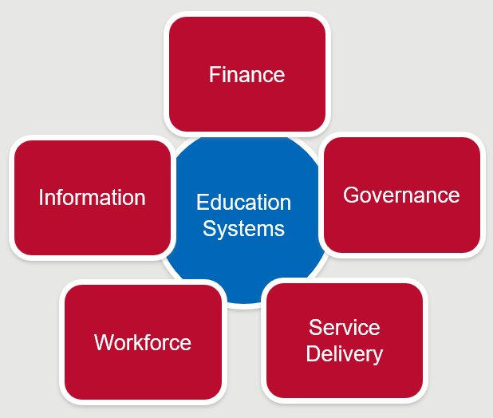

Source: [USAID 2018, Strengthening the service delivery system for inclusive education: The supply and quality side of providing education to children with disabilities in Africa](http://pubdocs.worldbank.org/en/976561540923815336/Strengthening-Service-Delivery-USAID.pdf).

## Governance

Governance factors which are central to a disability-inclusive education system are described below.

* **Disability-inclusive education policies, standards and guidelines** to provide a supportive scaffolding for developing and improving disability-inclusive education across all areas, including curriculum, assessment and school infrastructure, and all educational levels, including ECE, primary, secondary and PSET.
* **Management processes** to enable adequate, reliable processes for decision-making and management regarding quality disability-inclusive educational options.
* **Accountability** by governments and schools to monitor and report transparently about efforts towards disability-inclusive education, including financial data and indicators measuring policy, legislative and treaty obligations. This requires reporting on disability-disaggregated outcomes (see section on Information, below).
* **Collaboration and partnership** with stakeholders outside of the education system, e.g. communities, Disabled People’s Organisations, health services, transport.
* **Strategic and operational planning** to enable the availability of resources which support appropriate disability-inclusive education strategic and operational goals at the ministry and school levels.

## Service delivery

Service delivery factors which are central to a disability-inclusive education system are described below.

* **Positive attitudes** which challenge stigma and discrimination in the broader community and promote inclusive school communities and ministry environments.
* **Accessible school infrastructure** which enables disability-inclusive education by offering an environment which is accessible to all.
* **Teaching and assessment** **practices** which promote child-centred learning and achievement for all students.
* **Identification, screening, assessment and referral networks** to enable students with disabilities to access appropriate services and supports that facilitate their participation in learning.
* **Resource centres for inclusive education** which provide specialist services to mainstream schools to support disability-inclusive education.
* **Parent/caregiver and community involvement** to support individual learning goals of students with disabilities, encourage families to enrol children with disabilities in schools, and create positive disability-inclusive school environments.
* **Addressing factors related to out-of-school children with disabilities**, acknowledging that in many countries most children with disabilities are out of school. Barriers to their attendance at school may be within the school, as well as within homes and communities, and require strategies.
* **Consideration of factors which compound marginalisation** such as gender, sexual orientation and gender identity and disabilities which are less visible and more vulnerable to exclusion (for example deaf people and people with intellectual disabilities).
* **Planning for disability-inclusive education in emergencies** to ensure children with disabilities are included in education-in-emergencies activities after a disaster.

## Workforce

Workforce factors which are central to a disability-inclusive education system are described below.

* **Human resource management/development** to enable allocation of adequate skilled and confident leaders, teaching and management personnel.
* **Training effective teachers** which promote inclusive attitudes, knowledge and skills, particularly in relation to child-centred and differentiated learning approaches.

## Information

Information factors which are central to a disability-inclusive education system are described below.

* **Monitoring, evaluation and learning** to promote reflection and learning as a disability-inclusive education system strengthens.
* **Education Management Information Systems** **(EMIS)** which can disaggregate data by disability are essential to informing and monitoring disability-inclusive education.
* **Indicators for disability-inclusive education** to enable monitoring of progress towards disability-inclusive education goals.

## Finance

Financing disability-inclusive education requires the production of annual budgets to facilitate the implementation of disability-inclusive education policies, standards and guidelines, informed by information regarding effective practices and gaps generated through EMIS, evaluations and research.

# How can Development Partners Contribute?

There are several investment modalities available, to be selected and agreed according to the country context:

* Whole education sector budget support which would include provision for disability-inclusive education.
* Targeted support to disability-inclusive education through sub-sector investments.
* Ear-marked support to specific components e.g. EMIS, teacher training, infrastructure upgrades, advocacy.

The chosen approach will need to be developed collaboratively with the partner government, other development partners, and education stakeholders, and should be grounded in contextual realities.

**Note:** For more information view the *Disability-Inclusive Education: Practitioner* module, and the modules on *Basic Education, Monitoring and Evaluation, Education Sector Planning and Education Financing*.

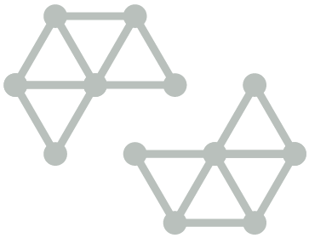

# Test your knowledge

## Assessment questions

Answer the following questions by ticking ‘True’ or ‘False’. Once you have selected your answers to all the questions, turn the page to ‘The correct answers are...’ to check the accuracy of your answers.

Question 1

Disability-inclusive education is focused largely on the education of children with learning difficulties.

Is this statement true or false? □ True □ False

Question 2

Governments should be encouraged to focus on inclusion in mainstream schools and gradually close down special schools.

Is this statement true or false? □ True □ False

Question 3

The education article within the Convention on the Rights of Persons with Disability is Article 24.

Is this statement true or false? □ True □ False

Question 4

Disability is the result of the interaction between a person’s impairment(s) and barriers that exist in the environment.

Is this statement true or false? □ True □ False

Question 5

There are approximately 10 million children with disabilities in the world, of whom 80 per cent live in developing countries

Is this statement true or false? □ True □ False

Question 6

Inter-sectoral solutions are required for a comprehensive system enabling quality disability-inclusive education.

Is this statement true or false? □ True □ False

Question 7

Educating children with disabilities in mainstream classrooms has been shown to disadvantage non-disabled students.

Is this statement true or false? □ True □ False

Question 8

The bi-directional links between disability and poverty are well evidenced.

Is this statement true or false? □ True □ False



## The correct answers are...

Question 1

Disability-inclusive education is focused largely on the education of children with learning difficulties.

**This statement is false.** Disability-inclusive education relates to people with all types of disabilities including physical, sensory (hearing, vision), intellectual, communication and psychosocial.

Question 2

Governments should be encouraged to focus on inclusion in mainstream schools and gradually close down special schools.

**This statement is false.** Special schools play an important role in building specialist skills such as Braille and sign language, and in providing education for students with complex difficulties and high support needs.

Question 3

The education article within the Convention on the Rights of Persons with Disability is Article 24.

**This statement is true.**

Question 4

Disability is the result of the interaction between a person’s impairment(s) and barriers that exist in the environment.

**This statement is true.**

Question 5

There are approximately 10 million children with disabilities in the world, of whom 80 per cent live in developing countries.

**This statement is false.** There are approximately 100 million children with disabilities in the world.

Question 6

Inter-sectoral solutions are required for a comprehensive system enabling quality disability-inclusive education.

**This statement is true.**

Question 7

Educating children with disabilities in mainstream classrooms has been shown to disadvantage non-disabled students.

**This statement is false.** There are benefits to students without disabilities, who experience improved social skills, a deeper ethical grounding and opportunities to consolidate their own learning within peer-to-peer education activities.

Question 8

The bi-directional links between disability and poverty are well evidenced.

**This statement is true.**

# References and links

**All links retrieved June 2019**

Alana Institute 2016, A Summary of the evidence on inclusive education, Sao Paulo, Brazil, Alana Institute, <https://alana.org.br/wp-content/uploads/2016/12/A_Summary_of_the_evidence_on_inclusive_education.pdf>

Alavi Y, Jumbe V, Hartley S, Smith S, Lamping D, et al. 2012, Indignity, exclusion, pain and hunger: the impact of musculoskeletal impairments in the lives of children in Malawi, Disabil Rehabil 34, p. 1736–46, <https://doi.org/10.3109/09638288.2012.662260>

CBM 2019, End the Cycle of Poverty & Disability, Australia, CBM, <https://www.endthecycle.info/>

DFAT 2015, Strategy for Australia’s aid investments in education 2015–2020, Canberra: Commonwealth of Australia, <https://dfat.gov.au/about-us/publications/Pages/strategy-for-australias-aid-investments-in-education-2015-2020.aspx>

Filmer D 2008, Disability, Poverty, and Schooling in Developing Countries: Results from 14 household surveys, World Bank Economic Review 22, p. 141–63, https://academic.oup.com/wber/article-abstract/22/1/141/1682417?redirectedFrom=fulltext

Graham N 2014, Children with Disabilities, Montreal, Canada, UNESCO Institute for Statistics, http://ais.volumesquared.com/wp-content/uploads/2015/01/OOSC-2014-Children-with-Disabilities-final.pdf

Kiuppis F 2014, Why (not) associate the principle of inclusion with disability? Tracing connections from the start of the ‘Salamanca Process’, International Journal of Inclusive Education, v. 18, p. 746-761, <https://www.tandfonline.com/doi/abs/10.1080/13603116.2013.826289>

Miles S & Singal, N 2009, The education for all and inclusive education debate: Conflict, contradiction or opportunity? International Journal of Inclusive Education, 2009, 14(1), p. 1-15, <https://www.tandfonline.com/doi/abs/10.1080/13603110802265125>

Mizunoya S, Mitra S & Yamasaki I 2016, Towards Inclusive Education: The impact of disability on school attendance in developing countries, Innocenti Working Papers no. 2016-03, Florence, Italy, UNICEF Office of Research, <https://www.unicef-irc.org/publications/845-towards-inclusive-education-the-impact-of-disability-on-school-attendance-in-developing.html>

Mitra S 2006, The capability approach and disability, Journal of Disability Policy Studies, 16(4), p. 236-247, <https://journals.sagepub.com/doi/10.1177/10442073060160040501>

Mitra S, Posorac A & Vick B 2012, Disability and poverty in developing countries: A Multidimensional study, In World Development, <https://www.sciencedirect.com/science/article/abs/pii/S0305750X12001465>

Mont D 2014, Childhood disability and poverty: Working paper series number 25, London, United Kingdom, Leonard Cheshire Disability and UCL, https://www.medbox.org/childhood-disability-and-poverty/download.pdf

Office of the United Nations High Commissioner for Human Rights 2013, Thematic study on the right of persons with disabilities to education, Geneva, Switzerland, United Nations, <https://www.ohchr.org/en/issues/disability/pages/studyrightofpersonswithdisabilitiestoeducation.aspx>

Pacific Islands Forum Secretariat 2016, Pacific Framework for the Rights of Persons with Disabilities 2016-2025: A regional framework to support national government actions on inclusive development for the rights of persons with disabilities, Suva, Fiji, Pacific Islands Forum Secretariat, <http://www.forumsec.org/wp-content/uploads/2019/02/Framework-on-the-Rights-of-Persons-with-Disabilities-.pdf>

Pacific Islands Forum Secretariat & University of the South Pacific 2018, Pacific Regional Education Framework (PacREF) 2018-2030: Moving Towards Education 2030, Suva, Fiji, Pacific Islands Forum Secretariat, <http://bit.ly/PacREF2018>

Planchamp C 2019, The inclusive school: Concerning integration in an inclusive school or how best to educate children with special needs, <https://lepole.education/en/pedagogical-culture/63-the-inclusive-school.html?showall=1>

Singal N & Jeffery R 2011, Inclusive education in India: the struggle for quality in consonance with equity, In: Artiles A, Kozleski E & Waitoller, F Inclusive education: Examining equity on five continents, Massachusetts, United States of America, Harvard Education Press, <https://trove.nla.gov.au/work/159412806?versionId=173768785>

UNESCO 2009, Towards inclusive education for children with disabilities: A guideline, Bangkok, Thailand, UNESCO Bangkok, <http://uis.unesco.org/sites/default/files/documents/towards-inclusive-education-for-children-with-disabilities-a-guideline-2009-en.pdf>

2005, Guidelines for Inclusion: Ensuring Access to Education for All, Paris, France, UNESCO, <http://www.ibe.unesco.org/sites/default/files/Guidelines_for_Inclusion_UNESCO_2006.pdf>

1994, The Salamanca Statement and Framework for Action on Special Needs Education, Salamanca, Spain, UNESCO, <http://www.unesco.org/education/information/nfsunesco/pdf/SALAMA_E.PDF>

UNESCO & World Education Forum 2015, Education 2030 - Incheon Declaration and Framework for Action for the implementation of Sustainable Development Goal 4: Ensure inclusive and equitable quality education and promote lifelong learning opportunities for all, Paris, France, UNESCO, <http://unesdoc.unesco.org/images/0024/002456/245656E.pdf>

United Nations 2016, Committee on the Rights of Persons with Disabilities: General Comment No. 4, Article 24: Right to inclusive education, New York, USA, United Nations, <https://tbinternet.ohchr.org/_layouts/treatybodyexternal/Download.aspx?symbolno=CRPD%2fC%2fGC%2f4>

2015, Sustainable development goals, New York, USA, United Nations, <https://sustainabledevelopment.un.org/>

2006, Convention on the Rights of Persons with Disabilities, New York, USA, United Nations, <http://www.un.org/disabilities/documents/convention/convoptprot-e.pdf>

United Nations Department of Economic and Social Affairs 2015, SDG Indicators, New York, USA, United Nations, https://unstats.un.org/sdgs/indicators/indicators-list/

United Nations Economic and Social Commission for Asia and the Pacific (UN-ESCAP) 2012, Incheon Strategy to “Make the Right Real” for Persons with Disabilities in Asia and the Pacific, Bangkok, Thailand, UN-ESCAP, https://www.unescap.org/resources/incheon-strategy-make-right-real-persons-disabilities-asia-and-pacific-and-beijing

2003, Biwako Millennium Framework for Action Towards an Inclusive, Barrier-Free and Rights-Based Society for Persons with Disabilities in Asia and the Pacific, Bangkok, Thailand, UN-ESCAP, <http://undocs.org/E/ESCAP/APDDP/4/REV.1>

United Nations General Assembly 1966, International Covenant on Economic, Social and Cultural Rights, United Nations, https://www.ohchr.org/en/professionalinterest/pages/cescr.aspx

1979, Convention on the Elimination of All Forms of Discrimination against Women, United Nations, https://www.ohchr.org/en/professionalinterest/pages/cedaw.aspx

1989, Convention on the Rights of the Child, United Nations, <https://www.ohchr.org/en/professionalinterest/pages/crc.aspx>

United States Agency for International Development 2018, Strengthening the service delivery system for inclusive education: The supply and quality side of providing education to children with disabilities in Africa, <http://pubdocs.worldbank.org/en/976561540923815336/Strengthening-Service-Delivery-USAID.pdf>

World Health Organisation & World Bank 2011, World report on disability, Geneva, Switzerland, World Health Organisation, <https://www.who.int/disabilities/world_report/2011/report.pdf>

Wapling L 2016, Inclusive education and children with disabilities: Quality education for all in low and middle income countries, London, CBM, https://www.cbmuk.org.uk/wp-content/uploads/2016/05/Quality_Education_for_All_LMIC_Evidence_Review_CBM_2016_Policy_Brief.pdf

World Bank 2008, Project appraisal document on a proposed credit to the People’s Republic of Bangladesh for a disability and children-at-risk project, Washington, United States of America, World Bank, <http://documents.worldbank.org/curated/en/485601468003560874/pdf/417950PAD0P1061ly100IDAR20081021911.pdf>

World Federation of the Deaf 2016, Policy - Education rights for Deaf children, Helsinki, Finland, World Federation of the Deaf, https://www.equalrightstrust.org/content/world-federation-deaf-policy-education-rights-deaf-children

**Learn more about…**

* DFAT’s Development for all 2015-2020: Strategy for strengthening disability-inclusive development in Australia’s aid program, found at:

<https://dfat.gov.au/about-us/publications/Pages/development-for-all-2015-2020.aspx>

* *A wide range of resources on disability-inclusive education are available on the* [*DID4all website*](http://www.did4all.com.au) *under the topic ‘Disability inclusive education’. This includes peer-reviewed evidence, case studies and practical guidance, including modifications to physical environments and teaching approaches. These can be found at:* <https://www.did4all.com.au/ResourceSubTheme.aspx?37169662-93b2-44bb-a44c-abafe03e742a>