Sustainable economic development
Improving food security
Thematic Strategy

AusAID’s Thematic Strategies
The fundamental purpose of Australian aid is to help people overcome poverty. Australia’s aid program is guided by five strategic goals, as set out in An Effective Aid Program for Australia: Making a real difference – delivering real results.
The strategic goals of the aid program are:
- saving lives
- promoting opportunities for all
- sustainable economic development
- effective governance, and
- humanitarian and disaster response.
Australia works with governments of partner countries, mostly in the Asia-Pacific region, civil society organisations and multilateral agencies to achieve these goals. Funding decisions are guided by individual countries’ development priorities, an assessment of poverty, Australia’s capacity to make a real and measurable difference and our national interest.
The thematic strategies provide further detail to inform program decisions in particular sectors.

© Commonwealth of Australia 2011
Published by the Australian Agency for International Development (AusAID), Canberra, March 2012.
This document is online at www.ausaid.gov.au/publications
For further information about the Australian Government’s international development program, contact:
Communications Section
AusAID
GPO Box 887
Canberra ACT 2601
Phone (02) 6206 4000
Internet www.ausaid.gov.au
Artwork by Great Impressions
Printed by Elect Printing

Contents
Contents 4
Summary 5
Purpose 6
Context 7
Rationale for investing in food security through rural development 8
Australia’s approach to food security through rural development 10
Pillar 1: Lifting agricultural productivity 11
Box 1: Lifting agricultural productivity through agricultural research and development 11
Pillar 2: Improving rural livelihoods 12
Box 2: Improving rural livelihoods by strengthening the functioning of markets 12
Pillar 3: Building community resilience 13
Box 3: Building community resilience through social protection 13
Outcomes for food security and rural development programs 14
Where Australia will work 15
Appendix A: Food security and rural development program 16
Indicative food security and rural development indicators 17
Endnotes 18

Summary
Improving food security by investing in agricultural productivity, infrastructure, social protection and the opening of markets is one of the ten development objectives for the aid program. Food security underpins all other development, as without it food insecure populations prioritise food and sustaining their own lives and those of their families over everything else. Australia’s approach to food security is centred on increasing the availability of food through increased production and improving trade, while also increasing the poor’s ability to access food.
Australia has prioritised three pillars of action to improve outcomes in food security:
- Lifting agricultural productivity through agricultural research and development.
- Improving rural livelihoods by strengthening markets and market access.
- Building community resilience by supporting the establishment and improvement of social protection programs.
These three pillars aim to increase the food available in markets and poor households and increase the incomes and employment opportunities of poor men and women. Food security expenditure is expected to grow strongly over the next few years, particularly in Africa, Indonesia, the Middle East, and South Asia. Desired results for achieving better food security outcomes include reducing the number of people living on less than US$1.25 a day, reducing the number of people suffering from hunger and achieving opportunities for full and productive employment.

Purpose
The fundamental purpose of Australia’s aid program is to help people overcome poverty¹. Sustainable economic development is one of the five strategic goals of the aid program helping to achieve this purpose. The aid program has ten development objectives that flow from these strategic goals, one of which is improving food security by investing in agricultural productivity, infrastructure, social protection and the opening of markets. This thematic strategy outlines Australia’s approach to food security², working through the twin strategies of increasing the availability of food (by increasing production and improving trade), while also increasing the poor’s ability to access food (by increasing incomes). The approach centres on three pillars of action:
- lifting agricultural productivity through agricultural research and development
- improving rural livelihoods by strengthening markets and market access
- building community resilience by supporting the establishment and improvement of social protection programs.
Improving incomes, employment and enterprise opportunities for the poor, improving gender equality and reducing the negative impacts of climate change and environmental degradation are other specific objectives that enhance food security. A results framework will be developed to measure the impact of our food security investments.
Parallel thematic strategies on private sector development, gender, health, infrastructure and climate change will guide investments in these closely related complementary areas, while the aid program’s Humanitarian Action Policy also guides support for food security in emergency and crisis recovery situations.

Context
The United Nation’s Food and Agriculture Organization (FAO) estimates that nearly one billion people go hungry every day, with two-thirds of these people living in the Asia-Pacific region. In Sub-Saharan Africa almost one in three people suffer from hunger. This ongoing challenge has been compounded by the global food crisis, which in 2008 pushed more than 130 million people back into poverty as the price of staple foods rose by between 50 and 200 per cent. Prices abated somewhat in 2009, but since mid-2010 they have risen above even 2008 levels, pushing an estimated 44 million people back into poverty, according to the World Bank.
The Millennium Development Goal (MDG) 1 target to halve the proportion of people suffering from hunger—from 20 per cent in 1990 to 10 per cent by 2015—remains off track. The proportion of people suffering from hunger has remained at around 16 per cent for the last decade³. An estimated 60 per cent of the hungry are women.
Recent climate events, such as floods in Pakistan and Thailand and drought in Laos have affected agricultural production and food security in Asia, as well as global stocks and prices. Grain yields in Africa are approximately half those in Asia, and limited commodity trade between African countries exacerbates domestic production shortfalls due to extreme weather. The poor do not have enough economic opportunity, which means they do not have money to buy enough nutritious food. In the absence of social protection, the impact of shocks is amplified. Conflict, such as in the Democratic Republic of Congo and Somalia, also have severe consequences for food security for those populations.

Rationale for investing in food security through rural development
Seventy-five per cent of the world’s poor live in rural areas and mostly depend on agriculture for their livelihood4. Improving food security enables the poor to earn money and become more resilient which, in turn, enables them to participate in economic activity and contribute to social development needs (including health and education).
Hunger places serious constraints on economic growth. Hungry workers are less productive. When faced with food shortfalls or high food prices, households are forced to use their cash reserves. This diminishes their potential to develop on-farm or off-farm enterprises and forces households into coping strategies that further entrench poverty. Food insecurity presents wider national and regional security concerns.
In recent years, food price spikes have been associated with riots and political demonstrations in a number of countries, affecting national and regional stability.
Looking towards the future, food prices will likely remain higher and more volatile than they were before 2008, which means sustained progress on food security will continue to be challenging. Growing populations and changing diets are steadily increasing demand, with the FAO forecasting that global agricultural output must increase by 70 per cent by 2050 to feed the expected population of 9.3 billion. Although high food prices encourage increased production, the supply response is restricted by land and water shortages, climate change, environmental degradation and diversion of food crops to biofuel production. This is compounded by high fuel prices which increase the cost of farm production and of the transport and distribution of food. The 2008 food crisis revealed systemic failures in global food markets, including widespread trade distortions and restrictions such as the use of export bans, thinly traded markets (particularly for rice) and a lack of reliable market information. Decades of subsidised agricultural production in OECD countries, together with market barriers, disadvantage farmers in developing countries and discourage agricultural investment in those countries.
Food producers are hamstrung by the legacy of underinvestment in agricultural innovation over the last 20 years, which has led to a long decline in the annual improvement in cereal yields. The FAO, the OECD and the World Bank expect productivity growth to remain weak over the next decade, with food markets more vulnerable to shocks than in the past.
Investing in agriculture and rural development is essential to improve food security for the majority of the world’s poor, who rely directly on agriculture for subsistence, income and employment. Agriculture is the major source of pro-poor growth⁵ in developing countries with large, poor rural populations. A one per cent increase in agricultural yields leads to between a 0.6 per cent and 1.2 per cent reduction in the percentage of people living on less than US$1 per day. Increasing farm income benefits nutritional outcomes, allows farmers to invest more in agriculture and stimulates off-farm economic activity and employment. Yet investment in rural areas is often neglected by governments in developing countries, making rural communities more vulnerable to price shocks, food insecurity and entrenched poverty.
Social protection programs, which reduce the vulnerability of poor people exposed to food price volatility, are essential. Social assistance, such as cash and asset transfer programs, can stimulate the economy and support targeted groups. Countries with scalable social protection programs in place before the 2008 food crisis responded much more effectively than those without such programs⁶.
There is global consensus that investment in agriculture and rural development in developing countries needs to be increased. In response to the food crisis, donors and governments around the world committed to reinvesting in agriculture, rural development and social protection. This was exemplified by the US$22 billion L’Aquila Food Security Initiative7.

Australia’s approach to food security through rural development
Two key challenges of food security are the availability of food and access to food:
- Availability: Increased food availability requires increased agricultural production and trade, through investments in agricultural productivity, distribution systems and policy reform.
- Access: To buy enough food, the poor need higher cash incomes and efficient local markets, to augment the variable supply from subsistence production. Investment is needed in food and other markets, as well as in social protection systems, to help disadvantaged people cope with chronic poverty as well as household-level and macro price shocks.
Australia is addressing the challenges of food availability and access through three pillars of action:
- Lifting agricultural productivity by increasing investment in agricultural research and development, through Australian and international organisations working on food policy and agricultural innovation.
- Improving rural livelihoods by strengthening markets in developing countries and improving market access, to increase incomes and employment and reduce risks for the rural poor—through enterprise development, better policies and access to financial services.
3. Building community resilience by supporting the establishment and improvement of social protection programs that reduce the vulnerability of the poor to shocks and stresses.
Our work through these three pillars will help address the challenges facing the rural poor in gaining access to enough nutritious food. The diagram at Attachment A outlines how Australia’s assistance across these pillars interact to reduce poverty and improve food security, both of which are directly linked to the purpose of the aid program of helping people to overcome poverty. There is strong evidence that development programs in these areas can achieve sustainable results on a large scale, resulting in large returns on Australia’s aid investment. For instance, a major study examining productivity increases and economic benefits resulting from research conducted by the Consultative Group on International Agricultural Research (CGIAR)⁸ estimated that for every US$1 invested in research, US$9 of additional food was produced by developing countries⁹.
Our focus on these pillars reflects Australia’s expertise in agricultural productivity, tropical and semi-arid agriculture, trade facilitation and market and economic reforms.
International agencies and governments have re-prioritised agricultural and rural development policies in the wake of the current food crisis. Australia’s focus on these three pillars aligns closely with responses by other leading global organisations working to improve food security.

Pillar 1: Lifting agricultural productivity
A primary cause of current food insecurity is the decline in the growth rate of global food production. Through programs led by AusAID and the Australian Centre for International Agricultural Research (ACIAR), Australia is investing in science and innovation to increase agricultural productivity. We are working with, and supporting, research institutions such as the CGIAR network, the Commonwealth Scientific and Industrial Research Organisation (CSIRO), and research organisations in developing countries to increase agricultural productivity while protecting the environment.
Australia is ensuring that research addresses the concerns of smallholder producers in developing countries, including the needs of male and female members of farming households. We will use an ‘innovation systems’ approach, ensuring that research addresses not only the technical issues, but also the policy, institutional and social factors that determine whether agricultural innovations are adopted on a large scale. In particular, ensuring that women gain access to agricultural technologies and inputs is critical. Increased emphasis is being placed on ‘adoption pathways’ to ensure research findings are implemented by end-users, including through the market development programs to be supported in Pillar 2.

Box 1: Lifting agricultural productivity through agricultural research and development
AusAID and ACIAR are increasing food production in East Timor by identifying and trialling higher yielding food crop varieties, many which have been sourced from CGIAR research centres. Since 2001 the Seeds of Life program has successfully released nine varieties of five staple food crops that are highly adapted to East Timor’s farming systems. Productivity has increased by between 23 and 80 per cent using these varieties. The program is working with partners to enable large-scale production and distribution of seeds and planting materials.
AusAID is supporting the Agricultural Research and Development Support Facility in Papua New Guinea, to build the capacity of local research organisations to conduct agricultural research for development. The Facility also uses competitive grants to catalyse innovation, promote research and develop partnerships among public, private and civil society organisations working in the agriculture sector.

Pillar 2: Improving rural livelihoods
To buy enough food, disadvantaged men and women need adequate income. The World Bank’s 2008 World Development Report found that agriculture’s most important contribution to food security is not subsistence production but the ability of the poor, particularly women, to earn money. Functioning markets support better livelihoods so poor households can grow food and generate income to buy affordable food, especially during seasonal food shortages.
Rural livelihoods are improved by strengthening market function. This includes having the right policies and regulations in place, reducing barriers to trade, generating domestic and export market opportunities and increasing private sector participation in food production. This may involve cooperation with government and civil society institutions, but direct cooperation with the private sector is often essential. Many private sector players are involved, including large companies, semi-subsistence farmers, the self‑employed in the non-farm informal economy as well as micro, small and medium-sized enterprises. A separate implementation strategy on broader private sector development issues will be released in 2012.
Key markets to target for food security include agricultural and fisheries inputs and output markets which support sustainable intensification of agricultural production. Australia also continues to advocate for more effective global food and agricultural markets, through removing subsidies and lowering trade barriers. We will also continue to help partner countries combat agricultural pests and diseases and upgrade quarantine systems so that they can participate more in international agricultural trade.
Financial services (including savings, loans, payment services, insurance and money transfers) are also an effective way to reduce poverty. These services help people increase incomes, build assets, participate in the market economy and reduce vulnerability in times of economic stress. Australia is supporting the development of financial services for the poor at country level and through global policy reform, including through the G20 Finance Ministers and Central Bank Governors. Financial inclusion is especially effective for women’s economic empowerment. In March 2010 the Australian Government launched Financial Services for the Poor: A strategy for the Australian aid program 2010–15, which describes our work in four priority areas: policy reform, institutional capacity, innovation and financial education.

Box 2: Improving rural livelihoods by strengthening the functioning of markets
The Cambodia Agriculture Value Chain Program is a five-year (2009–14) program that targets rice, fruit and vegetable farming systems in three provinces. It aims to increase farmer incomes and food production, and accelerate growth in the value of agricultural products and markets by helping to address systemic failures along the agriculture value chain from supplier to farmer to consumer.
The Smallholder Agribusiness Development Initiative in Indonesia (2006–10) focused on improving rural productivity and growth, including through support for smallholder marketing and private sector agribusiness. Promoting linkages between farmers and agribusiness, and organising farmer groups, helped improve post-harvest logistics and timing of harvests, thereby providing higher returns for farmers.

Pillar 3: Building community resilience
When shocks hit the vulnerable, such as food price increases or household-level emergencies (such as the income-earner becoming sick), people often resort to coping strategies which have long-term consequences, some of them irreversible. Nutrition worsens, use of health and education services declines and productive assets are often sold. Social protection can alleviate short-term suffering and help disadvantaged families avoid making choices that push them further into poverty.
Social protection mechanisms can be:
- untargeted and unconditional, such as price subsidies open to all
- targeted and unconditional, such as cash transfers in the form of pensions or employment insurance, workfare (food and cash-for-work), fee waivers and scholarships, or school feeding, or
- targeted and conditional, such as programs designed for poor families, providing cash grants upon evidence of children regularly attending school or mothers receiving health checks.
Though often viewed as a cost, social protection measures are also investments in the poor, which help strengthen economic growth in the medium to long term¹⁰.

Box 3: Building community resilience through social protection
AusAID and a consortium of donors are supporting a highly successful social protection program in Bangladesh. The Challenging the Frontiers of Poverty Reduction (2007–11) program targets the poorest of the poor. It offers soft loans or transfers of productive assets (such as livestock, agricultural implements or micro-enterprise equipment); a subsistence allowance of US$0.40 a day; two years free access to health care; and assistance for water, sanitation and housing. In its first phase nearly 100 per cent of the 100 000 beneficiary households ‘graduated’ out of extreme poverty and have sustained those benefits two years later.

Outcomes for food security and rural development programs
Through these three pillars of action, Australia’s food security and rural development programs aim to jointly contribute to achieving the following three development outcomes:
- more food available in markets and in poor households
- increased net income of poor women and men
- increased employment for poor women and men.
In order to help realise these three outcomes, Australia‘s programs will aim to achieve the following four program outputs:
- increased access to agricultural technologies by poor women and men
- better prices for goods sold by poor women and men
- increased access to financial services by poor women and men
- increased access to social transfers by poor women and men.
Appendix A lists the key indicators we will use to monitor and evaluate performance. It also includes a program logic diagram, illustrating the relationship between MDG targets and the key outputs and outcomes of Australia’s food security and rural development programs.

Where Australia will work
This policy will be implemented primarily through aid activities led by partner countries and through investments in selected global programs. Many of our partner countries are strongly committed to scaling up investments in agricultural productivity, rural livelihoods and community resilience. The balance between the three pillars in each country program will vary based on different country contexts and the value Australia can bring in each case.
By 2015–16 we expect to be investing approximately equal funding in each of the three pillars. The most significant investments in agricultural productivity include an expanded role for the ACIAR, including in the management of the new Australian International Food Security Centre¹¹. There will also be expanded support for the reformed CGIAR system and regional research programs in Africa and the Middle East.
The most significant investments in rural livelihoods will include expanded support for a competitive fund for enterprise development in Zimbabwe (the Africa Enterprise Challenge Fund), a Market Development Facility in Fiji and East Timor and a similar program in Indonesia. We also expect significant expansion of support to financial services.
Investment in social protection programs are expected to expand most rapidly from their currently low base. The most significant program is expected to be in Indonesia, involving support to the government for strategic investments in the national community empowerment program and new social protection instruments. Other significant investments include an expansion of programs in Bangladesh, ongoing support in Zimbabwe, investments in three country social protection programs in Africa and continued support for establishing a national social protection strategy in Cambodia. This support at country level will likely be augmented by support at a global level through the World Bank’s Rapid Social Response program.
By 2015–16 we anticipate that over 80 per cent of our food security funding will be allocated to bilateral activities with partner countries, but food security investments in global programs will also grow. We intend to focus global investments in a few highly effective programs that align with our three pillars, including the CGIAR, the World Bank’s Global Agriculture and Food Security program¹² and Rapid Social Response program¹³. Australia is also considering renewing its membership of the International Fund for Agricultural Development, a specialised agency of the United Nations dedicated to eliminating rural poverty in developing countries.

Appendix A: Food security and rural development program
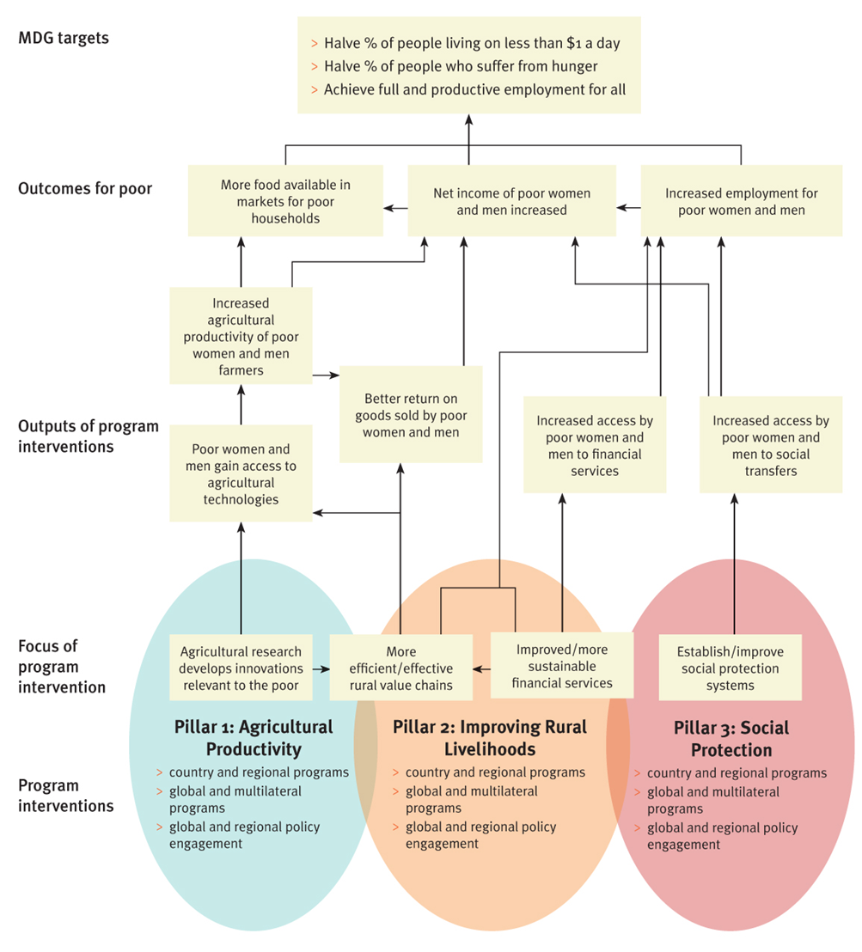

Indicative food security and rural development indicators
The following indicators may be used to monitor and evaluate the results of Australia’s food security assistance. A detailed results framework will be developed. Note: data will be disaggregated by sex, socio-economic quintile and relevant disability criteria where possible.
Pillars for Australia’s investment in food security | Indicators for food security outcomes | Indicators for food security outputs
Pillar 1. Lifting agricultural productivity through agricultural research and development | Value of additional agricultural production  Value of additional food production  Number of poor women and men who have increased their income  Number of (full-time equivalent) jobs created suitable for poor women and men | Number of poor women and men farmers who gain access to agricultural technologies  Number of poor women and men who increase their access to financial services  Number of additional poor women and men able to access social transfers  Number of people who benefit from improved social protection systems
Pillar 2. Improving rural livelihoods by strengthening markets and market access
Pillar 3. Building community resilience by supporting the establishment and improvement of social protection programs

Endnotes
1 Australian Government, An Effective Aid Program for Australia: Making a real difference – Delivering real results, Response to the Independent Review of Aid Effectiveness, July 2011.
2 Food security is defined as: when people have access on an ongoing basis to sufficient, safe and nutritious food to meet their dietary needs and food preferences for an active and healthy life.
3 United Nations (2011), Millennium Development Goals Report 2011, p11
4 World Bank (2007), World Development Report 2008, p45.
5 ‘Pro-poor growth’ here is defined as a pattern of economic growth in which the poor benefit disproportionately.
6 Grosh, Margaret, Colin Andrews, Rodrigo Quintana and Claudia Rodriguez-Alas (2011). Assessing Safety Net Readiness in Response to Food Price Volatility. SP Discussion Paper No. 1118. World Bank, Washington D.C.
7 The Initiative was set out in the L’Aquila Joint Statement on Global Food Security, July 2009 http://www.g8italia2009.it/static/G8_Allegato/LAquila_Joint_Statement_on_Global_Food_Security%5B1%5D,0.pdf
8 The Consultative Group on International Agricultural Research (CGIAR) is a global partnership between donors and a network of 15 international research centres engaged in research for sustainable development. The funders include developing and industrialized country governments, foundations, and international and regional organizations. The 15 research centres are members of the Consortium of International Agricultural Research Centres
9 For a summary of the literature on the impact CGIAR research, see CGIAR (2008), Bringing Together the Best of Science and the Best of Development: Independent Review of the CGIAR System, Report to the Executive Council, “Appendix 5: Impact of CGIAR research”.
10 OECD (Organisation for Economic Co-operation and Development) (2009), Social Protection, Poverty Reduction and Pro-Poor Growth, in Promoting Pro-Poor Growth: Social Protection, OECD, Paris.
11 For further details of the new Centre, see http://aciar.gov.au/aifsc
12 For further details see http://www.gafspfund.org/gafsp/content/global-agriculture-and-food-security-program
13 For further details see http://web.worldbank.org/WBSITE/EXTERNAL/TOPICS/EXTSOCIALPROTECTION/EXTSAFETYNETSANDTRANSFERS/0,,contentMDK:22333033~menuPK:6461372~pagePK:148956~piPK:216618~theSitePK:282761,00.html

