Fiji Women’s Crisis Centre (FWCC)

Mid-Term Evaluation

Final Report

Kaye Bysouth & Marilyn Cornelius

23rd January, 2025

**Acknowledgments**

The MTE Team wishes to thank the more than 80 stakeholders from within FWCC, DFAT, Government of Fiji, civil society organisations, service providers and selected communities, Regional Crisis Centres and PWNAVAW network members who gave freely of their time to inform the evaluation, during a very busy period.

Thanks also to Sheron Narayan, Program Manager and Emily Elliott, Senior Program Manager, Gender, Australian High Commission, Suva for their support in carrying out this evaluation.

**Authors’ Details**

* Kaye A Bysouth (Team Leader)
* Dr. Marilyn Cornelius (Gender Advisor)

SURGE <https://surge4genderequality.com.au/contact-surge>

Disclaimer: This report reflects the views of the Reviewers based upon consideration of the available evidence and does not necessarily reflect those of the Government of Australia.

# ACRONYMS

AFP Australian Federal Police

CSO Civil Society Organisation

DFAT Department of Foreign Affairs and Trade, Australia

DPP Department of Public Prosecution

DoSW Department of Social Welfare

DV Domestic Violence

DVRO Domestic Violence Restraining Order

EOPO End of Program Outcome

EVAW Eliminating Violence Against Women

EVAWG Eliminating Violence Against Women and Girls

FGD Focus group discussion

FWCC Fiji Women’s Crisis Centre

FWF Fiji Women’s Fund

FWRM Fiji Women’s Rights Movement

LGBTQI Lesbian, Gay, Bisexual, Trans, Queer and Intersex

MEF Monitoring and Evaluation Framework

MFAT Ministry of Foreign Affairs and Trade, New Zealand

MoWCPA Ministry of Women, Children and Poverty Alleviation

MoY&S Ministry of Youth and Sport

MTE Mid-Term Evaluation

NGO Non-Government Organisation

PIFS Pacific Island Forum Secretariat

PWNAVAW Pacific Women Network against Violence Against Women

ToR Terms of Reference

VAW Violence Against Women

VAWG Violence Against Women and Girls

VWC Vanuatu Women’s Centre

# EXECUTIVE SUMMARY

**Background**

1. Australia has supported the Fiji Women’s Crisis Centre (FWCC) for more than thirty years in its efforts to end violence against women, using a human rights and development framework. The current funding agreement between DFAT and FWCC (#78569) is for a period of 2 years (October 2023 to December 2025) with a total value of AUD4.8 million.
2. The Mid-Term Evaluation (MTE) was conducted between November 5th, 2024 and January 7th, 2025. The evaluation sought to assess FWCC’s progress towards the End-of-Program Outcomes (EOPOs), over the period July 2022 to the present; assess the effectiveness and efficiency of FWCC in delivering services in accordance with the DFAT funding agreement and compile lessons and considerations for the potential extension of the current agreement with FWCC for up to two years (September 2026-2028) and future work.

**Progress towards outcomes**

3. **Strong progress has been made towards the achievement of women’s empowerment** (EOPO1), **including in rural and remote areas** (EOPO3). During the evaluation period, over 5,000 women came in for their first counselling visit – the first, and hardest, step to asserting their rights. The branches in Ba, Labasa, Nadi and Rakiraki together accounted for more than half of new survivors presenting for their first counselling session. More than 10% of total new survivors were provided with legal assistance; approximately 3% were provided with emergency accommodation. More than 9,000 survivors came in for repeat counselling – embarking on the road to empowerment; the branches accounted for approximately two-thirds of survivors seeking repeat counselling.

4. **Inclusion and equitable access to services by marginalised groups remains a challenge but current efforts should yield medium-term results.** People with disabilities (PWD) have low levels of access to services; 3% of new survivors presenting to the centres were PWD; approximately 4.5% of repeat counselling sessions were for people with disabilities. FWCC has run three community education trainings in response to requests from disability people’s organisations. However, there is limited evidence of attendance by PWD at mainstream community education events. FWCC is giving high priority to disability equity at the Board level and in the workforce; access audits have been conducted for all centres and all are adequately accessible.

5. **Limited penetration in Indo Fijian and Muslim communities.** Although FWCC now collects data on the ethnicity of new clients, this does not yet appear to be included in reports. FWCC staff report that it is harder to reach Indo-Fijian communities because they don’t have a village setting where everyone is in one place. All branches have prioritised targeting of Indo-Fijian communities through community education workshops and mobile counselling. Muslim communities also remain difficult to penetrate although new strategies are being trialled (e.g. approaching Muslim League women leaders and Mothers Clubs).

6. **FWCC staff have a strong professional understanding of the way in which support services lead to women’s empowerment, but data is not adequately captured and reported upon**. There is scope for Counsellors to systematically record their professional judgements about where a (de-identified) survivor sits in terms of her own empowerment process, over time. This could be done using existing reporting formats and processes. Aggregating and analysing such qualitative data more systematically would support FWCC’s own reflection and review processes and facilitate greater communication with external stakeholders for the nature, timelines and results of the empowerment process.

7.**FWCC has been a major contributor / influence on the development and review of laws, policies and protocols that promote women’s rights in Fiji and the Pacific region** (EOPO4)This has been achieved via a range of strategies including direct lobbying of decision makers; participation in key decision-making bodies and/or responding to Ministerial invitations to inform decision-making processes; active engagement in relevant public forums/conferences; production of submissions to government on required law/policy changes; and extensive use of the media to increase public awareness. Major changes to which FWCC has contributed include, among others, the development of the National Action Plan to Prevent Violence Against All Women and Girls (VAWG) (2023 – 2028); Changes to the Domestic Violence Act; introduction of the ‘No Drop’ policy for police and Promulgation of the Crimes Decree (2010) which broadened the definition of the offence of rape.

8. **FWCC has had a moderate influence on service providers, leaders, community members and duty bearers to implement laws and policies (EOPO2, EOPO6)**

* FWCC played a significant role in training police recruits in the past, but training ceased under the previous government and is still halted under the current government, except for brief trainings as part of implementation of the NAP***.*** There is scope for the Australian High Commission (AHC), Suva to engage in policy dialogue with Government of Fiji (GoF) on recommencement of training.
* More than 300 people from a diverse range of service providers have been trained over the past two years. Recipients praise the high quality of training but FWCC cannot meet the demand for follow-up / refresher training.
* FWCC branches prioritise community education; ninety community mobilisation sessions and seven community education workshops have been conducted over the past two years, involving more than 3,500 participants.There is strong anecdotal and case study evidence to demonstrate social change as a result of this community education work.
* FWCC has a very active presence in the mainstream media and on social media although the extent of resulting influence is not systematically analysed.
* The male advocacy program (EOPO6) appears to generate substantial changes in attitudes of participants and downstream results in their own families and communities. However, careful monitoring is required to ensure continuing engagement of trained advocates and accountability to the women’s movement.

9. **The MTE team was unable to assess the extent to which Regional Network members and partners use best practice in their prevention and response to Violence Against Women** *(*EOPO5*)* Given that more than one-third of funding to Fiji women's crisis centre is regional funding for regional activities, there is a need to gather evidence about the effectiveness and efficiency of this work. This may be done as part of finalising the PGS design process for a regional program of support to crisis centres.

10. **The FWCC MEL system is a sound mechanism to demonstrate achievement of key deliverables, to facilitate decision-making and continuous improvement**. There is clear evidence that FWCC uses the information products generated by the MEL system to inform decisions at multiple levels of the organisation. However, there is scope for improved collection and analysis of qualitative data (i.e., on changes in levels of empowerment of victim/survivors and changes in attitudes of service providers and community members following FWCC training). There is also scope for streamlining the reporting coming to DFAT to focus on progress towards the delivery of shared strategic objectives. (See 17 below)

11. **FWCC’s demand-responsive and context specific approach results in frequent budget deviations.** Budget variations are the norm for a ‘going concern’ responding to the demands of its clients and the changing context. In order to better manage budget variations, all future grant agreements should include a provision to allow FWCC to shift underspends between budget lines through an email exchange. However, DFAT would still require relevant paperwork as supporting documents.

12. **Governance and management arrangements meet standards.** Following a Due Diligence Assessment in 2021, FWCC amended the FWCC Constitution and Trustees Terms of Reference, both of which were endorsed and adopted on 30th June, 2023. FWCC also finalised, endorsed and socialised all the documents/policies which were agreed to, and these were shared with DFAT and MFAT at the end of June 2023. The Board of Trustees meets regularly, members are aware of their responsibilities and the Trustees represent a good mix of skills and perspectives. Areas of strategic concern to the Board include the issue of succession for the Coordinator’s position; donor funding security; ability to provide community education refresher training; financial sustainability / resource mobilisation and the nature and quality of the partnership with DFAT. The Management Collective represents the entire organisation, meets regularly and appears to make evidence-based decisions.

13. **FWCC Personnel e skilled and experienced.** FWCC faces a challenge in finding the right kind of staff, those who are passionate and dedicated to the cause of EVAW and empowering women. FWCC also needs to be able to offer more than the current (mid-range) salaries to ensure retention of committed staff.

14. **AHC, Suva needs more support from the DFAT Canberra gender teams and from the SURGE panel.** Post has a number of personnel with long-term experience in EVAW, particularly amongst Locally Engaged Staff (LES). However, overall AHC, Suva needs more support from Canberra to engage with CSOs and with the evidence on EVAW, in order to improve understanding and collaboration with FWCC as a strategic partner.

**Factors influencing effectiveness and efficiency**

15. **The DFAT design approach is not a neat ‘fit’ for an ongoing organisation.** The attempt to collapse the strategic objectives of an on-going organisation into a set of time-bound outcomes has not been successful. None of the eight outcome statements of the FWCC design, nor the program logic, meet DFAT standards. This has, inevitably led to conflict. DFAT staff are attempting to manage what they see as a ‘program’ with discrete outcomes, timeline and budget. FWCC staff are attempting to run an organisation with a past, a present and a future. FWCC staff carry out operations which build upon FWCC’s long-term cumulative efforts, as well as the integrated and comprehensive nature of their programs, to respond to changing demands and context. FWCC staff also see the organisation as performing a significant, on-going role in the women’s movement. This significant difference of perspective has, inevitably, led to tensions between AHC, Suva and FWCC.

16. **The aid modality is inefficient.** the current funding arrangement – grant funding linked to a program design – plus regional funding for a list of discrete activities unfunded from the original design - represents a poor ‘fit’ with FWCC’s requirements, as well as Australia’s International Development Policy and Locally-Led Development policy.

**Considerations for the extension of support to FWCC**

17. **An alternative option to the current approach is the establishment of a Strategic Partnership Arrangement between DFAT and FWCC.** A key consideration for extension of the current agreement with FWCC is for DFAT to enter into a partnership agreement focused on the articulation of shared, strategic priorities over the medium term (i.e., five years). DFAT has previously entered into such non-binding arrangements with BRAC in Bangladesh, The Asia Foundation in multiple countries and RedR in Australia. The transfer of funds would still be managed via a Complex Grant Agreement, which may be for a shorter period, but a voluntary Strategic Partnership Arrangement (SPA) would set the ‘tone’ for the partnership. The SPA would articulate the respective strengths of the partners, the shared and individual objectives of the partners, the guiding values and principles of engagement, joint and respective contributions, partnership governance arrangements and monitoring and reporting. This type of arrangement directly fulfils Australia’s policy commitments to genuine partnership with Pacific partners and to locally led development.

18. **A Strategic Partnership Arrangement could replace the current program outcomes with strategic outcomes.** The strategic outcomes can only be determined by FWCC, DFAT and MFAT; however, examples would be:

* **An Institutional outcome** which would encompass FWCC’s aspirations to maintain and build its human resources, leadership skills and coordination and management processes.
* **A Programs outcome** which would encompass the delivery of *all* FWCCs programs / services (i.e., counselling, advocacy and support, accommodation services, external training, branch services, regional networking, FLARE and male advocacy). The outcome statement would articulate a general target (similar to DFAT’s Tier 3 targets). For example, “*85% of FWCC programs meet annual targets and achieve quality standards”*. The budget for this outcome area would be estimated annually, but targets and allocation of resources for particular programs / services would be determined by FWCC in response to demand and changes in the context. Funds could be moved between line items to maximise effectiveness / efficiency. The budget might also include greater provision for in-house research.
* **A Partnership Outcome** which would focus on strengthening the partnership (FWCC/DFAT/MFAT) to deliver faster progress in EVAW. While the regular management of the SPA would be fully delegated to FWCC, a SPA Steering Committee (or jointly agreed mechanism) would seek to maximise the value of the partners working together.

Grants would still be subject to separate financing agreements, but would not be tied to specific programs. They would be used to achieve the strategic outcomes outlined in the SPA agreement. However, this arrangement would not prevent the allocation of separate funds for specific projects or in response to specific events (e.g., humanitarian crises). Subject to agreement between the partners, the SPA might also provide a framework for the inclusion of other donors so long as values and objectives align.

# CONTENTS

ACRONYMS i

EXECUTIVE SUMMARY ii

CONTENTS v

INTRODUCTION 1

SECTION A: ASSESSMENT OF FWCC EFFECTIVENESS AND EFFICIENCY 5

SECTION B: KEY FACTORS INFLUENCING EFFECTIVENESS AND EFFICIENCY 26

SECTION C: A SUSTAINABLE PARTNERSHIP AND FUNDING MODEL 28

SUMMARY OF CONSIDERATIONS FOR ON-GOING SUPPORT TO FWCC 33

APPENDICES

A: Deliverables and Indicative Dates

B: Key Evaluation Questions and sub-questions

C: Analysis of interviewees and List of Persons Interviewed

D: Data collected weekly from FWCC Branches

E: Example FWCC/DFAT/MFAT Strategic Partnership Arrangement (SPA) - Terms of Engagement

# INTRODUCTION

## Investment Background

Australia has supported the Fiji Women’s Crisis Centre (FWCC) since 1989 (35 years). The goal of FWCC is to end violence against women, using a human rights and development framework. FWCC implements a regional program of training and mentoring to strengthen efforts to end violence against women and is the Secretariat of the Pacific Women’s Network Against Violence Against Women (PWNAVAW).

The current agreement between DFAT and FWCC (#78569) is for a period of 2 years (October 2023 to December 2025) with a total value of AUD4.8 million[1]. The agreement (and Deed of Amendment 1) sought to bring together two streams of DFAT support to FWCC under one grant (regional through PGS and bilateral from Suva Post).

In addition to DFAT funding, FWCC will receive NZD5.5 million from MFAT from July 2022 – June 2027, for the operation of its branches. FWCC also receives funding from the Government of Fiji to operate the National 24-hour Domestic Violence Helpline.

The current design of FWCC (2022-2027) has six end-of-program outcomes (EOPOs):

1. Women are asserting their rights and are empowered to make their own choices and decisions.

2. Service providers, leaders and community members respond sensitively to women survivors and promote equal rights, and duty bearers implement laws and policies.

3. Women, community leaders and members, and service providers in rural, remote, maritime areas of Fiji are accessing effective prevention and response services.

4. Government, other policy makers and decision makers develop and review laws and policies that promote women’s rights in Fiji and the Pacific region.

5. Regional Network members and partners use best practice in their prevention and response to violence against women.

6. Male advocates promote equal decision making and rights for women in the family, community, workplace, organisations and society.

## Purpose, audience and scope of the Evaluation

The Mid-Term Evaluation (MTE) was conducted between November 5th, 2024 and January 7th, 2025. The MTE schedule is attached as Appendix A.

### Purpose

The purpose of the MTE was to undertake an independent assessment of DFAT’s support to FWCC, with a primary focus on effectiveness, efficiency and learning.

Specifically, the evaluation sought to:

1. assess FWCC’s progress towards the End-of-Program Outcomes (EOPOs), including identifying areas that require improvement;
2. provide an assessment of the effectiveness and efficiency of FWCC in delivering services in accordance with DFAT funding agreement; and
3. compile lessons learned and considerations for the potential extension of the current agreement with FWCC for up to two years (September 2026-2028) and future work.

This evaluation built upon the previous end-of-program evaluation of FWCC, which was undertaken in 2020 including consideration of the following areas: FWCC’s communication of its approach to prevention; reach to Indo-Fijian communities, women and children with disabilities and the LGBTQI community; Monitoring, Evaluation and Learning (MEL) arrangements; approach to partnerships; and development of a long-term Strategic Plan as part of resource mobilisation.

While the evaluation did not specifically focus on aspects of FWCC’s work funded by MFAT (shelters) and Government of Fiji (24-hour hotline), it should be noted that the work of FWCC must be seen in a holistic and integral manner, regardless of the source of funding for that work. As such, DFAT also sought clearance of the ToR and this Evaluation Plan from MFAT.

### Audience

The key audience for the review is DFAT (Suva Post Management and Pacific Culture and Gender Section in Canberra); staff from FWCC; and members of FWCC’s Board of Trust and Management Committee; and MFAT. The secondary users are women’s Civil Society Organisations, including women’s crisis centres and PWNAVAW members across the Pacific.

### Scope

The MTE focused on the effectiveness and efficiency of the FWCC from July 2022 to the present day[2]. The findings of the evaluation will provide guidance for the potential extension of the current agreement from September 2025-2027 and future work, addressed to both DFAT and FWCC.

The evaluation addressed the above audiences, in the first instance, via an on-line presentation of preliminary observations and findings for the purposes of validation and to seek feedback; and further, through the production of this draft formal report in line with DFAT’s M&E standards[3].

## Approach and Methodology

At the commencement of this assignment, the Evaluation Team mapped the evaluation sub-questions included in the Terms of Reference (ToR) against DFAT’s standard sub-questions associated with the Effectiveness and Efficiency criteria and carried out a rapid evaluability assessment. The results of the mapping and evaluability exercises were then discussed with DFAT staff during a start-up briefing held on 8th November, 2024. The Evaluation team sought clear direction from DFAT on both the priorities for the evaluation and appropriate approaches to conduct of the evaluation.

The Key Evaluation Questions and sub-questions agreed upon with DFAT through this process were integrated into the approved Evaluation Plan which, in accordance with DFAT M&E Standards, then superseded the Terms of Reference (ToR). The amended KEQ and sub-questions included in the Evaluation Plan are attached as Appendix B.

In addition, the SURGE Gender advisor applied a gender lens the MTE to assess the GEDSI-responsiveness of FWCC’s work. The results of this analysis are integrated throughout the report; the full analysis is attached as Appendix F.

In accordance with the approved Evaluation Plan, the approach to investigating the KEQ involved the following stages:

* Document review
* Key informant interviews and Focus Group Discussions: more than 80 stakeholders were interviewed over a three-week period. A list of stakeholders consulted, together with demographic analysis of interviewees, is attached as Appendix C.
* Site visits (to FWCC branches in Ba, Rakiraki and Nadi. On-line interviews were conducted with FWCC Labasa branch staff)
* Presentation of findings and recommendations, initially via a virtual presentation to key stakeholders on December 20th and submission of draft MTE Report on 7th January.

## Limitations

The following challenges faced by the Evaluation team should be taken into account when considering the findings.

* **Timing of the evaluation:** The MTE was conducted at the same time as the *16 Days of Activism* to combat violence against women. This is a particularly busy time for both FWCC and relevant government and non-government entities in the women’s movement. All stakeholders were supportive and cooperative in conduct of the MTE but noted that the timing put undue pressure on them. Every effort was made by the MTE team to accommodate the pressures on the time of interviewees.
* **Time and resources:** The rigor of the data gathering and analysis processes for any evaluative exercise is ultimately constrained by the time and resources available. For example, in attempting to measure progress against EOPO5, it was only possible to obtain opinions from a non-representative sample of interviewees. In the absence of independent assessment of regional activities, this cannot not be regarded as strong evidence pertaining to the achievement of EOPO5. (Refer DFAT M&E Standards and quality reporting guidance and matrices).
* **Judgements:** The evaluation involved rapid qualitative methods of inquiry and required the informed professional judgement of the evaluation team to interpret stakeholder perspectives. However, every effort was made to triangulate information received from multiple sources, including via detailed review of documentary evidence, before professional assessments were finalised.
* **Effectiveness lag times:** The ‘window’ for this evaluation was narrow, July 2022 to December 2024. Given that FWCC is an autonomous, non-governmental organisation which is conceptually regarded as a ‘going concern.’ [4] In other words, it has existed since 1984 and is expected to continue to exist into the future. Depending upon the EOPO, results achieved over the evaluation period may, in fact, be the result of work carried out prior to the evaluation period. Similarly, results reported in future periods may be the results of work which has been carried out over the past two years.

## Report Lay-out

**Section A** presents evidence on the Effectiveness and Efficiency of FWCC based upon the evaluation questions and sub-questions and incorporating the characteristics of quality associated with these criteria in DFAT’s quality reporting guidance.

**Section B** discusses the key factors that have influenced Effectiveness and Efficiency.

**Section C** presents a rationale for moving beyond the current program approach to a longer-term partnership approach and provides guidance for doing so.

# SECTION A: ASSESSMENT OF FWCC EFFECTIVENESS AND EFFICIENCY

## Effectiveness

### 1.1 Differential standards of evidence are required to demonstrate progress against different outcomes

The FWCC program design identifies six strategic objectives, which are referred to as outcomes, despite not satisfying DFAT standards for outcome statements[5]. Section Two, below, discusses the difficulties created by attempting to collapse the strategic plan of an on-going organisation into a standard program design.

Whilst the strategic objectives are clear, if they are to be treated as outcomes (in the DFAT sense) the majority of the statements are neither realistic, nor measurable. Further, in reviewing the statements, it should be noted that, in accordance with DFAT standards:

* **FWCC can only be held *directly* accountable for the achievement of outcomes 1 and 3**, namely, that women (including women in remote, rural and maritime areas) have access to critical counselling, advocacy and support services which provide the foundation for the assertion of their rights and empower them to make their own choices and decisions.

The evidence required to demonstrate progress in respect of outcomes 1 and 3is:

1. the equitable and timely delivery of essential support services to victims, to a quality standard; and
2. that evidential links can be established between the delivery of these services and the empowerment of women.

* **FWCC may *contribute to, and influence*, the achievement of outcomes 2, 4, 5 and 6**. However, FWCC cannot be held accountable for changes in the behaviour of third parties, whether government, duty bearers, service providers or regional EVAW network members.

In order to demonstrate progress in respect of these outcomes, it is necessary to determine:

1. the nature of the contribution made by FWCC to the achievement of each outcome (e.g., minor, medium, major[6]); and
2. the extent of the outcome-level change which may be attributed to FWCC’s contribution / influence (e.g., moderate, major, significant[7]). The nature of the contribution and the resulting changes generated will vary across outcome areas.

On this basis, the MTE team finds that:

* Strong progress has been made towards women’s empowerment (EOPO1 and 3)
* FWCC has been a major contributor / influence on the development and renewal of laws and policies that promote women’s rights (EOPO4)
* While FWCC was the pioneer, and remains the thought and practice leader on EVAW in Fiji, the influence on duty bearers, service providers, leaders and community members has been moderate overall. (EOPO2 and 6)

The evidence underpinning these findings is outlined in detail below.

### 1.2 Strong progress has been made towards women’s empowerment (EOPO1 and EOPO3)

#### 1.2.1 FWCC has reliably provided counselling, advocacy, support and accommodation services to GBV victim/survivors, including in rural and remote areas.

While FWCC is not the only provider of essential support services to victim/survivors of GBV in Fiji, the range and scope of services offered is unequalled[8] The very existence of FWCC and the ‘one-stop-shop’ services it offers provides women with options that they otherwise would not have. A review of the evidence reveals that, over the evaluation period:

* **Over 5,000 women came in for their first counselling visit (Suva and branches)** including 3% people with disabilities**[9].** Given that more than two-thirds of women living with violence have never sought help from any agency whatsoever[10] the data on increasing numbers of women approaching the centres is critical because it takes great courage for women to take the first step in overcoming the very many social, cultural and religious constraints to visiting the centres*.* There has been a long-term trajectory of increases in the number of women seeking help from FWCC from single digits in 1984 to more than 5,000 by 2024.

Further, there is evidence that women in rural, remote and maritime areas have significant levels of access to FWCC services. In the years under review, the Branches[11] accounted for more than half of new survivors presenting to centres (57% in 2022/23; 52% 2023/24).

* **More than 10% of total new survivors were provided with legal assistance** (e.g. provision of legal advice, advocacy, assistance with legal forms, follow-ups with the judiciary, and emergency court representations) (11% in 2022/23; 14% in 2023/24;[12]). The assistance provided by FWCC to survivors within a given time period follows a ‘decision-tree’ approach. Assistance responds to the felt needs of survivors; initially this may be for medical assistance, emergency accommodation or moral support. Survivors often need lengthy periods of counselling before they are able, or prepared, to take legal action.
* **Approximately 3% of survivors were provided with emergency accommodation**[13]. The provision of emergency accommodation is a critical service provided by FWCC[14] although it is only offered when the survivor has no available temporary accommodation options with family and friends. In 2022/23 86 (3%) of new survivors presenting to FWCC were provided with emergency accommodation; 96 children were also accommodated. In 2023/24 110 new survivors (4%) received emergency accommodation, plus 163 children. The significance of safe accommodation to reduce the trauma for the children should not be overlooked.
* **More than 9,000 survivors came in for repeat counselling** including approximately 4.5%[15] PWD)**.** Again, rural women had equitable access to repeat counselling services during the period under review. The branches accounted for 68% of repeat counselling services in 2022/23 and 64% in 2023/24.

Repeat counselling is central to the survivor-centred approach practiced by FWCC. This process supports women to recognise the cycle of violence and to identify their own strengths, both of which are pre-requisites for being able to assert their rights and make their own choices about how to deal with the violence they experience. The long-term trend in women making repeat counselling visits (doubling in the last twenty years) is evidence of progress as more women walk the path of self-empowerment.

#### 1.2.2 Inclusion and equitable access to services by marginalised groups remains a challenge but current efforts should yield medium-term results

Consultations with both the Management Collective and FWCC branches revealed awareness of the challenges associated with inclusion and equitable access. The available evidence suggests:

* **Low levels of access to services by people with disabilities:** As outlined under 1.2.1 above, over the review period, 3% of new survivors were people with disabilities; approximately 4.5% of repeat counselling sessions were for people with disabilities.[16]

There is limited evidence of attendance by people with disabilities at mainstream community education events. FWCC trainers advise that, when communities request education events, FWCC specifically asks if there are people with disabilities in the community who might like to attend. To date PWD have attended community education sessions on an ad hoc basis.

Three community education trainings have been designed and implemented specifically in response to requests from organisations of PWD.

It is confidently expected that access for people with a disability will improve in the medium-term. At an organisational level, FWCC is giving high priority to disability equity. A director on the Board of Trustees is a person with a disability; attention is being given to reasonable accommodation and work adjustments to encourage people with disabilities to work with FWCC; there is a separate budget allocated for engagement with people with disabilities; access audits have been conducted for all centres and all are adequately accessible.

* **Limited penetration in Indo Fijian and Muslim communities**: Although FWCC now collects data on the ethnicity of new clients, this does not yet appear to be included in reports. Nor is the ethnicity of participants in community education activities routinely monitored. FWCC staff report that it is harder to reach Indo-Fijian communities because they don’t have a village setting where everyone is in one place. Nevertheless, sometimes Indo-Fijians are the most numerous survivors, or equal in numbers to iTaukeis.

All branches have prioritised targeting of Indo-Fijian communities through community education workshops and mobile counselling. Both the annual and quarterly reports detail efforts made to contact these communities. Some time will need to elapse before the results of this work become evident.

Muslim communities remain difficult to penetrate although new strategies are being trialled (e.g. approaching Muslim League women leaders and Mothers Clubs).

* **No specific policy or protocol for including LGBTQIA+ individuals in trainings.**  These individuals are reported to attend community education trainings on an ad hoc basis. They can self-select into the men’s or women’s training. FWCC defers to the ‘pride’ organisations, such as the Rainbow Pride Foundation (RPF), regarding the way in which they choose to address human rights and GBV issues amongst their members. The RPF provides legal assistance and counselling to those suffering from violence.[17]

#### 1.2.3 FWCC staff have a strong professional understanding of the way in which support services lead to women’s empowerment, but this is not adequately captured and reported upon.

#### Counsellors/Advocates/Trainers consistently described the process and indicators of empowerment to the evaluation team and this knowledge informs their everyday practice. Progression towards empowerment is demonstrated, for example, by a woman:

1. beginning to understand that she has rights and that those rights are being abused
2. being able to identify the different forms of abuse (i.e., including emotional and verbal abuse) and the specific ways in which her rights are being infringed
3. choosing to take action to change her situation, such as:

* separation from the partner
* deciding to leave a violent relationship

(iv) choosing to exercise her rights

* taking out DVRO
* filing for custody
* filing a case in Court

1. building her own confidence and autonomy, such as:

* making her own decisions for self and children
* accessing other services
* going to the police and social welfare on their own (i.e. with FWCC rep.)
* attending Court on their own
* taking a course
* getting a job; achieving financial independence

1. becoming an advocate for an end to violence against women, such as:

* supporting family members experiencing different types of violence
* reporting violence and referring other survivors to FWCC
* reporting breaches of DVROs.

Each case is unique and Counsellors emphasise that the process of empowerment is not linear. The number of counselling sessions needed to assist women to exercise their rights also varies enormously, since the process requires the survivor to rebuild her own self-confidence and self-esteem.

There is scope for Counsellors to systematically record their professional judgements about where a (de-identified) survivor sits in terms of her own empowerment process, over time. This could be done using existing reporting formats and processes. Aggregating and analysing such qualitative data more systematically would support FWCC’s own reflection and review processes and facilitate greater communication with external stakeholders on the nature, timelines and results of the empowerment process.

#### 1.2.4 There is scope for using secondary analysis of existing data to establish the evidential link between the provision of support services and women’s empowerment

A whiteboard from 
Ba Women's Crisis Centre showing 2024 Monthly statistics of enquiries, counselling sessions, numbers of women and children placed in emergency accommodation.

**Statistics whiteboard, Ba Women’s Crisis Centre - Image obtained with consent from FWCC staff**

FWCC currently reports on the empowerment of women via the case study format; a transparent process has been established for selection of case studies to be included in reporting.[18] While this is an extremely valuable descriptive tool, it does not provide external stakeholders with a holistic understanding of the process of empowerment which FWCC is supporting. Nor does it facilitate an aggregate assessment of what is happening for the thousands of women who present to the centres in any given year. However, a great deal of data is routinely collected by FWCC Suva and branches and sent to the research unit (see Appendix D).

If time and resources permitted, this data offers a rich resource for secondary analysis of, for example:

* the percentage of new survivors presenting to the centres who go on to seek repeat counselling
* the correlative relationship between numbers of repeat sessions and numbers of DVROs issued, cases filed, separations, jobs, independent accommodation secured, etc

### 1.3 FWCC has been a major contributor / influence on the development and review of laws, policies protocols that promote women’s rights in Fiji and the Pacific region (EOPO4)

There was consensus amongst the broad range of stakeholders consulted by the evaluation team that FWCC has been a major contributor to significant changes in the protocols, laws and procedures affecting women’s rights and efforts to end violence against women. This has been achieved via a range of strategies including direct lobbying of decision makers; participation in key decision-making bodies and/or responding to Ministerial invitations to inform decision-making processes; active engagement in relevant public forums, conferences; production of submissions to government as part of formal consultation processes on required law/policy changes; and extensive use of the media to increase public awareness.

FWCC Annual Reports during the evaluation period outline major contributions to changes to protocols, laws and procedures in Fiji. The veracity of these reports was triangulated by asking stakeholders to identify the key areas where FWCC had been a major contributor to change. Stakeholders identified a range of changes directly attributable to the work of FWCC; many predate the period under review but the changes still have an impact on the lives of victim/survivors. Changes are listed in order of frequency of mention by stakeholders.

* The National Action Plan to Prevent Violence Against All Women and Girls (VAWG) (2023 – 2028) Specific mention was made by multiple stakeholders of the acknowledgement in the NAP that patriarchy is a root cause of GBV, a point which has been the subject of intensive lobbying by FWCC over decades.
* Changes to the Domestic Violence Act, particularly around the duties of police and provision for the issue of Domestic Violence Restraining Orders (DVROs) (2009)
* Introduction of the ‘No Drop’ policy for police, preventing police from abandoning cases of abuse against women.
* Promulgation of the Crimes Decree (2010) which broadened the definition of the offence of rape.
* Act to amend the Criminal Procedure Code 2003 (sentencing of sexual offences)
* Under the Crimes (Sexual Offences) Amendment bill 1 June 2023 homosexuality decriminalised and “marriage” removed as a defence for rape.
* Reversal of a directive by the Acting Chief Justice which, initially, barred FWCC from representing survivors in Court.
* Repeal of ‘name change’ laws.
* Fiji Civil Service Workplace Harassment, Discrimination and Anti-Bullying Policy. (1st February 2024)
* Child Justice Bill (increasing the age of criminal responsibility from 11 to 14)
* The Fiji Country Gender assessment (UN)

Changes in the Pacific region attributed to FWCC include:

* Cook Islands de-criminalisation of homosexuality (Crimes – Sexual Offences – amendment bill.
* Tuvalu Gender Equity Policy 2024
* Revised Kiribati Eliminating Sexual Gender Based Violence Policy 2023 - 2032

### 1.4 FWCC has had a moderate influence on service providers, leaders, community members and duty bearers to implement laws and policies (EOPO2, EOPO6)

As mentioned earlier, FWCC cannot be held accountable for changes in the behaviour of independent, third party, entities. FWCC has had various levels of success in influencing service providers, leaders, community members (including male advocates) and duty bearers, employing a combination of advocacy, training and follow-up.

However, it is clear that efforts to influence the attitudes and behaviours of third parties will only be successful if they can be sustained over the long term. In many cases, this has not been possible.

#### 1.4.1 FWCC played a significant role in training police recruits in the past, but their ability to do so has been constrained over time.

#### The sensitivity and responsiveness of police to women survivors is a critical influence on their willingness and ability to assert their rights. Police stakeholders reported that Police officers trained by FWCC changed their attitudes and behaviours as a result of training (e.g., taking victims to a green room, not the usual charge room; ensuring that survivor’s rights were respected). However, trained staff have left and new staff have not attended training. FWCC Branch data and consultations confirm an overall deterioration in the sensitivity of police to women survivors. This constraint is also documented in the DFAT Partner Performance Assessment, 2023.

#### FWCC training of police recruits ceased under the previous government and is still halted under the current government, except for brief trainings as part of implementation of the NAP[19].

Given the critical role that police play as front-line responders to victim/survivors, and given Australia’s policy commitment to EVAW domestically and internationally, there is scope for the Australian High Commission (AHC), Suva to engage in policy dialogue with Government of Fiji (GoF) - potentially during the next Senior Officials meeting - to allow FWCC to recommence GBV training for police recruits, possibly with a specific budget allocation to support this work.

* Without consistent training and follow-up, the performance of duty holders, and the opportunities for collaboration, vary across Fiji. In Nadi, FWCC staff reported lack of timely action by social welfare and police. Examples were quoted of police delaying emergency DVROs. However, some change in behaviour was noted after the training session performed as part of NAP implementation. Similarly, in Ba, FWCC staff reported police failing to serve DVROs on time, providing incorrect information to survivors, being rude to survivors and making them wait for hours.

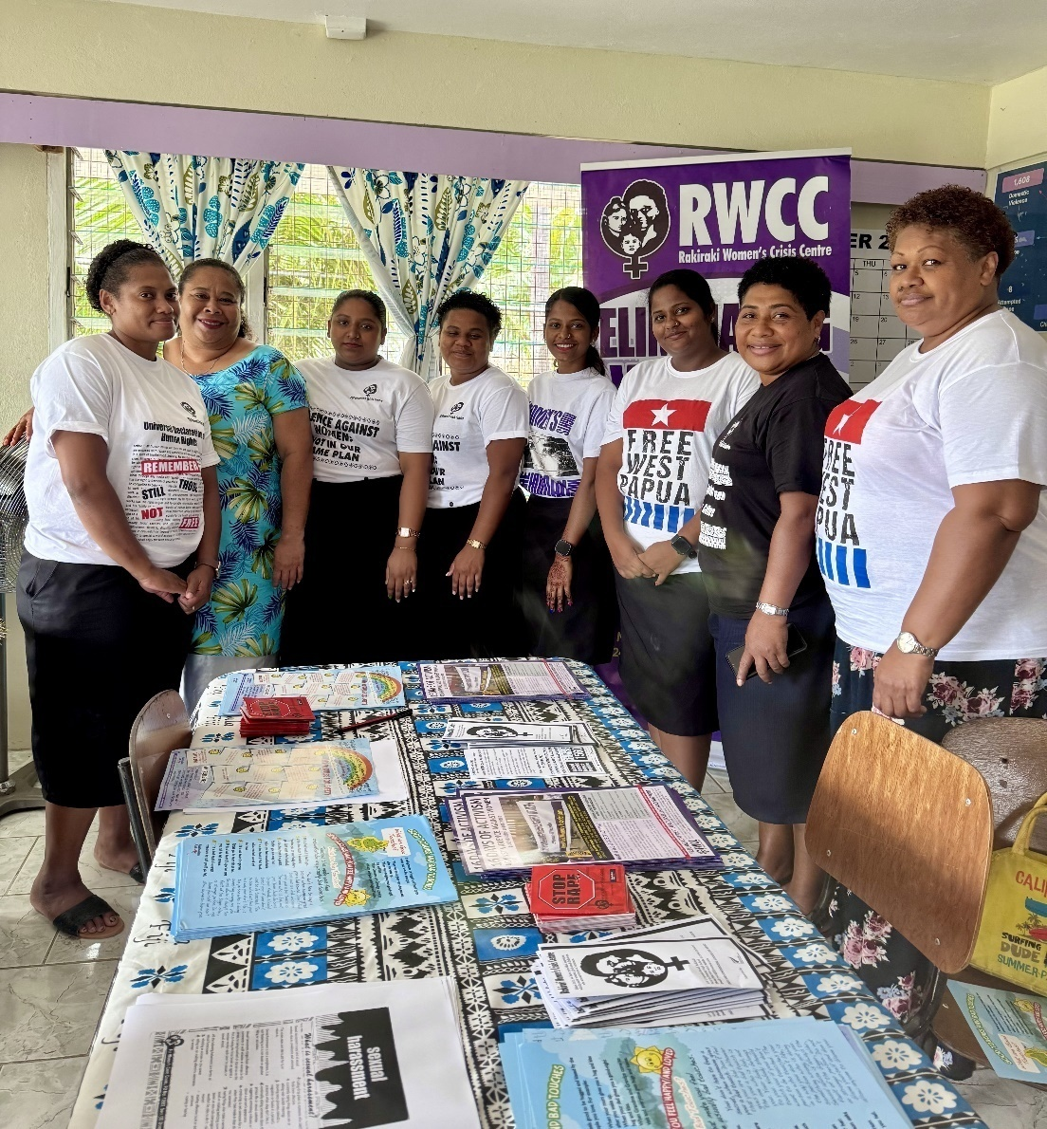

**Rakiraki Women’s Crisis Centre staff - Image obtained with consent from FWCC staff**

By contrast, Branch staff in Rakiraki reported strong, positive partnerships and collaboration with police and social welfare which has resulted from face-to-face meetings to promote smooth collaboration. Similarly, Labasa Branch staff reported seamless support from, and collaboration with, police, the court system and social welfare; referral pathways work well.

#### 1.4.2 More than 300 people from a diverse range of service providers trained over the past two years, but FWCC cannot meet the demand.

Interviews with a broad range of trainees reveal satisfaction with FWCC training and CSOs cite evidence of improved performance amongst trainees. Multiple respondents reflected upon the quality of the training, noting that FWCC use data and real, contextualised (de-identified) examples through counsellors, which has much greater impact than EVAW training imported from another country. Many CSO respondents indicated that they would like follow-up or refresher training but FWCC has to make strategic decisions about the best way to deploy limited resources.

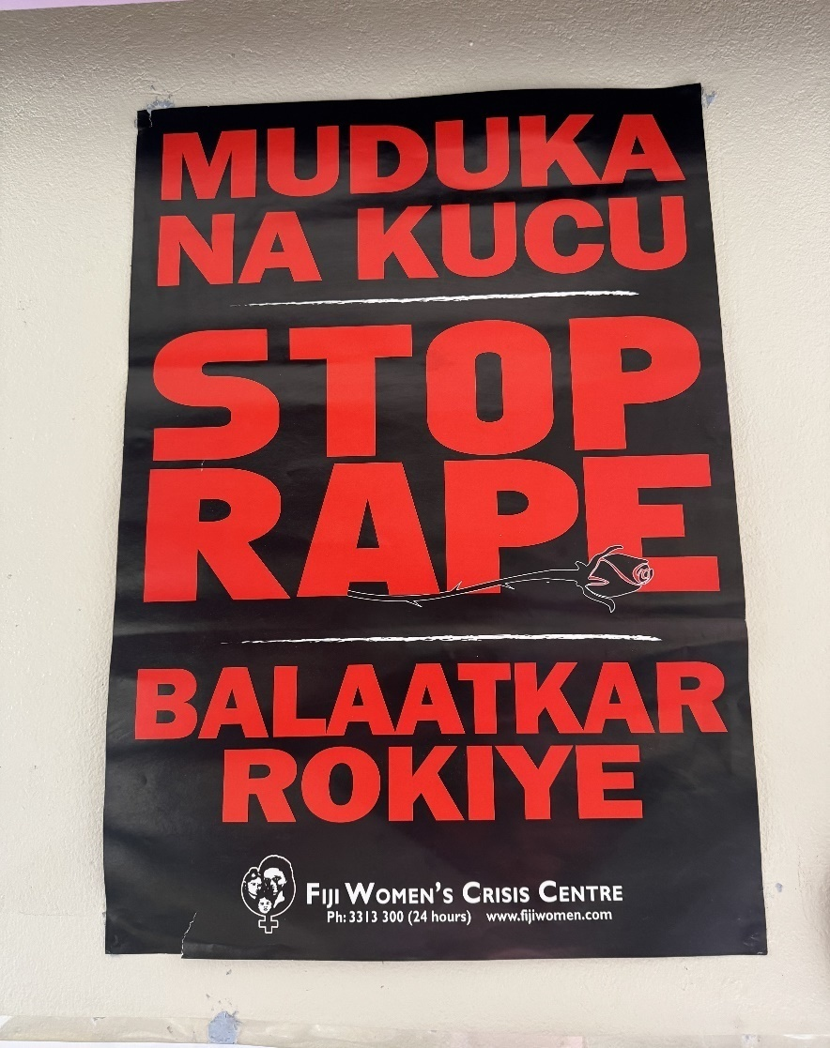

**Vernacular rape poster – Image obtained with consent of FWCC staff**

#### 1.4.3 FWCC branches prioritise community education but follow-up is difficult.

Community education aims to increase awareness of human rights and gender equality and is a key prevention strategy. The Branches have a critical role to play in mobilising and educating communities to end violence against women. Ninety community mobilisation sessions and seven community education workshops[20] (i.e., in response to demand and carried out in the necessary vernacular) have been conducted over the past two years, involving more than 3,500 participants.

The demand for community education (CE) continues to increase. However, FWCC has had to be strategic about the way it conducts this work, being mindful of the need for sustained engagement to bring change. Limited funding and availability of suitably capable and experienced staff also limits the level of engagement with communities.

There is substantial anecdotal and case study-based evidence to demonstrate the results of this work, including changes in individual behaviour (women and men), a reduction in violence in the village after CE training; increases in referral of victim/survivors to FWCC or police; communities holding police accountable; and taking action to influence other leaders and community members to end VAW.

Trainers also report that, when they conduct follow-up visits, the EVAW committees (established following community engagement) are still active.

FWCC trainers aim to carry out follow-up sessions in communities approximately six months after the original training workshops. However, it is not always possible to keep to this schedule due to constraints on staff (i.e., trainers perform multiple roles, including counselling ); transport and weather constraints.

#### 1.4.4 FWCC has a very active presence in the mainstream media and on social media although the extent of resulting influence is not systematically analysed.

Multiple stakeholders noted that FWCC uses the media very effectively as a tool to raise the visibility of gender-based violence, to hold government and duty holders accountable and to raise public awareness of human rights. Although FWCC is not the only voice raising these issues, Government, CSO and donor stakeholders reported a perception that FWCC’s long-term advocacy has been a major influence on a ‘shift’ in the willingness of Fijian society to at least discuss GBV.

Stakeholders referred to the fact that the 16 days of activism / FWCC commemoration march attracted over 800 people as a demonstration of increased willingness to publicly acknowledge GBV.

Media statements and public engagements on VAWG are routinely monitored by FWCC and lists are included in external reports. The MTE team was not aware of any content analysis being conducted or attempts to link media campaigns with resultant changes to government policies or practice.

FWCC uses a variety of means of communication depending on the audience (e.g. radio for rural communities, social media for teens, newsletters, posters and pamphlets for maritime people, TV for the general public). Key videos are repeated at specific times (e.g., festive season). The branches share information on which approaches are most popular with which audiences.

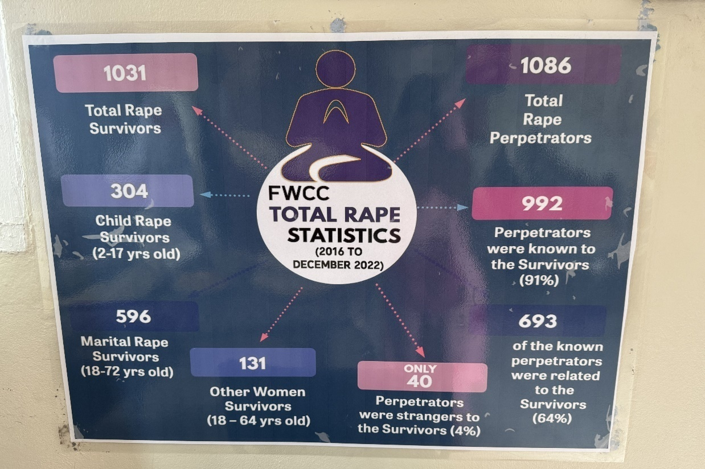

**FWCC communication poster on rape statistics 2016 – 2022 - Image obtained with consent of FWCC staff**

FWCC’s presence on social media expanded substantially over the review period (i.e. over 20% increase in Facebook followers and 13% increase in X followers from 2022/23 to 2023/24. Over two-thirds of the followers are women; over 70% are from Fiji; almost half are from the Suva area. From July 2022 to June 2024, 555 Facebook enquiries were received, one-third of which related to domestic violence.[21]

#### 1.4.5 The male advocacy program requires careful monitoring to ensure continuing engagement and accountability to the women’s movement (EOPO6)

FWCC and branches train, mentor, work with and monitor new and existing male advocates (i.e., their commitment, behaviours, activities, effectiveness) to promote and protect women’s human rights. Over the review period, FWCC carried out nine sessions involving training of 347 male advocates. FWCC reports highlight case studies of male advocates providing referrals and support to women experiencing violence. The majority of trained male advocates are reported to have sustained their commitment, advocacy and accountability to FWCC.

FWCC reviewed the male advocacy program during the review period and developed a refresher training model. Selected male advocates have also been provided with mobile phones and recharge for contacting the Centre to provide updates and referrals, as well as books to document their progress and activities.

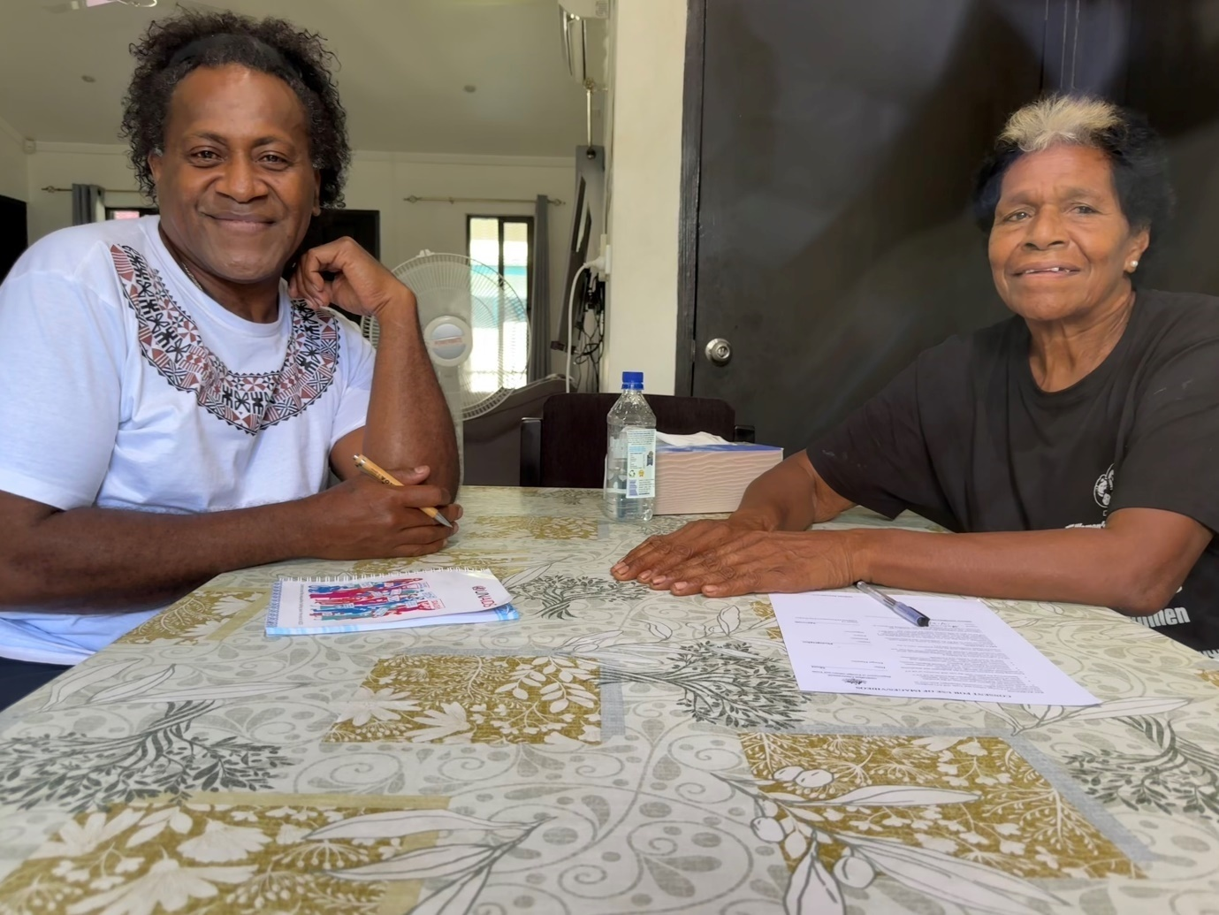**Male advocate and EVAW Committee Member, Nadi – Image obtained with consent**

The MTE team was not able to independently verify the performance of all male advocates. However, 5 male advocates were consulted, across Nadi, Ba, Rakiraki and Labasa branches; key points identified during these discussions included the following:

* Through CE training, male advocates are able to experience mindset shifts, change at a deep level, and become supporters and defenders of women’s human rights, and of children. Male advocates reported experiencing an inner transformation in their attitudes, and they concomitantly change their behaviour to be more supportive of women both within their own households, through sharing housework, and in the broader community through reinforcement of the training content and assistance with reporting DV and GBV cases.
* Rights-based training provides a robust, shared understanding that allows survivors and male advocates to identify cases of GBV – all interviews with counsellor advocates confirmed this. Male advocates stated that a rights-based approach helps them empower women in their communities – they reinforce the CE trainings and support women in reporting GBV incidents.
* The EVAW Committee structure that is created in communities includes male advocates.
* From a behavioral standpoint, male advocates are expected to model desired behaviours to other males.
* Male advocates also shared that more resources would help them access the large geographical areas they are responsible for. They also requested more frequent refreshers and check-ins, which, as stated earlier, is limited by resources available to FWCC.

FWCC already includes case studies of the work of male advocates in its Annual Reports. In addition, more systematic monitoring of the extent of attitudinal change of males following CE training could aid in FWCC’s efforts to communicate the nature and effectiveness of its community-level prevention work.

### 1.5 MTE team unable to assess the extent to which Regional Network members and partners use best practice in their prevention and response to Violence Against Women (EOPO5)

During initial discussions with DFAT, and in the Evaluation Plan ‘Limitations’ section, the MTE team advised that the pre-start-up ‘evaluability’ assessment indicated that it would not be possible to carry out a rigorous assessment of progress against EOPO5. Specifically, in the time available, and given that the field mission only focused on Fiji, it was only be possible to obtain limited opinions from a non-representative sample of interviewees, interviewed via remote communications. The evaluability assessment proved to be correct; only 3 respondents were able to comment on this outcome area. In the absence of independent assessment of regional activities, this cannot not be regarded as strong evidence pertaining to the achievement of EOPO5[22].

Given that more than one-third of funding to Fiji Women's Crisis Centre is regional funding for regional activities, there is a need to gather evidence about the effectiveness and efficiency of this work. This may be done as part of finalising the PGS design process for a regional program of support to crisis centres.

## QUALITY OF FWCC MONITORING SYSTEM

### 2.1 Treating the work of FWCC as a ‘program’ also distorts understanding of the purpose and intent of the M&E system

#### As discussed in Section Two below, the treatment of FWCC’s work as a ‘program’ rather than a ‘going concern’ – an established, autonomous non-government organisation – creates distortions of perspective and expectations. This is no where better demonstrated than in consideration of the MEL system. Under the current arrangements, where a grant is provided for implementation of work identified in a design (and associated annual workplans), DFAT staff appear to have developed an expectation that the FWCC MEL system needs to be primarily geared to meeting DFAT accountability, decision-making and learning requirements. This is not, in fact, correct.

Consistent with DFAT’s normal approach to M&E in partner-led designs, the *primary user* of FWCC’s performance information is the organisation itself. This is made clear in the DFAT-approved design document[23]. Even though the FWCC MEL system effectively meets DFAT standards it is not *compelled* to do so. Quite appropriately, neither the current s.23 funding approval, nor the Deed, require DFAT M&E Standards to be met.

### 2.2 The FWCC MEL system is a sound mechanism to demonstrate achievement of key deliverables, to facilitate decision-making and continuous improvement

A review of the FWCC MEL system indicates that the system is sound and represents a judicious use of time and resources. The evaluation team reviewed the processes of weekly data collection from all branches against 29 indicators (refer Appendix D), verification/quality assurance (dual level), as well as collation and storage of data (MS Access and Excel). The evaluation team is satisfied that the processes meet DFAT’s Value-for-Money requirement of ‘proportionality’[24], as well as DFAT’s M&E Standards. M&E personnel at Pacific Women Lead (PWL) Enabling Services unit (which receives and aggregates FWCC data for PWL reporting) confirm satisfaction with the robustness of the data.

While more sophisticated software might be available to analyse FWCC data, such software is often cloud-based, which could increase the risks of data breaches. Maintaining the privacy and security of victims’ information is FWCC’s primary priority.

The evaluation team found clear evidence that data is being fed back to different levels of the FWCC organisation to inform decision making and continuous improvement. For example, data is forwarded back to branches for awareness raising; success stories and complaints are shared across branches; data is collated quarterly for forwarding to the Management Collective to inform decisions about targeting community mobilisation efforts, training of service providers, training of FWCC Branch and shelter staff and to inform higher level advocacy; data is shared with the Coordinator for media releases and with the Board of Trustees to inform strategic planning.

### 2.3 There is scope for improved collection and analysis of qualitative data

Some secondary analysis has been carried out by FWCC in the past (e.g., analysis of rape numbers over time) and there are plans to conduct analysis to identify long term trends (e.g., in intergenerational abuse; age of perpetrators). However, this is all constrained by the availability of human and financial resources.

If resources were available, the MTE team found that there are opportunities for FWCC to make minor changes to existing reporting templates to improve the capture of qualitative data on the achievement of specific stages of empowerment by survivors (refer 1.2.3 above) and on attitudes and behaviour changes of service providers/duty bearers following FWCC training. This qualitative data could be analysed to:

1. identify the links between numbers of repeat clients and achievement of specific stages of empowerment
2. present (de-identified) aggregate data on the percentage of FWCC clients progressing along the road to empowerment at a given time;
3. present aggregate data on behavioural and attitude changes resulting from community mobilisation workshops and training of duty bearers.

Finally, it is noted that the M&E system does not currently attempt to link performance data to financial data. Any attempt to do this, even in a limited way, would be beneficial to the Management   
Team to inform their decision-making processes, advocacy and resource mobilisation efforts.

### 2.4 There is a mismatch between FWCC’s needs for information and DFAT / MFAT requirements

The performance information collected by FWCC is also used to prepare reports to donors. Multiple donor stakeholders noted that the information provided is excess to their requirements but, at the same time, does not necessarily answer all of the donor’s questions. DFAT / MFAT specifically require outcome level data, that is, data which addresses the current ‘poorly framed’ outcome statements in the design. FWCC, by contrast, needs and uses information to inform the delivery of key services for survivors, community mobilisation and education work, high-level advocacy, male advocacy and regional EVAW work.

On the one hand, even though a great deal of time and human resources are committed to the provision of reports, FWCC staff express disappointment that these reports do not stimulate meaningful discussions with DFAT on the nature and progress of the work. By contrast, FWCC’s provision of extensive, operational data has, perversely, encouraged a ‘down-in-the-weeds’ form of investment management on the DFAT side which has generated some conflict between the partners.

On the other hand, time poor DFAT and MFAT staff have difficulty in digesting the extensive, output focused, Annual Reports and often seek further and better answers to their outcome-level questions between reporting rounds. This generates frustration amongst FWCC staff as the information sought is, invariably, contained within previously submitted reports. However, to be fair, some secondary analysis is often required to yield answers to DFAT’s questions.

A move to core funding based upon a Partnership Agreement (see Section Three below) would provide an opportunity for spelling out the information requirements of both partners and, thereby, streamlining the reporting coming to DFAT to focus on progress towards the delivery of shared strategic objectives.

## Efficiency

### Deviations from budget are the norm for a ‘going concern’

Section Two (below) discusses the inappropriateness of the aid modality, grant funding linked to a time-bound program design and budget. The frequent deviations from budget (and the associated administrative burden for both FWCC and DFAT) demonstrate amply demonstrate this point.

While staff salaries, rent, utilities and core coordination and management costs remained relatively stable over the review period, there were substantial variances (mostly underspends) between budget and actuals for a range of non-recurrent line items (e.g., training - internal and external -, campaigns and support to network member programs).

These variances generate substantial work for FWCC in preparing change frames and reconciliations. Budget variances also generate substantial management difficulties for DFAT. It is a credit to both partners that they have managed this situation as well as they have.

However, it needs to be recognised that budget variations are the norm for a ‘going concern’ responding to the demands of its clients and the changing context. The ‘going concern’ concept is derived from International Standards on Auditing and assumes that an entity will continue its operations for the foreseeable future. All FWCC independent audit reports are carried out on the basis that FWCC is a ‘going concern’, not a time-bound program and this is accepted by DFAT.

As a result, the independent audits of FWCC’s financial statements over the period under review have not only confirmed that the financial statements give a true and fair view of the financial position of the Centre, but also that “*no material uncertainty exists which may cast significant doubt upon the Centre’s ability to continue as a going concern.”* [25]

Section Three (below) suggests a shift from the current aid modality to grant funding based upon a Strategic Partnership Arrangement which recognises FWCC as a going concern. Such an approach could streamline financial management for both FWCC and DFAT without undermining DFAT’s commitments under the Public Governance and Performance Assessment (PGPA) Act.

In order to better manage budget variations, all future grant agreements should include a provision to allow FWCC to shift underspends between budget lines through an email exchange. However, DFAT would still require relevant paperwork as supporting documents.

### Governance and Management meets standards

#### Due Diligence assessment revealed moderate/low risks which have been addressed

A comprehensive due diligence assessment of FWCC, undertaken in 2021, assessed 10 out of 14 risks as ‘moderate’ (i.e., requirements appear to be established and some evidence of controls/measures and there are some risks against minor criteria, which require treatment); and assessed four as ‘low’ (Requirements established and there is demonstrable evidence of effective controls/measures.)[26]

The Assessment recommended that FWCC review several policies, the Constitution, and the Trustees’ Terms of Reference. It was also recommended that FWCC draft new policies to document procedures and processes that were already in practice. FWCC implemented the majority of the report recommendations. This included amending the FWCC Constitution and Trustees Terms of Reference (ToR), both of which were endorsed and adopted on 30th June, 2023.

In keeping with the Management’s response to the Due Diligence Assessment, FWCC finalised, endorsed and socialised all the documents/policies which were agreed to, and these were shared with DFAT and MFAT at the end of June 2023.

#### 3.2.2 Board of Trustees meets regularly, members are aware of their responsibilities and represent a good mix of skills and perspectives

The Board of Trustees includes members from a variety of backgrounds, including environment/ human rights, mental health, law and disability inclusion (lived experience). The Trustees meet monthly or quarterly depending upon issues needing to be addressed. They see their role as to:

* Hold the officers to account
* Ensure accountability to the donors and laws of Fiji
* Maintain the overall integrity of the organisation
* Approve statements made on behalf of the organisation around public issues
* Review financial statements (including discussions with administration staff to clarify issues)

The Board of Trustees identifies five areas of strategic concern:

1. **Succession:** Given the importance of maintaining the culture and integrity of FWCC’s work, the Board has resolved to fill the Coordinator’s position, when required, from within. The Board has established a coalition of a group of leaders drawn from across the crisis centres. This group is working on the succession process.
2. **Short-term donor funding:** The Board’s perspective is that funding is now provided for very short periods (2-3 years).[27] This affects FWCC’s ability to provide staff with anything more than one-year contracts. This, in turn, affects the ability of the organisation to recruit and retain staff; for example, without access to longer contract, a staff member cannot obtain a loan from a bank.
3. **Refresher training:** Community education training needs to be refreshed. It is not being done regularly enough. In Ba and Lautoka the police are pushing back because they have new recruits who have not been trained and do not understand the importance of gender sensitivity in handling domestic violence and family violence cases.
4. **Financial sustainability / resource mobilisation:** The Board gives on-going consideration to this issue, but points out that it is not a straightforward matter. For example:

* Private sector funding has attendant moral risks. FWCC is built upon some core values and principles which must not be eroded by forming inappropriate private sector partnerships. FWCC cannot hold government agencies accountable if they are not perceived to be independent.
* Government funding is limited. Currently the government funds the 24/7 Helpline, but it is unlikely that any additional fund will be available for EVAW, except the NAP implementation funds which have been allocated to various government departments.
* There is a conflict of interest between service provision and money-making activities. FWCC does carry out training for various corporations and charges a fee. However, this is not core business. The Board sees a serious conflict of interest in deploying scarce resources in this way, rather than prioritising service provision. Further, the organisation is not set up to charge fees and receive monies. Any attempt to do this on a larger scale would require substantial administrative changes (e.g., setting up a Trust Account)

1. **The nature and quality of the partnership with DFAT.** The relationships with DFAT and MFAT are meaningful to FWCC but, given the increasingly transactional nature of the relationship, coupled with DFAT’s apparent reluctance to commit long-term funding, the Board questions whether FWCC should move beyond Australia and NZ as the partners of choice. The Board expressed confusion about what DFAT wants and identified some examples of different messages being conveyed by different parts of the department. Some clear messaging would be appreciated.

The Board is aware that donor support is shrinking and many new NGOs are entering the EVAW space and being funded; donors are not necessarily looking at their record or the quality of the work they do.

#### 3.2.3 The Management Collective represents the entire organisation, meets regularly and appears to make evidence-based decisions

The Management Collective involves representatives from all sections and branches of the organisation. Each collective member manages their own team and report monthly to the collective and quarterly to the Board of Trustees. Based upon the data presented to them by the Research Team (refer Appendix D) the management collective discuss performance in particular locations, with particular target groups and the challenges being faced. The feedback from the various centres indicates what the priorities are.

### 3.3 Personnel are skilled and experienced, but need further support

**FWCC:** Although there are clearly staff shortages, the MTE team was impressed with the integrity, capacity and commitment of FWCC staff. Key staff, such as Counsellor Advocates, are subjected to rigorous training, mentoring, observation and ongoing assessment lasting from six months to one year. Community education trainers undergo a 2 to 3-year process of observation of experienced trainers, learning-by-doing; independent training under supervision; and final approval.

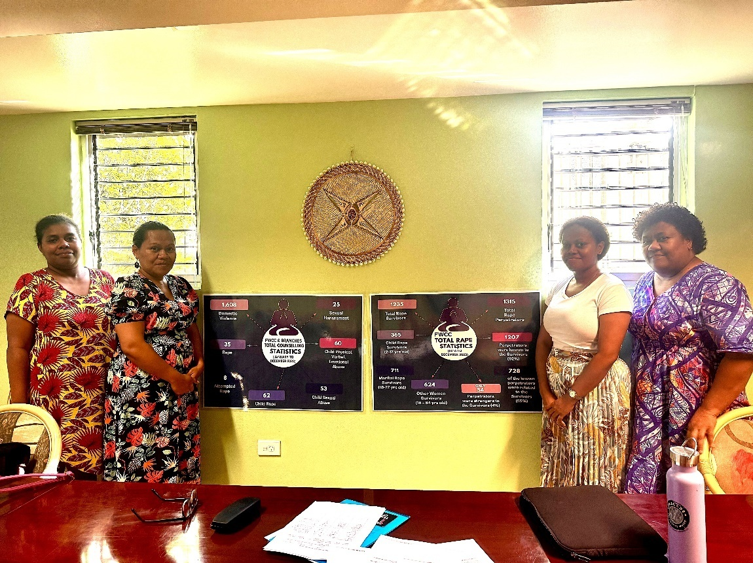

**Suva Counsellor Advocates – Image obtained with consent of FWCC staff**

Although FWCC need more staff to meet the increasing demand, the Management Collective emphasises the point that they need a certain kind of staff – passionate and dedicated to the cause of EVAW and empowering women . FWCC also needs to be able to offer more than the current (mid-range) salaries to ensure retention of committed staff.

**AHC, Suva:** Post has a number of personnel with long-term experience in EVAW, particularly amongst Locally Engaged Staff (LES). However, overall AHC, Suva needs more support from Canberra to engage with CSOs and with the evidence on EVAW, in order to improve understanding and collaboration with FWCC as a strategic partner. There are resources available within the DFAT Canberra Gender teams and from the SURGE Panel. More opportunities should be made available for Post to access this support to strengthen their own work. This recommendation was also made in the PWSPD 6-year evaluation.

### 3.4 Harmonisation and alignment with other donors and government

As an independent NGO, FWCC has played a key role in holding government accountable for inaction, identifying gaps and advocating for work to fill the gaps. At the same time, FWCC has worked with government to fill identified gaps, most notably in development of the NAP. FWCC has worked closely with the Ministry of Women, Children and Social Protection (MoWCSP) and the UN to develop the NAP and are now working with the NAP Committee to address GBV across all the priority settings (i.e., traditional, education, faith, sport, rural, remote, maritime areas). Senior government stakeholders argue that the NAP was born out of the partnership between government and the FWCC. Both UN and government stakeholders commented upon the key role that FWCC played in convening and coordinating broad CSO input into NAP preparation.

FWCC has also worked with government in setting standards for referrals and service provision (counselling and support services). Through its work with the Regional Working Group (managed by SPC) FWCC has been able to standardise the requirements for GBV counselling to go above and beyond normal counselling.

The National Women’s Machinery is also working with FWCC to train the training providers (i.e., in gender equality, human rights and gender-based violence ).

Both government, multilateral and CSO stakeholders commented that a lot of development agencies are moving into the EVAW space and not necessarily meeting best practice standards in their work. FWCC is already working with government to set performance standards across a range of domains. However, again, there is a role for DFAT in policy dialogue with GoF, to support the introduction of screening mechanisms for new entrants to prevent harmful practices which may negatively impact on women and children and increase the burden on FWCC. DFAT’s support to the implementation of the Fiji National Action Plan to Prevent Violence Against Women and Girls (2023-2027), led by the Ministry of Women, Children and Social Protection, will contribute to improvement in standards by GBV service providers.’

# SECTION B: KEY FACTORS INFLUENCING EFFECTIVENESS AND EFFICIENCY

## 1.1 The DFAT design approach is not a neat ‘fit’ for an ‘ongoing concern’

The first task of the FWCC MTE was to assess progress towards the achievement of outcomes. A basic prerequisite for carrying out this task is, in fact, that the outcome statements are clear, realistic and measurable[28] and that the pathways to achieving the outcomes (the program logic) are evidence-based and feasible[29].

None of the eight outcome statements of the FWCC design, nor the program logic, meet DFAT standards in this regard. The ‘so-called’ outcomes are, in fact, strategic objectives developed as part of a process undertaken in 2020/21 by FWCC, with DFAT/MFAT support, to identify organisational priorities over the next five years. This was, in fact, an organisational strategic planning exercise, which has fundamentally different intentions and results, to a program design exercise.[30] Once completed, however, and despite recognition of deficiencies in the design,[31] the strategic plan was treated as a ‘partner-led’ program design and funded on a 2+ 2-year optional basis. This built on previous DFAT practice.

The attempt to collapse the strategic plan of a ‘going concern’[32] into a standard, time-bound, program design was not a comfortable ‘fit’, a point noted by multiple DFAT personnel during interviews. This structural problem has, inevitably, led to tensions between AHC, Suva and FWCC.

DFAT staff are attempting to manage what they see as a ‘program’ with discrete components, timeline and budget. FWCC staff are attempting to run an organisation with a past, a present and a future. FWCC staff carry out operations which build upon FWCC’s long-term cumulative efforts, as well as the integrated and comprehensive nature of their programs, to respond to changing demands and context. FWCC staff also see the organisation as performing a significant, on-going role in the women’s movement.

The use of the program design approach as a mechanism to fund FWCC’s work would now appear to be out of step with Australia’s International Development Policy commitments to forge partnerships of respect and support locally-led change, including to “*provide multi-year funding and capacity development to local organisations, with support as needed to meet policy requirements*.”[33] The approach is also a less than efficient aid modality, a matter discussed in the next section and an alternative funding approach is recommended in Section Three.

## 1.2 The aid modality is inefficient

As with the program design approach, the current funding arrangement – grant funding linked to a program design – plus regional funding for a list of discrete activities[34] unfunded from the original design - represents a poor ‘fit’ with FWCC’s requirements, as well as Australia’s International Development Policy and Locally-Led Development policy.

The initial observations of the MTE team, confirmed by stakeholder consultations across a range of organisations, are that the current funding model is not working.

The current funding model, based upon funding for the delivery of a ‘program’ on a 2 + two-year option basis:

* **Creates an administrative burden for DFAT.** This is the latest iteration of a series of such funding models which, taken together, have required nine (9) amendments to s23 agreements and associated deeds since June 2020 in order to accommodate the organic nature of FWCC’s work and DFAT’s changing budget options.
* **Increases the financial management and reporting burden for FWCC** in order to reconcile actuals with budgets in a demand-driven and changing environment.
* **Does not provide financial stability for FWCC**; the downstream effects include waste of partner resources in preparing a design, as well as a later proposal for funding when additional funds became available under the regional program. Short-term funding also creates difficulties for FWCC in recruiting and retaining quality staff on short term contracts.
* **Reduces the relationship between DFAT and FWCC to a transactional relationship** based upon a funding arrangement, rather than a partnership based upon a commitment to shared objectives. As a result, FWCC is forced to commit time and resources to meeting continuous demands to ‘prove’ that the work is worthy of support, rather than focusing on the work itself, secure in the knowledge that DFAT and FWCC have shared objectives to EVAW.

The Pacific Gender Section of DFAT’s Office of the Pacific, responsible for designing the new regional program of support to crisis centres, reports that none of the crisis centres are interested in having a program-based funding model, but are looking for partnership arrangements with DFAT. PGS respects this position and is looking at ways to respond to it in the new design.

# SECTION C: A SUSTAINABLE PARTNERSHIP AND FUNDING MODEL

## 1.1 The rationale for continued funding of FWCC remains strong

* **The risk of doing nothing is too great.** While publicly available data is outdated, a 2011 prevalence study found that 64% of women in Fiji had experienced physical or sexual violence over their lifetime; 24% had experienced this type of violence over the previous 12 months. Consultations carried out during the conduct of this MTE suggest that the prevalence is rising.

Australia is required to meets its international human rights and gender equality commitments to address this suffering and end violence against women. In addition, there is ample research to demonstrate that countries with higher rates of domestic violence are subject to higher levels of political unrest.[35] As a result, GBV is a direct challenge to Australia’s diplomatic and development efforts to support a stable, peaceful and prosperous Pacific.

* **EVAW is a high priority for the Australian government,** both domestically and internationally. The Australian Government’s commitment to ending GBV in all its forms is outlined in the [Working for Women Strategy](https://genderequality.gov.au/working-for-women/priority-area-1-gender-based-violence) (priority area one) and [National Plan to End Violence against Women and Children](https://www.dss.gov.au/national-plan-end-gender-based-violence). The Strategy and National Plan provide a Whole of Government Framework for all of Australia’s ending GBV efforts, domestically and internationally.

In addition, Australia’s [International Development Policy](https://www.dfat.gov.au/publications/development/australias-international-development-policy) highlights Australia’s continuing commitment to respond, prevent and address gender‑based violence in all its forms across our programs, policy, and diplomatic efforts (page 11). It also highlights the importance of supporting and strengthening local organisations and locally led efforts.

The Fiji-Australia Vuvale Partnership includes the following joint pledge:

*We commit to the implementation of our respective National Action Plans to End/Prevent Violence Against Women and Girls and meeting our obligations under the Convention on the Elimination of All Forms of Discrimination against Women.[36]*

* **FWCC’s effectiveness and efficiency has been independently validated on multiple occasions.**
* The Pacific Women Shaping Pacific Development six-year evaluation (2020) recommended that the on-going program should continue to support local organisations providing holistic care for survivors of violence.[37]
* The FWCC End-of-Program Evaluation (2020) found that FWCC’s work remains highly relevant; good progress was being made towards the achievement of outcomes; an adequate level of efficiency had been achieved and that the work was highly sustainable.
* The evidence presented in Section 1 of this MTE report echoes these findings.

The MTE was not tasked to make a recommendation regarding an extension of funding to FWCC for the next two years as there is little doubt that DFAT will continue this support. FWCC is one of the few providers of essential support services to survivors of GBV in Fiji. It is the only provider that includes a range of services such as counselling, legal, aid, shelter, and assistance with housing, groceries, and children's school needs. Aside from medical services, FWCC is a one-stop-shop for survivors of domestic violence.

By contrast, the scope of support available from other service providers is less comprehensive. MSP provides some similar services, including counselling and legal aid; House of Sarah provides faith-based support; and Empower Pacific provides general counselling, rather than GBV counselling. The Salvation Army Family Care Centre has been set up very recently; it is a safehouse for survivors of domestic violence and human trafficking, and includes counselling.

The MTE team was tasked, however, to identify considerations for the potential extension. The primary considerations are outlined below.

## 1.2 The funding model needs to strengthen and enhance the partnership between DFAT and FWCC

### 1.2.1 Understanding the intent and prerequisites for core funding

Various staff at Post routinely refer to the support provided to FWCC as core funding or part core funding. However, the way in which funds are being made available to FWCC does not meet the standard definition of core funding, namely, that: “***Core contributions*** *support an agency’s core mandate and objectives.”[38]*  Core funding can also be referred to as unearmarked or unrestricted contributions. This often means paying for staff and costs related to them doing their jobs well, like budgets for communications, meetings, training and professional development, technology costs and media monitoring.

In fact, DFAT is already funding staff costs for FWCC; however, this funding is tied into a program design approach which both limits the flexibility normally associated with core funding and increases the administrative burden on FWCC – and DFAT.

By contrast, the *intent* of core or unrestricted funding is to give recipient organisations the autonomy and flexibility to make their own decisions about how best to use funder dollars in order to bring about the greatest change.

There are two key prerequisites for the provision of core funding, namely:

* That the recipient organisation is an established and highly respected development organisation in its field
* That the donor and recipient have shared and overlapping objectives and priorities which are best served by a joint, partnership approach to development.

### 1.2.2 An alternative option to program funding: a Strategic Partnership Arrangement between DFAT and FWCC

A key consideration for extension of the current agreement with FWCC is for DFAT to enter into a partnership agreement focused on the articulation of shared, strategic priorities over the medium term (i.e., five years). There are a number of examples of DFAT developing partnership arrangements with organisations which meet the above prerequisites.[39] The transfer of funds would still be managed via a Complex Grant Agreement, which may be for a shorter period (see 3.2.3 below) but a voluntary Strategic Partnership Arrangement (SPA) establishes the framework for both the provision, and receipt, of donor funds over time.

The arrangement recognises the respective strengths of the partners, the shared and individual objectives of the partners, the guiding values and principles of engagement, joint and respective contributions, partnership governance arrangements and monitoring and reporting.

This type of arrangement directly fulfils Australia’s policy commitments to genuine partnership with Pacific partners and to locally led development. An example Strategic Partnership Arrangement agreement is attached at Appendix E. Key elements of the suggested approach are outlined below.

* **Replace program outcomes with strategic outcomes**

The current six (poorly framed) program outcome statements which generate voluminous, output level reports and are the source of multiple budget variations (refer sub-sections 2.4 and 3.1 ) would be replaced by three strategic partnership outcomes as follows:

* **An Institutional outcome** which would encompass FWCC’s aspirations to maintain and build its human resources, leadership skills and coordination and management processes.

The *budget* for this outcome would be relatively stable and predictable, incorporating staff salaries, rent, utilities, core coordination and management costs and internal training.

*Acquittals and reporting* would be carried out as per current practice.

* **A Programs outcome** which would encompass the delivery of *all* FWCCs programs / services (i.e., counselling, advocacy and support, accommodation services, external training, branch services, regional networking, FLARE and male advocacy).

The outcome statement would articulate a general target (similar to DFAT’s Tier 3 targets). For example, “*85% of FWCC programs meet annual targets and achieve quality standards”*

The *budget* for this outcome area would be estimated annually, but targets and allocation of resources for particular programs / services would be determined by FWCC in response to demand and changes in the context. Funds could be moved between line items to maximise efficiencies and impact. In return for this flexibility, FWCC would be expected to keep the overall budget variance for the program outcome within tolerable limits.

The budget might also include greater provision for in-house research based upon secondary analysis of data collected from branches, to inform strategic thinking and planning.

*Monitoring to underpin FWCC decision making and continuous improvement would continue as currently.* All data would remain available to be accessed during independent evaluations or for spot checks, as required.

*Reporting to DFAT against this outcome* would, by contrast, focus on a) Headline results[40], agreed between the partners and b) evidence-based discussion of key influences on the achievement of results. This could involve the presentation of macro level analysis on key issues (i.e., relationships between repeat counselling and the process of empowerment; changes in attitudes and practices of cohorts of third-party trainees).

* **A Partnership Outcome** which would focus on strengthening the partnership (FWCC/DFAT/MFAT) to deliver faster progress in EVAW. While the regular management of the SPA would be fully delegated to FWCC, a SPA Steering Committee (or whatever mechanism is jointly agreed) would seek to maximise the value of the partners working together.

This could include consideration of opportunities for joint policy engagement with government or CSOs; opportunities to facilitate access to top level decision makers in donor partner organisations; facilitation of partnerships and connections with other development actors and programs; sharing research / documentation which may be useful to the partners.

The *budget* should encompass at least two meetings per year (at least one day in length) of the SPA Steering Committee (DFAT/MFAT/FWCC); one meeting could be a field visit to various FWCC branches.

*Formal reporting is less important* than a commitment to frank sharing, openness to giving and receiving feedback and a focus on mutual learning.

* **Contributing development partners (DFAT, MFAT) make separate grants to FWCC**

Grants would still be subject to separate financing agreements, but would not be tied to specific programs. They would be used to achieve the strategic outcomes outlined in the SPA agreement. However, this arrangement would not prevent the allocation of separate funds for specific projects or in response to specific events (e.g., humanitarian crises).

Subject to agreement between the partners, the SPA might provide a framework for the inclusion of other donors so long as values and objectives align.

## 1.3 An approach to mitigating funding uncertainty

The MTE team has found no evidence to suggest that the short-term funding model has been beneficial for either FWCC or DFAT. Nevertheless, it is recognised that the most recent short term funding arrangement was entered into to encourage a focus on the implementation of due diligence requirements by FWCC.

Despite the challenges DFAT faces in entering into medium-term funding agreements, a SPA can legitimately express DFAT’s *intent* to maintain core funding to achieve strategic outcomes over the medium to long term, subject to budget availability.

While the SPA may still be funded via successive, short-term grants, the provision of this funding within the context of a medium-term partnership agreement provides some security for the partners and a foundation for DFAT and FWCC to think and plan together on ways to strengthen and empower women and end gender-based violence.

# SUMMARY OF CONSIDERATIONS FOR ON-GOING SUPPORT TO FWCC

In accordance with the approved Evaluation Plan, the MTE was required to compile lessons learned and considerations for the potential extension of the current agreement with FWCC. A range of issues have been identified throughout this MTE report for consideration by DFAT, FWCC, or both. These are summarised below, in order to priority and significance. Each consideration is cross-referenced to the section of the report addressing each issue.

|  |  |  |  |  |
| --- | --- | --- | --- | --- |
| **#** | **Issue** | **Why? Document reference** | **Who is responsible?** | **By when?** |
| 1. | A key consideration for extension of the current agreement with FWCC is for DFAT to enter into a partnership agreement with the Centre focused on the achievement of shared, strategic outcomes. The transfer of funds would still be still managed via a Complex Grant Agreement, but a voluntary Strategic Partnership Arrangement (SPA) establishes the framework for both the provision, and receipt, of donor funds over time. | 3.2.2 | AHC, Suva, MFAT/  FWCC | By October 2025 |
| 2. | Despite the challenges DFAT faces in entering into medium-term funding agreements, a SPA can legitimately express DFAT’s *intent* to maintain core funding to FWCC to achieve strategic outcomes over the medium to long term, subject to budget availability. Grants may still be provided for shorter-term periods under the auspices the SPA. | 3.3 | AHC, Suva | New DFAT grant to commence January 2026 |
| 3 | In order to better manage budget variations, all future grant agreements should include a provision to allow FWCC to shift underspends between budget lines through an email exchange. However, DFAT would still require relevant paperwork as supporting documents. | 3.1 | AHC, Suva | When drafting next Complex Grant Agreement |
| 4. | AHC, Suva needs more support from Canberra to engage with CSOs and with the evidence on EVAW, in order to improve understanding and collaboration. There are resources available within the DFAT Canberra Gender teams and from the SURGE Panel. More opportunities should be made available for Post to access this support to strengthen their own work. | 3.3 | DFAT Pacific Gender and Culture Section  Gender Equality: Strategic Budget and Investment Section | ASAP |

|  |  |  |  |  |
| --- | --- | --- | --- | --- |
| **#** | **Issue** | **Why?**  **Document reference** | **Who is responsible** | **By when?** |
| 5. | Given the critical role that police play as front-line responders to victim/survivors, and given Australia’s policy commitment to EVAW domestically and internationally, there is scope for the AHC, Suva to engage in policy dialogue with GoF (potentially during the next of Senior Officials Meeting) to allow FWCC to recommence GBV training for police recruits, possibly with a specific budget allocation to support this work. | 1.4.1 | Director, Fiji Section, Fiji and Vanuatu Branch | Prior to next Senor Official Meeting |
| 6. | There is scope for FWCC Counsellors to systematically record their professional judgements about where a (de-identified) survivor sits in terms of her own empowerment process, over time. This could be done using existing reporting formats and processes. | 1.2.3 | FWCC Research Team | If approved by Management Collective, prior to commence-ment of next reporting period |
| 7. | There is scope for using secondary analysis of existing FWCC data to establish the evidential link between the provision of support services and women’s empowerment. For example:  * the percentage of new survivors presenting to the centres who go on to seek repeat counselling * the correlative relationship between numbers of repeat sessions and numbers of DVROs issued, cases filed, separations, jobs, independent accommodation secured, etc . | 1.2.4 | FWCC Research Team | If approved by Management Collective, when time and resources permit. |
| 8. | There are opportunities for FWCC to make minor changes to existing reporting templates to improve the capture of qualitative data on the achievement of specific stages of empowerment by survivors (refer 5 above) and on attitudes and behaviour changes of service providers/duty bearers following FWCC training. This qualitative data could be analysed to:   1. identify the links between numbers of repeat clients and achievement of specific stages of empowerment 2. present (de-identified) aggregate data on the percentage of FWCC clients progressing along the road to empowerment at a given time; 3. present aggregate data on behavioural and attitude changes resulting from community mobilisation workshops and training of duty bearers. | 2.3 | FWCC Research Team | If approved by Management Collective, when time and resources permit. |
| **#** | **Issue** | **Why?**  **Document reference** | **Who is responsible** | **By when?** |
| 9 | More systematic monitoring of the extent of attitudinal change of males following CE training could aid in FWCC’s efforts to communicate the nature and effectiveness of its community-level prevention work. | 1.4.5 | FWCC Research Team | If approved by Management Collective, when time and resources permit. |
| 10 | The M&E system does not currently attempt to link performance data to financial data. Any attempt to do this, even in a limited way, would be beneficial to the Management Collective to inform their decision-making processes, advocacy and resource mobilisation efforts. | 2,3 | FWCC Research Team and Administration team | When and if the Management Collective considers this type of analysis to add value to their work; and when time and resources permit. |
| 11 | Given that more than one-third of funding to Fiji women's crisis centre is regional funding for regional activities, there is a need to gather evidence about the effectiveness and efficiency of this work. | 1.5 | AHC, Suva  PGS | Possibly as part of the process of finalising the PGS regional design process. |

## Appendix A – Deliverables and Indicative Dates

| **Deliverables** | **Indicative dates** |
| --- | --- |
| Initial team briefing provided by DFAT to the review team to highlight key priorities and expectations of the review team and provide relevant documentation | 8th November, 2024 |
| Initial document review. A list of documents to be reviewed will be prepared by DFAT | 5th-7th November, 2024 |
| MTR team prepares and submits draft review plan | 8-13th November, 2024 |
| DFAT reviews and accepts the review plan | 14th – 30th November |
| MTR team finalises and submits final review plan to DFAT | 1st December |
| In-Country Mission: Briefing with DFAT and final team preparations for data collection  Data collection field work   * Interviews/data collection (including virtual interviews with regional partners) * Team discussions * Preliminary data synthesis and analysis * Data collection (travel to RakiRaki, Ba and Nadi will be required) | 2nd – 19th December |
| Presentation to DFAT, FWCC and MFAT on preliminary observations and findings | 20th December |
| MTR team drafts review report | December/January |
| Draft MTR report submitted to DFAT for review | 7th January |
| DFAT, FWCC and MFAT provide written feedback to team on report | 17th January, 2025 |
| Review leader finalises and submits report | 20th – 21st January, 2025 |
| Presentation on review findings to DFAT and FWCC | 23rd January |

## Appendix B – Key Evaluation Questions and sub-questions

During a DFAT briefing held on 8th November, 2024, the KEQ included in the ToR were discussed with AHC Suva Post staff. Prior to the briefing, the Evaluation Team mapped the ToR sub-questions against DFAT’s standard sub-questions associated with the Effectiveness and Efficiency criteria and carried out a rapid evaluability assessment. The results of the mapping and evaluability exercises were then discussed with DFAT staff in order to seek clear direction on both the priorities for the evaluation and appropriate approaches to conduct of the evaluation. The following table summarises the directions provided and agreements reached.

**EFFECTIVENESS**

**1. TO WHAT EXTENT HAS PROGRESS BEEN MADE TOWARDS FWCC’S END OF PROGRAM OUTCOMES?**

1.1 **EOPO1**: **Women are asserting their rights and are empowered to make their own choices and decisions.**

1. To what extent is there evidence of increased empowerment and assertion of rights amongst target groups?
2. To what extent is FWCC delivering progress towards outcomes for women in all their diversity?
3. To what extent is FWCC reaching Indo-Fijian communities, women and children with disabilities and the LGBTQI community?

1.2 **EOPO2: Service providers, leaders and community members respond sensitively to women survivors and promote equal rights; and duty bearers implement laws and policies.**

1. To what extent are providers/leaders/community responding sensitively to women survivors and promoting equal rights; and duty bearers implementing laws and policies
2. To what extent are FWCC branches meeting the needs of target groups?
3. To what extent is there evidence of satisfaction and behaviour change among partners, local actors and beneficiaries?

1.3 **EOPO3. Women, community leaders and members and service providers in rural areas of Fiji are accessing effective prevention and response services.**

1.4 **EOPO4. Government, other policy makers and decision makers develop and review laws and policies that promote women's rights in Fiji and the Pacific region**

1.5 **EOPO5: Regional Network members and partners use best practice in their prevention and response to Violence Against Women**

1. How effective are the multiple activities that FWCC is undertaking under the GBV grant regionally including activities/coordination with the Regional Network?

**1.6 EOPO6: Male advocates promote equal decision making and rights for women in the family, community, workplace, organisations and society.**

**2. TO WHAT EXTENT DOES THE MEL SYSTEM PRODUCE GOOD QUALITY INFORMATION ON PROGRESS TOWARDS OUTCOMES; FACILITATE BETTER DECISION-MAKING AND FACILITATE LEARNING?**

**EFFICIENCY**

**2. HOW EFFICIENTLY IS FWCC USING TIME AND RESOURCES TO ACHIEVE OUTPUTS AND OUTCOMES?**

2.1 To what extent have there been deviations from budget and how has this affected implementation?

2.2 To what extent is this an efficient modality?

2.3 To what extent do FWCC personnel have the skills and experience levels required to achieve the outcomes?

What progress has been made in developing FWCC’s long-term Strategic Plan for expansion, inclusive of potential partnerships for pooling of resources and funding sources, and progress in the implementation of FWCC’s Resource Mobilization Strategy?

2.4 To what extent are FWCC’s activities harmonised and aligned with other donors and government?

## Appendix C – Analysis of interviewees and list of persons interviewed

### Analysis of interviewees

A total of 85 stakeholders were interviewed between December 2 and 7th January, 2024. The charts below indicate the gender, age ranges, and differential abilities of those interviewed. 82% of interviewees were females; 17% were males and 1% were non-binary. 39% of interviewees were in the age range 35-44; 27% were aged 45-60; 20% were 25-34 years of age; 9% were over 60; and 5% were in the 18-14 age range.

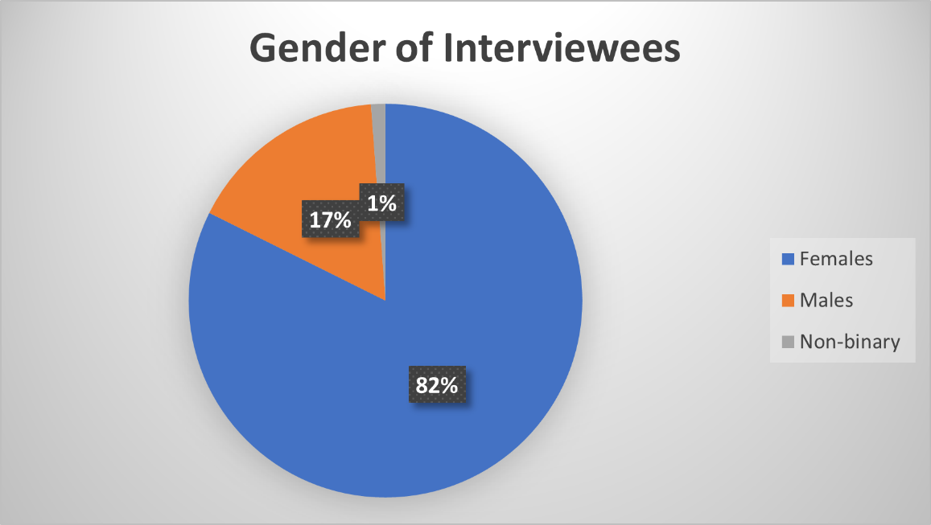

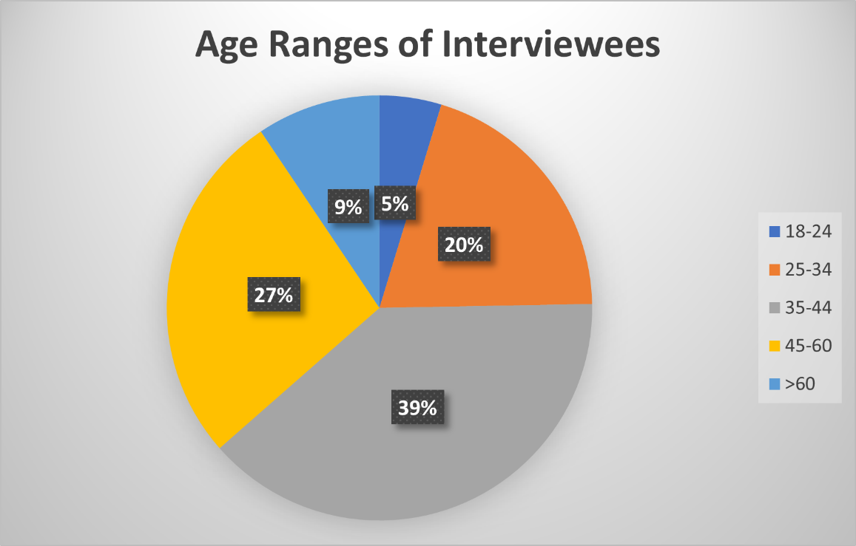

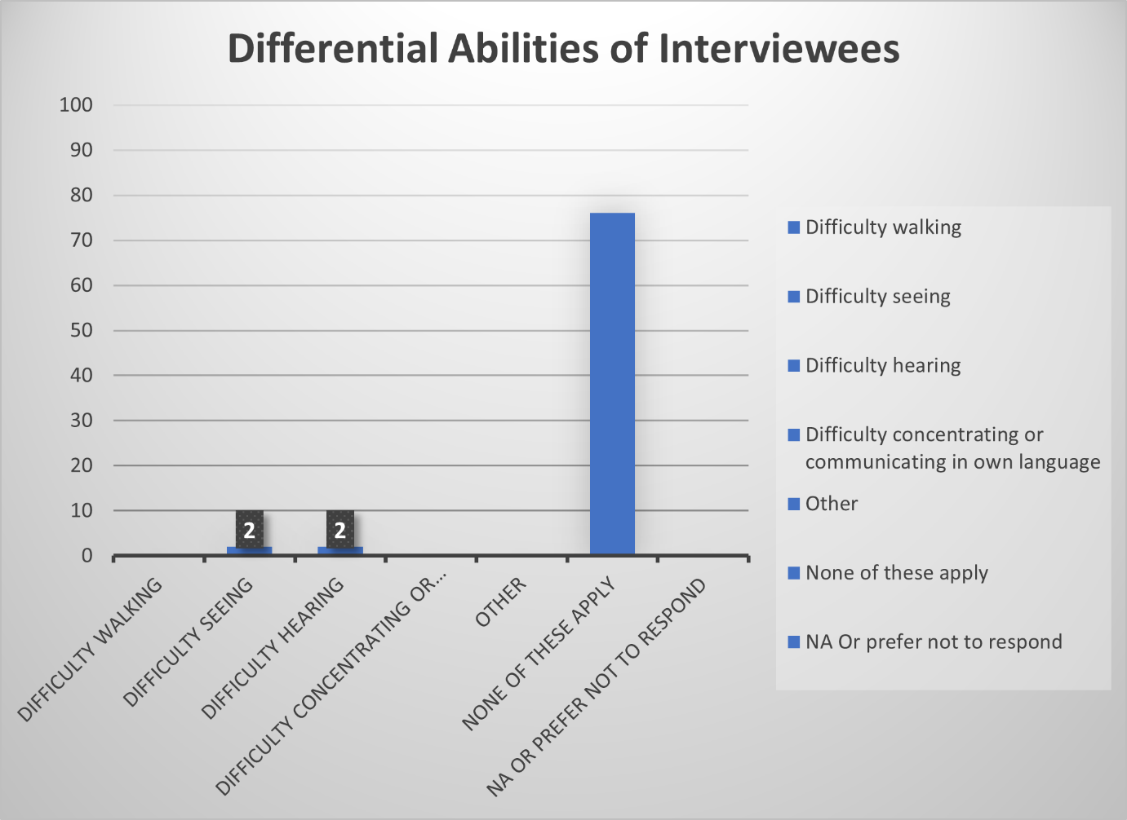

### List of Persons Interviewed

**DFAT**

* Australian High Commission, Suva:
  + Sophie Temby, Counsellor, Human Development
  + Tess Mcspedden, A/g Counsellor, Human Development
  + Emily Elliott, Senior Program Manager Gender
  + Sheron Narayan, Program Manager Gender
* Fiji Section, Fiji and Vanuatu Branch:
  + James Sweeting
  + Courtney, Director
* DFAT Pacific Development Enabling Section:
  + Jane Bastin-Sikimeti, Director
* DFAT Pacific Gender and Culture Section:
  + Geraldine Tyson, A/g Director
  + Marit Jones-Virma, Senior Policy Officer
* Gender Equality: Strategic Budget and Investment Section:
  + Jayne Harries, Assistant Director
* DFAT Vanuatu Post:
  + Jodie Kapalu, Program Manager Gender

**Government Duty Bearers**

* NAP Secretariat, Selai Korovusere, National Consultant – Senior VAWG Prevention Coordinator, UN Women Fiji MCO
* Fiji Police Force, Inspector Mereani Moimoi, Sexual Offences Unit, Fiji Police Force, CID, Inspector
* Office of the Director of Public Prosecutions, Paulini Madanavosa, Assistant Director of Public Prosecutions
* Ministry of Women, Children and Social Protection , Emily Veiqati , Acting Director, MOWC&SP
* Department of Social Welfare, MoWCSP , Veremo Muria, Director Social Welfare

**Civil Society Organisations / Service Providers**

* House of Sarah , Rev. Sereima Lomaloma , Founder & Board Member
* Suva Volleyball Association, Semaima Lagilagi, President
* Salvation Army, Captain Varea Rika , Family Care Centre Consultant, Divisional Director for Women Ministry
* Empower Pacific, Reshmi Singh, Clinical Supervisor

**Regional Organisations / Networks / Programs**

* SPC, Miles Young , Director, Human Rights and Social Development Division (Suva)
* SPC Regional Counselling Framework Working Group , Sokotia Kulene , (Director of the Tuvalu Gender Affairs Department (GAD) – Chair); Mereseini Rakuita,
* Regional Training Program (RTP), Terina Teiri-Karate, School Counsellor, Cook Islands
* Pacific Women Lead Enabling Services (PWLES), Joanne Kunatuba, Team Leader
* PWLES, Emily Miller, MEL Specialist; Briggitte Leduc , Pacific Women Lead - Gender Equality and Social Inclusion Adviser, Tuvalu

**Other Donors / Funders**

* New Zealand Ministry of Foreign Affairs and Trade (MFAT), Jane Anderson , First Secretary
* UN Women, Jurgita Sereikaite, Fiji Manager, Pacific Partnership to End Violence Against Women

**Fiji Women’s Crisis Centre**

**FWCC Suva**

* Board of Trustees: Mele Rakai, Mrs. Batirerega, Mrs Tuinabu, Mr Deo, Ms Naidu
* Management Collective: Shamima Ali, Nalin Ram, Miliana , Ilisapeci Veibuli, Elina Cagilaba
* Trainers: Shamima, Stephanie, Ilisapeci Veibuli, Elina, Mili, Raisua, Lusia,
* Communications Team: Semi Turaga, Vasiti Zink, Vaseva Samugh,
* Administration Section : Nalin Ram, Milika, Michelle, Tanya, Abdul, Alesi,
* Research Section: Ilisapeci Veibuli, Rosie, Josephine
* Counsellor Advocates: Elina Cagilaba, Lusia, Una, Akisi, Manjeeta,
* Community Educators: Lavenia Tuitabu (FWCC), Meri Adilagi (RWCC), Seini Raoma NWCC, Aseri (LWCC), Anjelene (LWCC), Shaireen (BWCC), Ilisapeci Maria, Elina (FWCC), Lusia (FWCC)**,**

**FWCC Branches**

* Branch staff and Shelter staff: Project Officers - Sonam, Ronika, Nazia, Vina; EVAW Committee Members - Teresia Baleidina, Diunisi Tabakei, Meresiana Sinu; Male advocate - Ropate Sigadua
* Rakiraki Branch and shelter staff: Meri Adilagi, Project Officer (focal point) Losalini Osbourne, Shelvia Lata, Vasenai Bui, Sulueti Bera, Ashna Lal, Shiva Chetty,
* Ba Branch and shelter staff: Shaireen Project Officer (focal point), Vilomena, Seini Evo, Amelia Merewalesi, Litia, Sitaanjalin Shirinta, Vandana Volina,
* Nadi Branch and Shelter staff: Seini Raoma Project Officer (focal point), Ilisapeci Maria, Ashna, Rosalia, Aachal, Jasmeen
* FWCC RP participants, Terina Teiri-Karaiti,

## Appendix D – Data collected weekly from FWCC Branches

29 tables for new survivors

1. Came in,
2. or phone – all new and repeat survivors summary
3. ethnic composition, for new only
4. Age composition of new clients
5. Age composition new child abuse, adult survivor clients,
6. Religion of new clients
7. Relationship status, area for new clients (where they come from)
8. Provinces for new itaukei,
9. Provinces for indo-fijians and
10. Provinces for others
11. Means of referrals
12. Number of new clients assisted legally E.g. DVRO
13. Type of abuse for new child abuse clients
14. Types of abuse for new adult who were abused when young
15. Types of violence for new DV clients
16. Clients assisted with DVROs
17. Phone counselling – DV, child abuse, adult child abuse survivor by sexual, physical…etc.
18. Means of referral for new clients for phone counselling
19. Clients reporting marital rape/child abuse survivor by which session (1, 2, 3 etc.)
20. New clients reporting rate to police – yes or no
21. History of violence for new “others” clients e.g. divorce, separation, property, immigration, adoption, FNPF, in law issues…etc. (context of abuse)
22. Disabilities for new clients and repeat counselling visits – type of disability, new or repeat, and category – born with or acquired and type of abuse
23. Number and types of complaints against other agencies e.g. legal aid, etc.
24. Number and types of supportive agencies (rare)
25. Email enquiries
26. FB enquiries
27. Accommodation – adult clients- here or through counselling with family or friends

**Definitions: Weekly data collection**

1. **Came-In Clients** – these survivors have physically walked into the centre to seek counselling services provided. They are both categorized as new and repeat survivors. New walk in are survivors that have accessed the centre’s services for the first time and repeat survivors are the ones that have accessed the centre’s services more than once.
2. **Phone Counselling/Enquiry Clients-** These are the survivors that accessed the centre’s counselling services via phone call. They are also categorized as new and repeat survivors. New survivors are the ones that called the centre for the first time whilst repeat survivors are the one that have been calling the centre more than once. Enquiry phone calls are when survivors call in to enquire about services that FWCC provides or they call on behalf of another person they do not call for counselling.
3. **Ethnic Composition of New Clients-** This table is used to compile the different ethnicities who are new walk-in survivors that have accessed the services provided by the centre. There are three main ethnicities, which are I-Taukei (classed as indigenous Fijians), Indo-Fijian (classed as Indian descent) and others (classed as Chinese, Polynesian and European descent -Australian, New Zealand etc.)
4. **Age Composition of New Clients-** This is used to compile the age composition of new walk-in survivors according to their age cohorts ranging from below 18 to above 55 for the survivors.
5. **Age Composition of New Child Abuse/ Adult Survivor Clients**- This table is used to compile the different ages of new child abuse survivors who walk - in (below 18) and adult survivors (18 and above) it also is used to compile different types of abuse experienced by the child abuse survivors.
6. **Religion of New Clients-**This table is categorized used to compile the different religions practised by the new walk-in survivors. The religions categorized are as follows: Hindu, Muslim & Christians are as follows Methodist, Catholic, Seventh Day Adventist, Assembly of God and Other Christian Denomination (Christian religion practises that are not specified in the table). Lastly, other religions that are practised in a minority form as the numbers are less.
7. **Relationship Status of New Clients-** refers to new walk-in client’s current relationship status when visiting the centre.
8. **Provinces for new itaukei** identifies the different provinces from which itaukei survivors come.
9. **Provinces for new Indo-Fijians i**dentifies the different provinces from which Indo-Fijian survivors come.
10. **Provinces for others**
11. **Means of Referral for New Clients – Came in Counselling-** refers to the different referral methods whereby the survivors are referred to the centre by means of social media, Friends, Relatives, Community Education, Police Force, Social Welfare, Doctor, Lawyer, Priest, Employer and through the Domestic Violence Helpline.
12. **Number of New Clients Assisted Legally-** refers to survivors that were seeking legal assistance and were assisted legally by the centre some ways the survivors are assisted legally is helping them with filling out DVRO’s, supporting survivors for court hearings etc.
13. **Types of Abuse for New Child Abuse Clients (CA)- refers** to the different types of abuse that are experienced by Child Abuse survivors such as physical, Sexual and emotional and verbal this is for walk-in new survivors. Some child abuse survivors experience more than one type of abuse, for child abuse survivors that experience sexual abuse can also be categorised as child rape survivors. There are two forms of sexual abuse if there is penetration it is classified as child rape, however if there is no penetration it is not classified as child rape.
14. **Types of Abuse for New Adult Child Abuse Survivors (ACAS) -** refers to the different types of abuse that are experienced by child abuse survivors that are above the age of 18.
15. **Types of Violence for New Domestic Violence Clients-** refers to the different types of abuse that domestic violence survivors experience when coming into the centre. The different types of abuse are as follows physical, sexual, emotional, verbal, economic and coercive control. Some survivors either experience one or all forms of abuse.
16. **Clients Assisted with DVRO-** refers to clients that have been assisted with filling in DVRO forms by the counsellors of the centre this applies for both new and repeat walk-in survivors.
17. **Phone Counselling- (Types of Abuse for New Domestic Violence and Child Abuse Clients)** **–** refers to types of abuse experienced by survivors that have accessed the centre via phone counselling this is for both domestic, child abuse and adult child abuse survivors. The different types of abuse are as follows sexual, physical, emotional and verbal.
18. **Means of Referral for New Clients for Phone Counselling**- refers to the different referral methods whereby the survivors are referred to the centre by means of social media, Friends, Relatives, Community Education, Police Force, Social Welfare, Doctor, Lawyer, Priest, Employer and through the Domestic Violence Helpline. This is for the new and repeat survivors.
19. **Clients reporting Marital Rape/ Child Abuse Survivor after which session number** - refers todomestic violence survivors that experience non-consensual sex within the marriage, which is termed as marital rape.
20. **New Clients Reporting Rate to Police**- refers to survivors that have reported their situation to the police before walking into the centre**.**
21. **History of Violence for New “Others” Clients**- refers to survivors that have experienced a history of violence (e.g. divorce, separation, property, immigration, adoption, FNPF, in law issues…etc.)
22. **Disabilities for New Clients & Repeat Counselling Visits (IF APPLICABLE)** – This table compiles the number of survivors with disabilities that have accessed the centre via walk-in or phone counselling for both new and repeat survivors.
23. **Number and Types of Complaints against other Agencies** – This table compiles the number of complaints against different agencies this is whereby either the counsellors or the survivors find difficulty with service providers. These service providers could be the police force the types of complaints varies from assault (physical/sexual harassment), Non-implementation of No-Drop Policy.
24. **Number and Types of Supportive Agencies**- this table collects the number of supportive agencies that worked in partnership with the centre in terms of survivor cases they also act as referral pathways for the centre.
25. **Email Enquiries-** is used to compilethe email enquiries of survivors that used emails as a form of contacting the counselling services their issues could vary from domestic violence, sexual offences, child abuse, etc.
26. **Facebook Enquiries-** is used tocompile the enquiries made by the survivors via the Facebook page of the centre through messenger.
27. **Accommodation: Adult Clients-** is used to compile the number of survivors along with their children that either were accommodated at the centre shelters or were assisted with accommodation whilst being accommodated by friends or family.

## Appendix E EXAMPLE FWCC / DFAT / MFAT STRATEGIC PARTNERSHIP ARRANGEMENT (SPA)

## TERMS OF ENGAGEMENT

### Preamble

Fiji Women’s Crisis Centre (FWCC) is a non-government organisation that commenced operations in 1984 and celebrated its 40th Anniversary in 2024. FWCC is a respected professional organisation and has succeeded in influencing public opinion in Fiji such that most sectors of society recognise and support the need for emergency services and ongoing support for women who are subjected to any form of violence.

Australia (represented at the time by AIDAB – now DFAT) first commenced providing financial support to FWC in 1990 and has continued ever since. New Zealand (represented by MFAT) has been providing direct support to the FWCC since 2000.

The Strategic Partnership Arrangement (SPA) provides the framework for the maturing of the relationship between FWCC and Australia and New Zealand. All partners are committed to deepening the partnership based on a shared commitment to human rights and ending violence against women. They are also committed to demonstrating and communicating the effectiveness of a partnership approach between bilateral development agencies and a local non-government organisation.

The SPA will continue to support highly effective activities to end violence against women with measurable results. It is not time bound and is separate to DFAT and MFAT’s bilateral and regional financing arrangements. Via their partnership, DFAT, MFAT and FWCC aim to accelerate the implementation of Fiji’s National Action Plan to End/Prevent Violence Against Women and Girls.

### Purpose of this document

This document sets out the values, definitions, principles, objectives and governance arrangements under which FWCC and contributing development partners (DFAT and MFAT) will enter into the SPA. All parties will abide voluntarily by these Terms of Engagement. The Terms of Engagement provide principles-level guidance for how the SPA will be implemented.

### Principles

* Equity, joint purpose and mutual respect
* Enhanced resource mobilisation, efficiency and sustainability
* Trust, transparency and internal communication
* Sharing of knowledge and effective external communications
* Joint evaluation and learning

### Purpose of the SPA

To support FWCC’s mission to end violence against women and to empower women to assert their human rights and to make their own choices and decisions.

To demonstrate the efficacy of moving development assistance away from a program-based model towards a strategic partnership between bilateral development partners and a Fiji NGO.

### Objectives of the SPA

1. To support and strengthen FWCC and its branches. (Institutional outcome)
2. To facilitate flexible support to FWCC programs to increase effectiveness, efficiency and impact. (Programs outcome)
3. To improve the collective effort and impact of the partners to contribute to ending violence against women in Fiji and the Pacific. (Partnership outcome)

### Scope of the SPA

Contributing development partners will, unless otherwise agreed, will make grants to FWCC, subject to separate grant agreements. Grants provided under the SPA are not tied to the achievement of individual programs or services, but may be allocated according to FWCC’s evidence-based assessments of the way to maximise impact. FWCC will be accountable for demonstrating that the programs/services, taken together, achieve an agreed level of performance (i.e. 85% of programs meet or exceed internal targets).

This arrangement will not prevent the allocation of other forms of financing, for example, for humanitarian/emergency responses.

### SPA governance arrangements

Implementation of the SPA will be fully delegated to FWCC but contributing development partners and FWCC will form a Steering Committee, comprising the Coordinator of FWCC and senior representatives in Fiji of the development partners. The Committee will set strategic priorities for the partnership; establish mechanisms for ensuring knowledge exchange between the partners and their staff at multiple levels; and identify opportunities for shared advocacy and policy dialogue. The Committee will meet twice a year (for one full day); one of these meetings will involve a field visit to an FWCC branch.

### Additional clauses

These may articulate agreements on such issues as:

* Contributing partner access to programs, program data and analysis
* Reporting requirements
* Joint review / evaluation of the SPA
* New contributing development partners
* Dispute resolution
* Intellectual property
* Communications and branding

## Appendix F – GEDSI-Responsiveness of the work of FWCC

### Purpose of GEDSI Analysis and Methodology

The purpose of this analysis was to ensure a gendered lens was employed in conduct of the mid-term evaluation. This appendix contains in more detail, analyses that are summarized and integrated into the MTE report.

The methodology employed by the SURGE Gender Advisor involved a document review, DFAT briefing and conduct of 23 interviews with a range of FWCC Branch staff, community members, regional partners, and DFAT personnel. The Gender Advisor wrote notes and performed analyses on emergent themes, participating in frequent consultation meetings with the Team Leader during data collection. She shared notes, analysis, and consented photos, and consent forms with the Team Leader, and provided input into the initial content and strategy for the draft evaluation report. She provided a summary of interviews conducted, disaggregated by gender, age and differential ability. She provided qualitative analysis on the gendered aspects of assessing effectiveness, including GEDSI-responsiveness.

It is important, as part of evaluating effectiveness, to assess the GEDSI-responsiveness of FWCC’s work. This analysis answers the questions – is FWCC reaching women in all their diversity in ways that are inclusive, equitably accessible, empowering, and accountable? Are women of all diversities asserting their rights and empowered to make their own choices and decisions? Diversity in this case includes intersectionality and demographic diversity: women of all ages and ethnicities, religions, cultures, socioeconomic statuses, women and children with disabilities, children of all genders, and members of LGBTQIA+ communities. Through analysis of the documents provided, in particular the 2023 and 2024 Annual Reports, and all the branch interviews conducted, findings are discussed below.

### Inclusion and Equitable Access

**Ethnicity**

While the FWCC is doing all it can to conduct outreach to all communities, the iTaukei community presents a more amenable structure, both geographically through villages where all community members are clustered, and socially, with clear entry points through the village and clan headmen (*turaga ni koro, turaga ni mataqali*), according to multiple interviews. In one community, the headman interviewed shared that he asked for and received support from the rugby advocate (who is also a male advocate), and the lay preacher (*talatala*) for monitoring and reporting gender-based violence in his village.

By contrast, interviewees in multiple branches pointed out that Indo-Fijian communities are more difficult to penetrate due to dispersed families with no clear geographical clustering, and various religious affiliations. There was no mention of Hindu women, and some mention of the difficulty in reaching Muslim women, due to the conservative nature of the Muslim community. Some efforts are underway in Nadi to leverage the women leaders of the Muslim League, and Mothers Clubs, to try and penetrate into these communities, according to Nadi branch staff. Despite the difficulty in accessing these communities, many Indo-Fijian women come to centres for assistance, according to FWCC staff.

The problem of domestic violence appears pervasive across all branches and their respective socioeconomic levels. In Ba, for instance, Indo-Fijian women in high socioeconomic brackets are survivors, while many other Ba women who come for assistance need funds for basic needs such as groceries. According to counsellor advocates interviewed, the FWCC practices non-judgment and empathy to ensure survivors feel heard and safe. Similarly, male advocates are trained to be as inclusive as possible.

**Disability and LGBTQIA+**

All FWCC branch staff interviewed mentioned that all their facilities, including shelters, are accessible to persons in wheelchairs. There are also provisions to have a written or sign language counselling session for those who have speech and hearing impediments respectively.

Some people with disability access the Labasa centre, while LGBTQIA+ community members use the phone service. Ba and Nadi shelters, upon observation, were visibly accessible to persons with disabilities.

LGBTQIA+ survivors are small in numbers across all branches – some are adult survivors of child abuse. The FWCC management collective interview revealed that, while FWCC supports the LGBTQIA+ community, they have their own organization. It is unclear which organization was meant, but it could possibly be the Rainbow Pride Foundation, which was mentioned by the only non-binary male advocate interviewed, who spoke at length about their close connections with RPF. The RPF, importantly, offers counselling and legal assistance to abuse survivors. Indeed, the FWCC also networks actively with 129 organizations as part of the Pacific Women’s Network Against Violence Against Women (PWNAVAW).

Community Education (CE) trainings are conducted by Counselor Advocates (CAs) in communities such as iTaukei villages and for groups, such as groups of persons with disability, by request. In one of the final interviews with counsellor advocates who conduct community education trainings, there was mention that a group of people from a particular district requested a training, and it was specifically for persons with disabilities and organizations focused on disabilities. FWCC clarified that 3 such trainings were held within the review period.

According to the counsellor advocates, there are many advantages of CAs running CE trainings, including CAs being able to use survivor-centred observation, begin private counselling during the training for those who need it, and share de-identified survivor stories. CE trainings are also focused on behavior changes in the home at individual level, result in more reports and referrals, and end with an EVAW Committee structure that includes male advocates, tasked with reinforcing the learnings, and encouraging reporting of GBV cases, according to counsellor advocate interviews.

Despite all these positives, interviews reveal that the trainings do not appear to include any systematized or documented approach to inclusion of persons of disability in communities or catering to their specific needs for the training session. Additionally, there is no section in the five-day CE training that focuses on the specific vulnerabilities of persons with disability with regard to GBV, based on interviews with counsellor advocates. The same is true for LGBTQIA+ individuals. However, CE trainings have included persons with disability, and LGBTQIAS+ individuals on an ad hoc basis, and this was mentioned by interviewees.

These insights, from interviewing CAs, suggest scope for improving CE trainings to be more inclusive – a look at the training curriculum would reveal more. It is unclear the extent to which the youth training covers child abuse and child sexual abuse[41], as it does in schools (Interview with Suva Counsellor Advocates). Given that interviews across the branches indicate these types of abuse are on the rise, it would be important to devote a specific section on this in CE trainings to educate and empower community children, including children with disabilities in particular, if this is not already being done.[42]

Training of the counsellor advocates appears very rigorous based on interviews across all branches – the rigor is in the survivor-centredness of the approach and length of ongoing assessment. There appears to be no specific training course or manual, but a 2-3 year process of observation in the field, and learning by doing, with approval from a senior counsellor advocate and the Coordinator required before a counsellor advocate can begin running CE trainings in communities.

A significant obstacle is the argument made by some men in communities that religious teachings in the Bible state that women must submit to men. The counter argument is that there are faults in the translation of Bible verses from English to iTaukei. According to the counsellor advocates interviewed, a high level of confidence is needed when facing such arguments from men in the communities, and a senior counselling advocate who oversees and trains others for CE work deems which of her colleagues is ready to run trainings with men. Thus, the intersecting influences of patriarchy and religion continue to pose barriers to the FWCC’s work, but the staff are well equipped to handle them.

**Youth and Sport**

Outreach to children is classified together with youth and sporting groups when it comes to CE trainings, (p 21, Annual Report 2023), but the FWCC is also conducting training in schools after a pause enacted by the Ministry of Education. Interviews suggest that while some primary schools are receiving training, there is a gap in secondary schools. Trainings are by invitation, which suggests a need to explore mandatory school trainings, so that norms for “good touch and bad touch” are taught to children universally across the nation. There are also barriers to outreach in schools; according to interviews with counsellor advocates, teachers tell children that the father is the head of a “normal” household, reinforcing patriarchal conditioning. It is unclear the extent to which trainings in schools are intentionally inclusive of children with disabilities, and LGBTQIA+ children, but this would likely be the case, given the classroom constitutes a captive audience.

In FWCC’s ongoing work with the Suva Volleyball Association, the FWCC has played a role in ensuring equal representation of girls in sports clubs and associations, according to interview data. Some disability inclusion gaps are apparent, while LGBTQIA+ inclusion in sports is working well. It is likely that disability inclusion gaps in sports is not the sole responsibility of FWCC, it would require a collaborative approach and increased funding, as illustrated by this quote:

*“Most sporting places are not disability friendly. I don’t know if DFAT would give a disability sports grant. This work needs special training so they are not left behind. FWCC is not touching this because of so many barriers – access to venues, costs. There is lots of work in that space that remains.”*

In summary, there are some inclusion gaps, including reaching the Indo-Fijian community, persons and children with disabilities in general and in sports, and LGBTQIA+ groups (although the latter have assistance from the RPF). Given that the FWCC is operating commendably with staff and funding shortages, it is possible more funding and more trained personnel could help address these gaps.

### Empowerment and Accountability

Best Practices

Given that the root cause of GBV is understood to be patriarchy, and this is now recognized in the NAP (p14), FWCC’s work is efficacious in that it grounds its approach in survivor empowerment. The patriarchy systematically disempowers women through social, cultural, and religious conditioning. A survivor-centred approach, such as the one FWCC applies, is a best practice in the field. Central to this approach is the empowerment of women, who are given options, encouraged to make their own decisions, and become independent citizens who can provide for themselves and their children. Options include counselling, access to justice, safe and subsidized housing, financial assistance, and ongoing moral support from counsellor advocates. Thus, FWCC’s work is well tailored to the needs of women in GBV crisis.

Survivors are also counselled to become emotionally and psychologically empowered and to break the patterns of abuse they previously faced. Male advocates are part of the approach, and they are able to experience mindset shifts, change at a deep level, and become supporters and defenders of women’s human rights, and of children. From a behavioural standpoint, male advocates are modelling the desired behaviour to other males, which is also a strength of FWCC’s approach. Rights-based training provides a robust shared understanding that allows survivors and advocates to identify cases of GBV and for survivors to empower themselves by standing up for their rights – all interviews with counsellor advocates supported this view. Male advocates stated that a rights-based approach helps them empower women in their communities – they reinforce the CE trainings and support women in reporting GBV incidents.

M&E Gaps

The FWCC’s survivor-centred counselling best practice, according to interviewees, and as documented in the Annual Reports, is empowering over time, and this lends credence to repeat visits as an indicator of women’s empowerment. However, while data on empowerment is being collected, it is not quantified. For instance, in each annual report, the summary of EOPO1 contains indicators of empowerment, such as obtaining DVROs, leaving abusive relationships, and becoming financially independent (p 18, AR April to June, 2024; p14, AR 2023). If the FWCC were to quantify these indicators for new and repeat clients, empowerment could be measured more precisely, making a stronger case for FWCC’s effectiveness as a GBV counselling service provider.

While the FWCC collects sizable amounts of data on new and repeat clients, and it is disaggregated by gender, ethnicity and socioeconomic status, this data appears to be missing from the annual reports. Counsellor advocates, in interviews, stated they do make note of the ethnicity and apparent socioeconomic status of clients. It would be useful to collect such data to assess penetration into diverse communities. Relatedly, The FWCC may want to align its M&E methods to the NAP (p36), which states:

*“All data collection and reporting will ensure the highest standards of safety and ethics in alignment with global guidance, as well as disaggregated by gender, age, geographical location, disability and other indicator-specific measures, as relevant.”*

Disability and LGBTQIA+ data are reported, indicating scant participation rates in trainings by LGBTQIA+ individuals, for example, 8 individuals participated in trainings in 2023 (p 193, Annual Report 2023) and there were zero LGBTQIA+ individuals attending CE trainings in that year (p 184, Annual Report 2023). It is difficult to interpret the proportionality of this finding because there is no source found in the document review that states the number of LGBTQIA+ individuals in any given community. Since hate crimes are still happening against people from the LGBTQIA+ communities, this kind of data might perhaps be too sensitive to collect and certainly should not be publicized. Confidentiality and safety are key priorities of the FWCC, according to counsellor advocate interviews and the risks are also acknowledged in the NAP (p91):

*“Disability, sexual orientation and gender identity are also factors that can increase the risk of violence in societies where there is continued discrimination against people with disabilities and people of diverse SOGIESC.”*

The FWCC collects data on the types of disability survivors have, including the number of new clients with disabilities (intellectual, physical, and sensory) and women with disabilities who make repeated visits (p157 and p161, Annual Report 2023). Disability is classified into two categories: 1) born with a disability, or 2) disability as a result of GBV. Data gathering is inclusive of women and children, including, for example, how many women and children are housed in shelters (p15 of the Annual Report 2023).

Organisational Culture

Aside from monitoring and evaluation, the FWCC also has an organizational culture that demands accountability, in the sense of breaking patriarchal patterns in the workplace and in employees’ homes. Those staff members who do not change their behaviour in feminist ways, are usually let go. This approach of leading by example has resulted in changes in staff members’ homes, and their families’ workplaces, a ripple effect mentioned in interviews, but not measured or documented formally.

In summary, the FWCC would benefit from the development and use of quantified indicators to augment its monitoring and evaluation, thereby doing more justice to its effective approach to empowering survivors and changing social norms.

### Conclusion:

Overall, it is clear that the FWCC’s work is highly GEDSI-responsive despite resource constraints. More resources could enhance GEDSI-responsiveness, especially through more trainings for persons with disability, more initiatives to penetrate into Indo-Fijian communities, and more CE trainings and refreshers, including for male advocates.

1. Agreement # 78569 was signed on 28.9.23 covering the period 2nd October 2023 to 31st August 2025 with total value of AUD3,000,000. Subsequently, a Deed of Amendment DOA1 was signed on 24.5.24 to amend the investment period to October, 2023 to December 2025 with an increased value of AUD4,835,397.
2. This period is covered by two agreements; Interim Grant Agreement 77254 DoA1,DoA2, DoA3 and Grant Agreement 78569, plus DoA1.
3. https://www.dfat.gov.au/sites/default/files/monitoring-evaluation-standards.pdf
4. Refer discussion under Efficiency Section 3. below
5. DFAT’s Quality Reporting Guidance indicates that End-of-program outcomes should be written as an end state, i.e. who or what is expected to change, by when. The type of change should cover a change in knowledge, behaviour, or condition. The outcome statements must be clear, realistic and measurable. In 2022, DFAT undertook an internal, informal appraisal of the FWCC design (with GEB, PGS, PRD and Pacific Regional Posts) which raised some concerns about the design quality - e.g. links to end-of-program outcomes and prioritisation of activities. Given the design had been accepted by (FWCC and MFAT) partners and was already being implemented and given the challenges of negotiating the due diligence implementation, DFAT was not in the position to seek changes to the FWCC partner-led design.
6. FWCC would be regarded as having made a minor contribution if the organisation was simply one voice or one source of support among many. A medium level of contribution may be defined as one where, amongst a group of contributors, FWCC was the main source of advocacy, technical advice or research/analysis. FWCC may be assessed as having been a major contributor to change where the organisation has been the lead actor in promoting change.
7. Moderate changes are short-term or of limited scale, which may not be sustainable. The training of police recruits who have left or moved on would be an example of moderate change.

   Major changes are those which have a medium-term impact, on a broader scale. Evidence of greater public willingness to discuss GBV and establishment of counselling standards are examples of major changes.

   Significant changes are those which will have long term impacts and have the potential to transform the lives of victim/survivors. The adoption and implementation of changes to laws affecting women’s rights, survivor-centred policies and large-scale programs (e.g., the NAP) are examples of significant changes.
8. Medical Service Pacific provides some similar services (child GBV support), including counselling and legal aid; House of Sarah provides faith-based support; and Empower Pacific provides general counselling - GBV counselling is not their specific focus. The Salvation Army Family Care Centre has been set up very recently; it is a safehouse for survivors of domestic violence and human trafficking, and includes counselling. 
9. 2557 Total new survivors –July 2022/June 2023; 2532 - July 2023/24
10. FWCC. 2013. Somebody’s Life, Everybody’s Business: National Research on Women’s Health and Life Experiences in Fiji, A survey exploring the prevalence, incidence and attitudes to intimate partner violence in Fiji. FWCC. Suva: 113.
11. FWCC has branches in Ba, Labasa, Nadi and Rakiraki.
12. Figures derived from data included in Annual Reports and cross-validated with long term data on FWCC website
13. FWCC does not provide longer term accommodation but help survivors find accommodation with other service providers, such as Koroipita Homes.
14. The lack of safe accommodation is one of the biggest barriers to women leaving violent relationships.
15. Of 4805 total repeat counselling visits in 2022/2023, 234 (5%) were with people with disabilities. In 2023/24 4976 repeat counselling sessions were conduct, of which 187 (4%) were people with disabilities.
16. It is worth noting that Counsellor advocates distinguish between persons born with disabilities and those who acquire a disability due to violence (e.g., suffer a stroke due to stress; or are partially blind due to continuous beatings). However, the data does not appear to be disaggregated to take this into account.
17. <https://rainbowpridefoundation.org/initiatives>
18. Refer FWCC Annual Report 2022-2023 Annex 4D, pg. 212
19. Three-hour training of 19 police officers. Previous training took one week.
20. Women’s training is first, then male advocacy, then youth (each is 5-days long),
21. FWCC Annual Report July 2024 Table 1.4B pg. 165
22. Refer DFAT 2024 IPR Good Practice Note which emphasises the importance of basing the assessment of performance and quality on evidence. Further, the supporting performance and quality ratings matrices defines Strong evidence as evidence derived from multiple reliable sources such as independent reviews/evaluations, quality assured monitoring data, implementing agency reports validated by monitoring trips, and independent research conducted in the sector.
23. Fiji Women’s Crisis Centre Programs to eliminate Violence Against Women in Fiji and the Pacific Design Document July 2022 to June 2027 Section 6.4 pg. 89
24. Principle 4: Organisational systems are proportional to the capacity and need to manage results and/or deliver better outcomes and are calibrated to maximise efficiency.
25. INTERNATIONAL STANDARD ON AUDITING 570 (REVISED) GOING CONCERN paragraph 2, page 1
26. Comprehensive Due Diligence Assessment Report Fiji Women’s Crisis Centre Assessment completed by:

    KPMG Advisory (Fiji) Pte Limited
27. It should be noted that MFAT has a current five-year grant funding arrangement in place with FWCC.
28. End-of-program outcomes should be written as an end state, i.e. who or what is expected to change, by when. The type of change should cover a change in knowledge, behaviour, or condition. The outcome statements must be clear, realistic and measurable.
29. DFAT Design and M&E Standards, Standard 3: Program Logic / Theory of Change
30. An organisation’s Strategic Plan is long-term and defines its direction and priorities; it is aspirational and analytical in nature. A strategic plan provides an organisation with a framework for action but does not necessarily precisely define the actions to be taken. In many cases, actions can only be taken as and when resources are available. A strategic plan should *not* be confused with a program-based approach - in the DFAT sense - which aims to achieve specific, defined changes (outcomes) within a specified period of time and based upon an agreed budget.
31. The DFAT design approval minute noted that there were some issues with design quality, particularly around the program logic and M&E. The minute also noted that there was limited ability to address these issues in a partner-led design.
32. The concept of a ‘going concern’ assumes that an entity will continue its operations into the foreseeable future. (International Standard on Auditing ISA 570). This is the financial framework used by auditors when assessing FWCC and this framework is accepted by DFAT..
33. Australia’s International Development Policy for a peaceful, stable and prosperous Indo-Pacific August 2023 Locally-led change pg. 33
34. Agreement # 78569 DoA 1 dated 21st May 2024
35. Centre for Feminist Foreign Policy. (2024).  [Strongmen and Violence: Interlinkages of Anti-Feminism and Anti-Democratic Development.](https://centreforfeministforeignpolicy.org/wordpress/wp-content/uploads/2024/02/CFFP-strongmen-and-violence.pdf)  [Strongmen and Violence: Interlinkages of Anti-Feminism and Anti-Democratic Developments](https://centreforfeministforeignpolicy.org/wordpress/wp-content/uploads/2024/02/CFFP-strongmen-and-violence.pdf);

    [How Domestic Violence Fuels Wider Conflict - Cois Coiribe](https://impact.universityofgalway.ie/articles/how-domestic-violence-fuels-wider-conflict/#:~:text=Research%20shows%20that%20strong%20links,conditions%20for%20violence%20across%20society.)
36. Fiji-Australia Vuvale Partnership – Signed in Canberra on 18 October 2023 – Sub-secton 5.3
37. Pacific Women Shaping Pacific Development – Six Year Evaluation Report Recommendation IV
38. DFAT International Development Programming Guide pg. 29
39. DFAT has entered into partnership arrangements with BRAC in Bangladesh, The Asia Foundation – in multiple countries, and RedR in Australia, to name a few.
40. Headlines results might include: *Number of services provided to victim/survivors of sexual and gender-based violence* (DFAT Tier 2 indicator); numbers of police and service providers trained; numbers of communities and community members participating in community education / primary prevention training; changes in laws, policies to which FWCC has been a major contributor.
41. Feedback from FWCC on the draft MTE Report indicates that FWCC offers the Gender, Human Rights and VAWG training as part of youth trainings. This covers child abuse and child sexual abuse with the laws in detail.
42. FWCC comment on draft MTE report indicates that this is already being done.