**End of Program Evaluation Report**

**Fiji Community Development Program**

Submitted by

Keren Winterford, Salaseini Tupou, David Hesaie

10 May 2017

Table of Contents

Executive summary 1

1 Introduction 3

2 Background 3

2.1 Fiji Community Development Program 3

2.2 Key Program Achievements 3

2.3 Australian Aid support to Fiji civil society sector 3

3 Background to the evaluation 4

3.1 Evaluation purpose 4

3.2 Key evaluation questions 4

3.3 Evaluation approach 4

3.4 Evaluation methods 4

3.5 Evaluation limitations 4

4 Findings 5

4.1 Context to situate findings 5

4.2 FCDP response to context 7

4.3 FCDP management 8

4.4 Objective 1 11

4.5 Objective 2 13

4.6 Goal 16

4.7 Social inclusion 16

5 Conclusion 17

6 Recommendations 18

Annexes 21

Annex 1: Evaluation Purpose 21

Annex 2: Evaluation Key Questions and Focus Areas of Inquiry 22

Annex 3: FCDP Theory of Change (and Focus Areas of Inquiry for the evaluation) 24

Annex 4: Evaluation consultations 25

Annex 5: Rationale and description of sampling for comparative cases 26

Annex 6: FCDP Management - mechanisms to influence change in CSO strengthening 28

Annex 7: Documents reviewed for evaluation 29

Annex 8: Online CSO survey – results 31

**Acroynms**

|  |  |
| --- | --- |
| AusAID | Australian Aid for International Development |
| CAP | Community Action Program |
| CBO | Community-based Organisation |
| CCB | Community Capacity Building Approach |
| CDP | Community Development Plan |
| CHW | Community Health Worker |
| CoP | Community of Practice |
| CSO | Civil Society Organisation |
| DFAT | Department of Foreign Affairs and Trade, Australian Government |
| DRM | Disaster Risk Management |
| ET | Evaluation Team |
| EU | European Union |
| FCDP | Fiji Community Development Program |
| FBO | Faith-based Organisation |
| FGD | Focus Group Discussion |
| GES | Government Engagement Strategy |
| GESI | Gender Equality and Social Inclusion |
| GoA | Government of Australia |
| GoF | Government of Fiji |
| IGP | Income Generating Project |
| INGO | International Non-government Organisation |
| LGBTI | Lesbian, Gay, Bisexual, Transgender, Intersex |
| MEL | Monitoring Evaluation and Learning |
| MFAT | Ministry of Foreign Affairs and Trade, New Zealand Government |
| MoHMS | Ministry of Health and Medical Services |
| NGO | Non-Government Organisation |
| PEC | Program Executive Committee |
| PIFS | Pacific Island Forum Secretariat |
| PRRP | Pacific Risk Resilience Program |
| PwD | People with Disability |
| TC | Tropical Cyclone |
| TOR | Terms of Reference |
| UNDP | United Nations Development Program |
| UNICEF | United Nations Children’s Fund |
| WASH | Water Sanitation and Hygiene |

# 

# Executive summary

This report presents the key findings, lessons learned and recommendations of the end of program evaluation of Australia’s Fiji Community Development Program (FCDP). The Department of Foreign Affairs and Trade (DFAT) commissioned the evaluation, which was conducted in February-May 2017 by a three-member independent evaluation team.

FCDP is a five-year program (2012-2017) worth $20.946 million implemented by the managing contractor Coffey International Development PTY LTD. The Program goal is *to deliver social and economic benefits to the people of Fiji through strengthened civil society organisations (CSO)*.

The Program has two main objectives:

Objective 1 - *To mitigate social and economic hardship faced by poor, vulnerable and excluded communities in Fiji by funding the community development work of CSOs*

Objective 2 - *To strengthen CSO capacity to deliver relevant and efficient programs for poor, vulnerable and excluded communities in Fiji*.

FCDP has been implemented in two phases: phase one – May 2012 to May 2015 ($12.911 million); and phase two – May 2015 to May 2017 ($8.035 million). DFAT required an independent mid-term review towards the end of phase one, which recommended a phase two extension.

A Program Executive Committee (PEC) was established to provide strategic direction for FCDP and approve annual work plans and funding to CSOs. The PEC comprise eminent Fiji community members, DFAT and FCDP.[1] The Program operates from three office locations: Suva (Central Division) and regional offices in Lautoka (Western Division) and Labasa (Northern Division).

This evaluation examined six areas of inquiry: context, management, program goal, program objectives, gender equality and social inclusion. It draws on the FCDP theory of change (see Annex 3) to guide data collection, analysis and reporting. The evaluation used multi stakeholder and mixed methods approach and situated the findings in the broader social, political, economic, environmental context.

This evaluation also considered the Fiji civil society sector, CSO-Government of Fiji (GoF) relations, CSO-community relations, and development partners’ engagement and support for CSOs in Fiji.

The Evaluation Team (ET) undertook document review, online survey of CSOs, semi-structured interviews with CSOs and community representatives, focus group discussions (FGD) for CSOs in each Division, including *Talanoa* sessions*[2]*, and field observations.

The ET identified strong evidence that the FCDP has achieved its stated objectives. The ET found evidence of the program mitigating social and economic hardship for poor, vulnerable and excluded communities (Objective 1), making a positive difference in people’s lives. Social hardship has been mitigated through the provision of basic services such as water, sanitation and health, especially in remote areas with limited access. Economic hardship has been addressed through the provision of income generating projects, such as poultry raising and setting up local stores, and introducing means of saving money such as the use of solar power. Community ownership and sustainability of results are varied and influenced by a range of factors: community governance structures, the inclusion of women and youth, equitable sharing of tangible benefits, and engagement skills of CSOs.

The ET found strong evidence of CSO strengthening as a direct result of FCDP’s support (Objective 2), particularly in the areas of community engagement, external relations, institutional policies, financial management and project management. Building relationships, trust and confidence to work with individual CSOs were key to the Program’s success. FCDP capacity strengthening responded to the varied nature of CSO needs to support effective delivery of grants. Fundraising, program development and institutional governance are areas that CSOs need further support, especially for smaller organisations.

FCDP prioritised alignment of CSO activities with existing GoF community development objectives, from 2014 onwards. This increased linkages between CSOs and GoF and is a potential area for further consolidation to promote the role of CSOs as development partners at sub-national levels. This will ensure that efforts and resources of CSOs, GoF, and development partners such as DFAT are coordinated and maximised to meet the priorities of the Fijian people.

Informed by the evaluation findings, the ET makes seven practical and strategic recommendations that DFAT should consider when implementing the Australia-Fiji Civil Society Engagement Strategy 2016-2019. The Strategy articulates how Australia will engage with CSOs to deliver its aid program objectives in Fiji, as outlined in its Fiji Aid Investment Plan 2015-2019.

**Recommendation 1:** Establish different types of funding support and capacity development arrangements for CSOs, for example:

1. *Core funding with project implementation and capacity strengthening*
2. *Twinning / partnership grants with capacity strengthening*
3. *Transition grants for community-based and faith-based organisations (CBO/FBO) with capacity strengthening*
4. *Sector level support through a Community of Practice (CoP)*
5. *A disaster and emergency rapid response fund.*

**Recommendation 2:** Integrate inclusive community development planning processes across CSO activities that DFAT supports.

**Recommendation 3:** Ensure partnerships between CSO and GoF for community development activities at sub-national level are an explicit part of CSO community development grants.

**Recommendation 4:** Establish a Monitoring Evaluation and Learning (MEL) framework to draw out good practice and disseminate learning to stakeholders (CSOs, GoF, development partners) on civil society engagement.

**Recommendation 5:** Maintain divisional field offices to engage CSOs, support place-based communities of practice (CoP) and promote connections with GoF processes.

**Recommendation 6:** Form a Program Executive Committee or a Steering Group to support the implementation of the Australia-Fiji Civil Society Engagement Strategy administered by the Facility.

**Recommendation 7:** Employ a strengths-based approach as part of DFAT’s engagement strategy with civil society and community.

# Introduction

This report presents the key findings, lessons learned and recommendations of the end of program evaluation of Australia’s Fiji Community Development Program (FCDP). The evaluation was commissioned by the Department of Foreign Affairs and Trade (DFAT) and conducted by a three-member independent evaluation team in February-May 2017. The report is structured in five parts: background to the FCDP, overview of the evaluation, findings, conclusion and recommendations.

# Background

## Fiji Community Development Program

FCDP is a five-year program (2012-2017) worth $20.946 million implemented by the managing contractor Coffey International Development PTY LTD. The Program goal is *to deliver social and economic benefits to the people of Fiji through strengthened civil society organisations (CSO)*.

The Program has two main objectives:

Objective 1 - *To mitigate social and economic hardship faced by poor, vulnerable and excluded communities in Fiji by funding the community development work of CSOs*

Objective 2 - *To strengthen CSO capacity to deliver relevant and efficient programs for poor, vulnerable and excluded communities in Fiji*.

FCDP has been implemented in two phases: phase one – May 2012 to May 2015 ($12.911 million); and phase two – May 2015 to May 2017 ($8.035 million). DFAT required an independent mid-term review towards the end of phase one, which recommended a phase two extension.

A Program Executive Committee (PEC) was established to provide strategic direction for FCDP and approve annual work plans and funding to CSOs. The PEC comprise eminent Fiji community members, DFAT and FCDP.[3] The Program operates from three office locations: Suva (Central Division) and regional offices in Lautoka (Western Division) and Labasa (Northern Division).

## Key Program Achievements

FCDP completion reporting[4] captures the key achievements of the Program. The Program surpassed its five-year targets of reaching 70,000 beneficiaries and 70 CSOs. Since inception, the FCDP has:

* Reached 304,328 beneficiaries across Fiji (49% male, 51% female), including 1,873 people with disability (PwD) in 1,336 communities (villages and settlements) and 654 schools through community development projects and disaster relief responses implemented by CSOs partners;
* Disbursed FJD13.4 million in 146 grants;
* Supported 123 CSOs through its grant and capacity building activities; and
* Strengthened CSO capacity in governance, management practices, human resource management, service delivery, financial management, program and organisational sustainability.

This evaluation seeks to assess the broader impact FCDP has made in delivering its two program objectives and the direct and indirect causal contribution of the Program.

## Australian Aid support to Fiji civil society sector

The FCDP builds on a long history of Australian support to the civil society sector in Fiji. From May 2017, support to civil society will be through the Fiji Program Support Facility (the Facility) which commenced in January 2017. This evaluation provides important recommendations on the ongoing support to Fiji CSOs administered by the Facility and through other DFAT initiatives.

The evaluation also informs the ongoing implementation of the Australia-Fiji Civil Society Engagement Strategy 2016-2019. The Strategy was finalised in August 2016 and articulates how Australia will engage with CSOs to deliver its aid program objectives in Fiji, as outlined in its Fiji Aid Investment Plan 2015-2019.

# Background to the evaluation

## 3.1 Evaluation purpose

The evaluation is an assessment of the impact, including the causal contribution, of FCDP, and an assessment of the effectiveness and efficiency of the program’s implementation approach. The evaluation also compiles lessons and recommendations to inform implementation of the Australia-Fiji Civil Society Engagement Strategy 2016-2019 (See Annex 1: Evaluation Purpose for further details).

## 3.2 Key evaluation questions

The key evaluation questions and evaluation scope are set out in Annex 2: Evaluation Key Questions and Focus Areas of Inquiry. The questions are structured within focus areas of inquiry, drawing on the FCDP theory of change (see Annex 3) to guide data collection, analysis and reporting.

## 3.3 Evaluation approach

The Evaluation Team (ET): Dr Keren Winterford, Salaseini Tupou and David Hesaie completed 12 days of fieldwork in Central, Northern and Western Divisions during 3-27 April. The evaluation approach included:

1. *use of FCDP’s theory of change* to explore causal inference and assess contribution and attribution of FCDP to mitigating social and economic hardships of the people of Fiji through strengthening CSOs;
2. *comparative analysis[5]* to assess the different types of FCDP initiatives and to what extent initiatives worked for whom (CSO/community) and under what conditions;
3. *multi stakeholder approach* to explore different experiences of FCDP, particularly in relation to comparative cases (experience of CSOs and communities of the same grant); and
4. *mixed methods* to capture depth and breadth of learning and triangulate data to strengthen confidence in findings; and situate the findings to the broader social, political, economic, environmental context. An Evaluation Plan was prepared to guide the activity.[6] Fieldwork was complemented by document review (see Annex 7 for list).

## 3.4 Evaluation methods

Data collection tools and analysis link to the key evaluation questions ensuring a depth of inquiry (see Annex 2). Methods employed were: document review, online survey of CSOs, semi-structured interviews with CSO and community representatives); FGDs for CSOs at each Division, *Talanoa* sessionsand field observations. Annex 4 details list of consultations.

## 3.5 Evaluation limitations

The ET identified a number of limitations in planning this evaluation[7], which included: time allocated for data collection and analysis, volume of documentation for review, potential for positive bias, especially in the community, and time taken for a team approach to share findings and lessons learned.

Some limitations remain and need to be acknowledged since they will influence the readers’ interpretation of findings. Not all stakeholders were available during the period of fieldwork, which limited the ET’s understanding of different impressions of the FCDP and the Fiji context: staff from key national level ministries (Ministry of iTaukei Affairs, Ministry of Rural and Maritime Development) and only one of two external PEC members was interviewed.[8] A low response rate (48%)[9] to the online survey meant that the results are not fully representative of all CSOs who engaged with the FCDP; and there were low rates of participation at Divisional CSO FGDs[10]. Recognising that the FCDP grants reached 1,336 communities[11], and the ET visited only a limited sample of ten communities (via ET sampling strategy), the evaluation made efforts to capture a wide range of the FCDP and stakeholder experiences. Consultations were conducted in the Fijian vernacular to enable rich conversation and learning and, where common themes emerged, contribute to findings.

# Findings

This section presents findings in line with the key evaluation questions and focus areas of inquiry.

## 4.1 Context to situate findings

The evaluation considered the operating context in Fiji, including the Fiji CSO sector, CSO-GoF relations, CSOs in communities, and development partners’ engagement and support for CSOs.

*CSO sector:* There is a range of CSOs in Fiji. As described to the ET by various stakeholders: *“not one definition fits all”*. The term CSO used in this evaluation captures INGOs (international NGOs), Fijian founded CSOs, CBOs (community-based organisations) and FBOs (faith-based organisations). The FCDP has engaged with all of these types of CSOs.

CSOs in Fiji have different focus areas, including: community development, service provision, human rights and advocacy and policy influence. The FCDP engaged with organisations focused on community development and provision of services to rural/remote areas.

There are also different types of organisations across the different Divisions. INGOs are primarily based in the Central Division (Suva), larger Fijian founded CSOs are in the Western Division, and CBOs and FBOs operate in the Northern Division. Table 1 notes the different types of CSOs supported by FCDP.

Table 1: Total grants disbursed by type of organisation

|  |  |
| --- | --- |
| **Type of Organisation** | **No of Grants** |
| 29 CSOs | 106 |
| 5 FBOs and 5 CBOs | 33 |
| 3 INGOs | 7 |
| **Total grants disbursed** | **146** |

While the CSO sector in Fiji is often described as “fragmented” the ET found that many aspects of collaboration and coordination exist across the sector at both divisional and thematic levels.

Capacity varies across the sector, consistent with having a wide range of CSOs. Capacity issues relate to lack of good governance, succession planning and leadership and access to consistent funding. As noted by one CSO staff member when asked about the vision of the CSO sector in Fiji in 5 years’ time, *“I feel insecurity for CSOs; we don’t know where our funding will come from.”*

*CSO-Government relations*: Stakeholders described multiple examples of CSO-GoF engagement in relation to meeting basic needs in the community and addressing economic and social hardship:

* Government representatives at sub-national level and CSO staff described positive relations during response and recovery following TC Winston.
* Government staff at sub-national level noted that while protocols were in place for CSOs to work in community through government (via Provincial and District Offices), this often did not happen – although there is evidence the situation was improving.[12]
* Sub-national government representatives in all three Divisions described the challenges of CSOs working with government. As noted by one representative, “*CSO targets, timeframes, accountabilities are different to government*.” Another government representative explained, “*Government works in a bottleneck way which I know makes it difficult for CSOs.*”
* Health related CSOs described strong working relationships with the Ministry of Health and Medical Services (MoHMS) at national and sub-national levels, although the ET was not able to verify this with MoHMS.
* Government representatives interviewed at national and sub-national levels expressed a desire to have stronger relationships with CSOs in community development work.
* Some CSOs reported having a more positive experience working with government as a result of the FCDP grants (see Section 4.4 for more details).

*CSOs in community:* During consultations in the 10 communities visited, the ET found varied experiences with CSOs. For two communities, the FCDP supported grant was their first exposure to CSO projects. For six communities, the CSOs that implemented the FCDP grant were already known to the community and had been carrying out programs prior to the FCDP grant funding. A view commonly shared by community members was that generally CSOs come in and out with little feedback back to the community. As reported in one community: *“the experience with the majority of NGOs was a lot of talk and consulting, yet this did not eventuate to any project or provide any materials promised.”*

There is a wide range of grant opportunities in community development, especially on improving livelihoods, some of which is supported through CSOs and through a variety of government agencies (that is, Ministry of Agriculture, Department of Women and Ministry of Industry).

*Development partners / donors support for CSO:* While there are a number of donor agencies providing support to CSOs (DFAT, European Union (EU), New Zealand Ministry of Foreign Affairs and Trade (MFAT), Pacific Islands Forum Secretariat (PIFS)) the ET identified limited donor coordination including with GoF. Multiple agencies expressed a desire for stronger coordination. Donors have different focus areas and ways of funding CSOs, which may make coordination difficult to achieve. For instance, some donors focus on community development while others on human rights; some work more through country based NGOs in partnership with local CSOs while others provide direct support to local CSOs.

The ET also found limited coordination between DFAT funded programs that address CSO strengthening, community development and community planning.

## 4.2 FCDP response to context

*The evaluation was tasked to assess the extent to which FCDP managed risks (social, political, economic and environmental) and was adaptive to local change (economic, social and political).*

The evaluation found that FCDP has appropriately managed risk over the life of the program. Key risks that were identified and managed are detailed below:

*Risk of working in communities:* Working directly with communities to mitigate social and economic hardship is challenging as they often require intensive capacity development and mentoring to manage funds and activities. Working through CSOs is an effective strategy to help achieve human development outcomes because of their reach to community and particularly to those that are marginalised and vulnerable.

*Risk of low CSO capacity to manage grants:* Through due diligence assessments and strong financial management support, FCDP effectively managed this risk. During the life of the program, risks to effective delivery of grants to meet real needs of community were also identified and addressed in part through the introduction of the Community Action Program (CAP) approach in 2014 and refinement to CAP 2 in 2015.

*Risk of being Suva centric:* The Divisional field offices enabled FCDP to reach beyond the Central Division and provide support to CSOs and communities across more areas of the country[13]. This Divisional presence also increased visibility of FCDP and DFAT to more parts of the country. Following the mid-term review, FCDP prepared field office strategies to focus activities to meet program objectives. The FCDP facilitated CSO linkages with sub national government in the Northern and Western divisions. Revision to grant guidelines also reoriented funding from larger Suva based organisations to CSOs/FBOs already present in communities.

*Risk of natural disasters:* The Program had a significant focus on disaster risk management and was flexible and adaptable to the context. During FCDP’s implementation, two tropical cyclones (Evan 2012 and Winston 2016) hit Fiji. FCDP provided rapid response as well as preparedness and prepositioning grants to CSOs following these events. Simple proposal and report templates were developed for CSOs’ use during the process. The Program sought to strengthen connections between CSO and GoF in disaster risk management through on-going networking. FCDP also facilitated annual Disaster Risk Management (DRM) forums and trainings, and post-response reflection workshops to generate lessons learned. These forums and trainings have been well received.

As noted below in Section 4.3, the ET found that management of risks for individual projects was not uniformly practiced by CSOs compromising sustainability of program benefits.

The ET found that the FCDP adapted to changing contexts.

*Normalisation of Government of Australia (GoA) and GoF relations in 2014:* The change in relations provided opportunity for stronger engagement of FCDP with GoF. A Government Engagement Strategy (GES) was prepared June 2015 and focused on improving engagement with government at national and sub-national levels. CSOs connected with sub-national government representatives as part of community development planning processes. The ET found government engagement was mixed, with no substantive engagement at the national level.[14] Within the CAP, efforts were made to support development of Community Development Plans in line with GoF policy, which were endorsed by officials at the sub-national level. However, the ET found that this did not translate to community ownership or government commitment to these plans. Government representatives that were consulted expressed a desire for stronger CSO-GoF engagement.

*Meeting real needs in community:* The Program had three major funding rounds: Round 1 Funding in 2012-13; Community Action Program 1 (CAP1) in 2014-15 and; CAP 2 in 2016-17. After Round 1, focus shifted to communities identifying their own needs (CAP 1 and 2). The reorientation promoted community-driven approaches by equipping CSOs to facilitate community-led profiling and development planning. Learnings from CAP 1 informed CAP 2. A key element of this was drawing on CSO experience: “*FCDP used the feedback provided by CSOs in the ‘CAP Review and Reflection Workshop’ to inform the design of CAP 2 which builds on the strengths of CAP while proactively addressing its weaknesses” (FCDP Annual Report 2014-2015).*

## 4.3 FCDP management

*The evaluation was tasked to assess FCDP management and contribution to achieving program objectives and quality of outcomes achieved.*

The ET consider the managing contractor model to be the most effective way to deliver the FCDP objectives recognising the context in which the Program operated and limitations of alternative options such as:

* Direct grant support through DFAT - costly and resource intensive; direct engagement with numerous CSOs not feasible; high risk without an intermediary to provide support and oversight
* GoF management of grants - not feasible recognising GoF-GoA relations during initial phase of the Program and current GoF-CSO relations.

The contractor model supported effective staff recruitment, management and support, which enabled a strong local practice of the FCDP. CSOs described the value of the ‘FCDP Fijian way of working’. Words used by CSOs to describe the FCDP staff included: “*local”; “relevant”; “knowledgeable”; “flexible”; “accessible” and “responsive to CSOs”*. The FCDP was viewed by many CSO staff as accessible and supportive, as illustrated by one: *“FCDP was less daunting and more accessible than other donors.”*

The ET considers that FCDP was cost effective in delivering objectives, recognising the context in which the FCDP was implemented. This judgement was informed by the following considerations:

* Small grants reached communities and met real needs (often remote communities with limited access to development initiatives);
* Field Offices (especially in Northern and Western Divisions) were able to connect CSOs to communities, and monitor grants to proactively manage risks;
* Oversight, support and capacity building managed risks of working with CSOs; and
* A broader pool of CSOs (especially under CAP1 and CAP 2) was able to access grants.

However, the ET consider that cost effectiveness of single grants was compromised recognising that grant duration, especially in latter rounds, was too short to realise longer-term impact for many projects. The size of grants relative to administrative cost to manage the grant was not consistent.

DFAT established a Program Executive Committee (PEC), as noted in its TOR*[15]* to *“make high level decisions about the program’s strategic direction, work plans and budgets.”*

The ET considers that the PEC was under-utilised as a strategic oversight and governance body for FCDP. Key limitations include:

* Limited membership (especially from Fiji stakeholders) to consider the strategic and broader value of FCDP to the CSO sector;
* Lack of technical experts and oversight of thematic projects represented on the PEC (i.e. no technical review of grant projects such as Water Sanitation and Hygiene (WASH); income generation / agriculture based livelihood projects[16]; and health services);
* Little direct engagement of PEC members with CSOs and communities (monitoring);
* Volunteer status of the PEC members meant that FCDP secretariat support effectively managed members’ valuable time by vetting and making recommendations on grant proposals. As described by a PEC member, “*we relied on the assessment by FCDP. Their staff were really good and we were very satisfied with their assessment*”; and
* Change of PEC membership coupled with limited connection to CSO field-based activities during the life of the Program, may have reduced the strategic value of the PEC to consider the broad value of FCDP to the CSO sector and GoF.

*Implementation arrangements of FCDP* are considered appropriate and proportionate to the outcomes sought recognising the context in which the Program was implemented. During the life of the Program implementation arrangements for grant management and delivery were strengthened, which sought to sharpen focus to meet objectives. These included, focus on identifying and addressing community needs (community profiling and community development planning within CAP); training for strengthening capacity (peer-to-peer learning; mentoring and coaching rather than extensive ‘one size fits all’ workshops); and broadening reach of place-based CSOs (supporting CBO and FBO grantees through CAP).

FCDP management was well regarded internally by staff interviewed. Examples of effective management include: non-hierarchical structure and accessibility of senior management to staff and CSOs; regular team communication via weekly Skype meetings; regular communication between staff in similar positions[17]; preparation of and accessibility to work plans, weekly schedules and progress reports through the FCDP portals; participating in capacity building events and workshops with CSOs; and professional development activities. FCDP staff in Field Offices described a desire for stronger autonomy and decision-making powers with locally based CSOs and grant management.

*Monitoring and evaluation and learning (MEL)* activities of the FCDP are considered effective to support delivery of quality outputs and outcomes achieved. Key aspects of the MEL that contributed to the achievement of objectives are:

*Field Office monitoring.*  Key areas valued by CSOs and communities consulted during the evaluation were: high accessibility of the FCDP staff to CSOs and communities; consistent monitoring by Field Officers to achieve objectives; and quality staff experienced in CSO sector and working with GoF.

The evaluation found numerous examples where Field Office Program Officers provided guidance and advice to help communities address issues relating to community leadership and ownership. For example, in one grant, guidance was provided on community leadership to follow the Income Generating Project (IGP) business plan to maintain profits and ensure sustainability of the project rather than accessing profits early.

*Strong financial management:* Monitoring financial management of CSOs was a key area of the Program, and a way to manage risks and ensure quality implementation. The Program’s approach to financial management was valued by CSOs consulted during the evaluation and described *as “hands-on”; “friendly”; “accessible”; “supportive and encouraging”.* This finding is in accordance with FCDP documentation. As stated in the 2014/15 Annual Report: *“Regular visits by FCDP Finance Staff to CSO offices are still considered the most effective way to detect irregularities, provide corrective advice when needed, and provide ongoing tailored, appropriate capacity building”* (p3). Improved financial management was a key aspect of CSO strengthening (see Section 4.4 below).

*Monitoring / mentoring / capacity building seen as part of the same agenda:* The FCDP approached monitoring interactively. Finance and administration staff were allocated different CSOs to build relationships during the life of the Program. At the Divisional level, strong relationships were also forged between CSOs and the FCDP staff. The monitoring approach of FCDP was described as ‘hands on’ with capacity building a key outcome. As noted by one CSO representative: *“Financial management support – would rate FCDP as very good to excellent. We met quarterly – they came to our office and sat with us for two days – this process then helped us when we came to have external auditors.”*

*Monitoring templates raised awareness and influenced practice:* FCDP templates were an effective way to raise awareness and influence practice of CSOs especially in relation to gender equality and disability inclusion. As noted by a CSO representative during a CSO FGD: *“FCDP wanted us to include women – for us to be mindful and encourage women to participate. The FCDP templates also have mention of gender and therefore to be approved you have to take this into account. The reporting templates you had to include gender and disability.”* Another noted: *“Through this process women’s voices were heard.”* While on the whole CSO views on gender and social inclusion were positive, other views suggested that gender and social inclusion should not be imposed.

*Reflection and learning approach informed continuous improvement through the life of the program:* The FCDP carried out numerous activities[18] that stakeholders saw as enabling continuous improvement to program delivery, for example: review of Round 1 grant allocation resulted in revision to the CAP approach to include community profiling and community development planning to better meet the needs of community.

Limitations in terms of MEL should also be acknowledged. The MEL framework was developed part way through the Program (December 2014). As described by a few CSOs interviewed for the evaluation, changes in CSO monitoring templates part way through funding rounds were disruptive. The templates were prescriptive and a one-size approach for all. For some FBOs/CBOs the FCDP reporting requirements were too much, for other organisations with internally established systems, having a FCDP template was duplicative.

The ET identified some evidence of the FCDP using existing knowledge and expertise of target communities and CSOs, although this could have been strengthened.

* Contracting organisations with technical competency to train others on topics such as child protection;
* Peer-to-peer learning approach and supporting community exchange visits[19];
* Reflection meetings with participating CSOs as part of annual FCDP review process;
* CSO snapshots providing an assessment of organisational capacity and tailored FCDP efforts to build on and address CSO needs. While snapshot reports were valued by FCDP staff, they were only described by a few CSO representatives as being key to strengthening capacity;
* Community profiling process (CAP) focused on maximising participation of whole community (including women, youth and people living with disability).

Outside the scope of the evaluation questions, but equally important, is consideration of how the FCDP used existing knowledge and expertise of GoF. While this was not possible in the first phase of the Program (up until 2014), once relations between GoA-GoF were normalising this area was prioritised and effort made to connect with existing Government community development planning arrangements. The design of the FCDP did not change and continued CSO strengthening and support to communities through provision of grants. Within this scope, CAP 2 grants included CSO community development plans that were linked with and were endorsed by local government. FCDP reporting suggests that both CSOs and government recognised benefit from this approach.[20] The ET found that CSOs described increased engagement with GoF as a positive benefit of working through FCDP grant arrangements. Government representatives consulted during the evaluation at divisional, provincial and district levels all cited a desire for CSOs to engage more with government when working in community.

The ET found limited evidence of FCDP leveraging support from other DFAT programs, other donors, the Fijian government and the private sector. Below are some opportunities where the FCDP could have leveraged existing DFAT programs to achieve the FCDP program objectives:

* *Child protection* – Pacific Children’s Program (funded by DFAT) developed a facilitation package to promote community ownership of child protection. Now owned by Department of Social Welfare and supported by United Nations Children’s Fund (UNICEF) this package could have been promoted to CSOs/communities.
* *Disaster risk management / climate change* – Pacific Risk Resilience Program (PRRP) (funded by DFAT/implemented by UNDP) – promotes integration of risk into development planning. Tools and resources from PRRP, which draws on government approaches, could have been used by FCDP to ensure that projects (FCDP grants) consider these risks.

The ET did find one instance where connections were made between FCDP and DFAT regional disability programing. DFAT regional staff advised a man living with disability to contact the FCDP for possible grant support to people living with disability in his community. This initial contact resulted in a grant being awarded, managed by a community-based women’s club.

Evidence of leveraging Fijian government resources was found in relation to TC Winston. CSOs and government officials described FCDP playing a facilitating role coordinating CSOs and GoF with CSOs benefitting from GoF support.

Through the fieldwork activities the ET found no evidence of FCDP leveraging the private sector. FCDP reporting[21] notes that engagement with the private sector was not in the Program design and notes few instances where CSOs have connected with the private sector: *“There may be potential in the future for the private sector to engage more with CSOs and communities in the delivery of other services, too, such as solar lighting and WASH solutions”* (FCDP Program Completion Report, February 2017).

The ET further proposes that future efforts to engage the private sector be structured thematically. Appropriate areas may include disaster management, preparedness and response with particular focus on communication technologies. Another area may be application of business models, social enterprise models (building from existing Fiji examples), and banking in relation to income generating projects (IGPs). As noted by one CSO representative *“there is a need for future focus to strengthen business focus with livelihoods, this will support sustainability: ‘going beyond livelihood to support sustainability’”.*

## 4.4 Objective 1

*The evaluation was tasked to assess the extent to which the FCDP mitigated the social and economic hardship faced by poor, vulnerable and excluded communities in Fiji.*

As evidenced by the fieldwork conducted, the ET considers that ‘communities are better off with this investment than without it.’ Self-assessment by CSOs also aligns with this finding (see Annex 8). The ET considered the nature of the objective and key terminology to assess achievement against objectives. While FCDP has made efforts to define the objective[22], the terminology is not clear and offers scope for any type of investment to be appropriate. In future DFAT support, clarification of scope and focus may be helpful to better define program and CSO contribution and contribution to improvement in people’s lives.

The ET found strong evidence that social hardship was mitigated through FCDP grants in the 10 communities sampled for this evaluation (see Annex 5 for community and grant focus). The clearest and most immediate changes were related to provision of basic services: water, sanitation and hygiene (WASH); electricity; health services, especially in remote areas which have limited access to such services; and improved access to household goods. Mixed results were evident for grants focused on livelihood / food security (IGPs). This is reasonable considering the early stages of these projects and the need to consolidate business before profits are realised and distributed for community benefit. FCDP reporting also found that it takes take time for profits to accumulate and that benefits of impact are likely to be realised beyond the life of the individual grant.[23]

Social hardship faced by women has been addressed through the FCDP grants as evidenced through the community visits. For example, women and children, in particular, have benefitted and are less burdened from water supply improvement projects as they do not have to travel long distances to collect water for domestic use.

Provision of electricity has made women feel safer in their homes and communities. Women have also benefited through their involvement in IGPs in different ways within different communities highlighting the unique contexts of each community and gender relations. For some women, the FCDP grant was the first time they participated in a development project and had earned and managed money; for others the FCDP grant further strengthened their handicraft and business skills. A key issue in women-led IGPs is the potential for increased burden of labour. On the whole, this has not been addressed, although in one community men took on roles to support women’s involvement in the IGP activities. FCDP reporting also noted similar findings in relation to impact on women’s time. [24]

Positive unintended consequences beyond the initial grant focus were also evidenced through the evaluation. For example, one community is now planning further development initiatives because of improved access to water. Through IGPs, two communities have established contact with external stakeholders who are supporting them in spin off activities.

Economic hardship has been addressed through various grant projects, either directly or indirectly. It is too early to establish the longer-term benefit for income generating projects. The ET confirmed through consultations with community members that profits are being made, but as specified in business plans these profits are being retained to consolidate sustainability of the businesses.

Projects are helping communities save money. For example, in one village, community members noted that they are able to access household provisions in their communities instead of travelling to a larger town nearby – they save money on travel costs, they buy smaller amounts based on immediate needs. Previously, buying in bulk often meant food spoiled in their homes. In another settlement, households are saving money on electricity costs as noted by one individual: “*We used to pay electricity bill $20-50 per week, and since the solar we have been able to save that money. Previously, we would just worry so much about the electricity bill, we would give up some other things we wanted just to make sure we could have the money to pay for the electricity bill.”*

Based on the fieldwork carried out, the ET found mixed levels of ownership and sustainability of program benefits. Across the 10 communities visited: four communities are assessed as having a high likelihood of sustainability and project benefits; three communities as having mid-range likelihood of sustainability; and three having low likelihood of sustainability. Drawing on the experience across the 10 communities the ET identified factors, which support and undermine sustainability.

Table 2: Factors that support / undermine sustainability

|  |  |
| --- | --- |
| Factors which support sustainability | Factors which undermine sustainability |
| * Quality, strong community leadership / community governance * Access and ongoing exposure to external actors * Tangible benefits are felt and shared across the community * Longer-term CSO engagement in community sustains the momentum and agenda of the development project * Women are active and organised in the community and well connected to broader community governance structure * Youth are active and appreciated as key to the community development agenda by the community governance structure | * Weak community leadership / community governance * Weak link of the community development project to community leadership / community governance * Limited ownership of the project by community leadership / community governance * Fragmented community and limited shared benefits of the project * Weak link to relevant government agencies * Lack of continued engagement / monitoring / mentoring by CSO such that the project gets lost in the community |

Overall the FCDP has responded to community needs. In the Northern division, government representatives cited WASH as a priority issue, which was addressed through multiple grants. In most instances, priority issues identified by communities in community profiling and community development plans were aligned with FCDP grants, but this was not uniform across the 10 sample communities.

Based on findings from the community visits, broad concerns were identified by the ET:

* Informed by principles of aid/development effectiveness, to what extent should DFAT funds be supporting delivery of basic services, rather than strengthening local systems to better deliver these services?
* Efforts were made by the FCDP to value a community development planning process and outcome (a community development plan) in its own right, and as a unique contribution for the community, separate to the provision of grants. However, this distinction was not fully understood by CSOs and communities alike. Where projects were not funded, community members described to the ET confusion about the “process of talk and then no action.” The ET found evidence of only one community where the Community Development Plan (CDP) had community ownership and the community was empowered (through the *Turaga-ni-koro*) to prioritise development initiatives and seek assistance informed by the CDP.
* The process for community development planning was needs-focused and identified problems to be addressed which potentially undermines local ownership and sustainability.

## 4.5 Objective 2

*The evaluation was tasked to assess the extent to which CSOs capacity strengthened to deliver relevant and efficient programs in these targeted communities.*

The approach that the FCDP took to CSO strengthening was appropriate during the life of the program, prioritising mentoring, experiential and practical learning, and peer-to-peer learning. At the point of the Mid-Term Review the value of training workshops was questioned by some CSOs; however, at the point of End of Program, training workshops such as CAP 2, GESI, and governance training were valued by CSO participants.

The ET found strong evidence of CSO capacity strengthening across a range of areas, including: financial and project management, monitoring and reporting, community engagement, organisational policies[25] and strengthened CSO connection with government.

For thematic / sector focused CSOs:

* Community engagement has been strengthened by an appreciation of inclusive participation – men, women, youth; and using participatory processes to identify needs in the community.
* A few CSOs diverted focus to implement community development activities instead of their original thematic / sector focus.

For smaller FBO/CBOs:

* Capacity has been transferred across the whole organisation such as financial management, monitoring and report templates, and community engagement processes.

For larger CSOs:

* Individual / small team capacity strengthening was highly valued by individuals. A few examples of transfer of knowledge within organisations was cited.
* Within larger organisations, concern that organisational knowledge / strengthened capacity will be lost with staff transfer or turnover.

Throughout the life of the program, capacity building shifted from a focus on organisational strengthening and governance to community engagement, which CSOs interviewed for the evaluation appreciated. The ET did not think this shift created a balanced approach to CSO strengthening. FCDP maintained efforts in financial management and social policies (gender and social inclusion, child protection) especially in the latter period of the program. The impact of strengthening CSO governance and resource base for sustainability was less evident. For many organisations that FCDP supported, strengthening CSO governance still remains a priority issue to ensure sustainability and longevity of the organisations. This analysis aligns with FCDP’s completion report: “*Of the 26 organisations interviewed… 23% noted FCDP’s contributions to the sustainability of their projects and their resource base as an organisation”.* This compared to *“85% noted FCDP contribution to improved service delivery, particularly in the areas of community engagement, gender equality and child protection”* (p.34).

CSO strengthening was primarily described at an individual level. The ET found that there was not strong evidence that individual capacity building has been embedded organisationally. Ownership of capacity strengthening was also mixed, dependent on the type of organisation. The likelihood of ownership in smaller organisations is greater recognising that capacity building reaches more individuals, with less staff turnover in FBOs/CBOs than more established CSOs.

FCDP’s own assessment in CSO snapshot reports highlights mixed results in relation to organisational strengthening: *“Evidence of change in behaviour on a small scale i.e. individual staff members / projects”* and *“Evidence of a change in knowledge awareness of an individual”.* In line with the ET findings, assessment for smaller organisations was inclusive of: *“Evidence of change in behaviour on a large scale i.e. numerous staff members / projects.”*

In the future, there is need for stronger ‘beneficiary accountability’ to ensure that individual capacity building translates to broader capacity development for the organisation. Self-assessment by CSOs aligns with the ET finding (see Annex 8). No substantive learning was gained through survey results but does provide a general assessment of impact.

The ET employed the FCDP theory of change (see Annex 3) to assess the contribution of the FCDP to influencing change. Informed primarily by responses from CSOs, key mechanisms or pathways employed by the FCDP can be distinguished as triggers that influenced change. These are presented in Annex 6 and explained in detail below:

*Capacity building approach:*

* Grants plus capacity building offered an entry point to influence and strengthen CSO capacity;
* Capacity building was proactive and continuous throughout the life of grants/projects;
* CAP 2 was cited by many CSO representatives as influential in strengthening community engagement;
* Included Training of Trainers approach; and
* Engaged with heads of organisations to orientate on key topics – not only with staff.

Many CSOs noted that usually donors provide funds but then you rarely hear from them. As illustrated by one CSO *“Other funders have once a year monitoring – this was more often which we liked”* and another who noted: *“FCDP is more intentional (than other donors) holding / checking / discussing with you. Other donors they assume you know what you are doing – you write a good proposal - they send you the money – and then they wait for the report*”. As noted by one CSO representative *“they are the only donor offering that kind of training so we enjoyed sitting and learning from others.”*

*‘Way of working’:*

* Provided relational support; and
* Fijian support – knowledge of the context - CSO sector / government sector

CSOs positively described how the FCDP staff supported them in their work and in turn strengthened capacity. FCDP staff were described as *“accessible”; “friendly”; “approachable”; “flexible”;* and *“caring”*. As noted by one CSO: “*The personal side is right up there. It’s one of the best I have dealt with. The fact that they actually care is good. The appointment of the people, the caring of the people should be very high. The FCDP staff genuinely cared. The accessibility of the FCDP team was good, it was good they got out of the office and came out”.*

Networking, peer-to-peer learning and strengthening connections:

* Created space for networking and peer-to-peer learning;
* Forums / workshops to bring CSO-GoF together to share and learn, increase mutual understanding and shared commitment; and
* Field offices enabled connection between CSOs and with other stakeholders, especially GoF.

Field offices were described as *“accessible”; “friendly”; “approachable”; “entry point for CSOs to know each other”* and *“entry points to connect CSOs with Provincial government”.* As described in the CSO FGD in the Northern Division: “*Before FCDP, we stood on our own and now we know each other as organisations.”* Another noted: *“From the CAP process we created a network, we shared experience and knowledge, and they have created a good network”* (CSO representative).

The FCDP’s contribution to CSO strengthening was mainly positive; however, the ET did identify a few limitations to strengthening capacity:

* CSOs and a number of external stakeholders questioned whether the criteria to access grants was too rigid. As noted by one stakeholder: *“Who fits which criteria?”*
* During the course of the Program, capacity building focus shifted from governance strengthening to community engagement. However, this shift limited influence on the sustainability of CSOs particularly for those that engaged in latter grant rounds;
* While many FCDP staff viewed CSO snap-shots as a useful tool to assess capacity of CSOs and to record progressive changes, this did not translate to CSO ownership. The tool and learning generated was not universally owned by CSOs;
* Donor policy was not consistently translated and contextualised for CSOs which meant that practical application was limited by some and also by community. For example, CSOs described the need for practical guidance on how to implement disability inclusion in community. This is illustrated by one CSO staff member: *“FCDP influenced our work. They told us about people with disability and LGBTI[26] people. We started to think about this more. But to extend this it would have been better for them to provide training and technical support. How do you practically do this in the community? How do you identify these people and then once you have what are the special ways of working that you need to do?”*
* The training approach, although a positive experience for CSOs, was carried out relatively late in the life of the program limiting opportunities for consolidation of learning and practice.

Overall, FCDP capacity strengthening support met the needs of CSOs and was more focused on individual organisations and relevant to support effective delivery of grants. Fundraising, program development and institutional governance are still areas that need support, especially for smaller community-based organisations.

## 4.6 Goal

*The evaluation was tasked to identify impacts of the FCDP (intended, unintended, positive and negative) and assess sustainability of these. The evaluation also considered relevance of the FCDP to Fiji Government’s efforts to increasing economic growth and reducing poverty in Fiji.*

The FCDP is relevant to the Fiji Government agenda to increasing economic growth and reducing poverty in Fiji. The FCDP provided similar support to that provided by GoF in the form of IGP grants and livelihood projects. In the Northern Division government priorities of increasing access to water was also aligned with various FCDP projects. The FCDP is also relevant to gender equality, which is a priority of government.

The ET found priority issues for communities were different based on location. For remote areas lack of access to basic needs was the priority. In settlements, lack of formal recognition of settlements creates uncertainty and vulnerability based on insecure land tenure and limited access to basic services. To improve people’s lives these underlying issues need to be addressed.

The intended impacts on the whole were achieved; however, sustainability of grants projects is an area of concern and may lead to negative unintended consequences in the future. Leadership in community is a key aspect to sustainability inclusive of traditional leaders and *Turaga-ni-koros* / focal points who continue to lead development initiatives. There is a need to better connect community leadership with the governance structure to district and provincial levels and for CSOs to work effectively with these structures. Ownership at the community level does not equate to participation. Embedding development projects within broader governance structures and ensuring their ongoing responsibility for development projects is key to sustainability.

## 4.7 Social inclusion

*The evaluation was tasked to assess results of the FCDP’s approach to gender equality and disability inclusion, child protection and disaster risk management and extent to which beneficiaries were influenced in these issues.*

The ET found strong evidence that FCDP had influenced the priority of gender equality within CSO programming. CSO representatives noted that they had increased consciousness about the need and value to consider participation of both men and women. The FCDP has influenced this agenda through inclusion of a section on gender in proposal and monitoring templates, gender training and workshops. Similar findings were also present in the CSO online survey (see Annex 8). The more recent gender training (late 2015 and 2016) was well received by CSOs that attended.

A valuable approach taken in promoting gender equality was an invitation to heads of organisations (receiving FCDP grants) to attend a workshop. This proved valuable in promoting systematic change at an organisational level. As described by one organisation head: *“this translated into greater appreciation of gender equality, the recruitment of a gender officer to operate at an organisational level, in-house gender training and what was described as mainstreaming of gender across the organisation.”*

The ET found increased awareness of gender equality by CSOs who participated in FCDP; however, there were mixed results in translating this to sustained change at the community level. Across the ten communities visited, the ET assessed a range of gender equality outcomes. Three communities were considered as having low levels of gender equality; four communities with mid-levels; and three with higher levels. Gender equality was assessed in relation to: impact of grants for women and improved lives; increased participation of women in community based governance and decision-making structures; and evidence of mechanisms within community which encouraged increased women’s participation and women’s empowerment.

*Factors which support gender equality were identified:* strong community cohesion; supportive leadership by male dominated decision making structures for gender equality and inclusion; active participation of women in decision-making forums; and strong link of community project with community level governance.

Lack of evidence of broad changes in gender equality in communities is reasonable considering the relatively short timeframe of the program; the short timeframes to implement grants in communities and limited ability of CSO to influence change within this period.

While CSOs reported increased awareness on the need to integrate disability inclusion, there was still a need for guidance on how to practically integrate these into CSO activities.

In relation to child protection, improved policy for organisations was cited by many CSOs interviewed who appreciated training and support to review and update policies. For some CSOs, FCDP funding required the introduction of the policy for the first time. At the community level, the ET found some awareness about issues of child protection; however, there was limited understanding of everyday application. For example, the women in one community noted their local crime committee includes provision that children had to be in their homes by 9 pm; however, families did not comply. The committee also consisted of all-male members. In another less common community example shared by a CSO, few men looked after children when women attended training as part of the FCDP-funded activity in their communities.

# Conclusion

The ET identified strong evidence that the FCDP has achieved its stated objectives. The ET found evidence of the program mitigating social and economic hardship for poor, vulnerable and excluded communities (Objective 1), making a positive difference in people’s lives. Social hardship has been mitigated through the provision of basic services such as water, sanitation and health, especially in remote areas. Economic hardship has been addressed through the provision of income generating projects, such as poultry raising and setting up local stores, and introducing means of saving money such as the use of solar power. Community ownership and sustainability of results are varied and influenced by a range of factors: community governance structures, the inclusion of women and youth, equitable sharing of tangible benefits, and engagement skills of CSOs.

The ET found strong evidence of CSO strengthening as a direct result of FCDP’s support (Objective 2), particularly in the areas of community engagement, external relations, institutional policies, financial management and project management. Building relationships, trust and confidence to work with individual CSOs were key to the Program’s success. FCDP capacity strengthening responded to the varied nature of CSO needs to support effective delivery of grants. Fundraising, program development and institutional governance are areas that CSOs need further support, especially for smaller organisations.

FCDP prioritised alignment of CSO activities with existing GoF community development objectives, from 2014 onwards. This increased linkages between CSOs and GoF and is a potential area for further consolidation to promote the role of CSOs as development partners at sub-national levels. This will ensure that efforts and resources of CSOs, GoF, and development partners such as DFAT are coordinated and maximised to meet the priorities of the Fijian people.

# Recommendations

Informed by the evaluation findings, the ET makes seven practical and strategic recommendations that DFAT should consider when implementing the Australia-Fiji Civil Society Engagement Strategy 2016-2019. The Strategy articulates how Australia will engage with CSOs to deliver its aid program objectives in Fiji, as outlined in its Fiji Aid Investment Plan 2015-2019.

**Recommendation 1:** Establish different types of funding support and capacity development arrangements for CSOs, for example:

1. *Core funding with project implementation and capacity strengthening*

* DFAT establish criteria for ‘grant ready CSOs’
* Program approach to allow flexibility and responsiveness
* Multiple year funding (2-3 years) with appropriate budgets - dependent on progress to achieve outcomes.

1. *Twinning / partnership grants with capacity strengthening*

* DFAT to establish criteria for twinning partnerships
* ‘Grant ready CSO’ in partnership with CBO/FBO and communities
* Multiple year funding (2-3 years) with appropriate budgets
* Program approach to allow flexibility and responsiveness
* Include capacity building for both CSOs and CBO/FBO.

1. *Transition grants for community-based and faith-based organisations with capacity strengthening*

* CBO/FBO in partnership with communities
* Shorter time frames (12-18 months) and smaller budgets
* Encourage transition to twinning and/or inclusion in Community of Practice.

1. *Sector level support through a Community of Practice (CoP)*

* Support thematic or place-based group of CSOs in peer-to-peer learning
* Establish best practice/minimum standards
* CSO-GoF relationships for community development and promote sustainability of benefits for CSOs and community
* Provide learning opportunities for CBO/FBO to transition to twinning and/or ‘grant ready CSO’ status.

1. *A disaster and emergency rapid response fund*

* should be established separate to CSO engagement
* should include complementary capacity strengthening and prioritise alignment and connection to GoF emergency protocols.

Sector-level Community of Practice (CoP) can provide a launching pad for collaboration and cooperation between CSOs; CSO strengthening; and encourage CSO-GoF partnership for community development. Based on lessons learned from the FCDP and emerging practice, CoPs can provide opportunities for peer learning, promote and strengthen best practice and provide opportunity to define minimum standards of service.[27] Support to CoPs should be demand-led and responsive to priorities of CSOs. It is envisaged that support is provided for key activities and initiatives rather than providing structural support.

Capacity strengthening should take a balanced approach inclusive of institutional governance strengthening, community engagement and thematic/place-based collaboration (CoP). Within grants, promote stronger links to GoF (at proposal stage; grant implementation, reporting and on-going monitoring); Stronger focus on strengthening community governance / leadership; and fund monitoring beyond stage of project implementation/completion.

**Recommendation 2:** Integrate inclusive community development planning processes across CSO activities that DFAT supports.

Community development planning[28] (CDP) should be integrated into the work of CSOs. Strong relationships between CSO and GoF (at sub national) for community development activities should also be mandated as part of CSO community development grants.

Encourage CSOs to build on existing knowledge such as use of own templates and monitoring systems for CSOs who already have established systems; and use of existing community engagement strategies to build on in developing approaches similar to the FCDP CAP. Other areas for building on existing knowledge include:

* Intentionally employing a strengths-based approach in community profiling and community development planning;
* Use of exiting approaches and frameworks for community development planning - such as the community capacity building approach (CCB) employed in the Western Division; and
* Strengthen community governance structures and process - better connect community development projects to community governance structures as means of promoting local leadership, ensuring sustainability and championing social policies and social inclusion.

**Recommendation 3:** Ensure partnerships between CSO and GoF for community development activities at sub-national level are an explicit part of CSO community development grants.

Future support to CSOs should prioritise supporting partner systems particularly in relation to roles of sub-national government in community development recognising their mandated role in this work. Prioritise joint delivery and implementation, not simply CSO action and then expectation that government takeover (for example: water facilities) and consider how communities can be jointly supported through GoF-CSO work.

**Recommendation 4:** Establish a Monitoring Evaluation and Learning (MEL) framework to draw out good practice and disseminate learning to stakeholders (CSOs, GoF, development partners) on civil society engagement.

There is an appreciation of low levels of coordination within DFAT and leveraging DFAT support across the range of programs related to CSO funding. There is also need to better leverage the collective practice and outcomes of DFAT support to CSOs through a variety of mechanisms.

**Recommendation 5:** Maintain divisional field offices to engage CSOs, support place-based communities of practice (CoP) and promote connections with GoF processes.

**Recommendation 6:** Form a Program Executive Committee or a Steering Group to support the implementation of the Australia-Fiji Civil Society Engagement Strategy administered by the Facility.

Membership should be larger (than FCDP PEC) and more inclusive of relevant actors:

* Fiji CSO representatives (at least 3) (inclusive of youth representatives)
* GoF representatives
* Other development partners (donors) representatives (e.g. MFAT, PIFs, EU)
* DFAT Fiji
* Member of Fiji Women’s Fund Steering Committee
* People with Disabilities representative
* Private sector representative

**Recommendation 7:** Employ a strengths-based approach as part of DFAT’s engagement strategy with civil society and community.

Future activities need to prioritise a strength-based approach which builds on what is already working in the community, identifying and utilising local strengths, and enables the community to identify longer-term vision.

This should include:

* Promote community ownership and leadership of community development planning and responsibility for own community development initiatives (work alongside community commitment – start with what can be done in the community before accessing external resources); and
* Recognise the value of realising tangible benefits in the community as an entry point to influencing and supporting broader social outcomes.

# Annexes

## 

## Annex 1: Evaluation Purpose

*Terms of Reference End of Program Evaluation of the Fiji Community Development Program:*

The purpose of the end of program evaluation is to provide a systematic and objective assessment of the impact FCDP has made in delivering its two program objectives: mitigate social and economic hardship faced by poor, vulnerable and excluded communities in Fiji by funding the community development work of CSOs; strengthen CSO capacity to deliver relevant and efficient programs in these targeted communities. This includes an assessment of the direct and indirect causal contribution as well as unintended impacts of the program.

The evaluation also seeks to assess the effectiveness and efficiency of FCDP’s implementation approach, compile lessons learned, and, provide recommendations that will inform DFAT’s implementation of the Australia-Fiji Civil Society Engagement Strategy 2016-2019. The Strategy was finalised in August 2016 and articulates how Australia will engage with CSOs to deliver its aid program objectives in Fiji, as outlined in its Fiji Aid Investment Plan 2015-2019.

Australia’s support to Fijian CSOs from May 2017 will be channelled through the Fiji Program Support Facility which is scheduled to commence operations as early as December 2016.

The primary user of this evaluation is DFAT. The secondary users are the Australian public, civil society organisations in Fiji and Australia, the Government of Fiji and the Fijian public”.

## Annex 2: Evaluation Key Questions and Focus Areas of Inquiry

|  |  |  |  |
| --- | --- | --- | --- |
| **Evaluation focus area of inquiry** | **Sub area** | **Key evaluation question** | **Data methods** |
| A. Context | Risk management  Adaptation | (2.iv) Has FCDP sufficiently identified and managed social, political, economic and environmental risks?  (4.iv) Was FCDP adaptive to changes to the local economic, social and political context during its lifetime? | Online survey  Semi structured interviews  Focus Group/Talanoa and field observations |
| B. FCDP management | Contractor model  Grants management  Capacity building  Efficiency  PEC  Collaboration  M&E | (1.i.) Is the managing contractor model the most effective way to deliver FCDP’s objectives?  (1.ii.) How effectively has FCDP used the existing knowledge and expertise of target communities and CSOs to deliver its objectives?  (2.) To what extent has FCDP delivered its objectives in a cost effective way?  (2.i) Are the Program’s governance and implementation arrangements appropriate and proportionate to the outcomes sought?  (2.ii) How has FCDP leveraged support provided by other DFAT programs, other donors, the Fijian government and the private sector to achieve program objectives?  (2.iii) How has FCDP’s monitoring, evaluation and learning arrangements affected the quality of outputs delivered and outcomes achieved? | Online survey  Semi structured interviews  Focus Group/Talanoa and field observations |
| C. Objective 1 | Effects (intended, unintended, positive, negative)  Sustainability  Relevance | (1). To what extent has FCDP mitigated the social and economic hardship faced by poor, vulnerable and excluded communities in Fiji, and strengthened CSOs capacity to deliver relevant and efficient programs in these targeted communities?  *(3.iii) What evidence exists to suggest that there is ownership of the results amongst program stakeholders, particularly amongst community beneficiaries and CSOs?*  (4.i) Has FCDP responded to the identified needs of target communities, particularly the poor, disadvantaged and vulnerable? | Online survey  Semi structured interviews  Focus Group/Talanoa and field observations |
| D. Objective 2 | Effects (intended, unintended, positive, negative)  Sustainability  Relevance | (1). To what extent has FCDP mitigated the social and economic hardship faced by poor, vulnerable and excluded communities in Fiji, and strengthened CSOs capacity to deliver relevant and efficient programs in these targeted communities?  *(3.iii) What evidence exists to suggest that there is ownership of the results amongst program stakeholders, particularly amongst community beneficiaries and CSOs?*  (4.ii) Has FCDP met the needs of CSOs in Fiji and provided effective and targeted capacity strengthening support that meets these needs? | Online survey  Semi structured interviews  Focus Group/Talanoa and field observations |
| E. Goal | Causal inference  Effects (intended, unintended, positive, negative)  Relevance | (3). What impacts (intended, unintended, positive and negative) has FCDP had and how sustainable are these?  (3.i) What impact has FCDP made in delivering social and economic benefits to the people of Fiji?  (3.ii) What impact has FCDP made in strengthening civil society organisations in Fiji?  (4.iii) How relevant was FCDP to the Fiji Government’s efforts to increasing economic growth and reducing poverty in Fiji? | Online survey  Semi structured interviews  Focus Group/Talanoa and field observations |
| F. Social inclusion | Gender equality  Disability  Child protection  Disaster risk management | (5) To what extent has FCDP made a difference in gender equality and disability inclusion; child protection and disaster risk management?  (5.i) What are the results of FCDP’s approach to gender equality and disability inclusion, child protection and disaster risk management?  (5.ii) How has FCDP effectively influenced stakeholders’, including beneficiaries’, priorities and approaches to these issues?  (5.iii) Were sufficient resources and technical expertise allocated to implement appropriate strategies that are responsive to the different and individual needs of target beneficiaries? | Online survey  Semi structured interviews  Focus Group/Talanoa and field observations |

## Annex 3: FCDP Theory of Change (and Focus Areas of Inquiry for the evaluation)

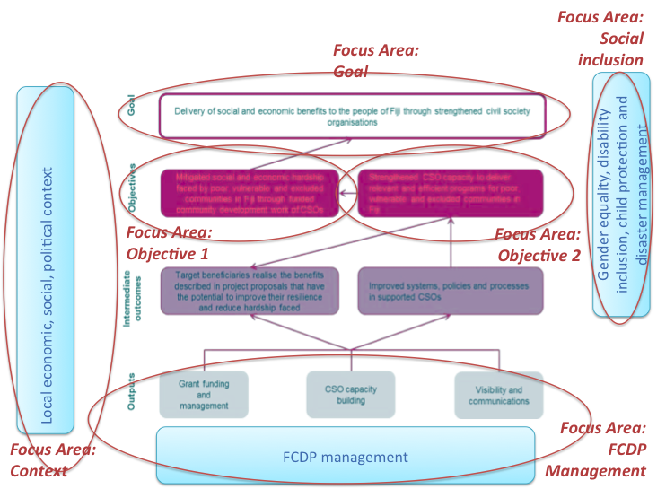

Source: FCDP Monitoring and Evaluation and Learning Framework, 2014. Focus areas adapted for evaluation – see table in Annex 2 for more details.

## Annex 4: Evaluation consultations

|  |  |  |  |  |
| --- | --- | --- | --- | --- |
| **Stakeholder Type** | **# Org** | **# Individuals** | *Men* | *Women* |
|  |  |  |  |  |
| CSO key informant interviews | 14 | **31** | *10* | *21* |
| Communities (village and settlements) | 10 | **121** | *60* | *61* |
|  |  |  |  |  |
| Government of Fiji | 6 | **9** | *4* | *5* |
|  |  |  |  |  |
| DFAT staff |  | **12** | *8* | *4* |
| Donors (development partners) | 3 | **6** | *2* | *4* |
| Other DFAT programs | 2 | **3** | *1* | *2* |
| FCDP staff |  | **12** | *3* | *9* |
| PEC |  | **1** |  | *1* |
|  |  |  |  |  |
| CSO Focus Group |  |  |  |  |
| > Central | 9 | **11** | *2* | *9* |
| > Northern | 4 | **4** | *2* | *2* |
| > Western | 5 | **5** | *2* | *3* |
|  |  |  |  |  |
| Place-based consultations * |  |  |  |  |
| Central Division |  | **22** | *5* | *17* |
| Northern Division |  | **7** | *6* | *1* |
| Western Division |  | **13** | *7* | *6* |
|  |  |  |  |  |
| PwD |  | **1** | *1* |  |
|  |  |  |  |  |
| **TOTAL** |  | **258** | **113** | **145** |
|  |  |  |  |  |
| *\* Including CSO and GoF reps. Variation in number based on multiple reps from same CSO joining consultations in Central Division.* | | | | |

## Annex 5: Rationale and description of sampling for comparative cases

A sampling strategy was required to focus the work of the ET within limited time / budget available. The focus of the evaluation on impact and exploring the causal contribution of the FCDP required in-depth inquiry. The evaluation needed to identify change beyond the quantitative targets achieved by the FCDP and to understand how that change happened. To allow for in-depth inquiry and exploring of multiple perspectives, comparative cases were employed to explore in-depth the breadth of the programming work of the FCDP. Multiple criteria was used as a basis to select cases: type of engagement with FCDP (grant); size of grant; theme of grant; and type of CSO. Selection was also be informed by a representative sample across the three FCDP office locations. Table 3 below details the way in which cases selected for the evaluation represented different aspects of the FCDP.

Table 3: Sampling of comparative cases

| **FCDP Field Office** | **Type of (FCDP) grants** | **Size of grant[29]** | **Grant focus / FCDP Theme** | **Type of CSO** | **Learning opportunity for ET** | **CSOs** | **Communities** |
| --- | --- | --- | --- | --- | --- | --- | --- |
| North | Round 1/Ext/CAP 2 TC Winston | More than 500,000  Less than 1,500,00 | Conservation / *Environment, climate change and disaster response* | CSO / INGO | INGO | Range of grants implemented |focus on environmental activities | Suva based with reach | WWF | Nakawaga village, Mali, Macuata |
| North | CAP/CDP/  CAP projects | Less than 60,000 | IGP (Poultry) / *Livelihood and food security* | CBO | Woman led org. | women as vulnerable / marginalised group | place based org. | Navaki Women’s Club | Tukavesi village, Cakaudrove |
| North | CAP/CDP/  CAP projects | Less than 60,000 | WASH / *Health (including WASH)* | CBO | Youth led org. | youth as vulnerable / marginalised group | place based org. | Cakaudrove Provincial Youth Council | Togaviti village, Cakaudrove |
| Western | Round 1/Ext; CAP 2; | More than 500,000  Less than 1,500,00 | Community Health / *Health (including WASH)* | CSO | Larger more established Fijian organisation | range of grant activities | specialised services | active founders | Veiseisei Sai Health Centre | Lauwaki settlement / Lomolomo village, Vuda |
| Western | Round 1/Ext; CB | More than 150,000  Less than 500,00 | Community health */ Health (including WASH)* | CSO | Smaller but established and focused Fijian organisation | range of grant activities | health focus | Suva based with reach | Fiji Society Blind | Tavualevu village, Tavua |
| Western | NEED TO ADD | Less than 60,000 | IGP (bee keeping / *Livelihood and food security* | CBO | Small scale org. | limited involvement | small size grant | cane farming settlement | Ra Naari Parishad | Nasavusavu settlement, Ra |
| Central | Core; Round 1; CAP 2 | More than 150,000  Less than 500,00 | IGP (screen printing) / *Livelihood and food security* | CSO | Larger more established Fijian organisation focused on community development | range of grant activities | Suva based with reach | Partners in Community Development Fiji | Saioko Village |
| Central | CAP 1 | More than 150,000  Less than 500,00 | Solar power / *Environment, climate change and disaster response* | FBO | Woman led org. | women as vulnerable / marginalised group | place based org. | Suva based with reach | Catholic Women’s League | Nanuku Settlement, Vatuwaqa, Suva |
| Central | CAP-CDP Project | Less than 60,000 | IGP (community store) / *Livelihood and food security* | CSO / INGO | Organisation focused on young girls | gender equality focus | Suva based with reach | Fiji Girl Guides Association | Daku village, Tailevu |

## Annex 6: FCDP Management - mechanisms to influence change in CSO strengthening

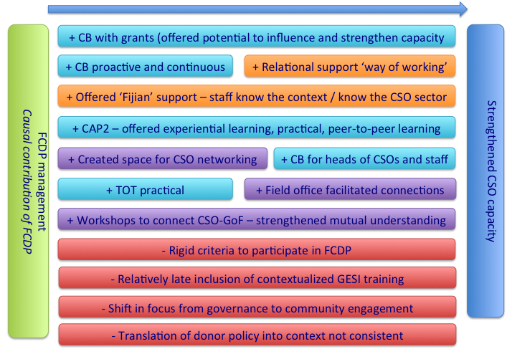

## Annex 7: Documents reviewed for evaluation

AusAID. (2017). *Fiji Community Development Program - Design Document.* Barton ACT 0221: Australian Government.

Department of Foreign Affairs and Trade. (2016). *Australia-Fiji Civil Society Engagement Strategy 2016-2019.* Barton ACT 0221: Australian Government.

Fiji Community Development Program. (2012). *Fiji Community Development Program Annual Workplan 2012-2013.* Suva: Fiji Community Development Program.

Fiji Community Development Program. (2012). *Fiji Community Development Program Grants Manual .* Suva: Fiji Community Development Program.

Fiji Community Development Program. (2013). *Fiji Community Development Program Annual Report 2012-2013.* Suva: Fiji Community Development Program.

Fiji Community Development Program. (2013). *Fiji Community Development Program Annual Workplan 2013-2014.* Suva: Fiji Community Development Program.

Fiji Community Development Program. (2013). *Fiji Community Development Program Progress Report May-December 2012.* Suva: Fiji Community Development Program.

Fiji Community Development Program. (2014). *Fiji Community Development Program Annual Report 2013-2014.* Suva: Fiji Community Development Program.

Fiji Community Development Program. (2014). *Fiji Community Development Program Annual Workplan 2014-2015.* Suva: Fiji Community Development Program.

Fiji Community Development Program. (2014). *Fiji Community Development Program Monitoring Evaluation and Learning Framework.* Suva: Fiji Community Development Program.

Fiji Community Development Program. (2014). *Fiji Community Development Program Progress Report July-December 2013.* Suva: Fiji Community Development Program.

Fiji Community Development Program. (2015). *Fiji Community Development Program Annual Report 2014-2015.* Suva: Fiji Community Development Program.

Fiji Community Development Program. (2015). *Fiji Community Development Program Annual Workplan 2015-2016.* Suva: Fiji Community Development Program.

Fiji Community Development Program. (2015). *Fiji Community Development Program Capacity Building Strategy.* Suva: Fiji Community Development Program.

Fiji Community Development Program. (2015). *Fiji Community Development Program Gender Equality and Social Inclusion Strategy.* Suva: Fiji Community Development Program.

Fiji Community Development Program. (2015). *Fiji Community Development Program Grants Manual.* Suva: Fiji Community Development Program.

Fiji Community Development Program. (2015). *Fiji Community Development Program Progress Report July-December 2014.* Suva: Fiji Community Development Program.

Fiji Community Development Program. (2015). *Fiji Community Development Program Targets Report 2015.* Suva: Fiji Community Development Program.

Fiji Community Development Program. (2016). *Fiji Community Development Program Annual Report 2015-2016.* Suva: Fiji Community Development Program.

Fiji Community Development Program. (2016). *Fiji Community Development Program Annual Workplan 2015-2016 and Exit Strategy.* Suva: Fiji Community Development Program.

Fiji Community Development Program. (2016). *Fiji Community Development Program In-depth Studies: Livelihoods, Health and Food Security.* Suva: Fiji Community Development Program.

Fiji Community Development Program. (2016). *Fiji Community Development Program Progress Report July-December 2015.* Suva: Fiji Community Development Program.

Fiji Community Development Program. (2017). *Program Achievements Report 2017 (Draft).* Suva: Fiji Community Development Program.

Fiji Community Development Program. (2017). *Program Completion Report (Draft).* Suva: Fiji Community Development Program.

Fiji Council of Social Services. (2016). *Strategic Plan 2016-2020.* Suva: Fiji Council of Social Services.

## Annex 8: Online CSO survey – results

Question 1: **Sex of survey respondent**

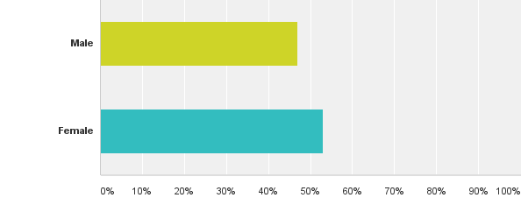

Question 2: **Survey respondent living with disability**

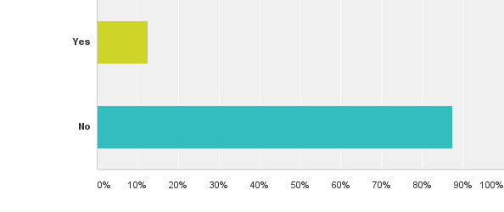

Question 3: **Type of CSO**

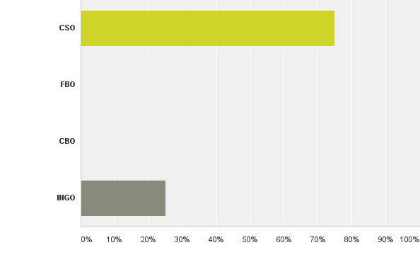

Question 4: **Number of paid staff in your CSO**

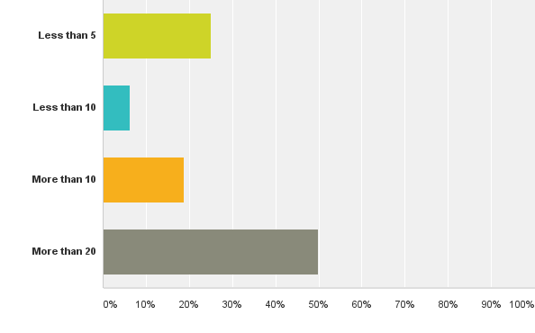

Question 5: **Year CSO established**

Before 1970 = 3

1970 – 1979 = 2

1980 – 1989 = 1

1990 – 1999 = 5

2000 – 2009 = 2

2010 – Present = 3

Question 6: **Number of paid staff in your CSO**



Question 7: **Does your organisation work with poor, vulnerable or excluded communities? Please tick (as appropriate more than 1)**

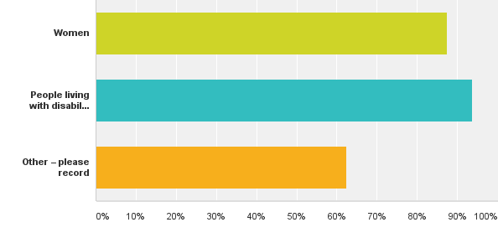

Question 8: **FCDP field office your CSO worked with**

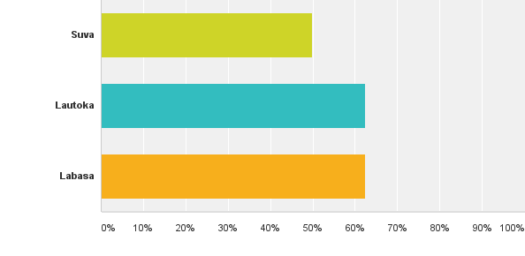

Question 9: **Type of engagement with FCDP** 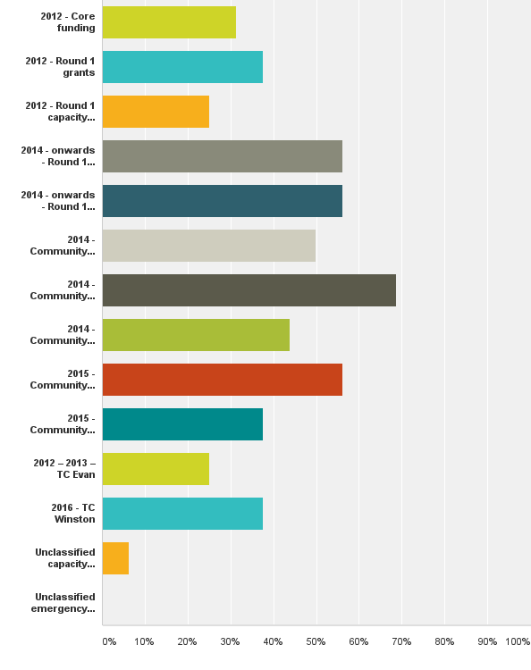

Question 10: **Through the work of my CSO, FCDP has delivered social and economic benefits to communities.**

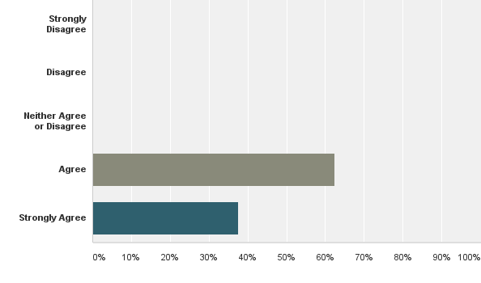

Question 11: **Results of social and economic benefits through the work of my CSO (and FCDP) are owned and will be sustained by community**

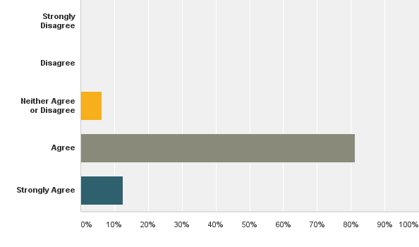

Question 12: **Through the work of my CSO, FCDP has reduced hardship (social / economic) faced by poor, vulnerable and excluded communities.**

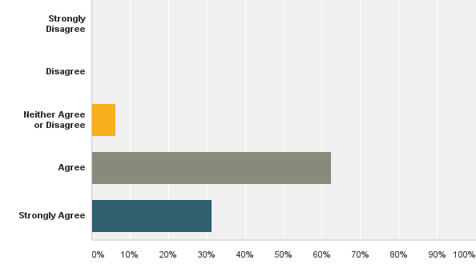

Question 13: **FCDP understood the capacity strengthening needs in my CSO.**

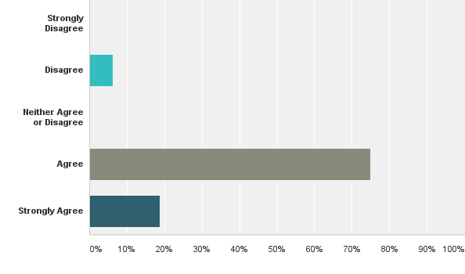

Question 14: **FCDP has met the needs of capacity strengthening in my CSO.**

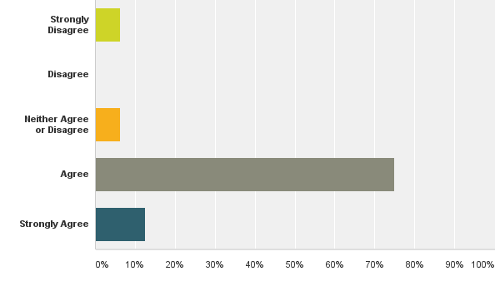

Question 15: **The delivery of the capacity strengthening was useful and relevant to my CSO.**

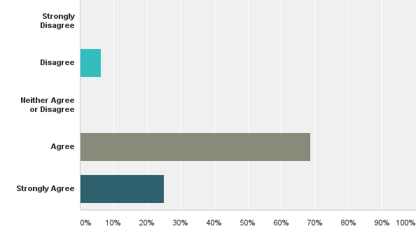

Question 16: **FCDP has strengthened my CSO capacity to deliver relevant, efficient programs in communities in Fiji.** 

Question 17: **FCDP has strengthened my CSO capacity to identify and respond to needs in community.**

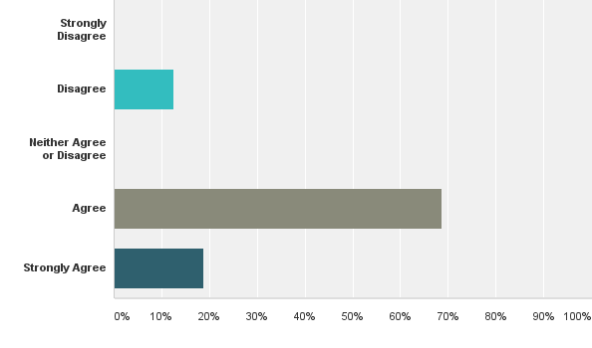

Question 18: **FCDP has strengthened my CSO capacity to access funds / grants.**

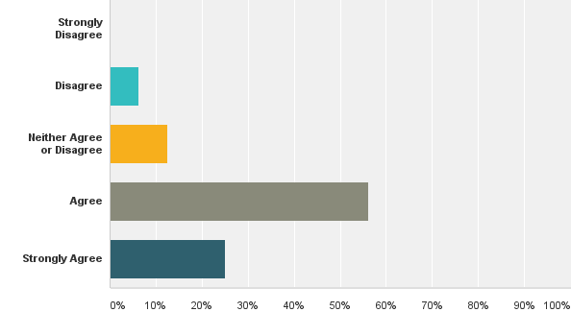

Question 19: **FCDP has strengthened my CSO capacity to coordinate and link with other CSOs and government**



Question 20: **FCDP has strengthened my CSO capacity in financial management**

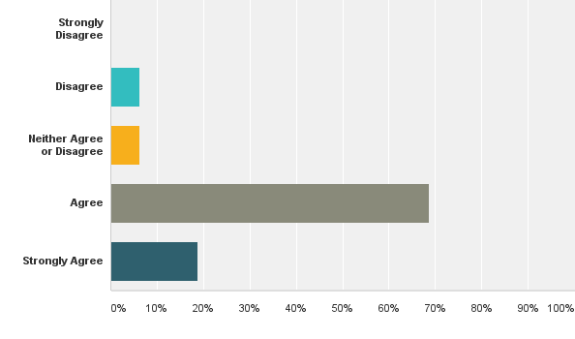

Question 21: **FCDP has strengthened my CSO capacity in monitoring and evaluation.**

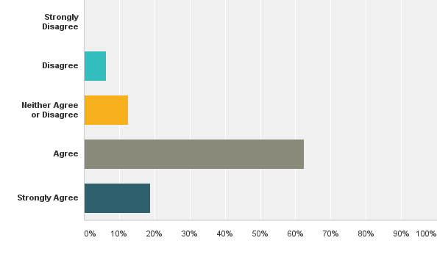

Question 22: **The outcomes of capacity strengthening initiatives have been sustained in my organisation.**



Question 23: **FCDP has used the existing knowledge and expertise of my CSO to strengthen CSOs and deliver social and economic benefits to the people of Fiji.**

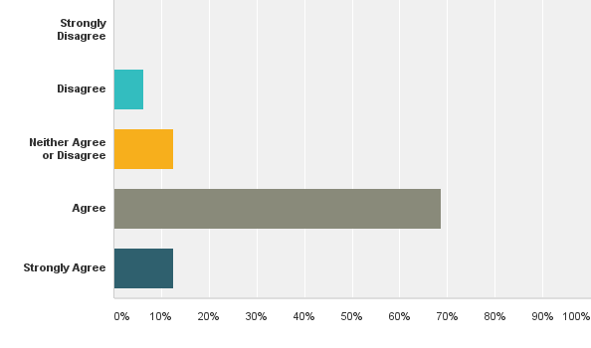

Question 24: **FCDP has used the existing knowledge and expertise of communities to strengthen CSOs and deliver social and economic benefits to the people of Fiji.**

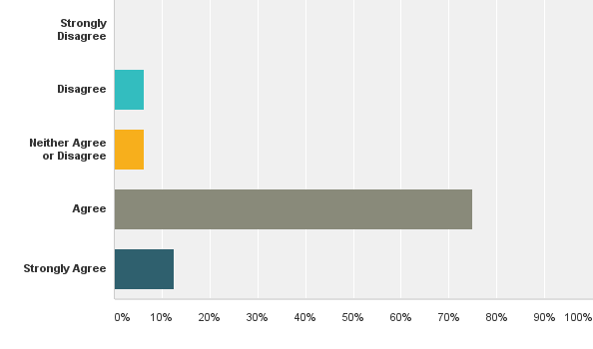

Question 25: **FCDP’s monitoring, evaluation and learning activities helped to strengthen my CSO.**



Question 26: **FCDP provided training and support to help my CSO include gender equality as part of our work.**



Question 27: **Gender equality has been an outcome of grants supported by FCDP**

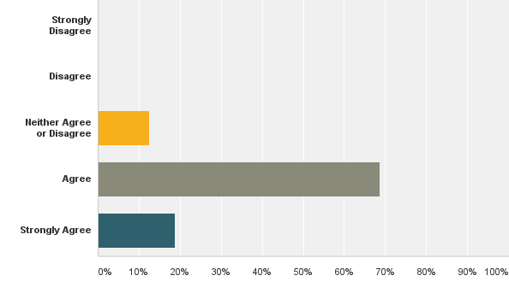

Question 28: **Inclusion of gender equality considerations is now a part of my CSO outreach in community.**

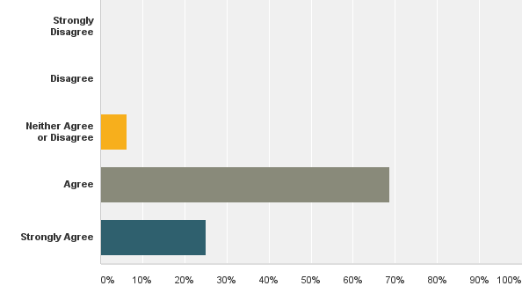

Question 29: **Consideration of gender equality is now owned and will be sustained by the community.**

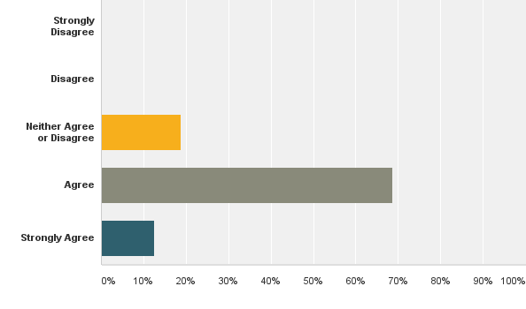

Question 30: **FCDP provided training and support to help my CSO to include disability inclusion as part of our work.**

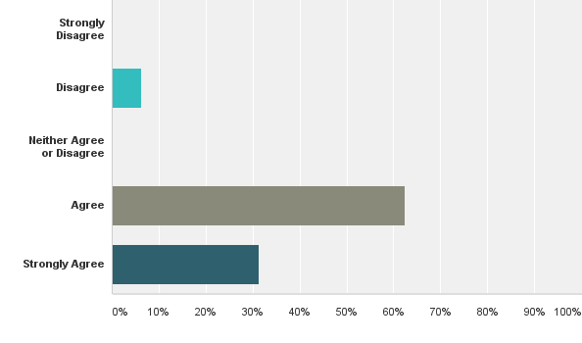

Question 31: **Disability inclusion has been an outcome of grants supported by FCDP.**

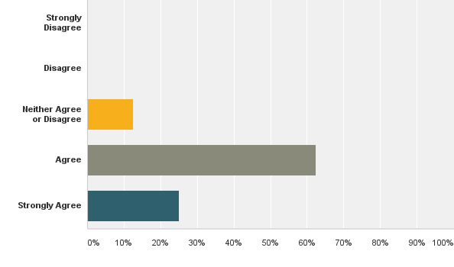

Question 32: **Disability inclusion is now a part of my CSO outreach in community**



Question 33: **Consideration of disability inclusion is now owned and will be sustained by the community.**

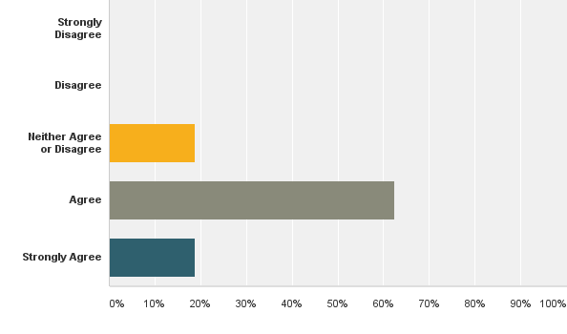

Question 34: **FCDP provided training and support to help my CSO to deal with child protection issues.**

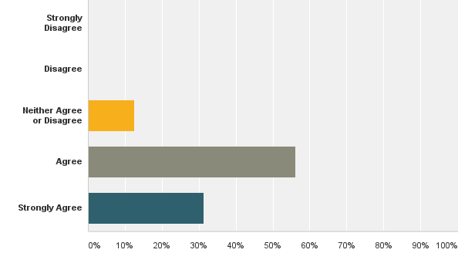

Question 35: **My CSO now has improved child protection practice as an outcome of grants supported by FCDP.**

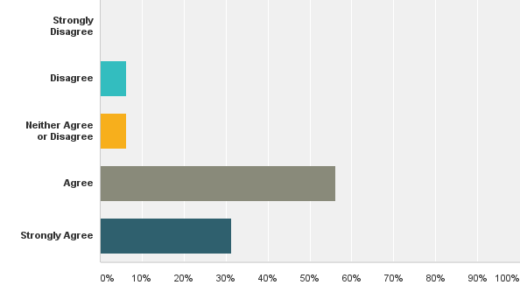

Question 36: **Consideration of child protection is now owned and will be sustained by the community.**



Question 37: **Is your CSO involved in disaster risk management activities?**

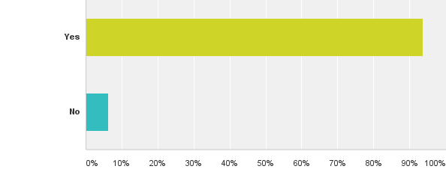

Question 38: **FCDP provided sufficient support and training to help my CSO to consider integration of disaster risk management as part of our work**

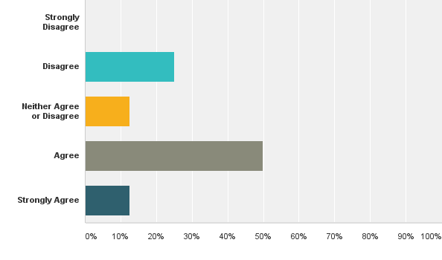

Question 39: **Disaster risk management has been an outcome of grants supported by FCDP.**

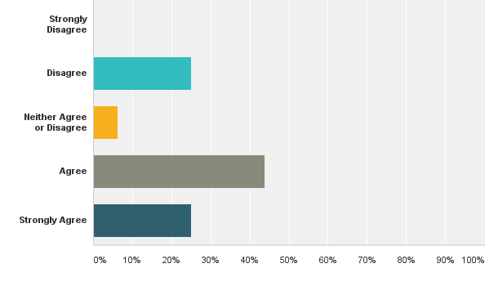

Question 40: **Consideration of disaster risk management is now owned and will be sustained by the community.**



1. See Fiji Community Development Program Executive Committee Terms of Reference, undated.
2. Talanoa refers to `conversation in a circle’ that allows for the co-production of knowledge. Its application in the evaluation is relevant given the Pacific Island context in which FCDP operates in, capturing learning and stories of change from recipients of the program. See [http://www.devnet.org.nz/sites/default/files/Farrelly,%20Trisia%20&%20Nabobo-Baba,%20Unaisi%20Talanoa%20as%20Empathic%20Research%20[paper]_0.pdf](http://www.devnet.org.nz/sites/default/files/Farrelly,%20Trisia%20&%20Nabobo-Baba,%20Unaisi%20Talanoa%20as%20Empathic%20Research%20%5bpaper%5d_0.pdf)
3. See Fiji Community Development Program Executive Committee Terms of Reference, undated.
4. FCDP Program Completion Report, 2017
5. Rationale and description of sampling for comparative cases is provided in Annex 5.
6. End of Program Evaluation Fiji Community Development Program (FCDP) Evaluation Plan
7. See Evaluation Plan, page 8-9.
8. The third member of the PEC, Ratu Joni Madraiwiwi passed away in late 2016
9. 16 responses out of 33 invitations
10. Central Division (11 CSOs participated out of 25 who received grants); Northern Division (4 out of 8): Western (5 out of 10). 
11. 146 grants were awarded. Source: FCDP Project Completion report, February 2017
12. The FCDP sought to address this situation by requiring community development plans to be signed off by Provincial staff. The ET did not find evidence that CDPs were developed in consultation with Provincial Office staff.
13. It should be noted that Eastern Division was also reached through FCDP grants.
14. Note limitation - GoF stakeholders at national level were not available for consultations at the time of the evaluation. See Section 3.5 for more details.
15. See Fiji Community Development Program Executive Committee Terms of Reference, undated.
16. An exception was for livelihoods projects – reviewed by DFAT SPM Economic Growth and Technical Business Trainer.
17. For example: Field Officers
18. See list of documents reviewed Annex 7.
19. One example was often provided by FCDP staff as a success and was valued as having high impact to the communities – recognizing this, supporting community exchange visits might have been an approach that was more widely used.
20. See FCDP In-depth Studies Report, June 2016
21. See FCDP Program Completion Report, February 2017; FCDP Annual Report 2015/16
22. See FCDP Monitoring, Evaluation and Learning Framework, December 2014. Indicator of Objective 1 defined: “changes in people’s lives.” Issues of poverty defined: “remote and rural communities; social exclusion; income instability and unemployment; high inflation rates and cost of living; political instability; social indicators (health, education); peace and conflict.”
23. FCDP In-depth Studies Report, June 2016
24. FCDP In-depth Studies Report, June 2016
25. focused on social dimensions (e.g. child protection)
26. Lesbian, Gay, Bisexual, Transgender and Intersex
27. Informed by current practice, ensure that the process for development builds from current practice and ensure that the process of establishing minimum standards is inclusive of all relevant CSOs and government as appropriate
28. Building from the work of FCDP and other DFAT funded programs including Pacific Risk Resilience Program
29. Sample across total funding disbursed to CSOs: Grants > 30,000 = 2 | Grants > 30,000 <60,000 = 2 | Grants > 60,000 and <175,000 = 1 | Grants >175,000 and < 550,00 = 2 | Grants >550,000 and < 1,500,00 = 2