* **General Questions**

1. What is the MELF?

* The Monitoring, Evaluation and Learning Framework (MELF) for the AusAID NGO Cooperation Program (ANCP) has been primarily designed as a tool to ensure consistent monitoring and reporting by Australian NGOs funded under ANCP.
  + - It does **not** replace the more complex monitoring and evaluation systems of the Australian NGOs or their in country partners.
* The MELF will provide the evidence base to demonstrate that ANCP is an effective use of funds and achieves results in poverty reduction.
  + - It draws from existing NGO systems to present a summary of information primarily for AusAID purposes of: accountability, learning, communication, and overall improvement of the ANCP.

1. How is it different from our previous reporting? What’s changed?

* The MELF streamlines reporting from ANCP NGOs. It enables Accredited Australian NGOs to present a summary of achievements to AusAID in one format. The report will be adapted from information available through NGOs’ current systems and through reporting from partners.
  + - The mid-year performance report which was due in April each year is **NO LONGER NEEDED**.
    - The Annual Development Plan (**ADPlan)** is still due **30 June** each year;
    - The Annual **Performance Report** with financial acquittal is due **30 September** each year.

1. Where is the ‘L’/learning in the MELF?
   * The MELF will undertake a biennial meta-evaluation of completed ANCP evaluations over the past two years.
     + The meta-evaluation will focus on examining and reporting on lessons learned and overall quality and range of outcomes for ANCP.
   * A biennial thematic review will be undertaken (on the ‘off year’ to the meta-evaluation) to develop a more in-depth exploration of development effectiveness issues between AusAID and ANCP NGOs.
     + The focus for the biennial review will be determined in consultation between AusAID and ANCP NGOs.
2. Who developed the MELF?

* The MELF has been developed following consultation with ANCP NGOs and AusAID over the period August 2011 to March 2012.
  + - The new MELF was released to ANCP NGOs on 9 May 2012.

1. How will the MELF be used?

* The Annual Performance Report will provide quantitative and qualitative information about the contribution being made by Australian NGOs to the aid program’s strategic goals.
  + - Information will be used to highlight ANCP achievements and outcomes as well as provide information about challenges.

1. Will the MELF be reviewed?

* We recognise the need for the ANCP to transition to the MELF and its introduction for 2011‑12 reporting will be a trial period.
* We will be reviewing the reporting templates at the end of 2012 in consultation with ANCP NGOs.
  + - We are likely to use the MELF Reference Group for this purpose but are open to suggestions on how this review should be undertaken.

1. What are the objectives of the MELF?

* The MELF will provide:

1. Accountability of AusAID funding to Australian NGOs in line with the objectives of ANCP.
2. Information about overall program performance of ANCP programs highlighting areas for improvement and further development;
3. Information about the range and scope of ANCP funded work in-line with the Transparency Charter for AusAID and other external audiences;
4. Information about high-level outcomes achieved through the funding provided under ANCP, including reporting against AusAID’s Comprehensive Aid Policy Framework (CAP-F) results; and
5. An opportunity to share learning about development effectiveness for both AusAID and ANCP NGOs.
6. What do we use for baseline and target in the beneficiaries table?

* The **baseline** depends on the context of the project.
  + If there are currently existing services/access/materials, etc., then the baseline would reflect this, i.e. 50% of the adult men and women in a community of 10,000 have access to family planning before starting the project. The baseline is then 5,000
  + But if the project is doing something new for a community which has no services, then the baseline would be 0.
* **Target** is where you hope to be at the end of the project and not at the end of the financial year unless your project is rolled out for only one financial year. Using the example above, we are hoping to reach 95% of the adult men and women in a community to have access to family planning. The target will be 9,500.
* **Technical Questions**

1. Why are the templates in Excel?

* We are using an excel format rather than a word format for ease of in-house data management. We are hoping this can feed into a longer-term online grants management system that AusAID is considering.

1. Cutting and pasting is difficult as it doesn’t want to paste text from Word into the Excel sheet merged cells.

* When you want to paste text from Word to the destination cell in Excel, you should use the formula bar in Excel (see below).
* Click on the formula bar using the mouse then paste the text. Press Enter key.

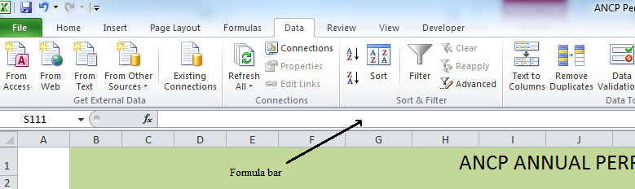

1. I’ve tried a couple of different ways of creating multiple copies of Part B: PROJECT SUMMARY – but I can’t get them to sit on a new page.

* You can select the rows you want to duplicate by selecting the first row on the far-left side. Expand the selection down by either using the mouse or by using the arrow keys of your keyboard.

1. Can we add rows in the template?

* We prefer that you do not alter the template. The only exceptions are:
  + Section 3. in the Project Summary Table, where rows can be added for each project by country.
  + Section 4. in the A: PROGRAM SUMMARY and B: PROJECT SUMMARY tables can be duplicated if needed. Please do not add any rows in each of these tables.

1. In section 4, if interest earned has been sent to the program and it is acquitted within the Performance Report, do we still need to mention it in section 2, or do we just put a dash?

* If the interest from a previous financial year has already been acquitted on a past performance report, then enter a dash. In this section, only mention interest earned and not programmed from previous year.

1. At what ‘level’ do we complete 4B of the ADPlan and Annual Performance Report?  Is it country-wide, regionally, or per community worked in?

* We expect in this section NGOs to report at country level, noting that the opportunity is given in the template to be more specific regarding the provinces or regions where the project is implemented. If the NGO wants to state the community targeted, please do so in the “Provinces / Regions” cell.

1. Do you have an expected date for the release of guidelines for the new MELF?

* We don’t have an expected date for the release of guidelines for the new MELF but it should be after the MELF review at the end of this year.

1. Why is the “Design, Monitoring and Evaluation” presented as a column in the section 3. Project Summary Table?

* AusAID encourages NGOs using up to 10% of ANCP funds provided for Design, Monitoring and Evaluation (DM&E) to implement development activity projects in developing countries. Following the OECD recommendation, AusAID considers DM&E to be part of a project, thus related to a specific sector code or DAC code. When possible, AusAID asks NGOs funded under ANCP to report DM&E funds as part of a project. If a DM&E activity is related to a number of projects/countries, please use a pro-rata approach to determine the appropriate proportion of funds related to a project. Some DM&E activities can be undertaken to broaden knowledge and train staff. Whether they are physically implemented in Australia or overseas, they should benefit the NGO’s global development activities in-developing countries. In this particular case, proportionality should be applied to the related projects if applicable or to “global unspecified”. This last geographical classification should be used only if you cannot relate the DM&E work to any project and the corresponding DAC code should be related to the DM&E sectoral activity.

1. How do I insert a picture / map or signature in Excel?

* Click where you want to insert the picture.
* On the Insert tab, in the Illustrations group, click Picture.

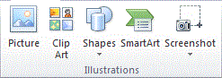

* Locate the picture that you want to insert, and then double-click it. For example, you might have a picture file located in My Documents.

To add multiple pictures, press and hold CTRL while you click the pictures that you want to insert, and then click Insert.

* To resize a picture, select the picture you have inserted in the spread sheet. To increase or decrease the size in one or more directions, drag a sizing handle away from or toward the center, while you do one of the following:
* To keep the center of an object in the same location, press and hold CTRL while you drag the sizing handle.
* To maintain the object's proportions, press and hold SHIFT while you drag the sizing handle.
* To both maintain the object's proportions and keep its center in the same location, press and hold both CTRL and SHIFT while you drag the sizing handle.

1. I can’t see the full text content in the cell.

* If the cell does not display the full text content you should increase the row height. Select the row by clicking on the row heading on the far left of the sheet. Right-click with your mouse still on the row heading and select Row Height (see picture below).

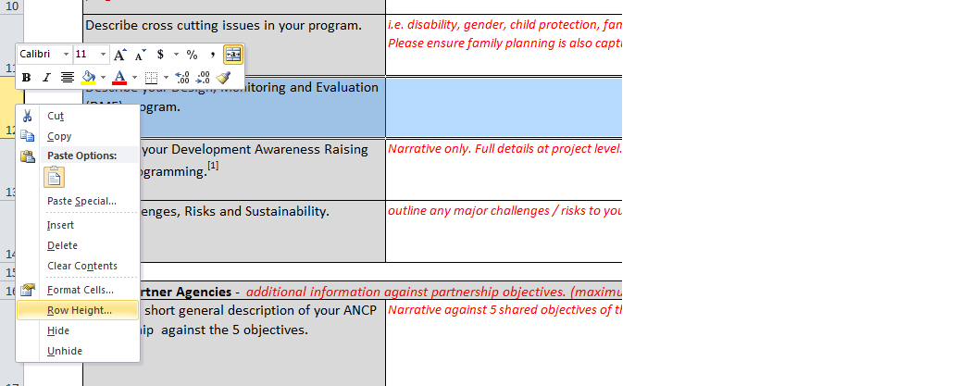

* In the Row Height window, enter a number 3 times larger than the one displayed in the row height cell. Press the Ok button. The row height should now be larger than before. Repeat these steps if needed. If you still can’t see the text in the destination cell, contact the MELF hotline. We will assist you with the issue.

1. How do I change the row height?

* Change the height of rows by using the mouse
  + - * To change the row height of one row, drag the boundary below the row heading until the row is the height that you want.

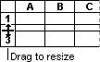

* Change the height of rows by setting the value
* Select the row or rows that you want to change.
* On the **Home** tab, in the **Cells** group, click **Format** then **Row Height…**
  + - In the Row Height box, enter a value then press ok to validate.