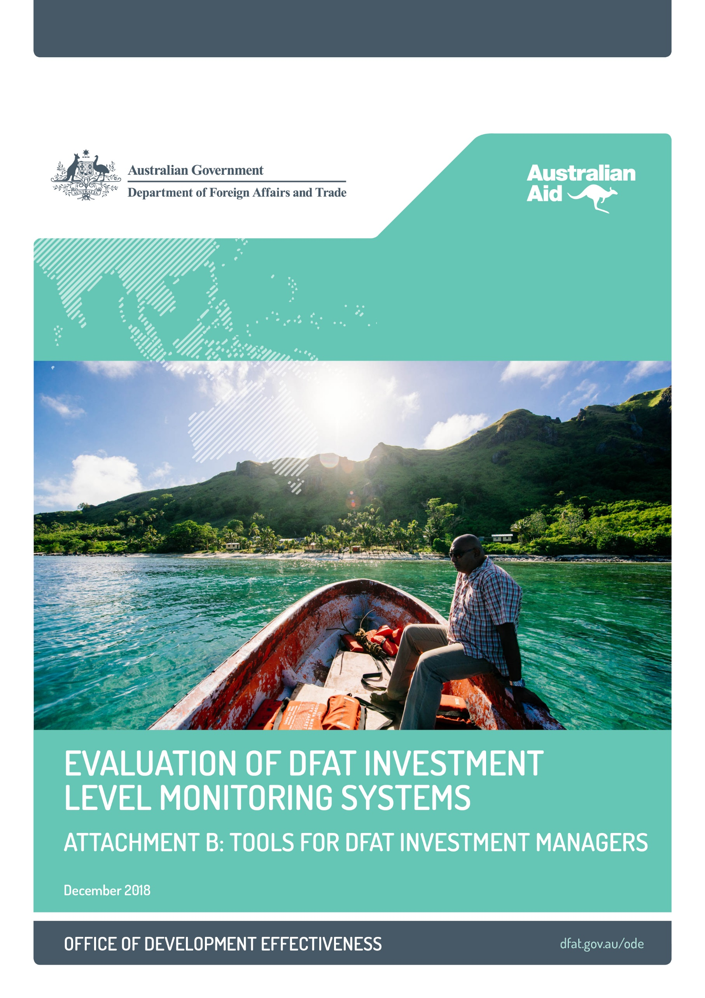



# Introductio

# WHAT MAKES A BETTER PRACTICE MONITORING SYSTEM?

### 1. Focusing on outcomes

High-quality monitoring systems are **outcomes focused** from the beginning. They both measure and guide progress towards achieving the intended outcomes of the investment. Clear objectives and a realistic theory of change, as described in the Department of Foreign Affairs and Trade’s (DFAT) *M&E Standard 1: Investment Design*, provide the foundations for an outcomes-focused monitoring system.

|  |
| --- |
| The Australia–Indonesia Partnership for Rural Development, an evaluation case study, has an outcomes-focused monitoring system built around a measurable goal and key performance indicators. All interventions within this large, complex investment collect data to report against these indicators. Together these provide a comprehensive snapshot of progress against the intended outcomes (goal). Notably, the monitoring framework was largely in place by the end of the design phase, due to significant work on this upfront.  The Policing and Justice Support Program in Vanuatu and the Indonesia Governance for Growth evaluation case studies are examples of the kind of refinements often required during early implementation to ensure the monitoring system provides sufficient information on outcomes. |

### 2. Quality assuring the system and data

High-quality monitoring systems are also **quality assured** in ways that are appropriate for their investment type and context. The application of monitoring standards, the presence of contestability mechanisms, and independent quality assurance can all form part of a better-practice monitoring system.

|  |
| --- |
| The Fiji Community Development Program case study is a good example of DFAT staff having consistently applied the department’s M&E standards as a framework to assess and improve the investment’s monitoring and reporting. In this case study, the standards have served as a shared point of reference and a clear set of expectations that are mutually understood by the managing contractor team and DFAT.  In some sectors, external quality standards can also serve this purpose. The Results Measurement Standard published by the Donor Committee for Enterprise Development (DCED) inform the monitoring system developed by the Australia–Indonesia Partnership for Rural Development, as evidenced in this case study, as well as those of other DFAT market systems development programs.  It is also good practice to have contestability built into a monitoring system. DFAT staff can serve this function by engaging critically with the design of the monitoring system, and with the content of reporting. Other ways to invite contestability include independent evaluation and review, as is the case with the Papua New Guinea Transport Sector Support Program case study, as well as appointing staff who are semi-independent from implementation to review monitoring data and reporting, as with the Australia–Indonesia Partnership for Rural Development case study.  For large, complex or particularly technical investments, independent verification of monitoring data and systems by technical experts can be warranted. The PNG Transport Sector Support Program case study is an excellent example of how critical independent verification can be, and the risks of underinvesting in this function. |

### 3. Using information effectively

High-quality monitoring systems **use monitoring information effectively**, serving multiple purposes and needs. In such a system, reporting is tailored to the needs of the internal investment team, to DFAT and to other stakeholders.

|  |
| --- |
| There are few examples of investments where reporting serves the needs of all stakeholders well.  Two evaluation case studies—the Australia–Indonesia Partnership for Rural Development and the Cambodia Agricultural Value Chain Program—are market systems development investments. They both show convincing evidence of the implementing team using monitoring information systematically to make ongoing decisions about implementation (in other words, adaptive management).  The Fiji Community Development Program and the Vanuatu Policing and Justice Support Program case studies show how the monitoring system can be tailored to meet the needs of in-country partners, as well as civil society and government implementing partners, respectively. The PNG Transport Sector Support Program case study demonstrates how data collected by an investment can substantially improve national records. In this case, it failed to do so until much later in the investment.  The Tonga Skills for Inclusive Economic  Growth case study is an example of a monitoring system that faced challenges generating useful information efficiently. The PNG Strongim Gavman Program case study is an example of where what was produced by the monitoring system was not fully used. This may have contributed to the long-term delay in addressing the investment’s strategic alignment with DFAT’s objectives. |

# FACTORS ENABLING BETTER-PRACTICE MONITORING

The ODE evaluation found that four factors strongly influence the quality of aid investment monitoring systems.

1. DFAT’s performance culture and expectations set the parameters for the culture of implementing partners. If DFAT expects the investment to provide credible evidence of results and be performance managed, this sends an indirect but strong signal that a high-quality monitoring system is required.

2. DFAT’s ability to set and maintain clarity about what aid investments are meant to achieve is a critical pre-condition for better-practice monitoring. This clarity lends focus to the monitoring system, such that what really matters can be monitored.

3. DFAT’s demand for quality monitoring data and the systems required to generate this data incentivise managing contractors to prioritise better-practice monitoring. This demand is expressed through the department’s policies, its procurement and contracting processes, and the actions of staff, all of which incentivise managing contractors to deliver.

4. The responsiveness of managing contractors and other partners toDFAT’s requirements and their capability to meet this demand is a key determinant of monitoring quality. Managing contractor technical readiness and the communicating of requirements more consistently and openly can improve responsiveness.

# MONITORING CHECKLIST FOR THE INVESTMENT MANAGER

This checklist is provided as a tool for investment managers to refer to throughout the life of managing an investment. It identifies questions that will be helpful in addressing the main challenges at each stage.

|  |  |
| --- | --- |
| **Investment concept and design** | **M&E standard** |
| Has the design met the requirements in M&E Standard 1: Investment Design? *(If not, what remediation is necessary?)*  **In addition:**  Is it clear how progress towards objectives will be measured? *Check for measurable targets against a clear objective.*  Is the design realistic about what information is needed to monitor risks, progress, outcomes and performance? *Consider what additional information DFAT might need to collect.*  Is there sufficient information about how monitoring will be undertaken? *Check for resourcing, roles and governance.*  Are arrangements for quality assurance through independent monitoring, scrutiny or verification in place, and are they sufficient? *Consider the value, complexity, nature and context of the investment in determining what is appropriate.*  Is the resourcing and expertise allocated to establish the *monitoring system* sufficient, including DFAT’s engagement? | M&E Standard 1: Investment Design |
| **Inception and early implementation** | **M&E standard** |
| Has the design met the requirements in M&E Standard 2: Investment Monitoring & Evaluation Systems? *(If not, what remediation is necessary?)*  **In addition:**  Have any significant changes (for example, policy and context) since the design was developed been addressed? *(If not, how does the investment need to be updated?)*  Is it clear who will use information generated by the monitoring system, and how? *(Consider* whether *in-country stakeholder needs are addressed).*  Has DFAT established its own role within the monitoring system (for example, field visits and independent contestability)?  Are sufficient resources (funds, staff, skills) in place to develop, embed and continue to operate the monitoring system? | M&E Standard 2: Investment Monitoring & Evaluation Systems |
| **Ongoing management** | **M&E standard** |
| Has progress reporting met the requirements in M&E Standard 3: Investment Progress Reporting? *(If not, what remediation is necessary?)*  Have monitoring visits been undertaken and met the requirements in M&E Standard 7: Monitoring Visits? *(If not, what remediation is necessary?)*  **In addition:**  Has the investment adapted in response to monitoring information, if warranted?  Has the monitoring data or system been contested by an independent party? (*If not, consider putting in place an appropriate quality assurance mechanism).*  Has DFAT led on establishing a culture of open communication and contestability with the implementing team? *(Consider, for example, whether staff have engaged substantively with reporting).* | M&E Standard 3: Independent Progress Reporting  M&E Standard 7: Monitoring Visits  *(* |
| **Mid-term review and/or evaluation** | **M&E standard** |
| Does the evaluation meet DFAT’s suite of standards for independent evaluations? (M&E standards 4, 5 and 6)?  **In addition:**  Will the evaluation be used to help to improve the investment monitoring system? | M&E standards 4, 5 and 6 specifying requirements for evaluations |
| **Learning and design** | **M&E standard** |
| Has final learning from the investment been identified and communicated to stakeholders?  Have weaknesses in the monitoring system been considered and/or addressed before any subsequent investment commences? | M&E Standard 1: Investment Design |