Environmental resilience
Module length: 4 x 60 minutes

Summary
This module explores the regional interconnections that exist between Australia and the Pacific. It focuses on the management of environmental hazards and risks within the region and their impact on communities, ecosystems and resources.
Students will investigate Australia’s contribution to the sustainable development of Pacific Island nations and strategies aimed at improving their environmental resilience. This includes an understanding of how Australia’s development investments are implemented through local strategies to address global challenges such as climate change.
This resource promotes student agency by fostering opportunities for them to plan a sustainable future as global citizens. Through learning activities and scenarios, students will practise social competencies such as collaboration, negotiation, critical thinking, leadership, mutual respect and problem-solving.
Students are encouraged to take action and think strategically within the timeframe provided for each activity. Success criteria
At the end of this module, students should be able to:
- explain how Australia supports other countries to build their environmental resilience using hazard-management terminology
- research and assess environmental risks and their possible impact on communities and resources
- use teamwork skills to make decisions and design an environmental resilience strategy.

Organising ideas
The organising ideas are global relationships, global responsibilities and global futures. These reflect the Australian Government’s aims to build genuine partnerships to jointly tackle global challenges, protect international rules, promote Australia’s international interests and sustain a peaceful and prosperous future that keeps our region stable.

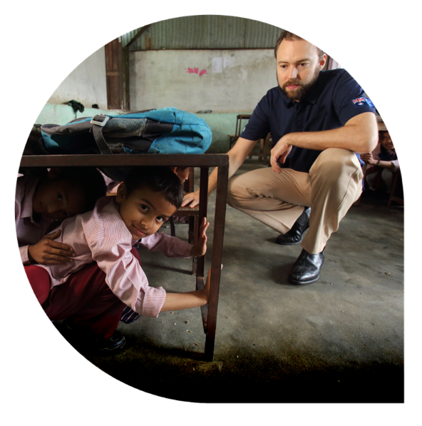
© Jim Holmes/Department of Foreign Affairs and Trade, CC BY

t of Foreign Affairs and Trade, CC BY
n
e
m
t
r
a
p
e
D
/
s
e
m
l
o
H
m
i
J
©

Prior knowledge
- A basic understanding of the geographic concept of interconnection.
- Knowledge of various natural disasters and climate change.
- An understanding of the term ‘geospatial technologies’ and possible examples.

Key terminology

adaptation
hazard
mitigation
preparedness
prevention
resilience
response
risk
sustainability
vulnerability

Curriculum links
The table below lists the Knowledge and understanding content descriptions explicitly addressed in this module. All Geography skills sub-strands for Years 7 and 8 are applicable to this module. There is also the opportunity to expand this module into an interdisciplinary project, incorporating the Science curriculum.

Geography

Knowledge and understanding: Water in the world
Year 7: classification of environmental resources and the way that water connects and changes places as it moves through environments AC9HG7K01
Year 7: the economic, cultural, spiritual and aesthetic value of water for people, including First Nations Australians AC9HG7K03
Year 7: the causes and impacts of an atmospheric or hydrological hazard, and responses from communities and governments AC9HG7K04

Knowledge and understanding: Landscapes and landforms
Year 8: the interconnections between human activity and geomorphological processes, and ways of managing distinctive landscapes AC9HG8K04
Year 8: the causes and impacts of a geomorphological hazard on people, places and environments, and the effects of responses AC9HG8K05

Geography (cont'd)

Skills
Year 8: collect, organise and represent data and information from primary research methods, including fieldwork and secondary research materials, using geospatial technologies and digital tools as appropriate AC9HG8S02
Year 8: interpret and analyse geographical data and information to identify similarities and differences, explain patterns and trends and infer relationships AC9HG8S03
Year 8: draw conclusions based on the analysis of the data and information AC9HG8S04
Year 8: identify a strategy for action in relation to environmental, economic, social or other factors, and explain potential impacts AC9HG8S05
Year 8: create descriptions, explanations and responses, using geographical knowledge and methods, concepts, terms and reference sources AC9HG8S06

Science

Biological sciences
Year 7: use models, including food webs, to represent matter and energy flow in ecosystems and predict the impact of changing abiotic and biotic factors on populations AC9S7U02

Earth and space sciences
Year 8: investigate tectonic activity including the formation of geological features at divergent, convergent and transform plate boundaries and describe the scientific evidence for the theory of plate tectonics AC9S8U03

General capabilities
Literacy: The knowledge and understanding in this module highlight the many legal dimensions that apply to global education. As such, literacy skills are widely used to define terms and introduce new concepts. Make sure students know that the word ‘nation’ is often used in global education and refers to countries.
Ethical Understanding: Throughout the module, there are opportunities to explore ethical issues regarding assessing and managing risks and hazards. Many activities will challenge students to make decisions or confront a dilemma, considering multiple and possibly competing perspectives.
Intercultural Understanding: Students will need to consider unfamiliar cultural contexts and appreciate the values, practices and perspectives of other cultures.
Personal and Social Capability: Empathy and community awareness are important aspects of this unit, as students explore difficult situations facing people around the world. Social management skills will be vital during one activity where teamwork and collaboration are necessary for making decisions.

Cross-curriculum priorities
Asia and Australia’s Engagement with Asia: As this module has a global focus, students will research topics or examples of Australia’s development programs that involve partners in the Asia-Pacific region. Global education clearly emphasises the interdependent nature of relationships and the importance of developing mutual understanding and accepting diversity.
Sustainability: This module explores many of the organising ideas within this priority. Students will gain an understanding of sustainable development and the interdependence of social, economic and environmental factors. Students will be challenged to consider sustainable futures when creating a hazard management plan.

How does Australia interconnect with the Pacific to manage environmental hazards?
Learning intentions | Materials
- To understand how Australia is supporting regional interconnections through official development assistance.  - To identify terms used when managing hazards. | - PowerPoint: Environmental resilience  - Worksheet: Australia's Pacific partnerships  - (Optional) Worksheet: Australia’s Pacific partnerships (flow map)  - Worksheet: Hazard management

Introduction (15 min)
Steps 1–3 aim to capture students’ attention and interest in the topic by showcasing human ingenuity and innovation in response to adversity. It is suggested to revise or define the geographical concepts of interconnection and geospatial technology in this introduction if students are not familiar with these terms from previous lessons.
Possible definitions are:
Interconnection explores how people, places and environments are influenced by each other at varying scales.
Geospatial technology is the use of digital tools to collect, track and analyse data that relates to geographic locations on the Earth’s surface. For example, drones, GPS networks and Google Maps.
- Display the Environmental resilience PowerPoint. As a learning hook, inform the class they are going to watch a short video, ‘Tuvalu’s land makers’ (6 min; on slide 2), from the Beyond Awesome series. Tell students there will be questions (or a quiz) after.
- The following questions aim to arouse discussion and intrigue about the lesson. You could present these as a quiz.
- Describe Tuvalu’s characteristics and location in one or two sentences.
Tuvalu is a country consisting of nine small islands in the Pacific Ocean and is only 26 km2 in size. Its population is 11,000.
- What risks does Tuvalu face due to climate change?
Coastal erosion due to sea-level rise and king tides from weather events.
Shrinking land mass may force relocation of population.
- How has geospatial technology assisted in understanding the risk?
Using LIDAR technology, Tuvalu has made a 3D digital model of the whole country.
It shows areas that will be submerged based on the forecast sea-level rise.
- What is the strategy used to reduce the risk to Tuvalu?
Tuvalu is building land on vulnerable coastlines by dredging sand from the ocean and pumping it to create an area more than 7 hectares in size as a shield to protect the community.
- Explain one interconnection that was apparent in the video.
At a local scale, the process of dredging is connecting the nearby ocean to the land by pumping sandy water through a pipe.
At a regional scale, Australia’s development assistance through funding and construction support to Tuvalu is another form of interconnection between two countries.
- Outline the learning intentions to the class (slide 3 of the PowerPoint) and explain that the following lessons will explore Australia’s interconnection with its Pacific neighbours to address the risks related to climate change and environmental hazards. For Year 7 Geography, you can align this further to the impact of atmospheric or hydrological hazards, water resources and liveability. For Year 8 Geography, the risks can be aligned to coastal landscapes and geomorphological processes and hazards.

Guided instruction: mapping interconnections (20 min)
- Give students access to the Australia's Pacific Partnerships worksheet.
- Display the map of Australia’s Official Development Assistance (link: https://adp.dfat.gov.au/locations) and, as a class, discuss the following:
- An understanding of what Official Development Assistance is: Explain that the Australian Government, through the Department of Foreign Affairs and Trade (DFAT) provides assistance to countries throughout the world. This is referred to as Official Development Assistance.
- How Official Development Assistance creates an interconnection between people and places: Focus on the distribution of Official Development Assistance using the map, zooming in on the regions Australia supports the most.
- Explore how Australia’s Official Development Assistance creates interconnection and can help the region to manage environmental hazards, as seen in the Beyond Awesome video ‘Tuvalu’s land makers’.
- Students will complete the map on the worksheet, showing the top 15 countries that receive the most Official Development Assistance from Australia. For smaller island nations, students may need to add a country label to the map. To help students, you can switch views on the website to browse investments either by map or by country. In country view, the Official Development Assistance amount is listed in descending order.
Extension: Students could create a flow map. An alternate worksheet has been created for this task, including space for students to record their own legend. This would require a legend with arrows in three or four different widths, each representing the amount of Official Development Assistance provided. For example, $50 million to $100 million, $100 million to $150 million. Students then draw arrows from the centre of Australia to each country, using arrows in the width that represents the amount of assistance given to those countries. This task could be performed digitally using auto shapes, or in hard copy.

Geospatial technology activity (optional): If your class is studying geomorphological hazards and plate tectonics, students could add the plate boundaries to their map using ArcGIS. This program allows users to navigate between map layers and zoom in to closely inspect various countries. For teachers who are new to using geospatial technology, allow students a chance to play with the site and learn how to use the features yourself at the same time.

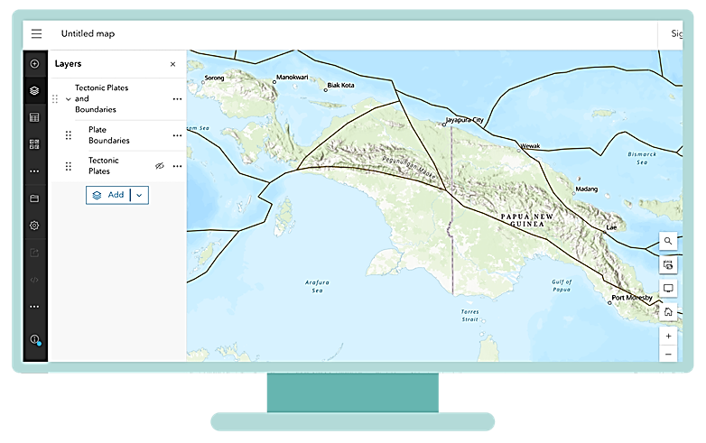
Tectonic plates have two sub-layers. This image shows the plate boundaries over the base map. Layers can be switched on and off by clicking on the eye icon.
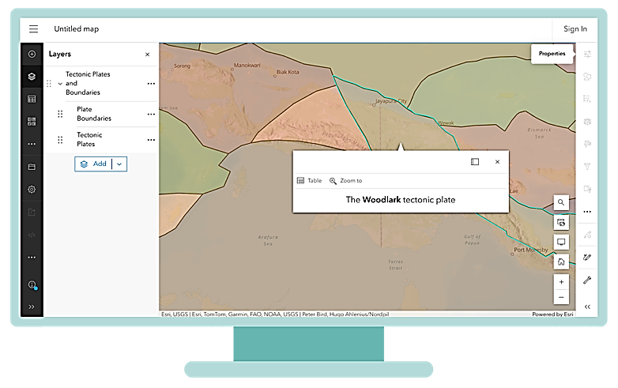
This image shows the tectonic plates shaded and reveals the plate name when selected. Transparency can be adjusted in the properties menu on the right-hand side.

Guided instruction: defining new knowledge (20 min)
There are many terms to describe the various strategies in hazard management. This activity will ensure students have a clear understanding of the difference between each.
- Ask students to discuss the word ‘hazard’ and decide on a class definition. This will be added to the Hazard management worksheet. Here is one definition: Hazards are risks or dangers that could cause harm to people or the environment, such as a bushfire, flood, cyclone or volcanic eruption.
- Students can then brainstorm some of the natural hazards and risks Pacific Islands could face. This could be specifically aligned to the year level and curriculum content. Further questions could explore the role of climate change and increasing risk of hazards in the area.
- Explain that in this lesson series students will explore the risks and hazards that the Pacific Islands nations face.
- Provide access to the Hazard management worksheet and ask students to complete questions 1 and 2. For question 2, discuss which words students already know or can infer. They may then use a process of elimination. Go through the answers as a class.

Learning review (5 min)
With so many terms introduced in this lesson, an engaging final activity would be a review quiz (possibly multiple choice or true/false) where students need to decide on the correct hazard management term. This could also include listing some of the countries that receive development assistance from Australia, or reviewing information on the tectonic plates (if relevant).

Australia’s Pacific partnerships
Using the AusDevPortal create a legend using arrows of varying widths to categorise the top 15 countries receiving Official Development Assistance from Australia.
The top 15 countries receiving Official Development Assistance from Australia:
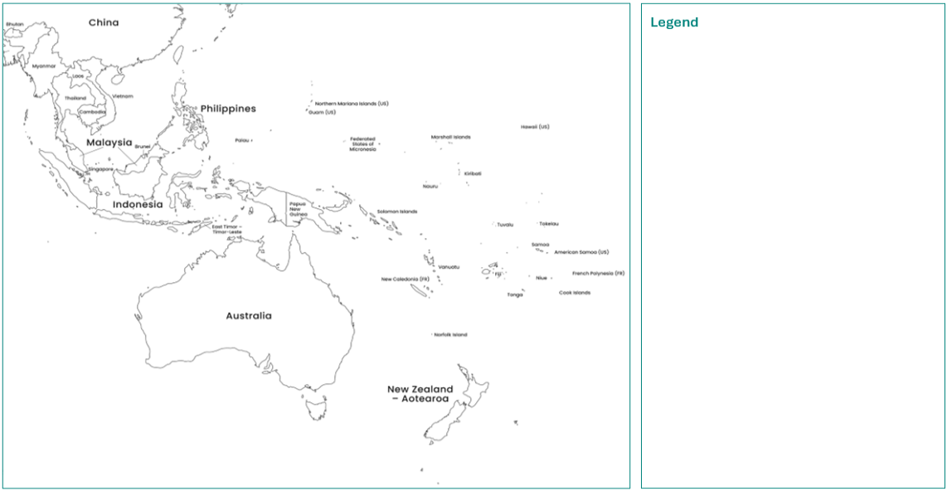
Adapted from: © VectorStock

Australia’s Pacific partnerships (flow map)
Using the AusDevPortal create a legend using arrows of varying widths to categorise the top 15 countries receiving Official Development Assistance from Australia.
The top 15 countries receiving Official Development Assistance from Australia:
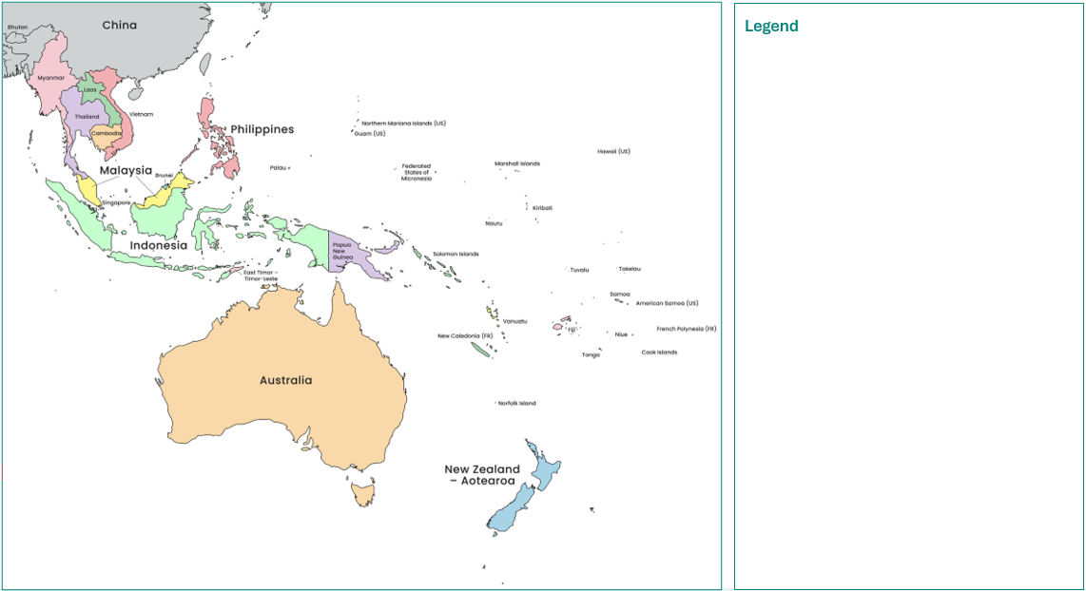
Adapted from: © VectorStock

Hazard management
- Define the term ‘hazard’.
- There are many terms to define elements of environmental resilience. Match the word to the correct definition and example. The examples are based on a scenario where you are walking along an icy or wet footpath where accidents and falls often happen.
Term |  | Definition |  | Example
Prevention |  | The ability to change to survive  and cope during a hazard. |  | Calling out for assistance after falling and spraining your ankle.
Mitigation |  | How possible it is that something  or someone will be harmed. |  | Putting on shoes with rubber grip in preparation for the icy footpath.
Preparedness |  | Actions are taken in advance to stop  harm from happening. The aim is to  reduce the chance of the hazard. |  | Alerting pedestrians using  signs to take caution  on icy footpaths.
Response |  | The process of restoring and rebuilding. |  | Wearing loose shoes  with no grip.
Vulnerability |  | Assistance or strategies needed during  the hazard or immediately after. |  | Blocking off the footpath  for pedestrians.
Adaptation |  | Making plans and testing them  to make sure that people are  ready to respond to a hazard. |  | Applying ice packs to your ankle  for the next 24 hours.
Recovery |  | Actions taken to reduce the impact  of a hazard, which limits the  negative consequences. |  | Changing your walking speed  on the footpaths in winter.

How does Australia assess natural hazards within the Pacific?
Learning intentions | Materials
- To assess the risk of hazards impacting land and water resources across the Pacific.  - To research and use data to inform decision-making. | - Worksheet: Assessing risks in the Pacific  - PowerPoint: Environmental resilience

Introduction (10 min)
This lesson will explore collaborations between Australia and Pacific Island nations to develop strategies to protect land and water security. The introductory activity will ensure that students understand what resilience means and how important this concept is within the Pacific region.
- Write the word ‘resilience’ on the board and ask students to think about what this word means to them. Create a mind map or a class word cloud using an online application to see what words are most common in student responses.
- Show students any or all of the following videos about building environmental resilience. Alternatively, students may choose one of three videos to watch on a device in pairs or small groups, ensuring all three are covered within the classroom. Ask them to pay close attention to all the ways that environmental resilience is portrayed, then report back to the class, including any key terms.
- Development matters – climate change (2 min)
- What is the Pacific Resilience Facility? (3 min)
- DFAT climate finance (3 min 30 sec)
- Add student responses to the mind map (possibly using different colours).
- Ask students to provide examples of strategies they saw in the video that relate to any of the hazard management terms learnt in Lesson 1.
- Outline the learning intentions on the PowerPoint (slide 5).

Scaffolding independent research (35 min)
- Use the Environmental resilience PowerPoint (slides 6–10) to guide this part of the lesson.
- Using the Assessing Risks in the Pacific worksheet and building on Lesson 1, students will now explore the risks for various Pacific Island nations. In the module resources folder, there are PDFs with risk profile infographics for each country receiving Official Development Assistance from Australia. Ask each student to open one of these PDFs (except Marshall Islands and Federated States of Micronesia as they are used in the teacher demonstration). Please note some of the data may be outdated. More recent population statistics can be investigated in the CIA World Factbook.
These documents provide many infographics and data relating to the risks for each island nation.
- Students choose one or two countries to investigate, and complete the table in the worksheet. (You could change the number of countries based on student ability.) Ensure that a spread of countries is covered throughout the class. The statistics cover relevant information for both the Year 7 and 8 Geography curriculum, including coastal, geomorphological and atmospheric hazards. There is a blank table on slide 8 of the PowerPoint and a completed table on slide 9. You may model the research process for students by demonstrating how to complete the task using one of the countries in the slideshow.
- Once students complete their table, they should answer questions 4 and 5 on the worksheet, analysing the data to explain why it is used to assess risk. Students may need support with structure. An example is given in the PowerPoint (slide 10). Using terms such as ‘social’, ‘economic’ and ‘environmental’ is encouraged as students compose each sentence.

Learning review (15 min)
Use the review activity: In case of emergency to allow students to evaluate risks and compare the data for various countries. It should only require 7–10 minutes. Group students with three to five other students who have covered a variety of different island nations. They will make judgements and comparisons to quickly rank the countries from highest to lowest risk based on different factors.
This task allows students to practise negotiation and problem-solving in pressure circumstances such as an emergency during a hazard.
- Students can read the following scenario with you in the review activity on their worksheet.
Australia knows that an emergency response could be necessary in the Pacific at any time. Imagine you are in Australia’s emergency response team and need to decide how to support each of the countries you studied as a hazard [choose a tsunami or cyclone] is expected within the next few hours. You have 1–2 minutes to make a decision for each of the factors listed below. There is no single correct answer.
- In their groups, students will answer the three questions below. Act as a timekeeper to inform them when to move on to the next question.
- Which country has the highest risk of facing significant damage to any land and water resources from the hazard?
- Which country is the least climate resilient to a hazard based on costs and size of population?
- Rank countries in your group according to how much Australian official development assistance you would allocate, based on your assessment of their environmental resilience.
- For the final few minutes, ask groups to share their evaluations and reasoning.
- Tell students that they have fulfilled the learning intentions during this process.

Assessing risks in the Pacific
- Go to the webpage Pacific regional – climate change and resilience and scroll down to ‘Working with Pacific partner governments’.
- Select one or two of the countries and then open the risk profile PDF for this country/these countries.
- Complete the table below. Your teacher will guide you through this process or you may have access to the PowerPoint.

Table: Risk assessment – country features
Features | Country 1) | Country 2)

% of coastal population within 1km of the ocean
Land area
Total population
% of population facing volcanic risk
Hazards with
a high likelihood
Costs of coastal protection per year

Table: Risk assessment – climate projections
Climate projection | Country 1) | Country 2)
Typhoon or cyclonic activity
Rainfall
Sea-level rise
by 2050

- Identify three statistics in your table that you believe present the greatest risk for your Pacific Island nation.
- Justify why you chose these three statistics. To justify means to give reasons. For example, the statistic you chose might suggest a risk to the environment, such as a loss of land or water pollution. Alternatively, it could pose a risk to the country’s economy such as the cost to rebuild or loss of businesses, or you may have social reasons, such as people left homeless.

Review activity: In case of emergency

Find three to five other students who researched the risk profiles of different Pacific Island nations to you. Together read the scenario below:
Australia knows that an emergency response could be necessary in the Pacific at any time. Imagine you are in Australia’s emergency response team and need to decide how to support each of the countries you studied as a hazard [choose a tsunami or cyclone] is expected within the next few hours. You have 1–2 minutes to make a decision for each of the factors listed below. There is no single correct answer.
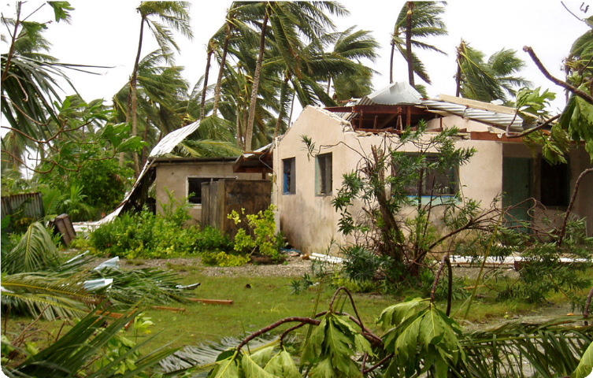
© Department of Foreign Affairs and Trade

- Which country has the highest risk of facing significant damage to any land and water resources from the hazard?
- Which country is the least climate resilient to a hazard based on costs and size of population?
- Rank countries in your group according to how much Australian official development assistance you would allocate, based on your assessment of their environmental resilience.

How are Australia’s Pacific partnerships building environmental resilience?
Learning intentions | Materials
- To understand how Australia’s Pacific partnerships manage hazards in the region.  - To think of an environmental resilience strategy, with consideration for the interconnected environments of the Pacific. | - Worksheet: Environmental Resilience Strategy

Introduction (10 min)
These two lessons will require students to apply the terms they learnt in Lesson 1. They will then develop their own strategies or plans for dealing with a potential hazard using the knowledge gathered about the region in Lesson 2. Students should work in groups of two or three.
- Tip: These lessons could further build on biological sciences learnt in Year 7 Science by looking at impacts of change on ecosystems.
- Outline to the class the learning intentions for these lessons. Explain that group work will be required throughout the lessons and establish a clear expectation for student behaviours. You may be able to align this to your school’s values.
- Ask the class if they know what the phrase ‘humanitarian assistance’ means.
- Show the video Development matters – humanitarian (2 min), which explains the assistance Australia provides to countries in need.
- As a class, create a list on the board of the many ways Australia provides humanitarian assistance.

Guided instruction
- Hand out the Environmental resilience strategy worksheet and read through the task and Activity 1 with
the class.
- Arrange groupings and allocate each group a different scenario that they need to manage from the table
of Pacific Island scenarios on the next page.
- You may wish to model the activity for students by working as a class on the final scenario in the table (regarding Tonga). This scenario is ideal as a case study for Year 8 Geography.
- Show the class the video Pandemic warriors: staying on-air (8 min 20 sec).
- Pause regularly to fill out the table in Activity 1 as a class. You could either give each student two copies of this page of the worksheet or recreate the table on the board and ask for students to contribute to it
- Modelling the process will make it much easier for students to complete their own scenario independently.
- Students should work as a group to brainstorm the causes and effects at the start of Activity 1. Completing the table of potential effects should be a short warm up task (5 min) to encourage effort and collaboration from all group members.

Table of Pacific Island scenarios requiring Official Development Assistance
El Niño is causing drought in Fiji and Solomon Islands.
Heavy rainfall has caused a huge landslide in Papua New Guinea.
Rising temperatures are bleaching coral and affecting ocean ecosystems in the Pacific.
Sea-level rise has caused seawater to infiltrate freshwater supplies and farming land in Nauru.
Cyclones are damaging the land and leading to huge tides polluting freshwater sources.
An earthquake has struck Vanuatu.
Optional: Tonga has faced an undersea volcanic eruption which led to a tsunami.

Working collaboratively
Aim to introduce this task within the first lesson so that each group can make decisions about which development programs they will research in Activity 2. It might also be completed as a homework task. In the second lesson, provide a clear time limit to keep students focused. This will simulate the urgency of decision-making that faces an Australian emergency taskforce.
- In Activity 2 of the worksheet, students will need to delegate and assign the research of varying Australian supported programs among the group. Ideally each student should research one project.
- Group members should then share their notes to ensure that all students can fill in all rows of the table.

Formulating a strategy
- Read through Activity 3 and the sample flow chart to develop an environmental resilience strategy with the class.
- Again, students should have a limited time to develop their strategy, requiring them to think critically, and problem-solve as a group.
Oral presentation assessment task: This task could be expanded into a third lesson by getting students to present their strategy to the class. If time permits, you could allow students to ask each group a few questions. Success criteria could be aligned to the organising ideas of global relationships, global responsibilities and global futures. In particular, exploring Australia’s development goals of working with partners to tackle global challenges and keeping our region stable.

Learning review (5 min)
The lesson could end with an exit ticket, asking students to answer one of the following questions, which relate
to the organising ideas and Australia’s development goals:
- Why is environmental resilience important?
- What do you think is the most important stage for strengthening environmental resilience?
- Provide one example of how Australia supports the environmental sustainability of the Pacific region.
- Provide one example of how Australia supports local Pacific communities who are living in hazardous areas.

Environmental resilience strategy
Working in small groups, you will be given a hazard scenario. Most of these scenarios are based on actual disasters that have occurred. Your task is to assess the situation, research current environmental resilience initiatives that Australia is supporting, and develop a strategy or plan to ensure the country can become more climate resilient.

Activity 1: Identify the cause and effect
Hazard scenario:
Potential causes of the hazard:
The causes of this type of hazard could be (circle any that are appropriate)
- prevented
- mitigated
- adapted to
- prepared for
As a group, brainstorm the potential effects of the hazard, using these four elements:
Land (for example, coastal, farming, forest environments)
Fresh water (for example, rivers, household water supplies)
Ecosystems (for example, plants, wildlife, coral, fish)
Community (including those most vulnerable)

Activity 2: Research Australia’s development programs
Access the webpage Pacific regional – climate change and resilience and scroll down to ‘Regional programs’. With your group, research several Australian development programs. Choose at least three that you think would help the community to strengthen their environmental resilience, covering various stages of the hazard management process. Take notes in the table below.
Australian supported program | How would it assist in managing the hazard? | Circle the type of management strategy
Prevention
Mitigation
Adaptation
Preparedness
Response
Recovery
Prevention
Mitigation
Adaptation
Preparedness
Response
Recovery
Prevention
Mitigation
Adaptation
Preparedness
Response
Recovery

Activity 3: Develop a strategy
As a group, compile your notes and create a flow chart that shows how a partnership with Australia could assist
the country in your scenario. The aim is to build this country’s environmental resilience and mitigate (reduce) the impacts of natural hazards.
Below is a template with examples. Some refer to actual Australian development programs. When creating a strategy, you are considering the interconnection between communities, the land and water. You will also gain more understanding of the interconnections between people when responding to hazards.
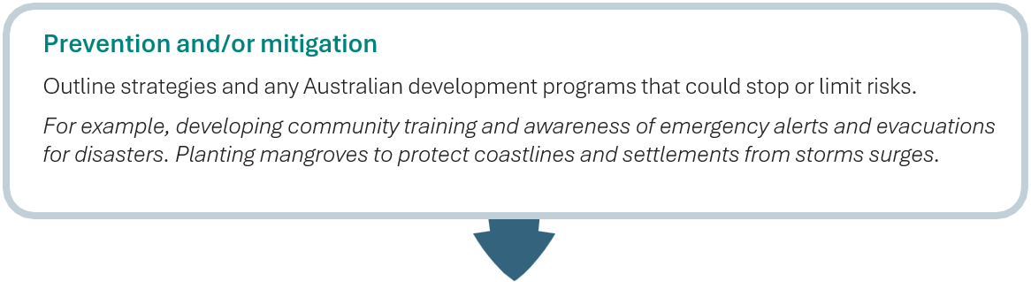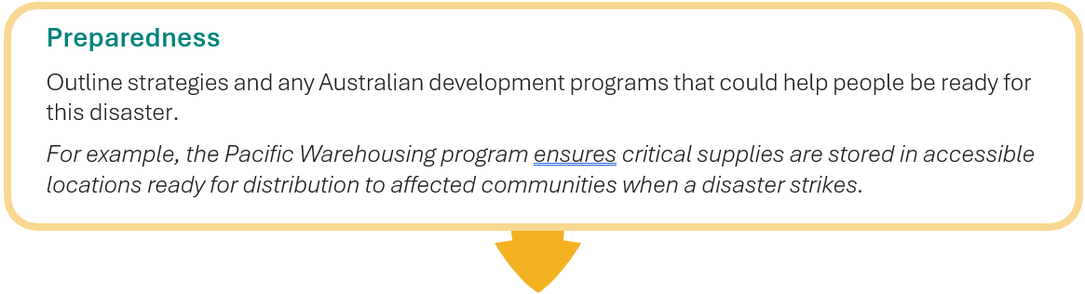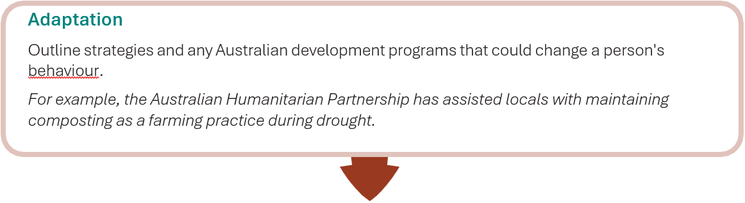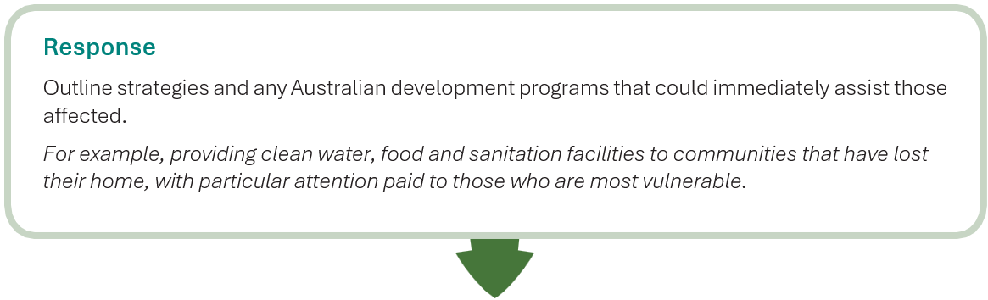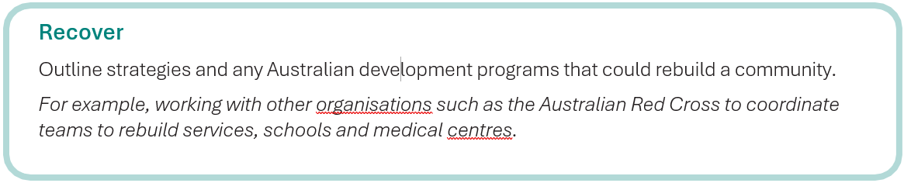

Environmental resilience strategy for a 