Australia’s Pacific partnerships
Using the AusDevPortal (link: https://adp.dfat.gov.au/locations) create a legend using arrows of varying widths to categorise the top 15 countries receiving Official Development Assistance from Australia.
The top 15 countries receiving Official Development Assistance from Australia:
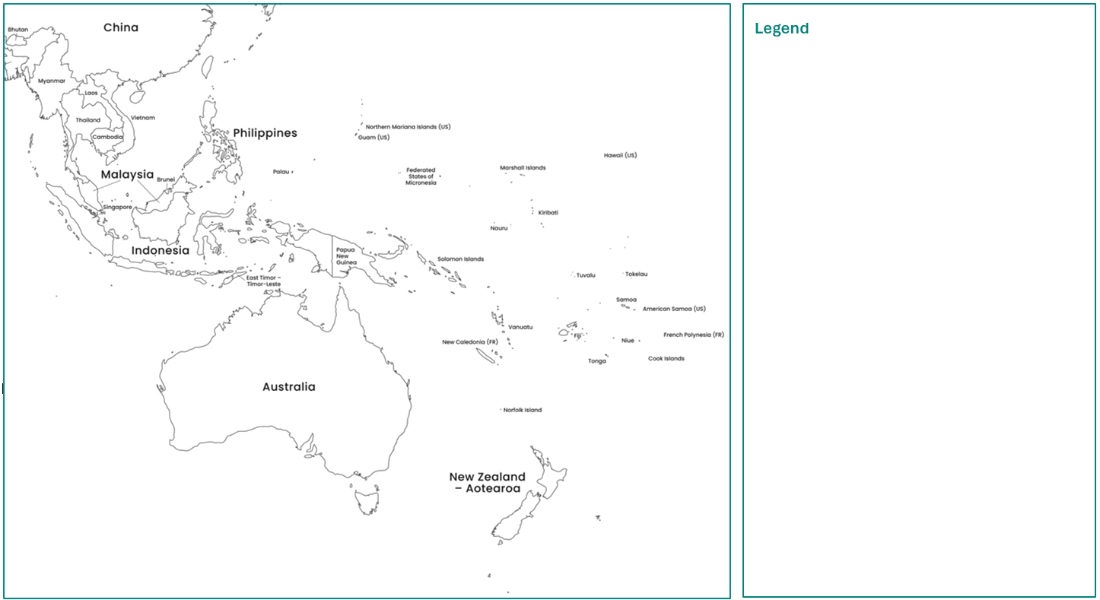

Australia’s Pacific partnerships (flow map)
Using the AusDevPortal (link: https://adp.dfat.gov.au/locations) create a legend using arrows of varying widths to categorise the top 15 countries receiving Official Development Assistance from Australia.
The top 15 countries receiving Official Development Assistance from Australia:
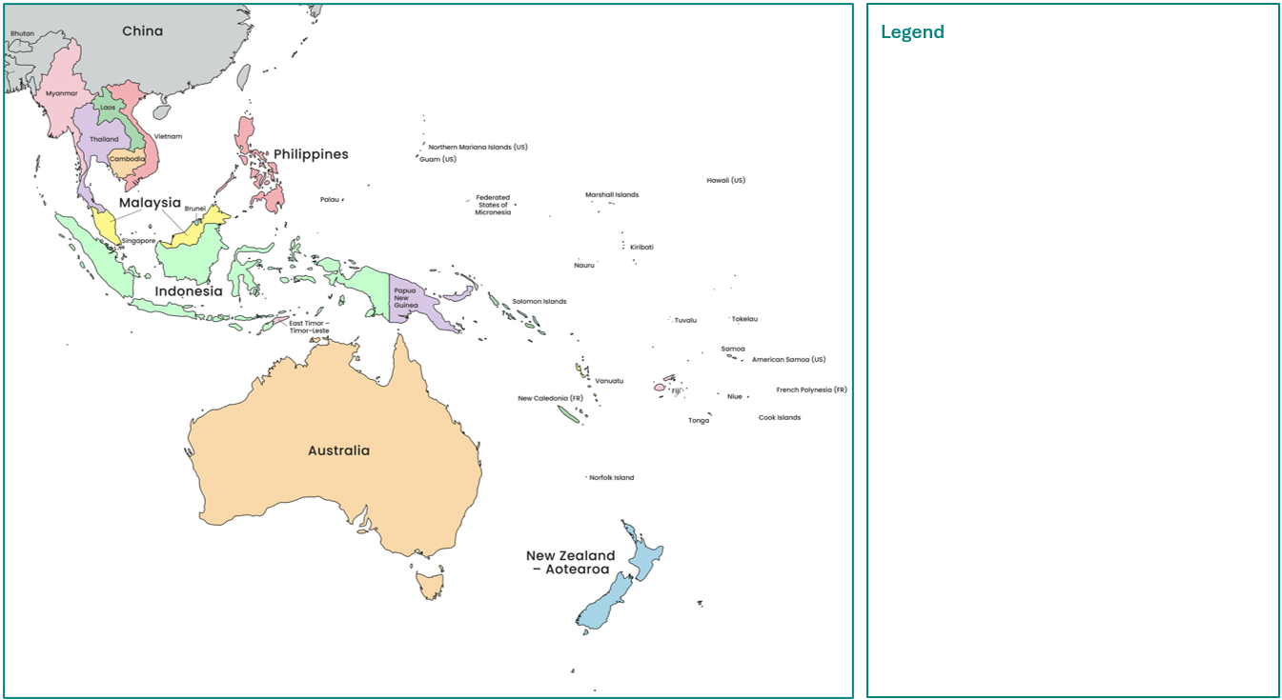
Adapted from: © VectorStock

Hazard management

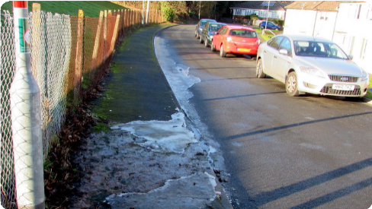
- Define the term ‘hazard’.
- There are many terms to define elements of environmental resilience. Match the word to the correct definition and example. The examples are based on a scenario where you are walking along an icy or wet footpath where accidents and falls often happen.
Term |  | Definition |  | Example
Prevention |  | The ability to change to survive  and cope during a hazard. |  | Calling out for assistance after falling and spraining your ankle.
Mitigation |  | How possible it is that something  or someone will be harmed. |  | Putting on shoes with rubber grip in preparation for the icy footpath.
Preparedness |  | Actions are taken in advance to stop  harm from happening. The aim is to  reduce the chance of the hazard. |  | Alerting pedestrians using  signs to take caution  on icy footpaths.
Response |  | The process of restoring and rebuilding. |  | Wearing loose shoes  with no grip.
Vulnerability |  | Assistance or strategies needed during  the hazard or immediately after. |  | Blocking off the footpath  for pedestrians.
Adaptation |  | Making plans and testing them  to make sure that people are  ready to respond to a hazard. |  | Applying ice packs to your ankle  for the next 24 hours.
Recovery |  | Actions taken to reduce the impact  of a hazard, which limits the  negative consequences. |  | Changing your walking speed  on the footpaths in winter.

Assessing risks in the Pacific
- Go to the webpage Pacific regional – climate change and resilience and scroll down to ‘Working with Pacific partner governments’.
- Select one or two of the countries, and then open the risk profile PDF for this country/these countries.
- Complete the table below. Your teacher will guide you through this process or you may have access to the PowerPoint.

Table: Risk assessment – country features
Features | Country 1) | Country 2)
% of coastal population within 1km of the ocean
Land area
Total population
% of population facing volcanic risk
Hazards with
a high likelihood
Costs of coastal protection per year

Table: Risk assessment – climate projections
Climate projection | Country 1) | Country 2)
Typhoon or cyclonic activity
Rainfall
Sea-level rise by 2050
- Identify three statistics in your table that you believe present the greatest risk for your Pacific Island nation.
- Justify why you chose these three statistics. To justify means to give reasons. For example, the statistic you chose might suggest a risk to the environment, such as a loss of land or water pollution. Alternatively, it could pose a risk to the country’s economy such as the cost to rebuild or loss of businesses, or you may have social reasons, such as people left homeless.

Review activity: In case of emergency
Find three to five other students who researched the risk profiles of different Pacific Island nations to you. Together read the scenario below:
Australia knows that an emergency response could be necessary in the Pacific at any time. Imagine you are in Australia’s emergency response team and need to decide how to support each of the countries you studied as a hazard [choose a tsunami or cyclone] is expected within the next few hours. You have 1–2 minutes to make a decision for each of the factors listed below. There is no single correct answer.
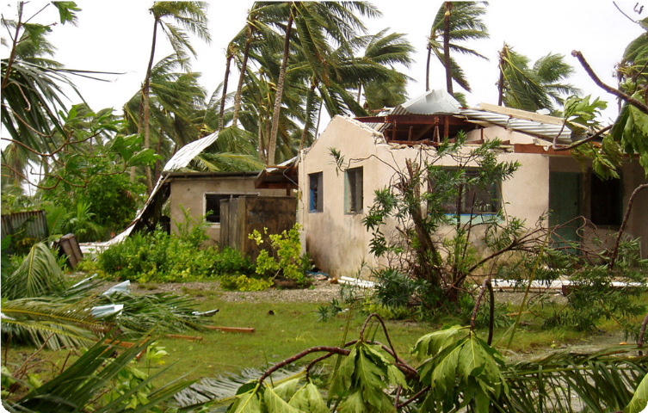
© Department of Foreign Affairs and Trade
- Which country has the highest risk of facing significant damage to any land and water resources from the hazard?
- Which country is the least climate resilient to a hazard based on costs and size of population?
- Rank countries in your group according to how much Australian official development assistance you would allocate, based on your assessment of their environmental resilience.

Environmental resilience strategy
Working in small groups, you will be given a hazard scenario. Most of these scenarios are based on actual disasters that have occurred. Your task is to assess the situation, research current environmental resilience initiatives that Australia is supporting, and develop a strategy or plan to ensure the country can become more climate resilient.

Activity 1: Identify the cause and effect
Hazard scenario:
Potential causes of the hazard:
The causes of this type of hazard could be (circle any that are appropriate)
Prevented
Mitigated
adapted to
prepared for
As a group, brainstorm the potential effects of the hazard, using these four elements:
Land (for example, coastal, farming, forest environments)
Ecosystems (for example, plants, wildlife, coral, fish)
Fresh water (for example, rivers, household water supplies)
Community (including those most vulnerable)

Activity 2: Research Australia’s development programs
Access the webpage Pacific regional – climate change and resilience and scroll down to ‘Regional programs’.
With your group, research several Australian development programs. Choose at least three that you think would help the community to strengthen their environmental resilience, covering various stages of the hazard management process. Take notes in the table below.

Australian  supported program | How would it assist in managing the hazard? | Circle the type of management strategy
Prevention
Mitigation
Adaptation
Preparedness
Response
Recovery
Prevention
Mitigation
Adaptation
Preparedness
Response
Recovery
Prevention
Mitigation
Adaptation
Preparedness
Response
Recovery

Activity 3: Develop a strategy
As a group, compile your notes and create a flow chart that shows how a partnership with Australia could assist
the country in your scenario. The aim is to build this country’s environmental resilience and mitigate (reduce) the impacts of natural hazards. Below is a template with examples. Some refer to actual Australian development programs. When creating a strategy, you are considering the interconnection between communities, the land and water. You will also gain more understanding of the interconnections between people when responding to hazards.
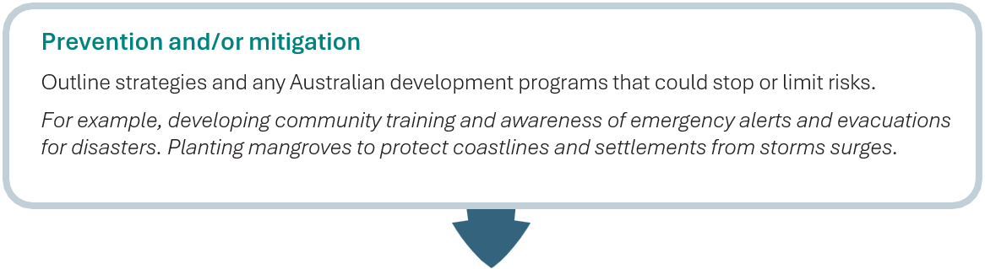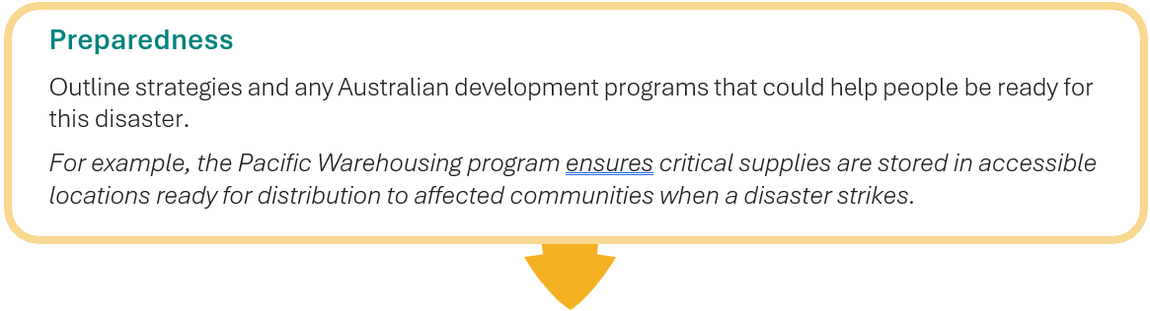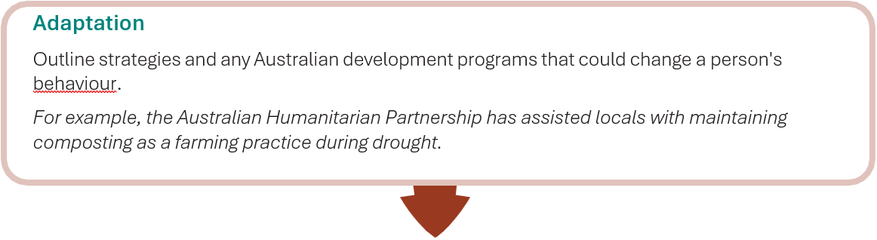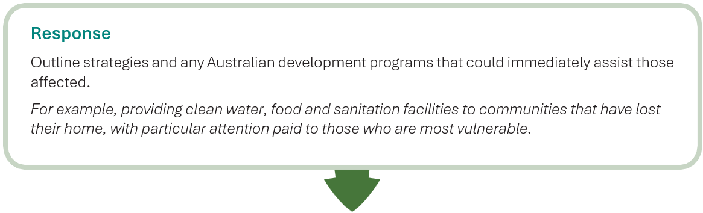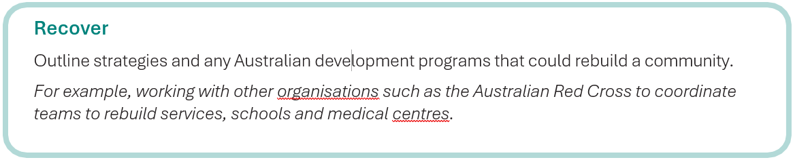

Environmental resilience strategy for: