ENVIRONMENTAL AND   
SOCIAL SAFEGUARD

POLICY ON MANAGING ASBESTOS RISK

**Updated April 2019 (version 1.3)**  
The policy is effective from April 2017 and applies to all new program investments initiated after that date.

Contents

1. INTRODUCTION 2

Scope 2

2. DFAT’S LEGAL OBLIGATIONS 3

*Work Health and Safety Act 2011* 3

*Environment Protection and Biodiversity Conservation Act 1999* 4

Other Commonwealth legislation 4

International legal obligations 4

Partner country laws 4

3. ASBESTOS AND THE AUSTRALIAN AID PROGRAM 5

Environmental, health and safety risks 5

Managing asbestos in Australian-funded aid investments 6

Working with partners to address asbestos risks 7

1. INTRODUCTION

This policy outlines the Department of Foreign Affairs and Trade’s (DFAT) approach to managing asbestos-related hazards in the Australian aid program, including implementation of its ban on the use of asbestos and Asbestos-Containing Materials (ACM) in Australian-funded aid investments.

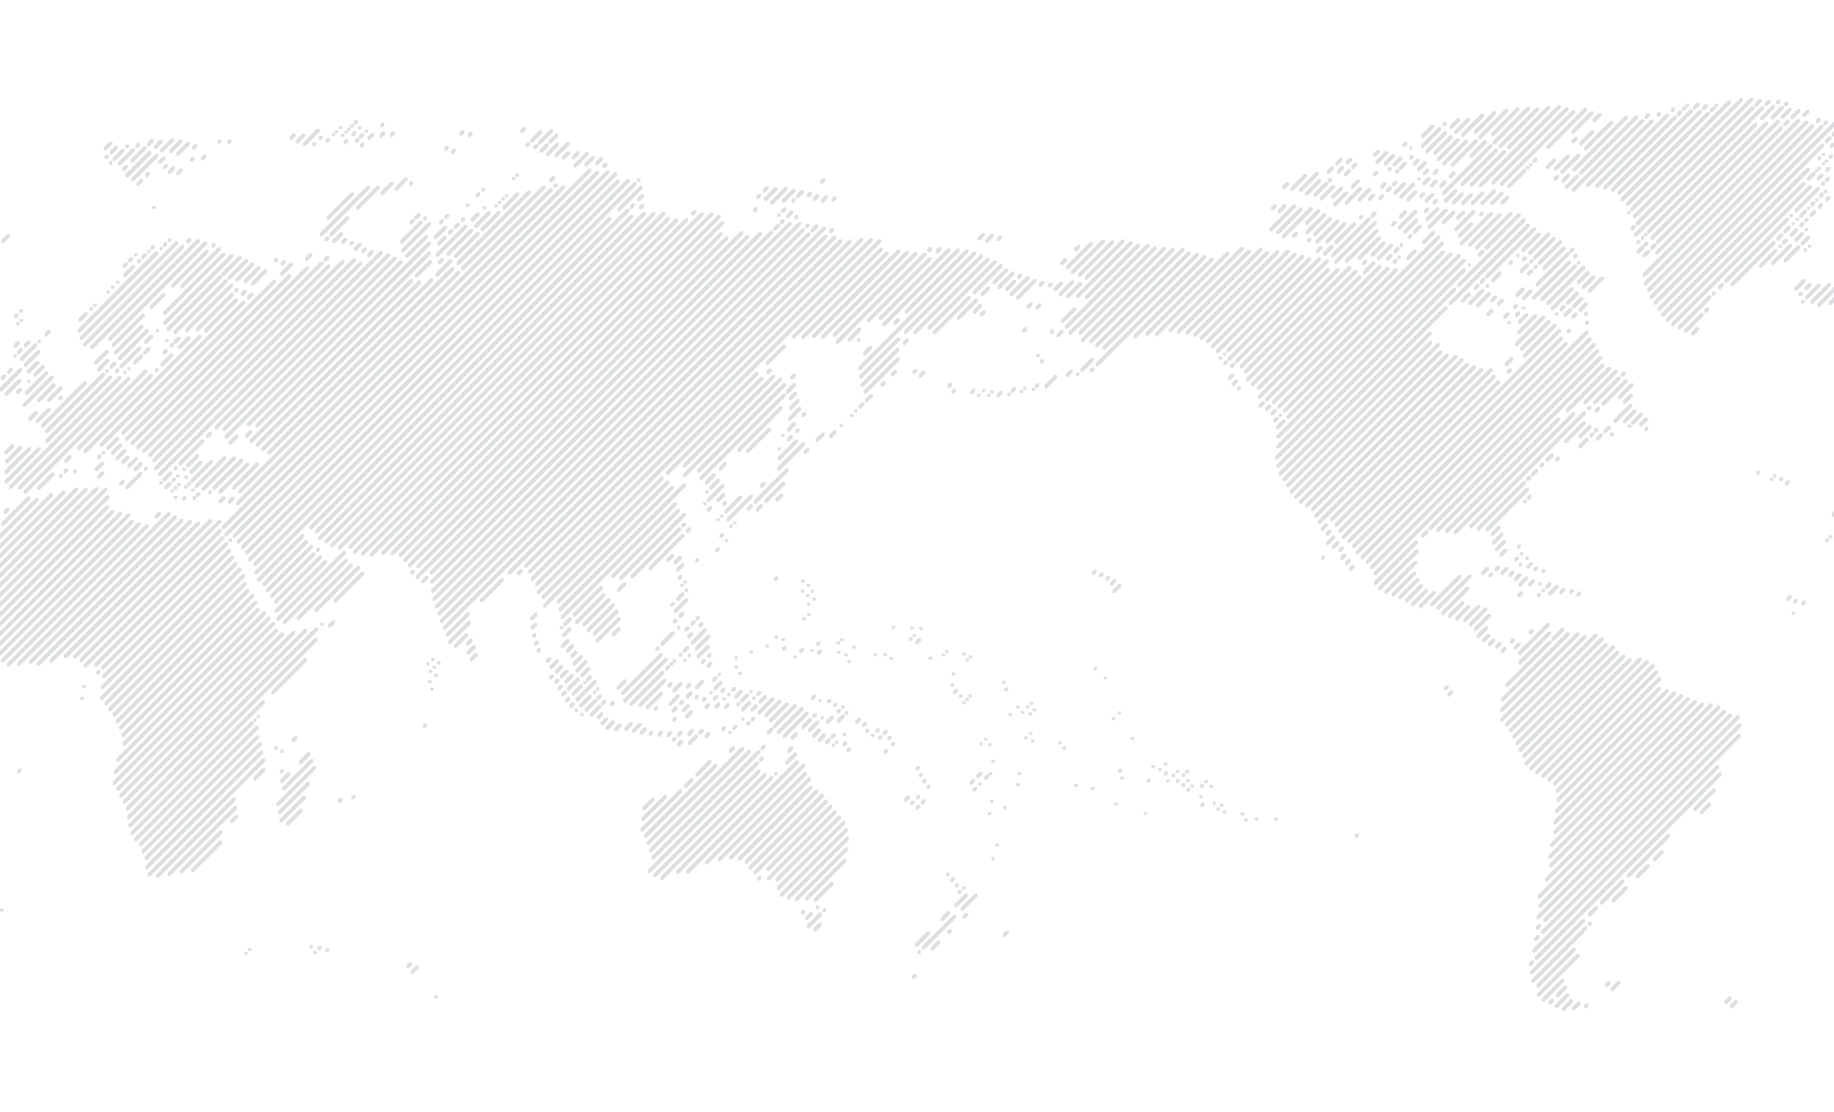Through implementation of this policy, DFAT aims to: minimise the risk to health and safety from ACM; improve awareness of asbestos risks and good management practices; and support a coordinated approach to addressing asbestos risks in the aid program.

**3**

**Australia has committed to international leadership on banning the use of asbestos worldwide and works with international stakeholders to promote the awareness and management of asbestos and ACM risks.**

**1**

**2**

**Where asbestos is encountered in aid program activities, it must be managed so that, as far as is reasonably practicable, it does not harm people or the environment.**

#### Key messages

**The Australian Government imposed a national ban on all asbestos products in 2003. The use of asbestos is not permitted in new Australian aid activities.**

## Scope

The policy applies to DFAT’s Australian Official Development Assistance (ODA) funded activities, regardless of value, partner arrangement or funding mechanism. Non-aid Departmental program investments should consider program risks in relation to this policy.

This policy does not apply to the DFAT’s owned and leased estate, which is subject to separate policies and procedures.

1. DFAT’S LEGAL OBLIGATIONS

The management of asbestos risks in Australian-funded aid investments can be complex. Aid investments that involve ACM may trigger a range of obligations under Commonwealth legislation, multilateral agreements, and partner country laws which need to be addressed.

## *Work Health and Safety Act 2011*

DFAT has obligations under the *Work Health and Safety Act 2011* (WHS Act) and the *Work Health and Safety Regulations 2011* (WHS Regulations) which apply to its overseas operations, including aid investments. Australia’s ban on the use of asbestos and ACM, and the prescribed processes for controlling and minimising the risk of asbestos are set out in the WHS Regulations and approved Commonwealth Codes of Practice in relation to asbestos management and removal.

The WHS Act requires DFAT to ensure, so far as is reasonably practicable, the health and safety of all DFAT ‘workers’[1] while they are at work. DFAT also has a duty, so far as is reasonably practicable, to ensure that the health and safety of others is not put at risk as a result of its operations. The extent of DFAT’s obligations under the WHS Act in relation to particular investments must be assessed on a case-by-case basis depending on the nature of the investment.

Information on what is reasonably practicable in terms of ensuring the health and safety of workers is set out in the WHS Regulations and Codes of Practice.[2]

## *Environment Protection and Biodiversity Conservation Act 1999*

The Environment Protection and Biodiversity Conservation Act 1999 (EPBC Act) is Australia’s principal Commonwealth legislation for the protection of the environment. The EPBC Act requires Commonwealth agencies to obtain and consider the advice of Australia’s Minister for the Environment before authorising any foreign aid project that has, will have, or is likely to have a significant impact on the environment. DFAT should ensure environmental impacts of its investments, including work involving asbestos and its disposal are assessed and managed.

## Other Commonwealth legislation

Additional obligations under Commonwealth legislation may apply to the management of asbestos in aid activities, including Australia’s Customs (Prohibited Imports) Regulations 1956, which restricts the importation of all types of asbestos and products containing asbestos, except under limited circumstances. The Hazardous Waste (Regulation of Exports and Imports) Act 1989 may also be relevant where importation and disposal of hazardous waste, including asbestos waste into Australia is planned.

## International legal obligations

Australia complies with its obligations under international laws and multilateral agreements primarily though compliance with Commonwealth legislation. Key multilateral agreements concerning the regulation and control of asbestos and ACM in Australian-funded aid activities include:

* ILO Asbestos Convention 1986 (No. 162) and Recommendation 1986 (No. 172)
* Basel Convention on the Control of Transboundary Movement of Hazardous Waste 1989
* Rotterdam Convention of Prior Informed Consent for Certain Hazardous Chemicals and Pesticides in International Trade 1989
* Waigani Convention to Ban the Importation into Forum Island Countries of Hazardous and Radioactive Wastes and to Control the Transboundary Movement and Management of Hazardous Wastes within the South Pacific Region 2001.

## Partner country laws

Where partner country laws and regulations exist, DFAT will meet partner country requirements and work with partner governments to develop appropriate asbestos management strategies. DFAT remains responsible for ensuring that activities it funds also comply with Australia’s legal obligations.

1. ASBESTOS AND THE AUSTRALIAN AID PROGRAM

ACM are still commonly available and used in developing countries. DFAT seeks to promote awareness and management of asbestos risks by preventing asbestos use in all Australian-funded aid investments. Eliminating ACM from activities is the best way of controlling and managing asbestos risks.

In the Indo-Pacific region, asbestos cement sheeting has been widely used for housing and building construction. The region is also vulnerable to events such as earthquakes, cyclones and tsunamis, which can expose communities, emergency response and recovery teams to ACM from debris, and damaged infrastructure.

Typical activities in the Aid Program where ACM may be encountered, include:

* Construction of new buildings and the renovation of existing buildings, such as schools in education programs and hospitals in health programs
* Humanitarian post disaster response and reconstruction work
* Water sanitation and hygiene (WASH) investments
* Water, wastewater and power infrastructure
* Maintenance, demolition, removal, transportation and disposal of waste associated with any of the above activities.

## Environmental, health and safety risks

DFAT’s [*Environmental and Social Safeguard Policy*](https://dfat.gov.au/about-us/publications/Pages/environmental-social-safeguard-policy.aspx) (safeguard policy) guides DFAT’s management of risks to the environment and people, and compliance with relevant Australian and partner country laws, and multilateral environmental agreements to which Australia is a signatory. All Australian-funded aid investments must be designed and implemented in accordance with the safeguard policy. Non-aid Departmental investments should consider program risks in relation to the safeguard policy.

The safeguard policy requirements relevant to the management of asbestos risks in Australian-funded aid investments include:

* Avoid the use of hazardous materials subject to international bans and phase outs
* Assess and manage potential impacts on the environment and people resulting from Australian-funded aid investments
* Monitor and report on environmental management and safety measures during design and implementation
* Comply with partner country environmental and health and safety laws
* Consult with stakeholders and disclose information transparently
* Promote improved environmental and safety outcomes.

## Managing asbestos in Australian-funded aid investments





**MANDATORY REQUIREMENTS**

ACM is not permitted in any new Australian-funded aid investments.

Eliminating ACM from investments and activities is the best way of controlling asbestos risk. Supplies and materials used in aid activities must not contain any asbestos. Local standards in some supplier countries may classify goods ‘asbestos free’ where they meet a certain low level of asbestos content. This would not comply with this policy and suitable non-asbestos alternatives should be used.

DFAT recognises that Australian aid program operations raise particular challenges in terms of managing asbestos risks overseas. Risks associated with asbestos are influenced by factors including: partner country laws and resources for enforcement; local resources and capacity to manage risks appropriately; the type of aid delivery arrangement; and DFAT’s degree of control over workplaces where aid investments are implemented.

While asbestos management strategies will vary depending on the situation, DFAT will ensure that it does what is reasonably practicable to manage asbestos risks in the aid program, consistent with its legal obligations, and departmental risk management policies and processes.

In accordance with its legal obligations, DFAT will ensure its workers exposed to the risk or involved in asbestos related work receive appropriate information, training and resources for the management of asbestos risks. DFAT will ensure its workers or other persons that may be exposed to asbestos are informed about exposure risks and control measures.



#### In practice

To ensure asbestos risks are adequately considered, all new aid activities must be   
screened for asbestos risk. Necessary management measures are incorporated  
into activity design and implementation to ensure that ACM is not used and that  
if it is present in existing infrastructure, it is appropriately managed.

If, despite screening, asbestos risks arise during implementation of aid activities (for example if ACM is encountered during works on existing buildings), DFAT will work promptly with partners to assess asbestos risks and develop and implement appropriate asbestos management strategies and plans. If DFAT workers are involved, there are requirements under the WHS Act.

Management of asbestos risks must be achieved in a way that is consistent with the [Workplace Health and Safety Management System guidance on asbestos management (WHSMS Procedure 7: Asbestos Management).](http://dfatintranet.titan.satin.lo/human-resources/work-health-safety-management-system/Documents/WHSMS%20SOP%207%20-%20Asbestos%20Management.pdf)

## Working with partners to address asbestos risks

| **1** | DFAT’s aid program delivery partners— whether they be developing partner governments, bilateral donors, multilateral development agencies or other delivery partners such as non-government organisations, contractors and suppliers — play a critical role in phasing out the use of ACM and managing its risks.  DFAT will work with partners to further global efforts to ban the use of asbestos, and apply international good practice approaches to the management of asbestos risks and hazards. DFAT will seek to improve awareness of asbestos risks, provide safe alternatives and to support the phase-out of ACM. |
| --- | --- |
| **2** | Australian partners — DFAT will work with its partners to support a ban on the use of asbestos, promote asbestos awareness and share knowledge, tools and information on best practice. Australian partners, including whole-of-government partners, NGOs and private sector organisations that are funded through DFAT programs may have obligations under the WHS Act and WHS Regulations. |
| **3** | Partner governments — Partner governments are responsible for ensuring protection of worker and public health and safety, and the environment in accordance with their national and local laws, and regulations. Where appropriate, DFAT will support countries’ efforts to use and strengthen their regulatory systems and approaches to managing asbestos risk, consistent with Australia’s commitment to strengthening partner country systems. |
| **4** | International donor partners — International partners and donor funds are expected to follow their own policies relating to asbestos. In cases where the Australian aid program co-finances activities managed by an international partner, DFAT is responsible for ensuring that those activities comply with Australia’s legal obligations. |
| **5** | Contract and grant agreements — DFAT agreement templates include requirements that assist DFAT in meeting this policy. DFAT will identify obligations including for consultation, mitigation, monitoring and reporting in both Requests for Tender and agreements for activities that have potential risks associated with ACM. Compliance will be assessed by reviewing monitoring reports, conducting site visits, and/or consultation with affected persons. |

1. As defined by the WHS Act, a DFAT ‘worker’ is any person carrying out work for the department, including work as an employee, a contractor or subcontractor, an employee of a contractor or subcontractor, an employee of a labour hire company assigned to work in the department, an apprentice or trainee, a student gaining work experience, or a volunteer.
2. Safe Work Australia has developed two Codes of Practice: *How to Safely Remove Asbestos* and *How to Manage and Control Asbestos in the Workplace.* These documents provide practical guidance for persons conducting a business or undertaking who have duties under the WHS Act and WHS Regulations.