Emerging Markets Impact Investment Fund (EMIIF)
  - IMPACT STUDY 2021-2022


Report prepared by:
Bernadette Whitelum and Queentries Regar – Alinea International
Jenna Hawes – Ninti One Limited
alineainternational.com
Front Cover Image: Participants of AVVs SHINE Incubator Program.
Alinea International acknowledge and pay respect to Aboriginal and Torres Strait Islander peoples as the Traditional Custodians of our land and its waters. We wish to pay respect to Elders, past and present, and to the youth, for the future. We extend this respect to all Aboriginal and/or Torres Strait Islander peoples reading this document.

Table of Contents
Glossary 4
Executive Summary 6
Key Findings 6
What is EMIIF? 10
Theory of Change 10
How EMIIF Works 11
Snapshot of Progress 16
Profile of EMIIF 16
Profile of SME Funds 16
Development Impact 19
Market Building Impact 22
Impact on Gender Equality 26
Organisational Learning 28
Annex 1: Approach and Governance 30
Annex 2: Key Informant Interviews 32

Glossary
Term | Definition
Additionality | Capital that is additional, addresses a specific market gap/shortfall and does not crowd-out private sector involvement. From an evaluation perspective, additionality is the extent to which desirable outcomes would not have occurred without EMIIF intervention.
Blended Finance | Blended finance is defined by the OECD as the strategic use of development finance (e.g. donor ODA funds) for the mobilisation of additional finance towards sustainable development in developing countries.
EMIIF Consortium | EMIIF implementing organisations consisting of Sarona Asset Management Inc. (Sarona), Mennonite Economic Development Associates (MEDA), Volta Capital Limited (Volta), and Whitelum Group, now Alinea International (Alinea).
Fund Manager | The organisation that manages the SME Funds with which EMIIF interacts.
Gender Equality | Gender equality means that women, men, and gender diverse people have equal conditions for realising their full potential for contributing to, and benefiting from, economic, social, cultural, and political developments. Gender equality is realised when all people regardless of how they define their gender share equally in the distribution of power and influence; have equal opportunities for financial independence through work or through setting up businesses; enjoy equal access to education and the opportunity to develop personal ambitions.
Gender Lens Investing | Gender lens investing involves consideration of gender biases, patterns, power dynamics, opportunities, and risks in investments. At its core, gender lens investment incorporates a gender analysis alongside impact and financial analysis to make better decisions that lead to better gender equality and economic outcomes.
Impact | Impact for an Official Development Assistance (ODA) project is defined by the OECD Development Assistance Committee (DAC) as economic development and welfare of developing countries. The use of the term “impact” in EMIIF inception products refers to any social, environmental and governance outcomes that can be linked or attributed to an investment and includes the full spectrum of EMIIF results: outputs, outcomes and impacts in the more specific OECD sense.
Impact Investing | Impact investing refers to the act of investing into companies, organisations, and funds with the intention of generating positive social, environmental and governance impact alongside a financial return. Impact investing requires (i) an intention to have a positive social, environmental or governance impact, (ii) expectations to generate financial returns and (iii) a commitment to measure impact to track progress against the investors’ objectives
Impact Management | Managing for intended positive gender equality, social, environmental and governance impact outcomes when selecting, making, managing, and exiting investments. Impact is not simply addressed as a goal to be achieved through EMIIF, but to drive better investment decision-making and monitoring of investments.
Capital Mobilisation | Capital mobilisation refers to the additional investment capital that is contributed by other investees (public and/or private) following and/or because of the EMIIF investment.
Private Sector Development | Expanding trade and business opportunities in the Department of Foreign Affairs and Trade (DFAT) partner countries through i) building better business and investment environments, ii) supporting growth in specific related markets, iii) maximising the developing impact of individual businesses.
Secretariat | The oversight body within DFAT responsible for overseeing EMIIF’s strategic direction and policy coherence. It consists of representatives from DFAT who are accountable for EMIIF.
SME | A small and medium-sized enterprise (SME) refers to a business that incorporates a for-profit motive and is smaller than a specific threshold in terms of staff size, value of assets and/or revenue levels. For this document, an SME is defined as a business that has 150 employees or fewer, or fewer than 250 employees in labour-intensive sectors.
SME Fund | An SME Fund is a financial intermediary (including but not limited to fund structures) that is focused on investing in SMEs.
Target Countries | Bangladesh, Cambodia, Fiji, Indonesia, Laos, Myanmar, Papua New Guinea (PNG), the Philippines, Sri Lanka, and Vietnam.
Target Region | Any country in South Asia, Southeast Asia and the Pacific which is eligible for Australian ODA.
Target SME | An SME seeking finance or funding of an amount between 5,000 USD to 2 million USD in initial investment.
Technical Assistance | Non-financial support including through training, mentoring and advice, to build the capacity of the recipient SME Fund and/or SME to carry out its business activities and achieve positive Development Impact in EMIIF Target Countries.
Trustee | Perpetual Trustee Company Limited or Perpetual.
Trust Deed | Means the Emerging Markets Impact Investment Fund – Trust Deed.

Executive Summary
The Emerging Markets Impact Investment Fund (EMIIF) is a development financing mechanism launched in June 2020 by the Department of Foreign Affairs and Trade (DFAT). EMIIF seeks to support the financing needs of small and medium-sized enterprises (SMEs) across Asia and the Pacific regions. SMEs in these regions are major drivers of job creation, drive innovation, and provide important goods and services. However, SMEs in Asia and the Pacific face consistent financing challenges. Recognising this, EMIIF invests in funds that provide much-needed financing to early and growth-stage SMEs that deliver important development impacts in challenging markets.
DFAT’s investments through EMIIF incentivise private sector co-investment, multiplying the impacts of DFAT’s development assistance contribution. Australia’s ODA has traditionally been provided through grant funding administered by DFAT. However, EMIIF is an impact investment fund, the first development financing modality of its kind for Australia. EMIIF’s ambition is to grow the impact investing and gender lens investing (GLI) market to increase the volume and impact of private capital flowing to emerging markets for inclusive economic growth. Understanding EMIIF’s impact is important for the Australian Government and the development sector to enable informed decision-making on future development financing mechanisms.
Key Findings
The Impact Study team assessed there is early evidence that EMIIF has demonstrated progress against its development and market building impacts objectives. This is well-aligned with Australian government’s objectives to narrow financing gap and multiply the impacts of Australia’s ODA in Asia and the Pacific using blended finance instruments. EMIIF has demonstrated its ability to deploy catalytic investment to grow the impact investing ecosystem in Southeast Asia. EMIIF has committed AUD 16.7 million (70% of its total investable capital) to three SME Funds in Southeast Asia. These include:
- AUD 5.7 million first loss to Lendable MSME Fintech Credit Fund (Lendable), a private debt fund focused on supporting fintech businesses in South and Southeast Asia. Lendable has reached final close of $164 million.
- AUD 5.3 million equity investment to Ascend Vietnam Ventures Alpha (AVV), a Vietnamese venture capital fund, with a focus on women-owned startups.
- AUD 5.7 million equity investment to Southeast Asian Women’s Economic Empowerment Fund (SWEEF), a Southeast Asian private equity fund focused on women-owned businesses and diversity and inclusion as a main value creation approach.
All three funds have begun disbursing finance to SMEs and generating positive development outcomes. Some deployment has been achieved during a time when the COVID-19 pandemic stalled many development finance vehicles. This rapid deployment of funds is major progress in the impact investing market. By way of comparison, similar government-led funds such as the Dutch Good Growth Fund typically take several years to move investable capital all the way to target SMEs. EMIIF’s remaining investable capital is on track to be completely committed in 2023.
The key findings and learnings related to the progress of EMIIF for this review period are summarised below.

Development impact
EMIIF’s investments have mobilised AUD 94 million in private investment and co-invested this alongside AUD 126 million in public investment (including DFIs). For every dollar invested, EMIIF has been able to mobilise over five dollars from the private sector. This mobilisation rate is above benchmarks for Asia and the Pacific. Throughout its investment process, EMIIF has built strong working relationships with key investors, including the DFI community and Australian impact investors.
EMIIF addresses the ‘missing middle’ challenge which refers to financing for companies that are too large to be served by microfinance institutions and yet too small for the formal banking sector. Additionally, EMIIF has filled the gap that results from a limited presence of active Asian and European DFIs in the region.
EMIIF’s investments have begun delivering early evidence of inclusive economic development impact in the regions. EMIIF has helped unlock capital for 16 portfolio companies in Vietnam, Indonesia, Bangladesh, and the Philippines. The majority of these businesses operate in essential services sectors, such as financial inclusion, agribusiness, and tech services supporting health and education.
EMIIF’s investment contributes to job creation in these regions. EMIIF’s investments have generated 2,651 new full-time equivalent jobs of which 59% are for women. This is positive progress for the economy amidst the COVID-19 pandemic crisis that has caused an economic downturn and disruption in the job market.
EMIIF plays an active role in accelerating the capital needed for growth by micro and SME business owners in emerging markets. EMIIF has contributed to AUD 62 million in capital being disbursed by Lendable and AVV for SMEs in South and Southeast Asia. There are around 10,349 microentrepreneurs and SMEs financed because of EMIIF support in the region.
There is early evidence that EMIIF is contributing to increased participation of women in the formal economy. The majority (96%) of microentrepreneurs and SMEs that received direct or indirect financing from EMIIF’s investments are women-owned or led. At the time of writing, there were over 9,000 women-owned or led microentrepreneurs and SMEs being financed by EMIIF. EMIIF has disbursed approximately AUD 1 million to women-owned or led SMEs or women-focused fintechs.

Market building impacts
EMIIF’s unique role as a gender-focused fund providing first-loss investment and targeting first-time fund managers is proving to be additional in the market. Several public investors have noted the importance of EMIIF’s role in shaping the market. While private investors have noted EMIIF’s high-quality due diligence as valuable support during their investment process.
Within two years, EMIIF has established a highly credible reputation in the impact investing ecosystem. Notable bilateral DFIs who have co-invested alongside EMIIF include the US International Development Finance Corporation (DFC), OeEB (the Development Bank of Austria), the Swiss Investment Fund for Emerging Markets (SIFEM), International Finance Corporation (IFC) and the Asian Infrastructure Investment Bank (AIIB). Crucially, EMIIF’s development finance offering, particularly its first loss investment facility, has proved additional to the development finance sector. This bodes well for DFAT’s first private sector development finance mechanism.
While still early in its deployment, EMIIF’s technical assistance (TA) services to both fund managers and portfolio companies are on track to leverage robust development impacts. At the time of writing, EMIIF had spent approximately AUD 800,000 (19%) of its total technical assistance budget. The TA supports fund managers to create or improve existing Environment, Social and Governance (ESG) policies, create impact frameworks, embed gender considerations in existing policies and processes and to apply DFAT safeguarding standards (such as the incorporation of Child Protection and PSEAH standards).
EMIIF’s collaborative approach with SME Funds and SMEs is a strength that has delivered tailored support. All three investees (Lendable, AVV, SWEEF) reported that EMIIF’s openness and willingness to listen enabled them to co-design the technical assistance in ways that suited their context and enabled them to implement impact-driven investment strategies.
Fund managers reported that EMIIF’s robust due diligence and ESG standards had been challenging to implement, but were ultimately positive for their company, mobilising capital, and achieving impact. Fund managers pointed out that EMIIF’s due diligence was complex and labour-intensive, requiring resources that they would usually put elsewhere. The Impact Study team felt this was, on balance, a positive for the impact investing eco-system that has been criticised for over-promising and under-delivering on ESG impact.
Some stakeholders reported that having technical assistance provided by multiple different EMIIF consortium members was confusing. Respondents noted that multiple interactions between Sarona, Volta, and MEDA for technical assistance led to confusion in the TA design and delivery. Given that most SME Funds are recipients of investments from more than one investor, and many bring their own targets and indicators, the technical assistance (TA) process can become burdensome.
It was suggested by some SME Fund respondents that EMIIF’s additionality value could be enhanced if its support were extended to smaller and/or first-time managers with small funds that have impact and commercial growth potential.
EMIIF’s strong pipeline suggests that it has significant potential to continue to mobilise and direct more private investment into the region. During a series of investor roundtable discussions hosted by DFAT and Ecotone Partners, Australian investors were interested in leveraging EMIIF more to explore investment opportunities in these regions. EMIIF’s most recent investment, SWEEF, was successful in mobilising Australian private investors for its fundraising process

Gender equality impacts:
EMIIF has contributed to fund managers advancing gender equality within their organisations. As a result of EMIIF’s technical assistance, there is an improved participation of women leadership and employees at Lendable. Now Lendable has 48% of women employees and 27% of women leaders (previously none). EMIIF also provides ongoing TA to AVV and SWEEF to further shape their gender equality strategic plans and priorities. On average, there are 66% of women employees and 51% of women leaders in fund managers supported by EMIIF.
All of the fund managers supported by EMIIF have put in place explicit strategies to advance gender equality within their own organisation. At the time of writing, all fund managers are applying advanced strategies such as formalising and systemising the incorporation of gender lens investing in the investment process to positively influence gender outcomes. Lendable has shown positive progress by complying with most of the 2X Challenge indicators.
Similar positive change also happened at Sarona, EMIIF’s investment manager. Sarona became a member of 2X Global to further advance gender smart investments including EMIIF. Sarona aligns with 2X Challenge’s Leadership criteria where over a third of its partners, board, and Investment Committees’ positions are held by women.

Organisational Learning
There is early evidence that DFAT and posts now have a better understanding of EMIIF and have shown eagerness to further utilise EMIIF. As a result of continuous engagement with DFAT’s blended finance team and posts, there is interest to utilise EMIIF’s unique development financing capabilities as a delivery mechanism. Interest includes Jakarta and Hanoi posts seeking to use EMIIF as a climate finance delivery mechanism.
EMIIF has sparked the conversation about how to deploy development financing to address high priority development challenges for the Australian Government. For example, DFAT is keen to see how impact investing could be harnessed to help countries transition to net-zero emissions, pursue low carbon development in Vietnam and advance economic growth in Bangladesh.
EMIIF’s unique role as a catalytic capital provider addresses a niche gap in the market and can help build Australia’s comparative advantage in these regions. All investor respondents reported that EMIIF’s unique strengths were its understanding of nascent markets, and its ability to de-risk investments and build market confidence. These strengths have been critical to overcoming barriers such as perceptions of market risks on the part of many investors, a position echoed by Australian investors.


Photo 1: ALAMI

What is EMIIF?
The Emerging Markets Impact Investment Fund (EMIIF) is a development financing mechanism for the Australian Government, designed and managed by DFAT. EMIIF is a new approach to how Australia ODA funds to achieve its development objectives. The AUD 40 million EMIIF program mobilises investment capital for the growth of impactful small and medium enterprises (SMEs) in Asia and the Pacific. EMIIF has earmarked up to AUD 24 million in investment financing and AUD 16 million towards operational costs, including AUD 4 million dedicated TA to fund managers and SMEs to bolster development impacts.
EMIIF is led by the Private Finance for Climate and Development Section of DFAT and implemented by a Consortium composed of Sarona Asset Management Inc. (Sarona) as the Investment Manager of EMIIF, Mennonite Economic Development Associates (MEDA) as the Technical Assistance provider to underlying SMEs and Volta Capital Limited (Volta) as the Technical Assistance provider to fund managers. Alinea International (Alinea) is a subcontractor to Sarona to support the Monitoring, Evaluation and Learning framework and biennial impact studies, The Trust Company (Australia) Limited (Perpetual) is the Trustee, APEX Group Pty Ltd is the custodian, and Ernst & Young Australia LLP (EY) is the auditor.
Theory of Change
EMIIF uses a Theory of Change to maintain a clear line of sight between its work and the outcomes it seeks to achieve over the ten-year life of the investment mandate. The Theory of Change articulates the causal linkages between outcomes that need to be met at intermediate stages of the Fund’s implementation. These measurable outcomes ensure the investments and those managing them stay on track. A summarised version of the Theory of Change is presented here (the full version incorporates more rigorous measurable statements of outcomes).
Figure 1: EMIIF Theory of Change
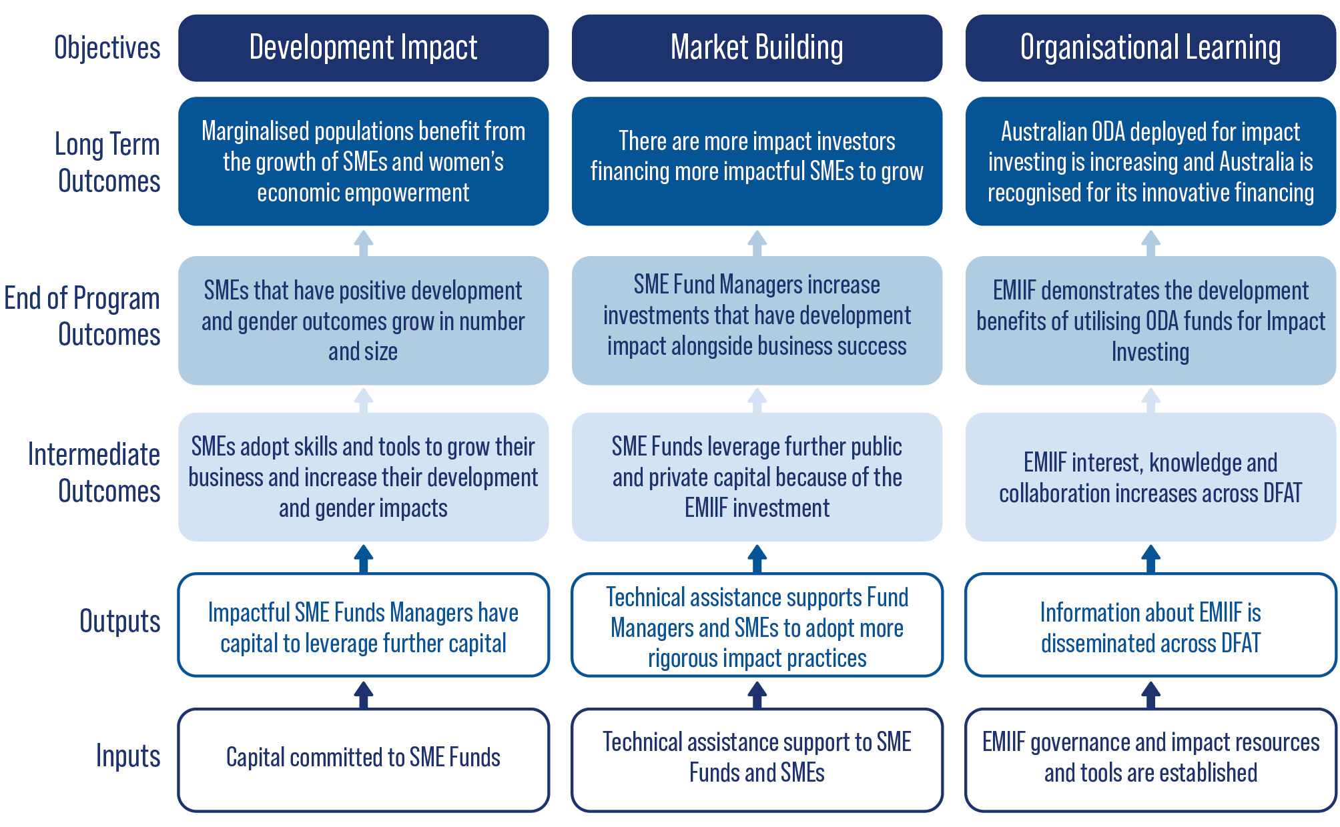
At this stage of EMIIF’s implementation, it is expected that EMIIF will have reached the level of inputs and outputs, with early evidence of achievements across the intermediate outcomes level.
How EMIIF Works
EMIIF represents a new and fundamentally different approach to ODA expenditure for Australia. It is a blended finance model that can provide catalytic first-loss capital, guarantees or concessional financing to encourage private capital flows to impact investments by improving their risk-return profiles and instilling market confidence. It is modelled on development financing vehicles developed by like-minded donor countries such as the Netherlands with its Dutch Good Growth Fund. Given EMIIF is Australia’s first foray into utilising ODA for investment funding rather than through grant funding, EMIIF is testing the business and development case for ODA impact investing. EMIIF supports flexible and patient capital. Flexible capital is particularly important for businesses at early stages, and for women-owned businesses, but it is hard to secure. Patient capital (investment which can tolerate longer timeframes for generating returns) can be a critical enabler for new impact-driven business models.
EMIIF crowds-in investments to SME Funds within DFAT’s target countries, which lays the foundation for a financially sustainable SME financing sector and its accompanying development impact. This crowd-in effect is facilitated in two different ways:
- At the time of investment, EMIIF directly leverages additional private capital by serving as the anchor investor that supports fundraising from other investors to capitalise investee funds.
- By supporting SME Fund’s growth, EMIIF mobilises their follow-on capitalisation in the medium term.
Figure 2: Crowd-in Effect: Leverage and Catalyse
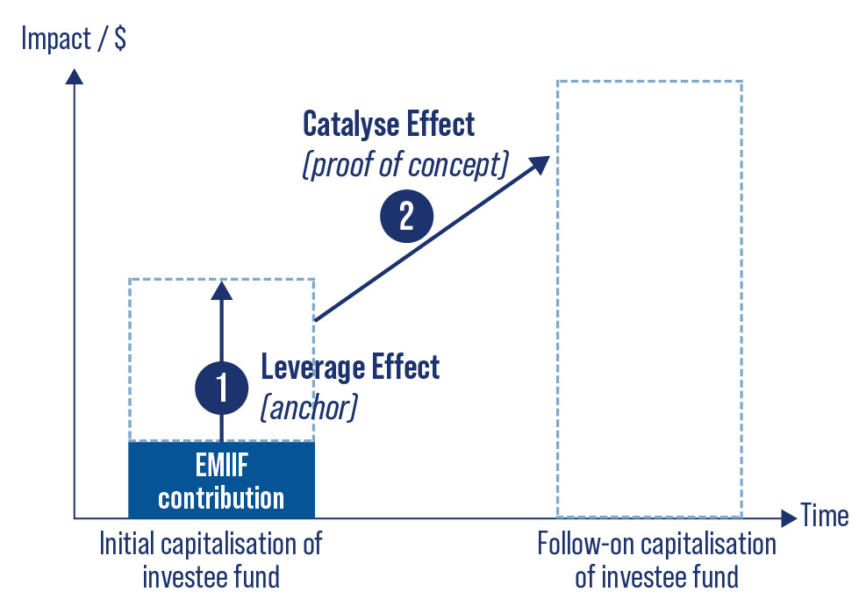
EMIIF’s investments indirectly mobilise capital at the SME level, as SME Funds provide initial capital to early-stage SMEs, which will mature to seek more commercial capital later.
EMIIF’s immediate co-investors (leverage effect) tend to be other donor and multilateral funds that have an explicit mandate to build the SME financing space and have a higher risk appetite than private investors. The leverage effect is amplified because EMIIF is able to take more risks than other DFIs because its target return is lower. In this way, EMIIF plays an important role in co-investing with like-minded public investors to address a key market gap where there is a significant need for additional capital in these regions.
Investing in a nascent market means EMIIF builds the foundation for mobilising commercially minded private investors to those markets over the long term. As the market matures and fund managers demonstrate successful track records, the regions’ SME Funds will become increasingly attractive to more conservative DFIs, local investors from South Asia and Southeast Asia, and Australian impact investors who are currently not willing to venture into these regions and/or into smaller or earlier-stage investments. This contributes to the market building objective of EMIIF.
EMIIF operates in Southeast Asia, South Asia, and the Pacific (its target region) with Bangladesh, Cambodia, Fiji, Indonesia, Laos, Myanmar, Papua New Guinea, the Philippines, Sri Lanka, and Vietnam as the target countries. It invests across a variety of sectors including health, education, agriculture, financial inclusion, climate change, and access to small-scale renewable energy.
Recognising that SMEs are major drivers of inclusive economic growth but often lack access to the capital they need to grow, EMIIF applies a Fund of Funds model to address the gap. EMIIF invests in several SME Funds and other financial intermediaries that, in turn, invest in early and growth-stage SMEs that will develop impact and financial returns.
Figure 3: EMIIF’s Fund of Funds Approach
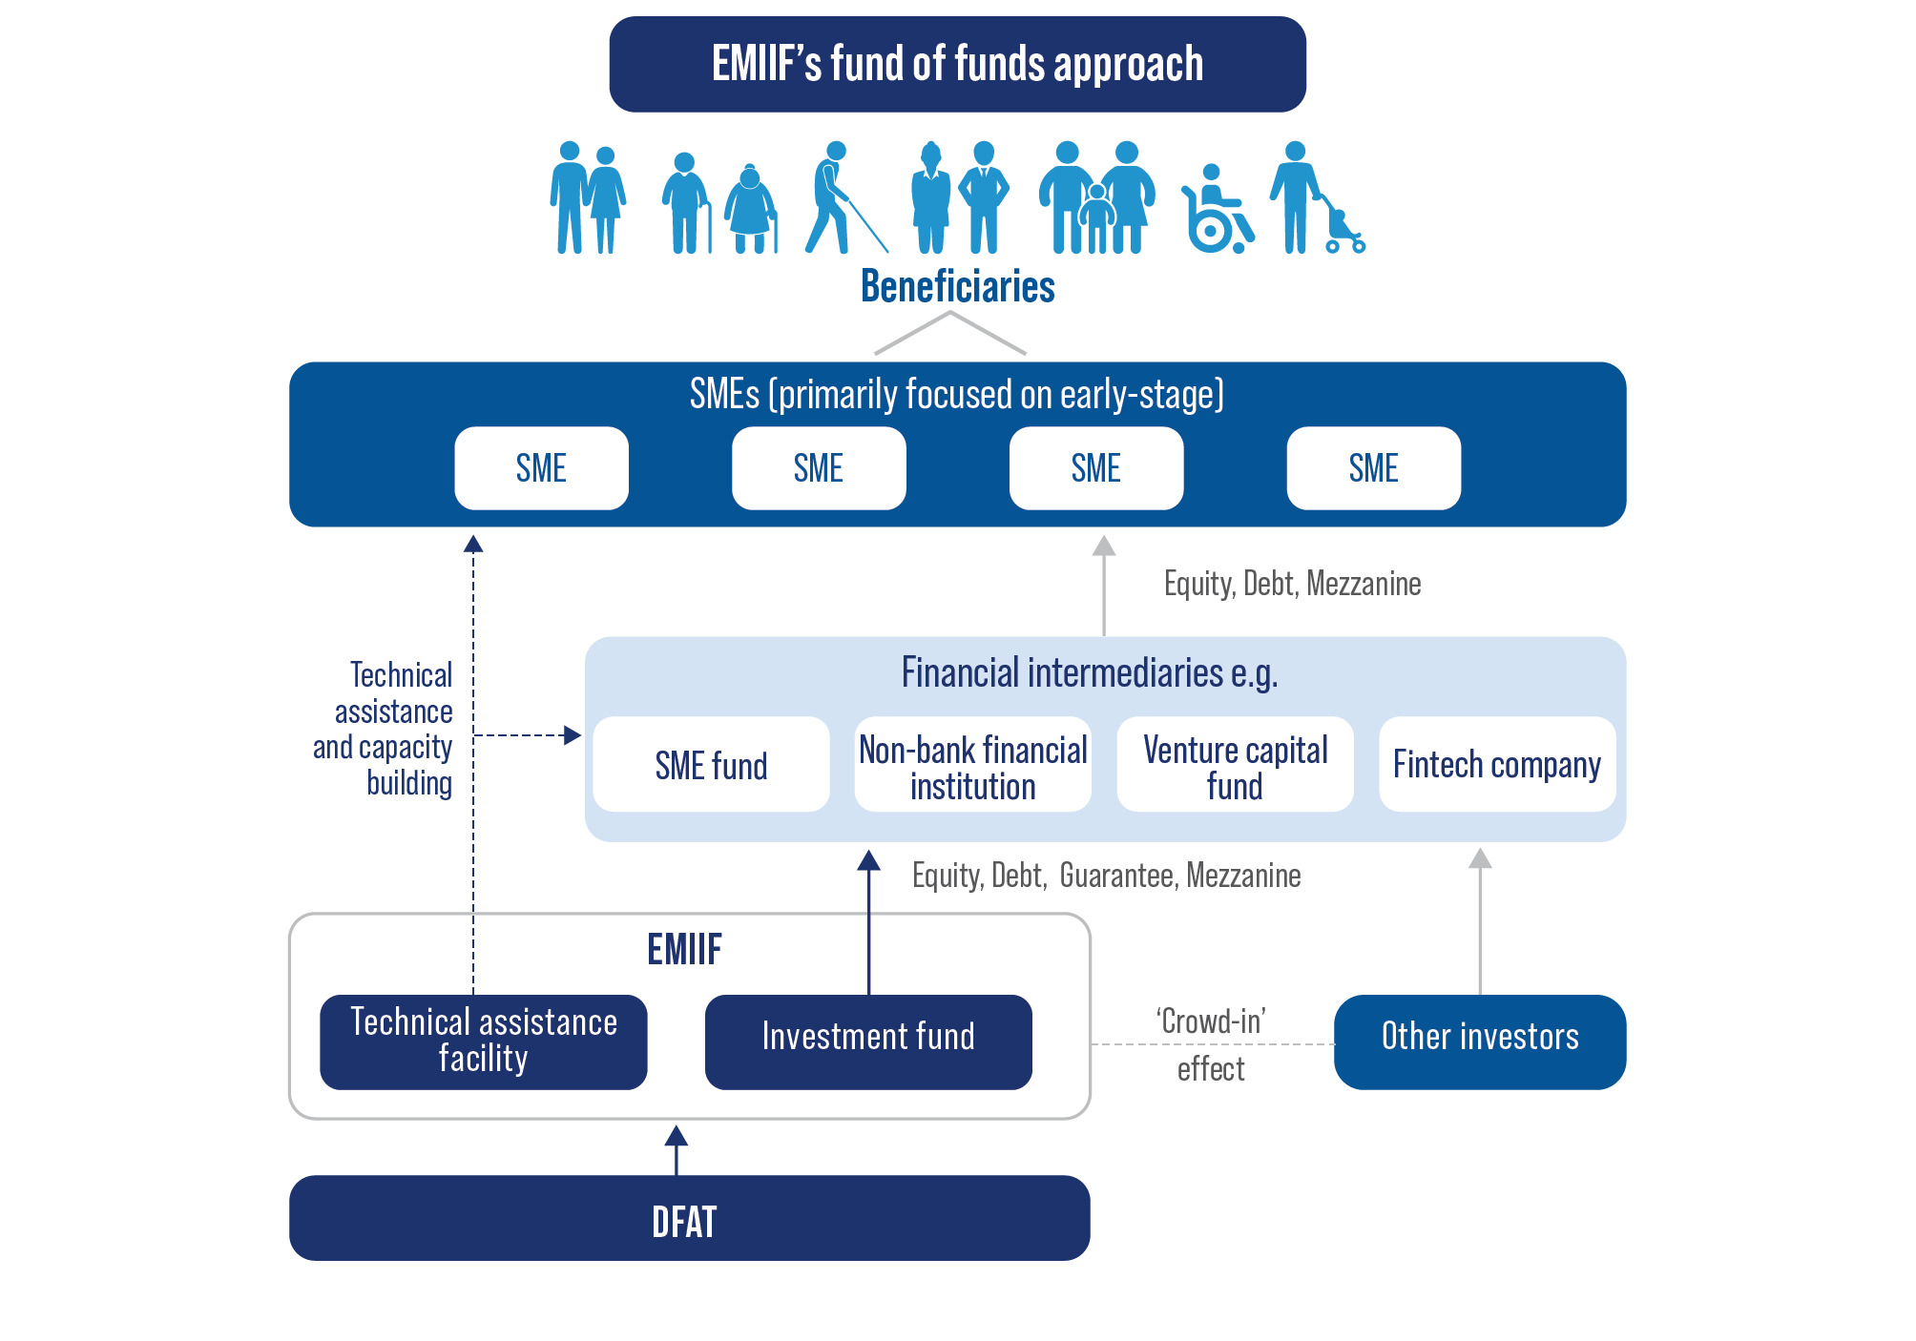

Gender Strategy
EMIIF seeks to advance gender equality and articulates its realisation as: “when all people regardless of how they define their gender, share equally in the distribution of power and influence; have equal opportunities for financial independence through work or through setting up businesses; enjoy equal access to education and the opportunity to develop personal ambitions.”
EMIIF operationalises its strategy by embedding gender equality not only in the strategic impact intent of its investment portfolio, but also in its operations and management within the EMIIF Consortium. SME Funds are assessed against gender equality indicators via the EMIIF Impact and Gender Equality Assessment Tool. EMIIF seeks to support SMEs that are women-led, provide products and services that sustainably improve women’s and girls’ lives, or promote gender equality in their workplaces. To that end, EMIIF incorporates gender analysis alongside financial and legal due diligence in its screening of all investments and actively assists fund managers and their portfolio companies to strengthen gender equality while maintaining profitability.
EMIIF applies its GLI Framework (see Figure 4) to identify the extent to which Funds Managers are integrating gender into their investment processes and operations, and to target TA services to areas requiring improvement. EMIIF supports targeted Funds Managers to progress along the continuum and reach Gender Smart or Gender Transformative stage.
Figure 4: EMIIF GLI Framework for Fund Managers
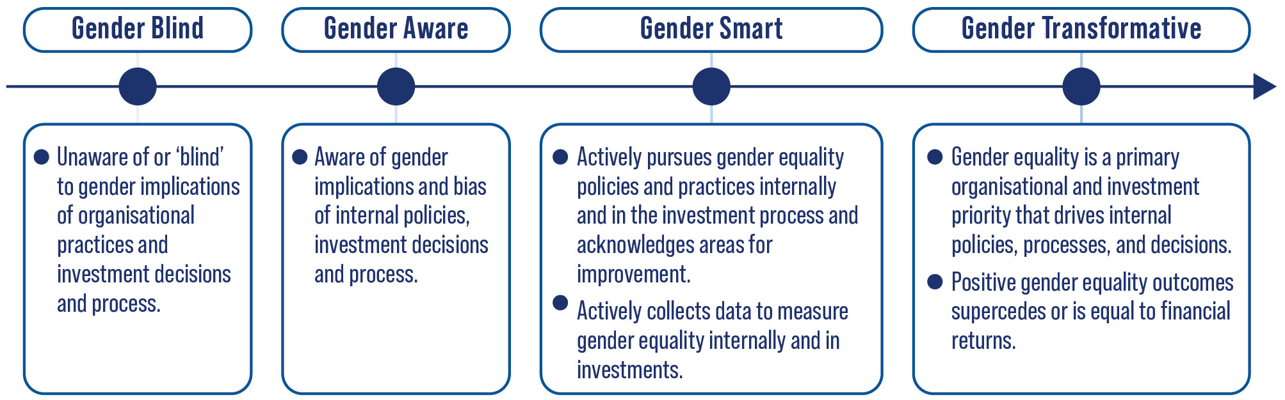

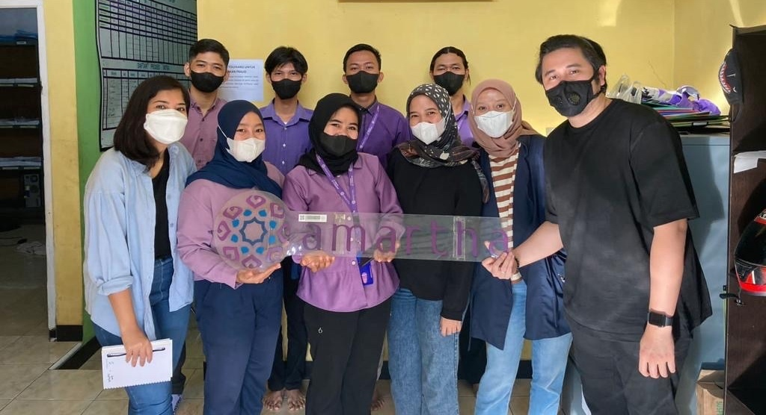
Photo 2: Amartha

About the Impact Study
EMIIF Impact Study 2022 is the first of four studies that will be conducted by Alinea International, one every two years. The longitudinal approach to the Impact Study will track the journey of EMIIF, the funds it invests in, and the SME beneficiaries of investments, and explore the impacts generated by this financing mechanism.
The Impact Study will review the progress of EMIIF following two years of operation, illustrate how the mechanism generates development benefits, and showcase the work to target audiences in Australia and the regions. The Impact Study is guided by the EMIIF Theory of Change and assesses evidence on the extent to which the inputs have contributed to outputs and outcomes.
This Impact Study has adopted both qualitative and quantitative methodologies including the following:
- A literature review that included international literature on impact investing and gender lens investing, and reports from DFAT and EMIIF regarding progress.
- 19 Key Informant Interviews (KIIs) with co-investors; fund managers; SME portfolio companies; DFAT (including relevant posts) and EMIIF staff.
- Statistical data drawn from EMIIF investment reports and analysis.
The results are detailed in the following chapters and organised in a way that aligns with the Theory of Change.

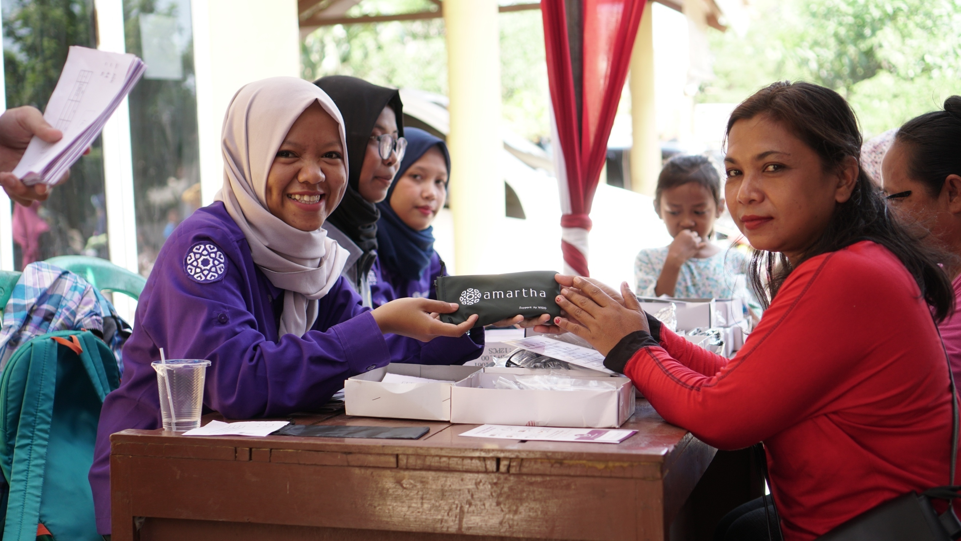
Photo 3: Amartha

Snapshot of Progress
(As of 31 December 2022)
Profile of EMIIF
Profile of EMIIF’s investment fund, technical assistance, and impact progress
(as of 31 December 2022).

Focus | Amount
  Total investable capital | AUD 24 million
Amount of investment committed (%) | 70%
Amount of investment deployed (%) | 29%
  Total technical assistance (TA) budget | AUD 4 million
Amount of TA spent (%) | 19%
  Number of SME Funds invested in | 3
Total private capital mobilised to date | AUD 94,215,155
  Number of portfolio companies financed | 16
Number of MSMEs indirectly financed by EMIIF through fintech portfolio companies | 10,338
  Number of new jobs created | 2,651
Number of new jobs created for women | 1,571 (59% of total new jobs)
  Number of deals reviewed | 104

Profile of SME Funds
Lendable is a platform financing alternative lenders that provide capital to MSMEs that lack access to finance across Asia, particularly focused in Indonesia, Vietnam, and the Philippines. The company was founded by two entrepreneurs with experience in venture capital funds, pay-as-you go solar lending, and technology enabled ride sharing. Since its inception in 2013 by two founders, Lendable has grown to 20+ employees, raised several funds from both public and private investors, invested in approximately 30 fintechs, and facilitated over USD 160 million in transactions.
AVV is a first-time venture capital fund that provides capital to early-stage tech start-ups in Vietnam. AVV focuses on the fintech, ed-tech, and health tech sectors. The firm was established in early 2020 by its two founders and raised its debut fund in late 2021. AVV will invest in approximately 25 companies, with an initial investment between USD 500,000 up to USD 2 million.
SWEEF is a private equity fund with a focus on making equity and quasi-equity investments of between AUD $1 million and AUD $2.5 million to women-led businesses in the Philippines, Vietnam and Indonesia. Sweef Capital, the fund’s company, is a women led independent impact investment firm anchored in Southeast Asia.
Indicator | Lendable | AVV | SWEEF
EMIIF’s investment | AUD 5.7 million as first loss equity commitment | AUD 5.3 million as equity investment | AUD 5.7 million as equity investment
Commitment Date | August 2021 | January 2022 | October 2022
Fund size | AUD 164 million | AUD 95 million | AUD 33 million
Private capital mobilised with EMIIF investment | AUD 11,070,165 | AUD 77,921,109 | AUD 5,223,881
Public capital mobilised along and after EMIIF investment | AUD 116,164,179 | AUD 4,477,612 | AUD 5,970,149
Number of portfolio companies | 7 companies  (Alami, Amartha, Uploan, Workmate, F88, Koinworks, ShopUp) | 9 companies  (Retrocasual, MFast, T&C Logistics, Foodmap, EasyGop, Mandu, Kilo, Virtual Internships, Good Story Time) | 1 company  (TEKY)
TA progress | The delivery of TA is underway, with Phase 1 TA completed in September 2022 and resulting in the review of Lendable’s impact strategy and creation of an impact management framework. | AVV has received first series of TA services in Vietnam by Volta in July 2022. | Sweef Capital received first tranche of TA focused on climate risk assessment of each sector they target. Their TA provider completed a climate assessment and action plan for their first investment.

Profile of SME Portfolio Companies
Figure 5: Distribution of EMIIF SMEs Investments (Per Amount of Fund Disbursed)
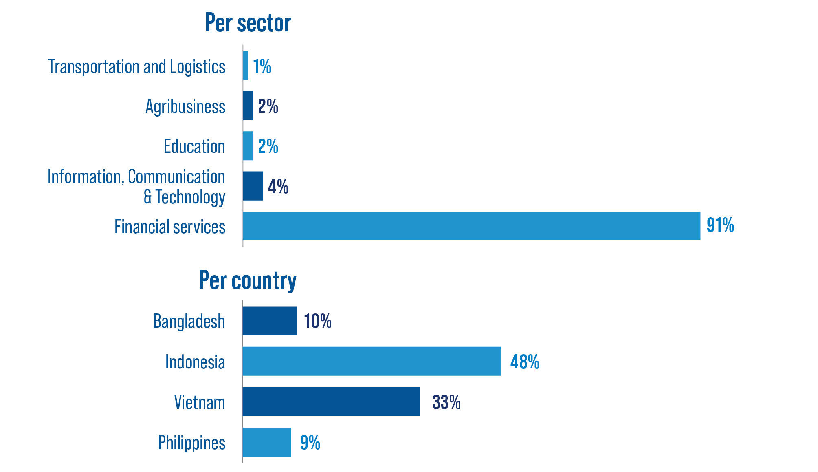

Photo 4: ALAMI

Development Impact
Figure 6: Snapshot - Progress Against the Theory of Change
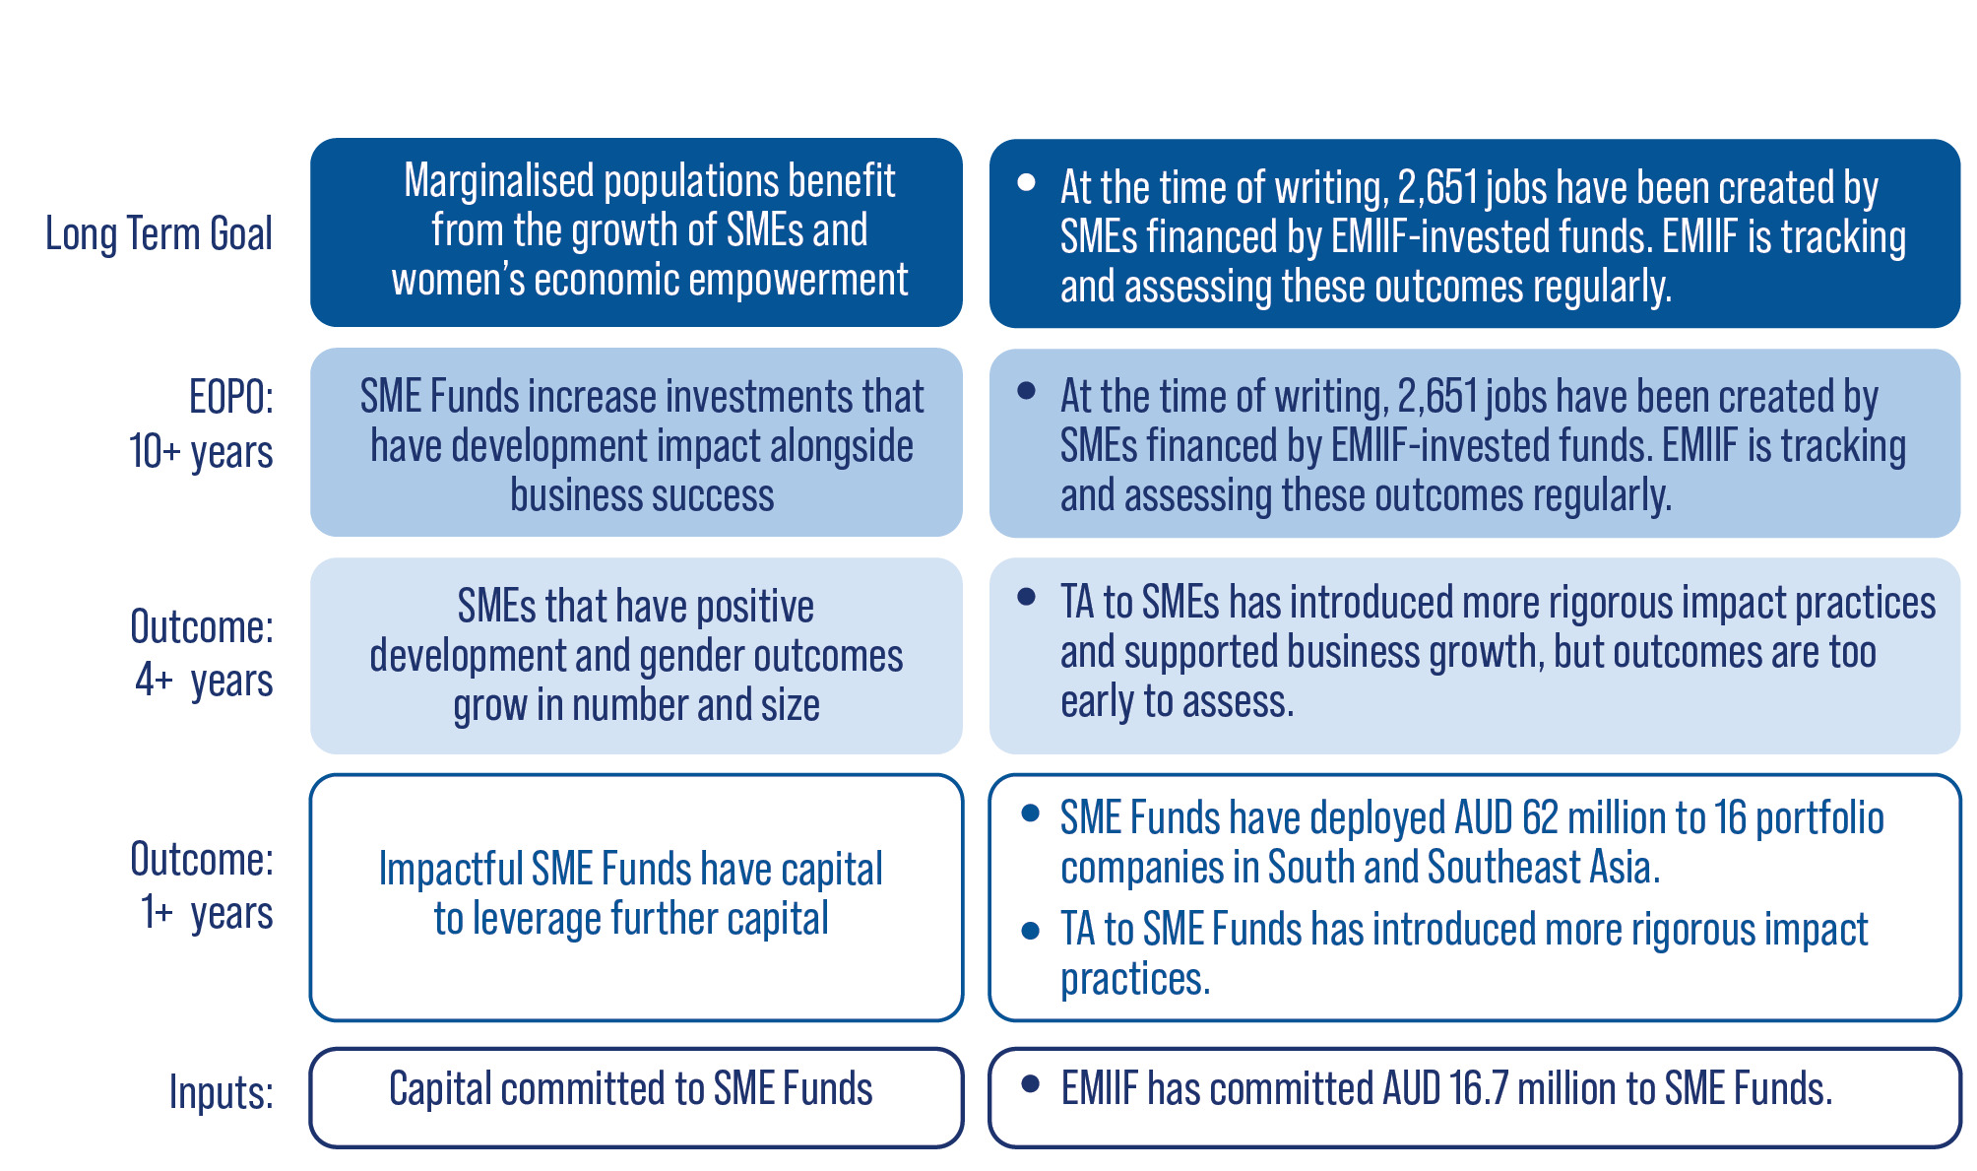
EMIIF has demonstrated progress against its development impact aligning with the Theory of Change envisaged. EMIIF’s catalytic nature has mobilised capital from public and private investors to further strengthen the impact investing ecosystem. To date, EMIIF has successfully mobilised public investments of approximately AUD 126 million and private investments of approximately AUD 94 million, to significantly bolster the capital-raising efforts of Lendable, AVV, and SWEEF. Public investors include the US DFC, OeEB, SIFEM, IFC and AIIB. EMIIF increased the flow of capital to the region and enabled Lendable and AVV to exceed their target fund size.
“DFC was the anchor investor in Lendable but there was a gap in the first loss. EMIIF came into the discussion and filled that gap. Finding that first loss capital is the hardest capital to identify. [In this way] EMIIF is unique as an investment partner in the region”
Justin Andrews - Managing Director of Prosper Africa, US DFC
“During our fundraising, no one was providing catalytic capital. No European DFIs did. It was hard to source a first loss investor. So, we were excited when EMIIF came in as the first-loss investment. EMIIF’s ability to provide this investment is a game changer for us.”
Daniel Goldfarb, Executive chairman of Lendable

SMEs worth investing in: the story of EasyGop
EasyGop is a lending platform supporting the underbanked population in Vietnam to gain access to credit, offering zero interest loans over a three-month period with no settlement fees. Founded in 2020 by CEO Olivia Nguyen, the idea for EasyGop was born from the experiences of Olivia’s childhood and seeing her mother struggle with cashflow to pay bills. Throughout her studies and a successful career in the financial technology sector, Olivia felt ready to commit her focus and expertise to helping mothers like her own. Olivia estimates that the population in need of short-term funds to pay for essential services such as health and education is as high as 90%. Since its establishment in 2022, EasyGop has served over 600 customers through its user-friendly mobile app, with an average lend size of USD $500 - 2000.
EasyGop has an equal gender split in its staffing and plans to institute a diversity policy to encourage greater inclusion of LGBTQI employees and mothers within its structure. EMIIF’s TA partner, MEDA, has helped EasyGop in its growth-orientated business planning and to deepen its approach to gender lens investing. Olivia participated in the SHINE Incubator Program that is dedicated to supporting women founders overcome the uncertainties they may face in the early stages of their start-up journey, and gain the clarity and confidence they need to grow and move their business forward.

EMIIF has demonstrated a strong contribution to its development outcome through the growth of impactful SMEs in the region. These SMEs (e.g., SME Fund portfolio companies) are usually too large to receive financing from microfinance institutions but are too small for traditional commercial banking loans. EMIIF addresses this “missing middle” by applying a minimum of 50% of the net asset value of SME Funds portfolio to be invested in SMEs needing finance between USD 5,000 to USD 2 million. EMIIF’s investments to date have helped to finance 455 of these target SMEs, demonstrating EMIIF’s ability to strategically deliver on development impact.
EMIIF investments are expected to generate both development benefit, and financial returns that can be reinvested into new opportunities for development impact. EMIIF plays an active role in accelerating the capital needed for micro and SMEs to grow in emerging markets. This is evident in EMIIF’s contribution to helping unlock AUD 62 million for 16 SMEs in Vietnam, Indonesia, the Philippines, and Bangladesh. The majority of total invested capital has been disbursed to essential services such as financial inclusion, agribusiness, tech services, and health and education. Financial inclusion is one of EMIIF’s largest sectors of exposure, tapping into a growing market in digital financial inclusion in Southeast Asia.
The evidence demonstrates that EMIIF is on the right track to have a substantial impact on inclusive economic development in the region. Within two years of operation, EMIIF has directly contributed to the creation of 2,651 new jobs, 59% of which are for women. This is a positive contribution to emerging market economies amidst the COVID-19 pandemic which caused an economic downturn and disruption in the job market. There have been around 10,349 microentrepreneurs and SMEs financed as a result of EMIIF support in the region.
Further, EMIIF is contributing to increased participation of women in the formal economy. The majority (96%) of microentrepreneurs and SMEs that received direct or indirect financing from EMIIF’s investments are women-owned or led. At the time of writing, there were over 9,000 women-owned or led microentrepreneurs and SMEs being financed by EMIIF. EMIIF has disbursed approximately AUD 1 million to women-owned or led SMEs. Whilst this is significantly higher than the impact investing average, there is room for EMIIF to increase the percentage of total capital invested that targets women-owned or led SMEs.
Developing impact in emerging markets: A case study in EMIIF’s transformational potential
ALAMI (an EMIIF portfolio company) has provided finance to more than 8,500 MSMEs in Indonesia and has reached more than 83,000 users since it launched in 2019. It is a sharia-compliant peer-to-peer lending platform for SME financing. ALAMI’s goal is to build a sharia ecosystem that enables the Muslim community to build sustainable lives. ALAMI is Lendable’s first fintech SME in the sharia sector. As of March 2022, its accumulated lend disbursements reached approx. AUD 210 million, doubling from September 2021.
In addition to lending and banking platform, ALAMI has an acceleration platform called Arqam and aims to reach more smallholder farmers and fishermen by investing in early-stage start-ups; it is currently one of the largest lenders in the fishery sector in Indonesia. ALAMI incentivises ESG impact by providing pricing discounts to MSMEs that embrace sustainability practices (e.g., waste recycling).
There is significant room for ALAMI to improve its gender impacts. The company does not have specific gender policies and its hiring practices are based on the dis-proven notion that merit is gender-blind: “we don’t have preference on women versus men, it is purely merit”. Its senior management team comprises only 25% women and its workforce comprises 30% women. At the borrower level, there is no sex-disaggregated data collected however ALAMI’s own estimation is that men dominate as borrowers, mirroring the status quo of men possessing greater access to and control of assets in Indonesia.
ALAMI, a growing company with significant reach, is precisely the sort of company that EMIIF seeks to shift along the gender continuum. ALAMI management is aware that impact, including gender impact, is critical to business success, but acknowledges that they have limited knowledge of gender impact concepts and how to implement them. MEDA (EMIIF’s TA provider to SMEs) will provide valuable guidance to ALAMI to realise its vision of becoming a green fintech and certified B-Corp company. Their journey from Gender Blind to Gender Smart will result in a significant and impactful shift for the company and for the market.

Market Building Impact
Figure 7: Snapshot - Progress Against the Theory of Change
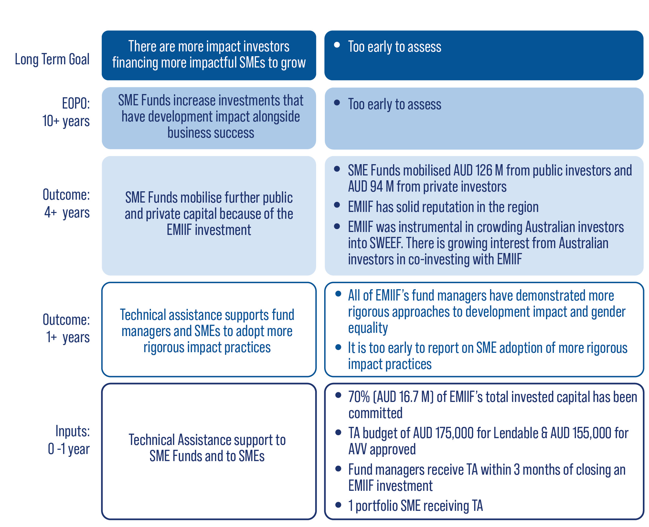
EMIIF has demonstrated strong progress in catalysing growth of the impact investing ecosystem by increasing the flow of capital for impacting investing in the region. In terms of progress against the Theory of Change, EMIIF has achieved intermediate outcomes that would not have been expected until the four-year mark of implementation. All EMIIF’s fund managers are already beginning to deploy capital to target SMEs. This rapid fund deployment for a fund-of-funds is major progress in the impact investing market. By way of comparison, similar government-led funds such as the Dutch Good Growth Fund, typically take several years to move investable capital all the way to target SMEs.
EMIIF plays a unique role as a first loss funder to SME Funds and de-risking investments has proven to be a strong incentive to attract other investors. Lendable was able to raise USD 110 million in capital after EMIIF’s crucial first loss investment. EMIIF enabled Lendable to expand its target markets from Africa and Latin America to include Asia. This reflects well upon the credibility of EMIIF’s due diligence in the eyes of investors who supported the fund manager to enter a new region. EMIIF has also invested early to help fund managers reach viable size. EMIIF, alongside DFAT’s Investing in Women program, were crucial in supporting AVV early and help them achieve their target fund size. For SWEEF, EMIIF was instrumental in crowding in Australian impact investors as well as the AIIB, getting SWEEF to a viable fund size.
“[There are] very few first loss investors in the region and EMIIF is the only interesting one for us because of its alignment on gender and impact, and their provision of technical assistance.”
A fund manager operating in Southeast Asia
“EMIIF is helping underrepresented fund managers in local [impact investing] markets. For example, a women’s fund is something that private capital organisations don’t often support.”
Kate Loose – Principal of Capria Ventures LLC
There is evidence that EMIIF is contributing to the growing impact investing market in Southeast Asia. EMIIF has a healthy pipeline with several potential deals in the region. EMIIF’s current role as an anchor investor in Southeast Asia can be further utilised to encourage Australian investors to tap investment opportunities in the region. The DFAT EMIIF secretariat has been proactively pursuing this potential.
DFAT has initiated a conversation with Australian investors with a view to attracting them to emerging markets through the EMIIF investment vehicle. Working in partnership with Ecotone Partners, DFAT has tested the appetite of Australian private investors for investments alongside EMIIF. A total of 13 family offices and 19 private investors were represented in the testing sample; the majority across both categories had not previously invested in emerging markets. Pleasingly, most investors described themselves as either ‘Quite interested but needing to understand the market more’ (57%), or a strong minority, were ‘Very interested and actively evaluating deals’ (19%).
Australian investors were surprised to learn of EMIIF and interested in engaging with an Australian Government-backed investment vehicle because it mitigates emerging market risks and can navigate the nuances of local political and market dynamics. These investors valued leveraging EMIIF’s stringent due diligence as a value-add for their own investment. They were very interested in having access to shared, quality due diligence from credible sources and deemed the EMIIF investment manager, Sarona, to be an appropriately credentialed entity. Therefore, Australian private investors reported that they would value a relationship with Sarona as EMIIF’s investment manager and requested facilitated introductions to the underlying fund managers. They would consider investing in a fund of funds that either invested alongside EMIIF (into SME Funds selected by EMIIF) or into secondary funds that acquired strongly performing assets from EMIIF.
EMIIF plays a unique role as a “supportive and value-add investor” by building relationships and collaboration with market players to stimulate the impact investing ecosystem. EMIIF’s investment manager, Sarona, has brought significant expertise to analyse the market and organise the fund efficiently, putting to rest early fears that EMIIF may not be able to form an active pipeline in the context of COVID-19. Bringing a good reputation and in-depth technical knowledge allows EMIIF to engage with and build buy-in from fund managers, investors, and other market actors in the region. A recent example is EMIIF’s ability to assist SBK Ventures in Bangladesh to become more investable. While this does not generate a financial return for EMIIF, it illustrates EMIIF’s commitment to nurture the ecosystem and support first-time fund managers. Additionally, EMIIF also brokered relationships with an investor by assisting with fundraising efforts and connecting with private investors. These examples demonstrate the value of relationship brokerage and getting buy-in within the ecosystem. Upcoming EMIIF investments to SEACEF and Wavemakers are worth a total of AUD 5.1 million and anticipated to mobilise an additional AUD 15 million of private finance.
EMIIF helps to shape the impact and growth of SMEs by providing TA for both fund managers and their portfolio companies, delivered in parallel to the capital investment provided. EMIIF applies a collaborative co-creation model to design TA with fund managers and their portfolio SMEs. All EMIIF-invested fund managers reported that EMIIF’s openness and willingness to listen enabled them to co-design the technical assistance in ways that suited their needs and contexts and enable them to implement impact-driven investment strategies. Technical assistance provided through Volta Capital was relevant to their commercial and development impact goals and helped them to develop tools for impact measurement.
“The partnership with EMIIF’s Volta is a positive one. The team is very consumer-centric and empathetic during the process. We discussed ESG references, and we are looking forward to working together in developing the strategy moving forward”
Eddie Thai, General partner of Ascend Vietnam Ventures (AVV)
Lendable and AVV have received TA on advanced ESG strategies and DFAT’s Safeguarding Analysis and Assessment. AVV has significantly improved its ESG policies since EMIIF’s first review in 2021. AVV, with the support of Volta as TA provider for EMIIF fund managers, is now incorporating DFAT’s thorough Child Protection and Preventing Sexual Exploitation, Abuse and Harassment (PSEAH) assessment into its screening and due diligence processes. If all the currently agreed ESG policies are implemented well, AVV will meet nearly all the global ESG standards.
Lendable has integrated strengthened impact management and GLI practices into its own organisation. With EMIIF’s technical assistance, Lendable’s recent internal impact metrics (June 2022) demonstrate that it is now close to passing all the 2X Challenge Criteria:
- Women on the Board (50% against a 30% women threshold)
- Women on the Investment Committee (33% against a 30% threshold).
- A 48% share of women in the workforce (the threshold is 30-50%)
- Adopts a Diversity, Equality, Inclusive (DEI) approach to their hiring policy
- 83% of Lendable portfolio companies meet the criteria of women in leadership and the workforce
- Lendable is close to achieving the share of women in senior management threshold (27% against the 30% threshold)
At the SME portfolio company level, MEDA (as the EMIIF consortium TA provider for SMEs) has identified 6 potential SMEs under Lendable’s portfolio to receive tailored technical assistance. As of June 2022, F88, a Vietnam-based SME funded by Lendable, has completed a gender analysis survey. MEDA is currently reviewing F88’s key material to develop TA plan. This will be followed up with strategy development, action planning, and monitoring. Based on MEDA’s rapid identification, AVV’s SME portfolio characteristics are micro and early stage with limited business data available. MEDA will follow up with identification of eligible SMEs for TA and co-design tailored TA for the selected SMEs. While still early in its deployment, MEDA’s technical assistance to the portfolio companies of SME Funds are on track to leverage robust development impacts. This reflects EMIIF’s commitment to supporting both Funds and the SMEs they support to generate impact and commercial returns. For EMIIF, being receptive to new ideas and feedback enables them to refine their investment processes.
Market Building: A case study in how EMIIF drives gender equality in markets
Ascend Vietnam Ventures (AVV) is a seed-stage venture capital firm that aims to empower tech entrepreneurs to positively change lives. AVV is a first-time fund manager and EMIIF’s second investment. Over 80% of AVV’s portfolio companies will target early-stage SMEs that are committed to both financial success and development impact.
Although AVV’s development targets were generally good, EMIIF’s gender gap analysis found that AVV had limited adoption of GLI principles in its investment process, no involvement in GLI-related networks or platforms, and no women on its Investment Committee. This would normally make AVV ineligible for an EMIIF investment. However, AVV demonstrated its willingness to change and worked diligently with EMIIF’s TA provider for fund managers, Volta Capital, to achieve its gender transformation.
AVV works collaboratively with EMIIF to improve their systems to better reflect their gender equality ambition. AVV has hired an Environmental Social and Governance (ESG) Manager to ensure impact targets are monitored and met.
To incentivise AVV to deliver on its impact goals, EMIIF put in place an innovative profit-sharing model. If AVV meets the following targets, it stands to benefit from EMIIF’s profits:
- AVV allocates 30% of first checks to women-owned or led SMEs;
- AVV allocates 40% of first checks to women-owned or led SMEs;
- AVV impact strategy and framework is ready for implementation within 1 year after first close; and
- AVV produces annual impact reporting in line with their impact/GLI strategy.
EMIIF’s support is a significant steppingstone for AVV in reaching its goal of approaching institutional investors and becoming a globally recognised Vietnam-based venture capital firm with top performing SMEs.

All fund managers interviewed for this Impact Study reported EMIIFs collaborative approach as a strength, delivering relevant tailored support that help them achieve their commercial and impact goals. EMIIF’s Investment Manager, Sarona, has been supported by DFAT to adopt a patient approach, supporting fund managers to build their technical capability to adopt and implement EMIIF’s development targets, whilst achieving their capital raising targets.
Within two years of operating, EMIIF has established its structure and reputation in the impact investing ecosystem. EMIIF has a robust structure and well-known reputation; both are valuable for SME Funds seeking follow-on capital investment. This bodes well for Australia’s first-ever ODA investment development financing model. Additionally, EMIIF provides technical assistance to support fund managers. This allows fund managers to have improved skills and tools to grow their development impact, particularly in relation to gender equality.
Fund managers and investor respondents valued EMIIF’s good reputation and the benefits it brought. For example, the International Finance Coorporation (IFC) became a co-investor in AVV fundraising as a result of EMIIF’s reference. Another fund manager reported that EMIIF’s robust institutional review and due diligence processes helped build the company’s readiness for obtaining additional capital investment. A co-investor respondent reported that the collaborative process with EMIIF during the due diligence process was helpful to share the workload.
EMIIF’s leadership is widely commended in the regional impact investing ecosystem. EMIIF has an active on-the-ground presence, with its Partner, Ralitsa Rizvanolli, based in Singapore. Ralitsa plays a pivotal role in steering EMIIF’s impact-driven investment direction and engaging with ecosystem actors. During interviews, approximately two-thirds (67%) of fund managers and investors reported that EMIIF’s active involvement and Ralitsa’s presence in the region has been critical in helping them build and operate funds. They valued the regular open and frank communication with EMIIF and DFAT as pivotal in setting their development and commercial goals. They rated the EMIIF team as highly competent and felt they brought an in-depth understanding of the impact investing ecosystem.
“EMIIF’s feedback was helpful... We particularly value the way EMIIF aligns itself in terms of governance and transparency.”
A fund manager operating in Southeast Asia
“I sent our deck to EMIIF’s Ralitsa. She really cares about gender lens investing. Her feedback is extremely helpful. She identified the red flags, exactly what we were looking for.”
A fund manager operating in Southeast Asia
Stakeholders interviewed for this Impact Study were asked to rate from 0-5 if they would recommend EMIIF to others, with 0 as the lowest score and 5 as the highest score. Of the ten SME Fund and investor interviewees who were asked this question, 50% provided a rating of 4 and 50% provided a rating of 5 for EMIIF. Several examples of reasons respondents gave for rating EMIIF 4 include: ‘our appreciation toward EMIIF’s insight into impact investing and structuring but there is hesitance that all impact will be feasible and interesting to other investors’, ‘EMIIF team has in-depth expertise but its mandate is not very clear’, and ‘EMIIF would be more recommended to a team who is on their second fund. That is a team who has the foundations established (such as staff and technical assistance are in place) to be able to make the most use of it without too much distraction”.
Those who rated EMIIF 5 gave the following reasons for their ratings: “EMIIF is a like-minded institution and came in as a first loss tranche is brilliant”, “EMIIF team is very professional, they understand the term and impact angle”, and “EMIIF has a top quality of working”.
Impact on Gender Equality
Interviews with fund managers, their portfolio companies, and investors for this Impact Study identified three key challenges faced by women in the impact investing ecosystem:
- Impact investing is a male-dominated field. For example, a women-led SME founder reported that the unconscious bias she faced has hampered both the establishment of her business and her ability to obtain finance. To address this EMIIF preferences SME Funds that:
- intentionally target women-owned or led SMEs; and/or
- intentionally promote inclusion of women in target SMEs’ employment practices, as customers, and/or in their supply chains; and/or
- adopt gender equality strategies within their company and/or adopt GLI principles in the investment process; and/or
- in parallel, EMIIF also provides TA to support SME Funds and SMEs on embedding GLI practices.
- Challenges in sourcing women-led or owned SMEs and women-focused SME Funds. Although there is no shortage of women-led or women-owned SMEs, they are less visible in the market due to a range of constraints, including lack of mobility and the double burden of household and care work in addition to their entrepreneurship. Traditional approaches to sourcing a pipeline tend to lack opportunities for women to engage. To address this, EMIIF:
- strategically plays its role as investor, market builder, and technical assistance provider to connect investors with potential investees.
- shares its due diligence results with like-minded investors who have not been able to reach women-led or women-owned SMEs, thereby reducing the resources required to build a pipeline.
- Investors reported a lack of private capital organisations supporting women-led funds, limiting the potential pool of appropriate funds for investment. To address this, EMIIF:
- seeks to build partnerships with like-minded private investors to enable a greater pool of funds to support women-led funds.
- as of writing, EMIIF-supported SME Funds investor composition comprises 56% private co-investors and 44% public co-investors, drawing more investors towards a GLI ecosystem.
EMIIF continuously encourages fund managers to advance gender equality in their companies and investments. On average, there are 66% of women employees and 51% of women leaders in fund managers supported by EMIIF. Almost all SME Funds supported by EMIIF have explicit gender strategies and activities to advance gender equality and are deploying highly innovative strategies to positively influence gender equality.
Sweef Capital is an all-women-led fund manager that fosters diverse and inclusive economies through its women’s economic empowerment and gender equality programmes. Its first flagship fund, Southeast Asia Women’s Economic Empowerment Fund (SWEEF), aims to make equity and quasi-equity investments in businesses that meet the requisite financial and impact criteria. Impact is measured and monitored by the Gender ROI™ (Resilience, Opportunity, Inclusion) Tool, that was developed to reveal economic inequalities, discrimination, and lack of representation that women may face as entrepreneurs, employees, and consumers.
AVV is taking bold steps to formalise and systemise the incorporation of gender lens investing in its investment process. EMIIF offered an additional impact incentive beyond the commercial standard allocation of carried interest, in the event where AVV succeeds in completing the agreed gender targets (e.g., AVV allocates 30% of first checks to women-owned or led SMEs). This is to better align the impact and GLI targets and provide an even stronger motivation for AVV to significantly exceed industry averages. Aligned with the gender equality pillar, EMIIF developed specific metrics to measure its economic impacts for women.
SMEs worth investing in: the story of Amartha
Amartha Microfinance Marketplace is a pioneer of peer-to-peer lending that has been providing business capital and financial literacy for (mostly rural) female microentrepreneurs in Indonesia since 2010. Amartha not only increases incomes of poor households, it also provides health hygiene and sanitation support, and financial relief to help families quickly get back on their feet following a disaster. Amartha is precisely the kind of company that emerging markets need to grow.
EMIIFs investment with Lendable contributed to a USD $1 million investment to Amartha. This will see the growth of over 100,000 women owned MSME’s in rural areas of Indonesia.
Amartha provides evidence to measure its development and gender impact, detailed in its annual Social Accountability Reports. Its metrics demonstrate positive results for women’s income, including throughout the COVID-19 pandemic. To achieve gender equality outcomes, Amartha has an internal impact team and a Chief of Sustainability to track and champion impact within the organisation.
Amartha’s success over 12 years of operation has not come without challenges. Gaining support for micro investments that focus 100% on female borrowers hasn’t been an easy feat. Over time (and with determination and patience), Amartha has proved to the market that women MSMEs lenders can be highly successful - commercially and in terms of development impact.

Organisational Learning
Figure 8: Snapshot - Progress Against the Theory of Change
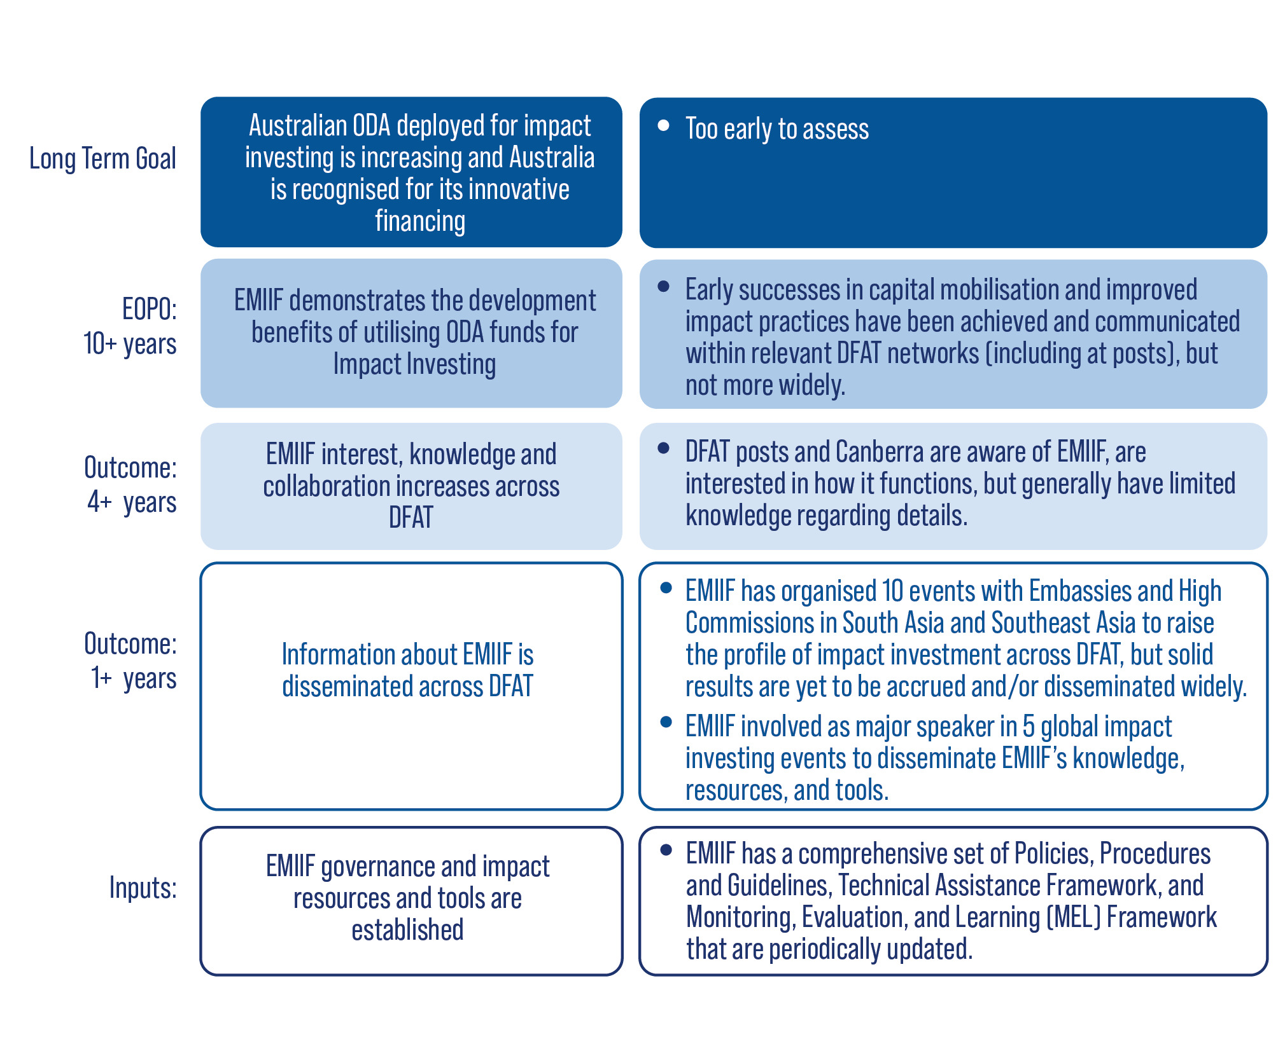
As a new way for Australia to invest in development, it is critical that DFAT (and government more broadly) acquire the technical knowledge needed to manage impact investing funds as a development financing mechanism and understand how to design and operationalise an impact fund, maximise its benefits and mitigate risks. To that end, the EMIIF Theory of Change includes a pillar devoted to DFAT organisational learning.
EMIIF and Bangladesh High Commission conducted a Women CEOs event which was attended by women business leaders. EMIIF also involved Hanoi Post in the launch of EMIIF investment in AVV. Together with posts and High Commissions, EMIIF actively promote public diplomacy and fosters good stories between Australia and the South and Southeast Asia countries through investment and engagement with local business players. EMIIF also continues to disseminate their learning, resources, and knowledge externally by taking part as major speaker in prominent impact investing events hosted by GIIN, AVPN, GenderSmart Climate and Gender Working Group, Convergence, and AFIFORUM.
Furthermore, EMIIF has sparked the conversation about better financing mechanisms to address contextual issues in the region. The interviews with Australian Embassies and High Commissions showed that there are interests to explore EMIIF as a mean to address the multiple contextual issues in emerging market. For example, Australia’s Embassy in Hanoi has the objective of supporting Vietnam in transitioning to low-carbon development and the High Commission in Dhaka aims to support Bangladesh in economic growth, education, and support for the Rohingya population. They perceive EMIIF as a potential mechanism able to target multiple sectors that align with their strategic priorities. The embassies reported that their current engagement with EMIIF is still at the introductory stage and that coordiatnion between embassies and EMIIF needs to be strengthened, in addition to DFAT’s internal capacity to drive EMIIF. However, they are keen to further discuss and learn about possible collaboration with EMIIF.
“We want investment that can target multiple sectors that align with our safeguards e.g., in inclusion, gender as well as in multiple business sectors. EMIIF allows us to do that. It is a program that can strengthen our work. Posts have limited bandwidth and EMIIF helps accelerate our work. EMIIF team has the technical expertise, has conducted their research about the market, and is well-prepared therefore not adding more tasks to Posts.”
An Australian Embassy Representative
EMIIF’s role as catalytic capital provider supporting emerging fund managers addresses a niche gap in the market and can help build Australia’s comparative advantage in the region. All investor informants described EMIIF’s strengths as lying in its profound understanding of nascent markets, and its ability to deploy first loss capital. Such strengths have proven crucial as for a ‘start-up’ development financing mechanism. This was echoed by Australian investors who, cautious of investing in emerging markets where they lack market knowledge and cultural expertise, are now keenly watching opportunities to work with EMIIF and have EMIIF’s presence in the emerging markets fills the gap of limited active Asian and European DFI funds. US DFC has a presence in Southeast Asia, but this region is not yet their focus. Therefore, in the longer term, this approach to development financing has the potential to support broader Australian Government investment objectives in the region. EMIIF complements the Australian Government’s ongoing effort to expand trade and investment in the Southeast Asia region which is Australia’s key trading partner. EMIIF’s engagement with Australian investors to promote investment in first-time and impactful SME Funds can be a catalyst for Australian investors to participate in impact investing in the Target Countries.
“EMIIF has been meaningful for the region, and it has built relationships, I think in the long term it will have other benefits to Australia through having investments and getting sponsorship of the business community through those investments. It also allows Australia to be influencing trade policy.”
Jennifer Buckley – Managing Director of Sweef Capital

Annex 1: Approach and Governance

Governance
EMIIF is led by the Private Finance for Climate and Development Section of DFAT and implemented by a Consortium composed of Sarona Asset Management Inc. (Sarona) as the Investment Manager of EMIIF, Mennonite Economic Development Associates (MEDA) is the Technical Assistance provider to underlying SMEs, Volta Capital Limited (Volta) is the Technical Assistance provider to fund managers, Alinea International (Alinea) is a subcontractor to Sarona to support the Monitoring, Evaluation and Learning framework and biennial impact studies, The Trust Company (Australia) Limited (Perpetual) is Trustee, Mainstream Fund Services Pty. Ltd (Mainstream) is custodian, and Ernst & Young Australia LLP (EY) are the auditor.
The legal structure and governance of EMIIF is designed to balance the level of DFAT strategic control over EMIIF with the flexibility to effectively implement EMIIF’s investment and technical assistance strategy. The governing bodies of EMIIF are:
- EMIIF Secretariat: The oversight body within DFAT that is responsible for overseeing EMIIF’s strategic direction and policy coherence.
- EMIIF Executive Committee (ExCo): the body responsible for implementing and managing EMIIF consisting of Ralitsa Rizvanolli (Sarona), Jonathan Landrey (Volta) and Jessica Villanueva (MEDA) as representatives of the three principal EMIIF Consortium partners.
- EMIIF Executive Committee Plus (ExCo+): a coordinating body consisting of the ExCo and the EMIIF Secretariat. The ExCo+ reviews conflict of interest matters.
- Sarona Internal IC: a governance body that approves the advanced pipeline and consists of three Sarona partners. The Sarona Internal IC resolves administrative or routine matters arising from EMIIF’s position as a shareholder or an advisory board member.
- EMIIF Investment Committee (EMIIF IC): a governance body that reviews and approves investment and technical assistance proposals. It comprises two representatives from Sarona and three independent members.

Investment Approach
EMIIF takes a rigorous approach to both investment selection and monitoring and evaluation of impact and financial performance. EMIIF assesses all potential investments against the following criteria:
- SME Funds that invest at least 50% of the net asset value of their portfolio in Target SMEs. Target SMEs refers to SMEs that seek finance or funding of an amount between USD 5,000 to USD 2 million in initial investment;
- SME Funds that comply or are willing to comply with ESG standards after EMIIF’s investment;
- SME Funds that demonstrate a clear path to financial sustainability and commitment to positive development impact; and
- SME Funds that are not investing in Excluded Activities on the IFC Exclusion List.

EMIIF has the following key element for its investment strategy:
- Inclusive economic development. EMIIF provides capital through SME Fund to SMEs that improve the lives of excluded communities through their products and services, supply chains or employment practices;
- Market Building. EMIIF addresses the financing and growth challenges faced by the regions SMEs particularly early-stage impact investments and women-led SMEs;
- Gender equality. EMIIF has explicit gender equality outcomes and intentionally embeds gender lens practices across all its investment and technical assistance processes as part of its impact management approach;
- Additionality. EMIIF makes use of blended finance instruments, bringing the potential to mobilise private finance for development. EMIIF’s technical assistance supports fund managers to embed impact management and GLI practices; and
- Capital preservation. EMIIF targets an overall return of capital and a modest positive return on a portfolio level to enable reinvestment of funds for greater impact.

EMIIF Investment Process
Funds approved by EMIIF’s Investment Committee (IC) are subject to a thorough assessment to identify risks and mitigating measures. EMIIF’s technical assistance partners, MEDA and Volta, then work with investees to develop action plans to ensure adequate environmental, social and governance (ESG) management and impact monitoring systems.
Figure 9: EMIIF Investment Process
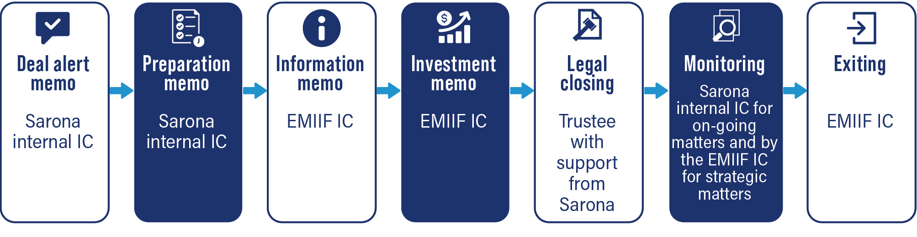

EMIIF has developed comprehensive systems for measuring the development benefit as well as the financial returns on its investments. It has developed standardised indicators, many of which have been adapted from the Global Impact Investment Network (GIIN)’s widely recognised impact measurement framework, IRIS, to assess social and environmental impact. These include measures such as jobs created, particularly for women, and SMEs serving communities excluded from or underserved by existing markets. EMIIF collects baseline data at the screening and due diligence stages, and progress is measured against the baseline over the life of each investment, assessing both direct contribution and additionality.
In addition to the investment funds, EMIIF provides technical assistance to fund managers and to their SME portfolio to enhance their commercial potential and development impact. TA is a critical component of EMIIF’s investment strategy. In line with its focus on impact and gender lens investing, EMIIF’s core technical assistance is focused on strengthening gender and other social and environmental impacts of fund managers and SME investees.
- For SME Funds, TA is focused on integrating impact management and GLI practices into the investment management and processes.
- For SME portfolios, the TA utilises a specialised Gender Equality Mainstreaming (GEM) framework that assesses a company’s operations and identifies, implements, and measures gender equality mainstreaming strategies to promote business growth.

Annex 2: Key Informant Interviews
No | Organisation | Type of organisation
1 | Ascend Vietnam Ventures (AVV) | Fund manager
2 | Lendable | Fund manager
3 | Sweef Capital | Fund manager
4 | SBK Tech Ventures | Fund manager
5 | Bamboo Capital Partners | Fund manager
6 | Teja Ventures | Fund manager
7 | U.S. International Development Finance Corporation (DFC) | Public investor
8 | International Finance Corporation (IFC) | Public investor
9 | Asian Infrastructure Investment Bank | Public investor
10 | Capria Ventures | Private investor
11 | Development Policy Centre - Crawford School of Public Policy, Australian National University | Academic think tank
12 | Sarona Asset Management | EMIIF Consortium
13 | Volta Capital Limited | EMIIF Consortium
14 | Former DFAT team member | EMIIF Consortium
15 | Australian Embassy Vietnam | Australian Government
16 | Australian High Commission in Bangladesh | Australian Government
17 | Amartha | SME
18 | ALAMI | SME
19 | EasyGop | SME

EMIIF uses OECD methodology to calculate the amount of private finance mobilised by ODA funds: https://www.oecd.org/dac/financing-sustainable-development/development-finance-standards/mobilisation.htm. For AVV, this includes Investing in Women (IW) calculation. Investing in Women is an initiative of the Australian Government, that catalyses inclusive economic growth through women’s economic empowerment in Southeast Asia. One of the three program pillars is Impact Investment for Women’s SMEs where IW partners with Impact Investors and ecosystem builders to expand market opportunities for women. See more at https://investinginwomen.asia/
DFAT 2022 – Blended Finance Portfolio report.
This number includes the underlying microentrepreneurs and SME borrowers financed by Lendable-invested fintechs in Indonesia.
This was analysed based on Key Informant Interviews (KIIs) results. Please see Annex 2 for list of KII participants.
Ecotone Partners is an investment advisor firm based in Sydney, Australia. Established in 2021, the firm builds and manages investment products that offer positive returns for its clients.
Formerly Mainstream Fund Services Pty. Ltd (Mainstream)
Catalytical first-loss capital (CFLC) is invested with the aim of achieving specific social or environmental goals. It takes the first loss (up to a pre-specified threshold) and therefore reduce risk for other investors, catalysing the participation of co-investors who may not have otherwise entered the deal. Commonly used CFLC instruments include grants, equity, subordinated debt, and guarantees. See GIIN Issue Brief: Catalytic First-Loss Capital. https://thegiin.org/assets/documents/pub/CatalyticFirstLossCapital.pdf
Organisation for Economic Cooperation and Development (2019), Social Impact Investment: The Impact Imperative for Sustainable Development. https://www.oecd.org/development/social-impact-investment-2019-9789264311299-en.htm, p.10.
SME Funds are funds that invest in high-growth and/ or innovative small and medium businesses. Types of SME Funds are usually venture capital funds and private debt funds.
Sarona, EMIIF Gender Strategy, 2020
See Annex 2. Key Informant Interview for detailed information.
Per OECD DAC methodology
Recently signed in February 2023
See Annex 4. SME Portfolio Companies for detailed information
Quote from Key Informant Interview with fund manager.
2X Challenge aims to inspire Development Finance Institutions (DFIs) and/or International Finance Institutions (IFIs) and the broader private sector to invest in the world’s women. It comprises five main criteria of Entrepreneurship, Leadership, Employment, Consumption, and Investments through Financial Intermediaries. Fulfilling one criteria makes an investment 2X eligible. Details on the criteria are available at https://www.2xchallenge.org/criteria
EMIIF Policies, Procedures and Guidelines section 5.3 EMIIF’s Gender Strategy
For EMIIF, gender lens investing (GLI) involves consideration of gender biases, patterns, power dynamics, opportunities, and risks in investments. At its core, gender lens investing incorporates a gender analysis alongside impact and financial analysis to make better decisions that lead to better gender equality and economic outcomes.
EMIIF Policies, Procedures and Guidelines defines women-owned or led SMEs as SMEs that are women-owned, provide goods and services to women and girls, and/or adopt workplace practices that promote gender equality and/or promote such practices at the SME level.
http://www.ifc.org/exclusionlist
Investment Committee (IC) is the governance body of EMIIF that makes the investment decision. It consists of a group of individuals with diverse and strong backgrounds in finance and impact investing. The EMIIF IC is comprised of Kylie Charlton (chair), Jeremy Cleaver, Maud Savary-Mornet, Gerhard Pries, and Serge LeVert-Chiasson.

