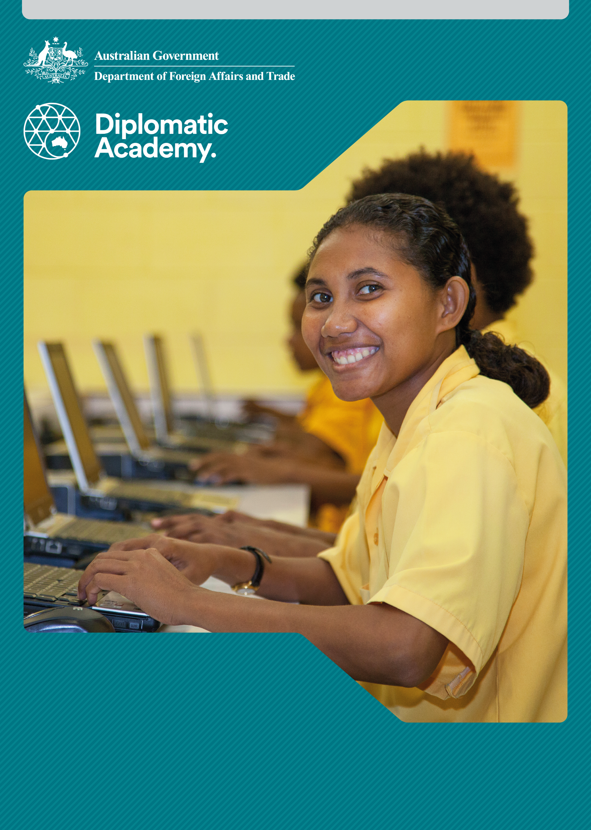
Education Learning and Development Module

Education planning

Practitioner Level

2019

CONTENTS

Acronyms 3
1 Introduction 3
2 Developing an Education Sector Plan 4
3 Education planning and data 10
4 Some international trends that impact education planning 13
5 Test your knowledge 24
References and Links 27

Acronyms
BRAC Building Resources Across Communities
EMIS Education Management Information System
ESP Education Sector Plan
ESWG Education Sector Working Group, Samoa
GPE The Global Partnership for Education
IIEP UNESCO International Institute for Educational Planning
LTSP Long Term Sector Plans
MESC Ministry of Education, Sports and Culture, Samoa
MTR Mid-Term Review
MoE Ministry of Education
MoF Ministry of Finance
MTEF Medium Term Expenditure Framework
MTSP Medium Term Sector Plans
NESP National Education Sector Plan, Myanmar
NGOs non-government organisations
NUS National University of Samoa
SQA Samoa Qualifications Authority
SWAps sector-wide approaches
UNGEI United Nations Girls’ Education Initiative
UNICEF United Nations Children’s Fund

Introduction
This Practitioner level module can be read in conjunction with the Foundation level module Education Sector Planning. The Foundation level module provides an introduction to education sector plans and their connection to a broad variety of planning instruments within the education sector (expenditure frameworks, operational plans and annual performance plans).
This Practitioner level module is more narrowly focused on education sector plans to allow a more in-depth treatment of the processes, issues and trends in education sector planning. The module applies to both medium term and long term education sector plans, with some specific attention to the alignment between Medium Term Expenditure Framework (MTEF) instruments and medium term education sector plans.

Developing an Education Sector Plan

What is the general process for developing an Education Sector Plan?
The general process for developing an Education Sector Plan (ESP) involves extensive consultation at every stage. The development of ESPs is typically coordinated by the Ministry of Education (MoE), with the engagement of other actors, including development partners. The five steps are described in brief below, with more detail following.

Step 1: Set up the taskforce
Considerations are:
- Identify all stakeholders.
- Get buy-in from government and other stakeholders (e.g. non-government providers, non-government organisations (NGOs), teacher unions).
- Identify roles and responsibilities of key actors.
- Ensure a process of engaging key parties from the beginning through to finalisation and release.
For further information refer to The Role of Key Stakeholders in Education and Aid Effectiveness Principles Foundation and Practitioner level modules.

Step 2: Analyse the sector
Considerations are:
- Identify the information required, which will include (i) demographic projections impacting on size and distribution of targeted populations, (ii) enrolment projections, (iii) educational institutions related data, (iv) financial data, and (v) relevant government plans and strategies.
- Ensure mechanisms to source and collect required information.
- Identify the roles and budgets of all institutions that shape the education sector.
- Identify any key service delivery areas which might benefit from a cost-effectiveness study to improve value for money.

Step 3: Prioritise policies and programs
Establish general goals and specific objectives (long and short term).
Considerations are:
- Stakeholder consultations.
- Identifying key constraints (resources).
- Develop a demographic financial model of the sector.

Step 4: Develop the plan
Considerations are:
- Develop program components.
- Plan the budget and timelines of all programs.
- Consult with stakeholders on a regular basis.
- Plan agreed and finalised, following national systems and templates.

Step 5: Implement, monitor and evaluate
Considerations are:
- Ensure adequate resource allocation for effective implementation, as well as monitoring and evaluation systems.
- Ensure development of required systems for delegation, action and implementation, monitoring and evaluation.
- Ensure a specific timeframe for monitoring and evaluation is agreed upon.


An ESP is a living reference framework for action
This implies:
Consensus
As a reference for action, the plan is ideally the result of a consensus building process, agreed by all those working in the fields and sub-sectors covered by the plan, and a wide range of key stakeholders contributing to and affected by its implementation. For further information refer to The Role of Key Stakeholders in Education and Aid Effectiveness Principles Foundation and Practitioner level modules.
Flexibility
As an indicative, living framework, it is designed to allow for adjustments to new developments as they arise during implementation.
Merging education objectives with budget
As a working tool, the education plan incorporates not only policy and high level expenditure projections, but also a hierarchy of objectives, key actions and institutional arrangements for implementation, monitoring and evaluation.
Note: You can learn more about an education sector plan by reading the Global Partnership for Education Guidelines for Education Sector Plan Preparation.
Source: Global Partnership Education 2015.

Establishing and building a taskforce
A taskforce is a group of people brought together to work on a single defined task, program or activity.
It is usually formed for a defined period, should have clear and agreed terms of reference and typically includes some of the key stakeholders who will benefit from or impact upon the specific task, program or activity for which the group has been formed.
This phase is usually an opportunity for development partners to assist with the provision of technical expertise. Government officials engaged in day-to-day activities, may require specific technical assistance in relation to concepts or tasks they are not familiar with.
In building the Education Sector Plan taskforce, the MoE typically assembles representatives from each main ministry department and sub-sector agency. The MoE’s planning section/department is frequently the administrative coordination point.
The taskforce may include representatives from other ministries, including Finance, Social Development, Women’s Affairs, and the ministries with responsibilities for early childhood development, technical vocational education and training, higher education and lifelong learning. In decentralised systems, sub-national representatives may be seconded to the taskforce.
A taskforce team may be augmented by specialists, including an education economist, education data analyst, and specialists in education sub-sectors or specific aspects of the education system (e.g. teachers, curriculum, learning materials, and infrastructure).
Representation of women in a taskforce is very important to ensure that there is an opportunity to address gender imbalance within the education system. Marginalised groups, such as ethnic minorities or persons with disabilities, should be represented.
A series of fora is usually organised for the purpose of ensuring a structured dialogue (e.g. through sector working groups at national, sub-national and local levels). Existing institutional structures, such as committees, may be useful, but may not include a full range of stakeholders necessary for an inclusive process.

Analysing the sector

In order to more fully engage stakeholders, the MoE usually prepares a sector analysis on the entire education sector. This considers the present delivery environment and the Ministry’s organisation structure, taking into account relevant government policies and long-term plans. The sector analysis often highlights the history of the education sector.
The sector analysis should identify the national goals and international commitments which are relevant to the education sector. These may be drawn from the national development strategy, the Sustainable Development Goals (SDGs), Education 2030 Targets, and other commitments made by the partner government (e.g. Convention on the Rights of the Child; Convention on the Elimination of all Forms of Discrimination against Women).
A good sector analysis considers gender aspects of the current context, existing policies, educational performance and system and institutional capacity and performance.
Source: United Nations 2015; UNESCO 2015; UN Human Rights 1989; UN Women 2009.

Prioritising policies and programs

Policies and programs must be clearly defined, costed and prioritised. Owing to the limited availability of resources, certain policies and programs will have to be prioritised above others. This is usually performed by establishing general goals and specific objectives (long and short term) based on the sector analysis; establishing targets for the Medium Term Sector Plan (MTSP) period; and deciding on the programs to be carried out in order to reach the targets.
Each program or initiative should have options for implementation presented including associated costs and differences in scope. Cost-effectiveness and/or ‘Strengths, Weaknesses, Opportunities and Threats’ analyses should be performed on selected programs according to their need, scale of costs and potential impact.

Policy first, financing second
This phase should ensure that policy priorities drive funding allocations within the sector, not the other way round. It should support decision making on program priorities and appropriate allocation of resources. Therefore, this phase must involve all major stakeholders, including local education stakeholders, all departments of the Education Ministry, other ministries directly concerned (Ministry of Finance, Ministry of Planning), and ultimately also the Cabinet of Ministers. Australia can assist by encouraging communication through provision of technical assistance and appropriate fora and working groups for government officials to discuss and agree priorities.

Prioritising policies and programs – an iterative process
Prioritising policies and programs is an iterative process, underpinned by constructive dialogue. The process of prioritisation is rarely a logical or simple one, often involving multiple steps, re-tracing previous decisions, consultation and re-confirmation. Prioritisation requires sound negotiation and communication skills and the management of competing interests. Establishing priorities should also account for feedback from the national and sub-national levels. A model for engaging sub-national government in the prioritisation process is outlined below:
- The provincial educational authorities propose targets that closely reflect the provincial policy goals. These policy goals should be the result of consultation with key stakeholder groups. The quality and clarity of these policy goals are often a function of the capacity of authorities to facilitate consultation with key stakeholders and to record, communicate and translate them into reports.
- The education planners assess the resources needed to attain these proposed targets.
Note: There is more detailed information on Demographic Financial Models later in this module.
- The planners and the decision-makers discuss the feasibility of the proposed targets.
- If they reach the conclusion that the proposed target is not feasible, a new target must be proposed and a new resources assessment carried out. This may involve numerous iterations until there is agreement on the programs and final budgets by the taskforce.

What should the plan include?

Education sector plans have a wide variety of formats. Some of the common elements included are:

- Introduction
- Rationale for the plan
- Process adopted in the development of the plan
- Key stakeholders included in the development of the plan
- Vision for the sector and objectives of the plan
- Alignment with national, provincial and international frameworks
- Current state assessment of the sector: general trends
- Scope of the plan
- Constraints to development
- Descriptions of major programs and justification for priorities
- Results framework
- Cost evaluation and financing plan
- Implementation strategy (including arrangements for periodic review and updating of the plan)
- Targets, indicators and measures
- Accountabilities
- Monitoring, evaluation and reporting of plan
- Risk Assessment
- References

The plan should include a scheme and budget for monitoring and evaluation. It should also incorporate programs to strengthen government systems, in particular the Education Management Information System (EMIS); financial and human resource systems; the school inspectorate framework and associated resourcing; and systems designed to measure learning outcomes. Information from these systems will be required to measure progress towards established goals.

Updating the plan

Monitoring will identify the targets that are being reached faster than anticipated and those targets that are taking longer to reach. Also, assumptions will change over the time that the plan is implemented (e.g. assumptions concerning salary scale, construction unit cost, school age population projections, etc.).
At regular intervals (usually every year) the plan should be reviewed. This may result in adjustments to targets or activities which can be captured in the medium term planning instrument (MTSP). Changes can either be represented through annual monitoring and evaluation reports or through updates to the MTSP.

The role of Development Partners
Development partners can play a significant role in assisting the government to monitor and evaluate the education system and to challenge governments on their findings. Often governments may be reluctant to be critical of plans or may want to suppress data which reflects badly on progress. Open dialogue should be encouraged, shortcomings and achievements acknowledged and appropriate actions developed to address these. This will usually occur in revisions of the planning documents.

Education planning and data

What are the most common issues concerning data?

Obtaining good data is often one of the most formidable challenges towards developing a good Education Plan. The following are common issues which must be addressed and, where possible, resolved when developing Education Plans.

Limited data availability
In many cases, particularly in fragile states, many items of data required for the Education Plan may not be available. For example, in many countries, data on student performance through standardised assessment is not available.
Suggestion - Stick to official data and avoid generating analysis from data that are known to be suspect in quality.

Resolving conflicting data
In many cases, data obtained from different sources may not correlate. This is particularly evident in countries with weak information systems. In some instances regional offices (local government or provincial offices) may operate different systems for different purposes to those of the national level government. For example: enrolment data collected by the local government may result in different totals to those in national surveys, simply because they are conducted at different times of the year.
Suggestion - Discrepancies (and a logical explanation of any differences) should be noted in the plan.

Dealing with politically sensitive data
In some countries, data may be manipulated or restricted to produce a favourable picture for political reasons, or to cover up misallocation. In other cases, certain statistics may be favoured, as these may reflect more positively on the government.
Suggestion - In all situations, open dialogue on the available data should be encouraged, to enable the allocation of scarce resources in the most effective way.

Partial data
In many cases, data will only be partially available. This may be the case for financial data where the real costs of the system are often hidden in parent contributions and school fees. It is also common in many countries that data on the non-government schools are not collected. If the non-government sector is not included in planning, then participation rates and projections will be inaccurate.
Suggestion - It is important to recognise where data gaps occur and, where possible, ensure those gaps are addressed.

Obtaining gender and other disaggregated data
Data disaggregation is key to gaining a more nuanced understanding of education sector performance. Which groups (e.g. urban males) are participating well in school, and achieving good learning outcomes? Which groups (e.g. rural, ethnic minority girls) are not? Good quality, disaggregated data raises awareness of the social and economic inequalities within an education system. The analysis of good quality, disaggregated data should in turn underpin investment decisions in the sector plan.
A special note: the availability of data disaggregated by disability is particularly scarce, due to a lack of agreement on the categorisation of disability and the limited inclusion of disability as an indicator in most EMIS systems.
Suggestion - Advocate the use of the Washington Group questions to help better understand the disability situation in-country.

Demographic impact and education planning

A Demographic Financial Model is a comprehensive planning tool designed to provide essential information needed for the planning process. It supports policy setting process, technical planning and plan implementation monitoring. In essence, education planners take the demographic data available for a school age population, combining it with intake rates, enrolments, number of teachers and infrastructure requirements, and extrapolates the likely expenditure required to fund education for that population.
Demographic Financial Models are also used to produce information for international programs such as the Global Partnership for Education (GPE), SDGs and Poverty Reduction Strategies, ensuring coherence between these programs and the national plan.
Demographic Financial Models are useful tools in policy dialogues, costing different scenarios, identifying and addressing resource gaps and articulating the status and progress towards objectives.
Source: GPE 2015; United Nations 2015; World Bank 2011.
Figure 1 - A demographic financial model should enable accountability, transparency, coherence and informed policy dialogue
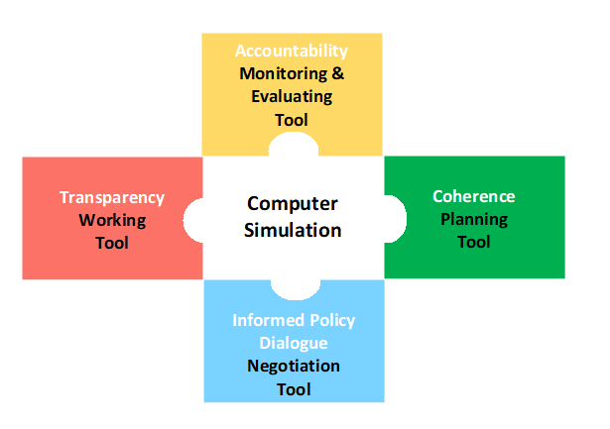
Figure 2 - Simplified Flow Chart of a Demographic Financial Model
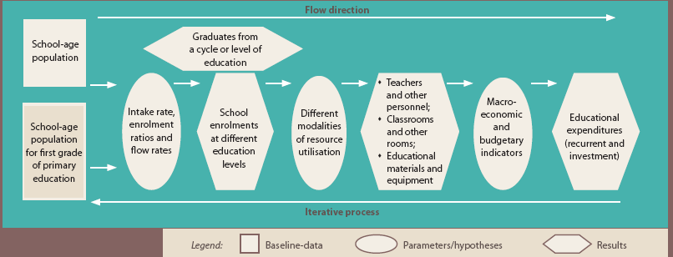
Source: Adapted from Education Policy and Strategy Simulation, UNESCO, 2001.

Where can I obtain Demographic Financial Models?
UNESCO and the International Institute for Educational Planning (IIEP) have produced some excellent open source demographic financial simulators which only require MS Excel to operate. Some examples are included in the lists of references and websites at the end of this document.

Some international trends that impact education planning

Supporting sector analysis and the development of the sector plan
In some cases, government strategic planning systems require substantial support. Development partners may therefore play a more prominent role in such countries, supporting the partner government to (re-)establish systems and capacities in the education sector. Examples include support to Vanuatu, Lao PDR and Papua New Guinea. In fragile or conflict-affected states, development partners can play a significant planning role. Development partner support usually takes the form of short term specialist advisors in areas such as demographic projections, student assessment, teacher training, EMIS and costing analyses. In the past a specialist agency like UNICEF or UNESCO might have led in the development of an ESP. More common is donor partner coordination to support an ESP. The ESP process can help to strengthen systems through the cooperation between external consultants with departmental staff and local consultants. This helps with professional development as well as identifying the skill gaps which can be addressed with subsequent technical assistance for human resource and system development.

To influence planning or not? A question for development partners
Questions arise about the extent to which development partners can and should legitimately shape the scope and content of the plan. The GPE provides good examples of the difficulty of striking a sensible trade-off. On the one hand, they strongly promote country ownership and leadership, but on the other, the GPE appraisal guidelines outline a fairly prescriptive set of characteristics of what a ‘credible’ plan should look like.
In-country experience indicates that governments generally welcome interventions to assist them to develop education plans, provided control and leadership over the plan is retained by government.
Source: GPE 2015.

What are some of the most significant trends impacting on education planning today?

Move towards program-based support
Since 2000, there has been some movement (particularly in larger country contexts) away from project-based support towards sector-based programs. This shift places greater emphasis on the development of robust partner systems and an encompassing sector plan and expenditure frameworks. There is a strong emphasis on partnerships and use of, or alignment with, government systems (up to and including sector budget support). This places even greater emphasis on the availability of robust and precise medium term planning instruments, such as the MTSP and Medium Term Expenditure Framework (MTEF).
The move towards sector-based programs recognises and encourages host country ownership and capacity development within the sector. It should also be understood that sector-based program support carries some increased risk – such as where host country technical capacity is particularly weak. It is also possible to adopt a sector based program approach but hedge against some risks by applying earmarked funding for a limited number of sensitive, critical or strategic line items.

From universal primary education to inclusive and equitable quality education and lifelong learning for all
Significant progress was achieved in terms of providing access to basic education over the
15 year period covered under the Millennium Development Goals. Many countries adopted what became known as the ‘expanded vision of basic education’, which incorporates access, equity and quality learning outcomes for all children through ‘formal’ and ’non-formal’ channels. Since the establishment of the SDGs, greater emphasis is being placed on building on these successes and expanding access to make education more equitable and more inclusive. There is also a commitment to lifelong learning which encourages the incorporation of skills and vocational learning in national Education Sector Plans.
Source: United Nations 2015.

The impact of global initiatives and standards
The drive to achieve global targets and participate in education in global initiatives, such as Education For All and the GPE, has influenced both the structure of plans, and the targets and goals by which a plan is measured. Global goals and targets help illustrate how far a country might be from a global target, which in turn can shape investment decisions. National standards provide a frame of reference for progress at the country level.

Primary to basic education
Over the past two decades most countries began referring to ‘basic education’, encompassing pre-school, primary education and junior secondary education. Definitions and boundaries of ‘basic education’ can vary, causing difficulties for international comparison. Primary education statistics remain important, with countries required to report progress for statistical digests such as the Education for All Global Monitoring Report.
Note: For further information please refer to the Basic Education modules.
Source: UNESCO 2019.

Learning outcomes and quality
There is an increased emphasis on delivering quality education to all. The past two decades have seen a growing interest in strengthening systems for measurement of learning outcomes. Initial advances were made with the introduction of measures such as:
- Trends in International Mathematics and Science Study
- Program for International Student Assessment
- Progress in International Reading Literacy Study.

These international learning assessment instruments have increasingly been adopted in developing countries, and can be supplemented by two other instruments:
- Early Grade Reading Assessment
- Early Grade Maths Assessment.
Access to education is increasingly being defined as ‘access to quality education’ and Education Sector Plans are including a facility for encouraging and measuring the quality of the education system.
For further information about these different learning assessment tools and approaches, please refer to the Learning Assessment modules.

Planning emphasis on equity
Development partners have driven a greater emphasis on equity, whereby gender and the needs of marginalised and disadvantaged groups are clearly addressed in education planning. This includes:
- geographic (mainly by region, state or district, urban/rural/island location)
- population group (including gender, ethnicity, disability, cultural and religious minorities and nomads)
- crisis-affected (including displaced persons, refugees, people with disabilities and populations affected by conflict).

Adopting a Sector-Wide Approach to planning

A Sector Wide Approach (SWAp) is an approach to international development that brings together governments, development partners and other stakeholders within education. The defining features of a SWAp are:
- host country leadership and a single comprehensive program and budget framework
- a formalised process for donor coordination and harmonised donor procedures for reporting, budgeting, financial management and procurement
- efforts to increase the use of local systems for program design and implementation, financial management, monitoring and evaluation.
Source: OECD 2006 Harmonising donor practices for effective aid delivery, volume 2.

Why are Education Sector Plans important to a SWAp?
Education Sector Plans (especially a MTSP) are important documents that can support SWAps in their feasibility and to operate more effectively. In the first instance, the MTSP is important for a SWAp because it takes into account development partners’ intended financial contributions to the sector. It is thus a key mechanism for integrating development partner funds into planning for the sector as a whole.
The MTSP is also something of an assurance document for development partners. SWAps typically involve aid modalities such as sector budget support or pooled funding, where development partners support the sector as a whole rather than carving out individual discrete projects to fund. So the underlying sector plan is an essential ‘structural’ element for a functional SWAp.
Why is gender important in SWAps?
Consideration of gender is crucial in SWAps because SWAps aim to shape the entire sector for long term equitable development. Analysis of the sector needs to include underlying conditions that produce unequal access for males and females and other marginalised groups including differences and inequalities in resources, access, needs and potential contributions. Without this, most plans focus on narrowly defined investments in girls, such as simply increasing the numbers of girls and women involved, rather than identifying the reasons for unequal access and striving for more equitable outcomes.
The GPE, in collaboration with United Nations Girls’ Education Initiative (UNEGI) and supported by UNICEF have launched a Guidance for Developing Gender-Responsive Education Sector Plans.
Source: GPE 2017.


Case study: Samoa Education Sector Plan - development and implementation
Samoa’s Ministry of Finance (MoF) in 2009 changed the sector planning process to require all ministries to develop sector-level medium-term (4 -5 year) strategies and strategic plans based on the overarching Strategy for the Development of Samoa (SDS). This would be followed by: (i) strengthening performance monitoring linked to the development of a three-year rolling MTEF; and (ii) developing sector wide strategies and investment plans for all major sectors to be used for setting output targets linked to budget allocations and monitoring sector performance.
Prior to this change, education sector contributions to the SDS were prepared separately by the Ministry of Education, Sports and Culture (MESC), the Samoa Qualifications Authority (SQA) and the National University of Samoa (NUS). In 2011, these stakeholders in the came together as an Education Sector Working Group (ESWG) to agree on the key outcome for the education sector in the 2012-2016 SDS. This input was incorporated into the SDS 2012-2016.
The forming of the ESWG was an essential step in a sector wide approach to high level national education planning, building on synergies between institutional plans and strengthening the coordination and delivery of educational services by all agencies to the whole of Samoa. Collaborative and sector level, it seeks to avoid unnecessary duplication and promotes the efficient management of scarce resources. The whole sector came together to decide how to improve education quality and standards, effective service delivery, the setting of priorities and the facilitation of development partner assistance.
DFAT supported the development of the education sector plan (ESP) through: providing technical assistance to assist in the design and preparation of the ESP plan; providing a long term adviser to assist in the monitoring, review and implementation of the plan; and being involved significantly in public consultation, review and planning.
The ESP (2012-2016) and ESP (2013-2018)
The ESWG continued and developed Samoa’s first Education Sector Plan (ESP 2012-2016) covering the whole sector, bringing together under five strategic sector-wide goals the Strategic Plans for MESC, SQA and NUS.

The subsequent sector plan 2013-2018 built on the ESP 2012-2016, feedback from the Cabinet Development Committee, and recommendations arising from its appraisal by MoF and development partners in June 2013.
Reviewing the ESP
MFAT and DFAT supported a 2016 Mid-Term Review (MTR) of the Samoa ESP. The MTR identified a number of issues limiting the effectiveness of ESP, including:
- although the sector demonstrated a willingness to coordinate in key areas, the tools for effective, strategic coordination did not exist
- the SWAp approach is complex and the Education Sector Coordination Division is struggling to implement this approach in an effective fashion.
Lessons learnt from supporting an ESP
The MTR of the Samoa ESP identifies the following lessons and many of these are likely to apply in other country contexts:
- Take the time that is necessary at the outset of a major programme to plan well. Both development partners and host agencies need to start planning early.
- International experience suggests that implementation of a budget support modality needs a long-time frame of at least five years before the benefits begin to become apparent.
- Start with small manageable steps and plan activities that can be phased in gradually in order to achieve sustainability. Lack of attention to in-country capacity, adoption of overly ambitious targets, and insufficient prior analysis of the country context are recurring lessons.
- Align the budget planning and reporting requirements for any sector budget support from development partners with those of the domestic budget processes.
- Ensure there is effective and timely communication and transparency about the funding available, and about the expectations with respect to performance of both implementing agencies and MoF.
- Consult during the development of individual performance indicators, to ensure the data required to report progress and achievement is available in the form required.
- Include clear guidelines for how performance-based funding will be distributed across sector agencies when key performance indicators are achieved.


An activity for you
Answer the following questions True or False.

Statement | True | False
1. Governments always function under a single national education sector plan
2. Where a number of education plans are evident, strong coordination should exist in order to manage the implementation of those plans
3. In governments where financial systems are weak or ineffective, development partners may seek ways to bypass government systems and channel funds directly to schools
4. Good education planning requires robust education information systems
5. Development partner partnerships with government weaken government planning
6. Decentralised planning often follows decentralisation of funding.
7. Provincial buy-in to national plans takes time and resources but will result in stronger implementation of programs and initiatives

Check your answers.
- Governments always function under a single national education sector plan. (False)
Note: A number of plans at different levels (national, provincial and district) are often developed.
- Where a number of education plans are evident, strong coordination should exist in order to manage the implementation of the plans. (True)
- In governments where financial systems are weak or ineffective, development partners may seek ways to bypass government systems and channel funds directly to schools. (True)
- Good education planning requires robust education information systems. (True)
- Development partners with government weaken government planning. (False)

Note: Development partners often bring expertise, experience and resources that help to strengthen government planning.
- Decentralised planning often follows decentralisation of funding. (True)
- Provincial buy-in to national plans takes time and resources but will result in stronger implementation of programs and initiatives. (True)

Test your knowledge

Assessment questions
Answer the following questions by ticking ‘True’ or ‘False’. Once you have selected your answers to all the questions, turn the page to ‘The Correct Answers are...’ to check the accuracy of your answers.

Question 1
Many development partners are more interested in program-based approaches than stand-alone projects.
Is this statement true or false? □ True □ False

Question 2
National Education Plans should ignore global standards and focus only on local (national) standards.
Is this statement true or false? □ True □ False

Question 3
Gender is only addressed in Sector Wide Approaches (SWAps) and by increasing the number of women teachers and planners.
Is this statement true or false? □ True □ False

Question 4
Primary education has become the main interest of national education planning in many developing countries.
Is this statement true or false? □ True □ False

Question 5
Sector planning is not important when implementing a SWAp
Is this statement true or false? □ True □ False

Question 6
A country can have many sub-sector SWAps and many Medium Term Sector Plans (MTSP).
Is this statement true or false? □ True □ False

The correct answers are...
Question 1
Many development partners are more interested in program-based approaches than stand-alone projects.
This statement is true.
Question 2
National Education Plans should ignore global standards and focus only on local (national) standards.
The statement is false. National education plans should be developed in the context of international, national, provincial/regional and local trends, globally agreed goals (e.g. MDGs and EFA Goals) and evolving priorities.
Question 3
Gender is only addressed in Sector Wide Approaches (SWAps) and by increasing the number of women teachers and planners.
The statement is false. These are but two approaches. Addressing inequities in gender education access and opportunities requires a multi-pronged approach which includes affirmative action programs, policy development and implementation, data disaggregation and highlights gender inequities at every opportunity.
Question 4
Primary education has become the main interest of national education planning in many developing countries.
The statement is false. Effective national education planning gives close consideration to all education sub-sectors.
Question 5
Sector planning is not important when implementing a SWAp.
The statement is false. Sector planning is vital to an effective SWAp.
Question 6
A country can have many sub-sector SWAps and many Medium Term Sector Plans (MTSP).
The statement is true.

References and Links
All links retrieved August 2019
Global Partnership for Education, Guidelines for Education Sector Plan Appraisal 2015, https://www.globalpartnership.org/content/guidelines-education-sector-plan-appraisal
2015, Guidelines for Education Sector Plan Preparation, http://www.globalpartnership.org/content/guidelines-education-sector-plan-preparation.
2015, The GPE funding model,
https://www.globalpartnership.org/content/gpe-funding-model
2017, Guidance for developing gender-responsive education sector plans, https://www.globalpartnership.org/content/guidance-developing-gender-responsive-education-sector-plans
International Institute for Education Planning 2003, Newsletter Vol. XXI, No. 2, April – June, Paris, http://unesdoc.unesco.org/images/0019/001928/192880e.pdf

OECD 2006 Harmonising donor practices for effective aid delivery, vol. 2, http://www.oecd.org/development/effectiveness/34583142.pdf
UNESCO 2001, Education Policy and Strategy Simulation (EPSSim), http://unesdoc.unesco.org/images/0021/002147/214778e.pdf
2015 SDG 4, Education 2030, https://en.unesco.org/themes/education2030-sdg4
2019 Global Education Monitoring Report, https://en.unesco.org/gem-report/allreports
United Nations 2015, Sustainable Development Goals, https://sustainabledevelopment.un.org/?menu=1300
UN Human Rights 1989, Convention on the Rights of the Child, https://www.ohchr.org/Documents/ProfessionalInterest/crc.pdf
UN Women 2009, Convention on the Elimination of All Forms of Discrimination against Women, https://www.un.org/womenwatch/daw/cedaw/
World Bank 2011, Poverty Reduction Strategies, http://web.worldbank.org/archive/website01404/WEB/0__CON-6.HTM
Learn more about…
- The Egypt National Strategic Plan for Pre-University Education 2014-2030, found at: http://www.unesco.org/education/edurights/media/docs/c33b72f4c03c58424c5ff258cc6aeaee0eb58de4.pdf
- Simulation and Projection Models (UNESCO) at this website, found at: http://www.unescobkk.org/education/epr/epr-resources/mtef-portal/themes/education-planning-methodology-and-tools/simulation-and-projection-models/
- EPSSim – a Simulation Model from UNESCO Bangkok at this website, found at: http://www.unesco.org/new/en/unesco/themes/icts/policy/epssim/
- Trends in International Mathematics and Science Study (TIMSS), found at: http://timss.bc.edu/
- The Program for International Student Assessment (PISA), found at: http://www.oecd.org/pisa/
- Progress in International Reading Literacy Study (PIRLS), found at: http://timss.bc.edu/
- Early Grade Reading Assessment (EGRA), found at: https://www.eddataglobal.org/reading/index.cfm
- Early Grade Maths Assessment (EGMA), found at: https://www.eddataglobal.org/math/
- The Guidelines for Education Sector Plan Preparation and Appraisal (UNESCO), found at: http://www.globalpartnership.org/media/docs/library/121106-Guidelines-for-Education-Sector-Plan-Preparation-and-Appraisal-EN.pdf
- Planning Processes (IIEP), found at: https://planipolis.iiep.unesco.org/
- Education Policy and Planning, an Applied Framework (UNECSO), found at: http://www.unesco.org/education/pdf/11_200.pdf
- The National Education Sector Development Plan: A result-based planning handbook, found at: http://unesdoc.unesco.org/Ulis/cgi-bin/ulis.pl?catno=144783&set=50A45248_2_1&gp=0&lin=1&ll=s
- A Gender Perspective on Educational Facilities, found at: http://www.oecd.org/edu/educationeconomyandsociety/centreforeffectivelearningenvironmentscele/45566604.pdf
- Developing Gender-Responsive Education Sector Plans, found at: http://www.ungei.org/GPE_Guidance_for_Gender-Responsive_ESPs_Final.pdf
- The Australian aid program’s Disability Accessibility Guidelines, found at: https://dfat.gov.au/about-us/publications/Documents/accessibility-design-guide.pdf
- An MTSP by reading the Global Partnership for Education, ‘Guidelines for Education Sector Plan Preparation and Appraisal’, 2012, found at: http://www.globalpartnership.org/media/docs/library/121106-Guidelines-for-Education-Sector-Plan-Preparation-and-Appraisal-EN.pdf
- Indicators Used to Measure Disability Inclusive Development Statistics, found at: http://www.google.com.au/url?sa=t&rct=j&q=&esrc=s&source=web&cd=1&ved=0CCgQFjAA&url=http%3A%2F%2Fwww.un.org%2Fdisabilities%2Fdocuments%2Freports%2Fstrategic_action_2010.doc&ei=rovxUu6eCuf9iAeP-YHwDQ&usg=AFQjCNFLzbe98xowuSU6TY2ZYAqDIPWkWQ&sig2=jSHFSj6xuaTjNMPGijsC0A&bvm=bv.60444564,d.dGI

