Report 1: 2015 ECONOMIC MODELLING OF INTERNATIONAL ACTION UNDER A NEW GLOBAL CLIMATE CHANGE AGREEMENT

McKibbin Software Group
20 August 2015

Report 1: 2015 ECONOMIC MODELLING OF INTERNATIONAL ACTION UNDER A NEW GLOBAL CLIMATE CHANGE AGREEMENT

  - FINAL REPORT

This report presents an assessment of the economic impacts on Australia and the world of known and expected international climate change action under the forthcoming Paris agreement. A second report (Report 2) Economic Modelling of Australian Action Under a New Global Climate Change Agreement addresses the impacts of potential additional emissions reductions by Australia.

This report has been prepared by Professor Warwick J. McKibbin, Director of Research, McKibbin Software Group Pty Ltd in consultation with the Department of Foreign Affairs and Trade.

All prices are in real United States dollars unless otherwise indicated.
Contents

Executive Summary 5
Introduction and context 6
Key assumptions and methodology 8
Approach to modelling 8
Assumptions and implementation 11
Australia 11
United States 12
China 13
Japan 13
European Union 14
Canada and New Zealand 15
Modelling results 17
Impacts on the global economy and Australia 17
Impacts on key countries 22
Impacts on emissions 24
Sensitivity testing and comparability to other modelling exercises 25
Sensitivity testing 25
Comparison to other modelling exercises 25
Conclusions 27
Appendices 28
- Announced and submitted post-2020 targets 28
- Technical specifications and assumptions 30
- Economic impacts on key countries 36
- Sensitivity testing 48
- Trade statistics 53
References 54
List of Tables and Figures
Table 1: Summary of climate targets in the Current Policies and Paris Scenarios | 9
Table 2: Regions and sectors | 10
Table 3: Target impacts on GDP and GNI, key countries, 2030 (percentage deviation) | 23
Table A-1: Parties that have submitted post-2020 targets to the UNFCCC as at 11 August 2015. | 28
Table B-1: Regional groupings in G-cubed model version E123 | 32
Table B-2: G-cubed sector mappings to International Standard Industrial Classification of All Economic Activities Revision 3.1 | 32
Table B-3: Technical characteristics of G-cubed model version E123 | 34
Table B-4: Modelling assumptions: macroeconomic parameters and emissions | 35
Table E-1: AUSTRALIA'S TOP 10 GOODS & SERVICES EXPORTS, 2014 | 53
Table E-2: AUSTRALIA'S TOP 10 GOODS & SERVICES IMPORTS, 2014 | 53
Figure 1: Australian energy sector emissions, Current Policies and Paris Scenarios, 2000 to 2030, (Mt CO₂-e) | 12
Figure 2a: Impacts of international action on Australian output, 2030 (percentage deviation in value) | 18
Figure 2b: Impacts of international action on Australian exports, 2030 (percentage deviation in value) | 19
Figure 3: Impact on GDP 2030 of post-2020 action: key countries | 21
Figure 4: Impact on emissions of post-2020 action: key countries | 22
Figure B-1: G-cubed model version E123 | 31
Figure C-1: Australia: Key indicators under Paris Scenario – Real GDP, consumption, investment and trade balance, 2030 (percentage deviation from Current Policies Scenario) | 36
Figure C-2: Australia: Impacts of Paris Scenario, 2030 (percentage deviation from Current Policies Scenario) | 37
Figure C-3: United States: Key indicators under Paris Scenario – Real GDP, consumption, investment and trade balance, 2030 (percentage deviation from Current Policies Scenario) | 38
Figure C-4: United States: Impacts of Paris Scenario, 2030 (percentage deviation from Current Policies Scenario) | 39
Figure C-5: China: Key indicators under Paris Scenario – Real GDP, consumption, investment and trade balance, 2030 (percentage deviation from Current Policies Scenario) | 40
Figure C-6: China: Impacts of Paris Scenario, 2030 (percentage deviation from Current Policies Scenario) | 41
Figure C-7: Japan: Key indicators under Paris Scenario – Real GDP, consumption, investment and trade balance, 2030 (percentage deviation from Current Policies Scenario) | 42
Figure C-8: Japan: Impacts of Paris Scenario, 2030 (percentage deviation from Current Policies Scenario) | 43
Figure C-9: European Union: Key indicators under Paris Scenario – Real GDP, consumption, investment and trade balance, 2030 (percentage deviation from Current Policies Scenario) | 44
Figure C-10: European Union: Impacts of Paris Scenario, 2030 (percentage deviation from Current Policies Scenario) | 45
Figure C-11: Canada: Key indicators under Paris Scenario – Real GDP, consumption, investment and trade balance, 2030 (percentage deviation from Current Policies Scenario) | 46
Figure C-12: Canada: Impacts of Paris Scenario, 2030 (percentage deviation from Current Policies Scenario) | 47
Figure D-1: United States: Macroeconomic impacts, Technology and Policy Mix Scenario and Paris Scenario, 2030 (percentage deviation from Current Policies Scenario) | 49
Figure D-2: Australia: Macroeconomic impacts, Technology and Policy Mix Scenario and Paris Scenario, 2030 (percentage deviation from Current Policies Scenario) | 50
Figure D-3: Australia: Macroeconomic impacts, Policy Uncertainty Scenario and Paris Scenario, 2030 (percentage deviation from Current Policies Scenario) | 51
Figure D-4: Australia: Sectoral impacts, Policy Uncertainty Scenario and Paris Scenario, 2030 (percentage deviation from Current Policies Scenario) | 52
Executive Summary
Post-2020 commitments anticipated under a new global agreement result in slower economic growth in Australia, with GDP 0.16 per cent lower in 2030 than it would be under current policies. The modelling does not account for potential new Australian policies or a post-2020 target.

Post-2020 commitments see global emissions 10 per cent lower in 2030 than under current policies, and global coal output falls. Global economic growth slows by 0.02 percentage points per year, resulting in the global economy being 0.20 per cent smaller in 2030 than under current policies. The value of global coal output falls by around 5 per cent from 2020 to 2030, compared to rising 12 per cent without new commitments. Coal continues to make up a significant share of global energy output.

Shifts in world demand have negative impacts on Australian fossil fuel based sectors.
Australian coal output and exports are both 8 per cent lower in 2030 than under current policies, and oil and gas sector exports are around 0.5 per cent lower than otherwise. Investment shifts away from fossil fuels, with real investment in fossil fuel sectors 0.9 per cent lower by 2030 than under current policies.

But stronger global action provides modest benefits to many Australian export sectors.
The value of exports from all other Australian sectors, accounting for more than 80 per cent of exports, increases modestly with new international commitments: up to 1 per cent in exports from mining, durable goods manufacturing and agriculture, and increases in exports of 1 to 2 per cent from non-durable manufacturing, transport, and services. These small gains across a broad base offset all of the negative impacts on coal, gas and oil extraction. The domestic trade balance improves overall due to a depreciation of the Australian dollar.

Impact on Australian emissions is limited, in the absence of new Australian policies. Australian emissions in 2030 are 0.2 per cent lower than they would be in the absence of other countries’ commitments. This compares with average OECD emissions being around 20 per cent lower.

Economic impacts across countries are not closely related to levels of effort. The modelling finds that economic impacts are primarily determined by policies, economic circumstances and trade effects rather than country target levels.

Introduction and context
Contact information

Dougal McInnes
Director, Climate Analytics and Partnerships
Department of Foreign Affairs and Trade
(02) 6178 5197 or dougal.mcinnes@dfat.gov.au

DFAT COMMISSIONED ECONOMIC MODELLING WITH TWO OBJECTIVES:
- ASSESS THE IMPACT on THE us, china, JAPAN, EUROPE and the world OF COLLECTIVE international POST-2020 CLIMATE CHANGE TARGETS AND POLICIES; AND
- ASSESS THE IMPACT on australia OF international action by THOSE COUNTRIES AND OTHERS in the absence of additional commitments or policies by AUSTRALIA.
A new global agreement
Parties to the United Nations have agreed under the Framework Convention on Climate Change to negotiate a new global agreement with all countries taking action in the period after 2020 to reduce greenhouse gas emissions. These nationally determined emission reduction targets will form the core of this new agreement.
Countries are taking action
At the time of modelling, countries that had already announced post-2020 targets included the United States, China and the European Union. The countries that had announced post-2020 targets accounted for more than half of global emissions, more than 60 per cent of global economic activity, and around half of Australia’s trade in goods and services.
Economic modelling to help assess the impact of post-2020 commitments
International climate action plays an increasingly significant role in shaping challenges and opportunities for growth. Because effective responses to climate change must be global, understanding other countries’ actions is a key consideration in Australia’s target setting process.
To assess the impact of the new global agreement on key markets in the global and domestic economy, DFAT commissioned McKibbin Software Group Pty Ltd to undertake economic modelling of key countries’ post-2020 targets, with two objectives:
- Assess the impact on the US, China, Japan, Europe and the world of collective international post-2020 climate change targets and policies; and
- Assess the impact on Australia of international action by those countries and others, in the absence of additional commitments or policies by Australia.
This modelling project is different to previous modelling undertaken in Australia because it assesses countries’ announced post-2020 targets and policies rather than assessing climate action in line with a long term goal. The model used has been selected for its sophisticated representation of trade flows and macroeconomic processes with sectoral disaggregation. No sectoral or scientific models are used, in line with the project’s focus on impacts relating to foreign trade, capital flows, investment and economic growth.
Scope and Limitations
The modelling can help explain the international economic context of post-2020 climate change action. However there are other factors that could be considered in target setting that are not addressed in this modelling, including the economic advantages of avoided climate damages or potential long-term targets and economic transitions beyond 2030.
The project focuses on the targets and policies adopted by the United States, China, Japan and the European Union. In the model used, Canada and New Zealand are grouped together, and the rest of the world is grouped into large economic regions. Japan and Canada announced their targets after the modelling was completed. Their announced targets were more ambitious than assumed in the modelling.
There is considerable uncertainty in the assumptions used in the modelling. Given the difficulty of predicting future economic conditions and countries’ actions, all results should be understood to be an expected outcome with a relatively large band of uncertainty around the point estimates. The estimates should be treated as indicative of the orders of magnitude of policy impacts and the likely relative size of impacts across sectors and countries, and should be used with caution.
The model accounts for energy sector carbon dioxide (CO₂) emissions – specifically, emissions from fuel combustion. Australian emissions in 2020 under the ‘Current Policies’ Scenario (described in the following section) are derived from the Australian Government’s emissions projections (Department of the Environment, 2015) on the assumption that emissions in both the energy and non-energy sectors are 5 per cent below their 2000 levels.

Key assumptions and methodology
two modelling scenarios capture the economy under current Policies and Additional post-2020 Policies.
climate targets are modelled using a sectoral approach which includes A mix of policy measures including regulations, standards and market-based incentives.

Approach to modelling
To assess the economic impacts of post-2020 targets two scenarios are modelled – a ‘Current Policies’ Scenario and a ‘Paris’ Scenario.
Current Policies Scenario
Global climate action that was already announced and implemented in 2014 forms the basis of the Current Policies Scenario. The scenario develops a projection of the global economy consistent with official Commonwealth Treasury and international agency forecasts in relation to population growth by each country, productivity growth in each sector by country, and existing macroeconomic settings in each country or region. Countries’ 2020 targets are also incorporated (Table 1).
The emissions trajectories are consistent with emissions projections from the International Energy Agency (2015) and the US Energy Information Administration (2015). Energy emissions for Australia are derived from the Australian Government’s most recent emissions projections (Department of the Environment, 2015).
Paris Scenario
The Current Policies Scenario is the starting point for evaluating the impact of policy changes associated with the commitments made by countries under the new global agreement that is due to be finalised in Paris in December 2015. These new commitments are captured under the Paris Scenario. The modelling estimates the additional effects of these new commitments, not the total cost of all emissions reductions pre and post Paris.
The Paris Scenario models the economic impact of ‘Nationally Determined Contributions’ and commitments under the Paris agreement. Announcements of post-2020 commitments from the United States, China and the European Union are modelled individually, along with an indicative target for Japan (Table 1). Announced or estimated targets for other regions or groups, including Canada and New Zealand, were also modelled. The modelling assumes all countries meet their pre and post-2020 commitments.
Table 1: Summary of climate targets in the Current Policies and Paris Scenarios
 | Current Policies:  Modelled pathway to 2020 | Paris:  Modelled pathway from 2020
Australia | 5% reduction on 2000 levels | No post 2020 commitment.
United States | 17% reduction on 2005 levels | 27% reduction on 2005 in 2025^{1,2}
China | 13% increase on 2015 levels | Carbon dioxide peaks in 2030
Japan | 15% reduction on 2005 levels | 22% reduction on 2005 in 2030³
European Union | 30% reduction on 1990 levels | 40% reduction on 1990 in 2030⁴
1. Mid-point of the announced range.
2. The modelling assumed a straight line extension to 2030 of the trajectory from 2020 to 2025, equivalent to a 37 per cent reduction on 2005 levels in 2030.
3. Japan has since announced a target of reducing emissions by 26 per cent below 2013 levels by 2030.
4. Equivalent to a 34 per cent reduction on 2005 levels in 2030.

Country commitments are modelled as sector-based policies
Each country’s commitments are modelled as being achieved through a mix of sector level policies. In most cases this involves a shift from fossil fuels to renewable electricity, supplemented by nuclear energy in some countries (particularly China), along with investments to improve efficient energy use. Without knowing the specific policies that would be implemented to achieve this shift in renewables and energy efficiency, a generic policy is calculated that would be a rough approximation to any particular policy that might be chosen. The modelling assumes that achieving emissions reductions through a mix of policies increases the price of electricity by 10 per cent more than caused by the cost-minimising policy, which is modelled as a first step. This reflects the cost of the technological shift to higher cost renewables. Emissions trading or a carbon price are included in the domestic policy mix for the EU, Japan, China and Canada and New Zealand, reflecting current and announced policies. Potential trade in international emission permits between regions is not included in the modelling.
Policy implementation is focused on reductions in CO₂ emissions from the energy sector, as set out in the policies and targets announced by key countries. The modelling does not account for reductions in non-energy industrial emissions (such as CO₂ from cement manufacturing), non-CO₂ emissions from livestock, or land use change.
Five key countries and twelve sectors are modelled
The modelling includes five individual key countries – Australia, the US, China, EU and Japan – with the rest of the world represented as four economic regions or groups. Within each country or group the model considers twelve distinct sectors, including six energy sub-sectors, as shown in Table 2. Definitions of the regions and sectors are provided in Appendix B.
Table 2: Regions and sectors
Economic regions |  | Economic sectors
1 | Australia | 1 | Other mining
2 | United States | 2 | Agriculture, forestry & wood products
3 | China | 3 | Durable goods manufacturing
4 | Japan | 4 | Non-durable goods manufacturing
5 | European Union | 5 | Transportation
6 | Canada & New Zealand | 6 | Services
7 | Russia & former USSR | Energy sectors
8 | Oil exporting countries & Middle East | 7 | Electric utilities
9 | Rest of world | 8 | Gas utilities
 |  | 9 | Petroleum refining
 |  | 10 | Coal mining
 |  | 11 | Crude oil extraction
 |  | 12 | Gas extraction

Assumptions and implementation
Australia
Target and policy assumptions, and model implementation
Report 1 assesses the economic impact on Australia of other countries’ targets. The modelling assumes that Australia does not adopt a new post-2020 target or new policies.
The modelling assumes that both energy and non-energy emissions in Australia in 2020 are 5 per cent below their 2000 level, as Australia achieves its 2020 emissions reduction target. Total abatement is 126 Mt CO₂-e in 2020, consistent with projections. The target was achieved in the model through adjusting energy efficiency and productivity without specifying the policies. It is consistent with the approach taken for other countries’ targets in order to have the Current Policies Scenario consistent with projections from international agencies.
This assumption on achieving Australia’s 2020 target means that Australian energy emissions in the modelling are around one-quarter lower in 2020 than in the most recent Government emissions projections (Department of the Environment, 2015), which do not factor in the impacts of the Emissions Reduction Fund and other Government policies to reach the 2020 target. Under this assumption, the energy sector delivers around 90 per cent of total emissions abatement in 2020. This represents a high share of total abatement based on historical estimates.
After 2020, the adjustments that achieved the 2020 target are left in place and total emissions grow at approximately the same rate as Government emissions projections. The model generates a lower share of abatement from energy after 2020, and averages around 80 per cent of total abatement over 2020 to 2030 (assuming that the abatement task is held constant at 126 Mt CO₂-e in 2030).
The technical modelling assumption that Australia does not take on any additional polices or post-2020 target allows the modelling to assess the impacts of international action on Australia, without conflating these impacts with the effects of domestic policy action. The resulting projections of Australian energy sector CO₂ emissions to 2030 are shown in Figure 1.
The modelling assumes that non-energy abatement is achieved through a combination of carryover from the Kyoto period, undershoot (where emissions are below the target level before 2015), and non-energy abatement from the Emissions Reduction Fund and complementary measures. The proposed approach is consistent with assuming that carryover is fully utilised by the end of 2020.
In determining the approach to modelling Australian policy, consideration was given to assessing the impacts of the Emissions Reduction Fund by implementing a subsidy to sectors undertaking abatement to offset the resource cost, and seeking to limit cost pass through in downstream prices. On balance, however, it was considered this approach would add unnecessary complexity and would not be expected to have a material impact on the core issues being assessed.
Figure 1: Australian energy sector emissions, Current Policies and Paris Scenarios, 2000 to 2030, (Mt CO₂-e)*^{1,2}
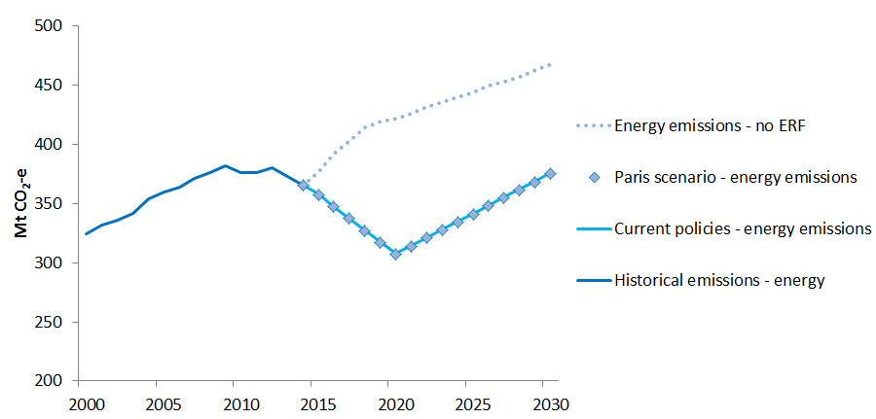
* Million tonnes of carbon dioxide equivalent
1. Because Australian emissions are virtually identical with and without the new post-2020 commitments, emissions for the Current Policies Scenario are shown as a solid line and those for the Paris Scenario as a series of line markers.
2. The dotted line projections do not include the impact of the Emissions Reduction Fund (ERF), complementary measures or any carryover from the Kyoto commitment period.
Source: Project modelling and Australia’s emissions projections 2014-15 (Department of the Environment, 2015).

United States
Target and policy assumptions, and model implementation
The US has announced it will reduce greenhouse gas emissions by 26-28 per cent below 2005 levels in 2025, and in the range of 17 per cent below 2005 levels in 2020. The US is considered on track to achieve its 2020 target. The Clean Power Plan is the central emission reduction policy and requires electricity generation carbon dioxide emissions from power plants to be around 30 per cent below 2005 levels by 2030.
In the Current Policies Scenario emissions are reduced 17 per cent below 2005 levels by 2020, consistent with the US 2020 target, and then follow a business as usual trajectory. In the Paris Scenario emissions are reduced 27 per cent below 2005 levels by 2025, consistent with the US announcement to reduce emissions 26-28 per cent below 2005 levels by 2025. Emissions continue to fall after 2025 at the same rate as the reduction required to meet this target. The US meets its 2020 and 2025 targets through the energy sector (increased energy efficiency and increased use of gas and renewables), broadly consistent with US policy.
China
Target and policy assumptions, and model implementation
China has announced a target to peak carbon dioxide emissions by around 2030, with the intention to try to peak earlier. China’s 2020 target is to reduce the carbon intensity of energy by 40-45 per cent below 2005 levels. China is considered on track to meet this target. The 2020 target allows China to increase emissions by around 13 per cent from current levels.
To achieve these targets China intends to increase the share of non-fossil fuels in primary energy consumption to 15 per cent by 2020 and around 20 per cent by 2030. China has also implemented a number of pilot emissions trading schemes and intends to launch a national scheme. While an official date has not been announced, officials have said they expect the emissions trading scheme to be launched by 2018.
In the Paris Scenario carbon dioxide emissions peak in 2030 and 20 per cent of energy comes from non-fossil fuel sources. Emission reductions are achieved through carbon pricing, increased energy efficiency and increased use of renewables. Emissions fall after 2030 at around half the rate of the rise in emissions to 2030.
In the Current Policies Scenario carbon dioxide emissions intensity is 40-45 per cent below 2005 levels by 2020. As in the Paris Scenario, emissions reductions are achieved through carbon pricing, increased energy efficiency and increased use of renewables, but emissions follow a business-as-usual trajectory post-2020.
Japan
Target and policy assumptions, and model implementation
At the time of modelling Japan had not yet announced its post-2020 target. The Paris Scenario assumed Japan’s emissions would decrease by 22 per cent below 2005 levels by 2030. Japan has since announced a target to reduce emissions by 26 per cent below 2013 levels by 2030.
Japan’s 2020 target is a 3.8 per cent reduction of emissions from 2005 levels, an abatement challenge of 45 Mt CO₂-e. Recent projections indicate that Japan is broadly on track to achieve this target under a range of scenarios.
Japan relies on a range of policies and measures to reduce its emissions, including a carbon tax levied as a surtax on fossil fuels (equivalent to around US$3 per tonne of emissions and covering around 80 per cent of energy-related CO₂ emissions); sub-national emissions trading schemes in two prefectures (Tokyo and Saitama); and a range of energy sector measures, including a feed-in tariff scheme and other tax benefits to promote renewable energy, emissions performance guidelines for centralized power plants, support for combined heat and power system installations, and energy management and efficiency measures. At the time of modelling, Japan had not settled its specific nuclear policy except that nuclear will be an important future baseload source. Japan has since announced that nuclear energy will account for between 20 and 22 per cent of the country's electricity mix by 2030.
The Paris Scenario assumes emissions decrease by 22 per cent below 2005 levels by 2030. The target is achieved through an energy mix of 55 per cent fossil fuels and 45 per cent nuclear and renewables. These energy mix assumptions are consistent with the International Energy Agency’s World Energy Outlook 2014: New Policies Scenario. This energy mix is accompanied by a carbon price of around $3 to raise $3.4 billion per annum, reflecting a continuation of current subregional carbon pricing policies.
The Current Policies Scenario assumes emissions decrease by 15 per cent below 2005 levels by 2020. This is a DFAT estimate, and is consistent with Bloomberg’s medium ‘return to nuclear’ scenario and the International Energy Agency’s World Energy Outlook 2014: Current Policies Scenario. Carbon pricing is modelled as described in the Paris Scenario, consistent with existing subregional policies.
European Union
Representation in the model
The European Union is approximated in the model by the “Western Europe” group which includes the European membership of the OECD in 1990. As a large majority of emissions from the EU is within this group, and Norway and Switzerland have adopted similar emission reduction targets to the EU, the representation in the model is consistent with EU climate targets and policies.
Target and policy assumptions, and model implementation
The European Union has announced targets for emissions to decrease by 40 per cent below 1990 levels by 2030, and 20 per cent below 1990 levels by 2020. The EU is on track to overachieve on its 2020 target, with the EU’s official projections showing emissions will be 22 per cent below 1990 levels by 2020 with existing measures, and 26 per cent below 1990 levels by 2020 with additional measures.
The European Union’s climate policies include emissions trading and targets for renewable energy and energy efficiency. For 2020, the EU will increase the share of energy consumption produced from renewable resources to 20 per cent, and improve energy efficiency by 20 per cent from business as usual levels. Emissions from sectors covered by the EU Emissions Trading Scheme (EU ETS) will be 21 per cent below 2005 levels by 2020. The EU ETS covers 45 per cent of EU emissions.
National governments have taken on binding targets for reducing greenhouse gas emissions not covered by the EU ETS. These range from 20 per cent below 2005 levels by some Member States to a 20 per cent increase by others. These add up to a 10 per cent reduction by 2020 across the EU, from 2005 levels.
For 2030, the EU has committed to increase the share of energy consumption produced from renewable resources to at least 27 per cent, and improve energy efficiency by at least 27 per cent from business as usual levels. Emissions from sectors covered by the EU ETS are to be 43 per cent below 2005 levels by 2030. Emissions not covered by the EU ETS will need to be cut by 30 per cent below 2005 levels to meet the overall target. The EU 2030 target is yet to be translated into targets for individual Member States.
The Paris Scenario assumes that emissions decrease by 40 per cent below 1990 levels by 2030, consistent with the European Union’s official announcements. The target is achieved through a carbon price, renewables consistent with the announced 2030 target (with the share of fossil fuels in electricity falling to 60 per cent by 2030) and energy efficiency consistent with the announced 2030 target.
In the Current Policies Scenario the modelling assumes that emissions decrease by 22 per cent below 1990 levels by 2020, consistent with the current emissions projections. This is achieved through a carbon price as described for the Paris Scenario, renewables consistent with the 2020 target, and energy efficiency consistent with the 2020 target.
Canada and New Zealand
Representation in the model
Canada and New Zealand are grouped together in the model in a region called “Rest of OECD” (ROECD). The model does not provide separate economic impacts from their individual post-2020 targets. However the results for the ROECD region can be used to draw some broad conclusions about the impacts on Canada, because Canada’s significantly larger economy accounts for the majority of the impacts on the ROECD grouping.
Target and policy assumptions, and model implementation
At the time of modelling, Canada had not announced a post-2020 target. The analysis for the Paris Scenario assumed Canada’s emissions would decrease by 22 per cent below 2005 levels by 2030. Canada has since announced a target to reduce emissions by 30 per cent below 2005 levels by 2030.
Canada’s 2020 target is to reduce emissions 17 per cent below 2005 levels, an abatement challenge of 246 Mt CO₂-e in 2020. Canada’s most recent emissions projections indicate that around half of the abatement challenge in 2020 can be met with current measures.
The Canadian Government has implemented standards in transport, fuels and electricity, and intends to regulate HFCs. Canada does not have a federal carbon price in place. However four provinces, contributing around 80 per cent of Canada’s emissions, have implemented a carbon price through sub-national policies.
The modelling assumes a post-2020 target for Canada of 22 per cent below 2005 levels by 2030. The target is met through a mix of carbon pricing and energy sector measures.
Given Canada’s announced target (Appendix A), the economic impacts on Canada out to 2030 may be greater than found by the modelling, although no firm conclusions can be drawn without additional modelling.

Modelling results

the GLOBAL and DOMESTIC economy continues to grow WHILE MEETING post-2020 targets.
australia’S ECONOMY IS 0.16 per cent smaller in 2030 due to international action, WHILE STILL GROWING AT 2.2 per cent annually.

Impacts on the global economy and Australia
The world economy expands while emissions ease
In the Paris Scenario, real global growth is estimated to average 2.25 per cent per year (above inflation) from 2020 to 2030. By comparison, the global economy is projected to grow at 2.26 per cent a year in the Current Policies Scenario.
The emissions reduction commitments in the Paris Scenario results in global emissions being 5 per cent lower in 2025 and 10 per cent lower in 2030 than projected for the Current Policies Scenario.
Global energy demand rises but the growth of fossil fuels slows
Total global energy use continues to increase in the Paris Scenario, growing 16 per cent from 2020 to 2030 compared to 19 per cent under the Current Policies Scenario. Emissions reductions are driven by an increase in low-carbon energy supply, increased capital investment, and slower growth in global fossil fuel output and trade.
Global coal production is projected to fall by around 5 per cent from 2020 to 2030 in the Paris Scenario, compared to increasing 12 per cent under Current Policies. Demand for oil and gas slows but continues to increase from current levels.
The impacts of international action on Australia
The modelling assesses the impacts of post-2020 commitments by other countries on Australia compared with Current Policies. It assumes no additional policy action by Australia post-2020. In the model, targets that are announced in 2015 for implementation post-2020 have an impact on the global economy before 2020 because some forward-looking firms and households change their behaviour in anticipation of the new policies.
The modelling finds that Australian gross domestic product (GDP) is 0.16 per cent smaller in 2030 than it would be without the Paris commitments, implying a reduction of just under 0.01 percentage points in average annual economic growth. These impacts are similar to the findings of previous studies (although this modelling differs in focussing solely on the impacts of global action without assuming new policies by Australia), underlining that international action has a mix of positive and negative impacts on different sectors. Slower growth in gas exports and a fall in coal exports would be offset by stronger growth in services, agriculture and non-durable manufacturing exports.
Shifts in world demand result in costs and benefits to different Australian sectors
The modelling finds that under the Paris Scenario, the value of coal output and exports in 2030 are 8 per cent lower compared to the Current Policies Scenario (Figures 2a and 2b). Oil and gas exports are around 0.5 per cent lower. The coal, gas and petroleum extraction sectors account for 2 per cent of projected Australian economic activity and around one sixth of exports in 2030.
Figures 2a and 2b show both the impact of international action on major sectors (the length of the bar), and the relative contribution of each sector to Australian economic output and exports (the height of each bar, adding to 100 per cent). The area of each bar is proportional to the aggregate value of impacts on the relevant sector.
Figure 2a: Impacts of international action on Australian output, 2030 (percentage deviation in value)
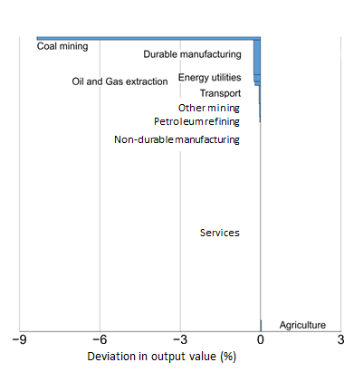
‘Energy Utilities’ output consists of the electric utilities and gas utilities sectors; ‘Oil and Gas Extraction’ consists of crude extraction and gas extraction sectors. See Appendix B for sector definitions.
The modelling finds modest positive impacts on Australia’s other mining and durable manufacturing exports, with export values between 0.3 per cent and 0.5 per cent higher in 2030 relative to Current Policies. These sectors account for around 16 per cent of Australian economic activity, and 44 per cent of Australian exports, as shown in Figures 2a and 2b.
The modelling finds an increase in the value of Australia’s agricultural exports by 0.7 per cent, non-durable manufacturing exports (including food processing) by 1.1 per cent and service exports by 1.6 per cent by 2030 (Figure 2b). Growth in Australia’s non-resources export base is due to energy efficiency measures in other countries (and their resulting capital flows) causing net capital outflows from Australia, putting downward pressure on Australia’s exchange rate and providing a boost for Australia’s less carbon-intensive export industries. This broad-based export growth offsets the negative impacts on exports from fossil-fuel based sectors.
Figure 2b: Impacts of international action on Australian exports, 2030 (percentage deviation in value)
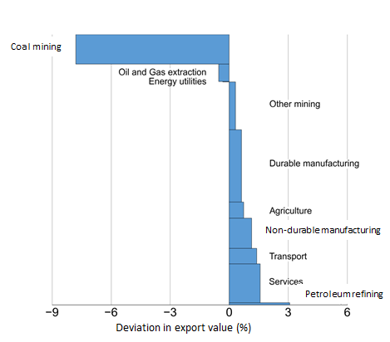
‘Energy Utilities’ exports consists of the gas utilities sector; ‘Oil and Gas Extraction’ consists of the crude extraction and gas extraction sectors. See Appendix B for sector definitions.

Some investment shift away from carbon intensive sectors
Other countries’ emissions reduction policies reduce global demand for carbon intensive goods, including Australian fossil fuel exports. So total investment in our fossil fuel extraction sectors falls by around 9 per cent by 2030 – and accounts for almost the entire decline in Australian investment out to 2030.
The trade balance improves slightly in response to a flow of capital out of Australia into other countries that are raising investment in electricity sectors in order to reach the specified targets. The Australian dollar also depreciates in real terms as capital flows overseas, which lowers the cost of Australian exports in foreign currency terms. Slower growth in coal and gas also puts downward pressure on input prices, including wages, benefiting other sectors including services, agriculture and non-durable manufacturing (largely food processing).
The impacts of international action on Australia
The projected impacts of other countries’ post-2020 commitments on Australia are smaller than the effects on China, the EU and Canada (Figure 3).
The modelling estimates that Australia will experience a larger impact from other countries’ targets than the US or Japan. Australia generates a significant amount of income through exports of fossil fuels and fossil fuel intensive goods into markets that are expected to take on significant emission targets. Further, Japan and the US are less affected by their targets because the underlying emission paths are already low (based on official projections used in the modelling) before the Paris commitments.
These relative economic impacts should be interpreted with some caution. They do not account for any potential new commitments or policies from Australia, whereas the projected outcomes for other countries include the effort of their own policies, and the combined effects on international trade.
Figure 3: Impact on GDP 2030 of post-2020 action: key countries
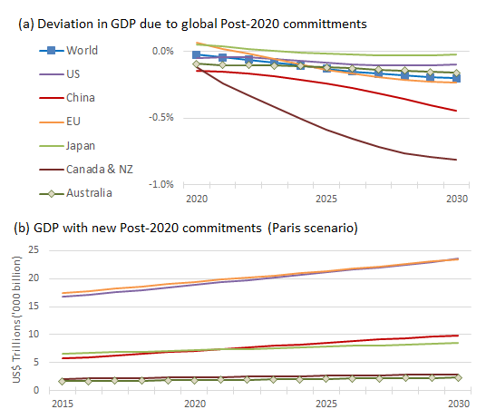
‘Western Europe’ group is used as a proxy for the European Union. See Appendix B for country and regional aggregations.
Economic impacts across countries are not closely related to levels of effort
The modelling finds that the relative economic impact of stronger policy action for each country is not closely related to the size of the additional emissions reductions as expressed relative to a historical base year. Expressing emissions reductions relative to a historical base year does not necessarily provide a robust guide to the abatement effort – in general this is more clearly indicated by reductions from the emissions trend without action. However, even for the same amount of reduction at a point in time, costs (which more accurately reflect ‘effort’) will also differ across countries due to different economic structures.
The ease and cost of emissions reductions depend as much on the structure of each economy as on the differences between targets and business as usual emissions. Figure 4 shows the difference in emissions for key countries, comparing the Current Policy Scenario with their modelled Paris Scenario commitments.
Figure 4: Impact on emissions of post-2020 action: key countries
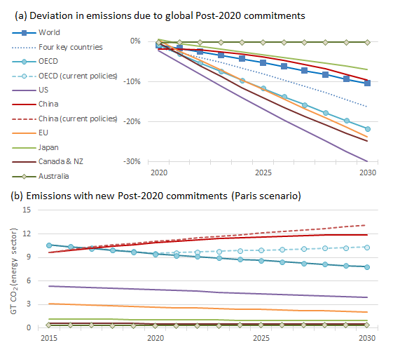
One GT is one trillion (‘000 billion) tonnes.
‘Western Europe’ group is used as a proxy for the European Union. See Appendix B for country and regional aggregations.
Four key countries: US, China, EU and Japan

Impacts on key countries
The impacts of post-2020 targets on GDP and gross national income (GNI) of key countries are summarised in Table 3. Further information is provided in Appendix C.
Table 3: Target impacts on GDP and GNI, key countries, 2030 (percentage deviation)
 | Modelled emissions pathway  (2005-2030) | Change in GDP  (per cent) | Change in GNI (per cent)
Australia | n/a | -0.16 | -0.10
US | -37%¹ | -0.10 | -0.12
Japan | -22%² | -0.02 | -0.07
Europe | -34% | -0.23 | -0.27
Canada | -22%² | -0.81 | -0.69
China | Peaking in 2030 | -0.45 | -0.40
1 The straight line extension of the trajectory from the US target 2020 target to its 025 target.
2. Japan and Canada have since announced targets of -25.4 percent and -30 per cent below 2005 levels, respectively.
United States
The modelling indicates that US GDP will increase by one quarter between 2020 and 2030 as countries take on post-2020 targets (the Paris scenario). By 2030, GDP is estimated to be one tenth of one per cent lower than it would if countries did not take on post-2020 targets (the Current Policies Scenario).
China
Under the Paris Scenario, China’s GDP is estimated to grow by 38 per cent between 2020 and 2030. By 2030, China’s GDP is estimated to be 0.5 per cent lower than under the Paris Scenario without a post-2020 target.
Japan
Japan’s GDP is estimated to grow by one fifth between 2020 and 2030 under the Paris Scenario. By 2030, Japan’s GDP is estimated to be 0.02 per cent lower than without a post-2020 target.
European Union
GDP in the European Union is estimated to grow by one fifth between 2020 and 2030 under the Paris Scenario. The modelling indicates that by 2030, Europe’s GDP will be 0.2 per cent lower than without a post-2020 target.
Canada
As previously noted, the impacts for the ‘Rest of OECD’ grouping, which consists of Canada and New Zealand, are considered indicative of the impacts on Canada because of the relative size of its economy in this grouping.
The modelling finds that under a 22 per cent target Canada’s economy would grow 22 per cent between 2020 and 2030. Canada’s GDP is estimated to be 0.8 per cent lower in 2030 as a result of countries’ post-2020 targets.
Impacts on emissions
Policy discussions on global climate action often highlight the potential for ‘emissions leakage’ where emissions reduction policies in one country force emissions intensive industries offshore, with little or no reduction in global emissions. While this is a genuine issue, in practice high sunk costs involved in existing infrastructure mean it is most likely relevant to globally mobile new green-fields investment, rather than the potential early closure of existing capital intensive facilities. Countries have also demonstrated a range of policy measures for maintaining the competitiveness of emissions intensive trade exposed industries.
The focus of this modelling raised the possibility that the analysis might find that Australia became a ‘pollution haven’ – attracting new investment in emissions intensive activities because Australia is not taking on a new post-2020 target. However, given that the variant of the model used does not include non-CO₂ gases or emissions outside the energy sectors, no firm conclusions can be made about the extent or causes of overall emissions leakage.

Sensitivity testing and comparability to other modelling exercises

Sensitivity testing
Technology and policy mix assumptions
The projected economic impacts are sensitive to assumptions about the policies used to achieve the targets, and future relative costs of renewable energy technologies. These issues are explored through varying the relative implementation cost of the policies used by the US to achieve its target. The modelling for the core Paris Scenario assumes that achieving emissions reductions through a mix of policies increases the price of electricity by 10 per cent compared to cost-minimising policy. To test the sensitivity of the results to this technology cost assumption, the impacts were analysed for a higher price increment of 50 per cent.
The modelling finds that under this higher cost assumption, the impact of countries’ post-2020 commitments on US GDP is twice as large (relative to the Paris Scenario) and that US electricity prices are almost 50 per cent higher. The results for differences in investment, consumption and GDP growth would be expected to be broadly similar for other countries. More details are provided in Appendix D.
Policy certainty and business confidence
A second sensitivity analysis assessed the significance of policy uncertainty, and its impact on business confidence. This is modelled as an increase in the risk premium in Australian energy sectors of four per cent (or 400 basis points) – a reasonable size of shock relative to swings in risk premia observed in markets in recent years. This lack of business confidence might arise from Australian policy settings – such as a decision not to announce a post-2020 target. Perceived investment risks in Australia could also be influenced by business confidence in relation to the actions and commitments of other countries.
The modelling finds that the negative impact of policy uncertainty on Australia’s real GDP is around three times larger than the impact of international action in the core Paris Scenario. This occurs because higher perceived risk reduces investment in the energy sector, and results in higher energy prices and business input costs. More details are provided in Appendix D.
Comparison to other modelling exercises
In recent years, the Australian modelling community gained substantial experience in understanding the economics of climate change targets and policies. Treasury and others conducted three major modelling exercises between 2008 and 2013. Each exercise involved two to three top-down general equilibrium models, at least four bottom-up partial equilibrium models, plus other tools such as a dedicated atmospheric model or financial transfer models. Each exercise involved four or five government agencies and a number of consulting contracts.
No attempt has been made to replicate these exercises in the current modelling. However, a robust economic assessment of post-2020 climate action is important for informing Australia’s own action and understanding the possible impacts of the actions of other countries.
This modelling took a different approach to the Treasury climate policy modelling to fulfil a specific purpose with regards to assessing the impacts of the Paris agreement. Different assumptions were made about international action and countries’ policy mixes based on up to date information, including countries’ stated actions and policy intentions. The model used (G-cubed) is a standalone model.
Comparisons of the results with other work should be approached with caution, and should take account of three broad issues. First, previous studies have typically assessed the combined impacts of stronger international action and potential new Australian policies to reduce emissions. All else equal this would be expected to result in those studies finding a higher economic impact on Australia.
Second, most previous studies have assumed Australia would make use of international emissions units to achieve its targets. This is not relevant to this project because it is not assessing the implications of potential new domestic policies. However, this was a key factor in the 2013 Treasury modelling, which estimated that the impact on GNI per capita from international action and Australia’s 2020 target would be a reduction of 0.02 per cent in 2020 relative to no action.
Third, the estimates of economic impacts are sensitive to assumptions about the future capital and operating costs of different energy technologies. Recent years have seen rapid declines in the costs of renewable energy technologies (which in some cases are now less than half the cost projected a few years ago). This implies that simple comparisons of results across different studies and models should be treated with caution.
Conclusions
Countries’ post-2020 emission reduction targets impact on rates of growth, the structure of their economies and the global economy.
- Australia is expected to experience strong economic growth under both the Current Policies and Paris Scenarios

The impacts of climate action differ among countries
Countries’ post-2020 emission reduction targets have a real impact on their rates of growth, the structure of their economies and on the global economy.
Some countries’ targets imply a greater economic transition than others. Canada and China’s post-2020 targets are estimated to have the greater impact relative to the Current Policies Scenario. Other countries are estimated to have smaller impacts. The variation in impacts is explained by underlying assumptions about the effectiveness of current actions built into official projections out to 2020 as well economic factors such as underlying economic growth, the economic structures and endowments of different economies, and their emissions intensities.
Sensitivity analysis shows that assumptions about emissions reduction costs can have a significant influence on the estimated impacts of post-2020 targets.
The impacts on Australia
A significant proportion of Australia’s wealth is derived from our high level of integration with the global economy, particularly through our energy exports. We also rely on durable manufacture imports. We are therefore subject to the impacts of international climate measures on the global economy.
Nonetheless, Australia is expected to experience strong economic growth under both the Current Policies and Paris Scenarios, with an annual difference of some 0.01 per cent. By 2030, Australia’s real GDP is forecast to be around 0.16 per cent lower in the Paris Scenario than in the Current Policies Scenario. Under the Paris Scenario, the Australian economy is projected to grow at an average of 2.21 per cent a year from 2020 to 2030, compared with 2.22 per cent a year under Current Policies.
APPENDIX A:
Announced and submitted post-2020 targets
Table A-1 shows countries announced and submitted post-2020 targets. The table does not represent the targets modelled.
Table A-1: Parties that have submitted post-2020 targets to the UNFCCC as at 11 August 2015.
Party | Description of post-2020 target
Australia | 26-28 per cent below 2005 levels by 2030
USA | 26-28 per cent below 2005 levels by 2025
China | 60-65 per cent reduction in carbon intensity from 2005 levels by 2030
EU28 | 40 per cent below 1990 levels by 2030
Japan | 26 per cent below 2013 levels by 2030
Canada | 30 per cent below 2005 levels by 2030
New Zealand | 30 per cent below 2005 levels by 2030
Andorra | 37 per cent below a business-as-usual scenario in 2030
Ethiopia | 64 per cent below a business-as-usual scenario in 2030
Gabon | 50 per cent below a business-as-usual scenario in 2025
Iceland | 40 per cent below 1990 levels by 2030
Kenya | 30 per cent below a business-as-usual scenario in 2030
Liechtenstein | 40 per cent below 1990 levels by 2030
Marshall Islands | 32 per cent below 2010 levels by 2025
Mexico | 22 per cent (up to 36 per cent) reduction against a business-as-usual scenario in 2030
Monaco | 50 per cent below 1990 levels by 2030
Morocco | 13 per cent (up to 32 per cent) reduction against a business-as-usual scenario in 2030
Norway | 40 per cent below 1990 levels by 2030
Republic of Korea | 37 per cent below a business-as-usual scenario in 2030
Russia | 25-30 per cent below 1990 levels by 2030
Serbia | 9.8 per cent below 1990 levels by 2030
Singapore | 36 per cent reduction in carbon intensity from 2005 levels by 2030
Switzerland | 50 per cent below 1990 levels by 2030
FYR Macedonia | 30 per cent reduction in CO₂ emissions against a business-as-usual scenario in 2030
Trinidad and Tobago | 30 per cent reduction in public transportation emissions against a business-as-usual scenario in 2030
Benin | Sectoral reductions equalling 283Mt CO₂-e (cumulative from 2020-2030) against a business-as-usual scenario in 2030

APPENDIX B:
Technical specifications and assumptions

The G-cubed model
G-cubed is a global, multi-sector, inter-temporal dynamic general equilibrium model originally designed to evaluate climate change policies. It has been used by the Australian Treasury and international governments, as well as the IPCC, the UN, the OECD, the World Bank, the IMF, the Asian Development Bank, academia and private corporations.
G-cubed has a detailed endogenous financial sector, distinguishes between physical and financial capital, and makes use of empirical evidence to support its partial adjustment mechanism. A partial adjustment mechanism accounts for firms and households that do not have perfect foresight or capital mobility, which better reflects real world behaviour.
While there are many different versions of the model depending on the nature of the question being evaluated, the version used in this modelling (Version E123) has nine countries/regions. Five countries are modelled individually: Australia, the US, China, EU and Japan. Within each country or region are 12 production sectors, including six energy sectors. Households, the government and the financial sector are also fully represented.
The sectoral and regional aggregations of the G-cubed variant used for this modelling are shown in Figure B-1, Table B-1 and Table B-2. Technical characteristics of the G-cubed model are set out in Table B-3.
Key assumptions about macroeconomic and emissions parameters are set out in Table B-4.
Limitations of the modelling
The twelve sectors used in the model are highly relevant for analysing the impact on Australia, and can demonstrate important high level trends for changes in other countries’ economies. But the model does not break Australia down into sub-regions and cannot deliver detailed information on the impacts on states or regions. Countries included but not disaggregated in the standard variant of the model include Canada and New Zealand.
Carbon dioxide emissions are modelled for energy sectors only – the model does not specify emissions from non-energy related sectors, such as carbon dioxide from cement manufacturing. It also does not capture non-carbon dioxide emissions, such as methane from livestock.

Figure B-1: G-cubed model version E123
9 countries
and regions
12 sectors
Japan
China
Western Europe
Rest of OECD
Oil exporting countries and Middle East
Eastern Europe and former USSR
Other developing countries
US
Australia
Crude oil extraction

Petroleum refining
Coal mining
Gas extraction

Durable goods manufacturing
Agriculture, forestry and wood products
Other mining

Gas utilities
Electric utilities
Non-durable goods manufacturing
Transportation
Services

Table B-1: Regional groupings in G-cubed model version E123
Region/country
United States
Japan
Australia
China
Western Europe (used as proxy for European Union)
Germany, France, Italy, Spain, Netherlands, Belgium, Luxemburg, Ireland, Greece, Austria, Portugal, Finland, United Kingdom, Norway, Sweden, Switzerland, Denmark, Iceland, Liechtenstein
Rest of OECD
Canada, New Zealand
Oil-exporting countries and the Middle East (also referred to as OPEC)
Ecuador, Nigeria, Angola, Congo, Iran, Venezuela, Algeria, Libya, Bahrain, Iraq, Israel, Jordan, Kuwait, Lebanon, Palestinian Territory, Oman, Qatar, Saudi Arabia, Syrian Arab Republic, United Arab Emirates, Yemen
Eastern Europe and Former Soviet Union
Albania, Armenia, Azerbaijan, Bulgaria, Belarus, Cyprus, Czech Republic, Estonia, Georgia, Croatia, Hungary, Kazakhstan, Kyrgyzstan, Lithuania, Latvia, Malta, Poland, Romania, Russian Federation, Slovakia, Slovenia, Ukraine, Republic of Moldova, Tajikistan, Turkmenistan, Uzbekistan
Other Developing Countries
All countries not included in other groups

Table B-2: G-cubed sector mappings to International Standard Industrial Classification of All Economic Activities Revision 3.1
G-Cubed | ISIC-3. 1 Code
Electric Utilities | 401 Production, transmission and distribution of electricity
Gas Utilities | 402 Manufacture of gas; distribution of gaseous fuels through mains
Petroleum refining | 232 Manufacture of refined petroleum products
Coal mining | 10 Mining of coal and lignite; extraction of peat
Crude oil and | 11 (part of) Extraction of crude petroleum and natural gas; service activities incidental to oil and gas extraction, excluding surveying
Gas extraction | 11 (part of) Extraction of crude petroleum and natural gas; service activities incidental to oil and gas extraction, excluding surveying
Other mining | 12 Mining of uranium and thorium ores  13 Mining of metal ores  14 Other mining and quarrying
Agriculture, Forestry and Wood Products | 01 Agriculture, hunting and related service activities  05 Fishing, aquaculture and service activities incidental to fishing  02 Forestry, logging and related service activities  20 Manufacture of wood and of products of wood and cork, except furniture; manufacture of articles of straw and plaiting materials
Durable manufacturing | 271 - Manufacture of basic iron and steel  2694 - Manufacture of cement, lime and plaster  2695 - Manufacture of articles of concrete, cement and plaster  29 Manufacture of machinery and equipment n. e. c.  30 Manufacture of office, accounting and computing machinery  31 Manufacture of electrical machinery and apparatus n. e. c.  32 Manufacture of radio, television and communication equipment and apparatus  33 Manufacture of medical, precision and optical instruments, watches and clocks  34 Manufacture of motor vehicles, trailers and semi-trailers  35 Manufacture of other transport equipment  26x Manufacture of other non-metallic mineral products, except 2694, 2695  272 - Manufacture of basic precious and non-ferrous metals  273 - Casting of metals  28 Manufacture of fabricated metal products, except machinery and equipment  36 Manufacture of furniture; manufacturing n. e. c.
Non-durable manufacturing | 24 Manufacture of chemicals and chemical products  17 Manufacture of textiles  21 Manufacture of paper and paper products  15 Manufacture of food products and beverages  16 Manufacture of tobacco products  18 Manufacture of wearing apparel; dressing and dyeing of fur  19 Tanning and dressing of leather; manufacture of luggage, handbags, saddlery, harness and footwear  22 Publishing, printing and reproduction of recorded media  231 - Manufacture of coke oven products  233 - Processing of nuclear fuel  25 Manufacture of rubber and plastics products  37 Recycling
Transportation | 60 Land transport; transport via pipelines  61 Water transport  62 Air transport  63 Supporting and auxiliary transport activities; activities of travel agencies  64 Post and telecommunications
Services | 50 Sale, maintenance and repair of motor vehicles and motorcycles; retail sale of automotive fuel  51 Wholesale trade and commission trade, except of motor vehicles and motorcycles  52 Retail trade, except of motor vehicles and motorcycles; repair of personal and household goods  55 Hotels and restaurants  403 - Steam and hot water supply  41 Collection, purification and distribution of water  65 Financial intermediation, except insurance and pension funding  66 Insurance and pension funding, except compulsory social security  67 Activities auxiliary to financial intermediation  70 Real estate activities  71 Renting of machinery and equipment without operator and of personal and household goods  72 Computer and related activities  73 Research and development  74 Other business activities  80 Education  85 Health and social work  90 Sewage and refuse disposal, sanitation and similar activities  91 Activities of membership organizations n. e. c.  92 Recreational, cultural and sporting activities  93 Other service activities
Reallocated to investment final demand | 45 Construction

Table B-3: Technical characteristics of G-cubed model version E123
Element | Specification
Type of model | Global, dynamic computable general equilibrium model
Model database | GTAP version 8; OECD Economic Outlook 93; World Bank; Energy Information Administration emissions data
Price units | All prices are in real 2012 US dollars
Elasticities | Extensive use of econometrically estimated consumption and production substitution elasticities
Dynamic intertemporal structure | Partial adjustment mechanism for firms and households accounts for imperfect foresight and capital mobility.
Forward-looking behaviour | Expectations a mix of rational and non rational. Some firms and households follow a rule of thumb that is optimal in the long run.
Countries/regions | In this version - limited regional disaggregation: 9 countries/regions (Figure B-1 and Table B-1).
Economic sectors | In this version - limited sectoral disaggregation: 12 production sectors, including 6 energy production sectors, plus household, government and financial sectors (Figure B-1 and Table B-2).
Firms | Firms produce output and maximize share market value subject to costs of adjusting physical capital.  Inputs: capital, labour, energy and material.
Households | Households maximize expected utility subject to a wealth constraint and liquidity constraints.
Financial sector | Detailed endogenous financial sector distinguishes between physical and financial capital, and makes use of empirical evidence to support its partial adjustment mechanism.  Financial markets for bonds, equity, and foreign exchange.
Physical capital, financial capital and labour | Physical capital within sectors and countries is sticky.  Financial capital is flexible and immediately flows to where expected returns are highest.  Short run unemployment possible due to wage stickiness based on labour market institutions.
International trade | International trade in goods, services and financial assets.
Energy | Energy is an endogenously determined intermediate input to production, with firms choosing from 5 energy-producing sectors.
Technology | CES production functions for each sector. Specific detailed technologies not modelled.

Table B-4: Modelling assumptions: macroeconomic parameters and emissions
Macroeconomic assumptions
GDP | Baseline: All countries: Mid-year economic and fiscal outlook 2014-15 (Department of the Treasury, 2014) (MYEFO)  Current policies: MYEFO with technical adjustments  Paris Scenario: model output
Population | By country/region – UN Medium fertility 2012 scenarios (United Nations, 2012)
Productivity growth | By country/region and sector – productivity catch-up model: each sector in each country/region closes the gap in productivity relative to the equivalent US sector by a constant percentage per year (2% per year for Australia, Japan, Europe; 5% per year for China; 1% per year for ROW and Russia; 0.5% per year for OPEC).
Monetary policy | By country/region – central banks follow an interest rate rule targeting nominal income growth and in some countries also a weigh on exchange rate variability.
Fiscal policy | Government spending fixed at 2012 share of GDP; exogenous fiscal deficit path and tax rates held fixed except a lump sum tax of households to hold the deficit fixed given endogenous tax revenue.
Energy efficiency improvement | Baseline, all countries/regions: 1 per cent per year  Current policies: output of energy sectors adjusted via productivity shocks and additional energy efficiency assumptions to approximately reach the emissions projections of the International Energy Agency and the US Energy Information Administration
Emissions assumptions
BAU and historical emissions | Australia: Australia’s emissions projections 2014-15 (Department of the Environment, 2015)  Other countries: Energy Information Administration Energy Outlook 2015
Gases | CO₂ from energy use only
Emissions sources included | Energy consumption  Excludes emissions from all sources that are not energy use (such as oil and gas fugitive emissions, cement production, agricultural activity)

APPENDIX C:
Economic impacts on key countries
Australia
Macroeconomic indicators
With the targets modelled, GDP in Australia in 2030 is estimated to be 0.16 per cent lower than if countries did not take on post-2020 targets (Figure C-1).
Figure C-1: Australia: Key indicators under Paris Scenario – Real GDP, consumption, investment and trade balance, 2030 (percentage deviation from Current Policies Scenario)
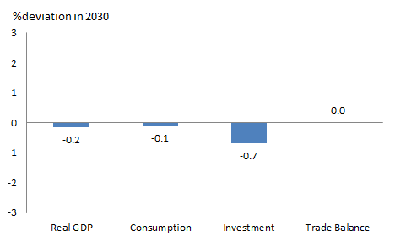
Note: Trade balance result is deviation in trade balance divided by GDP.
Trade impacts
Stronger global climate action reduces the value of Australian coal and gas exports, but this decline is offset by growth in agricultural exports, non-durable manufacturing exports (including food processing) and service exports (Figure C-2). Australia's imports continue to expand, but slightly slower than under the Current Policies Scenario and with a slightly different composition. This reflects both slower economic growth and reduced demand for capital goods that serve as inputs to Australia’s fossil fuel extraction industries (1.4 per cent lower by 2030).
Sectoral impacts
Energy sectors make up around 7 per cent of Australia’s economy and around a quarter of exports, the majority of which is coal (around 16 per cent of total) , natural gas (around 3 per cent), and crude petroleum (around 3 per cent). Australia’s energy exports increase from 2015 to 2030 in the Paris Scenario, but are around one third slower than in the Current Policies Scenario – the bulk of which is reflected in lower coal exports (Figure C-2).
Non-energy sectors, including agriculture, experience small increases in exports in the Paris Scenario, relative to the Current Policies Scenario. These sectors benefit from downward pressure on the exchange rate in response to capital outflows from Australia as other countries implement target policies.
Figure C-2: Australia: Impacts of Paris Scenario, 2030 (percentage deviation from Current Policies Scenario)
Exports
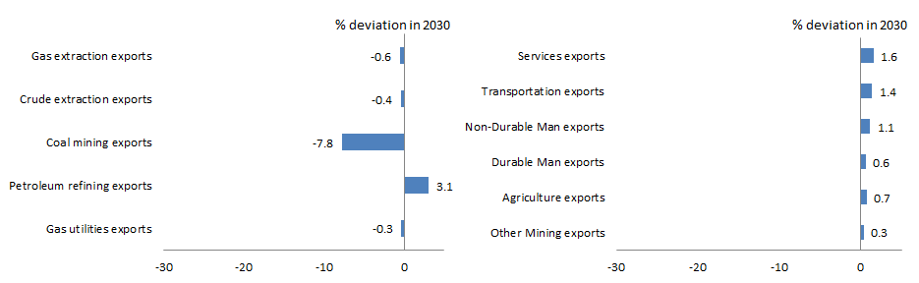
Output
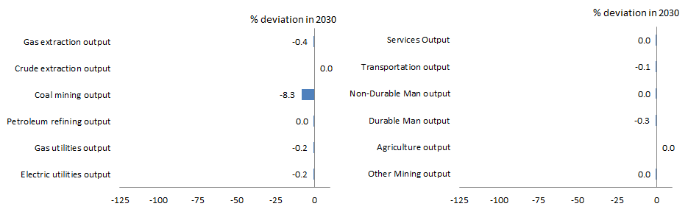
United States
Macroeconomic indicators
With the targets modelled, GDP in the US in 2030 is estimated to be 0.1 per cent lower than if countries did not take on post-2020 targets (Figure C-3).
Consumption is 0.4 per cent lower in 2030 compared with the Current Policies Scenario, as emissions policies raise prices and reduce real incomes. This is partially offset by increased investment in the electricity generation sector. The US exchange rate appreciates slightly as capital flows into the US to meet these investment requirements.
Figure C-3: United States: Key indicators under Paris Scenario – Real GDP, consumption, investment and trade balance, 2030 (percentage deviation from Current Policies Scenario)
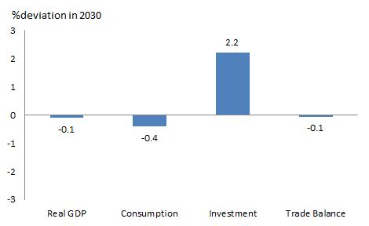
Note: Trade balance result is deviation in trade balance divided by GDP.
Trade impacts
The US trade deficit widens out to 2030 under both scenarios. In the Paris Scenario the competitiveness of US exports is reduced through higher domestic prices as a result of emissions policies, and through a higher exchange rate driven by net capital inflows. The US trade deficit is 1.5 per cent lower under the Paris Scenario than the Current Policies Scenario.
US exports are 0.6 per cent lower in 2030 compared to the Current Policies Scenario. Lower exports of durable goods make up half of this fall (Figure C-4). Imports are 0.03 per cent lower.
Sectoral impacts
While the modelling largely affects fossil fuel sectors, the nature of fossil fuels as an intermediate input to other sectors (particularly electricity generation) means that a substantial share of the decline in US economic output occurs in non-fossil fuel sectors.
However, firms’ demand for more energy efficient capital generates additional output that partly offsets the decline caused by climate action policies. Durable goods manufacturing output in 2030 increases with the introduction of climate policies (Figure C-4), and partially offsetting the output lost in the fossil fuel sectors. This is the sector that supplies most of the capital goods for investment.
Figure C-4: United States: Impacts of Paris Scenario, 2030 (percentage deviation from Current Policies Scenario)
Exports
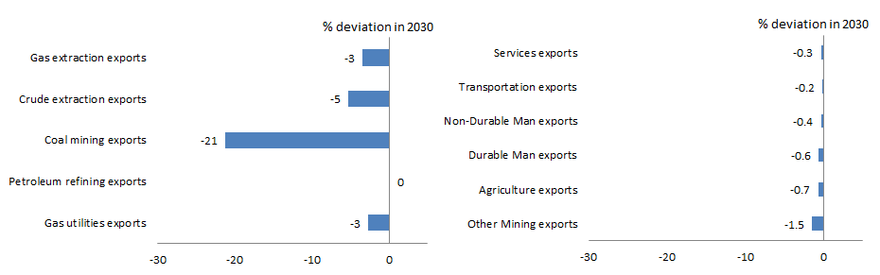
Output
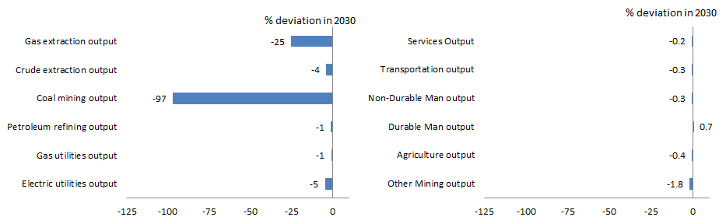
China
Macroeconomic indicators
With the targets modelled, GDP in China in 2030 is estimated to be 0.4 per cent lower than if countries did not take on post-2020 targets (Figure C-5).
Consumption falls as China’s climate policies raise prices and reduce real income. Investment also falls overall, although there is increased demand for more energy-efficient sources of capital in the electricity sector.
Figure C-5: China: Key indicators under Paris Scenario – Real GDP, consumption, investment and trade balance, 2030 (percentage deviation from Current Policies Scenario)
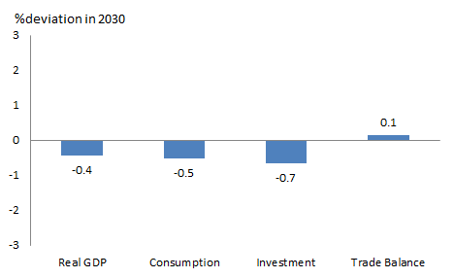
Note: Trade balance result is deviation in trade balance divided by GDP.
Trade impacts
China’s aggregate exports in 2030 are just one-third of a per cent lower under the Paris Scenario than in the Current Policies Scenario. Exports of durable and non-durable manufactures, which make up almost 90 per cent of total exports in 2030 under both scenarios, are 0.2 per cent and 0.3 per cent lower in 2030, respectively, than under the Current Policies Scenario (Figure C-6).
The effects of climate action on Chinese consumption and investment slow import growth. Combined with the relatively smaller reduction in exports, China’s net exports contribute positively to GDP growth out to 2030, partially offsetting the effects of lower consumption and investment. China’s imports in 2030 are around 1 per cent lower under the Paris Scenario than the Current Policies Scenario.
Chinese mining imports, including iron ore, continue to grow under the Paris Scenario. Mining imports are 0.6 per cent lower in 2030 than under the Current Policies Scenario.
Sectoral impacts
Under the Paris Scenario, output from all sectors grows to 2030, but more slowly than in the Current Policies Scenario. Most of the total reduction in China’s output relative to the Current Policies Scenario is in manufacturing, which makes up around two thirds of China’s economy. Durable and non-durable goods manufacturing output are 0.6 per cent and 0.4 per cent lower, respectively, in 2030 than under the Current Policies Scenario (Figure C-6). The largest proportional reductions in output relative to the Current Policies Scenario are in the relatively smaller energy sectors.
Figure C-6: China: Impacts of Paris Scenario, 2030 (percentage deviation from Current Policies Scenario)
Exports
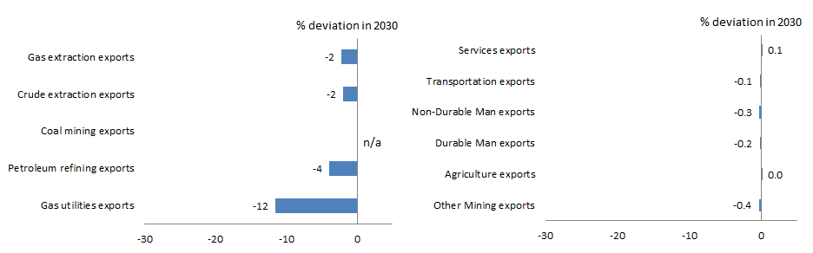
Output
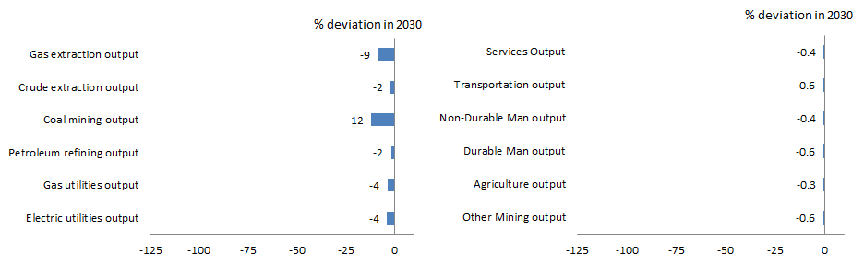
Japan
Macroeconomic indicators
With the targets modelled, GDP in Japan in 2030 is estimated to be 0.02 per cent lower than if countries did not take on post-2020 targets (Figure C-7). Reductions in investment due to the slowing of economic growth are partially offset by higher consumption.
There is a small increase in consumption under the Paris Scenario. Japan experiences a higher aggregate price level relative to other countries, which drives an appreciation in Japan’s real exchange rate, in turn lowering import prices and consumer prices, and increasing real incomes for Japanese consumers.
Figure C-7: Japan: Key indicators under Paris Scenario – Real GDP, consumption, investment and trade balance, 2030 (percentage deviation from Current Policies Scenario)
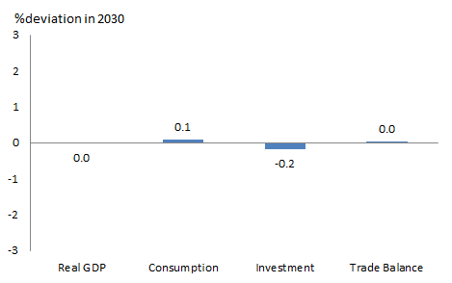
Note: Trade balance result is deviation in trade balance divided by GDP.
Trade impacts
Japan’s trade balance in 2030 is slightly improved relative to the Current Policies Scenario. Exports are lower, compared to the Current Policies Scenario (Figure C-8), but imports are also lower. The net impact is positive as aggregate exports fall less than imports.
Sectoral impacts
Under the Paris Scenario, Japan’s output continues to grow to 2030. Output from the services and manufacturing sectors, which dominate the economy, is less than one per cent smaller in 2030 compared with the Current Policies Scenario (Figure C-8). Large proportional reductions in output from the energy sectors have limited overall economic impacts due to their relatively small share of the Japanese economy.
Figure C-8: Japan: Impacts of Paris Scenario, 2030 (percentage deviation from Current Policies Scenario)
Exports
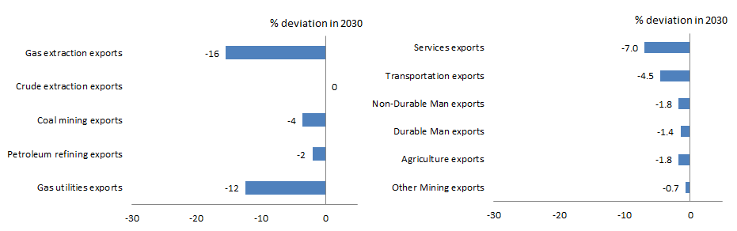
Output
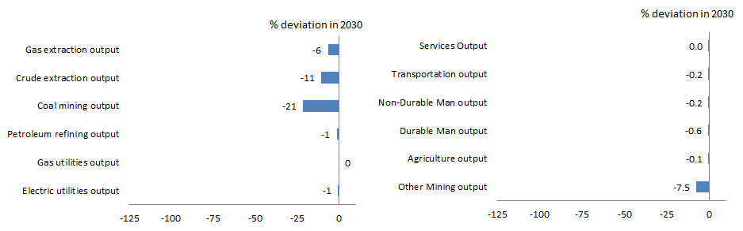
European Union
Macroeconomic indicators
With the targets modelled, GDP in the European Union in 2030 is estimated to be 0.2 per cent lower than if countries did not take on post-2020 targets (Figure C-9).
Consumption is slightly lower in 2030 relative to the Current Policies Scenario, as domestic price increases reduce real incomes and consumption, more than offsetting any real income benefit from a relatively higher real exchange rate. The price changes also cause a small reduction in investment in 2030 relative to the Current Policies Scenario.
Figure C-9: European Union: Key indicators under Paris Scenario – Real GDP, consumption, investment and trade balance, 2030 (percentage deviation from Current Policies Scenario)
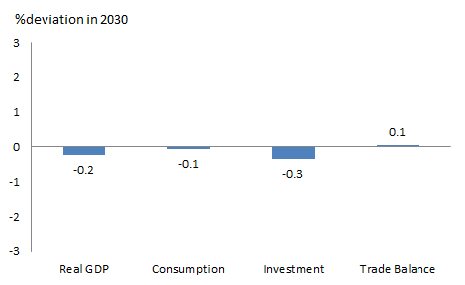
Note: Trade balance result is deviation in trade balance divided by GDP.
Trade impacts
Europe’s balance of trade in 2030 is slightly improved under the Paris Scenario, compared with the Current Policies Scenario. Imports are estimated to be around 2 per cent lower compared with the Current Policies Scenario, largely from reduced fossil fuel imports, and exports around 1.7 per cent lower. An appreciating real exchange rate, in response to net capital inflows, makes European exports less internationally competitive. The decline in exports is broad-based, as shown in Figure C-10, but is dominated by the manufacturing sector which makes up around 85 per cent of Europe’s exports.
Sectoral impacts
Under the Paris Scenario, Europe’s output continues to grow to 2030. Output from the services and manufacturing sectors, which dominate the economy, is less than one per cent smaller in 2030 compared with the Current Policies Scenario (Figure C-10). Large proportional reductions in output from the energy sectors have limited overall economic impacts due to their relatively small contribution to the economy.
Figure C-10: European Union: Impacts of Paris Scenario, 2030 (percentage deviation from Current Policies Scenario)
Exports
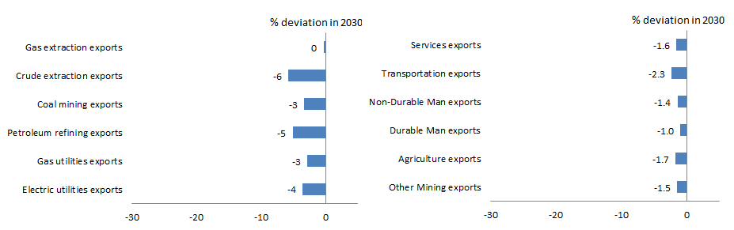
Output
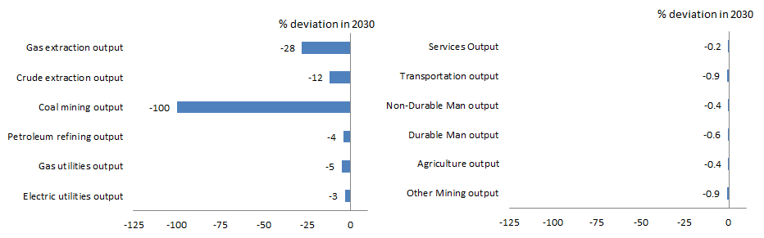
Canada
Macroeconomic indicators
With the targets modelled, GDP in 2030 is estimated to be 0.8 per cent lower than if countries did not take on post-2020 targets (Figure C-11).
Lower investment contributes around half the impact on Canada’s GDP of post-2020 targets in 2030. The targets result in rises in input prices, as energy prices rise, lowering investment and output across all sectors other than electricity generation. Investment increases in the electricity sector in response to demand for more energy-efficient capital. Consumption falls relative to the Current Policies Scenario, as higher prices reduce real income.
Figure C-11: Canada: Key indicators under Paris Scenario – Real GDP, consumption, investment and trade balance, 2030 (percentage deviation from Current Policies Scenario)
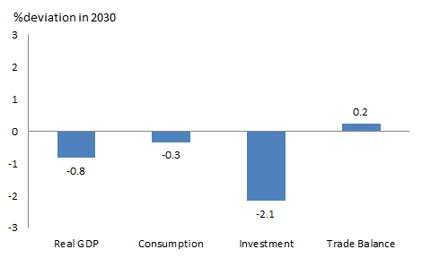
Note: Trade balance result is deviation in trade balance divided by GDP.
Trade impacts
Canada’s trade balance in 2030 improves slightly under the Paris Scenario, compared to the Current Policies Scenario. Imports are around 2 per cent lower, and exports 1 per cent lower. Imports fall as import prices rise, largely due to an appreciation in the US exchange rate. Higher export prices and reduced export demand arising from post-2020 emissions policies reduce fossil fuel exports, which make up 20 per cent of Canada’s export base. There is a partially offsetting increase in durable goods manufacturing exports to the US, as a result of the lower Canadian exchange rate (Figure C-12).
Sectoral impacts
Under the Paris Scenario, Canada’s output continues to grow to 2030. The energy sector experiences the largest reductions in output under the Paris Scenario (Figure C-12), but resources still contribute 10 per cent of Canada’s economy by 2030. Output from the services and manufacturing sectors is less than one per cent smaller in 2030 compared with the Current Policies Scenario.
Figure C-12: Canada: Impacts of Paris Scenario, 2030 (percentage deviation from Current Policies Scenario)
Exports
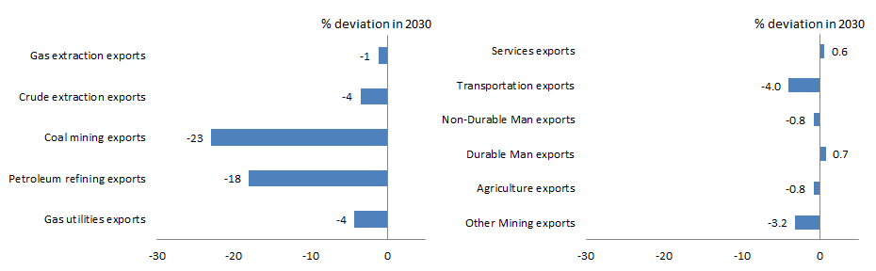
Output
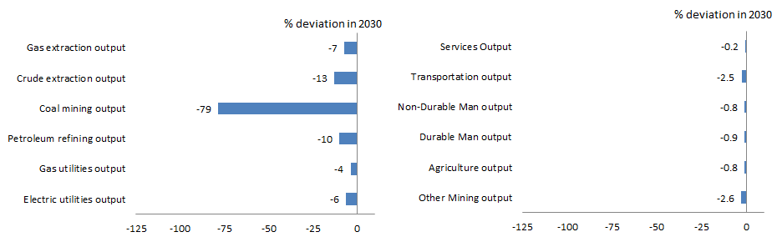

APPENDIX D:
Sensitivity testing
The modelling undertook two sensitivity scenarios. The first assesses the sensitivity of technology cost and policy mix assumptions. The second sensitivity scenario assesses the cost of policy uncertainty in Australia given that there is no Australian target in the modelling. This is modelled as an increase in the risk premium in Australian energy sectors.
Technology and policy mix assumptions
Projected impacts are sensitive to assumptions about future energy efficiency and renewable energy technology costs, which are inherently uncertain.
The modelling included sensitivity analysis of how varying the cost assumptions about low emissions energy technologies would affect the projected costs of the targets.
In modelling the Paris Scenario it is assumed that achieving emissions reductions through a mix of policies increases the price of electricity by 10 per cent more than caused by the cost-minimising policy. To test the sensitivity of the results to this technology cost assumption, the impacts were analysed for a higher cost increment of 50 per cent.
The modelling finds that in the sensitivity scenario the price of electricity in the US is approximately 50 per cent higher than under the Paris Scenario. The effect of higher electricity prices is transmitted through the economy with prices of all non-energy sectors rising by more under the high cost scenario than under the Paris Scenario.
The macroeconomic impacts on the US of the higher cost structure are shown in Figure D-1 (labelled ‘High cost’), together with the results for the Paris Scenario. The fall in GDP under the high cost scenario is twice as large as the Paris Scenario. Consumption is reduced due to higher electricity prices, but investment is higher because more expenditure is required to achieve the 2020 and post-2020 targets. Results are broadly similar in all countries where energy efficiency or non-fossil fuel expansion policies in electricity generation are undertaken.
Figure D-1: United States: Macroeconomic impacts, Technology and Policy Mix Scenario and Paris Scenario, 2030 (percentage deviation from Current Policies Scenario)
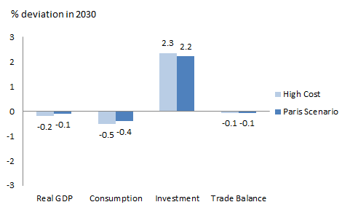
Notes:
‘High cost’ refers to the Technology and Policy Mix sensitivity scenario.
Trade balance result is deviation in trade balance divided by GDP.
Figure D-2 shows that a higher cost to other countries of reaching their targets reduces the impact of international action on Australia. This is because other economies are less competitive as a result of the higher cost policies, and Australia does not put forward new targets or policies in the modelling. As a result, exports of energy goods from Australia do not fall by as much as under the Paris Scenario and the Australian dollar is stronger. This tends to reduce exports of non-energy sectors slightly, but the real income effects of the currency change (and the enhanced competiveness relative to other countries) and the lower drop in energy exports has a net benefit to the Australian economy.
Figure D-2: Australia: Macroeconomic impacts, Technology and Policy Mix Scenario and Paris Scenario, 2030 (percentage deviation from Current Policies Scenario)
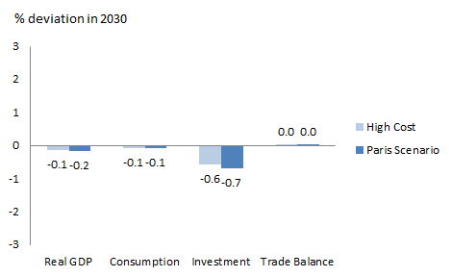
Notes:
‘High cost’ refers to the Technology and Policy Mix sensitivity scenario.
Trade balance result is deviation in trade balance divided by GDP.
Policy Uncertainty Scenario
The second sensitivity scenario focuses on the cost of policy uncertainty if Australia did not commit to any post-2020 target. This market uncertainty is modelled as an increase in the risk premium in Australian energy sectors of 4 per cent, compared with the Paris Scenario. This is a reasonable assumption relative to recent swings in risk premia observed in markets and calculations of the cost of policy uncertainty on the cost of debt for renewable energy in the US.
The results show that the impact of policy uncertainty (labelled ‘Higher risk’ in Figure D-3) on Australia’s real GDP is more than double the impact of international action in the Paris Scenario. This result is driven by changes to investment in the Australian economy.
Figure D-3: Australia: Macroeconomic impacts, Policy Uncertainty Scenario and Paris Scenario, 2030 (percentage deviation from Current Policies Scenario)
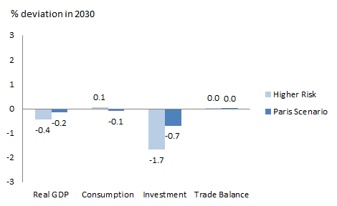
Notes:
‘Higher risk refers to the Policy Uncertainty sensitivity scenario.
Trade balance result is deviation in trade balance divided by GDP.
Figure D-4 shows the sectoral impacts on exports and output under the Paris Scenario and the Policy Uncertainty Scenario.
The higher uncertainty in the sensitivity scenario results in a significant contraction of output and exports in the energy sectors relative to the Paris Scenario. A higher risk premium implies less investment in these sectors which reduces the supply of production capacity in this sector and causes electricity prices to rise. This raises the cost of production in each energy sector which feeds into higher input costs across the economy. The slowdown in investment in the energy sectors raises the price of energy significantly.
The lack of investment in Australian energy generation also leads to less capital inflow and a depreciation of the Australian dollar. Sectors are hurt by higher energy input costs but trade exposed sectors benefit from a weaker currency.
Output and exports rise in some sectors such as services and non-durable manufacturing, but the higher input costs of energy particularly hurts sectors such as mining, transportation and durable manufacturing.
The modelling finds that overall the uncertainty arising from a lack of policy commitment has a large impact on investment and real GDP in the Australian economy. Even a relatively small risk premium shock can have significant consequences for investment in energy production and also on overall economic activity which feeds through all sectors of the economy.
Figure D-4: Australia: Sectoral impacts, Policy Uncertainty Scenario and Paris Scenario, 2030 (percentage deviation from Current Policies Scenario)
Exports
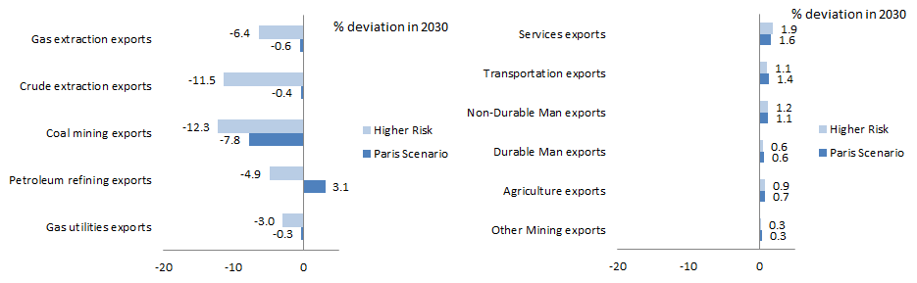
Output
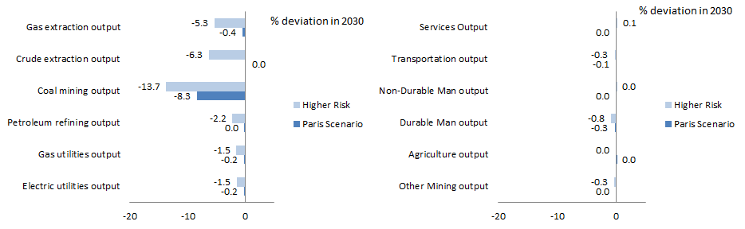
Note: ‘Higher risk refers to the Policy Uncertainty sensitivity scenario.

APPENDIX E:
Trade statistics

Table E-1: AUSTRALIA'S TOP 10 GOODS & SERVICES EXPORTS, 2014 (a)

Rank | Commodity | Value (A$ mil) | % share
 | Total trade (b) | 327,046
1 | Iron ores & concentrates | 66,005 | 20.1
2 | Coal | 37,999 | 11.6
3 | Natural gas | 17,760 | 5.4
4 | Education-related travel services | 17,037 | 5.2
5 | Personal travel (excl education) services | 14,227 | 4.4
6 | Gold | 13,460 | 4.1
7 | Crude petroleum | 10,582 | 3.2
8 | Beef | 7,751 | 2.4
9 | Aluminium ores & concentrates (incl alumina) | 6,321 | 1.9
10 | Wheat | 5,920 | 1.8

(a) Goods trade are on a recorded trade basis, Services trade are on a balance of payments basis.
(b) Total is balance of payments basis for all trade including top 10 commodities.
Based on ABS trade data on DFAT STARS database and ABS catalogue 5368.0 (Mar 2015).

Table E-2: AUSTRALIA'S TOP 10 GOODS & SERVICES IMPORTS, 2014 (a)

Rank | Commodity | Value (A$ mil) | % share
 | Total trade (b) | 336,971
1 | Personal travel (excl education) services | 24,597 | 7.3
2 | Crude petroleum | 20,199 | 6.0
3 | Refined petroleum | 18,662 | 5.5
4 | Passenger motor vehicles | 17,566 | 5.2
5 | Telecom equipment & parts | 9,845 | 2.9
6 | Freight transport services | 9,686 | 2.9
7 | Medicaments (incl veterinary) | 7,497 | 2.2
8 | Computers | 7,317 | 2.2
9 | Passenger transport services (c) | 6,141 | 1.8
10 | Goods vehicles | 6,008 | 1.8

(a) Goods trade are on a recorded trade basis, Services trade are on a balance of payments basis.
(b) Total is balance of payments basis for all trade including top 10 commodities.
(c) Includes related agency fees & commissions.
Based on ABS trade data on DFAT STARS database and ABS catalogue 5368.0 (Mar 2015).

REFERENCES
Climate Change Authority 2014, Reducing Australia’s Greenhouse Gas Emissions – Targets and Progress Review.
Department of the Environment 2015, Australia’s emissions projections 2014-15, Australian Government.
Department of the Treasury 2008, Australia’s Low Pollution Future: The economics of climate change mitigation.
Department of the Treasury 2011, Strong Growth, Low Pollution: Modelling a carbon price.
Department of the Treasury 2014, Mid-year economic and fiscal outlook 2014-15.
Department of the Treasury and DIICCSRTE 2013, Climate Change Mitigation Scenarios: Modelling report provided to the Climate Change Authority in support of its Caps and Targets Review.
Environment Canada 2015, “16 January 2015. Regulating Canada’s Greenhouse Gas Emissions” (http://climatechange.gc.ca/default.asp?lang=En&n=4FE85A4C-1)
International Energy Agency 2015, World Energy Outlook 2015.
Jotzo, F. 2011, “Comparing the Copenhagen Emissions Targets”, Crawford School Centre for Climate Economics & Policy Paper No. 1.10.
Kuramochi, T. 2014, GHG Mitigation in Japan: An Overview of the Current Policy Landscape, Working Paper, World Resources Institute, June.
McKibbin, W., Morris, A. and Wilcoxen, P. 2011, “Comparing Climate Commitments: A model-based analysis of the Copenhagen Accord”, Climate Change Economics, Vol 2, No 2. pp 79-103.
McKibbin, W. and Wilcoxen, P. 2013, “A Global Approach to Energy and the Environment: The G-cubed Model”, Handbook of CGE Modeling, Chapter 17, North Holland, pp 995-1068.
McKibbin Software Group 2015, Economic Modelling of Australian Climate Action Under a New Global Climate Change Agreement, for the Department of Foreign Affairs and Trade, July (unpublished).
United Nations 2002, International Industrial Classification of All Economic Activities (ISIC) Revision 3.1 (http://unstats.un.org/unsd/cr/registry/regcst.asp?Cl=17)
United Nations 2012, World Population Prospects, the 2012 Revision.
U.S. Energy Information Administration 2015, Annual Energy Outlook 2015.
Varadarajan, U., Nelson, D., Pierpont, B. and Hervé-Mignucci, M. 2011, “The Impacts of Policy on the Financing of Renewable Projects: A Case Study Analysis”, Climate Policy Initiative, San Francisco.

Based on DFAT analysis as at 29 April 2015. See Appendix A for a full list of countries that have put forward post-2020 targets.
A full list of announced intended Nationally Determined Contributions is at Appendix A.
Some technical adjustments were made to fit the objectives of the work. These adjustments are explained in Appendix B. The exact model used is G-cubed version E123.
Report 2 examines the impact of possible Australian targets, building on the modelling in Report 1.
The analysis is based on the draft US Clean Power Plan and does not include the US Clean Power Plan announcement of 3 August 2015.
At the time of modelling China had not announced a formal post-2020 target. (See Appendix A.)
Based on “With Measures” projection from Japan’s First Biennial Report. Excludes LULUCF emissions.
See Kuramochi (2014), p 3.
The first fifteen members of the European Union (Austria, Belgium, Denmark, Finland, France, Germany, Greece, Ireland, Italy, Luxembourg, Netherlands, Portugal, Spain, Sweden, United Kingdom) as well as Norway, Iceland and Switzerland.
See Environment Canada (2015).
DFAT analysis based on emissions data published by Environment Canada (2015).
This point is clearly established in McKibbin, Morris and Wilcoxen (2011) and Jotzo (2011).
Varadajan et al (2011) found that the cost of debt varies between 200 and 600 basis points depending on the clarity around renewable energy pricing in the US.
Department of the Treasury (2008 and 2011), Department of the Treasury and DIICCSRTE (2013).
Department of the Treasury and DIICCSRTE (2013).
See McKibbin and Wilcoxen (2013).
United Nations (2002)
For most countries, electricity utilities exports are not reported because they are zero or very small. Although Canada exports electricity to the US this is not reported because the results are skewed by the presence in the ‘Rest of OECD’ grouping of New Zealand. Electricity utilities exports are reported for the EU.
Impacts for the ‘Rest of OECD’ grouping, which consists of Canada and New Zealand, are considered indicative of the impacts on Canada because of the relative size of its economy.
See Varadajan et al (2011).

