REPORT 2: 2015 Economic modelling of Australian action under a new global climate change agreement

McKibbin Software Group
20 August 2015
  - FINAL REPORT

This report follows Economic Modelling of International Action Under a New Climate Change Agreement (Report 1). This report focuses on different levels of policy commitment in Australia, under different assumptions about the scale of emission reduction targets, energy technology costs, and the mix of policies used. The results highlight the range of economic outcomes and some of the uncertainties in the cost of an Australian post-2020 target.

This report has been prepared by Professor Warwick J. McKibbin, Director of Research, McKibbin Software Group Pty Ltd in consultation with the Department of Foreign Affairs and Trade (DFAT).

Technical information and background assumptions are provided in the appendices and in Report 1. All prices are in real United States dollars unless otherwise indicated.

Contents

Executive Summary 5

Introduction 6

Methodology 8

Modelling results for Australia 11

Appendices 18
- Emissions and abatement under target scenarios 18
B. Overall economic impacts 19
C. Key economic indicators 21
D. Sectoral impacts 24
E. Sensitivity to technology cost assumption 28
F. Sensitivity to policy mix assumption 30

References 34

List of Tables and Figures

Table 1: Key indicators (percentage deviation in 2030 from Paris scenario) | 13
Table 2: Target impacts on GDP, Australia and key countries, 2030 (percentage deviation) | 15
Table A-1: Energy sector emissions and abatement – core target scenarios and policy mix sensitivity analysis, 2030 (Mt CO₂) | 18
Table C-1: Key indicators – core target scenarios and policy mix sensitivity analysis, 2030 (percentage deviation from Paris scenario) | 23
Table C-2: Average annual GDP growth – Paris scenario, core target scenarios and policy mix sensitivity analysis, 2020 to 2030 (per cent) | 23
Table E-1: Average annual GDP growth – Paris scenario, core target scenarios and technology cost sensitivity scenarios, 2020 to 2030 (per cent) | 29
Figure 1: Target paths for emissions from energy, 2015 to 2030 (Mt CO₂) | 9
Figure 2: Cumulative abatement from energy, relative to the Paris scenario, 2020 to 2030 (Mt CO₂) | 9
Figure 3: Average annual growth, real Australian GDP, core target scenarios and Paris scenario, 2020 to 2030 (per cent per year) | 11
Figure 4: Australian real GDP, core target scenarios, 2020 to 2030 | 12
Figure 5: GDP impacts, core target scenarios and technology cost sensitivity scenarios, 2030 (percentage deviation from Paris scenario) | 13
Figure 6: Macroeconomic impact of -26 per cent target, 2030 (percentage deviation from Paris scenario) | 14
Figure 7: GDP growth, Australia and key countries, 2020 to 2030 (per cent) | 15
Figure 8: Energy sector impacts of -26 per cent target, 2030 (percentage deviation from Paris scenario) | 16
Figure B-1: Economic impacts – core target scenarios, 2015 to 2030 (percentage deviation from Paris scenario) | 19
Figure B-2: Economic impacts – technology cost sensitivity scenarios, 2015 to 2030 | 20
Figure C-1: Key indicators – core target scenarios and policy mix sensitivity analysis, 2030 (percentage deviation from Paris scenario) | 21
Figure D-1: 13% reduction target – core target scenario and policy mix sensitivity analysis, 2030 (percentage deviation from Paris scenario) | 24
Figure D-2: 26% reduction target – core target scenario and policy mix sensitivity analysis, 2030 (percentage deviation from Paris scenario) | 25
Figure D-3: 35% reduction target – core target scenario and policy mix sensitivity analysis, 2030 (percentage deviation from Paris scenario) | 26
Figure D-4: 45% reduction target – core target scenario and policy mix sensitivity analysis, 2030 (percentage deviation from Paris scenario) | 27
Figure E-1: Changes in GDP and GNI – core target scenarios and technology cost sensitivity scenarios, 2030 (percentage deviation from Paris scenario) | 29
Figure F-1: Cumulative abatement, domestic abatement and international units – policy mix sensitivity analysis, 2020 to 2030 (Mt CO₂) | 30
Figure F-2: GDP impacts, core target scenarios and policy mix sensitivity analysis, 2030 (percentage deviation from Paris scenario) | 31
Figure F-3: Impacts of the -26 per cent target, core target scenarios and policy mix sensitivity analysis, 2030 (percentage deviation from Paris scenario) | 32

Executive Summary

The Australian economy is expected to grow strongly to 2030 regardless of whether Australia adopts a post-2020 target.

The modelling explores four Australian targets for 2030, and compares these targets to Australia taking no further action after 2020 to limit emissions. The impact of the future costs of new energy technologies is also investigated. The analysis accounts for the costs of achieving abatement in the energy sector, and builds on previous commissioned modelling (Report 1) of the impacts of other countries’ post-2020 targets.

Under all four targets, average annual GDP growth continues to be above 2 per cent. Stronger targets have larger economic impacts. Growth rates range from 2.09 to 2.18 per cent a year.

A post-2020 target will cause a small slowing of economic growth. By 2030, all impacts are no more than one per cent of GDP. A 2030 target of -13 per cent (relative to 2005 levels) holds emissions constant from 2020 through to 2030. This results in GDP being 0.2 to 0.3 per cent lower in 2030 than it would be with no target. This range reflects different technology cost assumptions in the modelling.

Targets of -26, -35 and -45 per cent relative to 2005 result in GDP being from 0.4 to 1.0 per cent lower in 2030 than with no target.

Relative to holding emissions constant from 2020 – that is, compared against a -13 per cent target – a target of -26 per cent is estimated to reduce GDP in 2030 by 0.2 to 0.3 per cent. Higher targets of -35 and -45 per cent would reduce GDP in 2030 by 0.3 to 0.5 per cent and 0.5 to 0.7 per cent respectively, relative to the -13 target.

The cost impacts for Australia in this report do not include the cost impacts from Report 1.

A post-2020 target will have a slightly higher impact on Australia’s economy than most other developed economies, but Australia is expected to grow faster than Japan, the EU and Canada. Consistent with other studies, the modelling finds that Australia faces larger economic impacts than most other developed economies to achieve similar emissions reductions relative to a historical base year.

The impacts for Australia are higher than the GDP impacts of the US and EU targets, and around the same impact as China’s target – noting China has much lower income and emissions per person than Australia. Canada is the exception, with the modelling indicating Canada’s GDP impacts from its announced post-2020 target would be higher than either a -26 or a -35 target for Australia.

Target impacts are sensitive to future costs of new energy technologies. The core target scenarios assume relatively high abatement costs in the energy sector. Sensitivity analysis finds that economic impacts might be around 30 per cent less with lower, but still plausible, assumptions about future energy technology costs.

A further sensitivity scenario examines how assumptions about the policy mix used to achieve Australia’s post-2020 target influence impacts under the four target scenarios.

Introduction
DFAT COMMISSIONED ECONOMIC MODELLING to ASSESS THE IMPACT on Australia of differeNt Domestic emissions targets. Additional modelling Assesses the impact of assumptions about energy technology costs and the policy mix.

this report builds on PREVIOUS commissioned modelling (Report 1) that assessed the impacts globally and in Australia of other countries’ targets

A new global agreement
Parties to the United Nations have agreed under the Framework Convention on Climate Change to negotiate a new global agreement with all countries taking action in the period after 2020 to reduce greenhouse gas emissions. These nationally determined emission reduction targets will form the core of this new agreement.
Economic modelling can help to assess the impacts
In a first stage of modelling to assess the impact of the new global agreement (Report 1), DFAT commissioned McKibbin Software Group to use the G-Cubed Multi-Country Model of McKibbin and Wilcoxen (2013) to undertake economic modelling of key countries’ post-2020 targets, with two objectives:
- Assess the impact on the US, China, Japan, Europe and the world of collective international post-2020 climate change targets and policies; and
- Assess the impact on Australia of international action by those countries and others, in the absence of additional commitments or policies by Australia.
Results of the first stage of modelling are in the companion report Economic Modelling of International Action Under a New Climate Change Agreement (Report 1).
This report extends that analysis to action by Australia.
Scope and Limitations of Modelling
The modelling takes as given the policies that are modelled in Report 1.
Policy implementation is focused on reductions in carbon dioxide (CO₂) emissions from the electricity sector, consistent with the emphasis of policies and targets announced by key countries. It does not account for potential reductions in non-energy industrial emissions (such as CO₂ from cement manufacturing), non-CO₂ emissions from livestock, or potential emissions and sequestration associated with land use change.
The model accounts for energy sector carbon dioxide (CO₂) emissions – specifically, emissions from fuel combustion. Fugitive emissions from fuels are not covered. Unless specified otherwise, no assumptions are made about the cost of reducing emissions not covered by the model.
Energy emissions policies are represented in a stylised way for Australia; other policies relating to non-energy and non-CO₂ sectors are not covered. As a result, the modelling results are not a complete picture for abatement in non-energy sectors. The modelling assesses policies that have been announced or that are considered likely to be implemented, and assumes that implemented policies are cost effective.
While the modelling can help explain the economic consequences of alternative post-2020 climate change action, there are other factors that could be considered in target setting that are not addressed in this modelling. These include the economic advantages of avoided climate damages, and long-term targets and economic transition beyond 2030.
The results are sensitive to the specific assumptions made, including future technology costs. Given the difficulty of predicting future economic conditions and countries’ actions, all results should be understood to be an expected outcome with a relatively large band of uncertainty around the estimates. They should be treated as indicative of the orders of magnitude of policy impacts and the likely relative size of impacts across sectors and countries.
The cost impacts for Australia in this report do not include the economic impact on Australia of other countries’ post-2020 targets. These are examined in Report 1.
Methodology
FOUr alternative target paths capture the potential impacts on australia of post-2020 action.
- Emissions targets are modelled focussing on changing the energy structure of the Australian economy.
- Sensitivity analysis provides information on how energy technology costs and the policy mix affect impacts.

This report looks at the outcomes for Australia of different domestic emission targets to 2030. The impact of varying assumptions about the cost of taking action in the energy sector is also examined.
Impacts are estimated by comparing results for each target with results for Australia from the ‘Paris’ scenario (Report 1). The Paris scenario modelled the economic impact of ‘Nationally Determined Contributions’ and commitments under the new global agreement that is due to be finalised in Paris in December 2015. In the Paris scenario, all major countries other than Australia were assumed to take on and achieve post-2020 targets. Comparing against the Paris scenario shows the impact of Australian target policies, separate from the unavoidable impacts on Australia of other countries’ actions.
Alternative Targets
Four different post-2020 targets are considered. The model focusses on emissions from fuel combustion, rather than economy wide emissions, and assumes that for the four target scenarios, emissions abatement in the energy sector contributes two thirds of the “effort” of the abatement task. Official Government projections estimate that the energy sector will contribute around two thirds of Australia’s emissions in 2020 and 2030 (from all gases).
Emissions reductions targets of 26, 35 and 45 per cent below 2005 levels by 2030 are modelled. A fourth benchmark scenario models a 13 per cent reduction on 2005 emissions, which would hold total emissions constant at the level of Australia’s 2020 target from 2020 to 2030.
The target trajectories are assumed to start from Australia’s 2020 emissions target of 5 per cent below 2000 levels.
Emissions pathways for the four modelled targets are summarized in Figure 1. Results are reported relative to the Paris scenario (labelled ‘Paris’). The 13 per cent path rises slightly as the energy sector share of total emissions increases over time in the Paris scenario. Figure 2 shows cumulative abatement from energy under the targets relative to the Paris scenario. Appendix A presents economy-wide and energy sector emissions and abatement under the four targets.
Figure 1: Target paths for emissions from energy, 2015 to 2030 (Mt CO₂)*
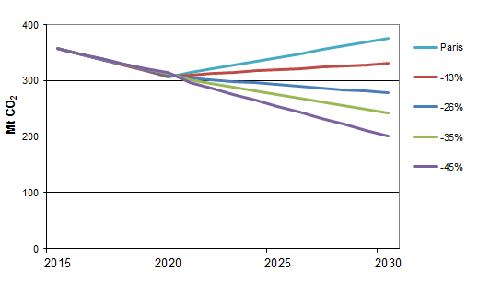
* Million tonnes of carbon dioxide
Figure 2: Cumulative abatement from energy, relative to the Paris scenario, 2020 to 2030 (Mt CO₂)
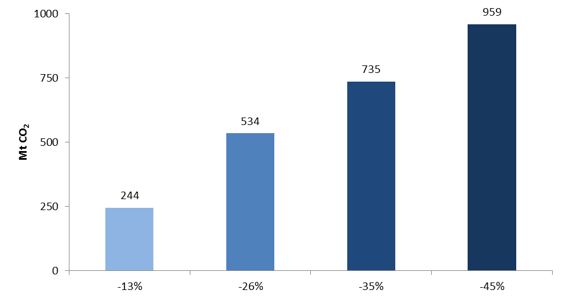

Australian policy modelled as sector-based policies
The modelling achieves the energy component of Australia’s targets through reducing CO₂ emissions from the energy sector. This involves reducing the share of coal-powered electricity and increasing the shares of gas and renewable energy, along with investments to improve energy efficiency.
This approach to modelling Australia’s targets is similar to the approach in Report 1 in which countries pursue a mix of energy efficiency and energy sector policies to reach the policy commitment. Further detail is contained in Report 1.
The modelling does not provide a robust estimate of the costs or potential to reduce Australia’s non-energy greenhouse emissions, such as CO₂ and non-CO₂ emissions from non-energy industrial processes (including from cement manufacturing and aluminium production), non-CO₂ emissions from livestock, or potential emissions and sequestration associated with land use change.
As a result, the modelling is deliberately conservative, and assumes the costs of reducing energy emissions are relatively high (through assumptions at the high end of the range for energy technology costs).
The implications of lower technology costs are addressed in sensitivity analysis on each of the four targets in Appendix D. The lower technology costs align with technology cost assumptions applied to key countries in Report 1.
The implications of varying the policy mix are investigated in sensitivity analysis in Appendix E. The sensitivity analysis allows international units to meet some – around 45 per cent – of the emissions abatement for each of the target scenarios. The analysis assumes these offsets are purchased from low income countries in the ‘rest of the world’ grouping, which includes developing countries other than China.
Modelling results for Australia
Australia continues to grow under each of the post-2020 targets.
- An Australian emissions target in 2030 of between 13 per cent and 45 per cent below 2005 LEVELS IS estimated to reduce real gDP by between 0.2 Per cent and 1.0 per cent by 2030.

Australian real gross domestic product (GDP) is projected to grow between 2.09 and 2.18 per cent per year (on average) from 2020 to 2030 across the range of Australian emissions targets (the ‘core target scenarios’), based on the technology costs assumed in the core target scenarios (Figure 3). Without a post-2020 target (the ‘Paris’ scenario), it is estimated GDP growth would average 2.21 per cent per year.
Figure 3: Average annual growth, real Australian GDP, core target scenarios and Paris scenario, 2020 to 2030 (per cent per year)
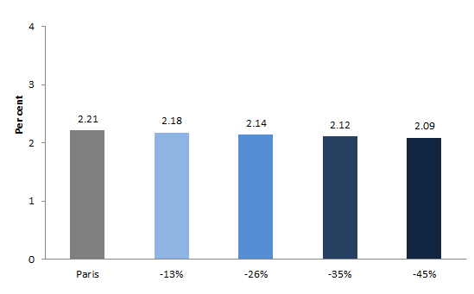
Figure 4 shows GDP results from 2015 to 2030 under each of the four core target scenarios (-13%, -26%, -35% and -45%) and the Paris scenario with no Australian post-2020 target. The upper panel shows the percentage difference in GDP relative to no Australian target (the ‘Paris’ scenario). The lower panel shows the absolute level of GDP under the core target scenarios and the Paris scenario. The closeness of the five trajectories in the lower panel arises because the spread across the scenarios in 2030 is 1 per cent of GDP.
The modelling projects that the announcement of the post-2020 target in 2015 provides a modest stimulus to GDP growth before 2020, due to increased investment in electricity generation assets, but slightly lower trend economic growth after 2020.
Figure 4: Australian real GDP, core target scenarios, 2020 to 2030
Deviation from Paris scenario (per cent)
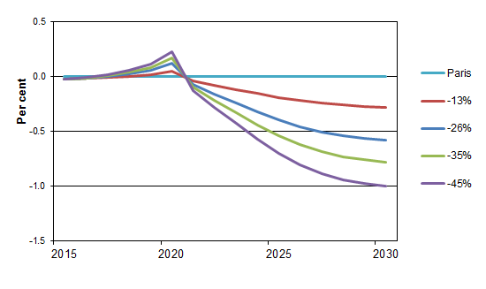
Absolute level (2012 US trillion dollars)
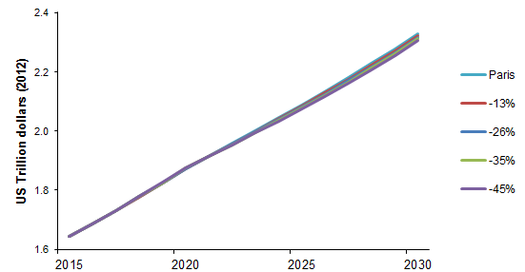
Note: Closeness of trajectories in bottom panel reflects that difference in GDP in 2030 from highest to lowest scenario is 1 per cent of GDP, as shown in the top panel.
Impacts in 2030
The core target scenarios estimate that targets ranging from -26 to -45 per cent would result in GDP being 0.6 to 1.0 per cent lower in 2030 compared to without a target (Figure 5 and Table 1).
These projected impacts are sensitive to the underlying assumptions. Assuming lower energy technology costs reduces these impacts by around one third. Under the lower cost assumptions, targets ranging from -26 to -45 per cent would reduce GDP in 2030 by between 0.4 and 0.7 per cent. (Sensitivity analysis on energy technology costs is presented in Appendix E and Table 1).
Figure 5: GDP impacts, core target scenarios and technology cost sensitivity scenarios, 2030 (percentage deviation from Paris scenario)
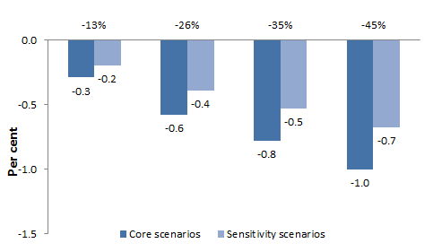
Table 1: Key indicators (percentage deviation in 2030 from Paris scenario)
 | Core target scenarios |  |  |  | Sensitivity scenarios - technology costs
Target | -13% | -26% | -35% | -45% | -13% | -26% | -35% | -45%
Real GDP | -0.29 | -0.58 | -0.78 | -1.00 | -0.20 | -0.39 | -0.53 | -0.68
Real GNI¹ | -0.27 | -0.56 | -0.76 | -0.98 | -0.18 | -0.38 | -0.52 | -0.67
1. Gross national income
The emissions targets are achieved by replacing existing capital in the electricity generation sector by lower emission or non-fossil fuel technologies. As these technologies are more expensive, the price of electricity rises. This reduces demand for electricity and for fossil fuels in generating electricity, and increases energy costs for the entire economy. The inputs used to produce these technologies are mostly purchased from the durable goods sector. Producing these new technologies increases durable goods demand from the electricity sector, although this growth does not fully offset the effects of higher energy costs.
The investment in the electricity sector that is required to meet the emissions target is partly funded through lower private consumption before 2030. Real income and GDP both grow more slowly as a result of higher energy prices and business input costs. The fall in GDP from higher input costs is consistent with the mix of lower consumption and higher investment in the Australian economy. This is illustrated in Figure 6 for the -26 per cent target. Full results for the core target scenarios are reported in Appendix C.
Figure 6: Macroeconomic impact of -26 per cent target, 2030 (percentage deviation from Paris scenario)
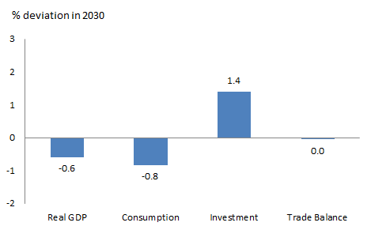

Comparison with impacts on other countries of their own targets
The modelling, together with Report 1, finds that Australia and Canada face larger economic impacts than other developed economies, including the US and EU, in achieving similar emissions reductions relative to a historical baseline.
Report 1, which examines the impacts other countries experience from their post-2020 targets, assumed a Canadian target in 2030 of 22 per cent below 2005 levels. It estimated such a target would reduce Canada’s GDP by around 0.8 per cent in 2030 (Table 2). Canada has since announced a target of 30 per cent below 2005, so the modelled result is likely an underestimation.
Depending on future technology costs, the current modelling estimates that a 2030 target of -26 per cent would reduce Australian GDP by 0.4 to 0.6 per cent, compared against no target. A -35 per cent target would reduce Australian GDP by 0.5 to 0.8 per cent (Figure 5).
Impacts for Australia are stronger than the impacts the US, the EU and Japan would experience from their targets. The US and Japan are estimated to experience the smallest impacts from their targets, with GDP reduced by 0.1 per cent and 0.02 per cent respectively in 2030. GDP in the European Union is estimated to be reduced by around 0.2 per cent in 2030 as a result of its targets.
The impact on Australia is estimated to be similar to the impact for China. China’s target is estimated to reduce its GDP in 2030 by 0.45 per cent.
Table 2: Target impacts on GDP, Australia and key countries, 2030 (percentage deviation)
 | Modelled emissions pathway (2005-2030) | Change in GDP  (per cent)
US | -37%¹ | -0.1
Japan | -22%² | -0.02
Europe | -34% | -0.2
Canada | -22%² | -0.8
China | Peaking in 2030 | -0.4
Australia |  | Core target scenarios | Sensitivity scenarios - technology costs
 | -13% | -0.3 | -0.2
 | -26% | -0.6 | -0.4
 | -35% | -0.8 | -0.5
 | -45% | -1.0 | -0.7
1 The straight line extension of the trajectory from the US target 2020 target to its 2025 target.
2. Japan and Canada have since announced targets of -25.4 percent and -30 per cent below 2005 levels, respectively.
Figure 7 shows these estimated target impacts for Australia and other countries. All the economies, including Australia, continue to grow and at similar rates to their growth in the absence of targets.
Figure 7: GDP growth, Australia and key countries, 2020 to 2030 (per cent)
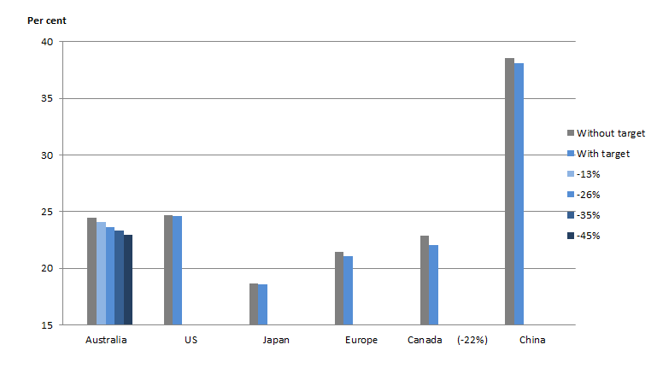
Note: Report 1 modelled a 2030 target of 22 per cent below 2005 levels for Canada.
Energy-focussed policy concentrates impacts in energy sectors, particularly coal
The model covers only energy-related CO₂ emissions so the policy mix assessed impacts directly on energy sectors, and indirectly on other sectors. Coal production is most strongly affected by a domestic target, as shown for the -26 per cent reduction target in Figure 8. Coal mining output is 14 per cent lower than without an Australian target. This reflects the fact that coal has the highest CO₂ emissions per unit of energy, and electricity generators shift away from coal towards gas and renewable energy. The coal, gas and petroleum extraction sectors remain a significant part of the economy, contributing around 2 per cent of output and one sixth of exports in 2030 – relatively unchanged from the Paris scenario. The results in Figure 8 are similar in relativities for the other core target scenarios. Impacts across all sectors and for all four core target scenarios are presented in Appendix D.
Figure 8: Energy sector impacts of -26 per cent target, 2030 (percentage deviation from Paris scenario)
Output
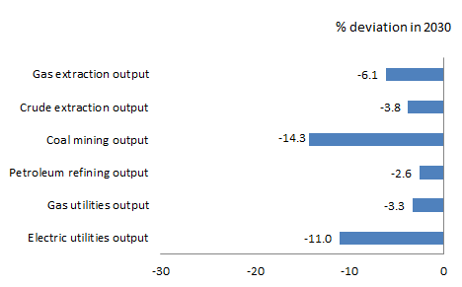
Exports
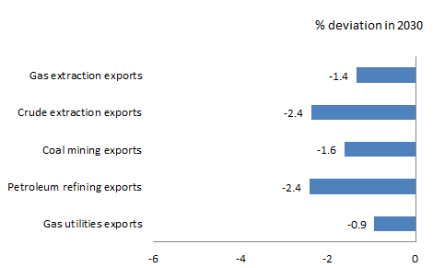

A domestic target is estimated to have a limited impact on energy exports. Most CO₂ emissions associated with energy arise from fuel combustion, which occurs in the country of export, rather than from Australian mining or extraction activities. (Report 1 finds that Australian energy exports and production are affected by the targets adopted in Australia’s energy export markets, as energy demand in those countries is impacted by their respective targets.)
The impacts on non-energy sectors from an Australian target are small, as they are impacted only indirectly by the energy sector policies modelled.
Appendix F presents sensitivity analysis on changing the policy mix. It finds that allowing some use of international units – around 45 per cent of abatement – reduces economic impacts by between one third and two thirds depending on the target.

Appendix A: Emissions and abatement under target scenarios
Table A-1: Energy sector emissions and abatement – core target scenarios and policy mix sensitivity analysis, 2030 (Mt CO₂)
 | Core target scenarios |  |  |  | Sensitivity scenarios –  policy mix
Target | -13% | -26% | -35% | -45% | -13% | -26% | -35% | -45%
Target emissions | 330.4 | 277.6 | 241.1 | 200.5 | 330.4 | 277.6 | 241.1 | 200.5
Emissions reduction | 45.6 | 98.4 | 134.9 | 175.5 | 45.6 | 98.4 | 134.9 | 175.5
Domestic abatement | 45.6 | 98.4 | 134.9 | 175.5 | 25.3 | 54.5 | 74.8 | 97.3
International units | na | na | na | na | 20.3 | 43.8 | 60.1 | 78.2

APPENDIX B: Overall economic impacts
Figure B-1: Economic impacts – core target scenarios, 2015 to 2030 (percentage deviation from Paris scenario)
Real GDP
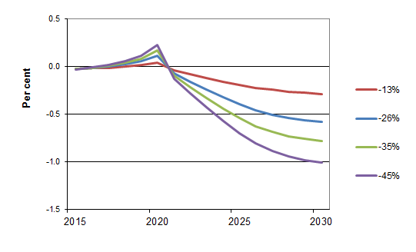
Real GNI
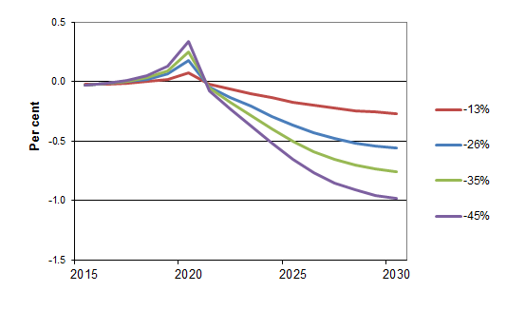

Figure B-2: Economic impacts – technology cost sensitivity scenarios, 2015 to 2030 (percentage deviation from Paris scenario)
Real GDP
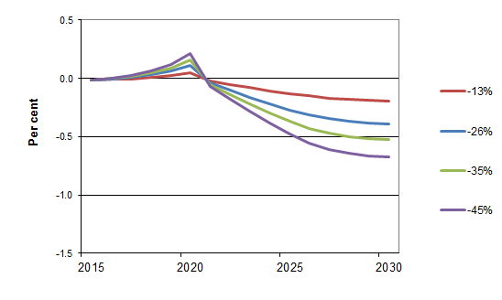
Real GNI
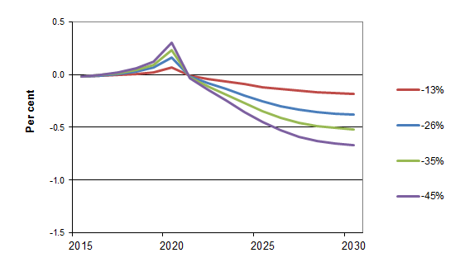

APPENDIX C: Key economic indicators
Figure C-1: Key indicators – core target scenarios and policy mix sensitivity analysis, 2030 (percentage deviation from Paris scenario)
Real GDP, consumption, investment, trade balance
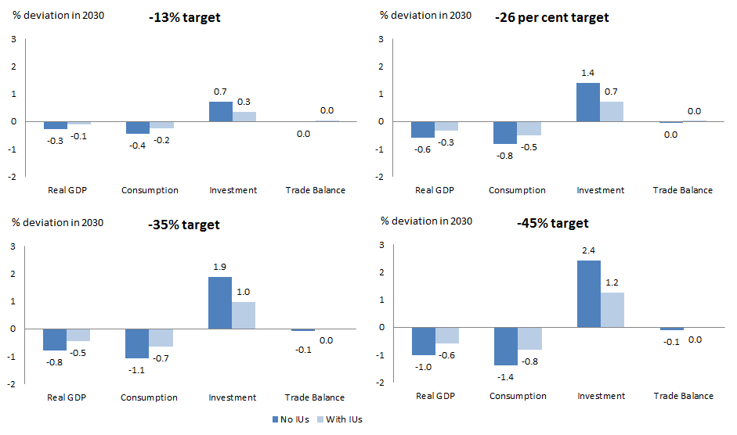
Note: IUs refers to sensitivity analysis on the policy mix, where the use of some international units is assumed (see Appendix F for details).
Employment, real wage, price
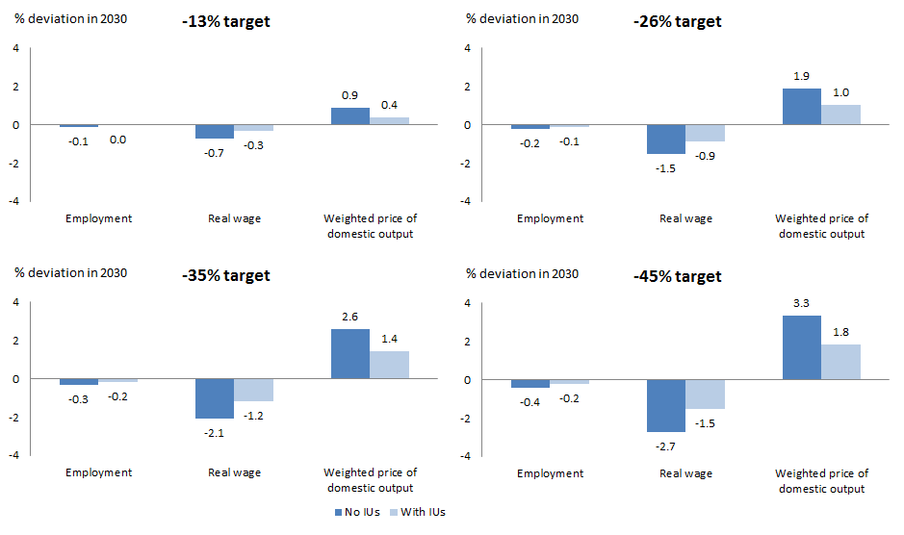
Note: IUs refers to sensitivity analysis on the policy mix, where the use of some international units is assumed (see Appendix F for details).

Table C-1: Key indicators – core target scenarios and policy mix sensitivity analysis, 2030 (percentage deviation from Paris scenario)
 | Core target scenarios |  |  |  | Sensitivity scenarios – policy mix (with international units)
 | -13% | -26% | -35% | -45% | -13% | -26% | -35% | -45%
Real GDP | -0.29 | -0.58 | -0.78 | -1.00 | -0.12 | -0.34 | -0.45 | -0.58
Real GNI | -0.27 | -0.56 | -0.76 | -0.98 | -0.11 | -0.33 | -0.45 | -0.59
Consumption | -0.44 | -0.82 | -1.09 | -1.38 | -0.24 | -0.51 | -0.66 | -0.83
Investment | 0.72 | 1.40 | 1.88 | 2.42 | 0.34 | 0.70 | 0.96 | 1.24
Trade balance | -0.01 | -0.04 | -0.07 | -0.10 | 0.01 | 0.00 | -0.01 | -0.02
Table C-2: Average annual GDP growth – Paris scenario, core target scenarios and policy mix sensitivity analysis, 2020 to 2030 (per cent)
 | Core target scenarios | Sensitivity scenarios – policy mix (with international units)
Paris scenario | 2.21 | -
-13% | 2.18 | 2.20
-26% | 2.14 | 2.18
-35% | 2.12 | 2.16
-45% | 2.09 | 2.15

APPENDIX D: Sectoral impacts
Figure D-1: 13% reduction target – core target scenario and policy mix sensitivity analysis, 2030 (percentage deviation from Paris scenario)
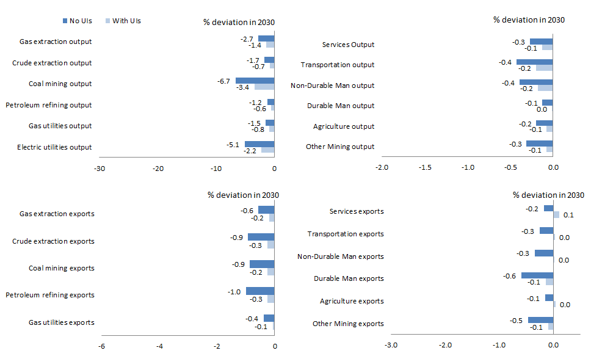
Note: IUs refers to sensitivity analysis on the policy mix, where the use of some international units is assumed (see Appendix F for details).
Figure D-2: 26% reduction target – core target scenario and policy mix sensitivity analysis, 2030 (percentage deviation from Paris scenario)
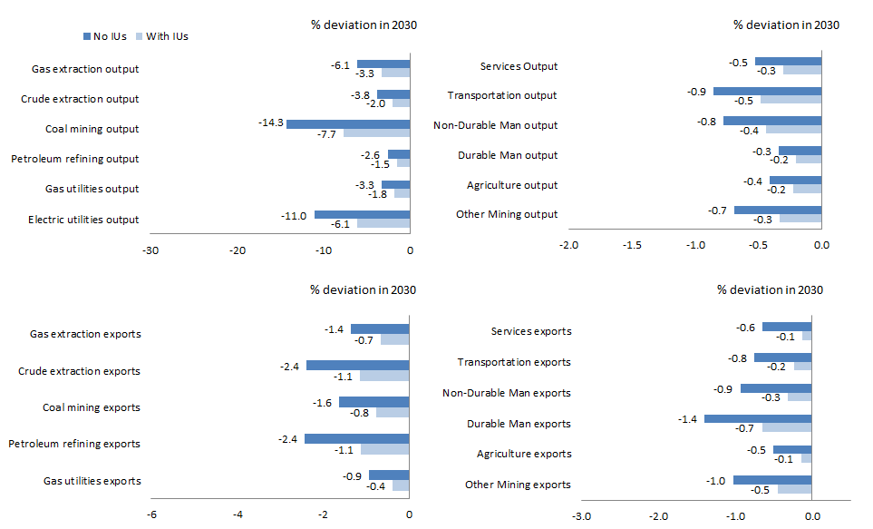
Note: IUs refers to sensitivity analysis on the policy mix, where the use of some international units is assumed (see Appendix F for details).
Figure D-3: 35% reduction target – core target scenario and policy mix sensitivity analysis, 2030 (percentage deviation from Paris scenario)
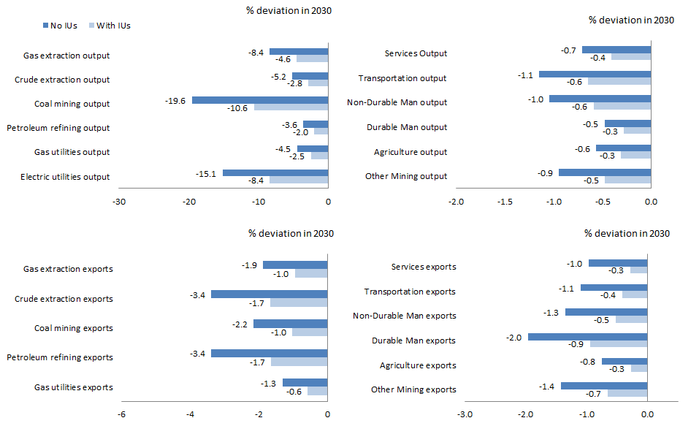
Note: IUs refers to sensitivity analysis on the policy mix, where the use of some international units is assumed (see Appendix F for details).
Figure D-4: 45% reduction target – core target scenario and policy mix sensitivity analysis, 2030 (percentage deviation from Paris scenario)
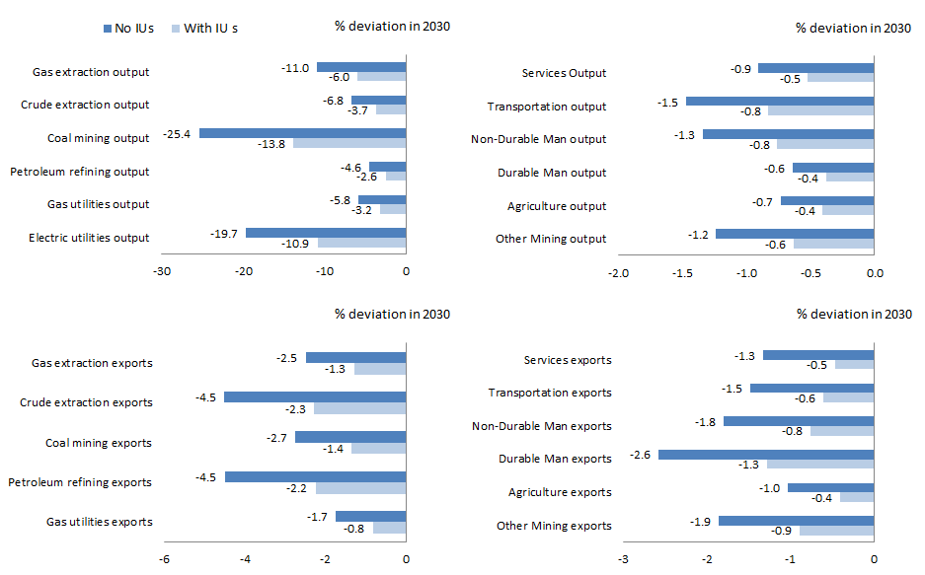
Note: IUs refers to sensitivity analysis on the policy mix, where the use of some international units is assumed (see Appendix F for details).
APPENDIX E: Sensitivity to technology cost assumption

Projected impacts are sensitive to assumptions about future technology costs. These costs are uncertain, and in recent years have fallen much more rapidly than anticipated. For example, the actual cost of key renewable energy technologies in 2012 was around half the cost projected for 2030 a few years earlier.
For this reason the modelling included sensitivity analysis of how varying the cost assumptions about low emissions energy technologies would affect the projected costs of the targets.
The core target scenarios assume technology costs are at the high end of the plausible range (in part to offset that the modelling does not account for the costs of non-energy abatement). It is assumed that achieving emissions reductions through a mix of policies increases energy technology costs by 50 per cent compared to cost-minimising policy. This is a conservatively high estimate.
To test the sensitivity of the results to this technology cost assumption, the impacts of the four targets were analysed for a lower cost increment of 10 per cent.
The sensitivity analysis finds that assuming technology costs at the low – but still plausible – end of the range would reduce national impacts by around a third compared with the core target scenarios.
Figure E-1 shows GDP impacts in 2030 for the sensitivity analysis and core target scenarios. For targets ranging from -26 to -45 per cent and assuming lower technology costs, the modelling finds that GDP in 2030 would be reduced by 0.4 to 0.7 per cent compared with no Australian target. That is, the lower technology costs modelled would reduce target impacts by between 0.2 and 0.3 percentage points of GDP in 2030 compared with the core target scenarios.
The sensitivity modelling also finds that GDP would grow between 0.02 and 0.03 percentage points faster per year, on average, from 2020 to 2030 with lower technology costs (Table E-1).
The GDP and GNI impacts to 2030 under the technology cost sensitivity scenarios are shown in Figure B-2 in Appendix B.
Figure E-1: Changes in GDP and GNI – core target scenarios and technology cost sensitivity scenarios, 2030 (percentage deviation from Paris scenario)
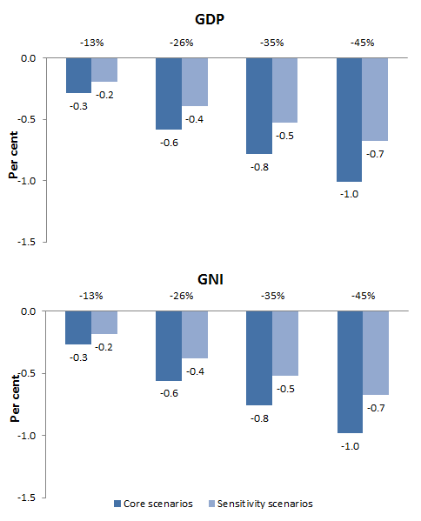
Table E-1: Average annual GDP growth – Paris scenario, core target scenarios and technology cost sensitivity scenarios, 2020 to 2030 (per cent)
 | Core target scenarios | Sensitivity scenarios - technology costs
Paris scenario | 2.21 | -
-13% | 2.18 | 2.19
-26% | 2.14 | 2.16
-35% | 2.12 | 2.14
-45% | 2.09 | 2.12

APPENDIX F: Sensitivity to policy mix assumption
Different policy mixes involve different costs, different patterns of co-benefits, and have different distributional impacts.
Modelling was undertaken to assess the economic impacts of targets with some use of international units. Each of the core target scenarios is replicated with the additional assumption that international units are available to meet some of the emissions abatement. The analysis assumes these offsets are purchased from low income countries in the ‘rest of world’ grouping, which includes developing countries other than China.
The price of reputable international units is assumed to start at US$5 per tonne of abatement in 2020, rising to US$10 per tonne by 2030. The volume of units is limited to around 45 per cent of the national abatement task, implying total volume of offsets in the range of 20 to 80 Mt CO₂ in 2030.
Figure F-1 shows cumulative abatement in the policy mix sensitivity scenarios from domestic sources and international units from 2020 to 2030.
Figure F-1: Cumulative abatement, domestic abatement and international units – policy mix sensitivity analysis, 2020 to 2030 (Mt CO₂)
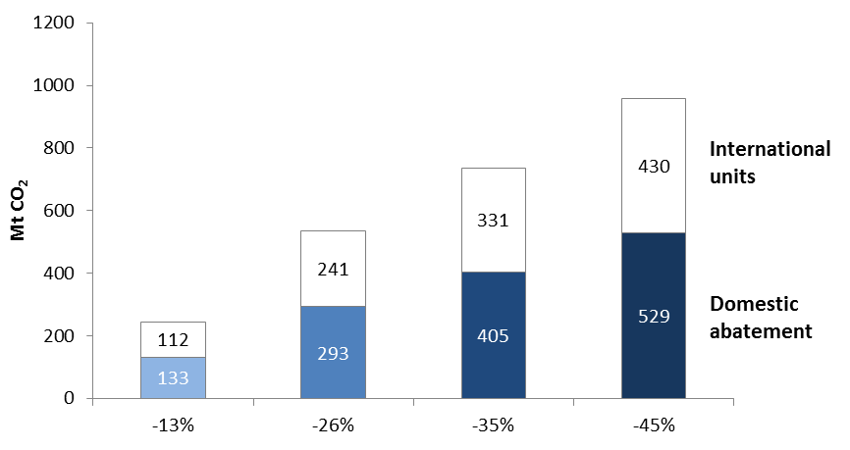
Figures may not sum to totals in Figure 2 due to rounding.

Allowing international units reduces the costs of the commitment
It is estimated that allowing international units to be used towards meeting the target would add between 0.2 and 0.4 percentage points to GDP in 2030, compared with no use of international units (Figure F-2).

Figure F-2: GDP impacts, core target scenarios and policy mix sensitivity analysis, 2030 (percentage deviation from Paris scenario)
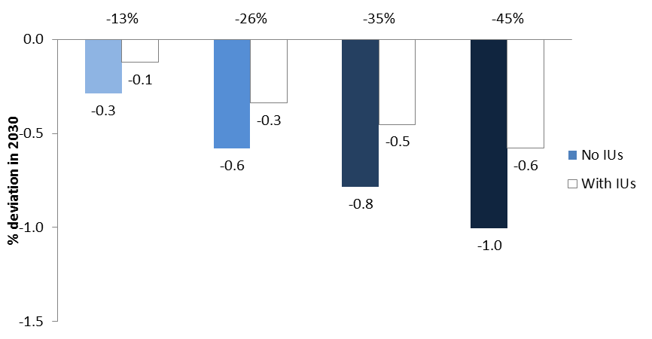Note: IUs refers to international units
Allowing international units reduces the impact of any given target by opening up access to lower cost abatement sources overseas. The size of this impact would depend on the availability and cost of international units.
Access to international units at the assumed prices reduces the amount of emission abatement required in Australia to reach a given emissions target. The cost is a payment for foreign suppliers of those permits. As long as the price of the international units is less than the marginal cost of reducing an equivalent additional unit of emissions in Australia, the Australian economy will benefit from access to international units. This is the case for each scenario considered, given the assumed price of international units.

In addition to reducing the amount of domestic abatement, access to international units reduces the energy price changes that are required to reach a given target. Smaller rises in energy price imply a smaller fall in real consumption. Investment in the electricity sector is also weaker because less change is required in the energy mix. The net effect on GDP of allowing international units is clearly positive in the modelling.

The impact of using international units is strongest in the sector where the target has the biggest impact – coal mining. It is estimated that coal output in 2030 would be between 3 and 12 percentage points higher if international units were used towards the target, depending on the target level. Results for the -26 per cent target are shown in Figure F-3. Results for the full set of policy mix sensitivity scenarios are in Appendices C and D.

Figure F-3: Impacts of the -26 per cent target, core target scenarios and policy mix sensitivity analysis, 2030 (percentage deviation from Paris scenario)
Macroeconomic impacts
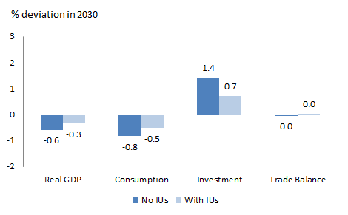
Energy sector – output
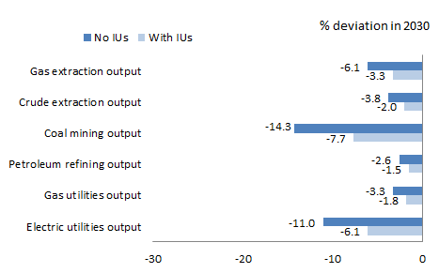
Note: IUs refers to international units
Energy sector – exports
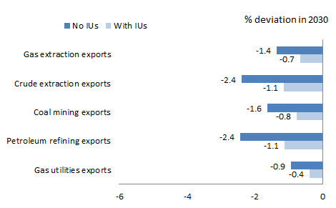
Note: IUs refers to international units

REFERENCES
Department of the Environment (2015), Australia’s emissions projections 2014-15, Australian Government, March.
Graham, P. and S. Hatfield-Dodds (2014), “Electricity Sector”, in ClimateWorks Australia, ANU, CSIRO and CoPS, 2014, Pathways to Deep Decarbonisation in 2050: How Australia can prosper in a low carbon world: Technical report, ClimateWorks Australia, Melbourne.
McKibbin Software Group (2015), Economic Modelling of International Climate Action Under a New Global Climate Change Agreement, for the Department of Foreign Affairs and Trade, May (unpublished).
McKibbin, W. and P. Wilcoxen (2013), “A Global Approach to Energy and the Environment: The G-cubed Model”, Handbook of CGE Modeling, Chapter 17, North Holland, pp 995-1068.

The required abatement is measured relative to estimated Australian emissions under the Paris Scenario. See Report 1 for further information on the Paris Scenario.
DFAT calculation from Department of the Environment (2015).
Price impacts will depend on the scope and implementation of emissions reduction policies. The modelling does not anticipate the policy mechanisms used for a post-2020 target.
Graham and Hatfield-Dodds (2014).

