Social protection and economic growth in Pacific Island countries

AusAID Pacific social protection series:   
poverty, vulnerability and social protection   
in the Pacific

March 2012

© Commonwealth of Australia 2012

Published by the Australian Agency for International Development (AusAID), Canberra, March 2012.

This document is online at www.ausaid.gov.au/publications

The principal authors of this research paper are Michael Samson and Elizabeth Miller.

**Disclaimer:** The views expressed in this publication are those of the authors and not necessarily those of AusAID.

For further information, contact:

AusAID  
GPO Box 887  
Canberra ACT 2601

Phone (02) 6206 4000  
Facsimile (02) 6206 4880  
Internet www.ausaid.gov.au

Contents

1. Introduction to the research 3

2. About this research paper 4

3. Social protection: pathways towards pro-poor economic growth 5

3.1. Human capital investment 5

3.2. Risk management 6

3.3. Empowerment and livelihoods 7

3.4. Pro-poor economic policies 8

3.5. Social cohesion and nation building 9

3.6. A note on the importance of program design and implementation 9

4. The global economic downturn: impact on Pacific Island countries 11

4.1. Rising international prices 14

4.2. Reduced demand for commodity exports 14

4.3. Rise in unemployment 15

4.4. Decline in tourism 15

4.5. Remittances 16

4.6. Fiscal space 17

4.7. Foreign direct investment 18

4.8. Official development assistance 19

5. Social protection as a response to global shocks and a stimulus for growth 20

Step 1 22

Step 2 22

Step 3 22

Step 4 22

6. Conclusions and recommendations 27

7. References 28

# 1. Introduction to the research

Pacific Island countries (PICs) have varying social protection systems, informal and traditional. These systems are important in supporting the most vulnerable members of society and those affected by personal and natural disasters. In the Pacific Islands social protection has typically   
been an area of low government involvement. Knowledge about formal social protection in the region is limited, and there have been no studies on the impact of such schemes on poverty, human development and economic growth.

There is no one agreed definition of social protection, but this body of research—commissioned by AusAID—uses the term to refer to the set of public actions aimed at tackling poverty, vulnerability and social exclusion, as well as providing people with the means to cope with major risks they may face throughout their life.

Social protection’s core instruments include regular and predictable cash or in-kind transfers to individuals and households. More broadly, social protection includes instruments that improve people’s access to education, healthcare, water, sanitation, and other vital services.

Traditional social protection in the Pacific Islands is stretched by new challenges, most recently the 2008–09 global food, fuel and financial crisis. This has led to greater attention to innovative social protection mechanisms that tackle chronic poverty, mitigate the impact of shocks, improve food security and overcome financial constraints to accessing social services. This attention has been driven by the success of mechanisms in other parts of the world.

In an environment with limited or conflicting information about patterns of poverty and vulnerability, knowing whether social protection represents a sound, or even appropriate, policy choice is difficult. This research looks at poverty, vulnerability and social protection across the dimensions of health and education, gender, social cohesion, economic growth, and traditional protection networks in the Pacific Islands. It aims to improve the evidence base on formal and informal social protection programs and activities in the Pacific region and make recommendations on support for strengthening and expanding social protection coverage so it can contribute to achieving development outcomes.

The research was conducted by social protection experts and is based on case studies in Kiribati, Samoa, Solomon Islands and Vanuatu—representing the three sub-regions of Melanesia, Micronesia and Polynesia—and a review of secondary literature. It also commissioned a set of research papers:

* an overview of poverty and vulnerability in the Pacific, and the potential role of social protection
* a briefing on the role of social protection in achieving health and education outcomes
* a life-cycle approach to social protection and gender
* an assessment of the role of social protection in promoting social cohesion and nation-building in the Pacific
* an assessment of the relationship between social protection and economic growth
* a review of the strengths and weaknesses of informal social protection in the Pacific
* a micro-simulation analysis of social protection interventions in Kiribati, Samoa, Solomon Islands and Vanuatu.

# 2. About this research paper

This research paper—‘Social protection and economic growth in Pacific Island countries’—assesses the potential role of social protection in stimulating economic growth and employment, and enabling PICs to better cope with local impacts of global economic shocks. The potential for economic growth is important for PICs because of the considerable structural constraints to growth they face.

The research paper is organised into four sections. The first discusses emerging evidence supporting the link between social protection interventions and pro-poor economic growth. The second assesses the context in which social protection policies in the Pacific must be evaluated, focusing on PICs’ economic vulnerability. The third examines the past, current, and prospective economic and social impacts of the global economic downturn. The fourth evaluates the potential role of social protection in enabling PICs to cope with local impacts of global economic shocks, and provides tools for identifying the most effective counter-cyclical instruments.

In the aftermath of the global economic downturn, governments and their development partners increasingly recognise that social protection can be a powerful tool for strengthening responses to aggregate shocks and crises. These shocks and crises often have the most severe impact on those least able to cope, further entrenching poverty, a consequence that can persist for decades. Social protection can help poor and vulnerable groups to better cope and it can serve as an investment with potentially high social and economic returns. Emerging evidence documents the strong links between social protection and pro-poor economic growth and development.

# 3. Social protection: pathways towards pro-poor economic growth

Emerging evidence—from Brazil to Zambia—demonstrates that social protection promotes pro-poor economic growth through various pathways. Most increase overall economic efficiency by taking advantage of economic capacity and improving resource allocation.[1] In this research paper the pathways relevant to the Pacific context are grouped into five broad economic and developmental pathways, discussed here:

* human capital investment
* risk management
* empowerment and livelihoods
* pro-poor economic policies
* social cohesion and nation building.

## 3.1. Human capital investment

Social protection can increase access to public services and investment in human capital, particularly in education and health, resulting in higher productivity and greater participation of the poor in labour markets. Effective social protection can prevent one of the worst consequences of poverty: the transmission of lifelong poverty to children.

In the area of education, schooling gives children skills and increases   
their chances of finding jobs. This helps break the inter-generational cycle of poverty.

Samoa acknowledged the important link between education and the development of its people when it introduced the School Fee Relief Scheme in 2010 making it free for primary school children to go to school, including children who could not previously attend because their families could not afford it. The scheme is relatively new so its impact remains to be seen. Evidence from Papua New Guinea (PNG) suggested that in countries with weaker governance and financial oversight, *subsidy leakage* (the difference between budget disbursements and reported receipts at schools) and *subsidy delay* may be significant problems.[2] However, studies in Latin America and South Africa repeatedly documented significant improvements in health and education, particularly in response to conditional and unconditional cash transfer programs and social health initiatives.[3] Education is especially important in the Pacific, as island countries move from subsistence agriculture to cash-based economic activity in urban centres.

In the area of health, malnutrition is a major issue and chronic malnutrition can impair long-term cognitive development and productivity, as well as increase the likelihood of ill health moving into the next generation.[4] The economic costs of malnutrition include increased burden on the healthcare system and indirect costs of lost productivity. It was estimated that childhood anaemia—a persistent problem in the Pacific—is associated with a 2.5 per cent drop in an adult’s wages.[5]

Evaluations of social protection programs frequently find positive nutrition and food security impacts, largely through an increase in household spending on food. For example, the Child Support Grant in South Africa improved nutrition.[6] The old-age pension in South Africa improved the health and height of children.[7] This evidence is important for the Pacific, where malnutrition and deficiency disorders persist. In Solomon Islands half of children under 5 and nearly half of women were anaemic, while in Vanuatu 34 per cent of children were anaemic.[8] In Vanuatu, 11 per cent of children under 5 years of age were underweight and 26 per cent stunted.[9]  
 In Kiribati, 18 per cent of children aged 0 to 2 years are malnourished.[10]

There is evidence that cash income improved children’s health, in part because Indigenous staples fill children’s small stomachs before they have consumed enough daily nutrients.[11] Cash can be used to buy rice and proteins which improve children’s nutrition and anthropometric status. Thus, cash transfers may be an effective way to improve persistent malnutrition and deficiency disorders across the Pacific.

Social protection can directly improve the health status of children and adults, which in turn promotes economic growth.[12] In 2001 the World Health Organization estimated that a 10 per cent increase in life expectancy adds an estimated 0.3 to 0.4 percentage point to the annual growth rates in per capita incomes.[13] These types of improvements can be the basis for long-term, pro-poor growth.

## 3.2. Risk management

Social protection can enable poor people to protect themselves and their assets against shocks, so they can defend their long-term, income-generating potential and make productive investments. Shocks can have significant long-term effects. Droughts in Ethiopia, for example, significantly reduced household earning power as long as 15 years later.[14] PICs are highly vulnerable to natural shocks, including cyclones, tsunamis, flooding, earthquakes and volcanic eruptions, as well price shocks and changes in global economic demand. For example, since 1960 more than 70 natural disasters have struck Vanuatu with recorded damage of US$250 million.[15]

It is impossible for small, isolated PICs to guard against all risks from natural disasters, price shocks and global downturns. One risk-management strategy used in some parts of the Pacific is to have some family members move away to get work. However, migration opportunities are limited for some of the poorest and most vulnerable households, often located in the most remote communities.[16] Social protection may enable these households to cope without depleting assets or hindering recovery. These ‘negative strategies’ include reducing the number or nutritional content of meals, taking children out of school and/or postponing health-related expenditures—all of which can lower current and future generations’ ability to make money and perpetuate a cycle of inter-generational poverty.

Social protection can help break the poverty cycle in many ways. Social health protection can help people cover hefty, but needed health expenditures.[17] Cash transfers can improve small-scale farmers’ resilience to shocks. Farmers are less likely to sell the livestock on which their prosperity depends if their immediate subsistence needs are met. The Copra Fund Subsidy—Kiribati’s largest social protection program—helps farmers cope with fluctuations in copra prices by guaranteeing a minimum purchase price from government. This maintains copra production in the outer islands and protects famers’ assets when prices are low. However, the program has come under criticism for possibly maintaining an artificially high price for copra, and also for the inequitable support it provides households, as those with less labour capacity receive smaller subsidies even though they are vulnerable.[18] Core social protection instruments—such as cash transfers—may tackle underlying risks more cost effectively and equitably.

Furthermore, social protection can help the poor manage risk by giving them flexibility to take on higher-risk, higher-return activities they might otherwise turn away from. Farmers protected by the Employment Guarantee Scheme in Maharashtra, India, invested in higher yielding varieties than farmers in neighbouring states.[19] These profits would not have been realised without risk, and social protection allowed for improved risk management, supporting long-term, pro-poor growth.

## 3.3. Empowerment and livelihoods

Social protection programs can combat discrimination and unlock economic potential. They have a documented history of empowering women. In Bangladesh, Brazil and South Africa, giving women more resources has improved child survival, nutritional status and school attendance, especially for girls.[20] This is because having increased resources elevates women’s power in the household, and in households where women are key decision makers a greater proportion of resources are spent on children.[21] This link is relevant for the Pacific, where   
violence against women remains widespread and a largely patriarchal socio-political tradition promotes the ascension and power of men.

Well-designed social protection programs can help the poor participate in labour markets by helping them cover the cost of searching for work, which can be expensive for poor households. In South Africa, workers who lived in houses that received social transfers put more effort into finding work than those in comparable households that did not receive transfers, and more succeeded in finding jobs as a result. The impact of cash transfers on women’s labour market activity is about twice as great as that for men.[22] Workers who have a better fall-back position (provided by social protection) can search for work that takes advantage of their capabilities, rather than accepting the first job that becomes available, raising overall labour market efficiency. The link between social protection and unemployment is important in the Pacific, where countries have high and increasing unemployment rates, particularly among youth.

Emerging evidence demonstrates how social protection can support employment and entrepreneurial activities. Participants in Zambia’s cash pilot scheme used a significant proportion of their benefits to hire labour—for example to cultivate their land—and consequently multiplied the value of the transfers while creating work for local youth.[23] Local multiplier effects are important for the Pacific, where the poorest are often isolated due to geographic constraints, living on small atolls or in remote mid-highland areas. Social protection can also improve the negotiating power of workers, smallholder farmers and micro-entrepreneurs in the marketplace. If social protection interventions complement, rather than replace, traditional social protection they can encourage entrepreneurship in the Pacific, improving the success and sustainability of micro-enterprises. The evidence shows that well-designed social protection programs minimise the potential for moral hazard, promoting development not dependency.

Social protection can empower the vulnerable by making them less dependent on a traditional social protection system that is changing as Pacific economies modernise. These traditional systems are embedded in Pacific Island culture, emphasising the extended family system and collectivism. Remittances are integral to this. However, as second and third generations of Pacific Islanders grow up in New Zealand and other destination countries, there is evidence that links to kin at home are declining.[24] A study of Samoan migrants in New Zealand found that migration, on average, increased household consumption and reduced poverty among former household members, but some evidence suggests the effects of this may be short-lived as remittances and income decrease the longer the migrant is abroad.[25]

Furthermore, Pacific Islanders living abroad have reported great financial pressure, impacting on their own ability to save.[26] If relying on remittances is unsustainable and if new generations move towards more individualistic cultures in their new homes, there may be a significant decline in remittances. Formal social protection instruments—such as cash transfers—could mitigate the effect of this and empower individuals to improve their circumstances. Formal social protection instruments can also reach the most disadvantaged families and communities, who may have no members working overseas or in urban centres, and therefore no remittance income.

Furthermore, international evidence suggests that financial pressures created by traditional social protection systems can act like a tax on the working poor, depressing work incentives and the resources available to meet their own consumption.[27] Wage increases are in part taxed by associated increases in family members’ demands on workers’ incomes, weakening the potential of higher wages to strengthen labour productivity.[28] This can create poverty traps, because higher wages are less likely to be sustainable without productivity improvements. However, well-designed formal social protection has the potential to directly benefit the poor, so that they do not have to pressure those who are better off for assistance. It also increases the resilience of the working poor.

Similarly, in Kiribati individuals entering business face *bubuti*, a traditional system of non-refusable requests for assistance. This has led to many businesses failing, affecting economic growth.[29] The impact has been so great that some business operators get a non-Kiribati family member to own or manage the business because they are more able to resist *bubuti*.[30] Social protection can address the disincentives created by traditional social protection systems, addressing underlying poverty while allowing workers to channel their earnings to productive investments.

## 3.4. Pro-poor economic policies

Social protection can generate economic gains for the poor and for a wider segment of the population. Understanding the link between social protection and broader economic growth can increase support for important economic reforms. For example, cash transfer initiatives have helped compensate the poor for reduced price subsidies in Indonesia   
and Mexico.

Social protection can also stimulate demand for local goods and services, promoting short-term growth. Cash transfers inject liquidity into communities, spilling over to households that are not direct beneficiaries and resulting in a multiplier effect. A social account matrix analysis of the Dowa Emergency Cash Transfer program in Malawi found multiplier impacts from the payments broadening benefits to the entire community.[31]  
 In Namibia, the spending power created by social pensions has   
revitalised local economic activity.[32] Predictable and regular transfers, such as pensions, can create assured continuous demand for emerging enterprise output.

Stimulating demand for local goods and services is important in the Pacific because households in rural areas and outlaying islands often lag behind urban areas in economic growth and human development indicators. Social protection can stimulate the growth of local economies, ensuring rural areas are not left behind. This goes beyond social protection being a *cost* to governments and aid partners, to being an *investment* with significant rates of return. However, the economic impact for any given country depends on the patterns of demand across income groups and the manner in which social transfers are financed. Design and financing is discussed further in this section’s conclusion.

## 3.5. Social cohesion and nation building

Social protection can contribute to an effective and secure state, promoting growth by building social cohesion and a sense of citizenship, as well as reducing conflict.[33] Providing benefits to vulnerable citizens is a visible demonstration of the state’s caring and protective role. The International Monetary Fund (IMF) recognises that the social pension implemented in Mauritius contributed to social cohesion and helped to lay the foundation for its ‘economic miracle’.[34] In South Africa the extension of pension and disability benefits to all races on an equal basis was a conscious strategy by the African National Congress Government to heal the wounds of apartheid and build social cohesion, with the collateral benefit of creating an environment conducive to investment and growth.

Opportunity exists to improve social cohesion in the Pacific. In Vanuatu, government and society tend to divide across linguistic French and English lines, while Solomon Islands is still recovering from ‘the tensions’, a period of ethnic civil unrest that began in 1998. More than 10 years later, real gross domestic product (GDP) per capita has barely reached pre-tension levels. A safe, predictable environment is crucial for investment. By building social cohesion, increasing equity and reducing tensions, social protection encourages productive investment and economic growth.

Through the five broad economic and developmental pathways listed above, social protection can help break the intergenerational transmission of poverty. During times of positive growth, social protection can translate to better circumstances for households facing hardship. During times of economic downturn, social protection can act as effective economic stimulus, protecting the most vulnerable and jump-starting economic recovery.

## 3.6. A note on the importance of program design and implementation

The impact of any social protection intervention on economic growth depends on design and implementation. Strong governance and effective financial oversight are needed if an intervention is to have real poverty impact and generate growth. Evidence from PNG indicates a significant problem of subsidy delay in the Pacific. The logistical weakness of public finance has delayed the country’s quarterly subsidy to schools by an average of three months.[35] This illustrates the important need for   
well-planned delivery systems and effective monitoring and evaluation. PNG’s school subsidy also shows the potential to ‘politicise’ certain   
social protection interventions, with politicians championing a particular one without fully analysing the community context and broader financial circumstances. The third section of this research paper provides frameworks policymakers can use to choose the social protection instrument that best fits their country’s social, policy and institutional context.

Program design is particularly important in the Pacific because the sharing of wealth within communities can affect the impact that formal social protection instruments have on poverty and economic growth. Interventions must be carefully targeted to prevent spillovers to better-off members of the extended family or community at the expense of the vulnerable. As discussed with *bubuti* in Kiribati, traditional social protection can create problems for enterprise development. Demands by relatives and the community for income and assets likely interact with social protection implementation; therefore interventions must be carefully designed and integrated with existing economic opportunities. Traditional social protection remains integral to community life across the Pacific, and can be a significant asset for the poor and vulnerable. To be successful, formal social protection instruments must complement, not crowd-out, traditional social protection.

Social protection is not without costs, including financial and administrative ones that can prove significant in the Pacific where national governments have limited fiscal space. In the most extreme case, Kiribati ran an unsustainable budget deficit, ranging between 20 and 30 per cent a year from 2004 to 2010.[36] Cash transfer programs must be fiscally responsible to avoid increasing budget deficits or creating inflationary pressures. However, well-designed and closely monitored social protection programs can be a cost-effective way to tackle poverty, improve livelihoods and stimulate economic growth across the Pacific.

# 4. The global economic downturn: impact on Pacific Island countries

The link between social protection and economic growth is important to PICs because they face structural economic constraints and are susceptible to the effects of global shocks. Impediments to economic growth in the region are well documented and include narrow natural resource bases, limited infrastructure, particularly in rural areas, small domestic markets, isolation from international markets and heavy dependence on fuel imports.[37]

Narrow natural resource bases mean PICs can only specialise in a few commodities, which increases their vulnerability to natural disasters and adverse changes in their terms of trade. Geographic remoteness from main markets means transportation costs are high and it is difficult for producers to achieve the economies of scale necessary to compete in foreign markets. Distance from foreign markets also increases the price of imported goods. The overexploitation of natural resources, mainly forestry and fisheries, is threatening the sustainable management and growth of these sectors, particularly with logging in Solomon Islands. These economic constraints are compounded by land-lease problems and insufficient investment. Most countries have substantial merchandise trade deficits, with the difference financed by remittances, tourism receipts and aid.[38]

It was in this context that PICs experienced the global economic downturn that, beginning in 2008, saw soaring commodity prices, an international financial crisis and a subsequent contraction in global economic demand. The effects of the ‘Triple F’ (food, fuel and finance) crisis were felt in the Pacific by late 2008 and throughout 2009. Increases in international commodity prices caused high inflation in 2008, though GDP growth rates remained relatively high. A strong tourism sector supported a growth rate of 6.3 per cent for 2008 in Vanuatu, while the unsustainably high rate of logging drove high growth in Solomon Islands.[39]

By 2009 PICs felt the effects of the global recession’s reduction in trade and investment. Economic growth rates declined across Kiribati, Samoa, Solomon Islands and Vanuatu, though to different degrees. GDP growth contracted sharply in Samoa and Solomon Islands in 2009 but recovered in 2010 due to a number of factors. Growth was already slumping in Kiribati and Vanuatu when the crisis struck, but the shocks intensified the downturn. However, declines in GDP growth cannot be solely attributed to the global downturn; volatility across the region reflected domestic factors, such as unsustainable logging practices in Solomon Islands and the 2009 tsunami in Samoa. Figure 1 illustrates GDP growth and decline from 2000, with projections into 2012.

Figure 1. The economic impact of the global economic downturn on   
Pacific Island countries

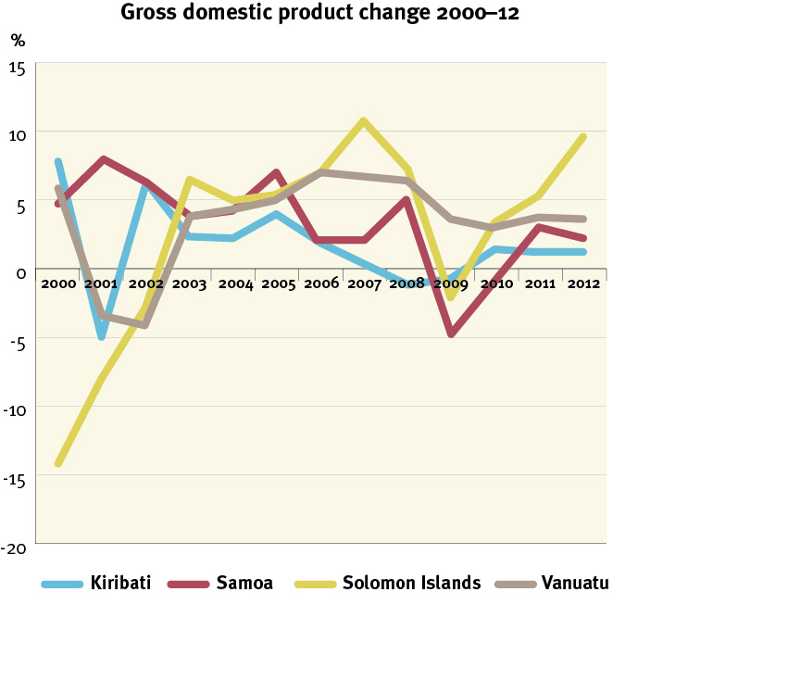

Source: IMF, World Outlook Database

IMF forecasts for Pacific GDP growth show a levelling of growth rates for Vanuatu and Kiribati at 3.5 per cent and 1.2 per cent respectively. Increasing growth rates for Solomon Islands are predicted, rising towards pre-crisis levels. Figure 2 compares the average rate of GDP growth for the Pacific to growth trends in Sub-Saharan Africa. The IMF forecasts a recovery for PICs similar to the path of middle-income countries in Africa.

Figure 2. Economic recovery from the global economic downturn

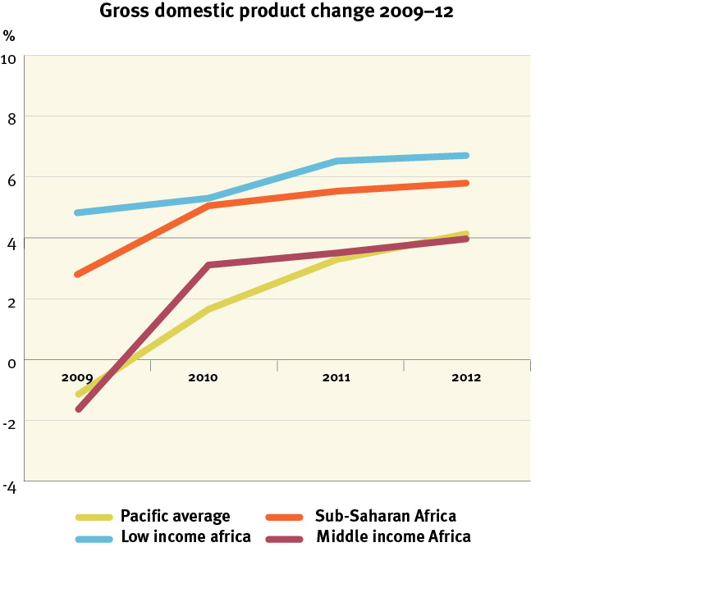

Source: IMF, World Outlook Database and World Economic Update

The significant decline in GDP growth in 2009 illustrates PIC vulnerability to global economic downturns. In the Pacific the indirect effects of the crisis posed a greater threat than the direct impact of deteriorating financial sectors in high-income countries. Indirect effects included reduced demand for commodity exports and tourism, increased transportation costs and inflationary pressures. PICs are vulnerable to indirect effects because of their size (with small domestic markets) and isolation (resulting in high transportation costs and a costly reliance on imported fuel), as well as their dependence on foreign demand (through trade and tourism).

In December 2008 the Pacific Department of the Asian Development Bank (ADB) evaluated the vulnerability of PIC economies using key indicators of macroeconomic soundness and their dependence on income from offshore investments, commodity exports, tourism and remittances. Countries were then classified in four groups: most vulnerable, highly vulnerable, vulnerable and cushioned. Of the four focal countries in this research paper, Kiribati and Solomon Islands were classified as most vulnerable, while Samoa and Vanuatu were classified as vulnerable.[40] High-income countries experienced the sharpest economic contractions as a result of the global economic downturn, but in the Pacific declining growth rates, combined with high levels of initial poverty, left many households highly exposed. Vulnerability is heightened if governments are constrained in cushioning the impacts because of limited institutional capacity and/or fiscal resources.

This section assesses the past, current and prospective economic impacts of the global economic downturn on PICs, including associated social effects. The impacts are grouped into eight areas:

* rising international prices
* trade
* unemployment
* tourism
* remittances
* fiscal effects
* foreign direct investment (FDI)
* official development assistance.

Analysis shows why PICs are vulnerable to global downturns and helps identify the most appropriate and effective social protection responses.

## 4.1. Rising international prices

Food and fuel prices peaked between May and July 2008, but fell to around half their highest levels by December 2008. PICs are highly vulnerable to shocks in global fuel prices because of the distance many imports and exports must travel. Despite their agrarian heritage, all countries in the region import food staples. In Kiribati food imports represent 36 per cent of food expenditure, while in Samoa they are 56 per cent.[41] Until the early 1990s Samoa’s main staple food was taro, which was produced domestically, but an outbreak of the taro leaf blight resulted in a shift to imported foodstuffs (primarily to rice as a staple), a pattern seen across   
the Pacific.

Rising food prices can create hardship at household level because a high proportion of household income is spent on food, even in rural areas.[42] While rural households are often the least engaged in markets due to geographic constraints, and thereby did not experience job losses because of the crisis, they were affected by increases in the prices of staple goods. Prices of imported food rose sharply with, for example, a 26 per cent increase in Solomon Islands in the first six months of 2008.[43] High global prices for food and fuel exerted tremendous inflationary pressures across all countries in 2008, with inflation reaching 18 per cent in Solomon Islands and 19 per cent in Kiribati.[44]

## 4.2. Reduced demand for commodity exports

In 2008 the prices of agricultural commodities commonly exported from PICs, such as palm oil, copra, hardwood and coffee, increased dramatically. However, price increases were more than offset by large price hikes in imported oil and food.[45] While products commanded higher prices, the cost of transporting them to destination markets increased with fuel price surges. Furthermore, the concentration of export revenue in only a few sectors increased vulnerability. For example, in Samoa only 12 products account for nearly the entire value of merchandise exports.[46] Lumber exports in Solomon Islands declined significantly in 2009   
(31.4 per cent), a major concern given they account for 40 per cent of government revenue and 70 per cent of export earnings.[47]

## 4.3. Rise in unemployment

High levels of unemployment and underemployment were significant problems across the Pacific before 2008, a situation worsened by the global economic downturn. Youth in particular face considerable difficulties entering the labour market. It is difficult to get reliable and recent figures on unemployment in the region.[48] However, the consensus is that unemployment rates are high, especially in urban areas.[49] In Kiribati there are an estimated 2000 new entrants to the labour market a year, while the formal economy generates less than 500 jobs a year.[50] In Vanuatu the annual output from the education system is 3500 while the formal economy produces less than 700 jobs a year.[51] In these countries, only a fraction of job seekers find paid employment.

While data is limited, there is anecdotal evidence of job losses resulting from the global economic downturn. In 2009, 53 per cent of Samoan employers had frozen or cut employment in recent months.[52] A highly visible impact was seen at the Samoa Yazaki plant, Apia. This factory was the largest private sector employer in Samoa (providing 16 per cent of all private formal sector jobs) but in the aftermath of the financial crisis it cut back 70 per cent of its Samoan workforce, the result of a weakening automotive market in Australia.[53]

Pacific countries were also affected by reduced demand for seasonal workers in New Zealand in 2009–10, with a decline of 23 per cent in the number of Samoans hired, and approximately 10 per cent for Tongans and ni-Vanuatu.[54] While there have been formal-sector job losses, the flexible labour force (low and unskilled workers in temporary jobs) may be even more vulnerable. In the developing Asia-Pacific region, women still constitute most of these workers.[55] Lacking education and skills, women tend to be less mobile across sectors and are less likely to find new opportunities if they lose their jobs.

## 4.4. Decline in tourism

A decline in tourist arrivals and receipts is frequently cited as a negative consequence of the global downturn in the Pacific; however, evidence on the actual impact is mixed. Total visitor numbers declined in 2008. For example, in Samoa tourist arrivals for December (the height of the tourist season) fell by 20.5 per cent in 2008 as compared to 2007, and fell further in 2009. This was the result of higher fuel prices and increased airfares, combined with the start of the financial crisis, all of which affected demand from tourist-source countries like Australia. Samoan tourist arrivals in late 2009 into 2010 were also affected by the tsunami.

However, tourism largely appears to have steadied quickly. By December 2010 tourist arrivals in Samoa had increased by 3.7 per cent compared to 2009 levels and receipts were 8.7 per cent higher.[56] The fall in tourism revenue may have been mitigated by a reorientation in travel plans   
by Australians and New Zealanders from European destinations to relatively less expensive Pacific destinations. In Vanuatu visitor arrivals in April 2009 were 24 per cent higher than in the same period in 2008.[57]

## 4.5. Remittances

PICs are often characterised as having MIRAB (migration, remittances,   
aid and bureaucracy) economic structures. However, remittances remain largely concentrated in Fiji, Samoa and Tonga. In 2008 these countries accounted for 89 per cent of all remittances received by the six Pacific countries for which data is available.[58] Overall, data shows that the global economic downturn did not have a consistent impact on remittances in the region (Figure 3). Samoa saw a decline in remittances in real terms by the final quarter of 2008 and a continued decline into 2009.[59] But when Samoan remittances are looked at as a percentage of GDP, they increased in 2008. Similarly, the slowing of economic growth in Australia, New Zealand and the United States in 2000–01 did not reduce remittance flows.[60] This may be the result of a strong private and voluntary response to the realisation of negative risks (for example, the global downturn), with workers sending home more money to help their families when times are hard, creating a safety net.

Remittance flows are sensitive to currency fluctuations, which may reduce their value. Remittances for seamen in Kiribati, for example, have been adversely affected by the depreciation of the United States’ dollar over the past two to three years.[61]

Figure 3. The global economic downturn and remittances in the   
Pacific region

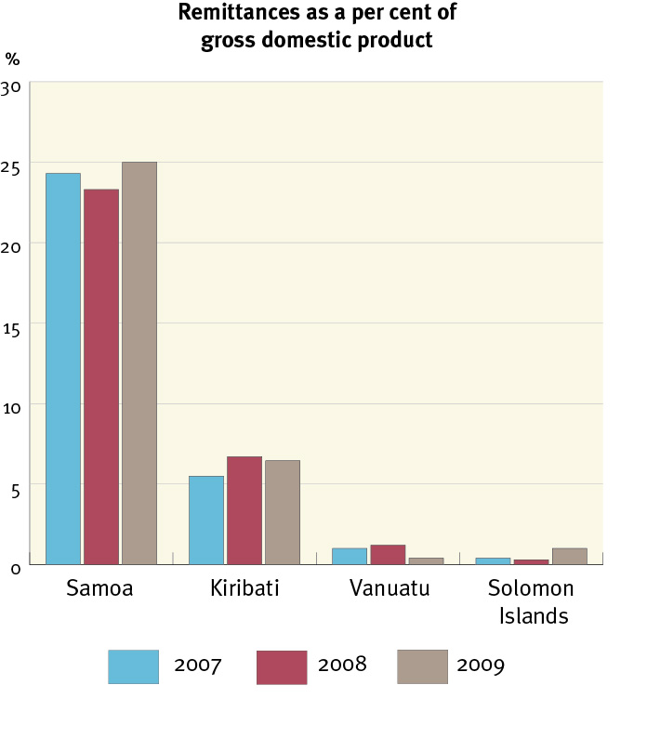

Source: World Bank, World Development Indicators

## 4.6. Fiscal space

The global economic downturn reduced government incomes across the Pacific. Taxes on international trade and domestic consumption account for most tax revenues, and government employee salaries account for a large share of recurrent government expenditure, so a global downturn has a direct impact on PIC government balance sheets.[62] Government investments were also significantly affected. Kiribati’s wealth fund dropped in value from A$637 million in 2007 to A$389 in 2008—with further decreases in 2009 and 2010—significantly reducing government income and raising concerns about the fund’s long-term sustainability.[63]  
 In Samoa debt-financed public investment has led to external debt surpassing the government’s 40 per cent of GDP target, creating a medium to long-term policy challenge.[64] In Solomon Islands the fiscal situation remained tight in 2010, resulting in restrictions on expenditure and a recruitment freeze.[65]

Reductions in government income are important during times of recession because they affect governments’ ability to respond. The government of Solomon Islands responded to the rapid rise in food prices by removing import duties and the sales tax on rice.[66] However, these measures need financing (in the case of subsidies) or they result in revenue loss (in the case of tax reductions). Both options reduce the amount of money a government has to spend in other areas.

## 4.7. Foreign direct investment

Internationally, the financial crisis negatively affected the capacity of many firms to invest, as they were deterred by tighter credit conditions, lower company profits and an uncertain economic outlook. Global FDI fell by more than 20 per cent in 2008 and another 40 per cent in 2009.[67] However, PICs were not uniformly affected by the decline in FDI. Fiji and PNG receive more than 75 per cent of FDI inflows to the region. Overall levels remain low in Kiribati, Samoa, Solomon Islands and Vanuatu, in part due to the high cost of doing business in these countries. While FDI declined in Kiribati, Samoa and Vanuatu in the second half of 2008 and into 2009, initial levels of FDI were low compared to other nations, such as Fiji (Figure 4).[68]

Figure 4. The global economic downturn and foreign direct investment

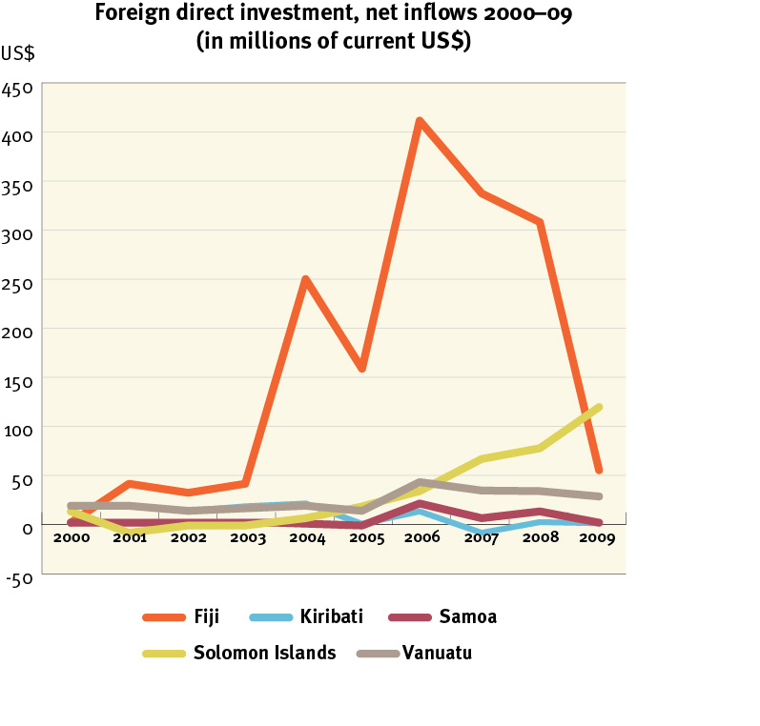

SOURCE: World Bank, World Development Indicators

## 4.8. Official development assistance

PICs receive some of the highest volumes of aid in the world, relative to the size of their populations. The largest donor over the past decade has been Australia, although the European Union, Japan, New Zealand and the United States are also major donors.

All major donor countries were significantly affected by the global economic downturn, but aid levels remained relatively stable. Comparing 2007 to 2008, net official development assistance increased by nearly US$50 million in Vanuatu, with much smaller increases in Kiribati and Samoa. Only Solomon Islands saw a decline. Furthermore, AusAID increased its assistance from 2009 to 2010; by 23 per cent for Samoa, 35 per cent for Kiribati, 10 per cent for Vanuatu and 6 per cent for Solomon Islands.[69] Higher GDP growth was predicted in Kiribati in 2011 and has been again in 2012, in part because several large, donor-funded infrastructure projects will start.[70]

# 5. Social protection as a response to global shocks and a stimulus for growth

The 2008 food, fuel and financial crisis demonstrated how international events can contribute to economic contraction in PICs. Social protection instruments can help to address economic downturn in several ways. They:

* constitute one of the most effective tools for reducing poverty and destitution in many countries
* can enable households to better manage risk and thereby help people get jobs and pursue livelihood activities
* support the consumption of the poor and can reinforce economic policies aimed at tackling the impacts of a contraction—this pathway may be particularly effective in the Pacific because households have a high propensity to consume, spending a large share of their income
* build human capital, reduce social risk and can promote long-term human capital development, livelihoods, employment and economic growth
* provide people with a stake in the economy, promote social cohesion and facilitate the implementation of other necessary reforms during times of economic contraction.

There is strong evidence for using social protection instruments in response to shocks and global economic downturns. The ‘menu’ of social protection instruments is extensive but how do PICs identify the best ones? Figure 5 illustrates four steps to building an appropriate social protection response to a downturn.[71]

**Figure 5. Four steps for building an appropriate social protection response to a downturn**

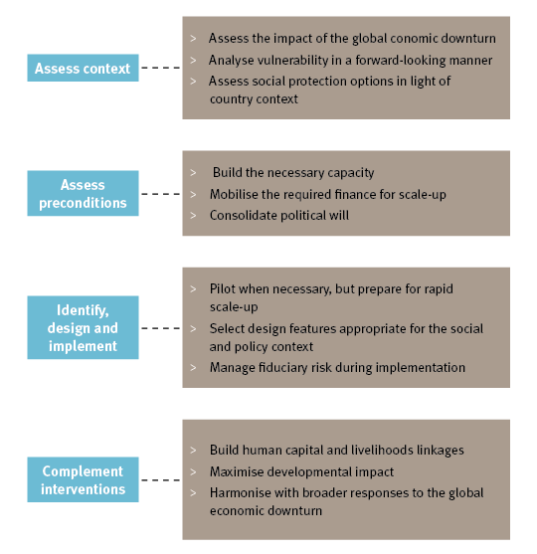

Source: EPRI (2010)

Step 1

This requires conducting a forward-looking risk and vulnerability analysis to build evidence for selecting the intervention and target groups. It involves assessing the transmission channels through which the global economic downturn and other crises affect the poor and who is most vulnerable to different crisis impacts. In the Pacific the poor are often vulnerable because they face greater risks and have fewer means of dealing with adverse shocks. Identifying the most appropriate instrument builds on the vulnerability analysis and an assessment of options, weighing key contextual factors and pre-existing social protection programs. In the Pacific key factors include low fiscal space, a largely informal labour market and chronic poverty. Figure 6 illustrates how the social, policy and institutional context affects choice of instrument.

Step 2

This requires identifying and addressing the preconditions for design and implementation. Three important pre-conditions are capacity-building, financing and political will. Implementation of universal pensions in several PICs demonstrates that all three preconditions can be met in the Pacific.

Step 3

This moves towards actual design and implementation of the intervention(s). It requires choosing the approach: adapting or reforming an existing intervention; building a new initiative from scratch; or delaying implementation.

Step 4

Social protection interventions are ideally implemented as part of a coordinated broader strategy for addressing global shocks, which may include complementary fiscal stimulus and other reforms. For example, the government of Solomon Islands responded to the global crisis by removing import duties and the sales tax on rice, strategies that could have been paired with social protection interventions for a more effective developmental impact. Social protection interventions on their own rarely achieve optimal developmental impacts—cross-sectoral links and complementary interventions, including vocational skills training or agricultural development, can maximise success. The significant role of international donors in PICs creates opportunities for complementary partnerships. For example, in Fiji the ADB ran a pilot on alternative livelihood development[72] and is exploring similar initiatives in the Pacific region. Samoa has a joint program with the New Zealand and Australian governments.[73]

The four steps for building an appropriate social protection response are not necessarily sequential, and they may be iterative. For example, pilots can be implemented to build capacity and address design questions, even before policymakers establish a national strategy. The framework aims to guide policymakers towards responses that protect the poor and invigorate inclusive growth.

Figure 6. How the social, policy and institutional context affects choice of instrument

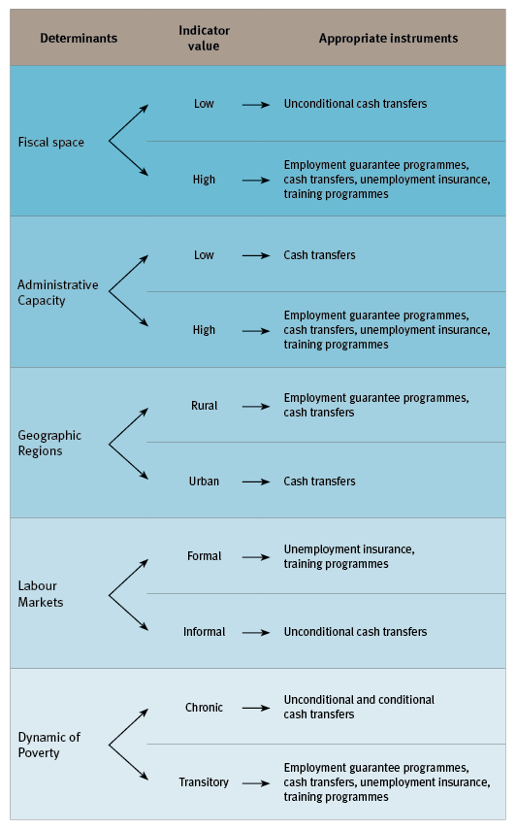

Source: EPRI (2010)

The cost of social protection is a significant consideration, especially in the Pacific where many governments face fiscal constraints. Existing programs can provide a general yardstick for costs. In Samoa the Senior Citizen Benefit Scheme provides a monthly benefit of 130 tala (approximately A$55) to 8700 beneficiaries from age 65 years, for a total cost of about 1 per cent of GDP.[74] In Kiribati the Elderly Fund provides a universal non-contributory pension (A$40 a month) for all citizens more than 67 years of age. There are currently 2090 beneficiaries (97 per cent of those eligible).[75] The overall budget in 2010 for the Elderly Fund was A$1 068 000, around 0.6 per cent of GDP. If coverage was extended to everyone more than 60 years of age, the cost would increase to approximately 1.65 per cent of GDP.[76]

Micro-simulation analysis of household surveys quantifies the likely costs of potential social transfer programs and their impacts. The following analysis examines two types of cash transfers—a child benefit and a pension in five different scenarios:[77]

* low social protection benefit package: a child benefit equal to 10 per cent of each country’s national poverty line for all children under 5 years of age, and a social pension equal to 25 per cent of the national poverty line for all persons 65 years of age or older
* medium social protection benefit package: a child benefit equal to 20 per cent of the poverty line, and a social pension equal to 50 per cent of the poverty line
* high social protection benefit package: a child benefit equal to 30 per cent of the poverty line, and a social pension equal to 100 per cent of the poverty line
* high child benefit: a child benefit equal to 30 per cent of each country’s national poverty line for all children under 5 years of age
* high social pension: a social pension equal to 100 per cent of each country’s national poverty line for all persons 65 years of age or older.

The model assumes universal take-up of each benefit and did not include administrative costs. The household survey analysed was the 2008 Household Income and Expenditure Survey for Samoa and Vanuatu, and the 2006 Household Income and Expenditure Survey for Kiribati and Solomon Islands. The costs of the five scenarios are in Table 1.

Table 1. Social protection costs as a per cent of gross domestic product (survey year)

|  | **Scenario 1**  ***low* package** | **Scenario 2**  ***medium* package** | **Scenario 3**  ***high* package** | **Scenario 4**  ***high* child benefit** | **Scenario 5**  ***high* social pension** |
| --- | --- | --- | --- | --- | --- |
| Kiribati | 1.1 | 2.2 | 3.8 | 1.8 | 2.0 |
| Samoa | 1.0 | 2.0 | 3.6 | 1.5 | 2.0 |
| Solomon Islands | 0.8 | 1.6 | 2.6 | 1.6 | 1.0 |
| Vanuatu | 0.4 | 0.7 | 1.2 | 0.7 | 0.5 |

Table 2 reports on the impact of these scenarios in reducing household poverty rates in the four PICs modelled. The first three scenarios demonstrate increasing impacts as benefit levels rise, and the stand-alone child benefit (scenario 4) and social pension (scenario 5) yield impacts similar to the medium package (scenario 2). It also reports the impact of these scenarios in reducing household poverty gaps. The first three scenarios demonstrate the same pattern found for poverty rates, with increasing impacts as benefit levels rise. The stand-alone child benefit (scenario 4) and social pension (scenario 5) yield impacts falling between the low and medium social protection package scenarios (scenarios 1 and 2).

Overall, the results show that core social protection programs, including child benefits and social pensions, are affordable for the countries of Kiribati, Samoa, Solomon Islands and Vanuatu, and can have a significant impact on the poor and vulnerable.

Table 2. Simulated program impact on reducing poverty

|  | **% reduction** | **Scenario 1**  ***low* package** | **Scenario 2**  ***medium* package** | **Scenario 3**  ***high* package** | **Scenario 4**  ***child* benefit** | **Scenario 5**  ***social* pension** |
| --- | --- | --- | --- | --- | --- | --- |
| Kiribati | household poverty rate | 7.3 | 11.6 | 18.8 | 10.7 | 9.9 |
| national poverty gap | 7.9 | 14.8 | 24.2 | 10.4 | 14.4 |
| Samoa | household poverty rate | 4.4 | 10.0 | 17.7 | 8.2 | 7.2 |
| national poverty gap | 10.3 | 19.9 | 31.6 | 17.9 | 14.8 |
| Solomon Islands | household poverty rate | 5.5 | 11.2 | 16.8 | 9.4 | 8.1 |
| national poverty gap | 7.2 | 13.5 | 20.8 | 12.8 | 8.7 |
| Vanuatu | household poverty rate | 4.6 | 9.6 | 15.6 | 8.7 | 6.6 |
| national poverty gap | 6.6 | 12.5 | 19.3 | 11.3 | 8.2 |

# 6. Conclusions and recommendations

Evolving global evidence demonstrates the positive role for social protection in promoting pro-poor and inclusive economic growth through several transmission mechanisms, including strengthened human capital development, improved household risk management, more productive livelihoods and labour market engagement, better pro-poor economic policies and improved social cohesion. A review of Pacific Island experiences documents the lessons that apply to PICs, particularly in the face of structural economic constraints and the economic shocks, including the recent global downturn, that afflict these countries.

Global evidence provides models for effective social protection responses, which vary with each country’s social and policy context. In the Pacific the most important consideration is that formal social protection instruments complement existing traditional systems.

The choices of some PICs (Kiribati and Samoa) to adopt social cash transfer programs (specifically social pensions) highlight one kind of positive social protection instrument that has worked in the Pacific context. These kinds of interventions are affordable and protect the consumption of the most vulnerable. In addition, the benefits stimulate short-term economic activity and improve resilience in a manner that strengthens prospects for long-term economic growth and development.

# 7. References

Adato, M 2007, ‘Combining Survey and Ethnographic Methods to Evaluate Conditional Cash Transfer Programs’, paper presented at the conference on Q-Squared in Practice, 7–8 July, Hanoi, Vietnam, 2007.

Asian Development Bank 2008, ‘A Note on Vulnerability to the Global Crisis’, Asian Development Bank.

Ibid. 2009a, *Fiji Islands: Alternative Livelihoods Development Project: Completion Report*, Asian Development Bank.

Ibid. 2009b, ‘Taking the Helm: A Policy Brief on a Response to the Global Economic Crisis’, *Pacific Study Series*, Asian Development Bank.

Ibid. 2011, ‘Pacific Economic Monitor’, Asian Development Bank, Pacific Department, February 2011.

Aguero, JM et al. 2006, ‘Poverty and Inequality in the First Decade of South Africa‘s Democracy: What Can be Learned from Panel Data?’, staff paper no. 493 (February), Department of Agricultural and Applied Economics, University of Wisconsin, Madison, United States.

AusAID 2009, *Pacific Economic Survey 2009: Engaging with the World,* prepared by AusAID, Commonwealth of Australia, Canberra, Australia.

Ibid. 2011, *Pacific country profiles and funding profiles,*   
<http://www.ausaid.gov.au/country/southpacific.cfm>, viewed at   
7 September 2011, AusAID, Commonwealth of Australia, Canberra, Australia.

Bloom, DE, Canning C & Sevilla J 2004, ‘The Effect of Health on Economic Growth: A Production Function Approach’, *World Development*, vol. 32, no. 1, pp. 1–13, National Bureau of Economic and Social Research, Cambridge, Massachusetts, United States.

Bourguignon, F & Ravallion M 2004, *Social protection and economic growth,* commissioned by the Department for International Development, London, United  Kingdom.

Brown, R & Connell J 2005, ‘Remittances in the Pacific: An Overview’, *Pacific Studies Series,* prepared for the Asian Development Bank.

Case, A 2001, ‘Does Money Protect Health Status? Evidence from South African Pensions’, in *Perspectives on the Economics of Aging*, National Bureau of Economic Research, Cambridge, Massachusetts, United States.

Cichon, M & Knop R 2003, Mission Report, Windhoek, Namibia,   
19–26 January 2003, joint International Labour Organization/Luxemburg Government mission.

Davies, S 2007, ‘Making the Most of It: A Regional Multiplier Approach   
to Estimating the Impact of Cash Transfers on the Market’, *Concern Worldwide,* Lilongwe, Malawi.

Davies, S & Davey J 2007, ‘A regional multiplier approach to estimating   
the impact of cash transfers: The case of cash aid in rural Malawi’,   
*Concern Worldwide*, University of Bath, United Kingdom.   
<http://mpra.ub.uni-muenchen.de/3724>, viewed at 7 September 2011.

Davies, M, Oswald K & Mitchell T 2009, ‘Climate Change Adaptation, Disaster Risk Reduction and Social Protection’, *Promoting Pro-Poor Growth: Social Protection*, OECD, Paris, France.

Dercon S 2004, ‘Growth and Shocks: evidence from Rural Ethiopia’, *Journal of Development Economics,* August, vol. 74 (2), pp. 309–29, Elsevier.

Duncan, R & Nakagawa H, *Obstacles to Economic Growth in Six Pacific Island Countries,* World Bank, Washington DC.

Department for International Development 2005, ‘Social transfers and chronic poverty: Emerging evidence and the challenge ahead’, p. 6, DFID practice paper, London, United Kingdom.

Elisaia 2009, statement by HE Ambassador Ali’ioaiga Feturi Elisaia, Permanent Representative of Samoa to the United Nations, at the UN Conference on the World Financial and Economic Crisis and its Impacts on Development, June 2009.

Economic Policy Research Institute 2010, *Strengthening Social Protection Responses to the Global Economic Downturn: A policy toolkit for developing countries,* commissioned by DFID and produced by EPRI, Cape Town, South Africa.

Food Security for Papua New Guinea 2000, proceedings of the Papua New Guinea Food and Nutrition 2000 Conference, Papua New Guinea University of Technology, Lae, Papua New Guinea 26–30 June 2000.

Freeland, N & Robertson K 2011, ‘Vanuatu country case study’, AusAID, Canberra, Australia.

Gibson, J 2010, ‘Recent Shocks and Long-term Change in the Samoan Economy’, *Pacific Economic Bulletin,* 5(3), pp. 5–21.

Gibson, J et al. 2010, ‘The Importance of Selectivity and Duration-Dependent Heterogeneity When Estimating the Impact of Emigration on Incomes and Poverty in Sending Areas: Evidence from the Samoan Quota Migration Lottery’, World Bank, Washington DC.

Gyimah-Brempong, K & Wilson, M 2004, ‘Health, Human Capital and Economic Growth in Sub-Saharan African and OECD countries’, *The Quarterly Review of Economics and Finance,* vol. 44, no. 2, pp. 296–320.

HelpAge International 2006, ‘Counting Carers: How to improve data collection and information on households affected by AIDS and reduce the poverty of carers, people living with HIV and vulnerable children’, HelpAge International.

Heywood, P & Hide, R 1994, ‘Nutritional Effects of Export-Crop Production in Papua New Guinea’, *The United Nations University Press Food and Nutrition Bulletin,* vol. 15, no. 3.

Hormansdörfer, C 2009, ‘Health and Social Protection’, *Promoting Pro-Poor Growth: Social Protection*, OECD, Paris.

Horton, S & Ross, J 2003, ‘The Economics of Iron Deficiency’, *Food Policy* (28): pp. 51–75.

International Labour Organization, 2009a, *Decent Work Country Programme: Kiribati (2009–12),* International Labour Organization, final draft.

Ibid. 2009b.

Ibid. 2009c.

International Monetary Fund, 2010, World Economic Outlook Database, October 2010 edition. International Monetary Fund, Washington, DC, <http://www.imf.org/external/pubs/ft/weo/2010/02/weodata/index.aspx>, viewed at 7 September 2011.

Ibid. 2011, ‘World Economic Outlook Update’, International Monetary Fund, Washington, DC, January 2011.

*Joint Samoa Program Strategy 2006–2010,* Government of Samoa, 2006, Government of Australia, and Government of New Zealand.

Kidd, S et al. 2009, ‘Social Protection in the Pacific: Scoping Report’, prepared for AusAID, Canberra, Australia.

Kidd, S & Mackenzie, U 2011, ‘‘Kiribati country case study’, AusAID, Canberra, Australia.

Kumar, S 2010, ‘Policy Options for Small Pacific Island Economies in the Event of Global Economic Crises’, School of Economics, University of the South Pacific Suva, Fiji.

Organisation for Economic Co-operation and Development 2009, ‘Social Protection, Poverty Reduction and Pro-Poor Growth’, *Promoting Pro-Poor Growth: Social Protection,* OECD, Paris, France.

Papua New Guinea: Public Expenditure and Service Delivery 2004, World Bank, Washington DC.

Parks, W & Abbott, D 2009, ‘Protecting Pacific Island children and women during economic and food crises: Working Edition One for advocacy, debate and guidance’, Suva: UNICEF Pacific and UNDP Pacific Centre, Suva, Fiji.

Ravallion, M 2003, ‘Targeted Transfers in Poor Countries: Revisiting the Tradeoffs and Policy Options’, policy research Working Paper 3048, World Bank, Washington, DC.

Roy, D & Subramanian, A 2001, ‘Who Can Explain the Mauritian Miracle: Meade, Romer, Sachs, or Rodrik?’, International Monetary Fund working paper number 01/116, IMF, Washington, DC.

Sachs, JD 2002, ‘Resolving the debt crisis of low-income countries’, *Brooking Papers on Economic Activity,* The Brookings Institution, Washington DC.

‘The Samoa School Fee Relief Scheme: Background Analysis (2009)’, draft, commissioned by AusAID, Commonwealth of Australia, Canberra, Australia.

Samson, M 2002, ‘The Social, Economic, and Fiscal Impact of Comprehensive Social Security Reform for South Africa’, *Social Dynamics: A Journal of African Studies,* vol. 28, no. 2, pp. 69–97.

Samson, M 2011, ‘Micro-simulation analysis of social protection interventions in Pacific Island countries’, AusAID, Canberra, Australia.

Samson, M & Williams, M 2007, ‘Social Grants and Labour Market Behaviour: Evidence from South Africa‘s Household Surveys’, research paper 43, EPRI, Cape Town, South Africa.

Samson, M et al. 2002, *Social Security Reform and the Basic Income Grant for South Africa, Economic Policy Research Institute,* commissioned by the International Labour Organization, Geneva.

Samson, M. et al. (2004), *The Social and Economic Impact of South Africa‘s Social Security System,* Final Report Executive Summary, commissioned by the Economics and Finance Directorate, Department of Social Development, research paper no. 37, Economic Policy Research Institute, Cape Town, South Africa.

Samson, M et al. 2007, ‘Social Transfers Evidence Base: Synthesis Document. The Social and Economic Impact of Cash Transfers’, commissioned by DFID and produced by EPRI, Cape Town, South Africa.

Sirimanne, S 2009, ‘The Gender Perspectives of the Financial Crisis’, Interactive Expert Panel, UNESCAP Commission on the Status of Women, Fifty-third session, New York, United States, 2–13 March.

Slater, R 2011, ‘Solomon Islands country case study’, AusAID, Canberra, Australia.

Sundborn, G. et al. 2006, ‘Differences in health-related socioeconomic characteristics among Pacific populations living in Auckland,   
New Zealand’, *Journal of the New Zealand Medical Association,* 119 (1228).

Tembo et al. 2008, ‘Social Cash Transfers and Household Welfare in Zambia’, presented at the conference *Social Protection for the Poorest in Africa: Learning from Experience,* 8–10 September 2008, Kampala, Uganda.

United Nations Children’s Fund 2007, *State of the World’s Children*, UNICEF, New York, United States.

World Health Organization 2001, ‘Report of the Commission on Macroeconomics and Health’, *Investing in Health for Economic Development,* WHO, Geneva, Switzerland.

World Bank 2010, World Development Indicators. Washington DC,   
<http://data.worldbank.org/indicator>, viewed at 7 September 2011.

1. A useful summary of the existing evidence base on the link between social protection and pro-poor growth can be found in the Organisation for Economic Co-operation and Development (OECD 2009), which provides the conceptual foundation for this section.
2. PNG: Public Expenditure and Service Delivery 2004.
3. Adato 2007; Samson et al. 2007; Samson et al. 2004.
4. United Nations Children’s Fund (UNICEF) 200).
5. Horton & Ross 2003.
6. Aguero et al. 2006; Samson et al. 2004; Samson et al. 2007.
7. Case 2001.
8. Slater 2011; 2008 MICS survey, cited in Parks 2009.
9. Vanuatu nutrition survey 2007, cited in Freeland & Robertson 2011.
10. Entelberg 2007, cited in Kidd & Mackenzie 2011.
11. Heywood & Hide 1994.
12. Sachs 2002; Gyimah-Brempong & Wilson 2004; Bloom et al. 2004.
13. World Health Organization 2001.
14. Dercon 2004.
15. Kidd et al. 2009.
16. Food security for PNG 2000.
17. Hormansdörfer 2009.
18. Kidd & Mackenzie 2011.
19. Ravallion 2003.
20. UNICEF 2007; Samson et al. 2004; 2007.
21. HelpAge International 2006.
22. Samson et al. 2004; Samson & Williams 2007.
23. Tembo et al. 2008.
24. Brown & Connell 2005.
25. Gibson et al. 2010.
26. Sundborn et al. 2006.
27. Samson 2002.
28. Ibid.
29. Kidd & Mackenzie 2011.
30. Ibid.
31. Davies & Davis 2007; Davies et al. 2007; Davies 2007.
32. Cichon & Knop 2003.
33. Samson et al. 2002; Bourguignon & Ravallion 2004; United Kingdom Department for International Development 2005.
34. Roy & Subramanian 2001.
35. PNG: Public Expenditure and Service Delivery 2004.
36. Kidd & Mackenzie 2011
37. AusAID 2006; Gibson 2006, Pacific 2020: Challenges and opportunities for growth; Nakagawa and Duncan 2005, Are the Pacific Island Countries Growth Failures?; World Bank, Obstacles to Economic Growth in Six Pacific Island Countries.
38. Duncan & Nakagawa 2005.
39. IMF World Economic Outlook Database, October 2010.
40. ADB 2008.
41. Secretariat of the Pacific Community, Ministries of Agriculture and Foresty 2/WP 1,   
    25 August 2008, cited in Parks 2009.
42. Parks 2009.
43. McGregor et al. 2009, cited in Kidd et al. 2009.
44. Per cent change, end of period consumer prices, IMF 2010.
45. Kumar 2010.
46. Joint Samoa Program Strategy 2006–2010, 2006.
47. Year-on-year figure, ADB 2011; Parks 2009.
48. There is an absence of good labour market surveys, as well as debate over whether those involved in subsistence agriculture and farming should be considered unemployed.
49. Parks 2009.
50. ILO 2009a.
51. Ibid. 2009c.
52. Ibid. 2009b.
53. Elisaia 2009.
54. Gibson 2010.
55. Sirimanne 2009, cited in Parks 2009.
56. ADB 2011.
57. AusAID 2009.
58. World Bank 2010.
59. ADB 2009b.
60. Kidd et al. 2009.
61. Ibid.
62. Kidd et al. 2009.
63. ADB 2011; IMF 2011.
64. ADB 2011.
65. Ibid.
66. AusAID 2009.
67. United Nations Conference on Trade and Development figures.
68. World Bank 2010.
69. AusAID 2011.
70. ADB 2011.
71. This framework is drawn from Strengthening social protection responses to the global economic downturn: a policy toolkit for developing countries, EPRI (2010).
72. ADB 2009a.
73. The Samoa School Fee Relief Scheme: Background Analysis 2009.
74. Samson 2011.
75. Kidd & Mackenzie 2011.
76. Ibid.
77. These programs are analysed in greater detail in Samson 2011.