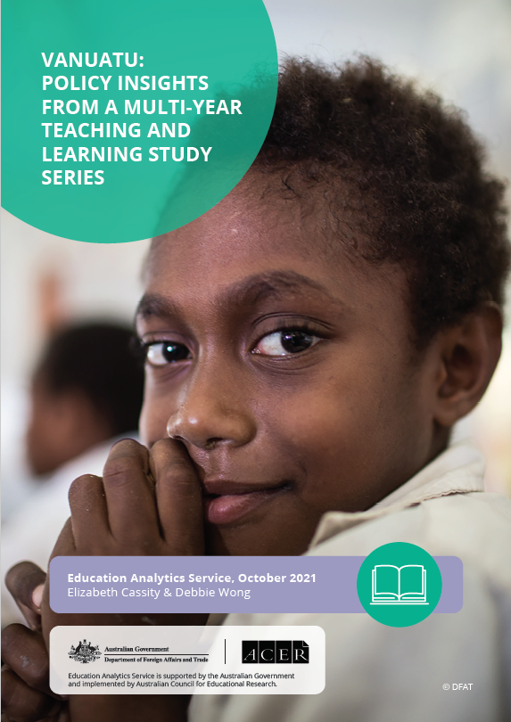
The Australian Government is supporting significant education reforms in Vanuatu. This policy note summarises findings on primary school teacher practice and student learning outcomes, during the first phase of major curriculum changes. Key findings include the need for consistent investment in ongoing professional learning given that new content and pedagogies require significant change and learning for teachers and other education actors. In addition, better engagement with school communities builds understanding of the reforms and encourages greater parental involvement in education. Part of a multi-year study, the Education Analytics Service is investigating how the Vanuatu Education Support Program (VESP) is making a difference to the Government of Vanuatu’s ongoing primary education reforms. The study series was commissioned by the Australian Government’s Department of Foreign Affairs and Trade (DFAT), to investigate teacher and learning development initiatives in three countries: Lao PDR,
Timor-Leste and Vanuatu.

The Vanuatu Education Support Program (VESP)
VESP was developed in partnership between DFAT and the Vanuatu Ministry of Education and Training (MoET). VESP aims to increase equitable access to education, improve the quality of education, and strengthen the management of education systems. One outcome is for school principals, teachers, parents and communities to collaborate to enable students to achieve improved literacy and numeracy skills. A key purpose of the VESP is to develop and support the MoET’s staged implementation of a new primary education curriculum. The core components focused on teachers are:
New primary education curriculum
Supported by Phase I of the VESP (2016-2019), the Vanuatu MoET began implementation of a new primary education curriculum for Years 1 to 3. The new curriculum promotes teaching practices that support inclusive education, language transition and classroom-based assessment practices. A significant change is the implementation of Vanuatu’s National Language Policy which allows schools to use a vernacular or Bislama in the early grades. Phase II (2019-2022) continues this agenda with an expanded focus on teacher and student support materials and the roll-out of the Years 4 to 6 curriculum.
Professional learning for teachers, principals and education officers
In-service professional learning involves a series of in-service training modules closely linked to the roll-out of the new curriculum. The priorities of VESP Phase II are to consolidate teacher development in Kindergarten to Year 3, expand teacher development to Years 4 to 6, and to provide greater support for the new pedagogies.

Study Design
The Education Analytics Service has been commissioned to undertake an independent study to investigate to what extent has the VESP investment improved teaching quality and student learning through three research questions:
- To what extent has the investment improved teaching quality in Vanuatu?
- To what extent has the investment in teacher training and mentoring supported effective implementation of Vanuatu’s new curriculum?
- To what extent have teacher training and support activities led to improved learning outcomes?
The study uses a mixed methods approach utilising both quantitative and qualitative methods. Given the diversity of Vanuatu’s provinces, the study is implemented across a variety of contexts over multiple years to see how VESP investments are taken up – or not – in particular contexts. The study commenced after the intervention began and is not longitudinal. These design choices were made in line with the preferences of DFAT and education ministry counterparts.
In the study’s first year (2019), reported here, qualitative case study data comprising of interviews and focus group discussions involving education stakeholders was collected and analysed from 12 schools across two provinces. Student assessment data from the earlier 2015 and 2018 Pacific Islands Literacy and Numeracy Assessment (PILNA) and the 2017 Vanuatu Standardised Test of Achievement (VANSTA) provide insights into student learning outcomes under the previous curriculum. The analysis of PILNA and VANSTA data following introduction of the new curriculum is a feature of the study from the second year. This will enable investigations of student learning progress, especially for the student and teacher cohorts (Year 1-3) participating in the initial curriculum roll-out supported by VESP Phase I.
Table 1: Overview of data collection methods, tools, intended study duration and reporting
 | Data Collection Details
Quantitative | Student learning assessment data.
Qualitative | Range of school case studies – purposively selected by province  and island each study year.  Interviews and focus group discussions with education stakeholders, classroom observations from 2021/22.
Intended Study Duration | 5 years, with three cycles of data collection.
Reporting | Interim Report 1 (summarised here)  Interim Report 2  Final Report  EAS Study Series Final Report

Key Findings
The study’s first year focused on the experiences of Vanuatu education stakeholders during the first phase of the roll-out of the new curriculum. The findings will help identify key areas for priority action and investment as the curriculum, teaching and assessment reforms continue to flow through Vanuatu’s primary education system.

PROFESSIONAL LEARNING AND INSTITUTIONAL SUPPORT
The new content and pedagogies included in the national curriculum require significant change and learning for teachers, principals, education officials and school communities. This highlights the value of consistent investment in professional learning.
Results from the first year of the study indicate the VESP training and support have helped teachers and principals to be more confident, knowledgeable and apply new pedagogies.
- Training and support has strengthened principal and teacher knowledge on lesson planning, subject matter and pedagogical approaches.
- Training has boosted teacher motivation and self-confidence, particularly for untrained and temporary teachers.
- Many teachers reported they use a more diverse range of student activities, and are incorporating different strategies to support a range of student abilities.
- Principals who attended leadership training reported it helped them gain a better understanding of their role and strategies to support teachers to improve teaching and learning.
Not all teachers – permanent, temporary or untrained – have had the opportunity to participate in the full suite of training.
- There are significant numbers of untrained and temporary teachers with minimal training who are delivering the new curriculum to Year 1 and 3 and to multi-grade classes.
There is an urgent need for consistent, ongoing institutional support for teachers.
- School-based support from Provincial Trainers (PTs) and School Improvement Officers (SIOs) remains infrequent and of varying quality. There is an absence of ongoing follow-up training and support to schools, and resourcing challenges for PTs and SIOs to regularly monitor and provide quality advice to schools, especially remote schools.
- Teacher working groups and peer learning, which already exists in some schools, is valued by teachers.

LANGUAGE POLICY
The National Language Policy 2012 (MoET, 2012) states that Bislama or the vernacular can be used in teaching during the first two years of primary school with either English or French introduced as a subject in Year 3.
The use of a language most students in a school are familiar with, and confident in, are more likely to support students’ learning in the early years.
- Some teachers and principals observed students were more interested in lessons and confident in speaking in a familiar language.
- The ability of teachers to use Bislama or a vernacular language in the classroom was reported to be a factor in improving teaching practice.
- There is recognition that the more parents understand what their children are learning, the better they are able to support them in school.
Some schools and communities have expressed concern about the uneven messaging and application of the language policy.
- The language policy requiring the use of Bislama or the vernacular is applied differently in some communities given the mix of languages.
- Awareness campaigns, where they have taken place, have supported community understanding of the new curriculum. This parent and community support appears to be an important factor in facilitating the successful implementation of the new curriculum.
The transition to English or French presents a challenge to maintaining learning gains.
- Many teachers and principals report the new curriculum is helpful in supporting students’ learning, but that the transition to English or French happens too quickly, with some teachers reporting students have challenges with reading and writing.
- Teachers in Years 3 and 4 preparing for the language transition reported they need additional support during these critical years.
- The delay in training for Year 4 teachers, despite it being a key language transition year, presents a risk to any learning gains made in Year 1 to 3.

Recommendations

PROFESSIONAL LEARNING AND INSTITUTIONAL SUPPORT
Extending and deepening professional learning and institutional support for teachers, principals, SIOs and PTs.
Findings from the study suggest that investments in training through VESP have made a positive contribution to teaching quality. But given the diversity in qualifications and experiences of the teacher workforce, differentiated and continuous and ongoing professional learning is needed.
- Providing follow-up or more extended training for untrained and temporary teachers could boost the performance of those without immediate access to more formal teacher training programs.
- Developing measures to support teachers in multi-grade settings and those teaching Years 3 and 4 (key language transition years) must be a priority.
Strengthening institutional support systems can go some way towards ensuring initial gains in teaching quality can be sustained. In resource constrained environments, cost-effective ways to improve the quality and availability of support provided by principals and provincial officers need to be found.
- PTs and SIOs can coordinate observation and training activities through measures such as joint and rotated visits.
- PTs and SIOs need additional training on effective coaching and mentoring to improve the effectiveness of their support to schools.
- Principals can be encouraged and given additional resources to lead teaching and learning in their schools, and to find ways for knowledge exchange across schools through support teacher working groups and peer collaboration.
Clear accountability structures are also important. As part of the curriculum and learning reforms, introducing structures detailing the actors that will deliver support to teachers, principals and communities can improve accountability for driving teaching and learning improvements.

COMMUNITY ENGAGEMENT
Engaging communities on the new curriculum and language policy can support their successful implementation.
Awareness campaigns and ongoing dialogue with school communities about the new curriculum and language policy can facilitate greater community engagement in education and an understanding of the reforms. Ensuring implementation can take into account local contexts and needs, such as languages in the community and the availability of teachers and resources, may encourage greater Involvement of parents and communities in education at school and home. Furthermore, these interactions provide an opportunity to emphasise the important role families and communities play in supporting early language acquisition, which supports children’s readiness for school, and ultimate learning success.
- Measures could be implemented to institute ongoing support for principals, teachers and provincial officers in effectively liaising with parents and communities about the objectives of the new curriculum reform and language policy, and practical ways in which they can support children’s learning at home and in school.
- Ongoing follow-up curriculum support for all education staff is needed to increase their capacity to support broader understanding of curriculum objectives and content.

Further Reading
Cassity, E., Chainey, J. Hollingsworth, H., Pereira, T., Sarmento, D. & Wong, D. (2019). ‘Teacher professional learning in Timor-Leste, Lao PDR and Vanuatu: Inclusive programs that support education system actors’. Panel presented at UKFIET, The Education and Development Forum. Oxford: United Kingdom.
Education Analytics Service. (2019). Teacher Development Evaluation Conceptual Framework. Melbourne: Australian Council of Educational Research.
Education Analytics Service. (2020). Teacher Development Multi-Year Study Series: Vanuatu Interim Report 1. Melbourne: Australian Council for Educational Research.
Office of Development Effectiveness. (2015). Investing in Teachers. Canberra: Department of Foreign Affairs and Trade.

About the Authors
Elizabeth Cassity is a Senior Research Fellow in the Educational Monitoring and Research Division at the Australian Council for Educational Research. Elizabeth co-leads the Vanuatu Study component of the DFAT teacher development study series together with Debbie Wong.
Debbie Wong is a Senior Research Fellow in the Educational Monitoring and Research Division at the Australian Council for Educational Research. Debbie is the Project Manager for the DFAT teacher development study series, and co-leads the Laos Study component together with Hilary Hollingsworth.
© 2021 The Commonwealth of Australia, represented by the Department of Foreign Affairs and Trade.
Recommended APA citation:
Cassity, E. & Wong, D. (2021). Vanuatu policy insights from a multi-year teaching and learning study series. Australian Council for Educational Research. https://research.acer.edu.au/eas

Study duration has been impacted by COVID-19 travel restrictions.

