Early Recovery – Humanitarian Strategy Guidance NOte

Central elements: Building Resilient Communities and Engaging Vulnerable Groups.
Circular representation: response-relief; repsonse-early recovery; recovery and reconstruction and ongong development.  The Humanitarian Cycle

* Relief (~+1 to ~30 days): to coordinate lifesaving support with other response actors (key priorities – Health, WASH, Food, Shelter and Protection), informed by quick assessment requests from government, partners and post - subject to Australian Government priorities;
* Early Recovery (~+1 to ~90days): to align with flash appeals, informed by rapid assessments – subject to Australian Government priorities – mindful of the existing Aid Investment Plans.
* Recovery and Reconstruction (~+2months to ~24months): to align with National Recovery and Reconstruction Plans, informed by Post Disaster Needs Assessments (PDNA) - subject to Australian Government priorities, as expressed in the existing Aid Investment Plans.
* The timescales referenced in this guidance note are indicative, e.g. Relief may often be longer than 30 days, or in some cases shorter. The diagram is designed to convey the importance of acting timely and focused whilst taking into account ongoing monitoring and assessments.

## Humanitarian Response: Relief and Early Recovery

DFAT’s 2016 Humanitarian Strategy outlines the direction for humanitarian preparedness and response and recovery. This guidance note is designed to describe the core priorities and three key result areas required to deliver an effective Early Recovery result as part of the response, specifically Objective 4, Enabling Early Recovery.

The Humanitarian Response, Risk and Recovery Branch (HMB), within the Humanitarian, NGOs and Partnership Division (HPD) provides specialist support for Early Recovery.

Early Recovery is designed to arrest, and begin to reverse the decline in the development trajectory of an affected country or region as a result of a natural disaster or humanitarian crisis.

Early Recovery begins alongside humanitarian relief, in the response phase, and lays the foundations for longer term recovery / reconstruction and development activities.

Early Recovery programing is subject to consultation with the host government and will seek to leverage existing Australian Aid Investment Plan programming. Early Recovery investments help to localise a post-crisis response by empowering local actors, including women and children, people with disabilities and other marginalised and vulnerable groups and supporting the local private sector, particularly small to medium enterprises, to get back on its feet.

Early Recovery programming ideally will align with the flash-appeal priorities of host government and timelines (nominally ~+1 to ~90 days). Early Recovery activities can terminate once they have achieved their stated goals, or can be continued as part of the National Recovery and Reconstruction plan in the out months and years.

A key vehicle for these activities will be DFAT’s partnerships with the host government, UN agencies, the Red Cross movement and non-government organisations, international and national, including the Humanitarian Partnership Agreement and the Australian Defence Force.

### How will the Humanitarian Response, Risk and Recovery Branch assist the Country Program (Post / Desk)?

#### Timeline: Day 1 to ~ Day 30

#### (in tandem with the relief phase)

HMB and the Humanitarian and Refugee Policy Branch (HUB) are tasked with implementing Australia’s responses to rapid onset and protracted crises respectively, in cooperation with the affected Post(s) and host government(s), and other agencies, including the Australian Defence Force and the UN/Red Cross and non-government organisations.

* HMB will support the Humanitarian Operations Centre, Desk / Post and with specialist advice outlined in this guidance note, including preparing plans on Early Recovery.
* HMB will provide specialist advice to Desk / Post on the expected aid processes that flow from a humanitarian disaster, including UN Flash Appeals (which prioritises activities which focus on the first 90 days and are released in the first three weeks), informed by rapid assessments. Including offering the use of technical assistance.

Early Recovery Key Result: Accelerate the trajectory of recovery:

The sooner work on Early Recovery begins the shorter and more effective the post-crisis recovery process is likely to be.

HMB along with HUB will propose and review Early Recovery activities that could be adopted to accelerate the trajectory of recovery; mindful of current relief activities, leveraging the existing Aid Investment Plan, the Humanitarian Partnership Agreements and international best practice. This may include leveraging public private partnerships, in energy, water and communication restoration.

* The attached activity and performance measure table (Appendix 1) provides an outline of what can be developed between HMB and Post/Desk to promote Early Recovery (aligned with host nation priorities and flash appeals).

**KEY ACTION: Prioritise the restoration of basic services** **(essential health, education and infrastructure);** for example, in responding to Tropical Cyclone Winston in Fiji, we prioritised children returning to school as soon as possible, with temporary learning centres, school feeding programs and psychosocial support implemented through UNICEF and Save the Children.

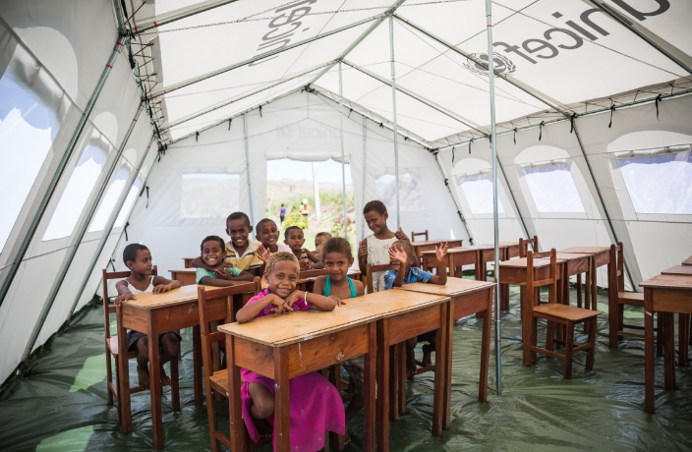

Temporary Learning Centre: TC Winston 2016. UNICEF.

Health services were maintained by establishing tents in places where buildings were lost, and national health services were augmented by an Australian Medical Assistance Team.

HMB leverages relationships with key partners (focusing on water, energy and transitional shelter) to facilitate the rapid deployment of technical essential service personnel to a humanitarian disaster or crisis. For example, in TC Winston, we worked with Australia’s energy distributers to support the Fiji Electricity Authority to restore power to affected communities.

**KEY ACTION: Support the resuscitation of markets and livelihoods**; for example, through cash-based transfers that catalyse economic activity, stimulate local markets and empower affected populations to rebuild their livelihoods

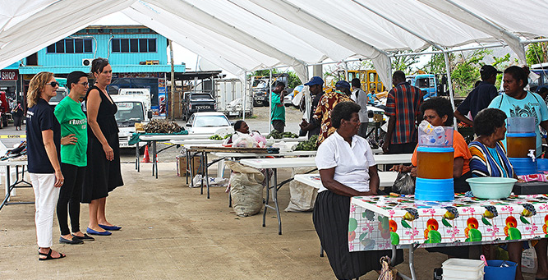

Temporary Market Space: TC Winston 2016. UN Women

In TC Winston, our partner Save the Children conducted a cash for work program to pay villagers in Ra Province to remove and recycle debris, which protected the villagers from injury and vector borne viruses. Recipients used the money to pay for transport to town to buy essential supplies.

**KEY ACTION: Support protection measures**; to promote community cohesion in maintaining resilience and engaging vulnerable groups; for example, in TC Winston our partner UNFPA established “Women Friendly Spaces” which were sought out by 2,000 women and girls needing support.

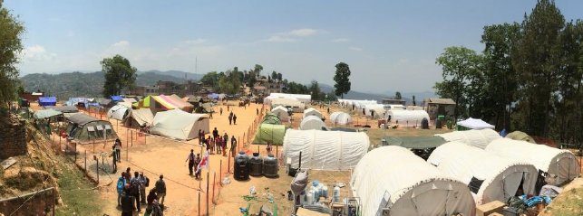

Safe housing provided after the 2015 Nepal Earthquake. IOM

Early Recovery Key Result: Ensure timely access to technical expertise and assistance

Provide technical assistance to partner organisations and governments to assist Early Recovery efforts.

Technical expertise and resources can ensure that the transition from humanitarian response to recovery and reconstruction is as timely and effective as possible. HMB will maintain and strengthen our ability to deploy Early Recovery specialist personnel and teams including government personnel (e.g. the Crisis Response Team) and civilian specialists (including the Australian Civilian Corps, RedR and Australian Volunteers).

In TC Winston, Australian Civilian Corps (ACC) deployees were stationed within the Fijian National Disaster Management Office and played essential roles during the response phase (building on their preparedness work) by assisting Fijian authorities to better coordinate activities.

#### Timeline: ~ Day 30 to ~ Day 90

#### (in tandem with the flash appeal phase*)*

HMB will support Post / Desk to engage stakeholders including NGO and UN partners in order to produce a more successful coordinated and resilient recovery.

* Monitor needs and adjust support where required.
* Support Desk / Post to advocate with the affected country to develop a government led Recovery and Reconstruction Plan, informed by a Post Disaster Needs Assessment (usually led by the World Bank).
* Assist the Country Program to undertake a rapid review of Early Recovery activities in country, to determine the effectiveness of programming to date and to assist Desk / Post consider changes to their Aid Investment Plan, in light of the severity of the disaster; thereby making the investments Australian makes more resilient to the next disaster.

#### Timeline: The First Year

#### (in tandem with the recovery and reconstruction phase and reducing disaster risk priorities)

HMB will continue to support to Post / Desk in advocating for, and monitoring the implementation of a national recovery and reconstruction plan.

* Support partner governments and local actors to prepare recovery and reconstruction policies and strengthen coordination and funding mechanisms before the next crisis, including around land issues.
* Advocate with host government to prioritise the preparation of host government systems to use cash based transfers in humanitarian response.

Early Recovery Key Result: Incorporate the “Build Back Better” principle into recovery and reconstruction

Early Recovery programming offers the opportunity to prioritise reducing vulnerability to hazards and disasters in the future.

HMB will support Posts / Desks to work with partner governments to ensure that post disaster activities result in greater resilience, both physically and institutionally.

* DFAT to build greater flexibility into country and regional aid programs to allow them to refocus and accommodate Early Recovery activities if required, particularly in disaster prone countries.

For example, by constructing more disaster-resilient and accessible buildings, and raising public awareness about the dangers of unsafe buildings and locations. It will be harder for a community to recover economically or sustainably from a disaster event if they are not able to find permanent shelter.

### How will DFAT measure success?

The Performance Assessment Framework in the 2016 Humanitarian Strategy outlines how DFAT will assess its effectiveness, including the three key result areas described for early recovery. This includes actively learning so as to produce a more effective future humanitarian response.

Early Recovery is a key component of the work being undertaken in the joint Australia / New Zealand Humanitarian Monitoring and Evaluation Framework project.

### Links to protracted and slow onset crises.

The above three key result areas also apply in a protracted and slow onset scenario, focusing in this context on Building Resilience**.**

Appendix 2 shows some activities and performance measures that could be considered to create and maintain a functioning community.

#### Contact:

Disaster Resilience and Recovery Section,

Humanitarian Response, Risk and Recovery Branch,

Humanitarian, NGOs and Partnerships Division

Email: [earlyrecovery@dfat.gov.au](mailto:earlyrecovery@dfat.gov.au)

|  |  |  |  |  |
| --- | --- | --- | --- | --- |
| Key Result 1: Accelerate the trajectory of recovery | **Possible Rapid Assessment questions.** | **Possible Activities** | **When** | **Possible Measures** |

## Appendix 1: Examples of activities and performance measures in Early Recovery (rapid onset) by key result area

|  |  |  |  |  |
| --- | --- | --- | --- | --- |
| Restore Basic Services | | | | |
| Health | Are the health centres open? How many destroyed? Is the staff still there?  What services are still operating? | Minimum Initial Service Package (MISP) for Reproductive Health | Start immediately, in place within 7 days. | Rate of women receiving assistance with emergency child birth / pre disaster rate |
| Primary Health / Aid Posts: treat injured people and then the expected 2nd wave from people cleaning up | Start immediately, in place within 7 days. | % aid posts operational within 7 days of disaster; compared to before disaster |
| Is water and sewage still operating? Who is fixing it? | WASH activities prioritised, especially mindful of waterborne diseases | Start immediately, in place within 7 days. | # People receiving the SPHERE standards for water and sanitation |
| Education | Are the schools open? How many destroyed?  Are the staff still there? | Safe Schools – children need normalising activity ASAP post disaster, also allows parents to concentrate on basic needs | Start immediately, in place within 7 days. | Rate of children attending education / pre disaster enrolment rate |
| Infrastructure | Is the phone network still operating? Is the NDMO using it to text updates? If down, who is fixing it? | Communication: restoration of mobile phone service functionality – private sector led | Start immediately until finished | Coverage (time / distribution) at which SMS alerts restored / pre disaster coverage |
| Is power still operating? Who is fixing it? | Restoration of power and water supplies – prioritise public goods eg health, education, law and order and supermarket facilities | Start immediately until finished | Time it takes to restore services to pre-disaster coverage |
| Can schools and hospitals be ‘made usable’ using the military? (eg attaching roofs, strengthening walls) | Using available military units to ‘make usable’ community infrastructure. Includes the purchase / supply of commodities. | Negotiated with host government | Did the military follow advice from host government and DFAT? |
| Resuscitate Markets and Livelihoods | | | | |
| Restore Community mobility | Are the roads open? Are the bridges functioning? Who is clearing (debris removal) / fixing it (engineer issues)? | Safe Debris Removal – mindful of hazards, such as tree, landslides, access, chainsaws, electrical wires,  Repair / make safe roads, bridges and ports / jetties. | Start immediately until finished | Community can safely move around their community to assist with the relief and recovery effort and work |
| Support local markets | What are the markets doing? Can they still get stock? Is there a price spike? Can people afford it? | Cash grants to families post disaster. Cash grants to market holders to dampen inflation. | Based on needs assessment – start within 30 days until target met. | Capacity of market to support the community / pre disaster capacity |
| Farmers return to their land[1] | What happened to the crops?  What are the issues surrounding land ownership? | Seeds and Root stock distributed | % farms with planted fields / pre disaster % |
| Business operating | What is the impact on business? | Consider supporting businesses to restart quickly to ensure employees continue to be paid. | % of workforce back at work / pre-disaster % |
| Protection of vulnerable populations – maintain and promote community cohesion | | | | |
| Women and children protected | Are the police still focused on their job in protecting vulnerable groups?  Are women’s shelters still operational? | Support Women’s shelters to be operational and accessible | Start immediately, in place within 7 days. | # women and children able to access services / pre disaster services |
| Aged people and people with a disability protected | Are services for elderly, disabled still functioning? | Support Aged Care and Disability Services to be operational and accessible | Start immediately, in place within 7 days. | #people (sex / age / disability) disaggregated receiving services / pre disaster services. |
| Key Result 2: incorporating – Build Back Better | Possible Rapid Assessment questions | Possible Activity | When | Possible Measure |
| Community infrastructure | How did community shelter respond? What is the extent of personal housing loss? What is the capacity for self-response? | Repair / make safe schools, hospitals | Start when safe until finished | Repairs, if undertaken need to be resilient enough to last until replaced by more permanent structures |
| Key Result 3: Access to Technical Assistance | Possible Rapid Assessment questions. | Possible Activity | When | Possible Measure |
| Providing technical surge capacity | What is the capacity in country to respond? Will government, UN and others be open to technical support? | Deploying technical teams to support key response activities, assessments, services etc | Within agreed timelines | Was the deployment undertaken during a time that enabled the full impact of the activity to be useful |

|  |  |  |  |  |
| --- | --- | --- | --- | --- |
| Key Result 1: Building Resilience | Assessment questions | Possible Activities | When | Possible Measures |

## Appendix 2: Examples of activities and performance measures in Building Resilience (slow onset / protracted) by key result area

|  |  |  |  |  |
| --- | --- | --- | --- | --- |
| Maintain Basic Services | | | | |
| Health | Are the health centres open? How many destroyed? Is the staff still there?  What services are still operating? | Minimum Initial Service Package (MISP) for Reproductive Health | Start immediately | Rate of women receiving assistance with emergency child birth / pre disaster rate |
| Primary Health / Aid Posts: treat injured people | Start immediately | % aid posts operational within 7 days of disaster; compared to before disaster |
| Is water and sewage still operating? Who is fixing it? | WASH activities prioritised, especially mindful of waterborne diseases | Start immediately | # People receiving the SPHERE standards for water and sanitation |
| Education | Are the schools open? How many destroyed?  Are the staff still there? | Safe Schools – children need normalising activity, also allows parents to concentrate on basic needs | Start immediately | Rate of children attending education / pre disaster enrolment rate |
| Infrastructure | Is the phone network still operating? Are the authorities using it to text updates? | Communication: maintenance of mobile phone service functionality – private sector led | Start immediately until finished | Coverage (time / distribution) at which SMS alerts restored / pre disaster coverage |
| Is power still operating? Who is maintaining it? | Maintenance of power and water supplies – prioritise public goods eg health, education, law and order and supermarket facilities | Start immediately until finished | Time it takes to restore services to pre-disaster coverage |
| Maintain and Resuscitate Markets and Livelihoods | | | | |
| Restore Community mobility | Are the roads open? Are the bridges functioning? | Repair / make safe roads, bridges and ports / jetties. | Start immediately until finished | Community can safely move around their community to assist with the relief and recovery effort and work |
| Support local markets | What are the markets doing? Can they still get stock? Is there a price spike? Can people afford it? | Cash grants to families. Cash grants to market holders to dampen inflation. | Based on needs assessment – start ASAP. | Capacity of market to support the community / pre disaster capacity |
| Farmers stay on their land | What is happening to the crops and livestock? | Seeds and Root stock distributed, livestock support | % farms with planted fields & livestock / pre disaster % |
| Business operating | What is the impact on business? | Consider supporting businesses to continue to ensure employees continue to be paid or new jobs created. | % of workforce back at work / pre-disaster % |
| Protection of vulnerable populations – maintain and promote community cohesion | | | | |
| Women and children protected | Are the police still focused on their job in protecting vulnerable groups?  Are women’s shelters still operational? | Support Women’s shelters to be operational and accessible | Start immediately | # women and children able to access services / pre disaster services |
| Aged people and people with a disability protected | Are services for elderly, disabled still functioning? | Support Aged Care and Disability Services to be operational and accessible | Start immediately | #people (sex / age / disability) disaggregated receiving services / pre disaster services. |
| **Key Result 2: incorporating – Build Back Better** | **Assessment questions** | **Possible Activity** | **When** | **Possible Measure** |
| Community infrastructure | How is community shelter responding? What is the extent of personal housing loss? What is the capacity for self-response? | Maintain and make safe schools, hospitals | Start when safe until finished | Structures need to be resilient enough to last until replaced by more permanent structures |
| **Key Result 3: Access to Technical Assistance** | **Assessment questions** | **Possible Activity** | **When** | **Possible Measure** |
| Providing technical surge capacity | What is the capacity in country to respond? Will government, UN and others be open to technical support? | Deploying technical teams to support key response activities, assessments, services etc | Within agreed timelines | Was the deployment undertaken during a time that enabled the full impact of the activity to be useful |

1. Land issues are complex post disaster and can slow recovery until resolved.