Due diligence framework

July 2024

# Due Diligence Framework

**INTRODUCTION**

The Due Diligence Framework (Framework) is a risk management tool to assess a potential delivery partner’s ability to deliver in line with relevant legislation and the policy requirements of the Australian development program. It responds to the Australian development program’s reliance on partnerships and third-party delivery mechanisms by better informing partner engagement, risk management and program delivery throughout the program cycle, while other DFAT processes inform partner performance and program impact.

The Framework provides a structured and consistent approach for the identification and assessment of delivery partner risk prior to entering into agreements/arrangements and providing funding.

The Framework applies to individuals, commercial contractors, private sector entities, multilateral organisations and development banks, international and regional organisations and civil and non-government organisations. Due Diligence is not required for most credit card purchases, venue hire or catering services.

Key risks identified in the due diligence process need to be assessed, documented and monitored in line with the International Development Programming Guide, [Chapter 8 Development Program Risk Management](http://dfatintranet.titan.satin.lo/managing-aid/international-development-programming-guide/Pages/international-development-programming-guide.aspx).

## 1.1 Objectives

The key objectives of the Framework include:

* undertaking due diligence assessments in a consistent and pragmatic manner proportional to the risk of the agreement/arrangement;
* strengthening risk management processes through identification and assessment of delivery partner risks prior to selection and agreement/arrangement finalisation;
* assisting delegates to satisfy *Public Governance, Performance and Accountability Act 2013 (PGPA Act)* requirements by systematically identifying delivery partner risks and mitigation strategies prior to entering into agreements/arrangements;
* supporting funding decisions to be transparent, robust and defensible.

## 1.2 GUIDING PRINCIPLES

The operation of the Framework is guided by the following principles:

* **Proportionality** – the scope and depth of detail in the assessments are proportional to the risk of the proposal. The scope and depth of an assessment is determined by the Delegate.
* **Evidenced based assessment** - assessments will be based on the best available and most current, objective and verifiable information and where appropriate will draw on third party assessments.
* **Validity** – assessments will remain valid for up to three (3) years, or until such time as a significant change to the assessed delivery partner’s circumstances may warrant review.
* **Centralised coordination and storage** – centralised coordination and storage of completed assessments enables a repository of information available for DFAT.
* **Delegate responsibility** – the financial delegate remains responsible for ensuring due diligence activities have been appropriately undertaken and will determine if any additional due diligence activities are required.

## 1.3 Key Features

The key features of the development Due Diligence assessment process include:

* Financial delegates determine that the scope of the due diligence assessment is commensurate to the risk of the agreement/arrangement.
* Assessment tools are available to support the conduct of assessments.
* Development Risk and Management Section (DRM) will centrally store completed due diligence assessment reports and make these available for use by program areas and decision makers.
* Individuals, Baseline and Baseline Downstream Partner due diligence assessments are typically completed by Agreement Managers and involve a desktop review to accomplish the assessment.
* Multilateral organisations and development banks and international and regional organisations’ due diligence assessments may be conducted with contractor support. Access to the Due Diligence Services Panel is available through the Australian Government’s AusTender’s DS4P.
* All Comprehensive due diligence assessments must be conducted with contractor support. Access to the Due Diligence Services Panel is available through the Australian Government’s AusTender’s DS4P.

Due Diligence is not required for most credit card purchases, venue hire or catering services.

**when to conduct due diligence**

Financial delegates are ultimately accountable for the risk management undertaken and the extent to which they apply due diligence prior to finalising an agreement/arrangement even if the assessment was approved by a separate Due Diligence Approver.

In most cases due diligence assessments commence at the time a potential delivery partner is identified and to be **concluded prior to the delegate finalising the S.23 PGPA Act approval minute to commit and enter into an arrangement**.

Due diligence assessments remain valid for a maximum of three (3) years and are centrally stored by DRM on the [Due Diligence Assessment Register](http://dfatintranet.titan.satin.lo/managing-aid/other-aid-management-risk-policies/due-diligence/Pages/assessment-register.aspx). Agreement Managers can request a copy of a completed due diligence assessment for their review and consideration as part of their due diligence process. (see section 4.1 below)

While a due diligence assessment is valid for a maximum period of three (3) years, a delegate may determine that an earlier re-assessment is required where circumstances indicate that:

* Partner risks have not been properly identified.
* Partner risk control strategies are ineffective.
* There is significant change in a partner’s circumstances (such as a corporate restructure).
* A shorter period between undertaking an assessment is deemed more appropriate.

## 2.1 Contract Amendments

Where there is the intention to extend a current agreement/arrangement, the program area should consider if the current due diligence assessment provides an adequate level of assurance for their Delegate or if another due diligence assessment is warranted. Over the years, there is strong likelihood that DFAT policies, the partner’s policies and operations as well as the delivery context would have changed or evolved. Program area should consider the age of previous due diligence reports for continued relevance as well as the broader program context. Particularly, if the agreement/arrangement extension means it will be more than three (3) years since the last due diligence assessment was carried out.

DFAT DUE DILIGENCE processes

Due diligence activities occurs across the Australian development program for a range of objectives and through various institutional capacity assessment processes including tender and grant evaluations, assessment of partner government systems and the Australian NGO Accreditation process.

A Due Diligence Assessment based on the Due Diligence Framework constitutes just one type of assessment to provide confidence in a potential delivery partner’s ability to deliver in line with relevant legislation and the policy requirements of the Australian development program.

Financial delegates are responsible for due diligence undertaken for any funding agreement/arrangement as well as its scope – for example the decision between an Individual, Baseline, Baseline Downstream Partner, or Comprehensive assessment. Delegates should exercise judgement in how best to apply the Framework to their program context and circumstances.

A summary of the delivery partners and their Due Diligence Assessment requirements are in Table 1.

**Table 1:** Delivery partners Due Diligence Assessment requirements

|  |  |
| --- | --- |
| DELIVERY PARTNER | DUE DILIGENCE ASSESSMENT REQUIREMENTS |
| Commercial and Private Sector Partners | A due diligence assessment is required. |
| Non-Government & Civil Society Organisations | A due diligence assessment is required unless accredited under the [Australian NGO Cooperation Program](http://dfat.gov.au/aid/who-we-work-with/ngos/Pages/list-of-australian-accredited-non-government-organisations.aspx) (ANCP).  Direct Aid Program (DAP) partners are subject to a due diligence process, please refer to DAP Managers Toolkit. |
| International & Regional Organisations  (e.g.: ASEAN, SPC, USP) | A due diligence assessment is required. The requirement is a Baseline Multilateral due diligence assessment. |
| Multilateral Organisations & Development Banks | A due diligence assessment is required. The requirement is a Baseline Multilateral due diligence assessment. |
| Bilateral Partners  (i.e. other Donors) | A due diligence assessment is not required.  Reviewed as part of regular formal and informal engagement. |
| Partner Governments | A due diligence assessment is not required.  An assessment of national and sector‐level public financial management and procurement systems must be undertaken. |
| Australian Government Agencies, Commonwealth entities and companies subject to the PGPA Act | A due diligence assessment is not required.  Australian Government governance and accountability mechanisms apply.  Note: Due Diligence assessments are required for Commonwealth entities/ companies who operate outside of the PGPA Act. |
| Australian State/Territory Government Departments | A due diligence assessment is not required. Australian State/Territory governance and accountability framework apply.  Note: For Australian State/Territory Agencies and related Entities, a Due Diligence assessments is required for entities operating outside of the relevant State/Territory governance and accountability framework. |
| Australian Education Institutions (e.g.: Universities delivering Australian awards/scholarships) | A due diligence assessment is not required.  Australian and State / Territory legal and policy compliance standards and accountability mechanisms apply.  Note: Due Diligence assessments are required for related/affiliated organisations such as research centres, institutions, councils and the like, who operate outside of the related Australian Education Institutions governance and accountability framework. |

## 3.1 Due Diligence Framework Assessment Tools

Under the Due Diligence Framework delivery partners are assessed at the corporate governance level. The assessment determines the delivery partners compliance with Australian development program requirements and can be broadly categorised into two key pillars that focuses on organisation capacity and risk management.

Defined assessment criteria underpin the pillars. These assessment criteria reflect legislative requirements, areas of potential risk to the Australian development program and DFAT policy priorities. The suite of assessment options reflects the principle of proportionality and are based on partner type and the associated risk profile. Assessment options include Individual, Baseline, Baseline Downstream Partners, Comprehensive or Baseline Multilateral.

Due Diligence Assessments are a pragmatic evaluation of the best available evidence. Sources of assessment information can include information held on record by DFAT, robust information already in the public domain, information provided by the partner for the purpose of the assessment, information reported to other Government agencies and departments and third-party assessments (e.g. other donor assessments available to the Australian development program).

Figure 1 illustrates how each of the due diligence assessment criteria are organised under the two pillars. How the criteria are applied to each of the due diligence assessment options are included in the following Figures 2 to 6, and the specific criteria applied to these due diligence assessments, respectively.

**Figure 1** Due Diligence Criteria Pillars

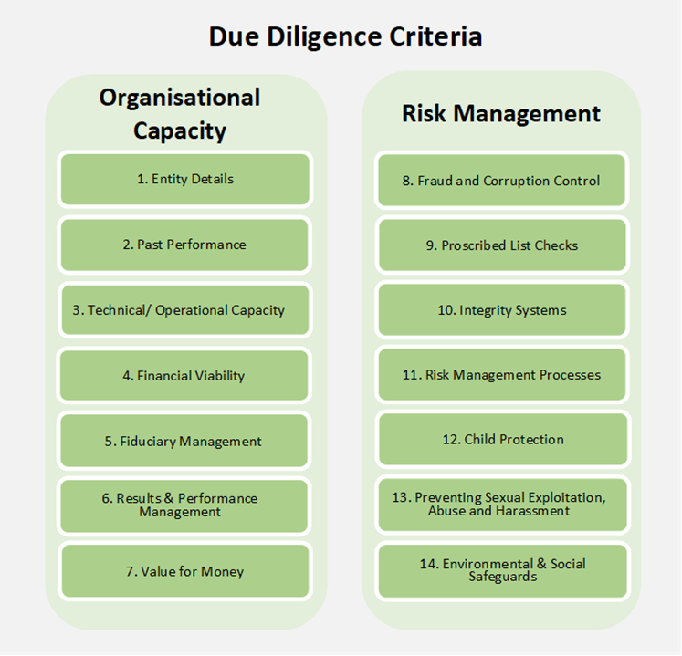

## 3.2 Individual due diligence Assessment

The Individual Baseline Due Diligence Assessment utilises five (5) of the seven (7) Baseline assessment criteria and is typically conducted by DFAT program, agreement or relationship managers as a desktop review. This assessment is adapted from the Baseline due diligence criteria and reflects a commensurate approach to engaging individuals. The individual due diligence assessments five (5) mandatory criteria are detailed in Figure 2 below.

Assessments of individual providers must be conducted by a DFAT officer/s using the individuals due diligence assessment tools and guidance. “***Individual” for the purposes of assessment means the engagement of a single consultant/person. The consultant/person must operate as either a sole trader/sole proprietor or other like self-employed business type.*** For due diligence assessments on individuals who are engaged via a consulting firm or recruitment entity or other medium/large organisations, a Baseline Due Diligence Assessment must be conducted on the organisation rather than the individual.

**Figure 2** Individual Due Diligence Criteria

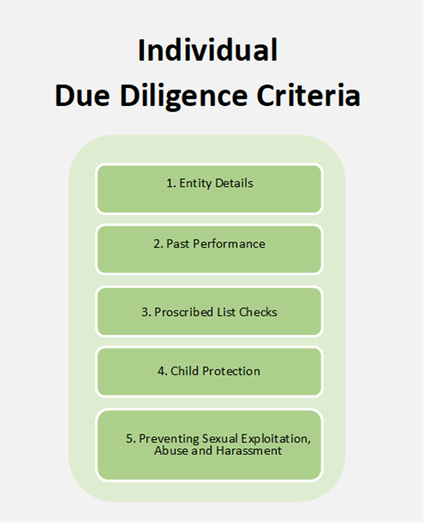

## 3.3 Baseline due diligence Assessment

A Baseline Due Diligence Assessment is the minimum assessment required for most organisations and addresses seven (7) assessment criteria. The seven (7) mandatory criteria that make up the Baseline Due Diligence Assessment are shown in Figure 3 below.

Program areas should consider due diligence assessments as an opportunity to develop a deeper, evidence based, understanding of their potential delivery partners at an early stage of engagement and prior to agreement/arrangement signature. This can help identify and interpret any risks of working with the partner on a specific program and assess whether the partner has the capacity and capability to deliver. Early assessment may enable certain risk mitigation actions to be included as part of agreement/arrangement negotiations.

Baseline assessments are generally conducted by a DFAT officer/s as a desktop review using the baseline assessment tools and guidance.

***The Baseline Due Diligence Assessment Report is not appropriate for assessing a delivery partner who will make use of downstream partners or for assessing multilateral organisations and development banks or international and regional organisations***. See sections 3.4 and 3.5 for more information on these types of assessments.

**Figure 3** Baseline Due Diligence Criteria

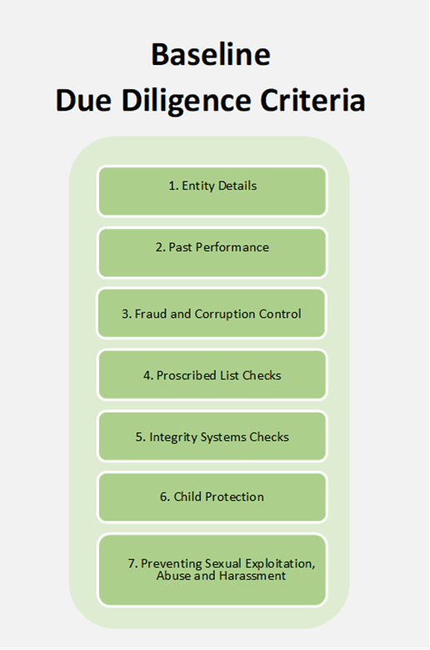

## 3.4 Baseline Downstream Due Diligence Assessment

The Baseline Downstream Due Diligence Assessment mirrors the criteria of the Baseline Assessment but expands on the assessment requirements. DFAT partners should be taking steps to understand their own downstream partners/ delivery chain and managing the associated risks from working through them. This assessment focusses on how a delivery partner manages their downstream risks including how due diligence is reflected further down the delivery chain. The seven (7) mandatory criteria that make up the Baseline Downstream Due Diligence Assessment are shown in Figure 4 below.

Baseline downstream assessments are generally conducted by a DFAT officer/s using the baseline downstream assessment tools and guidance.

***The Baseline Downstream Due Diligence Assessment is not appropriate for assessing multilateral organisations and development banks or international and regional organisations.*** For assessments on multilateral organisations and development banks or international and regional organisations the minimum requirements are detailed in section 3.5 below.

**Figure 4** Baseline Downstream Due Diligence Criteria

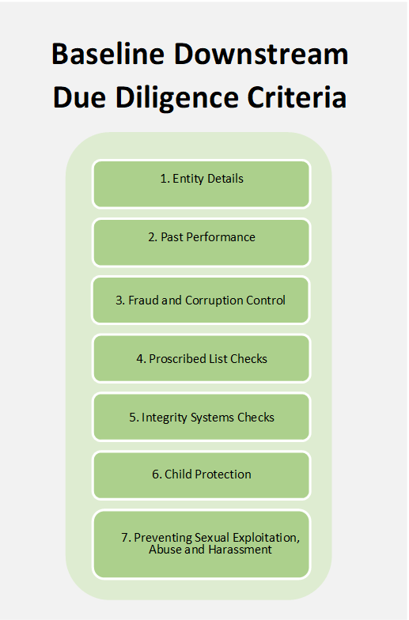

## 3.5 Baseline Multilateral Organisations, Development Banks or International and Regional Organisations

For due diligence assessments on a multilateral organisation, development bank or an international and regional organisation (now referred collectively as Multilaterals), the minimum due diligence requirements are to conduct a Baseline multilateral assessment. The baseline multilateral assessment includes the seven (7) criteria as per Figure 5 below. However, the information and evidence to be considered when undertaking a multilateral assessment is appropriate and proportionate to the size and complexity of the organisation and the value of the proposed agreement/arrangement.

Baseline multilateral assessments are generally conducted by a DFAT officer/s using the baseline multilateral assessment tools and guidance, however this assessment may also be conducted with contractor support. Access to the Due Diligence Services Panel is available through the Australian Government's AusTenders DS4P. The due diligence assessment is conducted in close cooperation with the multilateral organisation.

While many Multilaterals are viewed as trusted partners, the aim of a due diligence assessment is to provide an overall judgement of the risks related to working with that particular partner. These risks should be addressed by assurances from the partner that they have an appropriate governance structure; that central policies, controls and processes of sufficient quality are in place and well aligned to DFAT policies. That these established policies and procedures are operating effectively in practice. That suspicions or allegations of fraud, corruption, terrorism financing, child abuse or sexual exploitation, abuse and harassment (SEAH) are identified, communicated and dealt with appropriately.

Baseline Multilateral Due Diligence Criteria. 1. Entity Details 2. Past Performance 3. Fraud and Corruption Control 4. Proscribed List Checks 5. Integrity Systems Checks  6. Child Protection 7. Preventing Sexual Exploitation, Abuse and Harassment

**Figure 5** Baseline Multilateral Due Diligence Criteria

## 3.6 Comprehensive due diligence Assessment

Comprehensive due diligence assessments address the full fourteen (14) assessment criteria, including the baseline assessment criteria in greater depth as shown in Figure 6 below. Comprehensive assessments are conducted with contractor support using the comprehensive assessment tools and guidance. Access to the Due Diligence Services Panel is available through the Australian Government's AusTender’s DS4P.

Given the level of detail and information required, the delivery partner is often required respond to information requests with more frequency during the assessment process. Further, the findings and conclusions of the assessment are typically discussed, and fact checked with the delivery partner prior to the finalisation of the report.

The financial delegate is responsible for determining if a comprehensive assessment is required (ie the scope). The delegate also needs to be satisfied that the depth of detail in assessment provides an adequate level of assurance. The scope and depth of detail in a due diligence assessment needs to be proportional.

In determining the scope and depth of detail in the assessment, consideration should be given to relevant factors including but not limited to:

* current knowledge of and historical relationship with the partner (including past performance and their ability to meet the requirements of Australian government policy)
* delivery context, including who the delivery partner will be working with and what they are being asked to do and how
* the financial value and risk of the proposed agreement/arrangement
* the degree of public interest the agreement/arrangement may attract; and
* partner type.

**Figure 6** Comprehensive Due Diligence Criteria

Comprehensive Due Diligence Criteria. Organisational Capacity 1. Entity Details 2. Past Performance 3. Technical/ Operational Capacity 4. Financial Viability 5. Fiduciary Management 6. Results and Performance Management Risk Management 8. Fraud and Corruption Control 9. Proscribed List Checks 10. Integrity Systems 11. Risk Management Processes 12. Child Protection 13. Preventing Sexual Exploitation, Abuse and Harassment 14. Environmental and Social Safeguards

## 3.7 A Note on proportionALITY

As detailed above, the S23 delegate responsible for agreement/arrangement is also responsible for determining the scope of the due diligence assessment. The depth of detail in the assessment needs to provide an appropriate level of assurance to satisfy the delegate.

Generally, considerations that help us understand the overall due diligence risk context associated with a potential delivery partner include the following:

* Our prior experience of working with, and knowledge of, the proposed delivery partner’s performance. In other words, what do we know of this delivery partner’s ability to meet our policy requirements and their record of performance?
* The characteristics of a particular partner type (eg multilateral, NGO, etc) may reflect inherent risk and the options for risk mitigation limited.
* The level of complexity associated with the agreement/arrangement accomplishing its objectives. This takes into consideration the operating environment including political context as well as the complexity of the program design itself.
* The level of exposure, political and reputational risk associated with the agreement/arrangement.
* The financial value of the agreement/arrangement.

For example, an agreement/arrangement of moderate value involving a delivery partner we have worked with before may still present significant potential risk. This may be because the program/activity design and the context in which it is being delivered are complex or sensitive. Similarly, a low value program/activity with a delivery partner we have limited experience and understanding of – for example a local civil society organisation – may present significant risk of reputational damage if we do not apply a method to understand that organisation’s credentials and ability to meet DFAT’s policy requirements.

Due diligence reports and approval

Many due diligence assessment processes will require material to be obtained in-confidence from delivery partners for the purposes of undertaking the due diligence assessment. Accordingly, assessment reports are to have a minimum classification of ‘Official: Sensitive’ and are not intended for external distribution.

Sharing draft or completed assessments with the assessed Entity is possible and is with full consideration of the operational and relationship context. If in doubt please discuss with your Delegate. Sharing completed assessments with third parties is possible only with the written consent of the assessed entity.

## 4.1 Central Storage and use of Existing Reports

The [Due Diligence Register](http://dfatintranet.titan.satin.lo/managing-aid/other-aid-management-risk-policies/due-diligence/Pages/assessment-register.aspx) should be examined before commencing any due diligence assessment process to avoid potential assessment duplication. If a current assessment report exists, a copy may be requested via email to [due.diligence@dfat.gov.au](mailto:due.diligence@dfat.gov.au) with the details of the required assessment report and reason for requesting a copy. Program areas are to review and consider the adequacy of the due diligence report in the context of their proposed engagement and if required supplement the report findings with additional assessment (eg request updated policy documents). Details of the due diligence process undertaken, any identified risks and risk mitigation should be outlined in the appropriate section of the S23 Approval to Commit and Enter into an Agreement minute for Delegate consideration.

Please note that although the listed reports are current and valid for the delivery partner for up to three (3) years from the date of approval, it may be necessary for agreement/arrangement managers to reconsider the adequacy of the existing assessment to ensure the due diligence assessment addresses issues related to their particular program/activity. This decision is the responsibility of the S23 delegate for the proposed agreement/arrangement.

Due Diligence assessments should be conducted using the templates and guidance materials available on the [due diligence page on the intranet](http://dfatintranet.titan.satin.lo/managing-aid/other-aid-management-risk-policies/due-diligence/Pages/default.aspx).

Original Due Diligence Reports and supporting material should be stored by the area conducting the assessment on EDRMS

## Approving Due Diligence Reports

Final approval for Due Diligence reports is provided by the Due Diligence Approver. The Approver role is at a minimum, the relevant EL2 in Canberra or the relevant Counsellor (or equivalent position) at Post. See roles and responsibilities detailed below. The Due Diligence Approver can be the PGPA Act s23 Financial Delegate, however, the Due Diligence Approvers cannot approve assessment completed by themselves.

Low risk due diligence assessments are not a prerequisite for receiving DFAT funding. A due diligence assessment that returns risk ratings of High and Very High can still be funded, provided appropriate risk mitigations are introduced. The Delegate’s decision around funding decisions is within the broader risk context.

## 4.2 ROLES AND RESPONSIBILITIES

**Agreement/Arrangement Managers** - must undertake due diligence assessments which are appropriate and proportionate to their proposed funding agreement/arrangement. The depth of detail in the assessment needs to provide an adequate level of assurances to satisfy the delegate including assurances that risks have been properly considered and that risk mitigation actions/strategies are appropriate. Once complete, ensure that a signed copy of the completed due diligence assessment is emailed to [due.diligence@dfat.gov.au](mailto:due.diligence@dfat.gov.au) for inclusion in the Due Diligence Assessment Register.

Where a current due diligence assessment has been identified and obtained, the Agreement/Arrangement Manager is required to review the assessment and consider the appropriateness of the assessment applicable to their proposed funding agreement/arrangement and if required supplement the assessment to ensure the Approver and Delegate has an appropriate level of assurance to make a fully informed decision.

**Due Diligence Approver** – must diligently review and consider due diligence assessments to ensure both appropriateness and accuracy of claims within the report. The Approver is encouraged to provide comments on the overall assessment including comments on the risks identified and the recommended strengthening options. In approving the due diligence assessment, they have specifically considered each criterion risk rating and have satisfied themselves with the overall report.

The Due Diligence Approver must ensure that relevant due diligence risks and risk mitigation strategies are detailed in the s23 Approval to Commit and Enter into an Agreement minute.

**PGPA Act s23 Financial Delegates -** the financial delegate has the overall responsibility for the due diligence undertaken for any funding agreement/arrangement as well as establishing the scope for the assessment.

In the instance that the due diligence assessment with a particular entity was completed for the funding agreement/arrangement, the Approval to Commit and Enter into an Arrangement Minute must include the following details for the delegate’s consideration:

* A copy of the final due diligence assessment report;
* Details of findings and any identified risks; and
* Any proposed treatments and monitoring options.

Where a due diligence assessment had been previously completed and identified from the Due Diligence Register, the delegate must satisfy themselves that an adequate level of review had been undertaken appropriate to the proposed context of the funding agreement/arrangement. The Approval to Commit and Enter into an Arrangement Minute must also include: a copy of the due diligence report; details of any risks; and proposed treatments and monitoring options.

Where assessments reveal risks attached to a partner, the financial delegate must consider the appropriateness of how identified risks will be treated and monitored and within the broader risk context whether or not to proceed with the partner.

The delegate may decide that the overall risks of partnering with a particular entity are too significant and because they cannot be sufficiently mitigated it is not possible to work with this partner at the time.