Disability equity and rights in AUSTRALIA’s International development program
  - Good practice note

Overview
This good practice note outlines DFAT’s approach to disability equity and rights in Australia’s international development program and identifies main entry points for disability considerations within the program management cycle. It supports the implementation of Australia’s International Disability Equity and Rights Strategy (IDEARS) which continues Australia’s legacy of support for the rights of people with disability. IDEARS outlines how Australia will meet the demands of a changing world, integrating disability equity across our international engagement on foreign policy, international development, trade policy, humanitarian assistance and climate action. IDEARS was a commitment in Australia’s International Development Policy and complements Australia’s International Gender Equality Strategy and Humanitarian Policy.

The importance of disability EQUITY and RiGHTS
Everyone benefits from disability equity. Poverty, isolation and disadvantage are reduced. The potential for economic growth is stronger. Cohesive societies are more peaceful, resilient and stable. To be effective in reducing poverty, development must actively include and benefit people with disability. People with disability are the largest and most disadvantaged minority in the world. They make up 16 per cent of the global population (about one billion people) and one-in-five of the world’s poorest have a disability. Effectively addressing the needs of those who experience greatest vulnerability, including people with disability, provides the bedrock for social cohesion and contributes to a resilient and prosperous region.
Disability rights are firmly on the global agenda. Disability is a cross-cutting priority in the United Nations (UN) Sustainable Development Goals (SDGs) and the UN Convention on the Rights of Persons with Disabilities (CRPD) is near-universally ratified. The Pacific has set its priorities through the 2050 Strategy for the Blue Pacific Continent, and the UN Economic and Social Commission for Asia and the Pacific (ESCAP) community has declared its fourth Decade of Persons with Disabilities (2023–2032) to ‘make the right real’ for people with disability.
As a party to the United Nations Convention on the Rights of Persons with Disabilities (CRPD), Australia has committed to supporting other countries implement the CRPD, including through ensuring our development programs and humanitarian efforts are inclusive of and accessible to people with disability.
DFAT approach to disability equity and rights
Australia’s approach to disability equity and rights is underpinned by five key concepts.
Supporting local leadership and decision-making: Advancing equity and rights for people with disability requires strong leadership and commitment at the local level. DFAT is committed to supporting and empowering partner governments to implement their own solutions, take accountability and exercise sovereignty over their development trajectories.
Working in partnership: Disability equity and rights can only be achieved through strong collaborations. Australia champions disability rights as a cross-cutting issue at international forums including the UN, the Association of Southeast Asian Nations (ASEAN), the Pacific Islands Forum and the Commonwealth, and promote coalitions that advance equity and rights. Partnerships with OPDs that are focused on mutual priorities are an integral part of how Australia implements IDEARS.

Do no harm: People with disability experience violence, exploitation, neglect and abuse at significantly higher rates than people without disability. Some groups are at even greater risk, including women and girls with disability, LGBTQIA+ people with disability, First Nations people with disability, and people with intellectual, cognitive and psychosocial disability. Through our work we identify, mitigate and manage these risks.

Leave no one behind: The UN’s 2030 Agenda for Sustainable Development establishes an ambitious plan of action for people, planet and prosperity. At its core is the pledge to leave no one behind – including people with disability – in efforts to achieve the SDGs. Australia is a strong supporter of the SDGs and is committed to ensuring people with disability are not left behind as the world develops.

Twin-track efforts: Australia will continue its long-term twin-track approach by supporting both targeted and mainstream approaches to disability equity. Targeted approaches address the specific priorities and needs of people with disability, and mainstream approaches work to actively include people with disability in all policies and programs. Mainstreaming disability equity requires deep expertise, resourcing and commitment. A combination of these two approaches at all levels is critical to achieving the vision set out in IDEARS.
Actively including people with disability in mainstream development efforts is necessary to ensure that broader systems, policies and services include and benefit people with disability. This cannot be fully realised without complementary targeted efforts to facilitate equality of access and participation for people with disability. For example, you can make a school’s infrastructure accessible and train a teacher on disability inclusion (mainstream approach) but if a child is deaf or has a vision impairment these changes will not lead to equitable access without a sign language interpreter or provision of the necessary assistive technology (e.g. magnifier or screen reader) (targeted approach).

Barriers for people with disability
People with disability commonly face a range of barriers in participating in society and benefitting from development investments. The types of barriers include:
- Attitudinal and / or societal barriers (such as stigma)
- Communication (such as information unavailable in accessible formats or available in one format only)
- Physical and / or environmental barriers (such as stairs, inaccessible transport) and
- Policy and / or systemic barriers (such as legislation, policies and procedures that explicitly or implicitly discriminate against people with disability).

Reasonable accommodation: Reasonable accommodation is the provision of support, modifications, and/or adjustments that meet the individual needs of people with disability to enable them to participate on an equal basis with others. People with disability have the right to request reasonable support or adjustments that they consider to best support their participation in a specific situation. Checking whether reasonable accommodation is required should be built into processes, so it is not the sole responsibility of people with disability to ask.
As a party to the UN Convention on the Rights of Persons with Disabilities (CRPD), Australia has a responsibility to ensure its international cooperation, including development programs and humanitarian action, is inclusive of and accessible to people with disability. In line with this, IDEARS identifies reasonable accommodation as a key enabler for inclusion of people with disability across society.

INTERNATIONAL DISABILITY EQUITY AND RIGHTS STRATEGY
This framework outlines Australia’s strategic approach to strengthening disability equity and rights in international development, foreign and trade policy, humanitarian assistance, disaster risk reduction and climate action.

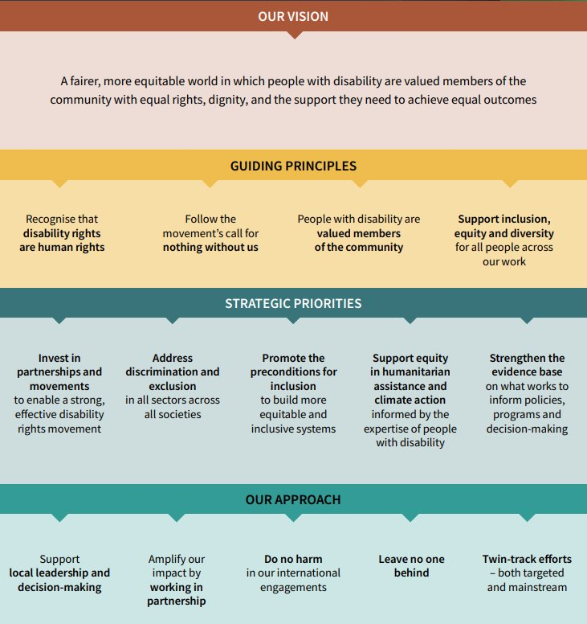

Entry points in the development program management cycle
Disability equity and rights should be considered at all stages of the development program management cycle – in policy and planning, design and procurement, implementation and performance management and review and evaluation. Entry points to strengthen the disability objectives and outcomes include:
- Conducting disability analysis (including as part of an intersectional GEDSI analysis) to identifying key challenges and barriers to disability equity and rights in the country/ region.
- Consulting with people with disability and organisations of people with disabilities (OPDs).
- Identifying opportunities to address challenges and barriers to disability equity and rights through targeted and mainstreamed approaches.
- Making disability equity and rights actions clear in all program documentation including designs, risk assessments, analyses, contracts and grant agreements, evaluation frameworks, reviews and evaluations.
- Ensuring adequate funding has been set aside (approximately 3 to 5 per cent of the budget should be allocated specifically for ensuring the program or strategy development process is inclusive and accessible) to cover potential costs associated with ensuring people with disabilities and their representative organisations can participate in and benefit from the program.
- Ensuring people with disability and OPDs can meaningfully participate in monitoring and evaluation.
- Finding opportunities to leverage other work and engage in policy dialogue to promote disability equity and rights (e.g. using a political economy lens to identify when, where and through whom policy change on disability equity and rights might be possible or most effective).
- Supporting people with disability and their representative organisations to promote disability equity and rights.
- Encouraging partner governments to ascertain disability prevalence by incorporating the Washington Group questions in national censuses and administrative surveys, alongside sex disaggregation.
- Using the Washington Group questions to disaggregate program-level data by disability (and by sex where it is possible) and ensuring there are qualitative data collected which enables processes and outcomes related to disability inclusion, equity and rights to be measured.
For guidance on disability inclusion and equity in humanitarian settings, please refer to the Protection in Humanitarian Action Framework and the Inter-Agency Standing Committee Guidelines, Inclusion of Persons with Disabilities in Humanitarian Action.

Measuring results
DFAT needs to report on results from development investments, and ensure those results are credible. DFAT monitors performance on disability equity and rights through its annual investment monitoring report process. IDEARS commits to working with people with disability throughout the program cycle, including in monitoring and evaluation. DFAT investment monitoring, evaluation and learning (MEL) systems should include qualitative and quantitative indicators on disability equity and collect and use disability disaggregated data, where applicable. Investments that are clear about what they want to achieve on disability equity and rights are more likely to be effective in implementation and delivery of disability equity outcomes and mitigate the risk of adverse effects on people with disability.

Annex 1: check list for disability inclusion within the development program management cycle

Policy and Planning
- Cross reference design documents with disability equity and rights commitments e.g. IDEARS, DFAT’s International Development Policy.
- Has a disability (or broader gender equality, disability and social inclusion) analysis been completed or planned for the design stage?

Design
See the Disability Equity in Investment Design Good Practice Note for detailed design guidance.
Key design considerations:
- Has disability analysis informed the investment concept? This can include disability issues identified through e.g. intersectional GEDSI analysis, political economy analysis, social safeguarding assessments or other disability-related research or reviews.
- Does the design commit to developing a disability or GEDSI strategy or action plan?
- Has expertise in disability equity and rights been sought to inform the investment concept and design? This should include consulting diverse people with disability and their representative organisations from the local context.
- Has approximately 3 to 5 per cent of the budget been set aside to ensure people with disability and their representative organisations can meaningfully participate in the design, implementation and monitoring and evaluation of the investment (for example, support person, sign language interpreters and accessible transport).

Procurement
- Do terms of references require implementing partners to be disability-inclusive, including providing reasonable accommodation?
- Are there disability-inclusion deliverables clearly outlined in the Statement of Requirement or agreement, and financed (recommended at 3 to 5 per cent of the budget)? Do they include plans on:
  - how people with disabilities will be included in the development of the investment concept and/or investment design
  - what measures will be taken to ensure people with disabilities will be able to participate in and benefit from the given investment
  - what specific targets will be used to monitor progress towards disability-inclusion and how will data be disaggregated by disability status
  - hiring people with disabilities as implementers, evaluators and researchers (where possible)?

Implementation and performance management
- Has a baseline of disability equity and rights been established to measure progress (using quantitative and qualitative data)? A lack of available data should not prevent action on disability equity and rights – approximately 16 per cent of a given population has a disability and is often higher in developing or conflict-affected countries.
- Are both quantitative and qualitative indicators used to track progress on disability-inclusive development outcomes within the M&E framework?
- Is disability disaggregated data being collected and analysed using the Washington Group short set of questions? Is this data also disaggregated by sex and age to assess the impacts on women, men, girls, and boys with disability?
- Have systems been established from the outset to capture disability information for Investment Monitoring Reports (required for those over $3 million).
- Does the MEL plan enable regular monitoring of the implementing partner’s disability equity performance?
- Have people with disability expertise – including people with disability and/or their representative organisations – been involved in developing the M&E framework and actively engaged in monitoring and evaluation?

Review and Evaluation
- Are program evaluations designed to measure disability inclusion, equity and rights outcomes and process.
- Does the evaluation and the final investment reporting assess how well the investment performed on disability-inclusion and detail lessons learned?
- Have people with disability expertise – including people with disability and/or their representative organisations – been involved in program evaluation activities.
Additional resources
DID4All: Resources for Disability Inclusive Development: includes detailed evidence and guidance on mainstreaming disability-inclusive development in a range of sectors. Requests for technical assistance may be logged through the DID4sAll disability help desk managed by DFAT and partner CBM Australia
Reasonable accommodation in development programs Good Practice Note: supports DFAT staff and partners to understand what reasonable accommodation is, DFAT’s obligations to ensure it is provided, and how to use it as a tool for enabling participation of people with disability on an equal basis with others. It includes specific examples across the development program cycle and suggestions for systemic improvements to ensure access to reasonable accommodation wherever and whenever it is needed.
DFAT (2025) Disability Equity in Investment Design Good Practice Note Investment design is a critical enabler of disability equity and rights across development programs. This Good Practice Note helps program managers and design teams to embed disability equity and rights in investment designs, aligned with DFAT’s International Development Programming Guide.
Accessibility Design Guide: Universal design principles for Australia’s aid program: provides practical information about how to apply universal design principles to physical infrastructure (such as schools, roads, hospitals and courthouses) to minimise barriers and enable people with disabilities to participate more fully in social and economic life.

For further assistance or advice on disability equity, please contact GEDSI.GEB@dfat.gov.au

Annex 2: Written version of strategic framework
Top tier of the framework articulates ‘Our vision: A fairer, more equitable world in which people with disability are valued members of the community with equal rights, dignity, and the support they need to achieve equal outcomes.’
Second tier, Guiding Principles:
- Recognise that disability rights are human rights
- Follow the movement’s call for nothing without us
- People with disability are valued members of the community
- Support inclusion, equity and diversity for all people across our work
Third tier, Strategic Priorities:
- Invest in partnerships and movements to enable a strong, effective disability rights movement
- Address discrimination and exclusion in all sectors across all societies
- Promote preconditions for inclusion to build more equitable and inclusive systems
- Support equity in humanitarian assistance and climate action informed by the expertise of people with disability
- Strengthen the evidence base on what works to inform policies, programs and decision-making
Fourth tier, Our approach:
- Support local leadership and decision-making
- Amplify our impact by working in partnership
- Do no harm in our international engagement
- Leave no one behind
- Twin-track efforts – both targeted and mainstream

World Health Organization (2022), Global report on health equity for persons with disabilities.
World Bank and World Health Organization, World Report on Disability, 2011.
United Nations Convention on the Rights of Persons with Disabilities, Articles 11 and 32.
Centre of Research Excellence in Disability and Health (CRE-DH), Research report: nature and extent of violence, abuse, neglect and exploitation against people with disability in Australia, report for the Royal Commission into Violence, Abuse, Neglect and Exploitation of People with Disability, CRE-DH, Melbourne, 2021.
Kelly, L and Wapling, L.; 2012, ‘Mid-term Review of Development for All - Towards a disability-inclusive Australian aid program 2009-2014, p. 42
The Washington Group’s short set of six questions is recommended by the United Nations for use in all national censuses and household surveys to provide internationally comparable disability data: Washington Group on Disability Statistics, Short Set of Questions on Disability, viewed 3 December 2020, <https://www.washingtongroup-disability.com/question-sets/wg-short-set-on-functioning-wg-ss/>
AusAID, Protection in Humanitarian Action Framework for the Australian aid program 2013, July 2013, PUB9 < https://www.dfat.gov.au/about-us/publications/Pages/protection-in-humanitarian-action-framework>
IASC, IASG Guidelines, Inclusion of Persons with Disabilities in Humanitarian Action, 2019. Viewed 17 December 2020, < https://interagencystandingcommittee.org/iasc-task-team-inclusion-persons-disabilities-humanitarian-action/documents/iasc-guidelines>

