Trade statistical pivot table  
User guide



With the exception of the Commonwealth Coat of Arms and where otherwise noted, this report is licenced under a Creative Commons Attribution 3.0 Australia licence <http://creativecommons.org/licenses/by/3.0/au/>.

You are free to reuse, modify, remix and distribute this material. The entire publication may be included as an appendix in your work for reference if you wish. Under the terms of the licence, you are required to attribute DFAT material in the manner specified (but not in any way that suggests that DFAT endorses you or your use of the work).

DFAT material used ‘as supplied’

Provided you have not modified/remixed the material in this publication in any way it may be reused provided the following attribution is given:

Source: DFAT publication ‘Trade Statistical Pivot Table User Guide’.

Use of the Coat of Arms

The terms under which the Coat of Arms can be used are detailed on the It’s an Honour website <http://www.itsanhonour.gov.au/coat-arms/index.cfm>.

Disclaimer

The Department of Foreign Affairs and Trade (DFAT) has taken great care to ensure the information contained in this publication is as correct and accurate as possible.

However, DFAT does not guarantee, and accepts no legal liability whatsoever arising from or connected to, the accuracy, reliability, currency or completeness of any material contained in the publication.

DFAT recommends that users exercise their own skill and care with respect to their use of the material contained in the publication and users carefully evaluate the accuracy, currency, completeness and relevance of the material for their purposes.

**Produced by  
Statistics Section, Office of Economic Analysis  
Investment and Economic Division**

**Updated: 2018**

Contents

Trade statistical pivot table User guide

Pivot table user guide 1

Introduction 1

About this guide 1

Using pivot tables in Microsoft Excel 1

Prerequisites 1

DFAT’s Trade statistical pivot tables 1

Where to find the Trade statistical pivot tables 1

Trade statistical pivot tables 1

Caution with using the Australia level and State level pivot tables 2

Confidentiality in ABS trade data 2

Structure of the trade statistical pivot table 3

Fields 3

Report filter (page area) 4

Values (data area) 4

Row area 5

Column heading 5

Pivot table field list 5

Using fields to summarise data 6

Moving fields 6

Stacking fields 7

Filtering data 9

Selecting data 10

Sorting items and data 11

Display top countries/commodities 12

Copying data from pivot tables 14

Further information 15

Pivot table user guide

## Introduction

### About this guide

The Department of Foreign Affairs and Trade (DFAT) publishes a range of trade statistical datasets in Microsoft Office Excel Pivot table format. The purpose of this guide is to assist users to understand how to make the most of this trade data while also providing information on how to manipulate data within these pivot tables.

### Using pivot tables in Microsoft Excel

Pivot tables are a powerful, easy to use data analysis tool that enables you to reorganise, filter, group and summarise data by choosing, or dragging and dropping variables into and out of a table.

### Prerequisites

A working knowledge of Microsoft (MS) Office Excel is required to use the trade statistical pivot tables. The pivot table has been generated in MS Excel 2010 and is compatible with MS Excel 2007 or later versions. It cannot be used in earlier versions of Excel.

For more information on how to use MS Excel see [MS Support](http://office.microsoft.com/en-au/support/?CTT=97).

For further information about DFAT’s trade products and services, please email [statssection@dfat.gov.au](mailto:statssection@dfat.gov.au).

## DFAT’s Trade statistical pivot tables

### Where to find the Trade statistical pivot tables

The trade pivot tables are located on the DFAT website at:

<https://dfat.gov.au/about-us/publications/Pages/trade-statistical-pivot-tables.aspx>

### Trade statistical pivot tables

DFAT publishes four trade statistical pivot tables, two at the Australia level and two at the State/Territory level:

* Country and commodity pivot table
* Country and TRIEC pivot table
* State by country and SITC pivot table
* State by country and TRIEC pivot table.

These tables provide an alternative output format for information contained in the DFAT trade statistical publications [Composition of Trade](http://dfat.gov.au/about-us/publications/Pages/composition-of-trade.aspx) and Australia’s trade by State and Territory.

The ***‘Country and commodity*’** pivot table expands on the tables included in Section 7 of the Composition of Trade publication – *Australia's major merchandise trading partners’ top 20 exports and imports*.

In this pivot table, Australia’s merchandise exports and imports is based on the United Nations' Standard International Trade Classification revision 4 (SITCr4) at the 3-digit level, for all partner countries and selected partner country groups. Yearly time series data is available from 2005-06 and annual time series data is available from 2006.

The ***‘Country and TRIEC*’** pivot table expands on the tables included in Section 4 of the Composition of Trade publication - *Australia’s merchandise trade by level of processing*.

In this pivot table, Australia's merchandise exports and imports is based on DFAT's Trade Import Export Classification (TRIEC) at the 1-, 2-, 3- and 4-digit levels for all partner countries and selected partner country groups. Export data is also split between total exports and Australian produced exports. Yearly time series data is available from 1989-90 and annual time series data is available from 1990.

The two State pivot tables provide a State/Territory split of the **‘*State by country and SITC*’** and **‘*State by country and TRIEC*’**.These pivot tables expand on tables included in Australia’s trade by State and Territory publication.

The pivot tables should be used in conjunction with the **Explanatory notes** in these publications.

## Caution with using the Australia level and State level pivot tables

Data compiled for the Australia level pivot tables has been adjusted by DFAT from the raw monthly trade data published by the Australian Bureau of Statistics (ABS). These adjustments help resolve a number of under-reporting issues impacting on the raw ABS data at the total Australia level. However these adjustments cannot be applied at the State/Territory level. As a result the total Australia level in the State pivot tables will not match the totals in the Australian pivot tables. This also applies to partner country totals. The Australian pivot tables provide a more accurate picture of Australia’s trade as this level.

For more information on the adjustments DFAT applies to the raw ABS monthly trade data please refer to the DFAT adjustments document on the DFAT website at: <http://dfat.gov.au/about-us/publications/trade-investment/Pages/dfat-adjustments-to-abs-official-trade-data.aspx>.

## Confidentiality in ABS trade data

To avoid divulging commercially-sensitive details of individual firms, the ABS restricts release of statistics on certain commodities. Such details are aggregated into a ‘dump’ item (SITC code 988) or (TRIEC code 3041) in the pivot tables.

To assist users of Australian trade data, the ABS publishes a monthly list of all Australian Harmonized Export Commodity Classification (AHECC) and Harmonized Tariff Item Statistical Code (HTISC) commodities with confidential restrictions in place in the publication *International Merchandise Trade: Confidential Commodities List* (ABS [catalogue 5372.0.55.001](http://www.abs.gov.au/AusStats/ABS@.nsf/MF/5372.0.55.001)). The relevant SITC code is also published. This publication is an essential reference guide for users of ABS merchandise statistics to ensure they are interpreting the trade statistics correctly.

DFAT has also written a number of articles on confidentiality in ABS merchandise trade statistics. A number of these articles are updated on a regular basis. The most useful articles include:

* Confidentiality in Australian merchandise export statistics
* Impact of ABS confidential restrictions on exports of nickel (updated annually)
* Australia's imports of aircraft & parts (updated annually).

The articles are available on the [DFAT website](http://dfat.gov.au/about-us/publications/Pages/recent-trade-statistical-articles-and-information-papers.aspx) at: <http://dfat.gov.au/about-us/publications/Pages/recent-trade-statistical-articles-and-information-papers.aspx>.

# Structure of the trade statistical pivot table

The following guides use the **‘*Country and commodity*’** pivot table as the working example. However all four pivot tables are structured in a similar way and the instructions can be applied equally to the other pivot tables.

The following diagram shows the basic structure of the ***‘Country and commodity*’** pivot table. There are a series of fields such as Year, Trade Type, SITC 3-digit, Country, Geographical level 1, 2 & 3, APEC, ASEAN, EU28 & OECD, Sector and A$’000s to choose from to create a report.

The pivot table will load with the *Pivot Table Field List* displayed (right-hand side panel in ***Figure 1*** below).

#### Figure 1: Structure of the Country and commodity pivot table

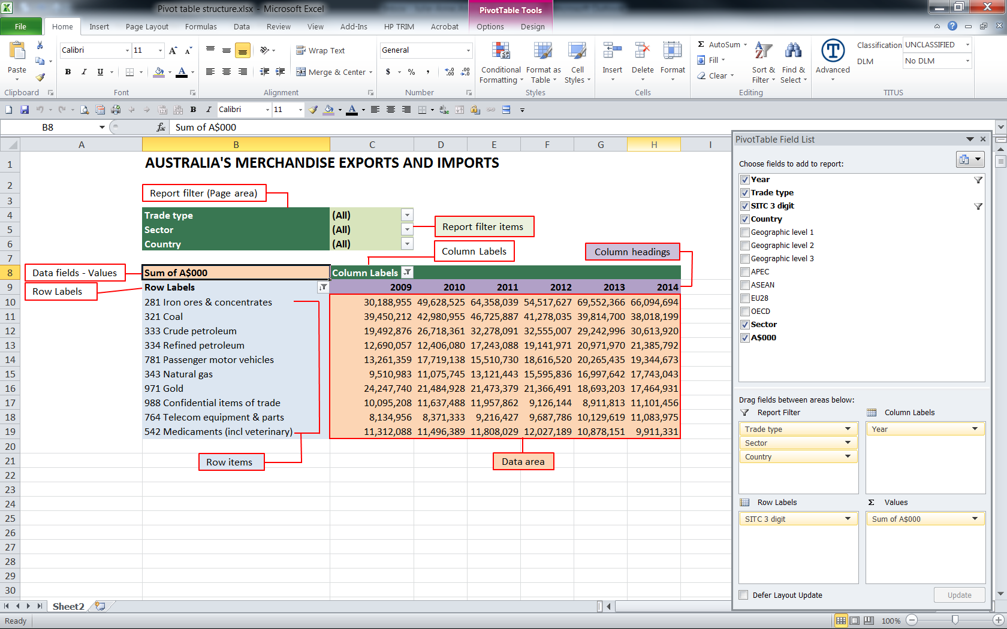

## Fields

Fields are also known as data items or variables. They are what enable us to specify the data to be displayed in the pivot table.

Fields enable the data to be summarised or filtered.

Within each of these fields are items. For example the items of the field called **Trade type** are:

* All (= Total trade)
* Total Exports
* Total Imports

Clicking the down arrow at the right of the field name will reveal the item selector, showing the items that make up the field.

There must be at least one data field (values) in the table to provide the numbers for the summary. In the example above it is **Sum of A$000**.

All the fields can be moved to different areas within the pivot table (i.e. report filters, column labels; row labels; values) by using the mouse to drag and drop via the *PivotTable Field List* (or by directly dragging the items on the pivot table) to give different summaries of the data.

## Report filter (page area)

*Dark green and light green highlights in Figure 1*

The **Report filter** (dark green highlight) is used to display the fields used for filtering the data.

The **Reporter filter items** (light green highlight) is used to select the items needed to create a report

* In ***Figure 2*** the **Country** field has been clicked to reveal the list of countries available. In the **Country** field select either (All) for total all countries or select an individual country. This filter is reflected in the numbers in the data area – see Filtering data for further information.

#### Figure 2: Page area

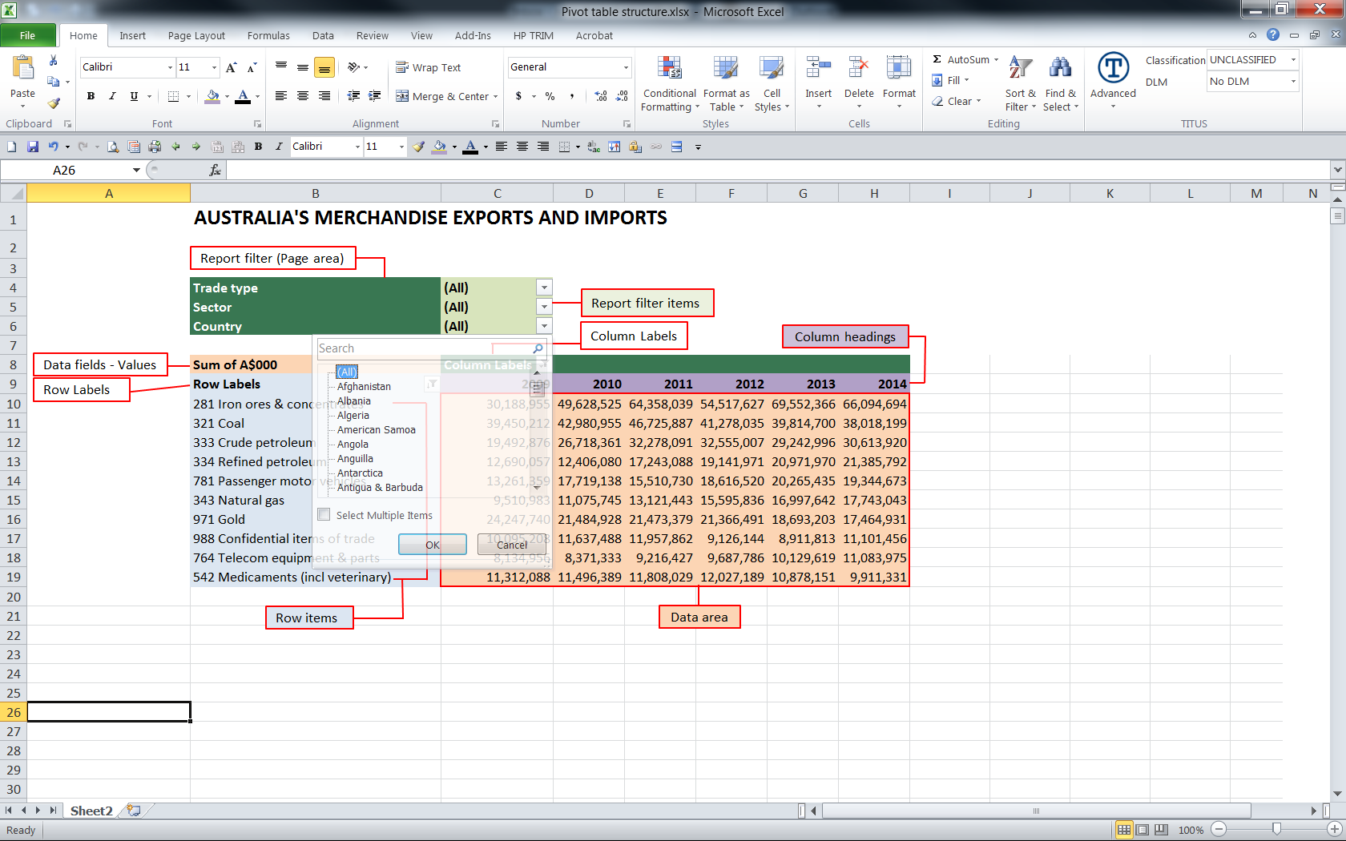

## Values (data area)

*Light orange highlight in Figure 1.*

This area contains the numeric summaries determined by the organisation of the fields in the page, row and column fields.

In the example above the data (values) field is **A$000**.

The type of summary used in the example is SUM, giving:

* Sum of A$000.

See below for more way to summarise the data.

**IMPORTANT**

When using DFAT pivot tables, the data field is A$000. This is the only field that should be placed in the data (values) area.

## Row area

*Light blue highlight in Figure 1.*

The items of fields placed in the row area will be displayed and the summaries created will form the rows of the data area.

In the example above the **SITC 3-digit field** is in the row area and displays the row items.

For fields in the row area, when the items are revealed, selection boxes appear next to each item enabling selection of specific items.

## Column heading

*Purple highlight in Figure 1.*

The items of fields placed in the column heading will be displayed and the summaries created will form the columns of the data area.

In the example above the **Year field** is in the column heading.

The same item selection rules apply to fields in the row area and column heading.

## Pivot table field list

Not all available fields need to be shown in the Report filter, Row, Column or Values areas. To simplify using the pivot table, only select the fields required to be displayed.

* A full list of all the fields available can be seen in the **Pivot Table Field List**.
* To open the Pivot Table Field List:
  + Hover over the pivot table with the mouse pointer and right-click to reveal the Pivot Table Sub-Menu

O Select Show Field List.

* Fields that are currently displayed on the pivot table are shown in bold (see Figure 1).
* Fields that are not displayed are shown in normal font.
* To display a field not already on the pivot table:
  + Use the mouse to select the field from the Pivot Table Field List, drag/drop it to the appropriate area on the pivot table
  + The field will now be shown in bold in the field list.
* To remove a field that is currently displayed on the pivot table:
* Use the mouse to deselect the field from the Pivot Table Field List OR
* Drag it out of the pivot table area until you see an X beside the mouse icon and drop the field icon
  + The field will now appear in the Pivot Table field List in normal font.

The Pivot Table Field List can be locked to the sides of the screen. Drag the box to the left or right and when positioned correctly it will snap to the side and expand out. In this position it will remain displayed while a cell in the pivot table is selected.

# Using fields to summarise data

## Moving fields

Fields in any part of the pivot table can be moved to any other part.

To move a field select the field name with the mouse and drag and drop the field in the new location. The table will then be automatically updated with the revised table layout and data. If a field is placed in the wrong position, simply select, drag and drop to the correct location.

The A$000 field should only be in the values area.

* The example below shows **Trade Type** (All), **Sector** (All) and **Countryfields** (with China only selected) in the Report Filter; **SITC 3-digit** in the Row Labels; **Year** in the Column Labels and **A$000** in Values.

***Report generated from above:*** *Australia’s total trade (exports plus imports) with China by commodity*

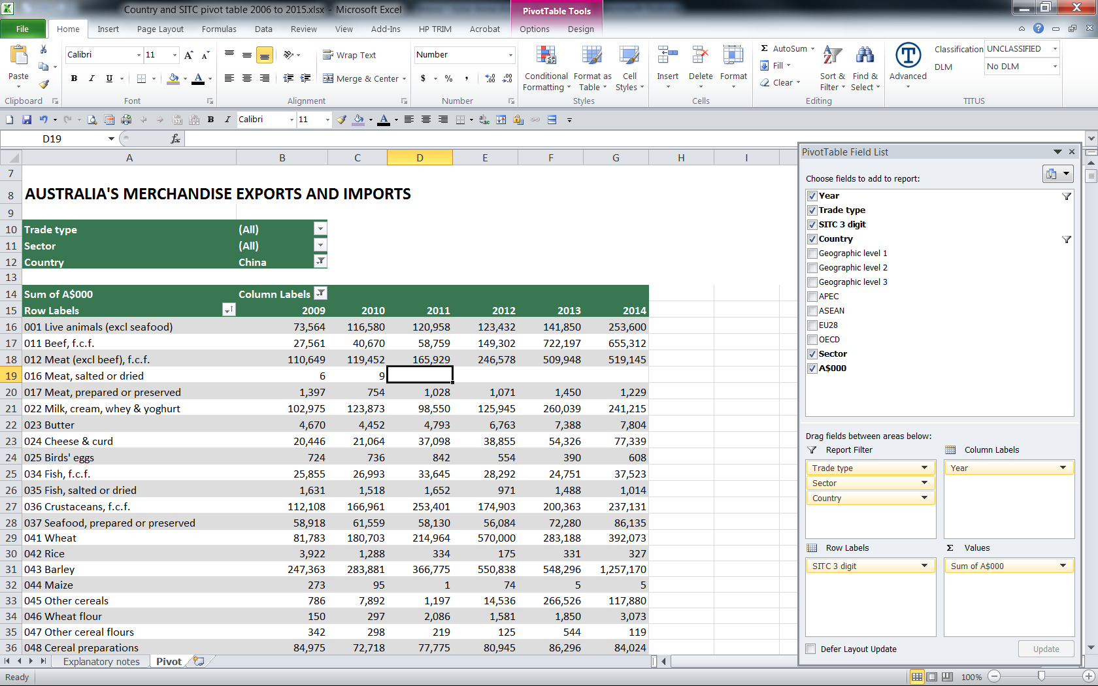 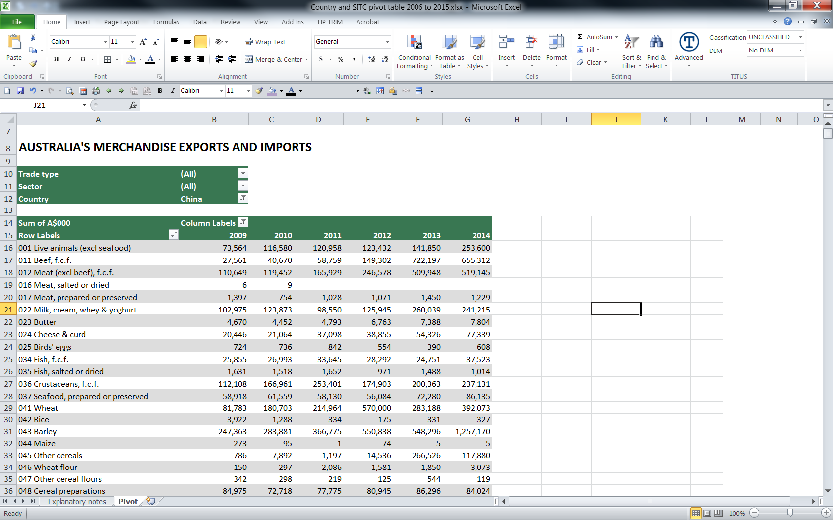

* The example below shows Total Exports selected in the **Trade type** and Manufactures selected in the **Sector fields** in the Report Filter; **SITC 3-digit** in the Row Labels; **Year** in the Column Labels and **A$000** in Value. Country data wasn’t required in the pivot table and has been unchecked.

***Report generated from above:*** *Australia’s total manufactures exports by commodity*

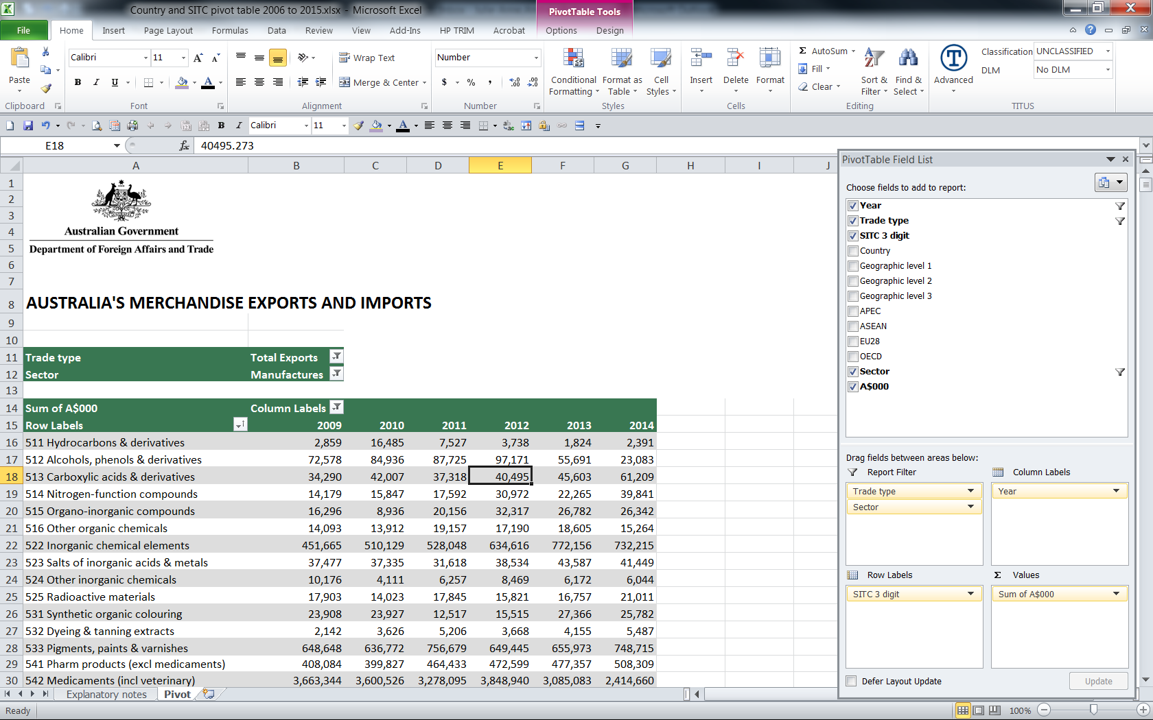 

## Stacking fields

Complex tables can be created from the data in the pivot table by stacking the row or column areas.

* To stack fields, select the fields and drag/drop them into the appropriate row and/or column areas
* You can re-order how they are stacked to suit your requirements (eg you can click and drag the SITC 3 digit field above the Country field in the Row Labels)
* You can stack several fields, but stacking too many fields can make the data difficult to read
* The example below shows the **Country** and **SITC 3-digit fields** are **stacked** in the Row Labels, providing a breakdown of country by commodity (Row) and Year (Column) and A$000 (Values)

***Report generated from above:*** *Australia’s imports by country by commodity (ranked by top 10 in 2014)*

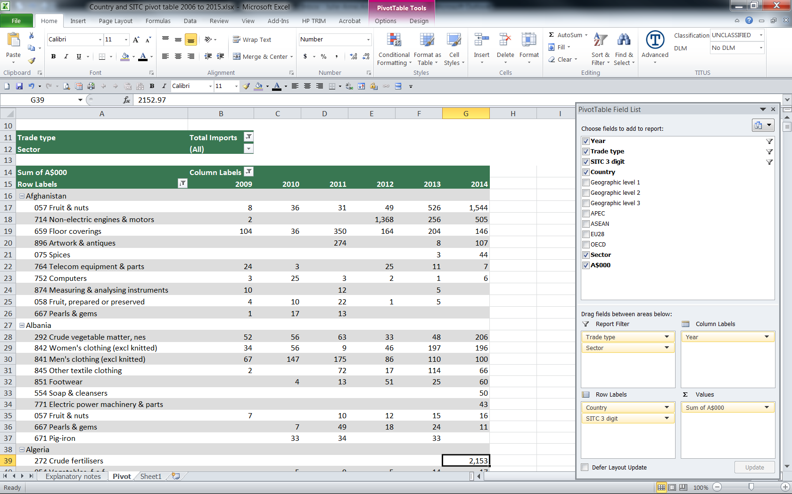 

A subtotal can be added for the Country totals by right clicking on one of the country labels in the row labels field and selecting Subtotal “country” from the drop down menu as displayed in the example below.

* The example below shows the **Country** and **SITC 3-digit fields** are **stacked** in the Row Labels, providing a breakdown of country by commodity (Row) and Year (Column) and A$000 (Values) with a subtotal for the Country.

**Please note**: If pivot table is ranked by top 10 etc the subtotal for the country will be incorrect as it will only be summing those top 10 commodities and not all the commodities (see 3rd screen shot below). Ensure the filter has not been selected (see the **Display top countries/commodities** section).

***Report generated from above:*** *Australia’s exports by country by commodity (with country subtotal in 2014)*

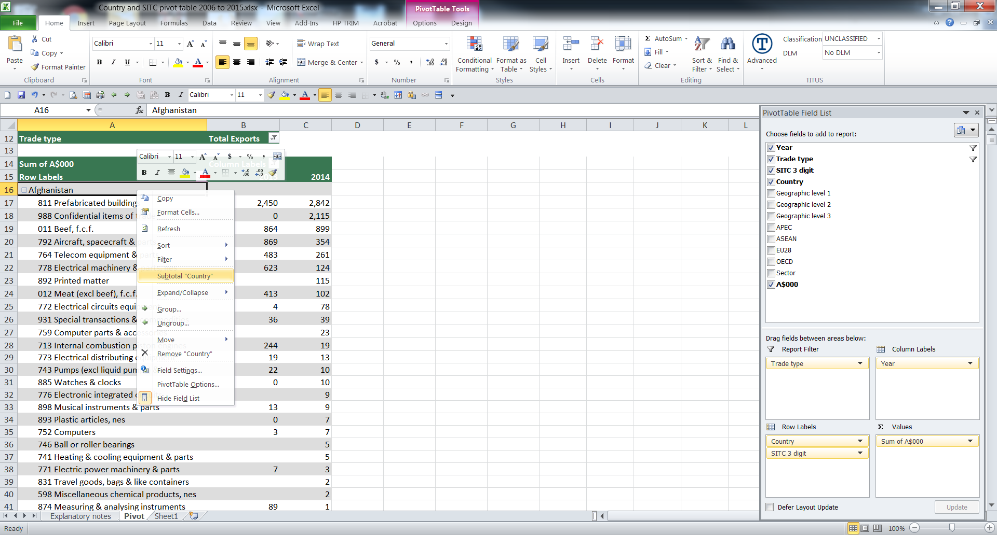 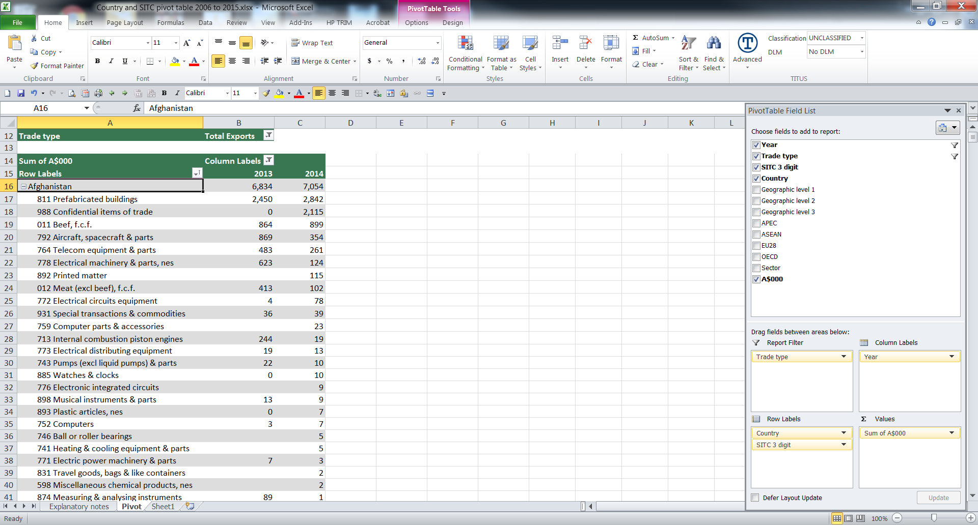

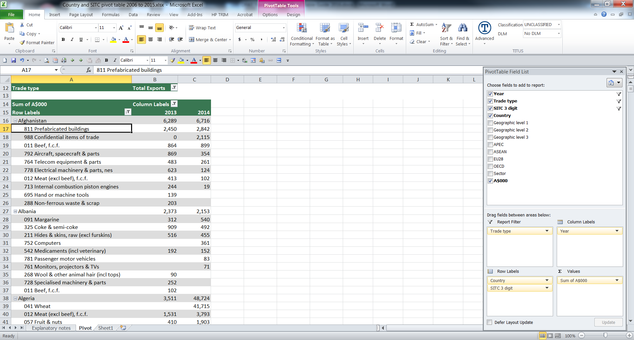

Subtotal above is showing the sum of all exported commodities to Afghanistan.

Subtotal to the left is showing the sum of the top 10 exported commodities only to Afghanistan as a filter was used.

## Filtering data

Fields appearing in the Page area (Report Filter) can be used to filter the data. For example you may just want to analyse data for one particular country.

To apply a filter, do the following:

* Make sure the field to be filtered is in the Page area. [If the Country field is not in the Report Filter page area, use the mouse to drag it there.]
* Click the down-arrow at the right of the field box. This will reveal the items of the field.
  + In the Report Filter it is advisable to only select one item for the Trade Type and Sector fields. To select multiple items ensure the box is checked next to Select Multiple Items (see examples below).
  + Within the Country field, a variety of combinations can be selected – (All) for total all countries (clicked once it will SELECT ALL items, clicked a second time it will DE-SELECT ALL items), an individual country or a selection of countries to get a group total (i.e. selecting the countries in the G20 will produce a G20 total) by checking or unchecking the box next to the country name (see example below).

**Trade type:**

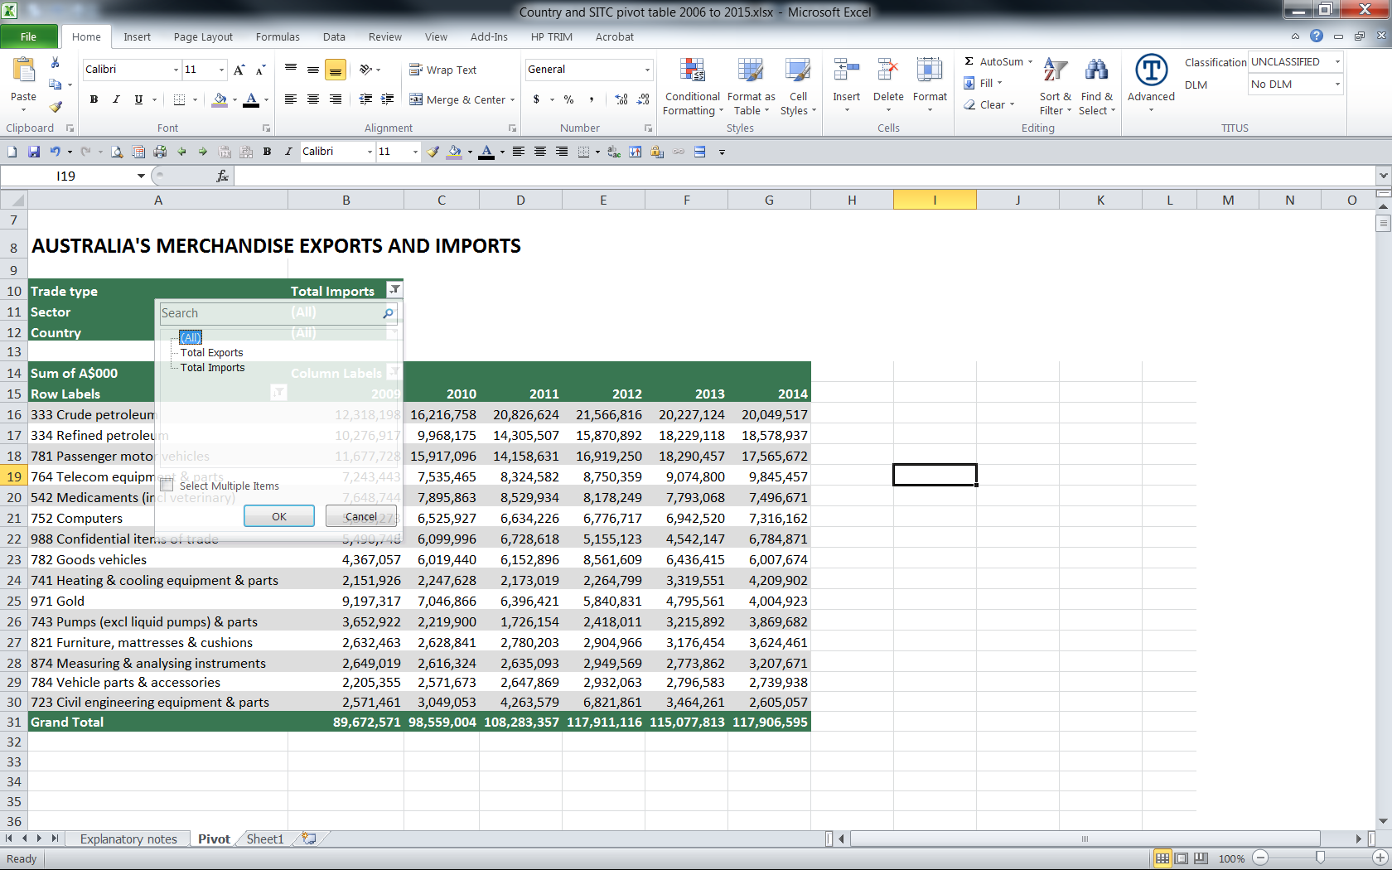

**Sector:**

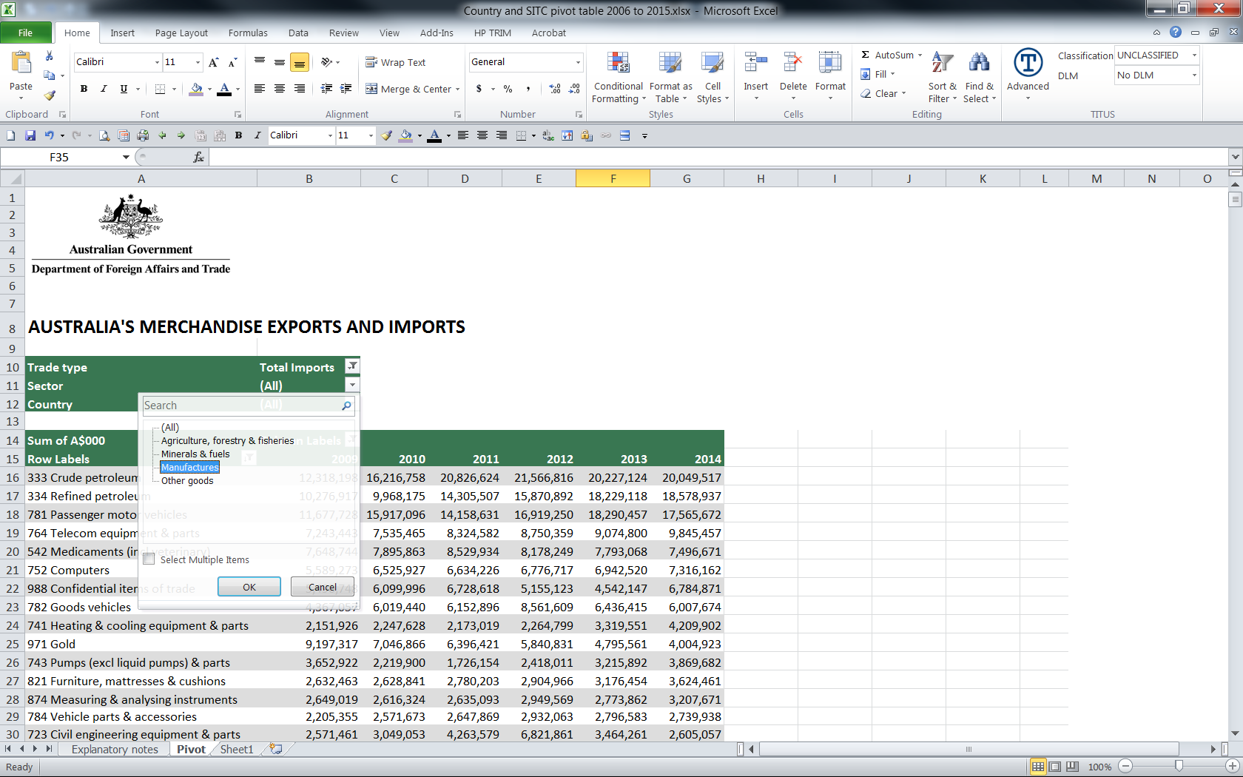

**Country:** **Select Multiple Items** has been checked. Algeria, Angola and Anguilla have been selected – this will give a total imports figure for those 3 countries only.

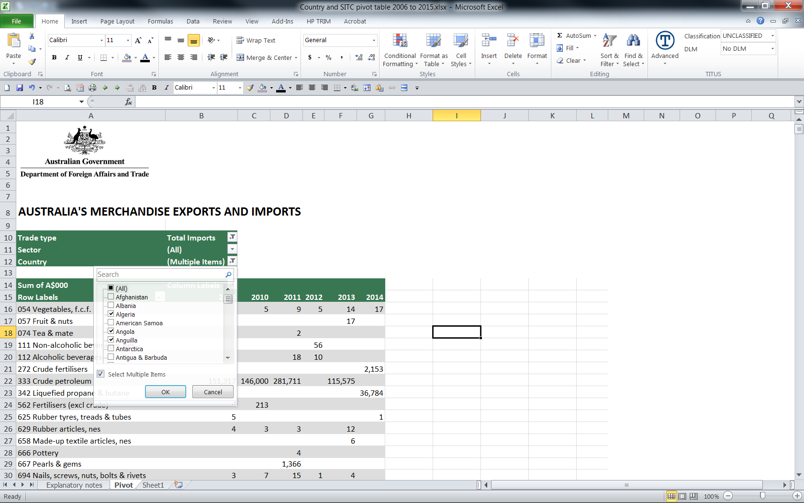

Click on the drop down arrow  and click the item/s to be selected and OK

* The data and summaries will now reflect the selection applied
* The field will show the value of the selection applied
* To remove the selected items, click on the drop down arrow  and click **(All)** and OK.

## Selecting data

When fields are displayed in the row or column areas you can use the item selector to limit what data is displayed. This is similar to applying a filter whereby you can select more than one item from the field to display.

* The item selector is a good way to see what items are contained within a field, if the field name is ambiguous
* In the example below, the SITC 3-digit field items (Row labels) are shown with just 333 Crude petroleum and 334 Refined petroleum selected and displayed
* When specific selections are made the summaries in the data area and grand totals reflect these selections
* The **(Select All)** option enables you to over-ride an existing selection. Clicked once it will SELECT ALL items. Clicked a second time it will DE-SELECT ALL items

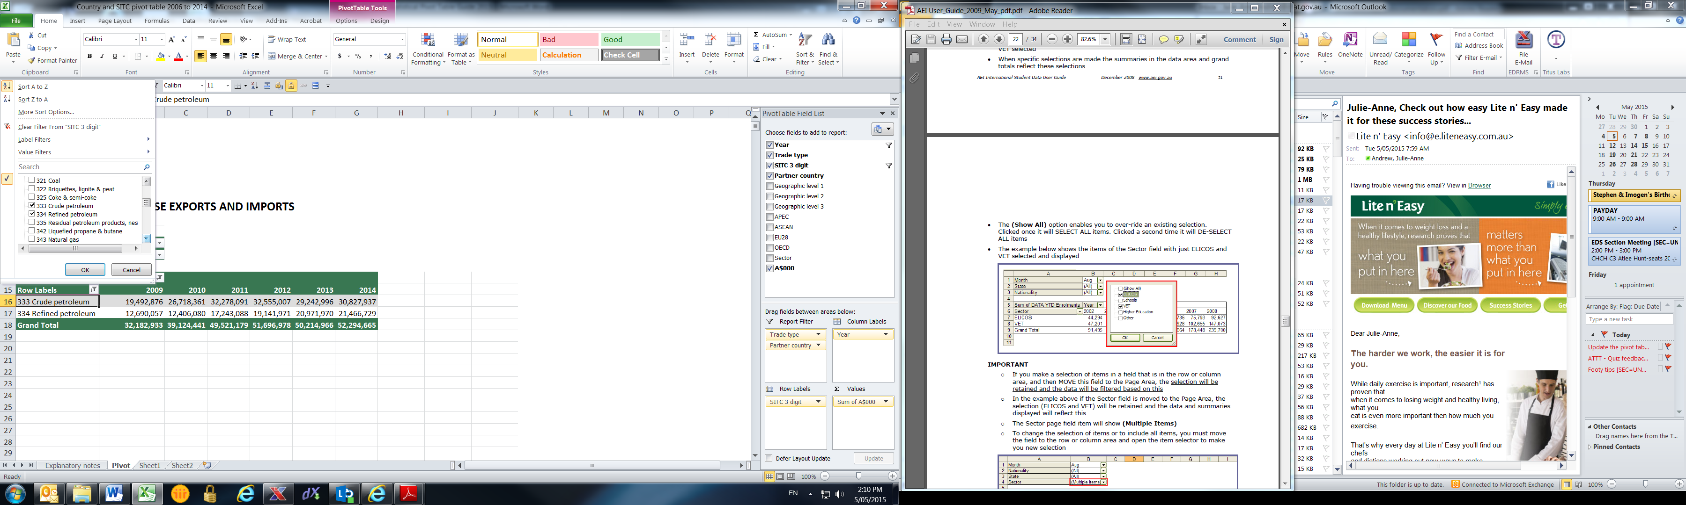

**IMPORTANT**

* If you make a selection of items in a field that is in the row or column area, and then MOVE this field to the Page area, the selection will be retained and the data will be filtered based on this
* In the example above if the SITC 3-digit field is moved to the Page Area, the selection (333 and 334) will be retained and the data shown as a total of 333 and 334 (see example below)
* The SITC 3-digit page field item will show **(Multiple Items)**
* To change the selection of items or to include all items, simply select the Item Selector to make a new selection.

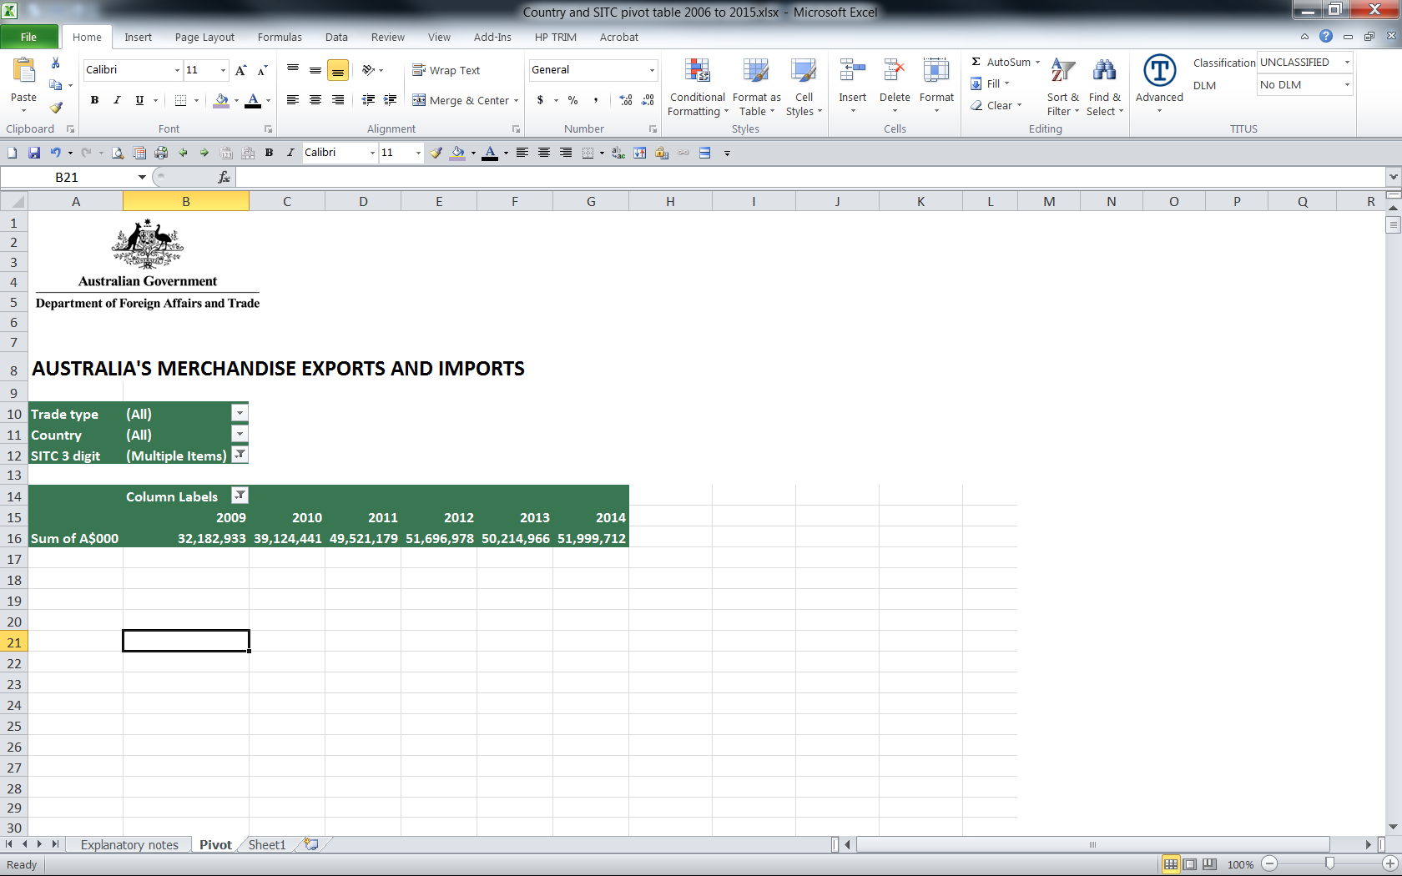

## Sorting items and data

It is often convenient to sort items in different ways. For example you may want to sort Country alphabetically, or by largest to smallest.

To sort items by name:

* Locate the field to be sorted in the row area
* Place the cursor in any cell in the item list
* Right-click, select Sort. Choose the required option (either Sort A to Z or Sort Z to A)
* OR in the PivotTable Tools tab select the Option Tab. Select ascending or descending in the menu at the top of the screen.

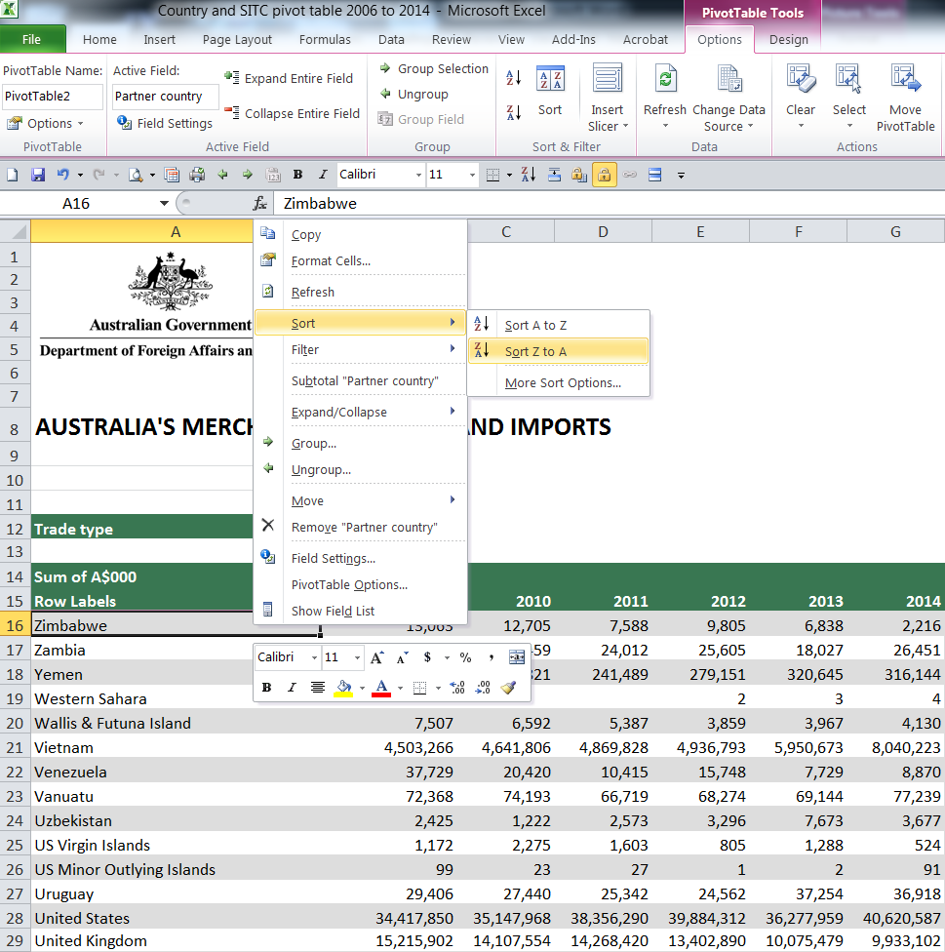

To sort items by data values:

* Locate the field to be sorted in the column area
* Place the cursor in any cell within the column to be sorted
* Right-click, select **Sort**. Choose the required option (either **Sort smallest to largest** or **Sort largest to smallest**)
* OR in the PivotTable Tools tab select the Option Tab. Select the **Sort icon** in the menu at the top of the screen.

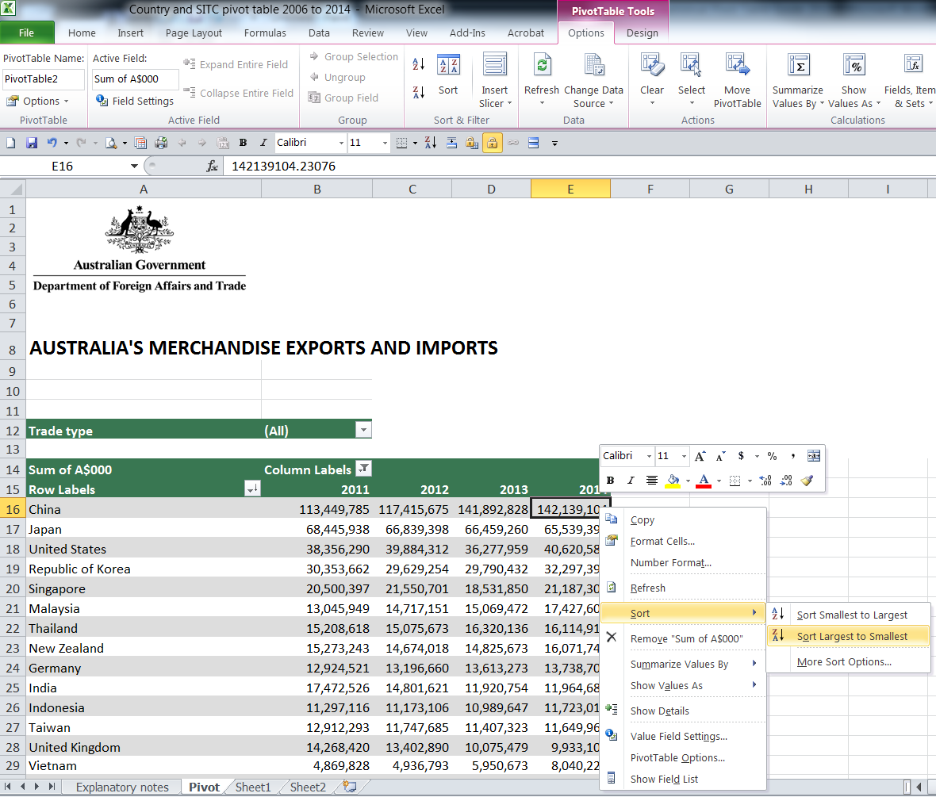

## Display top countries/commodities

It is often convenient to display just the top trading partners or commodities in the pivot table.

To sort items:

* Locate the field to be sorted in the row area (Country)
* Click any cell in the country item list
* Right-click, select **Filter**, select **Top 10**. In the example below, the number has been set at 12, click OK.  
    
  Note: The Grand Total row is only displaying the total of the top 12 countries for Agriculture, forestry & fishing exports
* To remove this filter, select any cell in the country item list, right-click, select **Filter** then click **Clear filter from “Country”**.

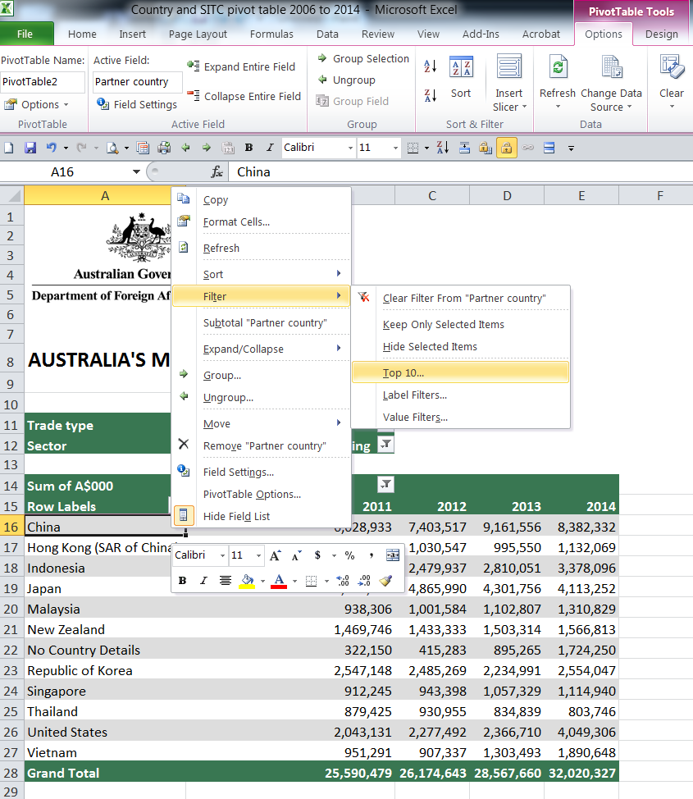 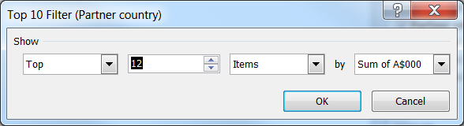

# Copying data from pivot tables

It is often useful to copy data summaries from a pivot table to another excel file for archiving, presentation or further analysis.

Care should be taken when copying data from a pivot table to another spreadsheet, especially if the new spreadsheet is to be subsequently emailed.

Depending on how you copy and paste the data, you can inadvertently copy all the data underlying the pivot table as well, which will increase the size of the excel file many-fold, although you may not be able to see the data.

To copy data from a pivot table to another excel file:

* Highlight the area you wish to copy, press **Ctrl + C** on your computer keyboard, navigate to desired cell in the destination excel file
* Select the **Paste icon** ⇒ **Paste Values** and select **Values and number formatting**, click OK

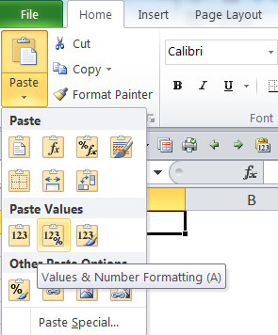

The data values will be pasted as formatted values. You will not be able to add or change the output once copied to a different file. The underlying data will not be pasted resulting in a smaller destination file. See the result below:



# Further information

Classifications used for DFAT pivot tables:

* [United Nations SITCr4](http://unstats.un.org/unsd/trade/sitcrev4.htm) (Standard International Trade Classification – revision 4)
* [DFAT TRIEC](http://dfat.gov.au/about-us/publications/Pages/trade-import-and-export-classification-triec.aspx) (Trade Import and Export Classification)

Confidential commodities list - ABS catalogue [5372.0.55.001](http://www.abs.gov.au/ausstats/abs@.nsf/mf/5372.0.55.001)

Article on [DFAT adjustments to ABS official trade data](http://dfat.gov.au/about-us/publications/trade-investment/Pages/dfat-adjustments-to-abs-official-trade-data.aspx)

Other useful DFAT trade and investment products:

* [Trade and investment publications](http://dfat.gov.au/trade/resources/Pages/trade-statistical-publications.aspx)
* [Trade and investment articles](https://dfat.gov.au/trade/resources/publications/Pages/trade-and-investment-articles.aspx)
* [Trade time series data](http://dfat.gov.au/trade/resources/trade-statistics/Pages/trade-time-series-data.aspx)
* [Foreign investment statistics](https://dfat.gov.au/trade/resources/investment-statistics/Pages/foreign-investment-statistics.aspx)
* Interactive [Trade at a Glance](http://dfat.gov.au/trade/resources/trade-at-a-glance/Pages/default.aspx)
* [Fact sheets for countries and regions](http://dfat.gov.au/trade/resources/Pages/trade-and-economic-fact-sheets-for-countries-and-regions.aspx)
* [Statistical consultancy services](http://dfat.gov.au/trade/resources/trade-statistics/Pages/statistical-information-service.aspx)