DFAT

People Strategy

2025–2028
Investing in our people to build and maintain Australia’s
security and prosperity amidst rising global challenges.

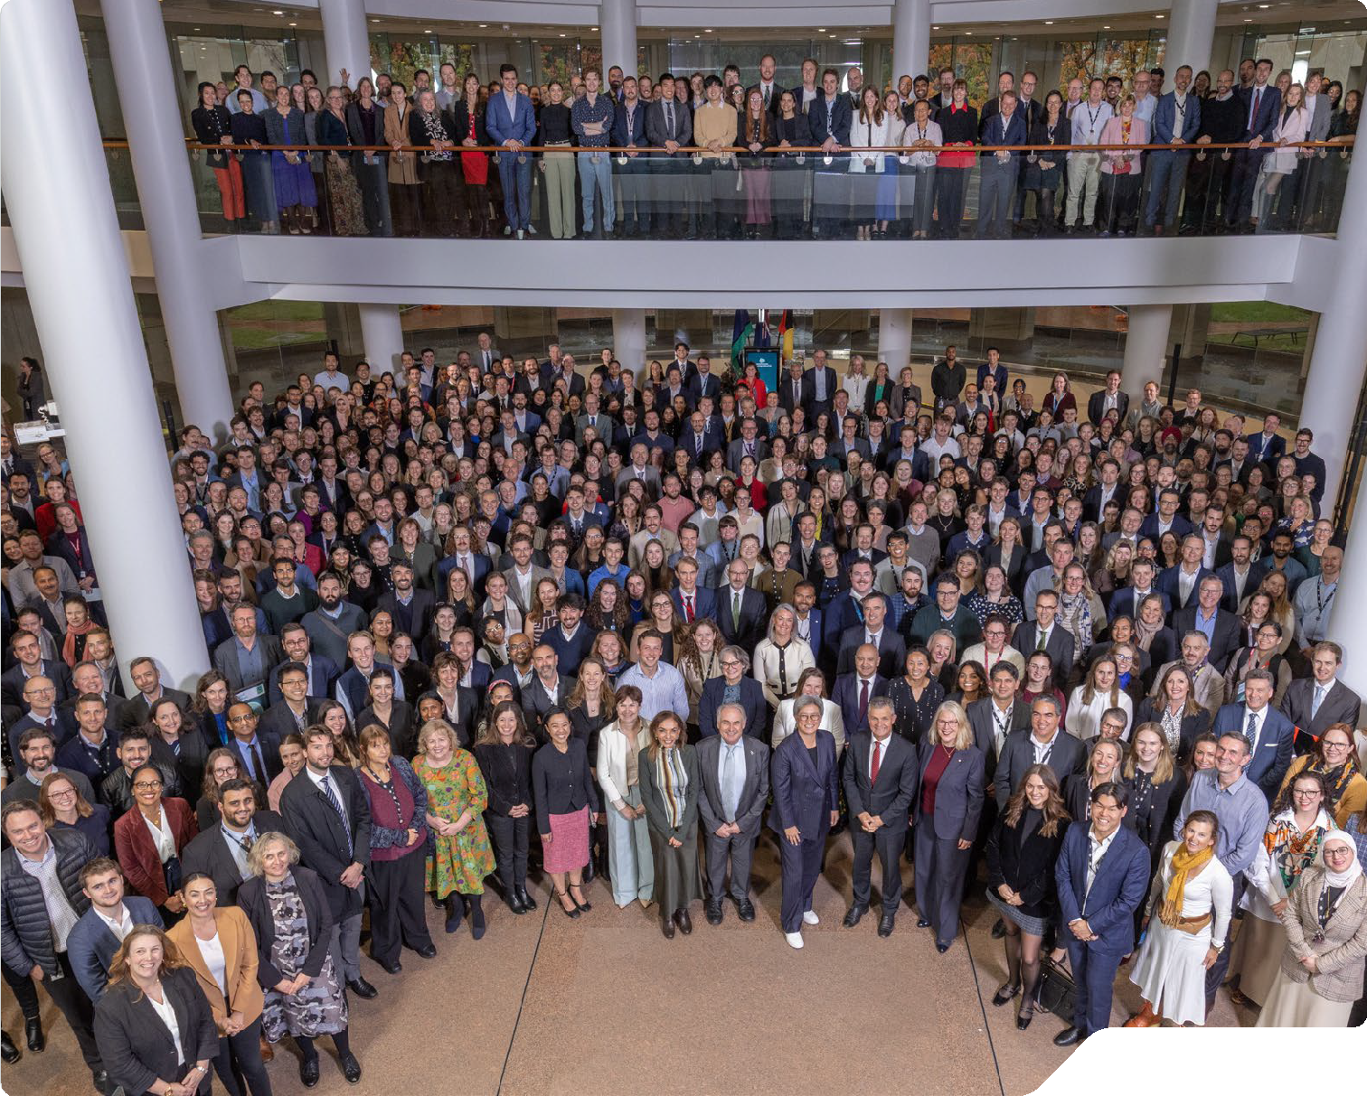 DFAT.GOV.AU


Our people are key to delivering on our purpose. As we face unprecedented changes in our global operating environment, we need a strong and agile workforce.’

Foreword
I am pleased to present the DFAT People Strategy 2025–2028.
Our people are key to delivering on our purpose. As we face unprecedented changes in our global operating environment, we need a strong and agile workforce. The People Strategy reflects the department’s efforts to embed the work of the Ten-Year Future Capability Plan and invest in our people and our infrastructure.
The People Strategy commits us all to action; to ensure we continue to attract and retain a diverse and highly skilled workforce; to lead with influence and integrity; and to ensure our policies, practices and workplaces enable our people to deliver results. These themes will shape the department’s global workforce, ensuring we have the tradecraft and technical expertise to perform, and respond to changing priorities. They also reiterate the department’s commitment to a workforce that reflects modern Australia at all levels, to reflect the community we serve to achieve our purpose.
Each theme of the People Strategy articulates our expectations of all DFAT officers. This is a strategy for each of us to enact, drive positive workforce behaviours and culture, and commit to action.
I am immensely proud of our dedicated and highly skilled people who continue to deliver for Government and Australians, often in the most challenging circumstances. I encourage you to read the People Strategy and actively implement it in your work areas.
Jan Adams Secretary

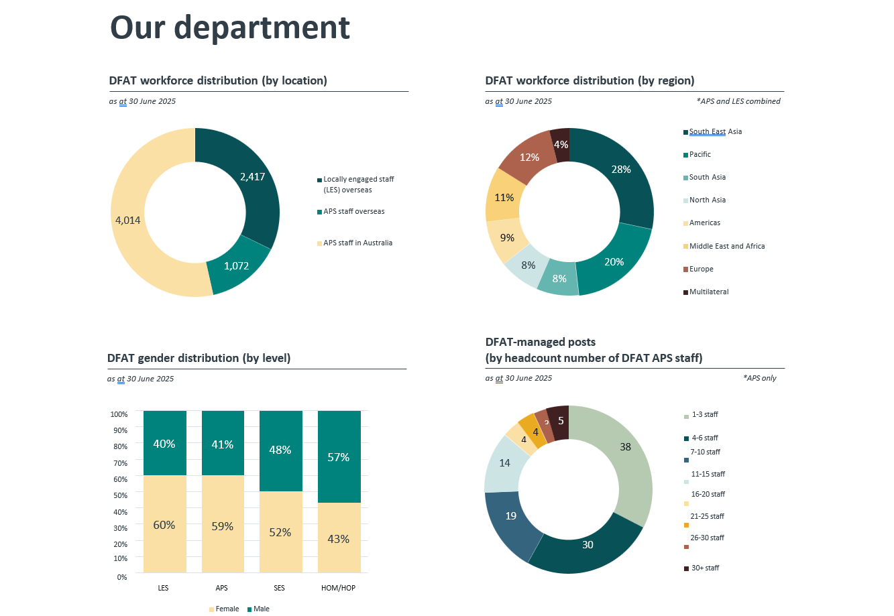

Strategy at a glance

01 We attract and retain a diverse and highly skilled workforce

Attracting and retaining talent
We attract and retain the right people with the right skills at the right time, to ensure our workforce can respond to changing priorities.

A diverse and inclusive workforce
Our workforce reflects modern Australia at all levels, leading to a diversity of experience and thought and more innovative outcomes.
We prioritise safe and respectful environments where our people feel valued and empowered.

Developing our people
Our global workforce is equipped with the tradecraft and technical expertise required to perform their role.

02 We lead with influence and integrity

Influential leadership
Our leaders drive the achievement of outcomes through clearly defined priorities and purpose.

A pro-integrity culture
Our people exemplify integrity by upholding and rewarding high standards of ethical behaviour.

03 Our people policies, practices and workplaces enable our people to deliver results

Enabling and equitable people policies and practices
Our people policies and practices, including remuneration settings, support the rapid mobilisation of our global workforce to meet operational priorities both in Australia and overseas.

Health, safety and wellbeing across our global network
All our offices and facilities are safe and accessible. We promote mentally healthy workplaces by actively managing psychosocial risks.

Modern ways of working
We use accessible, easy-to-use and modern technology, make data driven workforce decisions and have responsive workforce models to adapt to changing priorities.

01 We attract and retain a diverse and highly skilled workforce

Focus areas

Attracting and retaining talent
We attract and retain the right people with the right skills at the right time, to ensure our workforce can respond to changing priorities.

A diverse and inclusive workforce
Our workforce reflects modern Australia at all levels, leading to a diversity of experience and thought and more innovative outcomes. We prioritise safe and respectful environments where our people feel valued and empowered.

Developing our people
Our global workforce is equipped with the tradecraft and technical expertise required to perform their role.

Roles and responsibilities

We all will…
- Behave in a way that provides and promotes an inclusive and respectful workplace.
- Commit to ongoing professional development including improved cultural awareness and capability.

Our managers will...
- Lead by example in demonstrating safe, respectful and inclusive workplace practices.
- Build diverse teams including by supporting First Nations team members and people from under-represented backgrounds to drive achievement of outcomes.
- Complete diversity training including First Nations cultural capability training.
- Understand and utilise attraction and retention strategies to target talent.
- Engage in regular and effective performance discussions to identify opportunities to develop capability.
- Actively promote knowledge sharing and regular on- the-job learning, including coaching and mentoring to enhance performance.
- Ensure an understanding of the skills and capabilities required to deliver the government’s purpose.

Our SES will...
- Be champions and role models for safe, respectful and inclusive workplace practices.
- Extend their own cultural learning by participating in cultural capability training and embracing diverse perspectives.
- Commit to visibly boosting First Nations employment and diverse teams.
- Lead in the practice of meaningful cultural safety.
- Actively sponsor and support the development of staff by identifying and supporting opportunities to build capabilities to improve outcomes.
- Identify the expertise required to execute the government’s purpose and adapt to changing priorities.

Our department will...
- Maintain an Employee Value Proposition (EVP) that targets and retains diverse talent.
- Undertake deliberate recruitment activities for people from diverse and under-represented backgrounds including First Nations people.
- Ensure our end-to-end recruitment processes are effective, and responsive in responding to business needs and targeting top talent.
- Embed inclusion through workplace policies, guidelines and tools.
- Offer targeted professional development aligned with our core, critical and cultural capabilities.
- Support integrated foreign, trade and development policy analysis and advice.
- Facilitate internal and external mobility opportunities to enhance employee capability and experience including internal placements, postings, temporary transfers and secondments.
- Provide clear and accessible pathways for the development of subject-matter expertise and tradecraft, including through on-the-job learning, formal training and specific skills development programs including for overseas posts.

02 We lead with influence and integrity

Focus areas

Influential leadership
Our leaders drive the achievement of outcomes through clearly defined priorities and purpose.

A pro-integrity culture
Our people exemplify integrity by upholding and rewarding high standards of ethical behaviour.

Roles and responsibilities

We all will…
- Hold ourselves and our peers accountable for the delivery of outcomes.
- Demonstrate the APS and DFAT Values, act with integrity at all times and abide by applicable Codes of Conduct (APS/LES/Overseas) and contract provisions.
- Proactively ensure our understanding of integrity, its importance, and our integrity responsibilities.
- Be confident recognising, responding to and reporting concerns of unacceptable behaviours.

Our managers will...
- Hold themselves and their teams accountable for the delivery of outcomes and acceptable behaviours.
- Lead by example through upholding obligations and show integrity, be honest, ethical, respectful, transparent and accountable.
- Recognise and reward the efforts and achievements of our people.
- Drive excellence in the achievement of outcomes through effective prioritisation of workloads.
- Promptly address behaviour inconsistent with the APS Values and Code of Conduct.

Our SES will...
- Be stewards of integrity through ethical leadership.
- Champion and uphold the APS and DFAT values and the Secretaries Charter of Leadership Behaviours including by eliminating behaviours that breach these requirements.
- Champion the recognition of positive integrity behaviours.
- Foster psychologically safe and inclusive workplace practices where staff are empowered to raise issues, be collaborative, innovate and embrace risk.
- Ensure priorities are clearly articulated to ensure effective workload management and delivery of government priorities.

Our department will...
- Develop guidance and tools on how we work to achieve objectives in a psychologically safe environment.
- Embed a consistent approach to leadership performance that clearly defines the outcomes and behaviours expected of SES aligned with the APS-wide approach.
- Provide training, policies and systems to enable staff to maintain the department’s integrity.
- Maintain clear and accessible pathways to report unacceptable behaviour including conduct, fraud and corruption.
- Monitor and evaluate organisational integrity.

03 Our people policies, practices and workplaces enable our people to deliver results

Focus areas

Enabling and equitable people policies and practices
Our people policies and practices, including remuneration settings, support the rapid mobilisation of our global workforce to meet operational priorities both in Australia and overseas.

Health, safety and wellbeing across our global network
All our offices and facilities are safe and accessible. We promote mentally healthy workplaces by actively managing psychosocial risks.

Modern ways of working
We use accessible, easy-to-use and modern technology, make data driven workforce decisions and have responsive workforce models to adapt to changing priorities.

Roles and responsibilities

We all will…
- Commit to building an understanding of people policies and practices and a foundation-level literacy of data and evidence relevant to our role.
- Develop literacy and capability in relation to mental health and wellbeing, including knowing how to identify, manage and report on psychosocial risks.
- Develop literacy and capability in technology and continually identify better ways of doing things through IT tools and technology.

Our managers will...
- Design teams that support appropriate workforce structures in line with the APS Optimal Management Structure guidance and that support rapid deployment of our workforce, to the highest priorities.
- Adopt a safety culture focussing on prevention and early intervention, to enhance productivity.
- Respond promptly to unacceptable behaviour.
- Engage regularly with staff with a focus on wellbeing.
- Utilise data and evidence to inform delivery of outcomes.
- Support modern ways of working including through flexible work practices.
- Integrate workforce planning efforts with business planning processes to allow identification of core and critical capabilities aligned to the delivery of departmental priorities.
- Identify opportunities to utilise technology to enhance delivery of outcomes.

Our SES will...
- Embed the practice of making decisions in accordance with APS and departmental policies, practices and priorities.
- Lead by example in fostering physically and psychologically safe workplaces in the execution of our work.
- Actively promote the use of data and evidence when making decisions and delivering initiatives.
- Be a steward for good workforce planning practices that support effective structures for the delivery of work.
- Lead by example and create space for all staff to innovate including with better use of new tools such as AI pilots to drive continuous improvements

Our department will...
- Ensure people policies and practices (including recruitment, internal movements, deployments and learning and development) are informed by business needs and priorities.
- Provide efficient, accessible and reliable HR advice through a single entry-point for HR enquiries.
- Continue to meet our work, health and safety legislative obligations by maintaining a safe work environment and providing staff with access to wellbeing guidance and programs.
- Develop a consistent methodology to plan for the required workforce, and ensure accurate workforce data is available and utilised.
- Equip our workforce with the capabilities required to confidently engage with data to inform decisions.
- Invest in technologies that support staff to work securely and safely, and digital transformation programs to enable workforce productivity and self-service functionality.

Annex A: Our department chart text version

DFAT Workforce Distribution (by location)
4,014 APS staff in Australia
2,417 Locally engaged staff overseas
1,072 APS staff overseas

DFAT workforce distribution (by region)
28% South East Asia
20% Pacific
12% Europe
11% Middle East and Africa
9% Americas
8% South Asia
8% North Asia
4% Multilateral

DFAT Gender Distribution (by level)
Locally engaged staff overseas - 40% Male / 60% Female
ASP Staff - 41% Male / 59% Female
Senior Executive Service - 48% Male / 52% Female
HOM/HOP - 57% Male / 43% Female

DFAT-managed posts (by headcount number of DFAT APS staff)
38 posts have 1-3 APS staff
30 posts have 4-6 APS staff
19 posts have 7-10 APS staff
14 posts have 11-15 APS staff –
4 posts have 16-20 APS staff -
4 posts have 21-25 APS staff –
3 posts have26-30 APS staff
5 posts have 30+ APS staff

