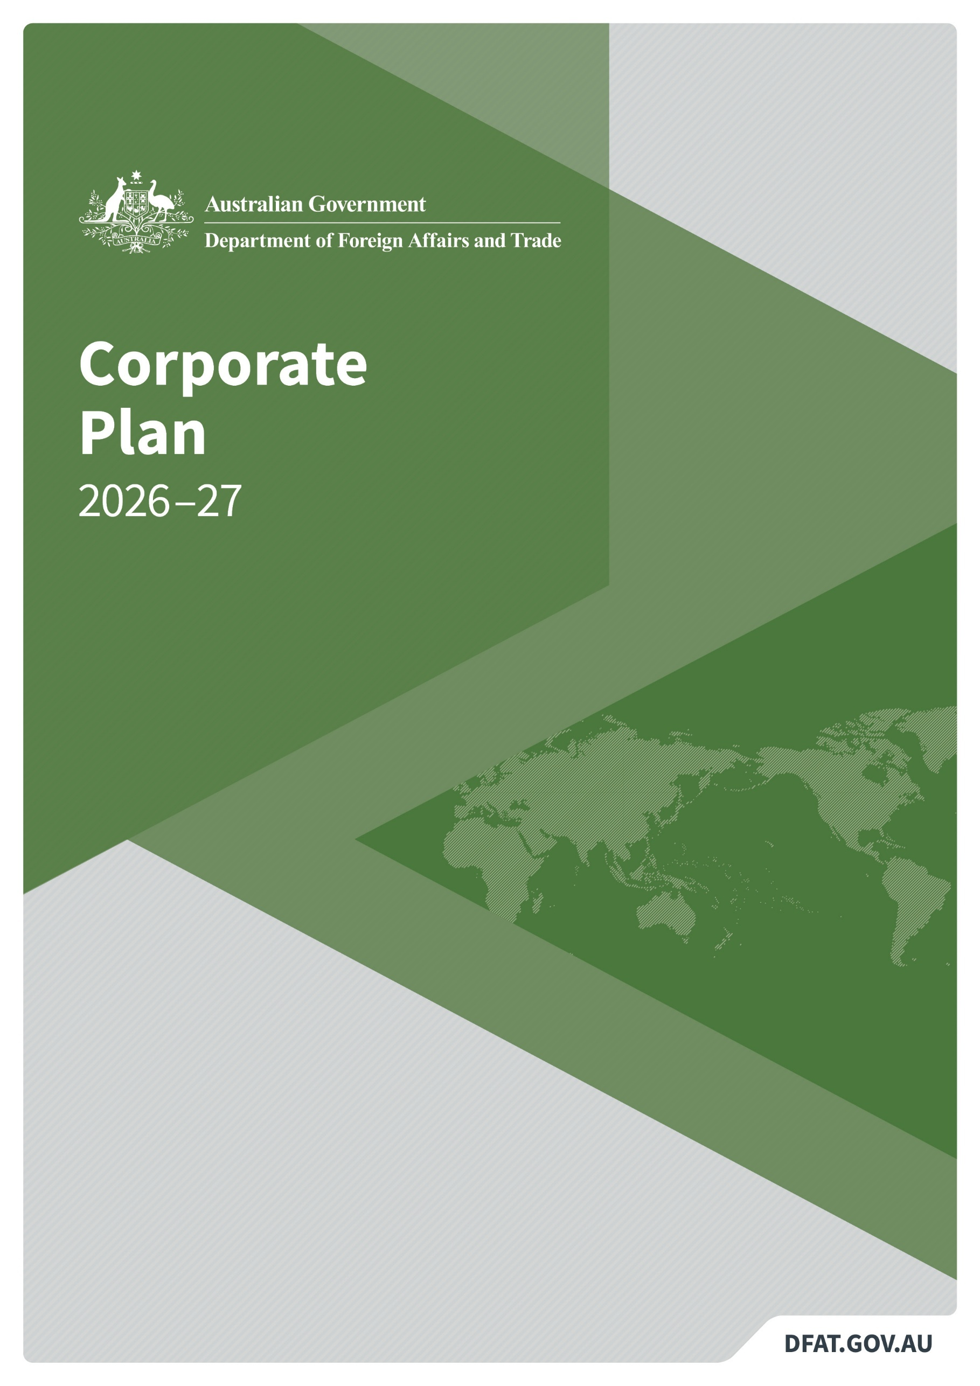
Corporate Plan
2026–27
[For insertion once finalised]
© Commonwealth of Australia 2026
ISSN 2653-567X

Creative Commons

With the exception of the Commonwealth Coat of Arms, the Department of Foreign Affairs and Trade logo, photographs, images, signatures and where otherwise noted, this
publication is provided under a Creative Commons
Attribution-NonCommercial-NoDerivatives 4.0 International (CC BY-NC-ND 4.0) licence, available at creativecommons.org/licenses/by-nc-nd/4.0.
The details of the relevant licence conditions are available on the Creative Commons website (accessible using the links provided), as is the full legal code for the CC BY-NC-ND 4.0 licence, available at creativecommons.org/licenses/by-nc-nd/4.0/legalcode.en.
Provided you have not modified or transformed the material in any way, the Commonwealth’s preference is that you attribute this publication (and any material sourced from it) using the following:
Department of Foreign Affairs and Trade, Corporate Plan 2026–27, © Commonwealth of Australia 2026. Licensed from the Commonwealth of Australia under a CC BY-NC-NB 4.0 licence.
Contacts
Inquiries about the corporate plan are welcome and should be directed to:
Performance and Planning Section
Executive Division
Department of Foreign Affairs and Trade
RG Casey Building
John McEwen Crescent
Barton ACT 0221
Australia
Phone: +61 2 6261 1111
Web: dfat.gov.au

Acknowledgement of Country
The Australian Department of Foreign Affairs and Trade acknowledges the Traditional Custodians of Country throughout Australia, and their continuing connection to land, waters and community. We pay our respect to all First Nations peoples, their cultures and to their Elders, past, present and emerging.
Title: Department of Foreign Affairs and Trade Corporate Plan 2026–27
Senior responsible officer: First Assistant Secretary, Executive Division (FAS EXD)
Created by: Performance and Planning Section, Governance, Risk and Performance Branch, Executive Division (BPP/GRB/EXD)
Date published: 27 August 2026
Maintained by: Performance and Planning Section, Governance, Risk and Performance Branch, Executive Division (BPP/GRB/EXD)

Contents
1 Secretary’s statement 1
Corporate plan snapshot 3
2 Operating environment 4
DFAT’s key activities 4
Our region 4
Relationships 5
Rules 5
Resilience 5
3 Capability 6
Leadership 7
Attraction and retention 7
APS Strategic Commissioning Framework 7
Wellbeing and culture 7
Diversity and inclusion 8
APS Values, Integrity and Code of Conduct 8
Overseas network 8
Technology 8
Infrastructure 9
4 Risk management 10
Governance 12
5 Cooperation and partnerships 13
Australian Government partners 13
States and territories and other domestic stakeholders 13
Regional and strategic partnerships 14
Multilateral cooperation 14
Development and humanitarian partnerships 14
6 Regulator performance 16
Australian Safeguards and Non-Proliferation Office 16
Australian Sanctions Office 16
Foreign Arrangements Scheme 16
Principles of regulator best practice 16
7 DFAT’s approach to performance 18
Performance measures for Outcome 1 20
Performance measures for Outcome 2 34
Performance measures for Outcome 3 39
Appendix A: Changes to performance information 42
Appendix B: List of requirements 46
Appendix C: Alternative text image descriptions 48



1 Secretary’s statement
DFAT Secretary Jan Adams AO PSM, credit: DFAT
The purpose of the Department of Foreign Affairs and Trade (DFAT) is to make Australia stronger, safer and more prosperous, to provide timely and responsive consular and passport services, and to ensure a secure Australian Government presence overseas. DFAT delivers diplomatic, trade, economic, development and humanitarian outcomes that support Australia’s security and prosperity in a complex international environment.
DFAT leads the Australian Government’s international engagement through 114 posts in 85 countries of resident accreditation and 9 offices in Australia. This network helps Australia pursue its interests, build diverse relationships and deliver rapid, coordinated assistance to Australians affected by crises overseas.
DFAT operates in a period of acute global volatility and uncertainty. In this environment, Australia’s interests are best served by a stable international system, strong rules and norms, and practical cooperation on shared challenges. Over the life of this plan, DFAT will focus effort where Australia’s interests are most affected: in the Indo-Pacific, through the rules and institutions that support stability and prosperity, and through the systems that keep Australians safe and connected to the world.
This corporate plan sets out how DFAT will deliver in that environment. It explains the department’s operating context, the capability and risk settings needed to support delivery, the partnerships and regulatory functions that contribute to DFAT’s purpose, and the performance framework that will measure progress. Performance against the plan will be reported in the DFAT Annual Report 2026–27.
I am pleased to present the Corporate Plan 2026–27. This plan covers the period 2026–27 to 2029–30, as required under paragraph 35(1)(b) of the Public Governance, Performance and Accountability Act 2013. The corporate plan is prepared in accordance with the Public Governance, Performance and Accountability Rule 2014.

Jan Adams AO PSM
Secretary
21 August 2026

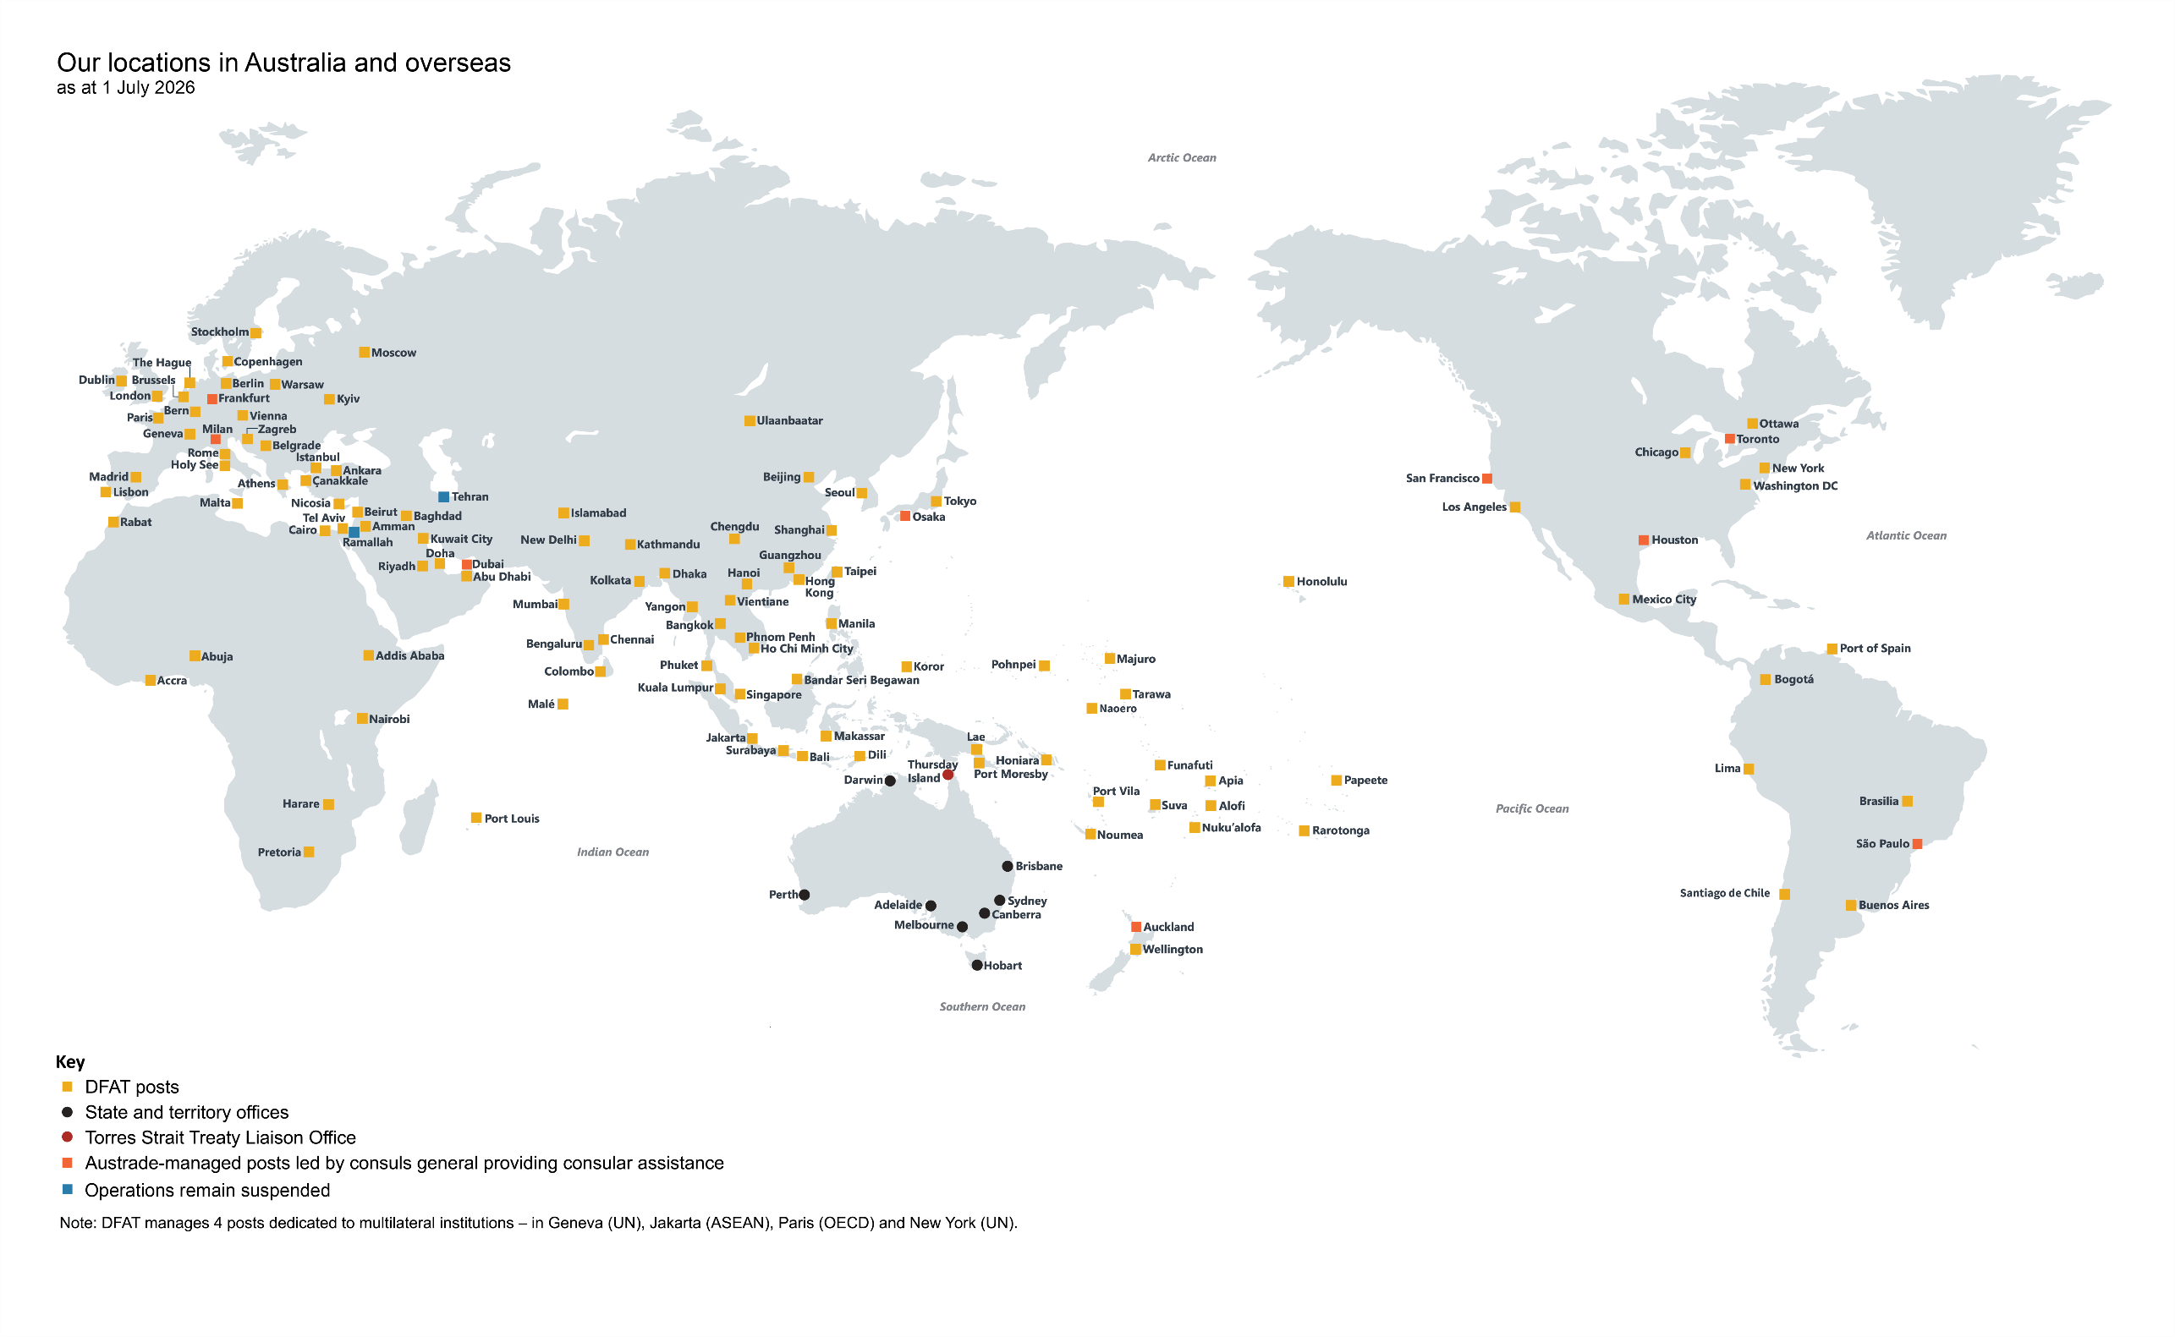

Corporate plan snapshot
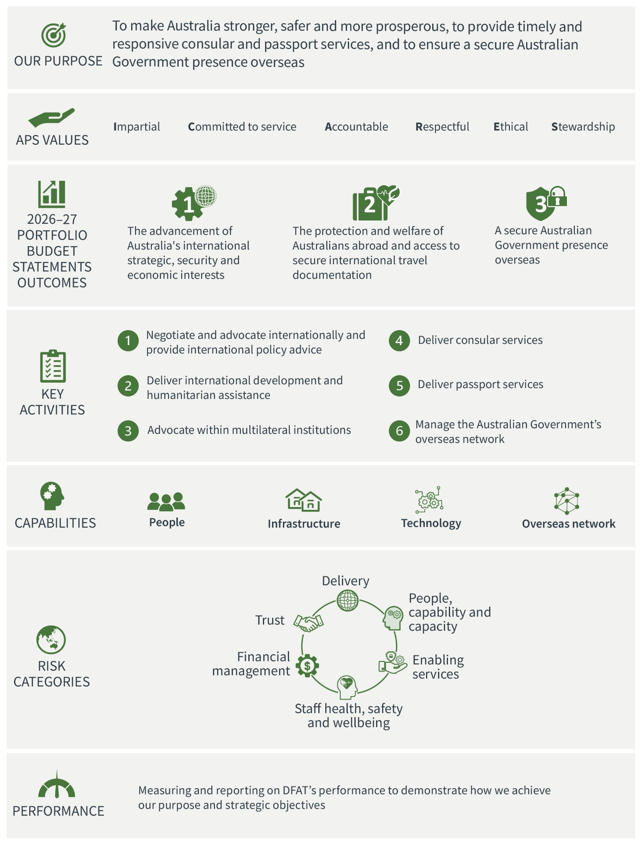

2 Operating environment
DFAT operates in a world that is becoming more contested and less predictable. Strategic competition is increasing. Supply chains, energy networks and our economic security are increasingly threatened. The international rules that support stability, security and prosperity are under pressure. Rapid technological change, especially artificial intelligence (AI), is reshaping global power and creating new opportunities and challenges. Climate change adds to these pressures.
DFAT will respond by mobilising diplomatic, trade and development efforts and coordinating Australian Government agencies overseas. DFAT will work with all levels of government, business and the community to keep Australians safe, build prosperity and advance Australia’s strategic, security and economic interests.
Over the term of this plan, DFAT will need to prioritise carefully, adapt to changing conditions and strengthen the internal systems and capabilities needed to deliver. DFAT will lead whole-of-government efforts to support an international environment in which all countries, large and small, can make sovereign choices in their national interests and free from coercion.
This operating context shapes how DFAT will deliver its purpose over the life of the plan. DFAT will focus effort where Australia’s interests are most affected, use the overseas network and partnerships to extend Australia’s influence, strengthen the systems that support delivery, and use performance information to improve planning and decisions.

DFAT’s key activities
DFAT delivers its purpose through 6 key activities:
- negotiate and advocate internationally and provide international policy advice
- deliver international development and humanitarian assistance
- advocate within multilateral institutions
- deliver consular services
- deliver passport services
- manage the Australian Government’s overseas network.
These key activities organise the performance framework outlined in this plan.

Our region
A peaceful, prosperous and resilient region means a safer and more prosperous Australia. DFAT’s diplomatic efforts will focus on strengthening alignment and deepening partnerships across the Pacific and Southeast Asia, including through the organisations that support regional cooperation, particularly the Association of Southeast Asian Nations (ASEAN) and the Pacific Islands Forum (PIF). A stable, prosperous and resilient region directly supports Australia’s security, economy and community connections.
DFAT will advance priorities shared with our Pacific partners, including climate change, economic development, regional security, improved infrastructure and connectivity, and action against transnational crime. This is increasingly important as some traditional development partners reduce assistance. Rising geostrategic competition and global shocks — including reductions in development assistance and energy disruptions linked to conflict in the Middle East — also place pressure on regional economies and underline the importance of relationships in Asia. As a reliable and responsive partner, Australia has reprioritised funding toward the Indo-Pacific. DFAT will continue to support Pacific-led solutions and deepen partnerships across the region to deliver sustainable and locally driven outcomes.

Relationships
In a more challenging environment, DFAT will strengthen and manage Australia’s relationships to protect Australia’s long-term interests in our region and globally. Strong relationships give Australia practical influence: they help manage differences, build cooperation and secure outcomes in Australia’s interests.
DFAT will support Australia’s close work with the United States of America, our principal strategic partner and ally. It will help maintain stable ties with China, cooperating where we can, disagreeing where we must and engaging in Australia’s national interests. DFAT will also deepen Australia’s cooperation with Japan, the Republic of Korea, India, Europe, the United Kingdom, Canada and New Zealand, and through groupings such as the Quad (with India, Japan and the United States of America). We will also work closely with our newest allies, Papua New Guinea and Fiji, as well as our other Pacific island partners, to support a peaceful, safe and prosperous Pacific. These relationships strengthen national resilience and support the kind of Indo-Pacific region Australia wants.
More detail on DFAT’s work with international organisations and through strategic partnerships is on pages 13–15 under ‘Cooperation and partnerships’.

Rules
As global power contests intensify, international law and established institutions face growing challenges. Strategic competition is also straining the norms that support global stability and prosperity, including Australia’s security and economic interests. The multilateral system that we rely on, including for cross-border cooperation and mutually agreed rules, is in urgent need of reform.
Australia and its partners must keep working through global institutions to uphold an open, rules-based system. Trade and supply chains are under strain. Geostrategic competition, more interventionist industrial policy, competition over critical minerals and the clean energy transition are reshaping the global economy. DFAT will support Australia’s economic security and resilience by diversifying trade and investment, attracting investment, deepening economic security partnerships and strengthening supply chains.

Resilience
A more volatile world carries a significant human cost. Conflict, humanitarian crises and climate impacts are increasing pressure on vulnerable communities and on the international system’s capacity to respond. A well-resourced anti-rights movement is eroding progress on gender equality and undermining democratic resilience. Through Australia’s development and humanitarian program, DFAT is strengthening peace, stability and prosperity in the region by investing in governance and economic security, supply chain resilience, building human capital and resilient communities, addressing humanitarian needs and upholding international law. Australia is strengthening conflict prevention architecture, reducing risks of miscalculation and misunderstanding, and building collective resilience to external shocks.
Digital technology, AI, information flows and automation are altering how people understand the world. They are also changing how governments engage, how economies operate and how security risks emerge. These shifts increase the pace and complexity of international engagement, creating new opportunities and challenges.
Crisis preparedness remains essential. International crises affecting Australians overseas are becoming more likely and more complex. Australians need secure travel documents, timely information and travel advice, responsive consular assistance and crisis support. DFAT will keep strengthening crisis preparedness across the overseas network so it can provide rapid, coordinated responses, information and assistance. DFAT will continue to secure the Australian Government presence overseas and manage the Commonwealth’s overseas property estate.

3 Capability
DFAT will strengthen the people, systems and infrastructure needed to deliver reliably in a more contested and less predictable world. In 2026–27, this means investing in workforce capability, leadership, the overseas network, technology, integrity systems, the property portfolio and enabling services so the department can deliver its 6 key activities and adapt as priorities shift.
DFAT’s People Strategy 2025–2028 sets the workforce framework for delivering policy, programs and global services. It embeds the Ten-Year Future Capability Plan and guides investment in people and supporting infrastructure through 3 pillars (see Figure 1).
DFAT will use workforce planning, learning and development, strategic prioritisation, and streamlined recruitment and deployment to strengthen capability. This will improve visibility of workforce capacity and skills and help the department anticipate and respond to changing priorities.
These priorities are mutually reinforcing. Workforce planning directs people to priority work; leadership and integrity settings support sound judgement; technology and data improve productivity and decisions; and infrastructure investment keeps the overseas network secure, resilient and fit for purpose.
Figure 1: People Strategy 2025–2028 pillars
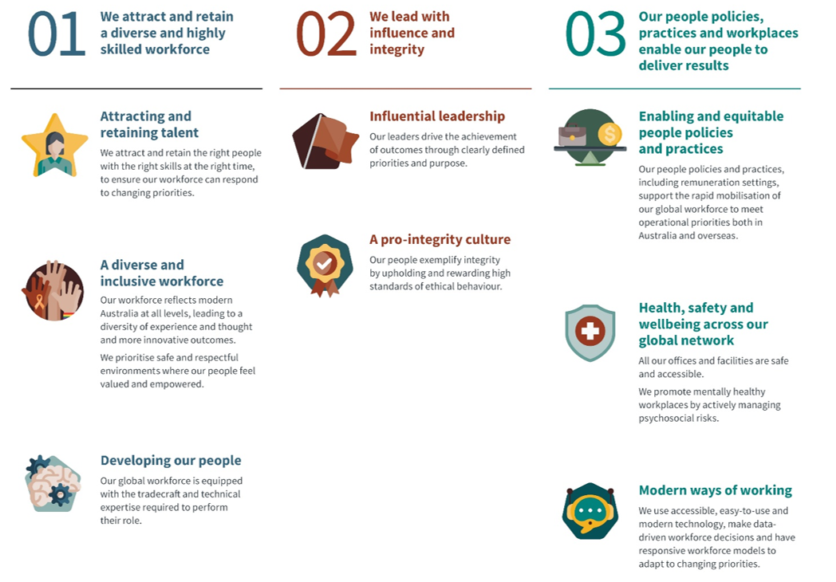

Leadership
DFAT will support leaders to deliver Australia’s objectives with influence, integrity and stewardship. Leaders will be equipped to set clear priorities, foster effective working environments, and manage physical and psychosocial risks across the global network. They will build engaged, productive and inclusive teams able to deliver high-quality outcomes in demanding circumstances.
In 2026–27, DFAT will maintain leadership initiatives including Senior Executive Service (SES) and Executive Level 2 leadership courses and tailored work health and safety training, regular knowledge sharing and panel discussions to build tradecraft. The Senior Administration Officer Pathways Program will equip corporate leaders for the international environment.
DFAT has implemented the Secretaries’ Charter of Leadership Behaviours within the SES performance management framework. The charter sets expectations for secretaries, the Senior Executive Service, and leaders at all levels of the APS under the APS Values and Code of Conduct. In 2026–27, DFAT will revise the non-SES performance management framework to incorporate the charter and strengthen leadership practices, organisational performance and culture.

Attraction and retention
DFAT offers structured career pathways to build and retain the talent and expertise it needs. Strong interest in the DFAT graduate program and targeted recruitment programs, in Australia and at posts, provides a pipeline of skilled professionals. DFAT’s International Graduate Program builds long-term connections with Australia’s regional counterparts as DFAT graduates and international participants progress through their careers.
DFAT fosters high performance through its performance management framework and recognises staff who
deliver beyond expectations. Reward and recognition approaches reflect the diversity of employees’ preferences and motivations.

APS Strategic Commissioning Framework
DFAT is implementing the APS Strategic Commissioning Framework (SCF) by building internal APS workforce capability across its core job families of international relations, consular, passports, and enabling services to the overseas network. This has reduced DFAT’s contracted workforce by 25% between June 2023 and March 2026. In 2026–27, DFAT will continue to implement the SCF to reflect budgeted staffing levels and the capability mix required to deliver government outcomes.

Wellbeing and culture
DFAT is committed to a high-performing, safe and positive workplace across its domestic and overseas network. Staff wellbeing is critical to the department’s capacity to deliver on its purpose, particularly during crisis response.
In 2026–27, DFAT will implement a Health, Safety and Wellbeing Action Plan to strengthen leadership, manage workplace safety risks, and increase focus on staff wellbeing and mental health.
DFAT provides practical support initiatives and resources to staff and families across the posting journey. These include professional health services through our Medical and Psychology units, and the Global Community
Liaison Office.
Staff feedback informs the DFAT APS Employee Census Action Plan 2025–2028, which is reviewed annually and supported by action at all levels. DFAT’s 2026 APS Employee Census results demonstrated continued confidence in the department’s leadership and showed improvements across innovation, communication and access to tools and resources. In 2026–27, DFAT will further implement APS Optimal Management Structures guidance and develop business process and productivity improvements.

Diversity and inclusion
DFAT is building a diverse and inclusive workplace that reflects the community it serves, as set out in the Inclusion, Equity and Diversity Strategy 2024–2027. Staff-led diversity networks and inclusion champions strengthen organisational capability. DFAT is improving recruitment, development and retention for under-represented groups, including First Nations peoples, and continuing actions under DFAT’s Stretch Reconciliation Action Plan and to support Closing the Gap priority reforms.

APS Values, Integrity and Code of Conduct
The foundations of DFAT’s culture are set out in the APS Values, Code of Conduct and Employment Principles under the Public Service Act 1999. They are complemented by the Locally Engaged Staff Code of Conduct, the DFAT Code of Conduct for Overseas Service, the Ethics, Integrity and Professional Standards Policy Manual and the DFAT Integrity Strategy 2024–26.
Together, these frameworks define the standards expected of all APS employees and locally engaged staff. They guide conduct and give the Australian community confidence that DFAT acts with integrity, accountability and ethics. In 2026–27, DFAT will review its Integrity Strategy to ensure delivery remains underpinned by the culture, systems and processes needed to maintain trust with the government, stakeholders and the Australian public.
Mandatory training helps staff understand their obligations and reinforces DFAT’s integrity and compliance standards. DFAT’s oversight of training compliance supports a professional, accountable workforce.

Overseas network
The Australian Government’s overseas network is central to protecting Australians overseas and advancing Australia’s interests. DFAT manages 114 posts across 85 countries of resident accreditation (see network map on page 2). DFAT enables the efficient use of government resources overseas, including property, staff and conditions of service, health and safety, security, information and communications technology (ICT), and finance. Austrade manages a further 9 posts, providing consular services and trade and investment promotion.
The network helps the Australian Government collaborate globally, advance Australia’s interests, deliver the development program and identify new market opportunities for Australian businesses.
The network provides consular and passport services to Australians travelling overseas and manages responses to international crises. In locations where the Australian Government has no post, 49 honorary consuls help maintain access to consular services in areas frequented by Australian travellers.

Technology
DFAT delivers information and communications technology (ICT) services and infrastructure, including for other Australian Government agencies, to enable a secure and resilient Australian Government presence overseas. Over the next 4 years, DFAT will strengthen its ICT capability to support a reliable, secure and sustainable global ICT network critical to DFAT’s delivery and crisis response capability.
DFAT is modernising its technology environment through a coordinated program of investment in cloud services, enterprise platforms, AI and cybersecurity uplift. DFAT’s Office of Data, Analytics, and Artificial Intelligence is working to expand the use of governed AI tools to improve productivity and decision-making. DFAT supports the responsible adoption of AI through strengthened governance, workforce capability and access to secure tools, helping staff make better-informed decisions, improve service delivery and focus on high-value activities.
DFAT will strengthen its cybersecurity by enhancing information security controls, improving visibility of cyber risks, and uplifting protective technologies to address an evolving threat environment. These activities are aligned with whole-of-government technology priorities and DFAT’s ICT and cybersecurity strategies, ensuring investments deliver secure, scalable and interoperable systems.

Infrastructure
Investment in the overseas and domestic property portfolio underpins the delivery of Australia’s interests in trade, development, foreign policy and consular and passport services. Long-term planning ensures assets remain secure, sustainable and capable of supporting Australia’s international engagement.
Overseas, investment includes the delivery of key projects across the global network, including relocating and expanding the chancery in Honolulu, new high commissions in Honiara, Malé and Abuja, and a new residence in Abuja. Targeted investments will maintain, enhance and expand Australia’s property footprint in the Pacific to support a growing Australian Government presence.
Domestically, DFAT is consolidating its Canberra operations into a single precinct in Barton, Canberra, which will include 2 buildings: the National Security Office Precinct and a leased facility at 19 National Circuit.
DFAT manages risks associated with its global property and infrastructure portfolio through a structured program of prioritised investment, maintenance and renewal. This will include uplifting critical ICT and security systems across the property estate to ensure facilities are fit for purpose, resilient and aligned with evolving security requirements.

4 Risk management
DFAT operates in a complex and increasingly challenging global environment. Effective risk management helps DFAT make deliberate choices about priorities, controls, resources and delivery across its 6 key activities. DFAT manages high risks carefully, takes proportionate risk where needed to achieve government objectives, and maintains clear accountability for risk acceptance and control effectiveness.
DFAT’s enterprise risk categories, shown in Figure 2, are defined in the department’s enterprise risk management policy. The policy explains how risk oversight, management and internal controls are embedded in governance, planning and performance. Where controls and treatments do not reduce risk to tolerance, authorised delegates must document risk and ongoing management.
During 2026–27, DFAT will review its risk management policy and strengthen its approach so it remains fit for purpose and responsive to the operating context. DFAT will build risk capability to reinforce positive risk behaviours and support compliance in decision-making.
Figure 2: DFAT’s enterprise risk categories
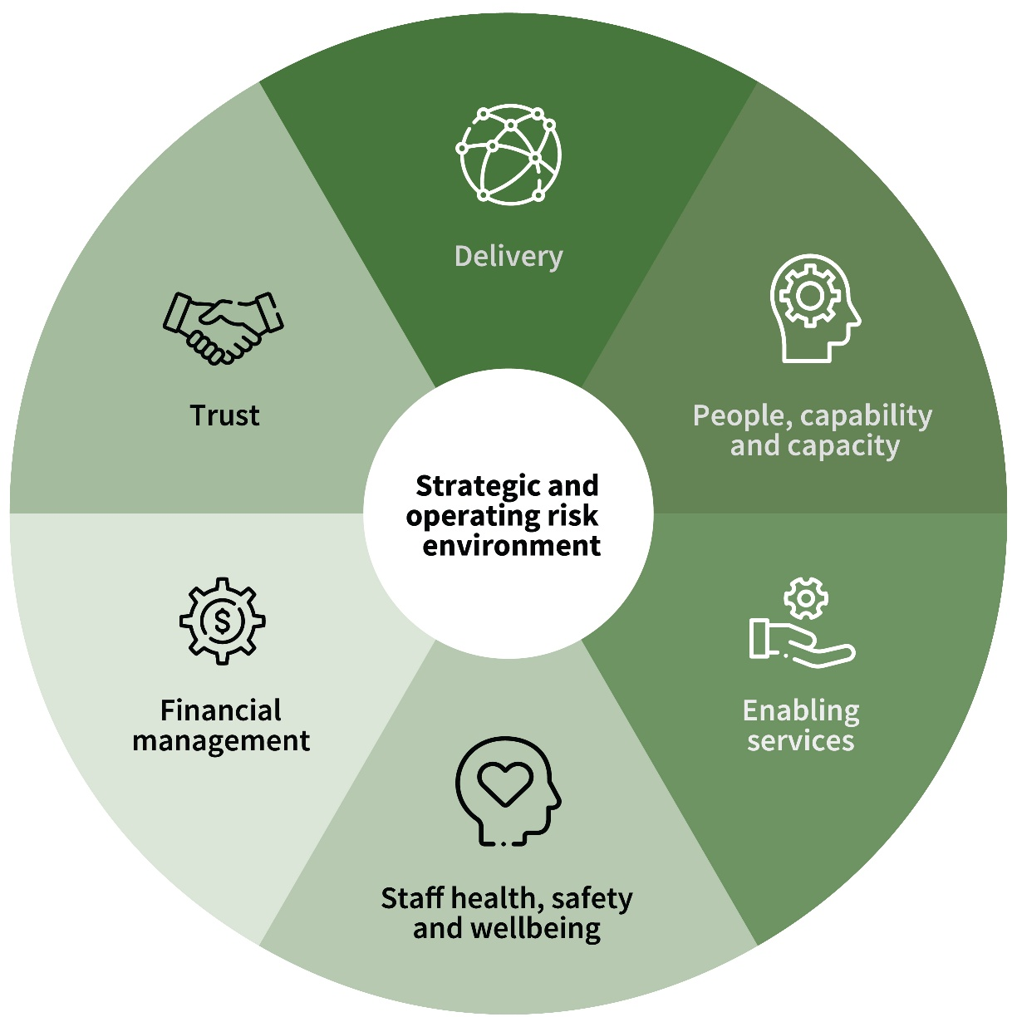
Enterprise risk category | Description
Trust | To maintain the trust of stakeholders we must:  - uphold the highest levels of integrity  - provide reliable and impartial advice to government  - have zero tolerance for inaction on unethical and illegal conduct  - have zero tolerance for deliberate violations of legislation  - have very low tolerance for unintentional violations of legislation  - safeguard information security and privacy.
Delivery | To deliver our services, programs and policy in support of our objectives and the national interest we must:  - innovate and maximise opportunities  - protect Australia’s international reputation in delivery of our programs  - establish resilient processes to avoid delays or disruptions to the delivery of critical services to Australians.
People, capability and capacity | To meet our objectives, we must align our people’s capabilities with key priorities and attract, develop and retain the capabilities we need.
Enabling services | Our people, information, assets and the national interest must be enabled and protected by our:  - ICT services  - security capability  - estate management.
Staff health, safety and wellbeing | - We must consider and mitigate risks to our people while delivering our objectives in the national interest.  - The health and safety of our people remains paramount and we are committed to providing a safe and healthy workplace.
Financial management | - We must use resources in a proper manner in pursuit of the government’s objectives and to maintain financial stability.

Governance
DFAT’s governance structure supports enterprise decision-making and strategic prioritisation. Committees provide oversight and assurance to the Secretary on performance, risk, compliance and accountability, underpinning effective delivery of DFAT’s purpose.
The Audit and Risk Committee provides independent advice to the Secretary on the department’s financial and performance reporting, risk oversight and management, and internal controls. It was established under section 45 of the Public Governance, Performance and Accountability Act 2013 and section 17 of the Public Governance, Performance and Accountability Rule 2014 (PGPA Rule).
The department’s governance committee structure is shown in Figure 3.
Figure 3: Governance committee structure as at 1 July 2026
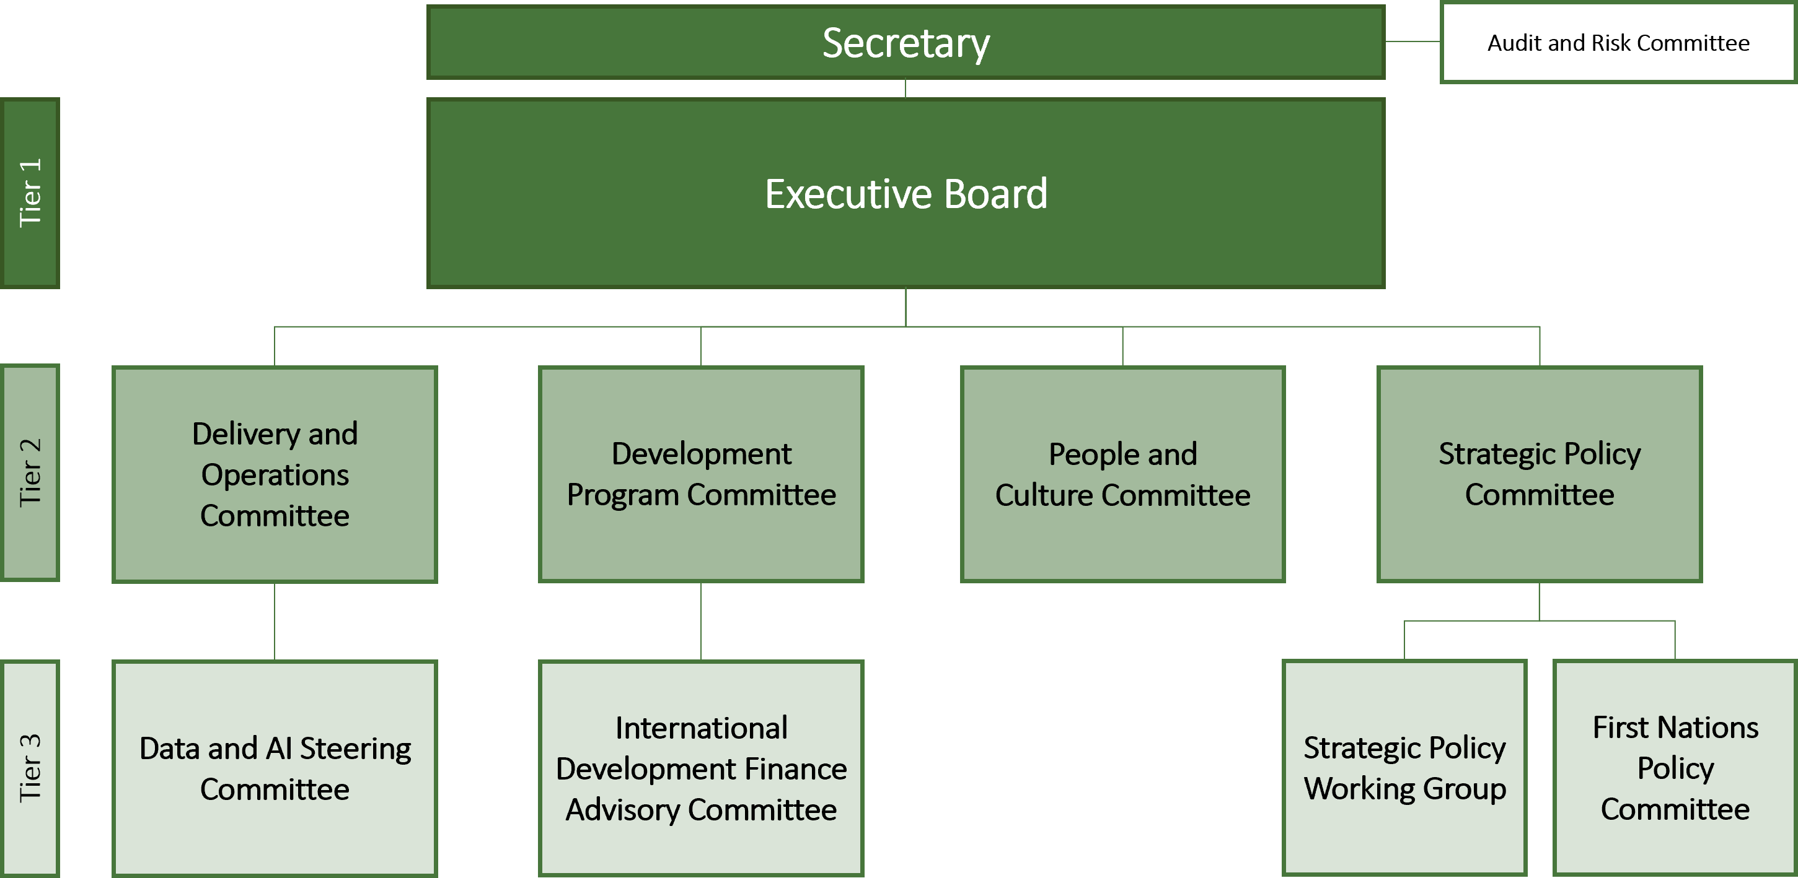

5 Cooperation and partnerships
Cooperation and partnerships, shown in Figure 4, are central to DFAT’s work because many foreign policy, trade, development, consular and security outcomes depend on coordinated action beyond the department. DFAT uses partnerships to coordinate the Australian Government’s international engagement, connect domestic capability with global opportunities, and build collective responses to shared challenges.
This section explains who DFAT works with, why those relationships matter and how cooperation helps DFAT achieve its purpose.
Figure 4: DFAT’s whole-of-government coordination with partners
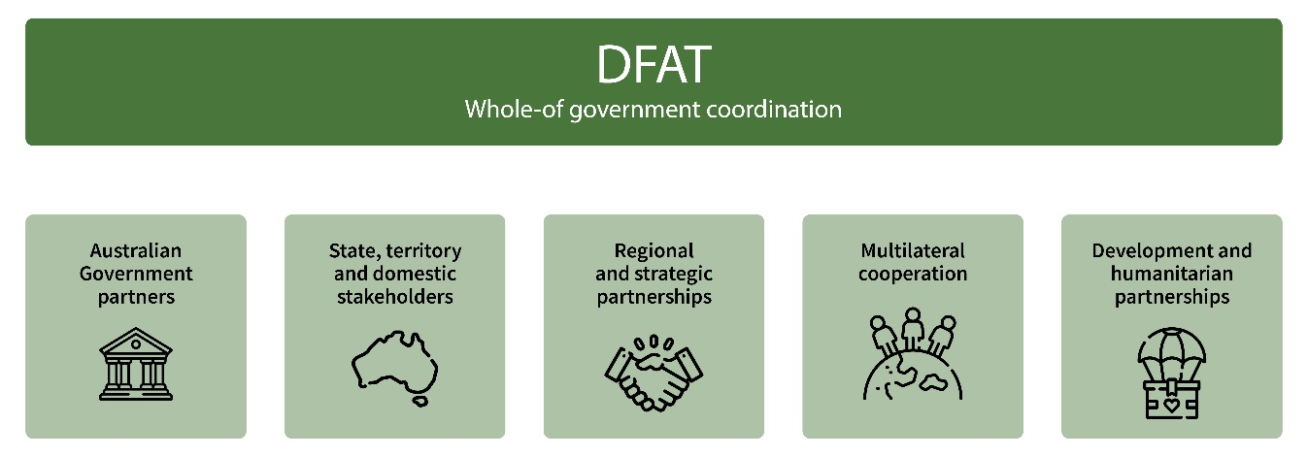

Australian Government partners
DFAT leads and coordinates the Australian Government’s international engagement. DFAT supports 34 Australian Government agencies overseas and 12 agencies domestically, enabling a unified Australian approach in policy development and in our bilateral, regional and multilateral engagement.

States and territories and other domestic stakeholders
DFAT partners with state and territory governments, businesses, universities, cultural and sporting bodies, research institutions, non-government organisations and First Nations stakeholders to advance Australia’s interests. These partnerships help connect Australian expertise and innovation with global opportunities, including trade diversification, investment attraction, research collaboration and community engagement.
DFAT draws on the strengths of Australia’s diverse communities. Our multicultural communities, diaspora networks and First Nations peoples strengthen cultural understanding, business relationships and people-to-people connections. Under DFAT’s First Nations International Engagement Strategy, DFAT will engage more than 360 First Nations stakeholders to embed First Nations perspectives, knowledge and interests in Australia’s international engagements. DFAT’s domestic network works in each state and territory and the Torres Strait to maintain these relationships, promote understanding of Australia’s foreign, trade, development and investment policies and to support effective regulation.

Regional and strategic partnerships
In the Indo-Pacific, DFAT works with partners and through regional forums to advance shared interests and deliver collective responses to common challenges. This cooperation spans diplomatic, economic, development and security issues.
Landmark strategic agreements with Pacific island countries are deepening our partnerships and safeguarding the region in line with our collective vision. These agreements are transforming our bilateral partnerships and will underpin Australia’s and our region’s collective security, prosperity and resilience. Agreements have included an Alliance and Pukpuk Treaty with Papua New Guinea, Vuvale Union Treaty and Ocean of Peace Alliance with Fiji, and treaty-level strategic agreements with Vanuatu, Naoero and Tuvalu.
DFAT’s work with partners in Southeast Asia builds resilience and supports a peaceful, stable and prosperous region. It promotes economic cooperation, regional institutions and stability. DFAT is working with Defence to drive Australia’s engagement with Indonesia to implement the Treaty on Common Security and deepen cooperation on shared strategic, economic and security priorities. We are strengthening Australia’s partnership with Timor-Leste through the groundbreaking Parseria Leaders’ Joint Declaration, supporting regional integration, economic security and institutional ties. DFAT is deepening people-to-people connections with our neighbours, including in the Pacific through First Nations diplomacy, sport and culture.
DFAT is diversifying Australia’s trade and economic partnerships through advancing economic and trade opportunities with India, implementing Australia’s free trade agreement with the United Arab Emirates and the conclusion of free trade agreement negotiations with the European Union. Equally, regional agreements including the Comprehensive and Progressive Agreement for Trans-Pacific Partnership, the Regional Comprehensive Economic Partnership Agreement and the ASEAN – Australia – New Zealand Free Trade Area increase opportunities for Australia. We are also building our economic security dialogues with strategic partners and key regional countries.

Multilateral cooperation
The department works through international institutions and forums, including the United Nations, the World Trade Organization (WTO), Group of 20 (G20), the Organization for Economic Co-operation and Development (OECD), multilateral development banks, regional architecture such as ASEAN, the Quad, Asia-Pacific Economic Cooperation (APEC), the PIF, the Indian Ocean Rim Association (IORA), and Australia’s network of free trade agreements. We engage to secure collective action on global challenges, strengthen international rules and norms, facilitate trade and investment, and enable Australia’s contribution to a stable and secure international system.
Focused on our region, Australia will partner with the Pacific to set the agenda for and preside over pre-COP events in Fiji and a special leaders’ side event in Tuvalu in October 2026, ahead of COP31 (the 31st Conference of the Parties to the United Nations Framework Convention on Climate Change). Our region is at the front line of the climate crisis, where the effects are real and immediate. COP31 will bring the focus of the world to the impacts, opportunities and priorities in our region.
DFAT engages the multilateral system where only a multilateral approach can deliver, or delivers best. The United Nations Security Council remains the UN’s most powerful body. In 2026–27, DFAT will launch Australia’s campaign to be elected as a non-permanent member of the Security Council for 2029–30, supporting Australia’s national security interests, profile and influence.

Development and humanitarian partnerships
DFAT partners with multilateral organisations, the private sector, non-government organisations, universities, faith-based organisations, and governments to deliver Australia’s international development and humanitarian program. This is a key pillar of Australia’s statecraft, working alongside diplomacy, trade and defence to advance shared interests. Through partnerships, DFAT supports regional and global efforts to strengthen resilience and deliver sustained development outcomes that support Australia’s interests. Through the launch and promotion of the Declaration for the Protection of Humanitarian Personnel, Australia is galvanising international support to better protect humanitarian personnel.
The majority of Australia’s development assistance is directed to the Indo-Pacific, and supports long-term resilience, sustainable economic growth, poverty reduction, climate resilience and inclusive development outcomes. DFAT programs focus on locally led development that contributes to a peaceful, stable and
prosperous region.

6 Regulator performance
Three regulatory functions sit within DFAT: the Australian Safeguards and Non-Proliferation Office (ASNO), the Australian Sanctions Office and the Foreign Arrangements Scheme. Regulator performance is assessed through performance measures 4 and 5 (see pages 24–27). The Foreign Arrangements Branch and ASNO both publish separate annual reports, which are tabled in parliament. The Australian Sanctions Office’s annual report will be published on DFAT’s website.

Australian Safeguards and Non-Proliferation Office
ASNO underpins international security by upholding Australia’s international non-proliferation commitments through robust domestic regulation, supports regional non-proliferation implementation, and shapes and strengthens global non-proliferation and disarmament verification mechanisms. ASNO is led by the Director General, an independent statutory officer reporting directly to the Foreign Minister.

Australian Sanctions Office
The Australian Sanctions Office implements sanctions that impose costs on foreign individuals, entities, regimes and governments for breaches of international law, human rights abuses and conduct contrary to Australian
values and national interests. It regulates activities in Australia, and the overseas activities of Australians and Australian companies.

Foreign Arrangements Scheme
The Foreign Arrangements Scheme ensures that arrangements between state and territory entities and foreign entities do not adversely affect Australia’s foreign relations or conflict with foreign policy. State and territory entities include governments, local government, and Australian public universities. The scheme supports a systematic and consistent approach to foreign engagement across all levels of government.

Principles of regulator best practice
DFAT’s regulators apply the 3 principles of regulator best practice (see Table 1). This commitment is reflected in statements of expectations from the Minister for Foreign Affairs, Senator the Hon Penny Wong, to the Secretary of DFAT and Director General of ASNO, and in their statements of intent.

Table 1: Principles of regulator best practice
Principle and description
Continuous improvement and building trust: Regulators adopt a whole-of-system perspective, continuously improving their performance, capability and culture to build trust and confidence in Australia’s regulatory settings.
Risk-based and data-driven: Regulators manage risks proportionately and maintain essential safeguards while minimising regulatory burden and leveraging data and digital technology to support those they regulate to comply and grow.
Collaboration and engagement: Regulators are transparent and responsive communicators, implementing regulations in a modern and collaborative way.
Source: Department of Finance, Regulator Performance (Resource Management Guide 128), Department of Finance website, n.d., accessed 30 June 2026.

7 DFAT’s approach to performance
DFAT’s performance framework provides accountability to the government, the parliament and the Australian public. It sets out what DFAT will do, what progress will look like, and how performance information will support accountability, learning and improvement.
DFAT uses qualitative and quantitative approaches to measure its work across services, regulation, policy influence, development program delivery, diplomacy and crisis response. Some results can be counted directly, such as passport processing times, completed assurance activities or payment timeliness. Other results, including diplomatic influence, public diplomacy outcomes and multilateral engagement, require evaluative judgement supported by evidence.
DFAT’s 13 performance measures align with its purpose and 6 key activities. Together, they assess effectiveness, efficiency and outputs. No performance measures have been established or removed since 2025–26. Changes to targets are detailed under each performance measure, if relevant, and summarised in Appendix A on
pages 42–45.
Performance results will be included in the annual performance statements in the DFAT Annual Report 2026–27 and used to identify lessons, strengthen delivery and inform future planning.
Figure 5 summarises how DFAT’s purpose, outcomes, key activities and performance measures connect to annual performance reporting.

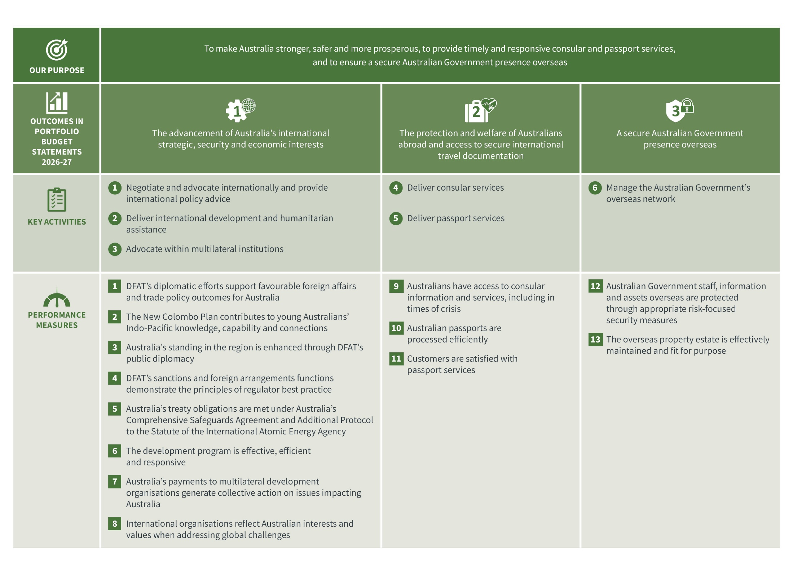
Figure 5: Overview of DFAT’s performance framework

Performance measures for Outcome 1


Outcome 1: The advancement of Australia’s international strategic, security and economic interests, including through bilateral, regional and multilateral engagement on Australian Government foreign, trade and international development policy priorities

Key activity 1: Negotiate and advocate internationally and provide international policy advice
Through diplomacy, advocacy and policy engagement, DFAT advances Australia’s international strategic, security and economic interests. DFAT works to shape an environment that supports peace, stability and prosperity, respects sovereignty, and upholds international rules and norms. Australia’s foreign policy is outlined in Australia in the World: 2025 Snapshot.
DFAT delivers targeted programs to increase Australia’s global engagement, with a focus on the Indo-Pacific. DFAT advances Australia’s interests by fostering enduring connections and creating shared opportunity with our region through diplomacy, trade and investment, people-to-people links, educational exchange, and industry and technical cooperation. DFAT helps strengthen Australia’s Asia capability, including by implementing the New Colombo Plan and strengthening its emphasis on learning the languages of our region.
DFAT provides legal services and regulatory functions to uphold Australia’s international legal obligations and advance Australia’s interests overseas. These functions reinforce Australia’s ability to negotiate, advocate and provide authoritative international policy advice. More information on DFAT’s regulators is at ‘Regulator performance’ on pages 16–17.
DFAT will use 5 measures to assess our performance under the 4 programs related to this key activity in DFAT’s Portfolio Budget Statements (PBS) 2026–27, including 2 measures aligned with the principles of regulator
best practice.

Performance measure 1: DFAT’s diplomatic efforts support favourable foreign affairs and trade policy outcomes
for Australia
Our role Engage in negotiation and advocacy
PBS program 1.1 Foreign affairs and trade operations
Measure type Qualitative; effectiveness
Targets for 2026–27
Three case studies demonstrate performance:
- elevating Australia’s partnership with Fiji
- strengthening Australia’s economic ties with Singapore through deeper energy engagement
- supporting Australia’s international leadership in diversifying critical minerals supply chains.
Rationale
DFAT pursues favourable foreign affairs and trade policy outcomes to advance Australia’s international interests and strategic objective. Strategic representation overseas helps the Australian Government advocate its values and deliver on our national interests. Influence is difficult to measure, so DFAT will use evaluative techniques to assess the extent to which diplomatic efforts contributed to intended objectives. Where possible, quantitative data will support the qualitative assessment.
Methodology
DFAT used purposive sampling to identify the 3 case study topics for 2026–27 reporting. This included developing a comprehensive list of potential topics, shortlisting representative topics, and seeking approval from an internal governance committee.
Topics were selected to provide a fair representation of DFAT’s efforts to achieve foreign affairs and trade policy outcomes for Australia. As DFAT’s operations are primarily focused on the Indo-Pacific, most case studies will assess activities focused on Australia’s interests in the region, while also reflecting Australia’s diversification and partnerships agenda.
DFAT will use an evaluative approach to assess how effectively it delivered intended outcomes and responded to changes in the operating environment. Each case study will identify patterns and lessons to support continuous improvement in diplomatic efforts.
Data sources
A range of primary and secondary sources, including internal reporting cables, briefings and speeches. Data sources will be different for each topic.
Changes from previous year
For 2026–27, we will use 3 new case studies to demonstrate performance.

Performance measure 2: The New Colombo Plan contributes to young Australians’ Indo-Pacific knowledge, capability and connections
Our role Manage the New Colombo Plan
PBS program 1.5 New Colombo Plan – transforming regional relationships
Measure type Quantitative; outputs
Targets for 2026–27
Target 1: 400 Australian university undergraduates awarded a New Colombo Plan scholarship to study in the Indo-Pacific region.
Target 2: 40% of the Australian university undergraduates awarded under the New Colombo Plan as a whole have a planned language-learning component(s).
Targets for 2027–30
Target 1: 500 Australian university undergraduates awarded a New Colombo Plan scholarship to study in the Indo-Pacific region.
Target 2: 45% of the Australian university undergraduates awarded under the New Colombo Plan as a whole have a planned language-learning component(s) for scholarships, semester and mobility programs.
Rationale
The New Colombo Plan (NCP) is an Australian Government initiative to strengthen Indo-Pacific capability and Asia literacy by supporting Australian undergraduate study, language learning and work in the region. DFAT delivers the NCP through policy development, program management and oversight, working with stakeholders to support implementation. In 2025, the NCP shifted from a primary focus on increasing participation and expanding program reach to an emphasis on capability development and sustained engagement in the Indo-Pacific region, aligned with Australia’s strategic priorities. This second phase of the NCP prioritises longer and more immersive experiences in the region, expands the scholarship offering, and promotes Asian language learning. The targets reflect these reforms by measuring the scale and depth of participation (through the number of longer-term NCP Scholarships awarded) and the nature of engagement (through language-learning opportunities), providing insight into the program’s contribution to young Australians' Indo-Pacific knowledge, capability and connections.
Methodology
Assessment of the number of Australian university undergraduates awarded under the NCP Scholarship program to study in the Indo-Pacific region.
Assessment of the percentage of the Australian university undergraduates awarded under the NCP who have a planned language learning component(s), through receiving a grant under the NCP Scholarship program or participating in a grant offered to Australian universities under the NCP Semester and Mobility programs.
Data sources
A third-party grants management platform is used by DFAT to administer NCP programs. The system captures application, assessment, award and participant data and provides the source data used to assess performance.
Changes from previous year
Target 1 has increased to align with program reform recommendations to expand to 500 NCP Scholarships per year by 2028.
Target 2 has been revised to assess language outcomes across the NCP, rather than at the individual program level.
Together, these changes align with program objectives of supporting a larger cohort of Australian undergraduates to undertake more immersive Indo-Pacific experiences to build regional capability and Asia literacy.
The program will use SmartyGrants for grants administration and reporting against the performance measure for the 2027 round onwards, in place of Endeavour Online and International Student Exchange Online.
Performance measure 3: Australia’s standing in the region is enhanced through DFAT’s public diplomacy
Our role Project a positive and contemporary image of Australia
PBS program 1.6 Public information services and public diplomacy
Measure type Qualitative; effectiveness
Targets for 2026–27
Case study demonstrates performance: contribute to Australia’s risk-informed cooperation with China, by enhancing engagement, lifting capability and supporting communities through the National Foundation for Australia–China Relations.

Rationale
DFAT’s public diplomacy – through arts, sport, education and other cultural initiatives – is a tool of influence that helps strengthen ties with other countries and raise Australia’s profile as an innovative, contemporary and creative nation. It builds people-to-people links and fosters mutual understanding, helping others understand more about Australia and its values. Public diplomacy contributes to building trust, enhancing Australia’s ability to influence and persuade, and building consensus and resilience domestically, while strengthening Australia’s standing in the region. DFAT projects a positive and contemporary image of Australia and prosecutes national interests through engagement with a wide range of stakeholders, including academia, cultural institutions, think tanks, non-government organisations and media. For the 2026–27 reporting period, DFAT will assess its performance through a case study focusing on the National Foundation for Australia–China Relations.
Methodology
Consistent with performance measure 1, we undertook a purposive sampling approach to identify the case study topic for 2026–27 reporting. We selected the topic with a view to providing a fair representation of DFAT’s efforts in enhancing Australia’s standing in the region through public diplomacy. DFAT will use an evaluative approach to understand how effectively the department delivered on intended outcomes and responded to changes in the operating environment. We will examine the case study to identify patterns and lessons across a range of activities as part of continuous improvement in our diplomatic efforts.
Data sources
A range of primary and secondary sources, including internal reporting cables, briefings and speeches.
Changes from previous year
For 2026–27, we will use a new case study to demonstrate performance.

Performance measure 4: DFAT’s sanctions and foreign arrangements functions demonstrate the principles of regulator best practice
Our role DFAT’s regulatory functions contribute to Australia’s foreign policy objectives by administering, promoting and enforcing compliance with Australia’s sanctions laws and ensuring that foreign arrangements entered into by sub-national entities are consistent with Australia’s national interests.
PBS program 1.1 Foreign affairs and trade operations
Measure type Quantitative; efficiency; effectiveness
Targets for 2026–27 to 2029–30
Target 1: At least 85% of sanctions compliance matters are finalised within 12 months of commencement of assessment.
Target 2: At least 85% of arrangements notified to the Foreign Arrangements Scheme are assessed as in scope.
Rationale
This measure seeks to demonstrate DFAT’s sanctions and foreign arrangements performance in relation to the principles of regulator best practice outlined in the Department of Finance guidance on regulator performance.
Sanctions compliance matters
The Australian Sanctions Office (ASO), within DFAT, is responsible for efficient and effective administration of Australia's sanctions laws and promoting and enforcing compliance across the regulated community. To support these objectives, the ASO maintains sanctions frameworks and the Consolidated List, provides guidance and education to regulated entities, engages with stakeholders, assesses permit applications, and responds to potential instances of non-compliance.
These activities are undertaken in accordance with regulator best-practice principles. Through stakeholder engagement, consultation and education, the ASO promotes collaboration, transparency and trust. In responding
to potential non-compliance, the ASO applies intelligence-informed, risk-based decision making, integrating appropriate compliance strategies to determine proportionate regulatory responses. As a relatively new regulator, the ASO also maintains a strong focus on continuous improvement to strengthen its processes, governance
and capability.
This target measures timeliness. Timeliness is used as a proxy for efficient regulatory administration and may contribute to regulatory effectiveness by supporting prompt action to address regulatory risks. The timely resolution of compliance matters supports regulatory best practice by demonstrating the ASO's ability to
efficiently assess and resolve matters, apply risk-based regulatory responses, and provide certainty to the
regulated community.
Effective sanctions frameworks contribute to Australia's foreign policy objectives by seeking to respond to situations of international concern and imposing costs on those responsible. Effective administration of sanctions frameworks also helps reduce unnecessary regulatory burden without compromising robust risk mitigation or strategically relevant sanctions development.
Foreign Arrangements Scheme
DFAT administers the Foreign Arrangements Scheme (Scheme), which ensures that arrangements entered into by state and territory governments, local governments and Australian public universities with foreign entities are consistent with Australia’s foreign policy and national interest. The Scheme promotes transparency of foreign engagements and supports a nationally aligned approach to international engagement in an increasingly complex strategic environment.
DFAT supports these objectives through a proportionate, risk-based approach that assesses notified arrangements against legislative requirements, and foreign policy considerations. The Department also provides guidance, education and targeted outreach to support understanding of notification obligations, promote compliance and improve the quality of foreign engagement.
The proportion of arrangements notified to the Scheme assessed as in-scope provides an indicator of regulatory effectiveness by reflecting stakeholder understanding of and compliance with the Scheme. These insights inform guidance materials, stakeholder engagement activities and regulatory priorities. The target will help gauge whether the regulated community has understood legislative changes introduced in response to the Independent Review of the Scheme.
DFAT’s regulatory approach is supported by complementary reporting, including the Foreign Arrangements Scheme Annual Report.
Methodology
Assessment of the proportion of closed sanctions compliance matters finalised within 12 months of triage decision. Assessment of the number of foreign arrangements notified in compliance with legislative requirements.
Data sources
Sanctions Compliance Action Report. Notification of arrangements received through the Foreign Arrangements Scheme online portal. The Australian Sanctions Office’s annual report will be published on DFAT’s website. The Foreign Arrangements Scheme’s annual report is published on the Foreign Arrangements Scheme website.
Changes from previous year
Target 1 was revised for 2026–27 to provide more meaningful performance information by measuring regulatory responsiveness, timeliness as a proxy for efficient regulatory administration, and compliance outcomes, aligning with the Minister’s Statement of Expectations.
Target 2 language has been amended to clarify the scope of assessment.

Performance measure 5: Australia’s treaty obligations are met under Australia’s Comprehensive Safeguards Agreement and Additional Protocol to the satisfaction of the International Atomic Energy Agency
Our role Implement Australia’s international nuclear non-proliferation obligations
PBS program 1.8 Nuclear-powered submarine program
Measure type Qualitative; effectiveness
Target for 2026–27 to 2029–30
The International Atomic Energy Agency (IAEA) grants a ‘broader conclusion’ for Australia, confirming Australia’s compliance with its Comprehensive Safeguards Agreement and Additional Protocol treaty obligations.
Rationale
The Australian Safeguards and Non-Proliferation Office (ASNO) is a specialist office within DFAT. ASNO supports Australia’s foreign policy, national security and regulatory objectives by implementing Australia’s nuclear safeguards, nuclear security and chemical weapons non-proliferation obligations.
Under the Nuclear Non-Proliferation (Safeguards) Act 1987 (Safeguards Act) ASNO is the national authority for ensuring Australia’s compliance with its obligations to the International Atomic Energy Agency (IAEA) under the Nuclear Non-Proliferation Treaty, Comprehensive Safeguards Agreement and Additional Protocol. ASNO maintains an independent domestic regulatory system, supported by reporting, verification and international engagement.
The AUKUS nuclear-powered submarine program is subject to nuclear safeguards and nuclear security regulation by ASNO under the Safeguards Act. Maintaining a robust, credible and effective regulatory framework supports Australia’s continued cooperation under the AUKUS Naval Nuclear Propulsion Agreement.
The measure is based on the IAEA reaching the broader conclusion for Australia. The broader conclusion is the highest-level safeguards conclusion for a state with both a Comprehensive Safeguards Agreement and an Additional Protocol in force. For Australia, it provides independent assurance that declared nuclear material remains in peaceful use, that there are no indications of undeclared nuclear material or activities, and that Australia is complying with its safeguards obligations. As a non-nuclear weapon state, this measure is an important indicator of Australia’s commitment to, and compliance with, international safeguards and non-proliferation obligations. Australia has received the IAEA’s assessment of the broader conclusion every year since 2000, longer than any other country.
The measure is informed by regulator best-practice principles, including ‘continuous improvement and building trust’, being ‘risk-based and data-driven’, and ‘collaboration and engagement’. ASNO ensures that all relevant nuclear material, equipment and nuclear-related activity in Australia is accurately declared, and that none of Australia’s nuclear facilities or associated items can be used to produce or process undeclared nuclear material. Regulation is managed primarily through a series of permits issued to relevant entities under the Safeguards Act. ASNO permit holders are diverse and permits are developed with conditions proportional to the activity being undertaken by a regulated entity. ASNO engages with permit holders to support their reporting and conduct inspections.
ASNO ensures that Australia is meeting its safeguards obligations through the collection of this information, analysis and verification of safeguards data, and ongoing engagement with stakeholders. ASNO uses this information gathered from these activities to report as required to the IAEA. The IAEA reviews this information and undertakes inspections in Australian nuclear facilities and other locations to verify that the information ASNO has provided is both correct and complete. Each year the IAEA assesses the results of this verification activity and if appropriate, recertifies that Australia has achieved the broader conclusion – demonstrating that all nuclear material in Australia remains in its declared uses and activities [not diverted to support nuclear weapons] with no indication of diversion and no evidence of undeclared nuclear materials or activities. Performance against treaty obligations and regulatory responsibilities is reported through ASNO’s annual report.
Methodology
Compliance is independently verified by the IAEA. Compliance with Australia’s obligations on a continuous basis is a prerequisite for achieving the broader conclusion the following year.
Data sources
The IAEA Safeguards Statement and its conclusion. ASNO’s annual reports include the Safeguards Statement and list IAEA inspections that occurred in the reporting period. The Safeguards Statement is issued in June for the prior calendar year.
Changes from previous year
Nil.

Key activity 2: Deliver international development and humanitarian assistance
DFAT leads the design and delivery of Australia’s international development and humanitarian assistance. The development program supports our national interests by working with partners to address the challenges facing our region, including climate change, economic uncertainty, health emergencies, displacement and conflict.
DFAT ensures effective and transparent planning, implementation, monitoring and evaluation takes place across a portfolio of more than 1,000 active investments that make up the development and humanitarian assistance program. Long-term direction for the development program is set by Australia’s International Development Policy. DFAT also addresses humanitarian needs where they are most acute, to save lives, alleviate suffering and build resilience, as guided by Australia’s Humanitarian Policy. In line with Australia’s International Development Performance and Delivery Framework, DFAT publishes details on development and humanitarian program performance and results in the annual Performance of Australian Development Cooperation Report and on the interactive website, AusDevPortal. Details of Official Development Assistance (ODA) expenditure are published annually in Australia’s Official Development Assistance: Statistical Summary.
We will use one measure to assess our performance under the PBS program related to this key activity. This measure draws on longstanding and embedded systems to assess and report on overall efficiency and effectiveness, in line with international standards. The measure captures reporting from Australia’s investments in humanitarian action, including responsiveness to requests for assistance made by country partners.
Performance measure 6: The development program is effective, efficient and responsive
Our role Design and deliver Australia’s international development program
PBS program 1.2 Official development assistance
Measure type Quantitative; effectiveness
Target for 2026–27 to 2029–30
At least 85% of investments are assessed as satisfactory on both effectiveness and efficiency criteria in the investment monitoring reports (IMR) process.
Rationale
The objective of Australia’s development program is to advance a peaceful, stable and prosperous Indo-Pacific region. This depends on supporting sustainable development and lifting people out of poverty. To achieve this objective, the development program must be effective, efficient and responsive to partners’ priorities and needs. Development programs with official development assistance (ODA) budgets of more than $3 million are required to report on performance through annual investment monitoring reports (IMR) (evidence-based assessments that rate investment performance against criteria including effectiveness and efficiency). The 85% target for both effectiveness and efficiency reflects a long-term average of between 85 and 90%. Performance has been reported through the IMR process for over a decade and is core to Australia’s International Development Policy. This measure is reflected in the annual Performance of Australian Development Cooperation Report.
Methodology
Analysis of annual IMR, humanitarian IMR (HIMR), and final IMR (FIMR) ratings is based on data collected once per year through the Investment Performance Reporting cycle.
Ongoing data quality assurance and validation processes mean that initial analysis and aggregate results published in DFAT’s Annual Report may be refined and updated upon release of the annual Performance of Australian Development Cooperation report.
Data sources
IMR, HIMR and FIMR ratings. Development program investment performance data (including IMR, HIMR and FIMR ratings) are published on the online development transparency portal, AusDevPortal.
Changes from previous year
Nil.

Key activity 3: Advocate within multilateral institutions
DFAT advances Australia's interests by helping to sustain an international system based on agreed rules and norms, cooperation and collective action. We work through multilateral institutions – including the United Nations system and its specialised agencies – to influence decisions, rules, norms and standards; promote Australian interests and values; and mobilise collective action on global and regional challenges that no country can address alone.
We work to ensure Australian perspectives – and those of our region – are reflected in multilateral decision-making and to strengthen Australia's influence through a range of targeted activities, such as multilateral candidatures and placements, representation and advocacy, and engagement in international forums.
We work through multilateral development banks (MDBs) and other international organisations to address shared challenges and deliver outcomes that support Australia's interests. Through Australia's financial contributions, policy engagement and partnerships, we help generate collective action and leverage the expertise, reach and resources of international partners to support a more stable, prosperous and resilient Indo-Pacific region.
We will use 2 measures to assess our performance across the 2 Portfolio Budget Statement programs related to this key activity.

Performance measure 7: Australia’s payments to multilateral development organisations generate collective action on issues impacting Australia
Our role Advocate within multilateral development institutions to generate collective action on issues impacting Australia
PBS program 1.3 Official development assistance – multilateral replenishments
Measure type Quantitative; outputs
Target for 2026–27 to 2029–30
Mandatory payments to multilateral development institutions are paid on time.
Rationale
Australia works with multilateral development banks to support regional development priorities and deliver transformative outcomes across the Indo-Pacific. This is achieved through core funding contributions to institutions such as the World Bank Group and the Asian Development Bank, including replenishments to their concessional lending arms, which provide financing to low-income countries.
DFAT negotiates encashment (payment) schedules with the multilateral development banks on Australia's behalf. These schedules are formalised through legally binding instruments of commitment signed by Australia's Minister for Foreign Affairs and promissory notes signed by Australia's Treasurer.
Ensuring payments are made on time, including during periods of domestic budgetary constraint, demonstrates Australia's reliability and ongoing commitment to the multilateral development bank system. This credibility strengthens Australia's ability to influence policy and operational priorities within these institutions.
Timely payments enable multilateral development banks to provide predictable financing for multi-year development programs and projects, consistent with the expectations of Australia and other donors. This measure assesses whether Australia has met its payment commitments on time, providing assurance that funding is available as intended to support the operations and development activities of these institutions.
Methodology
An assessment of mandatory payments made to multilateral development institutions against the agreed schedule. Public and bank holidays may impact transfer or receipt of funds. Encashments are implemented through established administrative arrangements between DFAT, the Treasury, the Reserve Bank of Australia (RBA) and the multilateral development banks.
Data sources
Instruments of Commitment and encashment schedule.
Changes from previous year
Nil.
Performance measure 8: International organisations reflect Australian interests and values when addressing
global challenges
Our role Advocate for Australia’s interests in international organisations
PBS program 1.4 Payments to international organisations
Measure type Quantitative; qualitative; effectiveness
Target for 2026–27 to 2029–30
Two focus areas demonstrate Australia’s influence and engagement in international institutions:
- election of Australian multilateral candidatures
- delivery of the Multilateral Placements Program.
Rationale
Global security, stability and prosperity depend on agreed international rules and norms, underpinned by an effective multilateral system and architecture, including key international organisations. These organisations serve as platforms for dialogue, negotiation and cooperation between countries on global challenges that cannot be effectively tackled by individual countries, or smaller groups of countries alone.
Australia seeks to influence international organisations to secure outcomes that advance our interests. We work within the multilateral system to build a world governed by rules, norms and standards, to enhance security, contribute to stability, and foster prosperity for Australia, the Indo-Pacific region and the world.
Under this performance measure, we will assess 2 focus areas that illustrate the multifaceted approach of how Australian interests and values are reflected in international institutions. The focus areas have substantive and direct links to Australia’s influence in international organisations.
Candidatures
As the whole-of-government coordinator for multilateral candidacies, DFAT supports and advises on Australia’s election to governing bodies of international organisations, and the election of Australians to senior roles within the multilateral system. This strengthens Australia’s capacity to achieve priority outcomes and directly influence decision-making on key issues within the remit of these organisations.
Multilateral Placements Program
Australia’s Multilateral Placements Program (MPP) places Australians in strategic positions in the multilateral system. This includes through the Junior Professional Officer (JPO) Program, a UN initiative that allows early-career professionals from participating countries to gain practical hands-on experience working in international organisations, as well as through more senior placements. Through the MPP, DFAT supports Australian officials to work in UN agencies, building Australia’s influence and capability in the international system.
Methodology
Analysing the outcomes of Australian multilateral candidatures and the delivery of the MPP to understand DFAT’s effectiveness in those focus areas.
Data sources
Internal reporting cables; election outcomes for Australian candidacies; internal administrative circulars; communications with UN agencies on deployments under the MPP.
Changes from previous year
A focus area on High-Level Week has been removed as it was less meaningful to this performance measure. The focus area on the JPO has been amended to consider the broader MPP. Given significant changes in the multilateral system over the past 12 months, new target(s) will be set for the MPP focus area for 2026–27.

Contribution to Outcome 1 made by linked programs
Australia maintains a whole-of-government approach in the pursuit of foreign, trade and investment, tourism, development and international security interests abroad. DFAT is supported by partner agencies in its associated leadership, advocacy and coordination roles at overseas missions. Key partner agencies for DFAT in the delivery of Outcome 1 are the Attorney-General’s Department, the Australian Centre for International Agricultural Research, the Australian Federal Police, the Australian Submarine Agency, the Australian Trade and Investment Commission, the Department of Climate Change, Energy, the Environment and Water, the Department of Defence, the Department of Education, the Department of Employment and Workplace Relations, the Department of Home Affairs and Tourism Australia.

Performance measures for Outcome 2


Outcome 2: The protection and welfare of Australians abroad and access to secure international travel documentation through timely and responsive travel advice and consular and passport services in Australia and overseas

Key activity 4: Deliver consular services
DFAT delivers a range of consular services for Australian citizens travelling or living overseas, with care and compassion, in line with our Consular Services Charter. Each consular case is unique and the assistance DFAT provides depends on the circumstances and our ability to assist. DFAT strives to empower Australians to increase their preparedness and self-reliance when travelling overseas, allowing DFAT to deliver a consular service focused on Australians most in need. We provide consular services to Australian citizens and, in certain locations, Canadian citizens as part of the Canada–Australia Consular Services Sharing Agreement.
It is also our role to effectively prepare for and manage overseas crises. In an international crisis, DFAT provides support to Australian citizens and permanent residents.
We will use one measure to assess our performance under the PBS program related to this key activity.
Performance measure 9: Australians have access to consular information and services, including in times of crisis
Our role Provide consular services to Australian travellers and Australians overseas
PBS program 2.1 Consular services
Measure type Quantitative; outputs
Targets for 2026–27 to 2029–30
Target 1: 100% of destination-specific travel advisories reviewed biannually for destinations in a volatile risk environment and/or where there are elevated Australian interests. 100% of destination-specific travel advisories reviewed annually for all other destinations.
Target 2: 100% of posts certify annually that crisis and contingency planning is in place for all locations of accreditation.
Rationale
This measure assesses Australians’ access to consular information and services through timely travel advice and DFAT’s preparedness to provide consular assistance during overseas crises. Current travel advisories help Australians make informed decisions. Crisis and contingency planning strengthens DFAT’s ability to respond and provide assistance during emergencies.
Travel advisory reviews
DFAT maintains 179 destination-specific travel advisories. Each advisory has specific information about safety, health, local laws, travel and local contacts. These advisories, published on the Smartraveller website, are a primary source of up-to-date information to help Australians travel safely overseas. They help Australians to avoid difficulties overseas and to make informed decisions while travelling, including during a crisis.
DFAT regularly reviews all destination-specific travel advisories to assess risks to Australians overseas. All advisories are reviewed either annually or biannually, based on the safety and security, health, local laws and travel risks of the destination, as well as the level of Australian interest in the destination. Additional updates are published throughout the year as risks change to ensure travel advice remains current and accurate.
The advisories are supplemented by thematic pages and social media updates, which do not form part of the performance measure but provide valuable information to keep Australians informed while travelling overseas.
Crisis and contingency planning
Under the Australian Government Crisis Management Framework, DFAT leads the response to overseas crises that may affect Australians or Australian interests. To support this role, all overseas posts must maintain current Crisis Action Plans (CAPs), which set out how they prepare for and respond to incidents and crises across their countries of accreditation.
Each year, heads of mission or heads of post must certify that crisis and contingency planning arrangements are in place for all locations of accreditation and have been tested through exercises or real-world CAP activation. Testing may include scenario exercises, simulations and activation drills that assess crisis response arrangements, staff roles, communications and coordination. Regular testing improves CAPs and strengthens preparedness across
the organisation.
The annual certification process is supported by internal assurance checks to verify compliance with CAP requirements.
Together, these activities provide confidence that posts are prepared to respond effectively during overseas crises, helping DFAT deliver timely consular assistance and support to Australians when it is needed most.
Methodology
Travel advisory updates are informed by credible information from Australian diplomatic missions overseas, threat assessments from the National Threat Assessment Centre, intelligence reporting, information from our consular partners, other Australian Government agencies, media and open-source reporting, and feedback from travellers. Performance is assessed by comparing completed travel advisory reviews against the schedule.
CAP certification is measured by calculating the percentage of certified CAPs relative to the total number of required CAPs across Australia’s overseas network. This includes all CAP types: full, compact and exempt.
Data sources
Travel advisory reviews and records of CAP certifications.
Changes from previous year
Target 1 was amended to clarify the scope of assessment.
Target 2 was revised to better focus the measure on DFAT’s readiness to provide consular services to clients overseas. Measuring that CAPs are in place and updated for all locations of accreditation will provide a more accurate measure of the ability of DFAT to assist Australians in case of a crisis overseas.

Key activity 5: Deliver passport services
DFAT provides secure international travel documents through efficient and responsive passport services in Australia and overseas. These services enable Australian citizens to travel, work, study and connect globally with confidence, supported by a secure and internationally recognised passport that protects their identity.
DFAT delivers these services under the Australian Passports Act 2005, related laws, and the Convention on International Civil Aviation. This ensures Australian passports meet global standards for security, integrity and usability. The latest R-series passport includes advanced security features to protect personal identity, prevent fraud, and uphold Australia’s reputation for secure travel documents.
Australians can access passport services across Australia and at Australian missions overseas. DFAT also issues other travel documents, such as convention travel documents, to eligible non-citizens living in Australia. DFAT aims to make these services accessible, inclusive and responsive.
Customer experience is central to service delivery. DFAT aims to provide clear and consistent information, apply policies fairly, and protect personal information. DFAT monitors service standards and performance to better meet the needs of Australians.
DFAT measures performance by how efficiently applications are processed and how satisfied customers are with the service.
DFAT will use 2 measures to assess performance under the PBS program linked to this activity.

Performance measure 10: Australian passports are processed efficiently
Our role Provide passport services in Australia and overseas
PBS program 2.2 Passport services
Measure type Quantitative; efficiency
Targets for 2026–27 to 2029–30
Target 1: 95% of travel documents are available within 6 weeks of lodgement.
Target 2: 98% of priority passports are processed within 2 business days.
Target 3: 98% of fast-track passports are processed within 5 business days.
Target 4: Travel document processing efficiency is greater than or equal to 90% of the agreed benchmark.
Rationale
The Australian Passport Office (APO) delivers passport services to Australians in Australia and overseas. Efficient passport processing helps ensure Australians can access passport services when needed, reducing potential travel disruption and providing confidence in the availability and responsiveness of a key government service.
Travel document timeframes
There is no legislated timeframe for processing routine passport applications; however, customers reasonably expect a timely service. APO advises customers to allow a minimum of 6 weeks to receive a passport. The target calculates the time from application lodgement to the delivery or customer notification that the passport is available for collection. The 95% target recognises that a small number of applications may exceed stated timeframes due to case complexity, seeking additional information from customers, or high-demand periods.
Priority passports and fast-track passports
Passport applicants may choose between a routine or accelerated service. Priority service attracts an additional fee to support processing applications within 2 business days, while the fast-track service, introduced on 1 July 2024, attracts an additional fee to support processing applications within 5 business days. These timeframes are set out in the Australian Passports (Application Fees) Determination 2015. If the applicable processing timeframes are not met, a refund may be requested. The 98% target recognises that a small number of applications may exceed stated timeframes for reasons such as case complexity, system outages or high demand periods.
Travel document processing efficiency
The Australian National Audit Office report on the efficiency of APO confirmed the importance of an efficient passport processing service for Australian citizens. This target captures how many passports staff process each business day. Passport demand changes across the year and depends on when people renew their passports. During the pandemic, many Australians delayed renewal, creating peaks and troughs in demand every 5 and 10 years. DFAT is resourced to manage these fluctuations. When application volumes are low, there may be less work for staff, but this is generally short-lived and followed by an increase.
APO uses demand modelling to forecast passport applications. The forecast supports budget, workload and workforce planning. A 10% margin of error is built into demand management. The 90% target aligns with this tolerance and allows short periods of low application volumes to still be considered efficient.
Methodology
An analysis of passport lodgement and processing data, Australia Post delivery data and human resources system data.
Data sources
IT platforms data on finalised passport applications.
Changes from previous year
Target 1 was updated to improve clarity regarding the scope being measured.
Performance measure 11: Customers are satisfied with passport services
Our role Provide passport services in Australia and overseas
PBS program 2.2 Passport services
Measure type Quantitative; effectiveness
Target for 2026–27 to 2029–30
85% satisfaction rate overall from customer surveys.
Rationale
The Australian Passport Office (APO) conducts regular, independent customer satisfaction surveys to assess customers’ overall experience with Australian passport services. The surveys measure satisfaction across service channels and track results over time. This helps DFAT understand whether services are effective, secure, responsive and meeting community expectations and the APO service commitment.
Survey responses provide direct feedback on the quality, accessibility and effectiveness of passport services. Results support evidence-based decisions by identifying strengths and areas for improvement in service delivery, customer communications and service design. Tracking satisfaction over time helps DFAT assess service improvements and supports continuous improvement. The 85% target reflects DFAT’s expectation to deliver consistently high-quality passport services.
Methodology
An independent third-party provider conducts a monthly customer satisfaction survey. Customers are randomly selected, and the survey sample reflects location and application type. Survey design aligns with better practice market survey methods. The survey does not capture withdrawn or refused applications.
Data sources
Responses to the monthly customer satisfaction survey.
Changes from previous year
Nil.
Contribution to Outcome 2 made by linked programs
The Australian Federal Police and the Australian Trade and Investment Commission support DFAT in the delivery of high-quality consular services, including the provision of Australian passport information services and the repatriation of vulnerable Australians. Australia Post provides a nationwide shopfront on behalf of the Australian Passport Office.

Performance measures for Outcome 3


Outcome 3: A secure Australian Government presence overseas through the provision of security services and information and communications technology infrastructure, and the management of the
Commonwealth’s overseas property estate

Key activity 6: Manage the Australian Government’s overseas network
DFAT is the responsible agency for managing consistent and efficient use of government resources for all represented Australian Government agencies overseas. DFAT secures Australia’s overseas network of embassies, high commissions, consulates, representative offices and multilateral missions. This includes providing security services and information and communications technology (ICT) infrastructure, as well as managing the Commonwealth’s owned overseas property estate through DFAT’s Overseas Property Office and its contracted service provider.
These services support all Australian Government agencies represented overseas by providing secure environments, reliable technology and fit-for-purpose facilities—ensuring Australia’s diplomatic, consular and trade activities can operate effectively in diverse and often high-risk environments.
Australia’s overseas network is supported through a coordinated and intelligence-informed approach to security, protecting people, information and assets and safeguarding against a range of evolving threats.
Ongoing investment in security capabilities strengthens physical security at posts, enhances training for personnel, expands specialist capability and improves the ability to respond to changing risk environments. This helps ensure Australian officials can operate safely and effectively overseas.
Secure, resilient and modern ICT services underpin Australia’s international engagement. ICT infrastructure, connectivity and digital platforms enable reliable and interoperable systems across DFAT and whole-of-government operations at post. Ongoing uplift in cyber security, network resilience and digital capability supports service delivery in complex overseas environments, safeguarding information and supporting effective international engagement.
The Australian Government’s overseas property estate is managed to support the effective operation of the network and represent Australia’s interests internationally. Cost-effective management of owned and leased properties ensures facilities are fit-for-purpose and aligned with operational needs. Well-maintained properties provide safe and secure environments for personnel and their families, support efficient service delivery, and contribute to Australia’s presence and reputation overseas. Carefully managed properties are critical to the success of overseas missions, help project a positive image of Australia to host governments and partners, and support the delivery of Australia’s international objectives.
Two measures will be used to assess performance over the 2 budget programs related to this key activity.

Performance measure 12: Australian Government staff, information and assets overseas are protected through appropriate risk-focused security measures
Our role Provide protective security measures and ICT infrastructure for the overseas network
PBS program 3.1 Foreign affairs and trade security and IT
Measure type Qualitative and quantitative; effectiveness
Targets for 2026–27 to 2029–30
Target 1: DFAT achieves the set security performance standards across a majority of its posts in the areas of compliance, culture and responsiveness to incidents.
Target 2: DFAT delivers the Overseas Resilience to Cyber Activities program to 80% of posts selected through its annual risk-based planning process.
Rationale
A secure and resilient overseas presence enables the Australian Government to deliver its functions – through DFAT – including advancing Australia’s interests and providing consular and passport services. This measure assesses the effectiveness of the department’s security and the delivery of the Overseas Resilience to Cyber Activities (ORCA) program to posts selected through an annual risk‑based planning process.
Methodology
Ongoing assessments of compliance, culture and responsiveness to incidents for each of DFAT’s overseas posts. Assessment of the number of completed Overseas Resilience to Cyber Activities for planned posts during the year.
Data sources
Data collected for each post on compliance with security, culture and responsiveness to incidents. Completion reports of the Overseas Resilience to Cyber Activities program.
Changes from previous year
Nil.
Performance measure 13: The overseas property estate is effectively maintained and fit for purpose
Our role Manage the overseas estate
PBS program 3.2 Overseas property
Measure type Quantitative; outputs
Targets for 2026–27 to 2029–30
Target 1: At least 80% satisfaction rating with the performance of the outsourced property service provider and the Overseas Property Office (OPO).
Target 2: Annual reinvestment in the DFAT portfolio of a minimum of 2% of the building asset value.
Target 3: At least 90% of the owned property estate planned and preventative maintenance program is completed as per the agreed schedule.
Rationale
An effective and fit-for-purpose overseas property estate enables the Australian Government to safely, securely and effectively deliver diplomatic operations overseas.
Client satisfaction with property services
The department measures client satisfaction with the Overseas Property Office (OPO) and its outsourced service provider through an annual survey administered by a third-party provider to all overseas posts. Satisfaction ratings provide insight into whether property management and maintenance services meet business needs and provide assurance that OPO and its contracted service provider are effectively maintaining the overseas estate. The 80% satisfaction target is based on historical survey results.
Annual reinvestment
Maintaining an appropriate level of reinvestment in the overseas property portfolio ensures DFAT sustains the capability and condition of its property infrastructure over time. The 2% target aligns with the annual depreciation rate of building assets with an expected life of 50 years.
Planned and preventative maintenance program
Completion of the planned and preventative maintenance program supports the ongoing functionality and capability of the overseas estate. Delivering scheduled maintenance helps ensure buildings operate efficiently, extend asset life, and prevent degradation and failure. The 90% target recognises that, while full completion is the objective, a small proportion of activities may not be delivered each year.
Methodology
An annual client satisfaction survey conducted by an independent third-party service provider, an annual independent valuation program of real property assets and the annual completion rate of the planned and preventative maintenance program. Post locations are excluded from the survey where regional operational challenges inhibit survey participation or constrain access to contractors and the delivery of works.
Data sources
Responses to the annual customer satisfaction survey, external independent property valuation reports, property expenditure data and records of maintenance work orders maintained by the outsourced service provider.
Changes from previous year
Nil.

Appendix A: Changes to performance information
Table A1 sets out the revisions to performance measure targets from the Corporate Plan 2025–26. We have revised targets under performance measures 1–4 and 8–10 for 2026–27 to better reflect the intent and performance of the program of work and strengthen alignment with the PGPA Rule.
Table A1: Summary of changes to performance measures in 2026–27
Portfolio Budget Statements 2026–27 Outcome 1: program 1.1, key activity 1 (pages 34–35).
Measure 1: DFAT’s diplomatic efforts support favourable foreign affairs and trade policy outcomes for Australia.
Relevant performance information from DFAT  Corporate Plan 2025–26 | Performance information  revisions in DFAT  Corporate Plan 2026–27 | Rationale for change
Target: Three case studies demonstrate performance:  - implementing the Nauru–Australia Treaty  - increasing Australia’s trade and investment ties with Indonesia through Australia’s Business Champion for Indonesia  - enhancing Australia’s cooperation with India through implementation of the New Roadmap for Australia’s Economic Engagement with India. | Target: Three case studies demonstrate performance:  - elevating Australia’s partnership with Fiji  - strengthening Australia’s economic ties with Singapore through deeper energy engagement  - supporting Australia’s international leadership in diversifying critical minerals supply chains. | New case studies identified for the reporting period.

Portfolio Budget Statements 2026–27 Outcome 1: program 1.5, key activity 1 (pages 40–41).
Measure 2: The New Colombo Plan contributes to young Australians’ Indo-Pacific knowledge, capability
and connections.
Relevant performance information from DFAT  Corporate Plan 2025–26 | Performance information  revisions in DFAT  Corporate Plan 2026–27 | Rationale for change
Target 1: 300 Australian university undergraduates awarded a New Colombo Plan scholarship to study in the Indo-Pacific region. | Target 1: 400 Australian university undergraduates awarded a New Colombo Plan scholarship to study in the Indo-Pacific region. | Target 1 increased from 300 to 400 university undergraduates in 2026–27, with the target further increasing to 500 across the forward estimates as published in the PBS  2026–27, in line with program reforms.
Target 2: 15% of the Australian university undergraduates awarded under the New Colombo Plan have a planned language-learning component(s) for scholarships, semester and mobility streams. | Target 2: 40% of the Australian university undergraduates awarded under the New Colombo Plan as a whole have a planned language-learning component(s). | Target 2 increased from 15% in 2025–26, to 20% in 2026–27 as published in the PBS  2026–27.  Following PBS publication, the methodology was revised from program-specific to a whole-of-NCP assessment approach, resulting in a new baseline of 40% for 2026–27.  The revised methodology also applies across the forward estimates, with the target set at 45%.

Portfolio Budget Statements 2026–27 Outcome 1: program 1.6, key activity 1 (page 42).
Measure 3: Australia’s standing in the region is enhanced through DFAT’s public diplomacy.
Relevant performance information from DFAT  Corporate Plan 2025–26 | Performance information  revisions in DFAT  Corporate Plan 2026–27 | Rationale for change
Target: Case study demonstrates performance: Growing Australia’s sports partnerships with Papua New Guinea. | Target: Case study demonstrates performance: Contribute to a stable and constructive Australia–China relationship, by enhancing engagement, lifting capability and supporting communities through the National Foundation for Australia–China Relations. | New case study identified for the reporting period.

Portfolio Budget Statements 2026–27 Outcome 1: program 1.1, key activity 1 (page 35).
Measure 4: DFAT’s sanctions and foreign arrangements functions demonstrate the principles of regulator
best practice.
Relevant performance information from DFAT  Corporate Plan 2025–26 | Performance information  revisions in DFAT  Corporate Plan 2026–27 | Rationale for change
Target 1: 100% of sanctions compliance matters finalised in the reporting period applied a graduated risk-based approach. | Target 1: At least 85% of sanctions compliance matters are finalised within 12 months of commencement of assessment. | Target 1 is new and provides more meaningful performance information on the Australian Sanctions Office's regulatory functions and better aligns with the Statement of Expectations.
Target 2: At least 85% of notifications to the Foreign Arrangements Scheme are in scope. | Target 2: At least 85% of arrangements notified to the Foreign Arrangements Scheme are in scope. | The language was amended to clarify the scope of assessment.

Portfolio Budget Statements 2026–27 Outcome 1: program 1.4, key activity 3 (pages 38–39).
Measure 8: International organisations reflect Australian interests and values when addressing global challenges.
Relevant performance information from DFAT  Corporate Plan 2025–26 | Performance information  revisions in DFAT  Corporate Plan 2026–27 | Rationale for change
Target: Three focus areas demonstrate Australia’s influence and engagement in international institutions:  - delivery of planned strategic objectives for the United Nations General Assembly (UNGA) High-Level Week  - election of Australian multilateral candidatures  - delivery of the UN Junior Professional Officer (JPO) Program. | Target: Two focus areas demonstrate Australia’s influence and engagement in international institutions:  - election of Australian multilateral candidatures  - delivery of the Multilateral Placements Program. | The PBS 2026–27 indicated that the targets for this performance measure were under review. Following the review, revised targets were established and incorporated in the Corporate Plan 2026–27.  The High-Level Week focus area has been removed as it was considered less meaningful to this measure.  The JPO Program focus area was amended to consider the broader Multilateral Placements Program.

Portfolio Budget Statements 2026–27 Outcome 2: program 2.1, key activity 4 (pages 48–49).
Measure 9: Australians have access to consular information and services, including in times of crisis.
Relevant performance information from DFAT  Corporate Plan 2025–26 | Performance information  revisions in DFAT  Corporate Plan 2026–27 | Rationale for change
Target 1: 100% of travel advisories reviewed biannually for posts in a volatile risk environment and where there are elevated Australian interests. 100% of travel advisories reviewed annually for all other posts. | Target 1: 100% of destination-specific travel advisories reviewed biannually for destinations in a volatile risk environment and/or where there are elevated Australian interests. 100% of destination-specific travel advisories reviewed annually for all other destinations. | The PBS 2026–27 revised the target wording to clarify that the assessment applies to destination-specific travel advisories. Following publication of the PBS, the target was further refined to expand the scope of assessment to all destinations, rather than only those associated with posts. This change has been incorporated into the Corporate Plan  2026–27.
Target 2: A maximum of 2 unplanned Consular Emergency Centre telephony outages greater than 5 minutes per financial year. | Target 2: 100% of posts certify annually that crisis and contingency planning is in place for all locations of accreditation. | The 2026–27 PBS introduced a new target to provide more meaningful insight into the department’s crisis preparedness and delivery of consular services.

Portfolio Budget Statements 2026–27 Outcome 2: program 2.2, key activity 4 (pages 50–51).
Measure 10: Australian passports are processed efficiently.
Relevant performance information from DFAT  Corporate Plan 2025–26 | Performance information  revisions in DFAT  Corporate Plan 2026–27 | Rationale for change
Target 1: 95% of passports processed are available within 6 weeks of lodgement. | Target 1: 95% of travel documents are available within 6 weeks of lodgement | The language was amended to improve the clarity of scope being measured.  This change was reflected in the PBS 2026–27.

Appendix B: List of requirements
Subsection 16E(2) of the PGPA Rule sets out the matters that must be included in a Commonwealth entity’s corporate plan. Table B1 indicates page numbers in the DFAT Corporate Plan 2026–27 for each required topic.
In addition, the Department of Finance’s Resource Management Guide 132, Corporate plans for Commonwealth entities, requires the inclusion of regulator performance information in an entity’s corporate plan. Our regulator performance information appears on pages 16–17.
Table B1: List of required topics in DFAT Corporate Plan 2026–27
PGPA Rule reference | Required element | Legislative requirement | Page number
16E(2),  item 1 of the PGPA Rule | Introduction | The following:  - a statement that the plan is prepared for paragraph 35(1)(b) of the Act  - the reporting period for which the plan is prepared  - the reporting periods covered by the plan. | 1
16E(2),  item 2 of the PGPA Rule | Purposes | The purposes of the entity. | 3
16E(2),  item 3 of the PGPA Rule | Key activities | For the entire period covered by the plan, the key activities that the entity will undertake in order to achieve its purposes. | 18, 19, 20, 28, 30, 34, 36, 39
16E(2), item 4 of the PGPA Rule | Operating context | For the entire period covered by the plan, the following: | 4–15
16E(2),  item 4(a) of the PGPA Rule | Environment | - the environment in which the entity will operate | 4–5
16E(2),  item 4(b) of the PGPA Rule | Capability | - the strategies and plans the entity will implement to have the capability it needs to undertake its key activities and achieve its purposes | 6–9
16E(2),  item 4(c) of the PGPA Rule | Risk | - a summary of the risk oversight and management systems of the entity, and the key risks that the entity will manage and how those risks will be managed | 10–11
16E(2),  item 4(d) | Cooperation | - details of any organisation or body that will make a significant contribution towards achieving the entity’s purposes through cooperation with the entity, including how that cooperation will help achieve those purposes | 13–15
16E(2),  item 4(e) of the PGPA Rule | Subsidiaries | - how any subsidiary of the entity will contribute to achieving the entity’s purposes. | DFAT has no subsidiaries
16E(2),  item 5 of the PGPA Rule | Performance | For each reporting period covered by the plan, details of how the entity’s performance in achieving the entity’s purposes will be measured and assessed through:  - specified performance measures for the entity that meet the requirements of section 16EA  - specified targets for each of those performance measures for which it is reasonably practicable to set a target. | 18–41

Appendix C: Alternative text image descriptions
Below is the detailed alternative text description for images within this document.
Image: Our locations in Australia and overseas (page 2)
Alternative text descriptions: DFAT posts: Abu Dhabi, Abuja, Accra, Addis Ababa, Alofi, Amman, Ankara, Apia, Athens, Baghdad, Bali, Bandar Seri Begawan, Bangkok, Beijing, Beirut, Belgrade, Bengaluru, Berlin, Bern, Bogotá, Brasilia, Brussels, Buenos Aires, Cairo, Çanakkale, Chengdu, Chennai, Chicago, Colombo, Copenhagen, Dhaka, Dili, Doha, Dublin, Funafuti, Geneva, Guangzhou, Hanoi, Harare, Ho Chi Minh City, Holy See, Hong Kong, Honiara, Honolulu, Islamabad, Istanbul, Jakarta, Kathmandu, Kolkata, Koror, Kuala Lumpur, Kuwait City, Kyiv, Lae, Lima, Lisbon, London, Los Angeles, Madrid, Majuro, Makassar, Malé, Malta, Manila, Mexico City, Moscow, Mumbai, Nairobi, Naoero, New Delhi, New York, Nicosia, Noumea, Nuku‘alofa, Ottawa, Papeete, Paris, Phnom Penh, Phuket, Pohnpei, Port Louis, Port Moresby, Port of Spain, Port Vila, Pretoria, Rabat, Ramallah (operations remain suspended), Rarotonga, Riyadh, Rome, Santiago, Seoul, Shanghai, Singapore, Stockholm, Surabaya, Suva, Taipei, Tarawa, Tehran (operations remain suspended), Tel Aviv, The Hague, Tokyo, Ulaanbaatar, Vienna, Vientiane, Warsaw, Washington, Wellington, Yangon, Zagreb.
State and territory offices: Adelaide, Brisbane, Canberra, Darwin, Hobart, Melbourne, Perth, Sydney.
Torres Strait Treaty Liaison Office: Thursday Island.
Austrade-managed posts: Auckland, Dubai, Frankfurt, Houston, Milan, Osaka, San Francisco, São Paulo, Toronto.
Image: Corporate plan snapshot (page 3)
Alternative text description: Our purpose: To make Australia stronger, safer and more prosperous, to provide timely and responsive consular and passport services, and to ensure a secure Australian Government presence overseas.
APS Values: Impartial, Committed to service, Accountable, Respectful, Ethical, Stewardship
2026–27 Portfolio Budget Statements Outcomes: The advancement of Australia’s international strategic, security and economic interests. The protection and welfare of Australians abroad and access to secure international travel documentation. A secure Australian Government presence overseas.
Key activities: Negotiate and advocate internationally and provide international policy advice. Deliver international development and humanitarian assistance. Advocate within multilateral institutions. Deliver consular services. Deliver passport services. Manage the Australian Government’s overseas network.
Capabilities: People, Infrastructure, Technology, Overseas network
Risk categories: Delivery, People capabilities and capacity, Enabling services, Staff health, safety and wellbeing, Financial management, Trust
Performance: Measuring and reporting on DFAT’s performance to demonstrate how we achieve our purpose and strategic objectives.
Image: Figure 1: People Strategy 2025–2028 pillars (page 6)
Alternative text description: We attract and retain a diverse and highly skilled workforce. Attracting and retaining talent. We attract and retain the right people with the right skills at the right time, to ensure our workforce can respond to changing priorities. A diverse and inclusive workforce. Our workforce reflects modern Australia at all levels, leading to a diversity of experience and thought and more innovative outcomes. We prioritise safe and respectful environments where our people feel valued and empowered. Developing our people. Our global workforce is equipped with the tradecraft and technical expertise required to perform their role.
We lead with influence and integrity. Influential leadership. Our leaders drive the achievement of outcomes through clearly defined priorities and purpose. A pro-integrity culture. Our people exemplify integrity by upholding and rewarding high standards of ethical behaviour.
Our people policies, practices and workplaces enable our people to deliver results. Enabling and equitable people policies and practices. Our people policies and practices including remuneration settings, support the rapid mobilisation of our global workforce to meet operational priorities both in Australia and overseas. Health, safety and wellbeing across our global network. All our offices and facilities are safe and accessible. We promote mentally healthy workplaces by actively managing psychosocial risks. Modern ways of working. We use accessible, easy-to-use and modern technology, make data-driven workforce decisions and have responsive workforce models to adapt to changing priorities.
Image: Figure 3: Governance committee structure as at 1 July 2026 (page 12)
Alternative text description: Diagram flow chart showing DFAT's governance structure. The Tier 1 level at the top of the diagram shows the Secretary connected to the Audit and Risk Committee off to the right. Next level down under the Secretary is the Executive Board.
Under the Executive Board, all on the same Tier 2 level, Delivery and Operations Committee, Development Program Committee, People and Culture Committee and Strategic Policy Committee. The Delivery and Operations Committee is connected to the Data and AI Steering Committee at the Tier 3 level. The Development Program Committee is connected to the International Development Finance Advisory Committee at the Tier 3 level. The Strategic Policy Committee is connected to the Strategic Policy Working Group and the First Nations Policy Committee, both at the Tier 3 level.
Image: Figure 5: Overview of DFAT’s performance framework (page 19)
Alternative text description: Our purpose: to make Australia stronger, safer and more prosperous, to provide timely and responsive consular and passport services, and to ensure a secure Australian Government presence overseas.
Outcomes in Portfolio Budget Statements 2026–27. The advancement of Australia’s international strategic, security and economic interests. The protection and welfare of Australians abroad and access to secure international travel documentation. A secure Australian Government presence overseas.
Key activities. Negotiate and advocate internationally and provide international policy advice. Deliver international development and humanitarian assistance. Advocate within multilateral institutions. Deliver consular services. Deliver passport services. Manage the Australian Government’s overseas network.
Performance measures. DFAT’s diplomatic efforts support favourable foreign affairs and trade policy outcomes for Australia. The New Colombo Plan contributes to young Australians’ Indo-Pacific knowledge, capability and connections. Australia’s standing in the region is enhanced through DFAT’s public diplomacy. DFAT’s sanctions and foreign arrangements functions demonstrate the principles of regulator best practice. Australia’s treaty obligations are met under Australia’s Comprehensive Safeguards Agreement and Additional Protocol to the Statute of the International Atomic Energy Agency. The development program is effective, efficient and responsive. Australia’s payments to multilateral development organisations generate collective action on issues impacting Australia. International organisations reflect Australian interests and values when addressing global challenges.
Australians have access to consular information and services, including in times of crisis. Australian passports are processed efficiently. Customers are satisfied with passport services.
Australian Government staff, information and assets overseas are protected through appropriate risk-focused security measures. The overseas property estate is effectively maintained and fit for purpose.

DFAT, DFAT’s People Strategy 2025–2028, n.d., DFAT website, accessed 10 August 2026.
APSC, Secretaries’ Charter of Leadership Behaviours, n.d., APSC website, accessed 10 August 2026.
DFAT, DFAT APS Employee Census Action Plan 2025–2028, n.d., DFAT website, accessed 10 August 2026.
DFAT, Inclusion, Equity and Diversity Strategy 2024–2027, n.d., DFAT website, accessed 10 August 2026.
APSC, APS Values, Code of Conduct and Employment Principles, n.d., APSC website, accessed 10 August 2026.
DFAT, First Nations International Engagement Strategy, n.d., DFAT website, accessed 11 August 2026.
DFAT, Resources: Annual reports, Foreign Arrangements Scheme website, n.d., accessed 30 June 2026; and ASNO, Annual reports, ASNO website, n.d., accessed 30 June 2026.
See DFAT, Regulatory functions, DFAT website, n.d., accessed 30 June 2026; and ASNO, Statement of expectations and statement of intent, ASNO website, n.d., accessed 30 June 2026. The Director General of ASNO, as an independent statutory officer, submits a separate statement of intent to the Foreign Minister on ASNO’s operations, in response to the Foreign Minister’s statement of expectations.
DFAT, Australia in the World: 2025 Snapshot, DFAT website, n.d., accessed 10 July 2026.
Department of Finance, Regulator performance (Resource Management Guide 128), Department of Finance website, n.d., accessed 16 July 2026.
Sanctions are measures not involving the use of armed force that are imposed in response to a situation of international concern. They aim to limit adverse consequences, impose costs on those responsible, and support the resolution of situations of international concern without the use of force.
The central repository of designated persons and entities.
DFAT, Resources: Annual reports, Foreign Arrangements Scheme website, n.d., accessed 16 July 2026.
The IAEA can draw the ‘broader conclusion’ for a state as a whole that ‘all nuclear material remains in peaceful activities’. This is a more expansive assessment for a state than the IAEA’s narrower assessment category that ‘declared nuclear material remain in peaceful activities.’
Australia’s International Development Policy, DFAT, August 2023.
Australia’s Humanitarian Policy: Making a difference for people in crisis, DFAT, October 2024.
Australia’s International Development Performance and Delivery Framework, DFAT, August 2023.
Performance of Australian Development Cooperation Report 2024–25, DFAT, April 2026.
Australia’s Development Portal (AusDevPortal), DFAT website, n.d., accessed 7 July 2026.
Australia’s Official Development Assistance: Statistical Summary 2024–25, DFAT, March 2026.
This target covers 3 types of investment monitoring reports including a standard IMR, a humanitarian investment monitoring report (HIMR) and a report completed in the final year of implementation of an investment, known as a final investment monitoring report (FIMR).
The Development Assistance Committee of the Organisation for Economic Co-operation and Development (OECD) has defined standard evaluation criteria for development interventions.
DFAT, Australia’s Development Portal, AusDevPortal Website, n.d., accessed 28 July 2026.
DFAT, Consular Services Charter, Smartraveller website, n.d., accessed 30 June 2026.
DFAT, Canada–Australia Consular Services Sharing Agreement, Smartraveller website, n.d., accessed 30 June 2026.
DFAT, Smartraveller, Smartraveller website, n.d., accessed 8 July 2026.
A full CAP is a comprehensive document completed for a post or country of accreditation. A compact CAP is a streamlined version used where the risk profile, Australian interests or operational requirements do not warrant a full CAP. An exempt CAP applies where a Head of Mission or Head of Post has determined that a full or compact CAP is not required, although minimum contingency information must still be maintained.
Travel documents’ refers to official documents that allow a person to travel internationally, including passports, certificates of identity, convention travel documents and documents of identity.
Customer service | Australian Passport Office, DFAT, n.d., accessed 6 July 2026.
Further information on methodology is held at a secure classification level.
The Overseas Property Office is a function within DFAT.

