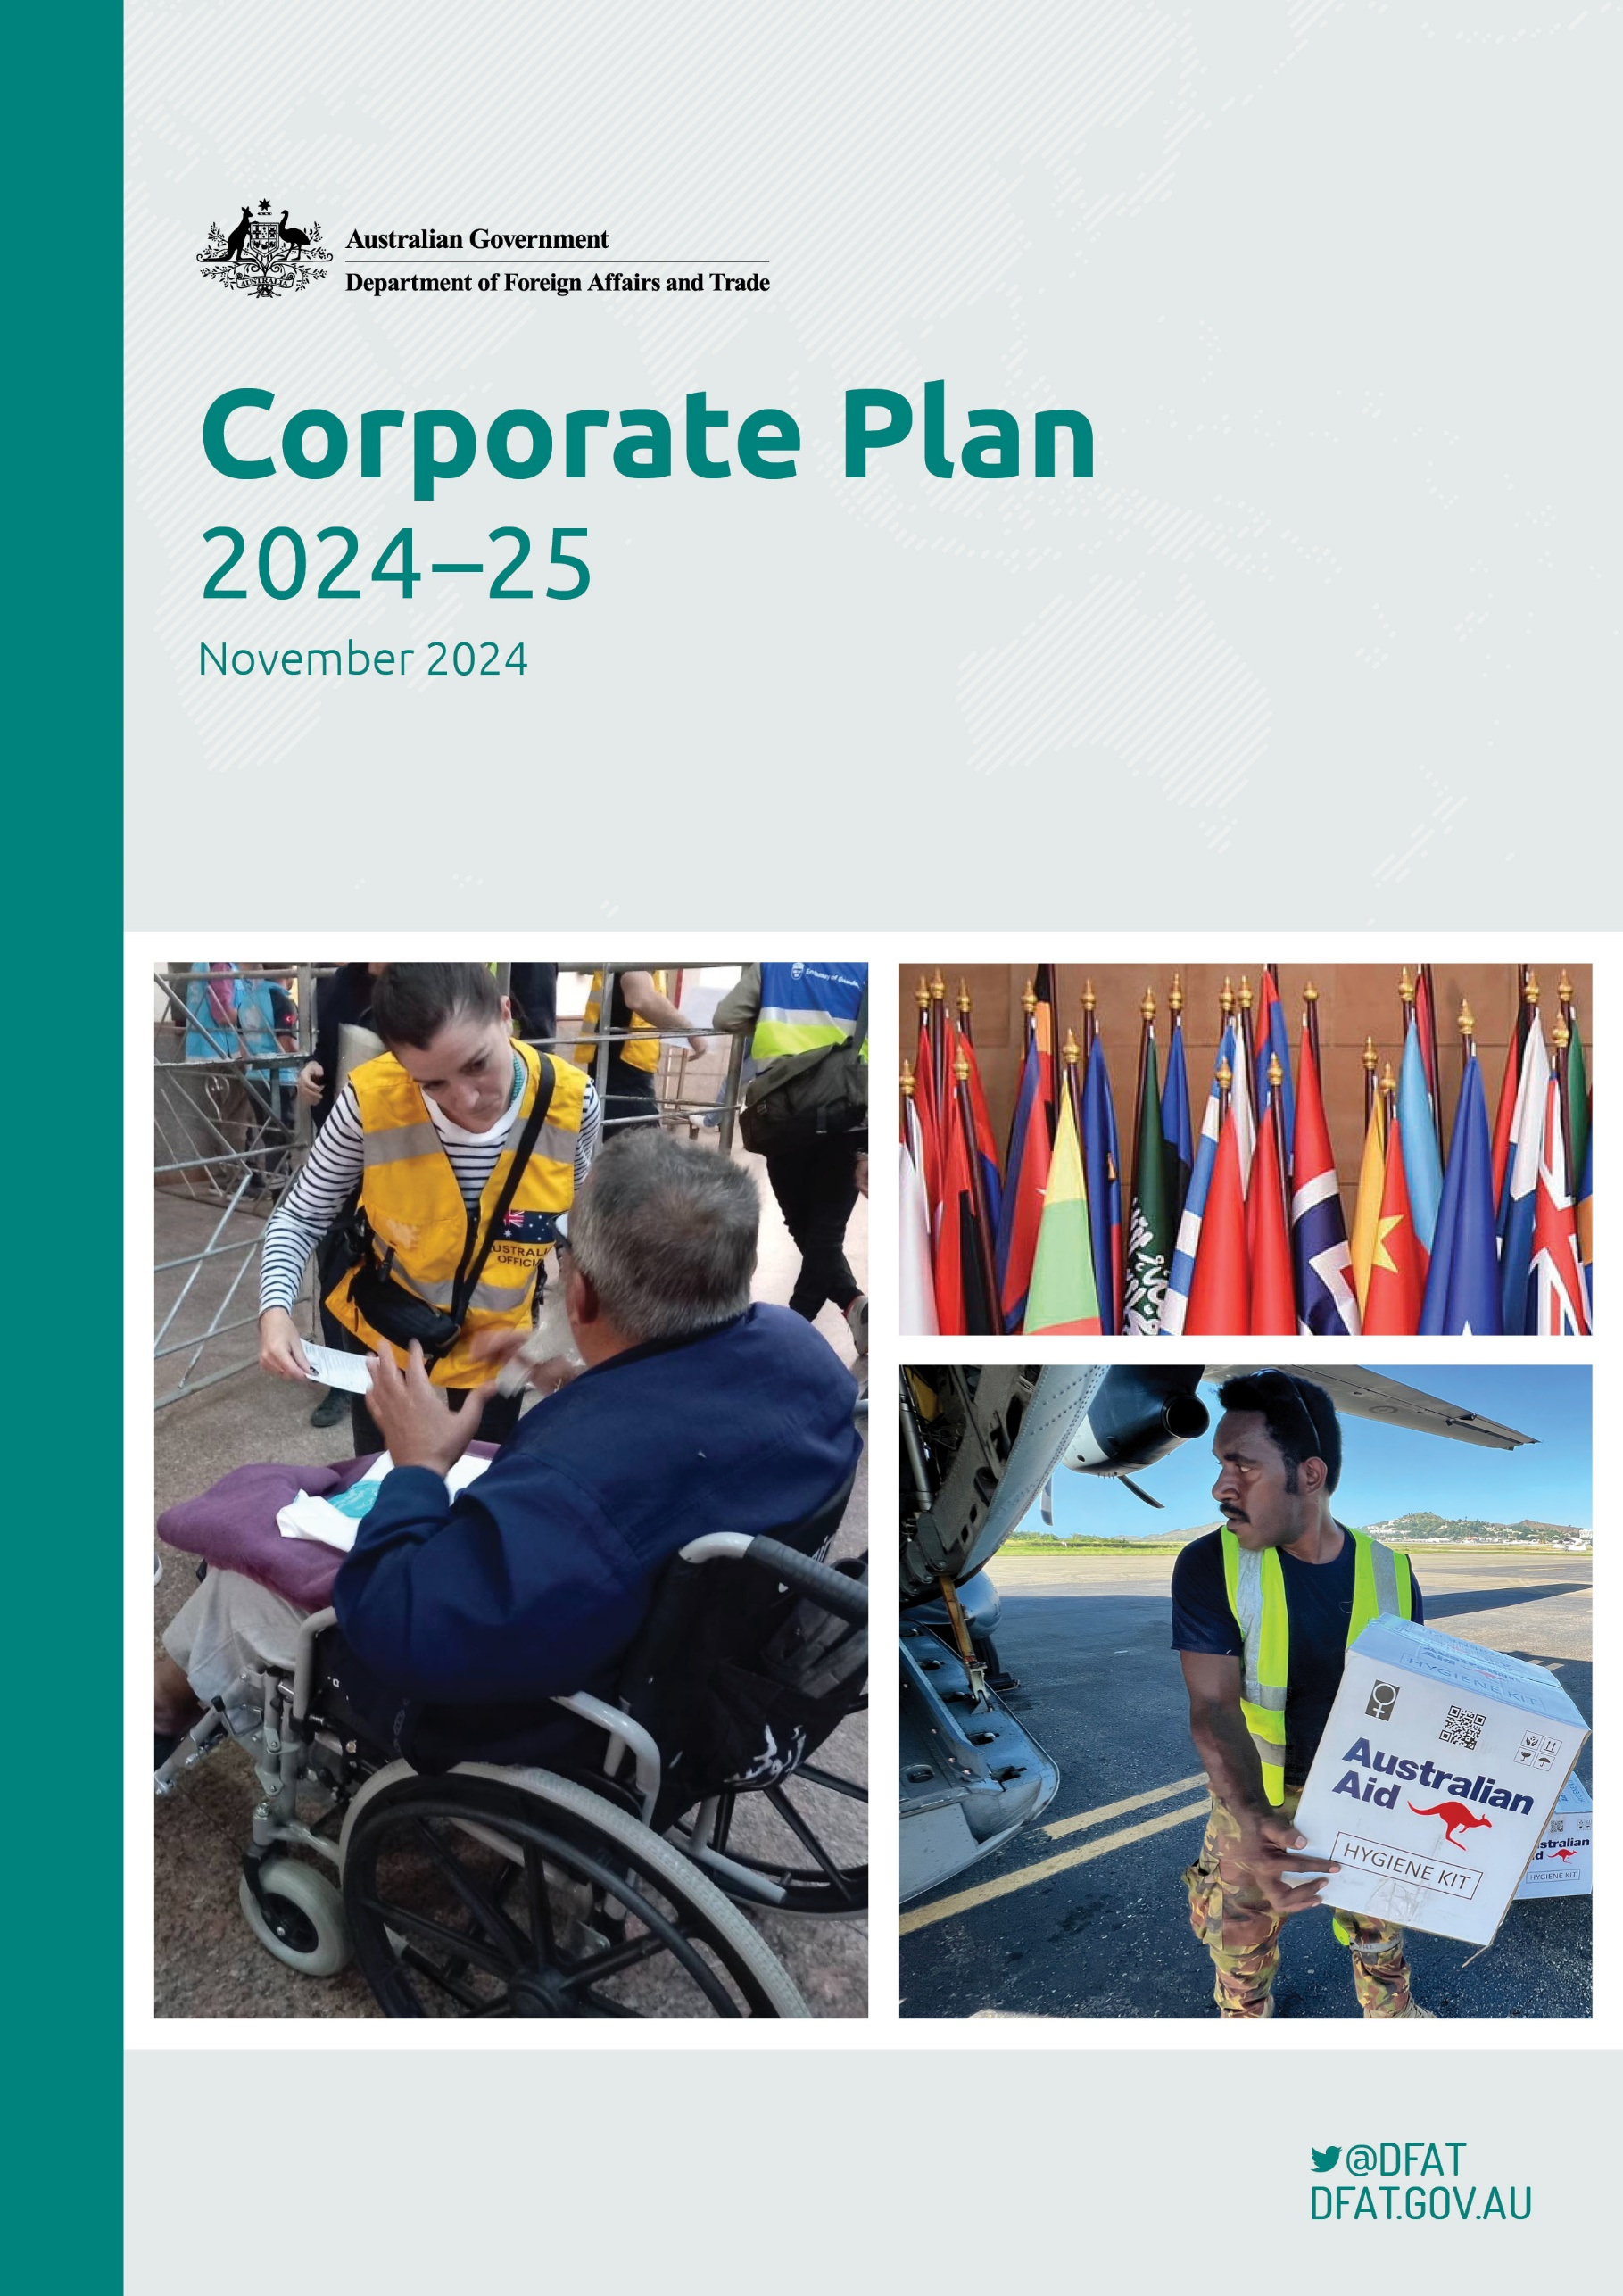

# Corporate Plan

# Creative commons

With the exception of the Commonwealth Coat of Arms and where otherwise noted all material presented in this document is provided under a Creative Commons Attribution 4.0 International, available at <https://creativecommons.org/licenses/by/4.0/>

The details of the relevant licence conditions are available on the Creative Commons website (accessible using the links provided), as is the full legal code for the CC BY 4.0 International licence, available at <https://creativecommons.org/licenses/by/4.0/legalcode.en>

Commonwealth of Australia, Department of Foreign Affairs and Trade, Department of Foreign Affairs and Trade Corporate Plan 2024–25, November 2024  
ISSN: 2653-567X

## Contact

Enquiries about this document should be directed to:

Planning and Performance Section

Executive Division

Department of Foreign Affairs and Trade

R G Casey Building

John McEwen Crescent­

Barton ACT 0221, Australia

Phone +61 2 6261 1111

## Images on front cover:

1. Rafah Border Crossing, Egypt: Australians were met by DFAT officials at the Rafah border crossing, Egypt,   
   and in Ismaili Egypt. DFAT officials assisted Australians and families to travel to Cairo after leaving Gaza, on   
   21 November 2023. Credit: DFAT.
2. Photo of flags including Papua New Guinea, Nepal, Myanmar, Saudi Arabia, Estonia, Uruguay, Norway, China, Mongolia, Kosovo, Finland, Sweden and Australia. Credit: DFAT.
3. Humanitarian supplies are off-loaded from Royal Australian Aircraft as part of the Australian Government’s assistance to Papua New Guinea on 28 May 2024, led by the Department of Foreign Affairs and Trade.   
   Credit: Nicholas Kittel.

Title Department of Foreign Affairs and Trade – Corporate Plan 2024–25 (November)Senior Responsible Officer FAS EXD

Created By Planning and Performance Section (BPP/GRB/EXD)

Date Created 06.04.2024

Maintained By Planning and Performance Section, Executive Division (BPP/GRB/EXD)

|  |  |  |  |  |
| --- | --- | --- | --- | --- |
| Version Number | Modified By | Modifications Made | Date Modified | Status |
| 2 | AS GRB | Pages 12-13 added reporting on Strategic Commissioning Framework.  Page 22 added case study topics to performance measure 1  Page 25 added case study topic to performance measure 3  Page 30 added focus areas to performance measure 7  Page 37 correct typographical error  Page 40 update Appendix A | 30/11/2024 | Published |
| 1 | AS GRB |  | 21/08/2024 | Published |

# Acknowledgement of country

The Department of Foreign Affairs and Trade acknowledges the Traditional Owners and custodians of the lands on which we work, and we pay our respects to their Elders past, present and emerging.

Elizabeth Peak, with the Prime Minister of Papua New Guinea, James Marape, 
and his wife, Rachael Marape, standing in front of Ngunnawal elders holding a wooden dish containing smouldering native plants that is producing white smoke. 


Head of the Office of the Pacific, Elizabeth Peak, with the Prime Minister of Papua New Guinea, James Marape,   
and his wife, Rachael Marape, attending a welcome to country ceremony performed by Ngunnawal Elder Serena Williams in Canberra on 8 February 2024. Credit: Alexandra Peek/DFAT.

# Contents

Secretary’s introduction 5

Statement of preparation 7

Role of the Corporate Plan 8

Our role 8

Corporate Plan on a page 9

Our operating environment 10

Our culture and values 16

Our governance 17

Our risk management and oversight 17

Our performance 19

Our approach to performance 20

Measuring our performance 21

Compliance with PGPA Rule s16E(2) 37

Appendix A: Table of Revisions 38

# November reissue

This Corporate Plan has been revised since its August 2024 publication to include case study topics for Performance Measures 1 and 3 and amended targets for Performance Measure 7. The department’s reporting on the Strategic Commissioning Framework has been included.

# Secretary’s introduction

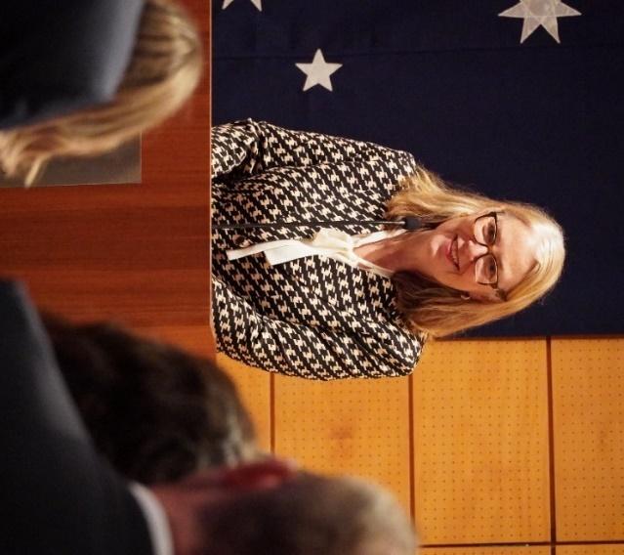

DFAT Secretary Jan Adams AO PSM addresses staff at the Australian Embassy   
Tokyo on 24 May 2024. Credit: DFAT.

I am pleased to present the Department of Foreign Affairs and Trade 2024–25 Corporate Plan. This plan sets out how we intend to achieve our purpose and deliver on the government’s priorities over the coming year.

Our purpose is to make Australia stronger, safer and more prosperous, to provide timely and responsive consular and passport services, and to ensure a secure Australian Government presence overseas.

In 2024–25, we seek to achieve this in one of the highest-risk global environments Australia has faced since the Second World War. Complex environmental, strategic and economic forces put at risk the long period of global order in which Australia has thrived. The temperature of geostrategic contest continues to rise and the prospect of continued peace faces significant challenges. We also face consequences from continued climate change. Communities all around the world are feeling the impacts, including here in Australia and in the Pacific at large.

Over the past year, the world continued to grapple with the disruptions brought about by Russia’s illegal invasion of Ukraine – a strong and unresolved challenge to international law and order. Israel’s military operation in Gaza following Hamas’ horrific terror attacks on 7 October 2023 has generated a humanitarian catastrophe and escalated tensions in the broader Middle East.

In this challenging context, Australia needs a diplomatic service that provides purposeful and effective diplomacy, sound and timely policy advice on international markets and trade opportunities, an effective development program and secure and responsive service delivery and infrastructure.

DFAT is at the forefront of supporting government and Australians with the wide-ranging impacts felt back home. Our consular officers help Australians affected by conflict and crises to return home safely. And our diplomats and trade negotiators work tirelessly to support the integrity of the international rules-based system and our interests in it, while also advocating for continued Australian access to energy supply chains, export markets, food security, business opportunities and safe travel.

Our department is deeply committed to projecting Australia’s diversity in all its aspects, including our extraordinary First Nations heritage. I remain intensely proud of the work we do every day in pursuit of Australia’s national interests.

The department is at the forefront of Australian Government efforts to deploy all arms of statecraft in its international engagement. We lead these efforts through stewardship of 116 embassies, high commissions and consulates around the world. DFAT also provides a world-class passport service to enable travel for business, education, leisure and cultural connection for our diverse nation.

We are committed to the multilateral system and active engagement in global and regional institutions, including our deep ties to the Association of Southeast Asian Nations and Pacific Island Forums. We continue to work within the United Nations and the World Trade Organization in pursuit of Australian objectives and global stability. And we foster those relationships, including through the Quad and AUKUS, that are committed to regional security.

We maintain an efficient and sustainable overseas property estate, a secure ICT capability resilient to increasing cybersecurity risks, and a highly skilled workforce of Australian and international staff. This provides a safe, secure and connected space for government, Australians and Australian business to achieve their outcomes, including during times of difficulties and crisis.

In the end, our ability to maintain a stronger, safer and more prosperous nation depends on the world we live in – so it is in our national interest to be influential and effective on the world stage.

This corporate plan reflects DFAT’s efforts to meet these significant challenges. Our plan also provides an overview of our operating environment, key activities, risks, capabilities and how we will measure our performance.

I look forward to reporting on how the department has performed this year in our 2024–25 Annual Report.

Jan Adams AO PSM   
Secretary

# Statement of preparation

I, Jan Adams, as the Accountable Authority of the Department of Foreign Affairs and Trade, am pleased to present the Department of Foreign Affairs and Trade’s Corporate Plan 2024–25 (November).

This covers the period 2024–25 to 2027–28 as required under paragraph 35(1)(b) of the *Public Governance, Performance and Accountability Act 2013* (the PGPA Act). The corporate plan is prepared in accordance with the Public Governance, Performance and Accountability Rule 2014(the PGPA Rule).



**Jan Adams AO PSM   
Secretary**

**15 November 2024**

# Role of the Corporate Plan

DFAT’s 2024–25 Corporate Plan sets out its purpose and outcomes, and the key activities it undertakes to achieve them. The plan complements the [Foreign Affairs and Trade Portfolio Budget Statements](https://www.dfat.gov.au/about-us/corporate/portfolio-budget-statements) (PBS) which outline   
the funds appropriated for the department to achieve our purpose and 3 outcomes over the period 2024–­25 to 2027–28. The plan sets the parameters for the department’s annual business planning cycle and individual performance and development agreements. It does so by bringing together our enterprise performance measures and risks, our capabilities and our values to provide clarity of purpose and line of sight from the enterprise to each DFAT staff member.

# Our role

DFAT leads the government’s engagement with the world, building relationships to ensure a coherent, consistent and collaborative whole-of-government approach to the conduct of Australia's international relations. We do this in a challenging and complex global environment, deploying creative and ambitious statecraft, and harnessing all elements of our national power. DFAT, in partnership with state and territory governments, businesses and the wider community, will pursue the government’s objectives, through excellence in public policy, program and service delivery, and constructive relationships with international partners.

A strong diplomatic network is essential for protecting and advancing Australia’s national interests and delivering on the government’s international agenda. DFAT is the lead agency managing Australia’s international presence at 116 locations across 86 countries in our overseas network. DFAT manages the Australian Government presence overseas, working across portfolios to promote an effective, secure and coordinated approach to Australia's overseas representation.

DFAT and its portfolio agency partners work with the broader Australian Public Service (APS) to promote and protect Australia’s interests internationally and contribute to economic growth and global stability.

## The Foreign Affairs and Trade portfolio

The Foreign Affairs and Trade Portfolio consists of:

* the Department of Foreign Affairs and Trade (DFAT)
* the Australian Trade and Investment Commission (Austrade)
* the Australian Secret Intelligence Service (ASIS)
* the Australian Centre for International Agricultural Research (ACIAR)
* Tourism Australia, and
* Export Finance Australia.

# ****Corporate Plan on a page****

Our purpose: to make Australia stronger, safter and more prosperous, to provide timely and responsive consular and passport services, and to ensure a secure Australian Government presence overseas. 
Leadership: be dynamic, be respectful, have integrity, value others, empower people. 
Our values: impartial, committed to service, accountable, respectful, ethical, stewardship. 
2024-25 Portfolio Budget  Statements outcomes: The advancement of Australia's international strategic, security and economic interests. 
The protection and welfare of Australians abroad and access to secure international travel documentation. A secure Australian Government presence overseas.
Key Activities: Negotiate and advocate internationally and provide international policy advice. Deliver international development and humanitarian assistance. Advocate within multilateral institutions. Deliver consular services. Deliver passport services. Manage the Australian Government’s overseas network.  
Capabilities: Our people, our property, our systems, our networks. 
Risks: delivery, people, capabilities and capacity, enabling services, staff health, safety and wellbeing, financial management, trust. 
Performance: An effective performance framework that ensures we are measuring and reporting on our performance to the Australian Government and the Australian people and demonstrating how we achieve our mission and purpose, and strategic objectives. 

# Our operating environment

The international environment has become more complex and challenging. Global challenges are interconnected and have a compounding impact.

How Australia responds to these challenges will have a profound impact on our nation and the future of our region. The department’s ability to successfully navigate these challenges will require targeted investment in our culture, capabilities and performance, and trusted, resilient international partnerships.

## Increasing geostrategic tensions in our region

Australia is facing its most complex and challenging strategic circumstances since the Second World War. Strategic competition is entrenched in the Indo-Pacific, largely driven by an unprecedented pace and scale of military build-up in our region. Conflict is on the rise globally and internationally agreed rules and norms that have underpinned our region’s security and prosperity are under increasing pressure. Despite the welcome resumption of US-China dialogue, there is a heightened risk of misunderstanding or miscalculation leading to conflict, particularly across potential regional flashpoints such as the South China Sea, Korean peninsula and the Taiwan Strait.

We are focused on ensuring the Blue Pacific remains peaceful, prosperous and equipped to respond to the challenges of our time. Through our enhanced support for the Pacific Islands Forum, we are building a stronger and more united Pacific.

More than ever, diplomacy has a critical role supporting Australia’s security and prosperity in the region, and the world. DFAT works to help government understand the risks and opportunities at play, identifying how government can bolster multilateral, bilateral and regional relationships to achieve the outcomes we seek.

Beyond the Indo-Pacific, Russia’s unprovoked, illegal and immoral invasion of Ukraine, and Iran’s support for Hamas and other proxies, are examples of how some states continue to challenge the rules and norms that are of vital importance to Australia’s national interests. Australia remains a committed international partner supporting humanitarian assistance in Ukraine and Gaza and promoting adherence to international law.

## Global economic changes and localised impacts

With strategic competition playing out across all domains, the global economic and technological environment is becoming increasingly complex and fractured. This has led to an increased focus from governments on economic security and resilience. The global economy is showing resilience in parts, but overall remains subdued and weak by recent historical standards. The challenge of inflation is lingering, including in North America, growth is slowing in China, and global conflict continues to affect supply chains. Countries are more frequently using economic tools for political, national security and strategic aims, disrupting agreed rules and economic institutions that have underpinned open, market-based trade and facilitated a cooperative environment essential for Australia.

Across the Indo-Pacific, countries face growing and compounding challenges brought on from climate change, conflict and fragility, uneven development and risks of disaster. Humanitarian assistance needs are growing. Demographic and technological changes present opportunities, but also challenge existing models of development. Developing countries, especially their most marginalised communities, often bear the greatest costs of change. Southeast Asia is at the centre of strategic competition, and presents economic opportunities for Australia with the clean energy transition critical to the region’s future.

In the Pacific, these issues are magnified and further exacerbated by local challenges, including food insecurity, high debt burden and increasingly severe weather events. Our work is supporting a united and cohesive region, including by aligning our work to the priorities articulated in the [2050 Strategy for the Blue Pacific Continent](https://www.google.com/url?sa=t&rct=j&q=&esrc=s&source=web&cd=&cad=rja&uact=8&ved=2ahUKEwiiqJzUmcGGAxV6iK8BHT3NCEwQFnoECAYQAQ&url=https%3A%2F%2Fforumsec.org%2F2050&usg=AOvVaw2cJfkoisXjoXALvTQpoJGQ&opi=89978449) and by building genuine and respectful relationships. We take a whole-of-nation approach, recognising the breadth of our shared interests and the challenges we face in the Pacific – none greater than the threat of climate change.

International trade underpins Australia’s prosperity and economic resilience. It boosts economic activity and job creation in Australia – with trade related economic activity supporting one in four jobs. Through our engagement with the World Trade Organization, and our negotiation of regional and bilateral free trade agreements, DFAT supports a rules-based approach to trade, providing a level playing field for Australian business, improving access to global markets and promoting stronger labour and environmental standards.

DFAT engages widely with stakeholders to negotiate new free trade agreements and get the most out of existing ones. We must also support a range of international partnerships to promote our trade policy objectives, including on digital trade and supporting the net zero transition.

Foreign investment is crucial to Australia’s prosperity. It helps drive economic growth, creates skilled jobs, improves access to markets and improves productivity, competition and innovation. DFAT works closely with Austrade to promote foreign investment in Australian industry, including for Australia’s net zero transition.

## Increasing impacts of climate change

Climate change is the greatest shared threat to all countries. It is disrupting trade, causing water, energy and food shortages, and placing pressures on governments and communities as they respond to increasingly frequent and intense disasters. Australia’s Pacific Island neighbours feel this acutely, where the growing effects of climate change and continued social inequality are dampening opportunities, especially for the young.

Measures to adapt and build resilience to climate impacts are urgently needed to defend against climate-induced loss and damage. Action to transition economies to achieve net zero emissions has accelerated, requiring large scale investment. For countries such as Australia, creative transformation of our natural endowments will create opportunities for new markets and trade in energy and other green economy products. Innovation is critical, and DFAT works to identify new opportunities in international markets, while facilitating trade opportunities through strengthening bilateral, regional and multilateral relationships. The impacts of climate change do not adhere to national boundaries. International and regional solutions to mitigating further impacts of climate change are critical, and DFAT will continue to support collaboration between government, business and researchers.

## A rapidly developing region but with uneven progress

The government’s [International Development Policy](https://www.dfat.gov.au/publications/development/australias-international-development-policy), released in August 2023, outlines Australia’s place within a dynamic region. With most of our nearest neighbours being developing countries, it is in Australia’s interest to advance a peaceful, stable, and prosperous region. Australia’s development program is effective and having real impact. It is making a significant contribution to the development aspirations of our partners and neighbours as we work together to achieve the Sustainable Development Goals.

However, development of the Indo-Pacific is uneven and income inequality remains entrenched. Southeast Asia has recovered well from COVID-19 economic shocks and has seen a steady decline in poverty. The Pacific has improved adult literacy rates and life expectancy. The region remains vulnerable to poor governance and economic shocks from crises and natural disasters.

Over 300 million people around the world will need humanitarian assistance   
this year, with more people displaced now than at any other time since the   
beginning of the century. One in five children are living in or fleeing from conflict.

Reflected in the Indo-Pacific are global challenges, including persistent poverty (600 million people will live in extreme poverty in 2030), acute food security, malnutrition, increasing debt distress or high debt risk in most developing countries, and increasing displacement due to war, violence, persecution and climate change.

As always, women, girls, people with disabilities and other at-risk members of society continue to suffer the most. We work with partners in government, civil society and the private sector to improve inclusion of the most vulnerable, including addressing gender equality, disability equity and rights and LGBTQIA+ equality.

DFAT will continue to lead the government’s efforts to support our neighbours in times of crisis. In our region we invest in local capabilities for disaster risk reduction and preparedness to build resilience. We also support each other during times of disaster. We work globally too **–** it is in Australia’s interest to support humanitarian response efforts where needs are most acute and to strengthen the multilateral humanitarian system.

Our work will be informed by a new Humanitarian Strategy, to be released in 2024. This strategy will shape our future investment in the Indo-Pacific and beyond to reduce need and build resilience.

## Australians resuming pre-COVID levels of overseas travel

The number of Australians traveling overseas increased during 2023–24, and monthly departures exceed   
pre-COVID-19 levels. Australians are now resuming their travel overseas in increasing numbers to a broader range of destinations for tourism, business and to visit family and friends.

The increase in travel has resulted in an increased demand for consular and passport services, which DFAT provides on behalf of government. We expect around 2.4 million passport requests in 2024–25. To ensure passport services meet community expectations, DFAT will invest in digital passport solutions this year.

As outbound travel grows, we expect further increases in demand for consular services and information in coming years. Our consular officers will continue to assist many thousands of Australians each year and also assist Australians in crisis-affected areas. The department will increase its capability to provide consular assistance and travel safety information that takes account of cultural and linguistic diversity.

## **Implementing a First Nations approach to foreign policy**

The government is implementing a First Nations approach to foreign policy that projects Australia’s shared and full identity: our modern diversity and the rich heritage of First Nations people. In recognition of this, and of the rich First Nations heritage around the world, the government has for the first time dedicated First Nations representation in its international engagement through the role of the Ambassador for First Nations people.

‘How you engage with the world, your national power, starts with who you are in all of its diversity. Whether it's our First Nations heritage or our diversity … that is a part of our national power, because it gives us common ground with so many of the world's people … you will see that power as part of our story.’  
*Senator the Hon Penny Wong, Minister for Foreign Affairs, Indian Ocean Press Conference, 9 February 2024.*

The rich and diverse culture of First Nations Australians resonates deeply with a diverse range of Pacific cultures. Recognising these unique cultural bonds within the Blue Pacific, DFAT has established connections between Australia’s First Nations people, local communities and senior representatives of Pacific governments. For Australia to fully participate in the international partnerships of First Nations people, businesses and Indigenous rights and human rights forums around the world, the department must continue to identify new areas of cooperation and enhance collaboration between First Nations communities and partners across the Indo-Pacific.

**Our capabilities**

DFAT’s people, international network and enabling services are essential to delivering our purpose, outcomes and key activities across our diplomatic missions and consular posts. Over 2024–25 we will further strengthen our core capabilities consistent with the government’s Strategic Commissioning Framework. The Department of Foreign Affairs and Trade’s APS workforce continues to lead the delivery of key activities across the department. Outsourced resources will be used in some circumstances, including where independent or specialist advice is required, or skills cannot be sourced from within the APS. We have taken action over recent years to reduce reliance on external labour, particularly within the Australian Passport Office.

The department is investing in its people capability. Under the APS Strategic Commissioning Framework we will see a $6.1 million reduction in contractor expenditure and a corresponding investment in our APS workforce throughout 2024-25.

## Our people

DFAT has a diverse, dedicated and high performing workforce in Australia and overseas. We take pride in our work and are dedicated to service, often in demanding and dangerous circumstances.

Managing an overseas network of posts means our efforts to build inclusive workplaces affects more than just our own workforce. At these posts, Australian citizens access consular and other services and staff from DFAT and other government agencies come to work, often accompanied on overseas postings by their family members.

We strive to build a workforce and workplace culture that is inclusive and reflects the diversity of the communities we serve. This enables us to project modern Australia, find common ground with the world’s peoples, and solve complex problems.

Our diversity is also reflected across our locally engaged staff, who bring cultural, linguistic, and contextual knowledge of overseas environments. The skills and expertise of our locally engaged staff are essential to DFAT’s ability to manage post operations, support Australians overseas and build relationships with local stakeholders.

DFAT’s approach to [inclusion and diversity](https://www.dfat.gov.au/sites/default/files/dfat-inclusion-equity-diversity-strategy-2024.pdf) will include practical changes to reduce barriers to workforce participation, strengthen career development and increase the representation of people from groups that remain under-represented, including at senior levels.

We will build on lessons learned over the last decade that saw gender parity achieved in our head of mission, head of post and senior executive roles. Our efforts will focus on strengthening representation across First Nations people, LGBTQIA+ people, people with disabilities, and people from culturally and linguistically diverse backgrounds. We will embed reconciliation with First Nations people in our workplace and through our work practices. We will continue to modernise our workplace policies, strengthen inclusive leadership and embed flexibility as the way DFAT does business, while implementing the Government’s Australian Public Service Reform agenda.



The Inclusion, Equity and Diversity Strategy launch on 21 March 2024 celebrated the diversity of staff in the department and committed to a future of inclusion. It was attended by Foreign Minister Wong and   
diversity champions from across the senior executive. Credit: Samuel Phelps, Rhiannon Johannes.

## Our overseas network

An overseas Australian Government presence is fundamental to Australia’s ability to meet the strategic challenges ahead, protect Australians overseas and advance Australia’s interests abroad. In 116 posts, DFAT is the lead agency in ensuring a consistent and efficient use of government resources, including managing properties, staff and conditions of service, health and safety, security, information and communications technology, and finance. Austrade manages an additional 9 posts in the network, which provide consular services.

The overseas network collaborates with a range of stakeholders globally to ensure Australia’s interests are represented in both bilateral and multilateral relationships and bodies. The network also enables the delivery of Australia’s development program and assists to identify and secure new market opportunities for Australian businesses overseas.

The network provides consular and passport services to Australians travelling overseas and manages responses to overseas crises. There are 48 Honorary Consuls in locations where there is no post, to ensure services are available in areas frequented by Australian travellers.

## Our systems

The department provides information, communication and technology (ICT) services and infrastructure, including for other government agencies, to enable a secure Australian Government presence overseas. The department will continue to enhance its ICT capability over the next 4 years, to support a reliable, secure, and sustainable global ICT network which is responsive in an uncertain operating environment. ICT is a critical enabler for the department.

Software tools, cloud technology and other new ICT capabilities have enabled DFAT staff to work smarter and remain agile to changing circumstances both domestically and abroad. DFAT will continue to focus on implementing new technologies to improve our ICT capability to ensure our systems are fit-for-purpose and secure.

## Our partnerships

In an uncertain world, the strength and diversity of Australia’s partnerships are critical. We work with partners in Australia, in our region and across the globe to deliver the government’s agenda.

DFAT partners with 28 Australian Government departments and agencies that have a presence overseas. We provide services to a further 9 agencies in Australia. DFAT is supported by partner agencies in its associated leadership, advocacy and coordination roles at overseas missions.

The department also has strong connections across state and territory governments, businesses, universities, scientific agencies, non-government organisations and the wider Australian community. Our 7 State and Territory Offices located in capital cities facilitate these partnerships, providing a critical connecting and enabling function for DFAT with the diverse stakeholder groups that seek engagement, advice and opportunities overseas.

We also have a Torres Strait Treaty Liaison Office on Thursday Island, which supports DFAT to manage the implementation of the Torres Strait Treaty with Papua New Guinea on behalf of the Australian Government. These on the ground partnerships and connections support a whole-of-nation effort to promote and protect Australia’s interests internationally and contribute to economic growth and global stability.

DFAT’s international partnerships extend across the Indo-Pacific and around the globe. We work through international institutions like the UN, WTO, International Atomic Energy Agency (IAEA), multilateral development banks and the Organisation for Economic Co‑operation and Development (OECD). We engage closely with regional counterparts through organisations such as ASEAN, Asia-Pacific Economic Cooperation and the PIF. We work in genuine partnership with international civil society organisations, including to deliver development outcomes in communities across the Indo-Pacific region. We advance and protect Australia’s interests through groupings and partnerships like the Quad (with India, Japan and the US) and AUKUS (with the UK and US).

DFAT Posts: Abu Dhabi, Abuja, Accra, Addis Ababa, Alofi, Amman, Ankara, Apia, Athens, Baghdad, Bali, Bandar Seri Begawan, Bangkok, Beijing, Beirut, Belgrade, Bengaluru, Berlin, Bern, Bogota, Brasilia, Brussels, Buenos Aires, Cairo, Canakkale, Chengdu, Chennai, Chicago, Colombo, Copenhagen, Dhaka, Dili, Doha, Dublin, Funafuti, Geneva, Guangzhou, Hanoi, Harare, Ho Chi Minh City, Hong Kong, Honiara, Honolulu, Islamabad, Istanbul, Jakarta, Kathmandu, Kolkata, Koror, Kuala Lumpur, Kuwait City, Kyiv, Lae, Lima, Lisbon, London, Los Angeles, Madrid, Majuro, Makassar, Malé, Malta, Manila, Mexico City, Moscow, Mumbai, Nairobi, Nauru, New Delhi, New York, Nicosia, Noumea, Nuku'alofa, Ottawa, Papeete, Paris, Phnom Penh, Phuket, Pohnpei, Port Louis, Port Moresby, Port of Spain, Port Vila, Pretoria, ,Rabat, Ramallah, Rarotonga, Riyadh, Rome, Santiago, Seoul, Shanghai, Shenyang, Singapore, Stockholm, Surabaya, Suva, Taipei, Tarawa, Tehran, Tel Aviv, The Hague, Tokyo, Ulaanbaatar, Vatican City, Vienna, Vientiane, Warsaw, Washington, Wellington, Yangon, Zagreb. 
State and territory offices: Adelaide, Brisbane, Canberra, Darwin, Hobart, Melbourne, Perth, Sydney. 
Torres Strait Treaty Liaison Office: Thursday Island.  
Austrade-managed posts providing consular assistance: Auckland, Dubai, Frankfurt, Houston, Milan, Osaka, San Francisco, São Paulo, Toronto. 

# Our culture and values

## 

Integrity is at the centre of the APS agenda. Integrity is also at the core of our values, our work and our commitment to delivering the best outcomes for Australia. We commit to the highest standards of integrity by upholding the APS Values, maintaining robust and secure systems, and through committed leadership.

## Leadership behaviours

The Secretaries’ [Charter of Leadership Behaviours](https://www.apsc.gov.au/initiatives-and-programs/learning-and-development/secretaries-charter-leadership-behaviours) sets out the behaviours departmental secretaries expect of themselves and the Senior Executive Service, and want to see in leaders at all levels of the APS. The Charter focuses on behaviours that support modern systems leadership within the construct of the [APS Values and Code of Conduct](https://www.apsc.gov.au/working-aps/integrity/integrity-resources/aps-values-code-conduct-and-employment-principles), and are summarised by the acronym DRIVE: be Dynamic, be Respectful, have Integrity, Value others, and Empower people.

## Our Values

At DFAT, we uphold and promote the [APS Values](https://www.apsc.gov.au/working-aps/information-aps-employment/aps-values). The APS Values are set out in section 10 of the   
*Public Service Act 1999.* They articulate the parliament’s expectations of public servants in terms of performance and standards of behaviour. The principles of good public administration are embodied in the APS Values, which are:

**Impartial**: The APS is apolitical and provides the government with advice that is frank, honest, timely and based on the best available evidence.

**Committed to service**: The APS is professional, objective, innovative and efficient, and works collaboratively to achieve the best results for the Australian community and the government.

**Accountable**: The APS is open and accountable to the Australian community under the law and within the framework of Ministerial responsibility.

**Respectful**: The APS respects all people, including their rights and their heritage.

**Ethical:** The APS demonstrates leadership, is trustworthy, and acts with integrity, in all that it does.

**Stewardship:** The APS builds its capability and institutional knowledge and supports the public interest now and into the future by understanding the long-term impact of what it does.

## Our Conduct

DFAT expects a high level of professionalism from its staff, including to adhere to the [APS Code of Conduct](https://www.google.com/url?sa=t&rct=j&q=&esrc=s&source=web&cd=&cad=rja&uact=8&ved=2ahUKEwiFtcCw_76HAxU2slYBHa_yIJwQFnoECCIQAQ&url=https%3A%2F%2Fwww.apsc.gov.au%2Fworking-aps%2Fintegrity%2Fintegrity-resources%2Fcode-of-conduct&usg=AOvVaw0JixOhVLiMX4dGiX753vE-&opi=89978449). In support of this, DFAT will provide staff with an integrity strategy in 2024–25. The DFAT Fraud and Corruption Control Framework will also be updated, supporting all staff, our contractors and partners, as well as the public, to understand DFAT’s zero tolerance to inaction on fraud and corruption, in line with recent government policies.

This framework and the integrity strategy will reflect DFAT’s frameworks, policies, assurance mechanisms, its employees and broader organisational culture. These documents will further ensure public trust in our administration and in the services we deliver to government and the community.

# Our governance

DFAT’s governance structure facilitates enterprise decision-making and determines the agency’s strategic priorities. It ensures the department delivers for government and for all Australians, across foreign, trade and development policy and program priorities and in the delivery of consular, passport, property, ICT and security services.

The Audit and Risk Committee provides independent advice to the Secretary on the appropriateness of the Department’s financial and performance reporting; system of risk oversight and management; and system of internal controls. We will continue to adapt the governance framework to meet the department’s current and evolving needs.

## DFAT Governance Committee Structure

DFAT committee structure, at 30 June 2024. 

Secretary. 

Audit and Risk Committee. At least 5 times per year.  Chair: Independent member. 

Development Program Committee (monthly). Chair: Deputy Secretary, Development, Multilateral and Europe Group.

Implementation and Enabling Committee (monthly). Co-chairs: Deputy Secretary, International Security, Legal and Consular Group and Deputy  Secretary and Head of the Office of the Pacific (rotating). 

Operations Committee (quarterly). Co-chairs: Chief Operating Officer and Deputy Secretary, Development, Multilateral and Europe Group (rotating).

People and Culture Committee (monthly). Co-chairs: Chief Operating Officer and Deputy Secretary, Strategic Planning and Coordination Group (rotating). 

Strategic Policy Subcommittee (monthly). Co-chairs: Deputy Secretary, Trade and Investment Group and Deputy Secretary, South and Southeast Asia Group (rotating).

1. DFAT Governance Committee Structure.

# Our risk management and oversight

Appropriately engaging with risk is at the core of our decision-making. It is an important enabler to take advantage of emerging opportunities in the national interest, ensure the welfare of our people, and meet our performance and legislative responsibilities.

## Risk appetite

DFAT requires bold, creative and innovative ideas and solutions to advance Australia’s national, security and economic interests, to deliver consular and passports services and to ensure a secure Australian Government presence overseas.

We recognise effective risk management is not about eliminating risk but understanding how risks could impact delivery of objectives and ensuring transparent and accountable actions in managing these risks.

The department works in complex and challenging environments, which attract high levels of risk. If controls and/or treatments are unable to reduce the risk to align with accepted tolerance levels, delegates must clearly document acceptance of the risk and a plan for ongoing management. Undertaking work which exceeds agreed tolerance levels is acceptable provided there is a clear and documented decision by an authorised decision-maker to accept that level of risk on behalf of the department.

To do this, senior leaders must promote an open and proactive risk culture so all staff are equipped to make informed risk-based decisions and are comfortable to escalate high risks to senior management where changes to the operating environment need increased risk oversight.

## Managing our enterprise risks

The department’s enterprise risks affect DFAT’s ability to meet its strategic objectives – our key activities and purpose. These risks are set out below and in the department’s Enterprise Risk Management Policy and are replicated at the business level through the Enterprise Risk Register. During 2024–25 we will continue to mature integration of enterprise risk reporting through improvements to the business planning process, and risk management training and outreach with staff at all levels. These activities will support increasing risk management literacy across the organisation and promote a positive risk behaviour culture.

Graphic portrays a wheel of six risk categories with ‘strategic and operating risk environment’ at the centre.  The categories are: 
- ‘delivery’, that to deliver our services, programs and policy in support of our objectives and the national interest we must: innovate; protect Australia’s international reputation; and establish resilient processes 
- next, ‘people capability and capacity’, that to meet our objectives we must align our people’s capabilities with key priorities and attract, develop and retain the capabilities we need.
- then ‘enabling services’, that our people, information and assets and the national interest must be protected by our ICT services; security capability and estate management
- then ‘staff health, safety and wellbeing’, that we must consider and mitigate risks to our people in delivering our objectives because the health and safety of our people remains paramount
- then ‘financial management’, that we must use resources in a proper manner and maintain financial stability
- and lastly ‘trust’, that to maintain the trust of stakeholders we must, have integrity, give reliable and impartial advice, have zero tolerance for inaction on unethical and illegal conduct or deliberate violations of legislation, low tolerance for unintentional violations and safeguard information security and privacy.

1. DFAT’s Enterprise Risk Categories.

## Managing a robust risk framework

Our Enterprise Risk Management Policy sets out our processes for managing risk in line with the expectations of the Commonwealth Risk Management Policy and supports integration of risk at all business levels to meet DFAT’s strategic objectives. The policy sets out responsibilities for all staff and contractors on how to identify, assess and mitigate risks, and escalate risks to senior management where risk exposures exceed tolerance settings.

We are strengthening linkages between business area risks, enterprise risks and business planning processes to ensure our Enterprise Risk Management Policy enables DFAT to achieve its strategic objectives. Risk management is integrated into the department's governance, and is a primary consideration in all decision-making.

# Our performance

Our purpose: the purpose of DFAT is to make Australia stronger, safer and more prosperous, to provide timely and  responsive consular and passport services, and to ensure a secure Australian Government presence overseas.
2024-25 PBS outcome 1: The advancement of Australia's international strategic, security and economic interests including through bilateral, regional and multilateral engagement on Australian Government foreign, trade and international development policy priorities.
Key Activity 1: Negotiate and advocate internationally and provide international policy advice.
Performance Measure 1: DFAT’s diplomatic efforts support favourable foreign affairs and trade policy outcomes for Australia. 
Performance Measure 2: Increased number and diversity of Australian university undergraduates with Indo-Pacific capability. 
Performance Measure 3: Australia’s standing in the region is enhanced through DFAT’s public diplomacy. 
Performance Measure 4: Australia’s treaty obligations are met under Australia’s Comprehensive Safeguards Agreement and Additional Protocol with the International Atomic Energy Agency. 
Key Activity 2: Deliver international development and humanitarian assistance. 
Performance Measure 5: The development program is effective, efficient and responsive. 
Key Activity 3: Advocate within multilateral institutions.
Performance Measure 6: Australia’s payments to multilateral development organisations generate collective action on issues impacting Australia. 
Performance Measure 7: International organisations reflect Australian interests and values when addressing global challenges. 
2024-25 PBS outcome 2: The protection and welfare of Australians abroad and access to secure international travel documentation through timely and responsive travel advice and consular and passport services in Australia and overseas. 
Key Activity 4: Deliver consular services. 
Performance Measure 8: Australians have access to consular information and services, including in times of crisis. 
Key Activity 5: Deliver passport services. 
Performance Measure 9: Australian passports are processed efficiently. 
Performance Measure 10: Customers are satisfied with passport services. 
2024-25 PBS outcome 3: A secure Australian Government presence overseas through the provision of security services and information and communications technology infrastructure, and the management of the Commonwealth’s overseas property estate. 
Key Activity 6: Manage the Australian Government’s overseas network. 
Performance Measure 11: Australian Government staff, information and assets overseas are protected through appropriate risk-focused security measures. 
Performance Measure 12: The overseas property estate is effectively maintained and fit for purpose. 

# Our approach to performance

DFAT continues to mature performance reporting, to better reflect what we do and to tell our story, in line with our obligations under the PGPA Act andthe wider APS Reform Agenda for improved transparency and accountability. In 2023–24 the Australian National Audit Office (ANAO) began an audit of DFAT’s annual performance statements against requirements of the PGPA Act. DFAT will consider recommendations from the ANAO on an ongoing basis and update the performance measure system throughout the year as appropriate.

The 2024–25 Corporate Plan reflects improved measurement and reporting of performance measures compared with previous years. Five measures have been amended since the 2023–24 Corporate Plan (Appendix A,   
pages 39-41). Five measures are also expected to be updated during the 2024–25 year. In 2024–25, DFAT commits to reporting on 12 performance measures for 2024–25. For 10 of these, we have set qualitative and quantitative targets. For 2 measures, we will undertake case studies to assess performance in major policy areas, applying a robust approach based on evaluation methodology. Case study topics collectively represent a sample of DFAT’s work from which we will draw conclusions about our performance more broadly.

DFAT’s regulatory functions are incorporated into the corporate plan in accordance with the official guidance ([Resource Management Guide 128)](https://www.finance.gov.au/government/managing-commonwealth-resources/regulator-performance-rmg-128) issued by the Department of Finance. DFAT is progressing a Ministerial Statement of Expectations and the Regulator Statement of Intent for the Australian Safeguards and   
Non-proliferation Office and the Australian Sanctions Office. These will be available at: [foreigninvestment.gov.au](http://www.foreigninvestment.gov.au/).



Deputy Secretary George Mina, Deputy Secretary Clare Walsh, artist Brooke Rigney-Lively and Deputy Secretary Craig Maclachlan attend a Reconciliation Week reception event on 30 May 2024, unveiling the original artwork by Ngarrindjeri and Kaurna woman Brooke Rigney-Lively, a South Australian artist commissioned by the department. Credit: Samuel Phelps.

# Measuring our performance

Outcome 1: The advancement of Australia’s international strategic, security and economic interests including through bilateral, regional and multilateral engagement on Australian Government foreign, trade and international development policy priorities.

Key Activity 1: Negotiate and advocate internationally and provide international policy advice   
Our job is to be where it matters, when it matters – we forge and maintain stakeholder networks in Australia, in our region and globally. These networks are critical to our ability to advocate and negotiate outcomes that advance Australia’s strategic, security and economic interests. They enable us to form strategic insights that underpin our foreign and trade policy advice. We deliver targeted programs to increase Australia’s global engagement, in particular with the Indo-Pacific region, and project a positive and contemporary image of Australia overseas. We provide legal services and regulatory functions to uphold Australia’s international treaty obligations and protect and advance Australia’s international interests. DFAT provides the legal, policy and diplomatic capability necessary to support Australia’s acquisition of conventionally-armed, nuclear-powered submarines, while setting the highest non-proliferation standards. We will use 4 measures to assess our performance over the 4 budget programs related to this key activity.

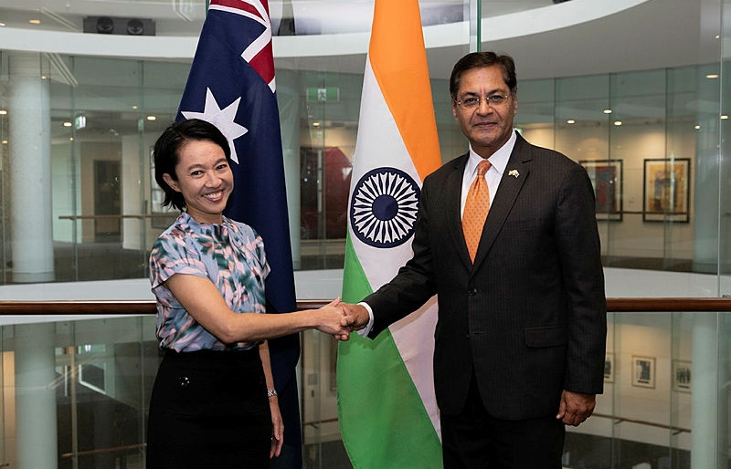

Deputy Secretary Michelle Chan with His Excellency, Manpreet Vohra, High Commissioner of India, on the occasion of the end of his posting to Australia on 7 December 2023. Credit: Alexandra Peek/DFAT.

|  |  |
| --- | --- |
| Performance measure 1 | DFAT’s diplomatic efforts support favourable foreign affairs and trade policy outcomes for Australia |
| Our role | Engage in negotiation and advocacy. |
| PBS Program | 1.1 Foreign Affairs and Trade Operations. |
| Measure type | Qualitative, outcome. |
| Targets  2024–25 to 2027–28 | Five case studies demonstrate performance:   * Upgraded relationships with Vietnam and the Philippines. * Resolution of the trade impediments with China on Australian live rock lobster exports, red meat and oaten hay. * Deliver a Comprehensive Roadmap for Economic Engagement with India. * Advocate for an enduring Australian banking presence in the Pacific, and support the World Bank to develop a regional banking solution. * Implement Year 1 of the France-Australia Roadmap deliverables. |
| Rationale | The work DFAT undertakes to pursue favourable foreign affairs and trade policy outcomes for Australia comprises the strategic pursuit of long-term objectives, as well as unplanned, short and long-term responses to a dynamic operating environment. This work is reliant on representation overseas, ensuring the Australian Government is influential in international decisions that affect Australia.  Measuring influence is difficult, including as to whether DFAT’s efforts can be attributed to favourable outcomes. DFAT will assess its performance by drawing on evaluative techniques to review performance against favourable outcomes, and draw on quantitative data where possible. |
| Methodology | Through an evaluative approach we will seek to understand how effectively we delivered our intended outcomes and how we responded to changes in the operating environment. We will evaluate each topic and look for patterns and lessons across multiple topics as part of continuous improvement across all diplomatic efforts. |
| Data source | A range of primary and secondary sources, including internal reporting cables, briefings, and speeches. Data sources will be different for each topic. |
| Changes from previous year | For 2024–25, five new case studies will be used to demonstrate performance. |

|  |  |
| --- | --- |
| **Performance measure 2** | **Increased number and diversity of Australian university undergraduates with Indo-Pacific capability** |
| **Our role** | Manage the New Colombo Plan (NCP). |
| **PBS Program** | 1.5 New Colombo Plan. |
| **Measure type** | Quantitative, output. |
| **Targets**  **2023–24 to 2026–27[1]**  **and 2024–25 to 2027–28** | 8,000 Australian university undergraduates complete an NCP program to the Indo-Pacific region in 2023–24 and 2024–25[2].  Diversity measures for First Nations[3], disability[4] and regional/remote students[5] are equal to or greater than the broader Australian university undergraduate cohort[6]. |
| **Rationale** | The NCP is an initiative of the Australian Government and aims to lift knowledge of the Indo-Pacific in Australia by supporting Australian undergraduates to undertake study, language training and internships in the Indo-Pacific. The NCP aims to deepen Australia's relationships in the region, at the individual level and through expanding university, business and institutional links. This plays an important role in creating an influential and diverse network of Australians with experience and strong networks across the Indo-Pacific region.  DFAT developed the targets based on previous years completion rates. |
| **Methodology** | Assessment of data submitted as part of the NCP application process and completion reports. For the diversity target, data will be compared with source statistics published by the Department of Education. The rating will be ‘achieved’ if both targets are ‘achieved’, ‘partially achieved’ if one target is ‘not achieved’, and ‘not achieved’ if both targets are ‘not achieved’. |
| **Data sources** | Two IT platforms are used (mobility and scholarship). The data relies on students and universities entering details and self-reporting diversity data. A third-party service provider provides overall data processing, analysis and reporting. There are some known data gaps in reported diversity data however it remains the only available source. A multi-year improvement process to address this is underway. |
| **Changes from previous year** | Targets were revised during the reporting period. For 2024–25, an alternate or adjusted measure and/or targets may be provided during the financial year. |



Flinders University students studying marine biology, animal behaviour, biodiversity and   
conservation had the chance to dive into Palau's ocean-dependent culture for 2 weeks, learning   
about marine environment and conservation efforts through a New Colombo Plan mobility project   
in December 2023. Credit: New Colombo Plan alum Chloe Paterson.

|  |  |
| --- | --- |
| Performance measure 3 | Australia’s standing in the region is enhanced through DFAT’s public diplomacy |
| Our role | Project a positive and contemporary image of Australia. |
| PBS Program | 1.6 Public information services and public diplomacy. |
| Measure type | Qualitative, outcome. |
| Targets  2024–25 to 2027–28 | Case study on implementation of planned first year activities of the Australia-ASEAN Foundation demonstrate performance. |
| Rationale | DFAT projects a positive and contemporary image of Australia internationally and promotes a clear understanding of government policies, objectives and engagement with the Indo-Pacific region through our soft power activities. |
| Methodology | Similar process as for measure 1. We will seek to understand, through an evaluative approach, how effectively we delivered on our intended outcomes, and how we responded to changes in the operating environment. We will look for patterns and lessons across multiple topics, with a view to continuing to improve our performance and risk management across all diplomatic efforts in 2024–25. |
| Data source | A range of primary and secondary sources, including internal reporting cables, briefings, speeches. Data sources will be different for each topic. |
| Changes from previous year | For 2024–25, a new case study will be used to demonstrate performance. |

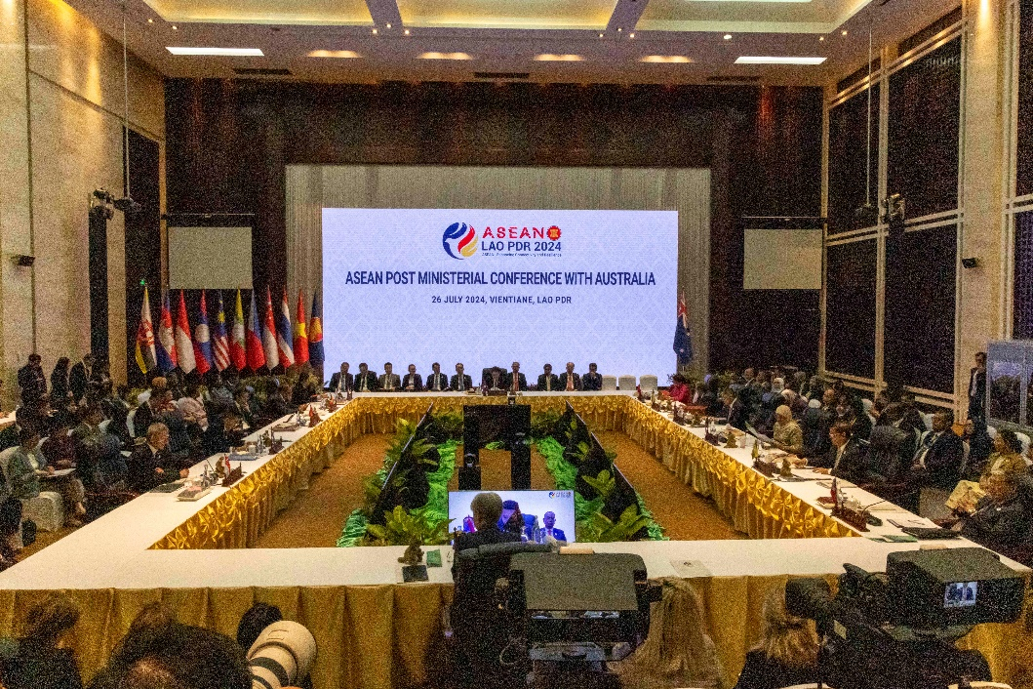  
Senator the Hon Penny Wong, Minister for Foreign Affairs, attends the ASEAN Post Ministerial Conference (PMC) at the National Convention Centre Vientiane, Laos on Friday 26 July, 2024. Credit: Sarah Hodges/DFAT.

|  |  |
| --- | --- |
| Performance measure 4 | Australia's treaty obligations are met under Australia's Comprehensive Safeguards Agreement and Additional Protocol to the satisfaction of the International Atomic Energy Agency (IAEA). |
| Our role | Implement Australia’s international nuclear non-proliferation obligations. |
| PBS Program | 1.8 Nuclear-Powered Submarine Program. |
| Measure type | Qualitative, effectiveness. |
| Target  2024–25 to 2027–28 | The IAEA grants a ‘Broader Conclusion[7]’ for Australia confirming Australia’s compliance with its Comprehensive Safeguards Agreement and Additional Protocol treaty obligations. |
| Rationale | ASNO within DFAT is responsible for ensuring Australia is in compliance with its international treaty obligations. This measure demonstrates Australia’s compliance with its international treaty obligations under the Comprehensive Safeguards Agreement and Additional Protocol, and Australia continues to implement the high non-proliferation standards. Australia has received an IAEA assessment of the ‘Broader Conclusion’ since 2000. |
| Methodology | Compliance will be independently verified by the IAEA. Complying with Australia’s obligations on a quarterly basis is a pre-requisite for achieving the Broader Conclusion rating the following year. |
| Data source | The IAEA Safeguards Statement and its conclusion. ASNO’s Annual Report[8] includes the Safeguards Statement and lists IAEA inspections that occurred in the reporting period. The Safeguards Statement is issued in April/May for the prior calendar year. |
| Changes from previous year | Refinements made to improve measure and target wording. |

Key Activity 2: Deliver international development and humanitarian assistance

DFAT leads the design and delivery of Australia’s international development and humanitarian assistance. The development program supports our national interests by working with our partners to address overlapping challenges facing the region, including climate change, COVID-19 recovery and volatile global economic conditions. DFAT ensures effective and transparent planning, implementation and monitoring and evaluation takes place across a portfolio of approximately one thousand active investments that make up the development program. When a request for assistance is made by a country in the Indo-Pacific in response to humanitarian crises, displacement and conflict, the government provides a response within 48 hours. Long term direction for the development program is set by *Australia’s International Development Policy*. Detail on development program performance will be published in the *Performance of Australian Development Cooperation Report 2024–25*.

We will use one measure to assess our performance over the PBS program related to this key activity. This measure draws on longstanding and embedded systems to assess and report on overall efficiency and effectiveness, in line with international standards.

|  |  |
| --- | --- |
| Performance measure 5 | The development program is effective, efficient and responsive. |
| Our role | Design and deliver Australia’s international development program. |
| PBS Program | 1.2 Official Development Assistance (ODA). |
| Measure type | Quantitative, effectiveness and efficiency. |
| Target  2023–24 to 2026–27[9]  and 2024–25 to 2027–28 | At least 85 per cent of investments are assessed as satisfactory on both effectiveness and efficiency criteria in Investment Monitoring Reports (IMRs)[10] process. |
| Rationale | Development programs with ODA budgets of more than $3 million are required to report on performance through annual IMRs. IMRs are evidence-based assessments that rate investment performance against criteria including effectiveness and efficiency (standard OECD Development Assistance Committee evaluation criteria). DFAT has maintained the 2023–24 target of 85 per cent for both effectiveness and efficiency taking into account a long-term average of between 85 and 90 per cent.  Performance has been reported through the IMR process for over a decade and is core to the International Development Policy. This measure is reflected in the annual Performance of Australian Development Cooperation Report. |
| Methodology | Analysis of annual IMR, Humanitarian Investment Monitoring Report (HIMR) and Final Investment Monitoring Report (FIMR) ratings. |
| Data source | IMRs, HIMRs and FIMRs.[11] |
| Changes from previous year | Minor adjustments were made to the target during the reporting period and will remain in place for the 2024–25 financial year. Previous targets will continue to be tracked through tier 3 indicators of Australia’s [International Development Performance and Delivery Framework](https://www.dfat.gov.au/publications/development/australias-development-policy-performance-and-delivery-framework) and reported annually in the *Performance of Australian Development Cooperation report*. |

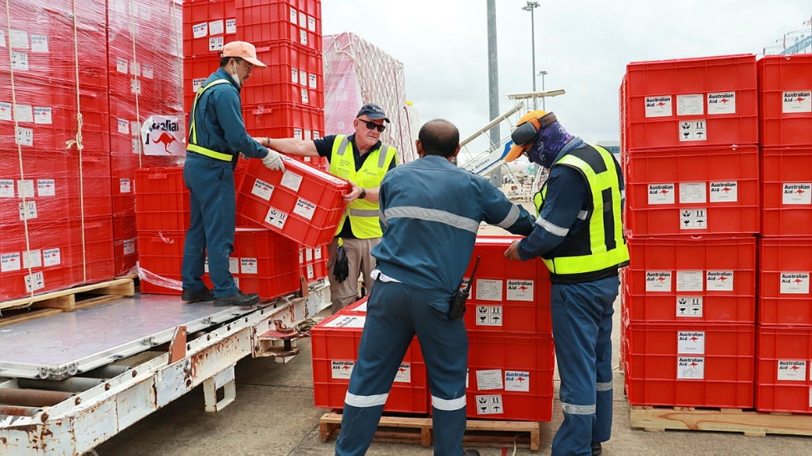  
Vientiane, Laos: The Australian Government pre-positions Australian Aid humanitarian supplies in Laos, through the Australian Humanitarian Logistics Capability. Credit: Skye Out/DFAT.

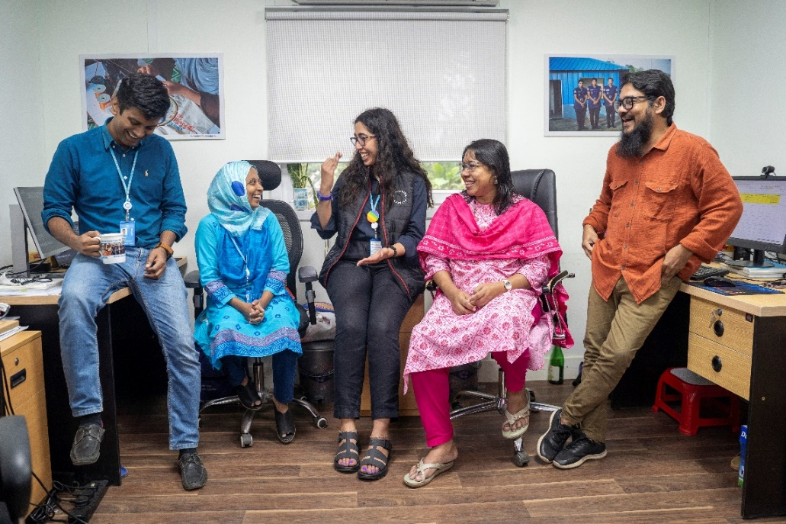

Australia Assists deployee Reem Elmeleegy (middle) is a Gender-Based Violence (GBV) Specialist supporting   
UN Women GBV programming in Rohingya Camps. Credit: Saikat Mojumder/DFAT.



Deputy Secretary Development, Multilateral and Europe Group, Rod Brazier, meets with International Organization For Migration Director General Amy Pope, 28 March 2024. Credit: Michael Godfrey/DFAT.

Key Activity 3: Advocate within multilateral institutions

Within multilateral institutions, including the UN and the WTO, DFAT advocates rules, norms and standards that reflect and advance Australia’s interests and values. We ensure the issues affecting Australia and our region are considered when multilateral institutions address global challenges.

The multilateral development banks (MDBs) provide finance and technical assistance to low-income countries to meet their development goals, contributing to a stronger, safer and more prosperous region. Through our financial contributions to the MDBs, DFAT leverages their expertise, presence and reach, supporting our interests and achieving outcomes that could not be achieved by acting alone. We will use 2 measures to assess our performance over the 2 PBS programs related to this key activity.

|  |  |
| --- | --- |
| Performance measure 6 | Australia’s payments to multilateral development organisations generate collective action on issues impacting Australia |
| Our role | Advocate within multilateral development institutions to generate collective action on issues impacting Australia. |
| PBS Program | 1.3 ODA – Multilateral Replenishments. |
| Measure type | Quantitative, output. |
| Target  2024–25 to 2027–28 | Mandatory payments to multilateral development institutions are paid on time. |
| Rationale | This target reflects Australia’s work negotiating encashment (payment) schedules with the multilateral development banks. The schedules are formalised through financially binding Instruments of Commitment (signed by Australia’s Minister for Foreign Affairs) and Promissory Notes (signed by Australia’s Treasurer). Ensuring payments are made on time, including during times of known domestic budgetary constraints, demonstrates Australia’s financial and political commitment to the multilateral bank system. This reliability enables Australia to advocate more effectively within these organisations. In turn, on-time payments allow multilateral development banks to finance multi-year projects with consistency, in line with expectations of Australia and all donors. |
| Methodology | A review of mandatory payments to multilateral development institutions. Public and Banking holidays may impact transfer or receipt of funds. |
| Data source | Instruments of commitments. |
| Changes from previous year | Nil. |

|  |  |
| --- | --- |
| Performance measure 7 | International organisations reflect Australian interests and values when addressing global challenges |
| Our role | Advocate for Australia’s interests in international organisations. |
| PBS Program | 1.4 Payments to International Organisations. |
| Measure type | Quantitative and qualitative effectiveness. |
| Target  2024–25 to 2027–28 | Three focus areas demonstrate Australia’s influence and engagement in international institutions including: Delivery of planned strategic objectives for United Nations General Assembly (UNGA) High Level Week; election of Australian multilateral candidatures; delivery of the UN Junior Professional Officer (JPO) Program. |
| Rationale | The multilateral system is critical to collective dialogue, collaboration, and inclusive action. Global security, stability and prosperity depend on an effective multilateral system. Australia’s multilateral engagement approach is a whole-of-government strategy for engaging in the multilateral system. Through this framework, DFAT aims to increase Australia’s presence and pursue influence in the system and leverage better outcomes to advance Australia’s national interests. Measuring influence is difficult, including as to whether DFAT’s efforts can be attributed to favourable outcomes. DFAT will therefore assess its performance by focusing on three focus areas that illustrate the multi-faceted approach to having Australian interests and values reflected in international institutions. |
| Methodology | Progress on the three focus areas will be reviewed regularly throughout the 2024‑25 financial year. At the end of the reporting period, we will review the three focus areas to assess the delivery of our intended outcomes. |
| Data source | Feedback from Minister’s office on High Level Week; internal reporting cables and records of conversation, including feedback from other countries and civil society on Australia’s efforts; voting patterns and number of signatories on Australian-led initiatives; election outcomes; JPO program performance framework and metrics; media tracking domestically and internationally. |
| Changes from previous year | The target has been revised in 2024-25 to measure DFAT’s efforts in three focus areas. These focus areas were selected as they directly address DFAT’s efforts related to the performance measure, and can be qualitatively and quantitively measured. |

## Contribution to Outcome 1 made by linked programs

Australia maintains a whole-of-government approach in the pursuit of foreign, trade and investment, tourism, development and international security interests abroad. DFAT is supported by partner agencies in its associated leadership, advocacy and coordination roles at overseas missions. Key partner agencies for DFAT in the delivery of Outcome 1 are: Attorney-General’s Department, Australian Centre for International Agricultural Research, Australian Federal Police, Australian Trade and Investment Commission, Department of Agriculture, Fisheries and Forestry, Department of Defence, Department of Education, Department of Employment and Workplace Relations, Department of Home Affairs, Services Australia, Tourism Australia, Treasury and Export Finance Australia.

Outcome 2: The protection and welfare of Australians abroad and access to secure international travel documentation through timely and responsive travel advice and consular and passport services in Australia and overseas.

Key Activity 4: Deliver consular services

DFAT provides consular services to Australian travellers and Australians overseas in line with our [Consular Services Charter](https://www.smartraveller.gov.au/consular-services/consular-services-charter). Each consular case is unique and the assistance DFAT provides depends on the circumstances and availability of consular resources. DFAT strives to empower Australians to help themselves overseas and deliver a consular service focused on Australians most in need. We provide consular services to Australian citizens and, in certain locations, Canadian citizens as part of the [Canada-Australia Consular Services Sharing Agreement](https://www.smartraveller.gov.au/our-services/consular-services-charter/CACSSA). It is also our role to effectively prepare for and manage overseas crises. In an international crisis, DFAT provides support to Australian citizens and permanent residents. We only assist Australian dual nationals in the country of their other nationality in exceptional circumstances. We will use one measure to assess our performance over the PBS program related to this key activity.

|  |  |
| --- | --- |
| Performance measure 8 | Australians have access to consular information and services, including in  times of crisis |
| Our role | Provide consular services to Australian travellers and Australians overseas. |
| PBS Program | 2.1 Consular Services. |
| Measure type | Quantitative, output. |
| Targets  2024–25 to 2027–28 | 100 per cent of travel advisories reviewed biannually for posts in a volatile risk environment and where there are elevated Australian interests. 100 per cent of travel advisories reviewed annually for all other posts.  A maximum of 2 unplanned Consular Emergency Centre telephony outages greater than 5 minutes per financial year. |
| Rationale | DFAT travel advisories, published on our Smartraveller website, are a primary resource Australians use to obtain information for safe international travel. We review all our travel advisories annually or biannually, according to the safety and security risks of the location and the level of Australian interests. This includes ad-hoc updates to travel advice if risks to Australians have changed.  DFAT provides consular services overseas through our network of embassies, high commissions and consulates. We provide emergency consular assistance 24 hours a day through our Consular Emergency Centre (CEC) in Canberra. After hours, Australians overseas can call the Australian embassy, high commission or consulate in the country they are visiting and follow the phone prompts for connection to the CEC. We have set a target of no more than 2 occurrences per financial year of unplanned CEC telephony outages greater than 5 minutes, based on the importance of ensuring Australians have access to consular information and services, especially in times of crisis. |
| Methodology | A count of travel advisory reviews and CEC telephony outages. The rating will be assessed as ‘achieved’ if both targets are ‘achieved’, ‘partially achieved’ if one target is ‘not achieved’, and ‘not achieved’ if both targets are ‘not achieved’. |
| Data source | Travel advisory reviews and records of CEC telephony outages. |
| Changes from previous year | Nil. |

Key Activity 5: Deliver passport services

DFAT provides access to secure international travel documentation through the delivery of high-quality passport services to Australian citizens domestically and overseas. This is delivered in accordance with the *Australian Passports Act 2005*, related laws and the Convention on International Civil Aviation. We also issue other types of travel documents, for example, Convention Travel Documents, to eligible non-citizens living in Australia. Australia’s diplomatic missions and consulates provide passport services overseas and we provide a phone helpline for customers. The Australian passport is regularly upgraded to protect passport holders’ identity and personal information in line with international best practice. All passports issued in Australia are now R-series, which includes advanced security features to prevent counterfeiting and identity theft. We will use 2 measures to assess our performance over the PBS program related to this key activity.

|  |  |
| --- | --- |
| Performance measure 9 | Australian passports are processed efficiently |
| Our role | Provide passport services in Australia and overseas. |
| PBS Program | 2.2 Passport Services. |
| Measure type | Quantitative, efficiency. |
| Targets  2024–25 to 2027–28 | 95 per cent of passports processed within 10 business days.  98 per cent of priority passports processed within 2 business days. |
| Rationale | Passport applicants choose between a routine or priority service. Priority service attracts a higher fee to support processing applications within 2 business days. This timeframe is set out in the Australian Passports Determination 2015. If the target is not met, a refund may be requested. As of 1 July 2024, a new fast-track (5-day processing) service will be introduced. A new sub-measure will be developed to monitor performance. There is no mandatory timeframe for processing a routine passport applications, however customers expect a timely service. Since 2004-05, DFAT’s target for processing routine passport applications is 10 business days. The ANAO 2024 audit report into the[*Efficiency of the Australian Passport Office*](https://www.anao.gov.au/work/performance-audit/efficiency-of-the-passport-office) confirmed the importance of the passport processing service to Australian citizens and highlighted the challenges of a cost-for-service model of efficiency, given current funding arrangements and the high baseload of fixed costs required to deliver a world-leading passport service. In the interim, this measure draws on timeliness of DFAT processing against expected timeframes as a proxy for efficiency. In 2024–25, the department will improve the evidence base for making financial efficiency assessments. The department will also consider how to more accurately capture the customer experience in end-to-end processing times (for example, considering lodgement and postal service times). The targets accept, despite best efforts, a small number of applications may exceed stated timeframes for reasons that may include case complexity, system outages or high demand periods. |
| Methodology | An analysis of passport processing data. The rating will be assessed as ‘achieved’ if both targets are ‘achieved’, ‘partially achieved’ if one target is ‘not achieved’, and ‘not achieved’ if both targets are ‘not achieved’. |
| Data source | IT platforms data on finalised passport applications. |
| Changes from previous year | Nil. DFAT is undertaking a review of this measure with the intent to provide more meaningful information reflective of user experience[12] and to capture the new fast track (5-day processing) service expected on 1 July 2025. An alternate or adjusted measure and/or targets may be provided during the 2024–25 financial year. |

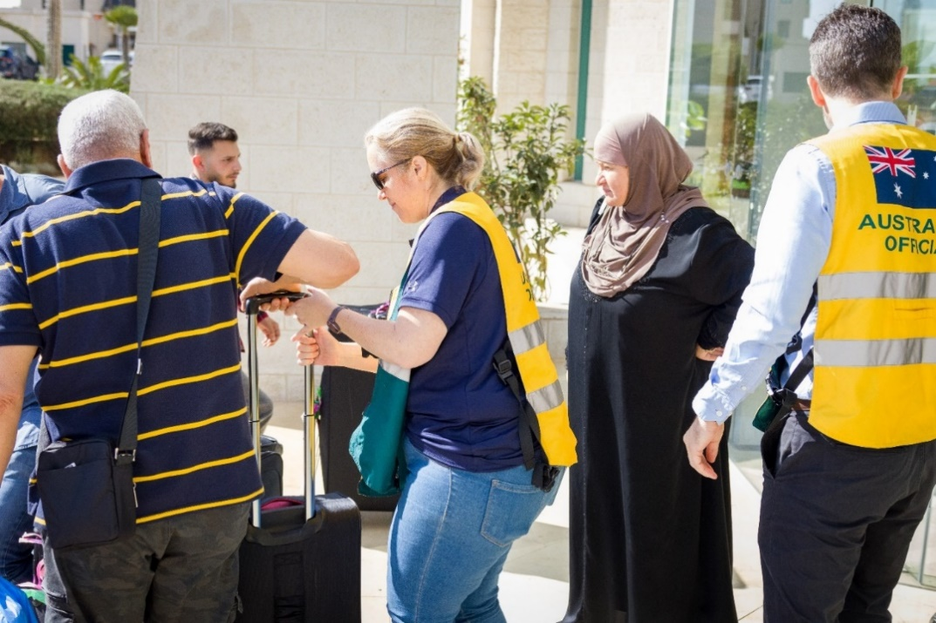

On 17 October 2023, Australian Representative Office in Ramallah staff worked with the Australian Crisis Response Team to perform consular activities. Credit: Nathan Fulton/DFAT.

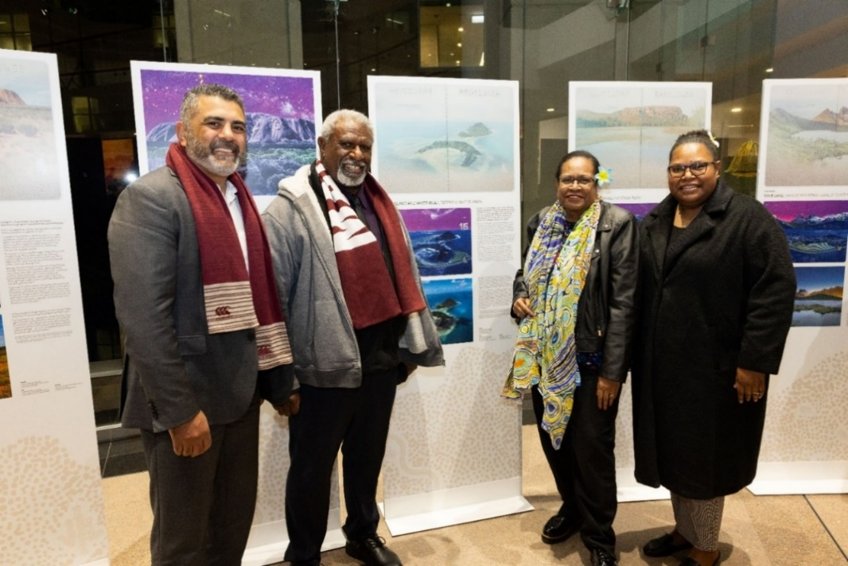

Ambassador for First Nations people Justin Mohamed reviews artwork used for the R-series Passport at the exhibition launch held at the RG Casey Building on 21 July 2023. Credit: Michael Godfrey /DFAT.

## Contribution to Outcome 2 made by linked programs

Services Australia, the Australian Federal Police and the Australian Trade and Investment Commission support DFAT in the delivery of high-quality consular services, including the provision of Australian passport information services and the repatriation of vulnerable Australians. Australia Post provides a nationwide shopfront on behalf of the Australian Passport Office.

|  |  |
| --- | --- |
| Performance measure 10 | Customers are satisfied with passport services |
| Our role | Provide passport services in Australia and overseas. |
| PBS Program | 2.2 Passport Services. |
| Measure type | Quantitative, effectiveness. |
| Target  2024–25 to 2027–28 | 85 per cent satisfaction rate overall from customer surveys. |
| Rationale | The survey asks Australian passport customers how satisfied they were with their experience of engaging with the passport service. Responses reflect performance across all customer engagement channels. The target is informed by customer satisfaction surveys undertaken for over 20 years. Overall customer satisfaction has been a consistent performance measure over this time. |
| Methodology | A monthly customer satisfaction survey conducted by an independent third-party provider. Customers are randomly selected for survey participation, and the overall population of the survey reflects a sample representative of location and application type. Survey design takes into account market survey methodology better practice.  The survey does not capture withdrawn or refused applications. Passports can be refused under circumstances such as incomplete applications submitted. |
| Data source | Responses to the monthly customer satisfaction survey. |
| Changes from previous year | Nil changes to the performance measure or target. However, the methodology for undertaking the survey was adjusted during the 2023–24 financial year to improve frequency of data collection, widen criteria for sampling, and allow options for full or short survey completion in order to improve participation rate. These changes will improve overall reliability of the results. |

**

On 16 October 2023, Australian Embassy staff in Tel Aviv, Israel with the   
Australian Crisis Response Team perform passport services. Credit: Maree Fay/ DFAT.

Outcome 3: A secure Australian Government presence overseas through the provision of security services and information and communications technology infrastructure, and the management of the   
Commonwealth’s overseas property estate.

Key Activity 6: Manage the Australian Government’s overseas network

|  |  |
| --- | --- |
| Performance measure 11 | Australian Government staff, information and assets overseas are protected through appropriate risk-focused security measures |
| Our role | Provide protective security measures for the overseas network. |
| PBS Program | 3.1 Foreign Affairs and Trade Security and IT. |
| Measure type | Qualitative, effectiveness. |
| Targets  2023–2024 to 2026–2713and  2024–25 to 2027–28 | DFAT achieves the set security performance standards across a majority of its posts in the areas of compliance, culture and responsiveness to incidents. |
| Rationale | A secure overseas presence enables the department to deliver its functions overseas, as part of its core business of making Australia stronger, safer and more prosperous. |
| Methodology | Ongoing assessments of compliance, culture and responsiveness to incidents for each of DFATs overseas posts.[13] |
| Data source | Data collected for each post on compliance with security, culture and responsiveness to incidents. |
| Changes from previous year | The target and methodology were revised during the reporting period.[14] |

In 116 posts overseas, DFAT is the lead agency in ensuring a consistent and efficient use of government resources for all agencies represented. This includes providing security services and information and communications technology infrastructure for our overseas network and management of the Commonwealth’s overseas property estate through DFATs Overseas Property Office (OPO) and its contracted service provider. We will use 2 measures to assess our performance over the 2 PBS programs related to this key activity.

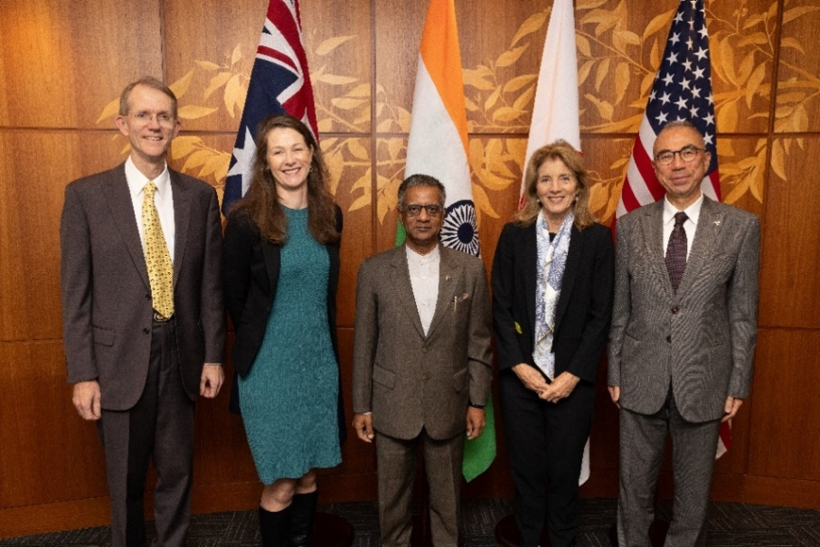

Deputy Secretary Elly Lawson and Deputy Secretary Graham Fletcher PM&C hosted her Excellency Caroline Kennedy, Ambassador of the United States of America, his Excellency Gopal Baglay, High Commissioner of India, his Excellency Suzuki Kazuhiro, Ambassador of Japan in Canberra on 8 May 2024. Credit: DFAT.

|  |  |
| --- | --- |
| Performance measure 12 | The overseas property estate is effectively maintained and fit-for-purpose |
| Our role | Manage the overseas estate. |
| PBS Program | 3.2 Overseas Property. |
| Measure type | Quantitative, output. |
| Target  2024–25 to 2027–28 | At least 80 per cent satisfaction rating with the performance of the outsourced property service provider and OPO.[15]  Annual reinvestment in the DFAT portfolio of a minimum of 2 per cent of the Building Asset Value.  At least 90 per cent of the owned property estate ‘Planned and Preventative Maintenance program’ is completed as per the agreed schedule. |
| Rationale | An effective and fit-for-purpose overseas property estate enables Australian Government diplomatic operations. Satisfaction ratings are a sound measure of whether OPO and its contracted service provider are effectively maintaining the overseas estate to enable Australian Government operations. An 80 per cent satisfaction rating was set on the basis of previous survey results.  An appropriate level of reinvestment in the overseas property portfolio indicates DFAT is maintaining capability of its property infrastructure to enable safe, secure and effective delivery of diplomatic operations overseas. The 2 per cent measure represents the depreciation rate of building assets with an expected life of  50 years. This measures DFAT’s investment in the estate.  Completion of the Planned and Preventative Maintenance program for the owned estate supports ongoing infrastructure capability. Completion of the program ensures buildings operate at optimum efficiency, extending lifespan of equipment and prevents degradation and failure. While striving to complete the program annually, the 90 per cent target accepts a small number of project elements may not be completed each year. |
| Methodology | An annual client satisfaction survey conducted by an independent third-party service provider, annual independent valuation program of real property assets and annual completion rate of the planned and preventative maintenance program. The rating will be assessed as ‘achieved’ if all targets are ‘achieved’, ‘partially achieved’ if two targets are ‘achieved’, and ‘not achieved’ if one target is ‘achieved’. |
| Data source | Responses to the annual customer satisfaction survey, external independent property valuation reports, expenditure data and records of maintenance workorders from external service provider. |
| Changes from previous year | The methodology was revised to clarify performance ratings. |

.

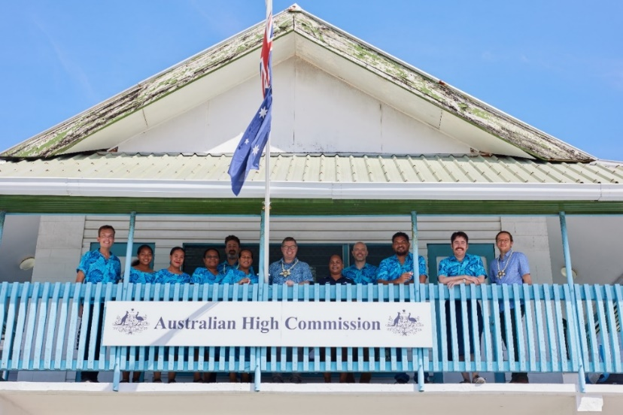

Minister Conroy with Australian High Commission and Office of the Pacific staff at the Australian Chancery in Funafuti, Tuvalu on 30 August 2023. Credit: Samuel Phelps/DFAT.

# Compliance with PGPA Rule s16E(2)

| Topic | Matters to be included | Page |
| --- | --- | --- |
| **Introduction** | The following:  a. a statement that the plan is prepared for paragraph 35(1)(b) of the Act  b. the reporting period for which the plan is prepared  c. the reporting periods covered by the plan. | 7 |
| **Purpose** | The purpose of the entity. | 5, 9, 19 |
| **Key Activities** | For the entire period covered by the plan, the key activities that the entity will undertake in order to achieve its purposes. | 21, 27, 29, 32, 36 |
| **Operating context** | For the entire period covered by the plan, the following:  a. the environment in which the entity will operate;  b. the strategies and plans the entity will implement to have the capability it needs to undertake its key activities and achieve its purposes;  c. a summary of the risk oversight and management systems of the entity, and the key risks that the entity will manage and how those risks will be managed;  d. details of any organisation or body that will make a significant contribution towards achieving the entity’s purposes through cooperation with the entity, including how that cooperation will help achieve those purposes;  e. how any subsidiary of the entity will contribute to achieving the entity’s purpose. | 10–12  12–14  17–18  8, 14, 31, 34  N/A |
| **Performance** | For each reporting period covered by the plan, details of how the entity’s performance in achieving the entity’s purposes will be measured and assessed through:  a. specified performance measures for the entity that meet the requirements of section 16EA; and  b. specified targets for each of those performance measures for which it is reasonably practicable to set a target. | 21–37  21–37 |

# Appendix A: Table of Revisions for 2023–24 Corporate Plan to the 2024–25 Corporate Plan

This table sets out the key performance measure revisions from the 2023–24 Corporate Plan to the 2024–25 Corporate Plan. As noted in the 2024–25 Portfolio Budget Statements, PM1, PM2, PM3, PM7 and PM9 will likely be updated during the 2024–25 reporting period. PM2 and PM7 underwent initial revisions in time for Corporate Plan publication, which are included in the table below. All other revisions anticipated to take place mid-cycle will be updated in accordance with advice from the Department of Finance and the ANAO. These anticipated revisions are noted in the relevant table for each performance measure.

| **PBS information** | **Relevant performance information from DFAT’s  2023–24 Corporate Plan** | **Change** | **Performance information revisions in DFAT’s 2024–25 Corporate Plan[16]** | **Rationale for changes** |
| --- | --- | --- | --- | --- |
| PBS outcome 1, program 1.1,  Key activity 1 | **Measure 1**  DFAT’s diplomatic efforts support favourable foreign affairs and trade policy outcomes for Australia.  **Planned Performance Results**  Case studies demonstrate performance | **Amended** | **Measure 1**  DFAT’s diplomatic efforts support favourable foreign affairs and trade policy outcomes for Australia.  **Targets**[17]  **•** Five case studies demonstrate performance: upgraded relationships with Vietnam and the Philippines; resolution of the trade impediments with China on Australian live rock lobster exports, red meat and oaten hay; deliver a Comprehensive Roadmap for Economic Engagement with India; advocate for an enduring Australian banking presence in the Pacific and support the World Bank to develop a regional banking solutions; implement Year 1 of the France-Australia Roadmap deliverable. | * Case studies identified for the reporting period |
| PBS outcome 1, program 1.1,  Key activity 1 | **Measure 2**   * DFAT’s ministers are satisfied with the advice and support provided by the department.   **Planned Performance Results**   * Maintain satisfaction levels  above 85%. | **Removed** | **N/A** | * Measure removed for 2024–25 and ongoing. The department seeks out regular feedback from its portfolio ministers, so this measure is removed to avoid duplication of departmental efforts. |
| PBS outcome 1, program 1.5  Key activity 1 | **Measure 3**   * Increased number and diversity of Australian university undergraduates with Indo-Pacific capability.   **Planned Performance Results**   * Number of Australian university undergraduates who complete an New Colombo Plan (NCP) program in the Indo-Pacific region. * Diversity of Australian university undergraduates who complete an NCP program in the Indo-Pacific region. | **Amended** | **Measure 2**   * Increased number and diversity of Australian university undergraduates with Indo-Pacific capability.   **Targets**   * 8,000 Australian university undergraduates complete an NCP program to the Indo-Pacific region in 2023–24 and 2024–25. * Diversity measures for First Nations[18], disability[19] and regional/remote students[20] are equal to or greater than the broader Australian university undergraduate cohort.[21] | * Targets were revised during the 2023–24 reporting period to better reflect the intent and performance of the NCP and to strengthen alignment with the PGPA Rule. * For 2024–25 an alternate or adjusted measure and/or targets may be provided during the financial year. |
| PBS outcome 1, program 1.8  Key activity 1 | **Measure 5**   * Australia’s treaty obligations are met under Australia’s Comprehensive Safeguards Agreement and Additional Protocol with the IAEA.   **Planned Performance Results**   * All IAEA reporting obligations are met and IAEA inspections supported to demonstrate Australia’s compliance with its obligations. | **Amended** | **Measure 4**   * Australia's treaty obligations are met under Australia's Comprehensive Safeguards Agreement and Additional Protocol to the satisfaction of the IAEA.   **Targets**   * The IAEA grants a ‘broader conclusion’ for Australia confirming Australia’s compliance with its Comprehensive Safeguards Agreement and Additional Protocol treaty obligations. | * Refinements made to measure and target wording for 2024–25 to improve clarity of intent. |
| PBS outcome 1, program 1.2  Key activity 2 | **Measure 6**   * The development program is effective, efficient and responsive.   **Planned Performance Results**   * At least 85 per cent of investments are assessed as satisfactory on both effectiveness and efficiency criteria in the Investment Monitoring Reporting process. * At least 80 per cent of investments are effective in addressing gender equality. * At least 70 per cent of completed investments are assessed as satisfactory on both effectiveness and efficiency criteria in the Final Investment Monitoring Reporting process. | **Amended** | **Measure 5**   * The development program is effective, efficient and responsive.   **Targets**   * At least 85 per cent of investments are assessed as satisfactory on both effectiveness and efficiency criteria in Investment Monitoring Reports process. | * Adjustments were made to the targets during the 2023–24 reporting period to better reflect the intent and performance of the development program. * Revised targets will remain in place for  2024–25. * The previous targets continue to be tracked through tier 3 indicators of Australia’s International Development Performance and Delivery Framework and reported annually in the *Performance of Australian Development Cooperation report*. |
| PBS outcome 1, program 1.4, key activity 3 | **Measure 8**   * International organisations reflect Australian interests and values when addressing global challenges.   **Planned Performance Results**   * At least one Australian-led activity per year involving a senior government representative in or related to a relevant multilateral forum on UN reform, WTO reform, First Nations, peace and security, and human rights. | **Amended** | **Measure 7**   * International organisations reflect Australian interests and values when addressing global challenges.   **Target**   * Three focus areas demonstrate Australia’s influence and engagement in international institutions including: Delivery of planned strategic objectives for United Nations General Assembly (UNGA) High Level Week; election of Australian multilateral candidatures; delivery of the UN Junior Professional Officer (JPO) Program. | * Targets were revised during the 2024–25 reporting period to better reflect the intent and performance of the program of work and to strengthen alignment with the PGPA Rule. |
| PBS outcome 3, program 3.1  Key activity 6 | **Measure 12**   * Australian Government staff, information and assets overseas are protected through appropriate risk-focused security measures.   **Planned Performance Results**   * DFAT meets or exceeds the Australian Government protective security standards across governance, personnel, physical and information security. | **Amended** | **Measure 11**   * Australian Government staff, information and assets overseas are protected through appropriate risk-focused security measures.   **Targets**   * DFAT achieves the set security performance standards across a majority of its posts in the areas of compliance, culture and responsiveness to incidents. | * Targets were revised during the 2023–24 reporting period to better reflect the intent and performance of the program of work and to strengthen alignment with the PGPA Rule. * The revised targets will remain in place for  2024–25. |

1. This target is updated from the DFAT Corporate Plan 2023–24, following a review of the measure and targets. This changed was flagged in DFAT’s Portfolio Budget Statement 2024–25.
2. Target of 8,000 Australian university undergraduates complete an NCP program to the Indo-Pacific region is per financial year.
3. A person of Aboriginal and/or Torres Strait Islander heritage who identifies as an Aboriginal and/or Torres Strait Islander and is accepted as such by the community in which they live, or formerly lived.
4. Any limitation, restriction or impairment which restricts everyday activities or assistance is required and has lasted or is likely to last for at least 6 months.
5. A region designated as regional or remote by the Australian Bureau of Statistics Australian Statistical Geography Standard.
6. Diversity measure targets: First Nations: 2.1%, Disability: 11.4%, and Regional/remote: 18.0%. This is the most recent comparable national data, dated 2022.
7. The IAEA can draw the ‘Broader Conclusion’ for a State as a whole that ‘all nuclear material remains in peaceful activities’. This is a more fulsome assessment for a State than ‘declared nuclear material remain in peaceful activities.’
8. The Director General of ASNO reports directly to the Minister for Foreign Affairs and presents a standalone Annual Report on ASNO’s operations to Parliament each year.
9. This target is updated from the DFAT Corporate Plan 2023–24, following a review of the measure and targets. This changed was flagged in DFAT’s Portfolio Budget Statement 2024–25.
10. Target covers 3 types of IMRs including a standard IMR report (IMR), a humanitarian response report (HIMR) and a report completed in the final year of implementation of an investment (FIMR).
11. *For more detail see* [*Australia’s International Development Performance and Delivery Framework*](https://www.dfat.gov.au/publications/development/australias-development-policy-performance-and-delivery-framework)
12. This is part of DFAT’s management response to the ANAO 2024 audit of the [Efficiency of the Australian Passport Office](https://www.anao.gov.au/work/performance-audit/efficiency-of-the-passport-office).
13. Further information on methodology is held at the secure classification.
14. See Appendix A for more information on the revisions.
15. The Overseas Property Office is a function within DFAT.
16. Performance Measures PM1, PM2, PM3, PM7 and PM9 are under review and an alternate or adjusted measure and/or targets may be provided during the 2024–25 financial year.
17. Wording change from Planned Performance Results to Targets for 2024–25.
18. A person of Aboriginal and/or Torres Strait Islander heritage who identifies as an Aboriginal and/or Torres Strait Islander and is accepted as such by the community in which they live, or formerly lived.
19. Any limitation, restriction or impairment which restricts everyday activities or assistance is required and has lasted or is likely to last for at least 6 months.
20. A region designated as regional or remote by the Australian Bureau of Statistics Australian Statistical Geography Standard.
21. Diversity measure targets: First Nations: 2.1%, Disability: 11.4%, and Regional/remote: 18.0%.