Australia’s Climate Finance 2020-2025
March 2026

Contents
Australia’s Climate Finance 2020-2025 1
Contents 2
Australia’s Climate Finance 2020-2025 3
Climate finance 3
Australia’s annual climate finance actuals by funding modality 2020–2025* 3
Australia’s total climate finance by geographic region 2020–2025 4
Pacific 5
Australia’s climate finance to the Pacific 2020–2025 5
Southeast Asia 7
Australia’s climate finance to Southeast Asia 2020–2025 7
Global 8
Multilateral climate funds 8
International financial architecture and MDB reform 8
Integrating climate change into our development program 9
Australia’s new programming in 2024–25 by climate objective* 9
Australia’s climate finance statistics 2020–2025 10
Australia’s climate finance provided and mobilised 2020–2025 10
Australia’s climate finance provided and mobilised to the Pacific 2020–2025* 10

Australia’s Climate Finance
The Australian Government is taking strong action on climate change at home and internationally, because no one country can solve these problems alone. Australia delivered $3.9 billion in climate finance from 2020 to 2025.
Climate change remains a foremost concern of our Indo‑Pacific partners and is the single greatest threat to the livelihoods, security, and well‑being of Pacific peoples. Climate change is a threat multiplier in exacerbating resource scarcity – causing water and energy shortages, disrupting trade and creating economic stress, increasing risks of pandemics and displacement, and reversing hard won development gains.
We have listened to the Pacific's call for urgent action and are working closely together to address the climate emergency. We met our commitment to provide $1.3 billion climate finance to the Pacific, the majority for adaptation.
In 2024–25, Australia’s investments improved adaptation to climate change and resilience to disasters for over 2.8 million people. Thirty‑five investments valued over $508 million contributed to low‑emissions development pathways or supported mitigation activities; and 64 investments totaling $502 million are improving climate change adaptation and disaster resilience.

Climate finance
- $3.9 billion climate finance provided between 2020–25
- 79% delivered through Official Development Assistance
- 59% delivered to support countries adapt to climate change
From 2020 to 2025, Australia delivered $3.9 billion in climate finance.
Australia provides high-quality and effective climate finance that responds to the needs of our development partners. We use a range of mechanisms, and work through trusted partners, to maximise impact and scale.
In the Pacific, we prioritise grant-based funding for adaptation, and we leverage additional finance to support mitigation efforts in Southeast Asia.

Australia’s annual climate finance actuals by funding modality 2020–2025*
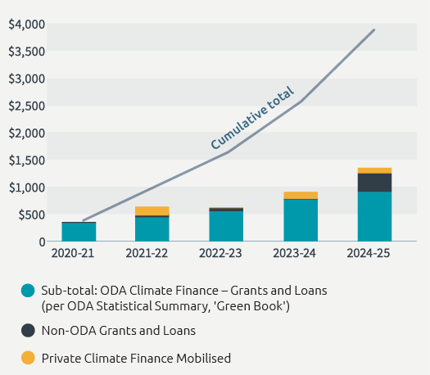
*The 2024–25 total includes ODA climate finance ($918.2 million), private climate finance mobilised ($102.6 million) and non-ODA grants and loans ($335.1 million).

Australia’s total climate finance by geographic region 2020–2025
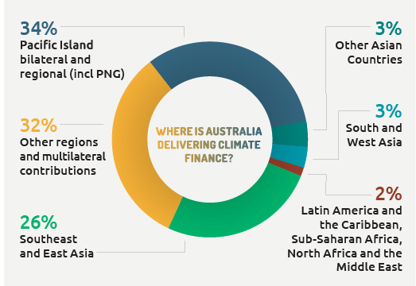
*Includes ODA and non-ODA grants and loans, and private finance mobilised.

Pacific
- $1.3 billion in climate finance
- 96% delivered through grants
- 75% towards climate adaptation to the Pacific
Australia met our commitment to provide $1.3 billion climate finance to Pacific island countries between 2020 and 2025. This reflects the impacts of climate change to the region and the priority we place on climate cooperation with our Pacific partners.
Since 2020, Australia has achieved a dramatic uplift in the climate finance provided to the Pacific region. The region received 42 per cent of our climate finance, principally to support countries adapt to the effects of climate change.

Australia’s climate finance to the Pacific 2020–2025
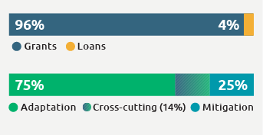
CASE STUDY: REnew Pacific
REnew Pacific is the Australian Government’s $75 million investment in off-grid renewable energy for rural and remote communities across the Pacific and Timor-Leste. The program provides grants to develop off-grid renewable energy systems, bringing reliable power – sometimes for the first time – to remote schools, healthcare facilities, water and agricultural systems.
In Vanuatu, the program equipped remote health facilities with reliable solar power, improving health care for more than 80,000 people. Delivered in partnership with the National Green Energy Fund, the project installed 20 new off-grid solar systems and refurbished 20 more across all six provinces. The systems will ensure vital medical equipment can operate when needed, saving lives, reducing the need for patients to be referred long distances, and enabling safer deliveries for mothers and newborns

CASE STUDY: Pacific Atoll Food Futures
Growing food on coral atoll islands is challenging. Poor soil, limited land and fresh water, and saltwater intrusion – all elements that are exacerbated by climate change – force communities to rely on imported, processed foods that are often less nutritious, more expensive and with a higher carbon footprint.
The Atoll Food Futures project, implemented in Kiribati, Tuvalu and Fiji, introduced a range of garden beds adapted to local conditions, including raised wicking beds and container gardens. These use less water and better protect against saltwater intrusion.
Of the 4,550 participants, 94 per cent reported growing more fresh food. Regular fruit and vegetable consumption increased from 27 per cent to 88 per cent, and half of participating households earned extra income from selling surplus produce.

CASE STUDY: Tropical Cyclone Yasa Recovery Program
In 2020, Tropical Cyclone Yasa caused extensive damage across Fiji in the northern island of Vanua Levu. Schools were severely affected, with some classrooms damaged beyond repair and students forced to study in tents.
Australia supported the Fiji Government to reconstruct 9 schools – totaling 25 classrooms, attended by 1,500 children. Building back better, reconstruction featured covered walkways, ventilation, solar panels, rainwater harvesting systems and improved water and gender sensitive hygiene systems – with all bathroom amenities complete with access ramps. To safeguard communities, each school had a building constructed to category 5 cyclone standards to be an evacuation centre in the future. Communities were consulted, including women, in the design process.
With classrooms restored, school attendance and academic results improved. The project also boosted the local economy, with materials sourced within Fiji, creating over 300 jobs.

Southeast Asia
- $997.1 million in climate finance to Southeast Asia
- 39% delivered through loans, equity and private finance mobilised
- 60% towards climate mitigation
In Southeast Asia, Australia provided $997.1 million* in climate finance between 2020-25 – 58 per cent of which was through grants.
Nearly half of the climate finance provided and mobilised is through development finance mechanisms – including equity, loans and blended finance – responding to the region’s demand for greater private climate investment.
We are partnering with the region on its clean energy transition and helping strengthen the region’s resilience to climate change, particularly in the Mekong subregion.
*Comprising $603.3 million grants, $160.8 million loans, and $233.0 million private finance mobilised.

Australia’s climate finance to Southeast Asia 2020–2025
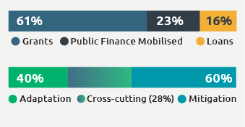
CASE STUDY: Efforts to encourage private sector investment
Australian Development Investments (ADI) – Australia’s AUD250 million impact investment ‘fund of funds’ – is helping accelerate Southeast Asia’s energy transition and meet climate opportunities and challenges.
ADI makes early-stage and concessional investments into impact investment funds. These funds provide financing to small and medium enterprises that deliver climate outcomes for the region. To date, with AUD51.5 million worth of investments, ADI has mobilised over AUD180 million of private capital to support development and climate impact. For every dollar invested by ADI, AUD3.50 has been mobilised from private investors.
ADI’s USD3.0 million (~AUD4.5 million) equity investment helped de-risk Clime Capital’s Southeast Asia Clean Energy Fund II to mobilise AUD75 million in private investment, like clean energy projects, scalable businesses delivering solar, wind power, energy storage and electric mobility.

Global

Multilateral climate funds

Pacific Resilience Facility
We will provide an anchor investment of $100 million in the Pacific Resilience Facility, a Pacific-owned and Pacific-led mechanism supporting vulnerable Pacific people exposed to climate change and disaster risks.

Green Climate Fund
We rejoined the Green Climate Fund with a $50 million contribution. We are improving access to finance for Small Island Developing States, particularly the Pacific, with 2025 seeing a five-fold increase in approved Pacific projects.

Fund for responding to Loss and Damage
We are contributing $50 million to the Fund for responding to Loss and Damage, which helps vulnerable communities recover from climate-related losses and damage resulting from incidents such as climate-induced extreme weather events, rising sea levels, and other climate-induced crises.

Global Environment Facility
We are a founding member of the Global Environment Facility, which addresses climate change, biodiversity loss, and land and ocean health. We contributed $80 million in the last replenishment.

International financial architecture and MDB reform
- We advocated for the World Bank to commit 45% of its annual financing to address climate challenges.
- We committed to offer Climate Resilient Debt Clauses in our sovereign loans by the end of 2025.
- We guaranteed USD200 million of the Asian Development Bank's lending to support climate action as part of the Innovative Financing Facility for Climate in Asia and the Pacific.
- We influenced the Asian Development Fund to allocate USD436 million to adaptation and disaster risk reduction, benefiting Pacific small island developing states.
- We ensured the Pacific is able to access more climate finance, embedding climate finance experts in Pacific island countries.
CASE STUDY: Green Climate Fund and the Tuvalu Coastal Adaptation Project
The Green Climate Fund (GCF) is the world’s largest dedicated climate fund. Australia rejoined the GCF in 2023, with the aim of being able to better advocate for improved access to GCF funding, particularly for the Pacific.
Since Australia’s re-engagement, annual Pacific project approvals have grown significantly, with 2025 seeing a five-fold increase in approved Pacific projects compared to the average over the previous 5 years, to over USD266 million – representing 8 per cent of total GCF global approvals.
For example, the GCF is co-funding the Tuvalu Coastal Adaptation Project (TCAP) with the Government of Tuvalu and Australia. TCAP is a leading example of how global climate finance can provide lifesaving resilience for the Pacific. With escalating risks from sea-level rise, storm surges and rapid coastal erosion, Tuvalu faces existential threats to homes, livelihoods and government services.
TCAP is helping build sea walls, reclaim land and reinforce coastal embankments to safeguard homes, schools, hospitals and transport links from climate risks. More than 60 per cent of Tuvalu’s population will benefit from the program.

Integrating climate change into our development program
- 48% of investments included a climate objective*
Climate action is a key pillar of our international development program because climate change has an impact on all development outcomes.
Australia’s International Development Policy drives our climate integration commitment to incorporate a climate objective in at least 50 per cent of all new bilateral and regional investments valued over $3 million in 2024–25. This goal increases to 80 per cent by 2028–29.
In 2024–25, 48 per cent of new investments in our international development program helped our partners to tackle climate change, including building resilience to climate impacts and disasters, and adopting clean energy and low emissions technologies.
Priorities for Australia's development assistance are identified jointly with our partners, ensuring our efforts add value to a country's national development plans, including their Nationally Determined Contributions and National Adaptation Plans under the Paris Agreement.
Through our elevated commitment to regional and global climate action, Australia is increasing the value of our climate finance and embedding climate objectives in more investments – and more sectors – across our development portfolio. Our renewed investment is delivering effective results and lasting change against the impact on climate change.
Gender inequality also intensifies climate risk, as existing inequalities – such as unequal access to land, finance, and decision-making – mean that women are often less equipped to adapt to climate change. Gender equality is not a peripheral concern – it is a solution multiplier that strengthens climate action, improves policy outcomes, and delivers more effective climate finance.

Australia’s new programming in 2024–25 by climate objective*
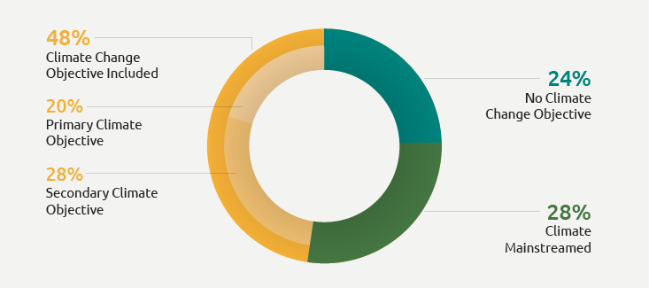
*Includes new regional and bilateral investments of over $3 million only

Australia’s climate finance statistics 2020–2025

Australia’s climate finance provided and mobilised 2020–2025
Region and type of flow | 2020-21 ($m) | 2021-22($m) | 2022-23 ($m) | 2023-24 ($m) | 2024-25 ($m) | Total ($m)
Pacific Islands bilateral and regional (includes PNG) | 166 | 223.7 | 265.9 | 334.2 | 304.2 | 1293.9
Southeast and East Asia | 44.4 | 56.5 | 132.4 | 156.2 | 212.8 | 602.3
South and West Asia | 10.9 | 13.2 | 21.3 | 33.1 | 19.4 | 97.9
Other Asia | 13.4 | 33.8 | 10 | 9.6 | 68.2 | 135.1
Sub-Saharan Africa | 7.3 | 9.5 | 11.8 | 12.2 | 14.5 | 55.3
North Africa and Middle East | 0.3 | 0.9 | 0.9 | 1.3 | 3.6 | 6.9
Latin America and the Caribbean | 0 | 0.1 | 0.1 | 0.1 | 0 | 0.3
‘Other’: unallocated global programs | 104 | 111.4 | 128.7 | 235.9 | 295.6 | 875.6
Sub-total: ODA Climate Finance - Grants and Loans (per ODA Statistical Summary, 'Green Book') | 346.3 | 449.2 | 571.1 | 782.6 | 918.2 | 3067.4
Non-ODA Grants and Loans | 2.4 | 64.8 | 41.6 | 3.3 | 335.1 | 447.2
Private Climate Finance Mobilised | 0 | 126.2 | 6.5 | 126.4 | 102.6 | 361.6
Sub-total: Other Climate Finance | 2.4 | 191 | 48 | 129.7 | 437.7 | 808.8
Total Climate Finance Provided and Mobilised | 348.7 | 640.2 | 619.1 | 912.3 | 1,355.90 | 3,876.20
Cumulative total | 348.7 | 988.9 | 1,608.10 | 2,520.40 | 3,876.30 | -

Australia’s climate finance provided and mobilised to the Pacific 2020–2025*
Region and type of flow | 2020-21 ($m) | 2021-22($m) | 2022-23 ($m) | 2023-24 ($m) | 2024-25 ($m)
Pacific Islands (includes PNG) | 166 | 242.4 | 264 | 334.8 | 305
Cumulative total | 166 | 408.5 | 672.5 | 1,007.30 | 1,312.30
*Includes both ODA and non-ODA finance

