ATTACHMENT 3: Revised Program Logic

The focus of the Transport Sector Support Program Phase 2 (TSSP2) is represented by the revised program logic agreed in June 2019, and priorities:

**Picture 1: End of Program Goal and Outcomes**

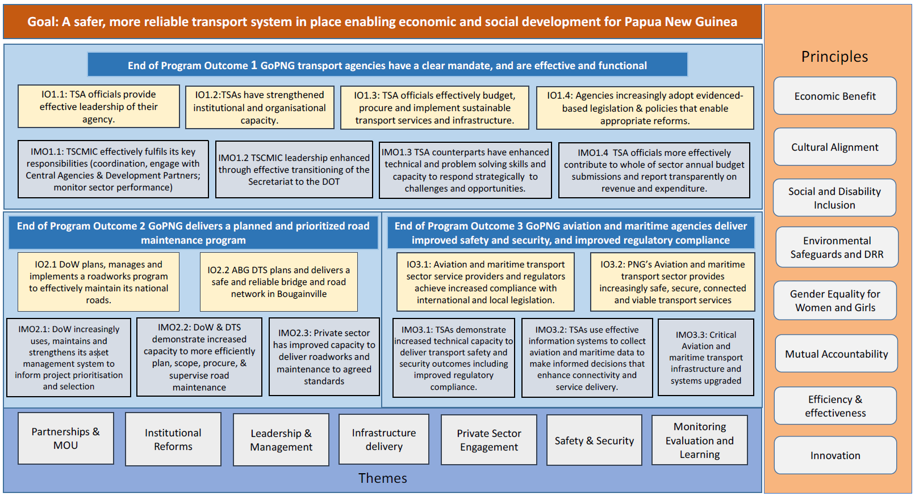

**Priorities**

| **Priorities for 2021** | **Expected outputs** | **Expected outcomes** |
| --- | --- | --- |
| **EOPO Outcome 1** |  |  |
| **(1) Support institutional and governance reforms in the broader transport sector, and specified agencies**  Relevance to GoPNG Priorities:   * MTTP2, NTS, ASAs, MTDP III * Support to the GoPNG *Non-Citizen Technical Advisor Act* through implementation of the Capacity Development Framework. * The ASAs provide detailed plans on the institutional and governance reforms as agreed with each specific agency aligned to GoPNG priorities and agency corporate plans. This directly supports the Government’s road sector reform program set out in the National Road Network Strategy, PNG Connect, the *Road (Management and Fund) Act 2020*, and the DoW Corporate Plan. | * TSCMIC transitioned to DoT. * Policy development framework collaboratively designed and implemented across the sector. * Leadership and management development. * Human resource capacity development through various professional development programs including mentoring and coaching. * Support to revenue generation in aviation. * Demarcation in the maritime sub-sector. * Establishment of the PNG Road Fund. * RUC Implementation Strategy and RUC Collection Agency Agreements. * Other appropriate road regulations under the Act. * Establishment of the Road Advisory Committee to advise the Minister and NEC on the declaration, classification and decommissioning of public roads and other related matters. * Department of Works and Highways to function as the sole national road authority until the PNG Highways Authority is established. * Transport Sector Funding Study socialised to appropriate audience. | * DoT improved capability to manage PNG sector holistically as well as domestic and international stakeholders. * Increase in agency-led capacity development projects and activities. * Policy and legislative reform aligned to international and national obligations and priorities. * More effective funding systems for the aviation sector and road maintenance progressively established. * Increase in national and international compliance in aviation and maritime subsectors. * More effective contemporary road management system by clearly demarcating the roles and responsibilities of the key agencies in the road sub-sector. * Empowered national, provincial and district authorities to act as road authorities. * Improved governance across the sector. * Sector revenue access and generation improved. |
| **(2) Ensure safeguards are mainstreamed in all components of TSSP2, including GESI and ECCDR safeguards across the agencies.**  Relevance to GoPNG Priorities:   * National Public Service Gender Equity and Social Inclusion Policy. * Environmental Safeguards, Climate change and Disaster Resilience policy development   and mainstreaming. | * Five partner agencies have internal GESI policy developed by key counterparts. * Five partner agencies have international, regional, and national policies and strategies embedded and aligned into the internal policy developed. * Safeguards Networks established across the sector for GESI and ECCDR. | * Key counterparts understand international, regional, national, and sectoral policy requirements to ensure alignment in the policy that is developed. * Key counterparts can review and critic GESI and ECCDR policies for improvement. * Innovation in sector approaches mainstreamed. |
| **(3) Strengthen the functionality of the Transport Sector Networks including Communications Network, Leadership, Gender, Environment**  Relevance to GoPNG Priorities:   * TSAs have strengthened institutional and organisational capacity. | * Key professional streams including leadership, gender, aviation working group within the sector will organise and attend professional networks. * TSCN counterparts will assume the Chair of the bi-monthly TSCN meetings. * TSCN will coordinate media and public relations to promote an understanding of the transport sector within the broader PNG community. * Support participation in extant global Women in Maritime and Women in Aviation programs. | * Improved whole of government and sectoral responses to transport-related initiatives, reforms, and innovations. * Improved transparency in communicating transport projects and progress in PNG. |
| **(4) Support delivery of innovative Capacity Building approaches for agency counterparts**  Relevance to GoPNG Priorities:   * PNG signatory to Declaration of Commemoration of the 75th Anniversary of the United Nations; MTTP2; MTDP III. * Transport Sector ASAs. | * TSSP2 Capacity Development Framework (Agency capacity development plans). * Agency corporate plans reviewed and revised. * Specific capacity building activities designed and implemented to target needs and prioritise support to corporate plans. | * Sector, agency, and Individual development in service delivery. |
| **(5) Support implementation of the Transport Sector MRE Framework 2**  Relevance to GoPNG Priorities:   * NTS | * Annual Transport Sector Performance Reports to be prepared and tabled at TSCMIC and submitted to respective national departments. * Agency Quarterly Performance Reports to be submitted promptly to DoT (MRESC Secretariat) and respective national departments. * Strengthen ongoing communication with national agencies (DNPM/ Treasury / PM& NEC) to ensure sector MRE is integrated well into the National Reporting framework. * Procedures manual that is used by staff when implementing the MRE process. * MRED staff are confident in managing the sector MRE processes as the chair and secretariat to the MRESC. * MRED staff can transfer absorbed MRE knowledge and skills across to MRESC members and their agency data proxies. * MRESC Secretariat can effectively represent the MRESC when liaising with national departments on issues and challenges. * Officials that perform data collection in the 11 agencies appreciate the sector monitoring, reporting and evaluation process and effectively implement it. | * Improvements in data collection and management. * Increased accuracy, reliability, and quality of reporting against MTTP2 implementation. * Improved utilisation of Annual Transport Sector Performance Reports in planning and decision-making. * Functional systems enabled by highly skilled effective MRED staff. * Streamlined sector performance reporting efforts. * Bottom-up level of monitoring and reporting is established in agencies. |
| **(6) Support the development of Policy and Legislative Reform including DoT Policy monitoring and evaluation strategy**  Relevance to GoPNG Priorities:   * Agency Corporate Plans including DoT 2016- 2020. | * 4 Sector Policy Priorities including aviation, maritime, transport green energy and NSSP. * MRED team have in place a template and process that can be used as a part of the policy review process. | * DoT is adopting evidence-based policies that enable appropriate reforms. |
| **(7) Support the development of an evaluation guide for assessing Transport Sector Capital Investments**  Relevance to GoPNG Priorities:   * TSMREF2 2019-2022. * NTS. | * MRESC have in place an evaluation guide that can be used to commission evaluative studies for infrastructure investments that have been completed. | * The sector can ascertain and report on the economic and social returns on investments. |
| **EOPO Outcome 2** |  |  |
| **(1) Oversight of the DoW contracted PMSC and the delivery of the annual DFAT-funded road maintenance program.**  Relevance to GoPNG Priorities:   * Delivery of road maintenance activities in line with the National Road Network Strategy. | * Completion of road maintenance contracts on time and within budget. | * Effective value for money delivery of road maintenance. |
| **(2) Optimise Bougainville roads maintenance investment.**  Relevance to GoPNG Priorities:   * Delivery of road maintenance activities in line with the National Road Network Strategy. | * Completion of road maintenance contracts on time and within budget. * DTS staff are assisting in the delivery of the DFAT funded road maintenance program. | * Effective value for money delivery of road maintenance. * On the job training in the scoping, planning and implementation of contracts for DTS staff. |
| **(3) Transition to majority LTMCs to deliver the roadworks maintenance program.**  Relevance to GoPNG Priorities:   * Delivering road maintenance more effectively through LTMCs is in line with the National Road Network Strategy. | * Roadworks in the maintenance program are delivered through LTMCs. | * Change in road maintenance planning outlook and practice favouring long-term planning and continual maintenance. |
| **(4) Transition from PMSC managing the Bougainville Roads Program to internal TSSP2 delivery.**  Relevance to GoPNG Priorities:   * Supporting the ABG to develop DTS. | * A tailored plan and long-term strategy to develop DTS capacity to plan and manage their own works. | * DTS can manage TSSP-funded works using their own staff and systems. |
| **(5) Support and oversight of the procurement, contracting and delivery of the AIFFP-funded Trans-National Highway upgrade.**  Relevance to GoPNG Priorities:   * The Trans National highway upgrade will support the first priority on the “Connect PNG | * Complete design of AIFFP-funded Trans- National Highway works, i.e. 9-Mile to Aseki turn-off. * Implementation of contracts within budget and schedule. | * Increased DoW capacity to plan, procure, manage, and monitor roadworks construction. |
| **(6) Support and oversight the contracting and delivery of the AIFFP-funded LTMC contracts.**  Relevance to GoPNG Priorities:   * The NRNS lists the Wau and Sepik Highways as priority roads with lengths lists as both core   and non-core. | * Implementation of contracts within budget and within schedule. | * Increased DoW capacity to plan, procure, manage, and monitor roadworks. |
| **(7) Strengthen road asset management system and capacity**  Relevance to GoPNG Priorities:   * This is in line with GoPNG’s priority to expend roads funding efficiently using an evidence- based approach. | * Collect and input up to date accurate road data into AMB’s10 asset management databases. * Produce road maintenance analysis and plans using AMB’s asset database and computer software systems demonstrating an evidence-based approach and cost-benefit analysis. | * Establishment of Asset Management Steering Working Group with clear mandate and procedures to ensure good governance and strong leadership support the AMB. * Build DoW staff capacity to maintain and operate the AMB database and software. * Best benefits to PNG road network achieved with the available funding. |
| **(8) Strengthen construction industry capacity**  Relevance to GoPNG Priorities:   * This supports the Government’s commitment to increase the engagement of local road contractors under the National Road Network Strategy, Connect PNG, and the Subnational   Roads Strategy. | * Local contractors are trained based on required competencies through the GoPNG Local Content and Contractor National Capacity Policy. * Design and deliver industry strengthening workshops. | * Increased engagement and capacity of local road contractors on progressively larger road projects. |
| **EOPO Outcome 3** |  |  |
| **(1) Progression of the support for the Four Ports development program throughout 2021.**  Relevance to GoPNG Priorities:   * The Four Ports Feasibility Studies and port development is a key maritime inclusion in the MTTP2. | * Substantial progress in the four ports feasibility studies. | * Better developed feasibility studies with funding options for the new infrastructure. |
| **(2) Establishment of a multi-agency TSCMIC maritime governance sub-committee, the MEG.**  Relevance to GoPNG Priorities:   * There are seven priority maritime sector policy and legislature programs highlighted in the MTTP2. | * MEG functionality meets regularly with a schedule throughout 2021 to address the seven policy and legislative programs. * Progress on maritime demarcation and policy development. | * Improved maritime sector agencies functional alignment, clear mandated responsibilities, compliance to domestic and international obligations. * Strategically aligned policy for the maritime sector. |
| **(3) Support the Ports Development Masterplan of PNGPCL**  Relevance to GoPNG Priorities:   * Commercial development of PNG ports to enable economic growth in accordance with the NTS. | * PNG Ports Masterplan and investment strategy, including the new AMP11 as a deliverable of the Masterplan. * Expected the Masterplan to be finalised by Q2 2021 * Better executed rehabilitation works on existing ports | * PNGPCL develops and fully adopts a live and active maintenance program for all the existing ports as part of the AMP. * Improved Quality outcomes to the rehabilitation works on the existing ports resulting in less maintenance in the future. |
| **(4) National Shipping Services Program**  Relevance to GoPNG Priorities:   * MTTP2 | * NSSP policy framework and business model completed by 2021. | * DoT is informed and organised to plan, budget and evaluate the implementation of a national shipping service for economic and social development * Enhanced governance, safety, and security in the maritime sector. |
| **(5) Deliver aviation safety and security investments as per agency ASA commitments**  Relevance to GoPNG Priorities:   * ASAs, Bilateral transport sector MoU’s, COVID-19 response plans, corporate plans, and national priority documents, 2000 Aviation White Paper. | ASA activities completed including:   * National Aviation Policy statement delivered responding to economic, COVID-19, security, industry, and regulatory priorities * Technical and staff competencies in air navigation delivered: VHF, NSPL12, GNSS13. * NAC14 and national airlines implement new aviation security arrangements. * Greater industry confidence in meteorological service. | * Effective service delivery and agency corporate planning is underpinned by the aviation policy statement. * Aviation policy delivers regulatory, economic and industry guidance. * Enhanced governance and compliance requirements of aviation agencies. * Compliance with international aviation safety and security obligations. * Evolution of air navigation technical capability. |
| **(6) Deliver maritime safety and security investments as per agency ASA commitments**  Relevance to GoPNG Priorities:   * ASAs, Bilateral transport sector MoU’s, COVID-19 response plans, corporate plans, and national priority documents. | ASA activities completed including:   * Small craft act fully implemented. * Life cells pilot completed. * Search and Rescue Operations centre operational. * PNG merchant shipping bill ratified, modernising PNG’s maritime legislation. * Maritime safety compliance/inspection capability enhanced. * Maritime safety information systems progressed, and hydrography needs assessed. | * Enhanced governance and compliance requirements of maritime agencies. * Improved capability to effectively respond to maritime disasters. |
| **(7) Search and Rescue support**  Relevance to GoPNG Priorities:   * MTTP2 | * A nationally coordinated approach to the management, coordination and oversight or search and rescue effort. | * NMSA and NSPL have operationalised coordination arrangement for search and rescue responsiveness, including funding for and tasking of assets. * PNG Accident Investigation Commission has access to necessary search and rescue data in conducting accident investigations. |