PROJECT BRIEF

Harnessing Agricultural Resilience, Value chains, and Enterprise for Sustainable Transformation (HARVEST)

Proposed duration: 2027 to 2032

Background
In September 2023, Australia’s long-standing diplomatic and development cooperation relationship with the Philippines was elevated to a Strategic Partnership. The Australia–Philippines Development Partnership Plan 2024–2029 (DPP) was launched in October 2024. The Government of the Philippines (GPH) has established climate and disaster resilience as a national priority. Australia has committed to increase climate finance and integrate climate resilience across the development program. Consistent with these shared priorities, and in consultation with the GPH, the Australian Embassy has designed a new flagship climate investment to strengthen and scale climate-resilient agriculture and food security in the Philippines: HARVEST.

The design for HARVEST was informed by a series of consultations with key stakeholders between October-November 2025. Consultations sought views from approximately 150 individuals from 43 agencies and organisations drawn from government, development partners, non-government and civil society organisations and the private sector, as well as provincial authorities and farmer organisations in Albay province.

Development challenges
The Philippines is among the world’s most disaster-prone countries, experiencing frequent and intensifying typhoons, floods, droughts, landslides and storm surges. Climate change is amplifying the risks of these hazards, reversing development and economic gains, and driving unsustainable increases in recovery costs. These pressures are acutely felt in the agriculture sector, which provides livelihoods for one-quarter of the Filipino workforce, contributes nine per cent of GDP and underpins national food security. Farmers and fishers remain among the poorest Filipinos. Poverty rates in the agriculture sector are 54 per cent higher than national average, with supply chain disruptions and price spikes from the global energy crisis adding further pressures.

Australia as a development partner
Australia and the Philippines have been development partners for over 50 years. The Australian Centre for International Agricultural Research (ACIAR) has been supporting agricultural research in the Philippines since 1983. Through Australia’s Strengthening Institutions and Empowering Localities Against Disasters and Climate Change (SHIELD) program, Australian agencies- the Bureau of Meteorology (BoM), Geoscience Australia (GA), and the Commonwealth Scientific and Industrial Research Organisation (CSIRO) have worked with GPH agencies to build capacity in science-based hazard mapping, risk assessments, forecasting and early warning systems.

Program logic
HARVEST will support innovative, science- and nature-based, low carbon technologies and approaches, coupled with inclusive and locally led climate governance, to reduce the vulnerability of farmers’ and fishers’ livelihoods to climate change and disasters, grow their businesses in a climate-resilient manner, and protect and strengthen their local ecosystems.

Australia’s objective for HARVEST is to support “climate- and disaster-resilient, sustainable, inclusive, and low-carbon agricultural and fisheries development in the Philippines.” HARVEST aims to meet this objective through two end-of-program outcomes (EOPO):
- EOPO1: Small-scale farmers and fishers in partner communities, including women and other marginalised groups, apply scalable strategies to strengthen climate- and disaster-resilient and food secure livelihoods.
- EOPO2: National and subnational agencies, research partners and diverse community groups develop and share inclusive, tailored technical knowledge, tools, and climate information to support local decision-making and enhance collaboration.
EOPO 1 reflects HARVEST’s primary focus on small-scale rural primary producers
HARVEST will address identified priority needs by undertaking a selection of collaborative activities designed to generate outputs, such as:
- Engaging farmers / fishers, through inclusive producer groups
- Co-designing plans to support inclusive, climate-informed advisory services and training and sustainable ecosystem management
- Delivering locally-appropriate, climate-adaptive and/or mitigating technologies and practices for diverse agriculture producers, with associated training and mentoring
- Proving opportunities for women, persons with a disability and Indigenous Peoples to access resilience-boosting small grants, credit and/or climate-linked insurance products
- Supporting Indigenous knowledge-holders to apply, demonstrate and mentor Indigenous Knowledge and Practices and other nature-based solutions among diverse producers
- Expanding Local market opportunities.
EOPO 2 addresses the policy and institutional context
Achieving lasting benefits cannot be achieved without a strong policy environment and support systems. HARVEST will work with public institutions at national and subnational levels to improve the effectiveness, inclusivity and local relevance of climate- and agriculture- related information, services and policies. Indicative outputs include:
- Developing relevant climate information services, informed by diverse local needs, and knowledge
- Establishing climate-informed training modules for agricultural extension officers
- Preparing needs assessments and co-designed plans to support inclusive, climate-informed advisory services and training and sustainable ecosystem management
- Developing user-friendly monitoring, evaluation and learning systems generating robust and GEDSI-disaggregated evidence on success factors and constraints
- Preparing policy-relevant communications products and advocacy.

Delivery approach
HARVEST will be managed through an Implementing Services Provider (ISP), selected via an open and competitive procurement process. The ISP will recruit and manage a multidisciplinary team to deliver the program. The Australian Embassy will retain a Flexible Fund, managed separately from the ISP contract. HARVEST is targeted to be implemented across three provinces in the Philippines, planned for: Agusan del Sur, Negros Occidental, and Pangasinan.

Local capability strengthening will be integrated across activities. HARVEST will support evidence-based policy and programming to support implementation of the National Adaptation Plan, National Determined Contributions and its Gender Action Plan, climate and disaster risk data systems, and technical collaboration for climate and disaster resilient agriculture, fisheries and ecosystem management.

Management and governance
HARVEST will be implemented in line with the General Agreement on Development Cooperation between the Governments of the Philippines and Australia. A mutually agreed HARVEST-specific Memorandum Subsidiary Arrangement will be co-signed by the Australian Embassy and the relevant GPH counterpart.

HARVEST’s Steering Committee (SC) will be the program’s primary oversight and governance body. It will endorse the annual HARVEST Work Plan and high-level budget allocations. Terms of reference and composition will be agreed between the Australian Embassy and GPH partners following procurement. Additional government and non-government entities may be drawn in as observers or resource persons if recommended. The Australian Embassy will provide strategic oversight and program leadership, manage the contract, coordinate policy and technical engagement, and ensure the program meets performance, risk, and safeguard requirements.

Gender equality, disability and social inclusion (gedsi)
Many women, people with disabilities and Indigenous Peoples are engaged in and reliant upon small-scale agricultural production for food security. Increasing inclusive resources for climate and disaster resilient practices will have community-wide benefits. Targeted support, including access to extension knowledge, cooperatives, tools and finance will bolster equity and sustainability at the same time.

Risk and safeguard management
Risk management will be embedded across the Australian Embassy, the ISP, and any delivery partners, with management of critical risks and safeguards (including Preventing Sexual Exploitation, Abuse and Harassment, and protecting children) treated as a standing governance priority.
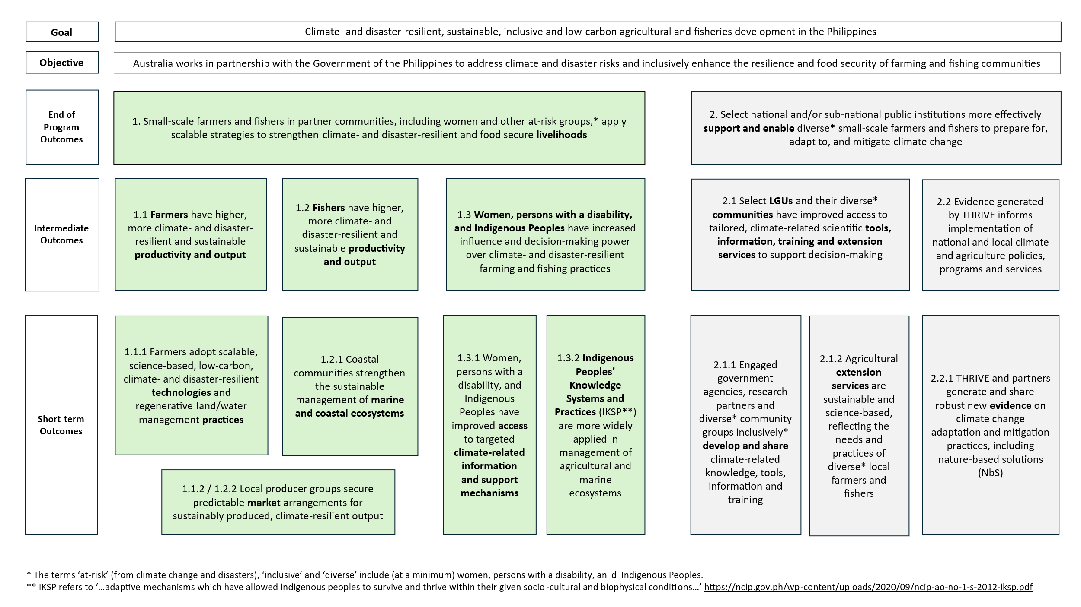
Program Logic

