DEVELOPMENT FOR ALL: Evaluation of progress made in strengthening disability inclusion in Australian aid

November 2018

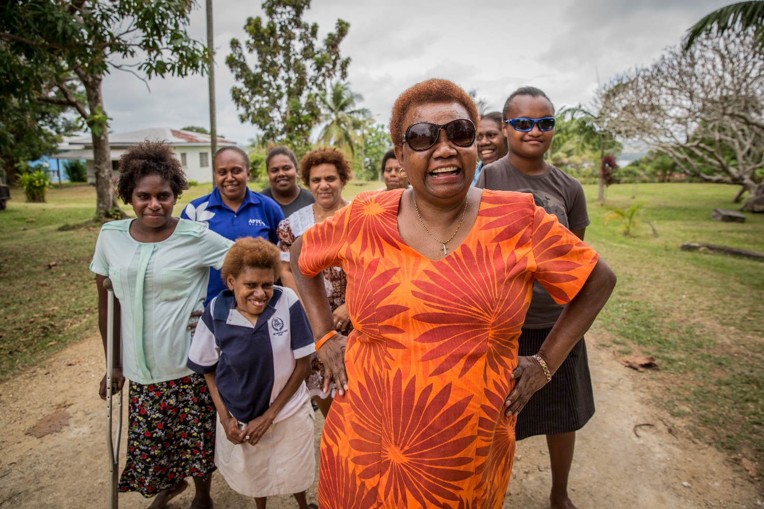

© Commonwealth of Australia 2018

ISBN 978-0-9954465-9-5

**Author:** Karen Ovington

Published by the Department of Foreign Affairs and Trade, Canberra, 2018.

**Disclaimer:** The views contained in this report do not necessarily represent those of the Australian Government.

With the exception of the Commonwealth Coat of Arms and where otherwise noted all material presented in this document is provided under a Creative Commons Attribution 3.0 Australia (http://creativecommons.org/licenses/by/3.0/au/) licence. The details of the relevant licence conditions are available on the Creative Commons website (accessible using the links provided) as is the full legal code for the CC BY 3.0 AU licence (http://creativecommons.org/licenses/by/3.0/au/legalcode). The document must be attributed as Office of Development Effectiveness, *Development for All: Evaluation of progress made in strengthening disability inclusion in Australian aid*, Canberra, 2018.

**This document is online at:** dfat.gov.au/ode

**For further information, contact:**

Office of Development Effectiveness  
Department of Foreign Affairs and Trade  
GPO Box 887  
Canberra ACT 2601  
Phone: + 61 2 6178 4000  
Facsimile: + 61 2 6178 6076  
Internet: dfat.gov.au/ode

Cover photo: Nelly Calleb, co-ordinator of the disabled people’s organisation (DPO) Disability Promotion and Advocacy Vanuatu (DPA) and some of her colleagues on Espiritu Santo. DPA was established in 1999 and has been supported by Australia for many years. DPA now has 22 community-based DPO affiliates which raise awareness and advocate for disability inclusion at the community level. DPA is still a small organisation, with the coordinator being their only full-time employee. Nelly reported that requests from development partners, government and others for advice and support were often overwhelming. The challenges are particularly large as Vanuatu’s population is widely dispersed across 64 islands. Photo: CBM Australia

The Office of Development Effectiveness

The Office of Development Effectiveness (ODE) is an office within the Australian Government Department of Foreign Affairs and Trade that is independent of aid program management. ODE monitors the Australian aid program’s performance and evaluates its impact. ODE’s work is overseen by the Independent Evaluation Committee, an advisory body that provides independent expert advice on ODE’s evaluation strategy, work plan, analysis and reports.

[www.dfat.gov.au/ode](http://www.dfat.gov.au/ode)

Foreword

People with disabilities are among the poorest and most marginalised of groups in societies. Systematic efforts are needed to overcome discriminatory attitudes and ensure the benefits of international development extend to people with disabilities. If people with disabilities are not fully included in development efforts they will be further marginalised and the sustainable development goals are unlikely to be met.

The Australian aid program has had strategies to support disability-inclusive development since 2009. These strategies have aimed to improve the lives of people with disabilities by advocacy work and making Australian development assistance disability inclusive. A previous Office of Development Effectiveness evaluation found that Australia has been a leading and effective global advocate for disability-inclusive development.

This evaluation confirms that Australian advocacy has been backed by serious efforts to make Australia’s own development assistance more disability inclusive. It assesses results across the spectrum of the aid program and finds progress is being made. Reflecting concerted efforts, some components of the aid program have made important contributions to improving the lives of people with disabilities. However, other efforts have met with less success, reflecting the difficulties of the challenges being addressed. Clearly, there is much more to be done.

An important longer-term issue is whether efforts to improve inclusion are both improving outcomes for people with disabilities and having broader impacts so that people with disabilities can be more fully engaged in their societies. The evaluation rightly suggests that the Australian aid program needs to establish a methodology to assess outcomes for people with disabilities so that the Department of Foreign Affairs and Trade can better measure whether disability-inclusive programming is making a real difference in the lives of people with disabilities.

**Jim Adams Signature**

**Jim Adams**Chair, Independent Evaluation Committee

Acknowledgements

The Office of Development Effectiveness (ODE) would like to thank all of those who contributed to this evaluation. ODE would particularly like to thank the Disabled People’s Organisations, both overseas and in Australia, who educated us, provided valuable insights and appraisals, participated in workshops and reviewed the draft evaluation report. Department of Foreign Affairs and Trade (DFAT) staff in Canberra and at Dili, Jakarta, Kathmandu, Port Vila, Suva and Yangon posts supported the evaluation and made informed contributions. The evaluation also benefited from inputs provided by managing contractors, officials in partner governments and representatives from a broad range of other organisations.

The evaluation had several inquiry teams. This included in-house ODE assessment, assessment undertaken by independent teams, and other inquiry undertaken by mixed internal and external evaluation teams. ODE staff who provided substantive inputs were Karen Ovington, Caitlin Dixon and Petra Kavunenko. Teams carrying out fieldwork included local disability consultants: Bahrul Fuad, Joaozito dos Santos, and Nellie Caleb. Analysis of disability inclusion using Aid Quality Check (AQC) ratings was undertaken by DFAT’s Contracting and Aid Management Division and ODE. The approaches taken in this work were informed by an analysis of disability inclusion in the 2015–16 AQC reporting round carried out by Kaye Bysouth and colleagues from IOD PARC Australasia. Disability inclusion in global programs was assessed by ODE with inputs from Anna Roche, Praxis Consultants. Disability inclusion in recent humanitarian responses was evaluated by Kate Sutton and Pip Henty from the Humanitarian Advisory Group with inputs from ODE. Bilateral and regional investments were reviewed by Linda Kelly, Anna Roche and Deborah Rhodes.

Author: Karen Ovington

Contents

Foreword 3

Acknowledgements 4

Executive summary 8

Approach and methodology 8

Assessing disability inclusion 8

Progress made in making the Australian aid program disability inclusive 9

Implementation of Development for All 2015–2020 9

Factors which have enabled disability inclusion 10

Work needed to further strengthen disability inclusion 10

Management response 14

Chapter 1: Introduction 30

Disability and its impact 30

The rights-based approach to inclusion 31

The need for inclusive development and humanitarian assistance 31

Australia’s commitment to disability-inclusive development 32

Development for All strategies 33

Technical assistance and resources to support disability inclusion 35

This evaluation 38

Chapter 2: Assessing disability inclusion 39

Use of Annual Program Performance Reports to assess disability inclusion 39

Use of Aid Quality Checks to assess disability inclusion 39

Rigour of Aid Quality Checks ratings for disability inclusion 39

Using Aid Quality Checks to assess disability inclusion across the aid program 41

Assessing progress being made in improving disability inclusion 41

Key findings for assessment of disability inclusion 44

Chapter 3: Disability inclusion across the Australian aid program 46

Assessment of disability inclusion in regional and country assistance using Aid Quality Checks 46

Disability inclusion in regional and country investments 49

Key findings for regional and country programs 58

Chapter 4: Disability inclusion in global programs 60

Assessment of disability inclusion in global programs using Aid Quality Checks 60

The Australian NGO Cooperation Program 60

Australia Awards 62

Australian Volunteers Program 69

Direct Aid Program 72

Key findings for global programs 80

Chapter 5: Disability inclusion in humanitarian assistance 82

Assessment of disability inclusion using humanitarian Aid Quality Checks 82

Disability inclusion in Australian humanitarian assistance 82

Disability inclusion in some recent humanitarian responses 83

Key findings for humanitarian assistance 87

Chapter 6: Factors enabling disability inclusion 88

Sustained effort, starting small and gradually scaling up 88

Disabled People’s Organisation capacity building and partnership 89

Availability and use of technical expertise 89

Dedicated funding for disability inclusion 92

Supportive and engaged senior management 92

Leadership by Australia 93

Knowledgeable and committed individuals 94

Innovative programming 95

Key findings for enabling factors 95

Chapter 7: Working towards a disability-inclusive aid program 96

Disability inclusion has been strengthened 96

Work to improve disability inclusion has aligned with the principles in DfA2 96

Approaches to support disability inclusion outlined in DfA2 have mostly been used 96

Opportunities identified in DfA2 have largely been exploited 97

Factors enabling disability inclusion are similar for most programs 97

Staying the course 98

Supporting ‘Nothing about us without us’ 98

Aligning with best practice 99

Building the understanding needed to strengthen inclusion 100

Improving disability inclusion in areas where performance is weak 100

Charting progress in making the aid program inclusive 101

Annex 1: Evaluation methodology 102

Sampling 102

Annex 2: Assessment of disability inclusion using Aid Quality Checks 106

Annex 3: Quality assurance of disability inclusion ratings for aid quality checks 2017–18 108

Annex 4: Disability ratings are higher for large-value investments which account for most aid expenditure 110

Annex 5: Annex 5: Disability ratings in the Aid Quality Checks have declined since 2015–16 111

Annex 6: The reliability of disability ratings in the 2015–16 Aid Quality Checks 113

Annex 7: Detailed case studies for Pacific regional investments 115

Annex 8: Detailed case studies for investments in Vanuatu 118

Annex 9: Detailed case studies for investments in Fiji 121

Annex 10: Detailed case studies for investments in Indonesia 124

Annex 11: Detailed case studies for investments in Timor-Leste 129

Acronyms and Abbreviations 133

Tables

Table of tables

Table 1: Disability criteria in the Aid Quality Checks 40

Table 2: The percentage of investments rated as disability inclusive in all Aid Quality Checks in 2017–18 42

Table 3: Modifications to the wording of D2 for the latest Aid Quality Check reporting round 44

Table 4: Percentage of investments in regional and country programs rated disability inclusive in 2017–18 46

Table 5: Table 5: Percentage of investments in different regions rated disability inclusive in 2017–18 47

Table 6: Percentage of disability-inclusive investments in 2017–18 for DfA1 focus countries in the Pacific 48

Table 7: Percentage of disability-inclusive investments in 2017–18 for DfA1 focus countries in South-east and East Asia 49

Table 8: Investments reviewed and their 2017–18 Aid Quality Check ratings for disability criteria 50

Table 9: The percentage of global program investments rated as disability inclusive in Aid Quality Checks in 2017–18 61

Table 10: ANCP Aid Quality Check ratings 61

Table 11: The percentage of ANCP projects that focus on disability 61

Table 12: Percentage of Australia Awards Scholarship programs rated as disability inclusive in Aid Quality Checks, 2017–18 63

Table 13: Table 13: A diversity of people with disabilities has been awarded scholarships 64

Table 14: Concerted efforts have increased the proportion of scholarships awarded to people with disabilities 65

Table 15: Number and percentage of people with disabilities people who apply to be and are recruited as volunteers 72

Table 16: Nepal disability-inclusive Disability Aid Program projects reviewed in this evaluation 76

Table 17: The percentage of investments for humanitarian crisis responses rated as disability inclusive in Aid Quality Checks in 2017–18 compared with those for the overarching priority area, Building Resilience 83

Table 18: Aid Quality Check disability criteria for 2015–16 106

Table 19: Aid Quality Check disability criteria for 2016–17 106

Table 20: Aid Quality Check disability criteria for 2017–18 107

Table 21: The number, value and level of disability inclusion for investments of different sizes 110

Table 22: Percentages of investments rated satisfactory for disability inclusion, by priority areas, for the last three years 111

Table 23: Declines in percentages of investments rated satisfactory for disability inclusion for the last three years 111

Table of figures

Figure 1: Intended outcomes and imprints of the DFAT-CBM partnership 37

Figure 2: Higher-value investments are more likely to be disability inclusive 43

Figure 3: Disability inclusion is relatively strong for the relatively small number of high-value investments which make up more than half of aid expenditure 43

Figure 4: Ratings for disability inclusion have declined over time 44

Figure 5: Disability inclusion is much stronger in some country programs 48

Figure 6: Disability inclusion is stronger in some priority areas 49

Figure 7: More people with disabilities being awarded scholarships 64

Figure 8: Volunteer assignments are increasingly disability focused 72

Figure 9: Direct Aid Program projects are increasingly likely to be disability inclusive 75

Figure 10: Many DFAT posts allocated more than 15 per cent of Direct Aid Program funding to support disability-inclusive projects, 2015–16 75

Figure 11: More disability-focused DAP projects are building DPO capacity 76

Figure 12: NGOs are more likely than other implementing partners to provide humanitarian assistance that is disability inclusive 85

Figure 13: Suggested revisions to ratings against disability criterion for Aid Quality Checks 2017–18 108

Figure 14: Revisions made by program areas following moderation 109

Figure 15: Impact of revisions made by program areas following moderation on the numbers of investments that are rated disability inclusive 109

Figure 16: CBM categorisation of need for disability inclusion 113

Figure 17: Investment managers in 2015–16 underestimated opportunities for disability inclusion 114

Figure 18: Opportunities for disability inclusion were not sufficiently recognised in all sectors in 2015–16 114

Executive summary

Australia was the first donor country to have a strategy to make development assistance disability inclusive.[1]Development *for All: Towards a disability inclusive Australian aid program 2009–2014* (DfA1)was the culmination of long-term advocacy by civil society organisations (CSOs), Australia’s ratification of the United Nations Convention on the Rights of Persons with Disabilities (CRPD) and bipartisan political support.

Australia’s commitment to disability-inclusive development continued with a more ambitious strategy, *Development for All 2015–2020: Strategy for strengthening disability-inclusive development in Australia’s aid program* (DfA2). This second strategy is at about the midpoint of its implementation. It is therefore opportune time for the Office of Development Effectiveness (ODE) to:

* 1. assess progress made in making the Australian aid program disability inclusive
  2. determine how well the strategy is being implemented
  3. identify factors which have enabled Australian aid to become more disability inclusive
  4. identify work needed to improve inclusion.

Approach and methodology

This evaluation assesses progress made in making Australian aid disability inclusive by examining the level and scope of disability inclusion across the aid program. Information from two of the activities performed under the aid program’s performance management system is used to assess disability inclusion. Case studies of regional and country investments, additional program-specific information for global programs and a review of recent humanitarian responses are also used to examine how disability inclusion has been achieved and identify enabling factors.

Assessing disability inclusion

Development for All 2015–2020 identifies two components of the Department of Foreign Affairs and Trade’s (DFAT’s) performance management system to be used to assess disability inclusion: Annual Program Performance Reports (APPRs) for country, regional and other programs; and Aid Quality Checks (AQCs)[2] for individual investments. This evaluation found AQCs, but not APPRs, to be useful in assessing disability inclusion. While there are some challenges with using AQCs, they provide an informed and standardised assessment of implementation of key aspects of disability inclusion across most areas of the aid program and are therefore useful for comparing across these areas.

The percentages of investments rated disability inclusive in the AQCs have declined for the last three years. This evaluation found evidence suggesting that these declines largely stem from an increasing understanding of disability inclusion in DFAT which has resulted in higher standards for ratings. Therefore, changes in AQC disability ratings do not reflect progress made in strengthening disability inclusion.

This evaluation found that measures other than the AQCs are needed to assess outcomes for people with disabilities and broader impacts delivered by disability-inclusive programs. Programs need to have specific measures of outcomes for people with disabilities that can be reported and synthesised in APPRs with reference to local needs and opportunities.

Progress made in making the Australian aid program   
disability inclusive

The Australian aid program has made good progress in strengthening disability inclusion. When the first Development for All strategy was launched, work to support disability inclusion was ad hoc and limited to disability-specific activities run by non-government organisations (NGOs). Disability is now a crosscutting priority for the aid program. In the most recent AQCs, about 40 per cent of all aid investments were reported to be disability inclusive. Larger-value investments are more likely to be disability inclusive so assessing disability inclusion using the percentage of investments rated disability inclusive underestimates the overall level of inclusion. For about 60 per cent of the aid program’s expenditure, more than half of investments are disability inclusive.

The Pacific regional and some country programs (Cambodia, Kiribati, the Philippines, Samoa, Timor-Leste and Vanuatu) have made good progress in building disability inclusion. Disability inclusion is increasingly being mainstreamed in sectoral programs and is strong in some priority sectors for the aid program. Investments are most likely to be inclusive if they are in the education sector with 55 to 73 per cent of investments being disability inclusive. Disability inclusion is also relatively strong in the governance sector at 46 to 50 per cent. It is weakest in the infrastructure sector with only 17 per cent of investments being disability inclusive and well below average for the agriculture, fisheries and water sector at 25 to 30 per cent.

Disability inclusion is relatively strong for the global programs reviewed and there is evidence that it is increasing. About 60 per cent of projects funded by the Australian NGO Cooperation Program (ANCP) report having a primary or significant focus on disability and only 10 per cent have no focus on disability. The proportion of Australia Award Scholarships awarded to people with disabilities has steadily increased and is now about 4 per cent. In the Volunteer Program the percentage of volunteers whose assignments are disability focused has increased to 18 per cent and 3 per cent of volunteers have disabilities. About 14 per cent of projects funded by the Direct Aid Program (DAP) are disability inclusive and many build the capacity of Disabled People’s Organisations (DPOs).

About one-third of recent responses to humanitarian crises were rated as disability inclusive in AQCs. Partnership agreements for almost all of Australia’s main humanitarian partners have recently been renegotiated and now make disability inclusion a requirement. Australia’s humanitarian assistance will increasingly become more disability inclusive as a result of new contracts. In recent humanitarian crises, more than half of Australia’s implementing partners carried out a disability analysis, mainstreamed disability and collected disability-disaggregated data. Assistance delivered by NGOs was found to be more disability-inclusive than that delivered by other types of implementing partners.

Implementation of Development for All 2015–2020

Efforts to strengthen disability inclusion were found to be closely aligned with Development for All 2015–2020.Disability inclusion is strongest in the geographic focus areas of the strategy, the Pacific and South-East Asia. Disability inclusion has been strengthened in most areas identified as providing opportunities for disability inclusion. People with disabilities are better able to realise their rights as implementation of the CRPD has been supported. Identified opportunities to improve inclusion in education investments, in humanitarian assistance and in infrastructure for water, sanitation and hygiene are being exploited. Opportunities in other types of infrastructure investments have not been well used.

The key principle outlined in the Development for All ‘Nothing about us without us’—has been embraced. All programs reviewed have built the capacity of DPOs which now have much greater capacity. More people with disabilities are actively involved in Australian aid programs. Work has also been in line with the other principles outlined in DfA2. Efforts to improve inclusion have been based on evidence and attempts have been made to ensure program benefits extend to the diversity of people with disabilities, including those with psychosocial and intellectual disabilities.

All but one of the approaches to improve inclusion identified in the second strategy have been used. Inclusion has been achieved through a twin-track approach with both mainstreaming and disability-specific activities. The approach of providing reasonable accommodation has also been well used. DFAT’s leadership has made the programs of implementing partners more inclusive. People-to-people links have been fostered through support for networks and coalitions. The approach that has not been well used is ‘harnessing private sector resources and ideas’.

Factors which have enabled disability inclusion

The factors which have enabled disability inclusion were found to be similar across the programs reviewed. Key enabling factors are:

* sustained effort, that is, starting small, gradually scaling up, and then maintaining a focus on disability for many years
* DPO capacity building and working in partnership with DPOs
* use of technical expertise.

Other important factors are supportive and engaged DFAT senior management and leadership by DFAT staff at all levels. Dedicated funding to support the implementation of disability inclusion, particularly funding for reasonable accommodation, is also an important enabler. In some instances, innovative programming and committed individuals working in DFAT and partner organisations have also enabled disability-inclusive programming.

Work needed to further strengthen disability inclusion

Although good progress has been made, the Australian aid program is still far from being fully disability inclusive. The work completed and knowledge gained to date, will support further work to strengthen disability inclusion. This evaluation found that when there is a focus on disability inclusion and resources are available, Australia’s development and humanitarian assistance has become more inclusive. Ensuring the enablers identified in this evaluation are in place across the aid program will strengthen disability inclusion.

Disability inclusion could be further improved in areas that have had successes. Capacity building for DPOs is a component of all programs reviewed and while it has been effective, capacity constraints still exist. People with disabilities play critical roles in bringing about the change necessary for inclusive programs, hence capacity building for their representative organisations should continue to be a priority. Disability inclusion in humanitarian response could be improved if more implementing partners actively involved people with disabilities.

Disability inclusion could be much improved in areas found in this evaluation to be less inclusive. Disability inclusion was relatively weak in regional investments in general, but particularly in Africa and the Middle East. Disability inclusion is also weak in some countries including Afghanistan, Myanmar, Nepal, Solomon Islands and Vietnam. Sectors found to have proportionally few inclusive investments, particularly in infrastructure and agriculture, fisheries and water, also provide clear opportunities to improve inclusion. Disability inclusion was also found to be weak in some components of global programs and with implementation in some countries. In recent humanitarian responses, assistance provided by some implementing partners was much less inclusive than that delivered by NGOs.

This evaluation makes the following recommendations:

|  |
| --- |
| Recommendation 1 |
| **Australia’s continuing commitment to  disability-inclusive development as a human rights and aid priority should be demonstrated by building on progress to date, including by:**   * continuing to support work needed for ratification or implementation of the CRPD * making it a requirement for disability inclusion to be considered at all stages of a program’s development, implementation and assessment * continuing to have a geographic focus on the Pacific and South East Asia * continuing to use the twin-track approach with disability-specific activities to support the effective mainstreaming of disability in aid and humanitarian investments * increasingly supporting work to address the compounding disadvantage linked to the intersection between gender and disability * broadening efforts to support the inclusion of diverse people with disabilities. |

|  |
| --- |
| Recommendation 2 |
| **DFAT should continue to prioritise DPO capacity building, including by:**   * providing funding including core funding * working in partnership with DPOs. |

|  |
| --- |
| Recommendation 3 |
| **DFAT should maintain a mechanism which provides DFAT and, where appropriate, partner agencies with ready access to quality disability-inclusive technical assistance and work to improve its effectiveness, including by:**   * building DFAT’s internal technical capacity to support disability inclusion by significantly increasing the number of staff positions in the Disability Section in Canberra and other measures * developing procedures to ensure that technical support is used where it is likely to have the greatest impact. |

|  |
| --- |
| Recommendation 4 |
| **DFAT should increase the knowledge and understanding of disability-inclusive development within DFAT, including by:**   * consistent messaging from senior management that disability inclusion is a priority human-rights issue * making DFAT’s own internal operations more inclusive, consistent with the DFAT Disability *Action Strategy 2017–2020* * having a systematic capacity development strategy that has targeted specific training opportunities, integrated disability into existing learning and development programs, incorporated work to improve and monitored disability inclusion in job descriptions, identified and built the capacity of disability focal points * developing a communication strategy to ensure learning on disability inclusion is used across programs. |

|  |
| --- |
| Recommendation 5 |
| **DFAT should improve disability inclusion in areas where this evaluation has found it to be relatively weak, including in:**   * regional programs * bilateral programs in some countries * some sectors such as infrastructure and agriculture, water and livelihoods * assessment of disability inclusion within the Australian NGO Cooperation Program and requiring Australian Partner NGOs to address areas of weakness * Australia Award short courses * implementation of the global programs reviewed in some countries, such as Australia Award Scholarships in some Pacific Island countries * assistance provided by humanitarian implementing partners other than NGOs * involvement of DPOs in humanitarian assistance. |

|  |
| --- |
| Recommendation 6 |
| **DFAT should establish methodology to improve assessment of disability inclusion across the aid program, including by:**   * working to improve the usefulness of AQCs as measures of implementation of disability-inclusive programs * developing mechanisms to ensure the APPRs capture meaningful data on disability outcomes and impacts * requiring programs to identify outcomes for people with disabilities which, where possible, are aligned across the aid program * requiring programs to include measures of outcomes in program monitoring and evaluation. |

Management response

DFAT welcomes the Office of Development Effectiveness’ (ODE’s) evaluation of progress made in strengthening disability-inclusion in Australian aid. This report complements ODE’s 2017 evaluation of Australia’s international advocacy for disability-inclusive development.

As verified in the previous evaluation, Australia is seen and valued internationally as a leader in disability-inclusive development. This positive and influential reputation is built on the strength of our advocacy and our ongoing efforts since at least 2008, when the first Development for All strategy was launched, in delivering a disability inclusive Australian aid program.

DFAT welcomes ODE’s finding that, overall, the Australian aid program has made good progress in strengthening disability inclusion, with about half of aid investments, including a third of humanitarian investments, assessed as disability inclusive in 2017–18. International consultations indicate that no other major international development partner has achieved this level of success. Nonetheless, DFAT also recognises that there is considerable room for improvement and further sustained effort is required so that people with disabilities are fully included in our development and humanitarian efforts.

The evaluation makes six overall recommendations, with 26 sub-recommendations. These recommendations are relevant to all areas of DFAT that manage aid and humanitarian programs and the areas which manage supporting processes and mechanisms. DFAT agrees with the six overall recommendations and most of the sub-recommendations. Specific actions have been identified for most sub-recommendations, except where specific responses are, as yet, unclear or would create an undue future reporting burden.

Many of the recommendations and sub-recommendations, particularly under recommendations 1, 2 and 3, validate DFAT’s existing approaches and recommend their continuation. These recommendations are particularly welcome in reaffirming where sustained effort and gradual scale up will continue to have the greatest impact. This includes building the capacity of, and meaningfully engaging with, people with disabilities and their representative organisations (disabled people’s organisations—DPOs) which is already strong in, for example, the Pacific, Indonesia and Timor Leste and improving elsewhere. It also confirms DFAT long standing view that DFAT’s partnership with CBM Australia is an essential enabler for accessing quality disability inclusive technical assistance and capacity building support.

Recommendations 1, 3, 4 and 6, focus on ways to enhance capability within DFAT to identify and respond to the need for a disability inclusive approach in aid investments, and to better track outcomes. DFAT’s response to these recommendations will be to build on existing elements of good practice to create an environment where disability-inclusion is naturally considered in the design, implementation and monitoring of aid and humanitarian investments. This can be achieved if DFAT officers are trained and supported, and appropriately prompted at key points in the investment life cycle, to consider the need for disability-inclusion.

The remaining recommendations, mostly under recommendation 5, highlight opportunities for further strengthening disability-inclusion in various geographic or thematic areas. These opportunities are many, varied and of differing resource implications and impact. These opportunities will be progressively realised by relevant areas of the department as their capacity improves, including through the implementation of other recommendations in this evaluation.

The action plan identified in the management response will be overseen by DFAT’s Disability Section (DS) and implemented by the following DFAT areas: Development Policy Division (DPD), Contracting and Aid Management Division (ACD), Humanitarian, NGOs and Partnerships Division (HPD), Multilateral Development and Finance Division (MDD), Multilateral Policy Division (MPD), Pacific Bilateral Division (PBD), Pacific Strategy Division (PSD), Middle East and Africa Division (MAD), South East Asia Division (SED), South and West Asia Division (SWD), and US and Indo-Pacific Strategy Division (AMD) together with all development posts.

Last, but not least, DFAT itself supports an inclusive work culture in which all staff can reach their full potential and contribute to advancing Australia’s interests. Enhancing inclusiveness is dependent on raising awareness of and improving access to information for people with disabilities and their carers. Our Disability Action Strategy 2017–2020 sets out what we do and will do to achieve our goal of being a model employer and APS-leader in disability inclusive practice.

Individual management response to recommendations

|  |  |  |  |  |
| --- | --- | --- | --- | --- |
| Recommendation 1 | | | | |
| **Recommendation** | **Response[3]** | **Explanation** | **Action plan** | **Responsible area(s) & timeframe** |
| Australia’s continuing commitment to disability inclusive development as a human rights and aid priority should be demonstrated by building on progress to date including by: | Agree | Disability inclusion is, as reflected in the 2017 Foreign Policy White Paper, a priority for Australia’s international engagement in development, humanitarian action and human rights. Action in response to this evaluation will contribute to effective implementation of this commitment. |  |  |
| * Continuing to support work needed for ratification or implementation of the CRPD. | Agree | Ratification and implementation of the CRPD by developing countries is central to disability inclusive development. Most countries in the Indo-Pacific have ratified the CRPD with the exception of Niue, Timor-Leste, Tonga and Solomon Islands. | DFAT will continue to support countries in our region to ratify the CRPD. DFAT will also support countries to implement CRPD including by supporting advocacy by DPOs to replace and update CRPD non-compliant policy and legislation. | DPD (DIS), SED, PSB, PSD (Ongoing) |
| * Making it a requirement for disability inclusion to be considered at all stages of a program’s development, implementation and assessment. | Agree | Disability inclusion should be considered through the investment life cycle. This expectation is already reflected in design templates and flows on to investment implementation and monitoring. | DFAT will map and promote the entry points for disability inclusion in existing design, implementation and monitoring documents and processes to better highlight where disability inclusion should be considered in the investment life cycle. | DPD (DIS) supported by ACD (By July 2019) |
| DFAT will undertake sample-based periodic spot checks of investments to verify that disability inclusion is being appropriately addressed in investment development, implementation and assessment. | ACD/DPD (DIS) (Ongoing by  mid-2019) |
| * Continuing to have a geographic focus on the Pacific and South East Asia. | Agree | Consistent with the Australian aid policy, DFAT will strengthen its focus on the Indo-Pacific region while continuing to address disability-inclusion across the breadth of the aid program, regardless of geography. |  | PSB, PSD, SED and all Development Posts (Ongoing) |
| * Continuing to use the twin track approach with disability specific activities to support the effective mainstreaming of disability in aid and humanitarian investments. | Agree | Consistent with the Australian aid policy, DFAT will strengthen its focus on the Indo-Pacific region while continuing to address disability-inclusion across the breadth of the aid program, regardless of geography. |  | PSB, PSD, SED and all Development Posts (Ongoing) |
| * Continuing to use the twin track approach with disability specific activities to support the effective mainstreaming of disability in aid and humanitarian investments. | Agree | As reflected in Development for All: 2015-2020: Strategy for strengthening disability-inclusive development in Australia’s aid program, the twin track approach underpins DFAT’s strategic framework for disability-inclusive development. | DFAT will continue to explore opportunities at country and regional levels to support disability specific programs (e.g. DPO capacity building and access to services) which contribute to wider mainstreaming across the program. | PSB, PSD, SED and all Development Posts supported by DPD (DIS)  (Ongoing) |
| * Increasingly supporting work to address the compounding disadvantage linked to intersection between gender and disability. | Agree | Gender responsive disability-inclusive development is essential to reduce poverty, strengthen economic development and empower women and girls. | DFAT will continue to seek opportunities to specifically target and support leadership and development opportunities and for women with disabilities.  The Department will continue an informal Gender & Disability Working Group to support collaboration and advocacy on the two cross-cutting priorities. The working group will also share good practice and coordination on implementation approaches and capacity building. | DPD (DIS), MPD (GEB) and all Posts (Ongoing) |
| * Broadening efforts to support the inclusion of diverse people with disabilities. | Agree | DFAT recognises that some groups within the disability community, particularly deaf people and people with psychosocial and intellectual disabilities, are at higher risk of marginalisation. | DFAT will continue to explore opportunities, including through DPO capacity building, to specifically target and support the inclusion of diverse people with disabilities in particular those at heightened risk of marginalisation. | DPD (DIS),  All Development Posts (Ongoing) |

|  |  |  |  |  |
| --- | --- | --- | --- | --- |
| Recommendation 2 | | | | |
| **Recommendation** | **Response[4]** | **Explanation** | **Action plan** | **Responsible area(s) & timeframe** |
| DFAT should continue to prioritise DPO capacity building including by: | Agree | Central to Australia’s approach to disability inclusion is supporting DPOs in developing countries to build their capacity so they can give voice to people with disabilities at all levels and contribute as decision makers in their communities. | DFAT will continue to use the DFAT-CBM Australia Partnership to provide capacity-building support to DPOS.  DFAT will continue to use the Australia Awards program to support DPO capacity building, including by providing development opportunities for people with disabilities, especially leaders in the disability movement. DFAT will also continue to use the Australian Volunteers Program to support DPOs. | All Development Posts, DPD (DIS), SCD (SCB), HPD (Ongoing) |
| * Providing funding including core funding. | Agree | Financial support of DPOs contributes to their capacity and sustainability. Funding modalities can include grants, project based funding or paying for the provision of technical assistance provided by DPOs. | DFAT will, subject to budget considerations, seek to provide at least $4.0 million dollars a year towards DPO capacity building at the global and / or regional level. | DPD (DIS) (Ongoing) |
| DFAT will also look for opportunities/mechanisms to provide small scale funding to emergent and grass roots DPOs. | All Development Posts (Ongoing) |
| * Working in partnership with DPOs. | Agree | Working in partnership with DPOs enhances disability-inclusive program design, implementation and monitoring, builds mutual capacity and supports stronger disability-rights advocacy. | At the country level DFAT posts will continue to  explore opportunities to partner with local and national DPOs, including in preparing for and responding to humanitarian crises. | All Development Posts, supported by DPD (DIS) and HPD as appropriate. (Ongoing) |
| DFAT will prepare and maintain guidance on how to meaningfully engage and partner with DPOs. | DPD (DIS) (By June 2019) |

|  |  |  |  |  |
| --- | --- | --- | --- | --- |
| Recommendation 3 | | | | |
| **Recommendation** | **Response[5]** | **Explanation** | **Action plan** | **Responsible area(s) & timeframe** |
| DFAT should maintain a mechanism which provides DFAT and, where appropriate, partner agencies with ready access to quality disability inclusive technical assistance and work to improve its effectiveness including by: | Agree | DFAT maintains a partnership with CBM Australia that builds understanding and technical capacity for disability inclusive development. The current Partnership operates until 2020. In 2017, an independent evaluation of the partnership (2015-2017) found that it was an effective model, provided critical technical expertise, sector knowledge and networks to support DFAT strengthen disability-inclusive development in Australia’s aid program. | DFAT will promote use of the disability help desk (known as DID4All) as a simple mechanism for accessing technical assistance to all areas of the department managing development assistance aid and humanitarian programs. | DPD (DIS) |
| * Building DFAT’s internal technical capacity to support disability inclusion by significantly increasing the number of staff positions in the Disability Section in Canberra and other measures. | Agree  in part | DFAT’s internal capacity to support disability inclusion is not dependent on staffing within Disability Section alone. Other measures, including building staff capacity and leveraging off the availability of technical assistance, are important. | DFAT will expand the use of the CBM Partnership to deliver greater internal technical capacity and capability. | DPD (DIS) (Ongoing) |
| * Developing procedures to ensure that technical support is used where it is likely to have the greatest impact. | Agree | While technical support is relevant at all stages of the investment life cycle, it can be particularly important in the design phase where appropriate support can embed an inclusive approach to the entire aid investment. | DFAT will develop a framework to manage prioritisation of requests for technical assistance.  DFAT will develop a user pays system for large volume requests to protect the capacity of the DID4All helpdesk to deliver technical assistance at the design phase. | DPD (DIS) (By August 2019)  DPD (DIS) (By February 2019) |

|  |  |  |  |  |
| --- | --- | --- | --- | --- |
| Recommendation 4 | | | | |
| **Recommendation** | **Response[6]** | **Explanation** | **Action plan** | **Responsible area(s) & timeframe** |
| DFAT should increase the knowledge and understanding of disability inclusive development within DFAT including by: | Agree | Enabling and supporting all DFAT staff working on the aid program to identify and respond to opportunity and need for disability inclusive approaches is central to delivering a disability inclusive development and humanitarian program. |  | GPC, MPD, DPD, MDD, HPD, SCD (Ongoing) |
| * Consistent messaging from senior management that disability inclusion is a priority human rights issue | Agree |  | Senior managers within DFAT, from the Secretary down, will continue to promote disability inclusion as a priority cross cutting issue for Australia’s international engagement in development, humanitarian action and human rights consistent with the Foreign Policy White Paper. | Secretary and other DFAT Senior Executive Service (SES) officers |
| * Making DFAT’s own internal operations more inclusive, consistent with the DFAT Disability Action Strategy 2017–2020 | Agree |  | DFAT will continue to implement the actions outlined within the Strategy and explore other avenues to ensure our internal operations are inclusive (i.e. the Disability Portal), including through regular consultation with our Disability Staff Network to identify areas for improvement | CPO (Ongoing) |
| * Having a systematic capacity development strategy that has targeted specific training opportunities, integrates disability into existing Learning & Development programs, incorporates work to improve and monitor disability inclusion in job descriptions, identifies and builds the capacity of disability focal points. | Agree |  | DFAT will develop a capacity development implementation plan for disability-inclusive training across DFAT and disability focal points in consultation with line areas and other stakeholders. | DPD (DIS), DAC  (By end of 2019) |
| Gender training will take an intersectional approach and include the needs of women with disabilities. | MPD (GEB) (By June 2019) |
| * Developing a communication strategy to ensure learning on disability inclusion is utilised across programs. | Agree |  | DFAT will develop and implement a communications plan to promote good practise in disability inclusive development and humanitarian action. | DPD (DIS), supported as appropriate by HPD  (By December 2019) |

|  |  |  |  |  |
| --- | --- | --- | --- | --- |
| Recommendation 5 | | | | |
| **Recommendation** | **Response[7]** | **Explanation** | **Action plan** | **Responsible area(s) & timeframe** |
| DFAT should improve disability inclusion in areas where this evaluation has found it to be relatively weak including: | Agree | While overall the Australia aid program has made good progress in strengthening disability inclusion DFAT acknowledges that there remains room for improvement. By addressing the recommendations of this report disability inclusion will be strengthened broadly across these areas. | DPD (DIS), with support from CBM Australia, will work with relevant areas of DFAT to identify actions most likely to have the greatest impact on disability inclusion in their context. |  |
| * Regional programs. | Agree |  |  | AMD (ARB) |
| * Bilateral programs in some countries. | Agree |  |  | All relevant Posts and geographic areas |
| * Some sectors-Infrastructure and Agriculture, Water and Livelihoods. | Agree |  |  | MDD (BFB & PXB), DPD, MPD (GFB) |
| * Assessment of disability inclusion within ANCP and requiring Australian Partner NGOs to address areas of weakness. | Agree |  |  | HPD (NVB) |
| * Australia Award short courses. | Agree |  |  | SCD (SCB) |
| * Implementation of the global programs reviewed in some countries such as Australia Awards scholarships in some Pacific Island countries. | Agree |  |  | SCD (SCB &WPB) |
| * Assistance provided by humanitarian implementing partners other than NGOs. | Agree |  |  | HPD and all relevant Geographic areas |
| * Involvement of DPOs in humanitarian assistance. | Agree |  |  | HPD |

|  |  |  |  |  |
| --- | --- | --- | --- | --- |
| Recommendation 6 | | | | |
| **Recommendation** | Response**[8]** | Explanation | Action plan | Responsible area(s) & timeframe |
| * DFAT should establish methodology to improve assessment of disability inclusion across the aid program including by: | Agree | There is a global deficiency in methodologies that reliably assess disability inclusion in development programs. | DFAT will continue to invest into the development of methodology and tools that advance the ability to measure disability inclusive outcomes. | DPD (DIS)  (Ongoing) |
| * Working to improve the usefulness of Aid Quality Checks (AQCs) as measures of implementation of disability inclusive programs. | Agree | AQCs are the principal tool to track and monitor the quality of aid investments and humanitarian responses. DFAT will continue to use the AQCs as part of its investment quality reporting system to assess disability inclusion effectiveness. | DFAT will identify and implement improvements to the AQC and HAQC processes ahead of the next Investment Quality Reporting cycle. | DPD (DIS), ACD, HPD (By February 2019) |
| * Developing mechanisms to ensure the APPRs capture meaningful data on disability outcomes and impacts. | Agree | APPRs include an analysis of Aid Quality Check quality criteria outcomes. This can also include an analysis of the overall results for the disability inclusion criteria reported in Aid Quality Checks | DFAT will clarify in APPR guidance and templates the need to analyse disability inclusion information from Aid Quality Checks. | ACD (By April 2019) |
| * Requiring programs to identify outcomes for people with disabilities which where possible, are aligned across the aid program. | Agree  in part | A consistent whole of aid program outcomes measure (i.e. an aggregate development result) would require counting how many people with disabilities benefit from the program and is not considered feasible. | DFAT will explore options for better measuring outcomes for people with disabilities in individual aid investments, including through investment monitoring and evaluation systems. | All areas (Ongoing) |
| * Requiring programs to include measures of outcomes in program monitoring and evaluation. | Agree | Under the Australian aid program performance framework, individual aid investments measure alignment with key policy priorities, including disability-inclusion. This is reported through the AQCs and program prioritised evaluations. Key aid delivery partners are also assessed against policy alignment (including disability inclusion) through Annual Partner Performance Assessments. Individual investments include M&E arrangements, developed with the guidance of various Performance Assessment Notes, which reflect relevant safeguards issues, including disability-inclusion. | DFAT will update and promote the Performance Assessment Note on disability-inclusive development.  DFAT will include appropriate consideration of disability in the terms of reference of evaluations and the ODE will include disability inclusion as a component of its strategic evaluations. Consistent with DFAT’s investment design and quality assurance requirements, investment concepts and designs, which include consideration of proposed M&E arrangements, will be peer reviewed from a disability-inclusion perspective | DPD (DIS) and ACD (By June 2019) |
| ODE (Ongoing)  All areas (Ongoing) |

# Introduction

Australia has been working to ensure people with disabilities[9] benefit from international development by making its own development assistance more inclusive and through global advocacy to shape the policies and programs of other development agencies. The purpose of this evaluation is to assess progress made in making Australia’s development assistance disability inclusive and to inform future work to strengthen disability inclusion (Box 1). This evaluation complements a recent evaluation of Australia’s global advocacy for disability-inclusive development.[10]

|  |
| --- |
| Box 1: Disability inclusive development |
| Disability inclusive development means that all stages of development processes are inclusive of and accessible to people with disabilities. An inclusive approach identifies and addresses barriers preventing people with disabilities from participating in and benefiting from development. The inclusion of people with disabilities as active participants in development processes benefits families and communities, reduces the impacts of poverty, and contributes to a country’s economic growth. |

Disability and its impact

Disability arises when there are barriers that prevent individuals with impairments from participating in society on an equal basis with others. Disability inclusion is not about tackling impairments. It is about removing the institutional, environmental and attitudinal barriers that prevent full participation in society and make people with disabilities less able to access their basic human rights.[11]

People with disabilities are part of all communities. About 80 per cent of people who have impairments that lead to disability acquire them after birth. Of the world’s population, about 15 per cent[12], or more than 1 billion people, have disabilities. About 110 to 190 million have very severe disabilities. Women and older people are more likely to have disabilities.[13]

There is a strong association between disability and poverty. Individuals with disabilities are more likely to live in poor households and be among the very poor.[14] Lower-income countries have a higher prevalence of disability so that about 80 per cent of people with disabilities live in developing countries. Disability accentuates poverty by preventing full participation in education, employment, health care, other services and society in general. Poverty can lead to exclusion from society that can cause or worsen impairments, resulting in disability and a cycle of exclusion.

The rights-based approach to inclusion

The human rights of people with disabilities are internationally enshrined in the United Nations Convention on the Rights of Persons with Disabilities 2007 (CRPD). Signatories to the CRPD commit to removing barriers to the full participation of people with disabilities and to respecting their rights as citizens (Box 2). The CRPD has been ratified by 177 countries including Australia and 70 per cent of countries in South East Asia and the Pacific.

|  |
| --- |
| Box 2: Principles of the United Nations Convention on the Rights of Persons with Disabilities |
| * 1. Respect for inherent dignity, individual autonomy including the freedom to make one’s own choices, and independence of persons.   2. Non-discrimination.   3. Full and effective participation and inclusion in society.   4. Respect for difference and acceptance of persons with disabilities as part of human diversity and humanity.   5. Equality of opportunity.   6. Accessibility.   7. Equality between men and women.   8. Respect for the evolving capacities of children with disabilities and respect for the right of children with disabilities to preserve their identities. |

A rights-based approach provides the basis for changing attitudes towards people with disabilities. It enables a shift from charity and medical models, to a model recognising that people with disabilities have the right to participate in all aspects of life and benefit from development equally as citizens. With this rights-based focus comes the understanding that people with disabilities should be active participants and advocates for shaping change.

The need for inclusive development and humanitarian assistance

As well as being a requirement of CRPD, there are economic imperatives for disability-inclusive development. Excluding people with disabilities from services, education and employment leads to costs for the state (for example, loss of productivity, loss of taxes, and additional spending on disability programs).[15] For lower and middle-income countries, the estimated loss from excluding people with disabilities from work ranges from 3 to 7 per cent of gross domestic product.[16] Conversely, inclusion of people with disabilities in economic life increases aggregate gains in household income[17] and increase a country’s tax base, potentially increasing government revenue[18],[19]

Sustainable, equitable progress in the agreed global development agenda cannot be achieved without the inclusion of persons with disabilities. If they are not included, progress in development will further their marginalization.[20]

Humanitarian crises can reverse hard-won development gains, increase poverty and cause instability that lasts for decades. Humanitarian assistance needs to be inclusive as people with disabilities are especially vulnerable and consequently over represented among victims of disasters.[21] Furthermore, crises increase the number of people with disabilities due to injury and trauma, the collapse of essential services and worsening barriers to participation.

Australia’s commitment to disability-inclusive development

Australia was the first donor country to have a strategy to make development assistance disability-inclusive. *Development for All: Towards a disability-inclusive Australian aid program 2009–2014* was developed at a time when donor activity in disability inclusion, including that of Australia, was characterised as small scale, ad hoc and lacking in people with disabilities playing real and tangible roles in their development.[22] The strategy was the culmination of   
long-term advocacy by CSOs, Australia’s ratification of the CRPD in 2008 (Box 3) and strong bipartisan political support.

The strategy, as well as the depth of analysis and extensive consultative processes through which it was formulated, established Australia as a leader among donors for disability-inclusive development. Australia’s commitment to disability-inclusive development continued beyond DfA1 with a second strategy covering2015–20.

Australia has committed to disability-inclusive humanitarian action by signing the Charter on the Inclusion of Persons with Disabilities in Humanitarian Action formulated at the World

Humanitarian Summit 2016 and in DFAT’s *Humanitarian Strategy 2016.[23]*

|  |
| --- |
| Box 3: Australia’s development assistance obligations under the Convention on the Rights of Persons with Disabilities |
| Article 32 requires signatories to work in partnership with national efforts, relevant international and regional organisations and civil society, in particular organisations of people with disabilities, to:   * ensure international development programs are inclusive of and accessible to people with disabilities * facilitate and support capacity building, including through the exchange and sharing of information, experiences, training programs and best practices * facilitate cooperation in research and access to scientific and technical knowledge * provide technical and economic assistance, including by facilitating access to and sharing of accessible and assistive technologies, and through the transfer of technologies.   Article 11 requires signatories to take all necessary measures to ensure the protection and safety of people with disabilities in situations of risk, including situations of armed conflict, humanitarian emergencies and the occurrence of natural disasters. |

The Australian *Foreign Policy White Paper 2017* reaffirmed disability inclusion as a crosscutting priority for Australia’s international engagement in human rights, humanitarian action and development assistance. DFAT’s internal *Disability Action Strategy (2017–2020),* complements DfA2 and is consistent with Australia’s National Disability Strategy.

Disability is not just a development issue. The White Paper clearly affirms that disability is a crosscutting priority in Australia’s foreign policy.[24]

Development for All strategies

The first Development for All strategy was closely aligned with CRPD as it had a rights-based approach to disability inclusion. It committed to a principle of ‘Nothing about us without us’, underlining the need for people with disabilities to be actively engaged in development programs. This commitment was reinforced through a focus on capacity building of Disabled People’s Organisations (DPOs). The strategy specified a twin-track approach, combining disability-specific initiatives with work to ensure that people with disabilities benefited from mainstream development programs (Box 4). Attempts to improve disability inclusion focused on some sectors (education and infrastructure) and in four countries (Cambodia, Papua New Guinea, Samoa and Timor-Leste).

|  |
| --- |
| Box 4: Twin-track approaches to disability inclusion |
| **Disability-specific initiatives**—targeting people with disabilities in development initiatives by providing them with the supports they need to participate fully in society and everyday life. Examples: providing support to a DPO; providing adaptive technology (such as canes, prosthetics, wheelchairs, glasses and hearing aids); developing and teaching Sign Language; and rehabilitation services.  **Disability mainstreaming**—actively involving people with disabilities as participants and beneficiaries of development efforts across all sectors. Example: identifying and addressing barriers to the inclusion of children with disabilities in an education program.  Mainstreaming and disability-specific actions are not two separate or siloed programming streams. They are inter-related and rely on each other for success. Unless people with disabilities receive the disability-specific supports they require to actively participate in society, they will not be able to take advantage of the mainstreaming efforts towards inclusion. For example, ensuring built environments include universal design elements, such as appropriate ramps, door openings and clear passageways, will only be inclusive of people with physical disabilities if they have assistive devices, such as wheelchairs, or prosthetics that allow them the mobility to travel to and move around the building. |

A mid-term review[25] found that DfA1 had contributed to increased access for people with disabilities to services in education, employment, health, and law and justice. It also found that people with disabilities were more able to work together for their own development and to advocate with local communities and national governments for their rights as citizens.

The second Development for All strategy is more ambitious than the first. Its geographic focus goes beyond the four focus countries in the first strategy to the Indo-Pacific with a focus on the Pacific and South East Asia. Improving disability inclusion across the aid program replaces the narrow sectoral focus of DfA1. DfA2 does, however, identify four areas that provide good opportunities for disability inclusion:

* 1. supporting governance for equality through the implementation of the CRPD
  2. enabling infrastructure and accessible water, sanitation and hygiene (WASH)
  3. ensuring inclusive education and skills
  4. building resilience in inclusive humanitarian assistance, disaster risk reduction and social protection.

Like the first strategy, a key principle of DfA2 is support for an active and central role for people with disabilities. DfA2 has three additional principles:

* 1. develop policies and programs based on evidence
  2. consider the interaction of gender and disabilities
  3. improve inclusion of the diverse range of people with disabilities.

DfA2 identifies four approaches to support inclusion:

* 1. twin-track approach
  2. reasonable accommodation (Box 5)
  3. partnerships and people-to-people links
  4. harnessing private sector resources and ideas.

|  |
| --- |
| Box 5: Reasonable accommodation |
| Reasonable accommodation is the provision of support, modifications and/or adjustments that meet the individual needs of people with disabilities to ensure they enjoy and exercise all human rights and fundamental freedoms on an equal basis with others, as outlined in the CRPD. It can include, for example, the provision of accessible transportation, sign-language interpreters, accessible meeting venues, and documents in accessible formats. |

Technical assistance and resources to support disability inclusion

The need for development to be disability-inclusive has only been widely accepted in the last decade. Consequently, there is limited experience in working in disability-inclusive ways. DFAT recognised that to achieve its objectives under the Development for All strategies, specialist expertise on disability was required over a sustained period across all operations. Formal partnership agreements between DFAT and CBM Australia (CBM) have supported both Development for All strategies. CBM is a DFAT-accredited Australian NGO specialising in disability inclusion. It is in a consortium with the Nossal Institute. Staff of CBM and the Nossal Institute provide technical advice under the partnership agreement.

The first partnership built DFAT’s understanding and technical capacity for disability-inclusive development and had additional flow-on benefits, such as networking and leveraging resources.[26] The shared objectives and joint work of DFAT and CBM were found to have been more effective than work undertaken by either partner alone.

The first partnership informed the second partnership agreement. The value of the second partnership increased to $2.01 million for 2.5 years starting in 2015–16 and then to about $0.8 million per year up to 2020–21. The current partnership (Figure 1) is valued by both DFAT and CBM[27] as it has:

* 1. supported DFAT to be a global and regional leader in disability-inclusive development
  2. improved disability-inclusive development awareness and capacity within DFAT
  3. provided critical technical expertise, sector knowledge and networks
  4. provided high-quality services required by Canberra, Posts and DFAT partners, including training, technical assistance, building relationships and networks, and input to public diplomacy activities needed to support DFAT to strengthen disability-inclusive development
  5. supported regional and national DPOs to provide technical assistance to governments, donors and implementing partners
  6. facilitated sharing and using evidence of good practice.

It is very much a partnership approach … The arrangement is very flexible. CBM can tailor visits to DFAT posts to help them understand, in practical terms, how to include people with disabilities.

Raine Dixon, Director of CBM’s Inclusive Development Department[28]

Under the partnership, CBM also manages the DID4All website, which provides public resources on disability-inclusive development. It also manages the DID4All Help Desk, a secure site for responding to specific enquiries from DFAT staff. There has been a steady increase in the number and complexity of Help Desk requests, indicating a growing demand for technical assistance.

In recognition that disability inclusion was new to DFAT, both strategies committed to developing and building strong internal expertise. Despite this, the human resources committed to disability inclusion in DFAT were reduced under the second strategy. The Disability Section in Canberra was reduced by two positions and regional disability specialists were not reappointed.[29] Demand on the Disability Section for technical assistance has increased largely due to increased staff awareness, the launch of the Disability-Inclusive Development Fund and the second Development for All strategy.[30]

Figure 1: Intended outcomes and imprints of the DFAT-CBM partnership

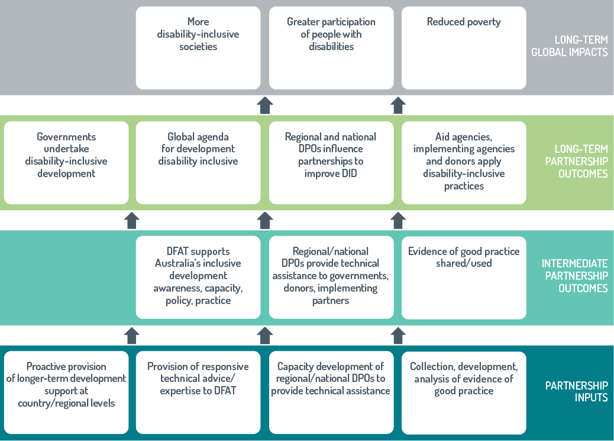

Country, regional and global funds have supported implementation of the Development for All strategies. Funding allocations to the Disability Section in Canberra have further supported implementation. DfA1 was supported by an annual budget of $7.5 million. This was increased to $12.9 million for DfA2. This funding has, for the most part, been used for the:

* DFAT–CBM partnership
* global and regional programs supporting capacity building of DPOs
* work to improve global disability data
* work to build more disability-inclusive United Nations programs.

Since 2016, up to $20 million of the funding to support the implementation of DfA2 has been allocated to a Disability-Inclusive Development Fund to enhance disability mainstreaming in-country and regional programs in the Indo-Pacific. DFAT Posts and programs could apply to the Fund for up to $1 million per year and 10 to 30 days technical assistance for up to four years from July 2016 to June 2020. In a competitive process, 7 of 31 proposals were funded for work in Laos, Papua New Guinea, Timor-Leste, Tonga, Sri Lanka and Vanuatu. A regional program in South East Asia was also funded.

This evaluation

The Development for All 2015–2020 strategy is at about the mid-point of implementation. It is, therefore, an opportune time for ODE to assess how well it is being implemented and, in so doing, identify how to improve its implementation.

Specific objectives for this evaluation included:

* A comprehensive assessment of the scope of disability inclusion across different areas of the Australian aid program.
* Identification of the ways in which investments have become more disability inclusive to determine how well work to improve disability inclusion aligns with the priorities, approaches and opportunities identified in DfA2.
* Identification of key factors which have enabled Australian aid to become more disability inclusive.
* Identification of work needed for further progress towards a disability-inclusive Australian aid program.

This evaluation assessed disability inclusion across the Australian aid program using ratings for disability inclusion collected in DFAT’s performance monitoring system and other program-specific data. This identified areas where disability inclusion is strong and areas where more work is needed. Detailed reviews of some regional and country investments, global programs and humanitarian responses identified ways in which disability inclusion has been improved and factors that have enabled DFAT to make Australian aid more inclusive. These reviews included document analysis, interviews, fieldwork and case studies. A detailed description of the methodology for the evaluation is in Annex 1.

This evaluation will be used by DFAT to improve implementation of DfA2 and inform the third Development for All strategy. As Australia was the first donor country to have a disability-inclusion strategy, this evaluation will also be of interest to a broad range of external stakeholders including people with disabilities and their representative organisations, other donors, development agencies and humanitarian agencies.

# Assessing disability inclusion

The Development for All 2015–2020 strategy identifies the two components of DFAT’s performance management system that will be used to assess disability inclusion. These are Annual Program Performance Reports (APPRs) and Aid Quality Checks (AQCs).[31]

Use of Annual Program Performance Reports to assess disability inclusion

Regional and country programs report annually in APPRs on the progress made across their development programs. Reporting on disability inclusion is not standardised and so coverage of disability has been variable.[32] Coverage of disability improved in the most recent APPRs but for many it was still minimal. The APPRs were therefore not used in this evaluation to assess disability inclusion.

Use of Aid Quality Checks to assess disability inclusion

Almost all Australian aid investments above $3 million complete annual AQCs. Performance is rated by program areas against a range of criteria on a six-point scale: 1 to 3 (underperforming), 4 (satisfactory) or 5 to 6 (performing well). Criteria for assessing disability inclusion were added to the AQCs in 2014–15[33] and have since been standardised (Table 1 and tables 18 to 20, Annex 2). A not-applicable option was added in the 2017–18 round.

This evaluation found AQCs useful in assessing disability as they provide detailed coverage across the aid program, standardise reporting on disability inclusion and cover the key aspects of disability inclusion. In this evaluation, investments are considered to be disability inclusive if they have ratings of ‘satisfactory’ or ‘performing well’ for the disability criteria. Investments rated ‘unsatisfactory’ for the disability criteria or for which disability was ‘not applicable’ are not considered to be disability inclusive. The level of disability inclusion in different components of the aid program is quantified by calculating the percentage of investments rated disability inclusive.

Rigour of Aid Quality Checks ratings for disability inclusion

The Disability Section in DFAT is working to improve the rigour of disability ratings. Guidance on how to rate disability in the AQCs has been developed and work to build the understanding of disability in DFAT is continuing. AQC ratings are based on self-assessments by program areas which is both a strength and weakness of the AQCs as measures of performance. It is a strength as those with the deepest knowledge of investments are providing the ratings and can take account of contextual and other constraints when judging achievements. Self-assessment can, however, be a weakness because when disability inclusion is not well understood, the need and opportunities for disability inclusion are likely to be underestimated.

Moderation and spot checks are routinely used to maintain the rigour of AQCs. Until this year, the ratings for disability inclusion have received little, if any, scrutiny. In the latest reporting round, the Disability Section trialled a moderation of AQC disability ratings for about one-quarter of investments (Annex 3). This moderation suggested that ratings should be changed from ‘disability inclusive’ to ‘not inclusive’ for about 30 per cent of investments and from ‘not applicable’ to ‘not inclusive’ for 10 per cent of investments (Figure 13, Annex 3). The reasons given for suggesting ratings be changed from ‘disability inclusive’ to ‘not inclusive’ were that the AQCs had insufficient detail describing how inclusion was achieved and lacked disability-disaggregated data to provide evidence of outcomes for people with disabilities.

Program areas were able to adjust disability ratings after receiving feedback from the moderation, but most chose not to do so. Ratings were only changed from ‘disability inclusive’ to ‘not inclusive’ as suggested by the moderation for about 10 per cent of investments (figures 14 and 15, Annex 3).

Table 1: Disability criteria in the Aid Quality Checks

|  |
| --- |
| Disability criterion |
| D 1 The investment actively involves people with disabilities and/or disabled people’s organisations in planning, implementation and monitoring and evaluation. |
| D 2 The investment identifies and addresses barriers to inclusion and opportunities for participation for people with disabilities to enable them to benefit equally from the aid investment. |

This evaluation identified two reasons why most AQC disability ratings were not changed:

* 1. programs areas had done more work to improve inclusion than they had described in the AQCs
  2. program areas rated disability inclusion against different standards than the moderation process.

Program areas assessed how well inclusive practices had been implemented given constraints imposed by the stage of the investment, context and operational considerations. In contrast, the moderation assessed disability inclusion against more ambitious standards—whether investments had exploited a broad scope of ways to improve inclusion and whether they had delivered outcomes for people with disabilities that were comparable to those for the broader population.

Financial and human resource constraints, as well as multiple demands and competing priorities, mean that investments inevitably have to identify and focus efforts in areas likely to achieve the best results.

The percentage of investments rated inclusive are likely to be higher than they should be, but not to the extent suggested by the moderation. This evaluation considers that the ratings provided by program areas after having been given feedback from the moderation are likely to be reasonable indications of the level of disability inclusion. Had all AQCs been moderated and had the same outcomes, the percentage of investments rated disability inclusive would have been 4 per cent lower for **D1** and 8 per cent less for **D2**.

Disability ratings in AQCs should be moderated but the moderation process should focus on implementation and recognise constraints. Outcomes for people with disabilities should be identified and quantified but this needs to be achieved by measures other than the AQCs.

Using Aid Quality Checks to assess disability inclusion across the aid program

In 2017–18, approximately 40 per cent of investments across the aid program were disability inclusive (Table 2).

Higher-value investments were more likely to be   
disability inclusive for both disability criteria than lower-value investments, with 60 per cent of investments over $100 million being disability inclusive for both **D1** and **D2** (Figure 2).

As higher-value investments were more likely to be disability inclusive, assessing disability inclusion using the percentage of investments rated disability inclusive underestimates the overall level of inclusion in the Australian aid program (Annex 4). While there are not many investments valued at $50 million or more which are more likely to be disability inclusive (53 per cent for *D1* and 58 per cent for D2), they make up more than half of total aid expenditure (Figure 3).

Assessing progress being made in improving disability inclusion

The percentages of investment rated disability inclusive in the AQCs declined in each of the last three reporting rounds (Figure 4). Declines occurred within most all sub components of the aid program such as investment priority areas (Table 23, Annex 5).

The declines could be because efforts to build disability inclusion have faltered and/or standards for rating disability inclusion have increased because of improved understanding of disability in DFAT. Disability inclusion across the aid program could be weaker as there has been a shift of funding away from sectors such as education in which disability inclusion is relatively strong, to sectors where inclusion is weaker. Disability inclusion could also have faltered due to contractions in the aid budget, reductions in staff at Posts, reductions in staffing of the Disability Section in Canberra and loss of regional disability advisers. However, the size of the decreases varied according to sectors and disability criterion suggesting the decline in ratings over time do not reflect a general loss of momentum for disability inclusion within DFAT (Table 23, Table 5). For example, for education investments the decline for **D2** was half the size of that for **D1**. For agriculture, fisheries and water investments, the decline for **D2** was three times greater than that for **D1**. For effective governance investments there were no declines for either disability criterion.

This evaluation identified six reasons why the declines may stem, to some extent, from increased standards for rating disability in the AQCs:

* 1. Changes to the disability criteria in the AQCs may have made managers less likely to rate an investment disability inclusive. In 2017–18, for example, the wording of **D2** was changed by adding the expectation that people with disabilities should *benefit equally* from investments (Table 3). In line with this, it was observed in this evaluation that ratings for some individual investments declined even though work to improve disability inclusion had not changed.
  2. Moderation of AQC disability ratings in 2017–18 lowered the proportion of ‘satisfactory’ ratings for **D1** and **D2** by about 2 per cent. These decreases accounted for about   
     26 per cent and 20 per cent of the decreases seen between 2016–17 and 2017–18.
  3. Ratings in the 2015–16 AQC reporting round were likely to be much higher than they should have been as a survey of managers found they markedly underestimated the need and opportunities for disability inclusion (Annex 6).
  4. CBM reported that the knowledge and understanding of DFAT staff about disability rights and inclusion had improved over the past five years. During DfA1, staff largely sought advice on why people with disabilities should be included in various processes and sectors. More recently, the advice requested has focused on how programs can work inclusively, suggesting that the understanding of disability has increased in DFAT. When disability is better understood, the need and opportunities for disability inclusion are better recognised, which is likely to increase the stringency of ratings.
  5. Reporting on disability in the 2017–18 AQCs has been given more prominence by disabiity inclusion being identified as a crosscutting priority and provision of a text box for supporting evidence for disability ratings. This may have increased the consideration given to disability ratings and therefore their stringency (Annex 2).
  6. The largest decreases in ratings were for sectors in which the human-rights approach to disability was the least developed (Annex 5). For example, the declines for **D2** were much smaller for the education sector (14 per cent) which has recognised the need for inclusion for some time, than for the infrastructure sector (54 per cent) which is only starting to embrace the need for inclusion, and for the health sector (46 per cent) which has until recently considered disability from a medical rather than a human-rights perspective.

Table 2: The percentage of investments rated as disability inclusive in all Aid Quality Checks in 2017–18

|  |  |
| --- | --- |
| Disability criterion | % of investments rated disability inclusive |
| D 1 The investment actively involves people with disabilities and/or disabled people’s organisations in planning, implementation and monitoring and evaluation. | ***37*** |
| D 2 The investment identifies and addresses barriers to inclusion and opportunities for participation for people with disabilities to enable them to benefit equally from the aid investment. | ***41*** |

Figure 2: Higher-value investments are more likely to be disability inclusive

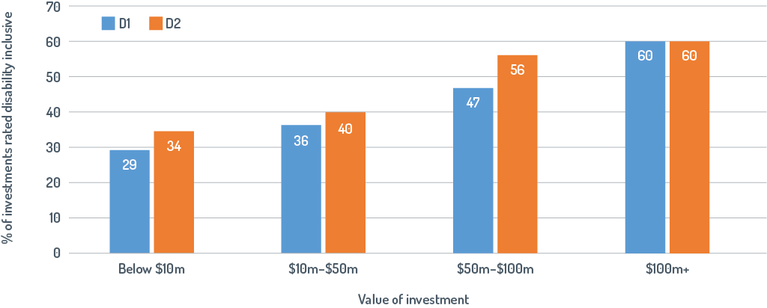

Figure 3: Disability inclusion is relatively strong for the relatively small number of high-value investments which make up more than half of aid expenditure

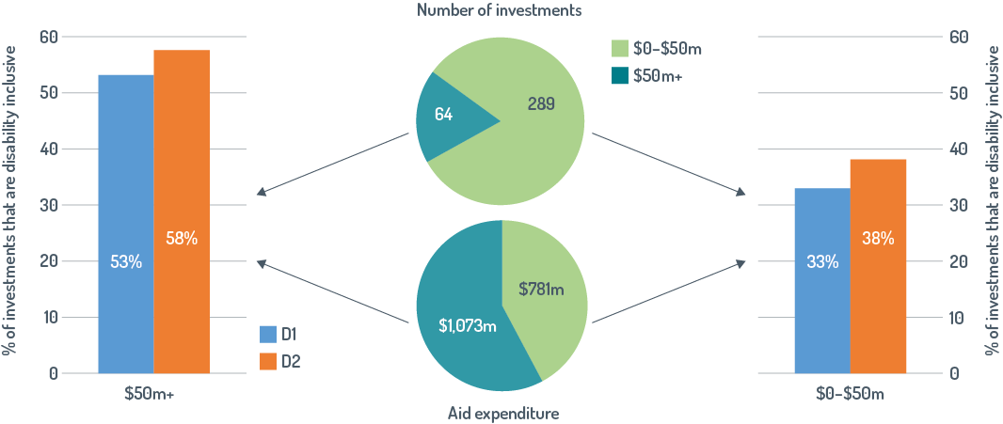

Figure 4: Ratings for disability inclusion have declined over time

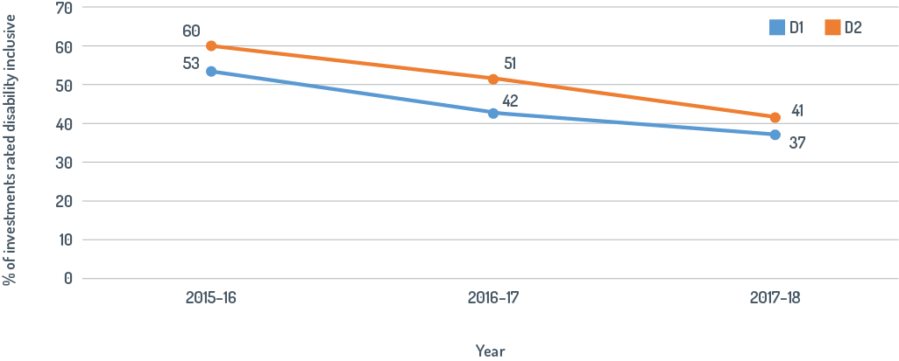

Table 3: Modifications to the wording of D2 for the latest Aid Quality Check reporting round

|  |  |
| --- | --- |
| Year | Disability criterion |
| 2016–17 | D 2 The investment identifies and addresses barriers to inclusion and opportunities for participation for people with disabilities. |
| 2017–18 | D 2 The investment identifies and addresses barriers to inclusion and opportunities for participation for people with disabilities to enable them to benefit equally from the aid investment. |

Other data sources and the review of programs presented later in this evaluation report suggest that disability inclusion in the Australian aid program is not weakening. The AQCs are therefore currently not useful in assessing progress over time in the implementation of disability-inclusive investments. However, they could become useful to assess progress if AQC reporting requirements for disability stay the same, the rigour of ratings is improved by revised guidance and appropriate moderation, and there is a good understanding of disability across DFAT’s operations.

Key findings for assessment of disability inclusion

* Reporting on disability inclusion in the APPRs for country programs is too variable and limited for them to be currently useful to assess disability inclusion.
* AQC ratings appear, to some extent, to overestimate the percentage of investments which are disability inclusive. Still, they provide a useful indication of the level of disability inclusion in program implementation and are useful in comparing the level of disability inclusion across the aid program.
* Measures other than AQCs are needed to assess outcomes for people with disabilities.
* In the most recent AQCs, about 40 per cent of aid investments were reported to be disability inclusive.
* Larger-value investments are more likely to be disability inclusive so assessing disability inclusion using the percentage of investments rated ‘disability inclusive’ underestimates the overall level of inclusion in the Australian aid program. For about 60 per cent of the aid programs expenditure, more than half of investments are disability inclusive.
* The percentage of investments that are rated disability inclusive in the AQCs has decreased each year for the last three years. The declines may largely stem from an increasing understanding of disability within DFAT which has increased standards for ratings.

# Disability inclusion across the Australian aid program

In 2017–18, Australia provided more than $2 billion in Official Development Assistance to more than 30 countries and four regions in the Indo-Pacific. Opportunities and approaches to ensure people with disabilities are included in, and benefit equally from, Australia’s development assistance are identified in Development for All 2015–2020. This section compares the implementation of disability-inclusive investments across the aid program, explores the scope of disability inclusion and identifies approaches used to improve inclusion.

Assessment of disability inclusion in regional and country assistance using Aid Quality Checks

In comparison with the aid program overall, the percentage of investments rated disability inclusive was substantially lower for regional investments and higher for country investments (Table 4). For country programs the percentage of investments rated ‘disability inclusive’ for **D1** was much lower than that for **D2**.

Table 4: Percentage of investments in regional and country programs rated disability inclusive in 2017–18

|  |  |  |  |
| --- | --- | --- | --- |
| Disability criterion | Regional programs % | Country  Programs % | Whole-of-aid program % |
| D 1 The investment actively involves people with disabilities and/or disabled people’s organisations in planning, implementation and monitoring and evaluation. | 22 | 40 | 37 |
| D 2 The investment identifies and addresses barriers to inclusion and opportunities for participation for people with disabilities to enable them to benefit equally from the aid investment. | 24 | 47 | 41 |

Table 5: Table 5: Percentage of investments in different regions rated disability inclusive in 2017–18

|  |  |  |  |  |  |
| --- | --- | --- | --- | --- | --- |
| Disability criterion | Pacific % | South-east and East Asia % | African and Middle East % | South and West Asia % | Whole-of-aid program % |
| D 1 The investment actively involves people with disabilities and/or disabled people’s organisations in planning, implementation and monitoring and evaluation. | 43 | 37 | 20 | 24 | 37 |
| D 2 The investment identifies and addresses barriers to inclusion and opportunities for participation for people with disabilities to enable them to benefit equally from the aid investment. | 45 | 43 | 27 | 41 | 41 |

Disability inclusion varied between geographic regions. Investments in the Pacific region were most likely to be disability inclusive (Table 5). Disability inclusion was close to the aid program averages in South-east and East Asia. It was well below average in Africa and the Middle East for both disability criteria and below average for South and West Asia for **D1.**

There was considerable variation in the percentage of investments in country programs that were disability inclusive (0 to 90 per cent, Figure 5). There was no correlation between total Australian aid expenditure in a country and the proportion of investments that were disability-inclusive. Most investments in Samoa and the Philippines (75 to 90 per cent) were disability inclusive for both criteria. Other strong performing country programs were Cambodia, Kiribati, Timor-Leste and Vanuatu. In contrast, Afghanistan, Myanmar, Nepal, Solomon Islands and Vietnam had proportionally very few disability-inclusive investments for either criterion. Investments in Bangladesh, Nepal, Sri Lanka, Tonga and Vietnam rated poorly for active involvement of people with disabilities.

With the exception of Papua New Guinea, countries that were a focus of DfA1 had proportionally more disability-inclusive investments than the average for their region (tables 6 and 7).

Figure 5: Disability inclusion is much stronger in some country programs

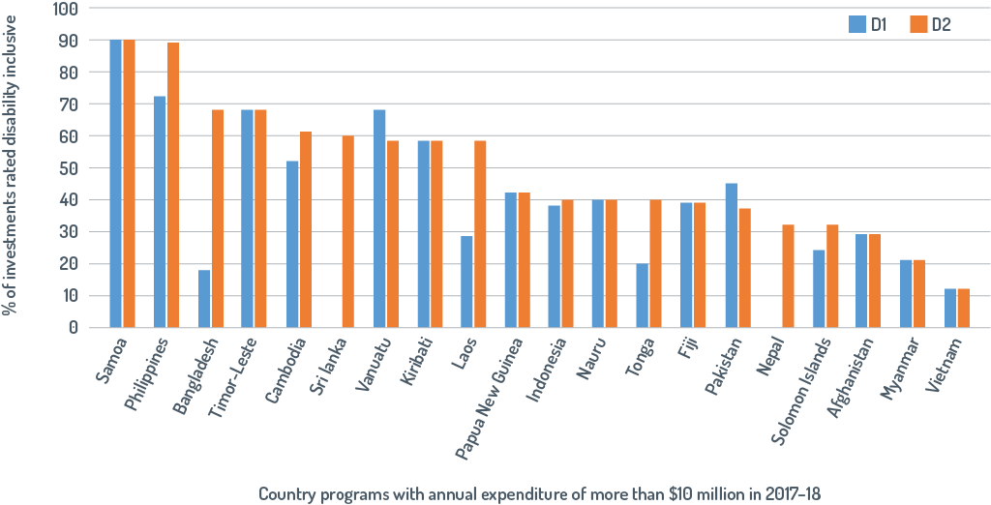

Table 6: Percentage of disability-inclusive investments in 2017–18 for DfA1 focus countries in the Pacific

|  |  |  |  |
| --- | --- | --- | --- |
| Disability criterion | Samoa % | Papua New Guinea % | Pacific % |
| D 1 The investment actively involves people with disabilities and/or disabled people’s organisations in planning, implementation and monitoring and evaluation. | 90 | 44 | 43 |
| D 2 The investment identifies and addresses barriers to inclusion and opportunities for participation for people with disabilities to enable them to benefit equally from the aid investment. | 90 | 44 | 45 |

Table 7: Percentage of disability-inclusive investments in 2017–18 for DfA1 focus countries in South-east and East Asia

|  |  |  |  |
| --- | --- | --- | --- |
| Disability criterion | Cambodia % | Timor-Leste % | South-east and East Asia % |
| D 1 The investment actively involves people with disabilities and/or disabled people’s organisations in planning, implementation and monitoring and evaluation. | 54 | 67 | 37 |
| D 2 The investment identifies and addresses barriers to inclusion and opportunities for participation for people with disabilities to enable them to benefit equally from the aid investment. | 62 | 67 | 43 |

Figure 6: Disability inclusion is stronger in some priority areas

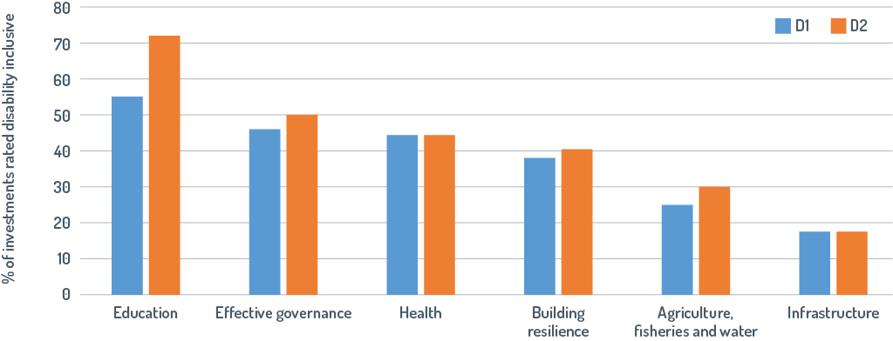

There were marked differences in the extent of disability inclusion in priority areas for Australian aid (Figure 6). Education investments were the most likely to be disability-inclusive, particularly for **D2**. Disability inclusion was also relatively strong for investments in effective governance and health. The percentages of investments in building resilience that were disability-inclusive were very close to the average for the aid program. The percentages of disability-inclusive investments for both infrastructure (less than 20 per cent) and agriculture, fisheries and water (less than 30 per cent) were well below average.

Disability inclusion in regional and country investments

Case studies of investments with high AQC ratings for disability inclusion were used to identify approaches that have been used to build inclusion. This included investments for the Pacific region and for four countries—Fiji, Indonesia, Timor-Leste and Vanuatu (Table 8). The case studies deliberately focused on investments that have successfully mainstreamed disability because mainstreaming has been a focus of DfA2, and proved difficult, but it is where the largest expenditure is and consequently where improvements have the potential to have the greatest impacts.[34] Descriptions of disability inclusion in the Pacific regional program, country programs and investments are in annexes 6 to 10.

Table 8: Investments reviewed and their 2017–18 Aid Quality Check ratings for disability criteria

|  |  |  |  |
| --- | --- | --- | --- |
| Program | Investment | Aid Quality Check rating 2017–18 | |
| **D1** | **D2** |
| **Pacific regional** | Regional Rights Resource Team | 5 | 4 |
| University of the South Pacific Partnership | 4 | 4 |
| Australia-Pacific Technical College Stage 2 (APTC) | 4 | 4 |
| **Fiji** | Fiji Community Development Program | 4 | 4 |
| Access to Quality Education Program, Fiji | 5 | 5 |
| **Vanuatu** | Vanuatu TVET Sector Strengthening Program Phase III, now Vanuatu Skills for Economic Growth (Phase IV) | 5 | 5 |
| Vanuatu Policing and Justice Support Program | 4 | 3 |
| **Timor-Leste** | Australia–Timor-Leste Partnership for Human Development (PHD) | 5 | 5 |
| Farming for Prosperity *To’os ba Maris Di’ak* (TOMAK) | 4 | 4 |
| Ending Violence Against Women in Timor-Leste (NABILAN) | 5 | 5 |
| **Indonesia** | National Rural Water Supply and Sanitation Project (PAMSIMAS-2) | 5 | 5 |
| Governance for Growth (KOMPAK) | 4 | 5 |
| Support to Marginalised Groups (PEDULI Phase II) | 6 | 6 |
| Australia Indonesia Partnership for Justice II (AIPJ II) | 6 | 6 |

Supporting ratification or implementation of the Convention on the Rights of Persons with Disabilities

Regional and country-level investments have improved disability inclusion by identifying and supporting work needed for ratification or implementation of the CRPD. The Pacific regional program funds the Regional Rights Resource Team of the Secretariat of the Pacific Community whose strategic objective is to build human rights in Pacific islands countries. The Team supports DPOs to advocate for their rights and assists governments to map their CRPD commitments and implement required actions (Annex 7). The Pacific Islands Forum Secretariat,which supports the implementation of the Pacific Framework for the Rights of Persons with Disability (2016–25), is also funded by the Pacific regional program.

Work needed for the ratification or implementation of the CRPD has also been supported in all case study countries. In Timor-Leste, the Australian Embassy has worked alongside, and supported, DPOs to advocate for the ratification of CRPD. In Indonesia, national ministries are being provided with assistance to formulate detailed regulations to guide implementation of the Indonesian Disability Law. In Vanuatu, the Vanuatu Policing and Justice Program provided technical support to the Disability Desk in the Ministry of Justice to assist with finalising its final national disability policy, and to mainstream this across all ministries.

Addressing barriers to inclusion

Barriers to inclusion make it difficult for people with disabilities to access services. This compounds their disadvantage. Many investments reviewed are helping people with disabilities realise their rights. For example, the Vanuatu Policing and Justice Program aims to improve access to justice for people with disabilities by:

* supporting the planning and reform agenda of the national government
* improving the capacity of Vanuatu Disability Promotion and Advocacy to engage in the justice sector
* establishing provincial disability committees
* modifying the operational procedures of the Vanuatu Police Force.

Another example of an investment helping people with disabilities realise their rights is the Marie Stopes Program, funded through Australia–Timor-Leste Partnership for Human Development. This investment has made reproductive health services more accessible to women with disabilities by increasing the understanding of staff about disability, having positions which specify disability-inclusion responsibilities and making health centres more accessible.

Work to build the capacity of Disabled People’s Organisations

A common feature of the Pacific regional program and of the four country programs reviewed has been the strong continued support for DPO capacity development. DPOs have been provided with core funding for many years (Box 6), which has given them the time and space needed to build skills, represent their members, become advocates in their own right, and work on their own priorities. Additional funding to build DPO capacity has been provided through the Disability Section in Canberra, which allocates funding to global organisations such as the International Disability Alliance and the Disability Rights Advocacy Fund.

DPO capacity has also been built by training and the technical support provided through the DFAT–CBM partnership and DPO participation in development processes and networks (Box 7). For example, through working in the Nabilan program in Timor-Leste, *Ra’es Hadomi Timor Oan* (RHTO) staff learned how to monitor and document human-rights violations and gained formal qualifications in social services. DPOs, including some Peduli partners in Indonesia, reported that working with DFAT has improved their operations, administration and financial management, making them credible organisations that are able to secure funding from a range of sources (Box 7).

|  |
| --- |
| Box 6: Building the capacity of Disabled People’s Organisations in the Pacific region |
| **The Pacific Disability Forum (PDF)** is an independent, non-government regional organisation that is the peak umbrella body for DPOs in the Pacific region. It has more than 30 full-member organisations in 21 countries. As the focal point on disability issues in the Pacific, PDF provides leadership and supports national DPOs, donor and development partners, as well as civil society.  Australia has supported PDF since 2008, with core funding starting in 2012. A DFAT evaluation of regional support for disability in the Pacific in 2016 concluded that the PDF’s work is consistent with DfA2. It also found that PDF was a professionally run organisation that had the networks and leadership needed for effective advocacy at global, regional, national and community levels. |

Working in partnership with Disabled People’s Organisations

Partnerships with DPOs have facilitated the active participation of people with disabilities and the implementation of contextually appropriate work to make investments disability inclusive. A good example of this is the Nabilan program which partnered with RHTO to identify work needed to reduce violence against women and children with disabilities in Timor-Leste. Another example is the Australia Indonesia Partnership for Justice which worked with a local DPO to identify changes needed to make court facilities and procedures accessible for the diverse needs of people with disabilities (Box 8). Working in partnership with DPOs has also helped make programs more inclusive. This is because DPOs are the most effective advocates. In Fiji, the increased enrolment of children with disabilities in demonstration schools in the Access to Quality Education Program was achieved by supporting a DPO to work with the families of children with disabilities to change their discriminatory attitudes.

|  |
| --- |
| Box 7: Building Disabled People’s Organisation capacity in Timor-Leste |
| RHTO officially registered as an NGO in 2008 and was legally recognised by the Ministry of Justice in 2010. It is primarily an advocacy and lobbying body that works with local and national levels of government and communities to improve inclusion. It also runs a community-based rehabilitation program, undertakes awareness-raising activities, and provides training on disability for NGOs, government and other development partners.  DFAT’s Dili Post includes RHTO in a wide range of events and processes, which, *inter alia,* demonstrate and promote disability inclusion. RHTO is now a high-capacity organisation that has been recognised for its sound financial management. It has representatives in many districts and the capacity to guide work to improve disability inclusion in Timor-Leste. Representatives from implementing partners, government agencies and DFAT staff interviewed in this evaluation reported they had worked with RHTO and highly valued its advice.  This photo shows a large group of diverse staff who work for RHTO.  Core funding has enabled RHTO to employ more than 40 staff and expand its operations across many districts. Some RHTO staff outside their headquarters in Dili. Photo: Petra Kavunenko |

|  |  |
| --- | --- |
| Box 8: Working in partnership with Disabled People’s Organisations | |
| Much of the success in making the Australia Indonesia Partnership for Justice disability inclusive was achieved because of partnerships with DPOs. In Yogyakarta*, Sasana Inklusi dan Gerakan Advokasi Difabel* (SIGAB), a local DPO, worked with court officials to identify changes needed to make court buildings and processes more accessible. The interaction of court officials with SIGAB and another DPO (also a partner of the Australia Indonesia Partnership for Justice) improved understanding of disability and accessibility. As a result, court officials recognised and implemented changes needed to improve accessibility and they allocated the necessary funding to achieve this. Some modifications required a change in attitude while the cost of other modifications was small enough to be covered by annual allocations for building maintenance. Court officials were enthusiastic about the impact they had on the Court’s function.  Disability activist, Bahrul Fuad, testing the modifications made to a Court near Yogyakarta. Ramps and moveable furniture have made the court accessible for wheelchair users. Toilets and one of the Court’s cells have also been modified to be accessible. Court information is available in Braille format, and a screen at the entrance gives information in Sign Language. Court procedures have been modified to meet the needs of people with psychosocial and intellectual disabilities. Photo: Karen Ovington | This photo shows that is it possible for a wheelchair to move up a ramp and through the double glass doors of a Court house. |

Twin-track approach

A twin-track approach, as proposed in DfA2, has been effectively used by almost all disability-inclusive investments reviewed in the case studies. Disability has been successfully mainstreamed in investments in the governance, education, health and WASH sectors. A broad range of disability-specific initiatives has enabled people with disabilities to benefit from mainstreaming efforts (annexes 7 to 10).

Examples of investments using the twin-track approach include the Australia–Timor-Leste Partnership for Human Development which provides core funding to two national DPOs and mainstreams disability across all sectors. The DPOs are actively involved in designing and implementing sectoral programs, providing training on disability inclusion for service providers, and monitoring accessibility of services in municipalities.

The Fiji Community Development Program, which works with CSOs to help mitigate the social and economic hardship faced by the poor, vulnerable and excluded communities, also illustrates how the twin-track approach has been used to support inclusion. Disability was mainstreamed by making disability inclusion a requirement for CSOs, supporting disability-specific initiatives (including services for the vision impaired in rural areas) and working with parents to improve the access of children with disabilities to education and other services.

Another investment which has successfully used the twin-track approach is the Australia-Pacific Technical College in Suva. Disability-specific actions, including targeted recruitment, are used to increase the enrolment of people with disabilities. The college run a Certificate II Skills bridging course specifically for people with disabilities who had limited previous access to education. Students with disabilities participate in the college’s mainstream program, with special assistance including scholarships and additional literacy and numeracy support. College staff receive training so they have the awareness, understanding and confidence necessary to embed disability inclusion into the College’s culture and processes.

Reasonable accommodation

Budgets for reasonable accommodation have facilitated disability inclusion. Partner DPOs felt that this approach was often key to people with disabilities being able to genuinely participate in and benefit from development programs. Budgets for reasonable accommodation have supported the active participation of people with disabilities by covering travel costs for DPO representatives to enable them to participate in meetings or visit project sites to review implementation.

The flexibility of budgets for reasonable accommodation has also allowed investments to identify and adjust support so that it was fit-for-purpose. For example, the Access to Quality Education Program provided demonstration schools with an Inclusive Education Small Grant to cover the costs of making school facilities accessible and providing for children’s disability-specific needs, such as transport, mobility devices and technical support.

Influencing implementing partners

Consistent messaging from DFAT staff about the importance of disability inclusion has influenced partners, including multilateral and regional partners, contractors, government partners and others. This policy leadership has improved disability inclusion, from analysis through to design, implementation and assessment.

A number of investments reviewed included demonstrations or pilots to provide the evidence needed to influence partner organisations. Support to Marginalised Groups Phase II (PEDULI), an Australian Indonesian Government partnership that promotes social inclusion to reduce poverty among marginalised people, has demonstrated how villages can be more inclusive. Villages receive funding from the Indonesian Government which they allocate according to their priorities. A local DPO funded by PEDULI established a Village Disability Forum to gather data about people with disabilities and their needs. This information resulted in a funding allocation for the Village Disability Forum to support disability-specific initiatives such as accessible infrastructure. The village DPO reported that the PEDULI project had increased respect for and acceptance of people with disabilities within their family and the village. The Inclusive Village model has now been taken up by eight villages and appears likely to be further scaled up. Consequently, funding provided by the Government of Indonesia to villages will be increasingly used to support disability-inclusive development.

The PAMSIMAS program also illustrates how disability inclusion has been achieved at a large scale due to strategic use of relatively small amounts of Australian funding to provide the evidence needed to make the practices of partners more disability inclusive (Box 9).

|  |
| --- |
| Box 9: Improving inclusion through influencing partners |
| Australia contributes about 6 per cent of the total funding of PAMSIMAS with the Government of Indonesia and the World Bank providing the rest. Australia’s flexible grant funding was used to pilot disability-inclusive practices and infrastructure in 200 villages in 2017. As the pilot was successful, disability-inclusive water and sanitation services are now being rolled out to more villages. It is expected that by 2020, 10 000 villages will have disability-inclusive water and sanitation services. The scale of what has been achieved and is underway in PAMSIMAS has provided a good example for other WASH programs and the broader development work of the World Bank. |

|  |  |
| --- | --- |
| Box 10: Recognising the needs of women with disabilities | |
| *Sentra Advocasi Perempuan Difabel dan Anak* (SAPDA, the Advocacy Centre for the Disabled, Women and Children) was established in 2005 in Yogyakarta, Indonesia, by a group of women with disabilities. It advocates for an inclusive society, focused particularly on the rights of women and people with disabilities and children, in the areas of education, health and employment. In line with its advocacy for an inclusive society, SAPDA identifies as a CSO rather than a DPO. It models inclusion by employing people with and without disabilities.  SAPDA has received core funding from DFAT since 2013 through the Australia Indonesia Partnership for Justice, and from Peduli since 2015. Staff reported this long-term support had allowed for the organisation to mature and develop the capacity of its staff and systems. Through working in DFAT programs, SAPDA has been able to widen its networks from its base in Yogyakarta to the national level and develop organisational and management systems.  SAPDA reported it is now seen as a ‘trusted organisation’ able to access other grant funding and mature enough to begin to become self-sufficient in the longer term. SAPDA is beginning to sell consulting and research services (for instance, it has been hired by an international NGO working in Indonesia to facilitate a meeting of its partners on inclusive programming) and is working towards developing a research centre for social inclusion that would be a resource for government and other organisations.  Nurul, SAPDA Director, commented: *‘The DFAT program gave us the authority and support to develop, implement and achieve our vision and we are confident that we will survive without DFAT support eventually.’* | This photo shows SAPDA’s female Director leaning on her crutch at work.  Nurul, Director of SAPDA. Photo: Karen Ovington |

Taking gender into account

The profiles of investments in the countries reviewed included some that specifically addressed the needs of women with disabilities. DfA2 recognises that women and girls with disabilities are at greater risk from all forms of violence. In Timor-Leste, which has some of the highest rates of gender-based violence in the world, the Nabilan program is working to address violence against women and girls with disabilities.

The interaction between disability and gender has also been addressed through partnerships with disability organisations that have a specific focus on women. In Yogyakarta, for example, the Advocacy Centre for the Disabled, Women and Children is one of Peduli’s partner organisations (Box 10). In the Pacific the interaction has been addressed through increasing disability inclusion in Pacific investments that focus on women. The Fiji Women’s Fund has introduced a special allocation of its grant funding to support disability-focused groups, especially those working with women with disabilities. Recently, the major DFAT regional program working for women’s empowerment, Pacific Women Shaping Pacific Development,has promoted opportunities to increase participation of women with disabilities.

Inclusion of a diverse range of people with disabilities

DfA2 emphasises the need for development programs to recognise there is a diverse range of people with disabilities. Regional and country programs have funded umbrella DPOs which provide support and capacity development to smaller DPOs. As these smaller DPOs often focus on a particular disability or issue, funding, to some extent, has empowered and supported the diverse range of people with disabilities.

Additionally, many investments reviewed addressed multiple barriers to inclusion. For example, the Australia–Indonesia Partnership for Justice made court buildings and processes more accessible for people with sensory, physical, psychosocial and intellectual disability.

Key findings for regional and country programs

* Disability inclusion is relatively weak for regional investments.
* Disability inclusion varied between geographic regions, with the Pacific being the strongest performing region.
* The proportion of investments that are inclusive varies greatly between countries.
* Countries, except for Papua New Guinea, which were a focus of DfA1, have proportionally more disability-inclusive investments than other countries in their region.
* Disability inclusion is relatively strong in some priority areas (education and effective governance) but weak in others (infrastructure and agriculture, fisheries and water).
* Ratings for identifying and addressing barriers to inclusion are typically higher than those for active involvement of people with disabilities.
* Building the capacity of regional and national DPOs has been a priority and been successful.
* Supporting umbrella DPOs allows DFAT to support the diverse range of people with disabilities.
* Ratification and implementation of CRPD has been supported at regional and country levels. Some investments are helping people with disabilities realise their rights.
* A twin-track approach and reasonable accommodation have helped make investments inclusive.
* The diversity of people with disabilities and the association between gender and disability have been taken into account in some investments.

# Disability inclusion in global programs

Australia contributes to a number of global initiatives that support development efforts around the world. This evaluation reviewed disability inclusion in significant global programs not considered in ODE’s evaluation of global advocacy.[35] Typically, DFAT global programs have central policy and/or program guidelines developed by DFAT in Canberra, which may be adapted differently by implementing areas such as DFAT posts.

Assessment of disability inclusion in global programs using Aid Quality Checks

Across all global programs, approximately 40 per cent of investments were disability inclusive (Table 9).

The Australian NGO Cooperation Program

The ANCP is a global program that provides matched funding (up to a ratio of 5:1) to accredited Australian NGOs. In 2017–18, it provided $128.8 million in grant funding to 57 accredited NGOs to implement 455 projects in 57 countries across a broad range of sectors.

ANCP accreditation requires Australian partner NGOs to demonstrate they have procedures to identify the barriers to inclusion, promote disability-inclusive practices throughout their programs and undertake periodic assessments of their own and their implementing partners’ disability-inclusion practices.[36]

ANCP is one investment so the program completes a single AQC. It was rated as ‘performing well’ for both disability criteria in 2015–16 and 2016–17 (Table 10). The rating was lowered to ‘satisfactory’ in 2017–18 as the program felt the level of evidence provided by the NGOs and DFAT’s own monitoring and engagement visits was insufficient to justify a higher rating. The level of evidence available in 2017–18 was similar to that available in previous years so the reduction may be a consequence of increased understanding of disability inclusion within DFAT.

ANCP also completes an Annual Program Performance Report (APPR). Disability inclusion was a *principal* or *significant* focus of at least 60 per cent of ANCP projects from 2014–15 to 2016–17 (Table 10). In 2016–17, only 11 per cent of ANCP projects had no focus on disability.

Table 9: The percentage of global program investments rated as disability inclusive in Aid Quality Checks in 2017–18

|  |  |  |
| --- | --- | --- |
| Disability criterion | Global programs % | Whole-of-aid program % |
| D 1 The investment actively involves people with disabilities and/or disabled people’s organisations in planning, implementation and monitoring and evaluation. | 38 | 37 |
| D 2 The investment identifies and addresses barriers to inclusion and opportunities for participation for people with disabilities to enable them to benefit equally from the aid investment. | 37 | 41 |

Table 10: ANCP Aid Quality Check ratings

|  |  |  |  |
| --- | --- | --- | --- |
| Disability criterion | 2015–16 | 2016–17 | 2017–18 |
| D 1 The investment actively involves people with disabilities and/or disabled people’s organisations in planning, implementation and monitoring and evaluation. | Performing well | Performing well | Satisfactory |
| D 2 The investment identifies and addresses barriers to inclusion and opportunities for participation for people with disabilities to enable them to benefit equally from the aid investment. | Performing well | Performing well | Satisfactory |

Table 11: The percentage of ANCP projects that focus on disability

|  |  |  |  |
| --- | --- | --- | --- |
| Level of focus on disability | 2014–15 (%) | 2015–16 (%) | 2016–17 (%) |
| Principal focus | 14 | 10 | 13 |
| Significant focus | 47 | 57 | 48 |

The results reported by ANCP partner organisations are used to calculate aggregate development results. More than a million men and women with disabilities are estimated to have benefited from ANCP projects. Disability outcomes from ANCP-funded projects in 2016–17 are reported to include:

* 1.4 million people with disabilities benefited
* more than 25 000 people provided with disability services like prostheses and assistive devices (half were women and girls)
* more than 3,000 adults with disabilities successfully obtained a livelihood as a result of skills training or capacity building (half of these were women)
* more than 3,000 teachers trained in disability inclusion (half of these were women and 6 per cent people with disabilities).

These results are impressive but a recent review of the data systems of ANCP’s NGOs found the disability-disaggregated data had an adequate-weak level of rigour due to a range of factors, such as local partner capacity, differences in definitions, use of estimations, and NGO perceptions on risk of further marginalisation.[37] The ANCP program is currently exploring options to improve reporting on disability outcomes. There would be value in aligning assessments of disability inclusion in ANCP projects with the disability criteria used in the AQCs.

This evaluation reviewed the ANCP database to identify ways in which projects were disability inclusive. Disability was addressed through disability-specific and/or mainstreaming approaches. Different types of disability, including psychosocial and intellectual disabilities, were addressed across the range of ANCP-funded projects. Many projects addressed the needs of people with disabilities and improved their access to services. Some projects actively involved people with disabilities and/or DPOs.

Disability inclusion in ANCP could possibly be improved by identifying components of the ANCP that are less inclusive and requesting Australian Partner NGOs to work to improve inclusion in these components. Disability inclusion could be assessed across the profile of projects supported by each Australian Partner NGO, in sectors and in countries.

The coverage of different types of disability and balance of mainstreaming to disability-specific activities should also be assessed. Follow-up work to improve inclusion would need to recognise that grants provided by funded Australian NGOs are very small and are given to local organisations which have a narrow focus. It may be impractical to expect the projects of these organisations to be disability inclusive.

Australia Awards

The Australia Awards is a whole-of-Australian government initiative administered by DFAT to provide education, training and professional development opportunities for people from developing countries. In 2017–18, Australia provided 4,031 scholarships, short courses and fellowships for individuals from more than 60 developing countries at a cost of about $320 million. This evaluation reviewed disability inclusion in Australia Award scholarships and short courses.

The overarching policy for Australia Awards, *Australia Awards Global Strategy: Investing in the next generation of global leaders for development 2016–2018,* emphasises that all awards have an ongoing commitment to removing barriers to participation by people with disabilities.

Australia Award Scholarships

The Australia Award Scholarships are prestigious grants to individuals to enable them to study at tertiary institutions in Australia and Pacific countries. Scholars are selected from large numbers of applicants by rigorous processes.

In 2017–18, AQCs, almost all Australian Award Scholarships investments were reported to be disability inclusive for both criteria (Table 12).

Disability inclusion has been mainstreamed through the provision of scholarships to people with disabilities. Since 2012, about 260 people with disabilities have been awarded scholarships and completed tertiary courses. Women have received about half of these scholarships. Overall, and in the four countries where the most scholarships have been awarded (Indonesia, Papua New Guinea, the Philippines and Vietnam)[38], the percentage of scholarships awarded to people with disabilities has increased (Figure 7). In 2017, almost 4 per cent of scholars were people with disabilities. In Vietnam, more than 7 per cent of scholars have disabilities. In several African countries, more than 5 per cent of scholars have disabilities. These are strong achievements as many people with disabilities have limited access to primary and secondary schooling.

Needs-based disability support has facilitated disability inclusion. Support needs and practical solutions are identified and used to develop Disability Support Agreements for each scholar which outlines the funding and support that will be provided. Between 2012 and 2016, $1.5 million has provided reasonable accommodation measures for scholars with disabilities. Recently limits have been set on the amount of reasonable accommodation for individual students.[39] Scholars have different degrees and types of impairments (Table 13) and therefore require different levels of support.

Table 12: Percentage of Australia Awards Scholarship programs rated as disability inclusive in Aid Quality Checks, 2017–18

|  |  |  |
| --- | --- | --- |
| Disability criterion | Scholarship programs % | Whole-of-aid program % |
| D 1 The investment actively involves people with disabilities and/or disabled people’s organisations in planning, implementation and monitoring and evaluation. | 100 | 37 |
| D 2 The investment identifies and addresses barriers to inclusion and opportunities for participation for people with disabilities to enable them to benefit equally from the aid investment. | 92 | 41 |

Figure 7: More people with disabilities being awarded scholarships

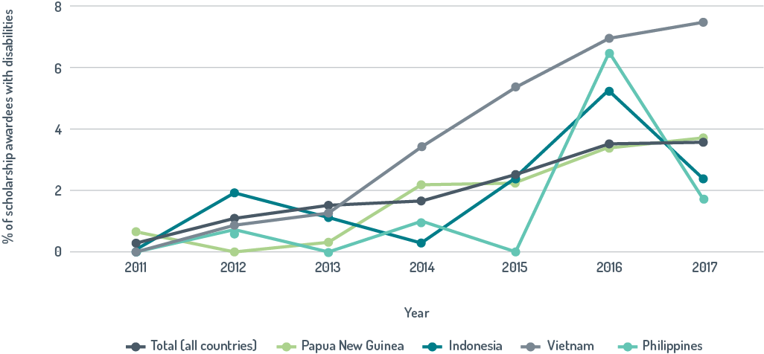

Table 13: Table 13: A diversity of people with disabilities has been awarded scholarships

|  |  |
| --- | --- |
| Type of impairment* | Number of scholars |
| Physical | 86 |
| Sensory | 87 |
| Psychosocial | 18 |
| Intellectual | 5 |
| Medical condition | 24 |
| Physical and intellectual | 2 |
| Physical and psychosocial | 3 |
| Sensory and intellectual | 1 |

*For some scholars, the type of impairment was not listed.

In addition, host institutions are provided with a Disability Administration Supplement of $300 per awardee, per semester. This acknowledges the additional support provided by institutions to awardees with disabilities. For example, the University of Melbourne has a dedicated Disability Support Unit which provides support and establishes links with community services such as Vision Australia and the Walking Cane Community of Melbourne.

While some countries have made good progress in increasing the number of scholarships awarded to people with disabilities, other countries have not. Few scholarships have been allocated to people with disabilities from some Pacific island countries, even though they have relatively large scholarship allocations. The percentage of scholarships awarded from 2011–17 to people with disabilities in Fiji was 2.5 per cent and less than 1 per cent for Samoa and Tonga. Only one person from Vanuatu who has a disability has been awarded a scholarship.

Success in increasing the number of scholars with disabilities reflects sustained and concerted efforts to make each phase of the scholarship cycle disability inclusive (Table 13). The Australia Awards program in Africa has deployed most of these approaches. The evaluation found completion rates for people with disabilities were as high as those of other scholars, despite some slight lowering of academic and English-language requirements in the award process. This suggests that a level of flexibility in awarding scholarships does not compromise outcomes.

After returning to their home countries, Australian Award scholars are often employed in influential roles and use the knowledge gained while on award to support development. Given this, inclusion of people with disabilities in the Australia Award scholarships has the potential to leverage significant outcomes for disability inclusion. DFAT is currently working with CBM to develop a substantive two-day training package on disability-inclusive development to be delivered to all scholars and New Colombo Plan[40] participants. The training would provide a foundational understanding of disability, outline the reasons for disability inclusion and illustrate how people with disabilities could be included in development programs.

Table 14: Concerted efforts have increased the proportion of scholarships awarded to people with disabilities

|  |  |
| --- | --- |
| Stage of scholarship cycle | Approaches used to increase the number of scholars who have disabilities |
| Recruitment | Explicit about commitment to disability inclusion  Information sent to organisations interested in disability  Targeted recruitment through DPOs  Information sessions in accessible locations  Accessible website  Promotional materials in Braille |
| Application | Guidance outlining support available to applicants |
| Selection | Interviews in accessible locations  Adjustment measures for interviews  Selection panels briefed by social-inclusion officer  Grade point average requirement slightly lowered  English language requirement slightly lowered  Recognition of skills and other qualifications |
| Pre-departure | Detailed information on support available  Disability support agreement  English language support  Alumni with disabilities share their experiences of life in Australia  Specific briefing for awardees with disabilities |
| On Award | Reasonable accommodation  English language lessons  Support from disability advisers  Administration supplement for host organisation |
| Post Award | Alumni with disabilities encouraged to participate in events  Events in accessible locations  Reasonable accommodation  Success stories in alumni newsletters  Small grants to support disability-specific activities |

|  |  |
| --- | --- |
| Box 11: Making Australia Award Scholarships more inclusive by increasing applications from suitably qualified people with disabilities | |
| In Fiji, DFAT asked DPOs to identify suitable candidates for Australia Award Scholarships and encourage them to apply. Sovaia Sisi Coalala reported that she only applied for a scholarship because of this encouragement as she felt her disability made her ineligible. Sisi was awarded a scholarship and completed a Masters’ in Strategic Human Resource Management at the University of Wollongong (2013–14). Sisi says that her experience in Australia during her studies has *‘… helped instil in me a self confidence that I would not have otherwise had … but most importantly, it has given me an opportunity to be a role model to my fellow women with disabilities to excel in their different professions and to have the sky as their limit.’* Sisi now works as Coordinator of the Fiji National University Disability Centre, a position which enables her to pursue her dream to help people with disabilities get the best possible opportunities for their success and independence. | This photo shows Sisi busy at work on her computer.  Sovaia Sisi Coalala at her work station in the Fiji National University Disability Centre. |

Australia Award short courses

Australia Award short courses are based on proposals developed and administered by DFAT Posts largely in response to partner governments’ requests for short-term, targeted training to fill skill gaps. Higher education providers and training organisations in Australia develop courses from two weeks to several months in length, with components in Australia and home countries. Some bilateral programs do not have short course awards while some, most notably Indonesia, have many.

Short courses are not covered by AQCs and there is no central database. This evaluation reviewed disability inclusion in 86 short courses run by the Australia Award program in Indonesia. A short course designed to build DPO leadership (Box 12) has been run twice. Almost all participants of these two courses were people with disabilities. Very few (0.2 per cent) of the participants of other courses had disabilities. About 20 per cent of short courses had some course content on disability inclusion.

Disability inclusion in the short courses could be improved by increasing the coverage of disability-inclusive development in all courses, running proportionately more disability-focused short courses and designing short courses to support work needed to improve disability inclusion. A short course run by the South and West Asia Australia Award program illustrates how the short courses can be used to support disability-inclusive development (Box 13).

|  |
| --- |
| Box 12: Using Australia Award short courses to build leadership in Disabled People’s Organisations |
| Indonesia Post supported a group of 20 DPO leaders from across the country to participate in a leadership short course run by the University of Sydney. In addition to building their networks and honing their leadership skills, the course aimed to improve organisational, management and advocacy skills. Participants also met with Australian disability activists.  DPO leaders reported that the course expanded their skills and views of inclusion beyond their organisations.  ‘One thing I learned was to think about issues related to our humanity together, rather than separating our different personal identity struggles into “sectors” because inclusion is not something that belongs to one identity alone.’  Fatum Ade, Field Coordinator for Se ntra Advokasi Perempuan, Difabel dan Anak (Advocacy Centre for People with Disabilities, Women and Children Indonesia) in Banjarmasin, South Kalimantan  This photo shows several course participants in wheelchairs all wearing t-shirts with the slogan (I am a DPO leader) talking with Kurt Fearney, Australian athlete, is in his wheelchair.  Course participants meet a disability activist and one of Australia’s top athletes, after watching the Australia Day 10-kilometre wheelchair road race. |

|  |
| --- |
| Box 13: Using Australia Award short courses to support inclusive education |
| A regional short course on inclusive education was run by the Australia Awards South and West Asia Program in 2016. The course aimed to broaden participant knowledge of inclusive education to improve capacity to bring about changes needed to make education policies and practices disability inclusive. Most of the 17 participants came from Nepal, three were from Bangladesh and one from Sri Lanka. The Nepali participants, including five with disabilities, were from the Ministry of Education and its line agencies, or DPOs. This evaluation used reporting on return-to-work plans and interviews with participants to identify outcomes attributed to the course.  Nepali participants reported that the course had influenced government officials by increasing their understanding of disability. As one participant said: *‘People are aware about disabilities that are very apparent but intellectual disabilities are hidden. The training covered intellectual disability. It was eye opening for our leaders from the Ministry.’*  Participants also commented on how the course improved their knowledge of inclusion, with one participant observing: *‘We see that the Ministry representatives are now speaking at different forums about inclusive education, so we do think there has been some change.’*  Finally, participants said the course made them more likely to consult with DPOs. As one participant concluded: *‘It is a great opportunity that activists, policy makers and government learn together. Prior to the course, the Ministries particularly Education, did not consult with us very often. But after the course, there have been frequent revisions of the curriculum, and more and more DPOs have been involved. Now we also go with Ministry officials to the districts to monitor the effectiveness of these.’* |

Australian Volunteers Program

Since the 1960s, the Australian aid program has supported Australians to undertake voluntary work in developing countries to promote public diplomacy and development outcomes. In 2017–18, the Australian Volunteers Program had a budget of approximately $37 million. This enabled 1097 Australians to volunteer in 723 organisations in 26 countries.

In the AQC reporting round for 2017–18, the Volunteers Program rated ‘performing well’ for both disability criteria.

Since 2013, policies with a clear focus on disability have improved disability inclusion in the Volunteers Program. The allocation of volunteers to assignments that focus on disability inclusion is the main way the program has become more inclusive. The proportion of volunteers whose assignments were disability focused increased to 18 per cent in 2017 (Figure 8). Volunteer assignments have helped build the capacity of DPOs working to address a broad range of impairments, including psychosocial and intellectual.

Concerted efforts to mainstream disability inclusion by mobilising volunteers who have disabilities have had some success (Table 15). Very few Australians with a disability apply for volunteer positions even though marketing and communications sections have targeted them and funding for reasonable accommodation is provided for volunteers and their carers.[41]

The requirement for volunteers to have formal education and professional qualifications may be a limiting factor, but the main limiting factors are more likely to be restricted accessibility in developing countries and restrictions around international travel time lengths associated with disability and carer’s pensions.[42]

Shorter deployments of volunteers with disabilities have recently been trialled. In a Disability Empowerment Skills Exchange, teams of Australian volunteers living with disabilities undertook well-supported, month-long missions to share their knowledge and skills with DPOs in Fiji and Laos. The exchange was valuable in building relationships, but too short for the Australian volunteers to make a significant contribution to the DPOs.

Disability has also been mainstreamed in the Volunteer Program by placements that support disability mainstreaming, disability-inclusiveness training for all volunteers and staff, and Disability Initiative Grants (Box 15).

|  |  |
| --- | --- |
| Box 14: Volunteers building the capacity of Disabled People’s Organisations | |
| In Nepal about 20 per cent of volunteer placements are in disability-focused organisations. The Independent Living Centre for Persons with Disabilities (CIL)—a well-established DPO in Kathmandu—recently hosted two volunteers. The Centre advocates for legislative, administrative and other reforms to improve accessibility so that people with disabilities can fully participate in society. It also helps individuals become more independent through developing their living skills and provision of personal assistant services, assistive devices, and employment or social security services.  Australian volunteer Ariane Forsythe had a placement as an Advocacy and Communications Officer to strengthen the Centre’s capacity to advocate. Claire Mercer’s placement as Organisational Development Advisor was to improve planning, administrative systems and reporting processes.  Staff of CIL were very enthusiastic about the contributions made by the volunteers and identified many positive changes they had instigated. Some changes, such as regular staff meetings, work schedules and evaluation of performance against the centre’s strategic plan, were felt to have improved how CIL operates. Other work, such as the identification of CIL’s key values and improvements to brochures and the website, were felt to have extended and professionalised CIL’s advocacy. Staff also reported that the volunteers had built their confidence and capacity through working alongside them and through the training courses and weekly English lessons the volunteers provided.  Overall the contributions made by Ariane and Claire were highly valued by CIL and thought by the organisation’s president to be likely to have sustainable impacts.  *‘The volunteers have increased our capacity and raised us and CIL to a higher level. The documentation and guidelines are very strong, so we can follow them after they return home.*’  Staff of CIL noted that the volunteers had learned much from their volunteering experience and commented:  *‘Disability is a new issue for them. It is a technical issue. We specifically work in disability so they will also benefit.’* | This photo shows a group gathered in front of the Independent Living Centre for Persons with Disabilities. The group includes two Australian volunteers, the program manager and the Secretary General of the Center in his wheelchair.  Back, left to right: Ganesh KC, President, CIL; Volunteer Claire Mercer; Deepa Upadhyaye, Program Manager, CIL; Volunteer Ariane Forsythe. In front: Krishna Gautam, Secretary General, CIL. Photo: Caitlin Dixon  This photo shows the Treasurer of the Independent Living Centre for Persons with Disabilities going home after work on her motorbike wearing a helmet and transporting her wheelchair on the side of the motorbike.  Ms Devi Acharya, Treasurer, CIL, heading home on a three-wheel motorbike which can carry her wheelchair. Photo: Karen Ovington |

Figure 8: Volunteer assignments are increasingly disability focused

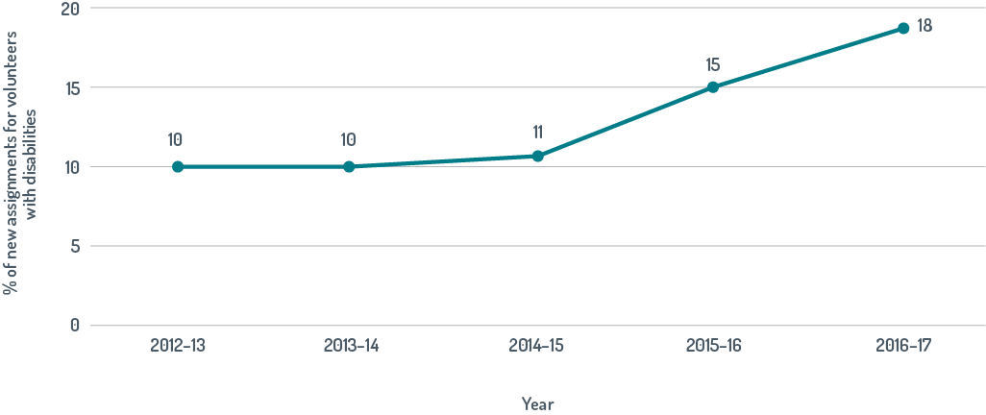

Table 15: Number and percentage of people with disabilities people who apply to be and are recruited as volunteers

|  |  |  |  |  |
| --- | --- | --- | --- | --- |
| Year # | Number of applicants identifying as having disabilities | % success rate of applicants identifying as having disabilities | Number* of volunteers mobilised who identify as having disabilities | % of new volunteers mobilised who identify as having disabilities |
| 2012–13 | 28 | 14 | 4 | 0.3 |
| 2013–14 | 41 | 2 | 12 | 2 |
| 2014–15 | 37 | 35 | 13 | 1 |
| 2015–16 | 42 | 24 | 15 | 3 |

# more recent data was not available * some people with disabilities do not self-identify

Direct Aid Program

The DAP is a flexible small grants program managed directly by DFAT Posts. Projects funded by DAP are expected to achieve practical and tangible development outcomes while also increasing the profile of Australia by creating a distinctive and positive image. In 2016–17, $22 million was allocated by 67 of DFAT Posts for projects in countries eligible for Official Development Assistance. The International Development Fund is a sub-program of the DAP managed through Australia’s permanent missions to the United Nations in New York, Geneva and Vienna, and to the World Trade Organization in Geneva. The Fund supports multilateral agendas that Australia wishes to advance and enables developing countries to participate in international meetings.

In 2014, the guidance provided to Posts to inform the selection of DAP projects was modified to increase disability inclusion. Projects which ‘support good governance, human rights and those with a strong advocacy component’ were identified as suitable and projects that ‘support people with disabilities to improve the quality of their lives through accessing the same opportunities for participation, contribution, decision-making, and social and economic well-being’ were strongly encouraged.

There is no requirement for the DAP to complete AQCs. Disability inclusion was assessed using a central database of DAP projects. DAP projects are increasingly likely to target or mainstream disability (Figure 9). In 2016–17, about 14 per cent of projects were disability inclusive, including 12 per cent focused on disability and 2 per cent that mainstreamed disability. The proportion of projects that mainstream disability is very low and likely to be underestimated as applicants are not required to indicate whether people with disabilities would benefit from projects. Applicants for DAP funding should be asked in their proposals to identify how people with disabilities will benefit as this provides a clear signal that disability inclusion is important.

In 2015–16, about $2.5 million (equivalent to 11 per cent) of total DAP funding was allocated to disability-inclusive projects. In about one-third of countries at least 15 per cent of funding was used for disability-inclusive projects (Figure 10).

|  |
| --- |
| Box 15: Mainstreaming disability inclusion in volunteer assignments |
| Volunteers can apply for a Disability Initiative Grant of up to $1,000 to implement small projects promoting disability-inclusive development. Australian volunteer, Zoe Keightley, worked as a Marketing and Communication Officer with the Municipal Association of Nepal. Zoe secured a Disability Initiative Grant to run a workshop for the Association, to increase awareness and understanding of disability in a municipal governance context. Participants included Kathmandu Valley Municipal Executives, Association staff, board members and representatives from DPOs. The workshop was relevant and timely as recent changes in Nepal’s Constitution had given municipalities and other local authorities greater power and responsibility for public service delivery.  This photo shows a female Australian volunteer with two female colleagues at work in the Municipal Association of Nepal.  Australian volunteer Zoe Keightley (center) and colleagues in the Kathmandu office of the Municipal Association of Nepal. Photo: Caitlin Dixon |

Immediately after the release of DfA1, disability-specific total DAP projects were most likely to address physical and, to a lesser extent, sensory impairments. Subsequently there has been more focus on other types of impairments, including psychosocial or intellectual. In 2015–16, DAP projects were equally likely to address physical, sensory and psychosocial impairments.

The proportion of disability-focused DAP projects that aim to build DPO capacity has increased to about 10 per cent (Figure 11). DAP grants are relatively very small. Commensurate with this, application and reporting processes are minimal. As such they are well suited for organisations like DPOs which often have limited resources and capacity.

Figure 9: Direct Aid Program projects are increasingly likely to be disability inclusive

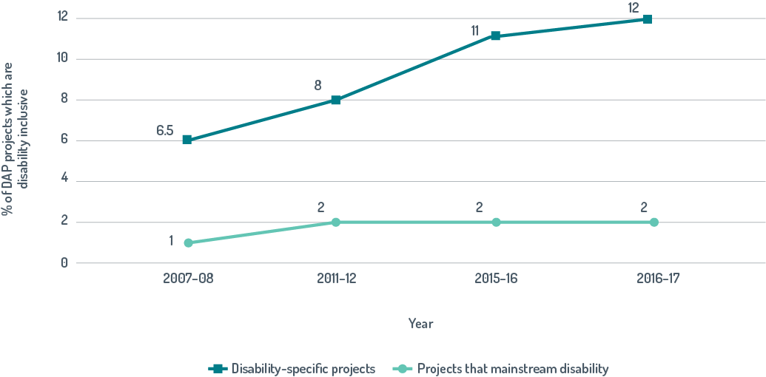

Figure 10: Many DFAT posts allocated more than 15 per cent of Direct Aid Program funding to support disability-inclusive projects, 2015–16

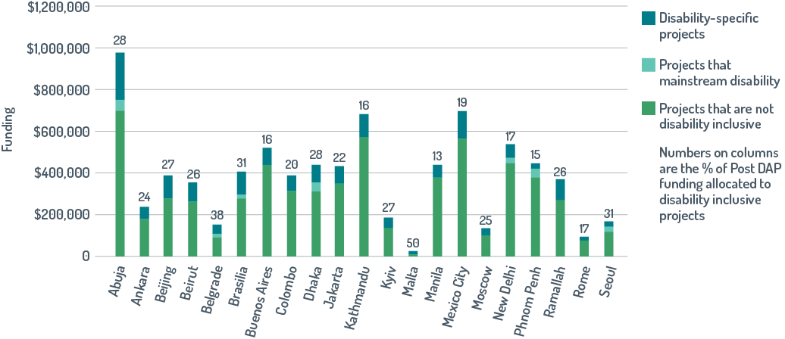

Figure 11: More disability-focused DAP projects are building DPO capacity

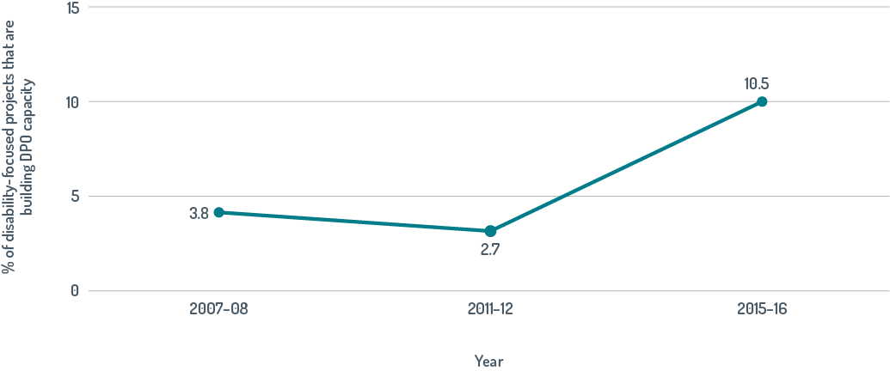

Review of the Direct Aid Program in Nepal

The Nepal DAP was reviewed to identify some ways in which DAP projects are disability inclusive and to identify factors enabling disability inclusion. The Nepal DAP was selected for review as it has one of the larger DAP budgets and also because disability-specific projects receive 16 per cent of funding. The projects reviewed were chosen to cover a range of approaches to improve disability inclusion (Table 16). In Kathmandu, DFAT staff have facilitated applications from DPOs by working with them to identify and scope suitable projects. Disability-focused projects are chosen to cover a broad range of disabilities.

Table 16: Nepal disability-inclusive Disability Aid Program projects reviewed in this evaluation

|  |  |  |
| --- | --- | --- |
| Organisation | Project | Funding |
| Cricket Association of the Blind Nepal | Inclusive Disability Sports Festival 2016–2017 | $13 500 |
| National Association for Welfare of the Blind | Development of Resources for Low Visibility and Blind persons 2015–2016 | $25 000 |
| National Federation of the Deaf Nepal | Improving the Education and Communication of Deaf People 2015–2016 | $39 241 |
| Autism Care Nepal Society | Expansion and Strengthening of Occupational Therapy and Vocational Training 2015–2016 | $35 000 |
| National Federation of the Disabled Nepal | Promoting Accessibility and Employment for People with Disabilities 2014–2015 | $23 918 |

Disability People’s Organisations capacity building

Most DAP projects reviewed appeared to have built the capacity of DPOs. For example, DAP funding for the Cricket Association of the Blind Nepal enabled it to run a disability sports festival with six tournaments for different sports and disabilities. The Association attributed new grants from local banks, an international foundation and another donor to the extensive national and international publicity they received from DAP-supported events. This additional funding has been used to expand the Association’s operations by increasing its geographic reach and the number of players.

Now we also get different grant funding—the DAP funding helped get more funding because we were in the media from the original tournament, on television as well.

Representative, Cricket Association of the Blind Nepal

DAP funding enabled the Autism Care Nepal Society to improve its facilities and develop training programs for educators and carers at its school for children with autism in Kathmandu. The training courses were then distributed to interested groups across Nepal. Members of the society felt that the work supported by the DAP enabled them to develop a stronger case for government funding as they only succeeded in securing funding from the Government of Nepal after being funded by the DAP.

Addressing barriers to inclusion

A broad range of stakeholders, including DFAT staff at Post, representatives from DPOs and other aid agencies, felt that DAP projects in Nepal were changing social perceptions about disability. This is significant as representatives from all Nepalese DPOs consulted during this evaluation identified stigmatisation resulting from a lack of knowledge and understanding as the main challenge facing people with disabilities in Nepal.

The Cricket Association of the Blind Nepaland many of its participants reported that extensive media coverage of the sports events facilitated by the DAP had changed societal perceptions of disability.

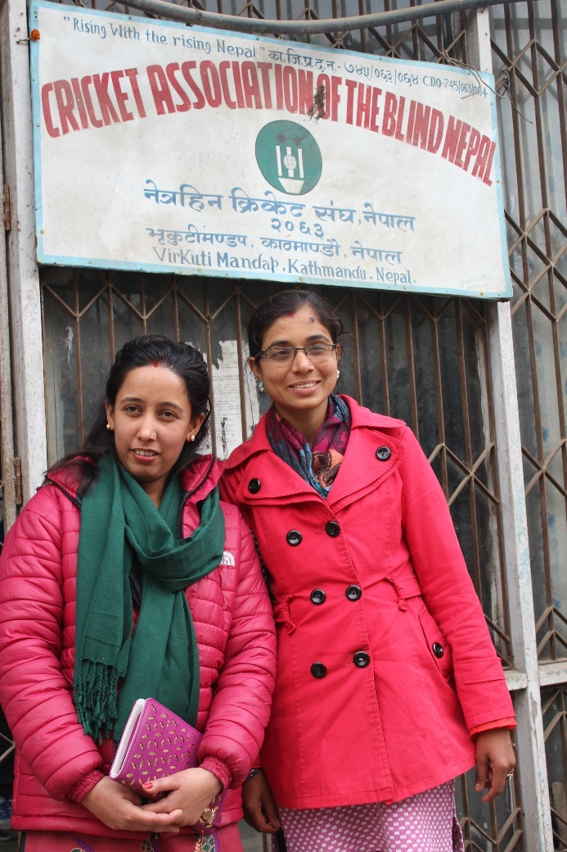

DAP-funded sports events are helping to change social perceptions of disability. Women cricketers Ms Gita Poudell, Lumbini Women’s Blind Cricket Team Captain (left), and Bhagawati Amgain, Blind Women Cricket Committee Coordinator. Photo: Karen Ovington.

‘When I was in the villages before I started cricket I used to be looked down on, but after I joined cricket with the help of others, I got publicity in the international and national media and people realised I had capacity. The same people from my home who used to look down on have now met my father and praised me to him.’

Female participant of blind cricket

Some DAP projects reviewed addressed key disability-specific needs. The National Federation of the Deaf Nepal used DAP funding to update the basic level Nepali Sign Language dictionary and distribute it to schools. This update, the first in 30 years, was needed to standardise Sign Language across Nepal and add new signs, especially for technical words. Teachers reported that the dictionary is a useful teaching resource which has made both teaching and learning easier.

The Sign Language dictionary is the most important medium through which deaf children can learn. There are very few other resources from which they can learn ... Increasing the number of entries is very important.

Teacher of students from a school for the blind

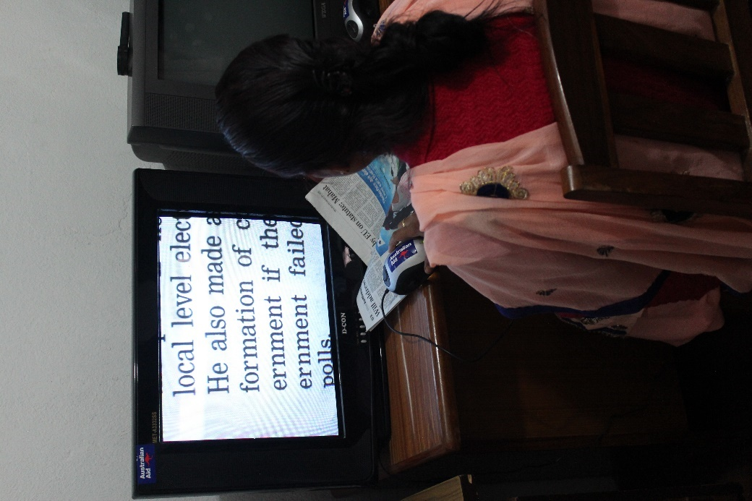

Magnifying equipment being used to increase the print size of a newspaper in the National Resource Centre for the Blind and Visually Impaired. Photo: Caitlin Dixon

The National Association for Welfare of the Blind used DAP funding to establish a National Resource Centre for Blind and Visually Impaired Persons. It has an updated Braille library and equipment to enable people with low vision to read printed text. The association and other DPOs reported that the assistive devices to magnify text have been especially useful for students in their later years of school and at university because their textbooks have small print and are not available in Braille.The National Federation of the Disabled Nepal, an umbrella organisation whose primary role is advocacy, used DAP funds to make their office accessible and to model how other workplaces can be made accessible.

Many organisations, including government agencies, have visited the refurbished offices to see how accessibility can be improved.

Representative National Federation of the Disabled Nepal

The National Federation of the Disabled Nepal also used DAP funding to work with employers to produce a book *Hiring Persons with Disabilities: A resource book for employers*. The launch of the book was well-attended and Merojob, a leading Nepali online job portal is using the book to advocate with employers for broader recruitment practices.

Before the book, I was not very informed about what people with disabilities could do. We were kind of aware, but not in a full context. We are trying to promote awareness, so employers know the real value. We have shared this message with a lot of employers. Hiring people with disabilities has not been a culture in Nepal.

Representative from Merojob

Alignment of disability and public diplomacy

Disability-inclusion projects that support advocacy for disability inclusion are well suited to deliver the intended development and public diplomacy outcomes of the DAP. DFAT staff in Kathmandu reported that while disability-focused projects are as likely to be publicised as are other DAP projects, they have delivered the most significant public diplomacy outcomes. The only DAP projects recognised by the President of Nepal at official receptions were the updated Sign language dictionary and one other disability-focused project. The blind cricket tournament is the only DAP project to have front-page newspaper coverage.

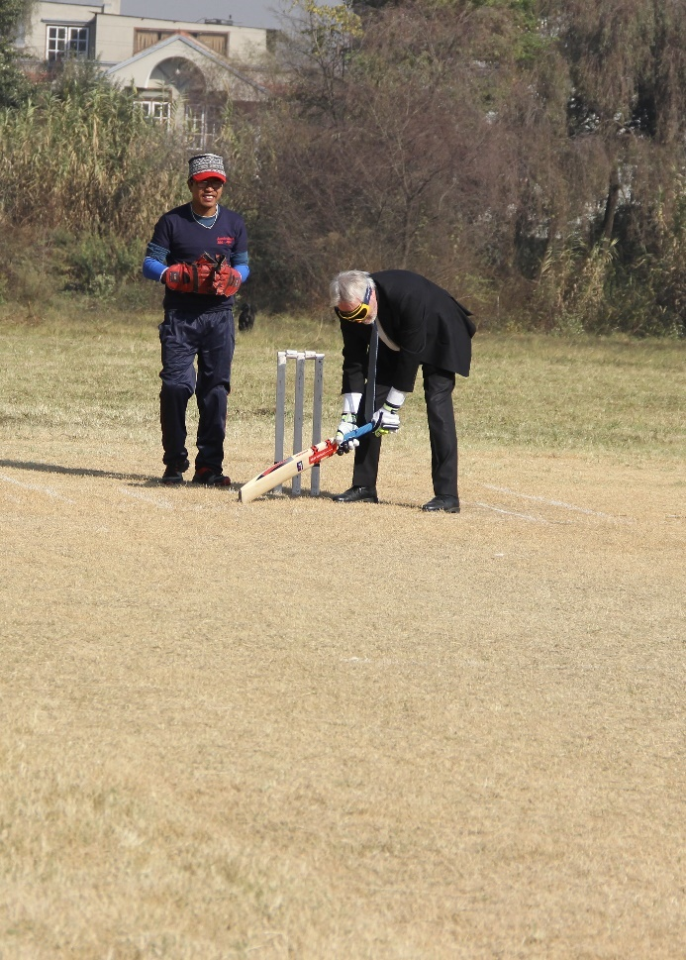

Australia’s former Ambassador to Nepal, Glenn White, listening for an incoming cricket ball and preparing for a sweep shot. Images like these were featured on the front page of newspapers in Kathmandu. Photo: *Kathmandu Post*

Key findings for global programs

* Disability inclusion in the global programs reviewed is strong. For all programs, other than the ANCP, there is evidence that disability inclusion is improving.
* More people with disabilities being awarded scholarships.
* Australian volunteers more likely to have disability-focused assignments and DAP projects more likely to be disability inclusive.
* Proposals for DAP funding should be required to identify how people with disabilities will benefit.
* All global programs reviewed are supporting disability-inclusive development and building DPO capacity.
* Global programs include the diversity of people with disabilities.
* Disability inclusion has been achieved through disability-focused activities, mainstreaming and reasonable accommodation.
* Within the global programs there are areas where disability inclusion could be improved:
  + components of some programs (for example, Australia Award short courses)
  + implementation in some countries (for example, Australia Award Scholarships for people with disabilities in some Pacific countries)
  + assessment of disability inclusion within the ANCP needs could be improved and used to identify components that are less inclusive.

# Disability inclusion in humanitarian assistance

Australia provides humanitarian assistance to save lives, alleviate suffering and maintain human dignity during and in the aftermath of conflict, disasters and other humanitarian crises. The aid priority ‘Building Resilience’ includes investments to support implementing partners to provide humanitarian assistance in crises. In 2017–18, Australia committed about $365 million to help people affected by humanitarian crises, including those in Afghanistan, Iraq, Myanmar, Nigeria, Pakistan, Somalia, Syria, Vanuatu and Yemen. Humanitarian assistance needs to be disability inclusive as people with disabilities are disproportionately affected and crises increase the number of people with disabilities.

Assessment of disability inclusion using humanitarian Aid Quality Checks

The percentage of investments which were disability inclusive was calculated for the 14 investments covered by humanitarian AQCs in 2017–18 (Table 17). Each investment covers assistance provided by a number of implementing partners. Disability inclusion was better for **D2** than **D1**. Disability inclusion was weaker for humanitarian crises responses than for the overarching aid priority area ‘Building Resilience’, especially for **D1**. This is not surprising given the challenges of providing assistance in times of crisis.

Disability inclusion in Australian humanitarian assistance

DFAT’s explicit policy and implementation requirements are making Australian humanitarian assistance more disability inclusive. Since 2015, multi-year funding agreements for six key implementing partners have been renegotiated to ensure that partners align with the Charter on Inclusion of Persons with Disability in Humanitarian Action and collect disability-disaggregated data. Disability inclusion has also been made an explicit requirement in the latest partnership agreement between DFAT and Australian NGOs. Partner NGOs are required to foster the inclusion of and leadership by people with disabilities, have a disability action plan and collect disability-disaggregated data. There has not been sufficient time for these new partnership agreements to be fully translated into more inclusive assistance, but this will increasingly be achieved.

Many of those interviewed felt that DFAT’s continued advocacy with implementing partners in workshops and high-level consultations, as well as in day-to-day interactions, has strengthened partner commitment and accountability for delivering assistance that is more inclusive (Box 16). DFAT has also undertaken specific initiatives with partners to raise awareness of disability inclusion more broadly in the humanitarian community. For example, concrete steps that humanitarian actors can take to ensure that disability rights are mainstreamed through all their work were identified at a recent Strategic Dialogue on Sexual and Reproductive Health and Gender Based Violence in Emergencies, co-hosted by DFAT and the United Nations Population Fund.

Table 17: The percentage of investments for humanitarian crisis responses rated as disability inclusive in Aid Quality Checks in 2017–18 compared with those for the overarching priority area, Building Resilience

|  |  |  |
| --- | --- | --- |
| Disability criterion | Humanitarian crises responses % | Building resilience % |
| D 1 The investment actively involves people with disabilities and/or disabled people’s organisations in planning, implementation and monitoring and evaluation. | 29 | 38 |
| D 2 The investment identifies and addresses barriers to inclusion and opportunities for participation for people with disabilities to enable them to benefit equally from the aid investment. | 36 | 41 |

|  |
| --- |
| Box 16: DFAT leadership- Influencing the World Food Programme |
| The World Food Programme (WFP) is DFAT’s largest humanitarian partnership. Globally, Australia is the sixth largest single government donor to WFP. DFAT has encouraged WFP to make its operations more inclusive through advocacy, funding agreements and support. Australia sits on the board of WFP for 10 out of every 12 years, giving DFAT a powerful voice. Australia worked with Finland, Italy and Uganda at board meetings and key events to encourage WFP to draft a stand-alone disability policy. WFP has subsequently agreed to develop and socialise a disability-inclusion policy which it is hoped will influence the ongoing development of WFP country plans. The funding agreement with WFP now explicitly mentions the need for WFP to deliver assistance that is more inclusive. It specifies, for example, that:  *‘In line with WFP’s and DFAT’s endorsement of the Charter on Inclusion of Persons with Disabilities in Humanitarian Action, DFAT requests WFP to demonstrate progress on strengthening disability inclusion. A targeted focus within the Partnership on operationalising this Charter should help strengthen advocacy and operational efforts to mainstream disability inclusion.’*  Additionally in 2018, DFAT began providing a disability advisor to build WFP’s knowledge and understanding of disability and help develop operational guidance to support inclusive practices. |

Disability inclusion in some recent humanitarian responses

Disability inclusion and the performance of individual implementing partners were reviewed in six recent humanitarian responses:

* 1. earthquake in Nepal in 2015
  2. Cyclone Pam in Vanuatu in 2015
  3. ongoing conflict in Myanmar
  4. famine in Yemen in 2017
  5. famine in South Sudan in 2017
  6. ongoing refugee crisis in Syria.

More recent humanitarian responses were found to be more disability inclusive with inclusion being particularly strong in the South Sudan and Syria responses. The use of multi-year funding in the Syria crisis allowed time in the design phase for a detailed analysis of disability inclusion in international programming.

Across the responses, the type of implementing partner influenced disability inclusion. NGOs performed markedly better than other implementing partners (Figure 12). The achievements of Australia’s NGO partners suggest that the challenges of providing disability-inclusive assistance in humanitarian crises are not insurmountable and other types of implementing partners could deliver assistance that is more disability inclusive.

Addressing barriers to inclusion

A disability analysis was done by about 60 per cent of implementing partners and almost 80 per cent of NGOs (Figure 12). The barriers for people with disabilities identified in the analyses included poverty, costs, accessibility and remoteness. Social barriers were under-examined or undocumented in most analyses. Disability analyses were used to inform the work of some partners. An implementing partner in Myanmar, for example, analysed the barriers for women with disability in relation to accessing sexual and reproductive health services and then designed their program accordingly. Identified barriers were, however, not always addressed. In Myanmar, an implementing partner found that children with disabilities were not able to access temporary learning spaces in internally displaced people’s camps but no activity to improve access was documented.

Mainstreaming disability

Implementing partners consistently and independently noted that mainstreaming disability in humanitarian assistance was challenging. Despite this, well over half of DFAT’s implementing partners, and more than 80 per cent of NGOs, reported having mainstreamed disability. Disability was typically mainstreamed by ensuring that facilities were accessible for people with disabilities as was done for education programs in Nepal and Syria and a WASH program in Yemen.

Disability-specific activities

All responses included some disability-specific activities with 44 per cent of partners delivering disability-specific assistance. In the Syria response, DFAT prioritised funding for disability-specific activities, as it was felt the international response was not sufficiently inclusive.[43] For example, UN Women was supported to promote income-earning opportunities for women and people with disabilities. After the Nepal earthquake, teachers were trained in inclusive education, and a teaching manual to support teachers of children with disabilities was developed. Disability-specific activities in Myanmar included rehabilitation centres run by the International Committee of the Red Cross, support groups run by the Danish Refugee Council and a photography course run by the United Nations High Commissioner for Refugees to enable people with disabilities to communicate the challenges they were facing. In Vanuatu, after Cyclone Pam, the United Nations Children’s Fund supported the Vanuatu Society for People with Disability, a disability service provider, to keep an early intervention playgroup running for children with disabilities.

The evaluation found that disability-specific activities mostly addressed physical disability. For example, in Myanmar, two of the three partners who had disability-specific activities focused exclusively on physical disability. However, nearly 40 per cent of camp residents in Kachin State have vision impairment and close to 25 per cent are deaf or hard of hearing.[44]

Figure 12: NGOs are more likely than other implementing partners to provide humanitarian assistance that is disability inclusive

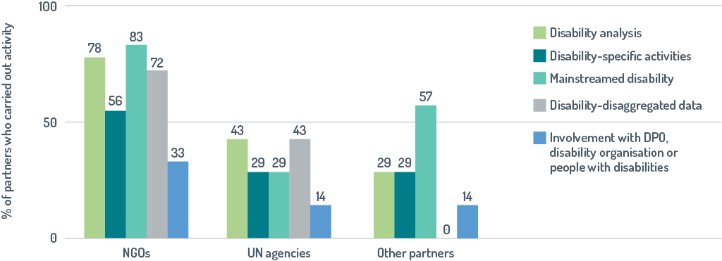

Disability-inclusive monitoring and evaluation

Overall, about half of DFAT’s implementing partners collected disability-disaggregated data, with NGOs performing better than other partners. Some NGOs reported using data on disability to inform their work. For example, CARE analysed how different groups in Nepalese society, including people with physical and mental disabilities, were affected by the earthquake and then designed assistance to address the main issues survivors were facing.[45]

Involvement of people with disabilities, Disabled People’s Organisations or disability organisations

The weakest aspect of disability inclusion was the involvement of people with disabilities with about 20 per cent of partners having ‘satisfactory’ ratings. Sometimes DPOs were consulted but opportunities for their active involvement, such as assisting with distribution of relief items or developing recipient lists, were typically not exploited. Interviewees noted that in crises, especially involving large-scale displacement and in areas that are remote or besieged by conflict, there were few, if any, DPOs. Those present had very limited capacity. Furthermore, DPOs in host countries do not necessarily represent the interests of people with disabilities in refugee populations.

Implementing partners also reported that the rapid and short-term funding of humanitarian crises and the need to act quickly limited their ability to work with local DPOs or disability organisations. The evaluation identified some instances in which long-term engagement with DPOs was found to have supported their involvement in humanitarian responses. Since 2013, Oxfam in Vanuatu has been building a civil society network supporting the national DPO, Disability Promotion and Advocacy Vanuatu. Capacity building and relationships built through the network enabled the DPO to be an active participant in cluster meetings and support a disability-inclusion working group in the aftermath of Cyclone Pam.[46]

DFAT has recently developed an innovative disaster preparedness program which should improve the involvement of DPOs in Australia’s responses to humanitarian crises in the Pacific region (Box 17).

|  |
| --- |
| Box 17: Working ahead of crises to support active participation by people with disabilities in times of crisis |
| The Australian Humanitarian Partnership Disaster Ready program aims to support Australian NGOs and their partners to strengthen disaster preparedness and management across the Pacific and in Timor-Leste. Disability inclusion is an overarching outcome and the program has been innovative in its inclusive practices. The program has won a DFAT award for best practice in disability inclusion.  It is great to see the voices of people with disabilities being part of the planning and design of this program. Too often we are left out. If you leave this group out during the planning stage, they are more likely to be left behind or left out during a disaster. Resilience cannot happen if all people are not included and their opinion considered.  Ipul Powaseu, Papua New Guinea Assembly of Disabled Persons  The program is expected to improve the participation of DPOs in responses to crises. It has built relationships between DPOs and agencies that respond to disasters. DPO capacity has been built by dedicating funding to ensure equal and active participation of people with disabilities in all country working groups. Additionally, a partnership with CBM International has been established to increase the capacity of the Pacific Disability Forum and its ability to strengthen the capacity of country-level DPOs. |

Every day people are aware of visible disability ... but there are also invisible disabilities

Representative of DPO, Myanmar

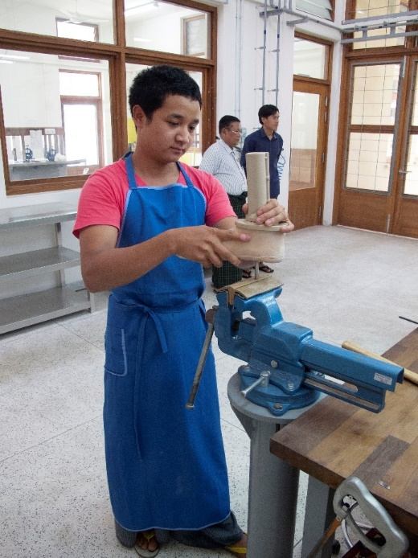

Myanmar has endured the world’s longest running civil war and is one of three countries with the most land mines. Australia has supported activities designed to help people with physical impairments overcome barriers to inclusion. Seng Lawt, a technician at the newly established Myitkyina Physical Rehabilitation Centre run by the International Committee of the Red Cross, is modifying a prosthetic limb. Across Myanmar, more than 3000 people with disabilities have received prostheses and physical rehabilitation in the rehabilitation centres. Photo: Kate Sutton

Key findings for humanitarian assistance

* Strong policy commitment to disability inclusion in humanitarian action and the development of the architecture to support this are increasingly making Australian humanitarian assistance more disability inclusive.
* DFAT has made implementing partner policies and approaches more inclusive through contractual requirements, consistent advocacy and leadership.
* About one-third of recent responses to humanitarian crises are disability-inclusive.
* NGOs are more likely than are United Nations agencies and other implementing partners to deliver humanitarian assistance that is disability inclusive.
* Disability inclusion could be improved if more partners carried out a disability analysis and used it to inform their work.
* Disability-specific activities supported inclusion, however this needs to be expanded to address the range of barriers faced by the diversity of people with disabilities.
* People with disabilities were not sufficiently actively involved in humanitarian crisis responses.
* Innovations in programming are addressing some of the factors that have constrained disability inclusion.

# Factors enabling disability inclusion

This evaluation identified the factors that have enabled the programs reviewed to become more disability inclusive.

Sustained effort, starting small and gradually scaling up

Sustained effort was found to be one of the most important enablers for being disability inclusive. The level of inclusion that has been achieved in the Volunteer Program and Australia Awards reflects efforts that began before DfA1 and have continued since. Disability inclusion was found to be strong in country programs when efforts had been sustained. Investments were more likely to be disability inclusive in the countries that had been a focus under DfA1, with the exception of Papua New Guinea. The notable progress made in Timor-Leste reflects work started during the consultations for the development of DfA1, and continued during DfA2. Impetus was provided by an internal disability working group, and the use of technical advice supplied through the DFAT–CBM partnership.

We are one step along a long path, but it is a solid step in a positive direction. It will take at least another 10 years to make our program disability inclusive.

Senior DFAT officer, Dili

Many interviewees noted that disability is built through progressive learning and practice. One Pacific organisation stressed that the journey is necessary and another reflected that starting small and gaining confidence over time is crucial.

In many disability-inclusive investments reviewed, disability inclusion builds on work in previous phases. A good example of this is the Vanuatu Skills Programwhich gradually, over four phases, improved implementing partner understanding of disability, built relationships and introduced processes to improve inclusion. Another example is the Australia Award Scholarships which have over many years adjusted procedures to increase the number of scholars with disabilities. Through funding disability-focused DAP projects for many years, DFAT in Kathmandu has identified the types of DAP projects that address key priorities and are likely to have sustainable benefits while delivering public diplomacy outcomes. Since 2010, funding was shifted from projects providing services or equipment to projects contributing to strengthening DPO capacity and supporting their advocacy.

Success in building disability inclusion informs and enables work to improve inclusion in other programs. Significantly, the partnerships with DPOs established through the DAP are being used to improve disability inclusion in other global and sectoral programs in Nepal. The importance of previous work in supporting inclusion is also illustrated by Australia’s largest aid investment in Timor-Leste, the Partnership for Human Development Program, which has a sound foundation for disability inclusion because previous Australian aid programs had built the capacity of Timorese DPOs and social-inclusion advisers.

Disabled People’s Organisation capacity building and partnership

The importance of DPO capacity building in enabling Australian aid to become more disability inclusive cannot be overstated. The increased capacity of DPOs has facilitated active involvement of people with disabilities in line with the principle ‘Nothing about us without us’ through enabling DPOs to work in partnership with DFAT and program implementers (Box 18).

We started at a low base and now we are happy that we have good people to work with in the two national disability organisations and our collective advocacy about disability inclusion is working.

Australian Ambassador to Timor-Leste

Successful partnerships between program implementers and DPOs have been a key enabler for disability-inclusive development. DPOs can identify simple, contextually appropriate solutions to address barriers to inclusion. Disability inclusion in the Volunteer Program has been built by partnerships with Australian DPOs which have helped to increase the number of applications from people with disabilities. In developing countries, partnerships with disability-focused host organisations enable flexible arrangements, including multi-year plans, for a number of volunteer placements and a ‘cluster approach’ where a volunteer works with a number of organisations that cannot individually manage a full-time volunteer.

Partnerships with DPOs have also improved inclusion by building the understanding of disability in DFAT (Box 18). The DAP’s achievements in Nepal stem from strong partnerships between the Post and DPOs which have improved DFAT officers’ understanding of disability inclusion.

The Australian Embassy has been very involved in DPOs and I have high regard for these works.

Representative from Nepal Disabled Human Rights Association

Availability and use of technical expertise

Programs which have successfully mainstreamed disability were able to do so because of technical advice from two main sources—the DFAT–CBM partnership and advisers with expertise in disability—made available through specific contract or partner arrangements.

People get gender, but disability is different having technical support from CBM has been essential.

DFAT staff, Dili

|  |  |
| --- | --- |
| Box 18: Working with Disabled People’s Organisations builds DFAT’s understanding of disability | |
| In Indonesia, DFAT has a number of partnerships with DPOs that establish connections between DFAT staff and people with disabilities. Andini Mulyawati (back), a Senior Program Manager for PEDULI and disability focal point for the Australian Embassy in Jakarta, and Purwanti (front), an Advocacy Manager for Sasana Inklusi and Gerakan Advokasi Difabel Indonesia, share a laugh. Andini credits her experience in working with people with disabilities as having increased her understanding of disability and making her committed to disability-inclusive development, saying *’I had an interest in disability as I completed a course on disability at college but working with people who have disabilities is what has made me appreciate why disability inclusion is so important.’* | This photo shows Purwanti in her wheelchair being pushed by Andini outside in front of PEDULI. The women are relaxing and engaging with other people with disabilities. |

Technical expertise provided through the DFAT–CBM partnership has been used to improve disability inclusion in all country programs reviewed and in the ANCP[47], Australia Award Scholarships[48] and the DAP.[49] Technical support has also been provided for Australia’s key humanitarian implementing partners.

The DFAT–CBM partnership is valued by DFAT’s Disability Section, DFAT staff, implementing partners and DPOs. Through the DID4ALL HelpDesk, the partnership makes contracted time and resources readily accessible to areas seeking advice using the available funding pool. The partnership is also valuable as it implements a range of capacity-development activities and offers proactive advice to the Disability Section in Canberra on issues such as resourcing, guidance notes and where to gather more evidence to support inclusive programming.

Post visits conducted jointly by CBM and the Disability Section were found to have been particularly effective in identifying work needed to improve disability inclusion. These generally include DPO brokering sessions, training run in collaboration with DPOs and technical meetings with program staff. During the technical meetings, CBM, the Disability Section and program teams discuss progress towards disability inclusion and entry points for disability inclusion within programs. Subsequently, program managers often use the Helpdesk to access further support.

The National Rural Water Supply and Sanitation Project (PAMSIMAS) illustrates how technical advice has enabled disability inclusion. In technical meetings during CBM’s visits to Jakarta Post, CBM and DFAT Jakarta discussed the potential impact that could be gained for people with disabilities in Indonesia if PAMSIMAS could be made more disability inclusive. DFAT and the World Bank cooperated to contract CBM to provide disability-inclusion training and used the Helpdesk for follow-up support. Now PAMSIMAS, the largest WASH program in the world, has made good progress in a journey towards disability-inclusive practice, and has been piloting new inclusive approaches in 100 districts.

Almost all investments reviewed in the case studies and global programs engaged technical advisers to support disability inclusion. Some programs, including the Vanuatu Skills Programand the Fiji Access to Quality Education Program, engaged disability advisers. In other programs, technical support was provided by gender and/or social-inclusion advisors. Some interviewees felt this was appropriate as disability inclusion and gender equity share common principles and implementation practices. However, many thought disability could be overlooked in the effort required to work for gender equity, especially where resources are limited.

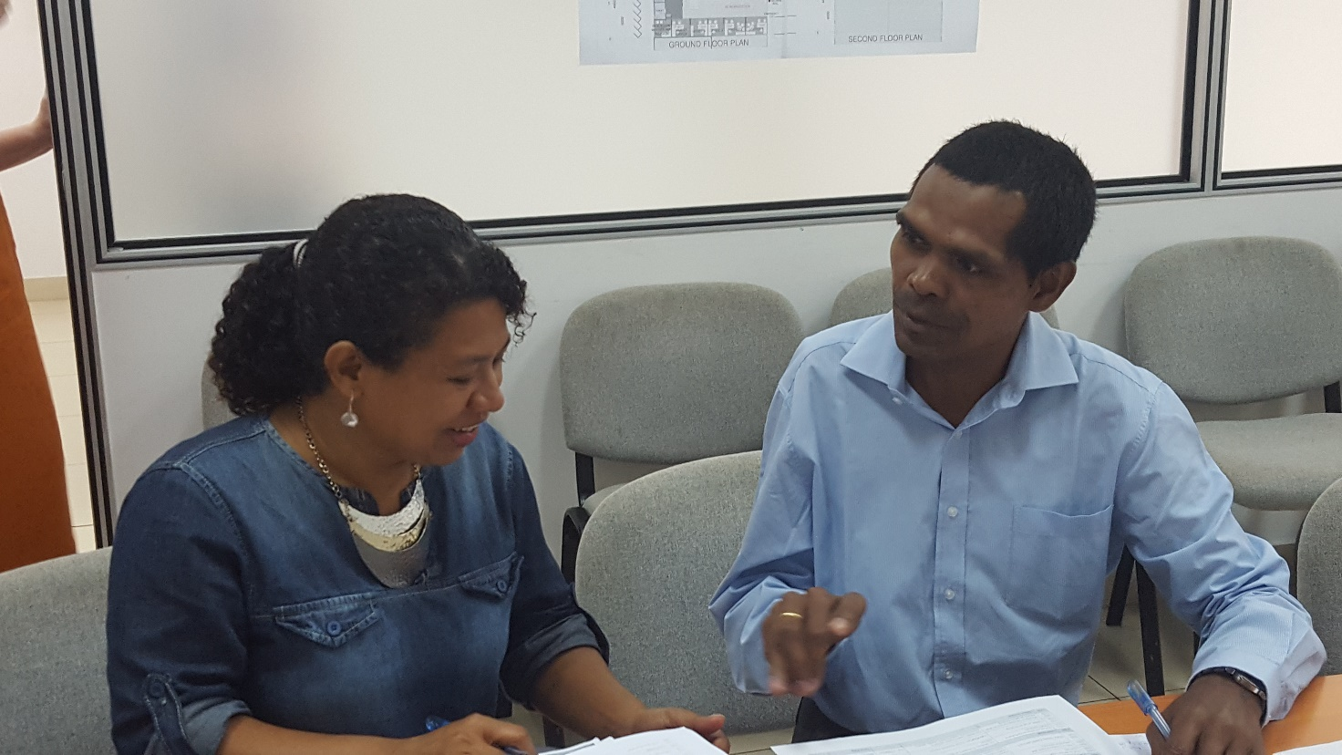

Some programs have been able to employ local technical experts who understand cultural values that influence disability inclusion issues. Dulce da Cunha, Technical Lead for Gender and Disability for the Australia–Timor-Leste Human Development program, working with Joaozito dos Santos, Director of RHTO, a national DPO.

Dedicated funding for disability inclusion

Although working in disability-inclusive ways is likely to cost a relatively small proportion of budgets, it still requires some financial allocation. Some interviewed in this evaluation felt that disability inclusion is improved in design and subsequent implementation when there is a specific budget line for disability from the beginning. In Fiji, one program team recommended that *‘… there needs to be specific line item for disability in budgets: it doesn’t have to be large, but having it keeps programs honest.’* The PEDULI program reported that the process of allocating a budget for disability inclusion was useful as it raised awareness about the rights of people with disabilities and DFAT’s policy on disability inclusion.

Programs which secured disability-inclusive development funding reported that it was catalytic. In Timor-Leste, a DFAT official commended this funding for *‘focusing attention on policy implementation in practice and helping the Post to take it seriously’*. The process of planning and applying for the funding was considered to have enabled deeper thinking and concerted effort to ensure each investment mainstreamed disability inclusion. Support from the fund ($3 million over four years) was reported to have been particularly significant for the Australia–Timor-Leste Partnership for Human Development as it ensured that disability inclusion was not lost among the other pressing demands of a large cross-sectoral program.

Disability-inclusive development funding has been the key driver for disability inclusion … With some exceptions, programs that haven’t had the funding have lagged behind.

DFAT staff, Dili

As well as supporting work to mainstream disability, disability-inclusive development funding has also stimulated additional work to extend inclusion. An example of this is the use of funding in Farming for Prosperity, a livelihoods program in Timor-Leste, for a stand-alone activity called Agrability. The activity worked with people with disabilities to find solutions and trial improvements to make it easier for them to grow and access nutritious food and earn a living from selling excess produce.

Allocation of funding for reasonable accommodation has also enabled disability inclusion. It is often key to people with disabilities being able to genuinely participate in and benefit from development programs. Reasonable accommodation has made it possible for people with disabilities to complete scholarships and short courses and work as volunteers.

Supportive and engaged senior management

A further enabling factor, commonly identified across Pacific regional and country programs, was leadership by DFAT senior management which underpinned ongoing focus on disability inclusion. The establishment of working groups for disability and the participation of senior staff in meetings reinforces the importance of disability inclusion by making staff aware that disability is a priority and holding them to account for progress in improving inclusion. The allocation of resources by senior management, including staff time to disability inclusion also sends a clear message that disability inclusion is a priority. Dili Post has dedicated human resources to disability inclusion, and a Disability Coordinator who works almost exclusively on disability inclusion, who is supported by the Second Secretary for Gender, Disability and Community Driven Development.

We take disability inclusion seriously and we understand what the point of it is.

Australian Ambassador to Timor-Leste

In Suva there has been strong leadership support for disability inclusion, with the former High Commissioner being personally strongly supportive and senior managers consistently making full use of opportunities to introduce the need for disability inclusion in discussions with counterparts and other stakeholders. In another example, support from Ambassadors and senior managers at Kathmandu Post has led to a continued prioritisation of disability inclusion in the DAP and more widely across Post’s operations. The Embassy has, as much as is practicable, been made accessible, representatives from DPOs are invited to official functions, events are held in accessible locations, opportunities to advocate for disability inclusion are exploited, and embassy staff are learning Sign Language. This has created a distinctive, positive image of Australia.

The contribution to disability sector from DFAT has been very significant, I don’t know of any other embassy that has contributed in this way to disability inclusion.

Representative, Nepal Disabled Women Association

Leadership by Australia

Leadership by DFAT has helped to improve disability inclusion in Australian aid investments and more broadly.

Influencing partners

Disability inclusion has been improved by influencing the policies and practices of implementing partners. As a result of Australia’s policy influence in PAMSIMAS, the World Bank has now independently contracted CBM and local Indonesian DPOs to provide disability-inclusion training for nine other World Bank and Government of Indonesia Urban Development programs. ANCP’s requirements for disability inclusion to be a crosscutting issue was a significant trigger for disability inclusion in the operations of ANCP partner organisations. Continued advocacy and technical support have been used to make the operations of the World Food Programme more inclusive. These examples demonstrate how DFAT’s policy influence can be catalytic.

Some partner organisations indicated that having to report on disability inclusion as a requirement of Australian funding provided strong encouragement to work inclusively. For example, the need for accountability against the Vanuatu Policing and Justice Support Program’s specific disability-related intermediate outcome was identified as one driver to collect disaggregated data on disability. The requirements for monitoring and evaluation to cover disability inclusion have helped ensure that ANCP-funded organisations work in inclusive ways.[50]

Modelling inclusion

Australia has also provided leadership through modelling inclusion. This includes by inviting people with disabilities to be members of committees, to participate in cross-sector consultations and to be actively involved in meetings. Inclusion has also been modelled in some programs by engaging people with disabilities as advisors (PEDULI and the Australian Indonesia Partnership for Justice) or leading and managing work to make facilities accessible (Nabilan).

Building coalitions and networks

Leadership by Australia has also improved disability inclusion by fostering cooperation and building coalitions. Significantly, the DFAT Pacific regional program has supported the development of coalitions and networks, across the region and within countries, between different organisations. This focus on coalition building has enabled more substantial action to improve disability inclusion. In the international Syria refugee response[51], DFAT took a lead role in advocacy for disability inclusion and worked with a coalition of like-minded donors to advocate for progress on disability inclusiveness with the governments of Jordan and Lebanon. Another example of coalition building by DFAT is supporting the Women’s Refugee Commission and a consortium of agencies led by Handicap International to foster the participation, inclusion and leadership of people with disabilities in humanitarian action.

Building the evidence base

The need for development to be disability inclusive has only recently been widely recognised and, consequently, work is needed to identify the most effective approaches. The evaluation found many examples of Australia providing leadership by building the evidence base needed to support disability-inclusive development. In Fiji, the Access to Quality Education Program demonstrated that children with disabilities could be included in mainstream schools with relatively few additional resources. Research and a trial supported by KOMPAK has led to the Indonesian Financial Services Authority delivering financial literacy training using Braille materials to improve economic opportunities for people with vision impairment.

Knowledgeable and committed individuals

This evaluation identified many examples of disability inclusion driven by knowledgeable and committed individuals. In Fiji, DFAT’s senior program manager championed disability inclusion, and facilitated the links between DFAT programs, United Nations agencies and regional organisations needed to improve inclusion. The disability adviser for the Australia Indonesia Partnership for Justice was a person with a disability who established collaborative partnerships with DPOs that facilitated disability inclusion. The extent and quality of disability inclusion in the DAP in Nepal reflects, to a large extent, the commitment, knowledge and leadership of a locally engaged DFAT officer who has managed the DAP program for many years. A disability adviser, whose considerable efforts have been recognised by a national disability award, has driven disability inclusion in the Volunteer Program.

More broadly the evaluation found that when DFAT officials understood the human-rights approach to inclusion they were more committed to, and better able to deliver, disability-inclusive programming. For some DFAT officials this understanding came from working with people with disabilities (Box 18). For others the understanding came from training.

Innovative programming

This evaluation identified many instances of different approaches being trialled and then used to overcome barriers to inclusion. Examples include the Volunteer Program which has explored many ways to improve inclusion including the Disability Initiatives Grants and the Disability Empowerment Skills Exchange. Another example is the adoption of new ways of working and the innovative design of programs to address factors that compromised disability inclusion in humanitarian assistance. Australia’s humanitarian assistance in the Pacific has recently, for the first time, used cash transfers to target assistance to people with disabilities (Box 19).

|  |
| --- |
| Box 19: Innovative approaches: cash transfers to support disability inclusion in crisis responses |
| Tropical Cyclone Gita hit the islands of Tongatapu and ‘Eua in Tonga in February 2018 throwing the lives of 80 per cent of Tonga’s population into turmoil. Since many families used their limited funds to purchase emergency supplies, they were unable to meet the special needs of the elderly and people with disabilities. A report from the Pacific Disability Forum found that many families lacked the funds needed to replace lost or damaged assistive devices. Australia and the Government of Tonga moved swiftly to make a cash payment of A$130 per person to Tongan pensioners over the age of 70 years and recipients of the Tongan Government’s Disability Welfare scheme in affected areas. This was a first for both Australia and Tonga. |

Key findings for enabling factors

* The key factors which have enabled disability inclusion were sustained effort, work to build DPO capacity and partnerships with DPOs, and the use of technical expertise.
* Technical advice to support disability inclusion can be delivered through disability advisers or gender and social-inclusion advisers.
* Senior management support, leadership by Australia and dedicated funding for disability are also important factors that enable disability inclusion.
* Leadership by DFAT staff at all levels has helped to improve disability inclusion through influencing partner agencies, modelling inclusion, building the evidence base, working in coalitions and supporting networks.
* Individuals who understand disability through working with people with disabilities or training have helped to drive disability inclusion.
* Innovative approaches are being used to improve inclusion.

# Working towards a disability-inclusive aid program

Disability inclusion has been strengthened

The Australian aid program has made good progress in strengthening disability inclusion. When the first Development for All strategy was launched in 2009, work to support disability inclusion was fragmented and largely limited to a small number of disability-specific projects delivered by DPOs. Disability inclusion is now a priority for the Australian aid program and there is an expectation that it is mainstreamed across all sectors and programs. About 40 per cent of aid investments and 53 per cent of aid expenditure are now reported to be disability inclusive. The progress made in strengthening disability inclusion appears to be much faster than that made for gender equity over the last 30 years.

This evaluation found that when there is a focus on disability inclusion and resources are available, Australia’s development and humanitarian assistance has become more inclusive. Disability inclusion is strongest for high-value investments and in the geographic focus areas identified in DfA2, the Pacific and South East Asia. Country programs that have prioritised disability are now implementing portfolios of disability-inclusive investments that are beginning to improve the lives of people with disabilities. All global programs reviewed have made efforts to improve disability inclusion and had successes. Disability inclusion is improving in Australia’s humanitarian assistance as obstacles to inclusion have been recognised and are being addressed.

Work to improve disability inclusion has aligned with the principles in DfA2

The principles outlined in DfA2 have been followed, including the key principle ‘People with disabilities have been supported to play active and central roles in development’. All programs reviewed have built DPO capacity and many have genuine partnerships with DPOs. The availability of technical advice supplied through the DFAT–CBM partnership or by programs engaging disability or social-inclusion advisors has helped ensure policies and programs are evidence-based. Many investments have built the evidence needed to support inclusion by research projects and demonstrate or pilot approaches to inclusion. In several high-quality examples, attempts have been made to ensure the benefits of programs extend to women with disabilities and the diversity of people with disabilities, including those with psychosocial and intellectual disabilities.

Approaches to support disability inclusion outlined in DfA2 have mostly been used

The twin-track approach, deploying disability-specific initiatives to support mainstreaming, has been effectively used in regional and country investments, humanitarian assistance and global programs. Reasonable accommodation has facilitated the improved participation of people with disabilities in Australia Awards and the Volunteer Program. It has also been used more widely to enable people with disabilities to play active roles in development work and to support modifications necessary for inclusion in a range of sectors. Investments are increasingly disability inclusive as implementing partners are required, and assisted, to make Australia’s development and humanitarian assistance disability inclusive. Disability inclusion has also been improved by fostering people-to-people links by prioritising disability across DFAT’s operations within partner countries, building coalitions, developing networks and implementing programs such as the Australia Awards. In contrast, ‘Harnessing private sector resources and ideas’ is identified in DfA2 as an approach to support inclusion but the evaluation found this approach has not been well used.

Opportunities identified in DfA2 have largely been exploited

Regional and country investments have supported partner governments to develop policies, action plans, legislation and coordinated approaches needed for ratification or implementation of the CRPD. All programs reviewed have indirectly supported implementation of the CRPD by building the capacity of DPOs so they are better able to with and support their governments and/or be powerful advocates to ensure people with disabilities can realise their rights. Most sectoral opportunities identified in DfA2 have been exploited. Education was found to be the strongest performing sector and Australia’s humanitarian partners are increasingly making emergency assistance more disability inclusive. Opportunities to improve disability inclusion in ‘Enabling infrastructure and accessible wash, sanitation and hygiene’ have only been partially exploited. The evaluation identified WASH investments in Indonesia and Timor-Leste in which DFAT has made disability a focus and achieved good results. However, the percentage of disability-inclusive investments was relatively very low in the infrastructure sector.

Factors enabling disability inclusion are similar for most programs

Factors enabling disability inclusion were similar across the programs reviewed. When disability inclusion was strong most of these factors were present.

This evaluation identified three key enablers.

The first key enabler is sustained effort. When DFAT policies make disability inclusion a requirement and supporting guidelines are in place, disability inclusion can be built through identifying entry points where disability inclusion can be easily achieved, exploiting these and then gradually expanding the scope of inclusion. Time and sustained effort are needed to change entrenched discriminatory attitudes and build knowledge of how to address barriers to inclusion. Where efforts have been sustained, disability inclusion has been markedly improved. Efforts that began during DfA1 and maintained through DfA2 have resulted in good progress, such as that seen for global programs and for the Pacific region and Pacific island countries (except for Papua New Guinea).

The second key enabler is the work required to build DPO capacity so people with disabilities can be actively involved as partners who inform and guide disability inclusion.

The third key enabler is technical expertise with the DFAT–CBM partnership being particularly important. The partnership has made technical advice easily available, built DPO capacity and improved understanding of disability within DFAT and more broadly.

There are other important enablers. Resourcing and dedicated funding has enabled inclusion in many different programs. Higher-value investments are more inclusive and funding provided by the DID fund or budget allocations has strengthened inclusion. Another important enabler is leadership by senior management in DFAT and by DFAT staff at all levels. Leadership has been shown through influencing partner agencies, building coalitions, modelling inclusion and building the evidence needed to support inclusive practice.

In some programs, highly committed individuals in DFAT and partner organisations and innovative approaches have enabled disability inclusion.

Staying the course

The Development for All strategies have established Australia as a leader among donors for disability-inclusive development. Leadership by DFAT staff at all levels has helped to improve disability inclusion in Australian aid investments and more broadly. Although good progress has been made, less than half of Australian aid investments are inclusive. Work completed to date is an important step on the long journey towards an inclusive aid program and truly inclusive societies. When development is not disability inclusive, people with disabilities will be further marginalised.

Disability inclusion does not happen quickly. It is built by starting small and then slowly scaling up. The current Development for All strategyhas been well implemented and it has improved inclusion. The achievements made, and knowledge gained, to date will underpin further work to make Australian aid more inclusive

|  |
| --- |
| Recommendation 1 |
| **Australia’s continuing commitment to disability-inclusive development as a human rights and aid priority should be demonstrated by building on progress to date, including by:**   * continuing to support work needed for ratification or implementation of the CRPD * making it a requirement for disability inclusion to be considered at all stages of a program’s development, implementation and assessment * continuing to have a geographic focus on the Pacific and South East Asia * continuing to use the twin-track approach with disability-specific activities to support the effective mainstreaming of disability in aid and humanitarian investments * increasingly supporting work to address the compounding disadvantage linked to the intersection between gender and disability * broadening efforts to support the inclusion of diverse people with disabilities. |

Supporting ‘Nothing about us without us’

Capacity building for DPOs has been a component of all programs reviewed. It has been effective. Some partner DPOs are now high-capacity organisations that are informing development programs and are able to secure funding from diverse sources. However, in humanitarian crises and even in countries which are in the geographic focus area for DfA2, DPO capacity is still insufficient. Investments were consistently, and often considerably, less likely to actively involve people with disabilities, than they were to identify and address barriers to inclusion. No investments in Nepal or Sri Lanka, and less than 20 per cent of investments in Bangladesh and Vietnam, were rated ‘satisfactory’ for the active involvement of people with disabilities. Consultation with, and the active involvement of, people with disabilities or their representative organisations was the weakest aspect of disability inclusion in Australia’s humanitarian assistance.

The demands on DPOs will escalate as the efforts of Australia, implementing partners, partner governments and international development to strengthen disability inclusion to strengthen disability inclusion become more ambitious.

|  |
| --- |
| Recommendation 2 |
| **DFAT should continue to prioritise DPO capacity building, including by:**   * providing funding including core funding * working in partnership with DPOs. |

Aligning with best practice

Programs which successfully mainstreamed disability inclusion were able to do so because of technical advice which helped ensure that work to improve disability inclusion was aligned with best practice. Technical expertise provided through the DFAT–CBM partnership has supported disability inclusion in all country and global programs reviewed in this evaluation. The DFAT–CBM partnership is also valued by DFAT and partner organisations as it implements a range of capacity development activities, brokers relationships, builds networks, and facilitates sharing evidence of good practice. A review of the second DFAT–CBM partnership found that the effectiveness of the partnership would have been greater if DFAT’s Disability Section had more capacity to engage with CBM.[52]

As DFAT and other agencies work to make aid more disability inclusive, the demands for technical assistance will increase. The ability of CBM to respond to increased demand will be limited by its capacity to train, recruit or retain skilled staff. DFAT needs to ensure that technical expertise continues to be easily accessible and, as part of this, ensure it is used effectively and where it is most valuable.

|  |
| --- |
| Recommendation 3 |
| **DFAT should maintain a mechanism which provides DFAT and, where appropriate, partner agencies with ready access to quality disability-inclusive technical assistance and work to improve its effectiveness, including by:**   * building DFAT’s internal technical capacity to support disability inclusion by significantly increasing the number of staff positions in the Disability Section in Canberra and other measures * developing procedures to ensure that technical support is used where it is likely to have the greatest impact. |

Building the understanding needed to strengthen inclusion

Leadership by senior management in DFAT and by DFAT staff at all levels was found to be a key enabler for disability inclusion. The evaluation identified many instances in which inclusion was driven by knowledgeable and committed individuals in DFAT. A human-rights approach to inclusion improves understanding of the need for disability inclusion and provides the basis for DFAT officials to hold implementation teams and others to account. For some DFAT officials, an understanding of the need for disability inclusion came from working with people with disabilities. For others the understanding came from training.

|  |
| --- |
| Recommendation 4 |
| **DFAT should increase the knowledge and understanding of disability-inclusive development within DFAT, including by:**   * consistent messaging from senior management that disability inclusion is a priority human-rights issue * making DFAT’s own internal operations more inclusive, consistent with the DFAT Disability Action Strategy 2017–2020 * having a systematic capacity development strategy that has targeted specific training opportunities, integrated disability into existing learning and development programs, incorporated work to improve and monitor disability inclusion in job descriptions, identified and built the capacity of disability focal points * developing a communication strategy to ensure learning on disability inclusion is used across programs. |

Improving disability inclusion in areas where performance is weak

There are clear opportunities to make the Australian aid program more disability inclusive by increasing efforts to support inclusion in areas found in this evaluation to be less inclusive.

|  |
| --- |
| Recommendation 5 |
| **DFAT should improve disability inclusion in areas where this evaluation has found it to be relatively weak, including in:**   * regional programs * bilateral programs in some countries * some sectors such as infrastructure and agriculture, water and livelihoods * assessment of disability inclusion within the Australian NGO Cooperation Program (ANCP) and requiring Australian Partner NGOs to address areas of weakness * Australia Award short courses * implementation of the global programs reviewed in some countries, such as Australia Award Scholarships in some Pacific Island countries * assistance provided by humanitarian implementing partners other than NGOs * involvement of DPOs in humanitarian assistance. |

Charting progress in making the aid program inclusive

Charting progress in making the aid program inclusive requires assessment of the level of disability inclusion. Disability inclusion across the aid program was assessed in this evaluation using ratings for disability inclusion collected in DFAT’s performance monitoring system, Aid Quality Checks and additional program-specific data. AQCs were found to be a useful comparative measure of the implementation of disability-inclusive programs as they have been standardised and cover all aid investments and include the most important aspects of disability inclusion—active involvement of people with disabilities and identifying and addressing barriers to inclusion.

The AQCs were, however, not found to be useful in assessing progress being made over time or outcomes for people with disabilities. In formulating the third Development for All strategy, the Australian aid program needs to identify program-specific measures that will be used to assess outcomes for people with disabilities.

|  |
| --- |
| Recommendation 6 |
| **DFAT should establish methodology to improve assessment of disability inclusion across the aid program, including by:**   * working to improve the usefulness of AQCs as measures of implementation of disability-inclusive programs * developing mechanisms to ensure the APPRs capture meaningful data on disability outcomes and impacts * requiring programs to identify outcomes for people with disabilities which, where possible, are aligned across the aid program * requiring programs to include measures of outcomes in program monitoring and evaluation. |

1. Evaluation methodology

The current Development for All strategy covers the Australian aid program and requires a complex and interactive set of implementation modalities. ODE therefore developed and commissioned a series of sequential inquiries using a range of methodologies. Each evaluative process had its own methodological rigour and coherence and contributed to a growing assessment and analysis. Subsequent inquiry processes built upon the findings from the earlier assessments.

* 1. Sampling

Components of the aid program reviewed

The evaluation reviewed disability inclusion in three major areas of the aid program:

* 1. Bilateral and regional assistance.
  2. Global programs:
  + Australian NGO Cooperation Program
  + Australia Awards (scholarships and short course awards)
  + Australian Volunteers Program
  + Direct Aid Program.
  1. Global health and education programs were not included in this evaluation as DFAT works to improve inclusion in these programs through advocacy. This has been covered in ODE’s evaluation of DFAT’s global advocacy for disability inclusion and published separately.[53]
  2. Humanitarian assistance.

Disability-specific initiatives and mainstreaming

Australian aid addresses disability inclusion through a   
twin-track approach (Box 5):

* disability-specific initiatives
* disability mainstreaming initiatives.

DFAT’s main system for assessing disability inclusion, the AQC system, does not distinguish between the two tracks. Thus, much of the quantitative assessment of the scope of disability inclusion throughout the report includes disability-specific activities and activities where disability inclusion has been mainstreamed.

For bilateral and regional programs, this evaluation deliberately focused on work to mainstream disability inclusion as this has proved difficult, but it is where the largest expenditure is and consequently where improvements are most valuable.[54]

Reporting of disability inclusion for global programs and humanitarian responses also tend not to make a clear distinction between the two approaches. Therefore, for these sections of the evaluation, most exploration of howdisability inclusion has been supported also covers targeted and mainstreamed disability inclusion.

Data collection and analysis

The evaluation primarily used both quantitative and qualitative approaches to assess disability inclusion.

Aid Quality Checks

The level of disability inclusion across the aid program was assessed using 2017–18 AQC[55] ratings for disability inclusion in about 400 investments. The analysis included standard AQCs, Final Aid Quality Checks and Humanitarian Aid Quality Checks. This provided the basis to compare the assessment of disability inclusion across the aid program. For this evaluation, investments are considered to have been rated disability inclusive in the AQC if they had ratings of ‘satisfactory’ or ‘performing well’ for the disability criteria. The AQC disability ratings were disaggregated in a range of ways including investment size, priority area, region and country.

Detailed case studies for bilateral and regional programs

More detailed case studies were undertaken for a purposive sample of Pacific regional investments and investments in Fiji, Indonesia, Timor-Leste and Vanuatu to identify approaches and practices that have facilitated disability inclusion. These countries were selected to provide geographic coverage and investments with good AQC disability ratings. Advice from DFAT staff at Post and a local DPO was also used to inform selection of investments for review.

After reviewing DFAT documentation, including program policies, guidelines, relevant existing evaluations, reports and assessments, evaluation teams undertook fieldwork. The teams included consultants, ODE staff, staff from Posts and representatives from local DPOs. Semi-structured interviews with stakeholders, including DFAT staff, DPOs, people with disabilities, partner government agencies, implementers and others, were used to build the case studies. Focus group discussions were also used to obtain insights from a broad range of DPOs.

Review of global programs

Disability inclusion in the global programs was assessed by reviewing documentation, discussing matters with program managers in DFAT Canberra, analysing DFAT’s databases for each program and analysing any other data sources that were available. The amount and quality of information in the data sources varied and was often limited or difficult to access.

Fieldwork in Fiji, Indonesia, Nepal, Timor-Leste and Vanuatu was used to obtain additional information for the DAP, the Volunteer Program, the Australia Awards and, to a lesser extent, ANCP. Evaluation teams carried out semi-structured interviews with DFAT managers, implementing partners, partner government agencies, volunteers, organisations hosting volunteers, Australia Awards alumni and DPOs.

Case study for the Direct Aid Program

Disability inclusion in the DAP was also assessed through a detailed review of the DAP in Nepal. It was selected for review because:

* the proportion of DAP funds allocated to disability-inclusive projects was above average
* these projects have focused on disability in Nepal for a number of years
* Nepal has a relatively large DAP allocation
* fieldwork in Nepal aligned with other work for global programs useful for this evaluation.

ODE staff conducted semi-structured interviews with DFAT staff in Kathmandu, staff in DPOs, people with disabilities, members of disability organisations, Government of Nepal officials, and managing contractors of a number of DFAT programs. The interviews explored disability issues in Nepal, the nature and relevance of disability-inclusive projects, factors that have supported inclusion, and achievements.

Review of recent responses humanitarian responses

Disability inclusion was reviewed in the humanitarian assistance provided in response to six recent crises:

* 1. earthquake in Nepal in 2015
  2. Cyclone Pam in Vanuatu in 2015
  3. ongoing conflict in Myanmar
  4. famine in Yemen in 2017
  5. famine in South Sudan in 2017
  6. ongoing refugee crisis in Syria.

Responses were chosen from a larger subset as they were the responses for which most information was available and because together they span different geographic contexts, rapid and slow onset crises, and different types of crises. Data from the South Sudan and Syria responses were not included in the quantitative analysis since insufficient information was available.

Disability inclusion was assessed by document analysis supplemented by semi-structured interviews with DFAT staff and implementing partners (some in person and some remotely). In 2017, the Humanitarian and Partnership Division of DFAT commissioned an independent evaluation of Australian humanitarian assistance in response to protracted crises in Myanmar. ODE commissioned additional work, including fieldwork, so that disability inclusion could be reviewed as a specific thematic issue in the Myanmar response.

Ongoing analysis

The analysis process was ongoing and included a range of qualitative methodologies, including critical theme analysis of reports and transcripts of interviews, to identify and organise the evidence, and to identify good practice and the factors that had enabled or constrained disability inclusion. The results were triangulated and crosschecked against other evidence collected during the evaluation (internal validity), with project stakeholders, including people with disabilities, with documentation and with other available data such as relevant published research (external validity).

Limitations

Given limited resources, many inquiry processes used a focused sampling approach, seeking to match sampling with the specific purpose of the inquiry and available resources. With a complex and large program operating in multiple countries around the world it is impossible for any sample to be completely representative. While this evaluation has been a rich and multilayered inquiry drawing from several sources, there will be some exceptions to the conclusions drawn.

The team reviewing humanitarian assistance deliberately selected responses at different stages of implementation. Some responses had completed the full project cycle when the review was implemented while others were in the early stages of implementation. For the most recent responses there was insufficient reporting available for them to be included in the analysis of disability-inclusive activities undertaken by individual implementing partners. Fieldwork was only completed for one of the crises reviewed. As a result, there was limited engagement with people with disabilities or DPOs. This limited the depth of analysis possible. The team was not able to verify all implementing partner-reported activities and outputs.

The evaluation benefited from several inquiry teams. This included in-house ODE assessment, assessment undertaken by independent teams and other inquiry undertaken by mixed internal and external evaluation teams. The ODE management team maintained consistency of analysis and direction for the evaluation throughout these inquiries. However, it is inevitable that different teams will have introduced their own perspectives and frames of analysis throughout the evaluation.

1. Assessment of disability inclusion using Aid Quality Checks

Criteria for assessing disability inclusion have been part of the AQCs since 2016[56] but the criteria, wording of the criteria and its positioning within the AQCs have changed each year (tables 18, 19 and 20).

Table 18: Aid Quality Check disability criteria for 2015–16

No space was provided for commentary specifically supporting the disability ratings.

|  |  |
| --- | --- |
| Aid Quality Check | Humanitarian Aid Quality Check |
| **Effectiveness: Are we achieving the results we expected at this point?** | **Protection: Is the investment protecting the rights safety and dignity of affected people?** |
| D 1 The investment actively involves disabled people’s organisations in planning, implementation and monitoring and evaluation. |  |
| D 2 The investment identifies and addresses barriers to inclusion and opportunities for participation for people with disabilities. | D 2 The investment identifies and addresses barriers to inclusion and opportunities for participation for people with disabilities. |
|  | D3 The monitoring and evaluation system collects sex, age and disability-disaggregated data. |

Table 19: Aid Quality Check disability criteria for 2016–17

No space was provided for commentary specifically supporting the disability ratings.

|  |  |
| --- | --- |
| Aid Quality Check | Humanitarian Aid Quality Check |
| **Effectiveness: Are we achieving the results we expected at this point?** | **Protection: Is the investment protecting the rights safety and dignity of affected people?** |
| D 1 The investment actively involves people with disabilities and/or disabled people’s organisations in planning, implementation and monitoring and evaluation. |  |
| D 2 The investment identifies and addresses barriers to inclusion and opportunities for participation for people with disabilities. | D 2 The investment identifies and addresses barriers to inclusion and opportunities for participation for people with disabilities. |
|  | D 3 The monitoring and evaluation system collects sex, age and disability-disaggregated data. |

Table 20: Aid Quality Check disability criteria for 2017–18

A text box was added for commentary supporting the disability ratings.

A ‘not applicable’ option for disability inclusion and other policy priority areas was introduced.

|  |  |
| --- | --- |
| Aid Quality Check | Humanitarian Aid Quality Check |
| **Alignment with key policy priorities** | **Alignment with key policy priorities** |
| D 1 The investment actively involves people with disabilities and/or disabled person’s organisations in planning, implementation and monitoring and evaluation. | D 1 The investment actively involves people with disabilities and/or disabled person’s organisations in planning, implementation and monitoring and evaluation. |
| D 2 The investment identifies and addresses barriers to inclusion and opportunities for participation for people with disabilities to enable them to benefit equally from the aid investment. | D 2 The investment identifies and addresses barriers to inclusion and opportunities for participation for people with disabilities to enable them to benefit equally from the aid investment. |

1. Quality assurance of disability inclusion ratings for aid quality checks 2017–18

The Disability Section in DFAT trialled a moderation process for the AQC ratings for disability inclusion in 2017–18. About one-quarter of investments were reviewed against current AQC guidance by the DID4All Help Desk and revisions to ratings suggested. In many cases the review noted insufficient evidence documented in the AQC to support the proposed rating against the current standard. If the ratings had been changed as suggested by the moderation, many more investments would have been rated not   
disability-inclusive (Figure 13).

Figure 13: Suggested revisions to ratings against disability criterion for Aid Quality Checks 2017–18

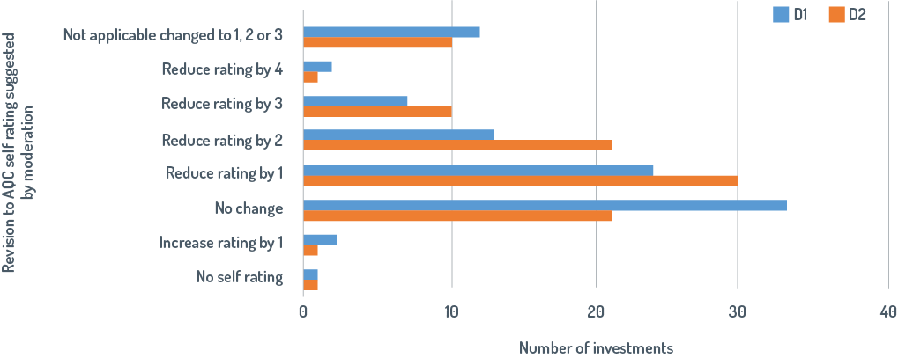

Figure 14: Revisions made by program areas following moderation

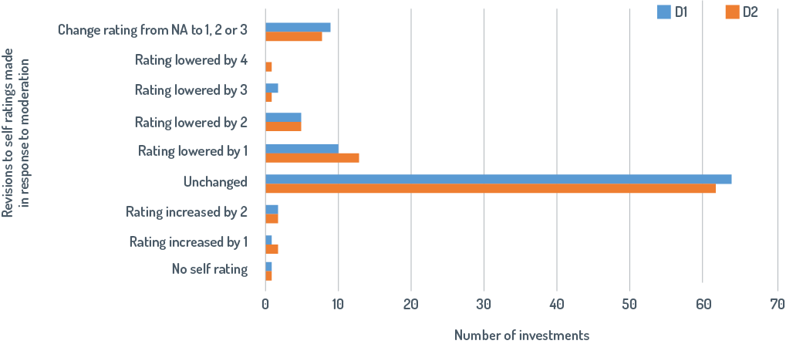

Figure 15: Impact of revisions made by program areas following moderation on the numbers of investments that are rated disability inclusive[57]

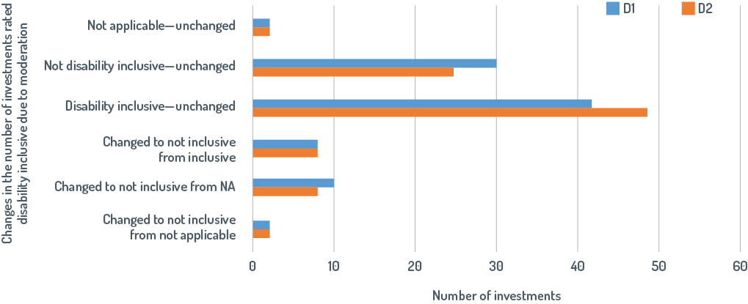

1. Disability ratings are higher for large-value investments which account for most aid expenditure

Disability inclusion was weakest for the 31 per cent of investments valued at less than $10 million but these investments only accounted for 7 per cent of total expenditure in 2017–18 (Table 21). In contrast, disability inclusion was much stronger in the 8 per cent of investments valued at $100 million or more which account for 34 per cent of total expenditure.

Table 21: The number, value and level of disability inclusion for investments of different sizes

|  |  |  |  |  |  |
| --- | --- | --- | --- | --- | --- |
| Investments covered by Aid Quality Checks in 2017–18 | Total value of investment  $million | | | | Total |
| **Below $10** | **$10 to $50** | **$50 to $100** | **$100 +** |
| Number of investments | 108 | 181 | 34 | 30 | 353 |
| Number of investments as a percentage of total number of investments | 31 | 51 | 10 | 8 | 100 |
| Expenditure in Australian dollars | $130 | $651 | $435 | $638 | $1 854 |
| Expenditure as a percentage of total expenditure | 7 | 35 | 23 | 34 | 100 |
| Number of investments rated disability inclusive for D1 | 31 | 65 | 16 | 18 | 130 |
| Percentage of investments rated disability inclusive for D1 | 29 | 36 | 47 | 60 | 100 |
| Number of investments rated disability inclusive for D2 | 37 | 72 | 19 | 18 | 146 |
| Percentage of investments rated disability inclusive for D2 | 34 | 40 | 56 | 60 | 100 |

1. Annex 5: Disability ratings in the Aid Quality Checks have declined since 2015–16

Table 22: Percentages of investments rated satisfactory for disability inclusion, by priority areas, for the last three years

|  |  |  |  |  |  |  |
| --- | --- | --- | --- | --- | --- | --- |
| D 1 The investment actively involves people with disabilities and/or disabled people’s organisations in planning, implementation and monitoring and evaluation. | | | | | | |
| **All aid quality checks** | **Agriculture fisheries and water %** | **Building resilience %** | **Education %** | **Effective governance %** | **Health %** | **Infrastructure %** |
| 2015–16 | 28 | 59 | 80 | 44 | 76 | 29 |
| 2016–17 | 27 | 47 | 67 | 40 | 50 | 27 |
| 2017–18 | 25 | 38 | 55 | 46 | 45 | 17 |
| **D 2 The investment identifies and addresses barriers to inclusion and opportunities for participation for people with disabilities.** | | | | | | |
| 2015–16 | 44 | 59 | 85 | 50 | 83 | 37 |
| 2016–17 | 32 | 53 | 84 | 51 | 58 | 35 |
| 2017–18 | 30 | 41 | 73 | 50 | 45 | 17 |

Table 23: Declines in percentages of investments rated satisfactory for disability inclusion for the last three years

|  |  |  |  |  |  |  |
| --- | --- | --- | --- | --- | --- | --- |
| D 1 The investment actively involves people with disabilities and/or disabled people’s organisations in planning, implementation and monitoring and evaluation. | | | | | | |
| **Change between 2015–16 and 2017–18** | **Agriculture fisheries and water** | **Building resilience** | **Education** | **Effective governance** | **Health** | **Infrastructure** |
| Reduction in % of disability-inclusive investments | 3 | 21 | 25 | 0 | 31 | 13 |
| Proportional reduction in % of disability-inclusive investments | 11 | 36 | 31 | 0 | 41 | 43 |
| **D 2 The investment identifies and addresses barriers to inclusion and opportunities for participation for people with disabilities.** | | | | | | |
| Reduction in % of disability-inclusive investments | 14 | 18 | 12 | 0 | 38 | 20 |
| Proportional reduction in % of disability-inclusive investments | 32 | 31 | 14 | 0 | 46 | 54 |

1. The reliability of disability ratings in the 2015–16 Aid Quality Checks

In early 2017, ODE surveyed investment managers in DFAT to see how well they recognised the need and opportunities for disability inclusion in the investments they manage. A random sample of 78 investments was drawn from the 431 investments that completed AQCs for the 2015–16 reporting round. This sample size was statistically sufficient to extrapolate findings to all AQC reports based on a 95 per cent confidence interval with a margin of error of +/- 10%. A survey using online platform SurveyMonkey was sent to the managers of these investments. Despite extensive prompting, only 66 responded. The survey was then sent to the next 25 investments on the randomised list of investments. Twelve investment managers from this group completed the survey giving a total response of 78, equivalent to 18 per cent of the total population of AQC reports.

In the survey, investment managers rated the potential for disability inclusion in the investment as high, medium or low. Two ODE staff independently rated the potential for disability inclusion in each investment. This assessment was conducted with advice from DFAT’s disability section and using a categorisation that had been previously developed by CBM (Figure 16). The ratings were largely consistent. Where there was disagreement, assessments were reconsidered and a rating agreed.

Figure 16: CBM categorisation of need for disability inclusion[58]

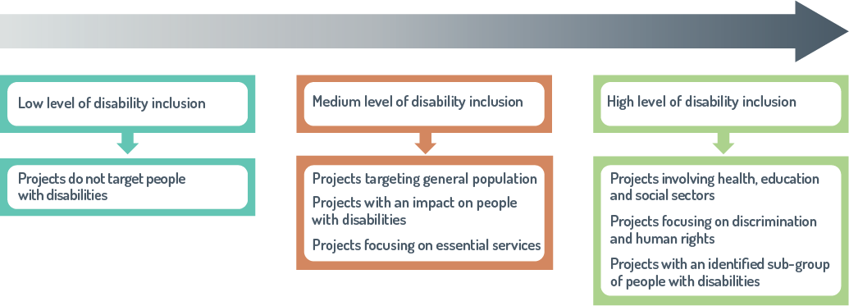

Investment managers substantially underestimated the need for disability inclusion (Figure 17). Almost 70 per cent of investments were considered by ODE to have high need for disability inclusion, but investment managers only recognised 27 per cent of investments having a high need. Investment managers rated about one-third of investments as having low need whereas ODE rated 10 per cent of investments as having a low need for disability inclusion.

The need for disability inclusion was not adequately recognised in all sectors (Figure 18). The plot shows the percentage of investments in each sector rated by ODE as having a high need for disability inclusion but rated by investment managers as having a low or medium need for disability inclusion in the 2015–16 AQC reporting round.

Figure 17: Investment managers in 2015–16 underestimated opportunities for disability inclusion

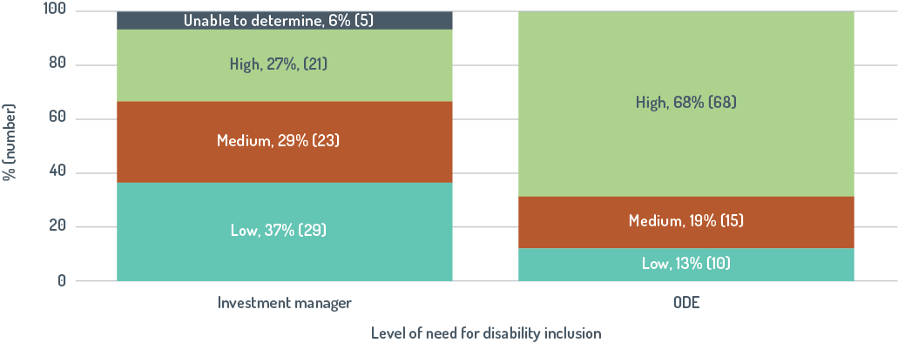

Figure 18: Opportunities for disability inclusion were not sufficiently recognised in all sectors in 2015–16

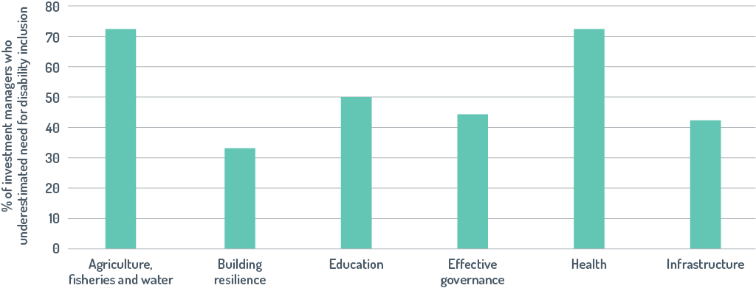

1. Detailed case studies for Pacific regional investments

The Australian Government provided an estimated $166.5 million in total funding through the Pacific regional program in 2017–18, including $127.3 million in Official Development Assistance funding across a broad range of sectors. Funding has been used to support advocacy and changes to policy and legal frameworks to enable people with disabilities to achieve their human rights as expressed in the CRPD. This has included support to a number of regional organisations and programs.

|  |
| --- |
| The Pacific Islands Forum Secretariat |
| The Pacific Islands Forum Secretariat was mandated by Forum Leaders to coordinate the implementation of the Pacific Regional Strategy for Disability 2011–15. The Secretariat continues to have this responsibility for the strategy’s successor, the Pacific Framework for the Rights of Persons with Disability 2016–25. The Secretariat received funding from Australia, over and above Australia’s core support, to fund the Disability Coordination Officer position and an assistant to support the implementation of the Pacific Regional Strategy for Disability. The Secretariat covers a broad range of economic and political issues at inter-governmental levels. Disability inclusion has been just one relatively small part of the its overall mandate and work plan. The Secretariat has not reached the envisaged potential in supporting disability inclusion, although it has coordinated the efforts of a diverse range of stakeholders and supported Disability Focal Points (officials in government ministries) in each country.  The Secretariat has been undergoing significant internal reorganisation. It is developing a new policy development framework and social policy hub to coordinate policy so social policy priorities, including disability, are mainstreamed across the Secretariat’s programs. |

|  |
| --- |
| University of the South Pacific Partnership |
| The University of the South Pacific has set up a Disability Resource Centre on its Suva campus that provides support to people with disabilities studying at the university. There is a dedicated building, funded by DFAT, for students with disability. It is safe, accessible and set up with facilities for study, including computers with accessible software. It also has facilities for relaxation, including kitchen facilities. Two members of staff and several volunteers provide support to people with disabilities throughout their engagement with the university, starting at the application stage.  Students approach the Disability Resource Centre directly and work with staff to create a student profile which identifies the support they need, such as reasonable accommodation measures. Other support includes identifying who can provide support and how. The team at the centre then organises and coordinates that support. Disability Resource Centre staff also liaise with teaching staff to ensure facilities, teaching resources and practices are accessible and appropriate, and that reasonable accommodation measures are implemented. They work with university staff, such as library staff, to understand the needs of students with particular disabilities, such as vision impairment, and are piloting dedicated library sessions for vision impaired and hard-of-hearing students.  There has been strong management support for the Disability Resource Centre, which is university policy and therefore mandatory. A ‘buddy’ scheme links a volunteer (paid a nominal sum) with a student with disability to provide support and expand social networks for both. Students with disabilities have set up their own student group that is formally affiliated to the university. This group, like all student groups, receives funding each semester and engages with university management about issues of concern. |

|  |
| --- |
| Regional Rights Resource Team |
| Australia has also provided ongoing funding for the Regional Rights Resource Team, a program of the Secretariat of the Pacific Communities. The team’s mission is to advance human rights, governance and equitable development in the Pacific region. Team members have supported disability inclusion across the Pacific by:   * raising awareness on disability as a human-rights issue * assisting Pacific states to commit to and observe the rights of people with disabilities * supporting country focal officers seconded to countries to support ministries with human-rights mandates.   It has worked successfully worked closely with the Pacific Disability Forum and PIFS on their work on the human-rights of people with disabilities. |

|  |
| --- |
| Australia-Pacific Technical College Stage 2 |
| The Australia-Pacific Technical College (APTC) offers Australian qualifications from Certificate III to Diploma level at five countries across the Pacific, including Fiji, Papua New Guinea, Samoa, Solomon Islands and Vanuatu. The DFAT contract for APTC implementation requires a disability policy, a work plan for inclusion and formal reporting on disability inclusion progress.  APTC has a twin-track approach to disability inclusion. People with disabilities are encouraged to apply for courses by engaging with DPOs and the Pacific Disability Forum to advertise courses and identifying individuals to approach. A scholarship scheme provides financial support to students with disabilities. Recognising that people with disabilities may have had less opportunity for formal learning, the program:   * considers both experience and prior learning in assessing eligibility for courses * provides support with literacy and numeracy if needed * provides support to students with disabilities including additional learning support and modifications to training and assessments (reasonable accommodation) * works to embed inclusion in its culture and processes, offering training to staff and working to address issues of awareness, understanding and confidence in including people with disabilities in the classroom.   APTC has also run a Certificate II Skills for work course specifically for people with disabilities. This is a bridging course supporting basic literacy and numeracy skills for people with disabilities with limited previous access to education. Some graduates have gained ongoing employment as a result of their work placements. APTC also offers certificate courses that provide training and support for people caring for and supporting people with disabilities in a range of disability services. |

1. Detailed case studies for investments in Vanuatu

Over a long period, DFAT has worked with relevant Government of Vanuatu ministries to support inclusion of people with disabilities. This has included funding a position in the Ministry of Justice to support the finalisation of the National Disability Policy and the mainstreaming of the policy across government. Recent results in the education sector include the government appointment of qualified education and disability inclusion officers, school construction that encompasses inclusion standards, and the production of teacher guides to support modification of activities for students with special learning needs.

There is a consistent message from senior management in the Port Vila High Commission about the importance of disability inclusion. Post’s approach to supporting disability inclusion is characterised by attention to local cultural beliefs and practices. This includes a focus on working with others and through relationships and networks. Attention has been given to challenging and further developing attitudes and beliefs about disability, including those of Australian Government staff. The Post has built on small achievements and adaptations to existing practice, seeking to understand issues in context, and working for the longer term.

DFAT has maintained an ongoing relationship with the national DPO and other service providers for people with disabilities. This has included support to strengthen organisations, enabling them to represent the voice and needs of people with disabilities.

|  |
| --- |
| Vanuatu Policing and Justice Program |
| The Vanuatu Policing and Justice Program builds on previous Australian Government support in law and justice, with a flexible design that is aligned with the planning and reform agenda of the Government of Vanuatu. It targets access to justice for the most vulnerable members of the community and includes an outcome that ‘Vanuatu Government sector agencies are responding more effectively to the needs of people with disabilities.’  The program has worked to build the understanding and expertise of its implementing team with training and ongoing technical advice from CBM Australia. It partners with the national DPO, Vanuatu Disability Promotion and Advocacy, and a local service provider, the Vanuatu Society for People with Disability, to strengthen overall capacity and specific capability to engage with the justice sector.  The program has a staff position with specific responsibility for disability and aims to mainstream disability in its activities and interactions with government and community partners. For instance, disability inclusion is one criterion in the assessment of applications for funding under its community grants scheme. Accountability against the program’s specific disability-related intermediate outcome has been a driver to collect disaggregated data on disability across all outcomes. This includes the new Police Information Management System that collects disaggregated data on disability. The data on disability inclusion is included in regular program monitoring and review processes to identify barriers and areas for improvement.  The program is working at national level to support the legal and policy framework for the rights of people with disabilities and has provided technical support for the national Disability Desk based in the Ministry of Justice. It has supported the establishment of disability committees in the provinces. Awareness about the rights of people with disabilities is now included in training for the Vanuatu Police Force. The program is also working with DPOs to develop standard operating principles to support this training in practice. |

|  |
| --- |
| Vanuatu Skills for Economic Growth Program |
| The Vanuatu Skills for Economic Growth Program, now called Skills Partnership and currently in its fourth phase, works with the Vanuatu Government’s Ministry of Education and Training to support the development of a quality-assured, demand-driven, flexible and accessible post-secondary education training system. It has focused on the decentralisation of access to skills with Skills Centres in four provinces. Over time it has supported national training providers to become more disability inclusive. People with disabilities now make up 8 per cent of trainees and people with disabilities are employed as trainers. There has been strong program management support for disability inclusion and it is included in job descriptions and performance assessments. Support was provided for staff to understand what this meant for their work and the program engaged a disability adviser who helped the program develop and implement its own disability policy.  Externally, the program has developed strong links and networks with people with disabilities and their organisations and has supported organisational development for mutual benefit. For instance, it has a memorandum of understanding with Vanuatu Disability Promotion and Advocacy, the national DPO, and supports a joint position located in its office. This position has supported the organisation’s advocacy and networking across Vanuatu with two aims:   * increase awareness among people with disabilities about the training opportunities available to them in the post-secondary education training sector * enable the program to better understand the training needs of people with disabilities.   Based on this, the program has worked to support the provincial Skills Centres and their training providers to develop appropriate courses and ensure that all courses are accessible, with small amounts of funding available for ‘reasonable accommodation’ needs.  An analysis suggested a willingness at all levels with the training providers to be more disability inclusive, but a lack of confidence about how to do this. The program worked with the Skills Centres to develop staff confidence and understanding, and there is now a disability focal point in each centre. At the same time, the program has developed practical tools for disability inclusion, such as detailed, step-by-step advice on how to organise and implement disability-inclusive training. To support implementation of inclusion the program also applied to the Disability-Inclusive Development Fund for money for training providers to implement their own disability action plans. At national level, the program has supported disability inclusion across the post-secondary education training sector in Vanuatu. |

1. Detailed case studies for investments in Fiji

There has been strong leadership support for disability inclusion at the Australian High Commission in Suva, with the High Commissioner and other senior managers ensuring disability is considered across their portfolio wherever opportunities arise. This includes meetings with counterparts and other stakeholders. Championing disability is a formal part of the High Commissioner’s role. A disability focal point advocates and provides support for mainstreaming disability into bilateral programs. Bilateral and regional work closely to support disability inclusion.

Flowing from this there has been a consistent message from DFAT to partners about the importance of disability inclusion. Implementing partners reported that DFAT held them to account for disability inclusion, and various programs had developed specific accountability measures to monitor and report on inclusion.

Suva Post benefits from a strong relationship with a number of regional bodies that play a role in disability-inclusive development for the whole region, including the Pacific Islands Forum Secretariat, the Regional Rights Resource team and, in particular, the PDF. There is a strong, ongoing relationship between DFAT and the Pacific Disability Forum, as well as with local DPOs through the Fiji Disabled People’s Federation. DFAT has provided long-term support to both organisations, increasing their capacity to represent the voice of people with disabilities and, more recently, enabling them to provide advice to DFAT.

|  |
| --- |
| Fiji Community Development Program |
| The Fiji Community Development Program (2012 to 2017) worked with CSOs to help mitigate the social and economic hardship faced by the poor, vulnerable and excluded communities in Fiji.  For the program, disability inclusion was viewed within a gender equality and social-inclusion approach, where disability is recognised as an intersecting social factor (such as gender, age or ethnicity) that leads to exclusion. Transformative change results from building individual skills and confidence, changing relations between people at household and community levels, and enabling structures to be more inclusive and equal. These complex issues require complementary interventions at multiple levels. All program staff were trained in this gender equality and social-inclusion approach and provided with ongoing technical support. The approach was mainstreamed through the program’s policies, procedures and forms and with regular prompts about its importance. This includes, for example, incorporating inclusion across all criteria in checklists and assessing inclusion in the annual quality audit for program implementation. The program modelled inclusion in its activities, for instance by making sure all meetings were held in accessible venues. The program’s gender equality and social-inclusion framework was also used by short-term consultants and community and other partners.  Grants to CSOs required that disability inclusion was incorporated, including through explanatory information such as ensuring forms had explicit prompts and examples of the type of information required. It was clear that the extent of inclusion was one criterion used for assessing grant applications and their outcomes. As a result, some CSOs partnered with DPOs to extend their programs to be inclusive of people with disabilities and some received funding to support people with disabilities in their wider programs. When monitoring data suggested that people with disabilities were under-represented in the program, the program began training CSOs in the gender equality and social-inclusion approach. This included an element for training trainers. After training, the program noted an increase in the quality of applications for community grants, especially with the level of inclusion of people with disabilities.  The program worked with CSOs (including DPOs) to enhance their community engagement approaches to ensure community development plans were inclusive of all groups in the community. For instance, in developing WASH programs it worked with community members to identify the needs of each household to ensure suitable facilities were provided.  In a twin-track approach, the Fiji Community Development Program also worked extensively with the Fiji Society for the Blind to extend services, such as for cataract operations, for the vision impaired in rural areas. In its work with communities, the program identified children with disabilities and worked with parents to increase access to education and other services. |

|  |
| --- |
| Access to Quality Education Program, Fiji |
| The Access to Quality Education Program worked with the Fiji Ministry of Education to increase options for children with disability by supporting a model of inclusive education and demonstrating how children with disabilities could be included in the classroom. As part of its strategy, five Inclusive Education Demonstration Schools—four rural primary schools across Fiji and one urban squatter settlement school—were selected.  Teachers received training, teaching resources and toolkits, and ongoing mentoring and monitoring to support them to provide a quality education to all students. Teacher aides were employed and trained in Sign Language and Braille skills, and Braille equipment and computers with screen reading software were provided. Each school received an Inclusive Education Small Grant to cover the costs of meeting the disability-specific needs of the children, such as transport for an appointment to get a hearing aid fitted, or the costs of a wheelchair. Teachers were able to refer children to appropriate technical support. It also supported the adaptation of school infrastructure, so they were physically accessible to children and adults with disability in line with the Australian Government’s Accessibility Design Guide. The schools collaborated with Fijian DPOs to encourage families to enrol their children with disability at school. As well as providing support to demonstration schools, the program trained a teacher who became the Special Needs Coordinator in each of the approximately 180 schools funded through the Access to Quality Education Program. These coordinators supported other teachers in their school to include children with disabilities in their classroom. Overall program outcomes included increased enrolment rates, reduced dropout rates and improved quality learning outcomes for children with disability.  The program supported the Ministry of Education in the development of its inclusive education policy and implementation plan. The demonstration schools model informed the development of this policy and provided the catalyst for raising the profile of children with disability. The program had a sharp focus on building understanding and evidence of what works in increasing access to quality education and worked with the Ministry of Education to ensure its Information Management Systems included disaggregated data on disability. The tools developed by the program are now used throughout Fiji schools.  Disability inclusion was a focus from the outset, with program implementation guided by the program’s Disability Inclusion Strategy. It was supported by a disability adviser who was engaged throughout the design and implementation and by a Fijian Disability Inclusion Coordinator with strong community links with additional advice from an international disability adviser. In December 2013, the program won the inaugural DFAT disability-inclusive development award for the strong evidence of disability inclusion throughout its design, tendering and implementation. The program built strong relationships with DPO and used their expertise in design, strategy building, awareness raising, capacity development and data collection and research. |

1. Detailed case studies for investments in Indonesia

The Australian Embassy in Jakarta has been proactive in disability inclusion since DfA1. Several programs have progressively improved disability inclusion by starting with small activities, and then gradually using evidence and learning to build inclusion. Attention to disability inclusion has been maintained over time through an ongoing commitment to disability inclusion by DFAT management, together with a focus on tracking results in disability inclusion through Post’s Performance Assessment Framework and Annual Program Performance reporting. In 2016, a disability working group was established to strengthen disability inclusion across programs, and to promote collaboration and sharing of data. Post staff have received training on disability inclusion.

Australia’s support for disability inclusion in Indonesia is strongly aligned with Government of Indonesia policy and practice. Australia has worked with other stakeholders to advocate for and support the development of the national law on disability and regulations to support implementation of this law. DFAT has also worked in partnership with the Indonesian Government in programs such as Peduli, providing advice to subnational governments to support implementation of the disability law. Through the provision of technical advice to the Indonesian Government and support for the involvement of DPOs, the Australia–Indonesia Partnership for Justice Phase II has contributed to the development of a national action plan on human rights.

Peduli and other programs, such as Towards a Strong and Prosperous Indonesian Societyand the Australia–Indonesia Partnership for Justice Phase II, have provided long-term organisational support for DPOs and facilitated their collaboration with Indonesian Government partners in developing policies and action plans to improve disability inclusion. This support has, among other things, enabled DPOs to play a critical role in drafting selected regulations on access to justice and assisting the government partners with the development of a more inclusive social protection systems in Indonesia.

|  |
| --- |
| Indonesia Governance for Growth |
| Indonesia Governance for Growth, or KOMPAK (2015–18), is a partnership between the Government of Indonesia and Australia with the objective that poor and vulnerable Indonesians benefit from improved delivery of basic services and from greater economic opportunities. It is aligned with Government of Indonesia priority areas for poverty alleviation and works at national and subnational levels. It is guided by Indonesia’s national development framework and implemented through relevant government ministries.  KOMPAK has taken a gender equality and social-inclusion approach, which includes disability inclusion as part of its strategy to include all poor, vulnerable and marginalised groups. It uses a twin-track approach, mainstreaming gender equality and social inclusion across all activities and designing and implementing specific activities for people with disabilities and other marginalised groups. The approach is included in the induction training for all new staff and a person with a disability is a facilitator in this training. There is a Gender Equality and Social Checklist Tool for each new proposed project or activity, and a participatory self-assessment tool for the project team to use in developing new projects. This underpinned the development of an action plan for new projects.  The program has some budget flexibility, so it can quickly take advantage of new opportunities. It aims to identify gaps through research and monitoring of its programs and to design solutions, often starting with small activities that develop learning and experience before rolling them out more widely. For instance, as part of its work on expanding economic opportunities for the poor and vulnerable, the program undertook research and analysis on financial inclusion for people with disabilities. As a result, in 2016 it piloted financial literacy training for people with vision impairment in Jakarta, including producing material in Braille. In 2017, this was replicated by the Indonesian Financial Services Authority in two more cities and further research was undertaken on financial inclusion for people with disabilities. A further five cities were involved in 2018 and Operational Technical Guidelines developed for further roll out.  At the subnational level, KOMPAK has worked with local CSOs to improve legal identity access, including for people with disabilities. At village level it has worked on disability responsive budgeting by involving the village community in collecting information about village issues and conditions. This also identified information about the number of people with disabilities in their village and their living conditions. This information was used a basis for work with the community on including people with disabilities in planning and budgeting for village funds allocated by government. As a result, there is now a budget allocation for activities identified by people with disabilities.  At national level the project has worked to strengthen inclusion in ministries. It has, for example, contributed to the Ministry of Health’s roadmap for disability inclusion and works in collaboration with other Australian-funded programs, such as PEDULI and the Australian Indonesia Partnership for Justice, and other partners, to share learning and smart practices. |

|  |
| --- |
| Support to marginalised groups Phase II |
| PEDULI is an Australian Indonesian Government partnership (2014–18) that aims to promote social inclusion to reduce poverty among marginalised people in Indonesia. Its six pillars focus on Indonesia’s most marginalised groups, including one focusing on people with disabilities. PEDULI supports a group of nine DPOs under the umbrella of a service provider with a focus on disability.  PEDULI has employed a number of strategies, including working with government to take opportunities to influence service accessibility and reduce stigma. It partners with other organisations, for instance by developing relationships with Islamic universities to influence the conversation about disability in religious teachings. It has some flexible funding that enables it to respond to unexpected opportunities. It provides technical advice and expertise, using this as a way into other organisations and networks.  PEDULI provides small grants to small local DPOs to plan and implement small projects to demonstrate what can be achieved. For example, a local DPO supported by PEDULI worked with the community and district government to introduce the concept of an inclusive village. A Village Disability Forum was established with a representative from each sub village to gather data about people with disabilities in the village. A village discussion, including people with disabilities, considered this information and the needs of people with disabilities in the village. The equal rights and responsibilities of people with disabilities were recognised in the discussion. After the discussion an allocation was made to the Village Disability Forum to use to support people with disabilities. The village DPO representative subsequently reported that because of the PEDULI program, people’s attitudes had noticeably changed so there was increased respect for and acceptance of people with disabilities in the village and within their family. The model has now been taken up by eight villages in the local subdistrict.  Support from PEDULI to the DPOs has contributed to their development and action in broader activities. For example, four of PEDULI’s DPO partners have played a significant role in drafting regulations on public service and social welfare for implementation of the Disability Law no. 8/2016. |

|  |
| --- |
| Australia Indonesia Partnership for Justice II |
| The Australia Indonesia Partnership for Justice (AIPJ) aims to support strong and accessible justice and security institutions that enhance respect for enforceable rights and rules-based governance systems. Its design included a focus on gender equality and disability rights, noting that people in Indonesia have poor knowledge of their legal rights and are reluctant to use legal systems for a number of reasons.  AIPJ’s focus on disability is implemented through a twin-track approach, by mainstreaming disability inclusion across all activities and implementing some specific disability-inclusion activities. A national disability adviser, who identifies as having a disability, oversees implementation of this approach.  Disability inclusion is integrated throughout program documentation, for instance in program reporting and through a checklist for disability inclusion in new activities. AIPJ has supported its partner DPOs to develop their organisations and has used its networks with the Government of Indonesia to facilitate the DPOs advocacy for people with disabilities. For instance, at a national level, AIPJ supported a coalition of local DPOs and others to advocate together to government, leading to the drafting of government regulation on legal services and on social welfare for people with disabilities, as part of implementing regulations of the Disability Law no. 8/2016.  AIPJ continues to support DPOs providing advice to the relevant ministries on the detailed regulations to implement the law. It also undertakes research to provide evidence to influence institutional change. For instance, it undertook a case analysis with a university of how judges responded to people with disabilities. This evidence was presented to the Judicial Commission which is responsible for the training of judges. As a result, training on disability issues has been integrated in the training of judges in Indonesia.  At local level, AIPJ has funded CSOs to provide an online legal aid service. Through its Disability Adviser, the program connected the CSOs with local DPOs to make the service more accessible and support CSOs to understand the needs of people with disabilities. AIPJ has also supported a local DPO who worked with the provincial justice system on an inclusive court. The DPO worked with court officials to make improvements to the court buildings and processes so they are more accessible for people with many types of disability. Court officials said these changes had been made at minimal cost over two or three years using their annual allocation for building maintenance. They also noted that other important changes had cost nothing because they only required a change in attitude. For instance, people with disabilities were treated with more respect and sign interpretation was allowed.  AIPJII has supported the intergovernmental Human Rights Secretariat in drafting the revised Human Rights Action Plan to include actions on disability and measures to assess progress. |

|  |
| --- |
| National Rural Water Supply and Sanitation Project |
| The National Rural Water Supply and Sanitation Project, or PAMSIMAS, is a national Government of Indonesia initiative aimed at increasing the number of under-served and low-income rural and peri-urban populations accessing improved and sustained water and sanitation services and improving hygiene behaviours. Funded through the World Bank, the program also receives support from Australia in the form of flexible grant funding.  Australia’s commitment to, and experience in, disability inclusion in development programs, including WASH programs, has contributed to PAMSIMAS increasing its focus on ensuring that all its facilities are accessible by people with disabilities. This process has become even more important since the Government of Indonesia committed to achieving 100 per cent access to water and sanitation across Indonesia by 2019. Work to make the program more inclusive was catalysed by technical advice provided through under the DID4All Help Desk during visits to Jakarta Post in late 2014 and 2015, when PAMSIMAS was identified as a program that could improve its practice on disability.  Australia contributes about 6 per cent of the total funding of PAMSIMAS (A$124 million out of US$1.6 billion for 10 years) with the Government of Indonesia and the World Bank providing the rest. Australia’s funding for PAMSIMAS was used to support improvements in project implementation and sustainability through the development of sustainable and innovative affordable technologies accessible and inclusive of people with disabilities. Australia funded the piloting of disability inclusion in 200 villages in 2017, with close monitoring of pilot sites and activities to develop standard operating procedures to guide future implementation. This is now being scaled up and rolled out to 10,000 villages in the PAMSIMAS program up to 2020.  Australian funding has facilitated disability-inclusive WASH training for 64 PAMSIMAS WASH facilitator managers and coordinators from districts across Indonesia and representatives from the World Bank and Government of Indonesia. As a result, a resource on inclusive WASH was prepared to be included in the standard WASH facilitation training. Australia’s relatively small contribution to PAMSIMAS is thus leveraging a large benefit for people with disabilities throughout Indonesia and is setting an example to other WASH programs and the World Bank.  Recent figures indicate that approximately 59,000 people with disabilities have been identified in program locations and approximately 25,000 of these people have received benefit directly from the program. This number will increase as PAMSIMAS is continuously updating their data in management information system (www.pamsimas.org). |

1. Detailed case studies for investments in Timor-Leste

Commitment to disability inclusion in the Timor-Leste program started during consultations in 2008, as part of the development of DfA1. Timor-Leste was included as a focus country for DfA1 and senior management has continued to support disability inclusion in DfA2. Training and specialist advice sourced through the DID4All Help Desk has been used to strengthen the knowledge and skills of DFAT staff and program implementation teams.

An internal working group was established to promote cross-Post engagement in disability-inclusive development. The disability working group has now merged with the gender working group and is led by Dili Post senior management which signals its importance. Members of the working group felt that the group strengthens disability inclusion by holding investment managers to account for progress in improving disability inclusion, providing opportunity for cross-investment learning and strengthening collaboration. The working group also helps to ensure disability issues are not siloed, but rather are the responsibility of all personnel, sections and sectors.

The Government of Timor-Leste has not yet ratified the CRPD. DPOs are strong advocates for ratification and are continuing to lobby, together with influential government staff, for disability-inclusive planning and budgeting. In Dili, DFAT has strong, long-term partnerships with, and provides core funding for, two national DPOs. Australian funding has enabled RHTO to strengthen its organisational capacity and outreach so it now is a valued partner which provides support and advice for the aid program. The Asosiasaun Defisiensia Timor-Leste has used Australian funding to expand its activities. It brings together, and provides small grants to, civil society groups that work across the spectrum of disability, including service providers and sports organisations. It also carries out research needed to provide the evidence to support inclusion.

|  |
| --- |
| Ending Violence Against Women in Timor-Leste |
| Nabilan is an Australian aid program focused on ending violence against women in Timor-Leste. Nabilan baseline’s study in 2015 provided the most comprehensive national research on the intersection between disabilities and intimate partner violence.  The design document for Nabilan reflected the engagement with the national DPO during the design process. It included specific actions to address inclusion and a commitment to inclusive monitoring and evaluation. Nabilan established good working relationships with local DPOs, which have been mutually beneficial. DPO members joined a certificate-level training course in social services, and the program assisted DPOs on CRPD reporting and identifying and documenting human-rights violations and violence. In turn, DPOs have assisted Nabilan to better understand the issues affecting lives of people with disabilities, particularly women, in relation to violence. This understanding has informed strategies to prevent violence and ensure that responses to violence are inclusive and the services accessible.  Nabilan has benefited from advice provided through the DFAT–CBM Partnership. The implementation team also credits DFAT’s monitoring process for ensuring that regular attention is paid to mainstreaming disability inclusion. The need for regular staff training, to cover staff turnover and extend basic skills, has been identified as an important factor to maintain attention to disability inclusion in this sector.  Recent reports indicate a four-fold increase in the number of new female clients with a disability compared to the 2014 baseline. Based on ongoing consultation with DPOs, the program has also provided technical advice to a review of the Ministry of Social Solidarity’s Standard Operating Procedures, which include new guidance on working with people with disabilities and assessing the victims level of risk. |

|  |
| --- |
| Australia–Timor-Leste Partnership for Human Development |
| The Australia–Timor-Leste Partnership for Human Development (PHD) was established in 2016 to manage a wide range of human development activities in eight sectors in Timor-Leste. It provides opportunities to mainstream inclusion across many areas of development cooperation. Funding for two national DPOs, RHTO and Asosiasaun Defisiensia Timor-Leste (a national DPO), is provided through PHD. The support has informed and contributed to sectoral programming areas. For example, representatives from the DPOs have been invited to participate in events and development processes, at national and district levels, and their understanding of the program helps inform their own advocacy and development work more broadly.  PHD employs a Timorese social-inclusion adviser, who supports disability-inclusive processes and generates effective inclusion strategies in all sectoral programs. In its first year, PHD used additional funds from the Disability-Inclusive Development Fund, enabling dedicated focus on mainstreaming disability inclusion across the sectoral activities. Funding ensured that disability inclusion was not lost among the other pressing demands on the implementation team and ensured DfA2 was applied in practical ways, relevant to the context and stage of each area. While there are differences in the extent to which sectors under PHD have become disability inclusive, the coordinated approach and dedicated resources are expected to contribute to progressive improvements.  The health sector has seen increased accessibility for people with disabilities to health facilities and services. This has included training for midwives on supporting pregnant women with disabilities. The health team has worked with the Ministry of Health to develop communication materials to support access to services for people with disabilities. In the education sector, PHD has worked with inclusive education resource centres to assist children and support teachers in developing plans and exploring referral pathways for children with disability. Teachers are being trained in inclusive education.  Social protection and WASH teams have developed a voucher system with specific vouchers for people with disabilities. These enable modifications to increase the accessibility of a household toilet. People with disabilities have representation within community water groups and are given the opportunity to voice their opinion in community decision making. |

|  |
| --- |
| Farming for prosperity To’os ba Moris Di’ak |
| *To’os ba Moris Di’ak*, or TOMAK, is Australia’s nutrition-sensitive agriculture program. It works with rural communities to strengthen nutrition awareness and practices, improve the supply of nutritious food and improve commercial smallholder agriculture. The program takes an explicitly inclusive approach to implementation. TOMAK works with rural communities that include people with disabilities. To work inclusively, the program aims to understand its implementing context, the issues faced by people with disabilities and their families and communities, as well as opportunities for inclusive approaches. Understanding inclusion issues relevant to market access, livelihoods and nutrition is also important.  Gender equality and social inclusion have been integrated through TOMAK from the outset as a priority in program design. The implementation team includes international and Timorese gender and social-inclusion experts who work across the program to ensure gender and social-inclusion issues are embedded and that the program is responsive to cultural norms. TOMAK has used technical assistance through the DFAT–CBM Partnership. There is a good working relationship with the national DPO and further training is planned to support capacity development of DPO partners. The program used funding from the Disability-Inclusive Development Fund to work with people with disabilities to trial approaches to accessible nutrition sensitive agriculture.  The program undertook a Gender Equality and Social Inclusion Analysis early in the mobilisation phase to identify the experience of vulnerable groups, including people with disabilities, and how this could be addressed in program implementation. The program’s work on nutrition-sensitive agriculture is couched in an understanding of inclusion in the Timorese context. Recommendations from the Gender Equality and Social Inclusion Analysis illustrated that working inclusively does not necessarily require specialised approaches but starts with consideration of the perspectives of people disability in all aspects of programming. |

Acronyms and Abbreviations

|  |  |
| --- | --- |
| AIPJ | Australia Indonesia Partnership for Justice |
| ANCP | Australian NGO Cooperation Program |
| APPR | Annual Program Performance Reports |
| APTC | Australia-Pacific Technical College |
| AQC | Aid Quality Check |
| CBM | CBM Australia |
| CIL | Independent Living Centre for Persons with Disabilities |
| CRPD | Convention on the Rights of Persons with Disabilities |
| CSO | Civil Society Organisation or Community Sector Organisation |
| DAP | Direct Aid Program |
| DfA1 | Development for All: Towards a disability-inclusive Australian aid program 2009–2014 |
| DfA2 | Development for All 2015–2020: Strategy for strengthening disability-inclusive development in Australia’s  aid program |
| DFAT | Department of Foreign Affairs and Trade |
| DPO | Disabled People’s Organisation |
| FCDP | Fiji Community Development Program, a national DPO |
| KOMPAK | Indonesia Governance for Growth |
| NGO | non-government organisation |
| ODE | Office of Development Effectiveness |
| PAMSIMAS | National Rural Water Supply and Sanitation Project (Indonesia) |
| PDF | Pacific Disability Forum, a regional DPO |
| PEDULI | Support to Marginalised Groups Program (Indonesia) |
| PHD | Australia–Timor-Leste Partnership for Human Development |
| RHTO | Ra’es Hadomi Timor Oan (Timor-Leste), a national DPO |
| TOMAK | To’os ba Moris Di’ak (Farming for Prosperity Program) (Timor-Leste) |
| WASH | water, sanitation and hygiene |
| WFP | World Food Programme |

1. Disability-inclusive development means that all stages of development processes are inclusive of and accessible to people with disabilities.
2. This includes three types—Aid Quality Checks, Final Aid Quality Checks and Humanitarian Aid Quality Checks.
3. Agree/Agree in part/Disagree
4. Agree/Agree in part/Disagree
5. Agree/Agree in part/Disagree
6. Agree/Agree in part/Disagree
7. Agree/Agree in part/Disagree
8. Agree/Agree in part/Disagree
9. People with disabilities is the accepted DFAT usage, which bridges the accepted international and domestic language. The CRPD uses persons with disabilities, while the accepted Australian domestic terms is people with disabilities.
10. ODE (2017). Unfinished business: Evaluation of Australian advocacy for disability-inclusive develop-ment. https://dfat.gov.au/aid/how-we-measure-performance/ode/strategic-evaluations/Pages/unfinished-business.aspx
11. Independent Commission for Aid Impact (2018). Report: ‘DFIDs approach to disability in devel-opment’, a rapid review
12. World Health Organization and World Bank (2011). World Report on Disability.
13. http://www.un.org/disabilities/convention/facts.shtml
14. Banks, L.M. & Polack, S. (2015). ‘The Economic Costs of Exclusion and Gains of Inclusion of People with Disabilities: Evidence from Low and Middle Income Countries’, London School of Hy-giene and Tropical Medicine.
15. Banks, L.M. & Polack, S. (2015). ‘The Economic Costs of Exclusion and Gains of Inclusion of People with Disabilities: Evidence from Low and Middle Income Countries’, London School of Hy-giene and Tropical Medicine.
16. Buckup, S. (2009). ‘The price of exclusion: The economic consequences of excluding people with disabilities from the world of work’. Employment Working Paper, International Labour Office. Ge-neva.
17. Awan, H., Khan, N. and Malik, S. (2012). ‘The economic burden of blindness in Pakistan: A socio-economic and policy imperative for poverty reduction strategies’. Indian Journal of Ophthalmolo-gy, vol. 60(5), pp. 358–364.
18. World Health Organization and World Bank (2011). ‘World report on disability’. WHO Press. Ge-neva.
19. Groce, N., Kett, M., Lang, R., & Trani, J-F. (2011). ‘Disability and Poverty: the need for a more nuanced understanding of implications for development policy and practice’. Third World Quarter-ly, 32(8), pp. 1493–1513.
20. UNDP (2010). Including the rights of people with disabilities in United Nations programming at country level: A Guidance Note for United Nations Country Teams and Implementing Partners.
21. United Nations Human Settlements Program (UN-HABITAT), (2007). Global Report on Human Set-tlements.
22. McCoy, M. (2017). ‘Review of the Development of Australia’s first disability-Inclusive Develop-ment Strategy.’ https://dfat.gov.au/aid/how-we-measure-performance/ode/Pages/the-office-of-development-effectiveness.aspx
23. DFAT Humanitarian Strategy (2016). http://dfat.gov.au/about-us/publications/Documents/dfat-humanitarian-strategy.pdf
24. DFAT (2017). Secretary’s Remarks, International Day of Persons with Disabilities, December 6.
25. Wapling, L. & Kelly, L. (2012). ‘Development for All Strategy, Mid-Term Review’, report, October.
26. DFAT–CBM partnership evaluation. Improving the quality of lives for people with disability: Building understanding and technical capacity for disability-inclusive development.
27. Review of the DFAT–CBM Australia Partnership (2015–2017). Final Report—April 2017.
28. https://www.devex.com/news/how-dfat-works-to-support-disability-inclusive-development-91903
29. Under DfA1, regional specialists in disability inclusion were appointed in Suva for the Pacific region and Cambodia for Southeast Asia. In addition, during the implementation period, focal points and advisers in disability inclusion were recruited for the Pacific and in certain posts, particularly in South-East Asia and the Pacific and Papua New Guinea.
30. Review of the DFAT–CBM Australia Partnership (2015–2017). Final Report—April 2017.
31. This includes three types—Aid Quality Checks, Final Aid Quality Checks and Humanitarian Aid Quality Checks.
32. ODE (2016). Quality review of aid program performance reports, https://dfat.gov.au/aid/how-we-measureperformance/ode/performance-quality-analysis/Pages/performance-and-quality-analysis-publications.aspx
33. Prior to that time the previous Quality at Implementation system did not contain any specific ques-tions about disability although there was the option of commenting on disability inclusion in the section on crosscutting issues.
34. Wapling, L. & Kelly, L. (2012). ‘Development for All Strategy, Mid-Term Review’, report, October.
35. ODE (2017). Unfinished business: Evaluation of Australian advocacy for disability-inclusive development. https://dfat.gov.au/aid/how-we-measure-performance/ode/strategic-evaluations/Pages/unfinished-business.aspx
36. DFAT (2017). ‘Australian NGO Cooperation Program. Manual of Procedures’, April.
37. https://dfat.gov.au/about-us/publications/Pages/aus-ngo-cooperation-program-ancp-data-systems-validation-review.aspx
38. These countries together account for more than 52 per cent of awards over the period from 2011 to 2017.
39. This has been justified because the costs of reasonable accommodation for a very small number of individual students have been very high and funding for Australia Awards is finite. DFAT pro-poses that while it is important to ensure that people with disabilities receive the assistance they need it is also important to make the scholarships open to many people with disabilities.
40. The New Colombo Plan is an initiative that supports Australian undergraduates to study and un-dertake internships in the region. It involves a scholarship program and a flexible mobility grants program for both short and longer-term study.
41. Disability-inclusive volunteering program policy for the Australian Volunteers for International De-velopment (AVID) Program, August 2018, and a formative evaluation of volunteer diversity in the Australian Volunteers Program July 2018.
42. The Australian Volunteers Program, is currently exploring ways to address pension restrictions on time spent overseas.
43. DFAT (2016). Syria Crisis Humanitarian Resilience Package design, http://dfat.gov.au/about-us/publications/Documents/syria-crisis-humanitarian-resilience-package-design.pdf. p. 23.
44. Godfred P. (2014). Situation of older people and their specific protection issues in Government Con-trolled Camps in Myitkyina and Bhamo Kachin State, Myanmar, HelpAge International.
45. Humanitarian Advisory Group (2017). Humanitarian Partnership Agreement: Saving lives through Collective Action, p. 23.
46. CBM—Nossal Institute Partnership for Disability Inclusive Development, Disability Inclusion in Disaster Risk Reduction: Experiences of people with disabilities in Vanuatu during and after Trop-ical Cyclone Pam and recommendations for humanitarian agencies.
47. CBM (2014). ‘Australian NGO Cooperation Program (ANCP) Research Project: An analysis of ANCP partner organizations’ engagement on disability inclusion and recommendations for future progress’, https://acfid.asn.au/sites/site.acfid/files/resource_document/ANCP-Research-Project.pdf (accessed 15 May 2018).
48. Disability Inclusive Development Helpdesk Response Ad Hoc Task 1187 of 2017. Australia Awards Back to the Office Report Review.
49. The DAP Disability Inclusion Guidance Note suggests practical ways to encourage more applica-tions for disability-inclusive projects and to make it more likely that non-disability-specific projects are inclusive; and highlights the need to ensure projects assist people with disabilities to access their human rights and suggests factors to consider in assessing whether projects achieve this: and describes how to compare the merits of disability-specific projects to increase both the extent and effectiveness of disability inclusion.
50. CBM (2014). ‘Australian NGO Cooperation Program (ANCP) Research Project: An analysis of ANCP partner organizations’ engagement on disability inclusion and recommendations for future progress’, https://acfid.asn.au/sites/site.acfid/files/resource_document/ANCP-Research-Project.pdf (accessed 15 May 2018).
51. DFAT (2017). Syria Crisis Humanitarian and Resilience Package—Design. http://dfat.gov.au/about-us/publications/Documents/syria-crisis-humanitarian-resilience-package-design.pdf, p. 4.
52. Review of the DFAT–CBM Australia Partnership (2015–2017). Final Report—April 2017.
53. Dunn, L. Ovington, K. & McClain-Nhlapo, C. (2017). ‘Unfinished Business: Evaluation of Australi-an Advocacy for Disability-Inclusive Development’, DFAT Office of Development Effectiveness, December.
54. Wapling, L. & Kelly, L. (2012). ‘Development for All Strategy, Mid-Term Review’, report, October.
55. DFAT undertakes an annual check on aid quality for all significant investments and all invest-ments above $4 million. The system requires an analysis of each investments against various criteria, including effectiveness.
56. Before that time, the previous Quality at Implementation system did not contain specific questions about disability although there was the option of commenting on disability inclusion in the section on crosscutting issues.
57. Most programs did not make the suggested revisions.
58. This guidance is no longer used by CBM.