# Development Cooperation Factsheet

## Water for Development

MAY 2025

### Overview

Estimated Australian ODA: $117.4m (2025-26)

#### Table 1: Australian ODA to Water for Development, 2023-24 to 2025-26

| Australian ODA | 2023-24 Actual ($m)* | 2024-25 Budget Estimate ($m)* | 2025-26 Budget Estimate ($m)* |
| --- | --- | --- | --- |
| Pacific | 23.8 | 16.9 | 20.8 |
| Southeast Asia | 49.6 | 36.4 | 56.7 |
| South and Central Asia | 13.5 | 13.6 | 5.8 |
| Middle East and Africa | 5.2 | 2.2 | 5.0 |
| Rest of the World^ | 33.1 | 32.2 | 29.2 |
| **Total Water for Development ODA** | **125.3** | **101.3** | **117.4** |

* Due to rounding, discrepancies may occur between sums of the component items in totals.

^Includes ODA that is not attributed to particular countries or regions.

#### Figure 1 presents the percentage of Australia’s Official Development Assistance (ODA) to Water for Development by region for the financial year 2025-26. This information is presented in a doughnut chart, where the five regions take a portion of shading in the doughnut in direct proportion to the total percentage attributable to each region. The percentages of total Australian ODA by region are: Pacific 18% Southeast Asia 48% South and Central Asia 5% Middle East and Africa 4% Rest of the World* 25%Figure 1: Australian ODA to Water for Development by Region, 2025-26 budget estimate

*\*Includes ODA that is not attributed to particular countries or regions.*

### Sustainable Development Goals

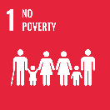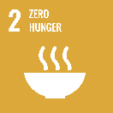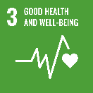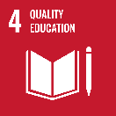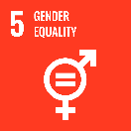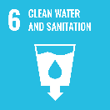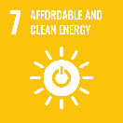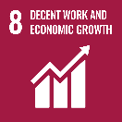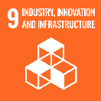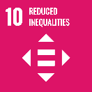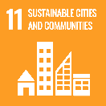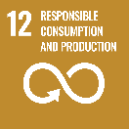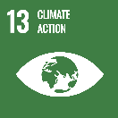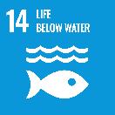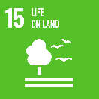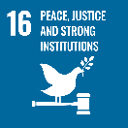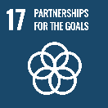

Australia’s investments improve management of scarce water resources, increase opportunities for economic growth, and improve access to inclusive, sustainable and safe drinking water, sanitation, and hygiene services. Increasingly, our investments acknowledge the close link between water and climate change, both adaptation and mitigation. Climate change is largely and immediately experienced through the water cycle: whether too much, too little or at the wrong time. This has significant implications for economies across the world as good water management is critical to building resilience to climate change and is increasingly recognised to play an important part in mitigation.

### Strategic direction

### Australia sees water as a development, foreign policy, and security issue. Water underpins all human activity: food production, livelihoods, health, and social stability. Water is also deeply and fundamentally inter-connected to energy and is closely linked to food security with around 80 per cent of available freshwater consumed by agriculture. Globally, some two billion people still lack access to safely managed drinking water, undermining community health and resilience. Climate change is putting strains on water security. It is estimated that by 2050 more than half of the world’s population and around half of global grain production will be at risk due to water stress.

### Australia's investments in the water sector are an integral part of our climate change response. Our support is focussed on the Indo-Pacific region and includes climate-resilient water, sanitation, and hygiene (WASH), water resources management and water infrastructure.

### Program highlights

Australia’s 2024-25 water investments:

* The Australian Water Partnership supports partners across the Indo-Pacific region to strengthen water resource management. Activities include water planning in the Lower Mekong Basin; groundwater management in India; industrial wastewater management in Indonesia and Vietnam; climate resilient water in Papua New Guinea; and water utility capabilities in the Pacific.
* The Water for Women Fund improves access to climate-resilient WASH services with a strong focus on supporting women, girls and people with a disability in some of the poorest communities across the region. Concluding in June 2025, it has directly reached 4.4 million people in 16 countries.
* The Mekong-Australia Partnership’s Water, Energy, Climate program builds environmental resilience, through improved water resource management and supports regional water cooperation in five Mekong countries.
* KIAT, an infrastructure partnership between the Indonesian and Australian governments, has improved water and sanitation infrastructure for hundreds of thousands of households.