# Development Cooperation Factsheet

## Vietnam

MAY 2025

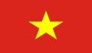

### Overview

Estimated Australian ODA: $96.6m (2025-26)

Gross National Income Per Capita: US$4,110 (2023)

Population: 100.4m (2023)

#### Table 1: Australian ODA to Vietnam, 2023-24 to 2025-26

| Australian ODA | 2023-24 Actual ($m)* | 2024-25 Budget Estimate ($m)* | 2025-26 Budget Estimate ($m)* |
| --- | --- | --- | --- |
| Country Program | 63.0 | 64.2 | 65.2 |
| Regional | 21.7 | 24.1 | 19.2 |
| Global / Other | 6.3 | 7.4 | 7.6 |
| Other Government Departments | 5.6 | - | 4.5 |
| **Total ODA to Vietnam** | **96.6** | **95.7** | **96.6** |
| **Percentage total Australian ODA** | **2.0%** | **1.9%** | **1.9%** |

Figure 1 presents the percentage of Australia’s Official Development Assistance (ODA) to Vietnam for the financial year 2025-26 attributable to seven sector groups.

This information is presented in a doughnut chart, where the seven primary Sector Groups take a portion of shading in the doughnut in direct proportion to the total percentage attributable to each Sector Group.

The percentages of total Australian ODA by Sector Groups are:
Agriculture, trade and other production services 29%
Economic infrastructure and services 10%
Education 23%
Governance 19%
Health 3%
Humanitarian 1%
Multisector and General Development Support 16%*Due to rounding, discrepancies may occur between sums of the component items in totals

#### Figure 1: Australian ODA to Vietnam by Sector Group, 2025-26 budget estimate

### Sustainable Development Goals

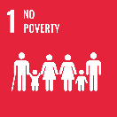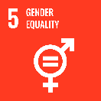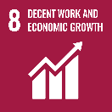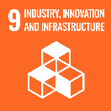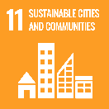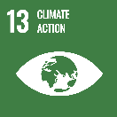

**Australia is working with Vietnam, building on our Comprehensive Strategic Partnership, to support a prosperous, secure and stable Vietnam.**

Australia and Vietnam’s partnership extends across political, security, economic, development and people-to-people activities. Since 1973, Australia has provided over $3 billion in development assistance to Vietnam. This includes technical and financial support to construct two bridges, 26.4 million COVID-19 vaccinations and over 7,000 Australia Awards Scholarships.

### Strategic direction

Australia is working in partnership with Vietnam to support progress towards achievement of Vietnam’s 2030 targets and its goal of becoming a high-income country by 2045. Australia’s development program will focus on economic growth; skills and human resource development; climate change; and gender equality, disability and social inclusion. These areas reflect the strengths of Australian support, as recognised by the Government of Vietnam, and complement the efforts of other development partners working in Vietnam.

### Program highlights

In 2023-24, Australia:

* Reduced over 27,000 tons of CO2 equivalent from rice production in the upper Mekong River Delta area.
* Provided over 37,500 people with high quality sexual and reproductive health and family planning information and services.
* Supported 820 women and child survivors to access in-person support at shelters (2024) and around 4,500 survivors to seek help through hotlines and expanded response service models including healthcare, psychosocial, legal and social services.
* Contributed to 218 organisational improvements (in terms of policies, practices, or performance standards) in the human resource sector, including increasing enrolments in logistics programs at 10 newly engaged vocational education and training (VET) school partners.
* Organised 24 capability building and knowledge exchange activities for 2,301 participants through the Vietnam Australia Centre, including two study missions for high level leaders (2024).
* Contributed to stronger governance via support for UNDP’s Provincial Governance and Public Administration Performance Index - more than 19,000 citizens were surveyed on their experiences and perception of policy and service delivery across all 63 provinces (2023).