# Development Cooperation Factsheet

Vanuatu

MAY 2025



### Overview

Estimated Australian ODA: $85.6m (2025-26)

Gross National Income Per Capita: US$3,820 (2023)

Population: 0.3m (2023)

#### Table 1: Australian ODA to Vanuatu, 2023-24 to 2025-26

| Australian ODA | 2023-24 Actual ($m)* | 2024-25 Budget Estimate ($m)* | 2025-26 Budget Estimate ($m)* |
| --- | --- | --- | --- |
| Country Programs | 57.7 | 50.0 | 50.0 |
| Regional | 14.7 | 19.0 | 22.2 |
| Global / Other | 13.5 | 12.8 | 12.2 |
| Other Government Departments | 2.3 | 1.4 | 1.3 |
| **Total ODA to Vanuatu** | **88.1** | **83.2** | **85.6** |
| **Percentage total Australian ODA** | **1.8%** | **1.7%** | **1.7%** |

*Due to rounding, discrepancies may occur between sums of the component items in totals

#### Figure 1: Australian ODA to Vanuatu by Sector Group, 2025-26 budget estimate

Figure 1 presents the percentage of Australia’s Official Development Assistance (ODA) to Vanuatu for the financial year 2025-26 attributable to seven sector groups.

This information is presented in a doughnut chart, where the seven primary Sector Groups take a portion of shading in the doughnut in direct proportion to the total percentage attributable to each Sector Group.

The percentages of total Australian ODA by Sector Groups are:
Agriculture, trade and other production services 7%
Economic infrastructure and services 12%
Education 27%
Governance 33%
Health 11%
Humanitarian 7%
Multisector and General Development Support 3%

### Sustainable Development Goals

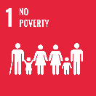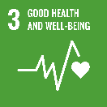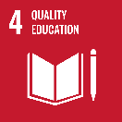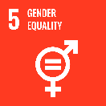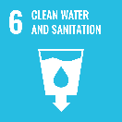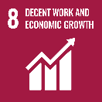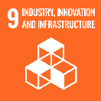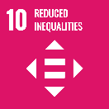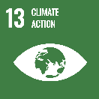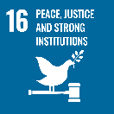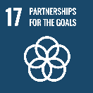

**Australia is Vanuatu’s largest development, economic and humanitarian partner.** **We have shared priorities and deep people-to-people links, built over 45 years of diplomatic relations.**

Our partnership aligns with Vanuatu’s [*National Sustainable Development Plan*](https://www.gov.vu/images/publications/Vanuatu2030-EN-FINAL-sf.pdf)and covers a range of sectors including health, education, skills, infrastructure, governance, justice, policing, economic development and humanitarian response and recovery.

### Strategic direction

Australia and Vanuatu share a strong connection as members of the Pacific community and have been close friends since before Vanuatu’s Independence in 1980. Our partnership is based on longstanding and enduring ties, and our wide-reaching relationships including between our governments, non-government organisations and communities enable us to work closely together – in good times, and in times of crises. Vanuatu’s development aspirations are at the heart of our partnership, which is contributing to our shared ambition for a Pacific region that is peaceful, stable and prosperous. Australia is committed to supporting Vanuatu to respond to the impacts of climate change, recover from recent disasters including the December 2024 earthquake, and to promoting locally led development.

### Program highlights

In 2024-25, Australia supported:

* In response to the December 2024 Vanuatu earthquake, Australia provided $22 million humanitarian and recovery assistance including the deployment of emergency medical and search and rescue teams, relief supplies, and funding to support the restoration of critical services and infrastructure.
* Australia has supported Vanuatu to build climate resilient roads on Santo, Pentecost, Ambae, Ambrym, Epi and Tanna islands, connecting communities to markets, health and education services.
* Between July 2023 – December 2024, the Australian-supported HELPR-1 medical ship provided health services to 45,400 people in rural and remote communities across all of Vanuatu’s 65 inhabited islands.
* In 2024, 30 new climate resilient classrooms were completed, providing safe learning spaces to 1,050 children impacted by recent disasters. These classrooms also function as community evacuation shelters.
* More than 15,000 people in communities on Tanna and Pentecost Islands are now benefiting from clean water supplied through climate-resilient gravity-fed water supply systems.
* In 2024, Australia upskilled 986 people (including 523 women and 43 people with disabilities) in sectors including agriculture, handicrafts and tourism, supporting livelihoods and growing businesses.
* From 2021 – 2024, Australia supported training for 2,290 police and justice officials (729 women), including training 322 new police constables (83 women), with a particular focus on improving services for women, children and people with disability.