Development Cooperation Factsheet

Tuvalu
MAY 2025


Overview
Estimated Australian ODA: $47.0m (2025-26)
Gross National Income Per Capita: US$8,770 (2023)
Population: 9,646 (2024)

Table 1: Australian ODA to Tuvalu, 2023-24 to 2025-26
Australian ODA | 2023-24 Actual ($m)* | 2024-25 Budget Estimate ($m)* | 2025-26 Budget Estimate ($m)*
Country Programs | 30.2 | 26.0 | 26.0
Regional | 29.7 | 60.5 | 20.0
Global / Other | 0.3 | 0.2 | 1.0
Other Government Departments | 0.0 | 0.0 | 0.0
Total ODA to Tuvalu | 60.3 | 86.7 | 47.0
Percentage total Australian ODA | 1.3% | 1.7% | 0.9%
*Due to rounding, discrepancies may occur between sums of the component items in totals

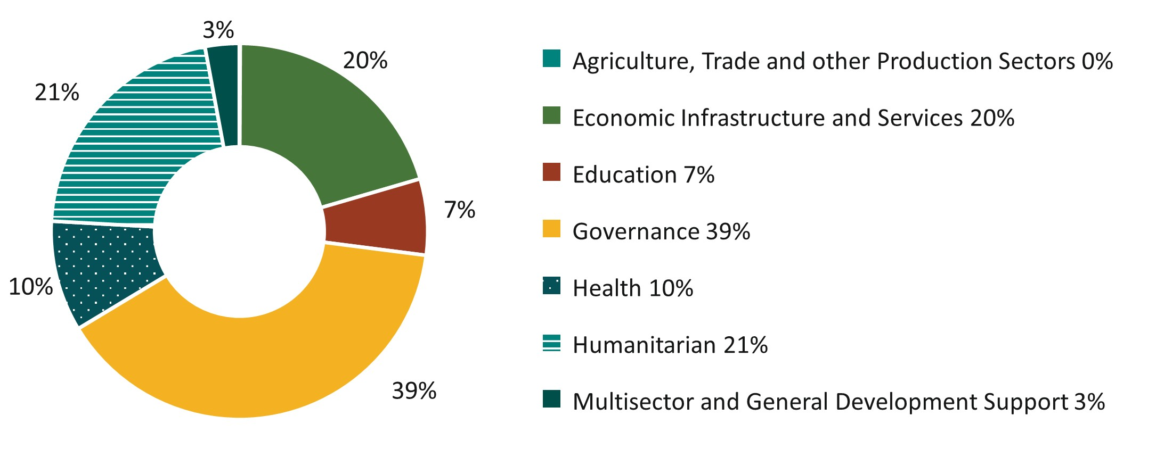
Figure 1: Australian ODA to Tuvalu by Sector Group, 2025-26 budget estimate

Sustainable Development Goals
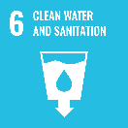
The Australia-Tuvalu Falepili Union Treaty entered into force on 28 August 2024, a momentous step in the elevation of the long-standing partnership between our two countries. The Falepili Union is about safeguarding the future of Tuvalu’s people, identity and culture for generations to come.
Australia and Tuvalu are committed to strengthening our development partnership through the Falepili Union and advancing our shared interests in a peaceful, stable and prosperous Pacific. Australia’s development program is supporting Tuvalu’s efforts to enable its people to continue to live and thrive in their territory. The program is responding to the Government of Tuvalu’s priorities, including climate adaption, economic governance, and improving health services, education, telecommunications and connectivity.

Strategic direction
Australia will continue listening to the concerns of the Government of Tuvalu and together we will advance the long-term security and prosperity of its peoples. The impacts of climate change remain the single greatest threat to the livelihoods, security and wellbeing of the people of Tuvalu. Australia will continue to support Tuvalu’s efforts to expand the availability of safe land through the Tuvalu Coastal Adaption Project (TCAP).
The Falepili Mobility Pathway will allow Tuvalu citizens to live, work and study in Australia, permanently or temporarily, if they choose. Tuvaluans can continue to participate in the Pacific Australia Labour Mobility scheme and Australia will continue to support Tuvaluan students to undertake full time studies at Australian and Pacific institutions through the Australia Awards Scholarships. We will explore options for greater access to skills and training opportunities to enhance the benefits of mobility. We will work closely with Tuvalu to support workers to preserve Tuvaluan culture, traditions and values while in Australia.
Australia is committed to supporting Tuvalu’s connectivity goals, including through the completion of Tuvalu’s first undersea communications cable. We will also deepen our security cooperation in line with our Treaty commitments to each other, including through the construction of a new National Security Coordination Centre. Through our ongoing budget support program, Australia will remain Tuvalu’s economic partner of choice and we will collaborate on supporting key economic reforms and building public financial management capacity.

Program highlights
In 2023-24, Australia supported:
- the expansion safe land to provide protection from sea level rise and extreme weather through TCAP.
- public financial management and essential government expenditure through budget support.
- strengthening Tuvalu’s health system, including through deployment of technical advisers and medical specialists to Princess Margaret Hospital.
- improving children’s foundational literacy and numeracy skills through the Tuvalu-Australia Partnership for Quality Education.

