# Development Cooperation Factsheet

## Tonga

MAY 2025



### Overview

Estimated Australian ODA: $69.7m (2025-26)

Gross National Income Per Capita: US$5,260 (2022)

Population: 0.1m (2023)

#### Table 1: Australian ODA to Tonga, 2023-24 to 2025-26

| Australian ODA | 2023-24 Actual ($m)* | 2024-25 Budget Estimate ($m)* | 2025-26 Budget Estimate ($m)* |
| --- | --- | --- | --- |
| Country Programs | 52.1 | 22.1 | 27.1 |
| Regional | 54.5 | 18.3 | 37.9 |
| Global / Other | 3.3 | 2.1 | 2.3 |
| Other Government Departments | 3.0 | 2.5 | 2.4 |
| **Total ODA to Tonga** | **112.8** | **44.9** | **69.7** |
| **Percentage total Australian ODA** | **2.3%** | **0.9%** | **1.4%** |

*Due to rounding, discrepancies may occur between sums of the component items in totals

#### Figure 1: Australian ODA to Tonga by Sector Group, 2025-26 budget estimate

Figure 1 presents the percentage of Australia’s Official Development Assistance (ODA) to Tonga for the financial year 2025-26 attributable to seven sector groups.

This information is presented in a doughnut chart, where the seven primary Sector Groups take a portion of shading in the doughnut in direct proportion to the total percentage attributable to each Sector Group.

The percentages of total Australian ODA by Sector Groups are:
Agriculture, trade and other production services 4%
Economic infrastructure and services 44%
Education 8%
Governance 28%
Health 12%
Humanitarian 3%
Multisector and General Development Support 1%

### Sustainable Development Goals

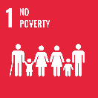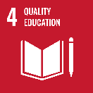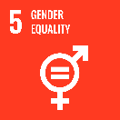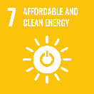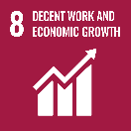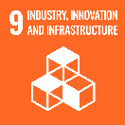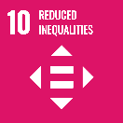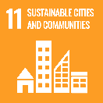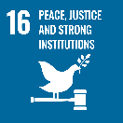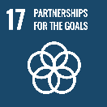

**Australia’s partnership with Tonga is anchored in shared values, respect and mutual benefit.**

We have a long history of working together to address shared social, economic and security priorities, including enhanced resilience, improved human development and climate action. Australia and Tonga recognise that our respective national interests are served by a strong and enduring bilateral partnership and a peaceful, stable and prosperous Pacific. Australia is proud to partner with the Government and people of the Kingdom of Tonga to support its development priorities.

### Strategic direction

Our bilateral partnership is guided by values of *Feveitokai’aki* (sharing and cooperating), *Falala’anga* (trust) and *Fefaka’apa’apa’aki* (mutual respect). Australia will continue to invest in what we know is working, while making changes to reflect the needs and voices of Tongans and focus where Australia can truly make a positive and sustainable impact.

Australia’s long-term vision, priorities and strategies for our development partnership with the Kingdom of Tonga is highlighted in the [Australia – Kingdom of Tonga Development Partnership Plan 2024–2029](https://www.dfat.gov.au/sites/default/files/australia-tonga-development-partnership-plan-2024-2029.pdf).

### Program highlights

Key activities in our development partnership include:

* ongoing support for economic recovery and humanitarian relief efforts after the devastating Hung-Tonga Hunga Ha’apai volcanic eruption and tsunami in 2022 and the COVID-19 pandemic
* $85 million budget support package to the Government of Tonga over 4 years from FY2024-25 to support Tonga manage it’s significant debt repayments and recover from economic shocks
* $69.7 million committed in Official Development Assistance in FY2025-26 to support new and ongoing development programs across climate, economic development, infrastructure, sports, gender and social inclusion, health, and security
* approximately $75 million worth of infrastructure support through the Australian Infrastructure Financing Facility for the Pacific – including the Tonga Hawaiki Submarine Cable Branch System, and financial support to the upgrading Tonga’s international port, and the reconstruction of Tonga’s Parliament House and the Office of the Legislative Assembly
* ongoing capability uplift and security cooperation, including through the Defence Cooperation Program, Tonga-Australia Policing Partnership, Pacific Maritime Security Program and other cyber programs
* 3,480 workers from Tonga participating in the Pacific-Australia Labour Mobility scheme (as of March 2025)
* over 600 Australian Awards scholarships to Tongan students since 1997.