# Development Cooperation Factsheet

## Sub-Saharan Africa

MAY 2025

### Overview

Estimated Australian ODA: $92.5m (2025-26)

Gross National Income Per Capita: US$1,621 (2023)

Population: 1.3b (2023)

#### Table 1: Australian ODA to Sub-Saharan Africa, 2023-24 to 2025-26

| Australian ODA | 2023-24 Actual ($m)* | 2024-25 Budget Estimate ($m)* | 2025-26 Budget Estimate ($m)* |
| --- | --- | --- | --- |
| Country Programs | 14.9 | 15.0 | 14.8 |
| Regional | 5.5 | 6.3 | 7.2 |
| Global / Other | 111.8 | 73.9 | 64.8 |
| Other Government Departments | 5.6 | 6.3 | 5.6 |
| **Total ODA to Sub-Saharan Africa** | **137.8** | **101.5** | **92.5** |
| **Percentage total Australian ODA** | **2.9%** | **2.0%** | **1.8%** |

*Due to rounding, discrepancies may occur between sums of the component items in totals

#### Figure 1 presents the percentage of Australia’s Official Development Assistance (ODA) to Sub-Saharan Africa for the financial year 2025-26 attributable to seven sector groups. This information is presented in a doughnut chart, where the seven primary Sector Groups take a portion of shading in the doughnut in direct proportion to the total percentage attributable to each Sector Group. The percentages of total Australian ODA by Sector Groups are: Agriculture, trade and other production services 20% Economic infrastructure and services 1% Education 14% Governance 14% Health 14% Humanitarian 23% Multisector and General Development Support 14%Figure 1: Australian ODA to Sub-Saharan Africa by Sector Group, 2025-26 budget estimate

### Sustainable Development Goals

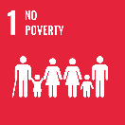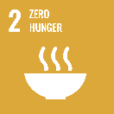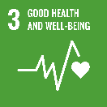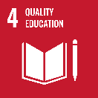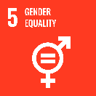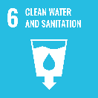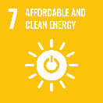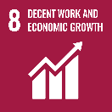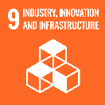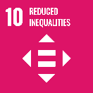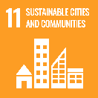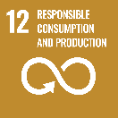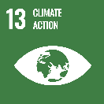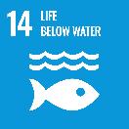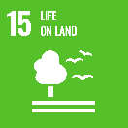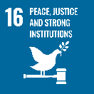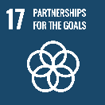

**Australia delivers a well-targeted development program in Africa to help build food security and resilience, strengthen government capacity in key sectors, empower vulnerable communities, and share knowledge on climate adaptation**.

Our development cooperation programs utilise Australian skills and technical expertise in education, climate resilience, agriculture and food security wherever possible. We ensure a strong focus on gender equality and disability inclusion across all our activities and partnerships.

### Strategic direction

Australia’s engagement with Africa reflects the diverse challenges and opportunities across the African continent.

We are providing immediate, lifesaving humanitarian support for those impacted by devastating drought, floods and conflict in the Horn of Africa and elsewhere, through our multilateral and Australian NGO partnerships.

Through high quality education and training programs, and deployments of technical experts, we are helping African nations to build capabilities, including in climate change adaptation and climate-resilient agriculture.

We are also reaching communities in Africa through community grants that help these communities recover from the social and economic impacts of COVID-19 and create safe and supportive environments for women and youth.

### Program highlights

In 2023-24, Australia supported:

* Australia Awards Masters Scholarships and courses focussing on: climate change; agriculture and food security; mining and energy; foreign policy and international security; and gender equality, disability and social inclusion.
* Humanitarian funding to address food security, including in the Horn of Africa.
* Deployments of Australian expertise through Australia Assists and the United Nations Junior Professional Officer Program.
* Funding to ACIAR to deliver the Africa-Australia Partnership for Climate Responsive Agriculture.
* Digital Earth Africa, a tool mapping impacts of climate change across the continent.