# Development Cooperation Factsheet

## Sri Lanka

MAY 2025



### Overview

Estimated Australian ODA: $26.8 (2025-26)

Gross National Income Per Capita: US$3,540 (2023)

Population: 22.0m (2023)

#### Table 1: Australian ODA to Sri Lanka, 2023-24 to 2025-26

| Australian ODA | 2023-24 Actual ($m)* | 2024-25 Budget Estimate ($m)* | 2025-26 Budget Estimate ($m)* |
| --- | --- | --- | --- |
| Country Programs | 16.0 | 16.0 | 16.0 |
| Regional | 3.2 | 4.3 | 6.7 |
| Global / Other | 3.1 | 3.0 | 4.0 |
| Other Government Departments | 2.4 | 0.5 | - |
| **Total ODA to Sri Lanka** | **24.7** | **23.9** | **26.8** |
| **Percentage total Australian ODA** | **0.5%** | **0.5%** | **0.5%** |

*Due to rounding, discrepancies may occur between sums of the component items in totals

#### Figure 1 presents the percentage of Australia’s Official Development Assistance (ODA) to Sri Lanka for the financial year 2025-26 attributable to seven sector groups. This information is presented in a doughnut chart, where the seven primary Sector Groups take a portion of shading in the doughnut in direct proportion to the total percentage attributable to each Sector Group. The percentages of total Australian ODA by Sector Groups are: Agriculture, trade and other production services 13% Economic infrastructure and services 8% Education 33% Governance 35% Health 2% Humanitarian 5% Multisector and General Development Support 4%Figure 1: Australian ODA to Sri Lanka by Sector Group, 2025-26 budget estimate

### Sustainable Development Goals

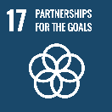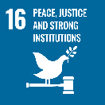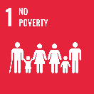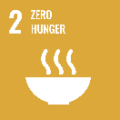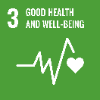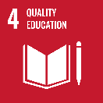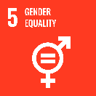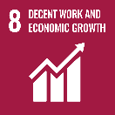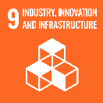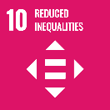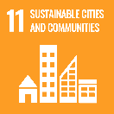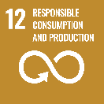

**Australia has a longstanding and impactful development program in Sri Lanka. Over the past decade, Australia has supported a wide range of economic and governance reform in Sri Lanka, as well as measures to strengthen civil society and build skills development.**

In response to Sri Lanka’s 2022 economic crisis, Australia provided a surge in funding ($75 million in 2022) to meet immediate humanitarian food security and health needs. As Sri Lanka’s economic recovery continues, Australia’s development program will seek to support inclusive, sustainable and resilient economic growth.

Australia is a trusted partner of choice for Sri Lanka. We listen carefully to Sri Lankan partners to build a better understanding of their needs and common challenges. We work in friendship on joint development solutions to support the growth of a strong, successful Sri Lanka, in turn contributing to a more resilient Indian Ocean region.

### Strategic direction

The overarching goal for the Australia–Sri Lanka development partnership is a peaceful, stable and prosperous Sri Lanka. With a stable economy recovering from several years of crisis, Australia’s focus on sustainable and inclusive livelihoods and growth aims to expand and diversify current markets and economic opportunities.

The Government of Sri Lanka is focused on building trust in governance systems by ensuring integrity, accountability and transparency; Australia is a longstanding and trusted partner in this area particularly at the sub-national level.

Additionally, our development assistance has a central focus on resilience and empowerment of people and communities alongside enhancing capabilities for stronger linkages, skills and knowledge exchange with Australia.

### Program highlights

In 2023-24, Australia supported:

* 24 emerging Sri Lankan changemakers and leaders to embark on Australia Awards Masters’ degrees at Australian universities building on the more than 1,250 Australia Awards scholarships provided since 1972.
* Cash assistance and distribution of high-quality climate resilient seeds to 11,301 farmers in vulnerable districts to optimize production practices and improve food affordability for communities.
* 176,518m2 of de-mining land clearance: Australia has supported efforts towards a mine-free Sri Lanka since 2009. This work has resulted in the safe relocation of more than 300,000 people displaced internally and helped reconstruct infrastructure such as roads, railways, and water supply and energy facilities.
* Expansion of organic backyard mango farming models into commercial cultivation, allowing 100 participants to harvest crops and sell surplus produce, improving access to safe nutritious food.
* The development of the tourism sector through a comprehensive study of Sri Lankan tour guides, running cookery upskilling programs and training and supporting 17 tuk-tuk drivers to achieve tour guide certification.
* Training of 244 Electoral Commission and Government officials across six districts in their native Sinhala and Tamil languages, a prerequisite for inclusive electoral processes.