# Development Cooperation Factsheet

## Sport for development

MAY 2025

### *Table 1: Key Program Figures*

|  | 2023-24 | 2024-25 | 2025-26 |
| --- | --- | --- | --- |
| Estimated Australian ODA | $6 million | $6 million | $6 million |
| Countries | 7 | 7 | 7 |
| Partnerships with Australian/regional organisations | 18 | 37 | 37 |

### *Table 2: Key Program Outputs*

|  | 2021 | 2022 | 2023 | 2024 |
| --- | --- | --- | --- | --- |
| Participants | 167,277 | 185,724 | 98,734 | 209,745 |
| % of female participants | 43% | 43% | 48% | 48% |
| % of primary school-aged participants | 28% | 25% | 36% | 37% |
| Participants with a disability | 2,134 | 4,374 | 4,837 | 7,843 |
| Volunteers and staff* | 1,019 | 679 | 628 | 339 |
| Individuals trained** | 3,964 | 7,419 | 4,410 | 4,158 |

* 47% women, 2% people with a disability and 18% identifying as LGBTQI+, including Pacific culture gender identities

** 50% women, 7% people with a disability and 0.4% identifying as LGBTQI+, including Pacific culture gender identities

### Sustainable Development Goals

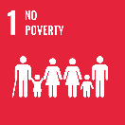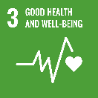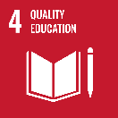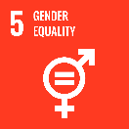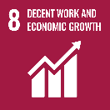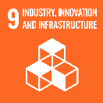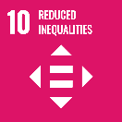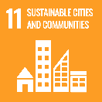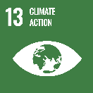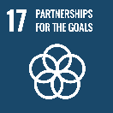

**Australia’s sport for development programs use sport to bring together communities, create opportunities and address social issues.**

Building on more than a decade of investment, *Team Up* is the Australian Government‘s flagship sports for development program in the Pacific.

### Strategic direction

*Team Up* aims to deepen Australia’s linkages with the region in line with Sports Diplomacy 2032+. The program’s goal is for sports partnerships to support all people to realise their full potential. The program focuses on achieving the following development outcomes:

1. sport programs attract and retain women and girls and people with a disability as well as boys and men;
2. sport organisations are safe, inclusive and accessible;
3. Australia and its partners in the Indo-Pacific use sport to strengthen relationships and build closer collaborations.

*Team Up* builds strategic partnerships with regional and global organisations, elevating Australia to a position of global influence in sports for development. It aligns with Australia’s international development policy, which is centred on ‘listening, respect and genuine partnership’ for a peaceful, stable and prosperous Indo-Pacific.

### Team Up Program highlights

*Team Up* has expanded across the Pacific, with 37 partnerships involving over 70 organisations transforming lives through sport. The Play for Equity Fund has provided small grants to 29 community initiatives using sport to advance gender and disability justice.

With *Team Up*’s support, FIBA Oceania developed the Hoops for Equality playbook, which helped shape FIBA HQ’s Global Basketball for Good, including content on equality and safeguarding. *Team Up* has influenced policy across the region in line with DFAT’s International Development Policy, driving change in safeguarding, disability and gender inclusion. Programs promoting healthy relationships and consent demonstrate this approach, including the Pacific adaptation of the NRL Voices Against Violence curriculum. *Team Up* is a member of the Oceania Impact Network and ONOC Equity and Education Commissions.

Former participants of *Team Up* programs are now competing internationally in several sports including basketball and soccer, with one representing Tonga at the Paris 2024 Paralympic Games.

For more detail:

* Team Up
* Sports Diplomacy 2032+ Strategy

### Participating Sports

AFL, Badminton, Basketball, Cricket, Football, Gymnastics, Hockey, Netball, Para-Athletics, Rugby League, Rugby Union, Swimming, Surfing, Table Tennis, and Volleyball.

### Team Up Countries

Fiji, Nauru, Papua New Guinea, Samoa, Tonga, Solomon Islands and Vanuatu