# Development Cooperation Factsheet

## Southeast Asia Regional

MAY 2025

ASEAN flag

### Overview

Estimated Australian ODA: $334.0m (2025-26)

#### Table 1: Australian ODA to Southeast Asia Regional, 2023-24 to 2025-26

| Australian ODA to Southeast Asia Regional | 2023-24 Actual ($m)* | 2024-25 Budget Estimate ($m)* | 2025-26 Budget Estimate ($m)* |
| --- | --- | --- | --- |
| Country Programs | - | - | - |
| Regional | 193.2 | 192.5 | 233.2 |
| Global / Other | 128.7 | 137.9 | 100.8 |
| Other Government Departments | 0.7 | - | - |
| **Total ODA to Southeast Asia Regional** | **322.6** | **330.4** | **334.0** |
| **Percentage total Australian ODA** | **6.7 %** | **6.7%** | **6.6%** |

*Due to rounding, discrepancies may occur between sums of the component items in totals

#### Figure 1 presents the percentage of Australia’s Official Development Assistance (ODA) to Southeast Asia Regional for the financial year 2025-26 attributable to seven sector groups. This information is presented in a doughnut chart, where the seven primary Sector Groups take a portion of shading in the doughnut in direct proportion to the total percentage attributable to each Sector Group. The percentages of total Australian ODA by Sector Groups are: Agriculture, trade and other production services 17% Economic infrastructure and Services 13% Education 4% Governance 12% Health 16% Humanitarian 2% Multisector and General Development Support 36%Figure 1: Australian ODA to Southeast Asia Regional by Sector Group, 2025-26 budget estimate

### Sustainable Development Goals

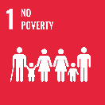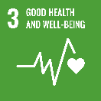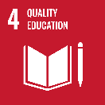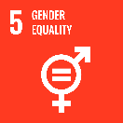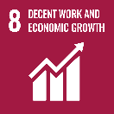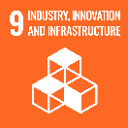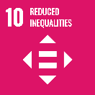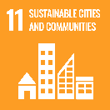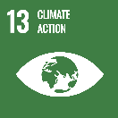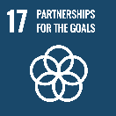

**Australia’s prosperity, security and economic future are intimately linked with Southeast Asia. Deepening Australia’s engagement with the region is a priority. We continue to work with our partners to sustain and protect the hard-won development gains of the nine ODA-eligible countries in the region.**

Building on our longstanding development partnerships, Australia’s $1.28 million in development assistance to Southeast Asia advances our collective interests and tackles shared challenges – including climate change, advancing gender equality, inclusive, sustainable growth and fostering resilient communities.

### Strategic direction

Australia shares a vision for a peaceful, stable and prosperous Southeast Asia. We are committed to working with the Association of Southeast Asian Nations (ASEAN) and the countries of the Mekong subregion (Cambodia, Laos, Myanmar, Thailand and Vietnam) to build a region that is peaceful, stable and prosperous, where countries and peoples can cooperate, trade and thrive, and where differences and disputes are settled through dialogue, existing institutions and agreed rules and norms. The Australia – Southeast Asia Regional Development Partnership Plan 2024–2028 (DPP) translates into action the development priorities Australia shares with Southeast Asia. It complements Australia’s seven bilateral DPPs with Southeast Asian countries.

### Program highlights

* + - * **Aus4ASEAN Futures**, the flagship ASEAN development program, is supporting over 30 projects, including the development of ASEAN’s post-2025 economic strategy, the Digital Economy Framework Agreement, the ASEAN Power Grid, and the ASEAN Centre for Climate Change.
* **The** **Partnerships for Infrastructure (P4I)** program has supported more than 3,000 infrastructure professionals per year from across the region to build their technical and policy expertise.

- Assisted Cambodia update its national standards for roads and bridges, to be used across its USD1.6 billion road infrastructure pipeline.

- Supported the adoption of Vietnam’s new Electricity Law and Power Development Plan VIII, which will unlock 44 gigawatts of new renewables capacity by 2030.

* **The** **Mekong-Australia Partnership (MAP)** seeks to bolster the resilience and support inclusive, sustainable growth in the Mekong subregion. Through MAP, Australia supported water security and climate change resilience by helping support riverine communities respond to environmental degradation (working with Oxfam and WWF).
* **Investing in Women** is a multi-country program that focuses on accelerating women’s economic equality in Southeast Asia. Since 2016, investment into over 90 women-led SMEs in Indonesia, the Philippines and Vietnam has helped catalyse over A$290 million in co-financing.
* **The** **Southeast Asia and Australia Government-to-Government Partnerships program** is enabling 17 Australian government agencies to deepen and sustain partnerships with their counterpart agencies in Southeast Asia. Thirty-four partnerships are underway across all countries in Southeast Asia and ASEAN, in areas such as food innovations for sustainability, biosecurity, transnational education, competition and consumer protection, and economic governance.