# Development Cooperation Factsheet

## South and Central Asia Regional

MAY 2025

### Overview

Estimated Australian ODA: $109.7m (2025-26)

#### Table 1: Australian ODA to South and Central Asia Regional by Program 2023-24 to 2025-26

| Australian ODA | 2023-24 Actual ($m)* | 2024-25 Budget Estimate ($m)* | 2025-26 Budget Estimate ($m)* |
| --- | --- | --- | --- |
| Country Programs | - | - | - |
| Regional | 8.8 | 12.0 | 13.9 |
| Global / Other | 27.3 | 90.5 | 95.4 |
| Other Government Departments | 1.0 | 0.6 | 0.4 |
| **Total ODA to South and Central Asia Regional** | **37.1** | **103.1** | **109.7** |
| **Percentage total Australian ODA** | **0.8%** | **2.1%** | **2.2%** |

*Due to rounding, discrepancies may occur between sums of the component items in totals

#### P43#y1Figure 1: Australian ODA to South and Central Asia Regional by Sector Group, 2025-26 budget estimate

### Sustainable Development Goals

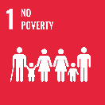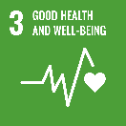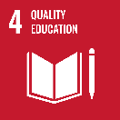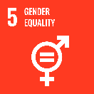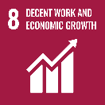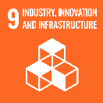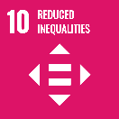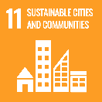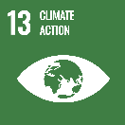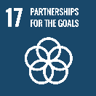

### Australia is working with partners in South and Central Asia to create a stable, prosperous and resilient region. South and Central Asia’s immediate needs are in climate resilience, economic infrastructure and services, skills and humanitarian aid.

### Australia’s regional development contributions to South and Central Asia focus on addressing transboundary challenges and deploying our expertise in water resources, agriculture, trade and infrastructure to support long-term stability and economic security.

### Strategic direction

### The South and Central Asia Regional program delivers on the commitments under the Australia-South Asia Regional Development Partnership Plan. Gender equality and climate change are focuses of all investments under the regional program. Australia is also building the capability of regional institutions, including the Indian Ocean Rim Association, and promoting greater cooperation in maritime safety and security, women’s economic empowerment and the blue economy of the Indian Ocean Region.

### Program highlights

In 2023-24, Australia supported:

* The South Asia Water Security Initiative (SAWASI) is strengthening city-level water governance and undertaking investments to increase access to reliable, safe water and sanitation services (especially for women and girls) while enhancing community resilience to climate change including flooding and other water-related shocks in South Asian megacities. There are two water sensitive cities piloted under SAWASI.
* The Australia Awards in South Asia and Mongolia (AASAM) program supports knowledge transfer and people-to-people links between Australia and the countries in South Asia region and Mongolia through a range of activities including Australia Awards scholarships, short courses, and on-award scholar and alumni engagements. 788 people have undertaken education, training and professional development programs during 2024.
* Through technical assistance, the South Asia Regional Infrastructure Connectivity Program (SARIC) is improving transport and energy connectivity across five countries in South Asia, by leveraging loans and investing in the private sector. More than 300 people from seven South Asian countries have received training in areas such as leadership, transport and green energy enabling better capability and networks across the region.